Summary of 2024 Landscape Guide Reviews

(Boreal and Great Lakes-St. Lawrence)

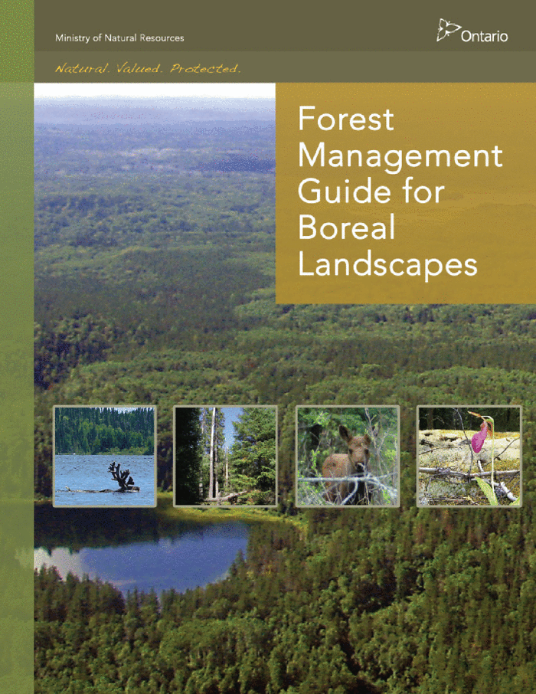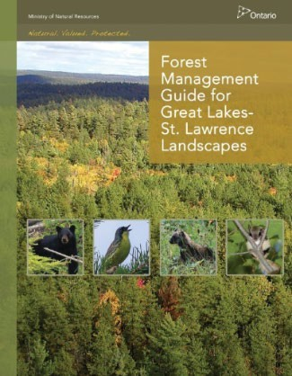

Final Report

June 26, 2025

Executive Summary

This report presents the findings and conclusions of the ten-year reviews of the Forest Management Guide for Boreal Landscapes and the Forest Management Guide for Great Lakes - St. Lawrence Landscapes. The reviews resulted in a recommendation to proceed with a scoped revision to modernize both the Boreal Landscape Guide and Great Lakes-St. Lawrence Landscape Guide. Short-term revision recommendations are focused on modernizing, clarifying and improving consistency of direction, without significant changes that would affect implementation.

The reviews included consideration of the results of applicable scientific investigations and monitoring programs, feedback from practitioners, Indigenous peoples, and stakeholders, as well as advances in technology and changes to operational practices. A series of information sessions, workshops and a survey engaged approximately 200 participants in the landscape guide reviews. Feedback was received from industry and MNR practitioners, First Nation communities and organizations, Métis communities and organizations, and stakeholders. Details of this engagement are provided in section 2, and the key themes of discussion included:

- Importance of communication (training, plain language)
- Inclusion of Indigenous Knowledge
- Concerns about Effectiveness Monitoring
- Climate Change, Cumulative Effects, Caribou
- Simulated Ranges of Natural Variation (SRNV)

Specific recommendations were grouped into general recommendations that do not require guide revisions, short-term recommendations for the Boreal Landscape Guide, short-term recommendations for the Great Lakes-St. Lawrence Landscape Guide, and long-term recommendations for both landscape guides.

General recommendations:

- Continue to deliver and improve training materials related to the landscape guide and supporting science and tools.
- Develop communication materials to explain the landscape guides to a public audience.
- Continue to update the science and maintain the tools supporting implementation of the landscape guides.
- Continue to support and improve effectiveness monitoring efforts to address key uncertainties related to landscape guide direction.

Short-term revision recommendation for the Boreal Landscape Guide:

- Incorporate the Spanish Forest into the Boreal Landscape Guide, as part of Landscape Guide Region 3E.
- Align texture and patch size indicator timing of assessment with recent changes to the Forest Management Planning Manual.
- Administrative updates to outdated references (e.g., policies, legislation)
- Update references to science and information packages:
  - to align with outcomes of Boreal Simulated Ranges of Natural Variation Project, and
  - to clarify landscape guide application where there is disagreement between the guide and science packages.

Short-term revision recommendation to modernize the Great Lakes-St. Lawrence Landscape Guide:

- Remove the Spanish Forest from the GLSL North Landscape Guide Region
- Align texture and patch size indicator timing of assessment with recent changes in the Forest Management Planning Manual
- Administrative updates to outdated references (e.g., policies, legislation).
- Include direction regarding favouring non-landscape guide indicator achievement to the GLSL Landscape guide, consistent with Boreal Landscape Guide direction.
- Clarify landscape guide forest unit assignments to landscape classes.

Long-term recommendations:

  - Collaborate on ways the landscape guide could be co-applied with Indigenous Knowledge and explore opportunities to enable this in the guide.
  - Identify options for the landscape guides to provide direction to planning teams regarding climate change at the landscape scale.
  - Identify options for the landscape guides to provide direction to planning teams regarding cumulative effects at the landscape scale.
  - Identify updates to caribou-related direction (Boreal Landscape Guide), consistent with results from Canada-Ontario Caribou Conservation Agreement
  - Continue to practice adaptive management and consider revisions where new science and information are available (e.g., results of effectiveness monitoring programs and projects)

Table of Contents
Executive Summary ii
General recommendations: ii
Short-term revision recommendation for the Boreal Landscape Guide: ii
Short-term revision recommendation to modernize the Great Lakes-St. Lawrence Landscape Guide: iii
Long-term recommendations: iii
1. Background 7
1.1 Policy context 7
1.2 Landscape guide implementation 7
1.3 Structure of the landscape guide reviews 9
1.4 Provincial Forest Technical Committee 10
1.5 Current projects related to the landscape guides 10
2. Summary of Engagement 11
2.1 Information Sessions 11
2.2 Workshops 12
2.2.1 Workshop Activities 13
2.2.2 Summary notes from each workshop 22
2.3 Survey 28
2.3.1 Overview of survey results 30
2.4 Additional Feedback 33
2.5 Overall Themes 34
2.5.1 Communication 35
2.5.2 Indigenous Knowledge 36
2.5.3 Effectiveness Monitoring 37
2.5.4 Climate Change, Cumulative Effects, Caribou 38
2.5.5 Simulated Ranges of Natural Variation (SRNV) 40
3. Additional Components of the Reviews 40
3.1 Reporting and audits 41
3.2 Scientific investigations, research, and monitoring programs 42
3.3 Advances in technology and changes to operational practices 45
4. Conclusion 46
4.1. Summary of Short-term Revision Recommendations 47
4.1.1 Boreal Landscape Guide: 47
4.1.2 Great Lakes-St. Lawrence (GLSL) Landscape Guide: 47
4.2. Summary of Long-term Recommendations 47
5. References 48
Appendix A: Landscape Guide Regions and Forest Management Unit Boundaries 53
Appendix B: Workshop Activity Results 54
Activity 1 54
Activity 2 63
Kenora (January 30, 2024) 63
Dryden (February 1, 2024) 65
Thunder Bay (February 6, 2024) 67
Timmins (February 13, 2024) 71
Hearst (February 15, 2024) 73
Peterborough (February 22, 2024) 76
Virtual (February 28, 2024) 79
Sault Ste Marie (March 5, 2024) 80
North Bay (March 7, 2024) 82
Bracebridge (March 12, 2024) 85
Activity 3 87
Activity 4 93
Thunder Bay (February 6, 2024) 93
Timmins Session (February 13, 2024) 95
Hearst Session (February 15, 2024) 96
Peterborough session (February 22, 2024) 97
Sault Ste. Marie session (March 5, 2024) 98
North Bay session (March 7th, 2024) 98
Appendix C: Survey results 100
Appendix D: Written comments provided by Regional Planning Biologists (MNR) 116
Appendix E: Independent Forest Audit Findings related to landscape guide direction 135
Appendix F: Boreal Landscape Guide: Re-estimating SRNVs 137
Summary 137
Issues with Simulated Ranges of Natural Variation 139
Landscape Guide Region 3E (lowland/upland confusion) 139
Landscape Guide Region 3S/4S (borders and parks data missing) 140
Landscape Guide Region 4W (red and white pine SRNVs missing) 140
Landscape Guide Region 3W (all ages conifer indicator suspect) 141
New Science and Information and Science Projects 143
Natural Succession 143
Post Disturbance Transitions 144
Science/Information Projects 144
Simulation and Assessment Tools 145
BFOLDS 145
ST-Sim 145
LANDIS-II 146
ALCES 146
Landscape Scripting Language (LSL) 146
Re-estimating SRNVS 147
Steps in re-estimating SRNVs 147
Estimated time to re-estimate SRNVS for a Landscape Guide Region 149

1. Background

This report presents the findings and conclusions of the ten-year reviews of the Forest Management Guide for Boreal Landscapes (OMNR 2014) and the Forest Management Guide for Great Lakes-St. Lawrence Landscapes (OMNR 2010). In this document, these guides are referred to as Boreal Landscape Guide (BLG) and Great Lakes-St. Lawrence Landscape Guide (GLSL LG), respectively. Collectively, this document refers to these guides as “the landscape guides”).

1.1 Policy context

The Ministry of Natural Resources (MNR) maintains a suite of forest management guides as a part of Ontario’s forest policy and management frameworks. These guides provide direction used by planning teams during the development of forest management plans.

The Forest Operations and Silviculture Manual (FOSM) 2020 is regulated under the Crown Forest Sustainability Act and requires forest management guides to be reviewed at least once every ten years. The BLG was published in 2014, and this is the first review of the guide. The GLSL LG was published in 2010, reviewed in 2015, and this is the second review of the guide.

The review of a forest management guide is part of the adaptive management approach described in FOSM, and is intended to inform whether revisions to the guide are warranted. This manual directs that the reviews will consider:

  - Results of applicable scientific investigations
  - Results of monitoring programs
  - Feedback from practitioners, Indigenous peoples, and stakeholders
  - Advances in technology and changes to operational practices

These points of consideration were incorporated into the landscape guide reviews. Emphasis was placed on seeking feedback from practitioners, First Nation peoples, Métis peoples and stakeholders, given the recent implementation of the landscape guides in forest management planning.

1.2 Landscape guide implementation

The objective of the landscape guides is to direct forest management activities to maintain or enhance natural landscape structure, composition and patterns that provide for the long-term health of forest ecosystems in an efficient and effective manner. These guides direct the amount and arrangement of different types and ages of forest on the landscape. The landscape guides, as well as the Forest Management Guide for Conserving Biodiversity at the Stand and Site Scales, incorporate a coarse and fine filter concept in the direction for forest management. In addition to landscape level direction, the BLG also includes stand and site level direction for caribou. Therefore, workshops held in context of the BLG included topics specific to the stand and site level direction for caribou.

Since the release of the landscape guides in 2010 (GLSL LG) and 2014 (BLG), all forest management units have fully incorporated landscape guide direction into their forest management plans. Section 1.4 of the landscape guides identifies how direction in these guides were expected to be incorporated in forest management planning, including a set of phase-in provisions for different stages of planning. Some forest management plans applied the theory and science supporting the landscape guides prior to their release, as an effort to include the best science and information available, as specified in the Forest Management Planning Manual. This application of the science and information products supporting the landscape guides was also part of pilot testing the landscape guides.

Figure 1 is an illustration of the landscape guide regions identified in the current landscape guides. The forest management unit boundaries (2024) are displayed within the landscape guide regions and identify which landscape guide was applied in planning. A more detailed map including labelled forest management units is included in Appendix A. A complete list of forest management plans and their effective dates can be found on the Ontario webpage.

Figure 1: Image of a map displaying the boreal (green) and Great Lakes-St. Lawrence (orange) Landscape guide regions, as well as underlying forest management unit boundaries.

1.3 Structure of the landscape guide reviews

The review for each landscape guide followed a similar structure as the 2015 GLSL LG review, which can be found in the Science and Information Package for Great Lakes-St. Lawrence. Practitioners, First Nation peoples, Métis peoples, and stakeholders were engaged in the reviews through a series of information sessions and workshops. There was also an online survey provided to participants and an offer to engage with specific groups or communities in separate meetings or formats (e.g., written feedback).

The engagement and workshops for both landscape guides were held concurrently to facilitate efficiencies in receiving feedback from practitioners, First Nation peoples, Métis peoples and stakeholders. Some practitioners have experience applying both landscape guides. The content of both guides is based on the same theory and have similar direction. Structuring the workshops to discuss both landscape guides concurrently also supported discussions about aligning the timeframe of any potential revisions and the consideration for amalgamating the guides, which was a recommendation in the 2015 GLSL LG review.

Invitations for the information sessions and workshops were sent to First Nation communities and organizations, Métis communities and organizations, stakeholders, practitioners, government staff, and other interested individuals. The information sessions were held virtually through MS Teams on January 23rd and 24th, 2024. The intent of these sessions was to provide an overview of the landscape guides and information about the review, timelines, and in-person workshops. These sessions provided an opportunity for individuals to ask questions about the review process and the content and format of the workshops, which also informed participant interest in attending a more technical workshop. A recording of the information session was made available upon request.

Nine in-person workshops and one virtual workshop were hosted between January 30th and March 12th, 2024. Table 1 lists the workshop dates and locations, as well as the landscape guide(s) that were the focus of each workshop. The workshops were technical in nature and focused on seeking feedback about the implementation of the landscape guides. The intended audience was individuals who are familiar with the landscape guides and have experience with their application (e.g., forest management planning team members). The structure of the workshop included a detailed review of direction in the landscape guide(s), four activities, and time to reflect on the day. A summary of the activities and workshop discussion is provided in section 2.

Table 1: List of 2024 workshop dates and locations. The third column identifies which landscape guide(s) each workshop focused on.
Date | Location | Landscape Guide Focus
January 30, 2024 | Kenora | Boreal
February 1, 2024 | Dryden | Boreal
February 6, 2024 | Thunder Bay | Boreal
February 13, 2024 | Timmins | Boreal
February 15, 2024 | Hearst | Boreal
February 22, 2024 | Peterborough | Great Lakes-St. Lawrence
February 28, 2024 | Virtual | Boreal & Great Lakes-St. Lawrence
March 5, 2024 | Sault Ste Marie | Great Lakes-St. Lawrence
March 7, 2024 | North Bay | Boreal & Great Lakes-St. Lawrence
March 12, 2024 | Bracebridge | Great Lakes-St. Lawrence

The online survey was hosted on MS Forms and made available between January 25th and March 29th, 2024, with some requests for extension. The survey included questions about guide implementation, science supporting the landscape guides, effectiveness and effects of guide direction, climate change, and caribou habitat (where applicable). Some participants opted to provide written feedback and/or meet with the MNR to provide comment. More details about each section of the survey and a summary of responses and written feedback is provided in section 2.

Other considerations in the review were current literature and approaches in other jurisdictions, reporting and audits, scientific investigations and monitoring programs, and advances in technology and changes to operational practices. Details on this information are described in section 3.

1.4 Provincial Forest Technical Committee

As per the FOSM, the Provincial Forest Technical Committee (PFTC) provides advice on the review and revision of forest management guides. Advice from PFTC is intended to ensure the direction reflects current scientific knowledge and forest management practices and that the direction can effectively and efficiently achieve the purposes identified in the Crown Forest Sustainability Act.

The PFTC was involved in the original development and review of the current landscape guides. For the 2024 landscape guide reviews, the PFTC was presented and provided feedback on the review approach at an early stage of preparing for the workshops. Some PFTC members participated in the information session and workshops supporting the review. The PFTC also received a presentation summarizing preliminary results from the workshops and provided input on next steps for the reviews.

1.5 Current projects related to the landscape guides

At the time of the landscape guide review workshops, there were several projects underway that specifically related to the landscape guides. Specific to the Boreal Landscape Guide, there is:

- a project titled “Re-estimation of the Simulated Ranges of Natural Variation in the Boreal Landscape Guide Regions”, which is intended to update the science and information used by forest management planning teams when implementing the BLG.
- a series of projects under the Conservation Measure 3.1 (Forest Management Planning), which were designed to support implementation and assess the effectiveness of the caribou-related direction in the BLG.

Related to both landscape guides, policy staff are working with MNR’s Science and Research Branch to validate the landscape classes identified in the landscape guides using empirical data, primarily collected through wildlife monitoring programs in the Biodiversity and Monitoring Section.

These projects were discussed to varying degrees during the workshops. More details about the projects and their potential to inform the landscape guide reviews is included in section 3 of this report.

2. Summary of Engagement

The following sections provide a summary of the engagement efforts described in section 1. An overview of participation in the information sessions, workshops, and surveys is provided, including details about the structure of workshop activities, structure of the online survey, and a summary of feedback received.

2.1 Information Sessions

Approximately 175 people registered to attend the online information sessions, and approximately 140 of those registrants joined the live session online. There were also several requests for copies of the recording. Participation included representatives of First Nation communities and organizations, Métis communities and organizations, stakeholders, practitioners, government staff, and other interested individuals.

Themes of questions and discussion during the information session included a need to improve Indigenous consultation and engagement, inclusion of Indigenous Knowledge in the landscape guides, consideration for cumulative effects and the need for integrated land use planning, communication challenges with the technical nature of the landscape guides, and clarification of what is in scope for the review and potential revisions.

During the information sessions, there were two word clouds created in response to the following questions (Figure 2):

- What word(s) come to mind when you think of the landscape guide(s)?
- What are the most important topics for focus in the landscape guide reviews?

The two most common words used in response to these questions were “caribou” and “climate change”. The topics of “old growth”, “natural disturbance”, “cumulative effects”, and terms related to spatial distribution (e.g., spatial arrangement”) and scale (e.g., “large areas” were also included. This exercise helped to inform the creation of workshop activity 3 (see section 2.2.1.3).
The information sessions generally achieved the intent to provide general communication about the landscape guide reviews to a broad audience. Clarification about the distinction between the review and revision process was provided, and information about next steps for the review were shared. The information sessions also prepared participants to join the more technical workshops by providing background information and an overview of the workshop structure.

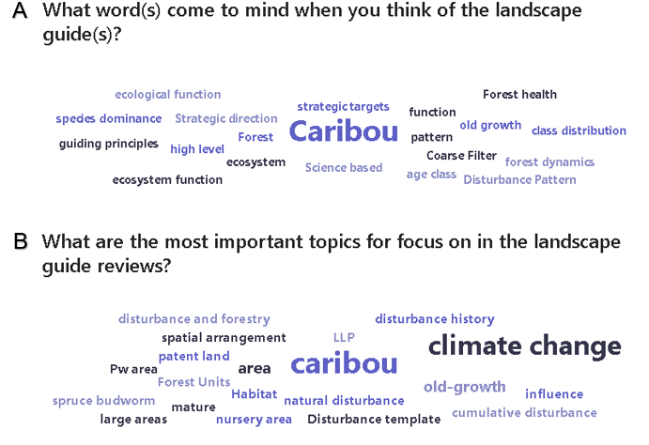
Figure 2: Word clouds generated in response to two questions during the information sessions. (A) What word(s) come to mind when you think of the landscape guide(s)? (B) What are the most important topics for focus in the landscape guide reviews?

2.2 Workshops

Approximately 200 people participated in the landscape guide review workshops, including representatives of First Nation communities and organizations, Métis communities and organizations, stakeholders, practitioners, government staff, and other interested individuals. For the workshops that focused on the BLG, there were approximately 120 participants, and for the GLSL LG there were approximately 50 participants. For the workshops that focused on both landscape guides, there were approximately 40 participants. Some participants attended multiple workshops depending on their experience and area of interest.

Section 2.2.1 provides a detailed description of each activity in the workshop and a brief summary of results. More detailed results are provided in Appendix B. Section 2.2.2 provides a brief summary of main discussion points and themes at each workshop.

2.2.1 Workshop Activities

After reviewing the mandatory direction (i.e., standards and guidelines) in the landscape guide(s), workshop participants completed four activities: dot voting, interview matrix, specific landscape guide topics, and cue cards.

2.2.1.1 Activity 1: Dot Voting

The goal of the Dot Voting activity was to receive participant input on the mandatory direction in the landscape guide. Specifically, what direction is important to maintain in the landscape guide, and what direction is a priority to consider revising. A display board with a copy of the mandatory direction from section 3 of the landscape guide was set up in the room, organized by subsections in the guide (Figure 3). A copy of this direction was also provided as a handout to participants, as well as six red dots and six green dots.

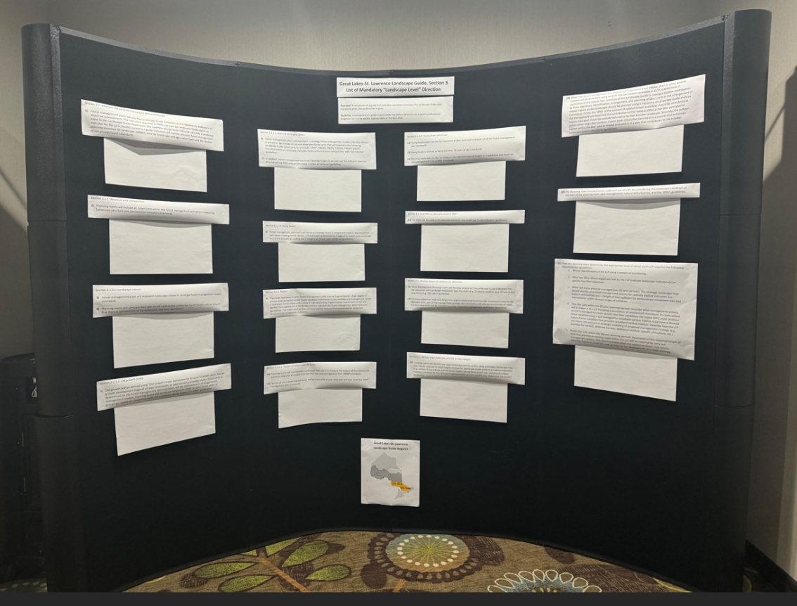
Figure 3: Example of the display board set-up for activity #1.

With reference to the current mandatory direction, workshop participants were asked to put a red dot on the direction or subsection(s) that they believe were the highest priority to consider revising and to put a green dot on the direction or subsection(s) that they believe were the highest priority to maintain (without revision). Participants could place as many or as few stickers on a given section as they would like to and could complete the activity any time throughout the day. The display board became a place to gather during the breaks and at the end of the day and hold informal discussions about the guide with colleagues. An example of the result of this activity is provided in Figure 4.

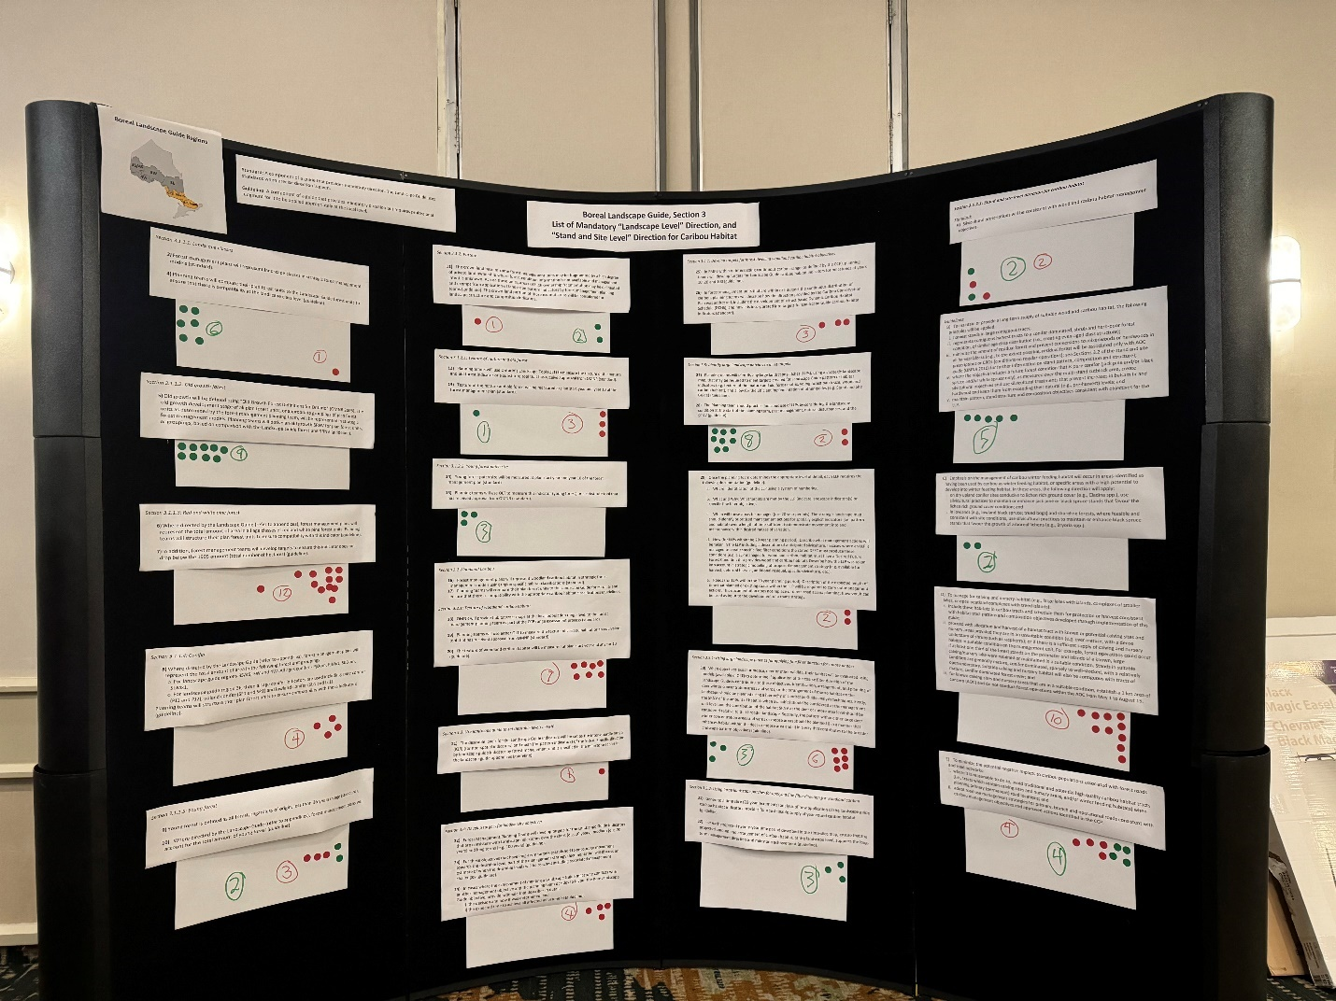
Figure 4: Example of a display board resulting from the completion of activity 1.

The number of dots used in this activity varied by workshop and participant. Some participants opted to use few or no dots, which is assumed to be driven by their experience in applying the guide(s). Therefore, the results should be considered general in nature, and the ability to make comparisons across workshops is limited. The context of how materials were presented and the discussion that occurred during the workshop also influenced results. For example, when the workshop presenter commented that direction related to the landscape classes received all green dots in previous sessions, it was the first workshop where red dots were placed on that section of the guide.

The results were summarized separately for workshops focused on each landscape guide. Figure 5 is a graph showing a summary of the average proportion of green and red dots that were placed on each subsection of the Boreal Landscape Guide. The direction for landscape classes, milestones, and large landscape patches (LLPs) generally received the highest support to be maintained without revision, while the caribou related direction, red and white pine indicators, and texture of mature and old forest indicators were identified as highest priority to be considered for revision.

Figure 5: Summary of dot voting activity to identify priority direction in the Boreal Landscape Guide to maintain and revise. The downward diagonal stripes (green) represent direction prioritized to be maintained without revision, and the upward diagonal stripes (red) represent direction prioritized for revision.

Figure 6 is a graph showing a summary of the average proportion of green and red dots that were placed on each subsection of the Great Lakes-St Lawrence Landscape Guide. The direction for pattern indicators and landscape classes generally received the highest support to be maintained without revision, while the young forest indicator direction and documentation of large landscape patches were identified as highest priority to be considered for revision.

Figure 6: Summary of dot voting activity to identify priority direction in the Great Lakes-St. Lawrence Landscape Guide to maintain and revise. The downward diagonal stripes (green) represent direction to be maintained without revision, and the upward diagonal stripes (red) represent direction prioritized for revision.

2.2.1.2 Activity 2: Interview Matrix

The goal of the Interview Matrix activity was to gain a better understanding of participant experience with the landscape guides, with a focus on implementation experience. The answers to four questions were explored:

- Question 1: What landscape guide direction would you want to maintain?
- Question 2: What landscape guide direction would you want to improve?
- Question 3: What new landscape guide direction would you want to introduce?
- Question 4: What landscape guide direction would you want to remove?

Participants were divided into groups of four, and each member of the group was given a number: 1,2,3 or 4. The number assigned to the participant matches the question number they were assigned to ask.

The first part of this activity required participants to interview each other within their group of four and take notes on the responses they received to their assigned question. The interviews were one-on-one, and conducted in a series of six rounds:
- Round 1: One (1) ask Two (2) and Four (4) ask Three (3)
- Round 2: One (1) ask Three (3) and Four (4) ask Two (2)
- Round 3: One (1) ask Four (4) and Two (2) ask Three (3)
- Round 4: Three (3) ask One (1) and Two (2) ask Four (4)
- Round 5: Two (2) ask One (1) and Three (3) ask Four (4)
- Round 6: Four (4) ask One (1) and Three (3) ask Two (2)
After the interviews were complete, participants joined a group with everyone who was assigned the same question. This resulted in four groups that collectively discussed the feedback they heard about what direction in the guide should be (1) maintained, (2) improved (3) introduced, and (4) removed. Each group summarized the key points on chart paper, and these findings were presented to all workshop participants.

Table 2 provides a summary of the key points discussed in the interview matrix activity specific to the Boreal Landscape Guide.

Table 2: Summary of results from Activity 2: Interview Matrix, specific to the Boreal Landscape Guide.
Group | Key Points
1. Maintain | - Overall structure of landscape guide, including flexibility  - Ability to make trade-offs with other objectives  - LGFU definitions  - Landscape classes  - Desirable levels and milestones  - Structure and composition indicators  - Texture and pattern indicators  - Documentation of LLPs  - Dynamic Caribou Habitat Schedule  - Old growth
2. Improve | - Messaging/communications  - Caribou direction  - Especially calving and nursery habitat  - Old growth direction  - Red and white pine direction  - Pre-industrial condition estimates  - LLP direction (e.g., limits, connectivity)  - Road-related direction  - Consideration for other land uses  - Ability to apply Indigenous knowledge  - Ability to apply spatial models  - Ontario’s Landscape Tool (OLT)  - Effectiveness monitoring
3. Introduce | - Climate change/resiliency  - Indigenous Knowledge  - Road-related direction  - Cumulative disturbance metric  - Social objectives  - Spatial distribution of mature and old forest (considerations of cumulative impacts)  - Time since fire based indicators  - Direction for wolverine  - Direction for Caribou Coastal Range and Discontinuous Distribution  - Plain language (e.g., summary of direction)
4. Remove | - LLPs for moose and deer (“pick one guide”)  - Caribou (separate guide)  - Remove prescriptive direction  - Young forest  - (Move away) from relying on age as an indicator of structure  - Ontario’s Landscape Tool (replace with new tools)

Table 3 provides a summary of the key points discussed in the interview matrix activity specific to the Great Lakes-St. Lawrence Landscape Guide.

Table 3: Summary of results from Activity 2: Interview Matrix, specific to the Great Lakes-St. Lawrence Landscape Guide.
Group | Key Points
1. Maintain | - Overall structure of landscape guide  - Old growth indicators (perhaps with some changes)  - Keep consistent LGFU as previously used  - Landscape classes and landscape guide indicators (support annual reporting)  - Inclusion of LLPs, including the flexibility in direction to apply them  - Support and development of OLT
2. Improve | - Red and white pine direction  - Support system for tools (e.g., OLT) to apply the guide  - Application of the guide through spatial modelling  - Messaging/communications, simplify the guide  - Elaborate on the direction related to “judicious use” of LLPs, and provide clarity on how planning teams can apply LLPs  - Old growth direction (consider pro-rating), separate terms “old” and “old growth”.  - Pre-industrial condition estimates  - Road-related direction  - Consideration for other land uses  - Increase flexibility to consider the achievement of non-landscape guide objectives as a priority over landscape guide indicators
3. Introduce | - Climate change/resiliency  - Social objectives  - Use spatial models to apply the guide  - Coordinate planning across management units  - Considerations for cumulative effects  - More clarification of connections with the stand and site guide  - Consider risk in implementation of the landscape guide  - More clarification on how the landscape guide applies to highly fragmented landscapes  - Make effectiveness monitoring approach clearer.
4. Remove | - Direction related to 1995 levels of red and white pine  - One workshop suggested the biodiversity indicators were redundant with other direction  - Texture assessments, noting that it is challenging to create young forest with silviculture systems in the south

2.2.1.3 Activity 3: Deeper Dive into Specific Landscape Guide Topics

The goal of the Deeper Dive activity was to receive participant input on more specific topics related to the landscape guides. The topics chosen for this activity were based on participant interests and informed by the word cloud activity described in section 2.1 (Figure 2). The list of potential topics to focus on in this activity included:

  - Alignment with other direction and land uses
  - Caribou (BLG only)
  - Climate change
  - Cumulative effects
  - Effectiveness monitoring
  - Large Landscape Patches
  - Milestones (including technical note)
  - Natural disturbances (types, severity, history)
  - Old growth
  - Red and white pine
  - Science and Information Packages and Ontario’s Landscape Tool
  - Silviculture Systems (GLSL LG only)
  - Simulated Ranges of Natural Variation (SRNVs)
  - Texture and pattern indicators

Participants were encouraged to consider Indigenous knowledge in all topics and were given the option to identify additional topics to include in the activity. Some additional topics that were included were “Landscape Classes and Forest Units” and “Biodiversity Indicators”. The latter topic amalgamated multiple topics from the original list.

Once the list of topics was agreed upon, participants voted on which topics would be included in this breakout group activity. They were provided six blue stickers as votes to identify the topic(s) that were their highest priority to discuss. Participants could place as many stickers on a given topic as they wanted. Figure 7 shows a summary of the votes for activity 3, where the BLG was the focus of the workshop. Effectiveness monitoring, cumulative effects, climate change, SRNVs, and caribou received the most votes across all workshops. Figure 8 shows the same summary for the GLSL LG, and effectiveness monitoring, natural disturbance, other land uses, cumulative effects, and climate change received the most votes.

Figure 7: Graph showing the relative number of votes for each topic considered in the “Deeper Dive” Activity (Activity 3) for workshops focused on the Boreal Landscape Guide.

Figure 8: Graph showing the relative number of votes for each topic considered in the “Deeper Dive” Activity (Activity 3) for workshops focused on the Great Lakes-St. Lawrence Landscape Guide.

The topics with the most votes were transferred to chart paper, and participants were asked to identify the biggest challenges and opportunities to address each topic on sticky notes.

After participants contributed their individual thoughts to each topic, groups were formed for each of the selected topics. Participants could join a topic of their choosing, and some participants opted to circulate between topics. The groups were tasked with summarizing the key points from the sticky notes and identifying how the challenges and opportunities could be addressed, including what changes to landscape guide direction might be required. Summaries from each group were presented to all workshop participants. Details from these discussions are captured in section 2.2.2, section 2.5 and Appendix B.

2.2.1.4 Activity 4: Cue Cards

The goal of the Cue Card activity was to receive any additional feedback from participants about the landscape guides and the review process for the guides (e.g., information session, workshops, survey). Participation was optional, and everyone was invited to write their comments on a cue card and place it in a feedback box, or to provide additional comments by email or phone. The feedback could be provided at any time during or after the workshops. The intent of this activity was to allow an additional avenue for feedback, especially for some people who may not be comfortable speaking in large groups. Comments through this activity were generally only received at the larger workshops.

The comments varied from general appreciation of the workshop structure and opportunities for participation, to detailed suggestions for revisions. Figure 9 is a word cloud summary of the comments received on cue cards. The landscape guide indicators, including old growth and other structure indicators were a focus in these comments. A record of all comments from this activity is found in Appendix B.

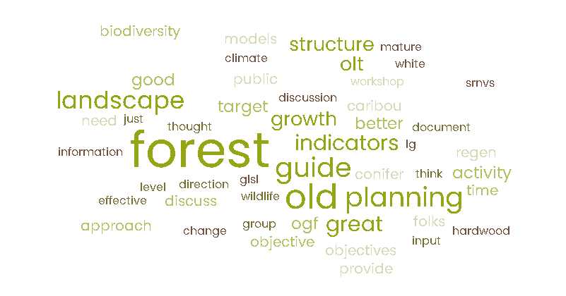
Figure 9: A word cloud summary of Activity 4 that summarize feedback provided by participants on cue card.

2.2.2 Summary notes from each workshop

Sections 2.2.2.1-2.2.2.10 provide brief summaries of the discussions and main themes at each workshop. These sections capture discussion items that were part of the workshop agenda item “Reflection from the day”. Many of these points echo what was heard in the workshop activities, and new considerations were also discussed.

2.2.2.1 Kenora Workshop

The workshop in Kenora occurred on January 30, 2024. Nine of the 12 individuals that registered participated. Participants included two forest industry representatives, a representative from a First Nation organization, and MNR staff.

Themes of discussion focused on:
- simulated ranges of natural variation (SRNVs),
- non-stand replacing disturbances,
- red and white pine forests,
- guide effectiveness monitoring,
- spatial modelling,
- a need to maintain/update tools and supporting documentation for landscape guide application, and
- potential delays in guide revision if the caribou direction is revised. There was a suggestion to create a separate guide for caribou related direction.

2.2.2.2 Dryden Workshop

The workshop in Dryden occurred on February 1, 2024. Sixteen of the 23 individuals that registered participated. Participants included forest industry representatives, a First Nation community representative, and MNR staff. Participants appreciated the opportunity to meet in-person and enjoyed the structure of the workshop.

Themes of discussion focused on:
- importance of effectiveness monitoring,
- cumulative effects (including disturbance assessments that support caribou related planning),
- opportunities to improve caribou-related direction,
- how direction around large landscape patches is applied in planning,
- challenges in achieving red and white pine objectives,
- landscape-level consideration for roads,
- suggestions to move away from species-specific related direction where possible (e.g., caribou, moose), and
- need for plain language communication materials about the landscape guide.

2.2.2.3 Thunder Bay Workshop

The workshop in Thunder Bay occurred on February 6, 2024. Forty-four of the 52 individuals that registered participated. Participants included forest industry representatives, an Indigenous community representative, stakeholders, government staff, and academic representatives. The feedback from this workshop was constructive overall and focused on landscape guide implementation.

Themes of discussion focused on:
- a need to maintain/increase flexibility in the guide,
- a need for training to increase the consistency of application of the guide,
- the need for plain language communication materials,
- a need for inclusion of Indigenous knowledge,
- improvements that could be made to the caribou related direction,
- importance of effectiveness monitoring and the need to communicate efforts,
- a need to consider climate change and associated challenges (including need to test multiple hypotheses),
- consideration of multiple scales when applying direction in the guide,
- importance of maintaining/improving tools to support implementation of the landscape guide,
- general concern that forest management guides in general (including the landscape guide) are too prescriptive and limit the ability for practitioners to respond to social demands, and
- potential delays to forest management planning due to potential revisions to the landscape guides, and
- concern about the timelines for the Boreal SRNV project results will delay forest management planning.

2.2.2.4 Timmins Workshop

The Timmins workshop occurred on February 13, 2024. Forty-two of the 44 individuals that registered participated. Participants included forest industry representatives, First Nation community and organization representatives, MNR staff, and stakeholders. Participants provided constructive feedback on landscape guide implementation and identified opportunities for improvement.

Themes of discussion focused on:
- the need to co-apply Indigenous knowledge,
- engaging meaningfully with Indigenous peoples,
- a need for communication of concepts in the guide in plain language,
- importance of effectiveness monitoring and a need to communicate updates on effectiveness monitoring efforts (specific comments on moose emphasis areas),
- training/communication to support consistent implementation of landscape guide direction (including “discretionary” direction),
- technical discussions about landscape guide indicators and content,
- a request for the Spanish forest to be moved from the Great Lakes-St. Lawrence landscape guide regions to the Boreal,
- a discussion about the value of amalgamating the landscape guide,
- concern for the lack of Indigenous involvement in the guide development process,
- concerns about the lack of effectiveness monitoring, and
- a discussion about timelines for potential guide revisions and concerns about potential delays to forest management planning.

2.2.2.5 Hearst Workshop

The Hearst workshop occurred on February 15, 2024. Eleven of the 14 individuals that registered participated. Participants included forest industry representatives and MNR district and regional staff.

Themes of discussion focused on:
- how to consider climate change in the landscape guide and forest management (including reference to an MNR initiative with the Hearst Forest “Climate Change Panel” ~10 years ago),
- applicability of some caribou-related direction to the Claybelt area,
- applicability of red and white pine direction,
- increasing flexibility in the landscape guide to respond to local considerations and Indigenous community desired forest and benefits,
- technical discussions about SRNVs and landscape guide structure (e.g., suggestion to remove caribou direction from the guide),
- importance of tools and communication to support implementation of the landscape guide,
- importance of effectiveness monitoring (including communication),
- concern about the consistency in implementation of caribou-related direction in the landscape guide,
- implementation of direction in the landscape guide that leads to identification of objectives/indicators that are not achievable and implications for the annual reports.

2.2.2.6 Peterborough Workshop

The Peterborough workshop occurred on February 22, 2024. Twenty-one of the 26 individuals that registered participated. Participants included forest industry representatives and MNR staff.

Themes of discussion focused on:
- mixed opinions on reducing and simplifying direction in the landscape guide (some suggested redundancies, suggestion to remove old growth indicator and old growth policy reference),
- suggestions to include more direction in certain parts of the landscape guide (i.e., large landscape patches),
- potential improvements to the landscape guide by better incorporating considerations of different silviculture systems,
- importance of effectiveness monitoring,
- suggestion to remove FMP reporting requirements for the landscape guide indicators,
- challenges in applying the landscape guide with other direction (e.g., amount of private land in the south, fine filter, broader land use planning),
- technical discussion on landscape guide application (e.g., milestone technical note, indicator assessments),
- importance of considering climate change in all forest management guides, and
- concerns about the number of large landscape patches (e.g., moose emphasis areas, deer emphasis areas) applied by forest management planning teams during implementation of the landscape guide and stand and site guide.

2.2.2.7 Virtual Workshop

The virtual workshop was hosted online on February 28, 2024, using MS Teams. Eighteen of the 23 individuals that registered participated. Participants included forest industry representatives, an Indigenous community representative and MNR staff.
Some participants had to leave for portions of the day, which resulted in some adaptations to the group activities.

Themes of discussion focused on:
- importance of maintaining and reporting on landscape guide indicators (especially landscape classes) to assess long-term trends,
- importance of communicating landscape guide concepts (e.g., support consistent implementation and public support)
- maintaining/improving supporting tools and documents,
- opportunity for Indigenous knowledge and local knowledge to be co-applied with landscape guide concepts,
- conflicting views on the need to revise landscape guide forest units (specifically for Great Lakes-St. Lawrence area),
- inclusion of landscape scale direction for roads (e.g., road density indicator),
- opportunity to clarify direction for old growth desirable levels and include considerations for different silviculture systems,
- opportunity for future improvements with spatial models and LiDAR metrics,
- inclusion of considerations for climate change and cumulative effects in the landscape guide,
- concerns that policy changes may compromise the ability to report on indicators and track long-term changes, and
- concern that tight timelines mean there are limited options for revisions to be ready for the next round of planning.

2.2.2.8 Sault Ste Marie Workshop

The Sault Ste Marie workshop occurred on March 5, 2024. Twenty of the 25 individuals that registered participated. Participants included an Indigenous community representative, forest industry representatives and MNR staff. The majority of the discussions at this workshop were solution oriented.

Themes of discussion focused on:
- opportunity to take advantage of technology improvements (e.g., LiDAR, spatial models),
- importance of maintaining/modernizing tools/models to support consistent and efficient implementation of landscape guides,
- need for training to increase consistency of application of the guide,
- need for plain language communication materials,
- socioeconomic factors limiting the ability to achieve landscape guide objectives (e.g., markets, social values),
- technical discussions about landscape guide indicators and content (e.g., clarification of t-stage, relevance of red and white pine indicator),
- consideration of multiple scales, cumulative effects and climate change when applying direction in the guide,
- importance of effectiveness monitoring (including reporting) and prioritization of associated work,
- support for the structure of the guide,
- good timing for revisions to occur alongside other policy changes, and
- suggested change in language to increase flexibility in the guide (e.g., remove specific reference to Ontario’s Landscape Tool).

2.2.2.9 North Bay Workshop

The North Bay workshop occurred on March 7, 2024. Twenty-four of the 28 individuals that registered participated. Participants included Indigenous community representatives, forest industry representatives, consultants with experience in spatial modelling, and MNR staff.

Themes of discussion focused on:
- opportunities of technology advancements and spatial models (e.g., other metrics of forest structure),
- importance of maintaining/modernizing Ontario’s Landscape Tool and training/communication to support consistent implementation of landscape guides,
- technical discussions about landscape guide indicators and content (e.g., order of application of the indicators),
- need for and importance of including Indigenous knowledge in revisions,
- consideration of multiple scales and cumulative effects when applying direction in the guide,
- importance of effectiveness monitoring (including silviculture),
- potential for fine filter direction to conflict with landscape guide coarse filter direction,
- discussions about potential improvements to old growth indicator,
- suggestion to include more text about climate change and how to assess risk,
- suggestion for more guidance around strategic landscape maps and roads,
- support for the structure of the landscape guides,
- suggestions to remove caribou direction from the boreal landscape guide,
- recommendation that feedback should be sought while planning teams are actively planning,
- divided opinions on the benefits of amalgamating the landscape guides,
- recommendation to move the Spanish forest from the Great Lakes-St. Lawrence landscape guide regions to the Boreal, and
- concerns about the timelines for potential revisions to support the next round of forest management planning, and suggestions to keep revisions tightly scoped.

2.2.2.10 Bracebridge Workshop

The Bracebridge workshop occurred on March 12, 2024. Ten of the 12 individuals that registered participated. Participants included forest industry representatives, consultants with experience in spatial modelling, and MNR staff.

Themes of discussion focused on:
- the landscape guide not being a major driver in forest management planning in the GLSL south,
- application of fine filter direction and protection of other values is a bigger driver in the south,
- limitation of the ability of management actions to influence the achievement of landscape guide indicators (e.g., due to amount of private land, silviculture systems used),
- general appreciation for the landscape guide structure but suggested “tweaks”, including that large landscape patches should not be applied in the GLSL South,
- importance of considering climate change an acknowledgement that climate change considerations expand beyond the landscape guide,
- importance of effectiveness monitoring (including consistency of reporting indicators across plans) and avoiding a process of “planning for the sake of planning”,
- importance of communication of training messages and plain language messaging for the public,
- importance of maintaining documents and tools supporting the implementation of the landscape guide,
- technical discussions about the landscape guide (e.g., potential changes to red and white pine direction, wind disturbance in the SRNV model),
- suggestion to consider managed forest and protected areas separately in indicator assessments,
- concerns expressed about the fine filter direction applied from other guides (e.g., stand and site guide) impacting the application of coarse filter direction in the landscape guide, and
- concern about the effort to apply some direction (e.g., large landscape patches) may not be worth the time/resources if not effective (i.e., importance of effectiveness monitoring).

2.3 Survey

The online survey was developed in MS Forms and was provided to participants of the information sessions and workshops during the landscape guide reviews. Participants could complete the survey between January 25th-March 29th, 2024. This survey was designed with targeted questions to inform the review of the landscape guides, and to complement the structure of the workshops. Some questions used the term "evidence", and respondents were encouraged to consider all forms of evidence and knowledge (e.g., Indigenous knowledge, western science) in their responses.

The survey had nine sections, listed below. Some questions were conditional on the answers to preceding questions (e.g., questions with "yes" or "no" answers), where additional questions would appear. There was a total of 77 questions, but not all questions were required to be answered. Section 1 was the only section with required fields, and respondents could skip any of the remaining questions or sections. Section 8 was only applicable to those who wanted to comment on the caribou habitat direction in the BLG. The following is a list of sections in the survey:

- Participant information and experience
- General guide questions
- Guide implementation (mandatory direction)
- Milestones
- Science supporting the landscape guide
- Effectiveness and effects
- Climate change
- Caribou habitat (if applicable)
- Concluding comments

The survey had 16 respondents who represented forest industry, local citizen committees (LCC), stakeholders, and government staff (Figure 10). Many of these individuals had experience as planning team members applying the landscape guide(s), and they included plan authors, foresters, biologists, analysts, and LCC members (Figure 11). Most respondents were not involved in the development of the landscape guide, and most respondents provided feedback in context of the Boreal Landscape Guide.

The number of respondents was lower than expected, and this limited the ability to summarize the results quantitatively in a meaningful way. The low response rate was likely due to a number of reasons, including the ability to participate in the other feedback opportunities (e.g., workshops, meetings, written comments), time constraints due to competing priorities, and length of the survey.

The following section (2.3.1) provides an overview of some results from the survey. More detailed results are found in Appendix C.

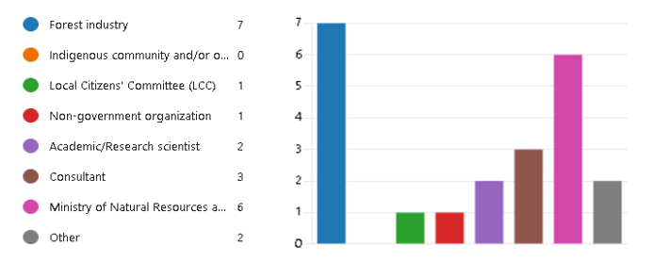
Figure 10: A graph showing affiliations of the 16 survey respondents.
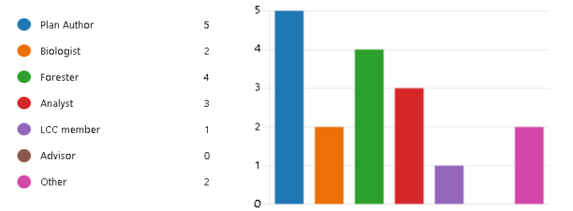
Figure 11: A graph of the planning team member role that survey respondents had when participating on forest management planning teams.

2.3.1 Overview of survey results

Respondents were asked to rate how easy it was to follow direction in the landscape guide on a scale of one to ten. The average response was 6.38, with 12/16 (75%) participants responding ≥7. However, 81% of respondents indicated that there was some direction in the landscape guide that was challenging to implement, with comments generally relating to challenges with achieving indicator desirable levels and with interpretation of guide direction. Approximately half of the respondents also indicated that the landscape guide direction conflicts with other sources of direction, indicating that the fine filter direction in the landscape guides and Stand and Site Guide sometimes compromise the ability to appropriately apply the coarse filter direction in the guide.

When asked if there were gaps with the landscape guide direction about half of respondents indicated they were not sure, and the majority of other respondents said there were gaps. For those who indicated there were gaps, most comments were generally related to updates that could be made to science supporting the implementation of the landscape guide. For example, improvements to the Simulated Ranges of Natural Variation (SRNVs) were suggested, including the addition of updated inventory information and insect outbreaks.

Respondents were asked, in their experience, what the relative influence of each landscape guide indicator group was on the strategic direction of a forest management plan. The results generally indicated that the area-based indicators for older seral stages had a greater influence on the long-term management direction in plans (Figure 12). When asked if they were able to achieve milestones, respondents had varying responses, with the majority saying “not sure”. Generally, during the workshop and in the survey, there was some confusion about the difference between SRNVs and milestones. The SRNVs are used to inform desired levels of the landscape guide indicators, while milestones inform targets for when those desired levels are to be achieved. Continued communication about this concept in the landscape guide is important to the success of the guide’s implementation.
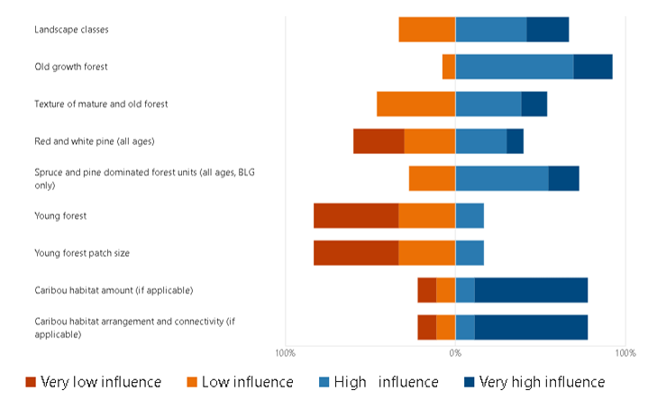
Figure 12: A graph indicating the level of influence (i.e., very low, low, high, very high) that respondents believed landscape guide indicator groups had on the strategic direction of forest management plans.

There were six respondents that answered questions related to caribou habitat direction in the BLG. Comments were generally related to experience with applying a Dynamic Caribou Habitat Schedule (DCHS) and making changes to existing DCHS designs implemented in a previous plan. Some comments indicated that there were challenges in achieving some landscape guide indicators when applying a DCHS, and additional resources to support this process would be helpful including ways to co-apply Indigenous knowledge. Figure 13 is a word cloud summarizing some of the key terms used in the responses.

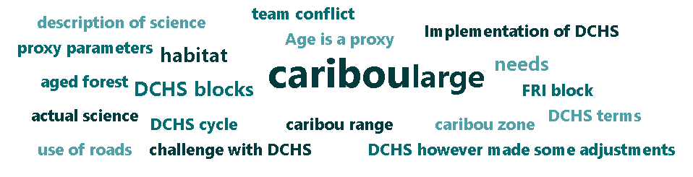
Figure 13: Word cloud summarizing key terms used in response to the following question: “What challenges are there in implementing the direction related to Dynamic Caribou Habitat Schedules (DCHS) and what were the lessons learned?”

Respondents were also asked if they believed the BLG and the GLSL LG should be amalgamated into one landscape guide. Similar to the feedback heard during the workshops, the majority of respondents said “maybe” (Figure 14). The consensus was that an amalgamation of the landscape guides would likely improve consistency in direction, but may not benefit planning teams implementing the guide. However, amalgamating the guides was perceived to have a risk of creating delays in revising guide direction, given the expanded scope.
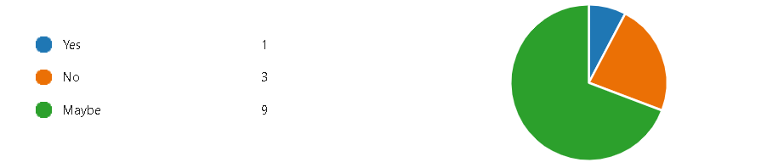
Figure 14: A graph showing the response to the question: “Do you believe the BLG and the GLSL LG should be amalgamated into one landscape guide?”.

When asked if the landscape guides should be revised, approximately half of respondents said “yes” and half of the respondents said “not sure”. The comments associated with these responses identified some specific suggestions for revisions (e.g., change which landscape class the PWUSC forest unit contributes to). More generally, the comments indicated support for the current structure of the landscape guides and most concerns from implementing the guide can be addressed through updates to science and information (e.g., SRNVs) and application of the milestone technical note. One respondent stated “These are good guides - they provide clear direction that both practitioners and regulators can stand behind - not something that all provinces have.”

Many respondents believed that there is insufficient time before the next round of forest management planning to make any major changes to the landscape guides, and the guides can be applied “as is”. However, there are some relatively minor changes that would be helpful to support the next round of management plans. There seemed to be a consensus from the survey and workshops that an addendum or minor revision to the landscape guides should be considered in the short-term. The scope of these revisions would be to update the guide to align with current policies and legislation and add clarity to some of the direction in the guide (e.g., alignment of forest units and landscape classes). The overall intent would be to support consistent application of the guides. One of the more significant suggested short-term revisions was to move the Spanish Forest from the Great Lakes-St. Lawrence Landscape Guide Regions to the Boreal. This suggestion was made during the workshop and in the survey and is further discussed in section 3.1.

Respondents also acknowledged a need to address items that apply to more than just the landscape guides, including climate change and Indigenous knowledge. Currently, section 2.3.1 of the landscape guides acknowledges how direction in the landscape guide is intended to address and enable management to adapt to emerging climate change science and information. Indigenous knowledge is not explicitly acknowledged in the landscape guides. Survey responses suggested establishing a task team or advisory team to explore these topics and how they can become a larger part of the landscape guide and associated implementation.

Other responses advocated for more support in implementing the landscape guides. Specifically, more training to help with the consistency of interpreting direction, more public communication materials, and updates to the science, information and tools used in planning. A specific comment was made requesting more resources and direction to support implementation red and white pine indicator (i.e., identify desirable levels). Respondents showed support for the milestone technical report and supported other direction following a similar format to provide planning teams with more flexibility when applying direction to local situations. Respondents also advocated for more effort to monitor the effectiveness of the landscape guides in emulating natural forest composition, structure, and patterns, and communication of these efforts.

More details from survey responses are provided in Appendix C. There are additional ways the results can be summarized which may be of interest, including a sentiment analysis related to key terms (e.g., caribou, climate change, science). These analyses may be explored in the future if time permits and can be appended to the review or included in the science packages.

2.4 Additional Feedback

There were several written responses provided outside of the workshops and surveys, as well as separate meetings. Feedback continued to be accepted until the end of June 2024. In general, these meetings echoed much of the feedback heard through the workshops and survey.

The comments indicated overall support for the landscape guides. There were specific recommendations for the timeline of potential landscape guide revisions to align with timelines in the Caribou Conservation Agreement (Palmer et al. 2024). After these comments were received, the Science Assessment Report (ECCC 2024) was released but did not provide conclusive recommendations for specific revisions to the landscape guide. There were also recommendations to enhance the focus of the landscape guide on ecological integrity by improving or including explicit considerations for old growth forest, high-integrity forests, forest degradation, carbon sequestration and co-benefits, cumulative disturbance, caribou, and wolverine (Palmer et al. 2024). These were recommended to be considered in the context of several federal commitments and initiatives (e.g., 2030 National Biodiversity Strategy) and the United Nations Declaration on the Rights of Indigenous Peoples (UNDRIP). There was also support expressed to continue current efforts in the Boreal SRNV Project to co-apply Indigenous knowledge to better understand natural forest conditions.

MNR regional planning biologists provided a consolidated list of comments for the landscape guide reviews, which is documented in Appendix D. A large portion of the comments related to caribou habitat, including suggestions for the direction to improve consistent application of a Dynamic Caribou Habitat Schedule and associated spatial assessments (e.g., time slice, texture assessment). The comments indicated concerns in determining “sufficient supply” of calving and nursery area habitat to inform application of the guide direction. There were also specific comments on areas to improve the applicability of direction to the Claybelt area in the Northeast Region and to provide clearer direction for caribou habitat in the Lake Superior Coast Range and Discontinuous Distribution.

More generally, the comments suggested improvements were needed to spatial assessments, particularly in the context of spatial models. In some plans, it was noted that the spatial assessments were not part of an iterative process to assess achievement of the indicators, which was partly a result of software limitations. There were also suggestions to address road-related objectives, and clarify direction of landscape guide indicators (e.g., when grouping of forest units are required).

Other comments echoed the feedback from the workshop and survey, and generally advocated for changes that would improve consistency in landscape guide implementation. There were recommendations for improving training and communication, and updating and maintaining the science, information and tools that support the landscape guides. There were also suggestions for formatting changes to the landscape guides and clarification. Finally, these comments indicated support for focusing efforts on effectiveness monitoring and transparent communication of these efforts.

2.5 Overall Themes

Overall, the feedback from the engagement sessions indicated that the landscape guides could be improved by simplifying the language in the guide. Participants generally expressed a reluctance to remove any direction from the guide without a clear understanding of the effectiveness and effects.

The feedback received from practitioners, First Nation peoples, Métis peoples and stakeholders are summarized in this section under five main themes:

- Importance of communication (training, plain language)
- Inclusion of Indigenous Knowledge
- Concerns about Effectiveness Monitoring
- Climate Change, Cumulative Effects, Caribou
- Simulated Ranges of Natural Variation (SRNV)

There was also specific feedback about suggested changes which may not be captured by these themes but were summarized in the previous sections and in the Appendices. These sections of the report are intended to be useful references when considering and drafting revisions to the landscape guide(s).

2.5.1 Communication

There was a clear message that many challenges in implementing the landscape guides can likely be overcome through improved communication. This includes the creation and delivery of consistent training materials for forest management planning teams, communication across planning teams, and the need for plain language communication materials for the public.

In the last round of planning, many planning teams experienced challenges in explaining how species-specific wildlife habitat was now captured in the landscape guide indicators. Previously, there were several species-specific guides that required planning teams to have species-specific indicators, which was relatively easy for a public audience to understand. The landscape guide uses landscape classes, which are groupings of forest types by age class that are intended to be meaningful to wildlife. These classes were derived from a cluster analysis of species-specific habitat classifications (Holloway et al. 2004). The development and delivery of materials to explain the landscape classes and broader forest management approach would be helpful to build understanding of the landscape guides within planning teams and the broader public.

Similarly, there were several comments during these reviews that suggested certain desired forest and benefits (e.g., values and objectives identified by First Nation communities or Métis communities) could not be included in the strategic direction of a forest management plan because they would conflict with requirements of the landscape guide. In some cases, practitioners may not be aware of the role professional expertise and local knowledge has in context-specific application of the guide. Some practitioners were also not aware of the guideline where rationale and revised milestones is required if the achievement of a non-landscape guide objectives are favoured over the achievement of a landscape guide milestone. This flexibility in guide direction enables planning teams to “supply the technological means to...sociological ends” (Behan 1966). Improved training messages and learning from the considerations and reflections described by Robinson et al (2024) may help forest management planning teams address these challenges in the future.

Evidence of a lack of understanding about landscape guide direction was also highlighted by statements during the engagement sessions that suggested the pattern indicators could be measured directly in spatial forest estate models. The forest estate modelling software being used in forest management plans from 2024 onward will be spatial, but they are not able to directly measure or apply constraints for these indictors in a model. There have not been any proxy measurements used for texture indicators, and young forest patch size proxies are not directly comparable to desirable levels for these indicators that were calculated using the Landscape Scripting Language. Enhanced training materials and simplified messaging can bridge this knowledge gap identified by practitioners.

2.5.2 Indigenous Knowledge

Indigenous knowledge is a term that is noticeably absent in the landscape guides. The feedback received from the landscape guide reviews was very supportive of including Indigenous knowledge in the landscape guides and co-applying western science and Indigenous knowledge. There was also acknowledgement that it would take time to achieve this respectfully and in a meaningful way. In the spirit of reconciliation, this work should not be rushed, should not be delayed, and should be approached in a good way (Reid et al. 2024). This work requires long-term thinking, but short term revisions may also be considered to promote the inclusion of Indigenous knowledge during application and implementation of the landscape guides.

A collaborative approach with First Nation communities and organizations and Métis communities and organizations should be pursued, and this comes with the challenge of trying to meaningfully engage with everyone at once. Suggestions for collaboration are included in Robinson et al. (2024), including: building relationships through proactive and creative opportunities for engagement outside formal planning processes, having conversations about forest management at larger spatial scales, and collaborating on higher level strategic opportunities (e.g., national biodiversity objectives). Nudds and Villard (2011) suggest focusing on how both western science and Indigenous knowledge value learning could promote collaboration by encouraging everyone to learn together. Each knowledge system has ways of storing, transmitting, revising and responding to knowledge gained through experience, which constantly evolves.

Examples of co-applying Indigenous knowledge and the landscape guide would be a valuable resource for planning teams. Currently, the Boreal SRNV Project Team established a Pre-industrial Condition Task Team that is focusing on Indigenous Knowledge to understand what a pre-industrial condition means, with a focus on forest landscape patterns. This knowledge is intended to help validate a simulation model that estimates what a natural range of forest conditions in the boreal forest may look like, and provide an example of landscape guide application as a resource to forest management planning teams.

One of the first steps taken by the task team was to proposed options for pursuing this work, and the team identified a set of guiding principles to inform their work: respect, relationships, reciprocity, collaboration and transparency. Meetings have begun with lands and resources representatives and knowledge holders from Apitipi Anicinapek Nation, Beaverhouse First Nation, Matachewan First Nation, and Mattagami First Nation. Details on how this work will proceed are still being discussed but is expected to include field- and desktop-based meetings. Results of this work are expected to help inform implementation of the landscape guides and is currently planned to be documented in the science and information packages.

More generally, this work in the Boreal SRNV Project may be considered an example of “democratizing science” that supports the landscape guides. The term “science” in this sense can be thought of as knowledge systems, including western science, Indigenous knowledge systems, and local knowledge systems (Salomon et al, 2018, Nudds 2025). The basic principle of this concept is to make the process for coproducing knowledge accessible and participatory, as demonstrated by Salomon et al. (2018) in their research on resiliency of social-ecological systems. The Boreal SRNV Project Team is an interdisciplinary team that represents and brings perspectives from diverse areas of expertise in a participatory process.

2.5.3 Effectiveness Monitoring

Effectiveness monitoring was the most popular topic in activity 3 for almost every workshop. As part of the adaptive management approach used in Ontario’s forest policy and management frameworks, monitoring programs and scientific investigations have been established to inform key uncertainties associated with guide direction. Guide effectiveness monitoring may include programs and projects internal or external to the MNR and follows the general direction for addressing critical uncertainty described in the Effectiveness Monitoring of Forest Management Guides Strategic Direction (Rempel et al 2011).

Feedback from the workshops and additional engagement highlighted that there is a lack of awareness of current effectiveness monitoring efforts as it relates to direction in the landscape guides. This resulted in a recommendation to improve communication about these efforts in a timely and transparent way. Participants were interested in understanding if the landscape guide direction is “working”, which is encouraging and seems to indicate support for the direction in the guides. Of particular interest was the uncertainty around the coarse and fine filter approach providing habitat for multiple wildlife species. Participants expressed a desire to understand wildlife population responses to management actions. Most workshops included a discussion about the challenges in directly assessing this key uncertainty, as the landscape guide direction applies to large spatial and temporal scales. Additionally, the landscape guides have only been applied for 10-15 years, and therefore a response of ecological communities and wildlife populations at the landscape would not necessarily be expected to have occurred. Study areas where guide direction has been applied as intended and that spans an appropriate spatial and temporal scale would need to be identified, as demonstrated by Rempel et al (2014).

During the workshops, there were discussions about current efforts to inform landscape guide direction. Forest Management Policy Section is currently working with the Science and Research Branch to validate the landscape classes using empirical data, primarily using data collected as part of the Multiple Species Inventory and Monitoring (MSIM) program and Ontario Wildlife Monitoring Network (OWMN). More information about this work is provided in section 3.2.

2.5.4 Climate Change, Cumulative Effects, Caribou

Climate change, cumulative effects, and caribou are complex topics that are acknowledged to require a significant amount of time and additional engagement prior to proposing revisions. These topics also span beyond the scope of just the landscape guides. Therefore, these topics are expected to be addressed through revisions to the landscape guides in the longer-term.

Climate change was also a significant topic in the 2015 GLSL LG review. At that time, it was concluded that the objective to maintain and enhance biodiversity is appropriate given the uncertainty associated with climate change. The following points were provided as supporting rationale:

- emulation of natural disturbance patterns to enhance and conserve ecosystem complexity and biodiversity is a reasonable strategy that enables forests to accommodate and respond to change
- ecosystem resilience, the capacity to absorb and recover from disturbance, is higher in more diverse forests
- ecosystem stability, temporal and spatial variability in function, is higher in more diverse forests
- diverse, resilient forests are better able to sustainably provide ecological goods and services upon which society depends
- traditional management approaches have transformed, fragmented, simplified, and homogenized forests that are less resilient to disturbance.

Comments received during the engagement sessions of the review strongly suggested incorporating climate change in the landscape guide, but most were not sure how this could be done. The terms “healthy”, “diverse”, “adaptable” and “socially acceptable” were identified as desirable goals for new direction. Many participants suggested assisted migration of drought-tolerant species northward and diversifying forests would create a forest that is more resilient to climate change. The Ontario Seed Transfer Policy includes flexibility for forest managers to consider future climate when making seed transfer decisions.

Some participants suggested the adaptive management process could address climate change concerns as new science and information becomes available. The regular review process for forest management guides and the requirement to develop forest management plans every 10 years allows this to occur at a reasonable interval given the temporal scale of climate change. Others suggested that current direction in the landscape guide has sufficient flexibility to address climate change concerns, and it might make more sense to provide specific direction outside of the landscape guide. Many participants also suggested the SRNV should account for climate change. Relationships between natural, historical and future ranges of variation (Safford et al 2012) were discussed in the 2015 GLSL landscape guide review. The current Boreal SRNV Project has identified work to explore how climate change can be considered in the modelling exercise, and any potential results are intended to be made available in the science and information packages.

There was proposed direction drafted and documented in the 2015 GLSL LG review report. The general consensus from presenting this direction at workshops in the GLSL review and to the PFTC was that it should not be included as a guide revision. The main reason for this conclusion was the low likelihood that planning teams would apply the direction due to the amount of supporting evidence required.

Cumulative effects of multiple activities and land uses on the landscape can be challenging to manage. In the GLSL, participants expressed concern about the cumulative impact of Area of Concern prescriptions (developed in applications of the Stand and Site Guide) on the achievement of landscape guide objectives. This part of the province already has a relatively fragmented landscape based on ownership. Other concerns about cumulative effects include access roads established for forest harvesting purposes subsequently being used for other purposes. The direction regarding large landscape patches and their collective development of a strategic landscape map is flexible and can be used to partially address concerns about cumulative effects. However, with multiple activities and land uses, this topic may be more fully addressed outside the context of just the landscape guides.

As noted in other parts of section 2, the caribou-related direction in the BLG was identified as a high priority for revisions. Several participants suggested that a disturbance indicator be included in the BLG. In general, updates to caribou-related direction were suggested to be consistent with results from the Canada-Ontario Caribou Conservation Agreement. However, there was also an acknowledgement that much of the on-going work under the caribou conservation agreement would not be available until at least 2027. The results of this work and other ongoing research are expected to provide directly relevant science and information that could inform potential revisions to the BLG. Wilson et al (2021, 2025b) have recently explored the cause and effect relationship of caribou habitat management actions and population responses, as assumed by caribou recovery planning. Factors other than habitat disturbance may be limiting the effectiveness of habitat restoration in recovering caribou populations (Wilson 2025b), which provides important context for Ontario’s forest management and policy. The development of a Knowledge Plan under Conservation Measure 1.4, including a comprehensive literature review, would be a valuable information source when considering revisions to the BLG.

Related to Conservation Measure 4.1 (Evidence-based Approaches), a Science Assessment Report was released in April 2024. The report recommended a “commitment to a transparent process for evaluating and incorporating new information in existing regulatory frameworks, in a timely manner.” This recommendation aligns with the review requirement identified in the FOSM, and the adaptive approach used in Ontario’s forest policy framework.

2.5.5 Simulated Ranges of Natural Variation (SRNV)

Engagement on the review of a forest management guide often identifies potential improvements that could be made to the science supporting implementation of guide. Many comments received during this review period suggested improving the SRNV estimates in the science and information packages and Ontario’s Landscape Tool (OLT). Prior to the landscape guide reviews commencing, it was decided to re-estimate the boreal SRNVs using available updated science and information. This decision was made based on feedback heard during the implementation of the BLG in forest management planning. Four key issues were identified with the boreal SRNVs:

- Accuracy of estimates of red and white pine
- Changes to upland/lowland ecosites in the inventories
- Edge effect of the Manitoba border and lack of inventory data for provincial parks
- Ability to achieve all ages conifer desirable level informed by the SRNV

A report on these issues and options to address these concerns can be found in Appendix F. This report identifies potential new science, information and tools that could be used to re-estimate the boreal SRNVs and approximate timelines and steps to follow. This report provided a starting point for the Boreal SRNV Project, driven by practitioner experience.

Feedback about the SRNVs from the landscape guide review workshops was shared with the Boreal SRNV Project Team for consideration while improving the current model. This feedback helped to prioritize the incorporation of spruce budworm into the model, which had not been included previously. Workshop participants also expressed a desire to be engaged in the project prior to results being released.

In the GLSL, participants were interested in whether there were any plans to update the SRNVs released in 2017. There was a suggestion to improve the inventory attribute (i.e., VERT) used to identify the overstory or understory as the managed canopy. Generally, age is a poor measure of structure in the GLSL in comparison to the boreal. Use of LiDAR information in the future may help to address these inventory-related concerns.

3. Additional Components of the Reviews

The engagement described in section 2 includes consideration of applicable scientific investigations, monitoring programs, and advances in technology as part of the feedback received from workshop participants. Full incorporation of landscape guide direction in the recent round of forest management planning meant that a focus of this review was to solicit feedback on implementing guide direction. However, there were additional considerations that warranted inclusion in these reviews. This section of the report provides a brief overview of provincial reporting and audit findings; current science, research and monitoring programs; and advances in technology relevant to the landscape guides.

3.1 Reporting and audits

A review of forest management plans and their annual reports concluded that the landscape guides are generally being applied as intended. However, there appears to be variation in the interpretation of some direction, and therefore differences in its application. For example, some landscape guide indicators are directed to be applied in appropriate forest type groupings (e.g., old growth indicator). Application of old growth indicators varied across regions, where each forest unit was maintained separately in the south, groupings of certain forest units identified in the northwest, and all forest units grouped in the northeast. Similarly, there appeared to be a lot of variation in the approach to identifying large landscape patches and associated objectives, particularly in the context of the texture of mature and old forest (see Natural Resources Information Portal).

Provincial level reporting for some landscape guide indicators is available on the Ontario webpage, though with limited measurements through time. The Forest Resources of Ontario 2021 report included summaries of landscape class area by landscape guide region, which can be compared to SRNVs. As part of this investigation, the forest composition and silviculture practices for the Spanish forest were also reviewed. The Spanish Forest is currently part of the GLSL landscape guide regions, and the management unit mostly overlaps with ecoregion 4E. The majority of the Spanish Forest is managed with silviculture systems (i.e., clearcut) consistent with practices in the boreal forest. Ontario’s Forest Facts webpage identifies Spanish Forest having 63,000ha of red and white pine forest (6% of the forest), and 1,322ha of tolerant hardwood forest (0.1% of the forest). Generally, less than 100ha per year are harvested under a shelterwood/partial harvest system. Therefore, these data appear to support the recommendations for the Spanish Forest to be managed following the Boreal Landscape Guide instead of the Great Lakes-St. Lawrence Landscape Guide.

Another source of information for reviewing a forest management guide is the Independent Forest Audits (IFAs). In general, few IFA findings directly relate to the landscape guides. Most of the relevant IFA findings are related to caribou, including recommendations for the MNR to complete a range management plan for the Lake Superior Coast Range and a habitat management strategy for the Discontinuous Distribution. There were also comments about silviculture practices and their support for the renewal of caribou habitat, rehabilitation of roads, and a concern that a lack of harvest could negatively affect the renewal of habitat. One recommendation from an IFA was for MNR to provide direction for DCHS block closure requirements in the DCHS blocks where harvest was deemed complete. This resulted in several forest management plans in the northwest region adopting a template to report on the status of harvest activities and caribou habitat for these areas, and this documentation helped to fulfill the documentation for large landscape patches that is required by the landscape guide.

3.2 Scientific investigations, research, and monitoring programs

The Ministry has an extensive history of science, research, and monitoring, including monitoring the effects of forest operations and the effectiveness of forest management guides in mitigating effects. Currently, Ministry research priorities are guided by two strategic science initiatives: the Integrated Science Action Plan (ISAP) and the Integrated Monitoring Framework (IMF). The monitoring activities documented in the IMF inform guide direction by assessing the effects of ecological and environmental changes on forest resources and the impacts and effects of management actions. ISAP objectives include:

- Collect information about the state of wildlife species to inform and evaluate wildlife policies including:
  - Monitoring landscape scale populations of cervid species (Objective 4a)
  - Inventorying the distribution and diversity of wildlife species as an indicator of the state of crown forest biodiversity and terrestrial habitats and ecosystems (Objective 4d)
- Acquire knowledge about forested landscapes, ecosystems, and associated species including conducting research to understand:
  - Effects of natural disturbance emulation, natural and anthropogenic post-disturbance ecology and succession on terrestrial and aquatic ecosystems, landscape processes, and cumulative impacts (Objective 8a)
- Acquire knowledge about wildlife species and their habitat by conducting research on game and furbearing species to address critical knowledge gaps (Objective 9a)

The landscape guides acknowledge that forested landscapes are part of a natural adaptive cycle (Gunderson and Holling 2002). Holling (2001) described sustainable management as a “logical partnership” with “the goal of fostering adaptive capabilities and creating opportunities” (Holling 2001) . Ontario’s forest policy and sustainable management framework were designed around principles of adaptive management, which are widely applied in North America (Powell 2021, Stankey et al. 2005, Bormann et al 1999, Baker 2000). An adaptive management approach links science and policy by treating policy as a hypothesis to efficiently promote continuous learning and to improve management practices.

The science behind the landscape guides and associated indicator system is generally supported by current literature (Rempel et al. 2016, Gauthier et al. 2009, Lindenmayer and Franklin 2002, Lindenmayer et al. 2000) and consistent with forest management approaches across boreal Canada. In British Columbia, the Interim Assessment Protocol for Forest Biodiversity in British Columbia (2020) is the current framework that includes a series of biodiversity indicators and associated rating system. Forest policy in Alberta (Ministry of Forestry and Parks 2025), Saskatchewan, Manitoba, and Québec generally require forest management plans to include a values, objectives and indicator table consistent with the Canadian Council of Forest Ministers (CCFM) Criteria and Indicators (Bridge et al. 2005) and Montréal Process framework. The Montréal Process committed member countries to implementing criteria and indicators that are science-based and inform progress in achieving sustainable forest management. The common basis for approaches across Canada is maintaining biodiversity through the emulation of natural disturbances and landscape patterns with an ecological indicator system. A key difference is that Ontario’s direction and supporting science and information is relatively transparent, publicly accessible, and generally more detailed especially in attempts to address forest patterns and processes.

Ontario’s forest management guides are supported by a strategy for monitoring and assessing the effectiveness of guide direction related to the emulation of natural disturbances and landscape pattern. Guide effectiveness monitoring includes programs and projects internal and external to the MNR. Collectively, this work is reviewed to identify how critical uncertainties were addressed, as described in the Effectiveness Monitoring of Forest Management Guides Strategic Direction (Rempel et al 2011). One of the key uncertainties is if the coarse filter in combination with the fine filter (including direction from other guides) produces a pattern of harvested and residual forest at stand and multi-stand scales that supports wildlife communities similar to those found in habitats disturbed by natural events.

Birds are believed to be an effective indicator of potential changes in habitat function between forests of natural and managed disturbance origin (Rempel et al 2016, Brown et al 2021). This theory appears to be generally supported by recent literature, with relatively few exceptions. Wyshynski and Nudds (2009) found no evidence of different patterns of variations in songbird and woodpecker diversity between managed and natural boreal forest landscapes in northwestern Ontario, and found species richness among forest types at the stand level varied more than between landscapes. Bӧrger and Nudds (2014) found that waterbird response to fire and harvesting were similar for 13 of the 14 most common species between 10-20 years post-disturbance, but up to 30 species may experience altered distribution dynamics in the short-term. Similarly, Rempel et al (2016) found that most forest bird species (11 of 14) occurred with equal occupancy rates in habitat originating from natural and harvesting disturbances in Ontario and that differences in quantity and/or quality of specific habitat types and/or features (e.g., standing residual trees) likely explain the variable responses. Zimmerling et al (2017) reported that more than half of 62 boreal forest bird species responded similarly to disturbances by fire and harvesting. However, they also observed differences in early (0-20 years) and mid-successional (21-80 years) stands, where species richness and abundance was lower in post-harvest compared to post-fire stands. Zlonis and Niemi (2014) found that unmanaged stands (i.e., older, mixed, and more structurally diverse) provided habitat for an increased abundance and richness of bird communities compared to managed stands, however, most early successional species did not differ between the two disturbance types. Bognounou et al. (2021) found salvage logging after fire had lower taxonomic and functional diversity than areas of fire-origin or resulting from forest management.

A current project to evaluate the effectiveness of landscape guide direction is focused on validating landscape classes using available wildlife monitoring data. In this project, MNR is modeling wildlife habitat for a set of wildlife species using available Multiple Species Inventory and Monitoring (MSIM) and Ontario Wildlife Monitoring Network (OWMN) data and relating these models to existing landscape classes. Wildlife observation data are being used to summarize habitat using regression and occupancy estimation. The project focuses on wildlife species with adequate data and will summarise the strength of support for landscape classes (Martin et al 2025). The project also intends to explore wildlife species responses to forest conditions based on other metrics (e.g., tree composition, stand age, Normalized Difference Vegetation Index) and use cluster or ordination analyses to identify major axes or groupings that capture large amounts of variation in forest wildlife habitat. Overall, this work is expected to inform whether the landscape classes are being used by wildlife as expected and may result in recommendations for different groups of forest type and structure that are meaningful to wildlife.

Another critical uncertainty associated with the BLG (Rempel et al 2011) is if the direction for caribou in the guide creates habitat that contributes to sustaining viable populations of caribou. This uncertainty closely aligns with priorities identified in the Caribou Conservation Agreement. Conservation Measure 3.1 (Forest Management Planning) focuses on supporting the implementation and assessing the effectiveness of caribou-related direction in the BLG in supporting self-sustaining caribou populations. There are six projects that are currently supporting the objectives of this conservation measure:

- Re-estimation of the Simulated Ranges of Natural Variation in the Boreal Landscape Guide Regions
- Evaluating caribou habitat definitions used in Ontario’s forest management:
- Application of a spatially explicit Population Viability Analysis model to simulated landscapes.
- Evaluating the effectiveness of caribou calving and nursery area direction
- Re-estimating cumulative disturbance in caribou ranges overlapping the managed forest.
- Assessment of caribou habitat connectivity measures

Recently, a report related to the connectivity project under Conservation Measure 3.1 concluded that Ontario was the Canadian jurisdiction with the most explicit strategy to measure, monitor and forecast changes in caribou habitat connectivity over time (Wilson 2025a). Caribou habitat management across Canada commonly involves zoning with varying degrees of associated regulation. Results from this project, the other Conservation Measure 3.1 projects listed above, and work from other Conservation Measures are expected to support potential guide revisions in the long-term

The Boreal SRNV Project is another example where updated science, information, and technology are informing landscape guide implementation. In this project, the forest succession rule inputs were informed by the findings of Lennon et al (2016, 2016b). The platform used to run the model is LANDIS-II, which has many academic users. This project supported programming changes to support compatibility of model extensions. The project relies on powerful virtual machines to complete the analysis, which were not available when the SRNVs were originally estimated.

There is emerging science related to managing forests in the context of climate change. Messier et al (2019) tested a functional complex network to manage forests for resilience to climate and disturbances by combining functional species trait information with network theory. The “DIVERSE” project is a Canadian research initiative supported by MNR and designed to inform forest management through research about the application of functional diversity and ecological connectivity concepts (e.g., complex function networks). The project seeks to enhance forest resiliency to global changes while fostering sustainable forest stewardship (Messier et al 2019). The compatibility of this work with the concept of emulating natural disturbances and landscape patterns is unknown. The research is focused on management actions that increase alpha level diversity, and the consideration of different scales of diversity is unclear.

3.3 Advances in technology and changes to operational practices

Overall, there were recommendations in the workshops to update the science and information packages and Ontario’s Landscape Tool (OLT) using modernized platforms. There was an appreciation for the amount of information available in the packages and OLT, but some of the embedded files cannot be opened in browsers and required the package to be downloaded. Continued maintenance and updates to the science and tools supporting the landscape guides is critical to effective and efficient implementation of guide direction.

The engagement session included suggestions to use Light Detection and Ranging (LiDAR) data and spatial models to implement landscape guide direction in forest management plans. LiDAR may be able to inform road conditions on the management unit, classify disturbance, identify old growth, and better define stand structure. This more detailed information on stand structure could be particularly useful in the Great Lakes-St. Lawrence, given that age is not a good measure of structure in these forests. Having a more reliable measure of structure at the landscape scale could provide opportunities to improve landscape guide direction. This information may be able to be incorporated into future estimates of the SRNV, with potential challenges created by the extent of data coverage. Novel ways to incorporate disparate datasets may need to be explored.

Pilot testing during the development of the landscape guide was conducted using a spatial forest estate model called Patchworks. Approximately half of the survey respondents indicated they used a spatial model in their forest management plan. With the growing use of spatial models and new requirements in the Forest Management Planning Manual (2024), it is logical to assess texture and pattern indicators identified in the landscape guide beyond plan start and plan end. Many planning teams are already running these types of assessments with and without spatial models. The use of a spatial model could help to address the concerns heard during the engagement sessions about challenges in implementing and improving the achievement of texture and patch size indicators.

4. Conclusion

The concluding recommendation of this review is to proceed with a scoped revision of both landscape guides in the short-term. A complete list of these recommendations for the BLG and GLSL LG are provided in section 4.1, while long-term revision recommendations for both guides are provided in section 4.2.

The core direction in the landscape guide was generally supported by participants of the workshops and surveys, as well as the review of relevant science and information. In order to evaluate the effectiveness of the direction in the landscape guide, more time is required to continue implementing the guides. Changes to direction should be carefully considered in this context, as long-term monitoring and reporting is often challenged to make comparisons through time.

There are several minor opportunities for revision that were identified in these reviews, which would primarily modernize the landscape guides by adding clarity to direction and supporting consistent implementation of the guides. These form the basis of the short-term recommendations, which are intended to be delivered in time to support the next round of forest management planning. Recommendations to pursue more complex and potentially contentious changes to landscape guide direction are proposed as long-term revisions, as they are expected to take multiple years to develop.

In addition to revision recommendations, there are four general recommendations from this review that relate to landscape guide implementation and do not require revisions to the landscape guides:

- Continue to deliver and improve training materials related to the landscape guides, supporting science and tools.
- Develop communication materials to explain the landscape guides to a public audience.
- Continue to update the science and support the tools supporting implementation of the landscape guides.
- Continue to support and improve effectiveness monitoring efforts to address key uncertainties related to landscape guide direction.

4.1. Summary of Short-term Revision Recommendations

In conclusion of this review, is it recommended to proceed with the following scoped revisions of both landscape guides in the short term. The order of revisions does not indicate priority or intended sequence of revisions.

4.1.1 Boreal Landscape Guide:
- Incorporate the Spanish Forest into the Boreal Landscape Guide, as part of Landscape Guide Region 3E.
- Align texture and patch size indicator timing of assessment with recent changes in the Forest Management Planning Manual.
- Administrative updates to outdated references. For example:
  - Update to references to legislation (e.g., remove reference to Declaration Order under the Environmental Assessment Act, and update references related to the Endangered Species Act)
  - Update references to other policies (e.g., other forest management guides, caribou-related policies)
  - Include reference to the Validating and Revising Milestone Technical Note and Milestone Repository.
- Update references to science and information packages:
  - to align with outcomes of Boreal Simulated Ranges of Natural Variation Project, and
  - to clarify landscape guide application where there is disagreement between the guide and science packages.

4.1.2 Great Lakes-St. Lawrence (GLSL) Landscape Guide:
- Remove the Spanish Forest from the GLSL North Landscape Guide Region (to be included in the Boreal Landscape Guide Region 3E).
- Align texture and patch size indicator timing of assessment with recent changes in the Forest Management Planning Manual
- Administrative updates to outdated references. For example:
  - Update to references to legislation (e.g., remove reference to Declaration Order under the Environmental Assessment Act)
  - Update references to other policies (e.g., other forest management guides)
  - Include reference to the Validating and Revising Milestone Technical Note and Milestone Repository.
- Include a guideline regarding favouring non-landscape guide indicator achievement to the GLSL Landscape guide, consistent with Boreal Landscape Guide direction.
- Clarify landscape guide forest unit assignments to landscape classes.

4.2. Summary of Long-term Recommendations

In the long-term, this review recommends that advisory teams are established to address larger topics related to landscape guide direction. Specifically:

- Collaborate on ways the landscape guide could be co-applied with Indigenous Knowledge and explore opportunities to enable this in the guide.
- Identify options for the landscape guides to provide direction to planning teams regarding climate change at the landscape scale.
- Identify options for the landscape guides to provide direction to planning teams regarding cumulative effects at the landscape scale.
- Identify updates to caribou-related direction (Boreal Landscape Guide), consistent with results from Canada-Ontario Caribou Conservation Agreement
- Continue to practice adaptive management and consider revisions where new science and information are available (e.g., results of effectiveness monitoring programs and projects)

5. References

Baker, J. A. 2000. Adaptive Management at the Landscape Level. Pages 310-322 in A. H. Perera, D. L. Euler, and I. D. Thompson, editors. Ecology of a managed terrestrial landscape: patterns and processes of forest landscapes in Ontario. University of British Columbia Press, Vancouver, British Columbia, Canada.

Behan, R. W. 1966. The myth of the omnipotent forester. Journal of Forestry 64: 398–400, 407.

Bognounou, F., L.A. Venier, S.L. Van Wilgenburg, I. Aubin, J.-N. Candau, A. Arsenault, C. Hébert, J. Ibarzabal, S.J. Song, and L. De Grandpré. 2021. Early avian functional assemblages after fire, clearcutting, and post-fire salvage logging in North American forests. Can. J. For. Res. 51:393-407.

Bӧrger, L. and T.D. Nudds. 2014. Fire, humans, and climate: modeling distribution dynamics of boreal forest waterbirds. Ecol. Appl. 24:121-141.

Bormann, B.T., J.R. Martin, E.H. Wagner, G.W. Wood, J. Alegria, P.G. Cunningham, M.H. Brookes, P. Friesema, J. Berg and J.R. Henshaw. 1999. Adaptive management. Pages 505-534 in: Johnson, N.C., A.J. Malk, W.T. Sexton, and R. Szaro (eds.) Ecological stewardship: a common reference for ecosystem management. Elsevier Science Ltd.: 505-534. Vol. 3.

Bridge, D. Cooligan, D. Dye, L. Moores, T. Niemann, and R. Thompson. 2005. Reviewing Canada's National Framework of Criteria and Indicators for Sustainable Forest Management. The Forestry Chronicle. 81(1): 73-80.

Brown, G.S., L. Pollock, P.D. DeWitt, N. Dawson. 2020. Responses of terrestrial animals to forest characteristics and climate reveals ecological indicators for sustaining wildlife in managed forests. Forest Ecology and Management 459: 117854

Brown, G.S., P.D. DeWitt, N. Dawson, L. Landriault. 2021. Threshold responses in wildlife communities and evidence for biodiversity indicators of sustainable resource management. Ecological Indicators 133: 108371.

Elkie, P., M. Gluck, J. Boos, J. Bowman, C. Daniel, J. Elliott, D. Etheridge, D. Heaman, G. Hooper, R. Kushneriuk, G. Lucking, S. Mills, B. Naylor, F. Pinto, B. Pond, R. Rempel, K. Ride, A. Smiegielski, G. Watt, M. Woods. 2019. Science and Information in support of the Forest Management Guides for Great Lakes-St. Lawrence Landscapes: Simulations, Rationale, Inputs and Results. Ontario Ministry of Natural Resources. Forest Policy Section.

Environment and Climate Change Canada (ECCC). 2024. Scientific Assessment of Federal and Provincial Frameworks for the Conservation of Boreal Caribou in Ontario: Science Assessment Report. Gatineau: King’s Printer of Canada. 25 pp.

Euler, D. and C. Wedeles. 2005. Defining old growth in Canada and identifying wildlife habitat in old growth boreal forest stands. National Council for Air and Stream Improvement, Research Triangle Park, North Carolina. Technical Bulletin 909.

Gauthier, S., Vaillancourt, M. A., Leduc, A., et al. (Eds.). 2009. Ecosystem management in the boreal forest (p. 572). Presses de l’Universite du Quebec.

Gunderson, L.H. and C.S. Holling. 2002. Resilience and adaptive cycles. Pages 25-62 in L.H. Gunderson, and C.S. Holling, editors. Panarchy: Understanding Transformations in Human and Ecological Systems. Island Press.

Holling, C.S. Understanding the Complexity of Economic, Ecological, and Social Systems. 2001. Ecosystems 4: 390-405.

Holloway, G., B. Naylor, and W. Watt, Editors. 2004. Habitat Relationships of wildlife in Ontario – revised habitat suitability models for the Great Lakes-St. Lawrence and Boreal East Forests. OMNR, Science and Information branch, Southern Science and Information and Northeast Science and Information. Joint Technical Report No. 1. Queen’s Printer for Ontario. 120 pp.

Interim Assessment Protocol for Forest Biodiversity in British Columbia – Standards for Assessing the Condition of Forest Biodiversity under British Columbia’s Cumulative Effects Framework. Version 1.0 (September 2020). Prepared by the Provincial Forest Biodiversity Technical Working Group – Ministry of Environment and Climate Change Strategy and Ministry of Forests, Lands and Natural Resource Operations and Rural Development. 50 pp.

Lennon. K., J. Parton, K. Major and G.J. Kayahara. 2016a. Evidence-based natural succession pathways for forest management planning in northeastern Ontario. Ontario Ministry of Natural Resources and Forestry. Science and Research Branch, Peterborough, ON. Science and Research Technical Report TR-15. 47 p. + appendices.

Lennon, K., J. Parton, K. Major and R. Bowen. 2016b. Evidence-based natural succession pathways for forest management planning in northwestern Ontario. Ontario Ministry of Natural Resources and Forestry, Science and Research Branch, Peterborough, ON. Science and Research Technical Report TR-16. 51 p. + appendices.

Lindenmayer, D.B., Margules, C.R., Botkin, D.B. 2000. Indicators of biodiversity for ecologically sustainable forest management. Conservation Biology 14 (4): 941-950.

Lindenmayer, D.B. and J.F.Franklin, 2002. Conserving Forest Biodiversity: A Comprehensive Multiscaled Approach. Island Press. 352 pp.

Martin, C., G. Holloway, H. Dorval, L.T. Stinson, R. Marrotte, J. Nielsen and P.D. DeWitt. 2025. [Draft] Validation of wildlife habitat models for Great Lakes-St. Lawrence Forest landscape classes in Ontario. In Science and Information in support of the Forest Management Guides for Great Lakes-St. Lawrence Landscapes: Simulations, Rationale, Inputs and Results (Elkie et al. 2019, Editors). Ontario Ministry of Natural Resources. Forest Policy Section.

Messier C., Bauhus J., Doyon F., Maure F., Sousa-Silva R., Nolet P., Mina M., Aquilué N., Fortin M.J. and Puettmann K. (2019). The functional complex network approach to foster forest resilience to global changes. Forest Ecosystems 6:21.

Millar, C. I., N. L. Stephenson, and S. L. Stephens. 2007. Climate change and forests of the future: managing in the face of uncertainty. Ecological Applications 17:2145-2151.

Ministry of Forestry and Parks. 2025. Seral stage objective: A guide for forest management planning. Forest Management and Wildfire Mitigation Branch, Alberta.

Nudds, T. 2025. Perspectives on Science, Policy and Governance for the Conservation of Biodiversity and Species at Risk on Canadian Agricultural Landscapes. The Canadian Agri-Food Policy Institute. Ottawa, ON. 26pp. https://capi-icpa.ca/wp-content/uploads/2025/05/2025-05-23-Tom-Nudds-Revised-Species-at-Risk-and-Agricultural-Lands-EN.pdf.

Nudds, T.D., M.A. Villard. 2011. Learning Together. Avian Conservation and Ecology 6(1): 8.

Ontario Ministry of Natural Resources [OMNR]. March 2010. Forest Management Guide for Great Lakes - St. Lawrence Forests. Toronto: Queen’s Printer for Ontario. 78 pp.

OMNR. March 2014. Forest Management Guide for Boreal Landscapes.
Toronto: Queen’s Printer for Ontario. 104 pp.

Palmer, L., Harris, L., Hohnen, R., O'Connor, C., Ray, J. and Scrafford, M. (2024). Input on the review of Ontario’s Forest Management Guide for Boreal Landscapes - April 2024. WCS Canada. https://wcscanada.org/resources/input-on-the-review-of-ontarios-forest-management-guide-for-boreal-landscapes-april-2024/

Powell, B.H. 2021. Managing Forests not Forestry: Law and Policy Recommendations for Ecosystem-Based Management of Alberta’s Forests. Environmental Law Centre. 253 pp.

Reid, A.J., D.A. McGregor, A.K. Menzies, L.E. Eckert. 2024. Nature Ecology & Evolution. OI: 10.1038/s41559-023-02309-0

Rempel, R.S., D.W. Andison, and A.J. Hannon. 2004. Guiding principles for developing an indicator and monitoring framework. The Forestry Chronicle 80(1): 82-90.

Rempel, R. S., J. Baker, P. C. Elkie, M. J. Gluck, J. Jackson, R. S. Kushneriuk, T. Moore and A. H. Perera. 2007. Forest policy scenario analysis: sensitivity of forest songbirds to changes in mature forest cover amount, composition, and configuration. Avian Conservation and Ecology - Écologie et conservation des oiseaux XX(YY): ZZ. http://www.ace-eco.org/volXX/issYY/artZZ/.

Rempel, R. S., J. Baker, G. Brown, J. Churcher, M. Gluck, B. Naylor. 2011. Effectiveness Monitoring of Forest Management Guides: Strategic Direction. Information Paper CNFER IP-006. Ontario Ministry of Natural Resources, Centre for Northern Forest Ecosystem Research, Thunder Bay, Ontario, Canada. 18pp.

Rempel, R.S., J.M. Jackson, and J.N. Robinson. 2014. Acoustic Monitoring and Assessment of Forest Songbirds: Sample Design, Analysis Methods, and Observation Error. CNFER Technical Report TR-012. Ontario Ministry of Natural Resources, Centre for Northern Forest Ecosystem Research, Thunder Bay, Ontario, Canada. 38 p. + append.

Rempel, R.S., B.J. Naylor, P.C. Elkie, J. Baker, J. Churcher, M.J. Gluck. An indicator system to assess ecological integrity of managed forests. Ecological Indicators, 60 (2016), pp. 860-869.

Robinson, L.W., I. Allen, J. Robinson, D. Flood, C. George and A. Quakegesic. 2024. Indigenous participation in forest management: Experiences and perspectives from Brunswick House, Chapleau Cree, and Missanabie Cree First Nations—Final report of the Indigenous Participation in Advancing Sustainable Forest Management Strategies project. Wahkohtowin Development GP, Chapleau, ON, and Ontario Ministry of Natural Resources and Forestry, Science and Research Branch, Peterborough, ON. 30 p. + appendices.

Safford, H.D., G.D. Hayward, N.E. Heller and J.A. Wiens. 2012. Historic ecology, climate change, and resource management: Can the past still inform the future? In Historical variation in conservation and natural resource management, First Edition, Edited by John A. Wiens, Gregory D. Hayward, Hugh D. Safford and Catherine M. Giffen. (pp. 47-62). 2012. John Wiley and Sons.

Salomon, A. K., K. Lertzman, K. Brown, K. B. Wilson, D. Secord, and I. McKechnie. 2018. Democratizing conservation science and practice. Ecology and Society 23(1):44. https://doi.org/10.5751/ES-09980-230144

Stankey, G.H. R.N. Clark, B.T. Bormann. 2005. Adaptive Management on Natural Resources: Theory, Concepts, and Management Institutions. USDA Forest Service General Technical Report PNW-GTR-654.

Wilson, S.F. 2025a. Management of Caribou Habitat Connectivity in Ontario’s Boreal Forest.

Wilson, S.F. 2025b. Causal attribution from retrospective data in Canada’s woodland caribou system. Ecological Applications 35(3): e70022. https://doi.org/10.1002/eap.70022.

Wilson, S.F., T.D. Nudds, A. de Vries. 2021. A causal modelling approach to informing woodland caribou conservation policy from observational studies. Biological Conservation 264: 109370. https://doi.org/10.1016/j.biocon.2021.109370.

Wyshynski, S.A., T.D. Nudds. 2009. Pattern and process in forest bird communities on boreal landscapes originating from wildfire and timber harvest. The Forestry Chronicle. 85(2): 218-226.

Zimmerling, J.R., C.M. Francis, C. Roy and A.M. Calvert. 2017. How well does forestry in Ontario’s boreal forest emulate natural disturbances from the perspective of birds? Avian Conservation Ecology 12:10. http://www.ace-eco.org/vol12/iss2/art10/.

Zlonis, E.J. and G. J. Niemi. 2014. Avian communities of managed and wilderness hemi boreal forests. For. Ecol. Manage. 328:26-34.

Appendix A: Landscape Guide Regions and Forest Management Unit Boundaries

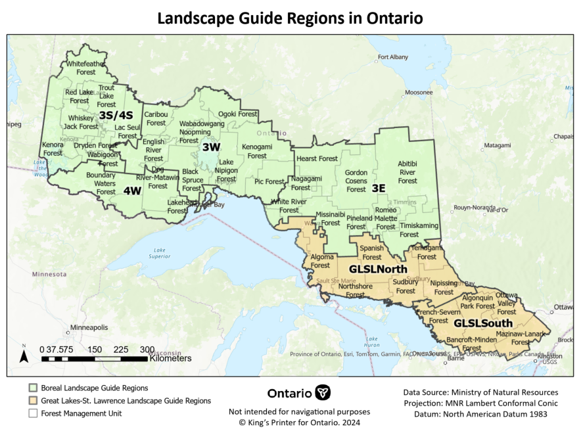

Appendix B: Workshop Activity Results
This appendix provides detailed results for each workshop activity.

Activity 1

Unique  ID | Workshop  Location | Workshop Date | Landscape Guide | Direction Number | Direction Group | Green Dot | Red Dot | Proportion Green | Proportion Red | Rep
1 | Kenora | 30-Jan-24 | Boreal | 3 | Landscape Classes | 5 | 0 | 1 | 0 | N
2 | Kenora | 30-Jan-24 | Boreal | 4 | Landscape Classes | 5 | 0 | 1 | 0 | Y
3 | Kenora | 30-Jan-24 | Boreal | 5 | Old Growth | 3 | 0 | 1 | 0 | N
4 | Kenora | 30-Jan-24 | Boreal | 6 | Red & White Pine | 0 | 8 | 0 | 1 | N
5 | Kenora | 30-Jan-24 | Boreal | 7 | Red & White Pine | 0 | 8 | 0 | 1 | Y
6 | Kenora | 30-Jan-24 | Boreal | 8 | Conifer | 3 | 0 | 1 | 0 | N
7 | Kenora | 30-Jan-24 | Boreal | 9 | Young Forest | 1 | 1 | 0.5 | 0.5 | N
8 | Kenora | 30-Jan-24 | Boreal | 10 | Young Forest | 1 | 1 | 0.5 | 0.5 | Y
9 | Kenora | 30-Jan-24 | Boreal | 11 | Pattern | 2 | 0 | 1 | 0 | N
10 | Kenora | 30-Jan-24 | Boreal | 12 | Texture Mature Old Forest | 2 | 0 | 1 | 0 | N
11 | Kenora | 30-Jan-24 | Boreal | 13 | Texture Mature Old Forest | 2 | 0 | 1 | 0 | Y
12 | Kenora | 30-Jan-24 | Boreal | 14 | Young Forest Patch Size | 3 | 0 | 1 | 0 | N
13 | Kenora | 30-Jan-24 | Boreal | 15 | Young Forest Patch Size | 3 | 0 | 1 | 0 | Y
14 | Kenora | 30-Jan-24 | Boreal | 16 | Woodland Caribou | 3 | 0 | 1 | 0 | N
15 | Kenora | 30-Jan-24 | Boreal | 17 | Woodland Caribou | 3 | 0 | 1 | 0 | Y
16 | Kenora | 30-Jan-24 | Boreal | 18 | Woodland Caribou | 3 | 0 | 1 | 0 | Y
17 | Kenora | 30-Jan-24 | Boreal | 19 | Woodland Caribou | 3 | 0 | 1 | 0 | Y
18 | Kenora | 30-Jan-24 | Boreal | 20 | Woodland Caribou | 3 | 0 | 1 | 0 | Y
19 | Kenora | 30-Jan-24 | Boreal | 21 | Desirable Levels | 4 | 0 | 1 | 0 | N
20 | Kenora | 30-Jan-24 | Boreal | 22 | Targets | 3 | 0 | 1 | 0 | N
21 | Kenora | 30-Jan-24 | Boreal | 23 | Targets | 3 | 0 | 1 | 0 | Y
22 | Kenora | 30-Jan-24 | Boreal | 24 | Targets | 3 | 0 | 1 | 0 | Y
23 | Kenora | 30-Jan-24 | Boreal | 25 | Caribou Targets | 0 | 3 | 0 | 1 | N
24 | Kenora | 30-Jan-24 | Boreal | 26 | Caribou Targets | 0 | 3 | 0 | 1 | Y
25 | Kenora | 30-Jan-24 | Boreal | 27 | Identify Large Landscape Patches | 0 | 2 | 0 | 1 | N
26 | Kenora | 30-Jan-24 | Boreal | 28 | Identify Large Landscape Patches | 0 | 2 | 0 | 1 | Y
27 | Kenora | 30-Jan-24 | Boreal | 29 | Document Large Landscape Patches | 0 | 0 | 0 | 0 | N
28 | Kenora | 30-Jan-24 | Boreal | 30 | LLPs for Moose/Deer | 5 | 0 | 1 | 0 | N
29 | Kenora | 30-Jan-24 | Boreal | 31 | LLPs for Caribou | 1 | 0 | 1 | 0 | N
30 | Kenora | 30-Jan-24 | Boreal | 32 | LLPs for Caribou | 1 | 0 | 1 | 0 | Y
31 | Kenora | 30-Jan-24 | Boreal | A | Caribou Silvaculture Standard | 3 | 0 | 1 | 0 | N
32 | Kenora | 30-Jan-24 | Boreal | B | Caribou Habitat Guidelines | 0 | 2 | 0 | 1 | N
33 | Kenora | 30-Jan-24 | Boreal | C | Caribou Winter Feeding Habitat | 0 | 2 | 0 | 1 | N
34 | Kenora | 30-Jan-24 | Boreal | D | Caribou Calving & Nursery Habitat | 0 | 8 | 0 | 1 | N
35 | Kenora | 30-Jan-24 | Boreal | E | Caribou Roads Direction | 1 | 2 | 0.333333 | 0.666667 | N
36 | Dryden | 01-Feb-24 | Boreal | 3 | Landscape Classes | 2 | 0 | 1 | 0 | N
37 | Dryden | 01-Feb-24 | Boreal | 4 | Landscape Classes | 2 | 0 | 1 | 0 | Y
38 | Dryden | 01-Feb-24 | Boreal | 5 | Old Growth | 0 | 3 | 0 | 1 | N
39 | Dryden | 01-Feb-24 | Boreal | 6 | Red & White Pine | 2 | 2 | 0.5 | 0.5 | N
40 | Dryden | 01-Feb-24 | Boreal | 7 | Red & White Pine | 2 | 2 | 0.5 | 0.5 | Y
41 | Dryden | 01-Feb-24 | Boreal | 8 | Conifer | 0 | 1 | 0 | 1 | N
42 | Dryden | 01-Feb-24 | Boreal | 9 | Young Forest | 0 | 0 | 0 | 0 | N
43 | Dryden | 01-Feb-24 | Boreal | 10 | Young Forest | 0 | 0 | 0 | 0 | Y
44 | Dryden | 01-Feb-24 | Boreal | 11 | Pattern | 4 | 0 | 1 | 0 | N
45 | Dryden | 01-Feb-24 | Boreal | 12 | Texture Mature Old Forest | 0 | 4 | 0 | 1 | N
46 | Dryden | 01-Feb-24 | Boreal | 13 | Texture Mature Old Forest | 0 | 4 | 0 | 1 | Y
47 | Dryden | 01-Feb-24 | Boreal | 14 | Young Forest Patch Size | 1 | 0 | 1 | 0 | N
48 | Dryden | 01-Feb-24 | Boreal | 15 | Young Forest Patch Size | 1 | 0 | 1 | 0 | Y
49 | Dryden | 01-Feb-24 | Boreal | 16 | Woodland Caribou | 0 | 2 | 0 | 1 | N
50 | Dryden | 01-Feb-24 | Boreal | 17 | Woodland Caribou | 0 | 2 | 0 | 1 | Y
51 | Dryden | 01-Feb-24 | Boreal | 18 | Woodland Caribou | 0 | 2 | 0 | 1 | Y
52 | Dryden | 01-Feb-24 | Boreal | 19 | Woodland Caribou | 0 | 2 | 0 | 1 | Y
53 | Dryden | 01-Feb-24 | Boreal | 20 | Woodland Caribou | 0 | 2 | 0 | 1 | Y
54 | Dryden | 01-Feb-24 | Boreal | 21 | Desirable Levels | 1 | 1 | 0.5 | 0.5 | N
55 | Dryden | 01-Feb-24 | Boreal | 22 | Targets | 4 | 0 | 1 | 0 | N
56 | Dryden | 01-Feb-24 | Boreal | 23 | Targets | 4 | 0 | 1 | 0 | Y
57 | Dryden | 01-Feb-24 | Boreal | 24 | Targets | 4 | 0 | 1 | 0 | Y
58 | Dryden | 01-Feb-24 | Boreal | 25 | Caribou Targets | 3 | 0 | 1 | 0 | N
59 | Dryden | 01-Feb-24 | Boreal | 26 | Caribou Targets | 3 | 0 | 1 | 0 | Y
60 | Dryden | 01-Feb-24 | Boreal | 27 | Identify Large Landscape Patches | 0 | 3 | 0 | 1 | N
61 | Dryden | 01-Feb-24 | Boreal | 28 | Identify Large Landscape Patches | 0 | 3 | 0 | 1 | Y
62 | Dryden | 01-Feb-24 | Boreal | 29 | Document Large Landscape Patches | 1 | 0 | 1 | 0 | N
63 | Dryden | 01-Feb-24 | Boreal | 30 | LLPs for Moose/Deer | 0 | 3 | 0 | 1 | N
64 | Dryden | 01-Feb-24 | Boreal | 31 | LLPs for Caribou | 2 | 0 | 1 | 0 | N
65 | Dryden | 01-Feb-24 | Boreal | 32 | LLPs for Caribou | 2 | 0 | 1 | 0 | Y
66 | Dryden | 01-Feb-24 | Boreal | A | Caribou Silvaculture Standard | 3 | 0 | 1 | 0 | N
67 | Dryden | 01-Feb-24 | Boreal | B | Caribou Habitat Guidelines | 0 | 1 | 0 | 1 | N
68 | Dryden | 01-Feb-24 | Boreal | C | Caribou Winter Feeding Habitat | 0 | 1 | 0 | 1 | N
69 | Dryden | 01-Feb-24 | Boreal | D | Caribou Calving & Nursery Habitat | 0 | 5 | 0 | 1 | N
70 | Dryden | 01-Feb-24 | Boreal | E | Caribou Roads Direction | 0 | 4 | 0 | 1 | N
71 | Thunder Bay | 06-Feb-24 | Boreal | 3 | Landscape Classes | 6 | 1 | 0.857143 | 0.142857 | N
72 | Thunder Bay | 06-Feb-24 | Boreal | 4 | Landscape Classes | 6 | 1 | 0.857143 | 0.142857 | Y
73 | Thunder Bay | 06-Feb-24 | Boreal | 5 | Old Growth | 9 | 0 | 1 | 0 | N
74 | Thunder Bay | 06-Feb-24 | Boreal | 6 | Red & White Pine | 0 | 12 | 0 | 1 | N
75 | Thunder Bay | 06-Feb-24 | Boreal | 7 | Red & White Pine | 0 | 12 | 0 | 1 | Y
76 | Thunder Bay | 06-Feb-24 | Boreal | 8 | Conifer | 0 | 4 | 0 | 1 | N
77 | Thunder Bay | 06-Feb-24 | Boreal | 9 | Young Forest | 2 | 3 | 0.4 | 0.6 | N
78 | Thunder Bay | 06-Feb-24 | Boreal | 10 | Young Forest | 2 | 3 | 0.4 | 0.6 | Y
79 | Thunder Bay | 06-Feb-24 | Boreal | 11 | Pattern | 2 | 1 | 0.666667 | 0.333333 | N
80 | Thunder Bay | 06-Feb-24 | Boreal | 12 | Texture Mature Old Forest | 1 | 3 | 0.25 | 0.75 | N
81 | Thunder Bay | 06-Feb-24 | Boreal | 13 | Texture Mature Old Forest | 1 | 3 | 0.25 | 0.75 | Y
82 | Thunder Bay | 06-Feb-24 | Boreal | 14 | Young Forest Patch Size | 3 | 0 | 1 | 0 | N
83 | Thunder Bay | 06-Feb-24 | Boreal | 15 | Young Forest Patch Size | 3 | 0 | 1 | 0 | Y
84 | Thunder Bay | 06-Feb-24 | Boreal | 16 | Woodland Caribou | 0 | 7 | 0 | 1 | N
85 | Thunder Bay | 06-Feb-24 | Boreal | 17 | Woodland Caribou | 0 | 7 | 0 | 1 | Y
86 | Thunder Bay | 06-Feb-24 | Boreal | 18 | Woodland Caribou | 0 | 7 | 0 | 1 | Y
87 | Thunder Bay | 06-Feb-24 | Boreal | 19 | Woodland Caribou | 0 | 7 | 0 | 1 | Y
88 | Thunder Bay | 06-Feb-24 | Boreal | 20 | Woodland Caribou | 0 | 7 | 0 | 1 | Y
89 | Thunder Bay | 06-Feb-24 | Boreal | 21 | Desirable Levels | 0 | 1 | 0 | 1 | N
90 | Thunder Bay | 06-Feb-24 | Boreal | 22 | Targets | 0 | 4 | 0 | 1 | N
91 | Thunder Bay | 06-Feb-24 | Boreal | 23 | Targets | 0 | 4 | 0 | 1 | Y
92 | Thunder Bay | 06-Feb-24 | Boreal | 24 | Targets | 0 | 4 | 0 | 1 | Y
93 | Thunder Bay | 06-Feb-24 | Boreal | 25 | Caribou Targets | 0 | 3 | 0 | 1 | N
94 | Thunder Bay | 06-Feb-24 | Boreal | 26 | Caribou Targets | 0 | 3 | 0 | 1 | Y
95 | Thunder Bay | 06-Feb-24 | Boreal | 27 | Identify Large Landscape Patches | 8 | 2 | 0.8 | 0.2 | N
96 | Thunder Bay | 06-Feb-24 | Boreal | 28 | Identify Large Landscape Patches | 8 | 2 | 0.8 | 0.2 | Y
97 | Thunder Bay | 06-Feb-24 | Boreal | 29 | Document Large Landscape Patches | 0 | 2 | 0 | 1 | N
98 | Thunder Bay | 06-Feb-24 | Boreal | 30 | LLPs for Moose/Deer | 3 | 6 | 0.333333 | 0.666667 | N
99 | Thunder Bay | 06-Feb-24 | Boreal | 31 | LLPs for Caribou | 3 | 0 | 1 | 0 | N
100 | Thunder Bay | 06-Feb-24 | Boreal | 32 | LLPs for Caribou | 3 | 0 | 1 | 0 | Y
101 | Thunder Bay | 06-Feb-24 | Boreal | A | Caribou Silvaculture Standard | 2 | 2 | 0.5 | 0.5 | N
102 | Thunder Bay | 06-Feb-24 | Boreal | B | Caribou Habitat Guidelines | 5 | 0 | 1 | 0 | N
103 | Thunder Bay | 06-Feb-24 | Boreal | C | Caribou Winter Feeding Habitat | 2 | 0 | 1 | 0 | N
104 | Thunder Bay | 06-Feb-24 | Boreal | D | Caribou Calving & Nursery Habitat | 0 | 10 | 0 | 1 | N
105 | Thunder Bay | 06-Feb-24 | Boreal | E | Caribou Roads Direction | 4 | 4 | 0.5 | 0.5 | N
106 | Timmins | 13-Feb-24 | Boreal | 3 | Landscape Classes | 18 | 0 | 1 | 0 | N
107 | Timmins | 13-Feb-24 | Boreal | 4 | Landscape Classes | 18 | 0 | 1 | 0 | Y
108 | Timmins | 13-Feb-24 | Boreal | 5 | Old Growth | 0 | 19 | 0 | 1 | N
109 | Timmins | 13-Feb-24 | Boreal | 6 | Red & White Pine | 1 | 10 | 0.090909 | 0.909091 | N
110 | Timmins | 13-Feb-24 | Boreal | 7 | Red & White Pine | 1 | 10 | 0.090909 | 0.909091 | Y
111 | Timmins | 13-Feb-24 | Boreal | 8 | Conifer | 0 | 4 | 0 | 1 | N
112 | Timmins | 13-Feb-24 | Boreal | 9 | Young Forest | 7 | 5 | 0.583333 | 0.416667 | N
113 | Timmins | 13-Feb-24 | Boreal | 10 | Young Forest | 7 | 5 | 0.583333 | 0.416667 | Y
114 | Timmins | 13-Feb-24 | Boreal | 11 | Pattern | 5 | 1 | 0.833333 | 0.166667 | N
115 | Timmins | 13-Feb-24 | Boreal | 12 | Texture Mature Old Forest | 2 | 12 | 0.142857 | 0.857143 | N
116 | Timmins | 13-Feb-24 | Boreal | 13 | Texture Mature Old Forest | 2 | 12 | 0.142857 | 0.857143 | Y
117 | Timmins | 13-Feb-24 | Boreal | 14 | Young Forest Patch Size | 2 | 4 | 0.333333 | 0.666667 | N
118 | Timmins | 13-Feb-24 | Boreal | 15 | Young Forest Patch Size | 2 | 4 | 0.333333 | 0.666667 | Y
119 | Timmins | 13-Feb-24 | Boreal | 16 | Woodland Caribou | 2 | 0 | 1 | 0 | N
120 | Timmins | 13-Feb-24 | Boreal | 17 | Woodland Caribou | 2 | 0 | 1 | 0 | Y
121 | Timmins | 13-Feb-24 | Boreal | 18 | Woodland Caribou | 2 | 0 | 1 | 0 | Y
122 | Timmins | 13-Feb-24 | Boreal | 19 | Woodland Caribou | 2 | 0 | 1 | 0 | Y
123 | Timmins | 13-Feb-24 | Boreal | 20 | Woodland Caribou | 2 | 0 | 1 | 0 | Y
124 | Timmins | 13-Feb-24 | Boreal | 21 | Desirable Levels | 2 | 2 | 0.5 | 0.5 | N
125 | Timmins | 13-Feb-24 | Boreal | 22 | Targets | 12 | 0 | 1 | 0 | N
126 | Timmins | 13-Feb-24 | Boreal | 23 | Targets | 12 | 0 | 1 | 0 | Y
127 | Timmins | 13-Feb-24 | Boreal | 24 | Targets | 12 | 0 | 1 | 0 | Y
128 | Timmins | 13-Feb-24 | Boreal | 25 | Caribou Targets | 0 | 5 | 0 | 1 | N
129 | Timmins | 13-Feb-24 | Boreal | 26 | Caribou Targets | 0 | 5 | 0 | 1 | Y
130 | Timmins | 13-Feb-24 | Boreal | 27 | Identify Large Landscape Patches | 11 | 0 | 1 | 0 | N
131 | Timmins | 13-Feb-24 | Boreal | 28 | Identify Large Landscape Patches | 11 | 0 | 1 | 0 | Y
132 | Timmins | 13-Feb-24 | Boreal | 29 | Document Large Landscape Patches | 3 | 2 | 0.6 | 0.4 | N
133 | Timmins | 13-Feb-24 | Boreal | 30 | LLPs for Moose/Deer | 5 | 0 | 1 | 0 | N
134 | Timmins | 13-Feb-24 | Boreal | 31 | LLPs for Caribou | 1 | 2 | 0.333333 | 0.666667 | N
135 | Timmins | 13-Feb-24 | Boreal | 32 | LLPs for Caribou | 1 | 2 | 0.333333 | 0.666667 | Y
136 | Timmins | 13-Feb-24 | Boreal | A | Caribou Silvaculture Standard | 0 | 6 | 0 | 1 | N
137 | Timmins | 13-Feb-24 | Boreal | B | Caribou Habitat Guidelines | 0 | 0 | 0 | 0 | N
138 | Timmins | 13-Feb-24 | Boreal | C | Caribou Winter Feeding Habitat | 0 | 0 | 0 | 0 | N
139 | Timmins | 13-Feb-24 | Boreal | D | Caribou Calving & Nursery Habitat | 1 | 10 | 0.090909 | 0.909091 | N
140 | Timmins | 13-Feb-24 | Boreal | E | Caribou Roads Direction | 4 | 5 | 0.444444 | 0.555556 | N
141 | Hearst | 15-Feb-24 | Boreal | 3 | Landscape Classes | 3 | 0 | 1 | 0 | N
142 | Hearst | 15-Feb-24 | Boreal | 4 | Landscape Classes | 3 | 0 | 1 | 0 | Y
143 | Hearst | 15-Feb-24 | Boreal | 5 | Old Growth | 0 | 2 | 0 | 1 | N
144 | Hearst | 15-Feb-24 | Boreal | 6 | Red & White Pine | 0 | 3 | 0 | 1 | N
145 | Hearst | 15-Feb-24 | Boreal | 7 | Red & White Pine | 0 | 3 | 0 | 1 | Y
146 | Hearst | 15-Feb-24 | Boreal | 8 | Conifer | 0 | 1 | 0 | 1 | N
147 | Hearst | 15-Feb-24 | Boreal | 9 | Young Forest | 0 | 1 | 0 | 1 | N
148 | Hearst | 15-Feb-24 | Boreal | 10 | Young Forest | 0 | 1 | 0 | 1 | Y
149 | Hearst | 15-Feb-24 | Boreal | 11 | Pattern | 0 | 1 | 0 | 1 | N
150 | Hearst | 15-Feb-24 | Boreal | 12 | Texture Mature Old Forest | 0 | 2 | 0 | 1 | N
151 | Hearst | 15-Feb-24 | Boreal | 13 | Texture Mature Old Forest | 0 | 2 | 0 | 1 | Y
152 | Hearst | 15-Feb-24 | Boreal | 14 | Young Forest Patch Size | 0 | 2 | 0 | 1 | N
153 | Hearst | 15-Feb-24 | Boreal | 15 | Young Forest Patch Size | 0 | 2 | 0 | 1 | Y
154 | Hearst | 15-Feb-24 | Boreal | 16 | Woodland Caribou | 0 | 2 | 0 | 1 | N
155 | Hearst | 15-Feb-24 | Boreal | 17 | Woodland Caribou | 0 | 2 | 0 | 1 | Y
156 | Hearst | 15-Feb-24 | Boreal | 18 | Woodland Caribou | 0 | 2 | 0 | 1 | Y
157 | Hearst | 15-Feb-24 | Boreal | 19 | Woodland Caribou | 0 | 2 | 0 | 1 | Y
158 | Hearst | 15-Feb-24 | Boreal | 20 | Woodland Caribou | 0 | 2 | 0 | 1 | Y
159 | Hearst | 15-Feb-24 | Boreal | 21 | Desirable Levels | 3 | 0 | 1 | 0 | N
160 | Hearst | 15-Feb-24 | Boreal | 22 | Targets | 5 | 0 | 1 | 0 | N
161 | Hearst | 15-Feb-24 | Boreal | 23 | Targets | 5 | 0 | 1 | 0 | Y
162 | Hearst | 15-Feb-24 | Boreal | 24 | Targets | 5 | 0 | 1 | 0 | Y
163 | Hearst | 15-Feb-24 | Boreal | 25 | Caribou Targets | 2 | 1 | 0.666667 | 0.333333 | N
164 | Hearst | 15-Feb-24 | Boreal | 26 | Caribou Targets | 2 | 1 | 0.666667 | 0.333333 | Y
165 | Hearst | 15-Feb-24 | Boreal | 27 | Identify Large Landscape Patches | 1 | 0 | 1 | 0 | N
166 | Hearst | 15-Feb-24 | Boreal | 28 | Identify Large Landscape Patches | 1 | 0 | 1 | 0 | Y
167 | Hearst | 15-Feb-24 | Boreal | 29 | Document Large Landscape Patches | 0 | 0 | 0 | 0 | N
168 | Hearst | 15-Feb-24 | Boreal | 30 | LLPs for Moose/Deer | 2 | 0 | 1 | 0 | N
169 | Hearst | 15-Feb-24 | Boreal | 31 | LLPs for Caribou | 1 | 0 | 1 | 0 | N
170 | Hearst | 15-Feb-24 | Boreal | 32 | LLPs for Caribou | 1 | 0 | 1 | 0 | Y
171 | Hearst | 15-Feb-24 | Boreal | A | Caribou Silvaculture Standard | 0 | 0 | 0 | 0 | N
172 | Hearst | 15-Feb-24 | Boreal | B | Caribou Habitat Guidelines | 0 | 5 | 0 | 1 | N
173 | Hearst | 15-Feb-24 | Boreal | C | Caribou Winter Feeding Habitat | 0 | 3 | 0 | 1 | N
174 | Hearst | 15-Feb-24 | Boreal | D | Caribou Calving & Nursery Habitat | 0 | 1 | 0 | 1 | N
175 | Hearst | 15-Feb-24 | Boreal | E | Caribou Roads Direction | 1 | 2 | 0.333333 | 0.666667 | N
176 | Peterborough | 22-Feb-24 | GLSL | 3 | Landscape Classes | 6 | 2 | 0.75 | 0.25 | N
177 | Peterborough | 22-Feb-24 | GLSL | 4 | Landscape Classes | 6 | 2 | 0.75 | 0.25 | Y
178 | Peterborough | 22-Feb-24 | GLSL | 5 | Old Growth | 3 | 8 | 0.272727 | 0.727273 | N
179 | Peterborough | 22-Feb-24 | GLSL | 6 | Red & White Pine | 1 | 10 | 0.090909 | 0.909091 | N
180 | Peterborough | 22-Feb-24 | GLSL | 7 | Red & White Pine | 1 | 10 | 0.090909 | 0.909091 | Y
181 | Peterborough | 22-Feb-24 | GLSL | 8 | Young Forest | 0 | 4 | 0 | 1 | N
182 | Peterborough | 22-Feb-24 | GLSL | 9 | Pattern | 3 | 0 | 1 | 0 | N
183 | Peterborough | 22-Feb-24 | GLSL | 10 | Texture Mature Old Forest | 2 | 2 | 0.5 | 0.5 | N
184 | Peterborough | 22-Feb-24 | GLSL | 11 | Texture Mature Old Forest | 2 | 2 | 0.5 | 0.5 | Y
185 | Peterborough | 22-Feb-24 | GLSL | 12 | Young Forest Patch Size | 2 | 6 | 0.25 | 0.75 | N
186 | Peterborough | 22-Feb-24 | GLSL | 13 | Young Forest Patch Size | 2 | 6 | 0.25 | 0.75 | Y
187 | Peterborough | 22-Feb-24 | GLSL | 14 | Young Forest Patch Size | 2 | 6 | 0.25 | 0.75 | Y
188 | Peterborough | 22-Feb-24 | GLSL | 15 | Desirable Levels | 1 | 1 | 0.5 | 0.5 | N
189 | Peterborough | 22-Feb-24 | GLSL | 16 | Targets | 5 | 3 | 0.625 | 0.375 | N
190 | Peterborough | 22-Feb-24 | GLSL | 17 | Targets | 5 | 3 | 0.625 | 0.375 | Y
191 | Peterborough | 22-Feb-24 | GLSL | 18 | Identify Large Landscape Patches | 1 | 1 | 0.5 | 0.5 | N
192 | Peterborough | 22-Feb-24 | GLSL | 19 | Identify Large Landscape Patches | 1 | 0 | 1 | 0 | N
193 | Peterborough | 22-Feb-24 | GLSL | 20 | Identify Large Landscape Patches | 8 | 0 | 1 | 0 | N
194 | Peterborough | 22-Feb-24 | GLSL | 21 | Document Large Landscape Patches | 0 | 3 | 0 | 1 | N
195 | Sault Ste Marie | 05-Mar-24 | GLSL | 3 | Landscape Classes | 6 | 0 | 1 | 0 | N
196 | Sault Ste Marie | 05-Mar-24 | GLSL | 4 | Landscape Classes | 6 | 0 | 1 | 0 | Y
197 | Sault Ste Marie | 05-Mar-24 | GLSL | 5 | Old Growth | 1 | 7 | 0.125 | 0.875 | N
198 | Sault Ste Marie | 05-Mar-24 | GLSL | 6 | Red & White Pine | 0 | 4 | 0 | 1 | N
199 | Sault Ste Marie | 05-Mar-24 | GLSL | 7 | Red & White Pine | 0 | 4 | 0 | 1 | Y
200 | Sault Ste Marie | 05-Mar-24 | GLSL | 8 | Young Forest | 0 | 4 | 0 | 1 | N
201 | Sault Ste Marie | 05-Mar-24 | GLSL | 9 | Pattern | 1 | 0 | 1 | 0 | N
202 | Sault Ste Marie | 05-Mar-24 | GLSL | 10 | Texture Mature Old Forest | 0 | 7 | 0 | 1 | N
203 | Sault Ste Marie | 05-Mar-24 | GLSL | 11 | Texture Mature Old Forest | 0 | 7 | 0 | 1 | Y
204 | Sault Ste Marie | 05-Mar-24 | GLSL | 12 | Young Forest Patch Size | 0 | 2 | 0 | 1 | N
205 | Sault Ste Marie | 05-Mar-24 | GLSL | 13 | Young Forest Patch Size | 0 | 2 | 0 | 1 | Y
206 | Sault Ste Marie | 05-Mar-24 | GLSL | 14 | Young Forest Patch Size | 0 | 2 | 0 | 1 | Y
207 | Sault Ste Marie | 05-Mar-24 | GLSL | 15 | Desirable Levels | 3 | 3 | 0.5 | 0.5 | N
208 | Sault Ste Marie | 05-Mar-24 | GLSL | 16 | Targets | 5 | 0 | 1 | 0 | N
209 | Sault Ste Marie | 05-Mar-24 | GLSL | 17 | Targets | 5 | 0 | 1 | 0 | Y
210 | Sault Ste Marie | 05-Mar-24 | GLSL | 18 | Identify Large Landscape Patches | 1 | 0 | 1 | 0 | N
211 | Sault Ste Marie | 05-Mar-24 | GLSL | 19 | Identify Large Landscape Patches | 0 | 2 | 0 | 1 | N
212 | Sault Ste Marie | 05-Mar-24 | GLSL | 20 | Identify Large Landscape Patches | 2 | 0 | 1 | 0 | N
213 | Sault Ste Marie | 05-Mar-24 | GLSL | 21 | Document Large Landscape Patches | 0 | 2 | 0 | 1 | N
214 | Bracebridge | 12-Mar-24 | GLSL | 3 | Landscape Classes | 4 | 0 | 1 | 0 | N
215 | Bracebridge | 12-Mar-24 | GLSL | 4 | Landscape Classes | 4 | 0 | 1 | 0 | Y
216 | Bracebridge | 12-Mar-24 | GLSL | 5 | Old Growth | 0 | 3 | 0 | 1 | N
217 | Bracebridge | 12-Mar-24 | GLSL | 6 | Red & White Pine | 0 | 2 | 0 | 1 | N
218 | Bracebridge | 12-Mar-24 | GLSL | 7 | Red & White Pine | 0 | 6 | 0 | 1 | N
219 | Bracebridge | 12-Mar-24 | GLSL | 8 | Young Forest | 0 | 0 | 0 | 0 | N
220 | Bracebridge | 12-Mar-24 | GLSL | 9 | Pattern | 3 | 0 | 1 | 0 | N
221 | Bracebridge | 12-Mar-24 | GLSL | 10 | Texture Mature Old Forest | 0 | 1 | 0 | 1 | N
222 | Bracebridge | 12-Mar-24 | GLSL | 11 | Texture Mature Old Forest | 0 | 0 | 0 | 0 | N
223 | Bracebridge | 12-Mar-24 | GLSL | 12 | Young Forest Patch Size | 0 | 0 | 0 | 0 | N
224 | Bracebridge | 12-Mar-24 | GLSL | 13 | Young Forest Patch Size | 0 | 0 | 0 | 0 | Y
225 | Bracebridge | 12-Mar-24 | GLSL | 14 | Young Forest Patch Size | 0 | 0 | 0 | 0 | Y
226 | Bracebridge | 12-Mar-24 | GLSL | 15 | Desirable Levels | 0 | 0 | 0 | 0 | N
227 | Bracebridge | 12-Mar-24 | GLSL | 16 | Targets | 0 | 0 | 0 | 0 | N
228 | Bracebridge | 12-Mar-24 | GLSL | 17 | Targets | 0 | 0 | 0 | 0 | Y
229 | Bracebridge | 12-Mar-24 | GLSL | 18 | Identify Large Landscape Patches | 1 | 1 | 0.5 | 0.5 | N
230 | Bracebridge | 12-Mar-24 | GLSL | 19 | Identify Large Landscape Patches | 0 | 0 | 0 | 0 | N
231 | Bracebridge | 12-Mar-24 | GLSL | 20 | Identify Large Landscape Patches | 2 | 0 | 1 | 0 | N
232 | Bracebridge | 12-Mar-24 | GLSL | 21 | Document Large Landscape Patches | 0 | 3 | 0 | 1 | N
233 | North Bay | 07-Mar-24 | Both | 3 | Landscape Classes | 8 | 0 | 1 | 0 | N
234 | North Bay | 07-Mar-24 | Both | 4 | Landscape Classes | 8 | 0 | 1 | 0 | Y
235 | North Bay | 07-Mar-24 | Both | 5 | Old Growth | 1 | 9 | 0.1 | 0.9 | N
236 | North Bay | 07-Mar-24 | Both | 6 | Red & White Pine | 0 | 12 | 0 | 1 | N
237 | North Bay | 07-Mar-24 | Both | 7 | Red & White Pine | 0 | 12 | 0 | 1 | Y
238 | North Bay | 07-Mar-24 | Both | 8 | Conifer | 0 | 1 | 0 | 1 | N
239 | North Bay | 07-Mar-24 | Both | 9 | Young Forest | 0 | 5 | 0 | 1 | N
240 | North Bay | 07-Mar-24 | Both | 10 | Pattern | 0 | 6 | 0 | 1 | N
241 | North Bay | 07-Mar-24 | Both | 11 | Texture Mature Old Forest | 3 | 0 | 1 | 0 | N
242 | North Bay | 07-Mar-24 | Both | 12 | Young Forest Patch Size | 0 | 5 | 0 | 1 | N
243 | North Bay | 07-Mar-24 | Both | 13 | Young Forest Patch Size | 0 | 5 | 0 | 1 | Y
244 | North Bay | 07-Mar-24 | Both | 14 | Young Forest Patch Size | 0 | 5 | 0 | 1 | Y
245 | North Bay | 07-Mar-24 | Both | 15 | Desirable Levels | 2 | 0 | 1 | 0 | N
246 | North Bay | 07-Mar-24 | Both | 16 | Targets | 1 | 0 | 1 | 0 | N
247 | North Bay | 07-Mar-24 | Both | 17 | Targets | 1 | 0 | 1 | 0 | Y
248 | North Bay | 07-Mar-24 | Both | 18 | Identify Large Landscape Patches | 0 | 0 | 0 | 0 | N
249 | North Bay | 07-Mar-24 | Both | 19 | Identify Large Landscape Patches | 1 | 0 | 1 | 0 | N
250 | North Bay | 07-Mar-24 | Both | 20 | Identify Large Landscape Patches | 3 | 0 | 1 | 0 | N
251 | North Bay | 07-Mar-24 | Both | 21 | Document Large Landscape Patches | 0 | 1 | 0 | 1 | N
252 | North Bay | 07-Mar-24 | Both | 22 | Caribou | 0 | 0 | 0 | 0 | N
253 | North Bay | 07-Mar-24 | Both | 23 | Caribou | 0 | 0 | 0 | 0 | N
254 | North Bay | 07-Mar-24 | Both | 24 | Achievement of Indicators | 13 | 0 | 1 | 0 | N
255 | North Bay | 07-Mar-24 | Both | 25 | Caribou targets | 0 | 1 | 0 | 1 | N
256 | North Bay | 07-Mar-24 | Both | 26 | Caribou targets | 0 | 1 | 0 | 1 | Y
257 | North Bay | 07-Mar-24 | Both | 27 | LLPs for Caribou | 0 | 0 | 0 | 0 | N
258 | North Bay | 07-Mar-24 | Both | 28 | LLPs for Caribou | 0 | 0 | 0 | 0 | N
259 | North Bay | 07-Mar-24 | Both | 29 | Woodland Caribou | 1 | 4 | 0.2 | 0.8 | N
260 | North Bay | 07-Mar-24 | Both | 30 | Woodland Caribou | 0 | 0 | 0 | 0 | N
261 | North Bay | 07-Mar-24 | Both | 31 | Woodland Caribou | 0 | 2 | 0 | 1 | N
262 | North Bay | 07-Mar-24 | Both | 32 | Woodland Caribou | 0 | 0 | 0 | 0 | N
263 | North Bay | 07-Mar-24 | Both | 33 | Woodland Caribou | 0 | 0 | 0 | 0 | N

Activity 2

Kenora (January 30, 2024)
Group | Key Points
1. Maintain | - Keep the landscape classes  - Good for complaining plan to plan  - Keep the desirable levels and milestone  - Structure and composition  - Document LLP’s  - Improve the process part of developing LLPs. Understand that LLP's will be different for different forests because of their unique needs however the standardized process for the determination LLP with consistent application across the regions.
2. Improve | - 3.5.2.1 D Caribou calving sufficient supply direction too vague, needs more direction  - Need more background information  - 3.3 improve messaging around setting desirable levels—trade offs more explicit and allow staying outside IQRs.  - 3.1.1.3 Red and white pine forest targets, improve target estimate for FMUs (especially boundary waters)  - How was targe derived not representative of FMU currently  - Would be nice to have a standardized process for planning teams to know how to select a appropriate Target for the a unit since Planning Team will not be provided a simulated range of natural variation.  - Operational Ramp up to get to significant numbers  - Looked at Ecosites capable of supporting PR and PW and set a target.  - Survey lines were not evenly distributed through.  - Improve messaging on indicator and objective achievement  - Have an indicator more towards the indicator Inter-quartile Range (IQR)  - Sime indicators did not have reasonable targets. Some resulted from succession rules  - Deer winter habitat extrapolation of southern Ontario habitat to northern Ontario habitat was not very appropriate. No hemlock up here they use poplar. Deer habitat query is not for Northern Ontario.  - SRNV succession rules need to be looked at by practitioners  - Climate change  - Needs to be more messaging on CC in the BLG there is lots of pressure form stakeholder to explain this in FMP’s comes up in every FMP public consultation.
3. Introduce | Climate change  - Climate change, add a requirement for carbon accounting.  - Have a rationale how climate change is considered in the development of the BLG SRNV’s  - Adaptive management cycle  Roads  - Roads consideration within emulating natural disturbance  - Cumulative impacts  - Other projects contributions  - Traffic etc.  - Mining, patent land would be hard to consider  - Feds are going towards a reginal cumulative impacts  - Linear feature density – spatial assessment  - Temporal landscape changes to areas of forests that are not succeeding  - Spatial distribution of mature and old  - Direction re. cumulative impacts (see roads above).
4. Remove | MEA and DEA  - Mature conifer and hardwood is overrated  - Having species specific direction that spans into strategic and operational planning in both the SSG and the BLG is confusing  Young forest  - Why is it needed if you are meeting all the indications (there can be instances where you are achieving all your indicators but way over your SRNV for this indicator)  Caribou – remove it from the guide  - Push for a condition instead of a habitat  - Remove caribou specifics from the guide  - i.e., handle in a directional technical note as research provides changes in direction  - Caribou – remove it from the guide  - Push for a condition instead of a habitat  - Remove caribou specifics from the guide  - i.e., handle in a directional technical note as research provides changes in direction

Dryden (February 1, 2024)
Group | Key Points
1. Maintain | - Keep the DCHS  - Keep the direction around texture  - Keep the landscape guide directions  - Keep the Red and White pine direction this was debated as there was discussions about the concentrations of white pine being difficult to achieve due to blister rust and leader Weevil. Perhaps there is some consideration that can be given for mixed bag planting which has historically occurred on many forest units but does not receive recognition in the BLG as it wasn't planted in pure enough concentration to constitute a FU. Little to none of the stands being established artificially have high white pine due to operational constraints such as seed availability.  - Time Slice direction (would like to see a clear definition of how to do a time slice analysis the process should be spelled out for planning teams what the target is in where the professional judgment pieces are)
2. Improve | - Direction around the utility of caribou calving and nursery area (CAN) when are they no longer useful to caribou  - Road use management strategies (RUMS) in LLPs cumulative effects/caribou habitat  - BMP’s for site specific Caribou habitat direction into standards and Guidelines  - Improve definition of sufficient supply how to estimate (consistently) direction for is sufficient supply cannot be determined  - Define caribou calving and nursery period consistent with general habitat description (GHD)  - Remove “growth” from “old growth” (i.e., just say “old forest”)  - Remove texture, replace with concentration of old and mature forest  - Ability to meet all ages conifer, improve approach—change threshold for conifer, extend hardwood to 30% (from 20%)  - Improve Red and White Pine Direction  - there is a need to split red and White pine  - white pine is impossible to measure at the landscape level in certain part of the boreal. Impossible to reintroduce the concentrations needed of PW so it makes it into a FU.  - Red pine is easy to regeneration however white pine is not. Question if forest removed forestry White pine from the landscape  - Texture doesn’t consider spatial connectivity doesn’t consider of spatial distribution of Mature and Old can all be in a park sitting in a corner of MU.  - Doesn’t look at the connectivity.  - Better integration/consideration between stand and site guide and landscape guide (e.g., moose/deer)  - Landscape pattern measurement—more timelines for review (instead of just start/end)
3. Introduce | - Setting RUS notably in Caribou is extremely difficult some better messaging or information that links the federal policy to the provincial guide requirements would be beneficial.  - Need to add direction around access management, cumulative disturbance metric  - More specific direction around access and site level direction  - There is no linear and cumulative disturbance direction in the guide which is important caribou management  - Climate change have a modelling target that can be used to inform the milestones or have a completely different scenario that is used to inform planning team Decisions.  - Evaluate the time since fire that would have on the fire cycle on the forest  - BFLODS looks a weather data that can be altered to accommodate Climate change scenarios and add those SRNV  - Introducing social constraints into Landscape level consideration (some disagreement)—the landscape guide should be the broad targets that we strive to achieve for optimally with recognition that there will be trade-offs with operationalization of the short medium and long-term indicators and objectives. Still within the planning team's purview to determine the appropriate balance of these objective achievements with valid rationalization of course (valid rationalization must be measurable and verifiable)  - Creates social objectives that address FMU with small or fragmented areas, indigenous considerations. There is already a framework within the landscape guide and the development of dynamic Caribou habitat schedule for this consideration for example the adaptive management zone around Slate Falls First Nation. the adaptive management zone is effectively a dynamic Caribou habitat schedule block with no timing that allows harvest at anytime essentially upon approval of the community.  - Modification of objectives for social impacts  - Indigenous landscape level influences  - Certification—size of management units/limits of area  - Definitions/measure around sufficient supply  - Direction around wolverine in the landscape guide very big AOC  - Develop Coles notes information or general public to understand (as professionals I think it personally behooves the forest practitioners to understand the monster guide language in a manner that allows them to explain it to the general public as if you cannot explain what you're doing to the general public you truly don't understand it yourself. (e.g., presentation to Ear Falls Trappers Council from 2019)
4. Remove | - Large patches/size requirement  - Texture as only unit of measure  - Make caribou priorities balance other species/social priorities  - Remove red/white pine stands/modelling reference  - Term old growth, replace  - Standard for objectives to be hard or flexible

Thunder Bay (February 6, 2024)

Group | Key Points
1. Maintain | - LSL  - Measure and describe current landscape for determining benchmarks  - 3.1, 3.1.1, 3.1.2, 3.1.2.1 (especially)  - More time needed to see what’s working  - Maintain indicator species when using the SRNV (old growth objectives); ability to have appropriate groupings (3.1.1.2)  - Biodiversity objective (3.4)  - DCHS—works  - Flexibility to allow for planning team decisions  - Keeping private land exempt  - Silviculture Rx specific to caribou  - Consistency of forest units  - 3.1.1.5 young forest know what the future holds  - Texture of mature and old (year 1 and year 10).
2. Improve | - First Nation and Métis use of land  - CLUPA? (stronger connections to land use policies)  - desired forest and benefits ≈ LCC (everything is so prescriptive and members of the public have little to no input in this process)  - PT decision making; block or ministry habitat area, way overgrown, old growth, do we harvest? What’s the next step, not appropriate caribou habitat, how do we put those patterns on the plan spatially  - Improve models and look for opportunities to make equivalent assessment as Ontario landscape tool, very focused on FMU; e.g., planning team only focused on Lakehead forest, is someone going to do more spatial modelling at the ecoregion and at the range level (e.g., Caribou range, Nipigon range;4 different management units but not in the entirety of those mgmt. units)  - Spatial modelling, reporting more frequently than 10 years, why are we doing something if we’re going to change it? What is the purpose of the change?  - SRNV needs to address climate change, or better, it’s not really reflected in the SRNV directly, use parks/conservation areas in the SRNV; (Jenn clarifies that previously some inventory info was missing but it has been improved)  - Improving inventory of SRNV  - Improve effectiveness monitoring guidelines  - Caribou; how to determine sufficient calving/nursery areas, how much latitude do planning teams have to debate over category 123, is it all up to MECP or does MNRF have a say – some direction is needed; what pieces can we discuss at the planning team level about this?  - Improve linear features benchmarks to evaluate effectiveness, improve direction for conflicting direction  - Improve direction for spatially connected suitable habitat  - SW not well reflected in conifer classes  - Reconsider conifer definitions  - New standard—if block containing high value harvest deferred to end of planning periods (e.g., 20 years)—provides function as long as it can.  - Review regeneration standards in caribou habitats  - Develop biodiversity targets for prescribed wildfire  - Longer term schedules to long term forest to have longer fire regen schedules to improve targets objectives
3. Introduce | - Increase direction around roads (e.g., within DCHS)  - Increase direction around silviculture level direction (higher level)  - 2 tier broad level management; strong social desire to manage for moose, how do you apply that in the guide?  - Longer planning cycles as they relate to DCHS; indicators, and time frame etc.  - When you have public input/ they would like to see mgmt. for mixedwood; we can’t plan for this because there is no flexibility to do so;  - Indigenous knowledge direction/inclusion (TEK). Flexible to be able to respond to desires.  - Ability to incl. federal land if there is rationale to explore it; at beginning of the guide Crown Land only; considering FMPs for reserves, why can’t it be considered for our FMPs?  - Include triad approach or zonal approach for intensive forest management; provides disincentive to intensively manage around a community; forced to be concentrated to one area; again – we do not have the flexibility to make this feasible at this point  - Re-align FMU boundaries with ecological boundaries (Wabigoon forest); i.e., Spanish Forest (straddling Boreal and GLSL – right now we just choose one) ecoregional evaluation with different FMUS with diff strategies and avoid looking at the FMU as whole; everyone has different objectives to meet – are we limited because they are administrative units as opposed to ecological units.  - Ability to include climate change as an indicator – climate change as a whole should be an entire section of the guide; at this point it is very limited. Lots of changes/how do they influence landscape objectives?  - Texture classes – include parks/conservation areas in this tool; currently they are being ignored (correction: parks/conservation reserves are included in these indicators)  - DCHS direction for hardwood marketability issues; very little market for hardwood – should be incorporated in strategic level of planning. What is the model? Areas w/ heavy hardwood concentration should be treated independently.  - Sw is not conifer landscape class  - Increased consideration as mixedwood as a landscape class; local input in FMP process  - Caribou values; bring general habitat description (GHD) definitions and connectivity of those landscapes  - Considerations for cumulative disturbance;  - Integrating LiDAR into guide; using data to contribute to habitat definitions. Finding ways to enable flexibility within the guide  - Include deforestation and degradation definitions;  - Updated models; make sure models are not stagnant and still relevant  - Ensure quality of data that is being put into the model is of a high quality as well  - Guide should be more of an enabling guide as opposed to a prescriptive guide; more helpful if it was more similar to forest manuals and technical specifications; ease of changing tables etc. Having separate documents of process of achieving objectives that can be more easily altered as processes change.  - Too prescriptive – all flexibility has been removed
4. Remove | - Hexagons (texture)  - Better tools exist (spatial)  - Doesn’t account for historical activities on landscape (i.e., changing guidelines)  - Requires you to commit to things you’ll never do—harvest small patches==not economical  - Milestones (3.4.2.2)  - Limited utility in planning process  - Parallel modelling process needed for each FMU to determine if they are realistic during development. Tenure in particular  - OLT  - Replace with spatial models  - Guides based on aspatial—how will they work with spatial (correction: landscape guide was piloted with spatial model).  - Share government models  - Large landscape patches  - To meet targets other than moose/deer/caribou  - Change “will” to “may” for application of LLP by planning team  - Old growth targets—instead use mature and overmature  - Remove 1995 Pr/Pw target (improve)  - Caribou standard to brining back pure conifer  - Fix caribou targets that don’t reflect local conditions\  - Remove caribou sufficient supply discussion from planning team (team instead MECP/experts)  - Last pt (36 year criteria for “young forest”) – wildlife perspective not applicable; right in the middle of an age class – could be moved younger or older  - Overall hesitation to remove things until we have assessed effectiveness of current approach.

Timmins (February 13, 2024)

Group | Key Points
1. Maintain | - Young forest patch size  - #11 provision to ignore fragmented land base  - Don’t change LGFU definition/classification  - Required link to PlanFU/SFU for science linkages  - Tracking change over time  - Pattern (3.1.2) and texture of mature and old forest (3.1.2.1)
2. Improve | - Difficult to implement cutting edge science  - OLT: there’s an opportunity to fix the current approach of pulling allocation out of spatial model and inputting it into OLT. OLT is time-consuming to run. Improve OLT.  - Texture—better measure, opportunities, higher priority  - Indigenous knowledge, esp. when it deviates from current policy/guidelines. Also, improve Indigenous knowledge pertaining to caribou in the guideline.  - Improve scale for social layer  - Incorporate trap line filter (greater than 5000 but smaller than landscape filter)  - Different communities have different buffer requirements—recognize these  - LLP direction requires improvement—improve clarity on pattern/texture to/for broad wildlife species (e.g., song birds); water restrictions (buffer restrictions)  - Look at roads from a landscape perspective  - Old-growth: intent of old-growth unit. Defining old-growth based on the stand’s successional history. Old growth should only come through natural succession (or artificially regen stands)  - Longer age of rotation more reflective of natural fire regime  - Caribou—rotation ages for DCHS based on disturbance regime, need better definitions for “sufficient and suitable” caribou habitat
3. Introduce | - Current model is based on historic weather data. Might be better to have SRNVs with weather data with artificial temp increases to have a context to refer to in terms of composition under climate change. Will steel BLG against criticisms that it doesn’t consider climate change explicitly. Helps w public opinion and helps management teams to make better decisions  - Can the landscape guide help to reflect the interconnectedness of wildlife populations with management plans?  - National guardian networks. Effectiveness monitoring through Indigenous ways of knowing. Can we not find some interactive collaborative approach where we’re all learning, working, and implementing together? It’s good to have these ideas up on the board, but it’s critical that they are implemented well.
4. Remove | - Not really necessary to outright remove anything, mostly moving around, replacing with something better, improving, clarifying, etc.  - Stand & Site Guide (SSG)re: 3.5.2.1 for caribou  - Pick a guide for LLP direction  - Replace OLT  - Direction #30, fine filter could be moved to SSG  - 3.3 (direction #21) boreal should have flexibility of using whiskers  - Indicators that aren’t very helpful, could be improved: conifer all ages, young forests (target is pushing for more disturbance than mill demand requires). Conifer all ages targets are not achievable  - Pw & Pr indicator—clarify, remove, improve?  - Met mill demand—pushing disturbance when not necessary  - 3.1.1.3 PRW indicator—overhaul.  - Remove/adjust the LG approach is all western based and static approach.  - the longer we wait to work meaningfully with Indigenous people and knowledge bases the more of that knowledge disappears. It has to happen now.

Hearst (February 15, 2024)

Group | Key Points
1. Maintain | - Targets for biodiversity—clarity in terms of targets of management team  - Large landscape patches and landscape classes  - Biodiversity indicators and milestone/directional statements  - Maintain road use strategies in LLPs  - LLPs for moose and deer.  - Landscape-level approach  - Emulate natural processes  - 3.1.2—pattern assessment to remove fragmentation  - Assessment: maintaining those assessments (e.g., 50 and 5000 ha hexagons) to gain a better understanding of what those landscapes look like  - Guide allows planning teams to make trade-offs when there’s competing/conflicting objectives (e.g., focus on conifer purity in caribou zone vs. objectives on hardwoods/mixedwood targets, planning teams can provide rationale/context on why they chose to favour the non-landscape guide indicator)  - Guide allows for flexibility/clarity
2. Improve | - Considerations of climate change, specifically adaptation by the planning team, strengthening planning team’s ability to model, set and achieve objectives  - Ensure latest science is applied to SRNVs in a climate change context  - Use up-to-date science, not old inventories for SRNVs (e.g., in Hearst, new inventory in 2014 but SRNVs didn’t account for that, only now are they talking about it—need to do that faster)  - PIC—how are BFOLDS and SRNV calculated? Have BFOLDS limitations been corrected/brought up-to-date?  - Pr & Pw – need more realistic desirable levels. Again, re-evaluate SRNVs  - Texture should be a consideration beyond 10 years  - Ensure DCHS blocks are more connected through corridor-based blocks  - More effectiveness monitoring—how do we know what we’re doing is working out there? Ties into science. Make sure it is done at the right time (need to do more)
3. Introduce | - Latest science should be used  - Account for impacts of climate change (i.e., setting PIC (is it still relevant)  - Have direction around climate change: assisted migration—transition zones for southern range of 3E and between boreal/GLSL  - We often focus on how do we account for changes in the forest under climate change. What about the physiological changes of individual trees (e.g., black spruce’s capacity to be sexually reproductive by 2040, while white spruce and jack pine are considered to be more adaptable/have more physiological plasticity)? Do we not also need some rules around assisted migration, transition zones? If stresses become too intense, how do you even regenerate naturally anymore? What does that mean for practitioners and what can be accomplished?  - Indigenous knowledge (both qualifying and quantifying)  - Indigenous knowledge. PIC not accounting for quantifiable data that has been shared by FN people. When FN objectives conflict with the guide can be overlooked b/c guide is based on rigorous science. Conflict can be difficult to mediate, especially when the guide doesn’t acknowledge FN existence. PIC is described as if forests were free of human intervention before industrial era. Flawed assumption that the forest before industrial logging was a pristine natural environment, when it wasn’t.  - Pests as disturbance (i.e., model for jack pine and spruce budworm)  - Road density threshold should have some sort of direction instead of leaving it up to planning team  - Flexibility vs prescription (caribou calving)  - Climate change (100 years, in different climate regimes); technology driven understanding climate of forest structure—old growth vs simulated old growth  - Incorporate climate change variables into modelling (BFOLDS)  - Species specific (e.g., Sb--moisture stresses on reproduction)  - Changes in composition, could this be done by adjusting Silvicultural Ground Rules (SGRs)  - how the guide and science is communicated—it’s not so much the direction but more so the science/conclusions that we think we’ve drawn from the science. How people understand models and how they function and what that implies. If we give people the chance to understand how models work, what science informs the guide, etc., this will help people to not see the guide as dogmatic.  - Include hyperlinks in the guide to recent science/rationale
4. Remove | - Red and white pine  - Mimicking the pre-industrial condition  - Is the reason for inclusion to address climate change? If so, say so! X PIC  - 3.1 landscape guide indicators as a proxy for biodiversity  - Is there a better approach?  - As we move to spatial models, can we get rid of OLT? Are there better tools that we can use? Aspatial vs texture  - Caribou—stand conversion only where it makes sense silviculturally (e.g., not Po/Mxd stands)  - Stand and site level direction for caribou—put it in the stand and site guide  - Young forest (or tweak): if you don’t meet your target for young forest, it incentivizes cutting more  - Maybe there’s nothing that needs to be completely removed. Room for improvement but reluctant to remove anything.  - we have a history of being reluctant to remove anything even if something better supersedes it (e.g., new science). We shouldn’t be afraid to remove anything.  - Landscape indicators as a proxy for biodiversity—is there a better way?  - Audience: a comment that he hears a lot is that it’s weird that we’re not looking at specific species, we just say “oh if we maintain this type of forest it’s all good”  - Visualization tool (“matrix”?) as communication piece, could make it available online so people better understand the justification behind this approach  - It has come up fairly often, how can we message this more clearly? Workshops/training, describing it better in the guide itself, etc.? There is an issue with people not understanding exactly what we do  - Audience: “this is what we’re doing for ____ animal”—that is what speaks to people  - E.g., people might get stuck on “marten cores don’t exist anymore,” without realizing that the texture piece accounts for marten (?)

Peterborough (February 22, 2024)

Group | Key Points
1. Maintain | - Old growth standards  - LLP  - 3.3 targets for biodiversity objectives  - Using SRNVs  - 3.1.1 Include all Crown land  - Keep landscape indicators (except textures)  - Consistent classification system (i.e., landscape classes)  - Young forests  - 3.4(direction #19) large landscape patches (deer yards)
2. Improve | - Simplify the guide:  - Landscape classes, old/young classes, and texture are key variables  - Add guidelines to ‘judicial use’ around LLPs (e.g., no more than 10-15% of land base as it becomes impractical to meet and track targets for LLPs if they are too big to ubiquitous on landscape  - Add process to involve team members to look at practicality of the LLP  - Input data for FRI (better data – better species composition strength, no quality metric in FRI)  - More rigor in effectiveness monitoring  - Improve clarity of roads (i.e., clustering and density, when does a road cease to be a road)  - Organize forest units, and what is silviculturally possible; consider revising forest units and if silviculture should be used in the classification  - Direction of LLP needs improvement, especially with retirement of OWHAM  - Update the models/science used in modelling  - Separate old and old growth (need areas of old growth stands to be identified/mapped – there was a plan to do it but never got done)  - Consider all species for old growth  - SRNVs need more flexibility as it may not reflect socio-economic considerations or industrial requirement (e.g., First Nation communities may not want to decrease Oak, or industry may not want to increase intolerants with no pulp market)  - SRNVs need to consider climate change  - Merge direction in LGs and SSG  - Need to consider socio-economic effects of management  - Improve direction of young forest patches and models  - Simplify the landscape guide. Basic direction could be: landscape classes, old, young, texture. Remove redundancies.  - Are we looking at LiDAR being used independently to the FRI? – check w/ FRI group and PPI advisory council (?). LiDAR could improve definition of “structure” of forest.  - Possibly look into the possibility of neighbouring FMUs talking to each other in a ‘landscape view’ sort of way  - More flexibility to have other objectives to be more important than JUST the objectives from the guide (i.e., there are political/socio boundaries within the MU that needs to be taken into account)  - Expectations on oak density within different Mus
3. Introduce | - Need to clarify the hierarchy of the different guides (which one takes higher priority). Issue of conflicting direction, limits application of the coarse filter.  - Introduce more prescriptive guideline for the development/implementation of LLP  - Landscape context – how are highly fragmented landscapes being implemented. Need more clear goals/objectives  - Consideration for climate change, tree insect/pests/disease, and how they interact with climate change. Include in models  - Changes due to disturbance regime, how can this be modelled and implemented in plans  - Need to update SRNV for GLSL in the future to include climate change impacts; clear direction in integrating climate change on benchmarks/milestones.  - Cover more direction for pine filter in the landscape guide (not SSG)  - How will the predictive data be introduced to milestones  - Try to integrate fine and coarse filters  - Fewer guides OR just being more clear of the directions of the guide. Merge the guides into one more comprehensive guide  - Direction can be opposite social values of community member perspectives  - Acknowledge the guide is science-driven  - Explanation of how the socio-economic perspectives are accounted for in the larger planning process  - Need to make effectiveness monitoring more clear, more emphasis. Is planning effective at achieving milestones or maintaining biodiversity.  - Add carbon storage in the planning process (as indicator related to climate change)  - Need a clear process of check and balances and evaluation of the guide direction.  - Effectiveness monitoring: how can it be done practically? Challenges – definition of effectiveness monitoring, how effective are the tools (we don’t know), how effective is the overall policy  - In MUs with low harvest levels, are the guide targets achievable (i.e., the landscape remains relatively the same as historically and change is slower than other Mus with larger harvests)  - Need to make Rumple(?) Document available for all (put in appendix)  - Add SQL
4. Remove | - Most people unsure what to remove. Remove nothing.  - LLPs – more replace than remove, makes more sense in S.Ont. as it is extremely fragmented (suggestion to possibly reduce the hexagon size as the landscape is so fragmented, that could possibly help to reach targets)  - Biodiversity targets are redundant and are being taken care of in other areas of the guide  - All landscape classes as they are not representative or flexible to the needs of the specific MU  - Red and white pine targets are redundant as white pine has a whole class and people don’t like adding red with white pine – better mechanisms in the guide that take into account  - Difficult to do a fragmented pattern in S.Ont. – not ideal in S.Ont.  - Young forests are unachievable in S.Ont. and selection does not create young forests – either redesign or remove altogether  - Textures is up on the note but is unfeasible to remove (can forest estate model replace OLT?)

Virtual (February 28, 2024)

Group | Key Points
1. Maintain | - Maintain landscape guide indicators  - Landscape classes and landscape guide indicators in particular  - Need for assessment of long-terms trends and evaluating sustainability  - Need enhanced annual reports to reflect on changes to indicators and not changes to how indicators are reported on  - Maintain the mandatory direction in the guide  - Standards provide direction on how the guide should be applied and the non-negotiables that keep planning on track  - Maintain direction around Large Landscape Patches  - Species specific direction continues to be important for ungulate species  - Planning of mature and old habitat areas  - Maintain support and development of OLT  - Important tool for use in evaluating BLG indicators. Needs to have continued support so it is available to PT members and updated where needed to reflect new inventories, habitat models, etc.
2. Improve | - FU classification – removal of classification of FU names  - More “beefed up” science package to support  - Improved monitoring mechanisms (moose – no clear monitoring mechanisms)  - Align current habitat definition with Federal definition  - Better job of managing large landscape packages  - More specific direction at the site level  - Lack of strategic direction for climate change  - Road density management  - Clarify table 3 (different stages of shelter wood), inconsistently applied  - Clarity on how to meet young forest class  - Improve B folds for all forests
3. Introduce | - Road direction on the full landscape  - Cumulative impact services other than for caribou (i.e. hydro dams, mining)  - Climate change  - New FMPM on spatial analysis – tie into those indicators. Cleaner introduction into spatial analysis indicators
4. Remove | - Nothing to remove, rather the option to improve/fix

Sault Ste Marie (March 5, 2024)

Group | Key Points
1. Maintain | - Overall structure of guide is good (provides quality control)  - Developing targets for biodiversity  - Landscape classes  - Biodiversity indicators/milestones * directional statements  - General metrics/old growth  - 3.1.2-pattern  - 3.1.1-structure
2. Improve | - Combining targets across Mus (e.g., Algoma, Northshore so in opposite directions, e.g., increase tolerant on one management unit, decrease on neighbouring management unit)  - Administrative boundaries vs broader objectives  - Improve consultation/training with First Nation and Métis communicates (especially capacity)  - How cumulative effects and climate change are incorporated  - Tool to better support spatial models (R support?)  - How do we know people are following best practices? Why have best practices with little to no compliance/enforcement  - Something to consider in spatial modelling: is there a clear way to link best management practices to the models?  - Integrate piece meal stuff from OLT into guides  - Direction #8: Improve t-stage and single tree selection  - Direction #3: Landscape classes  - Represent LGFU units by silviculture system  - With tolerant hardwood even ages/all age STS=US  - GLSL units with beech bark disease they do not have the quality or basal area  - How does beech disease impact old growth  - Direction #13: instead of using an age, use devstage as a proxy  - Better define young stands (age 36?)  - Use texture pattern indicator, explore opportunities with spatial models (patch size indicator); the guide should provide flexibility to innovate (optimize us)  - Remove and/or improve rationalizing  - application of texture indicators—planning teams need help doing this, clear approaches/examples. Hard to achieve on some forests  - MNR does not have capacity to do a deep dive into the indicators  - Very large process to maintain tools (uphill battle)  - We have red/white pine targets BUT why do we have the targets – what is the justification and what purpose does it serve? How relevant are the 1995 levels? Especially if it so difficult to achieve, seems arbitrary.
3. Introduce | - Spatial distribution  - Stand development stage that reflects modification through harvest (e.g., US 1st/2nd cut)  - STS?  - Effectiveness monitoring  - Indigenous values, knowledge  - Measurement of targets across FMUs (e.g., if same company within same guide)  - Climate change—variability, flexibility, multiple trajectories; SRNV not compatible with future climate)  - Standardized data format for data exchange within GLSL and between boreal and GLSL  - Disturbance impacts and patch size  - Cumulative impacts, percent disturbed overall (mines etc.)  - Managing for old growth characteristics (is there a suitable silviculture system?)  - Spread of invasive pests/pathogens (e.g., HWA)  - Flexibility to not use OLT (e.g., use ministry approved spatial models)  - Road direction, definitions, density, decommissioning  - Social aspects (primary, unmanaged forests; internation policy vocabulary)  - Irregular shelterwood?  - Road direction, definitions, density, decommissioning.  - Landscape class labels changes when switching from Boreal to GLSL  - Social aspects: global/international forest vocabulary is different from that in Canada  - Different companies don’t collaborate but there could be a third party that can help collaboration between them especially when their targets are the same, they can help each other achieve those targets
4. Remove | - The items written aren’t really remove, its more replace and improve  - Texture and old growth—new way to capture this  - Nothing—things need updating but not removal  - OLT—move to spatial (X3)  - Age classes for multistage pass review (canopy closure instead? How to relate to young forest age class)  - Remove red pine/white pine (PRW) specialness  - Pre-industrial condition (primary forest? How to establish goal).

North Bay (March 7, 2024)

Group | Key Points
1. Maintain | - Overall feeling: guide is good, and seems to be working  - Maintain premise of the guide and its flexibility  - Measuring system (provide consistency)  - Option to do large landscape patches  - Biodiversity indicators  - Milestones  - Old growth (qualitative/quantitative measures  - Old growth was a bit of hit and miss (perhaps look into improvement more than maintain)  - Indigenous knowledge : more for the improve group but it definitely came up in conversation quite a bit. communities would benefit if we were to go to the communities and explain the guide thoroughly, which will give them the opportunity/platform to improve their participation in the guide, right now, the way the industry looks at forests/sustainability and how the community looks at it is defined differently, which can provide misguidance
2. Improve | - Update table 3 so we aren’t splitting white pine shelterwood into 2 classes  - Move milestones table into science package – remove from guide  - 2017 SRNVs didn’t take into account the vertical structure just overstory condition  - Linkages between disturbance levels at caribou range level vs plan management unit level  - Improve pattern indicators, e.g., distribution of texture  - Assessment of texture—improved incorporated into spatial modelling context (OLT); in absence, here direction on how to incorporate in planning  - How implementation fine-scale impacts ability to landscape class targets; how to resolve conflict; direction found in GLG, not GLSL  - GLSL guide does not have the wording about what happens when conflicts occur between landscape guide direction and non-landscape guide direction (the wording is in the Boreal guide but not GLSL)  - Recalculation GLSL SRNVs before next planning cycle; account for vertical structure  - Better definition of old growth needed—currently open-ended (groupings vs no groupings)  - Planning teams are “deriving” old growth SRNV—how is that intended to be done?  - PRW 1995? How to do better  - Definitions for old growth in guide  - Language (Indigenous)  - Climate change  - Pre-industrial condition  - Ontario’s landscape tool  - Effectiveness monitoring  - Impacts of not fully utilizing your plan  - Impacts of fine filter application  - Roads and roads planning (decommissioning, density, optimizing against texture  - For roads: general guidance is needed about decommissioning roads (i.e., how and when); no clear definition of decommissioned roads; should road planning even be in the guide? Abandoned vs blocked roads also causes issues within communities. There might be some direction coming in the upcoming forest planning manual. Another issue: decommissioning vs rehabilitation of the roads (haven’t seen any roads being rehabilitates, just berms being put up and culverts being taken out) “when is a road no longer a road?”  - Strategic landscape map—not defined  - Age of selective harvest (better quantify “all age”: stands—links to landscape classes.  - Age is ambiguous, needs to be better described  - Is pre-industrial condition even relevant to today? Does it take into account climate change?
3. Introduce | - Indigenous Knowledge, language, monitoring  - E.g., non traditional forest products (structure/composition)  - Indigenous knowledge in the “science” development of direction (alignment)  - Climate/fire impacts; young forest fire factor, disease  - Other factors (risks): herbicide, utilization, markets  - Scale of SRNV/objectives (ecoregion to FMU, caribou range to FMU, FMU to protect/reserve.  - AOU/managed forest zone: apply to whole province, federal targets/natural  - Non-crown land assessments: cumulative effects assessments, plan around other anthropogenic disturbances (e.g., mining, agriculture, development)  - Conflict resolution: stand/site/SAR/LG; GLSL missing this direction  - Language enabling innovation (new technology)  - Alternatives to age (e.g., basal area); GLSL/selection/target achievement  - Young forest patch size in modelling direction  - Relate stand & structure guide and landscape guide  - What are the natural disturbance factors for young forests, so they (planners) aren’t being at the top of their range  - Risk factors: from modelling perspective, there are lots of factors that should be included but aren’t currently (currently there are 5?)
4. Remove | - A lot of this group aligns with the improve group  - Include all land types  - Young forest patch size (artefact of NDPEG)  - Young forest landscape indicator  - Don’t remove anything—review  - Milestone (put in tech note)—changes with each FRI  - Remove caribou from the landscape guide. Deserves a stand alone guide, is mostly silviculture  - Remove and combine guides (1 landscape guide)  - 1995 requirements for Pr/Pw Old growth. Is this a legacy artefact of obsolete policy?  - Remove old growth definition (2003), add definition from old growth guide (2025)  - Remove age from GLSL; it’s being used as a proxy for structure—better to use DBH, basal area.  - The complexity of GLSL is not in the guide, so we want to remove the way we do it now and improve how it should be done - How we measure pattern, composition, etc. does not due justice of the complexity of the GLSL  - Guide should be adaptable  - Caribou out of boreal guide and make it a standalone guide  - Big discussion on putting both guides together into one document (no consensus on this particular idea)

Bracebridge (March 12, 2024)

Group | Key Points
1. Maintain | - #9: be able to exclude areas where patent land is significant  - #10 texture of old/mature forest  - #11: overall statement of current forest being starting place (come concern over old growth definition in direction)  - 3.3: develop targets for biodiversity objectives  - #19: LLPs for wildlife (deer, moose); maintain flexibility  - LLPs have a good level of flexibility (#19)  - 3.12 (#9) Pattern: adjust when you have fragmented landscapes  - Some concern in #1) that old growth is mentioned – how is it being measured accurately? – i.e., age is a problematic and weak attribute, the future condition created by the model to determine SRNVs is so different than current conditions – stage of management practices adds to complexity of old growth, age in inventory is not accurate, definition of old growth is different between industry/landscape guide and public (this leads to problems with explaining to public – need to look into a new definition). Hard to address because it’s a stand level assessment. Rely less on age and more on LiDAR for defining old growth. No old growth in uneven-age forest on a strategic level (i.e., leave it out). Use SGR to maintain old growth characteristics
2. Improve | - Definitions for LG direction—make it consistent with SSG?  - Since stand and site guide is moving to different definitions, will they be consistent with the landscape guide (mandatory direction and optional direction vs standard, guideline)  - #2: Distinguish/measure separately managed vs protected  - Managed vs protected (#2): stronger recognition of protected vs crown land when planning, recognizing the influence protected has on management changes. Identify flexibility in the guide on protected areas.  - #5: Introduction of prorated SRNV based on the current forest condition (rather than the theoretical)  - Algonquin is only FMU that uses pro-rated approach, since the other ones had enough old growth to meet the objectives  - #9: Should not be optional (i.e., change “may” to “should”)  - #19: provide more structured guidance for delineating MEAs  - Needing more direction/clarity with the LLPs and the MEAs  - MEAs seems to have little biological value, it’s planning for the sake of planning  - #20: explain better what is meant by “judicious use”  - #21: large landscape patches: poorly defined/subjective, is it required for all plans?, forested to address objectives (e.g., harvest, silviculture, etc.) when not applicable  - #21: more thought to be given whether the 20 year planning is still valid with spatial planning?  - Either use more plain language or add more explanation
3. Introduce | - Incorporate climate change within the actual policy/ guide (but not sure how – make sure it’s not just a token thought); need to consider whether we need a new methodology (resiliency and adapting might be key)  - Extensive review over 10+ years has “seasoned” planners not feeling a new item is needed, just lots of tweaks; however, new science on climate change policy in other provinces/jurisdictions; political and climate reality need for addressing of climate change “emerging properties”.  - Climate change shouldn’t be it’s own module but needs to be placed throughout the guide  - From the more seasoned planners, there aren’t any glaring issues in the guide, just needs tweaks (i.e., how landscape classes are addressed, SRNVs of jack pine incorporated both protected and un-protected forests, longer range analysis might happen now with LiDAR)  - Keep models current  - Last sentence of 2.3.1  - Where is the climate change science coming from – having no guidance on where to start or who to talk to
4. Remove | - #6 (3.1.1.3): red and white pine: incorporate into 3.1.1.2 old growth (#6)  - #7: Indicator not dropping below 1995 levels; this is based on older coarser information (i.e., outdated)  - The 1995 levels was the overwhelming recommendation to remove – completely outdated, subjective  - Red and white pine (does the guide need to point to R&W pine specifically i.e., limiting the scope to the one species) – seems to be linked to old policy and analysis (hemlock seems to be moving that way now too)  - Use mature/late forest more as opposed to old growth (the term old growth is problematic)

Activity 3

Unique ID | Workshop Location | Workshop Date | Landscape Guide | Total Topics | Topic Number | Topic | Blue Dot | Rank | Relative Rank
1 | Kenora | 30-Jan-24 | Boreal | 13 | 1 | Alignment with other direction and land uses | 0 | 12 | 0.076923
2 | Kenora | 30-Jan-24 | Boreal | 13 | 2 | Caribou | 5 | 3 | 0.769231
3 | Kenora | 30-Jan-24 | Boreal | 13 | 3 | Climate change | 4 | 5 | 0.615385
4 | Kenora | 30-Jan-24 | Boreal | 13 | 4 | Cumulative effects | 1 | 9 | 0.307692
5 | Kenora | 30-Jan-24 | Boreal | 13 | 5 | Effectiveness monitoring | 8 | 1 | 0.923077
6 | Kenora | 30-Jan-24 | Boreal | 13 | 6 | Large Landscape Patches | 4 | 5 | 0.615385
7 | Kenora | 30-Jan-24 | Boreal | 13 | 7 | Milestones (including technical note) | 0 | 12 | 0.076923
8 | Kenora | 30-Jan-24 | Boreal | 13 | 8 | Natural disturbances (types, severity, history) | 5 | 3 | 0.769231
9 | Kenora | 30-Jan-24 | Boreal | 13 | 9 | Old growth | 1 | 9 | 0.307692
10 | Kenora | 30-Jan-24 | Boreal | 13 | 10 | Red and white pine | 3 | 7 | 0.461538
11 | Kenora | 30-Jan-24 | Boreal | 13 | 11 | Science and Information Packages and Ontario’s Landscape Tool | 2 | 8 | 0.384615
12 | Kenora | 30-Jan-24 | Boreal | 13 | 12 | Simulated Ranges of Natural Variation (SRNVs) | 6 | 2 | 0.846154
13 | Kenora | 30-Jan-24 | Boreal | 13 | 13 | Texture and pattern indicators | 1 | 9 | 0.307692
16 | Dryden | 01-Feb-24 | Boreal | 15 | 1 | Alignment with other direction and land uses | 3 | 8 | 0.466667
17 | Dryden | 01-Feb-24 | Boreal | 15 | 2 | Caribou | 2 | 10 | 0.333333
18 | Dryden | 01-Feb-24 | Boreal | 15 | 3 | Climate change | 0 | 14 | 0.066667
19 | Dryden | 01-Feb-24 | Boreal | 15 | 4 | Cumulative effects | 17 | 1 | 0.933333
20 | Dryden | 01-Feb-24 | Boreal | 15 | 5 | Effectiveness monitoring | 10 | 2 | 0.866667
21 | Dryden | 01-Feb-24 | Boreal | 15 | 6 | Large Landscape Patches | 8 | 3 | 0.8
22 | Dryden | 01-Feb-24 | Boreal | 15 | 7 | Milestones (including technical note) | 1 | 11 | 0.266667
23 | Dryden | 01-Feb-24 | Boreal | 15 | 8 | Natural disturbances (types, severity, history) | 1 | 11 | 0.266667
24 | Dryden | 01-Feb-24 | Boreal | 15 | 9 | Old growth | 0 | 14 | 0.066667
25 | Dryden | 01-Feb-24 | Boreal | 15 | 10 | Red and white pine | 6 | 4 | 0.733333
26 | Dryden | 01-Feb-24 | Boreal | 15 | 11 | Science and Information Packages and Ontario’s Landscape Tool | 1 | 11 | 0.266667
27 | Dryden | 01-Feb-24 | Boreal | 15 | 12 | Simulated Ranges of Natural Variation (SRNVs) | 4 | 7 | 0.533333
28 | Dryden | 01-Feb-24 | Boreal | 15 | 13 | Texture and pattern indicators | 5 | 5 | 0.666667
29 | Dryden | 01-Feb-24 | Boreal | 15 | 14 | Roads | 5 | 5 | 0.666667
30 | Dryden | 01-Feb-24 | Boreal | 15 | 15 | Socioeconomic considerations | 3 | 8 | 0.466667
32 | Thunder Bay | 06-Feb-24 | Boreal | 13 | 1 | Alignment with other direction and land uses | 6 | 10 | 0.230769
33 | Thunder Bay | 06-Feb-24 | Boreal | 13 | 2 | Caribou | 19 | 2 | 0.846154
34 | Thunder Bay | 06-Feb-24 | Boreal | 13 | 3 | Climate change | 18 | 3 | 0.769231
35 | Thunder Bay | 06-Feb-24 | Boreal | 13 | 4 | Cumulative effects | 11 | 6 | 0.538462
36 | Thunder Bay | 06-Feb-24 | Boreal | 13 | 5 | Effectiveness monitoring | 21 | 1 | 0.923077
37 | Thunder Bay | 06-Feb-24 | Boreal | 13 | 6 | Large Landscape Patches | 9 | 7 | 0.461538
38 | Thunder Bay | 06-Feb-24 | Boreal | 13 | 7 | Milestones (including technical note) | 1 | 13 | 0
39 | Thunder Bay | 06-Feb-24 | Boreal | 13 | 8 | Natural disturbances (types, severity, history) | 9 | 7 | 0.461538
40 | Thunder Bay | 06-Feb-24 | Boreal | 13 | 9 | Old growth | 9 | 7 | 0.461538
41 | Thunder Bay | 06-Feb-24 | Boreal | 13 | 10 | Red and white pine | 3 | 11 | 0.153846
42 | Thunder Bay | 06-Feb-24 | Boreal | 13 | 11 | Science and Information Packages and Ontario’s Landscape Tool | 12 | 5 | 0.615385
43 | Thunder Bay | 06-Feb-24 | Boreal | 13 | 12 | Simulated Ranges of Natural Variation (SRNVs) | 17 | 4 | 0.692308
44 | Thunder Bay | 06-Feb-24 | Boreal | 13 | 13 | Texture and pattern indicators | 2 | 12 | 0.076923
79 | Timmins | 13-Feb-24 | Boreal | 14 | 1 | Alignment with other direction and land uses | 2 | 13 | 0.071429
80 | Timmins | 13-Feb-24 | Boreal | 14 | 2 | Caribou | 10 | 8 | 0.428571
81 | Timmins | 13-Feb-24 | Boreal | 14 | 3 | Climate change | 20 | 2 | 0.857143
82 | Timmins | 13-Feb-24 | Boreal | 14 | 4 | Cumulative effects | 19 | 3 | 0.785714
83 | Timmins | 13-Feb-24 | Boreal | 14 | 5 | Effectiveness monitoring | 27 | 1 | 0.928571
84 | Timmins | 13-Feb-24 | Boreal | 14 | 6 | Large Landscape Patches | 8 | 10 | 0.285714
85 | Timmins | 13-Feb-24 | Boreal | 14 | 7 | Milestones (including technical note) | 9 | 9 | 0.357143
86 | Timmins | 13-Feb-24 | Boreal | 14 | 8 | Natural disturbances (types, severity, history) | 14 | 4 | 0.714286
87 | Timmins | 13-Feb-24 | Boreal | 14 | 9 | Old growth | 6 | 11 | 0.214286
88 | Timmins | 13-Feb-24 | Boreal | 14 | 10 | Red and white pine | 2 | 13 | 0.071429
89 | Timmins | 13-Feb-24 | Boreal | 14 | 11 | Science and Information Packages and Ontario’s Landscape Tool | 6 | 11 | 0.214286
90 | Timmins | 13-Feb-24 | Boreal | 14 | 12 | Simulated Ranges of Natural Variation (SRNVs) | 13 | 5 | 0.642857
91 | Timmins | 13-Feb-24 | Boreal | 14 | 13 | Texture and pattern indicators | 11 | 7 | 0.5
92 | Timmins | 13-Feb-24 | Boreal | 14 |  | Biodiversity Indicators | 13 | 5 | 0.642857
102 | Hearst | 15-Feb-24 | Boreal | 13 | 1 | Alignment with other direction and land uses | 1 | 9 | 0.307692
103 | Hearst | 15-Feb-24 | Boreal | 13 | 2 | Caribou | 8 | 1 | 0.923077
104 | Hearst | 15-Feb-24 | Boreal | 13 | 3 | Climate change | 7 | 2 | 0.846154
105 | Hearst | 15-Feb-24 | Boreal | 13 | 4 | Cumulative effects | 2 | 8 | 0.384615
106 | Hearst | 15-Feb-24 | Boreal | 13 | 5 | Effectiveness monitoring | 7 | 2 | 0.846154
107 | Hearst | 15-Feb-24 | Boreal | 13 | 6 | Large Landscape Patches | 3 | 6 | 0.538462
108 | Hearst | 15-Feb-24 | Boreal | 13 | 7 | Milestones (including technical note) | 1 | 9 | 0.307692
109 | Hearst | 15-Feb-24 | Boreal | 13 | 8 | Natural disturbances (types, severity, history) | 1 | 9 | 0.307692
110 | Hearst | 15-Feb-24 | Boreal | 13 | 9 | Old growth | 0 | 12 | 0.076923
111 | Hearst | 15-Feb-24 | Boreal | 13 | 10 | Red and white pine | 0 | 12 | 0.076923
112 | Hearst | 15-Feb-24 | Boreal | 13 | 11 | Science and Information Packages and Ontario’s Landscape Tool | 4 | 5 | 0.615385
113 | Hearst | 15-Feb-24 | Boreal | 13 | 12 | Simulated Ranges of Natural Variation (SRNVs) | 3 | 6 | 0.538462
114 | Hearst | 15-Feb-24 | Boreal | 13 | 13 | Texture and pattern indicators | 7 | 2 | 0.846154
115 | Peterborough | 22-Feb-24 | GLSL | 13 | 1 | Alignment with other direction and land uses | 12 | 1 | 0.923077
116 | Peterborough | 22-Feb-24 | GLSL | 13 | 2 | Climate change | 8 | 5 | 0.615385
117 | Peterborough | 22-Feb-24 | GLSL | 13 | 3 | Cumulative effects | 9 | 3 | 0.769231
118 | Peterborough | 22-Feb-24 | GLSL | 13 | 4 | Effectiveness monitoring | 10 | 2 | 0.846154
119 | Peterborough | 22-Feb-24 | GLSL | 13 | 5 | Large Landscape Patches | 5 | 9 | 0.307692
120 | Peterborough | 22-Feb-24 | GLSL | 13 | 6 | Milestones (including technical note) | 1 | 12 | 0.076923
121 | Peterborough | 22-Feb-24 | GLSL | 13 | 7 | Natural disturbances (types, severity, history) | 9 | 3 | 0.769231
122 | Peterborough | 22-Feb-24 | GLSL | 13 | 8 | Old growth | 8 | 5 | 0.615385
123 | Peterborough | 22-Feb-24 | GLSL | 13 | 9 | Red and white pine | 8 | 5 | 0.615385
124 | Peterborough | 22-Feb-24 | GLSL | 13 | 10 | Science and Information Packages and Ontario’s Landscape Tool | 5 | 9 | 0.307692
125 | Peterborough | 22-Feb-24 | GLSL | 13 | 11 | Silviculture Systems | 6 | 8 | 0.384615
126 | Peterborough | 22-Feb-24 | GLSL | 13 | 12 | Simulated Ranges of Natural Variation (SRNVs) | 2 | 11 | 0.153846
127 | Peterborough | 22-Feb-24 | GLSL | 13 | 13 | Texture and pattern indicators | 1 | 12 | 0.076923
128 | Sault Ste Marie | 05-Mar-24 | GLSL | 14 | 1 | Alignment with other direction and land uses | 3 | 10 | 0.285714
129 | Sault Ste Marie | 05-Mar-24 | GLSL | 14 | 2 | Climate change | 4 | 6 | 0.571429
130 | Sault Ste Marie | 05-Mar-24 | GLSL | 14 | 3 | Cumulative effects | 6 | 4 | 0.714286
131 | Sault Ste Marie | 05-Mar-24 | GLSL | 14 | 4 | Effectiveness monitoring | 9 | 1 | 0.928571
132 | Sault Ste Marie | 05-Mar-24 | GLSL | 14 | 5 | Large Landscape Patches | 2 | 13 | 0.071429
133 | Sault Ste Marie | 05-Mar-24 | GLSL | 14 | 6 | Milestones (including technical note) | 1 | 14 | 0
134 | Sault Ste Marie | 05-Mar-24 | GLSL | 14 | 7 | Natural disturbances (types, severity, history) | 7 | 2 | 0.857143
135 | Sault Ste Marie | 05-Mar-24 | GLSL | 14 | 8 | Old growth | 3 | 10 | 0.285714
136 | Sault Ste Marie | 05-Mar-24 | GLSL | 14 | 9 | Red and white pine | 4 | 6 | 0.571429
137 | Sault Ste Marie | 05-Mar-24 | GLSL | 14 | 10 | Science and Information Packages and Ontario’s Landscape Tool | 4 | 6 | 0.571429
138 | Sault Ste Marie | 05-Mar-24 | GLSL | 14 | 11 | Silviculture Systems | 7 | 2 | 0.857143
139 | Sault Ste Marie | 05-Mar-24 | GLSL | 14 | 12 | Simulated Ranges of Natural Variation (SRNVs) | 4 | 6 | 0.571429
140 | Sault Ste Marie | 05-Mar-24 | GLSL | 14 | 13 | Texture and pattern indicators | 6 | 4 | 0.714286
141 | Sault Ste Marie | 05-Mar-24 | GLSL | 14 | 14 | Socioeconomic considerations | 3 | 10 | 0.285714
142 | Bracebridge | 12-Mar-24 | GLSL | 13 | 1 | Alignment with other direction and land uses | 6 | 2 | 0.846154
143 | Bracebridge | 12-Mar-24 | GLSL | 13 | 2 | Climate change | 7 | 1 | 0.923077
144 | Bracebridge | 12-Mar-24 | GLSL | 13 | 3 | Cumulative effects | 4 | 6 | 0.538462
145 | Bracebridge | 12-Mar-24 | GLSL | 13 | 4 | Effectiveness monitoring | 6 | 2 | 0.846154
146 | Bracebridge | 12-Mar-24 | GLSL | 13 | 5 | Large Landscape Patches | 6 | 2 | 0.846154
147 | Bracebridge | 12-Mar-24 | GLSL | 13 | 6 | Milestones (including technical note) | 0 | 10 | 0.230769
148 | Bracebridge | 12-Mar-24 | GLSL | 13 | 7 | Natural disturbances (types, severity, history) | 6 | 2 | 0.846154
149 | Bracebridge | 12-Mar-24 | GLSL | 13 | 8 | Old growth | 0 | 10 | 0.230769
150 | Bracebridge | 12-Mar-24 | GLSL | 13 | 9 | Red and white pine | 1 | 9 | 0.307692
151 | Bracebridge | 12-Mar-24 | GLSL | 13 | 10 | Science and Information Packages and Ontario’s Landscape Tool | 0 | 10 | 0.230769
152 | Bracebridge | 12-Mar-24 | GLSL | 13 | 11 | Silviculture Systems | 2 | 8 | 0.384615
153 | Bracebridge | 12-Mar-24 | GLSL | 13 | 12 | Simulated Ranges of Natural Variation (SRNVs) | 3 | 7 | 0.461538
154 | Bracebridge | 12-Mar-24 | GLSL | 13 | 13 | Texture and pattern indicators | 0 | 10 | 0.230769
155 | North Bay | 07-Mar-24 | GLSL | 16 | 1 | Alignment with other direction and land uses | 5 | 7 | 0.5625
156 | North Bay | 07-Mar-24 | GLSL | 16 | 2 | Caribou | 4 | 8 | 0.5
157 | North Bay | 07-Mar-24 | GLSL | 16 | 3 | Climate change | 10 | 3 | 0.8125
158 | North Bay | 07-Mar-24 | GLSL | 16 | 4 | Cumulative effects | 4 | 8 | 0.5
159 | North Bay | 07-Mar-24 | GLSL | 16 | 5 | Effectiveness monitoring | 11 | 1 | 0.9375
160 | North Bay | 07-Mar-24 | GLSL | 16 | 6 | Large Landscape Patches | 0 | 14 | 0.125
161 | North Bay | 07-Mar-24 | GLSL | 16 | 7 | Milestones (including technical note) | 1 | 12 | 0.25
162 | North Bay | 07-Mar-24 | GLSL | 16 | 8 | Natural disturbances (types, severity, history) | 8 | 5 | 0.6875
163 | North Bay | 07-Mar-24 | GLSL | 16 | 9 | Old growth | 9 | 4 | 0.75
164 | North Bay | 07-Mar-24 | GLSL | 16 | 10 | Red and white pine | 1 | 12 | 0.25
165 | North Bay | 07-Mar-24 | GLSL | 16 | 11 | Science and Information Packages and Ontario’s Landscape Tool | 4 | 8 | 0.5
166 | North Bay | 07-Mar-24 | GLSL | 16 | 12 | Silviculture Systems | 0 | 14 | 0.125
167 | North Bay | 07-Mar-24 | GLSL | 16 | 13 | Simulated Ranges of Natural Variation (SRNVs) | 0 | 14 | 0.125
168 | North Bay | 07-Mar-24 | GLSL | 16 | 14 | Texture and pattern indicators | 3 | 11 | 0.3125
169 | North Bay | 07-Mar-24 | GLSL | 16 | 15 | Landscape Classes and Forest Units | 11 | 1 | 0.9375
170 | North Bay | 07-Mar-24 | GLSL | 16 | 16 | Need/scope for LG revision | 7 | 6 | 0.625

Activity 4

Thunder Bay (February 6, 2024)
- Thank you for hosting the workshop
- I appreciate the break in the routine with the group exercises
- This was awesome! Having forest industry and MNR in the same room is great
- All good exercises: great input and thought in the discussions
- Appreciate the fact that your Director took time out of his schedule to attend.
- Make sure the guide maintains some level of direction and doesn’t become just a shelf document.
- Great collaborative approach, group think
- Less prescriptive—allows for more space to discuss concerns, issues, and values to capture community concerns
- Could there be consideration for conservation within the guide?
  - E.g., Intact Forest Landscapes
  - Primary Forest
  - Other effective conservation measures
- Contributions to Canada’s international commitments
  - Protection
  - Restoration
  - Biodiversity
  - Etc.
- We are still very focused on timber production as our ultimate objective with other indicators as constraints.
- What about healthy, resilient ecosystems as the ultimate objective and timber (wood products) as a constraint?
  - How could we flip the narrative?
- Let’s not make too many changes, or major changes, before we fully analyze how we’ve been doing at meeting objectives—especially for wildlife.
- Boundary Water Forest SRNVs, science and information packages, OLT, BFOLDS
  - BWF largest ecoregion is 4S, not 4W and includes 5S as well. Next iteration of SRNVs and science and information package should recognize this—may result in some adjustments to SRNVs for some LG indicators—e.g., mature and late conifer/commix, mature and late hardwood and hardwood mixed, red and white pine.
- Climate Change
  - Greater consideration of forest shift—perhaps overlap with GLSL forest type and any shift in its distribution.
  - Discussion of invasives might fit here too.
- Continuity with other government policy/direction, as much as possible
- Cumulative Effects
  - Framework or opportunity to quantify/track impact on our landscape, our biodiversity goals, strategic objectives.
- BLG general
  - Ensuring there’s continuity between plans, discussion of intents, objectives from previous plans and how they fit into current objectives/strategy.
- Keep ecosites in inventory please
  - Important for other lines of MNRF business (e.g., environmental assessments, ecoregional criteria schedules; significant wildlife habitat delineation, renewable energy project, aggregates)
- AODA (Accessibility for Ontarians with Disabilities Act)
  - Format and plain language
  - Building document to be compatible for this while ideally keeping it still field compatible (not just html).
- Provide examples and case studies in the training or topic for those unfamiliar
- Provide public forums to discuss the landscape guide and discuss better ways to improve it from their perspective.
- Inclusion of VR in terms of a method of teaching?

Timmins Session (February 13, 2024)
- No MEA effectiveness monitoring—but moving into next round of plans not knowing if prior MEA worked.
- Thanks for organizing this event!
- I appreciated the open ‘coffee bar’
- Good venue for the event
- It was a good opportunity to discuss problems with guide implementation (and how to find solutions), with colleagues
- Great to have multiple parties involved—gov’t, Industry, LCC & First Nation partners
- Activity #2:
  - Could use more time for summarizing what the tables come up with.
- OLT:
  - Black box, not a good explanation of results
  - Use OLT for better explanation
  - Old technology
    - Too long to run
    - Inputs
  - Appendix explaining results
- Need clarify on which intervals are the targets for non-caribou texture indicators (similar to caribou). Because trying to better 1-1 intervals is easier than all intervals (i.e., improve one=decline in other).
- Want MEA work done in LTMD modelling stage discussed in LGs because often teams don’t want to start till Ops planning stage but first few steps done during strategic planning.
- The colour coding of the Landscape classes table is much easier for people to interpret vs the accessible version (with letter codes). Keep it.
- Make standards, guidelines & BMPs pop more in guide
- Towards climate change preparations, we should focus on renewing the forest to a better, healthier & more resilient forest
- There is a strong relationship between the quality of the stand regen & resiliency to climate change. It’s the best tool. We should crack down on high grading and poor regen.
- LG revisions need to happen ASAP to be in place for the White River Planning (2025?). Try to pick up the pace. Don’t bother asking “if”, it should be revised as there’s a clear need.

Hearst Session (February 15, 2024)
  - Great job done by Jenn, Dave & Charlotte to host facilitate & document these sessions!! Look to the GLSL sessions.
  - You guys set the bar for effective workshop approach. Thank you!!
- Activity #4
  - Section 3.1.1.3 Red & White Pine
  - 3E LG milestones “Increase to Pre-Industrial Condition” if this information is not available—i.e., via an SRNV—this indicator should be removed or a choice should be given to either—meet the indicator or do not drop below 1995 amounts. Not both.
- Activity #4
  - Section 3.1.1.2 Old Growth
  - Issues with which definition of Old Growth that were used in OLT. Old Growth should be better defined in the guide to support PTs not using OLT to measure indicators rather, defining indicators in their WS models. Difficulty in reconciling OLT definitions with old growth forest definitions.
  - Also—do we group or not? In NER many (or all) PTs grouped Old Growth. Is this an acceptable approach—can we defend this if challenged to employ finer groupings?
- Activity #4
  - PT must ensure compatibility of forest units with LGFUs
  - Is this still a requirement if LGFU will be defined as its own attribute in the inventory and in base models?
  - Can set targets based on LGFU and allocate/roll up planned harvest area & silviculture treatments by plan FU…
- Activity #4
  - S. 3.1.1.4 Conifer—all ages conifer grouping
  - Unclear intent—is the SRNV intended for the 3 conifer grouping combined or separately—if the latter, need to provide 3 milestones & directional statements not just one
  - This was not dealt with in the same manner for all PTs in the NER.

Peterborough session (February 22, 2024)
- Great session! Really good mix of perspectives and input. Thought provoking discussion.
- The 2004 habitat matrices that landscape classes were developed from are non-spatial models. Given the movement towards spatial modelling for forest management and the importance of pattern & texture for wildlife should those models be updated or redeveloped to have spatial components.
- Says redundancy (Biodiversity, Pw & Pr)
  - Having redundance built into guide gives effectiveness monitoring
  - Talk about young forest target in selection system—STS based on natural small scale disturbances and should not have target for young forest patches which would be created by fire or large midscale wind/ice storms. But this should be the case that naturally disturbed MH types of forest won’t create a frequent young forest class.
- Biodiversity indicators—provide checks & balances for stand structure, composition & pattern.
  - Using groups of indicators that capture the structure/composition of naturally disturbed forests-landscape classes so broad
  - I.e., if you are setting targets for say mature tolerant hardwood forest is the structure/comp of your stands reflective of the natural structure
    - Does it have adequate regen
    - Midstory structure
    - Overstory
  - 1 species bioindicator doesn’t reflect this but a multiple species system does (i.e. Black-throated Blue—understory regen, Brown Creeper==old/big trees, etc.)
- Separate old growth from old stands
  - Clumping old & OG basically ignores the inherent diff in OGF
  - Creates false impression, lots of OGF on landscape & too much of old/OGF on landscape compared to natural variation
  - Emphasis on only true OGF/or Pw & Pr narrow
  - Doesn’t recognize global/national goals that relate to OGF
  - I understand inherent problems of this WRT other policy but taking opportunity now enables this rare habitat feature gets acknowledged & factored into FMP planning processes.
- Some folks suggested to revise SQL – I don’t’ have enough experience in modeling stage during planning process so not sure how it will impact modeling. But I do see some impacts on plan implementation side. I know it’s been changed for few times in the past and I won’t be the only one that looking at all different SQLs in FMPs and scratching my head when doing analysis on regeneration/FTG survey.
- The result of effectiveness evaluation should be shared with public, at least share with ROD especially district folks. In this case, if the public have any questions the district folks will be able to answer or they know where to direct the public to. An example, I had Local Citizen Committee member that asked with all the effort we invest into Caribou planning does it really help and how effective our Caribou planning is.
- SFL suggested to move landscape target evaluation out of FMP products (FMPs& ARs) - I don’t agree with them. I think FMP and AR are perfect home for this.
- Some folks think we should evaluate landscape target at a regional level or with a boundary that make sense with the forest ecosystem. (i.e. not FMU level) – in an ideal world we should definitely do that. But it is not practical. From the implementation side it is very difficult to manage the forest when you have patches here and there that run towards different target.

Sault Ste. Marie session (March 5, 2024)
- The workshop was great. You kept us engaged and (impressively!) on topic. The structure was very conducive to input

North Bay session (March 7th, 2024)
- Excellent work! These sessions were super well thought out and it showed!
- Supporting direction about the DCHS time slice analysis should not apply now that we have spatial planning solutions. Time slide is an old approach from an inability to project texture of caribou
- Please add to GLSL:
  - 24) In cases where the achievement of meeting a lands ape guide milestone conflicts with another management objective and the planning team decides to favour the non-landscape guide objective….

Appendix C: Survey results

The following is a summary of the MS Forms survey results. There were a total of 16 respondents. Questions 1-3 were omitted from this summary, as the responses contained personal information.
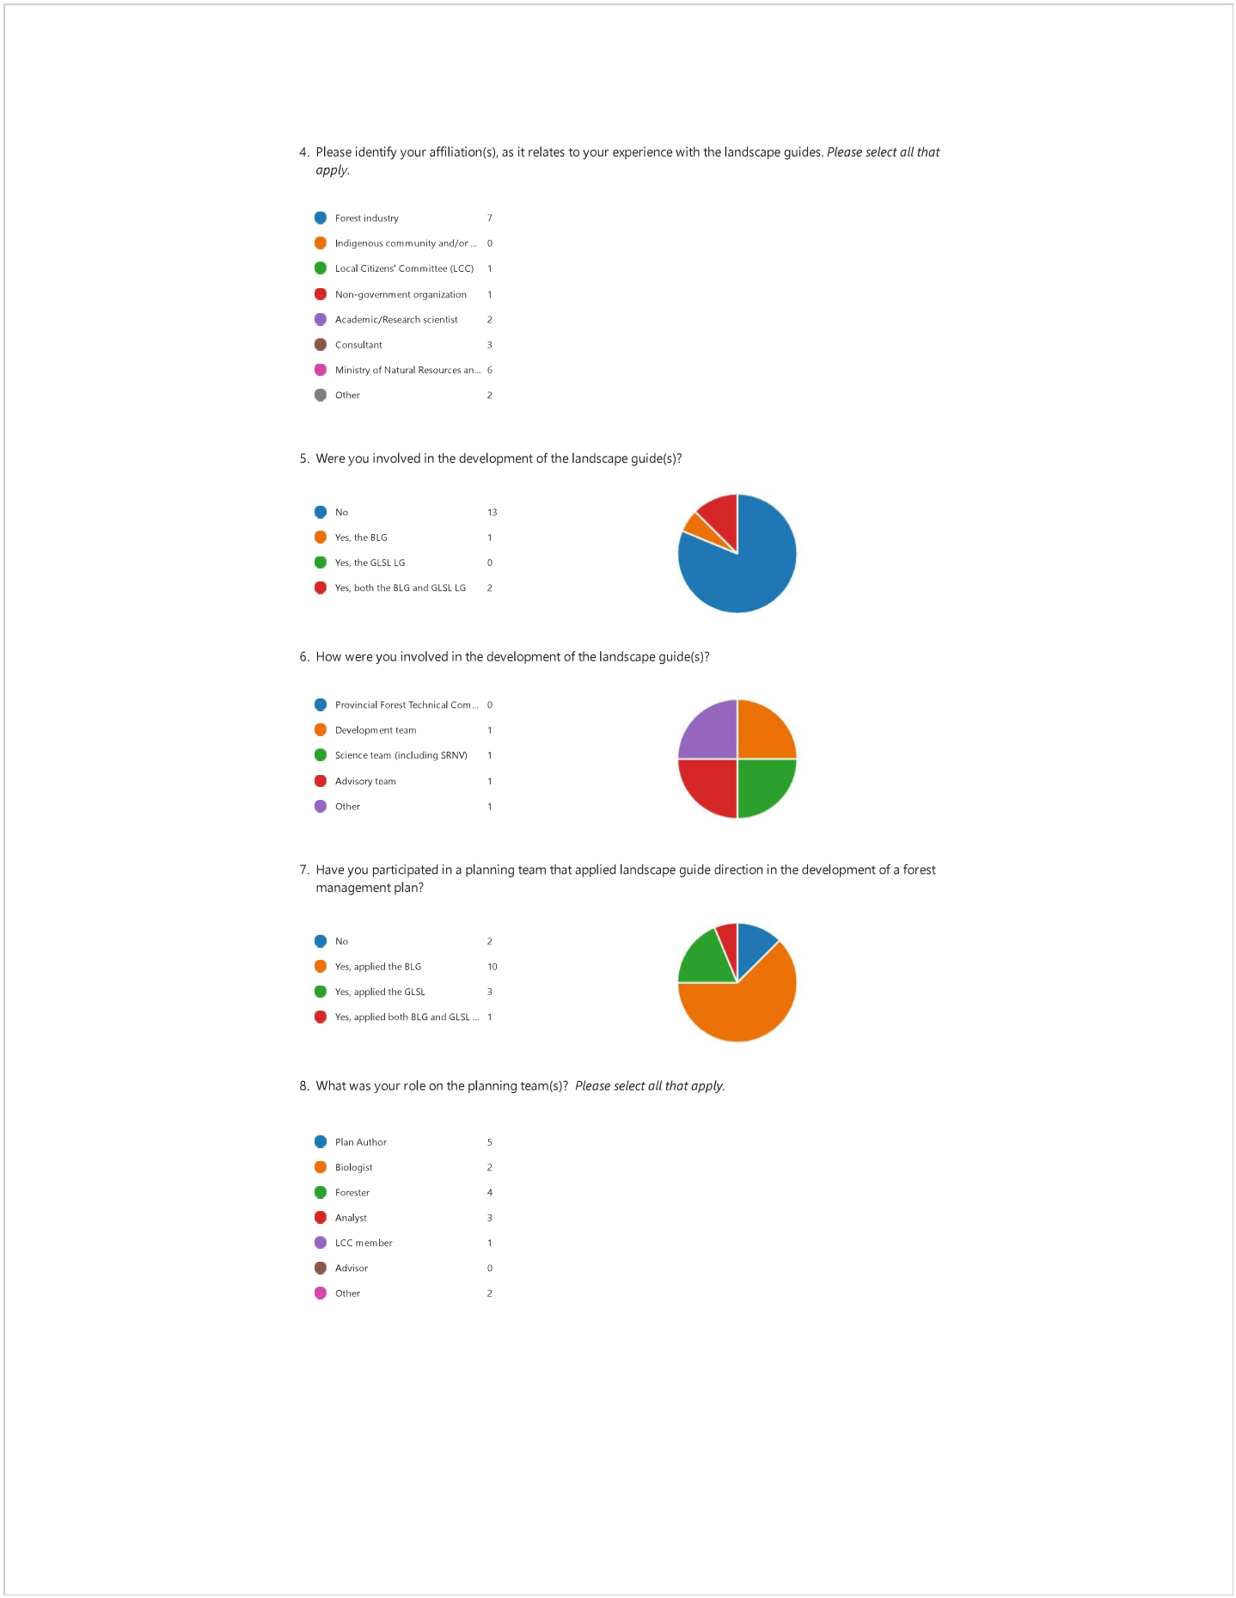
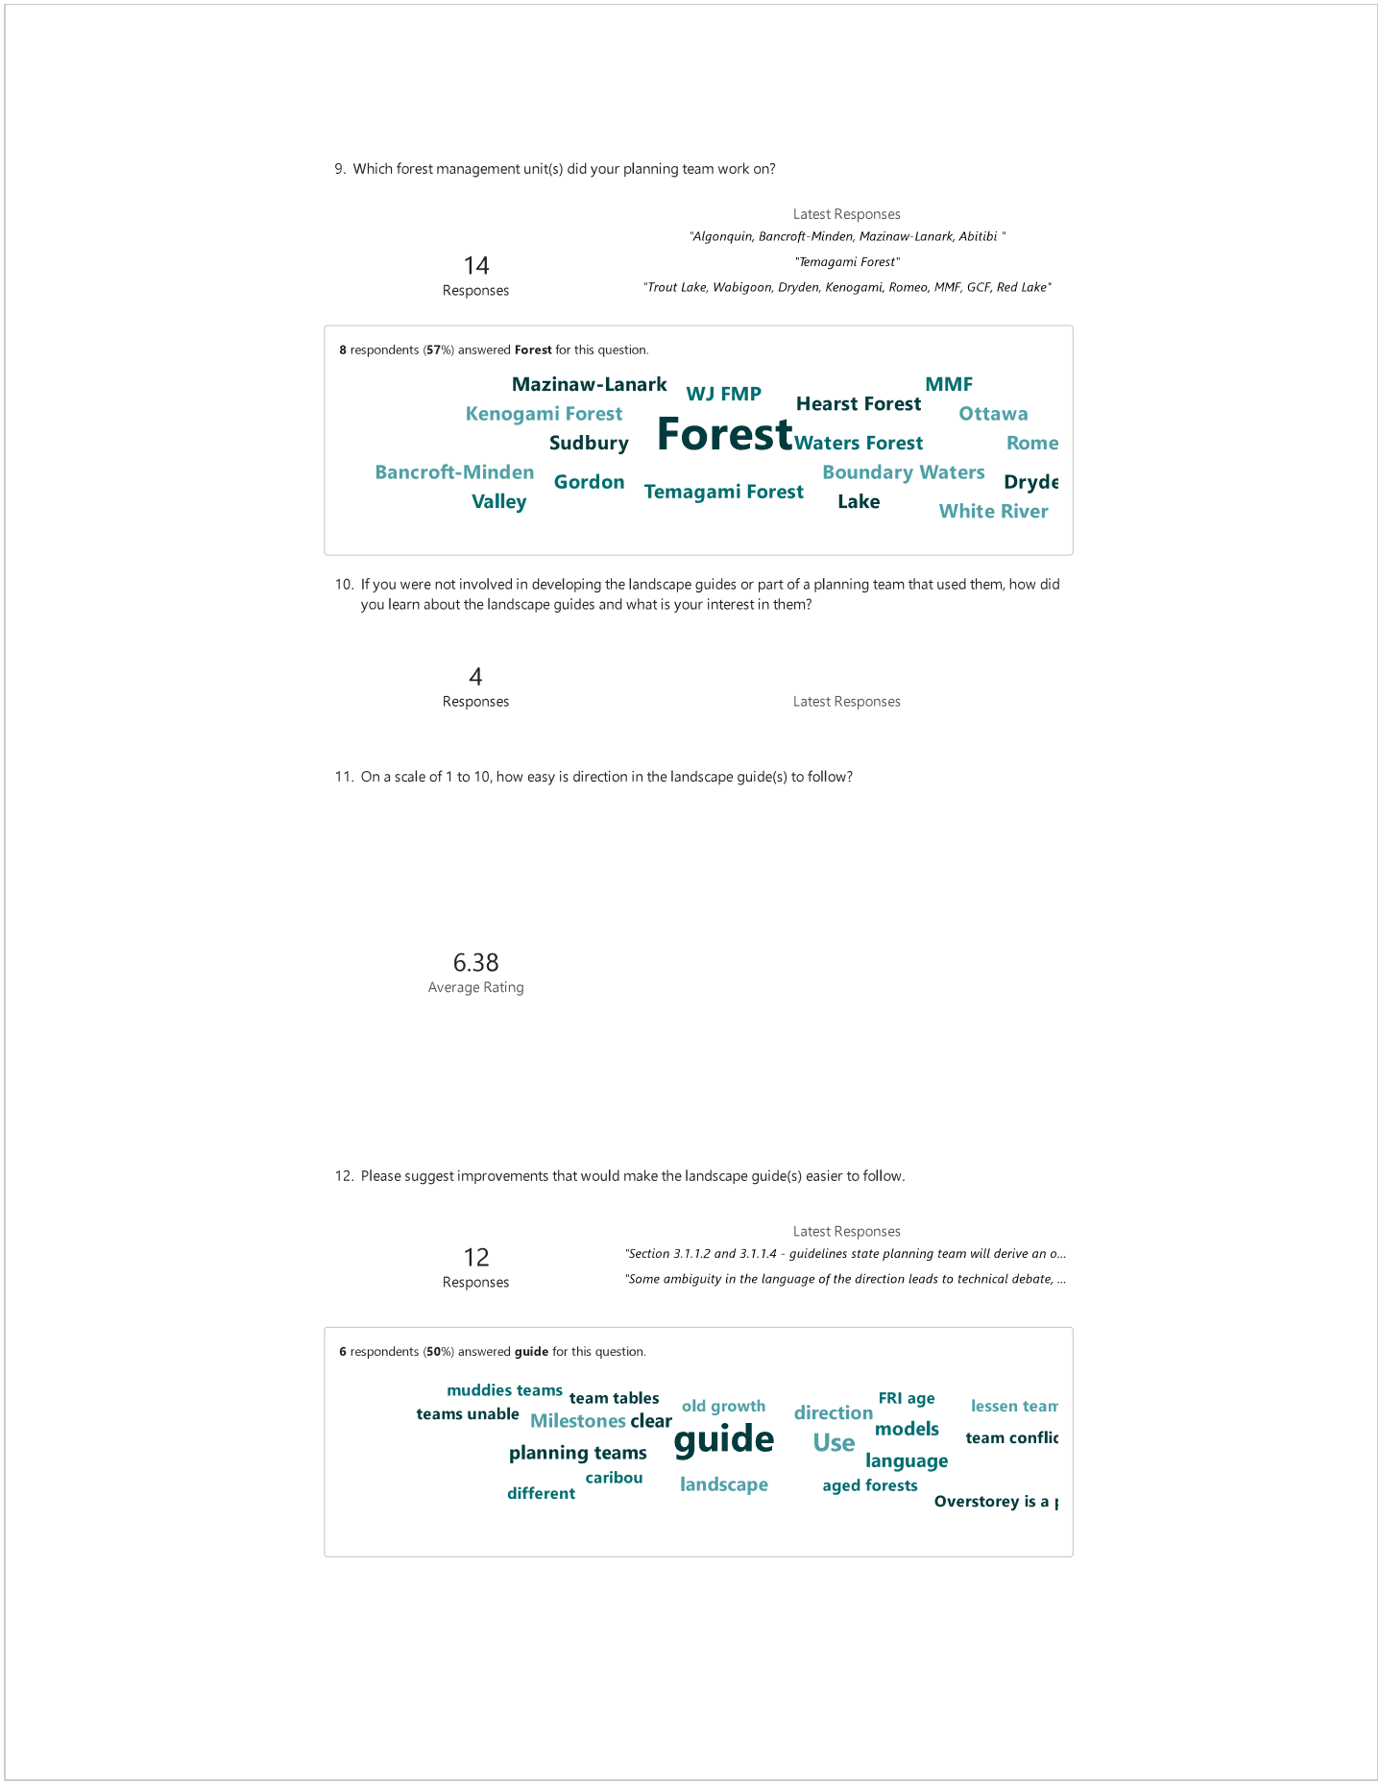
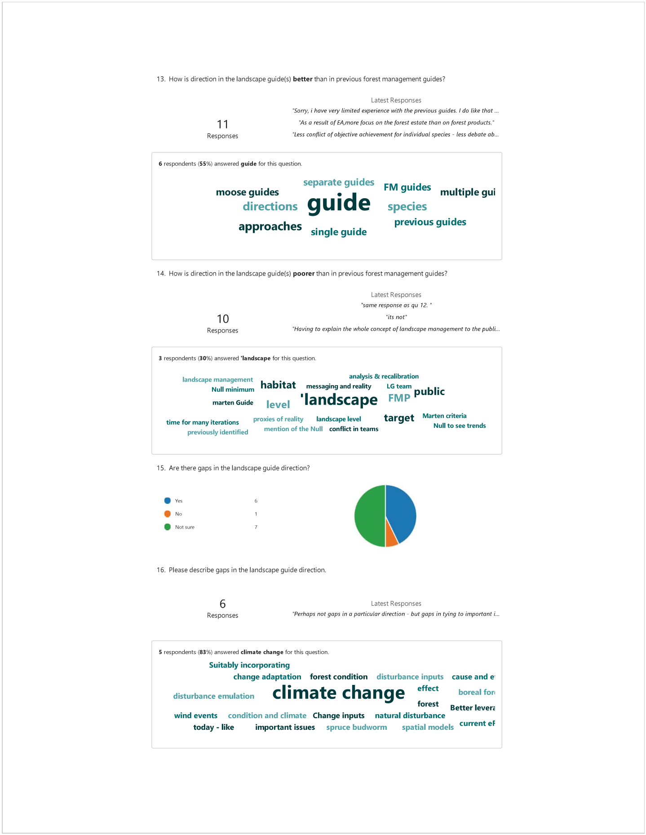
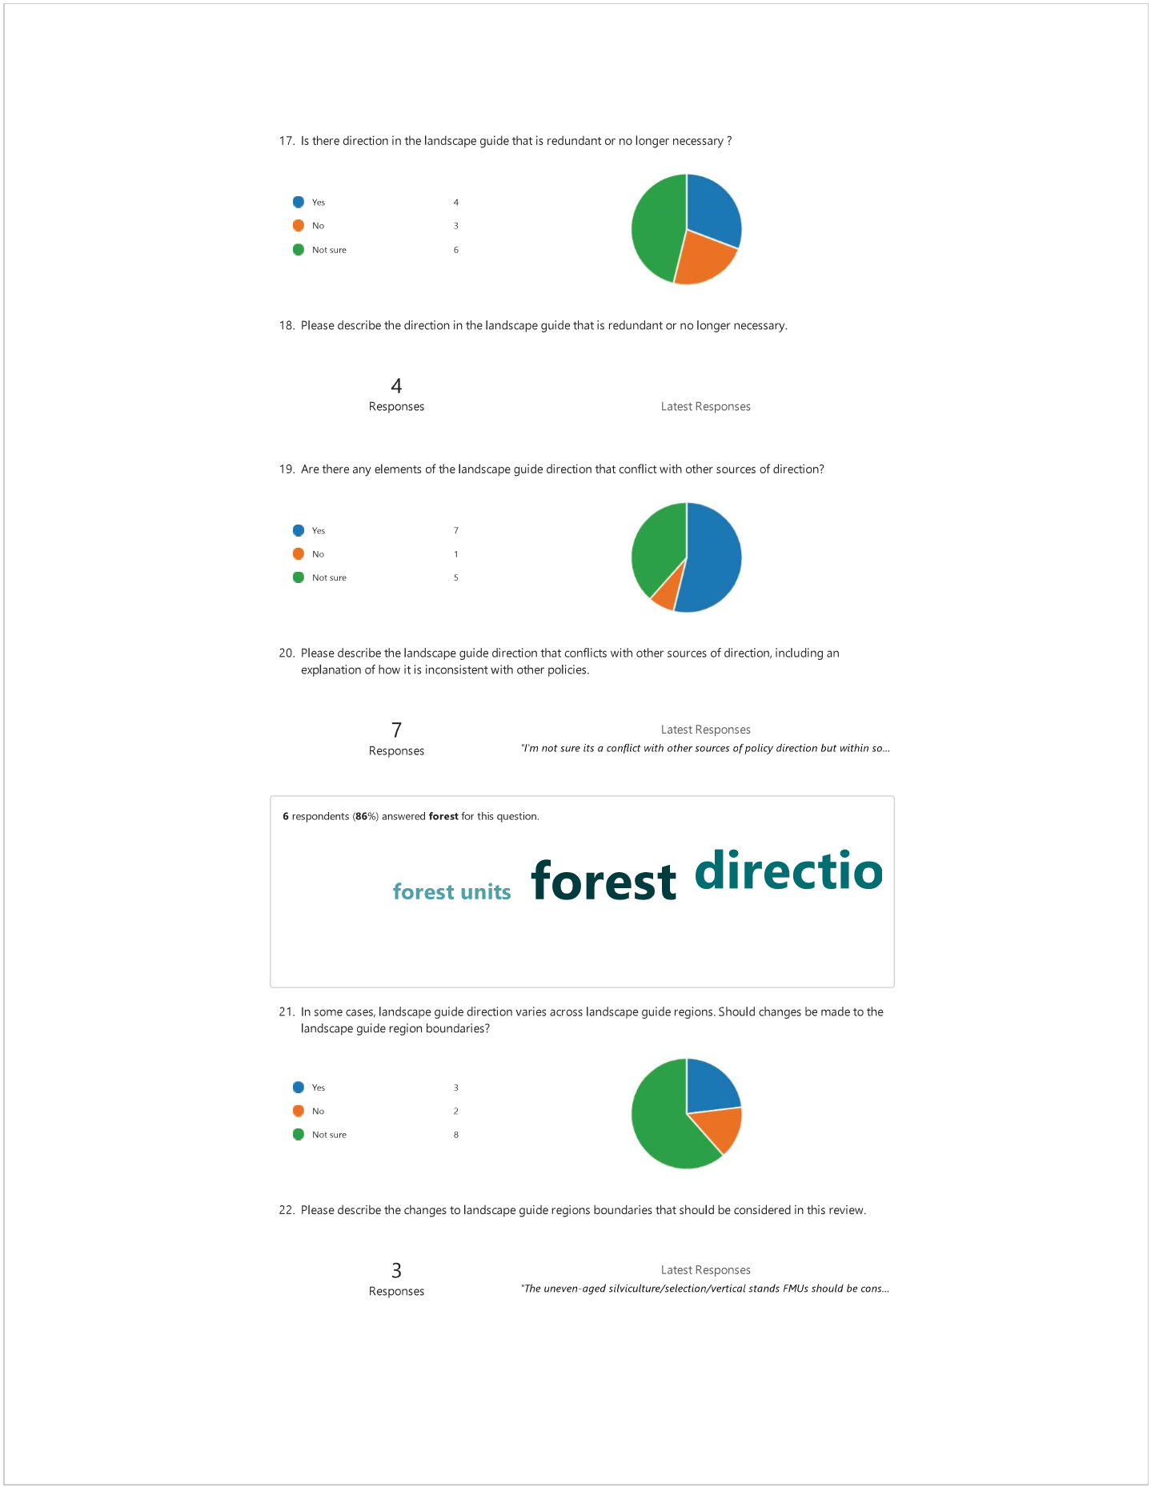
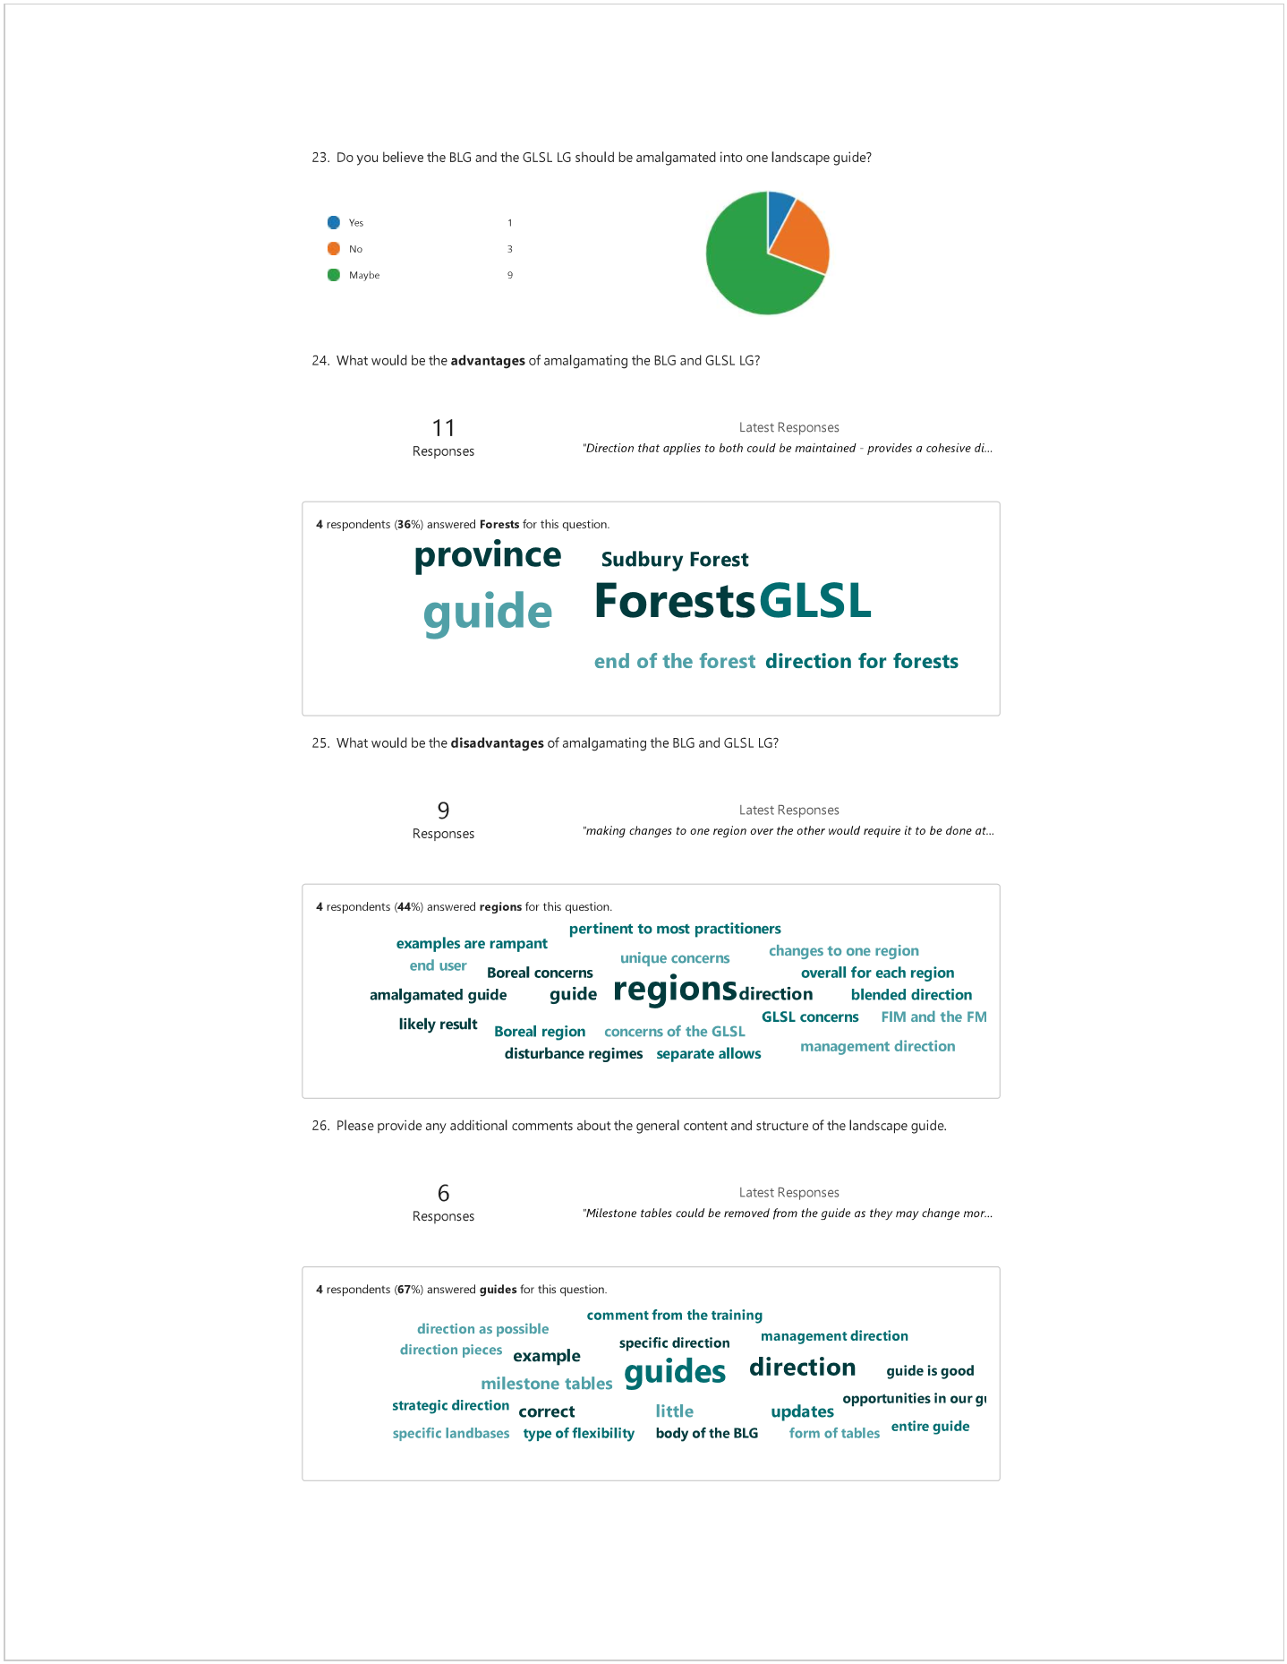
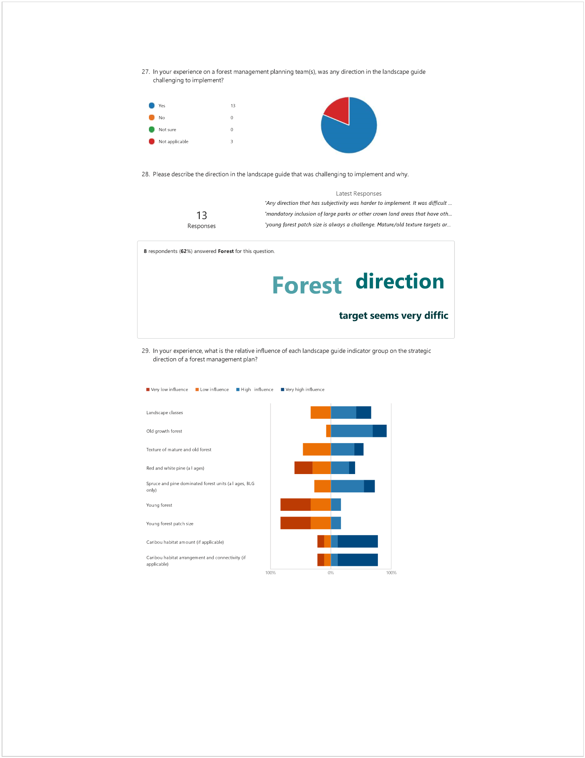
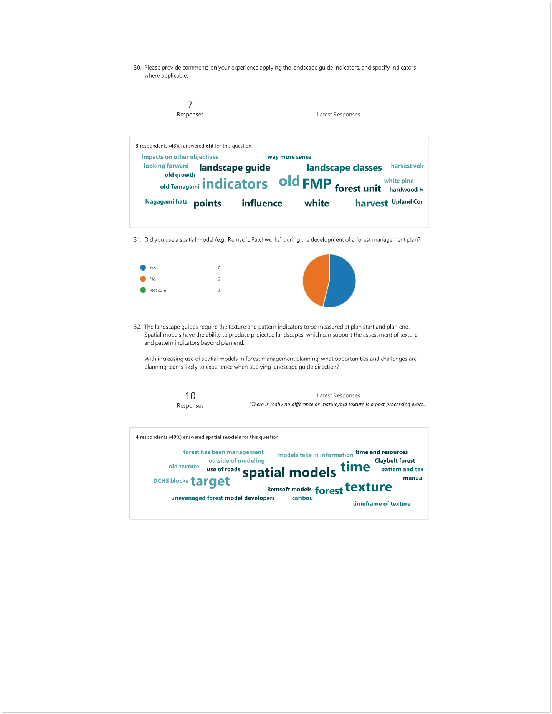
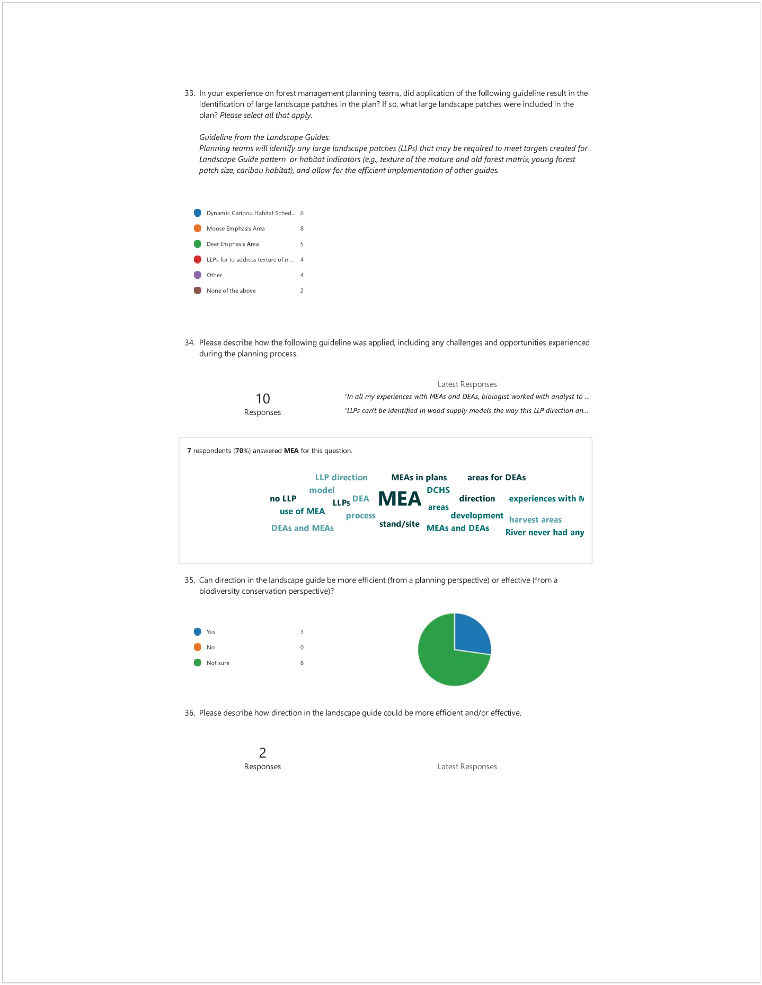
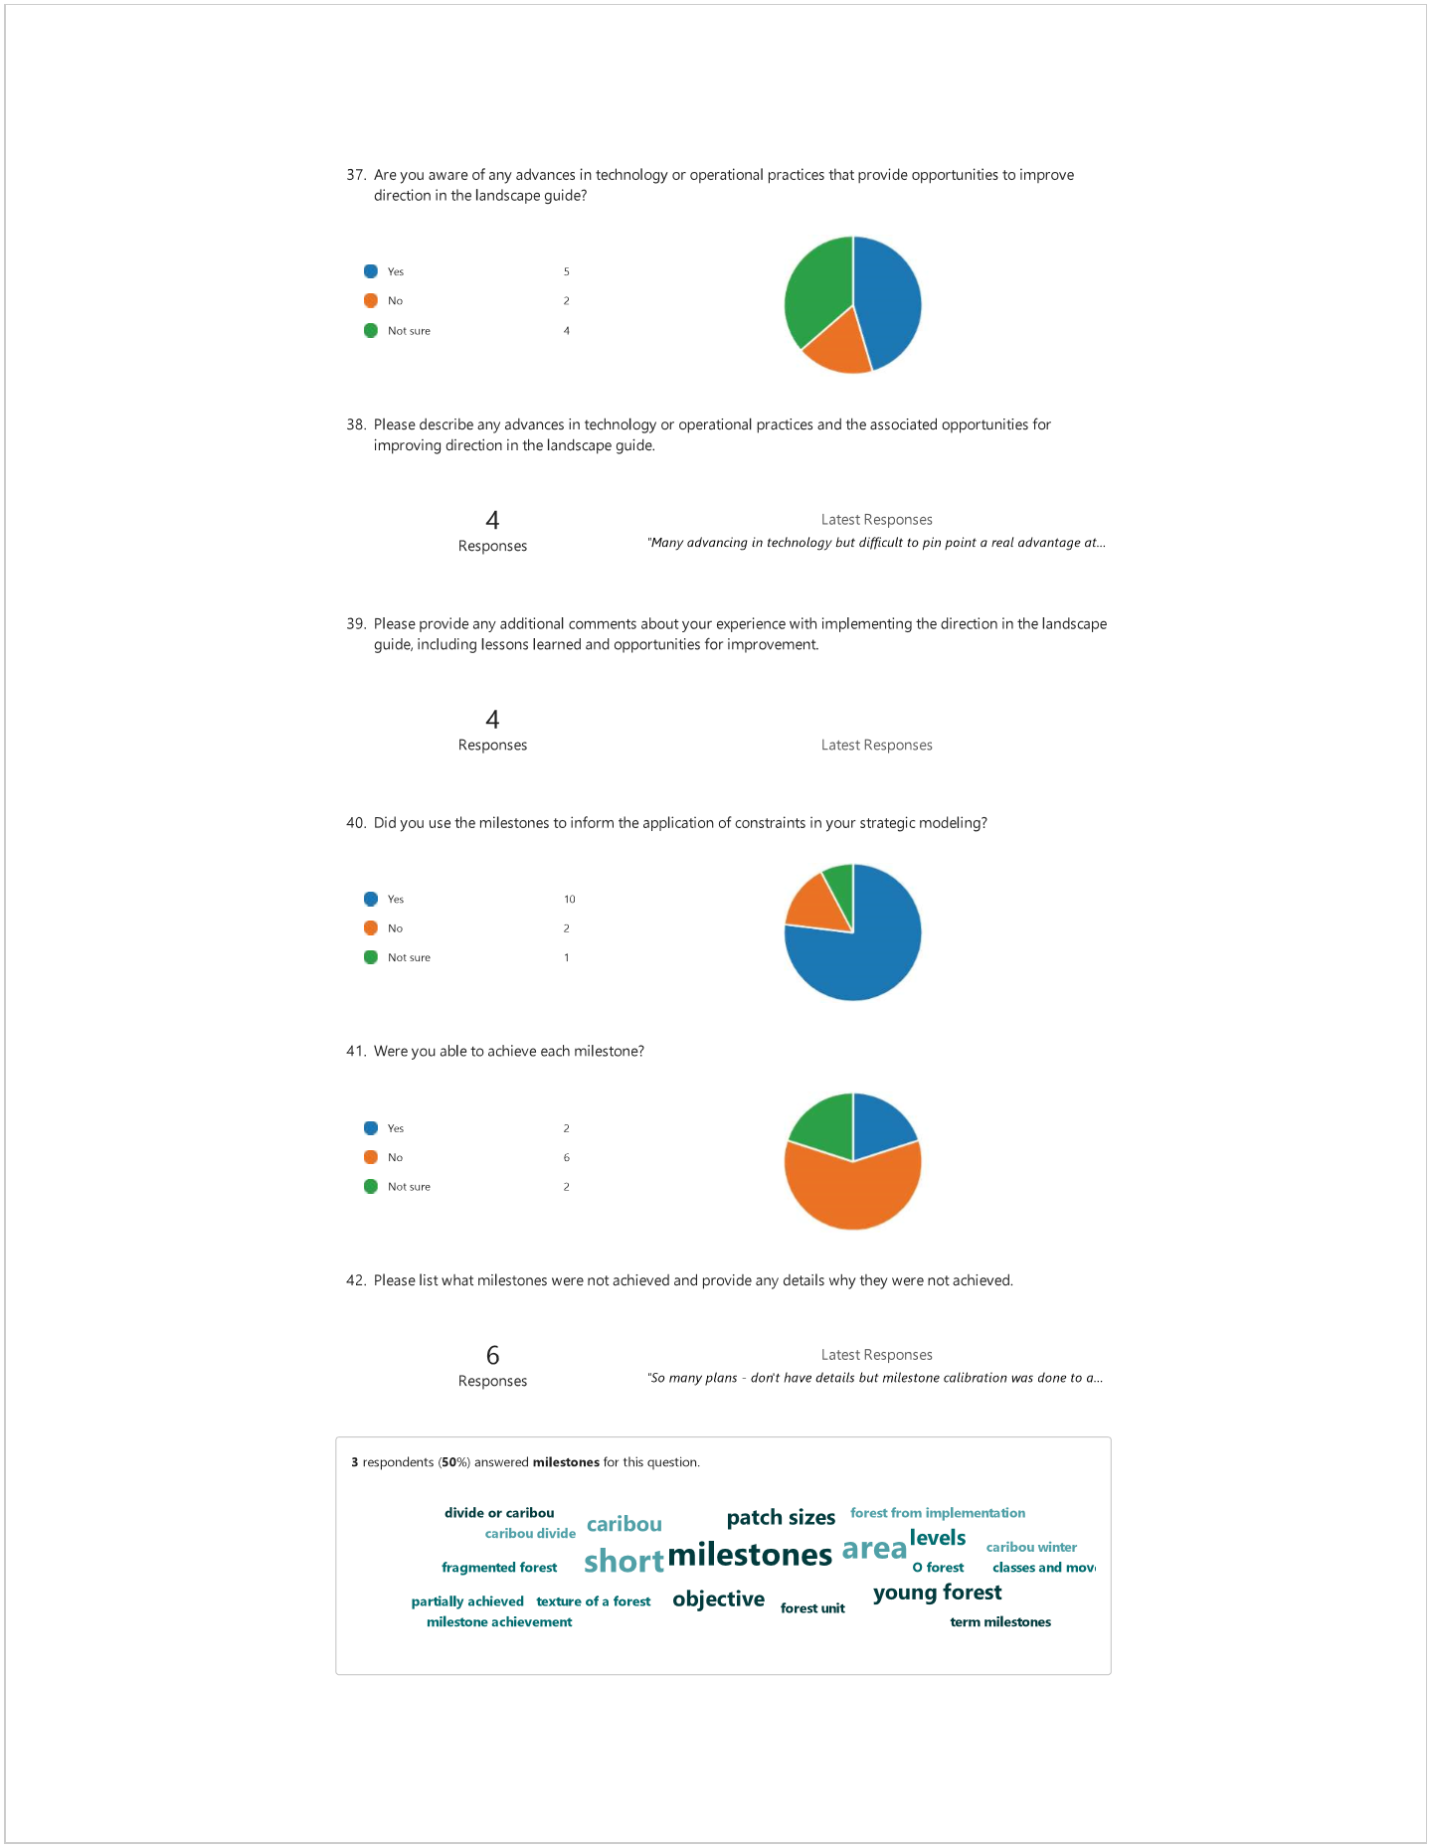
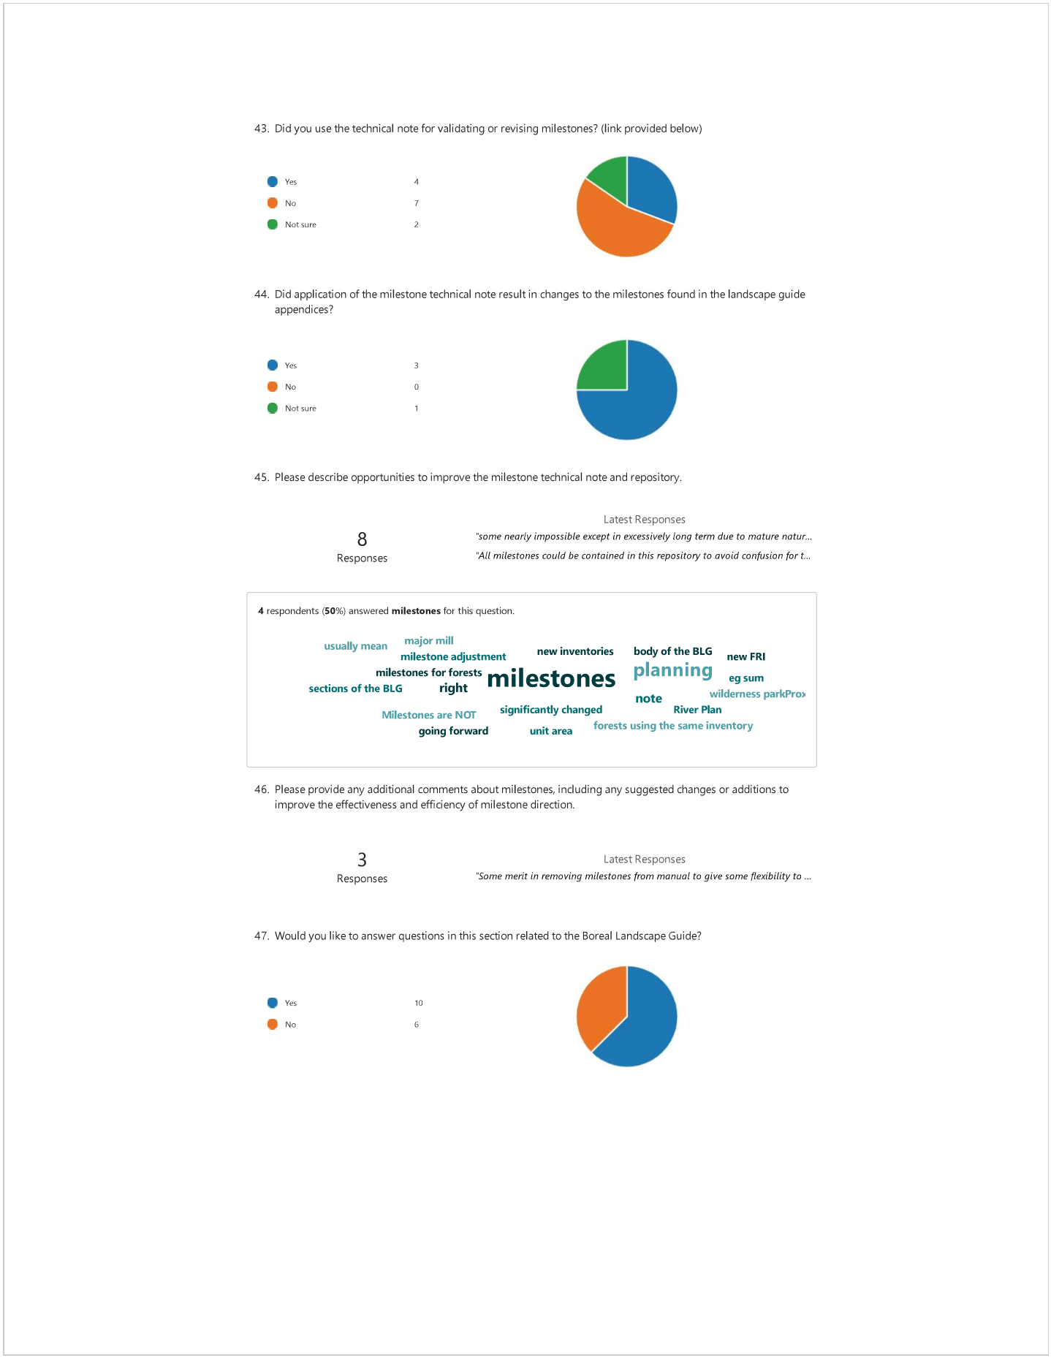
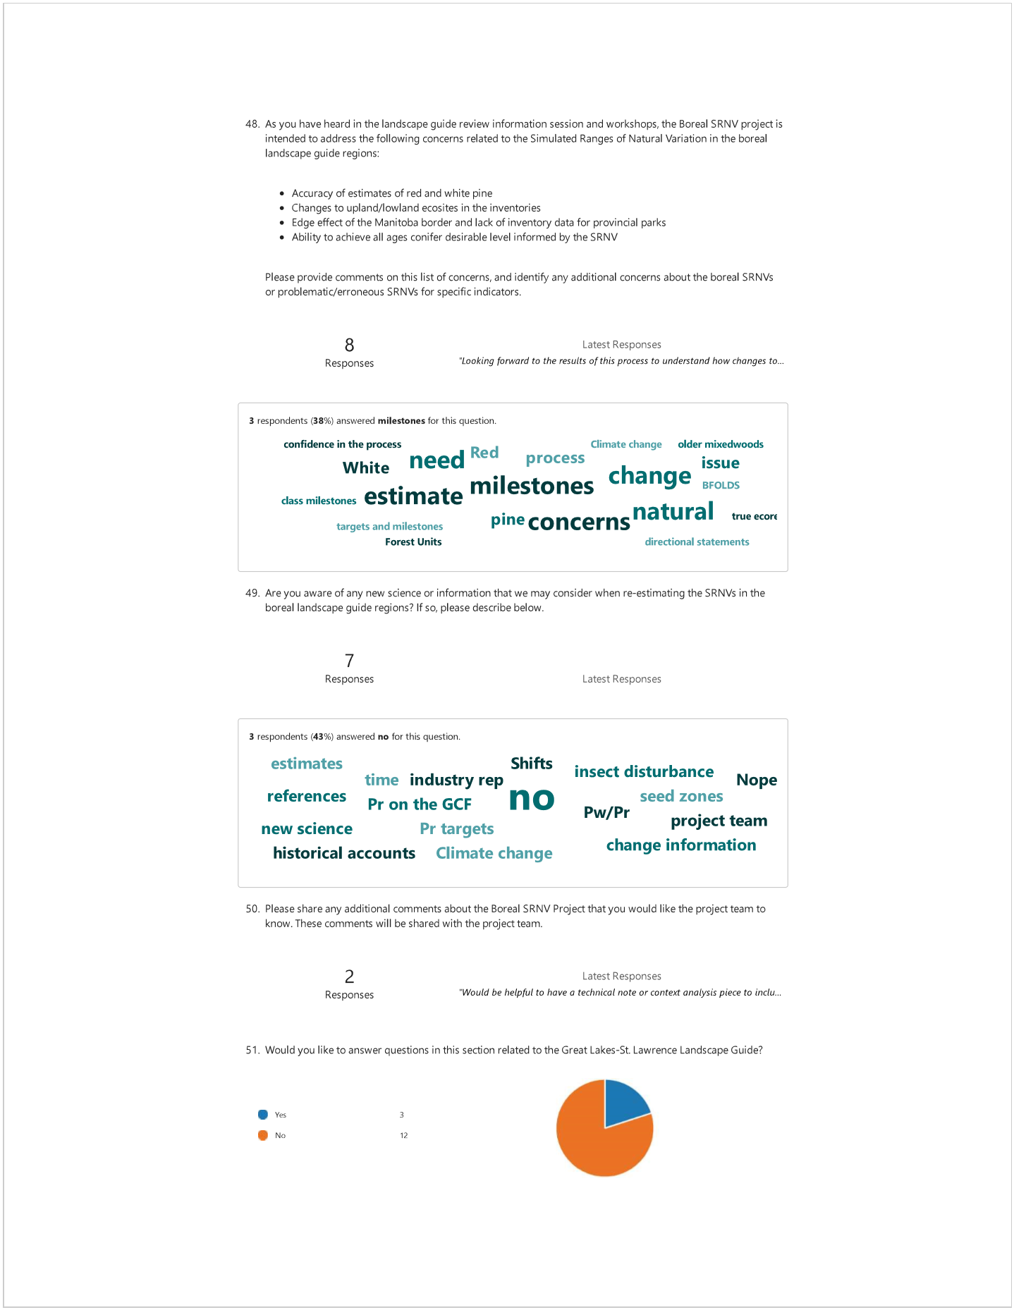
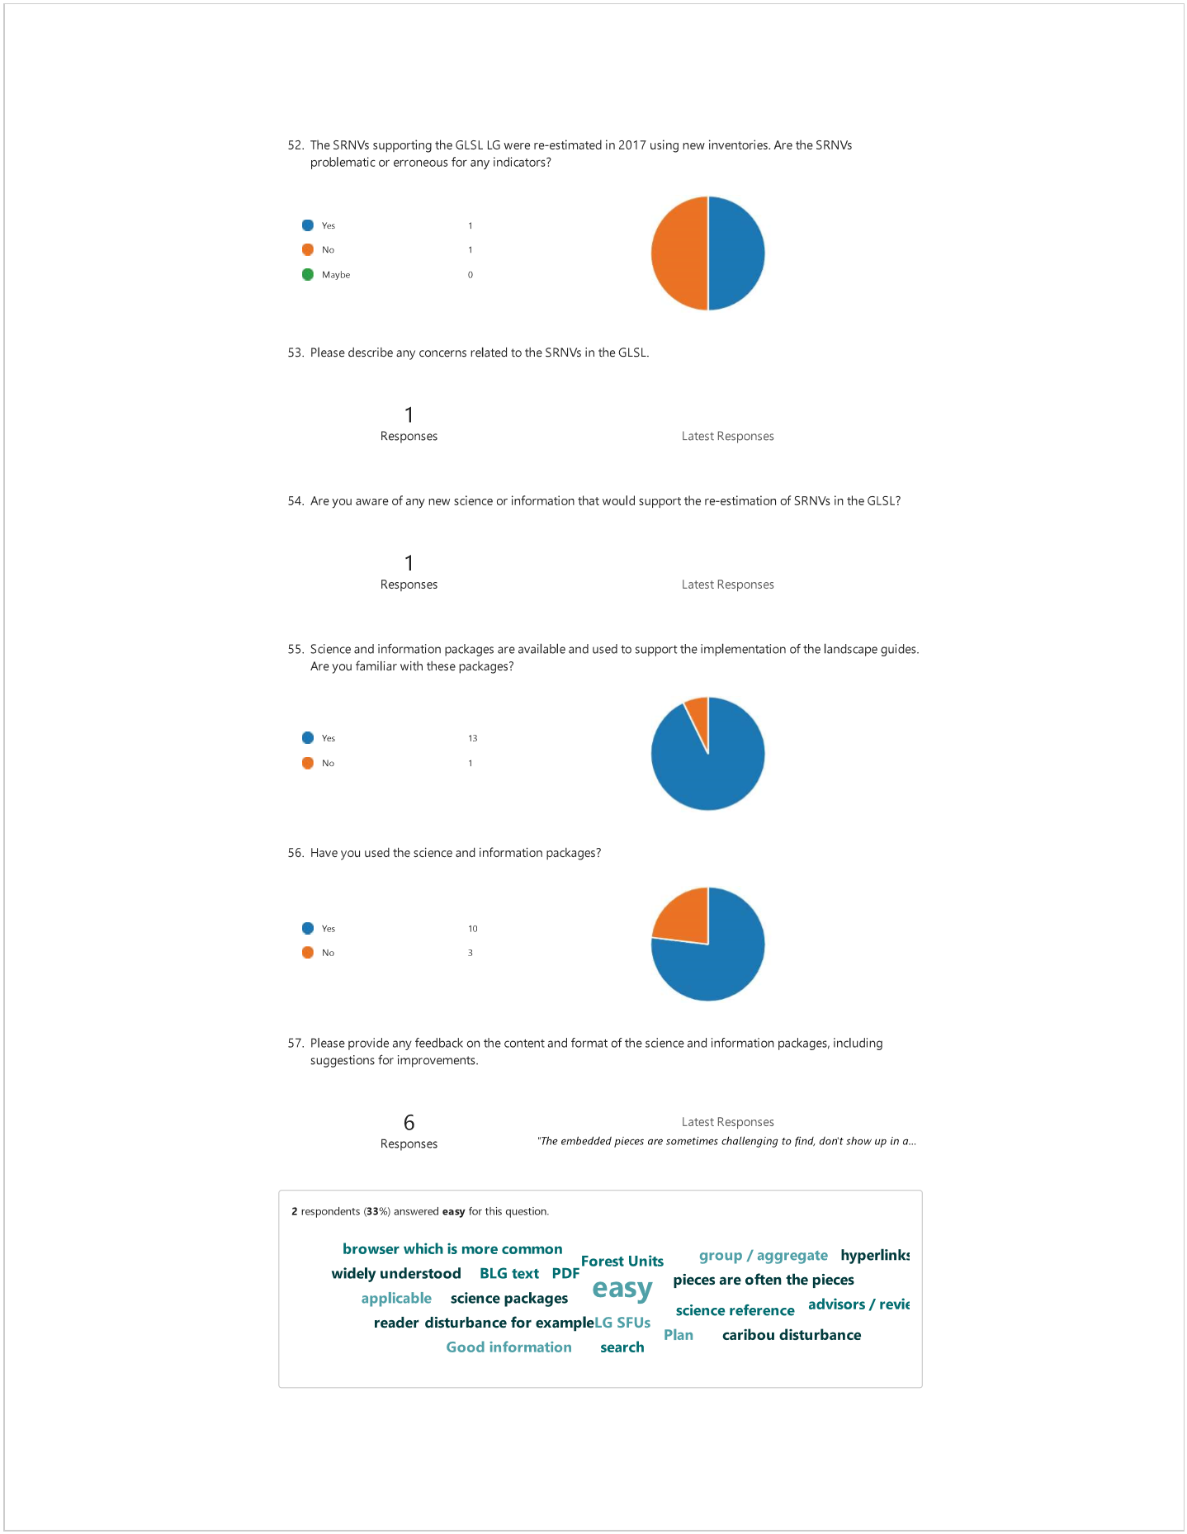
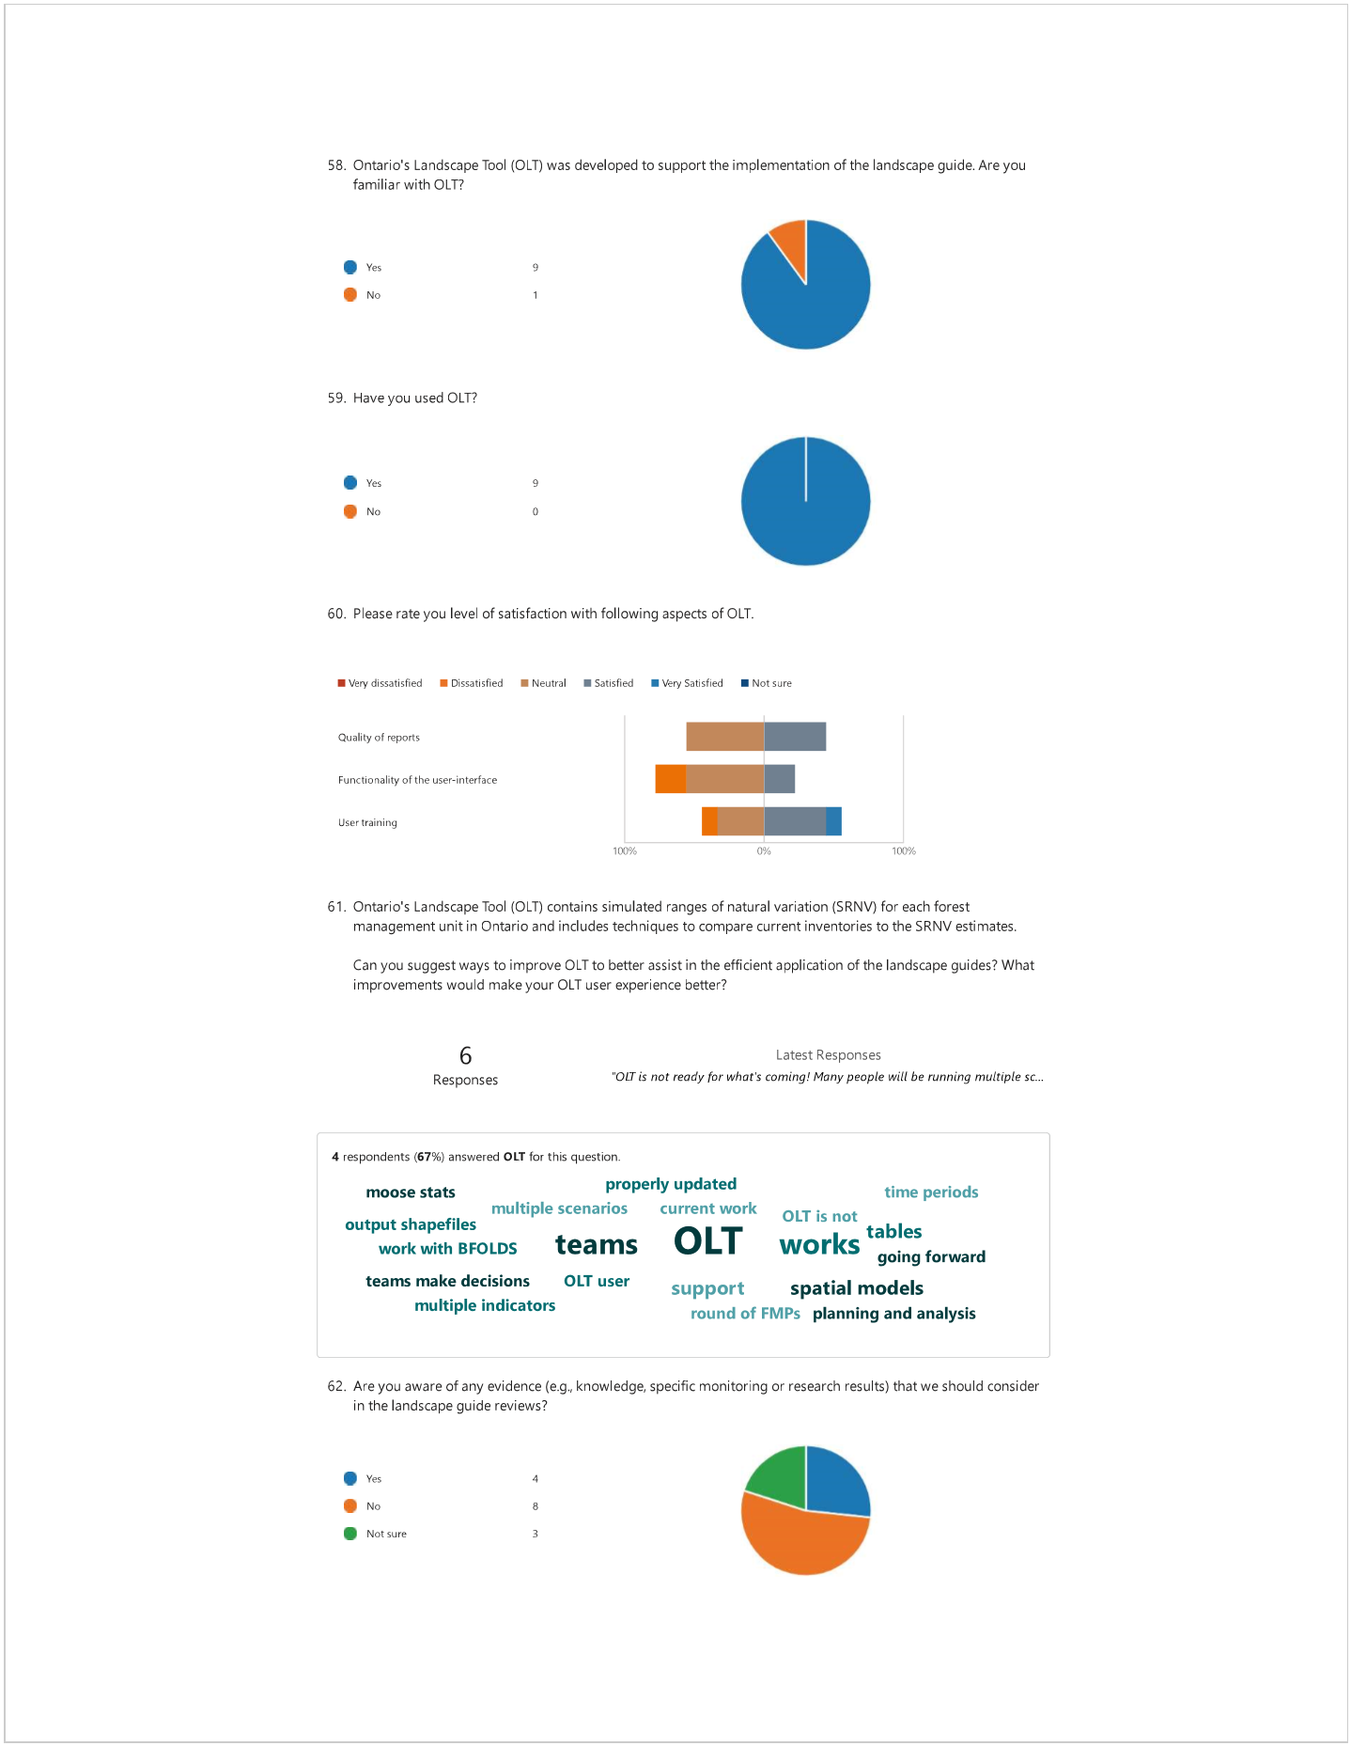
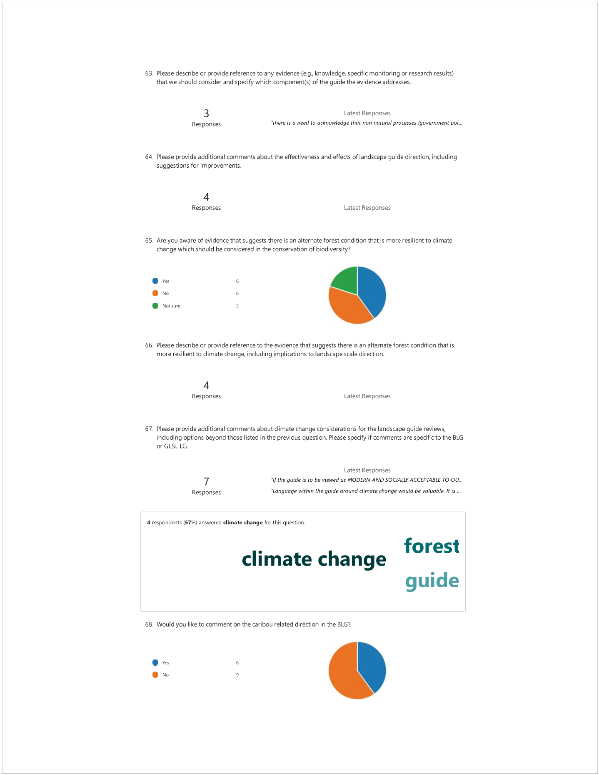
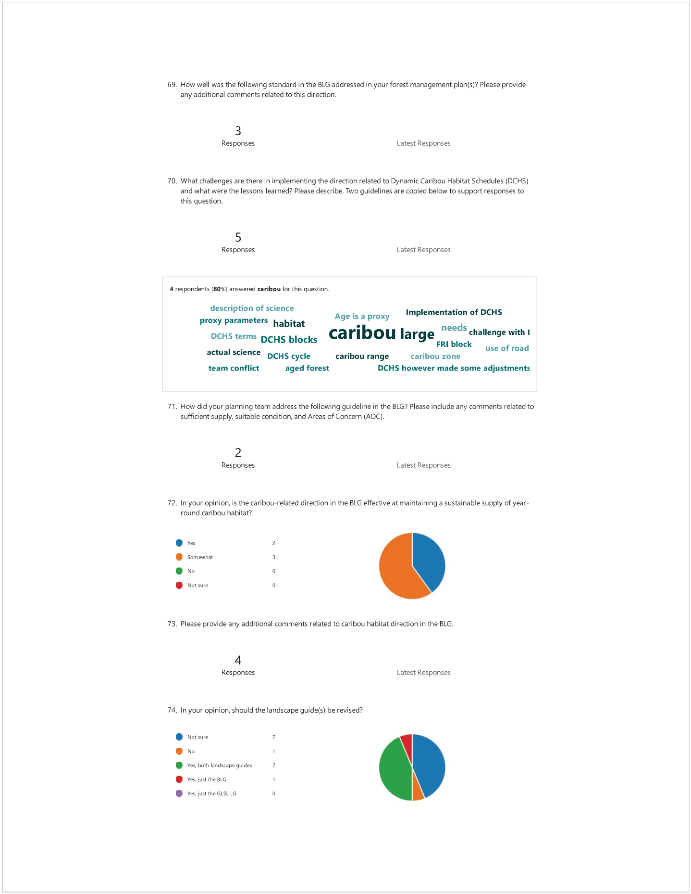

Appendix D: Written comments provided by Regional Planning Biologists (MNR)

Guide | Applicable Mandatory Direction | Specific Standard/ Guideline Comment Pertains To | Comment Type | Review Comment | Suggested Action/Potential Solutions | Additional Supporting Information | Is this causing Implementation Issues?
Boreal Landscape Guide | Section 3.5.2.1: Stand and site level direction for caribou habitat | Sufficient Supply of Caribou Calving/Nursery Areas | Develop Guidance and include in the BLG. | There is no formal direction written to assist with the determination of sufficient supply of caribou calving/nursery areas. The interim direction seen in some FMPs in the NWR is highly subjective and does not allow this determination to be made consistently from one biologist/PT to the next. Given the difference in caribou habitat ecology in the NE, is the determination of sufficient supply for caribou calving and nursery areas even feasible? After applying the interim criteria in the determination of sufficient supply, one does not come out the other end having an objective answer to the question of sufficient supply on a specific FMU. | Develop formal/scientifically based guidance to assist in the consistent determination of caribou sufficient supply of calving/nursery areas in FMPs. Incorporate this into the BLG. | Planning teams have considered the following information in the determination of sufficient supply of calving/nursery areas: 1) The range level habitat tract map, 2) Caribou habitat composition (refuge & winter) at the management unit and range level, 3) Caribou habitat pattern (winter) at the management unit and range level, 4) Time to achievement (milestones) of caribou habitat indicators by management unit, 5) Estimates and trends of habitat loss at the range level, 6) Estimates of range level population states (Integrated Range Assessment Reports). | The lack of formal direction to aid in the determination of sufficient supply is causing implementation issues of the BLG and this determination appears to be subjective from one FMP to the next or from one biologist to the next. It is possible that even two equally experienced biologists could make two completely separate calls on sufficient supply of calving/nursery areas on the same FMU.
Boreal Landscape Guide | Section 3.5.2.1: Stand and site level direction for caribou habitat | Allocation & Harvest of Habitat Tracts with Nursery Area | Develop Guidance and include in the BLG. | More guidance is needed regarding the characteristics that suggest a habitat tract and associated caribou nursery area are in an unsuitable condition as it relates to making an allocation and harvest decision. The lack of detailed guidance can cause subjectivity in these decisions and potential for an error in judgement to occur. | Develop detailed guidance to assist with identification of habitat tracts/caribou nursery areas that are in unsuitable condition. Incorporate this into the BLG. | When the BLG refers to unsuitable condition, is it pointing to DCHS blocks with caribou nursery areas in them being overmature and falling down (i.e., it is time to harvest the DCHS block). | The lack of formal direction to aid in this judgement call is causing implementation issues of the BLG and this too appears to be subjective from one FMP to the next.
Boreal Landscape Guide | Section 3.5.2.1: Stand and site level direction for caribou habitat | Stand & Site Level Direction for Woodland Caribou Habitat in the NER vs. NWR | Refine Guidance and include in the BLG. | Acknowledge the differences in caribou nursery habitat ecology between the northwest and northeast regions of Ontario and account for these differences in the text of the fine filter direction that is provided in the BLG. It is possible that there needs to be region-specific guidance developed for each of the regions within continuous caribou distribution. | Seek input from northeast district and region Biologists with expert knowledge about caribou nursery use in the NE Region. Work with them to write direction for caribou nursery areas that is applicable specifically to the NE Region circumstances. |  | The lack of region-specific guidance for caribou nursery habitat is causing implementation issues in the Northeast Region given the differences in caribou nursery habitat ecology.
Boreal Landscape Guide | Section 3.5.2.1: Stand and site level direction for caribou habitat | Stand & Site Level Direction for Woodland Caribou Habitat in the NER | Refine Guidance and include in the BLG. | The Stand and Site Level direction for calving and nursery areas is confusing and does not consider/is not reflective of what is known about caribou calving and nursery habitat ecology in the NER. Direction on allocation/harvest/retention of calving/nursery areas is highly needed and should be reflective of the experience and opinions of seasoned NER District Biologists. | Review guidance for caribou calving and nursery areas in the BLG and develop additional modified guidance that reflects the NER condition and variances in caribou ecology and habitat needs/use. |  | The lack of region-specific guidance for caribou nursery habitat is causing implementation issues in the Northeast Region given the differences in caribou nursery habitat ecology.
Boreal Landscape Guide | Section 3.5.2.1: Stand and site level direction for caribou habitat | Stand & Site Level Direction for Woodland Caribou Habitat in the NER | Refine Guidance and include in the BLG. | Application of the current caribou calving AOC approach may be creating small islands of calving forest surrounded by swaths of clear cut (especially in NER). There are concerns that cows will not cross the clear cut and find the calving areas, thus rendering them useless. Do we have any new monitoring information/science to incorporate into the BLG that provides evidence that caribou will continue to return to previous nursery areas even following adjacent logging around the AOC. | Further dialogue should happen with biologists and corridors of suitable habitat should be a requirement to ensure connectivity to calving AOCs. Direction should be revised to not create donuts. |  | Possibly
Boreal Landscape Guide | Section 3.5.2: Using large landscape patches for applying fine filter direction for woodland caribou | Spatial planning and arrangement of DCHS (blocks) for connectivity and temporal availability, time-slice analysis/'online' caribou habitat/link to quality caribou habitat. | Develop and refine guidance and include in the BLG. Re-evaluation of the concept of 'online' caribou habitat in the time slice versus provision of quality caribou habitat. | There is a lack of direction and standardized methodology as it relates to the spatial planning & arrangement of caribou habitat/DCHS blocks through time, across intervals, and across the FMU geography – much of the spatial arrangement aspect of caribou habitat planning is ‘eyeballed’ for connectivity. Aspects of spatially arranging caribou habitat dependent upon the time-slice exercise alone carries potentially disastrous assumptions about the likelihood of caribou use when DCHS blocks reach an ‘online’ status. To the inexperienced PT member, the time slice exercise may result in a perception that online DCHS blocks are all equally providing quality ‘online’ caribou habitat in a given interval. The reality is that many of these ‘online’ blocks may contain only very small proportions of preferred/quality caribou habitat and that preferred caribou habitat may be concentrated in only a handful of DCHS blocks. The time-slice exercise results in a certain proportion of DCHS blocks being ‘online’ at any given time in the planning horizon which is misleading given many of these DCHS blocks may be composed of very little high quality caribou habitat. There is a need to clarify 'online' availability of caribou habitat versus expectation of use by caribou given the quality of habitat in DCHS blocks. Consider including a quality control procedure for the assessment of this and written requirements to support the transparency of this in FMP. | Develop guidance related to the spatial planning and arrangement of DCHS blocks for connectivity and temporal availability of DCHS blocks that contain quality caribou habitat. Develop a procedure for ranking/measuring DCHS blocks for their quality of habitat and future value and expectation for caribou use. Make it a requirement for transparency of this in the BLG. |  | This is causing BLG implementation issues as there is currently no system to identify differences in caribou habitat quality from one DCHS block to the next in the final presentation of the DCHS in the FMP (unless the distribution of preferred/used caribou habitat is specifically shown which may not be fully understood by the general public.
Boreal Landscape Guide | Section 3.5.2.1: Stand and site level direction for caribou habitat | Stand & Site Level Direction for Woodland Caribou Habitat as it Pertains to Emphasizing Winter Caribou Habitat | Refine Guidance and include in the BLG. | Currently, in the BLG, the only mention of caribou winter feeding habitat occurs in the Stand and Site Level Direction for Woodland Caribou Habitat, where it exists simply as a guideline (as opposed to a standard) and only provides guidance as it relates to the renewal of areas having been used by caribou as winter feeding habitat or that have the potential to develop into winter feeding habitat. There is no discussion about the protection (through deferral) of existing caribou winter feeding areas similar to the direction for caribou nursery areas. There are two issues with this. The first issue is there is no formal procedure in place that requires a PT to complete a check that silvicultural practices to maintain or enhance the forest stands that favour the growth of the lichen rich ground cover condition or the growth of arboreal lichens are indeed being considered, utilized, and applied in candidate areas (as above) as the guideline is intended. Without a formalized procedure/checkpoint for this, there is a likelihood that this level of planning for future caribou winter feeding habitat may go unchecked. The second issue is that there is no "sufficient supply" or scrutiny exercise for existing caribou winter feeding areas in the guidelines when it comes to scheduling DCHS blocks for harvest or deferral similar to the consideration that is given to nursery areas during DCHS block scheduling. Caribou winter feeding areas are equally considered Category 1 Caribou High Use Areas under the Endangered Species Act (2007) yet they are not given the same level of consideration or scrutiny during the decision making process for the scheduling of harvest or deferral for DCHS blocks. | Develop a similar "sufficient supply" exercise as that for caribou nursery areas that requires Planning Teams to give a higher level of scrutiny/consideration to the scheduling of DCHS blocks containing known/existing Category 1 (or other) high use winter caribou feeding areas on FMUs in continuous caribou distribution. If an FMU contains only one known caribou winter feeding area that to the best of our knowledge is still being used by caribou for winter feeding, then it might be wise to schedule the DCHS block that it occurs in for continued deferral until other DCHS blocks can be confirmed as providing quality winter feeding areas for caribou. As well, develop a formal procedure/or check that requires planning teams to ensure the appropriate silvicultural practices needed to maintain or enhance the forest stands that favour the growth of lichen rich ground cover conditions or the growth of arboreal lichens are being applied in areas known to have been used by caribou for winter feeding or that have the potential to develop into winter feeding habitat . |  | The lack of a formal procedure to checking silvicultural practices as well as the lack of a "sufficient supply" of caribou winter feeding areas is causing issues in the full implementation of the BLG as both of these are required to ensure that suitable quality caribou habitat is not only being maintained now but also into the future.
Boreal Landscape Guide | Section 3.5.2: Using large landscape patches for applying fine filter direction for woodland caribou | Spatial planning and arrangement of DCHS (blocks) for connectivity and temporal availability, not following through with the scheduling for harvest component into blocks with no road access | Develop and refine guidance to address the implications of not harvesting scheduled DCHS blocks in the manner planned/intended and include in the BLG. | There have been regular instances where an SFL (for various reasons) has been unable to harvest a scheduled DCHS block which results in it being deferred to the next 20-year time interval which may cause the economic value of the wood to decline and interest in harvesting these DCHS blocks into the future declines as well. Oftentimes these tend to be DCHS blocks that currently have no road access and the SFL claims that it is not economically feasible to build road into them. There is a tendency for these deferrals to cause issues in the spatial arrangement of online caribou habitat (online habitat top heavy in non-accessible portions of an FMU, and less available online habitat in road accessible portions of the FMU). There have been questions regarding whether some of these non-accessible areas in a DCHS should even be included in the DCHS if there is no possibility of them ever being harvested. There are related questions regarding why the wood volume in these DCHS blocks is contributing to the overall allowable harvest area for the FMU, as it could lead to overharvest in the road-accessible portions of an FMU, which has already been witnessed on some FMUs (e.g., Lac Seul Forest). | Discuss the consequences of not harvesting DCHS blocks as scheduled from a caribou habitat and connectivity perspective. If there is never any intention to harvest these blocks, then perhaps wood volume should be removed from the allowable harvest area. |  | This is causing BLG implementation issues as the allowable harvest area is based partially on the contribution of the wood volume contained in the DCHS blocks that will never realistically be harvested. Given the overall lack of caribou monitoring, we have no guarantee that these DCHS blocks are still suitable for caribou in subsequent time intervals they are re-entered into.
Boreal Landscape Guide | Section 3.5.2: Using large landscape patches for applying fine filter direction for woodland caribou | Spatial planning and arrangement of DCHS (blocks) for connectivity and temporal availability, time-slice analysis/'online' caribou habitat/link to quality caribou habitat. | Develop way to balance area by interval | Currently there is no direction to ensure even allocation of area by each DCHS interval. The time slice analysis doesn’t do this, and allocation of area can be muffled by split blocks. On some forests, once the split blocks are in their ultimate interval there is not a good balance of area in the early terms. | A metric is required to ensure a more even distribution of total area by DCHS interval so as to not prevent a dip in habitat (and wood supply) in the very long term. This metric also needs to factor in the fact that not all areas assigned to an interval will be harvested in which case select DHCS blocks should be left untouched to promote even aged stands. |  | Yes causing implementation issues.
Boreal Landscape Guide (and the portion of the GLSL that overlaps coastal caribou range (Algoma Forest)). | Section 3.4.1: Develop targets for forest dwelling woodland caribou habitat objectives | Planning direction, habitat models, methods, and targets for caribou. | Develop Guidance and include in the BLG. | Currently there is no direction for FMPs in the Landscape Guides related to habitat planning, habitat models, methods, and targets for caribou discontinuous and coastal range caribou. The Caribou Conservation Plan committed to looking for opportunities through forest management planning to improve future connectivity between local and isolated populations. Without formalized direction in the BLG, there is no mechanism for requiring FMP teams to consider this during the FMP process, and the opportunities are missed. | Develop Landscape Guide direction that provides opportunities through forest management planning to improve future connectivity for caribou in the discontinuous zone through the use of suitable habitat planning tools, models, methods, and targets. At a minimum develop a formal set of caribou habitat management principles to be considered in FMPs that overlap discontinuous or coastal caribou range. Set habitat models for discontinuous and coastal area. |  | This is causing implementation issues because there is no mechanism to require FMP teams to consider the habitat needs or the benefits from planning for caribou in the discontinuous or coastal ranges. There is belief that strategies developed through the FMP process have the potential to improve future connectivity between local and isolated populations.
Boreal Landscape Guide | Section 3.5.2: Using large landscape patches for applying fine filter direction for woodland caribou | Temporal availability of DCHS blocks once deemed online. | Develop Guidance and include in the BLG. | The BLG does not include a stipulation regarding the length of time that DCHS blocks are intended to provide caribou habitat for once they are deemed online. Once a DCHS block comes online as suitable for caribou (according to the caribou habitat models), it should remain a deferral for a minimum of two terms (20 years) but ideally longer (4 terms or 40 years) to allow time for caribou use and maximum habitat benefit to caribou. The harvest of DCHS blocks should be more closely aligned with the rotation age of the specific forest it is composed of. There should be fewer instances of allocating DCHS blocks for harvest earlier than the ecological rotation age of a forest. Does not seem to align with sound wildlife habitat management and is too industrially driven. If caribou are still utilizing a DCHS block and the likelihood for continued use is high into the following twenty year interval, why should the block necessarily be allocated for harvest? The rotation and assigned timing of DCHS blocks need to carefully consider the type of forest they are composed of (e.g., PJ Dom versus Sb Dom or Sb Low) and the typical fire cycle of each of those types of forest. The rotation and assigned timing of DCHS blocks should be reflective of the fire cycle length known to be associated with the specific forest types they are composed of. | Develop Landscape Guide direction that standardizes the timeframe for which DCHS blocks provide online caribou habitat in accordance with ecological rotation ages. The target should be a minimum of one full twenty-year interval with consideration for a minimum of two full twenty-year intervals. Link this direction to a set of guiding principles for best practices associated with DCHS development and implementation. | Example: duration of online caribou habitat should be 101 years (i.e. 40-60yrs) where spruce (SbLow/SB1) is the dominant FU, rather than using the PJ condition. | This is causing BLG implementation issues because without temporally appropriate rotation of DCHS blocks that is tied to the ecology of the forest types they are composed of, it is likely that caribou are being lowballed on the duration of time they would normally be able to use DCHS blocks under a natural disturbance regime only (i.e., no harvest disturbance).
Boreal and Great Lakes St. Lawrence Landscape Guides | 3.4.1: Develop targets for forest dwelling woodland caribou habitat objectives | Rotation interval for DCHS. | Develop specific guidance for practitioners regarding DCHS rotation and how this is determined. | It's unclear how to set the duration of the DCHS intervals and how to consider the natural rotational schedule of the forest as well as sufficient time for caribou usage. Calculations are a bit ambiguous. This is the first step in DCHS development. Some DCHS's are too short in duration. | Provide the process for determining the DCHS duration that factors in natural forest rotation, fire cycle and sufficient time to use blocks before harvest. Revisit DCHS duration on forests to ensure they are sound | (I'm talking about the mechanical calculation process here). Not sure how much different this comment is from the one above, however please consider them both. | This is causing BLG implementation issues because without temporally appropriate rotation of DCHS blocks that is tied to the ecology of the forest types they are composed of, it is likely that caribou are being lowballed on the duration of time they would normally be able to use DCHS blocks under a natural disturbance regime only (i.e., no harvest disturbance).
Boreal Landscape Guide | Section 3.5.2.1: Stand and site level direction for caribou habitat | Silvicultural prescriptions to be consistent with caribou habitat management objectives and management of caribou winter feeding habitat and the use of silvicultural practices to maintain forest stands that favour a lichen rich ground cover condition. | Refine Guidance and include in the BLG. Address changes resulting from prohibitions against herbicide use. | How will losing the ability to use herbicide to accomplish forest renewal affect the ability to utilize silvicultural prescriptions consistent with caribou habitat management objectives or to maintain or enhance forest stands that favour the lichen rich ground cover condition that characterize high quality winter feeding areas? We suggest the existing direction be modified during this review to reflect that prohibiting herbicide use in the renewal of forests may lead to an inability for the FMP to meet the fine filter direction associated with using silvicultural practices to maintain or enhance lichen-producing forest stands. Perhaps there needs to be an acknowledgement in the introductory portion of the direction for caribou that states this could be an issue into the future. | Develop LG direction that provides for alternative silvicultural techniques to be utilized to maintain or enhance the prevalence of forest stands that favour the lichen rich ground cover condition that characterize high quality winter feeding areas. Or maintain the existing direction however strengthen it and be upfront in the LG that depending upon the silvicultural tools available, it may not be possible to meet/execute some standards/guidelines. |  | The prohibition or decrease in herbicide use to attain conifer purity could result in issues when implementing the BLG to maintain suitable mature coniferous caribou habitat now and into the future. This should be acknowledged in the BLG, and possibly new direction developed that speaks to additional tools that can be used to meet caribou habitat objectives related to coniferous forest.
Boreal Landscape Guide | Section 3.5.2.1: Stand and site level direction for caribou habitat | Maintaining and providing a long-term supply of suitable caribou habitat in an environment where guidelines are not followed. | Develop Guidance and include in the BLG. Strengthen existing guidance (e.g., change from guideline to standard). | In the Stand and Site Level Direction for Woodland Caribou Habitat of the Boreal Landscape Guide (pgs. 51 to 53), planning teams are provided standards, guidelines, and best management practices that are to be applied to areas where caribou habitat is to be emphasized (i.e., DCHS) that will aid in maintaining and providing a long-term supply of suitable woodland caribou habitat. This direction is not regularly or consistently being followed or practiced, as evidenced in Caribou A-block Closure reports. DCHS A-blocks are being closed out with low depletion percentages and unclear road decommissioning and silvicultural strategies planned to aid in the regeneration of DCHS blocks to even-aged mature coniferous forest. It seems as though every DCHS block has its shortcomings in the manner in which it will track to future quality caribou habitat based on the lack of commitment by industry to apply this direction. There is no ability to enforce this caribou habitat-related direction which is causing caribou habitat management to be misaligned with the intent and policy direction of the Caribou Conservation Plan and also causing DCHS blocks to not track towards future quality caribou habitat but rather degrading their quality over time. | Develop formal standards/guidance related to fully closing out caribou A-blocks in accordance with the existing BLG guidance to do so; develop direction on when A-blocks should be accepted as sufficiently closed and meeting requirements to proceed with opening B-blocks. Set standards, goals, planning approach, and methods to evaluate. Similarly for strengthening the guidance for ensuring harvested complete DCHS blocks are more closely tracking to future quality caribou habitat. | NER suggested taking a look at ARFs Caribou Exit Strategy for an example of one approach and build upon that. | There is no doubt that DCHS blocks not on track to providing future quality caribou habitat as a result of low forest depletion percentages and little road decommissioning will cause BLG implementation issues in that it will result in higher levels of habitat fragmentation on FMUs which will trigger a need to re-delineate habitat tracts and DCHS blocks in subsequent FMPs to map out areas that currently exist as contiguous tracts of caribou habitat or that will become guaranteed contiguous tracts of caribou habitat. This also has the potential to reduce the "quality" of caribou habitat in DCHS blocks as DCHS blocks will be intersected with non-decommissioned roads or forested areas that were bypassed during the last harvest rotation. Will result in uneven aged DCHS blocks that contain a road legacy whose decommissioning was never completed.
Boreal Landscape Guide | Editorial/For consideration | Provide practitioners with an overview of this review, key changes (or planned changes) and reasons for them, and external factors resulting in challenges associated with application and implementation. | Editorial & Summarize | Given the Landscape Guides are undergoing a review, the authors should take this opportunity to add a few new sections to the Guides for benefit of practitioners: 1) A Summary of the key challenges that have been experienced during application and implementation of the existing LG during FMP, 2) A summary of external factors not in the control of MNRF that may cause the direction in the LG to change during this review or that cause challenges in the intended application/implementation of the direction (e.g., limited ability to apply herbicide treatment to renew the forest to conifer likely translates into limited ability to maintain silvicultural prescriptions consistent with woodland caribou habitat objectives), and 3) A summary of key changes completed or planned to be completed as a result of this review and the reasons for undertaking those changes. | Develop a preface to the new versions of Landscape Guides that provide an overview of the review, key changes (or planned changes) and reasons for them, and external factors resulting in challenges associated with application and implementation. |  | No
Boreal Landscape Guide | Section 3.4.1: Develop targets for forest dwelling woodland caribou habitat objectives | How to address transitioning Z- and X- blocks into an existing DCHS | Develop Guidance and include in the BLG. | Develop and incorporate standards and considerations into the BLG that relate to caribou habitat (harvest pattern, movement towards the creation of large landscape patches of mature conifer caribou habitat) that must be considered/achieved in Z-DCHS blocks (open for harvest at all times) along with split blocks and X-blocks (permanent deferrals). | Develop formal guidance related to the short- and long-term intent of Z- and X- DCHS blocks and how they will be considered in DCHS development and implementation. | Additional comment from NER: Set a requirement that Z-blocks (open for harvest at all times) cannot be applied where they provide the only points of connection within caribou range and will bisect habitat along the only connection point (i.e. area where ARF & GC connect to southern patch of caribou range). Intent to maintain sufficient caribou habitat and thus connectivity is not met. | If this is not completed, there is potential to cause BLG implementation issues as it never becomes clear how these Z- and X-DCHS blocks are considered in DCHS development and implementation and why they are included in the DCHS to begin with.
Boreal Landscape Guide (and the portion of the GLSL that overlaps coastal caribou range (Algoma Forest)). | Section 3.5.2.1: Stand and site level direction for caribou habitat | Provide detailed and useful direction (standards and guidance) related to minimizing the potential negative impacts associated with forest roads and road networks. | Develop Guidance and include in the BLG. | Practitioners require guidance regarding when a road is no longer considered a disturbance in caribou range/DCHS and when it can be accepted back by the Crown. Also develop direction on how to document in the FMP the agreed-upon intent to decommission roads in a manner that is binding and conspicuous if FMP-18 is not the place. | Develop a procedure for requiring and documenting detailed intentions for road decommissioning that supports DCHS intention and implementation as direction is that FMP-18 is not the place. Direction for road decommissioning is too weak in continuous caribou distribution when it is allowed to be considered "guidance" or a best management practice. This leaves too much wiggle room for companies to wiggle their way out of truly having to commit to a comprehensive road decommissioning plan/strategy. | Burying this important direction and agreement in the RUMS or Caribou Supplementary Documentation is not sufficient nor is it a responsible location for these important commitments. | This will inevitably cause issues in BLG implementation when it comes to ensuring that quality caribou habitat is maintained now and into the future in DCHS blocks. DCHS blocks that carry a legacy of non-decommissioned roads are not considered high-quality caribou habitat.
Boreal and Great Lakes St. Lawrence Landscape Guides | 3.5 Identify Large Landscape Patches to Meet Targets - 3.5.1 Using LLPs for Applying Fine Filter Direction for Moose | Provide detailed and useful direction (standards and guidance) related to minimizing the potential negative impacts associated with forest roads and road networks. | Develop Guidance and include in the BLG. | Practitioners require guidance regarding when a road is no longer considered a disturbance for moose and when it can be accepted back by the Crown. Also develop direction on how to document in the FMP the agreed-upon intent to decommission roads in a manner that is binding and conspicuous if FMP-18 is not the place. | Develop a procedure for requiring and documenting detailed intentions for road decommissioning that supports a return to moose habitat as direction is that FMP-18 is not the place. Direction for road decommissioning is too weak in MEAs when it is allowed to be considered "guidance" or a best management practice. This leaves too much wiggle room for companies to wiggle their way out of truly having to commit to a comprehensive road decommissioning plan. Should be a requirement to document MEA road decommissioning planning in FMP-18 and Roads supp doc for primary, branch and operational roads. Need effectiveness monitoring and research to test the roads issues, get data to support our direction. | The roads aspect of all wildlife habitat planning that is facilitated through the Landscape Guides needs more grounding in science & effectiveness monitoring. As this is an enormous impact on the landscape & wildlife & this is going to be particularly troublesome when roads get added to an area that historically was unfragmented. Is the decommissioning of roads successful? Does it enable the habitat to function as a roadless state in terms of wildlife perspective. Do these MEA or whatever areas we are protecting or setting aside need to be evaluated from road density perspective as a first cut? Do we need to reconsider how we plan roads to reduce fragmentation ---even if this means more $$$ for industry. The protection of resource should come as priority goal, in my opinion! | 100% causing implementation issues.
Boreal Landscape Guide | Section 3.5.2: Using large landscape patches for applying fine filter direction for woodland caribou | The best management practices related to roads from page 49 through to 53 of the BLG are not being practiced and need to be elevated/strengthened in their priority for application and supported by science. | Develop Guidance and include in the BLG; review old guidance and remove weak portions that no one is following anyways. | The best management practices related to roads from page 49 through to 53 of the BLG are not being practiced to the extent possible nor are being seriously considered one by one during FMP/DCHS development/implementation. Requirements and methods to reduce road density/linear disturbance are too weak. Much more robust targets, methods, and standards need to be developed and articulated. | Develop more scientifically based robust and strong direction for managing road density (including decommissioning roads) in continuous caribou distribution overlapped by FMUs and include this in the BLG. Require consideration of these road guidelines and request movement towards improving their existing position. |  | 100% causing implementation issues.
Boreal Landscape Guide | New Section included in direction for Caribou | Adding a new section that addresses how Ontario intends to manage cumulative impacts through application of the BLG. | Develop Guidance and include in the BLG. | A cumulative impacts section is required to address requirements outlined in the Caribou Conservation Plan and consistent with the disturbance calculations done for each caribou range. We try to address cumulative impacts in the Caribou Supp Doc but it's weak due to lack of direction. | Methods to evaluate cumulative impacts to caribou and level of disturbance are needed. Objectives should include metrics to evaluate level of disturbance and cumulative impacts to caribou as well as targets to reduce those levels. The impacts should be tied both to harvest, regeneration and roads renewal. This could support companies achieving FSC requirements, if applicable. | NER suggested taking a look at ARFs Caribou Exit Strategy for an example of one approach and build upon that. | 100% causing application issues.
Boreal Landscape Guide | Editorial/For consideration | Restructuring/reorganizing comment for overall direction and layout in the BLG. | Editorial/Restructure/ Reorganize | Reformat structure of BLG to make stand and site level direction for caribou more distinct. Existing heading levels in LG guides make it challenging to know where you are in relationships to topics and planning stages. For instance, the time slice analysis section should not fall after the stand and site level direction for caribou section since it is considered landscape level and not fine filter direction. | Develop a more intuitive layout of BLG direction with proper flow and clear connections to phase in FMP planning. |  | The unorganized/non-intuitive current layout of some of the direction in the BLG could cause application and implementation issues especially to practitioners who are new in their positions of having to apply and implement the direction.
Boreal and Great Lakes St. Lawrence Landscape Guides | 3.5: Identify large landscape patches to meet targets | Documentation requirements for each Large Landscape Patch included in FMP. | Refine and develop specific and detailed guidance in the LGs. | Detailed documentation requirements for all types of LLPs and the location of documentation in the FMP is needed. Luckily , biologists/planning teams have been responsible in their approach to ensuring reasonably comprehensive documentation is developed and available for reference and background on the development of LLPs. However, it is possible into the future that not all teams will be as diligent or see the value in being comprehensive. | Develop detailed guidance on the documentation requirements for all types of LLPs and the location component in the FMP is also needed. Has there been any thought to developing standardized templates to write the LLP reports (e.g., Moose Emphasis Area, Deer Emphasis Areas, Dynamic Caribou Habitat Schedule). There are many good examples already being used that could form excellent templates for this documentation. |  | If documentation of large landscape patches is not being completed comprehensively, this could result in Landscape Guide implementation issues if there ends up being gaps in the information to draw upon to understand what the original intent and direction associated with each LLP was/is in applying it.
Boreal Landscape Guide | Section 3.4: Develop targets for biodiversity objectives | Clarify the direction regarding how red and white pine as indicators is to be addressed. | Refine and develop specific and detailed guidance in the LGs. | Refined direction on how the red and white pine indicators are to be addressed is needed, including methods, data sources, target setting, etc. Currently the approach is confusing, is largely debated, and SFLs frequently perceive the target to be a false representation of historic conditions. | Develop refined direction regarding red and white pine indicators and how these are to be addressed. Suggestion to show examples of how considered using different scenarios. Also suggestion to provide more background on historic condition in Science and Information Package as rationale to address the doubters. |  | Confusion related to the approach of applying this indicator is causing LG implementation issues for PT.
Boreal Landscape Guide | Section 3.4: Develop targets for biodiversity objectives | Clarify the direction regarding how the "all ages conifer" indicator is to be addressed. | Refine and develop specific and detailed guidance in the LGs. | Confusion over the application of this indicator given the vague direction and how the text in the LG body, milestone table and OLT isn't the same. | Refine the direction related to the 'all ages conifer' indicator in the LG body text, milestone tables, and OLT to clarify how this indicator should be addressed. Expand upon the 3 indicators in the milestone table and provide clarification on the regional differences regarding this indicator. |  | Confusion related to the approach of applying this indicator is causing LG implementation issues for PT.
Boreal Landscape Guide | Section 3.4: Develop targets for biodiversity objectives | Clarify the direction regarding how the "old growth forest" indicator is to be addressed. | Refine and develop specific and detailed guidance in the LGs. | Confusion over the application of this indicator given the vague direction and how many options there are in OLT. Some PT want to evaluate OG by FU and unclear on whether it should be done and whether targets are valid. | Refine the direction related to the 'old growth forest' indicator in the LG body text, milestone tables, and OLT to clarify how this indicator should be addressed. Expand upon the indicator in the milestone table and provide clarification on the regional differences regarding this indicator. |  | Confusion related to the approach of applying this indicator is causing LG implementation issues for PT.
Boreal and Great Lakes St. Lawrence Landscape Guides | Section 3.1.1.1 Landscape Classes | Biodiversity indicators | Clarity and transparency | Need a better explanation on how wildlife species are represented by landscape classes and indicators. Confusion among Planning Team members on how LG indicators address habitats of wildlife of interest. Wildlife habitat matrix is outdated and doesn't correspond to current Forest Units. | Could include a description of the habitat type expected to be provided by each landscape class and indicator and provide a few key examples of species whose habitat needs are addressed by each landscape class and indicator. Update wildlife matrix and provide better cross walks between LG indicators, Forest Units, and wildlife habitats. | SRB is helping to refine the histogram representations of Guide Indicator usage. Also investigating and verifying species by species representations. | LG implementation issues not necessarily being caused by the lack of explanation however would translate into more transparency in and reassurance that there are direct linkages between landscape classes and key groups of wildlife species' habitats being provided for through landscape class objectives and indicators. Provides a clearer biological/ecological linkage/relationship.
Both Guides | In Boreal Guide, 2.2.3 | *Talks about comparison of featured wildlife species guidelines and coarse filter direction | Move away from featured wildlife, bioindicators | Although this makes sense from a logistics point of view, for simplicity, the approach within these guides hinges on assumptions that may or may not be true. Given the nature of variability, the error imbedded within these models, and poor effectiveness monitoring, it would take much longer and much more effort to determine whether these approaches to managing forests are creating patterns, processes, and structures that are emulating natural patterns/processes and maintaining biodiversity. By having wildlife indicators embedded into the system, this serves as effectiveness monitoring & checks and balances. Just because you have a stand of a particular landscape class, does not guarantee the wildlife species indicative of that class will be present. If the species is present that provides greater assurance the stands and structures that are created are sufficient to maintain or create habitat. | Sometimes simple isn't always the best approach. We have to be critical of the risks of certain approaches and try to embed checks and balances into these approaches to ensure sustainability of our resources. I would suggest adding bioindicators that are scientifically sound and strong indicators for the habitat type you are examining. This might be a combination of species. It would be valuable to get a group of wildlife/plant experts together to discuss. |  | Uncertain
Boreal and Great Lakes St. Lawrence Landscape Guides | Editorial/For consideration | Add direction pertaining to the methods and direction for reevaluating and recalculating milestones. | Editorial for transparency sake | Add direction into the Landscape Guides that outlines the thinking behind the re-evaluation of milestones and the process, methodology, and standards for completing this assessment. | Suggest an introductory section that outlines why milestones were reevaluated and the process, methodology, and standards associated with that review and evaluation. Suggest a short summary highlighting the key changes in milestones for each FMU and the rationale for those changes. |  | No
Boreal and Great Lakes St. Lawrence Landscape Guides | Technical guidance on milestones and modeling | Comment pertains to overall development of long-term management direction for FMPs | Develop specific guidance for practitioners in an area where written guidance has been previously lacking | In terms of achieving milestone indicators, there is a lack of guidance regarding the nature and extent of modeling that should be undertaken in trying to achieve milestone indicators in FMPs. This exercise is done in an ad hoc fashion (some of which cannot be avoided) and is highly subjective from one FMP to another. Oftentimes, some PT members feel there is not enough transparency during this process, and uncertainty can remain regarding whether sufficient modeling has taken place, the correct inputs were considered, and whether the most sustainable scenarios have been selected. The process is complex and could benefit from some level of guidance to help PT feel more knowledgeable and comfortable with the process. There are situations where some key PT members feel they are having to accept specific scenarios without fully understanding what the alternatives are | Suggest outlining a very basic scenario in the LG that provides an example of the considerations that feed into whether milestones can be achieved or not and that includes a few model scenarios and the circumstances surrounding modeling for this scenario including knowing when sufficient modeling was completed. At a minimum, it would be beneficial to include a section in the LG that provides context around achieving milestone indicators and the challenges that can be associated with that. As well, providing a set of guiding principles could assist with comfort and knowledge levels when it comes to the modeling component used to balance objectives. | Suggest reviewing the list developed by NER RIAU & RPU of minimum scenarios required and expand to include more biological scenarios. | 100% causing implementation issues.
Boreal and Great Lakes St. Lawrence Landscape Guides | Editorial/For consideration | Ensure consistency in terminology and process between LG and OLT | In-depth review to ensure consistency | Caribou habitat model terminology in OLT & LGs not consistent and creates confusion. | It would be helpful to ensure that the terminology used in the Landscape Guides is consistent with that used in Ontario's Landscape Tool. Some of the wording for the Clay belt and conventional caribou models is overlapping and not same as in LGs. |  | Likely to be causing implementation issues.
Boreal and Great Lakes St. Lawrence Landscape Guides | Section 3.5.1: Using large landscape patches for applying fine filter direction for moose or deer | The use of LLPs to meet habitat objectives for moose or deer in Emphasis Areas. | The use of LLPs to meet habitat objectives for moose or deer in Emphasis Areas. | Clarify in the LG that the use of large landscape patches to create Moose and Deer Emphasis Areas contributes to the strategic direction that is developed in Long Term Management Direction and is actually tied to FMP indicators for moose and deer habitat. Consider moving some of the selection criteria from the Stand and Site Guide over to the Landscape Guides to highlight the important role of these large landscape patches in determining some of the strategic direction in FMPs. The way the LG direction is written for this minimizes the contribution of these large landscape patches to strategic planning for the FMP. PT's don't realize there's work to be done on MEAs & DEAs during strategic planning and with new modelling approach they should inform the models. | Improve the overall direction in the LG regarding the use of large landscape patches to create Emphasis Areas for moose or deer that contribute to the achievement of habitat objectives for the two species. Clarify the important contribution this makes to strategic planning. Consider if any information currently housed within the Stand and Site Guide for MEA and DEA selection/development is better housed in the LG. Ensure it's clear that MEAs and DEAs should inform models and that work on these is required during strategic planning. |  | This lack of emphasis of the importance of using LLP for habitat planning for deer and moose in strategic planning results in LG implementation issues and a lack of overall acceptance that this work is important to address during strategic planning and cannot simply be glazed over or underemphasized.
Boreal and Great Lakes St. Lawrence Landscape Guides | Section 3.5.1: Using large landscape patches for applying fine filter direction for moose or deer | The use of LLPs to meet habitat objectives for moose or deer in Emphasis Areas. | The use of LLPs to meet habitat objectives for moose or deer in Emphasis Areas. | Need language to ensure LLPs for moose are enduring features on the landscape to ensure the implementation/achievement of long-term habitat requirements and road use planning objectives. | Ensure MEAs are maintained in the original strategic location. Only move or change the location/configuration when new information is provided to the planning team (i.e. new MEA habitat requirement categories going from 3 to 5 indicators). |  | The lack of language indicating the intent of MEAs to be a enduring feature on the landscape is causing LG implementation.
Boreal Landscape Guide | 3.1.2.1 Texture of the Mature and Old Forest | Appendix 1 | Refine and develop specific and detailed guidance in the LGs. | Ensure texture indicators are not an afterthought in terms of both evaluating those indicators and attempting to achieve the targets, and the effort to improve on the condition between LTMD and final operations planning. Too often texture work is an afterthought or deemed low priority despite the priority ranking. There is not enough requirements to try to move towards these targets. | 1)Move texture indicator to top priority on Landscape Guide Indicator list. 2) Build in better enforcement of 40+ year strategic landscape map - use the map as a check-in for achieving mature and old texture throughout planning process (strategic and operational planning). 3) Need a procedure to address texture indicator application. 4) use 'deferral' planning to try to maintain good texture now and into the future. 5) all of these suggestions could and should be incorporated into the 'new' spatial modelling process. |  | Likely to be causing implementation issues.
Boreal and Great Lakes St. Lawrence Landscape Guides | None | Bridging Blocks | Guidance needed | Bridging blocks - need language to ensure the use of current guidelines/prescriptions, if possible. Example - road decommissioning in MEAs | Currently it is a planning team decision regarding the prescriptive nature of the bridging blocks. It is sometimes forgotten about until the end of the harvest allocation process. Currently only a line in the FMPM (1.3.4.1) - need to be added to the landscape guide as a requirement to identify and discuss adopting new prescriptions rather than the previous prescriptions in previous FMP. |  | Likely to be causing implementation issues.
Boreal Landscape Guide | 3.1.1 Structure and Composition | Forest Succession | Further investigation required for a potential landscape class | Poplar succession from pure aspen to boreal mixedwoods to Spruce/Fir represents a long timeframe covering up to 150 years. During this period, the habitat succeeds as well with a whole dynamic of coarse woody debris and cavity trees, for example. By basing landscape targets on age that reflects primarily an even-aged condition succeeding from fire, means we are missing critical stand dynamics as a stand transitions from aspen to a spruce-fir condition. | The SRNV group should be investigating a new indicator based on succession stage. We are unsure what wildlife habitat/species use/niche this indicator would represent but needs further investigation. | It is my understanding that succession models that underpin the guides are based on jumping plant communities, and do not consider within ecosite changes that occur within a stand through succession. This is especially problematic in GLSL where uneven-aged stands that undergo small scale disturbance retain the same ecosite classifications for years--maybe thousands before that stand is knocked back to primary succession. | Likely to be causing implementation issues.
Boreal Landscape Guide & GLSL Guide | Models & Base Information | Packages, models, new science, Lidar | Update models & rerun based on latest science. Is there a way to integrate our own results to finetune models. | These models & the current forest condition drive everything. In particular, in the GLSL the FRI data is not very accurate, particularly at aging stands. The FRI inventory can provide dramatically different results for "the current" condition of a stand depending on what inventory you are using... and often this information is poorly correlated with what is on the ground. In particular, if you are using age-based landscape classes as the foundation, but cannot generate data that provides accurate age-based estimates there is a big problem. | Reconsider how the landscape is classified. Why not use ELC as a basis to capture biodiversity of habitats more accurately. Use Lidar to derive models that create signatures for target landscape classes. As well, I think we need to analyse the data we have to test the effectiveness of our models--- is our G&Y models proving accurate? Are stands progressing through the stages in a way that reflects the models. Same with wildlife. Do the MEAs actually improve moose densities, moose survival? Does our wildlife data uncover good biodiversity indicators that can be used as a check & balance? Does the imagery accurately reflect with is on the ground. | We need to plan for the future, and take steps to improve what we do with the direction of this guide from how it currently exists. Some of these ideas, like Lidar, may be incremental. We need to be rigorous and diligent at testing the assumptions that these guides are based on. | Uncertain
Both guides--- particularly GLSL | 3.1.1.1, 3.1.1.2 Old growth Forest | Clumping of landscape classes [i.e. 3.1.1.1 mature & late] | By clumping old/mature/old growth or whatever terms are used, this assumes there is no difference between these stands & 100's of scientific papers on old growth exist across stand types that state otherwise. | Based on my understanding, in the GLSL, old growth is only considered for Pw & Pr stands. This is partly because of the links to our policy, which pay special attention to these stands. I am unsure why this is the case--perhaps the misperceptions that OGF is the big super canopy coniferous trees... but OG stage should be unique and not clumped. The problem with clumping as well, is that the SFLs create this misperception that they have created all this OGF & that we have way too much OGF on the landscape...which is clearly not the case. I know in the session I attended lots of issues raised about our OG policy & I hope that this policy can be updated & revamped & reflect social values & "natural conditions". Even if these stands, which get called OG, receive no protection or consideration in the FMP, at least there is an effort to identify them. | Put OG into its own unique category. Push these concerns with the policy up the ladder so that ON can catch up with the rest of the world in terms of OGF. Even though we are unaware of any species that require OGF in our landscape [i.e. Marbled Murrelet]-- this doesn't dismiss it's ecological relevance. Work on BBWO-- shows that this species is very sensitive. It may occur elsewhere but it is population sinks. What about Boreal Owl, Brown-creeper? As well.... just because a species is present, doesn't mean that habitat is sustainable, or optimal. | Evidence from Quebec studies that Black-backed woodpecker is a valuable indicator of OGF,.dependent on OG Jack Pine as a population source. | Uncertain
Boreal Landscape Guide | 3.5.2.1 Stand and Site Level Direction for Woodland Caribou Habitat | Caribou Stand and Site Guide Direction - where it is currently housed/sitting in the Boreal Landscape Guide | Strategic | Either move the Stand and Site Guide Direction for Caribou Habitat to the Stand and Site Guide or position it more strategically in the Boreal Landscape Guide. If it is moved to the Stand and Site Guide, there will need to be a cross reference in the Boreal Landscape Guide. | Either move the Stand and Site Guide Direction for Caribou Habitat to the Stand and Site Guide or position it more strategically in the Boreal Landscape Guide. If it is moved to the Stand and Site Guide, there will need to be a cross reference in the Boreal Landscape Guide. |  | No
Boreal Landscape Guide | Appendix 1 of the Boreal Landscape Guide | Appendix 1 | Suggestion | Remove Appendix 1 tables from guide. | Remove Appendix 1 tables from guide. Only provide direction, using examples on how to populate the cells. A comparison should be made to previous plan to ensure direction has not deviated from the original targets. |  | No
Boreal and Great Lakes St. Lawrence Landscape Guides | Applies in particular to the LG direction for Caribou and Caribou Habitat. | Road Density objectives | Refine and develop specific and detailed guidance in the LGs. | Need direction/guidance/procedures for determining road density thresholds/cumulative effects. | Road Density Objectives vary amongst FMPS. Need a consistent approach. | Some FMUs are trying to put in too many primary roads and upgrade roads to secure more funding. Result is road densities in caribou range are unduly high. | Yes, the lack of direction in determining road density thresholds and cumulative effects/impacts is causing LG implementation issues since a lack of commitment to road decommissioning translates into more and more roads being enduring features on the landscape which is contrary to the direction and science as it relates to caribou habitat.
Boreal and Great Lakes St. Lawrence Landscape Guides | 3.1.2 Pattern | This refers to the section in the Boreal Landscape Guide related to pattern, but pattern is relevant in both landscapes. | Old references that leave the impression fragmentation is not a problem in the boreal landscape | I do not disagree with everything that is written about pattern, but this needs to be updated to reflect new science and focus on these fragmentation impacts in continuously forested landscapes. The pattern that logging creates is not the same as natural disturbance and special attention needs to be used to guide LLP, because these are critical on the landscape. Fires would be expected to remove very large patches & hence create very big patches of uniform habitat as they succeeded. This needs to be considered in terms of wildlife species needs. | Need to manage to maintain LLP that are reflective of the species that use them. Need science to support direction re: influence of different effects as contributing to fragmentation -- notably roads & patch size/shape. | Conserving woodland caribou habitat while maintaining timber yield: a graph theory approach…....................................... Lots more references that indicate their dependency on old growth | Yes there are likely implementation issues resulting from this.
Boreal and Great Lakes St. Lawrence Landscape Guides | Broad Direction in Strategic Planning | Support, refinement, and improvement of OLT as used to support forest management planning and specifically strategic planning in FMP. | For LG Review Team Consideration. | Support and refinement of OLT in FMP is important - spatial modelling looks to be an expensive proposition for PTs and if some of this can be offset through an MNRF application this would be a positive and allow for greater independence and timeliness in decision-making. |  |  | Uncertain.
Boreal and Great Lakes St. Lawrence Landscape Guides | Broad Direction in Strategic Planning | Strategic Planning as exercised in the Landscape Guides. | For LG Review Team Consideration. | There should be the potential for modelling and consideration of areas considered through alternate resource management regimes in determining the potential for changes over the landscape and simulated changes to wildlife populations. |  |  | Uncertain.
Boreal and Great Lakes St. Lawrence Landscape Guides | Landscape Guide | General to entire LG. | Suggestion | Look up tables for all indicators need to be available to reduce confusion on the scripts/composition of indicators especially the texture indicators. | Provide look up tables for all indicators in supporting materials |  | Uncertain.
Boreal and Great Lakes St. Lawrence Landscape Guides | Landscape Guide | Specific to sections where these terms are used. | Editorial for clarity | Terminology of late forest versus old growth forest. | Terms need to be used consistently & defined clearly. The inherent problem with OGF is that lack of a standardized definition, or a global definition, and a lot of effort has been undertaken to define what OGF is and what it isn't & how we ID it on the ground. |  | Possibly
Boreal and Great Lakes St. Lawrence Landscape Guides | Overall Landscape Guides | Impacts of Climate Change and Relationship with Application of the LG | Suggestion: need to integrate knowledge from climate change research into LG if it is available or publishable at this time. | Seems like issues in the boreal forest related to climate change impact natural disturbance regimes & fire regimes, for example are changing. If climate change is expected to increase the intensity & heat of fires on the landscape & this is a cumulative effect -- how is this being addressed. If intense fires are causing issues with seed regeneration by killing the seeds.... | Use this as an opportunity to build in new knowledge & gain better understanding of cumulative effects & experts & knowledge. Need critical analyses of direction & ensure it is based on science and researcher's expertise & understanding of the systems. Expert knowledge is ahead of significant scientific results often & should be integrated into the guide and used as fact-checking. |  | Unlikely
Boreal and Great Lakes St. Lawrence Landscape Guides | Clarify approach for FMU that overlaps both LG Regions. | Spanish Forest - which LG to apply? | Clarity in approach for Landscape Guide Application | Clarify approach for Spanish forest being that it’s in two LG regions really. |  |  | Possibly
Boreal and Great Lakes St. Lawrence Landscape Guides | Clarify distinctions between Landscape Guides |  | Suggested | Highlight the distinctions further between the two LGs… namely the different targets (box vs whiskers) and the mandatory requirement to move towards all the targets in GLSL vs BLG is attempt to. |  |  | Not certain
Boreal and Great Lakes St. Lawrence Landscape Guides | Any LG Direction that has a Texture Component to it | Any Direction that has a Texture Component to it | Clarity needed. | Some FMUs unsure if they should have medium and long term targets for texture indicators | Clarify and set medium & long term targets for texture indicator if possible with new spatial modelling approach. Ensure details in milestone tables are accurate. |  | Possibly
Boreal and Great Lakes St. Lawrence Landscape Guides | 3.1.2.1 Texture of the Mature and Old Forest | Identify which Intervals are the Target | Clarity needed. | For texture of mature and old forest, clarify which intervals are the target. | For texture of mature and old forest, clarify which intervals are the target. |  | Possibly
Boreal and Great Lakes St. Lawrence Landscape Guides | Any LG Direction that has a Texture Component to it | Texture indicators |  | Texture indicators don't identify distribution across the forest - e.g. can meet targets by having all old growth concentrated in one small part of your plan - not resistant in the face of climate change (e.g. if a fire runs through that area) | Consider including a texture distribution indicator |  | Yes causing implementation issues as indicator is not meeting the intent of the Landscape Guides.
Boreal and Great Lakes St. Lawrence Landscape Guides | Applicable to all Direction Contained in the Landscape Guides, prioritized by the need for effectiveness monitoring. | Effectiveness monitoring | Suggestion but very much lacking and needed | Need to a) make the current effectiveness monitoring projects open and transparent, and be honest about their value and limitations, and b) sit down and make a true plan for effectiveness monitoring for the next 10 years. This needs to consider how effective the wording in the LGs (is it clear enough that planning teams were able to implement it according to intent?), how effective the guidance is in maintaining and improving the structure (are plans moving towards their targets compared to what they were when the LGs were implemented?), and how effective the indicators are in creating or preserving habitat for species (e.g. is old growth texture providing forest for species dependent on large swathes of old growth forest?) |  |  | The lack of effectiveness monitoring and potential results from effectiveness monitoring is causing LG implementation issues as new information gathered through effectiveness monitoring may elevate certain guidelines or best management practices to standards that MUST be followed and it would likely reduce the amount of wiggle room that Industry feels they have with many of the guidelines contained in the Landscape Guides.

Appendix E: Independent Forest Audit Findings related to landscape guide direction

Year | MU | Findings: | Findings
2017 | Lac Seul | 3; 8; | 3: Sioux Lookout District Ministry of Natural Resources and Forestry has not met a commitment to complete a review of the Crown Land Use Policy Atlas (CLUPA) policy report for the area south of the caribou line on the Lac Seul Forest; 8: Not enough consideration is given to natural ingress on some sites;
2017 | Nagagami | 5, 16, | Corporate MNRF has not fulfilled its commitment to developing a strategy for managing the discontinuous range of woodland caribou; The planned renewal approach in the caribou continuous distribution zone cannot be funded adequately under the existing schedule of forest renewal trust rates on the Nagagami Forest; The fire return time of 2,655 years is not appropriate and there is no consideration of the effects of climate change on this and other parameters in the review of model assumptions;
2016 | Algoma | 7 | Corporate MNRF shall fulfill its commitment to develop a strategy for managing the discontinuous range of woodland caribou to enhance connectivity between the northern continuous range and southern coastal Lake Superior populations. MNRF shall also provide appropriate assistance to planning teams in incorporating the strategy into future Forest Management Plans.
2016 | Pic River | 5; 6 | 5: Corporate MNRF shall fulfill its commitment to develop a management strategy for discontinuous woodland caribou range to enhance connectivity between the northern continuous range and southern coastal Lake Superior populations. MNRF shall also provide appropriate assistance to planning teams for incorporating the strategy into future Forest Management Plans; 6: NFMC shall conduct timely reporting of natural regeneration areas.
2023 | Gordon Cosens | 2; 3 | 2: Current and accurate caribou habitat use data was not provided for the protection of critical habitat; 3: The guidelines for the application of aerial herbicides in forestry in Ontario are outdated.
2021 | Temagami | 9 | Not all clearcut harvest blocks met the residual retention requirements, for species representation or size, as required in the Forest Management Guide for Conserving Biodiversity at the Stand and Site Scales.
2017 | Martel | 10 | MNRF NE Region is not providing the technical support to allow forest managers to complete the determination of forest disturbances required for the Year 7 annual report.
2016 | Mazinaw-Lanark | 3 | The Planning Team for the next FMP (expected in 2021) shall consider all aspects of natural disturbance when setting disturbance cycles for the MLF.
2021 | Lakehead | 2 | In the absence of reliable access, forestry and land use management objectives related to disturbance and renewal will not be fully achieved on the Black Bay Peninsula.
2017 | Abitibi | 3; 4 | No progress has been made in experimental testing to determine inexpensive yet effective ways to rehabilitate roads back to the natural state as soon as possible after the cessation of forest operations, as outlined in the 2012-2022 FMP (Supplemental Documentation, ARFMI Implementation Toolkit); The total area of declared natural renewal is not being amended to account for changes to the renewal prescriptions in the Trends Analysis Report.
2015 | English River | 6 | Conclusion: It may be that the procedure for closing “A” blocks is already in practice, but it has not been captured in written direction to District staff. A written procedure will help to make the process for closing “A” blocks clearer. Recommendation 6: Regional MNRF should provide MNRF District with interim direction on the criteria to be used for closure of an “A” caribou block.
2019 | Caribou | 4 | The underachievement of the planned harvest, if continued, will have serious negative implications for the achievement of long-term management objectives related to the provision of caribou habitat.

Appendix F: Boreal Landscape Guide: Re-estimating SRNVs

2019 Boreal Landscape Guide: Re-estimating SRNVs (Draft Report)
Phil Elkie
September 2019

Summary

This report provides a summary of potential issues with simulated ranges of natural variation (SRNVs) used to support the Forest Management Guide for Boreal Landscapes including a discussion of new science and information that may be used if SRNVs are re-estimated, a discussion of potential tools and an approximation of time to re-estimate SRNVs in a Landscape Guide Region.

Contents

Summary 137
Issues with Simulated Ranges of Natural Variation 139
Landscape Guide Region 3E (lowland/upland confusion) 139
Landscape Guide Region 3S/4S (borders and parks data missing) 140
Landscape Guide Region 4W (red and white pine SRNVs missing) 140
Landscape Guide Region 3W (all ages conifer indicator suspect) 141
New Science and Information and Science Projects 143
Natural Succession 143
Post Disturbance Transitions 144
Science/Information Projects 144
Simulation and Assessment Tools 145
BFOLDS 145
ST-Sim 145
LANDIS-II 146
ALCES 146
Landscape Scripting Language (LSL) 146
Re-estimating SRNVS 147
Steps in re-estimating SRNVs 147
Estimated time to re-estimate SRNVS for a Landscape Guide Region 149

Issues with Simulated Ranges of Natural Variation

Landscape Guide Region 3E (lowland/upland confusion)

In the initial implementation of the Boreal Landscape Guide, specifically the Hearst Forest, issues were identified with the SRNVs. The inventory used in the first round of simulations used to generate the SRNVs had differences that resulted in several prescriptive indicators being difficult to achieve.
When we first ran the simulations, we conducted sensitivity analyses to determine how long to run the simulations with the objective to estimate the condition of a forest without recent human influence. In other words, remove the human footprint. In the sensitivity analyses we observed the changes in variance of indicators over simulation time – both within and among simulation runs. The conclusion for the Boreal forest was to run the simulations for 100 years before beginning to make measurements used to estimate SRNVs (i.e. box and whisker). The idea was that regardless of the vintage of the initiating inventory used to estimate the SRNVs, the resulting box and whisker SRNV would be the same providing the inventories used to estimate the SRNVs were accurate.
In the case of much of the Boreal East – 3E, and in some cases 3W, lowlands were classified as uplands and uplands as lowlands. The succession rules we used ensured that these functional groupings remained the same - a lowland community could not succeed into an upland community and vise versa.
Misclassification/confusion between uplands and lowlands in the initial inventories versus the current more accurate inventories, has resulted, in several cases, in SRNVs that are problematic and consequently difficult to achieve.

Landscape Guide Region 3S/4S (borders and parks data missing)

Landscape Guide Region 3S/4S is on the western side of the NW region in an area that has a relatively short fire cycle. Fires occur more often and can be larger than in other parts of Ontario. Fires in this area move in SW to NE - W to E directions often igniting in Manitoba and moving across the provincial border.
In the initial simulations the movement of fires from Manitoba across the Ontario border was not explicitly dealt with resulting in SRNV results biased to a partial or incomplete model. We do not fully understand the implications of this problem and there are differing opinions of how this has biased the SRNV.
Data was missing or not available including forest cover and lightning strikes from Manitoba.
To exacerbate the border problem, Woodland Caribou Provincial Park (WCPP) is in the Region and is adjacent to several management units. At the time WCPP did not have a reasonable inventory to use in the simulations. Consequently, the lack of simulated fire behaviour within the park and its effect on adjacent management units may have biased the SRNVS in the Red Lake, White Feather, Kenora management units.
The park inventory problem was not unique to WCPP. A very coarse classification biased to conifer mixedwoods was applied in Landscape Guide Region 3W - Wabikimi Provincial Park. This may have skewed results in adjacent areas particularly when the indicator apportioning is based on fire behaviour and post disturbance transitions.
Quetico Provincial Park in the 4W simulations presented a similar border problem, (e.g. southern data missing) although because much of the border is water, we expect that the problem is not as significant. Also, although a Quetico inventory was used in 4W, as with all parks (i.e. Quetico, WCPP and Wabikimi), more current inventories are now available and can be used to strengthen the SRNV estimates.

Landscape Guide Region 4W (red and white pine SRNVs missing)

BFOLDS simulations, inputs and calibration in 4W was like the rest of the NW Region. Work that I have done in analyzing historic survey notes suggest that the proportion of the 4W Landscape Region at one time (e.g. estimate of natural) had a significant component, at the stand level, of red and/or white pine (+/- 19% of the entire landscape). The BFOLDS simulations did not account for PR and PW appropriately. Although they were included in initial model runs, the results were not considered trustworthy and as a result were blended into the coarser conifer results.
This has become a problem for planning teams in determining what is an acceptable amount of PR and PW to use as a target and inversely how much of the spruce/jack pine conifer targets currently being used would have been PR and PW. ROD has reported that this is a contentious and time-consuming issue for planning teams.

Landscape Guide Region 3W (all ages conifer indicator suspect)

The all ages conifer indicator (i.e. conifer forest units (non-hardwood or balsam fir mixed conifer)) is used in the BLG to ensure future, not just current, conifer purity is accounted for. In most forest management units, the magnitude of difference between the current amount of all ages conifer and the SRNV is considerable. Practitioners have challenged the differences and achieving the lower quartile is often not possible over 100 years. In re-estimating the SRNVs this issue could be checked and focused on to ensure that the estimates are valid and defendable. I would expect the evidence-based results reports (see reference below) and potential new fire information would help to support a revised result.
Although this issue exists in the entire NW region it is most pronounced in 3W.

In summary the following are current issues/needs (ordered in priority/magnitude) for re-estimating Boreal SRNVS;
- Robust SRNV estimates of red and white pine (esp. 4W and 3S/4S),
- New starting inventories with confirmation of upland / lowland ecosites
- Complete inventories for each Landscape Guide Region that include new park inventories (esp. 3W 3S/4S and 4W)
- All ages conifer SRNV confirmation (esp. 3W)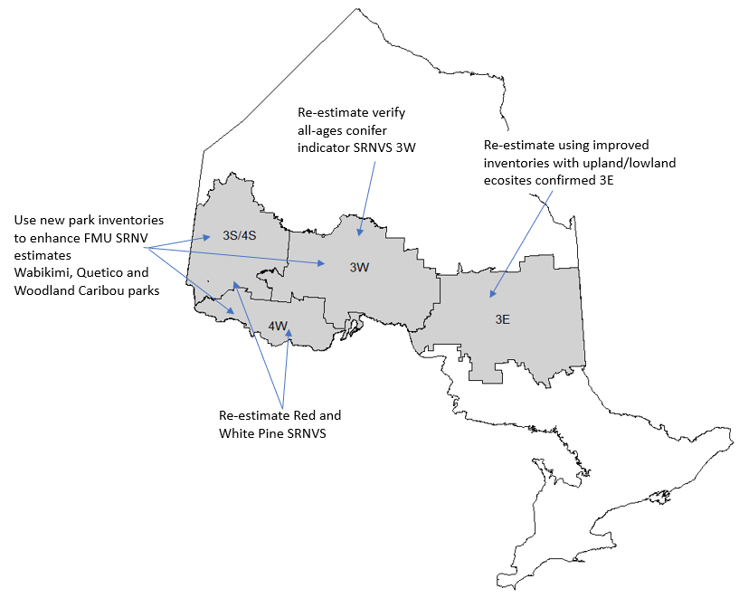
Figure illustrating locations of where SRNVs may be improved.

New Science and Information and Science Projects

Natural Succession

Ken Lennon and colleagues recently published a report (see citation below). The report is a summary of successive remeasurements of growth and yield plots with a quantitative summary and description of natural succession pathways for northeastern forest units used in forest management planning.
Much of the first run BFOLDS succession was opinion based and used information from current (at the time) forest management plans as a guide.
From my discussions with NW Regional staff, one of the key findings is that several of the more dominant forest units don’t succeed at the ages that were used in original BFOLDS simulations. Specifically, the time they would remain in the mature and old landscape classes is longer than first thought.
Presumably rerunning simulations may have unintended consequences in forest management planning with revised simulations resulting in higher levels of more “mature and old” and “old growth” forest.

Report citation: Lennon. K., J. Parton, K. Major and G.J. Kayahara. 2016. Evidence-based natural succession pathways for forest management planning in northeastern Ontario. Ontario Ministry of Natural Resources and Forestry. Science and Research Branch, Peterborough, ON. Science and Research Technical Report TR-15. 47 p. + appendices.

Currently a similar draft report for the Northwest region is being reviewed and is expected to be published and available early in 2020. This work is being led by Chris Stratton, Forest Productivity Specialist – Science and Research Branch – Thunder Bay.
This new science and information is available and should be used in new revised simulations. However, each simulation model/tool we’ve used to date to generate SRNVs (e.g. BFOLDS, TELSA/VDDT and ST-Sim) grows and succeeds the forest differently. Each model has its own unique set(s) of algorithms. Consequently, depending on the model chosen to re-estimate the SRNVs, the results of the new reports would have to be translated to be compatible with the chosen model.

Post Disturbance Transitions

Like natural succession, much of the information we used in the first round of SRNVs was expert opinion. In discussions with Gordon Kayahara and others there is new evidence-based information from both Ontario and Quebec that would be useful if rebuilding models. Gordon has indicated that this would require someone to do a literature review etc.

Science/Information Projects

- Translate new natural succession from Ken Lennon’s reports into selected simulation model algorithms.
- Review new literature focusing on forest composition - post disturbance (e.g. fire and insect infestation) transitions and provide report focusing on quantifying results.
- Translate post disturbance findings into selected model algorithms.
- If simulation model other BFOLDS is chosen, review literature and report on historic fire (crown and surface) in 4W and 3S/4S focusing on amount burned year-to-year and disturbance sizes. This would be used to calibrate simulation model.

Simulation and Assessment Tools

In the past we used several simulation tools to estimate SRNVS. BFOLDS was used in the entire Boreal Forest Region (e.g. Landscape Guide Regions 3S/4S, 4W, 3W and 3E). VDDT/TELSA was used in initial SRNV estimates in the GLSL and recently re-estimated using ST-Sim.

BFOLDS

BFOLDS is a process model where simulations use geography specific data (e.g. soils layers and lightning strikes) including daily weather, succession and post disturbance pathways combined with scientific knowledge of Canadian Forest Fire Behavior Prediction System and Fire Weather Index system.
In recent discussions with Marc Ouellette a spruce budworm module/add-on using LANDIS-II has been completed and is ready to be used. The lack of spruce budworm attacks/outbreaks has been raised as an issue in the Boreal simulations (GLSL simulations include budworm). Acknowledging spruce budworm in BFOLDS would support the objective of more robust estimations of the SRNV.
Ajith Perera (BFOLDS lead) has recently retired from the MNRF and my understanding is that Marc Ouellette is working on other projects although he has indicated that he is able and willing to rerun SRNVs. BFOLDS support will be important if a full scale rerun of Boreal SRNVS. In the initial SRNVs Marc had several computers running BFOLDS with results and data being exchanged between himself and others over several years.

ST-Sim

ST-Sim is an adaptation of the VDDT/TELSA tools we originally used in the GLSL.
ST-Sim is different from BFOLDS in that historic landscape attributes (e.g. fire size, fire amount etc.) are used as inputs. ST-Sim uses these as targets when simulating landscape dynamics. We have been successful with ST-Sim due to its ability to include generic inputs and easily modify. ST-Sim is available with support, at a cost, from Apex-RMS in Ottawa (contact name Colin Daniel).
Currently the ST-Sim models used in the GLSL could be modified and used in 4W and 3S/4S where we were unable to model the big pines with BFOLDS.

LANDIS-II

Landis-II is a widely used generic landscape simulation model which may be used as a stand-alone model in Ontario Boreal regions. Landis-II has many users world wide including users groups and includes modules and extensions that may be of use in climate change scenarios and when simulating other forest stressors. I am not aware if LANDIS II (generally stand level dynamics) is able to be parameterised on large landscapes. This would have to be tested.

ALCES

Alces is a tool that Rob Rempel has used here in Ontario for investigating cumulative effects among varying predicted future scenarios. ALCES may be used for SRNV estimating but with limited capabilities. In discussions with Rob Rempel, he has advised that ALCES is not a tool to re-estimate SRNVs

Landscape Scripting Language (LSL)

LSL is a landscape assessment tool developed by Rob Rempel and Rob Kushneriuk at CNFER. We have used and continue to use LSL in estimating all pattern indicators in the Landscape Guides – both in the GLSL and Boreal regions.
LSL is also used in Ontario’s Landscape Tool (OLT). OLT uses LSL as a spatial engine to assess surfaces and create maps and charts.
LSL is a relatively stable application. Rob Rempel is retiring in December 2019 and Rob Kushneriuk retired several years ago. We have not experienced issues (e.g. bugs) with LSL since Rob Kushneriuk left. However, we continue to depend on LSL due to its ability to measure landscape indicators using sampling techniques dependant on hexagons layers. We (OLT and future simulation assessments) will be vulnerable with LSL support being unavailable.
LSL has been used by other scientists in the OPS but nobody is currently maintaining.

Re-estimating SRNVS

When we estimated the first round of SRNVs we assembled science and modelling teams in each region consisting of MNR staff from Regional science units and ROD with some industry consultation.
Considering that at the time many of the inputs were mined from existing forest management plans and much was opinion based - many people contributed to the development of the simulation models. In contrast, in re-running the simulations, much of the same information may be used, and revisions made if and where new science and information is available (e.g. Lennon et al. reports).
It is difficult to estimate the capacity and resources required to re-estimate the SRNVs as it will be dependent on the tool used and experience of people available.
Instead I’ve listed steps to re-estimate which may help if/when scoping out project.

Steps in re-estimating SRNVs

- Create year 0 simulation start surface

  - Gather most current inventories
  - Classify inventories into modelling currency (forest units)
  - Join inventories at an appropriate scale (e.g. originally done at the landscape guide region with buffers)

- Develop succession and post disturbance rules

  - Translate Lennon et al.’s work into succession rules (dependent on simulation model used)
  - Search, review and report on new literature for post disturbance succession
  - Translate new post disturbance rules (dependent on simulation model)

- Search and review fire and wind literature and translate into selected simulation model (only applicable if BFOLDS not used)

- Search and review insect infestation literature and translate into selected simulation model (only applicable if BFOLDS not used)

- Build simulation model – this will require experienced working knowledge of model being used. In the past this was done by model developers,

- Run simulations

  - If BFOLDS is used – in the past this was done at OFRI – Marc Ouellette ran the simulations on several high-level computers.
  - If ST-Sim is used – in 2018 we (Apex-RMS) uploaded the ST-Sim models to external Amazon servers where the models were run. Other models may be uploaded to external servers as well.

- Process simulation results

  - Use LSL to summarize the resulting simulation surfaces (n= 40…….?) including estimating the box and whisker values for prescriptive and evaluative indicators and all spatial indicators (texture and patch based)
This will include using existing LSL scripts where possible but will require some coding/script writing (done in the past by Julie Elliott).

- Summarize simulation results and rebuild Science and Information Packages

  - LSL will create raw results in various file formats. This step includes creating box and whisker diagrams and texture maps/charts – and creating new Science and Information Packages.

- Populate Ontario’s Landscape Tool with new estimates

  - This is relatively straight forward and not time consuming but will require working knowledge of OLT from a developer’s perspective.

Estimated time to re-estimate SRNVS for a Landscape Guide Region

Figure: Approximate times required for each step to re-estimate SRNV for a Landscape Guide Region.
Note: Steps 2,3 and 4 can occur at same time. Total time to re-estimate 53 weeks.

