Digital Soil Mapping Data Description

Table of Contents
1. Overview 3
2. Digital Soil Mapping Rationale 3
3. DSM Resolution and Structure 3
4. Understanding Uncertainty in DSMs 4
5. Soil Properties Mapped 4
6. Appendix - DSM Data and Methods 5
6.1. Ottawa 5
6.1.1. Soil sampling 5
6.1.2. Environmental covariates 6
6.2. Peterborough 8
6.2.1. Soil Sampling 8
6.2.2. Environmental covariates 10
6.3. Machine Learning Models (Ottawa and Peterborough) 11
6.4. References 12
6.4.1. Ottawa DSM Scientific Publications 12
6.4.2. Peterborough Soil Data Scientific Publications 12
6.4.3. Other General References 13

Overview
The Ontario Ministry of Agriculture, Food and Agribusiness has created a suite of digital soil maps for Ottawa and Peterborough. These maps describe the spatial variability of soil properties at a high resolution and are suitable for use at multiple spatial scales to inform a variety of activities such as land use planning, agricultural land management and production planning, and as inputs for other modelling studies. The Ministry is working to roll out digital soil mapping across all of Ontario’s agricultural land.

Digital Soil Mapping Rationale
Digital soil mapping (DSM) combines geo-referenced soil observations with spatial environmental layers (covariates) which represent factors known to affect soil formation and variation across landscapes. These data are then used in statistical models to predict soil variation across a landscape as a function of environmental conditions. These models are based on well established, but often complex, relationships between soil properties and topography, biology, geology, and hydrology.
The methodology behind DSM is similar to previously used conventional soil mapping (i.e., the soil survey complex), wherein a trained soil expert would rely on soil observations and visible landscape features to estimate soil variation. However, DSM improves upon the conventional soil survey methodology in several ways. Digital soil mapping:
- enables better quantification of environmental variation
- explicitly links soil properties to environmental covariates (as opposed to implicit links in a soil scientist’s mental model)
- reduces bias introduced by human interpretation
- allows for higher resolution soil maps (in both 2 and 3 dimensions)
- allows for creation of spatially explicit uncertainty maps of soil prediction

DSM Resolution and Structure
DSM generates soil maps of a consistent, gridded resolution.
For the Ottawa and Peterborough counties, maps were produced at a 10 metre resolution, meaning that for each 10 x 10 metre grid cell, there is a unique soil property predicted value. Soil variation was also predicted through depth. For this project, soil properties were predicted at the depth intervals 0-5 cm, 5-15 cm, 15-30 cm, 30-60 cm, 60-100 cm, and 0-30 cm.
For example, the soil pH at the 0-5 cm interval predicts the average pH of the soil between 0 and 5 centimetres. The first five depth intervals are based on a standardized system for measuring soil across depth and we opted to also predict at a larger aggregated interval of 0-30 cm because we believe this depth is of interest to many agricultural users.
Maps are stored as raster “.tif” files (sometimes referred to as image) and can be displayed using GIS software. Maps are interpreted as the best estimates of the soil properties and there may be some disagreement between these predictions and in-field measurements of soil.

Understanding Uncertainty in DSMs
Digital soil maps are powerful tools to predict soil variation, however there will likely be some disagreement between these predictions and exact in-field measurements of soil due to uncertainty in the DSM modelling procedure.
To estimate the magnitude of disagreement between digital soil maps and in-field soil conditions, uncertainty of the soil maps was calculated using a 90% prediction interval (Kasraei et al. 2021) and these can be viewed in tandem with the soil maps. Uncertainty maps of each soil property can be identified by the “_90PI.tif” suffix.
For a full account of uncertainty in DSM, the prediction interval rasters need to be considered with the predicted-observed tables that are generated as part of the modelling procedure.

Soil Properties Mapped
For this project the following properties were mapped:
- Soil pH measured in water (unitless)
- Total organic carbon (%)
- Sand content (%)
- Silt content (%)
- Clay content (%)
- Texture class (Categorical classes)
- Cation exchange capacity (cmol+/kg)

Appendix - DSM Data and Methods

Ottawa

Soil sampling
Soil sampling in the Ottawa DSM project was initiated in 2014-2015 in two small pilot areas within Ottawa. It was subsequently expanded to the entire City of Ottawa boundary where sampling was conducted from 2016–2019 (Figure 1). A total of 1,802 soil profiles were used to generate digital soil maps of Ottawa. The number of profiles and horizons sampled varied across soil properties. Note that since sand, silt, and clay analysis cannot be conducted on organic soils, there are fewer profiles and horizons with these properties measured.
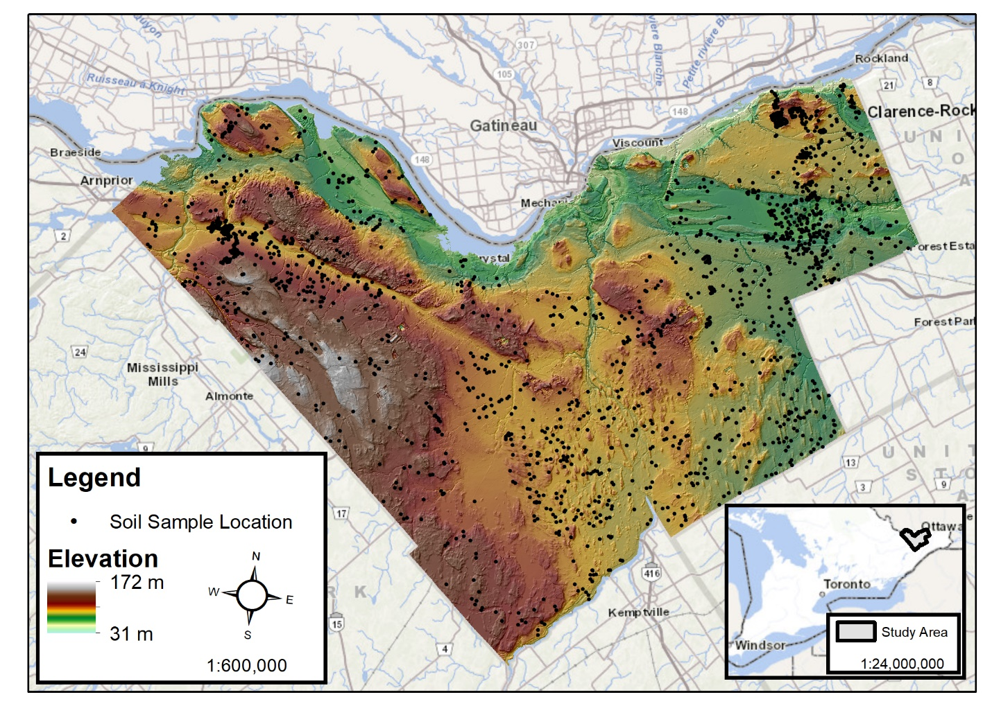
Figure 1. Sample sites (black dots) for the Ottawa digital soil mapping project collected from 2014–2019 displayed over the digital elevation model generated from light detection and ranging (LiDAR).

Table 1. Total number of soil profiles and horizons used to generate digital soil maps of Ottawa.
Soil Property | # Soil Profiles | # Soil Horizons
Cation Exchange Capacity | 1802 | 5647
pH | 1802 | 5734
Total Organic Carbon | 1802 | 5731
Sand | 1787 | 5518
Silt | 1787 | 5518
Clay | 1787 | 5518
Texture Class | 1787 | 5518

Environmental covariates
A total of 64 continuous covariates and 3 categorical covariates were considered for inclusion in the predictive models (Table 2). The continuous covariates can be grouped into categories based on their provenance. Most of the covariates (55) were generated from a 10 m resolution digital terrain model. Of the remaining continuous covariates, six were gamma-radiometric data and three were computed from a time-series of cloud-free normalized difference vegetation index (NDVI) images generated from Sentinel-2 imagery captured from June to September across the years (2018-2021). The three categorical covariates were quaternary geology, bedrock geology and soil order. All covariates were resampled to the same resolution as the digital terrain model (10 m). To reduce the number of environmental covariates and mitigate potential overfitting of the predictive models, a variance inflation factor (VIF) technique was applied to the continuous covariates, leaving 44 covariates for modelling (including 3 binary encoded categorical covariates). Note that some environmental covariates were represented at multiple scales/kernels. All covariates retained for modelling are listed in Table 2.
Table 2. Ottawa environmental covariates retained for predictive models of soil properties after variance inflation factor analysis.

Environmental covariate | Category
Catchment area | Topography
Convergence Index | Topography
Elevation | Topography
Deviation from Mean Elevation (multiple kernels) | Topography
Difference from Mean Elevation (multiple kernels) | Topography
Eastness | Topography
Elevation Percentile (multiple kernels) | Topography
Analytical Hillshading | Topography
Impoundment Size Index | Topography
ISI Dam Height | Topography
Topographic (LS) Factor | Topography
Max Difference from Mean Elevation (multiple kernels) | Topography
Max Elevation Deviation (multiple kernels) | Topography
Multi Resolution Ridge Top Flatness | Topography
Multi Resolution Valley Bottom Flatness | Topography
Mid Slope Position | Topography
Northness | Topography
Plan Curvature | Topography
Profile Curvature | Topography
Relative Slope Position | Topography
Slope Length | Topography
Slope Height | Topography
Stream Power Index | Topography
Skyview Factor | Topography
SAGA Wetness Index | Topography
Total Curvature | Topography
Topographic Position Index | Topography
Topographic Wetness Index | Topography
Valley Depth | Topography
Radiometric potassium | Radiometry
Radiometric thorium:potassium | Radiometry
Radiometric uranium:thorium | Radiometry
Quaternary (Surficial) Geology | Geology (Categorical)
Median of Normalized Difference Vegetation Index | Biology
Standard Deviation of Normalized Difference Vegetation Index | Biology
Soil Order | Soil (Categorical)

Peterborough

Soil Sampling
Soil sampling in the Peterborough DSM project was conducted in 2016-2018. A total of 914 soil profiles were used to generate digital soil maps of Peterborough. The number of profiles and horizons sampled varied across soil properties. Note that since sand, silt, and clay analysis cannot be conducted on organic soils, there are fewer profiles and horizons with these properties measured.

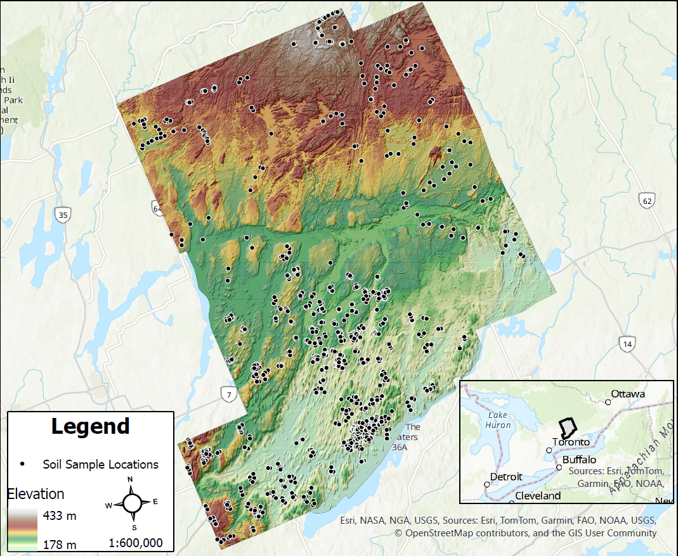
Figure 2. Sample sites (black dots) for the Peterborough digital soil mapping project collected from 2016–2018 displayed over the digital elevation model generated from light detection and ranging (LiDAR).

Table 3. Total number of soil profiles and horizons used to generate digital soil maps of Peterborough.
Soil Property | # Soil Profiles | # Soil Horizons
Cation Exchange Capacity | 913 | 2537
pH | 914 | 2601
Total Organic Carbon | 914 | 2601
Sand | 883 | 2372
Silt | 883 | 2372
Clay | 883 | 2372
Texture Class | 883 | 2372

Environmental covariates
A total of 53 continuous covariates and 1 categorical covariate were considered for inclusion in the predictive models (Table 2). The continuous covariates can be grouped into categories based on their provenance. Most of the covariates (47) were generated from a 10 m resolution digital terrain model. Of the remaining continuous covariates, three were computed from a time-series of cloud-free normalized difference vegetation index (NDVI) images generated from Sentinel-2 imagery captured from June to September across the years (2018-2021). The categorical covariate was soil order, derived from the soil survey complex. All covariates were resampled to the same resolution as the digital terrain model (10 m). To reduce the number of environmental covariates and mitigate potential overfitting of the predictive models, a variance inflation factor (VIF) technique was applied to the continuous covariates, leaving 27 covariates for modelling (including a binary encoded soil order categorical covariate). Note that some environmental covariates were represented at multiple scales/kernels. All covariates retained for modelling are listed in Table 4.
Table 4. Peterborough environmental covariates retained for predictive models of soil properties after variance inflation factor analysis.
Covariable environnementale | Catégorie
Catchment Area | Topography
Convergence Index | Topography
Elevation | Topography
Deviation from Mean Elevation (multiple kernels) | Topography
Eastness | Topography
Elevation Percentile (multiple kernels) | Topography
Analytical hillshading | Topography
Impoundment Size Index | Topography
Maximum Difference from Mean Elevation (multiscale) | Topography
Maximum Difference from Mean Elevation Scale (multiscale) | Topography
Maximum Elevation Deviation (multiscale) | Topography
Maximum Elevation Deviation Scale (multiscale) | Topography
Multiresolution index of ridge top flatness | Topography
Multiresolution index of valley bottom flatness | Topography
Northness | Topography
Plan Curvature | Topography
Profile Curvature | Topography
Slope Length | Topography
Stream Power Index | Topography
Sky View Factor | Topography
Total Curvature | Topography
Topographic Position Index | Topography
Topographic Wetness Index | Topography
Standard Deviation of HH polarisation | Biology
Standard Deviation of HV polarisation | Biology
Median of Normalized Difference Vegetation Index | Biology
Standard Deviation of Normalized Difference Vegetation Index | Biology
Soil Order | Soil (Categorical)

Machine Learning Models (Ottawa and Peterborough)
An ensemble approach was used for both the Ottawa and Peterborough DSM project. In this method, several machine learning models are used to generate soil property predictions and the results are combined (“ensembled”) to improve the accuracy of the final soil property maps. The following individual machine learning algorithms were used to develop the final maps:
- Cubist Decision Tree
- Random Forest
- Support Vector Machine
- Gradient Boosting Machine
- K-Nearest Neighbour
Ensembling was performed using Granger–Ramanathan averaging (Malone et al. 2014) (a generalized linear model approach).

References

Ottawa DSM Scientific Publications
Several scientific publications have resulted from the Ottawa DSM project, highlighting the technical rigour of the maps and ensuring the products meet the highest scientific standards:
John, K., Saurette, D.D., Heung, B. 2025. The Problematic Case of Data Leakage: A case for leave-profile-out cross-validation in 3-dimensional digital soil mapping. Geoderma. 457. DOI: 10.1016/j.geoderma.2025.117223.
Kasraei, B., Heung, B., Saurette, D.D., Schmidt, M.G., Bulmer, C.E. and Bethel, W. 2021. Quantile regression as a generic approach for estimating uncertainty of digital soil maps produced from machine learning. Environmental Modelling and Software. 144. DOI: 10.1016/j.envsoft.2021.105139.
Newman, D.R., Saurette, D.D., Cockburn, J.M.H, Dragut, L., and Lindsay, J.B. 2023. Assessing spatially heterogeneous scale representation with applied digital soil mapping. Environmental Modelling and Software. 160. DOI: 10.1016/j.envsoft.2022.105612.
Saurette, D.D. 2022. Comparing direct and indirect approaches to predicting soil texture class. Canadian Journal of Soil Science. 102. DOI: 10.1139/cjss-2022-0040.
Saurette, D.D., Heck, R.J., Gillespie, A.W., Berg, A.A., Biswas, A. 2024. Sample Size Optimization for Digital Soil Mapping: An Empirical Example. Land 13. DOI: 10.3390/land13030365.
Saurette, D.D., Heck, R.J., Gillespie, A.W., Berg, A.A., Biswas, A. 2025. Post-hoc Evaluation of Sample Size in a Regional Digital Soil Mapping Project. Land. 14. DOI: https://www.mdpi.com/2073-445X/14/3/545.

Peterborough Soil Data Scientific Publications
Several scientific publications have resulted from the soils data collected in Peterborough:
Arbor, A., Schmidt, M., Saurette, D., Zhang, J., Bulmer, C., Filatow, D. Kasraei, B., Smukler, S. Heung, B. 2023. A framework for recalibrating pedotransfer functions using nonlinear least squares and estimating uncertainty using quantile regression. Geoderma. 439. DOI: 10.1016/j.geoderma.2023.116674.
Chahal, I., Saurette, D.D., Van Eerd, L.L. 2023. Soil texture influences on soil health scoring functions in Ontario agricultural soils: a possible framework towards a provincial soil health test. Canadian Journal of Soil Science. 103. DOI: 10.1139/cjss-2021-0145.
Saurette, D.D., Deragon. R. 2022. Better recognition of limnic materials at the great group and subgroup levels of the Organic Order of the Canadian System of Soil Classification. Canadian Journal of Soil Science. 103. DOI: 10.1139/cjss-2022-0030
Gobezie, T. B., Saurette, D., Scott, S.D., Daggupati, P., Bedard-Haughn, A., Biswas, A. 2025. Application of multidimensional soil data harmonization to develop the Ontario Soil Information System (OSIS). Canadian Journal of Soil Science. 105. DOI: 10.1139/cjss-2024-0070.

Other General References
For additional information on digital soil mapping, you may find these papers useful:

Duchesne, L., Ouimet, R. 2021. Digital mapping of soil texture in ecoforest polygons in Quebec, Canada. PeerJ. 9. DOI: 10.7717/peerj.11685

Hengl, T., Mendes de Jesus, J., Heuvelink, G.B.M., Ruiperez, M., Kilibarda, M., Blagotić, A., Shangguan, W., Wright, M.N., Geng, X., Bauer-Marchallinger, B., Guevara, M.A., Vargas, R., Macmillan, R.A., Batjes, N.H., Leenaars, J.G.B., Ribeira, E., Wheeler, I., Mantel, S., Kempen, B. 2017. SoilGrids250m: Global gridded soil information based on machine learning. PLoS ONE. 12. DOI: 10.1371/journal.pone.0169748.

Heung, B., Bulmer, C.E., Schmidt, M.G., Zhang, J. 2022. Provincial-scale digital soil mapping using a random forest approach for British Columbia. Canadian Journal of Soil Science. 102. DOI: 10.1139/cjss-2021-0090

Malone, B.P., Minasny, B., Odgers, N.P., McBratney, A.B. 2014. Using model averaging to combine soil property rasters from legacy soil maps and from point data. Geoderma. 232-234. Doi: 10.1016/j.geoderma.2014.04.033.

Scull, P., Franklin, J., Chadwick, O.A., McArthur, D. 2003. Predictive soil mapping: a review. Progress in Physical Geography. 27. DOI: 10.1191/0309133303pp366ra.

McBratney, A.B., Mendonça Santos, M.L., Minasny, B. 2003. On digital soil mapping. Geoderma. 117. DOI: https://doi.org/10.1016/S0016-7061(03)00223-4.

