
Land Information Ontario (LIO) Warehouse
Data Class Name: Assessment Parcel
Documentation
Produced by: Spatial Data Support Unit
Ministry of Natural Resources and Forestry
Date: December 12, 2017

Purpose

This document provides additional information to support the use of geospatial data. The Physical Model Diagram provides a visual representation of the relationships in the data class. The Data Change History lists all the modelling and access changes that have occurred during the lifecycle of the data class. A data description identifying table and field names is available upon request.

Need Assistance?
Please contact LIO Support at lio@ontario.ca or 705-755-1878 if you require help.

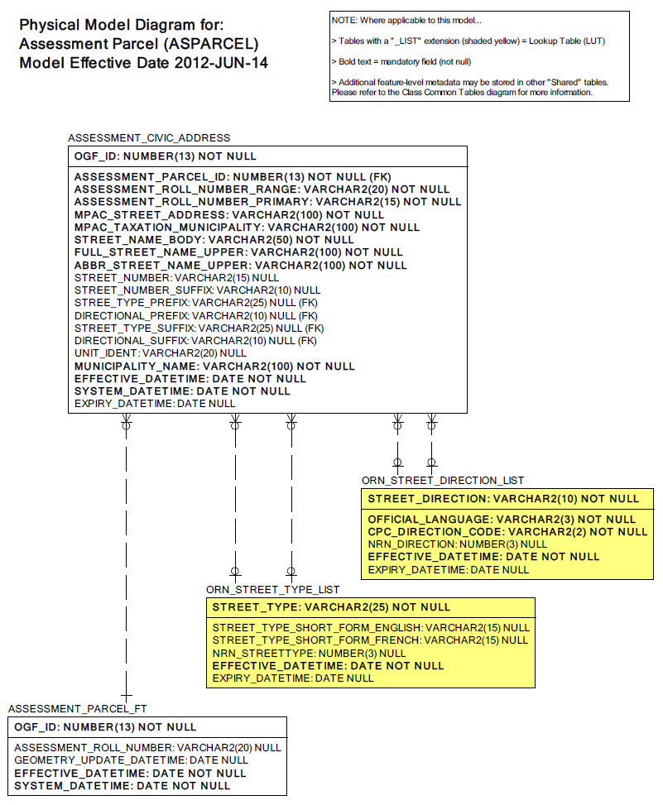
Data Class Change History

Data Class Name: Assessment Parcel
Data Class Short Name: ASPARCEL
Date  YYYY-MM-DD | Details of Change
2017-12-12 | Abstract Class changed from Single Non-Tessellating Polygons (SPSNTPOLY) to Multi Non-Tessellating Polygons (SPMNTPOLY). This reflects the current spatial rules and software capabilities associated with the spatial data being submitted. The change is also due to the fact that at the Spatial Database Engine (SDE) Layer Definition level, all polygon layers are defined as multi-part polygons and overlaps are permitted.
2014 | The Assessment Parcel data class contained a table named ASSESSMENT_CIVIC_ADDRESS. In order to assist with data loading, this table has been converted to a non-spatial data class named Assessment Civic Address (ASCADDR).
2009 | ASSESSMENT_CIVIC_ADDRESS/MPAC_TAXATION_MUNICIPALIT Column length increased from 80 to 100
2009 | ASSESSMENT_CIVIC_ADDRESS.MUNICIPALITY_NAME Column length increased from 80 to 100
2006 | Updated model to include table and field prefixes and suffixes.
2001 | NEW Data Class
Data Description
Please refer to the metadata record for the data description.

