
Land Information Ontario (LIO) Warehouse
Data Class Name: Bait Harvest Area
Documentation
Produced by: Information Access and Information Management Policy Unit
Ministry of Natural Resources and Forestry
Date: July 27, 2015

Purpose

This document provides additional information to support the use of geospatial data. The Physical Model Diagram provides a visual representation of the relationships in the data class. The Data Change History lists all the modelling and access changes that have occurred during the lifecycle of the data class. A data description identifying table and field names is available upon request.

Need Assistance?
Please contact LIO Support at lio@ontario.ca or 705-755-1878 if you require help.

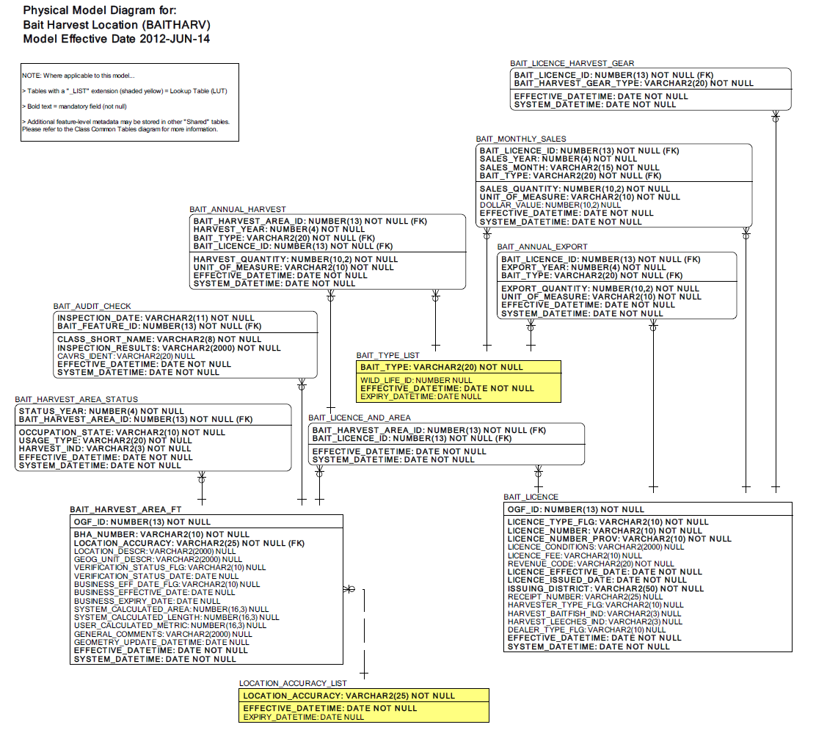

Data Class Change History

Data Class Name: Bait Harvest Area
Data Class Short Name: BAITHARV
Date  YYYY-MM-DD | Details of Change
2010 | GUT Retired: GUT #2625 Frog Harvest Area  The GUT for Frog Harvest Area will be retired. There is no longer a business need to track the area where frogs are harvested.
2010 | Column dropped: BAIT_LICENCE.HARVEST_FROGS_IND at the request of the information owner.
2010 | Lookup Table value expired in BAIT_TYPE_LIST: 'Crayfish and Frogs'
2007 | BAIT_LICENCE.RECEIPT_NUMBER Column changed from mandatory to optional.
2006 | The abstract class was changed from SPSNTCREGION to SPSNTCREGION.
2003 | NEW Data Class
Data Description
Please refer to the metadata record for the data description.

