Map Identifying Historic Bathymetry
Map Data Package Regions
in the Province of Ontario
  - Provincial Mapping Unit
  - Mapping and Information Resources Branch
  - Corporate Management and Information Division
  - Ministry of Natural Resources and Forestry
2020-02-27

Disclaimer
This technical documentation has been prepared by Her Majesty the Queen in right of Ontario as represented by the Ministry of Natural Resources and Forestry (the “Ministry”). No warranties or representations, express or implied, statutory or otherwise shall apply or are being made by the Ministry with respect to the documentation, its accuracy or its completeness. In no event will the Ministry be liable or responsible for any lost profits, loss of revenue or earnings, claims by third parties or for any economic, indirect, special, incidental, consequential or exemplary damage resulting from any errors, inaccuracies or omissions in this documentation; and in no event will the Ministry’s liability for any such errors, inaccuracies or omissions on any particular claim, proceeding or action, exceed the actual consideration paid by the claimant involved to the Ministry for the materials to which this instructional documentation relates. Save and except for the liability expressly provided for above, the Ministry shall have no obligation, duty or liability whatsoever in contract, tort or otherwise, including any liability or negligence. The limitations, exclusions and disclaimers expressed above shall apply irrespective of the nature of any cause of action, demand or action, including but not limited to breach of contract, negligence, strict liability, tort or any other legal theory, and shall survive any fundamental breach or breaches.
Cette publication spécialisée n’est disponible qu’en anglais.

Additional Information
The majority of the historic paper bathymetry maps have been scanned to digital files. Digital files will be added to this dataset when they become available. The digital files have been grouped and packaged by regions into several compressed (zipped) files for download. The following map of regions can be used to determine which package to download for the lake of interest. The bathymetry lookup table can be used to identify lakes contained in each package.
This document does not comply with all the applicable guidelines for accessible digital documents. For an alternative format please email Provincial Mapping Unit at pmu@ontario.ca.
For more information about this document, please contact Provincial Mapping Unit at pmu@ontario.ca.

Historic Bathymetry Map Regions in the Province of Ontario
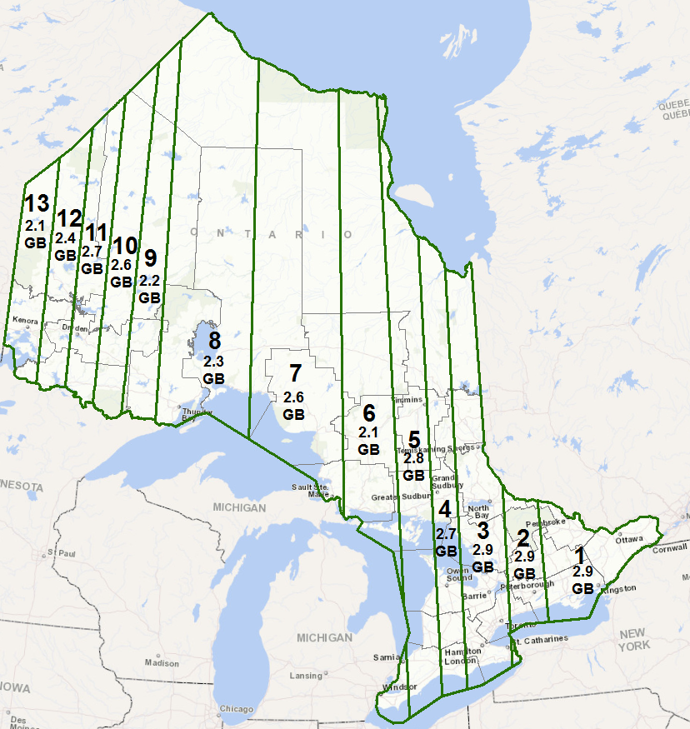
There is an additional package, Package 99, containing scanned maps whose location could not be determined. The file size of Package 99 is 39 MB.

To view the Metadata records for Historic Bathymetry Maps, navigate to:
Historic Bathymetry Maps
https://geohub.lio.gov.on.ca/datasets/mnrf::historic-bathymetry-maps
Bathymetry Lookup Values
https://www.sdc.gov.on.ca/sites/MNRF-PublicDocs/EN/CMID/BathymetryLookup.xlsx

Version 1617.1

