User Guide
for
Building as Symbol
and
Building to Scale
LIO Data Classes
  - Provincial Mapping Unit
  - Mapping and Information Resources Branch
  - Corporate Management and Information Division
  - Ministry of Natural Resources and Forestry
2020-03-03

Disclaimer
This technical documentation has been prepared by Her Majesty the Queen in right of Ontario as represented by the Ministry of Natural Resources and Forestry (the “Ministry”). No warranties or representations, express or implied, statutory or otherwise shall apply or are being made by the Ministry with respect to the documentation, its accuracy or its completeness. In no event will the Ministry be liable or responsible for any lost profits, loss of revenue or earnings, claims by third parties or for any economic, indirect, special, incidental, consequential or exemplary damage resulting from any errors, inaccuracies or omissions in this documentation; and in no event will the Ministry’s liability for any such errors, inaccuracies or omissions on any particular claim, proceeding or action, exceed the actual consideration paid by the claimant involved to the Ministry for the materials to which this instructional documentation relates. Save and except for the liability expressly provided for above, the Ministry shall have no obligation, duty or liability whatsoever in contract, tort or otherwise, including any liability or negligence. The limitations, exclusions and disclaimers expressed above shall apply irrespective of the nature of any cause of action, demand or action, including but not limited to breach of contract, negligence, strict liability, tort or any other legal theory, and shall survive any fundamental breach or breaches.
Cette publication spécialisée n’est disponible qu’en anglais.

Additional Information
This document does not comply with all the applicable guidelines for accessible digital documents. For an alternative format please email Provincial Mapping Unit at pmu@ontario.ca.
For more information about this document, please contact Provincial Mapping Unit at pmu@ontario.ca.

Executive Summary

Key Words
Base Data, Base Mapping, Building, Land Management, Land Use Planning, Municipal Planning, OBM, Ontario Base Mapping, Planning/Development

Abstract
This user guide details the specifications for the Building as Symbol (BUILDSYM) and Building to Scale (BUILDSCA) Land Information Ontario (LIO) Data Classes.

Table of Contents
Disclaimer 2
Additional Information 2
Executive Summary 3
Key Words 3
Abstract 3
Table of Contents 4
List of Figures 5
List of Acronyms 6
1. Introduction 7
2. Objectives 7
3. Data Class: Building 8
Building as Symbol (BUILDSYM) 8
Building to Scale (BUILDSCA) 8
4. Model Diagram: Building as Symbol (BUILDSYM), Building to Scale (BUILDSCA) 9
5. Data Description 10
BUILDING_AS_SYMBOL_FT 10
BUILDING_TO_SCALE_FT 11
6. Links to Additional Information 13
APPENDIX A: LIO Lookup Tables and Values 14
BUILDING_TYPE_LIST 14
LOCATION_ACCURACY_LIST 17
APPENDIX B: Table Key Dependency and Relationship Index 19
Main Business Area Tables 21
APPENDIX C: Frequently Asked Questions 22
How do I rotate a building point feature? 22

List of Figures
Figure 1: Buildings represented to scale and as symbols in the Peterborough area 7
Figure 2: Primary Key example 19
Figure 3: Foreign Key example 19
Figure 4: Alternate Key example 19
Figure 5: Example of an Identifying Relationship 20
Figure 6: Example of a Non-identifying Relationship 20
Figure 7: Model Diagram Relationship Symbology Table 20
Figure 8: ArcMap's Rotate function 22

List of Acronyms
BUILDSCA: Short Name for Building to Scale Data Class
BUILDSYM: Short Name for Building as Symbol Data Class
GIS: Geographic Information System
LIO: Land Information Ontario
MNRF: Ontario Ministry of Natural Resources and Forestry
OBM: Ontario Base Map
OGF: Ontario Geospatial Feature
PMU: Provincial Mapping Unit

1. Introduction
A building is defined as a structure with permanent walls and roofed construction. In Figure 1 (using the LIO Make a Topographic Map viewer) large buildings (e.g. apartment buildings) are represented to scale while smaller buildings (e.g. residential houses) are represented as symbols.
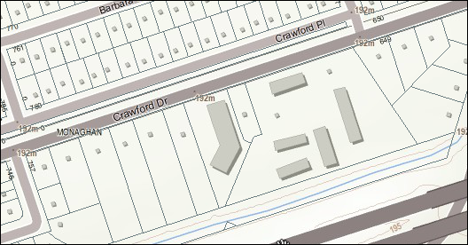
Figure 1: Buildings represented to scale and as symbols in the Peterborough area
The majority of data for Building as Symbol and Building to Scale was collected during the Ontario Base Map (OBM) program. Updates to improve the currency and accuracy of the two data classes are ongoing, but localized and irregular.

2. Objectives
This guide is intended for users with a general interest in the Building as Symbol and Building to Scale LIO Data Classes. The remainder of this document describes the extent and context of the information collected in these data classes.

3. Data Class: Building

Building as Symbol (BUILDSYM)
Small structures (including buildings less than 50 square metres) are not shown unless they constitute a point of orientation. When structures have one dimension larger than 50 metres for the 1:20,000 source scale and larger than 30 metres for the 1:10,000 source they are represented as points.
Building as Symbol locations are represented and maintained as point features in this data class.

Building to Scale (BUILDSCA)
When structures have one dimension larger than 50 metres for the 1:20,000 scale and larger than 30 metres for the 1:10,000 scale, they are represented as polygons. Smaller structures should be considered points and entered in the Building as Symbol data class.
Building to Scale locations are represented and maintained as polygon features in this data class.

4. Model Diagram: Building as Symbol (BUILDSYM), Building to Scale (BUILDSCA)
Model Effective Date: 2016-OCT-11
Table names with “_LIST” suffix are lookup tables with permissible values.
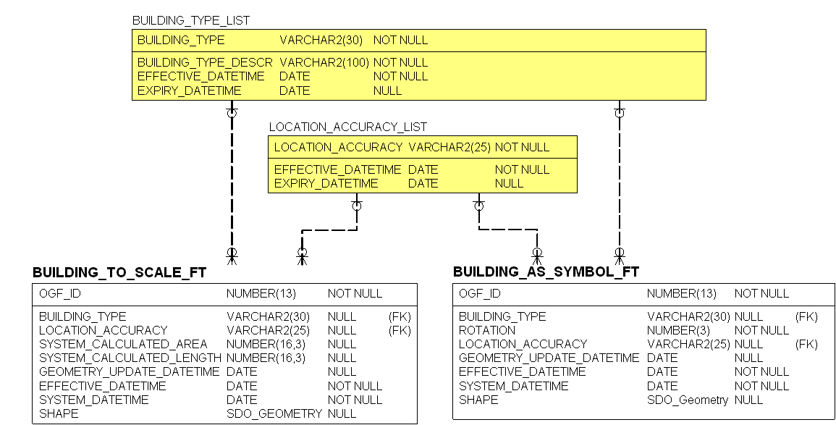
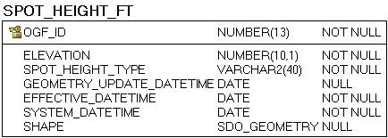

5. Data Description
The main business area table(s) for this model can be found below. Associated lookup tables will be listed in Appendix A of this document and are hyperlinked where referenced in this section.

BUILDING_AS_SYMBOL_FT
A building is defined as a structure with permanent walls and roofed construction. Small structures (including buildings less than 50 square metres) are not shown unless they constitute a point of orientation. When structures have one dimension larger than 50 metres for the 1:20000 source scale and larger than 30 metres for the 1:10000 source scale, they are considered to be polygons and entered as Building To Scale.
Column Name | Column Type | Mandatory | Short Name | Description
OGF_ID | NUMBER(13) | Yes | OGF_ID | Ontario Geospatial Feature identifier (OGF ID). A unique numeric provincial identifier assigned to each object.
BUILDING_TYPE | VARCHAR2(30) | No | BUILDING_T | A general classification of a building, often by use, such as educational building, religious building, residence, police station, hospital or fire station.  See table BUILDING_TYPE in Appendix for list of valid values.
ROTATION | NUMBER(3) | Yes | ROTATION | Amount in degrees that the representation of the feature should be rotated, with 0 representing no rotation. NOTE: Permissible values are between 0 and 359 degrees. DEFAULT = 0.  VALID VALUES: BETWEEN 0 AND 359  DEFAULT: 0
LOCATION_ACCURACY | VARCHAR2(25) | No | ACCURACY | The degree of conformity or closeness of a measurement within the database to its true value in the world.  See table LOCATION_ACCURACY_LIST in Appendix for list of valid values.
GEOMETRY_UPDATE_DATETIME | DATE | No | GEO_UPT_DT | Date/time the geometry was created or last modified in the source database.
EFFECTIVE_DATETIME | DATE | Yes | EFF_DATE | Date/time the record was created or last modified in the source database.
SYSTEM_DATETIME | DATE | Yes | SYS_DATE | Date/time the record was loaded into or last modified in the LIO database.  DEFAULT: SYSDATE
SHAPE | NUMBER(38) | No | SHAPE | Geometry attribute.

BUILDING_TO_SCALE_FT
A building is defined as a structure with permanent walls and roofed construction. When structures have one dimension larger than 50 metres for the 1:20000 scale and larger than 30 metres for the 1:10000 scale, they are considered to be polygons. Smaller structures should be considered points and entered in the Building as Symbol data class.
Column Name | Column Type | Mandatory | Short Name | Description
OGF_ID | NUMBER(13) | Yes | OGF_ID | Ontario Geospatial Feature identifier (OGF ID). A unique numeric provincial identifier assigned to each object.
BUILDING_TYPE | VARCHAR2(30) | No | BUILDING_T | A general classification of a building, often by use, such as educational building, religious building, residence, police station, hospital or fire station.  See table BUILDING_TYPE in Appendix for list of valid values.
LOCATION_ACCURACY | VARCHAR2(25) | No | ACCURACY | The degree of conformity or closeness of a measurement within the database to its true value in the world.  See table LOCATION_ACCURACY_LIST in Appendix for list of valid values.
SYSTEM_CALCULATED_AREA | NUMBER(16,3) | No | SYS_AREA | The area of a polygon measured in square metres by the system.
SYSTEM_CALCULATED_LENGTH | NUMBER(16,3) | No | SYS_LENGTH | The perimeter of a polygon or length of a line measured in metres.
GEOMETRY_UPDATE_DATETIME | DATE | No | GEO_UP_DT | Date/time the geometry was created or last modified in the source database.
EFFECTIVE_DATETIME | DATE | Yes | EFF_DATE | Date/time the record was created or last modified in the source database.
SYSTEM_DATETIME | DATE | Yes | SYS_DATE | Date/time the record was loaded into or last modified in the LIO database.  DEFAULT: SYSDATE
SHAPE | SDO_GEOMETRY | No | SHAPE | Geometry attribute.

6. Links to Additional Information
- Official LIO Metadata Record for Building as Symbol
- Official LIO Metadata Record for Building to Scale

APPENDIX A: LIO Lookup Tables and Values

BUILDING_TYPE_LIST
A general classification of a building, often by use, such as educational building, religious building, residence, police station, hospital or fire station.
Column Name | Column Type | Mandatory | Short Name | Description
BUILDING_TYPE | VARCHAR2(30) | Yes | BUILDING_T | A general classification of a building, often by use, such as educational building, religious building, residence, police station, hospital or fire station.
BUILDING_TYPE_DESCR | VARCHAR2(100) | Yes | TYPE_DESCR | A description of the building type.
EFFECTIVE_  DATETIME | DATE | Yes | EFF_DATE | Date/time the record was created or last modified in the source database.  DEFAULT: SYSDATE
EXPIRY_  DATETIME | DATE | No | EXP_DATE | Date/time that the record was expired from use.
BUILDING_TYPE_LIST Permissible Values
BUILDING TYPE | BUILDING TYPE DESCR | EXPIRY DATETIME
Airport – Hangar | A building used to house/maintain aircraft. | Not applicable
Airport - Terminal | A building used to process passengers and cargo for flight transportation. | Not applicable
Arena | An enclosed large surface used for sporting activities | Not applicable
Armoury | A building used by the militia | Not applicable
Barn Machinery Shed | A large utility building on a farm complex. | Not applicable
Boathouse | A building near water in which watercraft and/or water related equipment is stored. | Not applicable
Cabin | A building in a remote or wilderness area. | Not applicable
City Hall | A building where the principal offices of a city administration are located. | Not applicable
Coast Guard Station | A building housing the Coast Guard administrative offices. | Not applicable
Commercial Building | A building used for commercial retail e.g. grocery, hardware, alcohol, convenience stores etc. | Not applicable
Commercial Multi-Use | A building primarily used for commercial purposes including a secondary outlet e.g. Postal/Alcohol. | Not applicable
Community Centre | A public building in which community gatherings and/or sporting activities are held. | Not applicable
Cottage | A dwelling, typically in a rural or semi-rural location usually for vacation use. | Not applicable
Courthouse | A public building housing the judicial courts. | Not applicable
Customs Post | Where travelers and vehicles crossing an international border are inspected. | Not applicable
Dome | A building with arched roof used for storing salt or sand for road maintenance. | Not applicable
Education Building | An institution for elementary, secondary or post-secondary education. | Not applicable
Electric Power Station | A building where electricity is generated. | Not applicable
Financial Institution | A building used for financial management e.g. banks, credit unions, investment houses. | Not applicable
Fire Station | A building housing fire-fighting equipment. | Not applicable
Fish Hatchery | A facility where fish are hatched under controlled conditions. | Not applicable
Gas and Oil Facility | A structure dedicated to the production or distribution of gas and oil products. | Not applicable
Generic/Unknown | A unspecified building. | Not applicable
Government, Federal | A building operated by the Federal Government. | Not applicable
Government, Municipal | A building operated by a Municipal Government. | Not applicable
Government, Provincial | A building operated by the Provincial Government. | Not applicable
Grain Elevator | Used for the storage of grain, usually located along a railway. | Not applicable
Greenhouse | A building covered with a transparent material in which plants are grown. | Not applicable
Hall | A building used for public assembly. | Not applicable
Highway Service Centre | A building which provides automotive services and restaurant facilities. | Not applicable
Highway Weigh Scale | A complex along a highway for weighing commercial vehicles. | Not applicable
Hospital | An institution where sick or injured people receive medical care. | Not applicable
Industrial Building | A building for processing/preserving raw materials, manufacture products, or produce energy outputs. | Not applicable
Library | A building in which books, periodicals, newspapers and audio-visual media, are stored for loan. | Not applicable
Lodging Facilities | A building where sleeping accommodations are rented. | Not applicable
Medical Centre | Replaces a full service hospital in satellite communities or other area without hospital services. | Not applicable
Municipal Hall | Where the main offices of a municipal administration are located. | Not applicable
Museum | A public building set aside for the exhibition of natural, historic, artistic, or scientific objects | Not applicable
Observatory | A building equipped for astronomical observations. | Not applicable
Outbuilding | An outbuilding (i.e. garage, shed, outhouse, sauna). | Not applicable
Parliament Building | Where the elected or appointed members of provincial or federal governments meet and enact laws. | Not applicable
Penal Building | A facility for confining or rehabilitating persons convicted of breaking the law. | Not applicable
Police Station | The main offices of a local or regional police force, including RCMP. | Not applicable
Post Office | A building used or under licence by Canada Post for sending and receiving mail and / or parcels. | Not applicable
Railway Station | A building along a railway where the train stops to load and unload passengers or freight. | Not applicable
Recreation Camp | An area used for commercial tourist operations with a focus on outdoor activities. | Not applicable
Religious Building | A building serving as a place of worship or residence for a religious order. | Not applicable
Residence | A private dwelling place. | Not applicable
Sanatorium | A building used for the care and rehabilitation of people with mental or physical disorders. | Not applicable
Satellite Tracking Station | A building containing receiving devices to record information from satellites. | Not applicable
Senior Citizens Home | A residence where care is provided to the elderly. | Not applicable
Sewage Plant | A building primarily used for the collection and treatment of sewage. | Not applicable
Shopping Centre | A building which contains a large number of individual retail outlets. | Not applicable
Sportsplex | Provides facilities for various sporting and recreational activities. | Not applicable
Tobacco Kiln | A permanent heated enclosure used for drying tobacco. | Not applicable
Trading Post | A building in a remote area where goods are purchased or exchanged. | Not applicable
Warden/Ranger Station | A building housing national/provincial park or forestry administrative offices. | Not applicable
Youth Camp | An area used for commercial tourist operations with a focus on outdoor activities for youth. | Not applicable

LOCATION_ACCURACY_LIST
List of valid location accuracies.
Column Name | Column Type | Mandatory | Short Name | Description
LOCATION_ACCURACY | VARCHAR2(25) | Yes | ACCURACY | The accuracy of the location of the feature at an OBM scale. The degree of conformity or closeness of a measurement to the true value.
EFFECTIVE_DATETIME | DATE | Yes | EFF_DATE | Date/time the record was created or last modified in the source database.  DEFAULT: SYSDATE
EXPIRY_DATETIME | DATE | No | EXP_DATE | Date/time that the record was expired from use.
LOCATION_ACCURACY_LIST Permissible Values
LOCATION ACCURACY | EXPIRY DATETIME
Not Applicable | Not applicable
Over 10,000 metres | Not applicable
Within 1 metre | Not applicable
Within 10 metres | Not applicable
Within 10,000 metres | Not applicable
Within 100 metres | Not applicable
Within 1000 metres | Not applicable
Within 2 metres | Not applicable
Within 20 metres | Not applicable
Within 200 metres | Not applicable
Within 2000 metres | Not applicable
Within 5 metres | Not applicable
Within 50 metres | Not applicable
Within 500 metres | Not applicable
Within 5000 metres | Not applicable
AC Accurate (to 10m) | 2007-01-12
AP Approximate (to 500m) | 2007-01-12
GE General (to 10,000m) | 2007-01-12
MO Moderate (to 1000m) | 2007-01-12
RE Reliable (to 100m) | 2007-01-12
VA Very Accurate (to 2m) | 2007-01-12
VG Vague (to 100,000m) | 2007-01-12
^ Data Load | 2007-01-12

APPENDIX B: Table Key Dependency and Relationship Index
Keys are used to link or make relationships between tables through one or more columns. A Parent Table is the source of unique key columns used by a Child Table. The main key types are described below.
Primary Key (PK):
A Primary Key (PK) is a column that uniquely identifies each record in a table. There can be more than one PK defined for a table when additional rules for record uniqueness are needed. Primary Keys cannot contain null values.
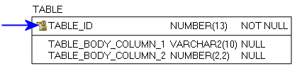
Figure 2: Primary Key example
Foreign Key (FK):
When a Primary Key from a Parent Table appears as a column in the Child Table it is referred to as a Foreign Key (FK). The FK may retain the same name of the Parent Table column, or it may be renamed.
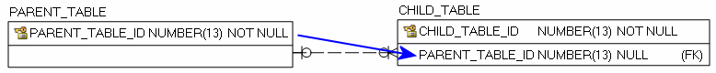
Figure 3: Foreign Key example
Alternate Key (AK):
Alternate Keys (AK) are secondary unique identifiers in a Parent Table. A Child Table can link to a Parent Table AK and use it as a Foreign Key (FK). The FK may retain the same name of the Parent Table column, or it may be renamed. Alternate Keys allow null values.
Figure 4: Alternate Key example

There are two relationship type options, identifying and non-identifying, which are described below.
An Identifying Relationship occurs when a column from the Parent Table is added to the key section of the Child Table. Though technically a Foreign Key (FK) in the child table, it now forms part of the Primary Key (PK). Identifying Relationships are symbolized with a solid line.
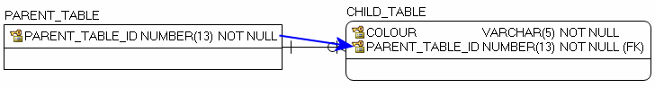
Figure 5: Example of an Identifying Relationship
A Non-identifying Relationship occurs when a column from the Parent Table is added to the main body of the Child Table where it is treated as a Foreign Key (FK). Non-identifying Relationships are symbolized with a dashed line.
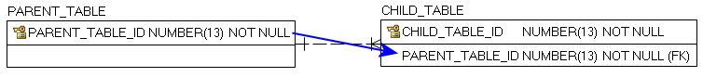
Figure 6: Example of a Non-identifying Relationship
The relationships between tables are set up with cardinality rules describing if the feature record in the Parent Table can relate to zero, one or more records in the associated Child Table and vice versa. These rules are symbolized in the model diagram as follows.
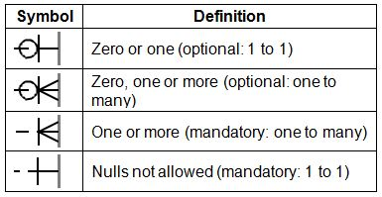
Figure 7: Model Diagram Relationship Symbology Table
The following section is an index of parent table primary keys identifying, where applicable, associated child table dependencies that have been implemented for the Building data classes.

Main Business Area Tables
Index of main business area table primary and associated foreign keys.
Note: Relationship type reference is either Identifying (I) or Non-Identifying (NI).
Parent Table: BUILDING_TYPE_LIST
Primary Key(s): BUILDING_TYPE
Data Type: VARCHAR2 (30)
Child Table | Migrated Foreign Key | Rel. Type | Parent to Child Relationship | Child to Parent Relationship
BUILDING_AS_SYMBOL_FT | BUILDING_TYPE | NI | Optional: 1 to many | Optional: 1 to1
Parent Table: LOCATION_ACCURACY_LIST
Primary Key(s): LOCATION_ACCURACY
Data Type: VARCHAR2 (25)
Child Table | Migrated Foreign Key | Rel. Type | Parent to Child Relationship | Child to Parent Relationship
BUILDING_AS_SYMBOL_FT | LOCATION_ACCURACY | NI | Optional: 1 to many | Optional: 1 to1
BUILDING_TO_SCALE_FT | LOCATION_ACCURACY | NI | Optional: 1 to many | Optional: 1 to1

APPENDIX C: Frequently Asked Questions

How do I rotate a building point feature?
ArcMap provides two options for rotation, Geographic and Arithmetic. Geographic rotates clockwise and has the origin at zero degrees, while Arithmetic rotates counter-clockwise and has the origin at ninety degrees. Arithmetic will align building symbols to road features.
Steps for using Rotation:
- Right-click on BUILDING_AS_SYMBOL_FT and choose Properties
- Click the Symbology tab
- Choose Features (single symbol) and assign a symbol for buildings
- Click Advanced and choose Rotation
- Select the Rotation field from the list
- Choose Arithmetic (counter-clockwise rotation)
- Click OK.
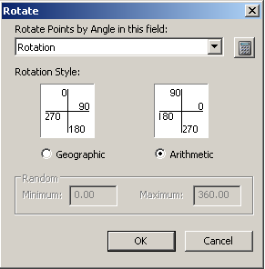
Figure 8: ArcMap's Rotate function

Version 1920.1

