User Guide
for
Contour
LIO Data Class
  - Provincial Mapping Unit
  - Mapping and Information Resources Branch
  - Corporate Management and Information Division
  - Ministry of Natural Resources and Forestry
2020-03-03

Disclaimer
This technical documentation has been prepared by Her Majesty the Queen in right of Ontario as represented by the Ministry of Natural Resources and Forestry (the “Ministry”). No warranties or representations, express or implied, statutory or otherwise shall apply or are being made by the Ministry with respect to the documentation, its accuracy or its completeness. In no event will the Ministry be liable or responsible for any lost profits, loss of revenue or earnings, claims by third parties or for any economic, indirect, special, incidental, consequential or exemplary damage resulting from any errors, inaccuracies or omissions in this documentation; and in no event will the Ministry’s liability for any such errors, inaccuracies or omissions on any particular claim, proceeding or action, exceed the actual consideration paid by the claimant involved to the Ministry for the materials to which this instructional documentation relates. Save and except for the liability expressly provided for above, the Ministry shall have no obligation, duty or liability whatsoever in contract, tort or otherwise, including any liability or negligence. The limitations, exclusions and disclaimers expressed above shall apply irrespective of the nature of any cause of action, demand or action, including but not limited to breach of contract, negligence, strict liability, tort or any other legal theory, and shall survive any fundamental breach or breaches.
Cette publication spécialisée n’est disponible qu’en anglais.

Additional Information
For more information about this document, please contact the Provincial Mapping Unit at pmu@ontario.ca.

Executive Summary

Key Words
Contours, Elevation, Altitude, Topographic

Abstract
A user guide to the extent and context of information stored in the Contour Land Information Ontario Data Class.

Table of Contents
Disclaimer 2
Additional Information 2
Executive Summary 3
Key Words 3
Abstract 3
Table of Contents 4
List of Figures 5
List of Acronyms 6
1. Introduction 7
Known Issues 7
2. Objectives 8
3. Data Class: Contour 8
Spatial Management 8
4. Model Diagram: Contour 9
5. Data Description 10
CONTOUR_FT 10
6. Links to Additional Information 11
APPENDIX A: LIO Lookup Tables and Values 12
LOCATION_ACCURACY_LIST 12
APPENDIX B: Table Key Dependency and Relationship Index 14
Lookup Table Indexes 16

List of Figures
Figure 1: LIO Mapper view of Contour data class layer 8
Figure 2: Primary Key example 14
Figure 3: Foreign Key example 14
Figure 4: Alternate Key example 14
Figure 5: Example of an Identifying Relationship 15
Figure 6: Example of a Non-identifying Relationship 15
Figure 7: Model Diagram Relationship Symbology Table 15

List of Acronyms
LIO: Land Information Ontario
LUT: Lookup Table
MNRF: Ontario Ministry of Natural Resources and Forestry
OGF: Ontario Geospatial Feature
WMS: Web Mapping Service

1. Introduction
Contours are lines representing equal elevations. The primary purpose of the contour layer is to represent elevation on a medium scale topographic map. A contour interval is the difference in elevation between adjacent contour lines. Multiple sources were used to develop contours and contour intervals will vary across the province depending on the sources.
The contours represented were captured using stereophotogrammetric methods and calculated based on a digital elevation model (DEM) or may have been captured manually using hard copy maps. In order to create a cartographic product, the contours were cartographically smoothed and attempts were made to remove extraneous contours in water.
Contour intervals are 5m in the southern part of the province, 10m in the central part of the province and are variable in the far north. The variability in the far north is due to the vintage and specifications of the mapping products.
The MNRF has a web map application that includes cartographic representation of contours. For more information visit the Make a Topographic Map application page (https://www.ontario.ca/page/topographic-maps).

Known Issues
- There are no contours in the Toronto area.
- The Hudson Bay Lowlands area contains limited contours.
- There may be overlapping contours along a Ministry of Natural Resources and Forestry district boundary.
For more information on Contour contact pmu@ontario.ca.
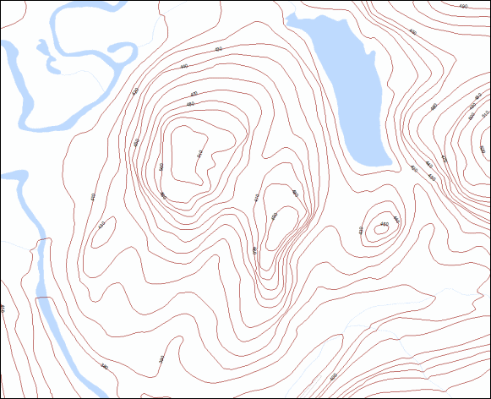
Figure 1: LIO Mapper view of Contour data class layer

2. Objectives
This user guide is intended for users with a general interest in the Contour LIO Data Class. The remainder of this document describes the extent and context of the information collected for this data class.

3. Data Class: Contour
Linear segments that connect contiguous points of the same elevation that are compiled and used to describe terrain relief.

Spatial Management
Contours are represented as linear features (lines) in this data class. Contours are not maintained with exception to the minimal adjustment of contour lines based on reported errors. It is anticipated that future maintenance will occur when a more accurate elevation source is available to support the generation of contours.

4. Model Diagram: Contour
Physical Model Diagram for Contour
Model Effective Date: 2012-JUN-14
Note: Where applicable to this model:
- Tables with a “_LIST” extension (shaded yellow) = Lookup Table (LUT)
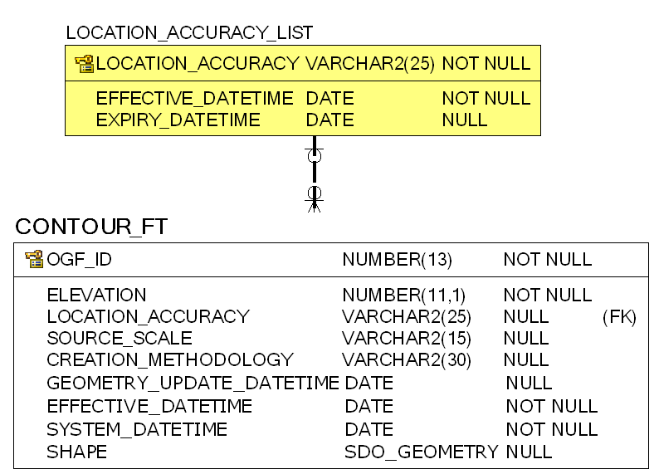

5. Data Description
The main business area table(s) for this model can be found below. Associated lookup tables will be listed in Appendix A of this document and are hyperlinked where referenced in this section.

CONTOUR_FT
Linear segments that connect contiguous points of the same elevation that are compiled and used to describe terrain relief and usually captured at a predefined contour interval.
Column Name | Column Type | Mandatory | Short Name | Description
OGF_ID | NUMBER(13) | Yes | OGF_ID | A unique numeric provincial identifier assigned to each object.
ELEVATION | NUMBER(11,1) | Yes | ELEVATION | Amount in metres that a geographic entity is above mean sea level.
LOCATION_ACCURACY | VARCHAR2(25) | No | ACCURACY | The accuracy of the location of the feature at an OBM scale. The degree of conformity or closeness of a measurement to the true value.
SOURCE_SCALE | VARCHAR2(15) | No | SRCE_SCALE | The scale of the vector base or aerial photography, the cell resolution of a grid, or the pixel resolution of an image used to record the location of the feature. Examples: For a vector source or aerial photography: 1:10,000 1:20,000 1:50,000.  For a grid or imagery source: 1 km, 10 m, 15 seconds.
CREATION_METHODOLOGY | VARCHAR2(30) | No | METHODOL | The method used to generate the lines for contours. For example, contours could be generated using a digital terrain model or digitized from hard copy maps.
GEOMETRY_UPDATE_DATETIME | DATE | No | GEO_UPD_DT | Date/time the geometry was created or last modified in the source database.
EFFECTIVE_DATETIME | DATE | Yes | EFF_DATE | Date/time the record was created or last modified in the source database.
SYSTEM_DATETIME | DATE | Yes | SYS_DATE | Date/time the record was loaded into or last modified in the LIO database.  DEFAULT: SYSDATE
SHAPE | GEOMETRY | No | SHAPE | Geometry attribute.

6. Links to Additional Information
To view the official LIO Metadata Record for Contour search for ‘Contour’ in the Ontario GeoHub (https://geohub.lio.gov.on.ca/).

APPENDIX A: LIO Lookup Tables and Values
Listing of Lookup Tables (LUT) and values that are used by the Contour Data Class.

LOCATION_ACCURACY_LIST
List of valid location accuracies.
Column Name | Column Type | Mandatory | Short Name | Description
LOCATION_ACCURACY | VARCHAR2(25) | Yes | ACCURACY | The accuracy of the location of the feature at an OBM scale. The degree of conformity or closeness of a measurement to the true value.
EFFECTIVE_DATETIME | DATE | Yes | EFF_DATE | Date/time the record was created or last modified in the source database.  Default: SYSDATE
EXPIRY_DATETIME | DATE | No | EXP_DATE | Date/time that the record was expired from use.
LOCATION_ACCURACY_LIST Permissible Values
LOCATION_ACCURACY | EXPIRY_DATETIME
Not Applicable | Not applicable
Over 10,000 metres | Not applicable
Within 1 metre | Not applicable
Within 10 metres | Not applicable
Within 10,000 metres | Not applicable
Within 100 metres | Not applicable
Within 1000 metres | Not applicable
Within 2 metres | Not applicable
Within 20 metres | Not applicable
Within 200 metres | Not applicable
Within 2000 metres | Not applicable
Within 5 metres | Not applicable
Within 50 metres | Not applicable
Within 500 metres | Not applicable
Within 5000 metres | Not applicable
AC Accurate (to 10m) | 2007-01-12
AP Approximate (to 500m) | 2007-01-12
GE General (to 10,000m) | 2007-01-12
MO Moderate (to 1000m) | 2007-01-12
RE Reliable (to 100m) | 2007-01-12
VA Very Accurate (to 2m) | 2007-01-12
VG Vague (to 100,000m) | 2007-01-12
^ Data Load | 2007-01-12

APPENDIX B: Table Key Dependency and Relationship Index
Keys are used to link or make relationships between tables through one or more columns. A Parent Table is the source of unique key columns used by a Child Table. The main key types are described below.
Primary Key (PK):
A Primary Key (PK) is a column that uniquely identifies each record in a table. There can be more than one PK defined for a table when additional rules for record uniqueness are needed. Primary Keys cannot contain null values.
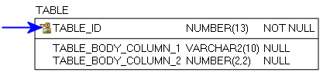
Figure 2: Primary Key example
Foreign Key (FK):
When a Primary Key from a Parent Table appears as a column in the Child Table it is referred to as a Foreign Key (FK). The FK may retain the same name of the Parent Table column, or it may be renamed.
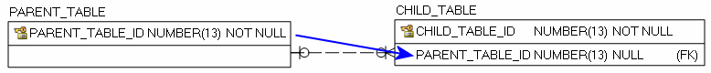
Figure 3: Foreign Key example
Alternate Key (AK):
Alternate Keys (AK) are secondary unique identifiers in a Parent Table. A Child Table can link to a Parent Table AK and use it as a Foreign Key (FK). The FK may retain the same name of the Parent Table column, or it may be renamed. Alternate Keys allow null values.
Figure 4: Alternate Key example

There are two relationship type options, identifying and non-identifying, which are described below.
An Identifying Relationship occurs when a column from the Parent Table is added to the key section of the Child Table. Though technically a Foreign Key (FK) in the child table, it now forms part of the Primary Key (PK). Identifying Relationships are symbolized with a solid line.
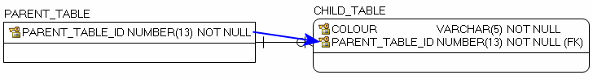
Figure 5: Example of an Identifying Relationship
A Non-identifying Relationship occurs when a column from the Parent Table is added to the main body of the Child Table where it is treated as a Foreign Key (FK). Non-identifying Relationships are symbolized with a dashed line.
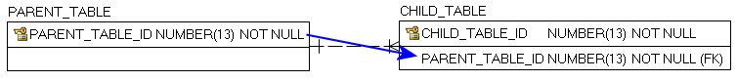
Figure 6: Example of a Non-identifying Relationship
The relationships between tables are set up with cardinality rules describing if the feature record in the Parent Table can relate to zero, one or more records in the associated Child Table and vice versa. These rules are symbolized in the model diagram as follows.
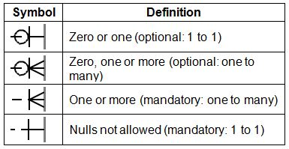
Figure 7: Model Diagram Relationship Symbology Table
The following section is an index of parent table primary keys identifying, where applicable, associated child table dependencies that have been implemented for the Contour data class.

Lookup Table Indexes
Where a lookup table primary key (PK) is used as a foreign key (FK) in other main business area tables in order to control permissible values.
Note: Relationship type reference is either Identifying (I) or Non-Identifying (NI).
Parent Table: LOCATION_ACCURACY_LIST
Primary Key(s): LOCATION_ACCURACY
Data Type: VARCHAR2 (25)
Child Table | Migrated Foreign Key | Rel. Type | Parent to Child Relationship | Child to Parent Relationship
CONTOUR_FT | LOCATION_ACCURACY | NI | Optional: 1 to many | Mandatory: 1 to1

Version 1516.1

