Data Packages Extent and History
for
Far North Hydrology and Elevation Maps
LIO Package Product
  - Provincial Mapping Unit
  - Mapping and Information Resources Branch
  - Corporate Management and Information Division
  - Ministry of Natural Resources and Forestry
Updated March, 2020

Disclaimer
This technical documentation has been prepared by Her Majesty the Queen in right of Ontario as represented by the Ministry of Natural Resources and Forestry (the “Ministry”). No warranties or representations, express or implied, statutory or otherwise shall apply or are being made by the Ministry with respect to the documentation, its accuracy or its completeness. In no event will the Ministry be liable or responsible for any lost profits, loss of revenue or earnings, claims by third parties or for any economic, indirect, special, incidental, consequential or exemplary damage resulting from any errors, inaccuracies or omissions in this documentation; and in no event will the Ministry’s liability for any such errors, inaccuracies or omissions on any particular claim, proceeding or action, exceed the actual consideration paid by the claimant involved to the Ministry for the materials to which this instructional documentation relates. Save and except for the liability expressly provided for above, the Ministry shall have no obligation, duty or liability whatsoever in contract, tort or otherwise, including any liability or negligence. The limitations, exclusions and disclaimers expressed above shall apply irrespective of the nature of any cause of action, demand or action, including but not limited to breach of contract, negligence, strict liability, tort or any other legal theory, and shall survive any fundamental breach or breaches.
Cette publication spécialisée n’est disponible qu’en anglais.

Additional Information
This document does not comply with all the applicable guidelines for accessible digital documents. For an alternative format please email the Provincial Mapping Unit at pmu@ontario.ca.
For more information about this document, please contact Provincial Mapping Unit at pmu@ontario.ca.

1 Spatial Extent of Far North Hydrology and Elevation Map Data Packages
Far North Hydrology and Elevation Map data packages are available for seven separate extents across the province for the 1:250,000 scale maps and eight for the 1:100,000 scale maps (see Figure 1). These extents cover secondary watersheds across Ontario’s Far North. A listing of the secondary watersheds associated with each Far North Hydrology and Elevation Map Data package can be found in Table 1 and Table 2.

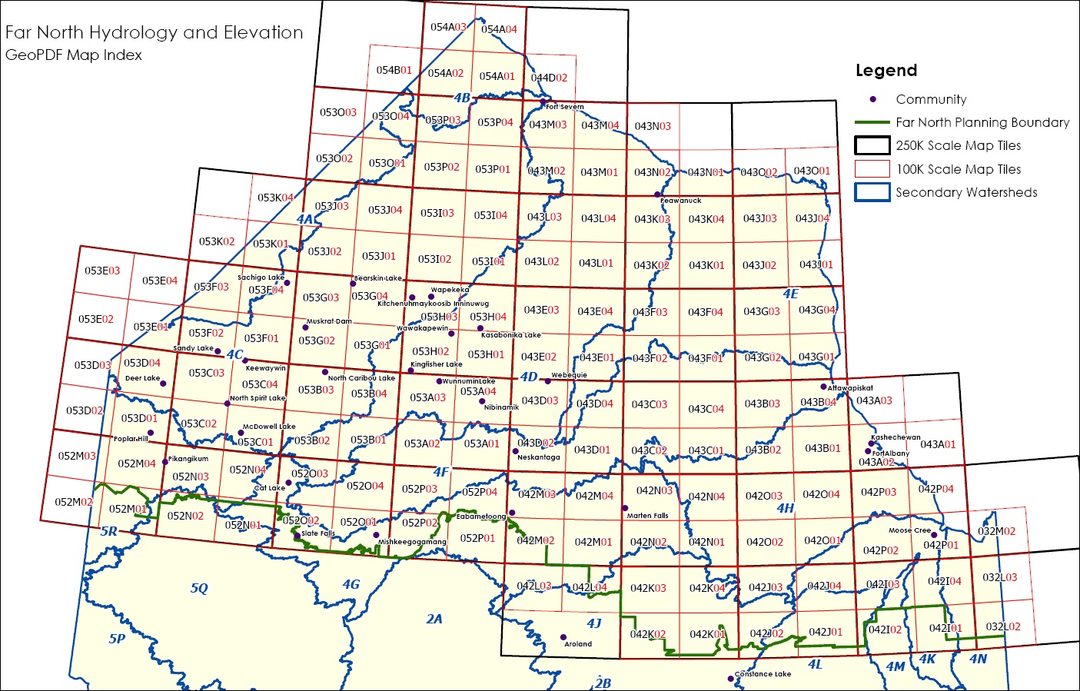
Figure 1: Extent of Far North Hydrology and Elevation Map Data packages.

Table 1. Far North Hydrology and Elevation Map package names and associated extent of secondary watersheds for 1:100,000 scale maps.
Package Name (1:100,000) | Secondary Watershed Names and Codes
4A – 4B | Hayes (4A)  Southwestern Hudson Bay (4B)
4C | Severn (4C)
4D | Winisk-Coast (4D)
4E | Ekwan-Coast (4E)
4F | Attawapiskat-Coast (4F)
4G – 4H | Upper Albany (4G)  Lower Albany-Coast (4H)
4J – 4N | Kenogami (4J)  Moose (4K)  Missinaibi-Mattagami (4L)  Abitibi (4M)  Harricanaw-Coast (4N)
5Q – 5R | English (5Q)  Eastern Lake Winnipeg (5R)

Table 2. Far North Hydrology and Elevation Map package names and associated extent of secondary watersheds for 1:250,000 scale maps.
Package Name (1:250,000) | Secondary Watershed Names and Codes
4A – 4C | Hayes (4A)  Southwestern Hudson Bay (4B)  Severn (4C)
4D – 4E | Winisk-Coast (4D)  Ekwan-Coast (4E)
4F – 4G | Attawapiskat-Coast (4F)  Upper Albany (4G)
4H – 4J | Lower Albany-Coast (4H)  Kenogami (4J)
4K – 4L | Moose (4K)  Missinaibi-Mattagami (4L)
4M – 4N | Abitibi (4M)  Harricanaw-Coast (4N)
5Q – 5R | English (5Q)  Eastern Lake Winnipeg (5R)

2 Data History of Far North Hydrology and Elevation Map Data Packages
Each of the nine Ontario Integrated Hydrology packages will have a package version number that indicates the currency of the data. The history of data changes for each package can be seen in Table 3 below.
Table 3. Data history of the Far North Hydrology and Elevation Map Data packages by version and release date.
Date | Details of Change
2012-03-30 | Initial release of data for all 15 packages.  Based on Version 1.0 (2012-11-01) of Ontario Integrated Hydrology.

Version 1920.1

