User Guide
for
Far North Hydrology and Elevation Maps
LIO Packaged Product
  - Provincial Mapping Unit
  - Mapping and Information Resources Branch
  - Corporate Management and Information Division
  - Ministry of Natural Resources and Forestry
Updated March, 2020

Disclaimer
This technical documentation has been prepared by Her Majesty the Queen in right of Ontario as represented by the Ministry of Natural Resources and Forestry (the “Ministry”). No warranties or representations, express or implied, statutory or otherwise shall apply or are being made by the Ministry with respect to the documentation, its accuracy or its completeness. In no event will the Ministry be liable or responsible for any lost profits, loss of revenue or earnings, claims by third parties or for any economic, indirect, special, incidental, consequential or exemplary damage resulting from any errors, inaccuracies or omissions in this documentation; and in no event will the Ministry’s liability for any such errors, inaccuracies or omissions on any particular claim, proceeding or action, exceed the actual consideration paid by the claimant involved to the Ministry for the materials to which this instructional documentation relates. Save and except for the liability expressly provided for above, the Ministry shall have no obligation, duty or liability whatsoever in contract, tort or otherwise, including any liability or negligence. The limitations, exclusions and disclaimers expressed above shall apply irrespective of the nature of any cause of action, demand or action, including but not limited to breach of contract, negligence, strict liability, tort or any other legal theory, and shall survive any fundamental breach or breaches.
Cette publication spécialisée n’est disponible qu’en anglais.

Additional Information
This document does not comply with all the applicable guidelines for accessible digital documents. For an alternative format please email the Provincial Mapping Unit at pmu@ontario.ca.
For more information about this document, please contact Provincial Mapping Unit at pmu@ontario.ca.

Executive Summary

Key Words
Far North, Ontario, Hydrology, Elevation, DEM, Map, GeoPDF, Spatial Data Infrastructure, SDI, Watershed

Abstract
This user guide details the specifications for the Far North Hydrology and Elevation Maps Land Information Ontario (LIO) Data Class. The Far North Hydrology and Elevation maps were created using GeoPDF technology as a resource for Community-Based Land Use Planning (CBLUP) in the Far North of Ontario. The maps are available at two scales (1:100,000 and 1:250,000). This document provides full description of the features of GeoPDF’s and how to use them.

Table of Contents
Disclaimer 2
Additional Information 2
Executive Summary 3
Key Words 3
Abstract 3
Table of Contents 4
List of Figures 5
List of Acronyms 6
1. Introduction 7
1.1 GeoPDF Maps 7
1.2 Additional Software 7
1.3 GeoPDF Map Components 7
2. Objectives 8
2.1 Common Tools 8
2.1.1 Setting Units 8
2.1.2 Turn Map Layers On and Off 10
2.1.3 Printing Maps 13
2.1.4 Calculating Distance or Area 14
2.1.5 Inserting Comments or Adding Shapes 16
2.2 Saving Changes 19
3. Links to Additional Information 19

List of Figures
Figure 1: An example of a GeoPDF when initially opened. 8
Figure 2: Opening the map preferences. 9
Figure 3: Setting the unit preferences. 10
Figure 4: Location of the layers button. 11
Figure 5: Accessing layers through the menu bar. 12
Figure 6: Turning layers on or off. 13
Figure 7: Printing maps. 14
Figure 8: Measuring length and area. 15
Figure 9: Length and area results. 16
Figure 10: Adding comments to the map. 17
Figure 11: Adding comments to the map. 18
Figure 12: Adding shapes to the map. 19

List of Acronyms
GIS: Geographic Information System
LIO: Land Information Ontario
MNRF: Ontario Ministry of Natural Resources and Forestry
SDI: Spatial Data Infrastructure

1. Introduction

1.1 GeoPDF Maps
Planning and reference maps were traditionally printed and mailed out upon request. Maps in digital format allow users to save them on their computer and print them when needed. GeoPDF maps in particular allow the user to view, mark up and interact with geospatial data. No GIS expertise or GIS software is required.

1.2 Additional Software
In order to open, view and use a GeoPDF you are required to download two software packages if they are not already installed.
- Adobe Reader – this software is commonly used to open PDF documents. Adobe Acrobat or Reader version 8.1.7 or later is necessary. Get Adobe Reader
- TerraGo Toolbar – this software offers tools that will help you measure distances and add comments or shapes to the maps. Get the TerraGo Toolbar
Each of these pieces of software only needs to be downloaded once.

1.3 GeoPDF Map Components
A GeoPDF map can be opened by placing the cursor over the file and either double clicking it with the mouse or using the right click feature and selecting open. An example of a GeoPDF map is provided in Figure 1.
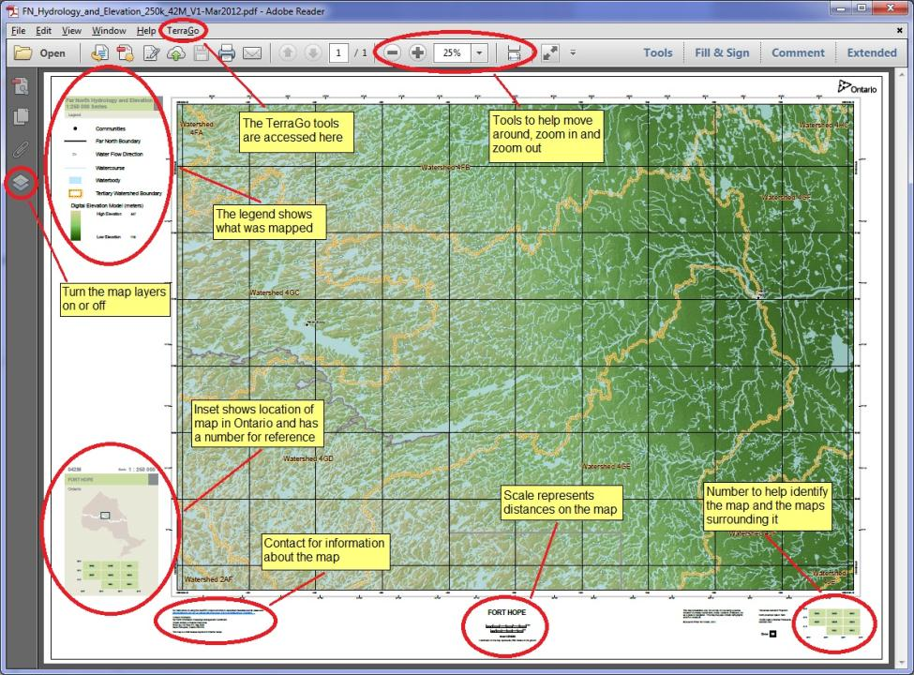
Figure 1: An example of a GeoPDF when initially opened.

2. Objectives
This guide is intended for users with an interest in the Far North Hydrology and Elevation Maps. These maps are in GeoPDF format and are part of a LIO Packaged Product. The maps are not currently being updated. The remainder of this document describes how to utilize the tools inherent in a GeoPDF map document.

2.1 Common Tools

2.1.1 Setting Units
Step 1 – Click on “Edit” in the menu bar and then “Preferences” and “TerraGo” – see Figure 2.
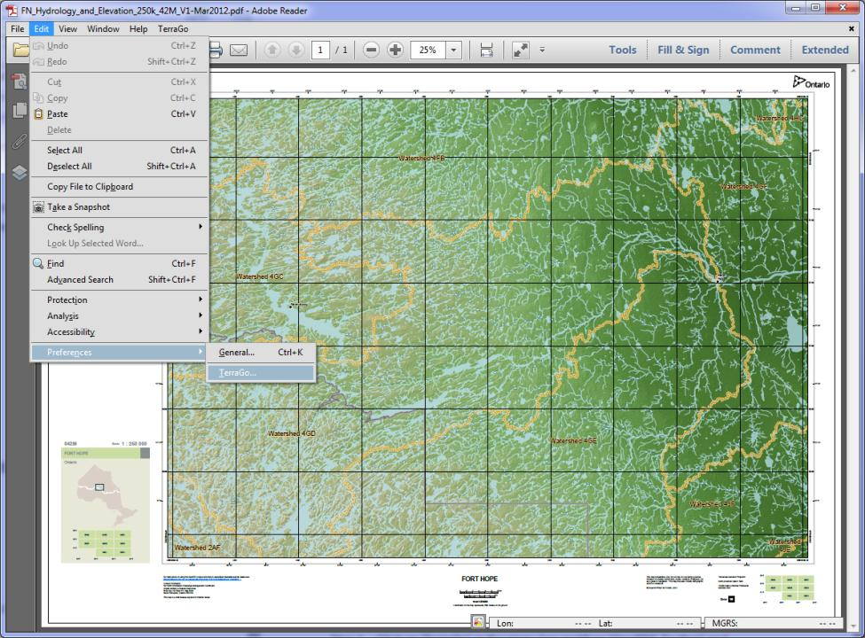
Figure 2: Opening the map preferences.
Step 2 – Select “GeoMeasure Tool Options” from the list of categories on the left – see Figure 3.
Step 3 – Change the default units using the drop-down boxes – see Figure 3.
Step 4 – Click OK – see Figure 3.
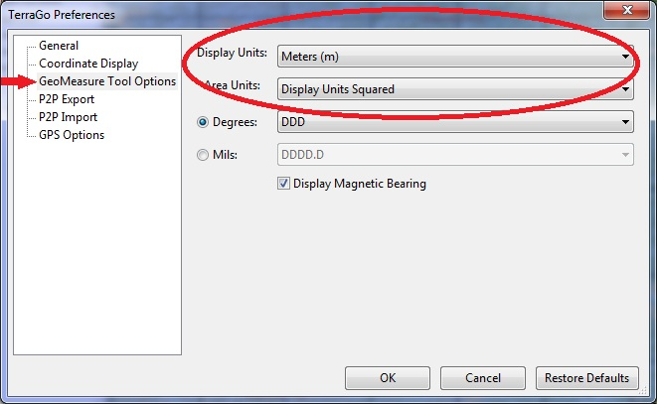
Figure 3: Setting the unit preferences.

2.1.2 Turn Map Layers On and Off
This feature is helpful when you only want to view or print specific layers.
Step 1 – Open the layers window by selecting the “layers” button – see Figure 4.
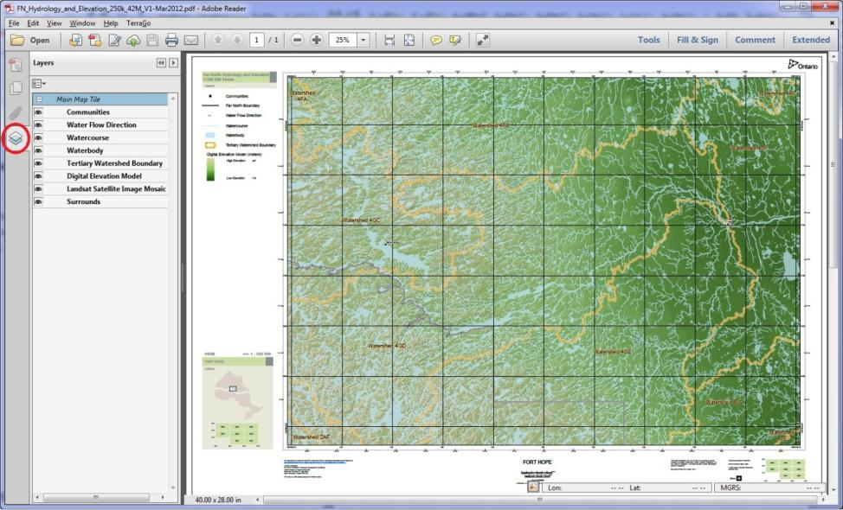
Figure 4: Location of the layers button.
If you cannot see the layers button you can open it through the menu bar. Click on “View” in the menu bar and then “Show/Hide” followed by “Navigate Panes” and then “Layers” – see Figure 5.
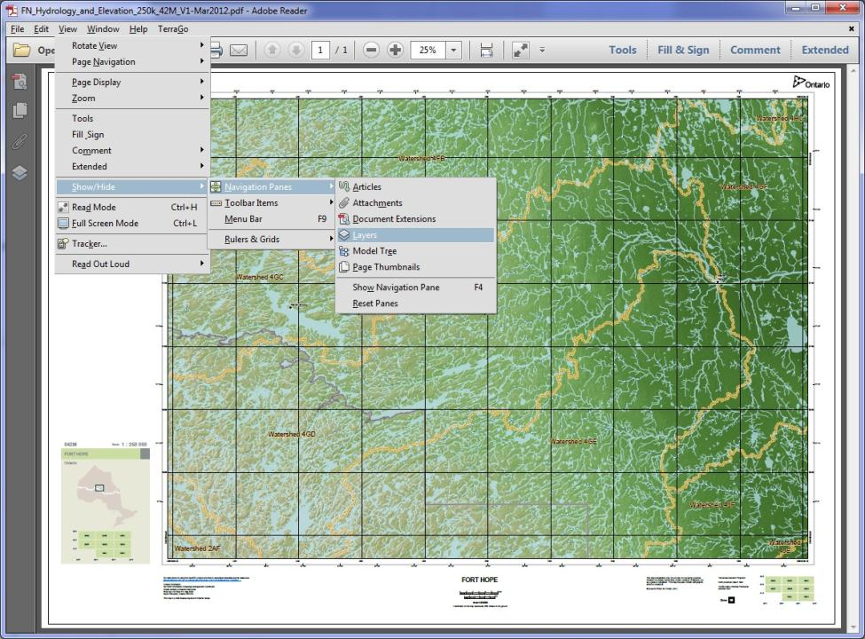
Figure 5: Accessing layers through the menu bar.
Step 2 – Turn layers on or off by clicking the box next to the layer name – see Figure 6.
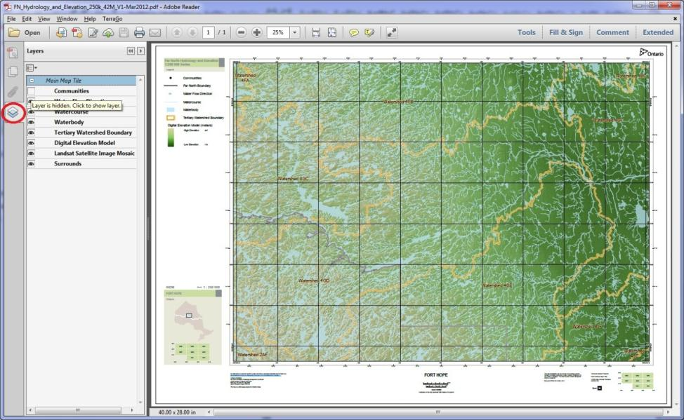
Figure 6: Turning layers on or off.

2.1.3 Printing Maps
Maps can be printed by clicking the “print” button – see Figure 7.
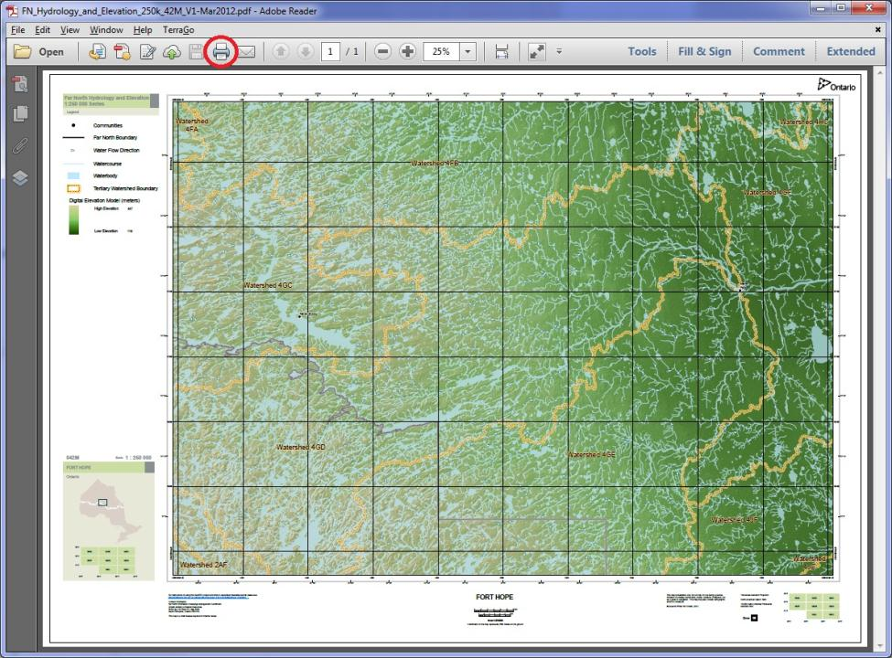
Figure 7: Printing maps.

2.1.4 Calculating Distance or Area
Distance can be calculated for any line created using the” Measure Length Tool”. Similarily, area can be calculated for any shape drawn on the map with the “Measure Area Tool”.
Step 1 – Click on “TerraGo” in the menu bar and then “GeoPDF Toolbar” and “GeoMeasure” to view the options “Measure Length” or “Measure Area” – see Figure 8.
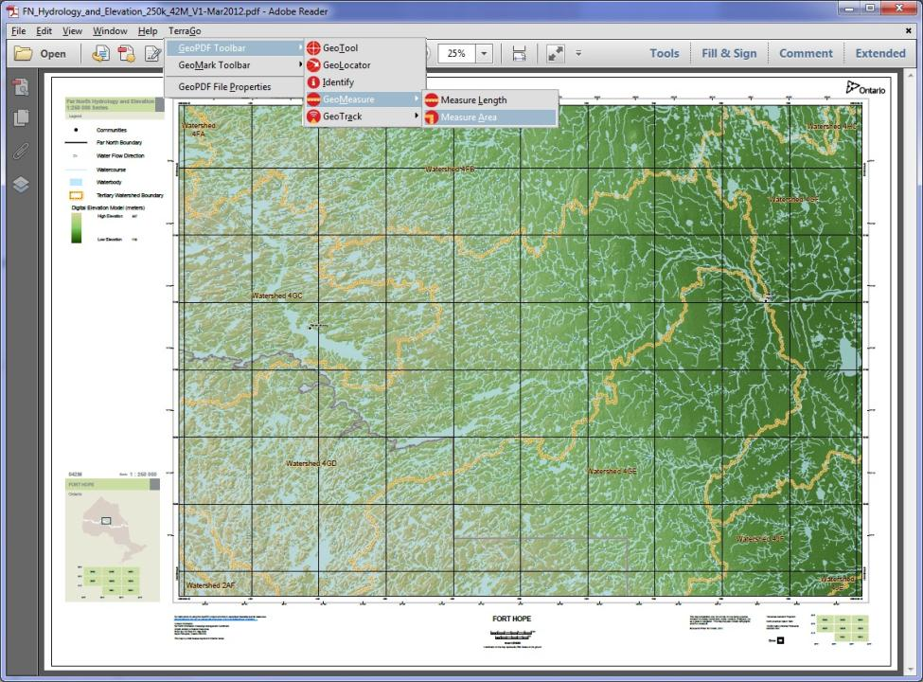
Figure 8: Measuring length and area.
Step 2 – Use the mouse to draw a line or shape and the distance or area is immediately shown in the measuring results window.
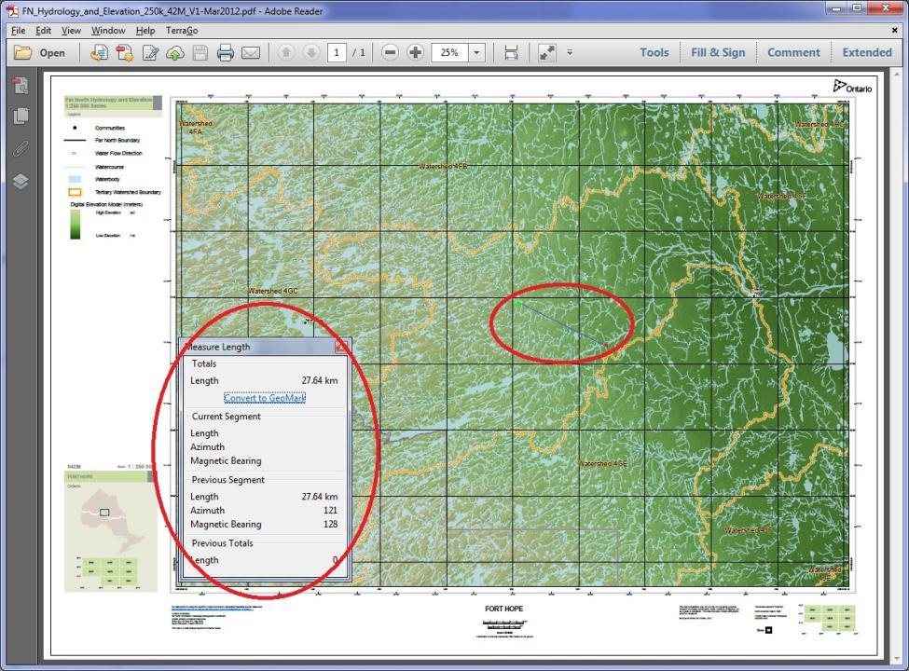
Figure 9: Length and area results.

2.1.5 Inserting Comments or Adding Shapes
With GeoPDFs comments, shapes or lines can be added to the map.
Step 1 – Click on “TerraGo” in the menu bar and then “GeoMark Toolbar” and “Add GeoNote” to add a comment – see Figure 10.
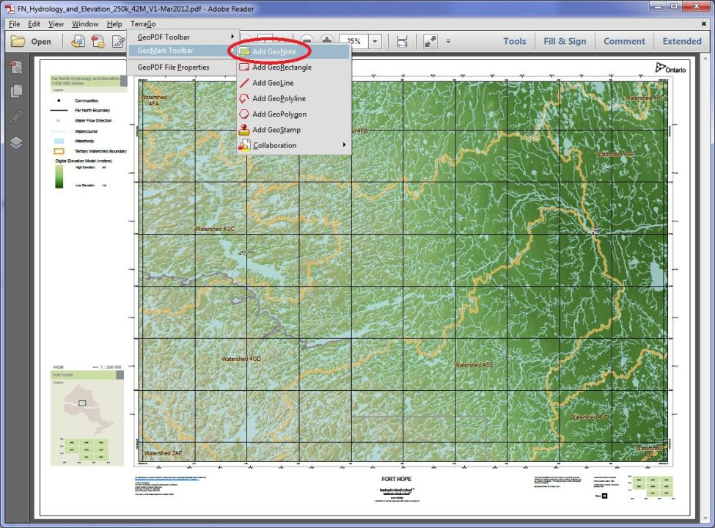
Figure 10: Adding comments to the map.
Step 2 – Click on the map where the comment is to be added and enter text in the comment window – see Figure 11.
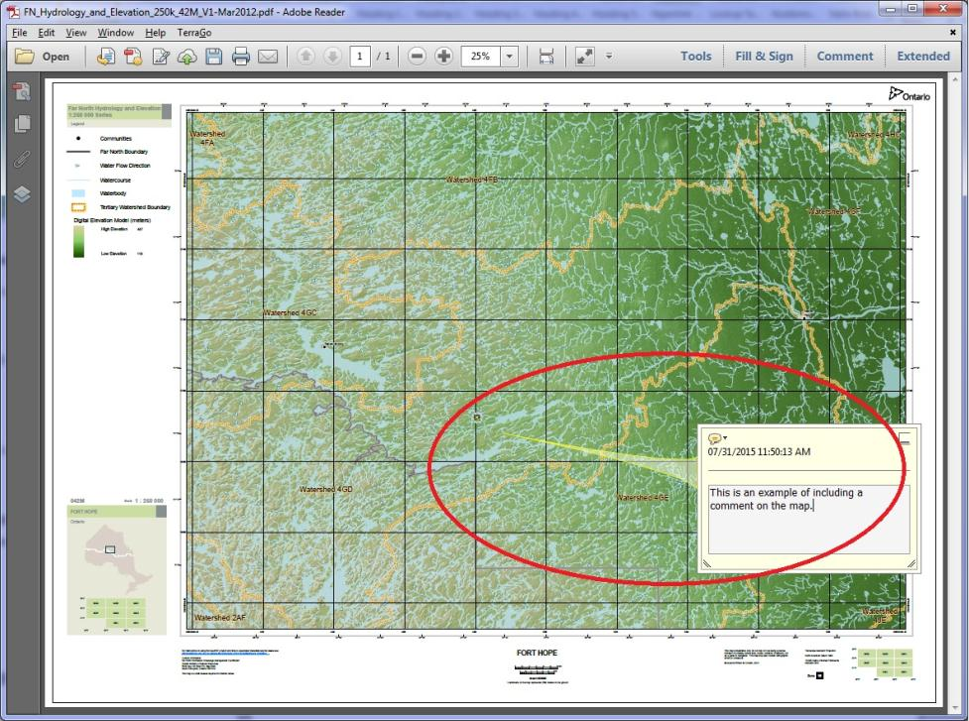
Figure 11: Adding comments to the map.
Step 3 - Click on “TerraGo” in the menu bar and then “GeoMark Toolbar” and choose the type of shape to add. Click on the map where the selected shape is to be added – see Figure 12.
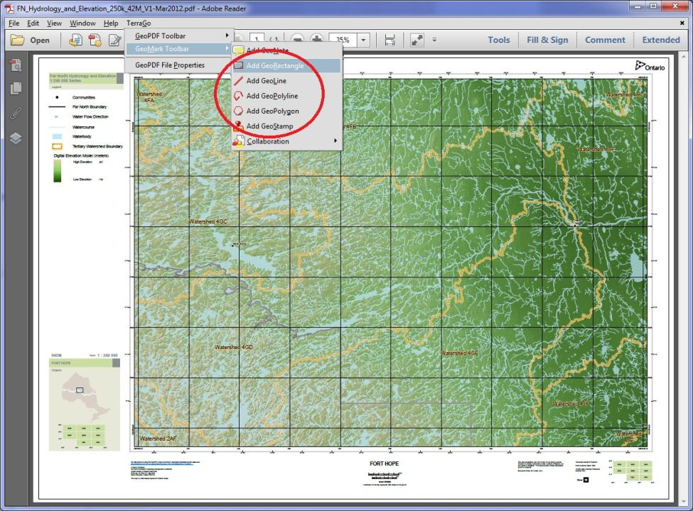
Figure 12: Adding shapes to the map.

2.2 Saving Changes
In order to ensure that any modifications to the map, be they the addition of text or shapes, are permanently captured by sure to use the Save or Save As feature as required.

3. Links to Additional Information
- For more information on using the TerraGo tools in a GeoPDF refer to the TerraGo Help (click Help in the menu bar and then TerraGo Help and choose Toolbar Help) or at TerraGo Support
- For questions related to the data used on the map contact pmu@ontario.ca
For all other inquiries contact Far North Branch, Ontario Ministry of Natural Resources and Forestry FARNORTHFEEDBACK@ontario.ca
- Data Source: Version 1.0 (2012-11-01) of Ontario Integrated Hydrology Data
Version 1920.1

