
Land Information Ontario (LIO) Warehouse
Data Class Name: Fire Disturbance Area
Documentation
Produced by: Information Access and Information Management Policy Unit
Ministry of Natural Resources and Forestry
Date: July 27, 2015

Purpose

This document provides additional information to support the use of geospatial data. The Physical Model Diagram provides a visual representation of the relationships in the data class. The Data Change History lists all the modelling and access changes that have occurred during the lifecycle of the data class. A data description identifying table and field names is available upon request.

Need Assistance?
Please contact LIO Support at lio@ontario.ca or 705-755-1878 if you require help.

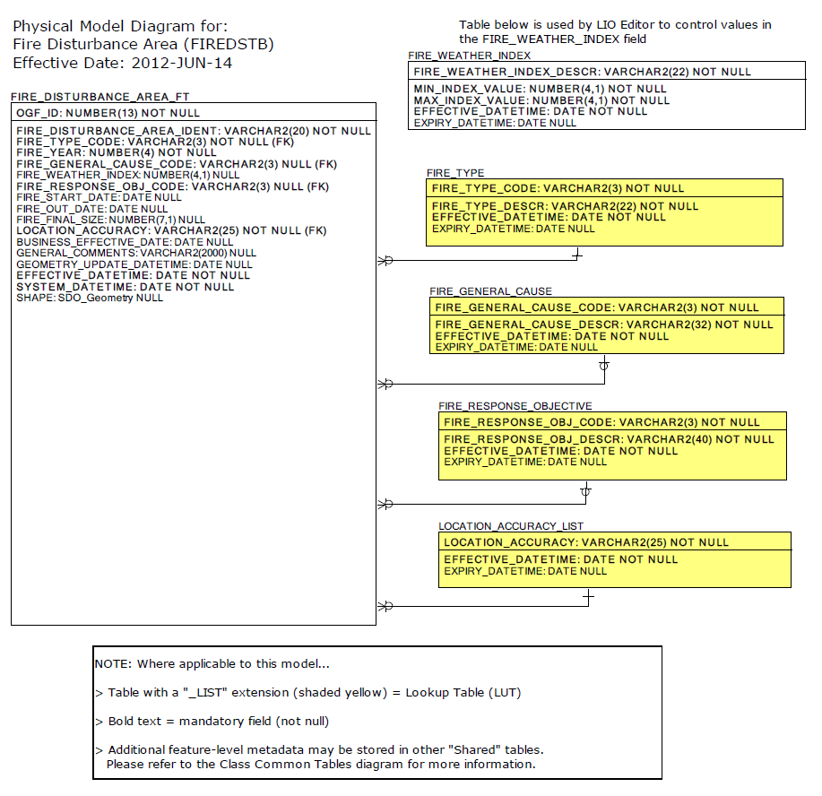

Data Class Change History

Data Class Name: Fire Disturbance Area
Data Class Short Name: FIREDSTB
Date  YYYY-MM-DD | Details of Change
2004-08-11 | Column Added: FIRE_DISTURBANCE_AREA.YEAR to table to accommodate NRVIS TOC breakdown by Fire Year.
2004-08-11 | FIRE_DISTURBANCE_AREA.FWI (Fire Weather Index) Column changed from 'mandatory' to 'optional'
2004-08-11 | New values added to LUT: FIRE_RESPONSE_OBJECTIVE to reflect the new Fire Management Strategies for Ontario:  - MDP: Modified Under Prescription  - MNP: Monitored Under Prescription
1998 | NEW Data Class

Data Description
Please refer to the metadata record for the data description..

