
Land Information Ontario (LIO) Warehouse
Data Class Name: Fishing and Hunting Licence Issuer Location
Documentation
Produced by: Spatial Data Support Unit
Ministry of Natural Resources and Forestry
Date: July 12, 2022

Purpose

This document provides additional information to support the use of geospatial data. The Physical Model Diagram provides a visual representation of the relationships in the data class. The Data Change History lists all the modelling and access changes that have occurred during the lifecycle of the data class. A data description identifying table and field names is available upon request.

Need Assistance?
Please contact LIO Support at lio@ontario.ca or 705-755-1878 if you require help.

Physical Model Diagram 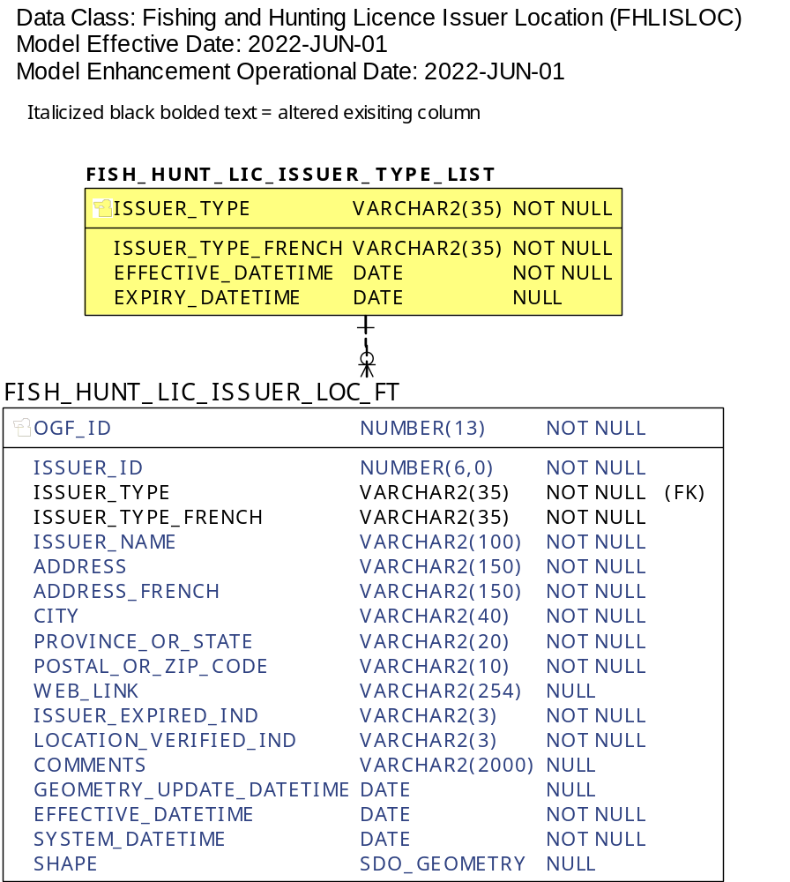

Data Class Change History
Data Class Name: Fishing and Hunting Licence Issuer Location
Data Class Short Name: FHLISLOC
Date  YYYY-MM-DD | Details of Change
2022-07-12 | FISH_HUNT_LIC_ISSUER_TYPE_LIST lookup table updates:  New Values:  - ISSUER_TYPE  - "ServiceOntario"  - "Year Round Licence Issuer"  - "Seasonal Licence Issuer"  - ISSUER_TYPE_FRENCH  - "ServiceOntario"  - "Délivreur de permis à l’année"  - "Délivreur de permis saisonnier"  Note: All prior existing lookup table values have been expired, with all feature table records updated to reflect the new values.  ISSUER_TYPE and ISSUER_TYPE fields have been increased from 15 to 35 characters to accommodate new values in the following tables:  - FISH_HUNT_LIC_ISSUER_TYPE_LIST  - FISH_HUNT_LIC_ISSUER_LOC_FT
2022-04-12 | NEW field added to FISH_HUNT_LIC_ISSUER_LOC_FT table:  - ISSUER_TYPE_FRENCH  NEW Lookup Table (LUT): FISH_HUNT_LIC_ISSUER_TYPE_LIST:  - Stores permissible English and corresponding French Licence Issuer Types (ISSUER_TYPE), ISSUER_TYPE_FRENCH).
2019-10-08 | NEW field added to FISH_HUNT_LIC_ISSUER_LOC_FT table:  - ADDRESS_FRENCH
2018-11-13 | 3 new fields added for internal use by business area:  - ISSUER_EXPIRED_IND  - LOCATION_VERIFIED_IND  - COMMENTS
2016-04-13 | NEW point Data Class supporting the Fish ON-Line web application.
Data Description
Please refer to the metadata record for the data description.

