User Guide for
Forest Management Unit (FMU)
Geospatial Ontario Data Class

  - Forest Management Policy Section
  - Crown Forests and Lands Policy Branch, Policy Division
  - Ministry of Natural Resources

  - 2026-01-06

Disclaimer
This technical documentation has been prepared by His Majesty the King in right of Ontario as represented by the Ministry of Natural Resources (the “Ministry”). No warranties or representations, express or implied, statutory or otherwise shall apply or are being made by the Ministry with respect to the documentation, its accuracy or its completeness. In no event will the Ministry be liable or responsible for any lost profits, loss of revenue or earnings, claims by third parties or for any economic, indirect, special, incidental, consequential or exemplary damage resulting from any errors, inaccuracies or omissions in this documentation; and in no event will the Ministry’s liability for any such errors, inaccuracies or omissions on any particular claim, proceeding or action, exceed the actual consideration paid by the claimant involved to the Ministry for the materials to which this instructional documentation relates. Save and except for the liability expressly provided for above, the Ministry shall have no obligation, duty or liability whatsoever in contract, tort or otherwise, including any liability or negligence. The limitations, exclusions and disclaimers expressed above shall apply irrespective of the nature of any cause of action, demand or action, including but not limited to breach of contract, negligence, strict liability, tort or any other legal theory, and shall survive any fundamental breach or breaches.
Cette publication spécialisée n’est disponible qu’en anglais.

Additional Information
For more information about this document, please contact geospatial@ontario.ca
Revision History
Date | Edition/Version | Description
2026-01-06 | 0.1 | Limited draft release
2026-01-06 | 1.0 | Public release

Executive Summary

Key Words
Forest Management Unit, Policy Division, Forest Management Policy Section, Crown Forests and Lands Policy Branch, Sustainable Forest License.

Abstract
Identifies the boundaries of Forest Management Units in Ontario. Ontario’s Crown forest is divided into geographic planning areas, known as forest management units. Most of these units are managed by individual forest companies under a Sustainable Forest License.
A forest management unit is identified by an assigned official name (e.g. Black Spruce Forest) and a unique numeric code. Before any forestry activities can take place in a management unit, there must be an approved forest management plan in place for each management unit.

Recommendations
Not for Legal Purposes. The user must consider the FMU's source/origin when associating a spatial accuracy level to any given FMU's boundary. Only a subset of FMU boundaries originate from an FRI/OBM source (1:10,000; 1:20,000). The remainder of FMU boundaries were derived from coarse scales and different map bases (Old 1:15,840; 1:100,000 etc.).
The user should be mindful of the FMU implementation date (stored in NRVIS as 'Business Effective Date') in association with the business identifier, since FMU boundaries may change over a specific period. This is a crucial step to meet the user's requirements, especially when using historical FMU boundaries with other historical datasets, such as Forest Resource Inventories.

Table of Contents
Disclaimer 2
Additional Information 2
Executive Summary 4
Key Words 4
Abstract 4
Recommendations 4
Table of Contents 5
List of Figures 6
List of Acronyms 7
1. Introduction 8
2. How Forest Management Units are Created 10
3. Area of the Undertaking (AOU) 11
4. Physical Model Diagram 11
5. Maintenance 12
Appendix A: Forest Management Unit Data Description 13

List of Figures
Figure 1: Forest Management Units in Ontario 9
Figure 2: Physical Model Diagram 11

List of Acronyms
AOU: Area of the undertaking
CFLPB: Crown Forests and Lands Policy Branch
CFSA: Crown Forest Sustainability Act
EA: Environmental Assessment
FMBP: Forest Management Business Plan
FMU: Forest Management Unit
FRI: Forest Resource Inventory
GEO: Geospatial Ontario
LIO: Land Information Ontario
MNR: (Ontario) Ministry of Natural Resources
NRVIS: Natural Resources and Values Information System
OBM: Ontario Basic Mapping
SFL: Sustainable Forest Licence

- Introduction
For the purposes of forest management, Ontario’s Crown forest is divided into geographic planning areas known as Forest Management Units (FMU). Forest management plans are prepared for each of these management units and are periodically renewed based on the forest management planning cycle. Forest Management Units are designated and administered by the Ontario Ministry of Natural Resources, Crown Forests and Lands Policy Branch (Information Owner) under the Crown Forest Sustainability Act (CFSA, Section 7).
Legislation with respect to forest management planning has been in effect in Ontario since 1947, since forest management planning required the designation of Forest Management Units. Under the legislation, The MNR designated ‘Crown Management Units’, while issuing large licenses in other areas of the province to forest industry companies. These individual large license areas were, in effect, management units.
In the mid-1990s, the Sustainable Forest Licence (SFL) project was initiated. The SFL project-initiated partnerships between the MNR and forest companies to transfer the operational responsibility for forest management from the Crown to forest industry.
Operational responsibility, within a forestry context, refers to activities such as planning, renewal, evaluation, compliance and reporting. SFL negotiation is a process of developing new licensing arrangements with existing harvesting and processing plans and does not involve land use planning or resource allocation. The transfer of operational responsibility for forest management to forest companies is one of the key elements in MNR's Forest Management Business Plan (FMBP). As such, the SFL project is the MNR's top priority in forest management business activity. The majority of Ontario’s Forest Management Units are currently administered under SFL agreements.
There has been a reduction trend of the total number of Forest Management Units in Ontario, especially since the Crown Forest Sustainability Act (CFSA) was legislated in 1995. This reduction is generally achieved through the amalgamation of 2 and sometimes 3 existing Management Units to create a new Forest Management Unit. Management Unit names/numbers will change as these amalgamations occur. The savings generated by amalgamation are primarily represented by forest planning and administrative efficiencies.
In all cases, new FMU designations occur during the same period as the implementation date of a new Forest Management Unit plan. This list of Forest Management Units is organized by the scheduled plan renewal year (e.g. scheduled year of implementation) and includes the applicable lead MNR District and MNR Region. New plans are normally scheduled to be implemented in April of the applicable plan renewal year.

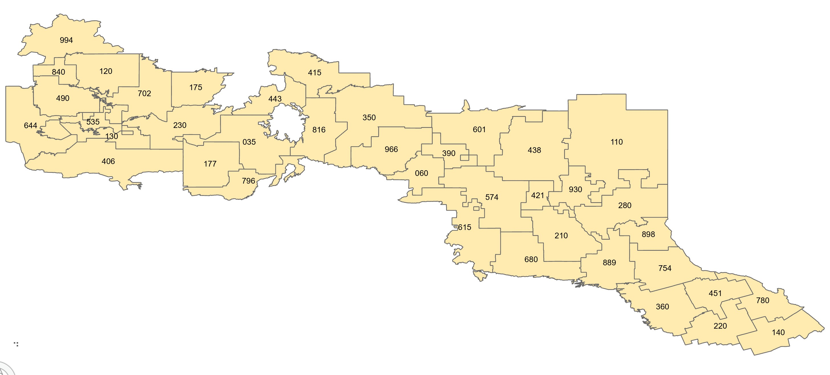
Figure 1: Forest Management Units in Ontario

- How Forest Management Units are Created
An assigned official name and a unique numeric code primarily identify a Forest Management Unit (FMU). The Crown Forests and Lands Policy Branch, Forest Management Policy Section of the Ontario Ministry of Natural Resources approves FMU boundaries, codes, official names, and maintains a set of files of designated management units signed by the Director of Crown Forests and Lands Policy Branch. SFL technical and administrative information is collected and maintained by the Wood Measurement Section, Operations Branch. These sections have a close working relationship with one another and with corporate forest industry and MNR Districts.
Through this relationship, individual FMU boundary locations are negotiated and verified, and any required alterations/amalgamations take the established locations of adjacent and shared FMU boundaries into consideration. The Wood Measurement Section interprets the FMU boundary locations into metes and bounds, and this information, along with a small-scale map of the FMU (1:100,000 – 1:350,000) is included as part of Appendix ‘A’ of the Sustainable Forest License (SFL) official file.
Crown Forests and Lands Policy Branch use a copy of these license files for the management unit designation. These files are stored individually on an FMU-by-FMU basis and are accessed primarily by MNR staff that has Forest Resource Inventory or Forest Management Planning requirements.
During the early stages of the Ontario Living Legacy project, a comprehensive review of each FMU boundary was completed. Several gaps, overlaps, and other inconsistencies were resolved. The review included research of the old license files, older 1:15,840-scale FRI maps and district and company consultations in some locations. With the numerous changes made to each FMU to achieve an accurate (and sometimes negotiated) spatial representation, it is not recommended to return to the historic files for future boundary interpretations.
The mapping standards of the 1960s, 70s and 80s resulted in different interpretations of the boundaries for forest operations. Adjustments have been made to reflect those operational conditions (predominantly completed in the Northwest Region).
- Area of the Undertaking (AOU)
The area within the geographic boundaries of the area of the undertaking is all land and water within forest management unit boundary lines. The northern boundary is generally the northern limit of current commercial timber operations; the southern boundary is generally the limit of the forest on Crown land. Of that area, 385,000 square kilometers (or 38.5 million hectares) is Crown land subject to the undertaking and is referred to as the "Area of the Undertaking" in this Decision. (Source: Ontario Environmental Assessment Board, April 1994. Reasons for Decision: Class Environmental Assessment by the Ministry of Natural Resources for Timber Management on Crown Lands in Ontario. Toronto: Ontario Environmental Assessment Board, report number EA-87-02.)
- Physical Model Diagram
The Physical Model Diagram provides a visual representation of the relationships in the data class.
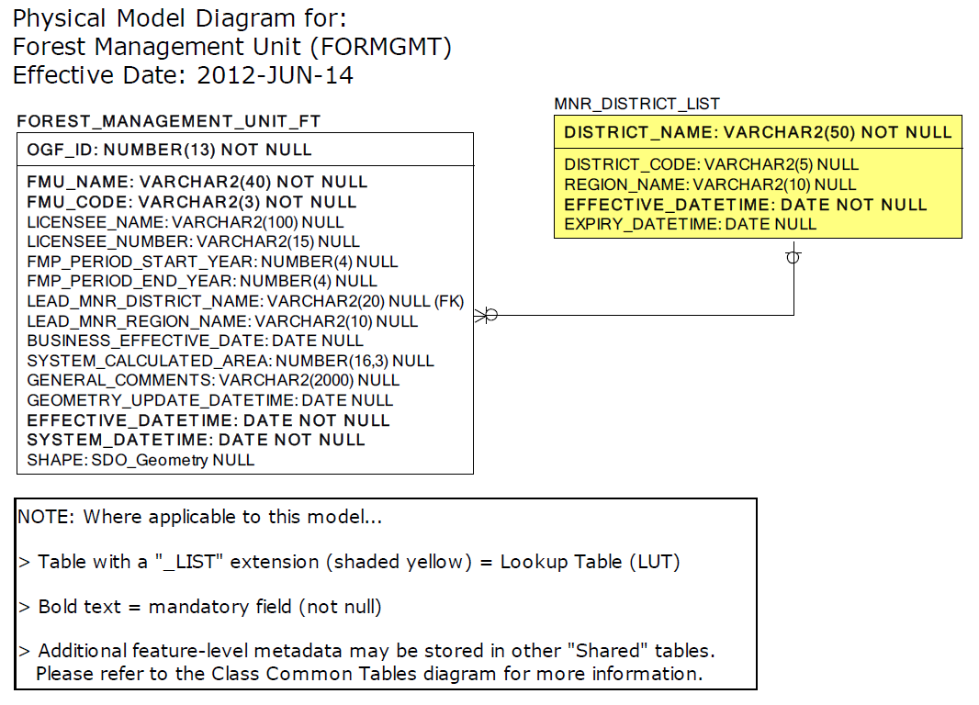
Figure 2: Physical Model Diagram
- Maintenance
The spatial and tabular information for FMUs will be managed by the Crown Forests and Lands Policy Branch, Forest Management Policy Section.
Any questions or concerns about FMU boundary locations and their attributes should be directed to the Forest Management Policy Section to be properly addressed and/or resolved.
For further information including scheduled FMP renewal dates go to Ontario.ca and search Forest Management Units.

Appendix A: Forest Management Unit Data Description

Class Short Name: FORMGMT
Represents the administrative boundaries of all, or part of a Crown forest designated as a "Management Unit" (MU) under Section 7 of the Crown Forest Sustainability Act. The mapped boundary locations are interpreted/derived from the Licensee/Management Unit text descriptions on file with the Ontario Ministry of Natural Resources, Crown Forests and Lands Policy Branch.
Spatial Multi-Non-Tessellating-Polygon: An object is represented by ONE or MORE polygons. Polygons may NOT overlap. HOLES within and GAPS between polygons ARE allowed. Example: the St. Lawrence Islands National Park, where the Park itself is made up of many islands.

FOREST_MANAGEMENT_UNIT_FT
Column Name | Column Type | Mandatory | Short Name | Description
OGF_ID | NUMBER(13,0) | YES | OGF_ID | A unique numeric provincial identifier assigned to each object.
FMU_NAME | VARCHAR2(40) | YES | FMU_NAME | The official designated name assigned to a FMU by the MNR, Crown Forests and Lands Policy Branch.
FMU_CODE | VARCHAR2(3) | YES | FMU_CODE | A numeric character code (with leading zeroes e.g. 011) which uniquely identifies each FMU within the province of Ontario. The FMU Code is assigned to each designated FMU by the MNR, Crown Forests and Lands Policy Branch.
LICENSEE_NAME | VARCHAR2(100) | NO | LIC_NAME | The name of the main Licensee (Sustainable Forest Licence) authorized by the Crown to conduct forest harvest operations within the geographical area of a forest management unit.
LICENSEE_NUMBER | VARCHAR2(15) | NO | LIC_NUM | The number assigned to the Licensee (Sustainable Forest Licence) and filed with the MNR. The number is prefixed by the license type: - SFL: Primary Sustainable Forest License (SFL) e.g.: SFL-542531 (Licensee Name: Iroquois Falls Forest) - SA: Supply Agreement e.g.: SA-490000 (Licensee Name: Algonquin Forest Authority) - FRL: Forest Resource License for Crown Management Units e.g.: FRL-NNNNNN
FMP_PERIOD_START_YEAR | NUMBER(4,0) | NO | START_YEAR | The assigned start year for the Forest Management Plan (FMP) period that is directly associated to an FMU.
FMP_PERIOD_END_YEAR | NUMBER(4,0) | NO | END_YEAR | The assigned end year for the Forest Management Plan (FMP) period that is directly associated to an FMU.
LEAD_MNR_DISTRICT_NAME | VARCHAR2(20) | NO | DISTRICT | The name of the lead MNR District Office that is responsible for managing the FMU. In some instances, an FMU is bisected by an MNR District where one of the District Offices is identified as the business lead contact.
LEAD_MNR_REGION_NAME | VARCHAR2(10) | NO | REGION | The name of the lead MNR Region within whose boundaries the FMU resides.
BUISNESS_EFFECTIVE_DATE | DATE | NO | BUS_EFF_DT | Date that the record becomes effective in relation to the business.
SYSTEM_CALCULATED_AREA | NUMBER(16,3) | NO | SYS_AREA | The area of a polygon measured in square metres by the system.
GENERAL_COMMENTS | VARCHAR2(2000) | NO | GNL_CMT | General comments.
GEOMETRY_UPDATE_DATETIME | DATE | NO | GEO_UPD_DT | Date/time the geometry was created or last modified in the source database.
EFFECTIVE_DATETIME | DATE | YES | EFF_DATE | Date/time the record was created or last modified in the source database.

MNR_DISTRICT_LIST
Column Name | Column Type | Mandatory | Short Name | Description
DISTRICT_NAME | VARCHAR2(50) | YES | DISTRICT_N | List of valid MNR District names.
DISTRICT_CODE | VARCHAR2(5) | NO | DISTRICT_C | Abbreviated name/acronym
EFFECTIVE_DATETIME | DATE | YES | EFF_DATE | Date/time the record was created or last modified in the source database.
EXPIRY_DATETIME | DATE | NO | EXP_DATE | Date/time that the record was expired from use.
REGION_NAME | VARCHAR2(10) | NO | NAME | MNR Region Name.

