GTA Mass Points and
Breaklines 2002
User Guide
  - Provincial Mapping Unit
  - Mapping and Information Resources Branch
  - Corporate Management and Information Division
  - Ministry of Natural Resources and Forestry
2020-03-17

Disclaimer
This technical documentation has been prepared by Her Majesty the Queen in right of Ontario as represented by the Ministry of Natural Resources and Forestry (the “Ministry”). No warranties or representations, express or implied, statutory or otherwise shall apply or are being made by the Ministry with respect to the documentation, its accuracy or its completeness. In no event will the Ministry be liable or responsible for any lost profits, loss of revenue or earnings, claims by third parties or for any economic, indirect, special, incidental, consequential or exemplary damage resulting from any errors, inaccuracies or omissions in this documentation; and in no event will the Ministry’s liability for any such errors, inaccuracies or omissions on any particular claim, proceeding or action, exceed the actual consideration paid by the claimant involved to the Ministry for the materials to which this instructional documentation relates. Save and except for the liability expressly provided for above, the Ministry shall have no obligation, duty or liability whatsoever in contract, tort or otherwise, including any liability or negligence. The limitations, exclusions and disclaimers expressed above shall apply irrespective of the nature of any cause of action, demand or action, including but not limited to breach of contract, negligence, strict liability, tort or any other legal theory, and shall survive any fundamental breach or breaches.
Cette publication spécialisée n’est disponible qu’en anglais.

Additional Information
For more information about this document, please contact the Provincial Mapping Unit at pmu@ontario.ca.

Executive Summary

Key Words
Vector, Mass Points, Breaklines, Softcopy Photogrammetry, WRIP, Water Resources Information Program, Provincial Mapping Unit, PMU, Greater Toronto Area, GTA.

Abstract
The Greater Toronto Area (GTA) Mass Points and Breaklines 2002 elevation data is a collection of highly accurate and precise 3D mass points and breakline features that were interpreted using softcopy photogrammetry from aerial photography. This data set encompasses the Greater Toronto Area (GTA) and the surrounding area extending from the Niagara region to Port Severn, the Kawartha Highlands and the Bay of Quinte regions.

Table of Contents
Disclaimer 2
Additional Information 2
Executive Summary 3
Key Words 3
Abstract 3
Table of Contents 4
List of Tables 5
List of Figures 5
List of Acronyms 6
1. Product Description 7
1.1 Geographic Extent 7
1.2 Reference System 8
2. Product Details 9
2.1 Vector Elevation Data 9
2.2 Vector Data Creation 9
2.2.1 Softcopy Photogrammetry 9
2.2.2 Z-Value Assignment of Regularly Spaced Points (10m Spaced Points) 10
2.3 TIN and DEM Products 10
2.4 Data Delivery Format 12
2.5 Use Restrictions 15
3. References 16

List of Tables
Table 1: Regularly spaced DTM specifications 9
Table 2: Breakline classification used to create the GTA TIN model. 11
Table 3: Breakline features and associated elevation values 13

List of Figures
Figure 1: Extent of GTA 2002 Project Area 7
Figure 2: A TIN without breaklines (A) and a TIN with breaklines (B) 10
Figure 3: Example of Tile Folder 12
Figure 4: Three Downloadable Package Areas 13

List of Acronyms
CGVD28: Canadian Geodetic Vertical Datum 1928
DEM: Digital Elevation Model
DTM: Digital Terrain Model
GIS: Geographic Information Systems
GTA: Greater Toronto Area
LIO: Land Information Ontario
NAD83: North American Datum of 1983
PMU: Provincial Mapping Unit
TIN: Triangulated Irregular Network
UTM: Universal Transverse Mercator

- Product Description
In the spring of 2002, a project was initiated to acquire leaf-off photography for the Greater Toronto Area (GTA) and to generate a highly accurate and precise elevation data set using softcopy photogrammetric techniques. This terrain data was designed to support the generation of a Digital Elevation Model (DEM) and other elevation data product derivatives (Regional Municipality of York, 2001).
  - Geographic Extent
The elevation data is organized into 20km x 20km tiles and encompasses the Greater Toronto Area (GTA) and surrounding area extending from the Niagara region to Port Severn, the Kawartha Highlands and the Bay of Quinte regions.
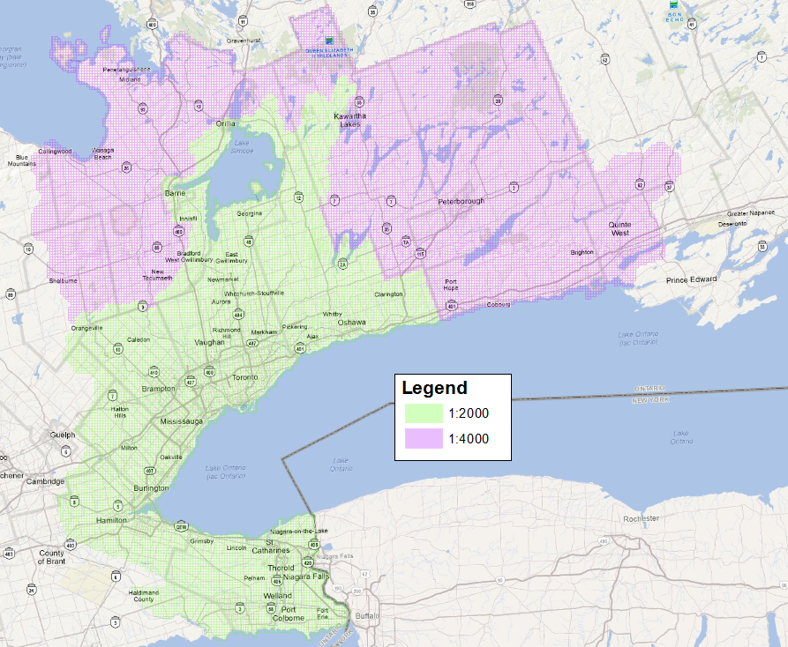
Figure 1: Extent of GTA 2002 Project Area
This data is intended to be used for pre-engineering survey and design as well as the production of planimetric mapping at differing accuracies with the following specifications for each:
- 1:2000 Scale Mapping: Horizontal and vertical accuracy 0.5m, suitable for 1m contour generation. Final point spacing of Digital Terrain Model (DTM) is 10m.
- 1:4000 Scale Mapping: Horizontal and vertical accuracy 1m, suitable for 2m contour generation. Final point spacing of DTM is 20m.
  - Reference System
Horizontal Reference System
The horizontal coordinate system of the vectors is the Universal Transverse Mercator (UTM) and covers zones 17 and 18. The horizontal datum of the vector data is the North American Datum of 1983 (NAD83).
The horizontal unit of measure (coordinate system axis units) for all raster grid cells in the DEM is meters (m).
Vertical Reference System
The vertical coordinate system of the vector data is based on the Canadian Geodetic Vertical Datum 1928 (CGVD28) of the Geodetic Survey Division of Natural Resources Canada and is measured in metres above mean sea level. For more information please see the Height Reference System Modernization (https://www.nrcan.gc.ca/height-reference-system-modernization/9054#_Canadian_Geodetic_Vertical_1).
- Product Details
  - Vector Elevation Data
An objective of the GTA softcopy photogrammetry project was to create elevation data that supported the accurate generation of 1m contours. Elevation data has been generated in two formats in order to meet this objective. First, a series of linear features have been identified as terrain influencing features and interpreted from aerial photography using softcopy photogrammetry. A regularly spaced network of 3D (x,y,z) data points has also been generated to ensure the precision & accuracy of the intended 1m contours. Table 1 provides a brief summary of the specifications of this product.
Table 1: Regularly spaced DTM specifications
Scale | Point Spacing | Horizontal Accuracy | Vertical Accuracy
1:2000 | 10 x 10 m | 0.5 m | 0.5 m
1:4000 | 20 x 20 m | 1 m | 1 m
  - Vector Data Creation
    - Softcopy Photogrammetry
Bare earth elevation measurements are always the ultimate goal of any elevation modeling for hydrologic purposes. The presence of vegetation poses the greatest problem in obtaining this information.
Elevation data was collected using soft-copy photogrammetry. This method differs from typical analog photogrammetry methods as it incorporates analytical stereoplotter functionality and integrates numerous photogrammetric tasks into one digital (computer) environment. Using photo stereo pairs the computer software automatically calculates a stereo model and, from that, a digital terrain model. Using digital stereo glasses in order to see in three dimensions, an analyst creates point and breakline features in x, y and z coordinate space (3 dimensions). In order to capture an elevation measurement, the analyst moves the cursor up or down until they are certain that the cursor is located on the bare surface of the model.
    - Z-Value Assignment of Regularly Spaced Points (10m Spaced Points)
Z values for this data set were assigned using widely used and accepted soft copy photogrammetric methods. All x/y locations for this data set were generated automatically. Assignment of bare earth z values was then completed, in most cases using automated processes in combination with interactive/manual editing by GIS technicians using the soft copy photogrammetric methods.
  - TIN and DEM Products
The GTA Mass Points and Breaklines 2002 elevation data was delivered in a format best suited for 3D surface modelling using a Triangulated Irregular Network (TIN) data model. A TIN and DEM have been generated to honour the original vector data as much as possible. The DEM has been generated from the vector data by first creating an ArcGIS Terrain using the elevation points, lines and polygons then this Terrain was converted to a DEM using a Natural Neighbours interpolation.
Breaklines are a key dataset that is used when creating a TIN as they define rapid or sharp changes in elevation. Without the use of breaklines, a TIN will yield poor representation of the terrain surface. Figure 2 demonstrates the level of detail added within a TIN by including breaklines.
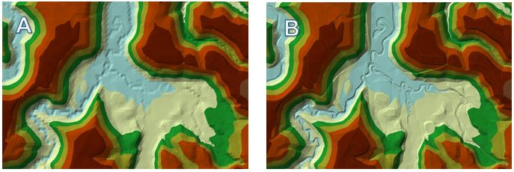
Figure 2: A TIN without breaklines (A) and a TIN with breaklines (B)
Prior to TIN modeling, each coded breakline feature that was captured had to be designated to an appropriate TIN category based on their use as a hard or soft breakline feature before they were used in the TIN modeling process (see Table 2). Decisions were made based on whether the features were coded as approximate or actual and using a basic understanding of hydrology.
Table 2: Breakline classification used to create the GTA TIN model.
Classification Code | Feature Class | TIN Input | Description
Ditch C/L | Polyline | Hard Breakline | All major ditch centerlines that will ensure the proper generation of 1.0m contours.
Marsh/Swamp | Polygon | Soft Replace | The outline of visible interpretable marshes/swamps. Avoid wet areas that are likely seasonal.
Creek/Stream C/L | Polyline | Hard Breakline | The centerline of creeks and streams that are less than 4 meters wide.
Creek/Stream C/L approx. | Polyline | Soft Breakline | Where the creek/streams are difficult to accurately compile (i.e. tree cover), or where the path may be uncertain.
River/Shoreline | Polygon | Hard Replace | Both sides of rivers greater than 4 meters wide, also contains ponds and reservoirs.
River/Shoreline approx. | Polygon | Soft Replace | Where the river/shoreline may be difficult to accurately compile (i.e. tree cover).
WaterBody | Polygon | Hard Replace | All identifiable water bodies such as Lake Ontario, Lake Scugog, Lake Wilcox.
Headwall/Culv | Polygon | Hard Replace | Outline of all headwalls and culverts to scale (concrete box culverts, not corrugated steel culverts)
Dam2Sc. | Polygon | Hard Replace | The outline of all Dams to Scale.
AccWay | Polygon | Hard Replace | All major access ways required to ensure the proper generation of 1.0m contours.
RoadEdgPv | Polygon | Hard Replace | All paved road edges
RoadEdgCb | Polygon | Hard Replace | All curbed road edges.
RoadEdgGr | Polygon | Hard Replace | All gravel road edges
Rail C/L | Polygon | Hard Replace | All rail centerlines
Bridge | Polygon | Hard Replace | All bridges which service roads or rails.
RetWall | Polygon | Hard Replace | All significant retaining walls.
Breakline | Polygon | Soft Replace | Generic breaklines for all pits/piles, top of bluff, gullies etc. to ensure the proper generation of 1.0m contours.
Mass Points | Point | Mass Points | Not Applicable
Once the polygons and lines were divided into their respective layers, a single DTM point layer was generated that was comprised of soft and hard breakline layers and hard and soft polygon layers. These datasets were then used as input for the TIN creation.
The final DEM product was created by converting the TIN model to a 5m raster elevation surface using a Natural Neighbours interpolation algorithm (ESRI, 2014).
  - Data Delivery Format
The GTA Mass Points and Breaklines 2002 data is currently distributed through the Ontario GeoHub as part of the Ontario Mass Points and Breaklines (https://geohub.lio.gov.on.ca/datasets/mnrf::ontario-mass-points-and-breaklines).
Each package consists of three files: point, line, poly, with line and polygon features representing 3D breaklines.
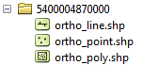
Figure 3: Example of Tile Folder
The products can be downloaded in three packages NE, NW and SW (see Figure 4).
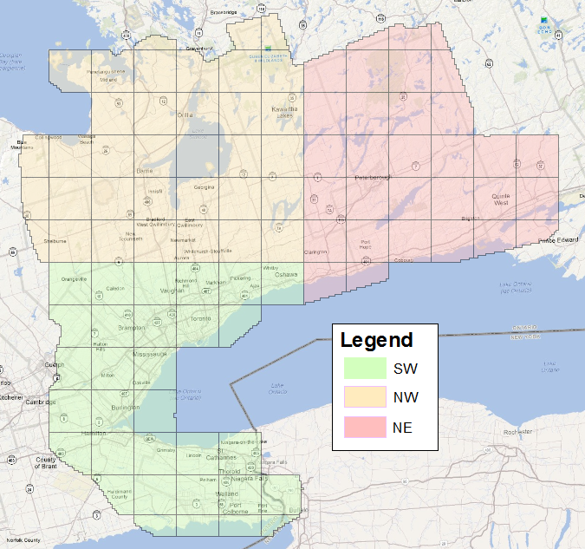
Figure 4: Three Downloadable Package Areas
Table 3 is a listing of all linear features captured. As is the case with all linear features a vertex marks any directional change. It is important to note that since this data is considered 3D, all points, lines, polygons and vertexes make up lines and polygons contain x, y & z coordinates.
Table 3: Breakline features and associated elevation values
Category | Classification Code | Feature Type(s) | Description
Drainage | Ditch C/L | Line | All major ditch centrelines that will ensure the proper generation of 1.0m contours.
Drainage | Marsh/Swamp | Polygon / Line | The outline of visible interpretable marshes/swamps. Avoid wet areas that are likely seasonal
Drainage | Creek/Stream C/L | Line | The centreline of creeks and streams that are less than 4 metres wide.
Drainage | Creek/Stream C/L approx. | Line | Where the creek/streams are difficult to accurately compile (i.e. tree cover), or where the path may be uncertain.
Drainage | River/Shoreline | Line / Polygon | Both sides of rivers greater than 4 metres wide, also contains ponds and reservoirs
Drainage | River/Shoreline approx. | Line / Polygon | Where the river/shoreline may be difficult to accurately compile (i.e. tree cover)
Drainage | WaterBody | Polygon | All identifiable water bodies such as Lake Ontario, Lake Scugog, Lake Wilcox.
Drainage | Headwall/Culv | Polygon | Outline of all headwalls and culverts to scale (concrete box culverts, not corrugated steel culverts)
Drainage | Dam2Sc. | Polygon | The outline of all dams to scale.
Transportation | AccWay | Line / Polygon | All major accessways required to ensure the proper generation of 1.0m contours.
Transportation | RoadEdgPv | Line / Poygon | All paved road edges
Transportation | RoadEdgCb | Line / Polygon | All curbed road edges
Transportation | RoadEdgGr | Line / Polygon | All gravel road edges
Transportation | RailC/L | Line / Polygon | All rail centrelines
Transportation | Bridge | Line | All bridges which service roads or rails
Miscellaneous | RetWall | Line | All significant retaining walls
Contour / DEM | Breaklines | Line / Polygon | Generic breaklines for all pits/piles, top of bluff, gullies etc. to ensure the proper generation of 1.0m contours

  - Use Restrictions
The GTA Mass Points and Breaklines 2002 are considered Open Data. You are free to copy, modify, publish, translate, adapt, distribute or otherwise use the Information in any medium, mode or format for any lawful purpose. If you do any of the above you must use the following attribution statement “Contains information licensed under the Open Government Licence – Ontario.”
- References
Earth Science Research Institute (ESRI). 2014. Terrain to Raster Function for ArcGIS software (http://resources.arcgis.com/en/help/main/10.1/index.html#//009t00000206000000)
Earth Science Research Institute (ESRI). 2014. Natural Neighbors Interpolation Algorithm (http://resources.arcgis.com/en/help/main/10.1/index.html#//005v00000027000000)
Regional Municipality of York. 2001. Request for Proposal P-01-71: Greater Toronto and Area Digital Orthophotography and Digital Terrain Data, Finance Department, Supplies and Services Branch, 44p.
Version 1516.1

