Quick Start Guide:
How to Order Ontario Imagery

Overview
Ordering imagery from Land Information Ontario (LIO) requires:
- A completed Imagery Order Form.
- A list of required FileNames (MS Excel, CSV, Notepad)
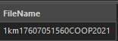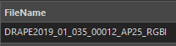
Ortho tile Stereo line

Quick Links
Compiling a FileName List 2
Imagery Orders Web App 2
Select by Point, Polygon or Lasso 2
Spatial Query 4
Desktop GIS Software 6
Submitting Your Order 6
The information in this document may not be compatible with assistive technologies. For an alternative format please contact imagery@ontario.ca or call LIO Support at 705-772-5891.
©King’s Printer for Ontario, 2024

Compiling a FileName List
A list of ortho tiles or stereo frames/lines must be included with your completed Imagery Order Form.
Compile the list using:
- The Imagery Orders Web App (for select projects); or,
- Your own desktop GIS Software (i.e., ESRI ArcGIS or QGIS)

Imagery Orders Web App
- Visit the Imagery Orders Web App
- Select the tiles that intersect your area of interest using:
  - Point, Polygon, or Lasso tools; or,
  - Spatial query with your area of interest
Tip: See instructions for selecting ortho tiles or stereo frames using the app, below.
- Export selection to CSV file.

Select by Point, Polygon or Lasso
- Click the ‘Select’ widget in the upper left corner of the app.
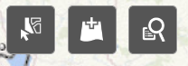

- Select your selecting tool from the list of options (point, polygon, or lasso).


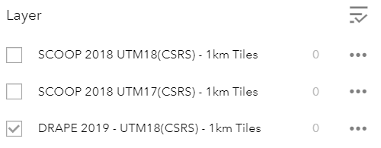
- Select the product using the checkbox.

- Perform the selection on the map based on your area of interest.
Tip: Make multiple selections by holding down the Shift key.
- Click the ellipsis button beside the product name.
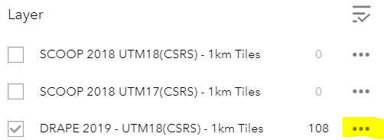
- Select ‘Export to CSV file.’

Spatial Query
- Click the ‘Add Data’ widget in the upper left corner of the app.
- Add your area of interest to the map. Do this by adding data from ArcGIS Online, a URL, or a File (.shp, CSV, KML, GPX or GeoJSON).

- Click the ‘Query’ widget in the upper left corner of the app.
- From the list of Tasks, select the project and product type.
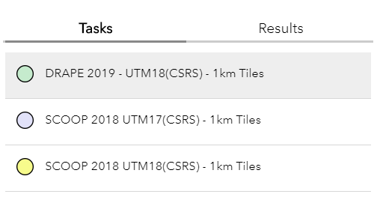
- Ensure the spatial filters are set up to intersect the layer that represents your area of interest. You can also apply a search distance or buffer as required.
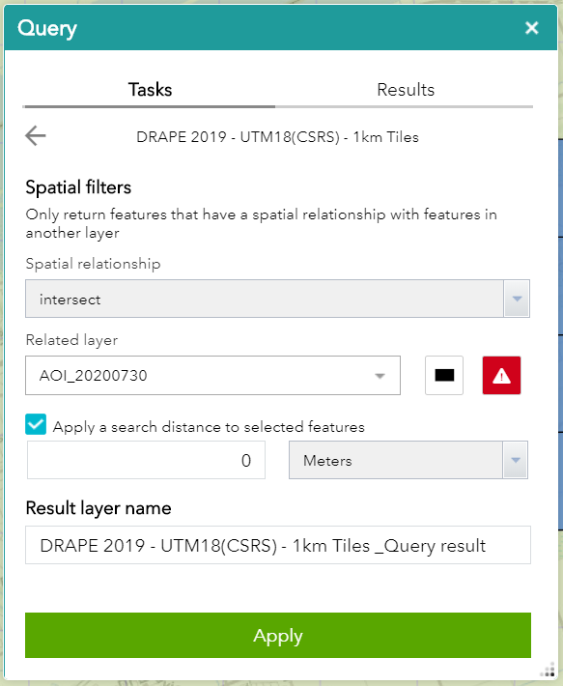
- Click Apply.
- Click the ellipsis button beside the query results.

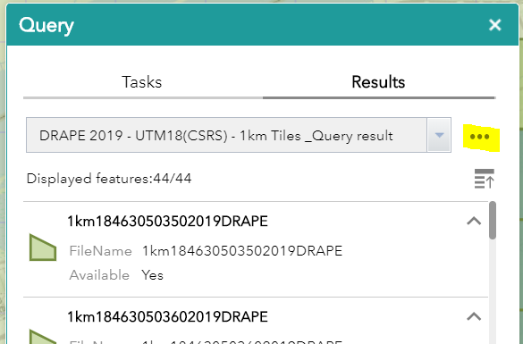

- Select ‘Export to CSV file.’

Desktop GIS Software
- Visit Ontario Geohub and click on the Ontario Imagery Program button to see a program overview, or browse all imagery collections using the search bar using keyword “imagery.”
- Download the corresponding ortho or stereo index (shapefile format) for your project. Click ‘Read More’ to reveal the rest of the page and the index is under ‘Available Products.’
- Using your desktop GIS software and the index(es) downloaded in Step 2, compile a list of FileNames for your area of interest and export to a shapefile or .dbf file.

Submitting Your Order
Submit your tile/stereo list(s) and completed Imagery Order Form to imageryorders@ontario.ca. A LIO Support Officer will contact you within two (2) business days regarding your order to discuss pricing and delivery options.

