LIO Open Data Services
User Guide
  - Land Information Ontario
Updated 2023-10-19

Disclaimer
This technical documentation has been prepared by His Majesty the King in right of Ontario as represented by the Ministry of Natural Resources and Forestry (the “Ministry”). No warranties or representations, express or implied, statutory or otherwise shall apply or are being made by the Ministry with respect to the documentation, its accuracy or its completeness. In no event will the Ministry be liable or responsible for any lost profits, loss of revenue or earnings, claims by third parties or for any economic, indirect, special, incidental, consequential or exemplary damage resulting from any errors, inaccuracies or omissions in this documentation; and in no event will the Ministry’s liability for any such errors, inaccuracies or omissions on any particular claim, proceeding or action, exceed the actual consideration paid by the claimant involved to the Ministry for the materials to which this instructional documentation relates. Save and except for the liability expressly provided for above, the Ministry shall have no obligation, duty or liability whatsoever in contract, tort or otherwise, including any liability or negligence. The limitations, exclusions and disclaimers expressed above shall apply irrespective of the nature of any cause of action, demand or action, including but not limited to breach of contract, negligence, strict liability, tort or any other legal theory, and shall survive any fundamental breach or breaches.
Cette publication spécialisée n’est disponible qu’en anglais.

Additional Information
This document does not comply with all the applicable guidelines for accessible digital documents. For an alternative format please email Land Information Ontario at lio@ontario.ca.
For more information about this document please email Land Information Ontario at lio@ontario.ca.
This document details how to use the LIO Open Data services. This is a living document which will be updated as new data and processes evolve.

Table of Contents
Disclaimer 2
Additional Information 2
Table of Contents 3
Introduction to LIO Web Services 4
Comparing functionality available by connection method 4
Location of Web Services 5
Web Services on the ArcGIS1 server 5
Web services on the ArcGIS2 server 5
Using Web Services in Esri Software 6
ArcGIS Desktop 6
ArcGIS Pro 6
Using Web Services in QGIS version 3.14 9
QGIS - ArcGisFeatureService 9
QGIS - ArcGisMapService 12

Introduction to LIO Web Services
Land Information Ontario (LIO) provides open geospatial data web services that are available to everyone, including the public, via the internet and internal web services that are only available to the Ontario Public Service (OPS) via the intranet.
This document describes how to access the LIO Open Data, LIO Topographic and Ontario Imagery services with ArcMap, ArcGIS Pro and QGIS. These GIS software applications may change functionality with each new version. The following descriptions of software applications and web services are as of the date of this document.

Comparing functionality available by connection method
Table 1: Functionality available in different GIS applications.
Application | View attribute table | Change symbology | Identify features | Label
ArcMap | No | No | Yes | No
ArcMap and ArcGIS OnLine | Yes | Yes | Yes | Yes
ArcGIS Pro | Yes | Yes | Yes | Yes
ArcGIS Pro and ArcGIS OnLine | Yes | Yes | Yes | Yes
QGIS – ArcGisFeatureServer | Yes | Yes | Yes | Yes
QGIS – ArcGisMapServer | No | No | Yes | No
QGIS – WMS/WMTS | No | No | Yes | No

Location of Web Services

Web Services on the ArcGIS1 server
Use these links to access:
- LIO_Cartographic/LIO_Topographic
Public (Internet) URL - https://ws.lioservices.lrc.gov.on.ca/arcgis1/rest/services
OPS (Intranet) URL - https://intra.ws.lioservices.lrc.gov.on.ca/arcgis1/rest/services

Web services on the ArcGIS2 server
Use these links to access:
- LIO_OPEN_DATA
- LIO_Imagery/Ontario_Imagery_Service (only available to OPS internal)
Public (Internet) URL - https://ws.lioservices.lrc.gov.on.ca/arcgis2/rest/services
OPS (Intranet) URL - https://intra.ws.lioservices.lrc.gov.on.ca/arcgis2/rest/services

Using Web Services in Esri Software

ArcGIS Desktop
ArcGIS Desktop is designed to work with services. For example, when you click Add Data, you can browse to a server connection and add map and image web services into your table of contents, just like you would with any other data source. For more information on how to connect visit About using ArcGIS services in ArcGIS Desktop—ArcMap | Documentation

ArcGIS Pro
ArcGIS Pro allows you to browse to a GIS server and access its contents from a folder connection. This may be useful if you create files using data in the server and store them in the same folder location as the server connection file. You will be able to change symbology, open the attribute table or turn on labels for the layer. For more information on how to connect visit Connect to a GIS server—ArcGIS Pro | Documentation

Add a layer to the map
- Open ArcGIS Pro > Map tab > Add Data drop-down list > Add Data From Path
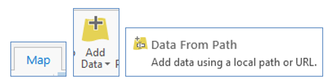
Figure 1. Steps to add a web service to ArcGIS Pro.
- Add the URL. Section 2 above describes how to navigate to the REST point and find the desired layer URL. For this example the layer URL is: https://ws.lioservices.lrc.gov.on.ca/arcgis2/rest/services/LIO_OPEN_DATA/LIO_Open03/MapServer/16 (copy and paste URL into form) > Add
- Layer options are available. You can open the table or zoom to layer.
- LIO_Topographic URL:
https://ws.lioservices.lrc.gov.on.ca/arcgis1/rest/services/LIO_Cartographic/LIO_Topographic/MapServer/0
- Ontario_Imagery_Service: (internal to OPS intranet)
https://intra.ws.lioservices.lrc.gov.on.ca/arcgis2/rest/services/LIO_Imagery/Ontario_Imagery_Web_Map_Service/MapServer/0

Add a service connection
If you use the Add Data option described in the previous section to add a service, then you will not be able to open the attribute table, change symbology or label the layer. Follow the steps below to add a connection to the service which will allow the full functionality.
- Insert tab > Connections drop-down > New ArcGIS Server
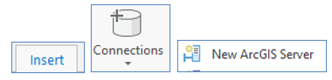
Figure 2. Steps to connect to a web service.
- Add the URL. Section 2 above describes how to navigate to the REST point and find the desired service URL. For this example the service URL is: https://ws.lioservices.lrc.gov.on.ca/arcgis2/rest/services/LIO_OPEN_DATA/LIO_Open03/MapServer (copy and paste URL into form) > Add.
- Open the Catalog pane > click the arrow at the left of Servers to drop-down the layers > drag a layer to the map
- Layer options are available. You can open the table or zoom to layer.

Add a layer from ArcGIS Online (AGOL)
- In the Catalog pane choose Portal > All Portal icon
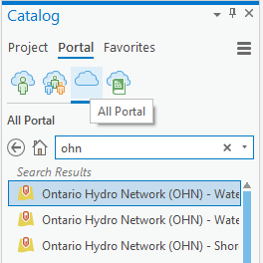
Figure 3. Catalog pane to search ArcGIS OnLine.
- Enter a search term (ex: ohn) > add the layer to map from returned list
- Check the publisher to make sure you are getting the right data
- You will be able to change symbology, open the attribute table or turn on labels for the layer.

Connect to related tables
- Add the table layer to the map: Add Data drop-down list > Add Data From Path > Copy and Paste the layer URL > Add
- Now you can create the relate.

Display limitations
- Only 1000 polygons display from layer (5000 for some layers)
- The 1000 polygons are not completely related to the map display extent. In a test with the wetland data, at 1:145,519 scale there were 760 wetland polygons on the display.
- When zooming in to 1:130,000 scale there were 667 wetland polygons on the display. Note: Polygons are displayed in this view between polygons that were displayed in the previous view.
- This means that even though there are less than 1000 polygons displayed, you do not necessarily see all the polygons that exist in the display extent. This could be misleading to users thinking that they are seeing all the data for this extent.
- Interestingly, there were fewer polygons visible at 125,000 than at 130,000.
- At about 100,000 all polygons seemed to be visible. (539 polygons in the map display).

Using Web Services in QGIS version 3.14
Note: QGIS version 3.18.3 has replaced the add ArcGisFeatureService and add AprGisMapService options with add ArcGIS REST Servers.
QGIS version 3.14.1 and earlier is being used to create this section. Different versions may behave differently. Three methods of connecting to the web services are described below. Some pros and cons are listed for each method.

QGIS - ArcGisFeatureService
Pros: Use this method if you want to be able to open the attribute table, change symbology, or label features.
Cons: Do not use this method if you want to load a raster layer like the LIO_Topographic or LIO_Imagery layers. Use the ArcGisMapService connection method instead.
Method: Note: There are several LIO Open web services and each service will contain approximately 20 layers. Connect to a service (ex: LIO_Open01) and not to an individual layer (ex: Building As Symbol).
- Open QGIS > right-click the "ArcGisFeatureService" icon > click “New Connection…” to open the connection form.
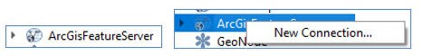
Figure 4. Steps to connect to an Arc GIS Feature Server.
- Add a name. This can be anything you want. This example uses the name of the service being connected “LIO_Open01”.
- Add the URL. Section 2 above describes how to navigate to the REST point and find the desired service or layer URL. For this example the service URL is: https://ws.lioservices.lrc.gov.on.ca/arcgis2/rest/services/LIO_OPEN_DATA/LIO_Open01/MapServer (copy and paste URL into form)
- Click OK
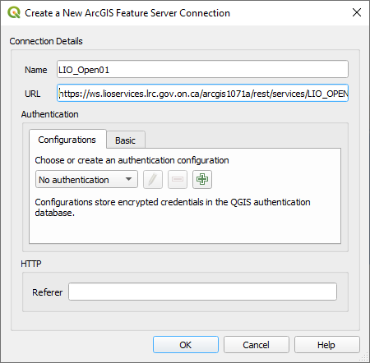
Figure 5. Create a New ArcGIS Feature Server Connection form.
- Click the arrow to the left of the added service to drop down the layers
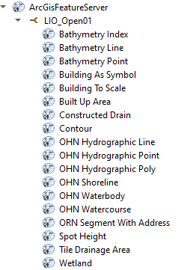
Figure 6. List of feature layers.
- Right-click a layer and select "Add Layer to Project”, or double-click a layer to add it to the Canvas
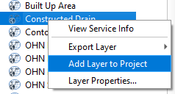
Figure 7. Add Layer to Project button.
- When you turn a layer on, it may take quite a while to draw the layer if it is a large dataset. QGIS will cache the data so it will be quick to draw next time you turn the layer on. The cache will be stored for 24 hours. If you zoom in to a small area it will draw faster.

QGIS - ArcGisMapService
Pros: Use this method if you want to load a raster layer like the LIO_Topographic or LIO_Imagery layers.
Cons: Do not use this method if you want to be able to open the attribute table, change symbology, or label features. Use the ArcGisFeatureService connection method instead.
Method:
- Open QGIS > right-click the "ArcGisMapService" icon > click “New Connection…” to open the connection form.
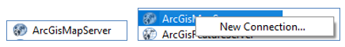
Figure 8. Steps to connect to an Arc GIS Map Server.
- Add a name. This can be anything you want. This example uses the name of the service “LIO_Topographic”.
- Add the URL. Section 2 above describes how to navigate to the REST point and find the desired service or layer URL. For this example the URL is: https://ws.lioservices.lrc.gov.on.ca/arcgis1/rest/services/LIO_Cartographic/LIO_Topographic/MapServer (copy and paste URL into form)
- Click OK
- click the arrow to the left of the added service to drop down the layers
- Right-click a layer and select "Add Layer to Project”, or double-click a layer to add it to the Canvas
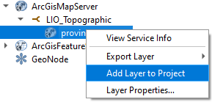
Figure 12. Add Layer to Project button.

Ontario Imagery Service
The imagery service is not open data and is only available to the OPS intranet. Use the ArcGisMapServer to connect.
https://intra.ws.lioservices.lrc.gov.on.ca/arcgis2/rest/services/LIO_Imagery/Ontario_Imagery_Web_Map_Service/MapServer

