User Guide
for
LIO Topographic Data Cache
Geospatial Ontario Data Class
  - Geospatial Services
  - Digital, Data, Information and Business Services Branch
  - Corporate Management and Information Division
  - Ministry of Natural Resources
2025-11-14

Disclaimer
This technical documentation has been prepared by His Majesty the King in right of Ontario as represented by the Ministry of Natural Resources (the “Ministry”). No warranties or representations, express or implied, statutory or otherwise shall apply or are being made by the Ministry with respect to the documentation, its accuracy or its completeness. In no event will the Ministry be liable or responsible for any lost profits, loss of revenue or earnings, claims by third parties or for any economic, indirect, special, incidental, consequential or exemplary damage resulting from any errors, inaccuracies or omissions in this documentation; and in no event will the Ministry’s liability for any such errors, inaccuracies or omissions on any particular claim, proceeding or action, exceed the actual consideration paid by the claimant involved to the Ministry for the materials to which this instructional documentation relates. Save and except for the liability expressly provided for above, the Ministry shall have no obligation, duty or liability whatsoever in contract, tort or otherwise, including any liability or negligence. The limitations, exclusions and disclaimers expressed above shall apply irrespective of the nature of any cause of action, demand or action, including but not limited to breach of contract, negligence, strict liability, tort or any other legal theory, and shall survive any fundamental breach or breaches.

Additional Information
This document does not comply with all the applicable guidelines for accessible digital documents. For an alternative format please email Geospatial Services at geospatial@ontario.ca.
For more information about this document, please contact Geospatial Services at geospatial@ontario.ca.

Executive Summary
    - Key Words
LIO Topographic Data Cache, Geospatial Ontario, Land Information Ontario

Abstract
This user guide provides information about the Land Information Ontario (LIO) Topographic Data Cache. The cache is a collection of topographic data that has been preprocessed for fast, seamless display at predefined scales.

Table of Contents
Disclaimer 2
Additional Information 2
Executive Summary 3
1.1.1 Key Words 3
Abstract 3
Table of Contents 4
List of Acronyms 5
2. Introduction 6
3. Objectives 6
4. LIO Topographic Data Cache 6
4.1 Layers 7
5. Links to Additional Information 10
APPENDIX A: LIO Topographic Data Cache (Raster) Legend 11

List of Acronyms
GEO: Geospatial Ontario
GIS: Geographic Information Systems
LIO: Land Information Ontario
MNR: Ontario Ministry of Natural Resources
NHPN: National Highway Planning Network
OHN: Ontario Hydro Network
ORN: Ontario Road Network
ORWN: Ontario Railway Network
OTN: Ontario Trail Network
- Introduction
The LIO Topographic Data Cache is a visually appealing cartographic product provided for use as a base map of Ontario’s features. The caches contain authoritative data for features such as road names, township boundaries and water features. Forty-three data layers make up the LIO Topographic Data Cache.
- Objectives
This user guide is intended for users of the LIO Topographic Data Cache. The remainder of this document describes both versions of the cache and the data layers used in their creation.
- LIO Topographic Data Cache
The LIO Topographic Data Cache is a collection of topographic data that has been preprocessed for fast, seamless display at predefined scales. The topographic data consists of constructed and natural features that make up the landscape of the Province of Ontario. The cache provides limited data from areas outside the province's boundaries, i.e. the United States and adjacent provinces and territories.
The cache uses a Web Mercator projection and standard scales (ESRI ArcGIS Online, Google) for familiarity. For more information, refer to ArcGIS Online moving to Google / Bing tiling scheme: What does this mean for you? Having the same projection, zoom levels and tiling scheme makes it easier for users to mash-up their own maps with other caches. The legend for the raster cache is shown in Appendix A.
Data was acquired from the following sources:
- GEO
- MNR
- GeoGratis
- United States - Department of Transportation - Research and Innovative Technology Administration's Bureau of Transportation Statistics
The raster version of the cache is composed of pre-created images of the data and may be better suited for older devices as there is limited drawing requirements. The raster version is approximately 700GB in total size.
The cache is updated annually. The contributing data layers may have different maintenance and update cycles. Some cache layers have been processed to optimize their display in a cartographic product. Other layers are unchanged from the authoritative data and simply symbolized. The cartographic symbology used in the data cache is intentionally muted to allow users to showcase their data. Because the LIO Topographic Data Cache is a derived product, users are directed to download the authoritative data from the Ontario GeoHub. The legend for the raster cache is shown in Appendix A.
  - Layers
The following layers are included in the LIO Topographic Data Cache:
- Airport Official
- Building as Symbol
- Building to Scale
- Canadian Geographic Names
- Conservation Reserve Regulated
- Contour
- Federal Land, Other
- Federal Protected Area
- Geographic Names Ontario
- Indian Reserve
- Large scale data, 1:10m
- Lot Fabric Improved
- Municipal Boundary – Upper Tier and District
- Municipal Boundary – Lower and Single Tier
- National Highway Planning Network (NHPN)
- National Road Network – Manitoba
- National Road Network – Nunavut
- National Road Network – Quebec
- North American Atlas – Boundaries
- North American Atlas – Hydrography
- North American Atlas – Populated Places
- OHN – Hydrographic Line
- OHN – Hydrographic Point
- OHN – Hydrographic Poly
- OHN – Small Scale Shoreline
- OHN – Small Scale Waterbody
- OHN – Small Scale Watercourse
- OHN – Waterbody
- OHN – Watercourse
- Ontario 30m Hillshade
- ORN – Road Net Element – Blocked Passage
- ORN – Road Net Element – Structure
- ORN Segment with Address
- ORWN Junction
- ORWN Station
- ORWN Structure Line
- ORWN Track
- OTN Segment
- OTN Access Point
- Province
- Provincial Park Regulated
- Spot Height
- Utility Line
- Wetland
- Wooded Area

- Links to Additional Information
- Geospatial Ontario (GEO)
(https://www.ontario.ca/page/geospatial-ontario)
- The Make a Topographic Map application
(https://www.ontario.ca/page/topographic-maps)
- Ontario Ministry of Natural Resources (https://www.ontario.ca/page/ministry-natural-resources)
- Ontario GeoHub: LIO Topographic Data Cache (Raster version) (https://geohub.lio.gov.on.ca/datasets/mnrf::lio-topographic-data-cache/)
For more information on the LIO Topographic Data Cache contact geospatial@ontario.ca.
We want your feedback. Please email a screen capture of the missing data or error to geospatial@ontario.ca. Submissions will be reviewed and considered where appropriate.

APPENDIX A: LIO Topographic Data Cache (Raster) Legend
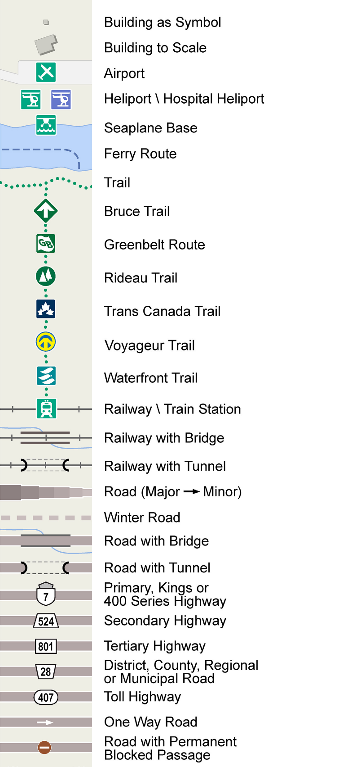
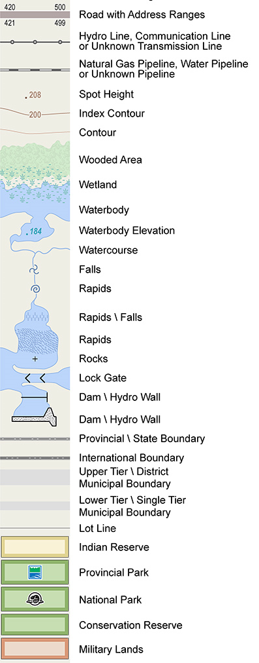

Version 2526.1

