Dataset Documentation:
Ontario Trail Network (OTN) Segment

Table of Contents
Table of Contents 1
Purpose 2
Data Class Name: OTN Segment 2
Data Change History 2
Physical Model Diagram 2
Data Dictionary 3
OTN_SEGMENT_DERIVED_FT 3
Cette publication spécialisée n’est disponible qu’en anglais.
This document does not comply with all the applicable guidelines for accessible digital documents. For an alternative format please contact Land Information Ontario at lio@ontario.ca.

Purpose
This document provides additional information to support the use of geospatial data. The Data Change History lists modifications made during the lifecycle of the data class. The Physical Model Diagram provides a visual representation of the relationships in the data class. It shows the cardinality and relationship between tables and lists the names of the attributes in each table. It also identifies primary and foreign keys. The Data Dictionary and Lookup Tables and Values describe the table and fields.

Data Class Name: OTN Segment
Data Class Short Name: OTNSEGAS

Data Change History
Date | Details of Change
2021-07-15 | NEW denormalized derived data class (Open Data) supporting the Ontario Trail Network (OTN). This data class should be used together with the OTN Access Point (OTNACCPT) data class.

Physical Model Diagram
Physical Model Diagram for OTN Network (OTNSEGAS) – Denormalized Derived
Data Class.
2021-06-16
OTN_SEGMENT_DERIVED_FT
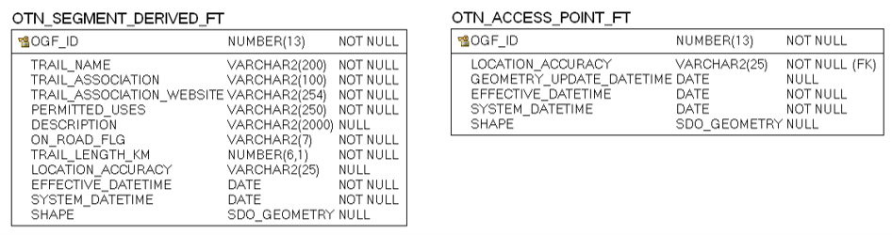

Data Dictionary

OTN_SEGMENT_DERIVED_FT
View of Ontario Trail Network (OTN) features including trail segments, permitted trail uses, identified trail associations and website links for authoritative details.
Column Name | Column Type | Mandatory | Short Name | Description
OGF_ID | NUMBER(13,0) | Yes | OGF_ID | Ontario Geospatial Feature Identifier (OGF_ID): A unique system identifier assigned to every spatial feature or table record.  SOURCE: OTN_SEGMENT_FT.OGF_ID
TRAIL_NAME | VARCHAR2(200) | Yes | TRAIL_NAME | The name that the trail is commonly known as.  SOURCE: OTN_SEGMENT_FT.TRAIL_NAME
TRAIL_ASSOCIATION | VARCHAR2(100) | Yes | ASSOC | The managing trail organization that can be contacted regarding additional trail information related to issues, maintenance, operations, administration and problems on the trail.  SOURCE: OTN_ASSOCIATION.TRAIL_ASSOCIATION via OTN_SEGMENT_FT.OTN_ASSOCIATION_ID
TRAIL_ASSOCIATION_WEBSITE | VARCHAR2(254) | Yes | WEBSITE | The URL for the trail association website address.  SOURCE: OTN_ASSOCIATION.TRAIL_ASSOCIATION_WEBSITE via OTN_SEGMENT_FT.OTN_ASSOCIATION_ID
PERMITTED_USES | VARCHAR2(250) | Yes | PERM_USE | Concatenated field listing all permitted trail uses for this trail. The concatenated value in this field is listed in the order of its assigned trail use rank.  SOURCE: OTN_PERM_USE.PERMITTED_USE via OTN_PERM_USE.OGF_ID association to OTN_SEGMENT_FT.OGF_ID
DESCRIPTION | VARCHAR2(2000) | No | DESCR | Free-text description or additional details about a trail.  SOURCE: OTN_SEGMENT_FT.DESCRIPTION
ON_ROAD_FLG | VARCHAR2(7) | Yes | ON_RD_FLG | Flag used to identify if one or more portions of the trail follows a roadway. A value of "Yes" indicates that it does, and users should exercise caution due to vehicles. A value of "No" indicates that the trail is completely off-road. A value of "Unknown" means that more information is required to determine if the trail is on/off road.  SOURCE: OTN_SEGMENT_FT.ON_ROAD_FLG
TRAIL_LENGTH_KM | NUMBER(6,1) | Yes | TRL_LEN_KM | The length of the trail provided by the trail association or when not available, the calculated trail segment feature length. Measured in Kilometers.  SOURCE: OTN_SEGMENT_FT.TRAIL_LENGTH_KM
LOCATION_ACCURACY | VARCHAR2(25) | No | ACCURACY | The accuracy of the location of the feature at an OBM scale. The degree of conformity or closeness of a measurement to the true value.  SOURCE: OTN_SEGMENT_FT.LOCATION_ACCURACY
EFFECTIVE_DATETIME | DATE | Yes | EFF_DATE | Date/time the record was created or last modified in the source database.  SOURCE: OTN_SEGMENT_FT.EFFECTIVE_DATETIME
SHAPE | SDO_GEOMETRY | No | SHAPE | Geometry attribute.
Return to Table of Contents.

