Final Report
For project:
Central East LiDAR
Prepared for:
Ontario Ministry of Natural Resources
2nd floor, North Tower, 300 Water Street,
Peterborough, ON, K9J 3C7
Prepared by:

Airborne Imaging
2700 – 61 Avenue SE
Calgary, AB T2C 4V2
February 2026

Contents
Contents 2
Introduction 1
Project Schedule & Personnel 2
LiDAR System & Flight Parameters 2
Project Control / Datum 5
Control Network 5
Check Points 8
Trajectory Processing 10
LiDAR Data Processing 10
Calibration Procedures 10
Data Tiling and Classification 10
Point Cloud Manipulation 11
Water Classification & Hydro-Flattening 11
Class definitions 12
Deliverables 13
Vertical Accuracy Assessment 14
Conclusion 15
Appendix A - Control Points – Published Coordinates 16
Appendix B – PPP Solutions 28
Appendix C - RTK Survey & Control Check 31

Introduction
The Ontario Ministry of Natural Resources and Forests contracted Airborne Imaging to acquire and deliver digital elevation data derived from airborne LiDAR (Light Detection and Ranging) to cover various regions in Ontario.

This report covers the Central East area, collected during the Spring of 2025. The report focuses on LiDAR acquisition details, such as flight parameters, project control, ground truthing results, data processing technique and deliverables.

The contracted area for the Central East area is 5,577 km².

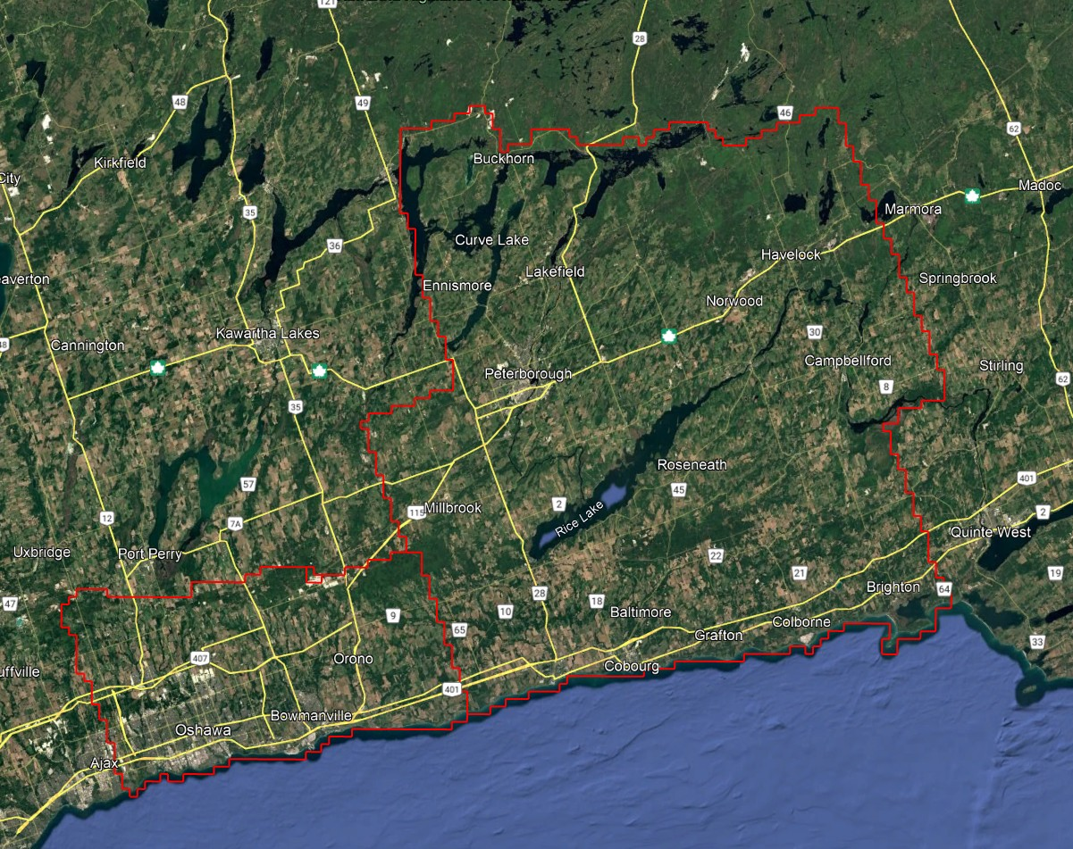
Figure 1: Map of Central East project area

Project Schedule & Personnel
The ground control occurred in April 2025. The surveyor collecting ground truth points during this period was Alistair Lorne. The Lidar data was collected in five missions from April 7 to April 23, 2025. See table below for the mission’s flight parameters.

A typical Lidar acquisition crew consisted of one Lidar Operator and one Pilot.

LiDAR System & Flight Parameters
A Riegl VQ-1560ii-S was used to collect the Lidar data. The system was installed in a Piper Navajo aircraft with call sign C-GMEC operated by Kasi Aviation.

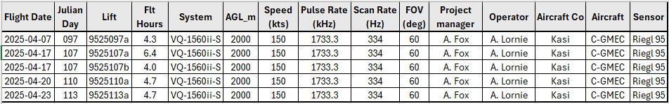

Table 1: lifts with their flight parameters.

Riegl VQ1560-ii-S | Flight plan
Altitude | 2000m AGL
Field of View (FOV) | 60°
Air Speed | 150 Kts
Pulse Rate | 1733.3 kHz
Sidelap | 20%
Point Density | > 8 pts/m²

Table 2: Project Parameters for the Central East area.

The flight lines were designed optimally to maximize time online versus time in turns.

Below is a map of the flight lines including cross-ties.

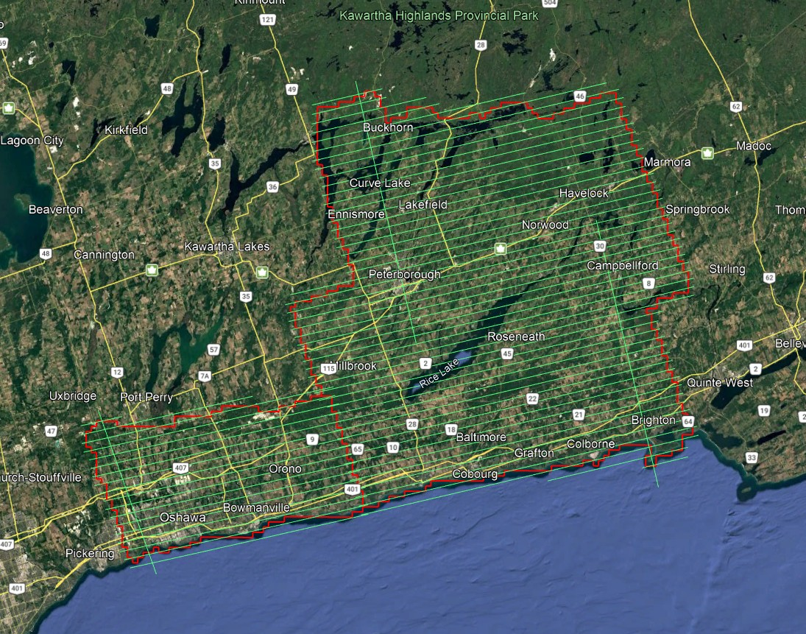
Figure 2: A map of the Central East flightlines

Below is a map of the flight line footprints.

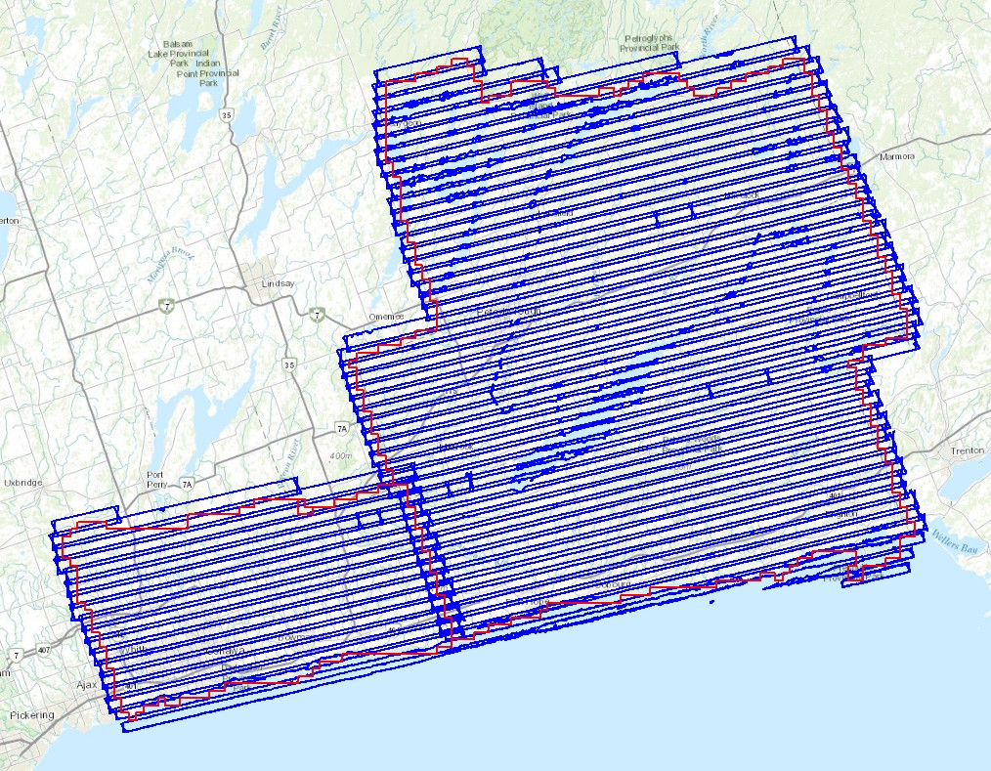
Figure 3: A map of the Central East flight line footprints

Project Control / Datum
Several baselines were measured by GPS static occupation between Can-Net Continuously Operating Reference Stations (CORS), existing NRCan 3D Passive Control Monuments, as well as newly established points by Airborne Imaging. The existing control used for the Central East area consisted of six Can-Net stations and three NRCan passive stations.

Appendix A shows the published station coordinate sheets.
Appendix B shows the PPP Solutions.
Appendix C contains a list of Control Points and their published coordinates.

The datum used for processing the Ground Control and all subsequent Lidar data are the Nad83 CSRS (epoch 2010.0) horizontal datum and the CGVD2013 vertical datum (CGG2013 undulation model).

Control Network
The ground control survey was collected using a combination of Trimble R8 Model 3 receivers and Hemisphere S631 receivers. The Trimble receivers were employed in establishing control and collecting kinematic cross sections and the Hemisphere receivers were used for RTK collection. The ground control data was processed using the NovAtel Waypoint software GraftNet and GrafNav.

First, to establish control in the area, baselines were measured via GPS observations between a network of NRCan 3D Passive Control Monuments, CanNet Continuously Operating Reference Stations (CORS), and Airborne’s intermediate bases which were established by the ground crew during collection. Baselines were observed for a minimum of 4 hours, and no baselines exceeded a length of 50km. The coordinates of the intermediate bases were established through a rigorous least-squares adjustment, tied to the established control monuments.
Datasheets for the published control monuments can be found in Appendix A at the end of this report. PPP Solutions for the intermediate bases were computed using NRCan’s PPP service and used as a-priori values for processing the network. They are included in Appendix B.

Below is an overview map of the control stations.
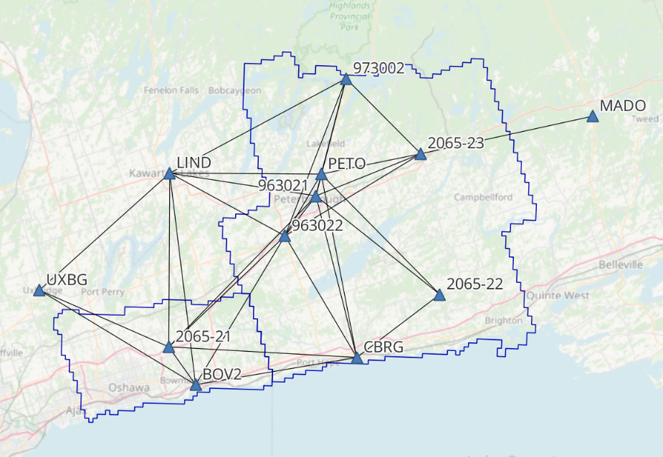
Figure 4: Central East Control Network

Central East - Control Station Coordinates

Station | Easting | Northing | Elevation | Description
2065-21 | 680833.300 | 4872659.932 | 178.136 | Airborne Intermediate Base
2065-22 | 745665.231 | 4887378.089 | 199.690 | Airborne Intermediate Base
2065-23 | 739859.527 | 4920866.429 | 221.358 | Airborne Intermediate Base
963021 | 715107.56 | 4909928.492 | 243.403 | NRCan 3D Passive Control
963022 | 707977.946 | 4900110.702 | 200.963 | NRCan 3D Passive Control
973002 | 721363.724 | 4938157.136 | 247.437 | NRCan 3D Passive Control
BOV2 | 687546.679 | 4863734.422 | 95.539 | CanNet CORS Station
CBRG | 726201.775 | 4871512.832 | 90.515 | CanNet CORS Station
LIND | 679915.784 | 4914311.895 | 274.857 | CanNet CORS Station
MADO | 780618.380 | 4931480.536 | 169.363 | CanNet CORS Station
PETO | 716178.171 | 4915176.716 | 243.586 | CanNet CORS Station
UXBG | 649365.169 | 4885492.473 | 295.288 | CanNet CORS Station

Table 3: Control Station Coordinates

Horizontal Datum: Nad83(CSRS) UTM Zone 17 (epoch 2010)
Vertical Datum: CGVD2013 (Geoid CGG2013a)

Check Points
RTK GPS

The NVA and VVA control points were collected via Real-Time Kinematic Survey, using Hemisphere S631 GNSS receivers. The Real Time Kinematic method uses 30 second observations of individual points. It achieves high accuracy by receiving real time differential corrections from the GPS reference base, positioned over a nearby control point. The RTK points are used for the vertical accuracy assessment of the Lidar point cloud and were not used to determine any vertical shift applied to the point cloud.

The ground crews collected a total of 79 NVA points and 66 VVA points. A full coordinate list of the NVA and VVA Check Points is included in Appendix C at the end of this report. Pictures of the final delivered RTK points (as well as the existing control) are provided in a folder included with the submission of this report.

See below for a map of the collected NVA and VVA ground control points.
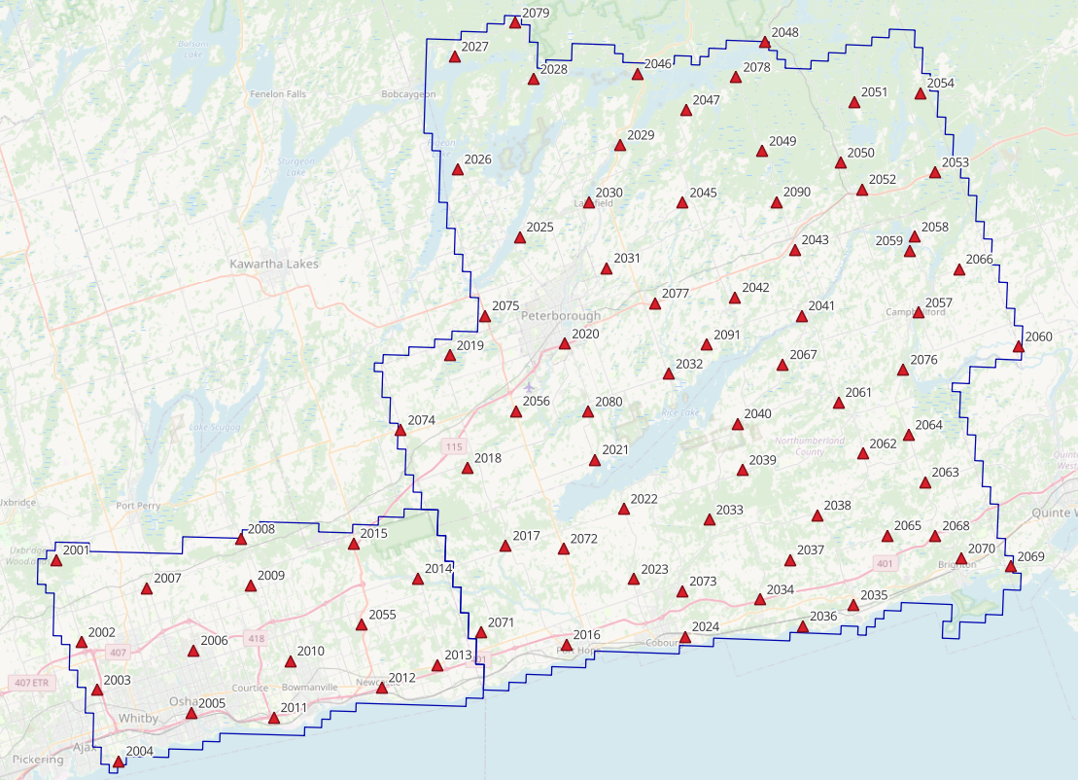
Figure 5: Central East NVA points
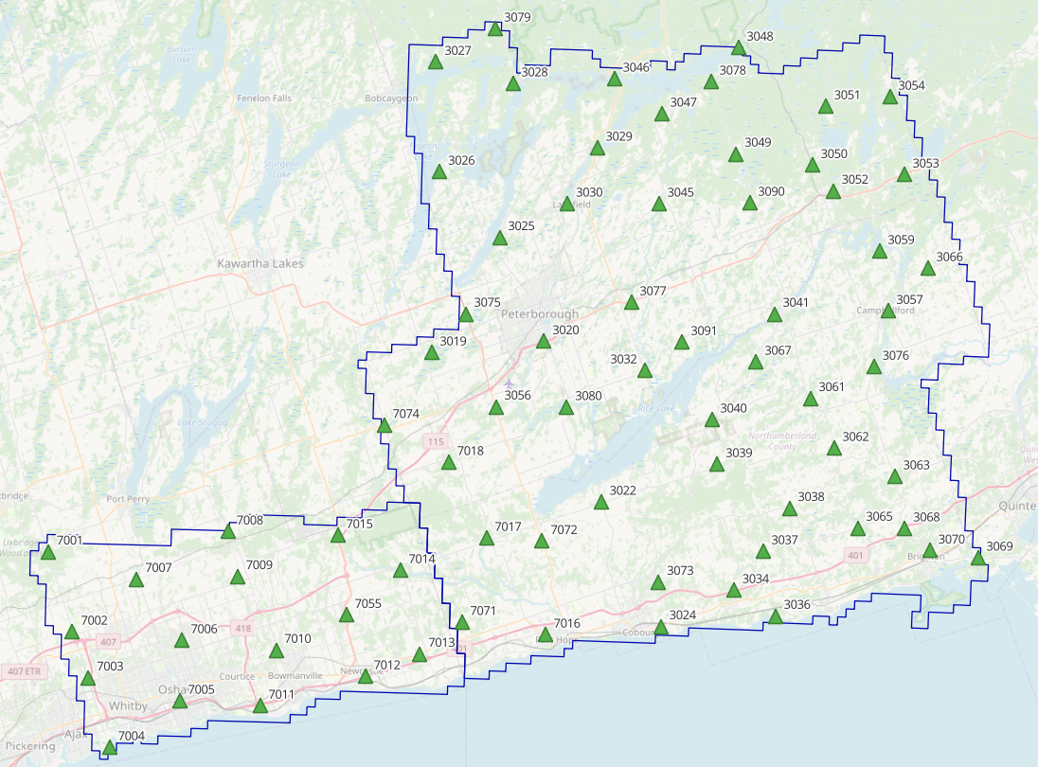
Figure 6: Central East VVA points

Trajectory Processing
The aircraft trajectory positioning for the missions over the Central East area were processed using the Precise Point Positioning (PPP) technique.

PPP is a positioning technique that removes and models GNSS system errors via precise satellite orbit data and clock corrections that are applied to the trajectory post mission, providing centimeter level positional accuracy without the use of ground base stations.

The TerraPOS software by Terratec was used to postprocess the PPP solutions to produce final kinematic trajectories accurate to 5 centimeters for each flight mission.

The horizontal datum used is Nad83 CSRS UTM zone 17 with the CGVD2013 vertical datum (CGG2013 undulation model).

LiDAR Data Processing

Calibration Procedures
After each mission, the field project manager creates the preliminary calibrated point cloud with each sensor’s set boresight values for each mission. Proprietary QC tools using the Lastools software are run on each mission to check for coverage, relative accuracy, point density, etc… If any data is found to be not meeting specifications, or coverage missing, the field crew is immediately notified and the areas affected reflown as soon as possible.

This preliminary calibrated point cloud is inspected in conjunction with the kinematic ground truth points to apply bulk shifts if necessary and further refine the calibration by applying corrections to the preliminary calibrated strips. The refined calibration is done using Bayesmap’s StripAlign software. Intensity values are also normalized by mission to be 16 bits (0 to 65535).

Data Tiling and Classification
The raw LiDAR data is processed into calibrated point cloud strips corresponding to flight lines. For ease of data manipulation, the strips are combined and saved in tiles of 1 km by 1 km. The format the strips and tiles are saved in is .Laz version 1.4. The tiling scheme is based on the UTM17 projection at the even kilometers.

The tiled point cloud is then processed with a series of algorithms to separate the “most-likely” ground returns from other returns. The point classification is done using a product by the TerraSolid software running on MicroStation Connect called TerraScan and TerraModeler.
In addition to our regular field QC and calibration procedures, we also generate various raster products using the Lastools software to assess coverage and calibration accuracy.

Point Cloud Manipulation
The TerraScan software uses macros that are set-up to measure the angles and distances between points to determine what classification a point should be: ground, vegetation, noise, other. The angle and distance values in the macros can be adjusted to be more or less aggressive with the classification of points by varying the incidence angles and estimated distances among neighboring points. The lower points are generally classified as ground returns, with the points above classified as undefined (class 1). Outliers and noise described in the table below are normally clouds, outliers or atmospheric noise in the data that are separated into above or below the ground level (high point or low points).

After the automated macro is run to determine classes, a systematic visual inspection is performed to fine tune the ground definition. To better understand areas for improvement for the ground surface, the points that are classified as ground are used to create viewable TINs and grid surfaces. These surfaces are inspected for areas that appear rough, artificially flattened or truncated, no data areas, or have other viewable errors.

In cleaning up ground points, the focus is concentrated in areas where few ground points have been left in the bare earth model and the ground appears rough or lower and flatter than it may be in reality. The scarcity of ground points may be a result from no penetration through a dense vegetation layer, water bodies, low reflectivity objects, or too aggressive values with the macro. A manual/visual inspection of these areas plays a major role in resolving any issues or irregularities with the bare earth model.

Once the first edits are completed, a one-meter grid of the ground surface is re-exported and hill shade images produced to QC the edited ground surface. This QC step is done iteratively as many times as necessary. Once the point cloud data has reached a satisfactory level of classification accuracy, the final deliverables are produced.

Water Classification & Hydro-Flattening
Once the ground class has reached the final level of classification accuracy, the water delineation process is initiated. The rivers and water bodies are digitized as break lines according to USGS specifications of a minimum of 8000 m² for water bodies and 30 m nominal width for streams and rivers. Ponds and lakes have their elevations set constant to just below ground. Stream and river hydro lines are collected using the downstream method. Once all hydro lines have been collected for an area, the ground points inside the hydro lines are classified to class 9 – Water. The ground points outside of the hydro lines but within 35 cm are classified to class 20 – Ignored ground (near breaklines). Using the TIN of class 2 (ground points), the hydro lines are used as constraints to generate the final 50 cm hydro-flattened DEMs in ESRI Ascii format, then converted to 32bit Geotiff format with the Global Mapper software.

Class definitions
The classification follows the ASPRS classification codes. The table below shows the classes for the delivered point cloud.

Classification Value | Description
1 | Unclassified
2 | Ground
6 | Building
7 | Low Points
9 | Water
17 | Bridge Decks
18 | High Points
20 | Ignored Ground (breakline proximity)
21 | Snow
22 | Temporal exclusion

Table 4: ASPRS Point Classes

Deliverables
The data was delivered in November 2025.

See below for a table of the folder structure and description of each deliverables.

DIFF
50cm rasters of flight lines differences, 1 X 1 km tiles in 32bit Geotiff format
e.g. 1km173850494302025LCENTRALEAST_diff.tif
DTM
Hydro-flattened 50cm Bare Earth DEMs, 1 X 1 km tiles in 32bit Geotiff format
e.g. 1km173850494302025LCENTRALEAST.tif
METADATA
Metadata files for Breaklines, DEM, LAS and Project in .XML format
e.g. CENTRALEAST_2025_Lidar_metadata_Breaklines.xml
POINTCLOUD
Point cloud data, 1 X 1 km tiles in .LAZ format 1.4
e.g. 1km173850494302025LCENTRALEAST.laz
PROJECT_POLYGON
Shape files of: Lift_metadata, Hydro_breaklines, Project_extent & Tile_index
e.g. Mission_9525113a_z17.shp

Vertical Accuracy Assessment

Non-Vegetated Vertical Accuracy (NVA)

Below is a summary of the statistics between the point cloud TIN from the ground class and the NVA points surveyed on flat hard surfaces:

Number of points: | 79
Average dz: | 0.000 | m
Minimum dz: | -0.065 | m
Maximum dz: | 0.089 | m
Average magnitude: | 0.023 | m
Root mean square: | 0.030 | m
Std deviation: | 0.030 | m
NVA Vertical Accuracy (95%): | 0.059 | m

For a complete listing of the RTK points and their differences, please refer to the provided spreadsheet named " Central_East_NVA_Accuracy_z17_Final.xlsx".

As seen in the NVA comparison above, the accuracy observed of 0.059 m meets the project requirement of QL0 NVA vertical accuracy of 9.8 cm (95%).

Vegetated Vertical Accuracy (VVA)

The elevations of the points surveyed in various vegetated land cover types were compared to the Lidar ground surface. Since the elevation differences for this type of accuracy does not follow a normal distribution, the percentile method is used and not the 95% confidence level. For the 66 VVA points surveyed, sorting the absolute differences from the smallest to the largest gives the accuracy at the 95th percentile (using the linear interpolation between closest ranks method). For this sample, the 62nd and 63rd largest differences are respectively 9.3 and 9.7 cm.

For this project, the VVA accuracy is therefore 9.6 cm.

This is within the required specifications of 15.0 cm (the QL0 VVA specification).

For a complete listing of the kinematic points and their differences, please refer to the provided spreadsheet named "CentralEast_VVA_Accuracy_z17_Final.xlsx".

Conclusion
This is the final report covering the Central East Lidar project. Topics such as field operations, control, data processing and final accuracy results were explained. The project went well, acquired in one season and delivered on schedule. The non-vegetated vertical accuracy meets specifications, and the vegetated accuracy is within the QL0 requirement.

Appendix A - Control Points – Published Coordinates
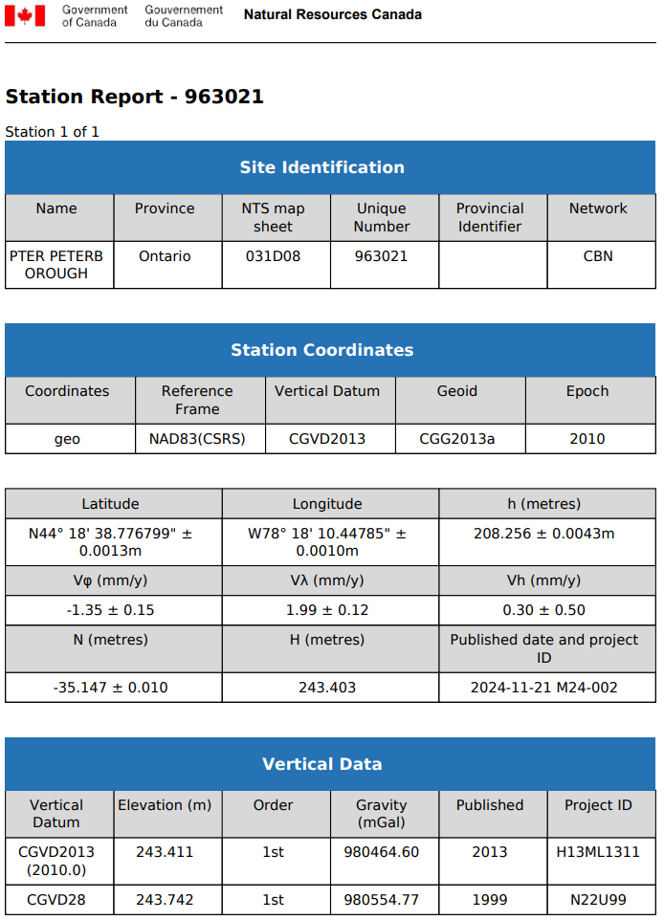
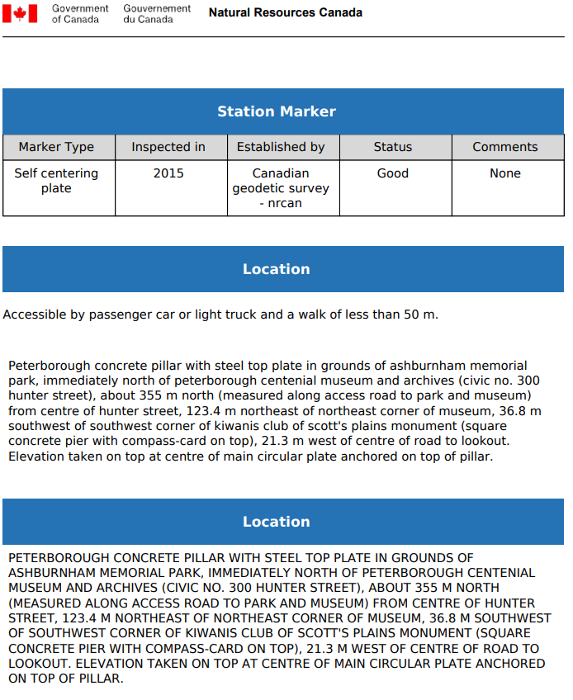
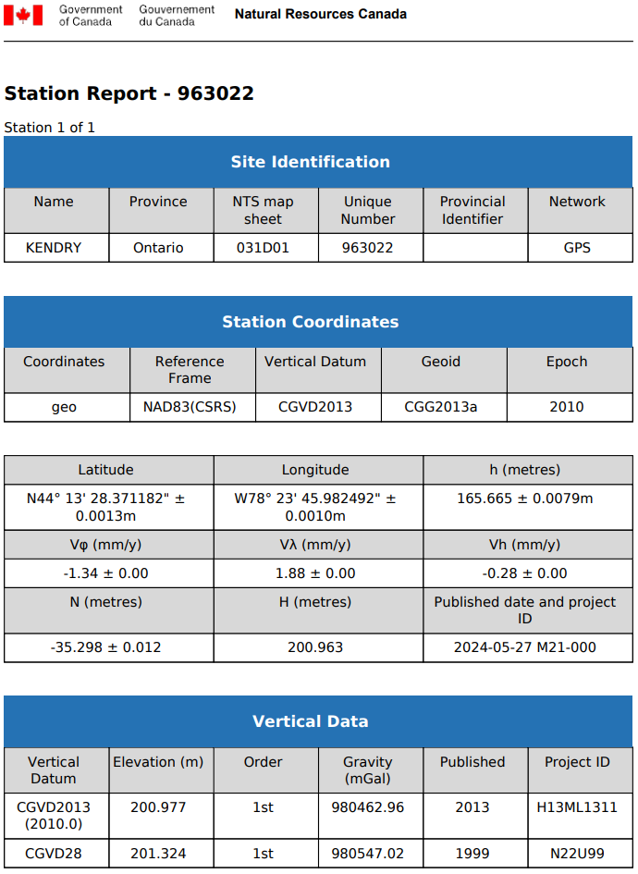
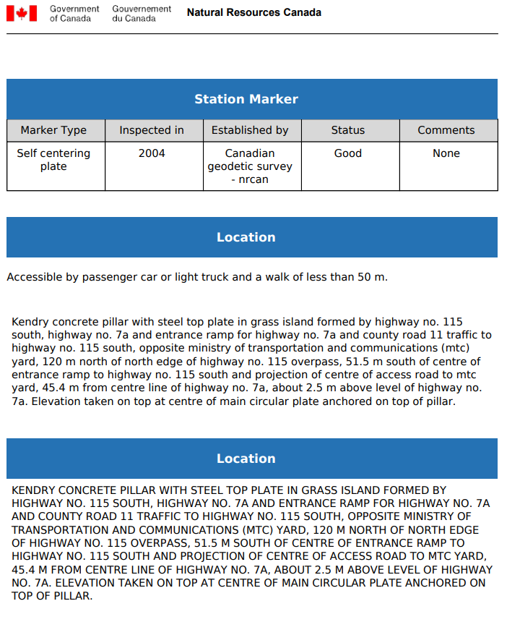
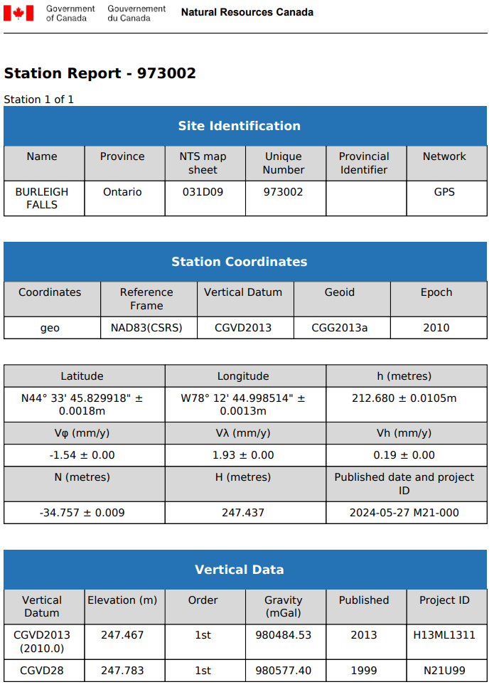
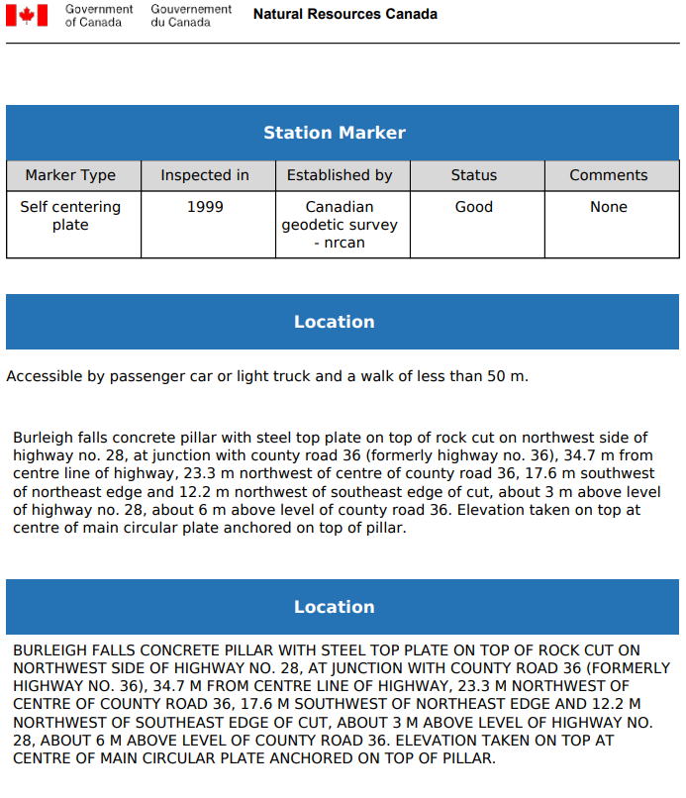
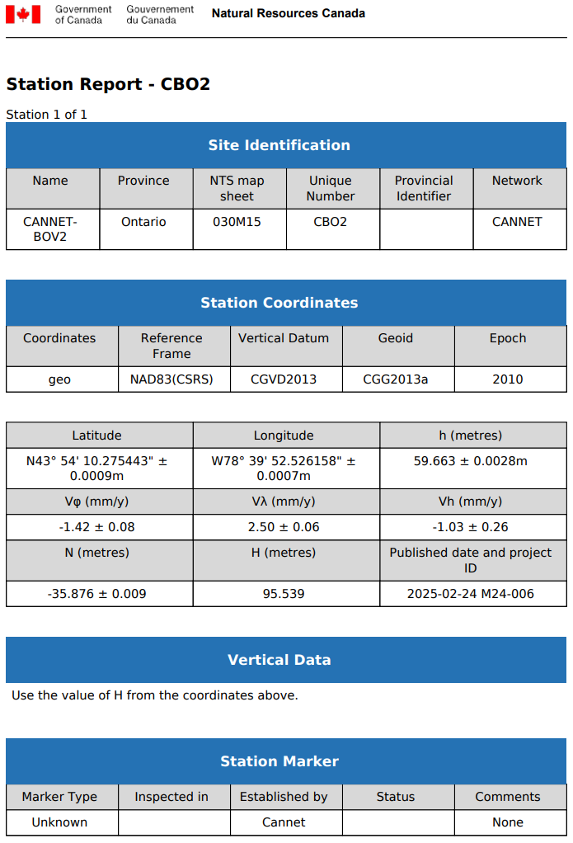
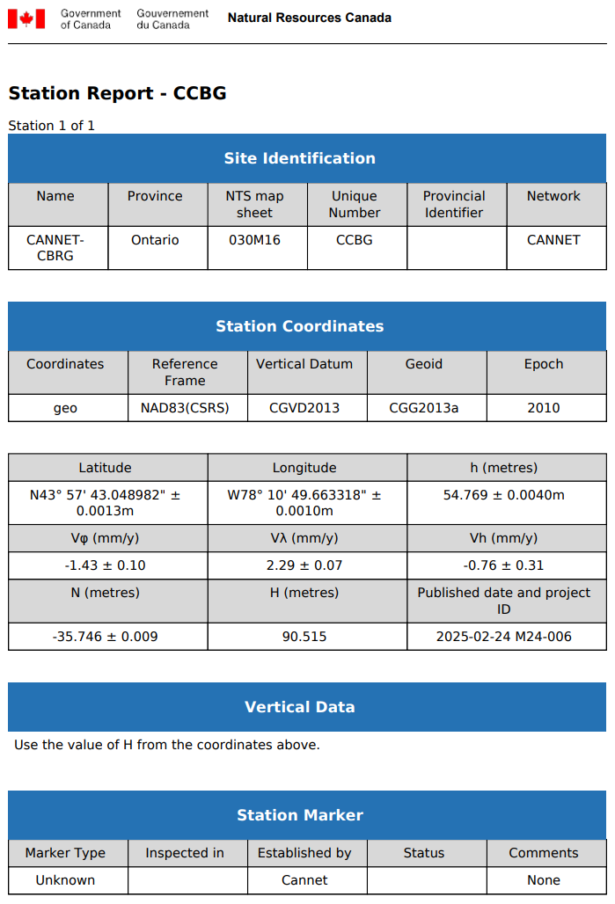
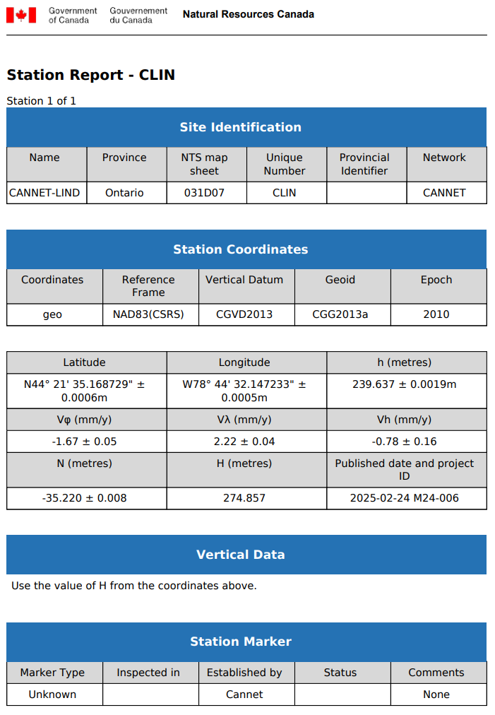
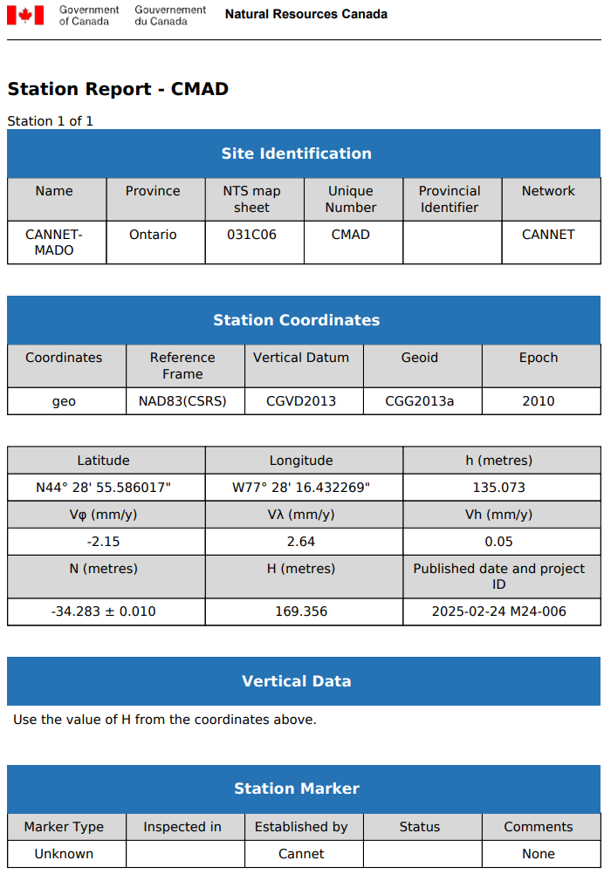
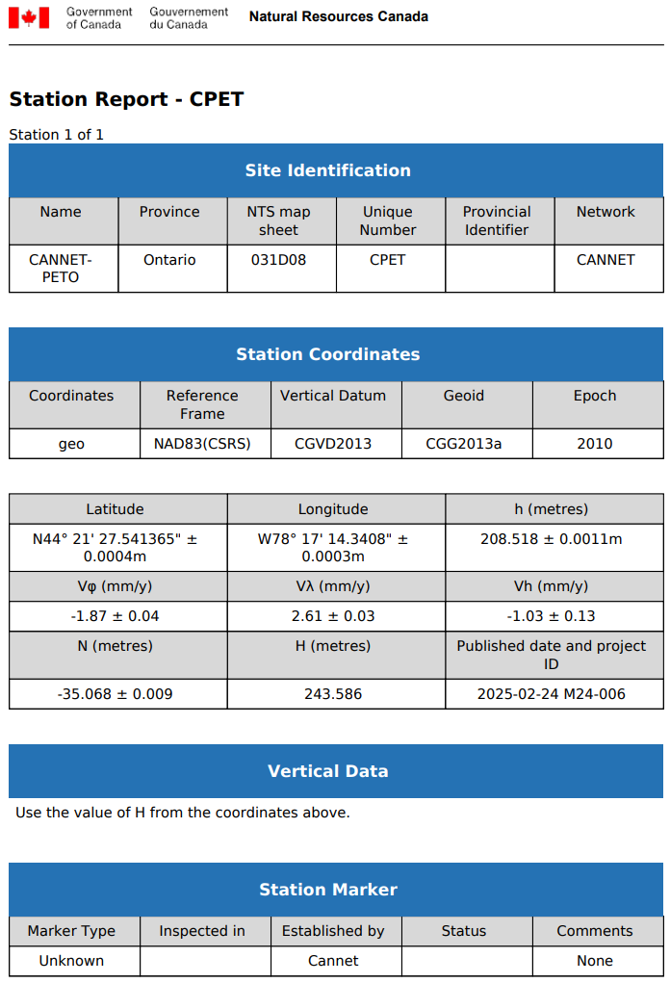
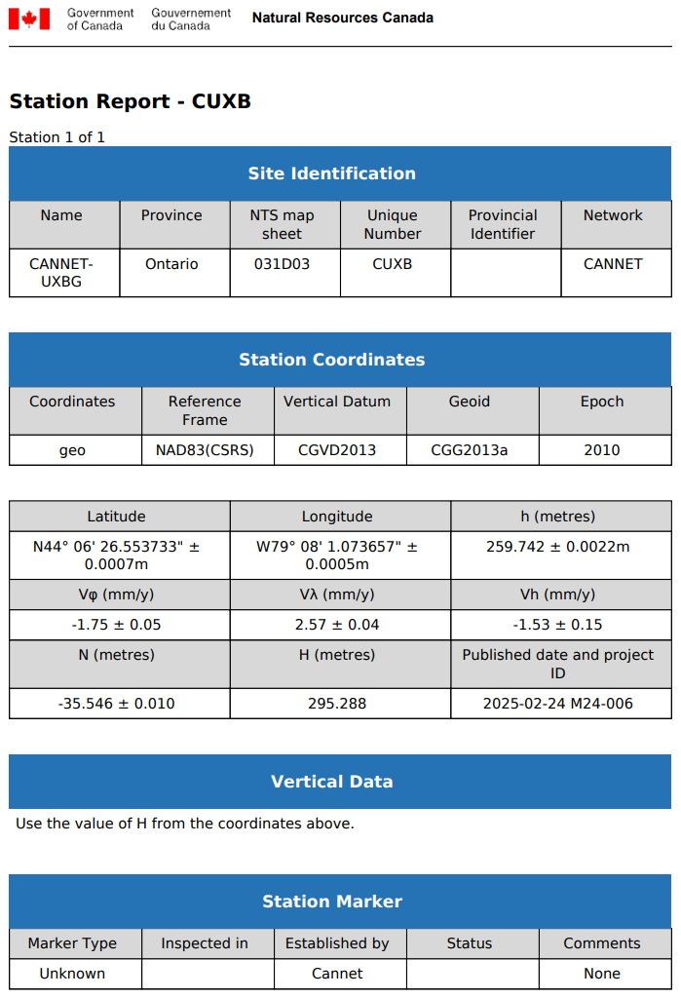

Appendix B – PPP Solutions
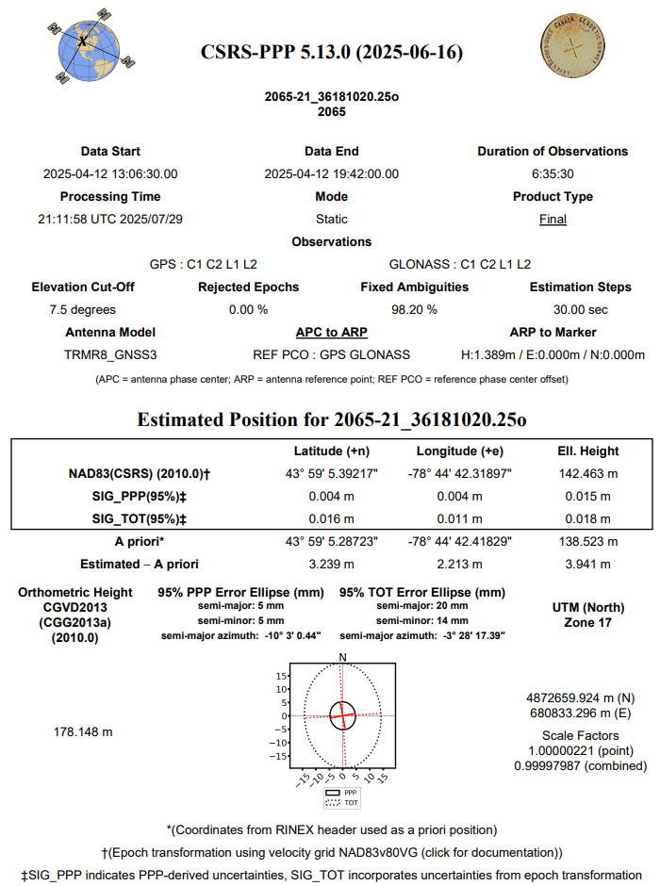
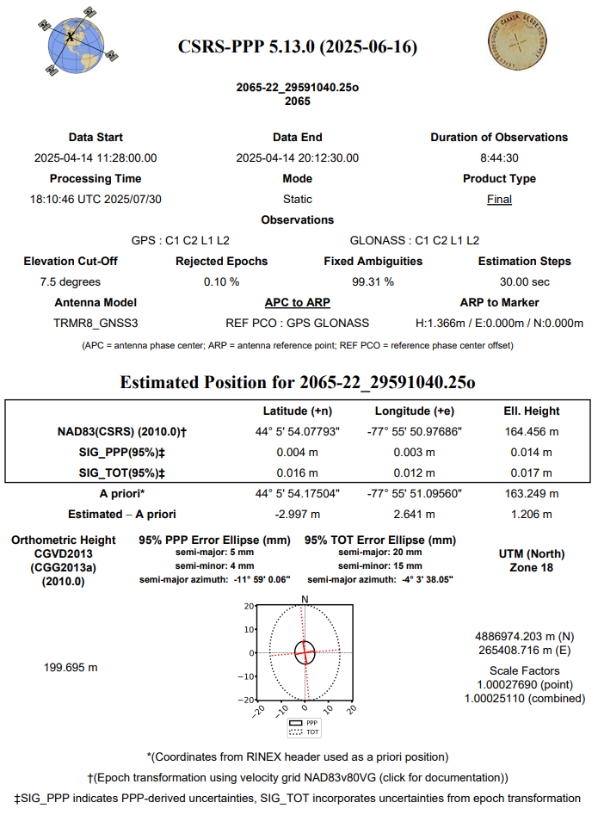
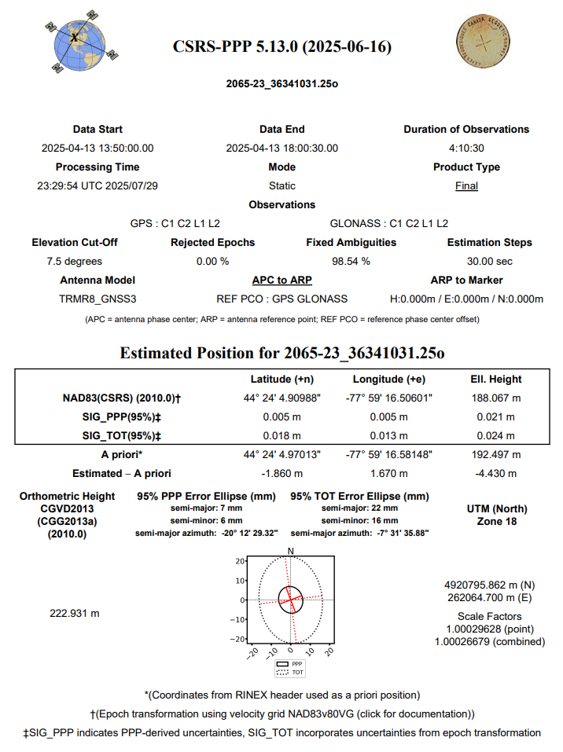

Appendix C - RTK Survey & Control Check
NVA Points

Number | Easting | Northing | Elevation
2001 | 655129.689 | 4878892.403 | 327.081
2002 | 658335.048 | 4869301.215 | 211.683
2003 | 660346.92 | 4863785.15 | 116.968
2004 | 663140.971 | 4855429.526 | 77.111
2005 | 671555.226 | 4861274.688 | 102.238
2006 | 671653.237 | 4868680.352 | 185.118
2007 | 665956.308 | 4875867.572 | 257.559
2008 | 676853.31 | 4881922.06 | 307.901
2009 | 678152.950 | 4876500.055 | 272.000
2010 | 683074.71 | 4867742.52 | 148.782
2011 | 681358.967 | 4861024.279 | 109.810
2012 | 693950.237 | 4864899.149 | 91.581
2013 | 700517.695 | 4867786.461 | 173.185
2014 | 697862.33 | 4877866.72 | 192.36
2015 | 690131.434 | 4881778.850 | 355.660
2016 | 715671.707 | 4870635.833 | 139.720
2017 | 708123.077 | 4882041.705 | 186.353
2018 | 703299.3 | 4891009.32 | 232.448
2019 | 700813.058 | 4904192.020 | 261.419
2020 | 714318.563 | 4905986.113 | 206.055
2021 | 718332.943 | 4892484.713 | 190.783
2022 | 721857.877 | 4886812.621 | 278.720
2023 | 723386.138 | 4878658.441 | 168.372
2024 | 729616.07 | 4872058.83 | 87.028
2025 | 708631.655 | 4918249.360 | 268.068
2026 | 701105.127 | 4925916.640 | 257.380
2027 | 700297.14 | 4939039.19 | 254.507
2028 | 709605.377 | 4936692.266 | 273.571
2029 | 720027.635 | 4929352.286 | 238.218
2030 | 716598.836 | 4922528.441 | 234.753
2031 | 718949.661 | 4914952.779 | 217.145
2032 | 726637.245 | 4902819.381 | 212.952
2033 | 731982.214 | 4885938.240 | 265.427
2034 | 738282.983 | 4876781.326 | 176.422
2035 | 749377.15 | 4876485.38 | 99.859
2036 | 743495.755 | 4873794.282 | 78.420
2037 | 741694.47 | 4881514.04 | 182.321
2038 | 744727.200 | 4886869.450 | 191.969
2039 | 735718.59 | 4891861 | 237.894
2040 | 734940.829 | 4897270.377 | 271.062
2042 | 734121.01 | 4912036.23 | 200.132
2043 | 740892.267 | 4917861.276 | 205.206
2045 | 727581.035 | 4922895.544 | 211.636
2046 | 721735.141 | 4937729.874 | 242.014
2047 | 727550.538 | 4933703.576 | 272.647
2048 | 736531.596 | 4941975.211 | 238.668
2049 | 736662.065 | 4929233.094 | 250.446
2050 | 745919.37 | 4928223.07 | 226.986
2051 | 747221.702 | 4935358.906 | 224.765
2052 | 748518.063 | 4925215.531 | 218.822
2053 | 756983.202 | 4927524.282 | 200.091
2054 | 754934.165 | 4936711.736 | 204.343
2055 | 691425.809 | 4872262.160 | 162.299
2057 | 755678.57 | 4911116.09 | 149.539
2058 | 754885.571 | 4919959.895 | 185.039
2059 | 754363.081 | 4918258.917 | 185.393
2060 | 767632.417 | 4907563.520 | 122.615
2061 | 746752.55 | 4900209.27 | 199.931
2062 | 749822.23 | 4894361.99 | 143.543
2063 | 757228.620 | 4891237.011 | 135.138
2064 | 755116.490 | 4896710.782 | 136.180
2065 | 753035.354 | 4884808.835 | 176.116
2066 | 760248.154 | 4916343.777 | 193.819
2067 | 740005.574 | 4904383.468 | 254.860
2068 | 758723.919 | 4884999.298 | 197.219
2069 | 767763.380 | 4881798.921 | 77.695
2070 | 761849.536 | 4882446.420 | 110.092
2071 | 705496.89 | 4871754.14 | 193.671
2072 | 714921.660 | 4881907.792 | 211.105
2073 | 729133.8 | 4877386.33 | 170.746
2074 | 695348.97 | 4895216.64 | 262.837
2075 | 704834.252 | 4908907.991 | 278.100
2076 | 754193.36 | 4904323.3 | 123.042
2077 | 724725.354 | 4911017.829 | 223.903
2078 | 733323.419 | 4937738.319 | 261.378
2079 | 707277.338 | 4943238.001 | 290.381
2080 | 717316.170 | 4898072.968 | 205.594
2090 | 738550.921 | 4923383.306 | 235.193
2091 | 730991.355 | 4906389.324 | 229.081

VVA Points

Number | Easting | Northing | Elevation
3019 | 700841.320 | 4904195.448 | 261.355
3020 | 714322.091 | 4905969.894 | 206.353
3022 | 721868.105 | 4886821.087 | 278.758
3024 | 729609.954 | 4872046.314 | 87.120
3025 | 708627.999 | 4918232.722 | 267.555
3026 | 701127.264 | 4925917.669 | 256.976
3027 | 700287.947 | 4939047.265 | 254.273
3028 | 709619.504 | 4936703.587 | 273.175
3029 | 720012.744 | 4929350.876 | 238.265
3030 | 716615.667 | 4922527.572 | 234.479
3032 | 726611.829 | 4902870.725 | 213.302
3034 | 738299.019 | 4876791.221 | 176.262
3036 | 743494.324 | 4873808.746 | 78.652
3037 | 741702.643 | 4881549.549 | 181.403
3038 | 744714.117 | 4886883.087 | 191.719
3039 | 735741.950 | 4891899.330 | 241.082
3040 | 734943.290 | 4897254.480 | 270.952
3041 | 742023.030 | 4910187.064 | 193.450
3046 | 721727.821 | 4937733.569 | 242.210
3047 | 727559.023 | 4933690.223 | 272.294
3048 | 736516.252 | 4941972.698 | 237.250
3049 | 736672.579 | 4929221.338 | 248.511
3050 | 745933.340 | 4928247.002 | 225.969
3051 | 747209.915 | 4935349.778 | 223.934
3052 | 748504.256 | 4925214.287 | 218.132
3053 | 757004.201 | 4927539.507 | 199.612
3054 | 754920.889 | 4936728.368 | 204.572
3057 | 755694.197 | 4911112.187 | 149.608
3059 | 754387.138 | 4918250.579 | 185.995
3061 | 746736.809 | 4900204.869 | 199.772
3062 | 749817.831 | 4894375.230 | 142.470
3063 | 757240.303 | 4891235.550 | 135.067
3065 | 753048.506 | 4884816.782 | 174.235
3066 | 760246.825 | 4916373.260 | 194.078
3067 | 739995.401 | 4904390.395 | 254.621
3068 | 758708.785 | 4885009.855 | 196.780
3069 | 767750.799 | 4881782.876 | 77.582
3070 | 761849.875 | 4882461.643 | 110.553
3073 | 729142.089 | 4877404.496 | 170.067
3075 | 704826.006 | 4908929.877 | 278.018
3076 | 754222.034 | 4904327.676 | 122.581
3077 | 724739.870 | 4911013.058 | 223.503
3078 | 733339.353 | 4937733.615 | 261.217
3079 | 707292.616 | 4943249.017 | 290.747
3080 | 717327.297 | 4898084.772 | 204.939
3091 | 731007.065 | 4906387.160 | 229.295
3099 | 738555.556 | 4923395.199 | 234.772
7001 | 655146.775 | 4878904.435 | 326.117
7002 | 658317.956 | 4869304.147 | 211.748
7004 | 663152.610 | 4855439.133 | 77.582
7005 | 671565.606 | 4861273.362 | 101.943
7006 | 671654.351 | 4868662.504 | 185.722
7007 | 665947.677 | 4875870.993 | 257.626
7008 | 676851.693 | 4881933.446 | 307.360
7009 | 678137.786 | 4876512.860 | 272.172
7010 | 683102.204 | 4867741.948 | 148.858
7012 | 693959.114 | 4864912.931 | 91.578
7013 | 700505.114 | 4867779.458 | 173.256
7014 | 697860.552 | 4877855.913 | 192.104
7015 | 690130.925 | 4881800.224 | 355.394
7016 | 715684.516 | 4870629.263 | 139.810
7017 | 708166.850 | 4882064.182 | 185.789
7018 | 703285.111 | 4891005.620 | 232.526
7055 | 691448.309 | 4872268.054 | 162.474
7071 | 705508.082 | 4871766.700 | 192.947
7072 | 714893.060 | 4881909.837 | 210.397
7074 | 695351.582 | 4895226.085 | 262.573

