Final Report
For project:
Dryden / Ignace / Sioux Lookout LiDAR
Prepared for:
Ontario Ministry of Natural Resources
2nd floor, North Tower, 300 Water Street,
Peterborough, ON, K9J 3C7
Prepared by:

Airborne Imaging
2700 – 61 Avenue SE
Calgary, AB T2C 4V2
October, 2025

Contents
Introduction 1
Project Schedule & Personnel 2
LiDAR System & Flight Parameters 2
Project Control / Datum 4
Control Network 5
Check Points 8
Trajectory Processing 13
LiDAR Data Processing 14
Calibration Procedures 14
Data Tiling and Classification 14
Point Cloud Manipulation 14
Water Classification & Hydro-Flattening 15
Class definitions 16
Deliverables 17
Vertical Accuracy Assessment 18
Conclusion 21
Appendix A - Control Points – Published Coordinates 22
Appendix B – RTK Survey & Control Check 23
Appendix C – Published Station Coordinate Sheets 27

Introduction
The Ontario Ministry of Natural Resources and Forests contracted Airborne Imaging to acquire and deliver digital elevation data derived from airborne LiDAR (Light Detection and Ranging) to cover various regions in Ontario.
This report covers the areas of Dryden, Ignace and Sioux Lookout, collected during the fall of 2024. The report focuses on LiDAR acquisition details, such as flight parameters, project control, ground truthing results, data processing technique and deliverables.
The contracted area for the three locations is 3,058 km².
Dryden 1,899 km²
Ignace 110 km²
Sioux Lookout 1,049 km²
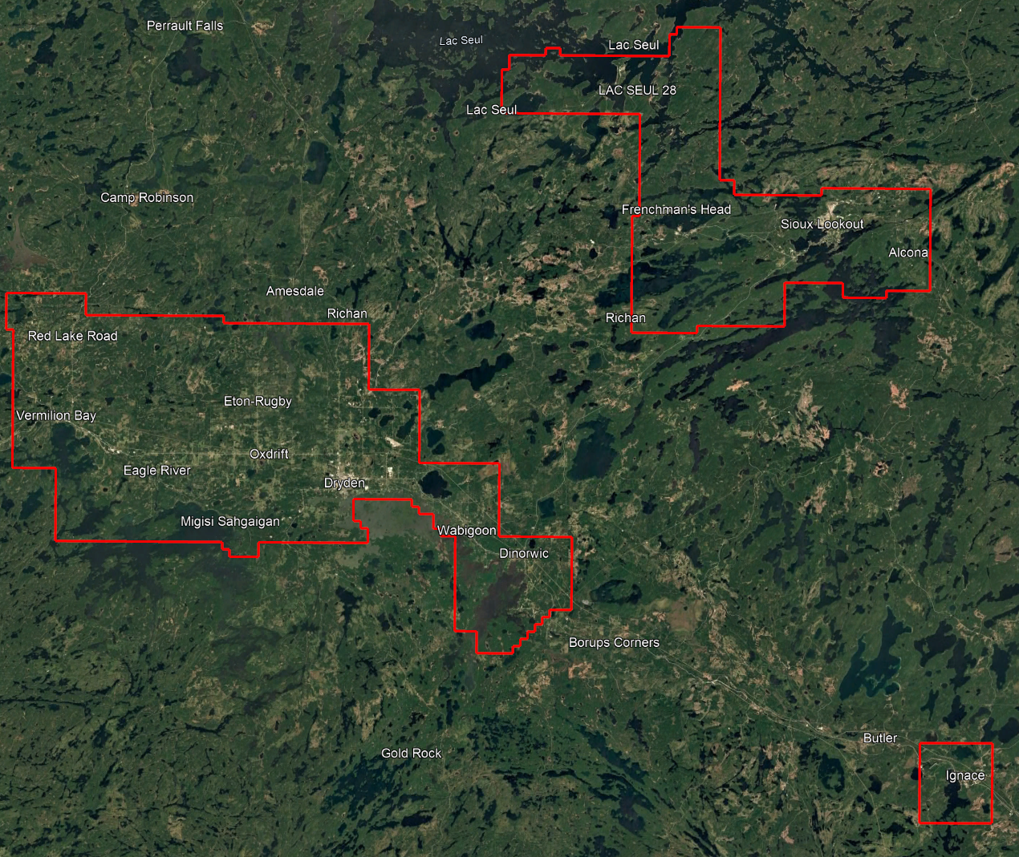

Project Schedule & Personnel
The ground control occurred in September 2024. The surveyor collecting ground truth points during this period was Alistair Lornie. The Lidar data was collected on the following dates for each area:
Dryden October 27, 28 & 31, 2024
Ignace November 1, 2024
Sioux Lookout October 31 and November 7 & 8, 2024
See table below for the mission’s flight parameters.
A typical Lidar acquisition crew consisted of one Lidar Operator and one Pilot.

LiDAR System & Flight Parameters
A Riegl VQ-1560ii-S was used to collect the Lidar data. The system was installed in Revolution Flight Cessna Caravan call sign N106RF.
Below is a table of the lifts with their flight parameters.
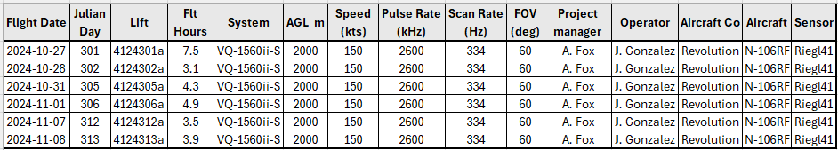
Table 1: Project Parameters for the Dryden, Ignace & Sioux Lookout areas.
Riegl VQ1560-ii-S | Flight plan
Altitude | 2000m AGL
Field of View (FOV) | 60°
Air Speed | 150 Kts
Pulse Rate | 2600 kHz
Sidelap | 20%
Point Density | > 8 pts/m²

The flight lines were designed optimally to maximize time online versus time in turn.
Below is a map of the flight lines including cross-ties.
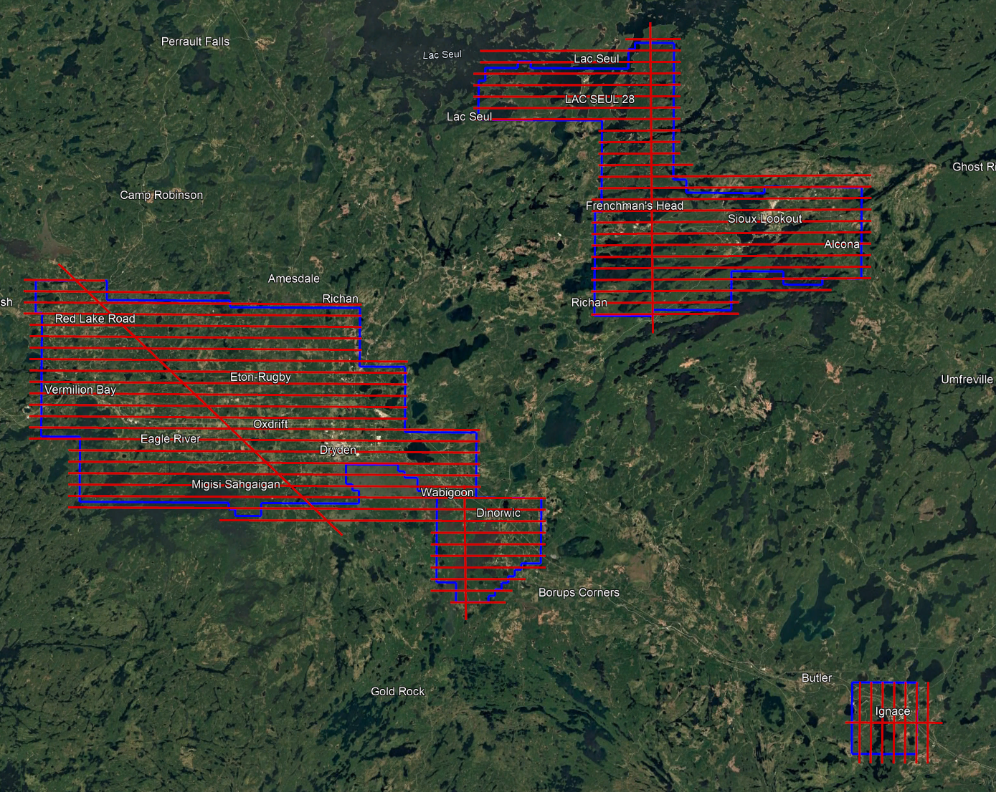

Below is a map of the flight line footprints.
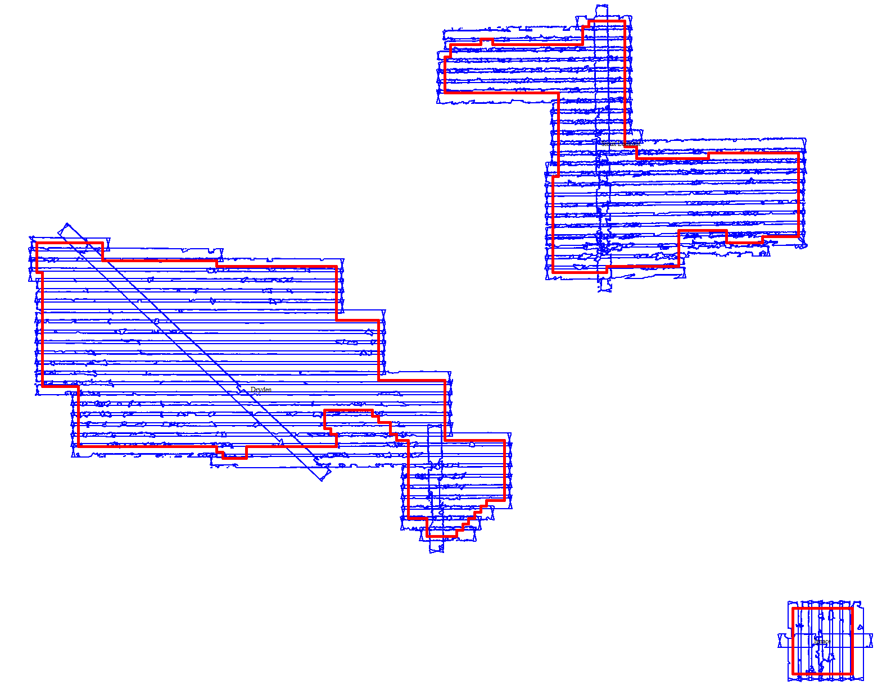
Fall 2024 (Blue)

Project Control / Datum
For each area, several baselines were measured by GPS static occupation between existing NRCan 3D Passive Control Monuments and newly established points by Airborne Imaging.
Appendix A contains a list of Control Points and their published coordinates.
Appendix B shows the coordinate list of deliverable check points.
Appendix C shows the published station coordinate sheets.
The datum used for processing the Ground Control and all subsequent Lidar data are the Nad83 CSRS (epoch 2010.0) horizontal datum and the CGVD2013 vertical datum (CGG2013 undulation model).

Control Network
The ground control surveys were collected using a combination of Trimble R8 Model 3 receivers and Hemisphere S631 receivers. The Trimble receivers were employed in establishing control and collecting kinematic cross sections and the Hemisphere receivers were used for RTK collection. The ground control data was processed using the NovAtel Waypoint software GraftNet and GrafNav.
First, to establish control in each area, baselines were measured via GPS observations between a network of NRCan 3D Passive Control Monuments and Airborne’s intermediate bases, which were established by the ground crew on the day of collection. The coordinates of the intermediate bases were established through a rigorous least-squares adjustment, tied to the established control monuments. See below for the control networks established in each of the Dryden, Ignace, and Sioux Lookout AOIs.
Datasheets for the published Control Monuments can be found in Appendix A at the end of this report. PPP Solutions for the observed bases were computed using NRCan’s PPP service and used as a-priori values for processing the network. They are included in Appendix B.
Airborne Imaging collected ground control to provide a vertical accuracy assessment for the deliverable LiDAR outputs. Following ASPRS guidelines, Airborne planned to collect and deliver Non-Vegetated Vertical Accuracy (NVA) and Vegetated Vertical Accuracy (VVA) check points as follows:
- Dryden: 45 NVA and 35 VVA Check Points (80 Total)
- Ignace: 20 NVA and 5 VVA Check Points (25 Total)
- Sioux Lookout: 30 NVA and 20 VVA Check Points (50 Total)
Additionally, kinematic cross-sections were collected to calibrate the LiDAR data in preliminary processing and assess the need for applying vertical shifts.
Pictures of observed control monuments, as well as NVA and VVA control points are included with the submission of this report.
Below are overview maps of the control stations in each AOI.
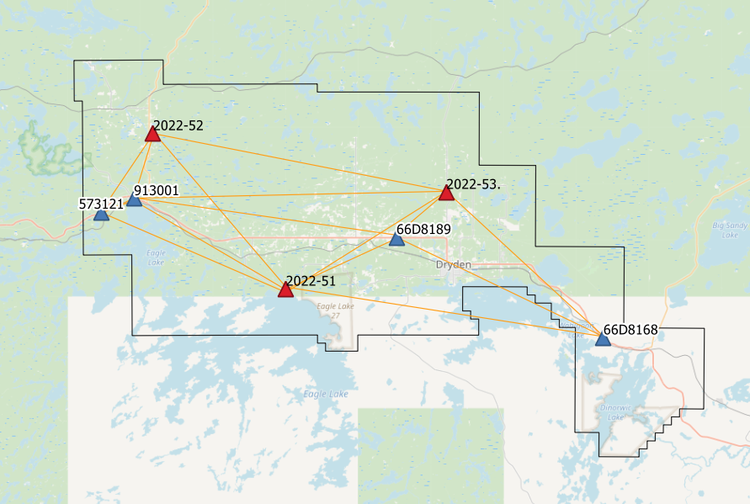
Dryden Control Network

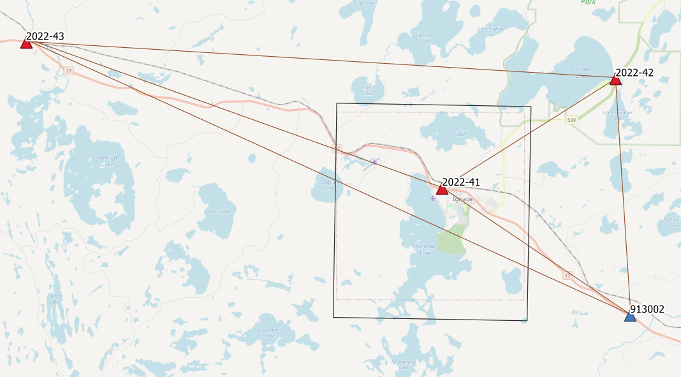Ignace Control Network
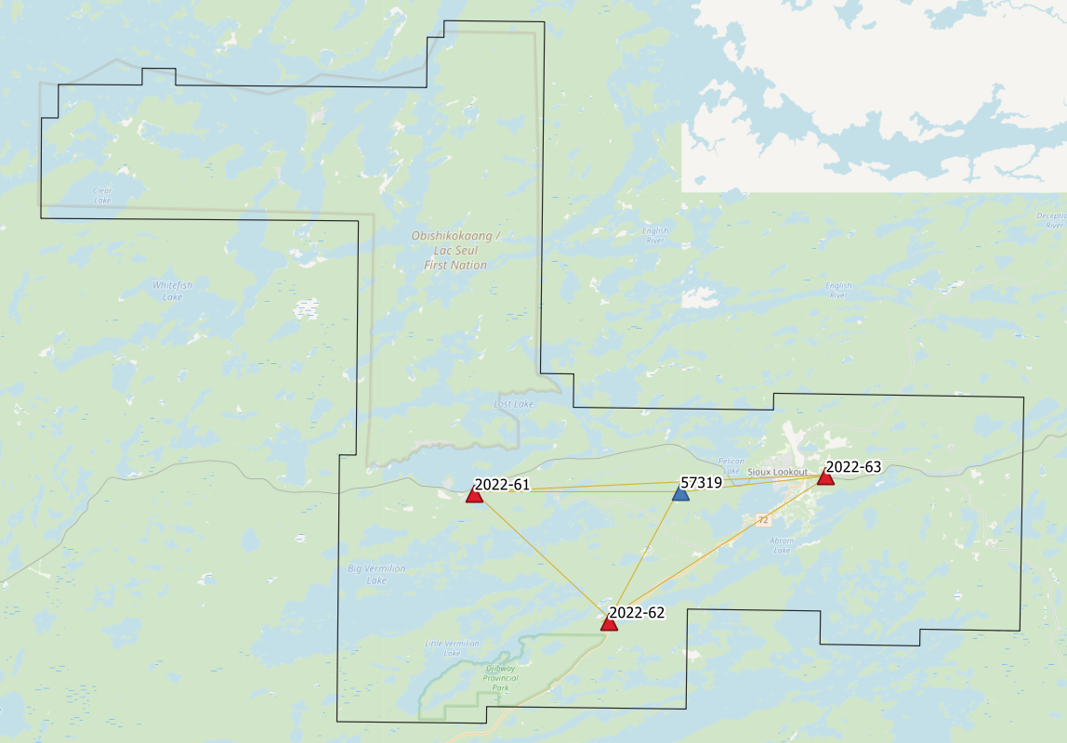
Sioux Lookout Control Network

Check Points
RTK GPS
The NVA and VVA control points were collected via Real-Time Kinematic Survey, using hemisphere S631 GNSS receivers. Using 30 second observations, Real Time Kinematic observations are individual points surveyed on open terrain, mounted on a pole while receiving real time differential corrections from the GPS receiver positioned over a nearby control point. These points are used just for the vertical accuracy assessment of the Lidar point cloud and were not used to determine any vertical shift applied to the point cloud.
The ground crews collected a total of:
- 49 NVA points and 38 VVA points in the Dryden AOI (87 Total)
- 21 NVA points and 17 VVA points in the Ignace AOI (38 Total)
- 31 NVA points and 22 VVA points in the Sioux Lookout AOI (53 Total)
A full coordinate list of the NVA and VVA Check Points is included in Appendix B at the end of this report. Pictures of the final delivered RTK points (as well as the existing control) are provided in a folder included with the submission of this report.
See Below for maps of the collected NVA and VVA ground control points.
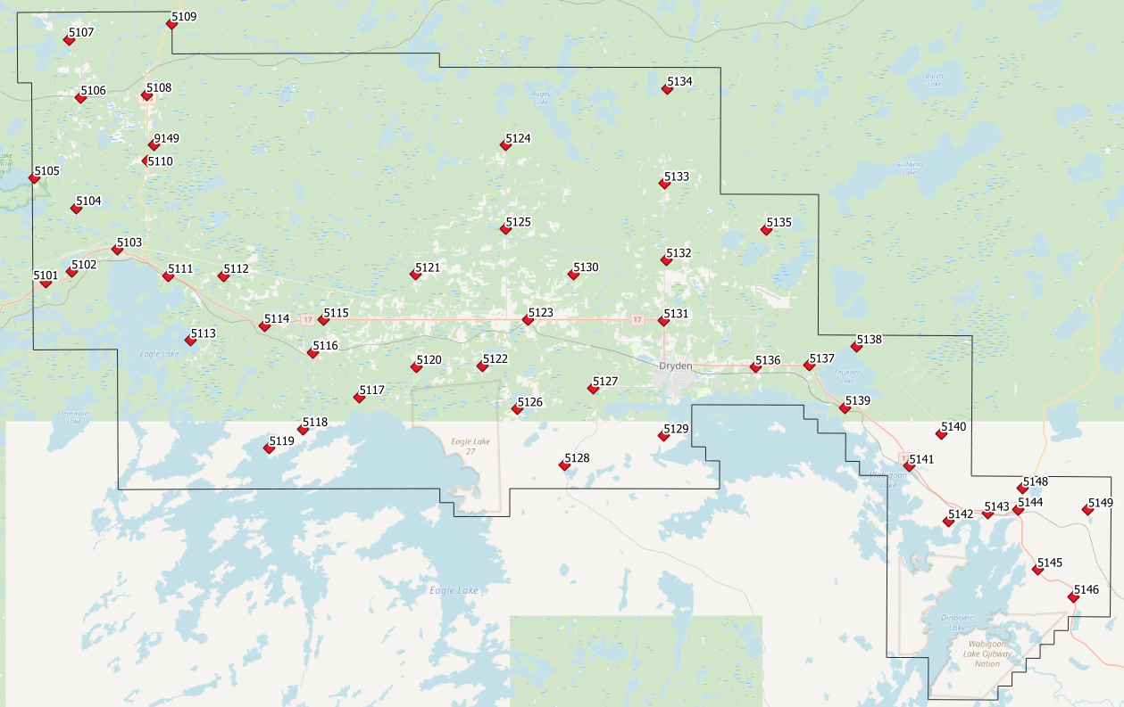
Map of the Dryden NVA points.
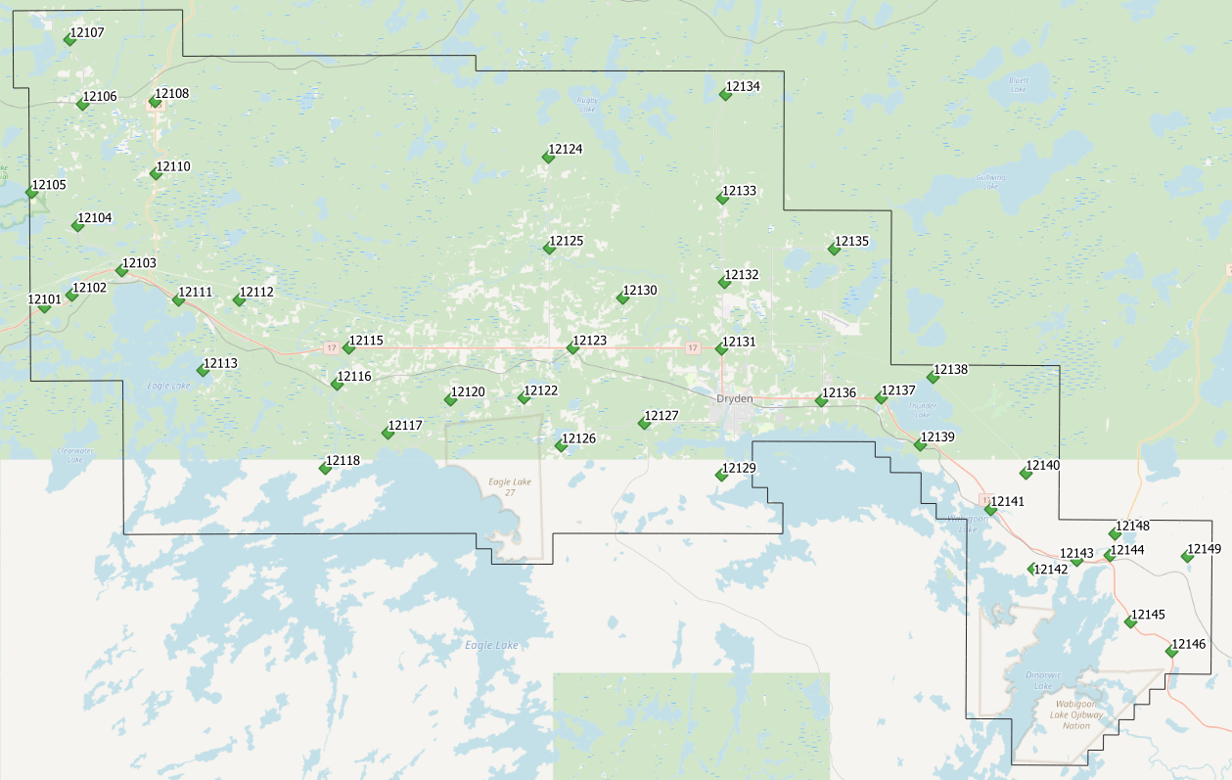Map of the Dryden VVA points.

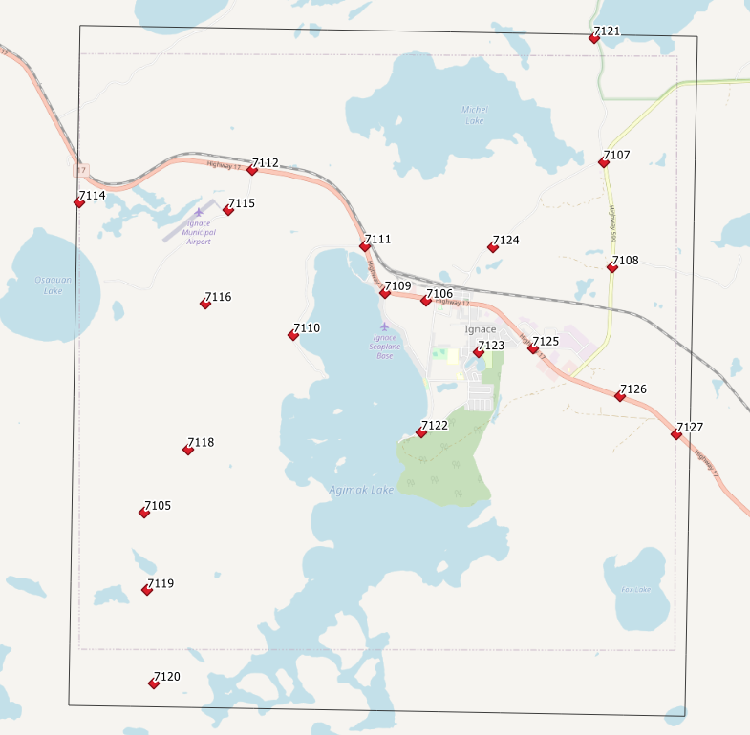
Map of the Ignace NVA points.

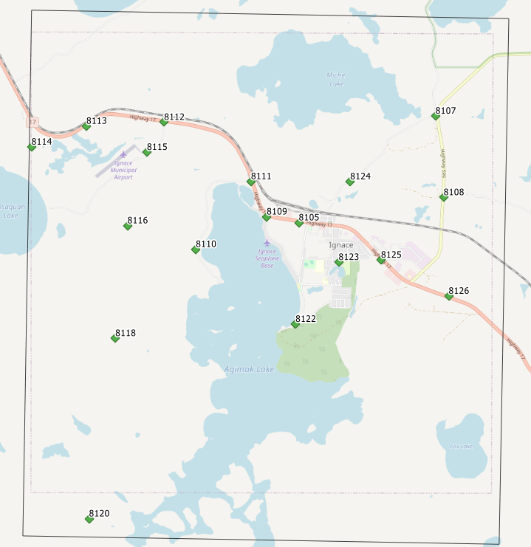Map of the Ignace VVA points.

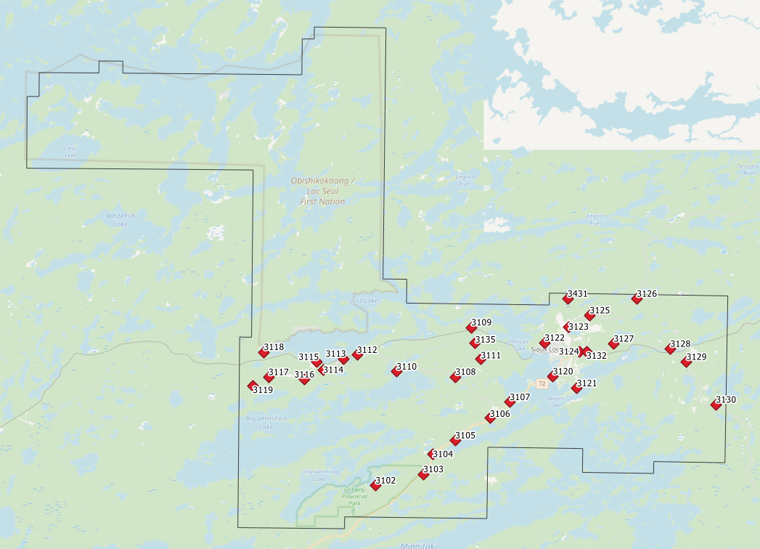
Map of the Sioux Lookout NVA points.

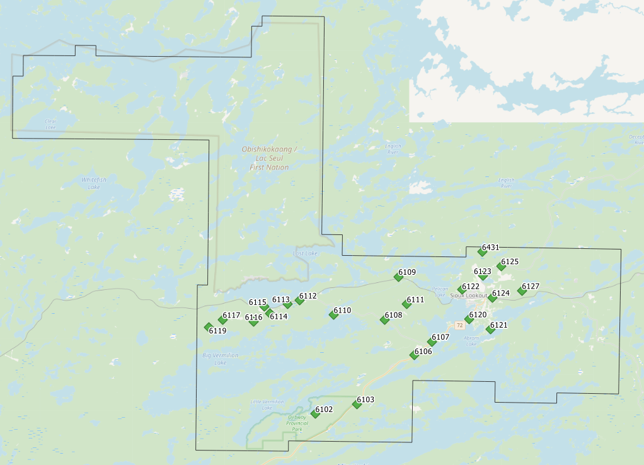
Map of the Sioux Lookout VVA points.

Trajectory Processing
The aircraft trajectory positioning for the mission over the Chapleau area was processed using the Precise Point Positioning (PPP) technique.
PPP is a positioning technique that removes and models GNSS system errors via precise satellite orbit data and clock corrections that are applied to the trajectory post mission, providing centimeter level positional accuracy without the use of ground base stations.
The TerraPOS software by Terratec was used to postprocess the PPP solutions to produce final kinematic trajectories accurate to 5 centimeters for each flight mission.
The horizontal datum used is Nad83 CSRS UTM zone 15 with the CGVD2013 vertical datum (CGG2013 undulation model).

LiDAR Data Processing

Calibration Procedures
After each mission, the field project manager creates the preliminary calibrated point cloud with each sensor’s set boresight values for each mission. Proprietary QC tools using the Lastools software are run on each mission to check for coverage, relative accuracy, point density, etc… If any data is found to be not meeting specifications, or coverage missing, the field crew is immediately notified and the areas affected reflown as soon as possible.
This preliminary calibrated point cloud is inspected in conjunction with the kinematic ground truth points to apply bulk shifts if necessary and further refine the calibration by applying corrections to the preliminary calibrated strips. The refined calibration is done using Bayesmap’s StripAlign software. Intensity values are also normalized by mission to be 16 bits (0 to 65535).

Data Tiling and Classification
The raw LiDAR data is processed into calibrated point cloud strips corresponding to flight lines. For ease of data manipulation, the strips are combined and saved in tiles of 1 km by 1 km. The format the strips and tiles are saved in is .Laz version 1.4. The tiling scheme is based on the UTM15 projection at the even kilometers.
The tiled point cloud is then processed with a series of algorithms to separate the “most-likely” ground returns from other returns. The point classification is done using a product by the TerraSolid software running on MicroStation Connect called TerraScan and TerraModeler.
In addition to our regular field QC and calibration procedures, we also generate various raster products using the Lastools software to assess coverage and calibration accuracy.

Point Cloud Manipulation
The TerraScan software uses macros that are set-up to measure the angles and distances between points to determine what classification a point should be: ground, vegetation, noise, other. The angle and distance values in the macros can be adjusted to be more or less aggressive with the classification of points by varying the incidence angles and estimated distances among neighboring points. The lower points are generally classified as ground returns, with the points above classified as undefined (class 1). Outliers and noise described in the table below are normally clouds, outliers or atmospheric noise in the data that are separated into above or below the ground level (high point or low points).
After the automated macro is run to determine classes, a systematic visual inspection is performed to fine tune the ground definition. To better understand areas for improvement for the ground surface, the points that are classified as ground are used to create viewable TINs and grid surfaces. These surfaces are inspected for areas that appear rough, artificially flattened or truncated, no data areas, or have other viewable errors.
In cleaning up ground points, the focus is concentrated in areas where few ground points have been left in the bare earth model and the ground appears rough or lower and flatter than it may be in reality. The scarcity of ground points may be a result from no penetration through a dense vegetation layer, water bodies, low reflectivity objects, or too aggressive values with the macro. A manual/visual inspection of these areas plays a major role in resolving any issues or irregularities with the bare earth model.
Once the first edits are completed, a one-meter grid of the ground surface is re-exported and hill shade images produced to QC the edited ground surface. This QC step is done iteratively as many times as necessary. Once the point cloud data has reached a satisfactory level of classification accuracy, the final deliverables are produced.

Water Classification & Hydro-Flattening
Once the ground class has reached the final level of classification accuracy, the water delineation process is initiated. The rivers and water bodies are digitized as break lines according to USGS specifications of a minimum of 8000 m² for water bodies and 30 m nominal width for streams and rivers. Ponds and lakes have their elevations set constant to just below ground. Stream and river hydro lines are collected using the downstream method. Once all hydro lines have been collected for an area, the ground points inside the hydro lines are classified to class 9 – Water. The ground points outside of the hydro lines but within 35 cm are classified to class 20 – Ignored ground (near breaklines). Using the TIN of class 2 (ground points), the hydro lines are used as constraints to generate the final 50 cm hydro-flattened DEMs in ESRI Ascii format, then converted to 32bit Geotiff format with the Global Mapper software.

Class definitions
The classification follows the ASPRS classification codes. The table below shows the classes for the delivered point cloud.
Table 2: ASPRS Point Classes
Classification Value | Description
1 | Unclassified
2 | Ground
6 | Building
7 | Low Points
9 | Water
17 | Bridge Decks
18 | High Points
20 | Ignored Ground (breakline proximity)
21 | Snow
22 | Temporal exclusion

Deliverables
The data was delivered at the end of March 2025.
See below for a table of the folder structure and description of each deliverables.
DIFF
50cm rasters of flight lines differences, 1 X 1 km tiles in 32bit Geotiff format
e.g. 1km153850494302024LDRYDEN_diff.tif
DTM
Hydro-flattened 50cm Bare Earth DEMs, 1 X 1 km tiles in 32bit Geotiff format
e.g. 1km153850494302024LDRYDEN.tif
METADATA
Metadata files for Breaklines, DEM, LAS and Project in .XML format
e.g. DRYDEN_2024_Lidar_metadata_Breaklines.xml
POINTCLOUD
Point cloud data, 1 X 1 km tiles in .LAZ format 1.4
e.g. 1km153850494302024LDRYDEN.laz
PROJECT_POLYGON
Shape files of: Lift_metadata, Hydro_breaklines, Project_extent & Tile_index
e.g. Mission_4124305a_z15.shp

Vertical Accuracy Assessment
Dryden
Non Vegetated Vertical Accuracy (NVA)
Below is a summary of the statistics between the point cloud TIN from the ground class and the NVA points surveyed on flat hard surfaces:
Number of points: | 49
Average dz: | -0.004 | m
Minimum dz: | -0.061 | m
Maximum dz: | +0.075 | m
Average magnitude: | 0.023 | m
Root mean square: | 0.030 | m
Std deviation: | 0.030 | m
NVA Vertical Accuracy (95%): | 0.059 | m

For a complete listing of the RTK points and their differences, please refer to the provided spreadsheet named " Dryden_NVA_Accuracy_z15_Final.xlsx".
As seen in the NVA comparison above, the accuracy observed of 0.059 m meets the project requirement of QL0 NVA vertical accuracy of 9.8 cm (95%).

Vegetated Vertical Accuracy (VVA)
The elevations of the points surveyed in various vegetated land cover types were compared to the Lidar ground surface. Since the elevation differences for this type of accuracy does not follow a normal distribution, the percentile method is used and not the 95% confidence level. For the 38 VVA points surveyed, sorting the absolute differences from the smallest to the largest gives the accuracy at the 95th percentile (using the linear interpolation between closest ranks method). For this sample, the 36th and 37th largest difference are respectively 12.2 and 14.0 cm.
For this project, the VVA accuracy is therefore 12.5 cm.
For a complete listing of the kinematic points and their differences, please refer to the provided spreadsheet named "Dryden_VVA_Accuracy_z15_Final.xlsx".

Ignace
Non Vegetated Vertical Accuracy (NVA)
Below is a summary of the statistics between the point cloud TIN from the ground class and the NVA points surveyed on flat hard surfaces:
Number of points: | 21
Average dz: | +0.014 | m
Minimum dz: | -0.028 | m
Maximum dz: | +0.057 | m
Average magnitude: | 0.022 | m
Root mean square: | 0.027 | m
Std deviation: | 0.023 | m
NVA Vertical Accuracy (95%): | 0.053 | m

For a complete listing of the RTK points and their differences, please refer to the provided spreadsheet named " Ignace_NVA_Accuracy_z15_Final.xlsx".
As seen in the NVA comparison above, the accuracy observed of 0.053 m meets the project requirement of QL0 NVA vertical accuracy of 9.8 cm (95%).

Vegetated Vertical Accuracy (VVA)
The elevations of the points surveyed in various vegetated land cover types were compared to the Lidar ground surface. Since the elevation differences for this type of accuracy does not follow a normal distribution, the percentile method is used and not the 95% confidence level. For the 17 VVA points surveyed, sorting the absolute differences from the smallest to the largest gives the accuracy at the 95th percentile (using the linear interpolation between closest ranks method). For this sample, the 16th and 17th largest difference are respectively 7.5 and 15.0 cm.
For this project, the VVA accuracy is therefore 9.0 cm.
For a complete listing of the kinematic points and their differences, please refer to the provided spreadsheet named " Ignace_VVA_Accuracy_z15_Final.xlsx".

Sioux Lookout
Non Vegetated Vertical Accuracy (NVA)
Below is a summary of the statistics between the point cloud TIN from the ground class and the NVA points surveyed on flat hard surfaces:
Number of points: | 31
Average dz: | +0.021 | m
Minimum dz: | -0.037 | m
Maximum dz: | +0.080 | m
Average magnitude: | 0.027 | m
Root mean square: | 0.033 | m
Std deviation: | 0.026 | m
NVA Vertical Accuracy (95%): | 0.065 | m

For a complete listing of the RTK points and their differences, please refer to the provided spreadsheet named " SiouxLookout_NVA_Accuracy_z15_Final.xlsx".
As seen in the NVA comparison above, the accuracy observed of 0.065 m meets the project requirement of QL0 NVA vertical accuracy of 9.8 cm (95%).

Vegetated Vertical Accuracy (VVA)
The elevations of the points surveyed in various vegetated land cover types were compared to the Lidar ground surface. Since the elevation differences for this type of accuracy does not follow a normal distribution, the percentile method is used and not the 95% confidence level. For the 22 VVA points surveyed, sorting the absolute differences from the smallest to the largest gives the accuracy at the 95th percentile (using the linear interpolation between closest ranks method). For this sample, the 20th and 21st largest differences are respectively 9.7 and 9.8 cm.
For this project, the VVA accuracy is therefore 9.8 cm.
For a complete listing of the kinematic points and their differences, please refer to the provided spreadsheet named "SiouxLookout_VVA_Accuracy_z15_Final.xlsx".

Conclusion
This is the final report covering the Dryden / Ignace / Sioux Lookout Lidar project areas. Topics such as field operations, control, data processing and final accuracy results were explained. The project went well, acquired in one season and delivered on schedule. Both the non-vegetated vertical accuracy and the vegetated vertical accuracy meet QL0 specifications.

Appendix A - Control Points – Published Coordinates
Dryden - Control Station Coordinates
Station | Easting | Northing | Height | Desription
2022-51 | 491074.871 | 5511672.226 | 382.689 | Airborne Intermediate Base
2022-52 | 474658.023 | 5530498.854 | 343.366 | Airborne Intermediate Base
2022-53 | 510960.181 | 5523667.128 | 361.022 | Airborne Intermediate Base
573121 | 468289.769 | 5521294.412 | 433.659 | NRCan 3D Passive Control
66D8168 | 530489.646 | 5505746.365 | 384.488 | NRCan 3D Passive Control
66D8189 | 504797.344 | 5518083.023 | 374.357 | NRCan 3D Passive Control
913001 | 472319.116 | 5522941.262 | 401.017 | NRCan 3D Passive Control

Ignace - Control Station Coordinates
Station | Easting | Northing | Height | Desription
2022-41 | 596468.306 | 5474732.213 | 451.861 | Airborne Intermediate Base
2022-42 | 605268.121 | 5480513.556 | 418.958 | Airborne Intermediate Base
2022-43 | 575001.703 | 5481881.162 | 453.446 | Airborne Intermediate Base
913002 | 606310.061 | 5468384.111 | 464.230 | NRCan 3D Passive Control

Sioux Lookout - Control Station Coordinates
Station | Easting | Northing | Height | Desription
2022-61 | 559136.925 | 5548774.750 | 375.467 | Airborne Intermediate Base
2022-62 | 567404.126 | 5541381.779 | 379.552 | Airborne Intermediate Base
2022-63 | 580205.585 | 5550116.130 | 370.029 | Airborne Intermediate Base
57319 | 571501.328 | 5549042.133 | 444.431 | NRCan 3D Passive Control

Horizontal Datum: Nad83(CSRS) UTM Zone 15 (epoch 2010)
Vertical Datum: CGVD2013 (Geoid CGG2013a)

Appendix B – RTK Survey & Control Check
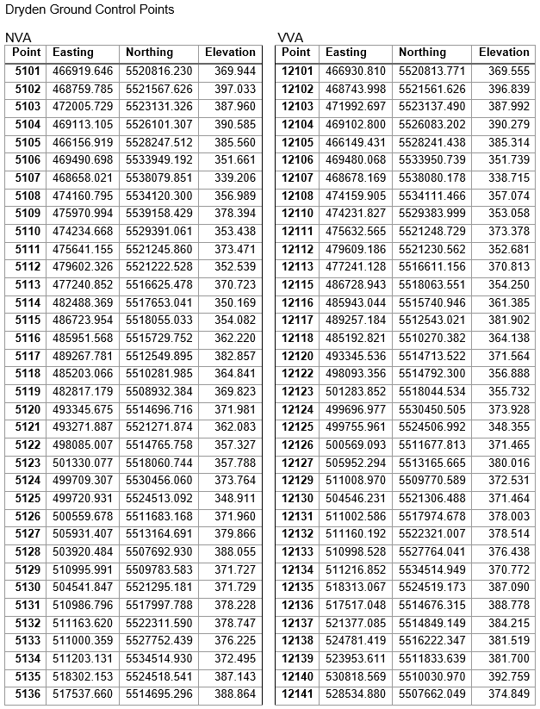
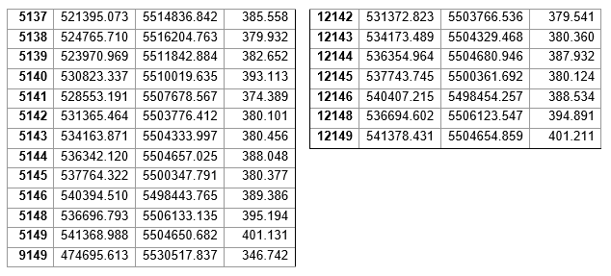

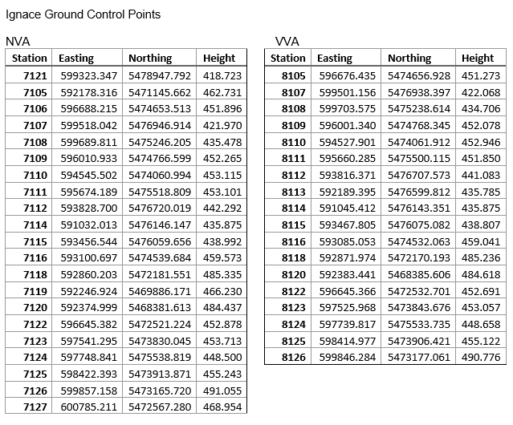
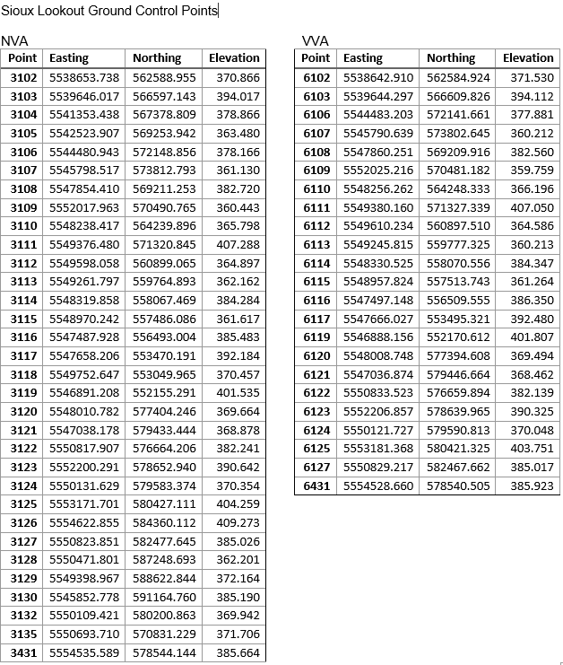

Appendix C – Published Station Coordinate Sheets
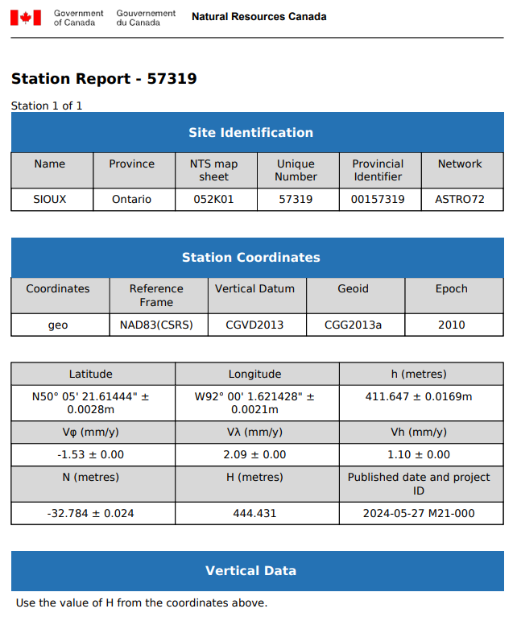
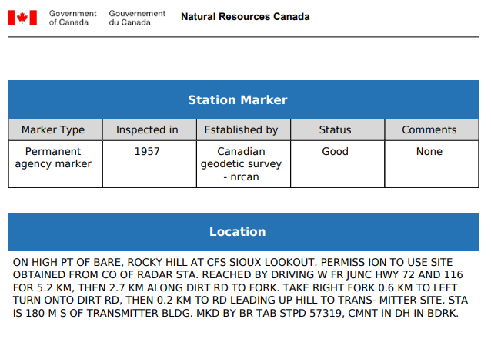
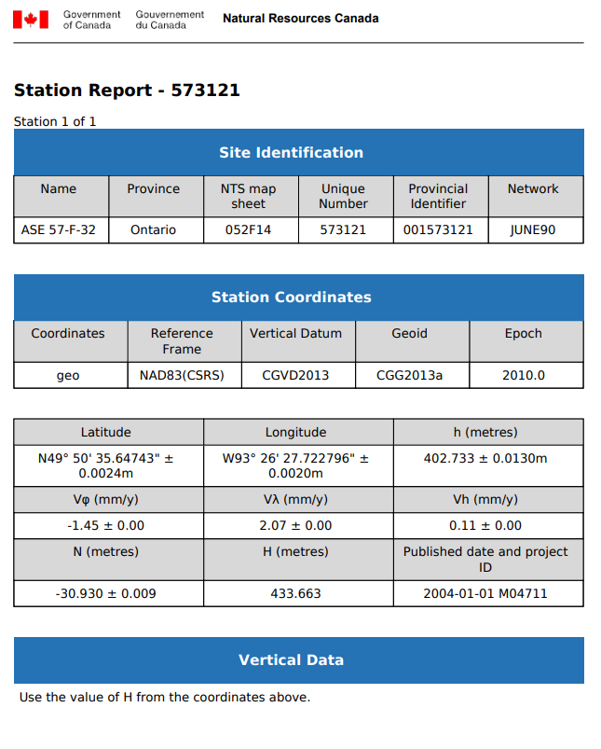
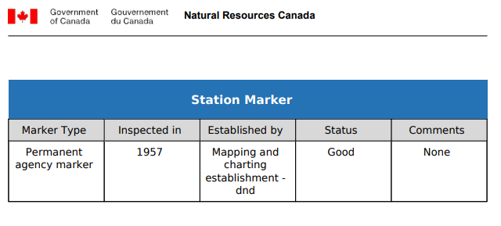
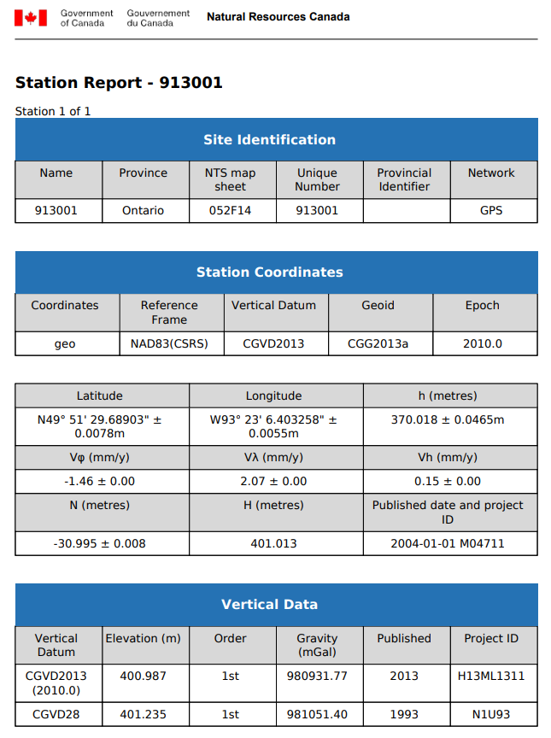
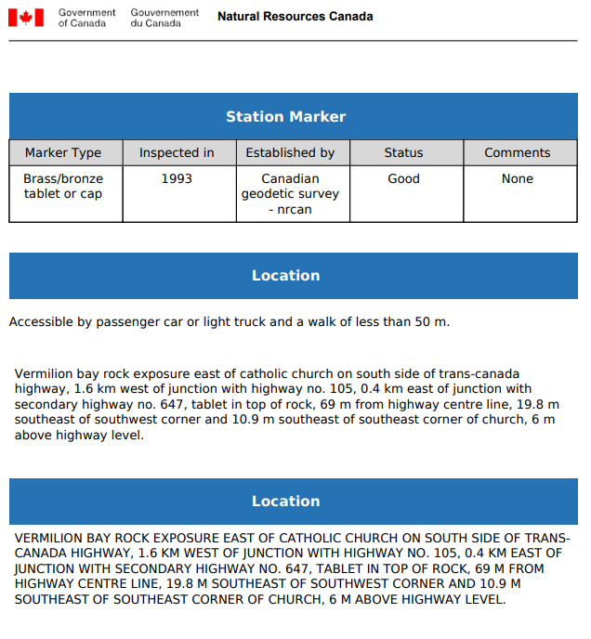
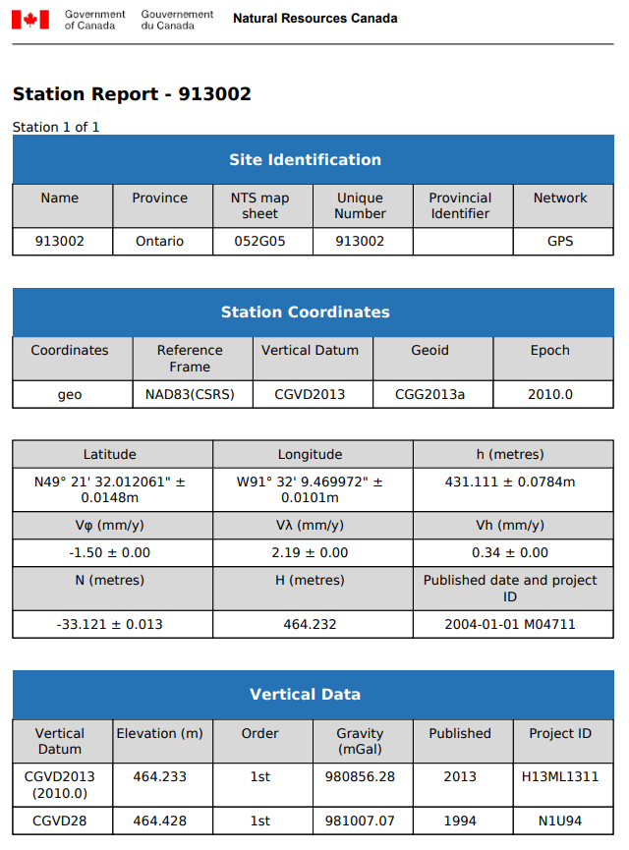
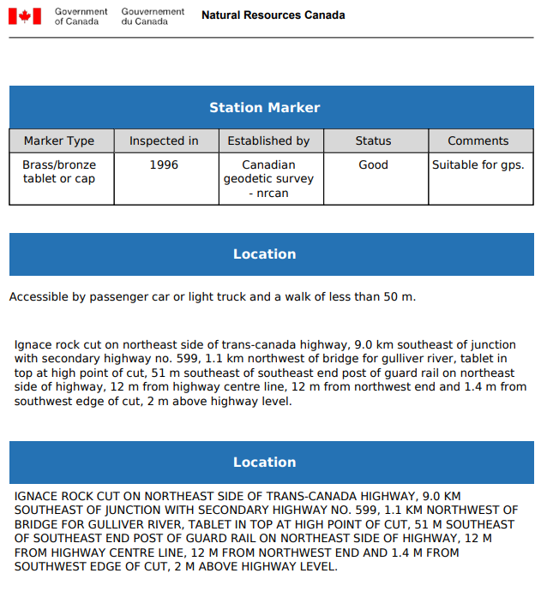
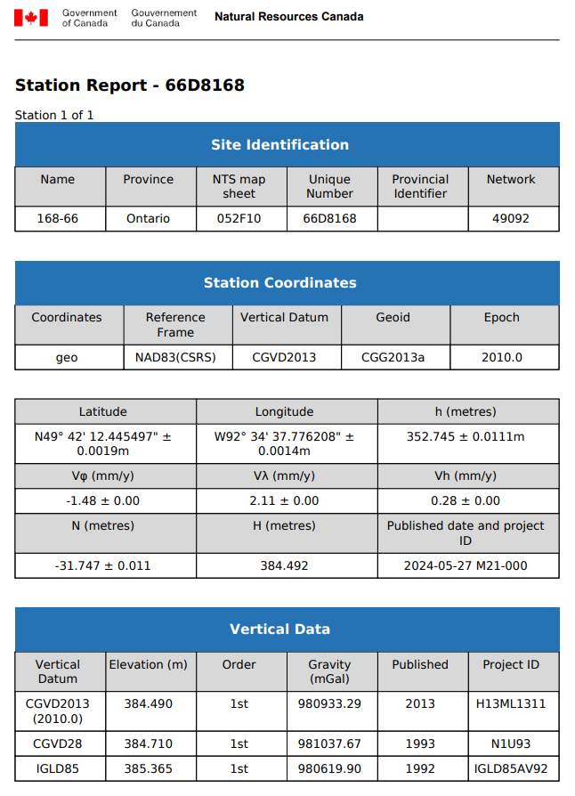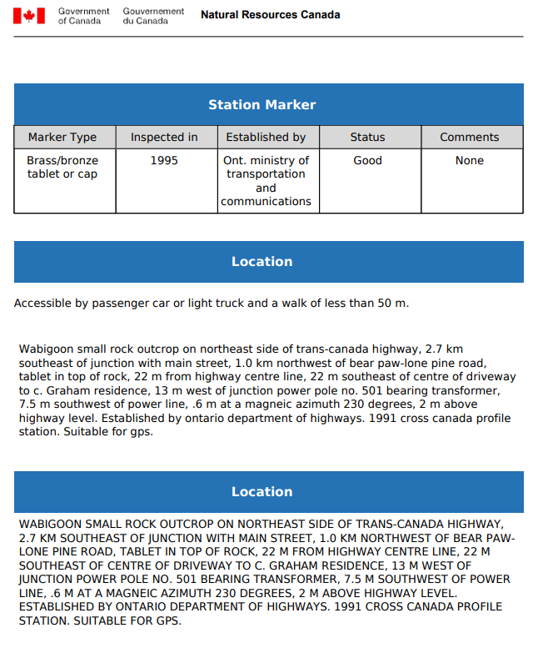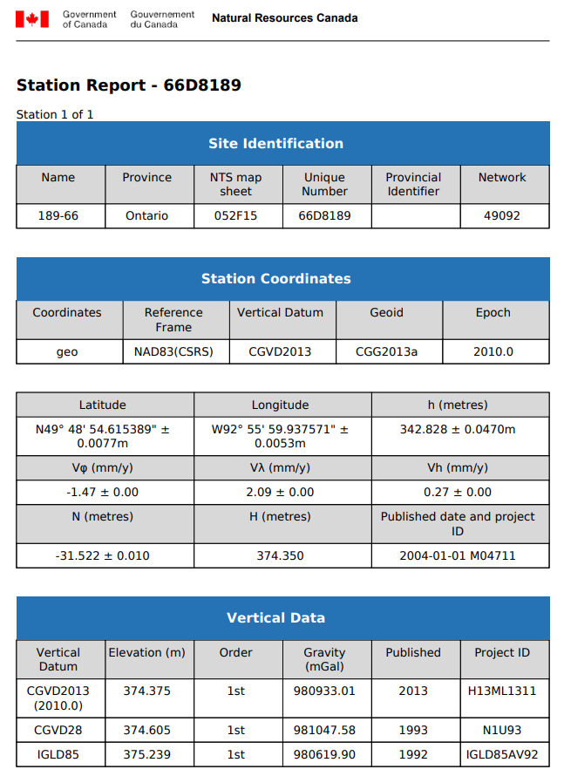
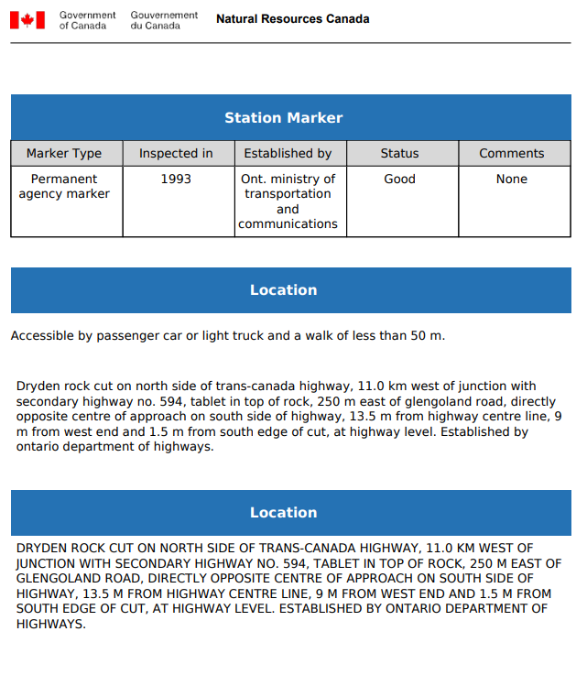
PPP Solutions