Final Report
For project:
Huron Georgian Bay LiDAR
Prepared for:
Ontario Ministry of Natural Resources
2nd floor, North Tower, 300 Water Street,
Peterborough, ON, K9J 3C7
Prepared by:

Airborne Imaging
2700 – 61 Avenue SE
Calgary, AB T2C 4V2
February 24, 2025

Contents
Introduction 1
Project Schedule & Personnel 2
LiDAR System & Flight Parameters 2
Project Control / Datum 4
Check Points 6
Trajectory Processing 9
LiDAR Data Processing 9
Calibration Procedures 9
Data Tiling and Classification 9
Point Cloud Manipulation 10
Water Classification & Hydro-Flattening 10
Class definitions 11
Deliverables 12
Vertical Accuracy Assessment 13
Conclusion 14
Appendix A - Control Points – Published Coordinates 15
Appendix B – RTK Survey & Control Check 16
Appendix C – Published Station Coordinate Sheets 26

Introduction
The Ontario Ministry of Natural Resources and Forests contracted Airborne Imaging to acquire and deliver digital elevation data derived from airborne LiDAR (Light Detection and Ranging) to cover various regions in Ontario.
This report covers the Huron Georgian Bay area, collected over three seasons: fall of 2022, spring of 2023 and fall of 2023. The report focuses on LiDAR acquisition details, such as flight parameters, project control, ground truthing results, data processing technique and deliverables.
The contracted area for the Huron Georgian Bay area is 16,944.54 km².
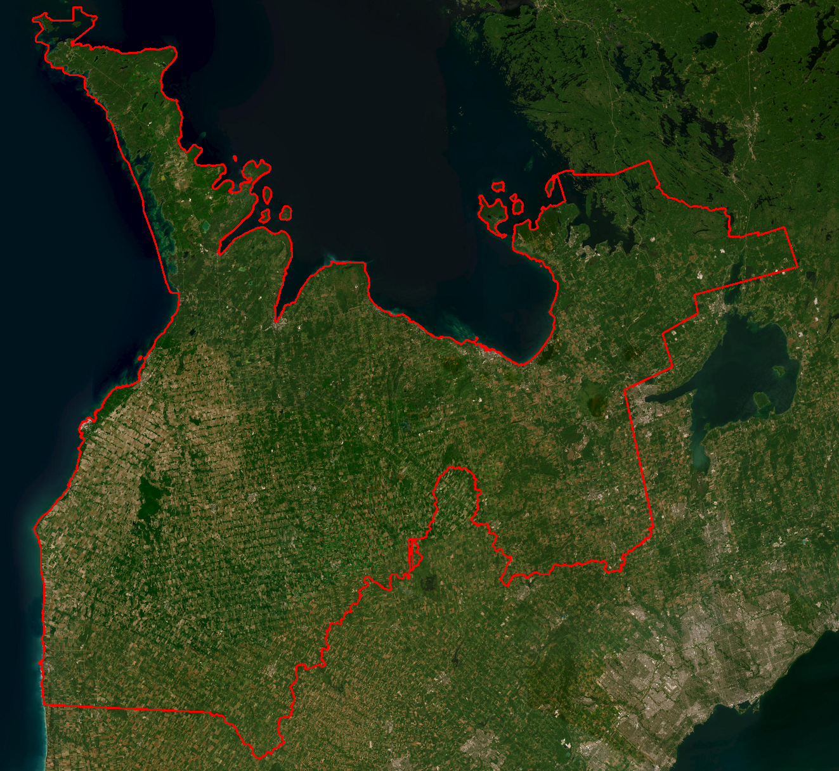

Project Schedule & Personnel
The ground control and Lidar acquisition occurred during the fall of 2022, spring of 2023 and fall of 2023. The Lidar data was collected in twenty-three missions. See table below for a list of missions. The surveyors collecting ground truth points during this period are Andrew Gruber, Tom Cooper and Alistair Lornie.
A typical Lidar acquisition crew consisted of one Lidar Operator and one Pilot. The project management was done remotely by Allyson Fox and Daniel Arteaga.

LiDAR System & Flight Parameters
Either a Riegl VQ-1560ii or VQ-1560ii-S was used to collect the Lidar data. The systems were installed in KASI Aviation’s Piper Navajos (call signs C-GMEC, C-GKSV and C-GPBN).
Below is a table of the lifts with their flight parameters.
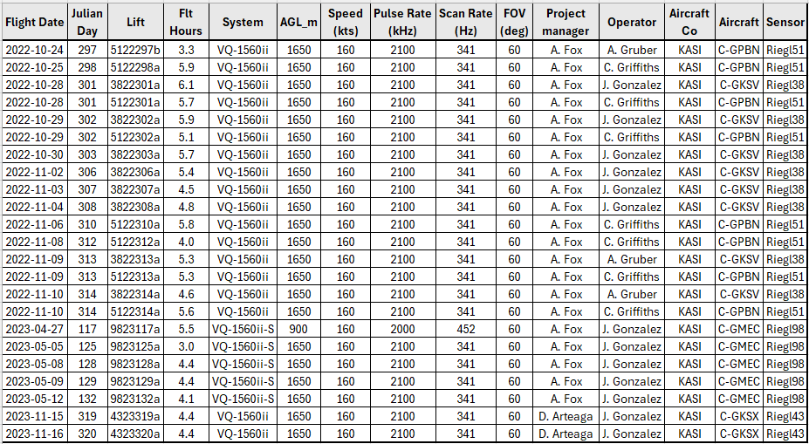
Table 1: Project Parameters for the Huron Georgian Bay area.
 | Regular flight plan | Lower flight plan (Meaford area)
Altitude | 1600m AGL | 900m AGL
Field of View (FOV) | 60° | 60°
Air Speed | 160 Kts | 160 Kts
Pulse Rate | 2100 kHz | 2000 kHz
Sidelap | 20% | 20%
Point Density | > 8 pts/m² | > 8 pts/m²

The flight lines were designed optimally to maximize time online versus time in turn.
Below is a map of the flight lines including cross-ties.
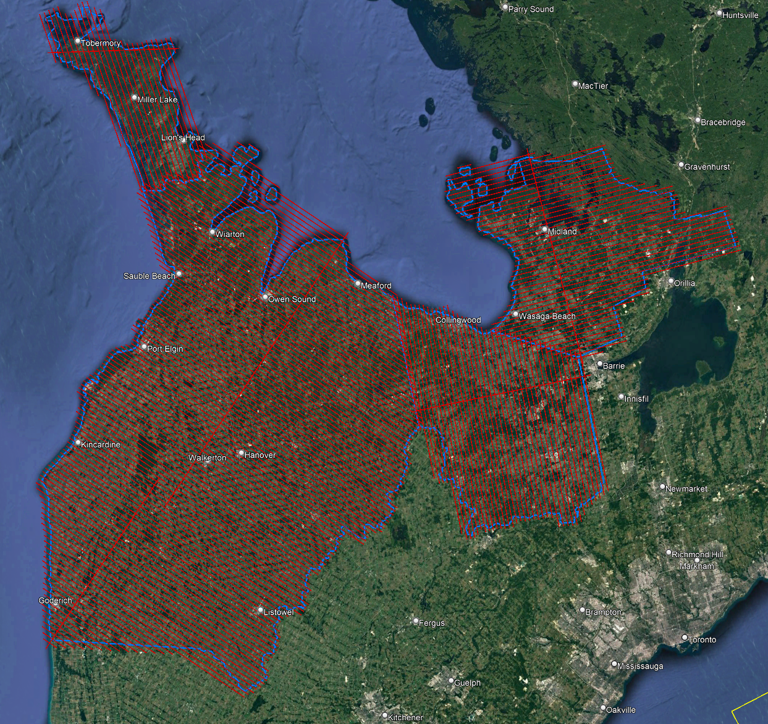

Below is a map of the flight line footprints colored by season of acquisition.
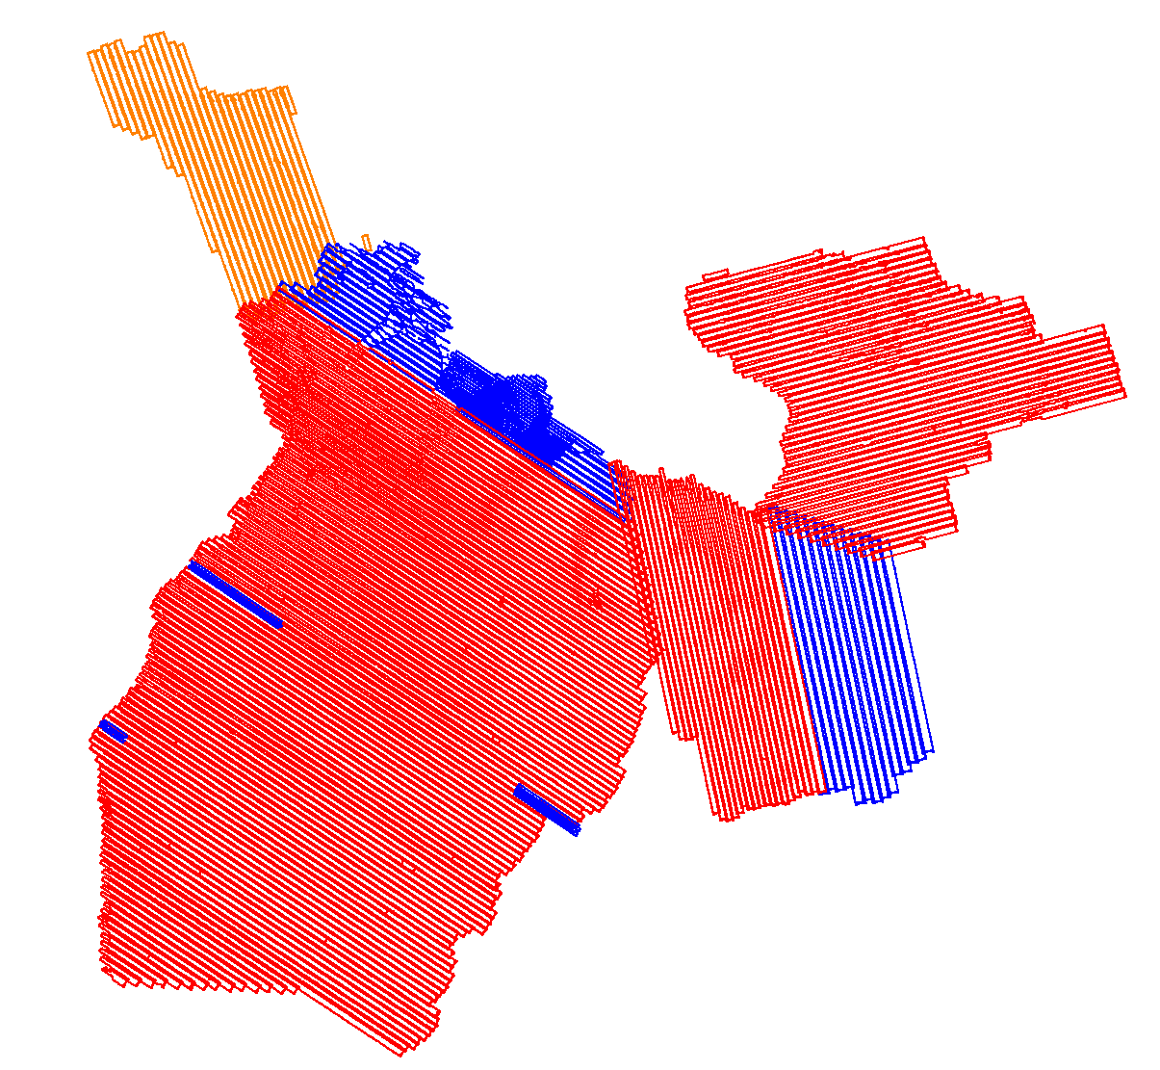
Fall 2022 (RED): collection of the majority of the project
Spring 2023 (BLUE): collection of the Meaford & Borden areas plus a few lines reflown
Fall 2023 (ORANGE): North Bruce area

Project Control / Datum
Several baselines were measured by GPS static occupation between the Cannet stations and existing NRCan, cosine points as well as newly established points by Airborne Imaging. The existing control used consisted of thirteen Can-Net Continuous Reference Stations (CORS), five NRCan 3D passive stations, and three Ontario COSINE points.
Appendix A contains a list of Control Points and their published coordinates.
Appendix B shows the checks performed between Cannet stations and passive stations with redundant checks.
Appendix C shows the published station coordinate sheets.
The datum used and therefore all subsequent Lidar data are based on the Nad83 CSRS (epoch 2010.0) horizontal datum and the CGVD2013 vertical datum (CGG2013 undulation model).
Below is an overview map of the control stations.
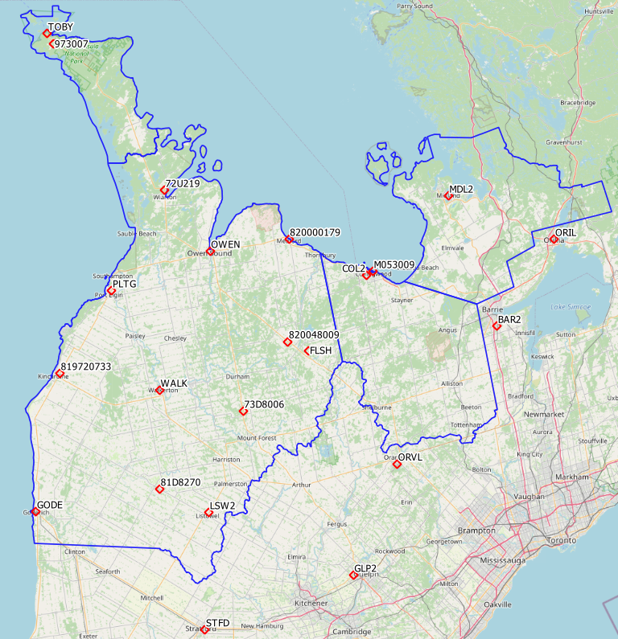

Check Points
Control check points were surveyed from different methods to use as vertical check and accuracy assessment. The kinematic method was used for calibration purposes and the RTK method for Non-Vegetated Vertical Accuracy Assessment (NVA) and Vegetated Vertical Accuracy Assessment (VVA).
Kinematic GPS
The first method called kinematic are profiles surveyed on open roads from a truck-mounted GPS receiver while driving. The post-processed kinematic coordinates, collected at an interval of one second are derived from a base station that is part of our control network.
Whenever possible, we try to select roads that are perpendicular to the flight line azimuth so the control points intersect as many Lidar strips as possible.
The output coordinates are analyzed and filtered to ensure only very reliable positions are kept. All points collected while moving slower than 2 meters per second are rejected. This removes all points when the truck was stationary that could skew the statistics.
The following points are also rejected:
- Points with a Quality Level worse than 1.
- Points with a forward/reverse vertical separation worse than 3 cm.
- Points with less than two solutions (forward & reverse).
- Points with a standard deviation worse than 2sigma.

Many sections of road were surveyed throughout the project giving us thousands of surveyed points on the road. We estimate that the vertical accuracy of these points is better than 5 cm.
During the calibration of the Lidar strips, the Lidar strips are matched vertically to these reliable kinematic points. These points are not used for the vertical accuracy assessment of the Lidar point cloud, but rather just for calibration monitoring and shifting. For that reason, the results of the kinematic surveys will not be discussed in this report.
RTK GPS
In order to meet the recommended ASPRS minimum number of points for a 17,000 square kilometer project, RTK points were surveyed in areas distributed throughout the project.
The second method called Real Time Kinematic are individual points surveyed on open terrain. Our surveyor collected GPS data mounted on a pole while receiving real time differential corrections from the GPS receiver positioned over a nearby control point.
248 points were surveyed on the Huron Georgian Bay project. Of these, 151 points were over non-vegetated ground conditions for NVA accuracy reporting and 97 of them were over vegetated areas for VVA accuracy reporting.
Pictures of these RTK points (as well as the existing control) are provided with this report in a folder called “HuronGeorgianBay_Control_Point_Pictures”.
These points are used just for the vertical accuracy assessment of the Lidar point cloud and were not used to determine any vertical shift applied to the point cloud.

See the green triangles on the map below.
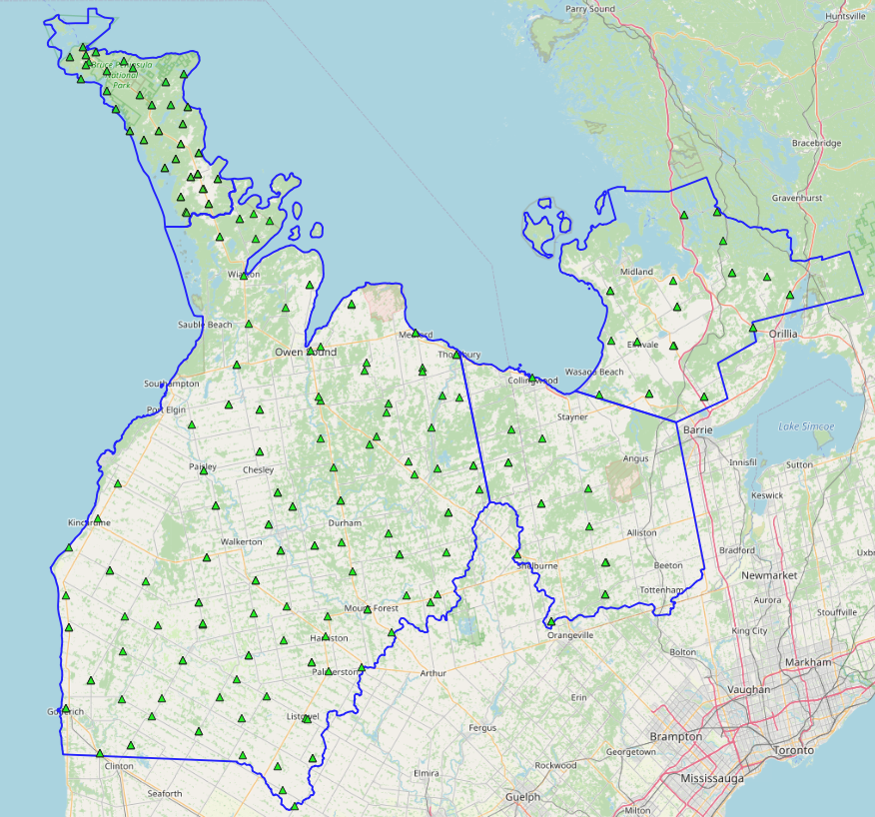
Blue = project outline
Green = Fast Static (NVA & VVA)

Trajectory Processing
The aircraft trajectory positioning for the missions over the Huron Georgian Bay area were processed using the Precise Point Positioning (PPP) technique.
PPP is a positioning technique that removes and models GNSS system errors via precise satellite orbit data and clock corrections that are applied to the trajectory post mission, providing centimeter level positional accuracy without the use of ground base stations.
The TerraPOS software by Terratec was used to postprocess the PPP solutions to produce final kinematic trajectories accurate to 5 centimeters for each flight mission.
The horizontal datum used is Nad83 CSRS UTM zone 17 with the CGVD2013 vertical datum (CGG2013 undulation model).

LiDAR Data Processing

Calibration Procedures
After each mission, the field project manager creates the preliminary calibrated point cloud with each sensor’s set boresight values for each mission. Proprietary QC tools using the Lastools software are run on each mission to check for coverage, relative accuracy, point density, etc… If any data is found to be not meeting specifications, or coverage missing, the field crew is immediately notified and the areas affected reflown as soon as possible.
This preliminary calibrated point cloud is inspected in conjunction with the kinematic ground truth points to apply bulk shifts if necessary and further refine the calibration by applying corrections to the preliminary calibrated strips. The refined calibration is done using Bayesmap’s StripAlign software. Intensity values are also normalized by mission to be 16 bits (0 to 65535).

Data Tiling and Classification
The raw LiDAR data is processed into calibrated point cloud strips corresponding to flight lines. For ease of data manipulation, the strips are combined and saved in tiles of 1 km by 1 km. The format the strips and tiles are saved in is .Laz version 1.4. The tiling scheme is based on the UTM17 projection at the even kilometers.
The tiled point cloud is then processed with a series of algorithms to separate the “most-likely” ground returns from other returns. The point classification is done using a product by the TerraSolid software running on MicroStation Connect called TerraScan and TerraModeler.
In addition to our regular field QC and calibration procedures, we also generate various raster products using the Lastools software to assess coverage and calibration accuracy.

Point Cloud Manipulation
The TerraScan software uses macros that are set-up to measure the angles and distances between points to determine what classification a point should be: ground, vegetation, noise, other. The angle and distance values in the macros can be adjusted to be more or less aggressive with the classification of points by varying the incidence angles and estimated distances among neighboring points. The lower points are generally classified as ground returns, with the points above classified as undefined (class 1). Outliers and noise described in the table below are normally clouds, outliers or atmospheric noise in the data that are separated into above or below the ground level (high point or low points).
After the automated macro is run to determine classes, a systematic visual inspection is performed to fine tune the ground definition. To better understand areas for improvement for the ground surface, the points that are classified as ground are used to create viewable TINs and grid surfaces. These surfaces are inspected for areas that appear rough, artificially flattened or truncated, no data areas, or have other viewable errors.
In cleaning up ground points, the focus is concentrated in areas where few ground points have been left in the bare earth model and the ground appears rough or lower and flatter than it may be in reality. The scarcity of ground points may be a result from no penetration through a dense vegetation layer, water bodies, low reflectivity objects, or too aggressive values with the macro. A manual/visual inspection of these areas plays a major role in resolving any issues or irregularities with the bare earth model.
Once the first edits are completed, a one-meter grid of the ground surface is re-exported and hill shade images produced to QC the edited ground surface. This QC step is done iteratively as many times as necessary. Once the point cloud data has reached a satisfactory level of classification accuracy, the final deliverables are produced.

Water Classification & Hydro-Flattening
Once the ground class has reached the final level of classification accuracy, the water delineation process is initiated. The rivers and water bodies are digitized as break lines according to USGS specifications of a minimum of 8000 m² for water bodies and 30 m nominal width for streams and rivers. Ponds and lakes have their elevations set constant to just below ground. Stream and river hydro lines are collected using the downstream method. Once all hydro lines have been collected for an area, the ground points inside the hydro lines are classified to class 9 – Water. The ground points outside of the hydro lines but within 35 cm are classified to class 20 – Ignored ground (near breaklines). Using the TIN of class 2 (ground points), the hydro lines are used as constraints to generate the final 50 cm hydro-flattened DEMs in ESRI Ascii format, then converted to 32bit Geotiff format with the Global Mapper software.

Class definitions
The classification follows the ASPRS classification codes. The table below shows the classes for the delivered point cloud.
Table 2: ASPRS Point Classes
Classification Value | Description
1 | Unclassified
2 | Ground
6 | Building
7 | Low Points
9 | Water
17 | Bridge Decks
18 | High Points
20 | Ignored Ground (breakline proximity)
21 | Snow
22 | Temporal exclusion

Deliverables
Since the project was collected over three seasons, multiple deliverables were made as the data was ready. The majority of the Huron Georgian Bay area was collected in the fall of 2022 and delivered in March 2023. The areas over the Meaford and Borden military bases were collected in the spring of 2023 and delivered in October 2023 (with a few reflights). The North Bruce peninsula was collected in the fall of 2023 and delivered in March 2024.
See below for a table of the folder structure and description of each deliverables.
DTM
Hydro-flattened 50cm Bare Earth DEMs, 1 X 1 km tiles in 32bit Geotiff format
e.g. 1km174390487802022LHURONGEORGIANBAY.tif
METADATA
Metadata files for Breaklines, DEM, LAS and Project in .XML format
e.g. HURONGEORGIANBAY2022_Lidar_metadata_LAS.xml
POINTCLOUD
Point cloud data, 1 X 1 km tiles in .LAZ format 1.4
e.g. 1km174400484302022LHURONGEORGIANBAY.laz
PROJECT_POLYGON
Shape files of: Lift_metadata, Hydro_breaklines, Project_extent & Tile_index
e.g. Mission_5122298a.shp

Vertical Accuracy Assessment

Non Vegetated Vertical Accuracy (NVA)
Below is a summary of the statistics between the point cloud TIN from the ground class and the NVA points surveyed on flat hard surfaces:
Number of points: | 151
Average dz: | -0.007 | m
Minimum dz: | -0.144 | m
Maximum dz: | +0.122 | m
Average magnitude: | 0.035 | m
Root mean square: | 0.042 | m
Std deviation: | 0.042 | m
NVA Vertical Accuracy (95%): | 0.083 | m

For a complete listing of the RTK points and their differences, please refer to the provided spreadsheet named " HuronGeorgianBay_NVA_Accuracy_Final.xlsx".
As seen in the NVA comparison above, the accuracy observed of 0.083 m meets the project requirement of QL0 NVA vertical accuracy of 9.8 cm (95%).

Vegetated Vertical Accuracy (VVA)
The elevations of the points surveyed in various vegetated land cover types were compared to the Lidar ground surface. Since the elevation differences for this type of accuracy does not follow a normal distribution, the percentile method is used and not the 95% confidence level. For the 97 VVA points surveyed, sorting the absolute differences from the smallest to the largest gives the accuracy at the 95th percentile (using the linear interpolation between closest ranks method). For this sample, the 92nd and 93rd largest difference are respectively 15.9 and 16.0 cm.
For this project, the VVA accuracy is therefore 15.92 cm.
This is slightly above the required specifications of 15.0 cm (the QL0 VVA specification).
For a complete listing of the kinematic points and their differences, please refer to the provided spreadsheet named " HuronGeorgianBay_VVA_Accuracy_Final.xlsx".

Conclusion
This is the final report covering the Huron Georgian Bay Lidar project. Topics such as field operations, control, data processing and final accuracy results were explained. The acquisition for this leaf off, snow off project was acquired over three seasons due to its size, poor weather and short acquisition windows between leaf off and the accumulation of snow (or vice versa, melting of snow and leaf on status). The non-vegetated vertical accuracy meets the QL0 requirement, and the vegetated vertical accuracy is slightly above the requirement (which is an indication of how well the laser penetrated in vegetated areas and is not an indication of the accuracy of the point cloud).

Appendix A - Control Points – Published Coordinates
Station | Easting | Northing | h | H (CGVD2013) | Status | Comment
STFD | 503007.702 | 4801423.870 | 332.900 | 367.775 | Published | Can-Net
LSW2 | 504329.108 | 4843266.883 | 359.647 | 394.487 | Published | Can-Net
GLP2 | 556066.788 | 4821156.748 | 315.118 | 350.529 | Published | Can-Net
GODE | 442705.012 | 4843795.305 | 194.830 | 229.801 | Published | Can-Net
WALK | 486867.066 | 4886684.321 | 264.024 | 299.317 | Published | Can-Net
OWEN | 504716.944 | 4935583.079 | 149.744 | 185.391 | Published | Can-Net
FLSH | 539535.287 | 4900727.811 | 452.804 | 487.838 | Published | Can-Net
PLTG | 470062.390 | 4921788.449 | 177.892 | 213.802 | Published | Can-Net
COL2 | 559821.583 | 4927419.998 | 166.252 | 201.720 | Published | Can-Net
ORVL | 571296.241 | 4860917.472 | 428.209 | 463.556 | Published | Can-Net
BAR2 | 606039.360 | 4910049.139 | 252.634 | 288.262 | Published | Can-Net
MDL2 | 588247.742 | 4955539.312 | 169.844 | 205.237 | Published | Can-Net
ORIL | 625681.385 | 4940970.863 | 195.767 | 231.065 | Published | Can-Net
TOBY | 447993.351 | 5011688.626 | 144.892 | 181.525 | Published | NRCan CACS
81D8270 | 486812.506 | 4851604.699 | 309.522 | 344.434 | Published | NRCan 3D Passive
73D8006 | 516506.445 | 4879258.199 | 339.756 | 374.771 | Published | NRCan 3D Passive
72U219 | 488727.546 | 4956939.366 | 176.581 | 212.559 | Published | NRCan 3D Passive
973007 | 450106.980 | 5008044.382 | 172.744 | 209.304 | Published | NRCan 3D Passive
M053009 | 562019.985 | 4928776.088 | 142.915 | 178.417 | Published | NRCan 3D Passive
820000179 | 532410.334 | 4939891.541 | 142.468 | N/A | Published | COSINE
820048009 | 532228.114 | 4903879.148 | 399.165 | 434.190 | Published | COSINE
819720733 | 451547.207 | 4892770.300 | 188.251 | N/A | Published | COSINE

Appendix B – RTK Survey & Control Check
Point # | Easting | Northing | H (Ellip) | H (Geoid) | JD (2022) | Comment | Etie | Ntie | ElevTie
CSTD_On | 503007.702 | 4801423.870 | 332.900 | 367.775 | 325 | Can-Net
4000 | 501718.557 | 4818901.326 | 335.133 | 369.944 | 325 | Paved road
CLS2_On | 504329.108 | 4843266.883 | 359.647 | 394.487 | 325 | Can-Net
4001 | 498712.991 | 4823065.725 | 328.382 | 363.185 | 325 | Paved road
4002 | 497205.769 | 4829400.738 | 324.233 | 359.039 | 325 | Paved road
4003 | 488168.201 | 4841520.483 | 320.118 | 354.969 | 325 | Paved road
4004 | 482450.226 | 4847044.505 | 306.971 | 341.866 | 325 | Paved road
4005 | 486848.482 | 4851608.069 | 308.457 | 343.369 | 325 | No picture
CGLP_On | 556066.788 | 4821156.748 | 315.118 | 350.529 | 325 | Can-Net
1935_chk01 | 535814.728 | 4817824.360 | 301.790 | 336.954 | 325 | Aii 1935-01 | -0.007 | 0.009 | -0.045
CLS2_On | 504329.108 | 4843266.883 | 359.647 | 394.487 | 326 | Can-Net
3000 | 506332.248 | 4831358.814 | 350.807 | 385.621 | 326 | Low brush
4005A | 506329.525 | 4831351.626 | 351.340 | 386.153 | 326 | Paved road
4006 | 504542.469 | 4841665.219 | 352.544 | 387.377 | 326 | Hard packed
4007 | 505007.316 | 4841265.547 | 355.948 | 390.779 | 326 | Paved road
4008 | 505977.767 | 4855972.395 | 340.223 | 375.120 | 326 | Paved road
3001 | 505967.848 | 4855996.430 | 340.222 | 375.118 | 326 | Short grass
4009 | 519009.686 | 4854635.776 | 385.235 | 420.125 | 326 | Parking lot
2000 | 509741.749 | 4862690.839 | 347.460 | 382.390 | 326 | Paint line
4010 | 498816.772 | 4861645.392 | 329.297 | 364.230 | 326 | Hard packed
4011 | 494474.355 | 4847275.582 | 321.497 | 356.368 | 326 | Parking lot
CGLP_On | 556066.788 | 4821156.748 | 315.118 | 350.529 | 326 | Can-Net
1935_Chk02 | 535814.728 | 4817824.340 | 301.804 | 336.968 | 326 | Aii 1935-01 | -0.007 | -0.011 | -0.031
CLS2_On | 504329.108 | 4843266.883 | 359.647 | 394.487 | 327 | Can-Net
4012 | 477087.533 | 4838375.747 | 320.684 | 355.541 | 327 | Paved road
3002 | 477081.869 | 4838363.525 | 319.880 | 354.737 | 327 | Crop
4013 | 464981.400 | 4842112.588 | 293.253 | 328.142 | 327 | Parking lot
4014 | 459388.811 | 4834891.542 | 259.927 | 294.796 | 327 | Paved road
3003 | 459394.270 | 4834905.633 | 258.978 | 293.846 | 327 | Crop
3004 | 451476.750 | 4832749.417 | 226.177 | 261.046 | 327 | Under canopy
4015 | 451471.487 | 4832767.070 | 226.380 | 261.250 | 327 | Parking lot
4016 | 442898.963 | 4844322.730 | 181.514 | 216.489 | 327 | Parking lot
CGOD | 442705.012 | 4843795.305 | 194.83 | 229.801 | 327 | Can_net
3005 | 442890.588 | 4844324.778 | 181.317 | 216.292 | 327 | Short grass
4017 | 457299.372 | 4846545.408 | 260.796 | 295.726 | 327 | Hard packed
4018 | 467627.645 | 4846907.275 | 305.561 | 340.475 | 327 | Paved road
CGLP_On | 556066.788 | 4821156.748 | 315.118 | 350.529 | 327 | Can-Net
1935_CHk03 | 535814.731 | 4817824.352 | 301.821 | 336.984 | 327 | Aii 1935-01 | -0.004 | 0.001 | -0.015
CGOD | 442705.012 | 4843795.305 | 194.83 | 229.801 | 328 | Can_net
4018A | 449264.978 | 4851430.041 | 217.448 | 252.451 | 328 | No picture
3006 | 449259.126 | 4851437.988 | 216.873 | 251.876 | 328 | Short grass
3007 | 443753.629 | 4865170.794 | 172.469 | 207.681 | 328 | Tall grass
4019 | 443751.776 | 4865172.554 | 172.482 | 207.694 | 328 | Paved road
4020 | 443141.512 | 4873393.107 | 166.858 | 202.217 | 328 | Hard packed
4021 | 443901.876 | 4885496.871 | 145.165 | 180.733 | 328 | Paved road
4022 | 454317.768 | 4879581.112 | 212.595 | 247.965 | 328 | Paved road
3008 | 454311.062 | 4879587.000 | 212.162 | 247.532 | 328 | Tall grass
2001 | 458250.358 | 4867928.454 | 232.846 | 267.987 | 328 | Paint line
4024 | 457711.304 | 4858846.281 | 260.369 | 295.397 | 328 | Paved road
4025 | 473041.124 | 4856382.023 | 280.034 | 315.016 | 328 | Paved road
4026 | 473040.127 | 4856379.832 | 280.101 | 315.082 | 328 | Paved road
CLS2_On | 504329.108 | 4843266.883 | 359.647 | 394.487 | 328 | Can-Net
4027 | 488255.053 | 4832011.254 | 320.710 | 355.530 | 328 | Hard packed
1935_Chk04 | 535814.738 | 4817824.353 | 301.727 | 336.891 | 328 | Aii 1935-01 | 0.003 | 0.002 | -0.109
CLS2_On | 504329.108 | 4843266.883 | 359.647 | 394.487 | 329 | Can-Net
81D8270 | 486812.489 | 4851604.741 | 309.517 | 344.428 | 329 | NRCan 81D270 | -0.017 | 0.042 | -0.005
4029 | 489916.428 | 4857819.905 | 308.380 | 343.316 | 329 | Paved road
3009 | 489922.463 | 4857817.850 | 308.242 | 343.177 | 329 | Tall grass
4030 | 491226.223 | 4868490.220 | 343.444 | 378.449 | 329 | Paved road
CWAK_On | 486867.066 | 4886684.321 | 264.024 | 299.317 | 329 | Can-Net
4031 | 491741.945 | 4876925.061 | 285.460 | 320.571 | 329 | Hard packed
3010 | 491735.413 | 4876932.703 | 285.431 | 320.543 | 329 | Short grass
3011 | 479269.599 | 4882643.904 | 253.233 | 288.514 | 329 | Short grass
4032 | 479266.620 | 4882644.701 | 253.309 | 288.590 | 329 | Paved road
4033 | 477146.004 | 4871182.890 | 275.656 | 310.781 | 329 | Parking lot
3012 | 477148.291 | 4871191.218 | 275.370 | 310.496 | 329 | Under canopy
4034 | 463613.662 | 4876682.610 | 248.069 | 283.328 | 329 | Paved road
4035 | 466642.917 | 4865494.940 | 274.340 | 309.421 | 329 | Paved road
4036 | 478131.213 | 4865814.765 | 295.300 | 330.349 | 329 | Paved road
3013 | 478129.086 | 4865802.869 | 295.245 | 330.293 | 329 | Tall grass
3014 | 478129.268 | 4865803.078 | 295.235 | 330.284 | 329 | No picture
CLS2_On | 504329.108 | 4843266.883 | 359.647 | 394.487 | 330 | Can-Net
1935_02 | 510504.989 | 4853638.507 | 364.681 | 399.561 | 330 | Aii 1935-02 | -0.015 | 0.02 | -0.068
4037 | 510502.550 | 4853639.555 | 364.805 | 399.685 | 330 | Hard packed
CWAK_On | 486867.066 | 4886684.321 | 264.024 | 299.317 | 330 | Can-Net
4038 | 499610.869 | 4870154.649 | 335.563 | 370.559 | 330 | Paved road
4039 | 526473.583 | 4863549.403 | 408.898 | 443.826 | 330 | Hard packed
4040 | 520423.972 | 4869460.417 | 378.302 | 413.256 | 330 | Hard packed
3015 | 520456.285 | 4869456.108 | 377.808 | 412.762 | 330 | Short grass
4041 | 510143.530 | 4867702.515 | 341.635 | 376.594 | 330 | Paved road
73D8006 | 516506.428 | 4879258.209 | 339.711 | 374.726 | 330 | NRCan 73D8006 | -0.013 | 0.018 | -0.043
4042 | 516505.382 | 4879204.900 | 336.875 | 371.890 | 330 | No pic
COWE_On | 504716.944 | 4935583.079 | 149.744 | 185.391 | 331 | Can-Net
4043 | 515971.251 | 4946963.866 | 195.296 | 230.924 | 331 | Paved road
3016 | 515968.269 | 4946952.304 | 194.860 | 230.488 | 331 | Tall grass
820000179 | 532410.328 | 4939891.562 | 142.488 | 178.010 | 331 | Cosine 820000179 | -0.006 | 0.021 | 0.02
3017 | 532399.609 | 4939883.193 | 142.658 | 178.180 | 331 | Short grass
2002 | 532363.930 | 4939868.250 | 142.302 | 177.823 | 331 | Paint line
4044 | 534162.051 | 4930085.842 | 387.530 | 422.858 | 331 | Paved road
4045 | 536618.974 | 4915807.125 | 198.840 | 234.021 | 331 | Paved road
4046 | 538016.085 | 4905520.652 | 389.025 | 424.104 | 331 | Paved road
CFLS_On | 539535.287 | 4900727.811 | 452.804 | 487.838 | 331 | Can-Net
4047 | 532213.541 | 4903881.342 | 399.398 | 434.464 | 331 | Hard packed
820048009 | 532228.122 | 4903879.142 | 399.130 | 434.197 | 331 | Cosine 820048009 | 0.008 | -0.006 | -0.035
4048 | 520874.809 | 4911485.255 | 362.655 | 397.816 | 331 | Paved road
4049 | 524964.997 | 4919674.937 | 377.372 | 412.583 | 331 | Hard packed
4050 | 520008.839 | 4932243.373 | 242.877 | 278.308 | 331 | Hard packed
4051 | 508258.048 | 4936139.751 | 198.549 | 234.148 | 331 | Paved road
COWE_On | 504716.944 | 4935583.079 | 149.744 | 185.391 | 332 | Can-Net
4052 | 482839.107 | 4964035.713 | 161.192 | 197.248 | 332 | Paved road
3018 | 482832.330 | 4964041.291 | 160.890 | 196.947 | 332 | Tall grass
4053 | 488841.782 | 4954107.075 | 150.406 | 186.371 | 332 | Paved road
4054 | 491884.933 | 4963327.404 | 211.899 | 247.861 | 332 | Hard packed
4055 | 495291.467 | 4967992.797 | 181.473 | 217.432 | 332 | Hard packed
4056 | 491410.648 | 4969748.612 | 216.949 | 252.946 | 332 | Hard packed
4057 | 487744.478 | 4968500.478 | 186.658 | 222.680 | 332 | Hard packed
3019 | 487745.868 | 4968509.256 | 186.303 | 222.324 | 332 | Tall grass
72U219 | 488727.555 | 4956939.388 | 176.562 | 212.540 | 332 | NRCan 72U219 | 0.009 | 0.022 | -0.019
4058 | 489963.191 | 4942152.420 | 183.517 | 219.403 | 332 | Paved road
4059 | 499507.869 | 4945945.938 | 209.486 | 245.274 | 332 | Paved road
4060 | 505446.710 | 4951924.726 | 210.709 | 246.474 | 332 | Paved road
3020 | 505440.831 | 4951928.354 | 210.627 | 246.392 | 332 | Short grass
COWE_On | 504716.944 | 4935583.079 | 149.744 | 185.391 | 333 | Can-Net
4061 | 507661.905 | 4923499.541 | 255.868 | 291.328 | 333 | Hard packed
4062 | 508187.548 | 4912924.018 | 283.823 | 319.147 | 333 | Paved road
4063 | 511578.528 | 4905716.177 | 313.092 | 348.296 | 333 | Hard packed
4064 | 513397.370 | 4897293.949 | 291.563 | 326.698 | 333 | Hard packed
3021 | 513385.347 | 4897311.172 | 291.373 | 326.508 | 333 | Tall grass
4065 | 513696.282 | 4886668.111 | 311.570 | 346.649 | 333 | Paved road
4066 | 525575.248 | 4888989.389 | 419.918 | 454.921 | 333 | Paved road
4067 | 528543.395 | 4883458.790 | 432.210 | 467.191 | 333 | Hard packed
3022 | 528548.307 | 4883461.387 | 431.846 | 466.826 | 333 | Short grass
4068 | 530244.259 | 4873187.604 | 425.191 | 460.146 | 333 | Hard packed
4069 | 538227.250 | 4873317.973 | 445.883 | 480.839 | 333 | Hard packed
4070 | 540417.420 | 4884105.484 | 446.891 | 481.857 | 333 | Paved road
4071 | 540888.394 | 4894229.347 | 446.101 | 481.095 | 333 | Paved road
3023 | 540875.629 | 4894226.105 | 445.322 | 480.316 | 333 | Tall grass
4072 | 548793.894 | 4900223.145 | 486.996 | 522.019 | 333 | Hard packed
4073 | 547170.705 | 4906150.853 | 441.123 | 476.192 | 333 | Paved road
3024 | 547175.112 | 4906155.191 | 440.976 | 476.045 | 333 | Tall grass
820048009 | 532228.123 | 4903879.122 | 399.153 | 434.220 | 333 | Cosine 820048009 | 0.009 | -0.026 | -0.012
CPTL_On | 470062.39 | 4921788.449 | 177.892 | 213.802 | 334 | Can-Net
819720733 | 4892770.3 | 451547.196 | 188.282 | 223.917 | 334 | Cosine 819720733 | 0 | -0.011 | 0.031
4074 | 4892762.003 | 451540.467 | 187.552 | 223.187 | 334 | Paved road
4075 | 4901736.086 | 456663.079 | 203.834 | 239.562 | 334 | Paved road
COL2_On | 559821.583 | 4927419.998 | 166.252 | 201.72 | 335 | Can-Net
4076 | 542792.249 | 4934266.200 | 161.374 | 196.843 | 335 | Parking lot
3025 | 542788.080 | 4934269.530 | 161.516 | 196.985 | 335 | Short grass
4077 | 543677.956 | 4923599.115 | 276.255 | 311.538 | 335 | Paved road
4078 | 556847.981 | 4915429.761 | 473.451 | 508.653 | 335 | Hard packed
4079 | 556254.530 | 4907064.011 | 484.522 | 519.633 | 335 | Paved road
CFLS_On | 539535.287 | 4900727.811 | 452.804 | 487.838 | 335 | Can-Net
3026 | 556251.112 | 4907062.099 | 484.468 | 519.579 | 335 | Short grass
3027 | 564727.747 | 4896781.175 | 471.817 | 506.973 | 335 | Short grass
4080 | 564732.140 | 4896781.749 | 471.916 | 507.072 | 335 | Parking lot
4081 | 558661.656 | 4883779.015 | 472.524 | 507.563 | 335 | Paved road
CORL_On | 571296.241 | 4860917.472 | 428.209 | 463.556 | 335 | Can-Net
4082 | 567607.373 | 4866642.667 | 444.209 | 479.453 | 335 | Hard packed
3028 | 567602.727 | 4866657.543 | 443.978 | 479.222 | 335 | Short grass
4083 | 581381.945 | 4873695.888 | 241.996 | 277.527 | 335 | Hard packed
4084 | 581381.965 | 4873695.748 | 242.039 | 277.570 | 335 | Hard packed
4085 | 581276.630 | 4881913.819 | 265.270 | 300.794 | 335 | Hard packed
3029 | 581284.025 | 4881911.802 | 264.166 | 299.691 | 335 | Short brush
2003 | 576865.964 | 4891126.318 | 277.834 | 313.254 | 335 | Paint line
CBA2_On | 606039.36 | 4910049.139 | 252.634 | 288.262 | 335 | Can-Net
4086 | 576533.655 | 4900587.732 | 220.037 | 255.499 | 335 | Hard packed
4087 | 564679.413 | 4913307.877 | 374.778 | 410.089 | 335 | Hard packed
COWE_On | 504716.944 | 4935583.079 | 149.744 | 185.391 | 335 | Can-Net
820000179 | 532410.318 | 4939891.533 | 142.404 | 177.926 | 335 | Cosine 820000179 | -0.016 | -0.008 | -0.064
COL2_On | 559821.583 | 4927419.998 | 166.252 | 201.72 | 336 | Can-Net
M053009 | 562027.958 | 4928768.132 | 142.938 | 178.440 | 336 | NRCan M053009
4088 | 562028.136 | 4928768.274 | 142.940 | 178.442 | 336 | Pad
4089 | 579003.915 | 4924680.726 | 147.941 | 183.508 | 336 | Hard packed
4090 | 591754.639 | 4924947.347 | 152.634 | 188.190 | 336 | Paved road
4091 | 591755.068 | 4924947.434 | 152.665 | 188.221 | 336 | Paved road
4092 | 605723.307 | 4924447.195 | 234.343 | 269.836 | 336 | Paved road
3030 | 605721.531 | 4924450.706 | 234.199 | 269.693 | 336 | Tall grass
4093 | 597821.796 | 4937203.563 | 218.986 | 254.398 | 336 | Paved road
3031 | 597835.091 | 4937208.696 | 219.130 | 254.542 | 336 | Short grass
3032 | 588657.701 | 4938178.795 | 172.559 | 208.041 | 336 | Crop
4094 | 588660.101 | 4938166.777 | 173.134 | 208.616 | 336 | Paved road
4095 | 598533.557 | 4947040.282 | 260.859 | 296.204 | 336 | Parking lot
CMD2_On | 588247.742 | 4955539.312 | 169.844 | 205.237 | 336 | Can-Net
4096 | 598533.684 | 4947040.360 | 260.829 | 296.174 | 336 | Parking lot
4097 | 597348.022 | 4953616.591 | 188.770 | 224.108 | 336 | Paved road
CMD2_On | 588247.742 | 4955539.312 | 169.844 | 205.237 | 336 | Can-Net
1935_chk_01 | 532410.326 | 4939891.541 | 142.405 | 177.927 | 336 | Cosine 820000179 | -0.008 | 0 | -0.063
1935_chk02 | 532410.414 | 4939891.605 | 142.398 | 177.921 | 336 | Cosine 820000179 | 0.08 | 0.064 | -0.063
1935_chk03 | 532410.387 | 4939891.620 | 142.418 | 177.940 | 336 | Cosine 820000179 | 0.053 | 0.079 | -0.05
CORI_On | 625681.385 | 4940970.863 | 195.767 | 231.065 | 337 | Can-Net
4098 | 617994.899 | 4942035.418 | 234.354 | 269.648 | 337 | Hard packed
3033 | 617997.645 | 4942038.822 | 234.247 | 269.540 | 337 | Short grass
4099 | 627030.570 | 4950646.884 | 186.820 | 222.024 | 337 | Parking lot
3034 | 627029.713 | 4950654.083 | 186.873 | 222.077 | 337 | Short grass
4100 | 621195.935 | 4955080.831 | 177.503 | 212.699 | 337 | Hard packed
3035 | 612429.832 | 4955845.455 | 153.828 | 189.063 | 337 | Short grass
4101 | 612423.543 | 4955843.286 | 154.135 | 189.370 | 337 | Paved road
CMD2_On | 588247.742 | 4955539.312 | 169.844 | 205.237 | 337 | Can-Net
4102 | 609959.510 | 4963983.537 | 162.333 | 197.520 | 337 | Hard packed
4103 | 608360.931 | 4971186.871 | 176.947 | 212.076 | 337 | Hard packed
3036 | 608353.252 | 4971192.024 | 176.663 | 211.793 | 337 | Short brush
4104 | 599956.967 | 4970168.347 | 162.672 | 197.877 | 337 | Paved road
3037 | 599948.662 | 4970165.699 | 162.199 | 197.404 | 337 | Tall brush
3038 | 581537.295 | 4950848.626 | 199.834 | 235.296 | 337 | Short grass
4105 | 581523.099 | 4950847.804 | 199.786 | 235.248 | 337 | Parking lot
3039 | 581907.789 | 4938335.457 | 182.476 | 217.998 | 337 | Tall grass
COWE_On | 504716.944 | 4935583.079 | 149.744 | 185.391 | 337 | Can-Net
820000179 | 532410.332 | 4939891.557 | 142.386 | 177.908 | 337 | Cosine 820000179 | -0.002 | 0.016 | -0.082
COWE_On | 504716.944 | 4935583.079 | 149.744 | 185.391 | 338 | Can-Net
4106 | 487032.649 | 4931629.056 | 192.172 | 228.012 | 338 | Parking lot
3040 | 487038.141 | 4931615.388 | 191.945 | 227.785 | 338 | Tall grass
3041 | 492671.939 | 4920365.210 | 202.410 | 238.064 | 338 | Short grass
4107 | 492669.113 | 4920374.180 | 202.888 | 238.541 | 338 | Hard packed
CWAK_On | 486867.066 | 4886684.321 | 264.024 | 299.317 | 338 | Can-Net
4108 | 492876.625 | 4909739.076 | 223.256 | 258.776 | 338 | Paved road
3042 | 492875.859 | 4909751.738 | 222.671 | 258.191 | 338 | Crop
3043 | 497398.305 | 4899122.970 | 265.120 | 300.459 | 338 | Tall grass
4109 | 497403.779 | 4899127.279 | 265.258 | 300.598 | 338 | Paved road
4110 | 495159.519 | 4891142.156 | 257.151 | 292.434 | 338 | Paved road
3044 | 495162.481 | 4891139.842 | 257.012 | 292.295 | 338 | Tall grass
3045 | 501059.069 | 4895777.730 | 264.454 | 299.716 | 338 | Short grass
4111 | 501060.562 | 4895780.223 | 264.566 | 299.828 | 338 | Paved road
4112 | 506808.568 | 4885833.870 | 279.407 | 314.536 | 338 | Hard packed
3046 | 506814.870 | 4885850.812 | 278.975 | 314.104 | 338 | Tall grass
3047 | 498136.194 | 4884424.215 | 238.945 | 274.125 | 338 | Short brush
4113 | 498137.182 | 4884418.510 | 239.480 | 274.660 | 338 | Paved road
4114 | 481488.730 | 4895985.891 | 225.905 | 261.385 | 338 | Hard packed
3048 | 481488.651 | 4895995.189 | 224.771 | 260.251 | 338 | Crop
3049 | 478518.708 | 4904900.855 | 198.404 | 234.033 | 338 | Tall grass
CPTL_On | 470062.39 | 4921788.45 | 177.892 | 213.802 | 338 | Can-Net
4115 | 478526.666 | 4904902.766 | 198.149 | 233.778 | 338 | Hard packed
4116 | 475624.518 | 4916636.812 | 182.535 | 218.339 | 338 | Hard packed
4117 | 484940.258 | 4921680.125 | 192.923 | 228.686 | 338 | Hard packed
3050 | 484935.087 | 4921677.103 | 192.385 | 228.148 | 338 | Crop
820000179 | 532410.323 | 4939891.526 | 142.410 | 177.932 | 338 | Cosine 820000179 | -0.011 | -0.015 | -0.058
COWE_On | 504716.944 | 4935583.079 | 149.744 | 185.391 | 339 | Can-Net
3051 | 505702.151 | 4935186.035 | 189.447 | 225.075 | 339 | Short grass
3052 | 519554.296 | 4930152.229 | 209.984 | 245.395 | 339 | Tall grass
COL2_On | 559821.583 | 4927419.998 | 166.252 | 201.72 | 339 | Can-Net
3053 | 534129.806 | 4930964.437 | 344.623 | 379.966 | 339 | Tall grass
3054 | 539182.977 | 4923852.247 | 197.022 | 232.311 | 339 | Short grass
3055 | 525485.256 | 4921757.330 | 392.422 | 427.654 | 339 | Tall grass
3056 | 508183.449 | 4922604.532 | 257.137 | 292.576 | 339 | Tall grass
3057 | 522614.980 | 4913562.014 | 379.972 | 415.139 | 339 | Crop
CFLS_On | 539535.287 | 4900727.811 | 452.804 | 487.838 | 339 | Can-Net
3058 | 530654.121 | 4907265.501 | 396.943 | 432.034 | 339 | Crop
820048009 | 532228.136 | 4903879.153 | 399.121 | 434.187 | 339 | Cosine 820048009 | 0.022 | 0.005 | -0.044
3059 | 536408.570 | 4871240.738 | 445.235 | 480.187 | 339 | Crop
CLS2_On | 504329.108 | 4843266.883 | 359.647 | 394.487 | 340 | Can-Net
3060 | 503902.066 | 4823147.535 | 334.423 | 369.233 | 340 | Crop
3061 | 497878.851 | 4833675.061 | 328.265 | 363.078 | 340 | Crop
3062 | 475177.629 | 4848867.246 | 301.120 | 336.042 | 340 | Crop
3063 | 463759.751 | 4858539.660 | 292.446 | 327.455 | 340 | Tall grass
CWAK_On | 486867.066 | 4886684.321 | 264.024 | 299.317 | 340 | Can-Net
3064 | 474556.654 | 4858791.113 | 272.494 | 307.491 | 340 | Short grass
3065 | 461136.994 | 4873397.710 | 262.925 | 298.140 | 340 | Tall grass
3066 | 486841.286 | 4851579.485 | 309.299 | 344.211 | 340 | Tall grass
81D270 | 486812.507 | 4851604.694 | 309.520 | 344.432 | 340 | NRCan 81D270 | 0.001 | -0.005 | -0.002
 |  |  |  |  | JD (2023)
1939-20 | 477221.910 | 4979837.811 | 152.853 | 189.014 | 348 | Base Station
2200 | 479991.829 | 4972182.430 | 156.480 | 192.583 | 348 | Paved Road
2201 | 474302.090 | 4970156.753 | 150.047 | 186.181 | 348 | Paved Road
2202 | 472901.443 | 4973956.490 | 146.406 | 182.563 | 348 | Paved Road
2203 | 475388.138 | 4979141.564 | 150.383 | 186.550 | 348 | Paved Road
2204 | 478632.680 | 4976001.125 | 155.884 | 192.016 | 348 | Paved Road
2205 | 482170.913 | 4978559.297 | 154.216 | 190.340 | 348 | Paved Road
2206 | 477638.747 | 4985165.759 | 157.874 | 194.071 | 348 | Gravel Road
2207 | 471746.940 | 4983477.651 | 153.046 | 189.257 | 348 | Paved Road
2208 | 473047.354 | 4987326.136 | 154.433 | 190.662 | 348 | Paved Road
2209 | 469057.967 | 4981314.006 | 141.494 | 177.707 | 348 | Paved Road
2210 | 467451.251 | 4990565.842 | 165.382 | 201.658 | 348 | Paved Road
2211 | 463599.242 | 4988508.792 | 143.324 | 179.609 | 348 | Paved Road
2212 | 460166.854 | 4990740.751 | 141.906 | 178.227 | 348 | Paved Road
2213 | 473541.139 | 4992364.469 | 161.938 | 198.203 | 348 | Paved Road
2214 | 474875.597 | 4996650.268 | 167.847 | 204.150 | 348 | Gravel Road
3000 | 479959.594 | 4972179.395 | 155.548 | 191.651 | 348 | Short grass
3001 | 474325.934 | 4970136.518 | 149.296 | 185.430 | 348 | Canopy
3002 | 472913.669 | 4973973.960 | 145.913 | 182.069 | 348 | Short grass
3003 | 475393.092 | 4979143.241 | 150.255 | 186.422 | 348 | Short grass
3004 | 478615.449 | 4976001.527 | 155.266 | 191.397 | 348 | Short grass
3005 | 482180.075 | 4978563.423 | 153.900 | 190.025 | 348 | Tall grass
3006 | 477631.386 | 4985172.180 | 157.738 | 193.935 | 348 | Tall grass
3007 | 471747.973 | 4983485.157 | 152.965 | 189.175 | 348 | Short grass
3008 | 473049.148 | 4987316.765 | 153.808 | 190.037 | 348 | Tall grass
3009 | 469053.428 | 4981323.239 | 141.449 | 177.663 | 348 | Tall grass
3010 | 467442.443 | 4990567.265 | 165.037 | 201.312 | 348 | Tall grass
3011 | 463583.558 | 4988507.527 | 143.022 | 179.307 | 348 | Short grass
3012 | 460175.872 | 4990736.475 | 141.079 | 177.400 | 348 | Brush
3013 | 473562.381 | 4992363.175 | 161.436 | 197.700 | 348 | Tall grass
3014 | 474870.937 | 4996646.834 | 167.506 | 203.809 | 348 | Tall grass
90R1 | 477193.918 | 4979824.382 | 152.813 | 188.974 | 348 | BM | -0.009 | -0.003 | 0.014
CHK1 | 477209.442 | 4979829.439 | 152.332 | 188.493 | 348 | Check In
CHK2 | 477209.431 | 4979829.430 | 152.337 | 188.498 | 348 | Check Out | -0.011 | -0.009 | 0.005
1935-21 | 465658.954 | 4997114.203 | 172.084 | 208.416 | 349 | Base Station
2215 | 470488.948 | 4997103.786 | 170.390 | 206.703 | 349 | Paved Road
2216 | 469203.539 | 5002838.511 | 163.772 | 200.142 | 349 | Hard Packed
2217 | 473798.887 | 5004846.653 | 188.022 | 224.401 | 349 | Hard Packed
2218 | 462831.172 | 4999642.455 | 156.423 | 192.790 | 349 | Paved Road
2219 | 456657.891 | 4996160.774 | 141.111 | 177.498 | 349 | Gravel Road
2220 | 454580.760 | 5000715.378 | 149.149 | 185.592 | 349 | Paved Road
2221 | 454591.681 | 5005804.678 | 164.150 | 200.642 | 349 | Paved Road
2222 | 458814.443 | 5008106.662 | 154.232 | 190.721 | 349 | Paved Lot
2223 | 449387.004 | 5007141.429 | 165.782 | 202.338 | 349 | Paved Road
2224 | 447911.097 | 5003789.765 | 140.899 | 177.439 | 349 | Gravel Road
2225 | 451717.320 | 5010579.121 | 163.282 | 199.862 | 349 | Paved Lot
2226 | 445266.916 | 5009154.501 | 142.405 | 179.037 | 349 | Paved Road
2227 | 448496.391 | 5011700.236 | 152.982 | 189.609 | 349 | Paved Road
2228 | 449384.262 | 5009655.554 | 161.989 | 198.579 | 349 | Hard Packed
2229 | 461112.986 | 5006313.872 | 176.797 | 213.246 | 349 | Hard Packed
973007 | 450106.973 | 5008044.383 | 172.742 | 209.301 | 349 | Control Monument Check | -0.007 | 0.001 | -0.002
3015 | 470488.553 | 4997087.286 | 168.966 | 205.278 | 349 | Tall Grass
3016 | 469206.544 | 5002839.836 | 163.779 | 200.149 | 349 | Tall Grass
3017 | 473778.723 | 5004845.189 | 187.958 | 224.337 | 349 | Canopy
3018 | 462827.031 | 4999654.254 | 155.986 | 192.353 | 349 | Short Grass
3019 | 456662.955 | 4996152.428 | 140.032 | 176.420 | 349 | Tall Grass
3020 | 454573.002 | 5000717.084 | 148.750 | 185.193 | 349 | Brush
3021 | 454590.909 | 5005813.442 | 163.776 | 200.268 | 349 | Tall Grass
3022 | 458832.485 | 5008087.630 | 153.762 | 190.251 | 349 | Canopy
3023 | 449378.656 | 5007139.954 | 165.539 | 202.095 | 349 | Tall Grass
3024 | 447909.126 | 5003795.193 | 140.876 | 177.416 | 349 | Short Grass
3025 | 451721.290 | 5010570.262 | 163.530 | 200.110 | 349 | Canopy
3026 | 445265.691 | 5009168.768 | 141.972 | 178.604 | 349 | Short Grass
3027 | 448485.757 | 5011715.868 | 153.150 | 189.777 | 349 | Brush
3028 | 449388.884 | 5009651.105 | 161.125 | 197.715 | 349 | Short Grass
3029 | 461116.191 | 5006311.593 | 176.472 | 212.922 | 349 | Canopy
CHK1 | 465673.228 | 4997130.404 | 171.956 | 208.288 | 349 | Check In
CHK2 | 465673.229 | 4997130.396 | 171.952 | 208.284 | 349 | Check Out | 0.001 | -0.008 | -0.004

Appendix C – Published Station Coordinate Sheets
