Final Report
For project:
Kawartha Lakes LiDAR
Prepared for:
Ontario Ministry of Natural Resources
2nd floor, North Tower, 300 Water Street,
Peterborough, ON, K9J 3C7
Prepared by:

Airborne Imaging
2700 – 61 Avenue SE
Calgary, AB T2C 4V2
February 24, 2025

Contents
Introduction 1
Project Schedule & Personnel 2
LiDAR System & Flight Parameters 2
Project Control / Datum 5
Check Points 6
Trajectory Processing 8
LiDAR Data Processing 8
Calibration Procedures 8
Data Tiling and Classification 8
Point Cloud Manipulation 9
Water Classification & Hydro-Flattening 9
Class definitions 10
Deliverables 10
Vertical Accuracy Assessment 11
Conclusion 12
Appendix A - Control Points – Published Coordinates 13
Appendix B – RTK Survey & Control Check 14
Appendix C – Published Station Coordinate Sheets 28

Introduction
The Ontario Ministry of Natural Resources and Forests contracted Airborne Imaging to acquire and deliver digital elevation data derived from airborne LiDAR (Light Detection and Ranging) to cover various regions in Ontario.
This report covers the Kawartha Lakes area, collected in the spring of 2023. The report focuses on LiDAR acquisition details, such as flight parameters, project control, ground truthing results, data processing technique and deliverables.
The contracted area for the Kawartha Lakes area is 3,375 km².
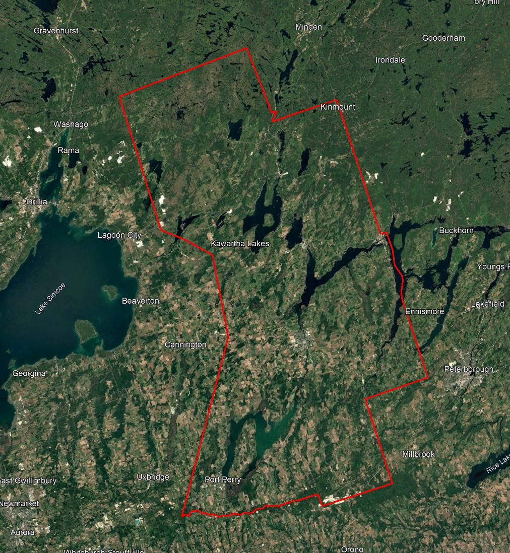

Project Schedule & Personnel
The ground control occurred during the spring of 2023. The surveyor collecting ground truth points during this period was Ryan Gemmel. The Lidar data was collected in three missions during the spring of 2023. See table below for a list of missions.
A typical Lidar acquisition crew consisted of one Lidar Operator and one Pilot.

LiDAR System & Flight Parameters
A Riegl VQ-1560ii-S was used to collect the Lidar data. Two systems were installed in KASI Aviation’s Piper Navajo call signs C-GKSX and C-KMEC.
Below is a table of the lifts with their flight parameters.
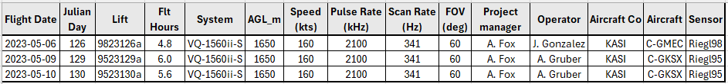
Table 1: Project Parameters for the Kawartha Lakes area.
 | Flight plan
Altitude | 165m AGL
Field of View (FOV) | 60°
Air Speed | 160 Kts
Pulse Rate | 2100 kHz
Sidelap | 20%
Point Density | > 8 pts/m²

The flight lines were designed optimally to maximize time online versus time in turn.

Below is a map of the flight lines including cross-ties.
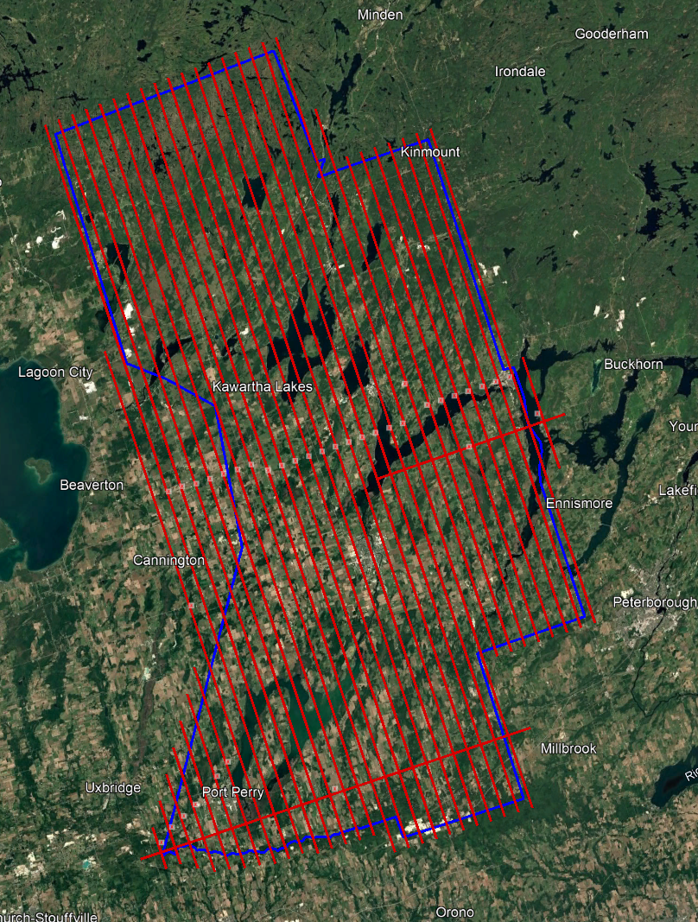

Below is a map of the flight line footprints colored by season of acquisition.
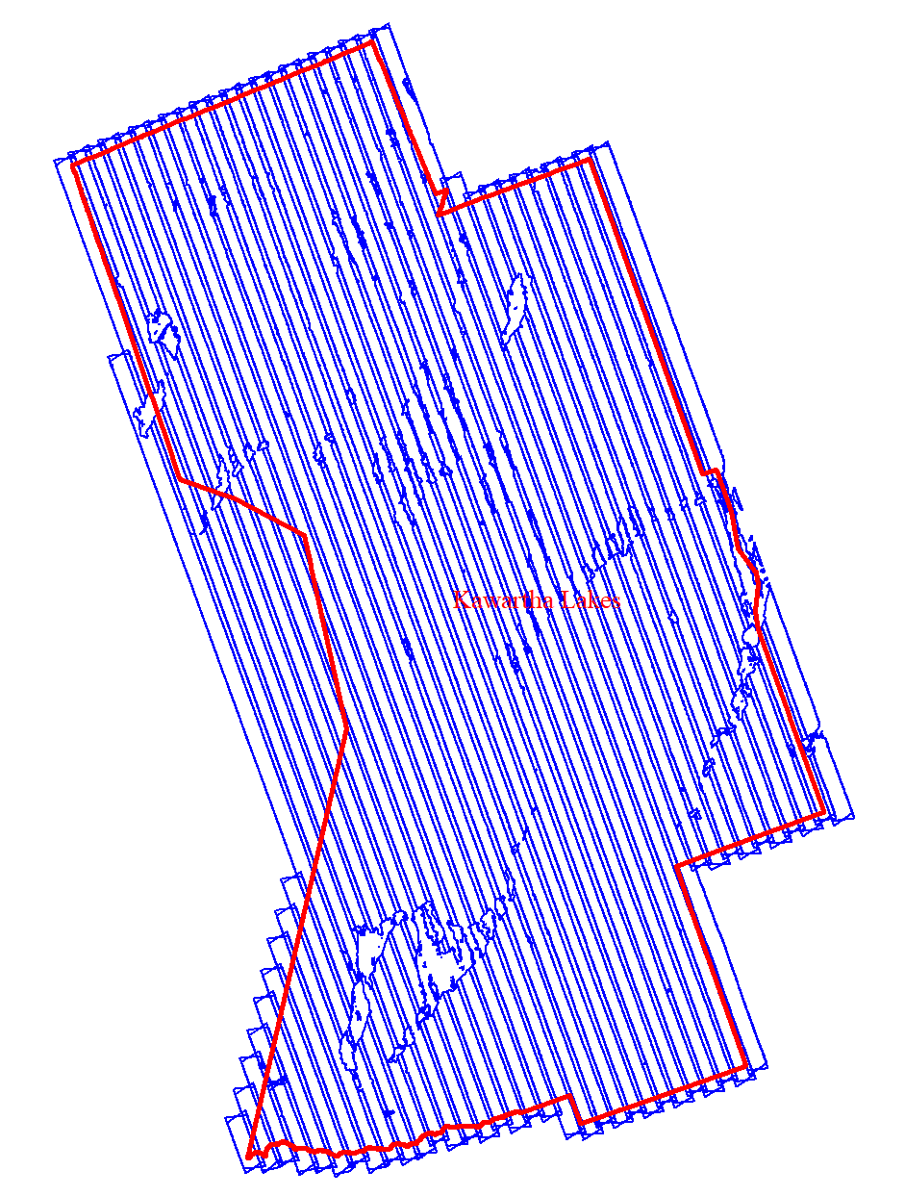
Spring 2023 (BLUE)

Project Control / Datum
Several baselines were measured by GPS static occupation between Can-Net Continuously Operating Stations (CORS), existing NRCan 3D Passive Control Monuments, and Ontario COSINE control points, as well as newly established points by Airborne Imaging. The existing control used consisted of four Can-Net stations, one NRCan passive station, and one Cosine point.
Appendix A contains a list of Control Points and their published coordinates.
Appendix B shows the coordinate list of deliverable check points.
Appendix C shows the published station coordinate sheets.
The datum used for processing the Ground Control and all subsequent Lidar data are based on the Nad83 CSRS (epoch 2010.0) horizontal datum and the CGVD2013 vertical datum (CGG2013 undulation model).
Below is an overview map of the control stations.
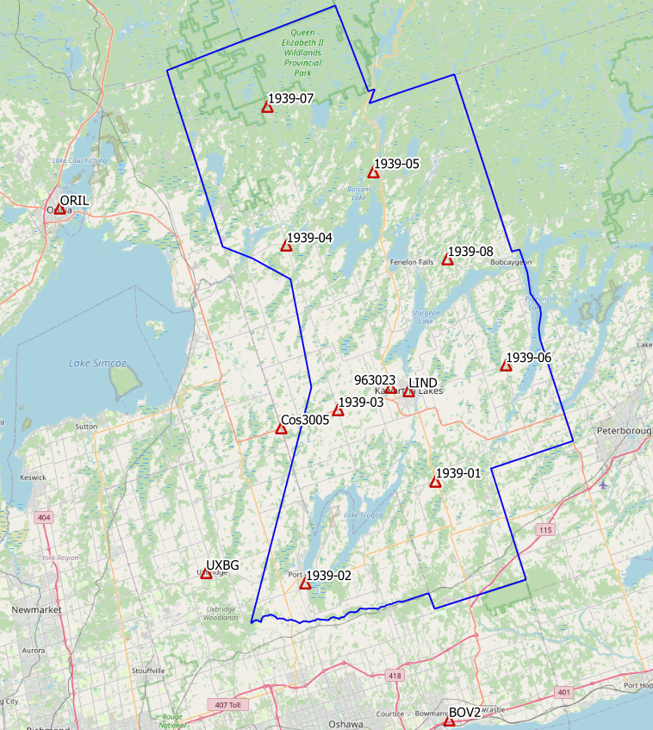
Figure 1 Map of Control Points for MNRF Kawartha Lakes

Check Points
RTK GPS
In order to meet the recommended ASPRS minimum number of points for a 3375.1 square kilometer project, RTK points were surveyed in areas distributed throughout the project. A minimum of 60 NVA and 49 VVA points were required to meet ASPRS standards. Real Time Kinematic points are individual points surveyed on open terrain. Our surveyor collected GPS data mounted on a pole while receiving real time differential corrections from the GPS receiver positioned over a nearby control point.
344 points were surveyed on the Kawartha Lakes project. Of these, 171 points were over non-vegetated ground conditions for NVA accuracy reporting and 173 of them were over vegetated areas for VVA accuracy reporting. Pictures of these RTK points (as well as the existing control) are provided with this report in a folder called “Kawartha_Control_Point_Pictures”. These points are used just for the vertical accuracy assessment of the Lidar point cloud and were not used to determine any vertical shift applied to the point cloud.
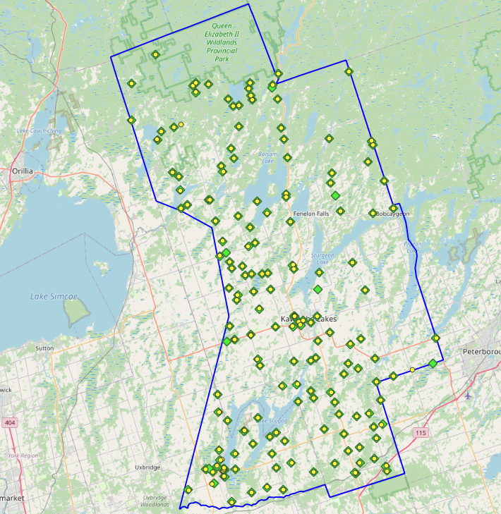
Figure 2 NVA (Yellow) and VVA (Green) Check Points

Trajectory Processing
The aircraft trajectory positioning for the missions over the Kawartha Lakes area were processed using the Precise Point Positioning (PPP) technique.
PPP is a positioning technique that removes and models GNSS system errors via precise satellite orbit data and clock corrections that are applied to the trajectory post mission, providing centimeter level positional accuracy without the use of ground base stations.
The TerraPOS software by Terratec was used to postprocess the PPP solutions to produce final kinematic trajectories accurate to 5 centimeters for each flight mission.
The horizontal datum used is Nad83 CSRS UTM zone 17 with the CGVD2013 vertical datum (CGG2013 undulation model).

LiDAR Data Processing

Calibration Procedures
After each mission, the field project manager creates the preliminary calibrated point cloud with each sensor’s set boresight values for each mission. Proprietary QC tools using the Lastools software are run on each mission to check for coverage, relative accuracy, point density, etc… If any data is found to be not meeting specifications, or coverage missing, the field crew is immediately notified and the areas affected reflown as soon as possible.
This preliminary calibrated point cloud is inspected in conjunction with the kinematic ground truth points to apply bulk shifts if necessary and further refine the calibration by applying corrections to the preliminary calibrated strips. The refined calibration is done using Bayesmap’s StripAlign software. Intensity values are also normalized by mission to be 16 bits (0 to 65535).

Data Tiling and Classification
The raw LiDAR data is processed into calibrated point cloud strips corresponding to flight lines. For ease of data manipulation, the strips are combined and saved in tiles of 1 km by 1 km. The format the strips and tiles are saved in is .Laz version 1.4. The tiling scheme is based on the UTM17 projection at the even kilometers.
The tiled point cloud is then processed with a series of algorithms to separate the “most-likely” ground returns from other returns. The point classification is done using a product by the TerraSolid software running on MicroStation Connect called TerraScan and TerraModeler.
In addition to our regular field QC and calibration procedures, we also generate various raster products using the Lastools software to assess coverage and calibration accuracy.

Point Cloud Manipulation
The TerraScan software uses macros that are set-up to measure the angles and distances between points to determine what classification a point should be: ground, vegetation, noise, other. The angle and distance values in the macros can be adjusted to be more or less aggressive with the classification of points by varying the incidence angles and estimated distances among neighboring points. The lower points are generally classified as ground returns, with the points above classified as undefined (class 1). Outliers and noise described in the table below are normally clouds, outliers or atmospheric noise in the data that are separated into above or below the ground level (high point or low points).
After the automated macro is run to determine classes, a systematic visual inspection is performed to fine tune the ground definition. To better understand areas for improvement for the ground surface, the points that are classified as ground are used to create viewable TINs and grid surfaces. These surfaces are inspected for areas that appear rough, artificially flattened or truncated, no data areas, or have other viewable errors.
In cleaning up ground points, the focus is concentrated in areas where few ground points have been left in the bare earth model and the ground appears rough or lower and flatter than it may be in reality. The scarcity of ground points may be a result from no penetration through a dense vegetation layer, water bodies, low reflectivity objects, or too aggressive values with the macro. A manual/visual inspection of these areas plays a major role in resolving any issues or irregularities with the bare earth model.
Once the first edits are completed, a one-meter grid of the ground surface is re-exported and hill shade images produced to QC the edited ground surface. This QC step is done iteratively as many times as necessary. Once the point cloud data has reached a satisfactory level of classification accuracy, the final deliverables are produced.

Water Classification & Hydro-Flattening
Once the ground class has reached the final level of classification accuracy, the water delineation process is initiated. The rivers and water bodies are digitized as break lines according to USGS specifications of a minimum of 8000 m² for water bodies and 30 m nominal width for streams and rivers. Ponds and lakes have their elevations set constant to just below ground. Stream and river hydro lines are collected using the downstream method. Once all hydro lines have been collected for an area, the ground points inside the hydro lines are classified to class 9 – Water. The ground points outside of the hydro lines but within 35 cm are classified to class 20 – Ignored ground (near breaklines). Using the TIN of class 2 (ground points), the hydro lines are used as constraints to generate the final 50 cm hydro-flattened DEMs in ESRI Ascii format, then converted to 32bit Geotiff format with the Global Mapper software.

Class definitions
The classification follows the ASPRS classification codes. The table below shows the classes for the delivered point cloud.
Table 2: ASPRS Point Classes
Classification Value | Description
1 | Unclassified
2 | Ground
6 | Building
7 | Low Points
9 | Water
17 | Bridge Decks
18 | High Points
20 | Ignored Ground (breakline proximity)
21 | Snow
22 | Temporal exclusion

Deliverables
The project was collected in the spring of 2023 and delivered in October 2023.
See below for a table of the folder structure and description of each deliverable.
DIFF
50cm rasters of flight lines differences, 1 X 1 km tiles in 32bit GeoTIFF format
e.g. 1km176410496102023LKAWARTHALAKES_diff.tif
DTM
Hydro-flattened 50cm Bare Earth DEMs, 1 X 1 km tiles in 32bit GeoTIFF format
e.g. 1km176410496102023LKAWARTHALAKES.tif
METADATA
Metadata files for Breaklines, DEM, LAS and Project in .XML format
e.g. KAWATHALAKES2023_Lidar_metadata_LAS.xml
POINTCLOUD
Point cloud data, 1 X 1 km tiles in .LAZ format 1.4
e.g. 1km176410496102023LKAWARTHALAKES.laz
PROJECT_POLYGON
Shape files of: Lift_metadata, Hydro_breaklines, Project_extent & Tile_index
e.g. Mission_9523129a.shp

Vertical Accuracy Assessment

Non-Vegetated Vertical Accuracy (NVA)
Below is a summary of the statistics between the point cloud TIN from the ground class and the NVA points surveyed on flat hard surfaces:
Number of points: | 173
Average dz: | 0.009 | m
Minimum dz: | -0.107 | m
Maximum dz: | +0.091 | m
Average magnitude: | 0.029 | m
Root mean square: | 0.037 | m
Std deviation: | 0.036 | m
NVA Vertical Accuracy (95%): | 0.072 | m

For a complete listing of the RTK points and their differences, please refer to the provided spreadsheet named "Kawartha_NVA_Final.xlsx".
As seen in the NVA comparison above, the accuracy observed of 0.072 m meets the project requirement of QL0 NVA vertical accuracy of 9.8 cm (95%).

Vegetated Vertical Accuracy (VVA)
The elevations of the points surveyed in various vegetated land cover types were compared to the Lidar ground surface. Since the elevation differences for this type of accuracy does not follow a normal distribution, the percentile method is used and not the 95% confidence level. For the 171 VVA points surveyed, sorting the absolute differences from the smallest to the largest gives the accuracy at the 95th percentile (using the linear interpolation between closest ranks method). For this sample, the 162nd and 163rd largest difference are respectively 14.8 and 15.1 cm.
For this project, the VVA accuracy is therefore 14.95 cm.
This is below the required specifications of 15.0 cm (the QL0 VVA specification).
For a complete listing of the kinematic points and their differences, please refer to the provided spreadsheet named "Kawartha_VVA_Final.xlsx".

Conclusion
This is the final report covering the Kawartha Lakes Lidar project. Topics such as field operations, control, data processing and final accuracy results were explained. The acquisition was done in one season and data processing went well. Both the vegetated and non-vegetated vertical accuracies meet the QL0 requirement.

Appendix A - Control Points – Published Coordinates
Kawartha Lakes - Control Station Coordinates
Station | Easting | Northing | h | H (CGVD2013) | Status | Comments
1939-01 | 684430.165 | 4900550.079 | 248.317 | 283.621 | Temporary | Airborne Intermediate Control
1939-02 | 664789.976 | 4884259.072 | 219.913 | 255.431 | Temporary | Airborne Intermediate Control
1939-03 | 669108.314 | 4911053.459 | 239.807 | 275.097 | Temporary | Airborne Intermediate Control
1939-04 | 660546.249 | 4936043.511 | 259.671 | 294.887 | Temporary | Airborne Intermediate Control
1939-05 | 673615.230 | 4947691.605 | 241.897 | 276.889 | Temporary | Airborne Intermediate Control
1939-06 | 694737.876 | 4918619.147 | 235.934 | 271.040 | Temporary | Airborne Intermediate Control
1939-07 | 657156.021 | 4957244.824 | 240.110 | 275.073 | Temporary | Airborne Intermediate Control
1939-08 | 685327.617 | 4934603.303 | 268.302 | 303.315 | Temporary | Airborne Intermediate Control
963023 | 677082.175 | 4914661.868 | 233.427 | 268.657 | Published | NRCan 3D Passive
BOV2 | 687546.684 | 4863734.431 | 59.640 | 95.516 | Published | CanNet CORS
Cos3005 | 660387.786 | 4908117.616 | 271.459 | 306.806 | Published | Ontario COSINE ‘00820130005’
LIND | 679915.777 | 4914311.893 | 239.627 | 274.846 | Published | CanNet CORS
ORIL | 625681.379 | 4940970.854 | 195.769 | 231.067 | Published | CanNet CORS
UXBG | 649365.172 | 4885492.470 | 259.722 | 295.268 | Published | CanNet CORS

Nad83(CSRS), epoch 2010

Appendix B – RTK Survey & Control Check
Point | Easting | Northing | Ellips | H (CGVD2013) | Julian day | Comment
1939-01 | 684430.165 | 4900550.078 | 248.317 | 283.621 | 137 | Aii Control - Base
2001 | 684473.261 | 4900556.609 | 246.713 | 282.018 | 137 | Paint line
3001 | 684539.012 | 4900560.794 | 242.816 | 278.12 | 137 | Under canopy
2002 | 692563.357 | 4907190.085 | 222.381 | 257.605 | 137 | Paint line
3002 | 692543.839 | 4907219.549 | 221.458 | 256.681 | 137 | Under canopy
2003 | 693886.107 | 4899436.275 | 249.365 | 284.649 | 137 | Paved road
3003 | 693925.823 | 4899458.975 | 249.306 | 284.59 | 137 | Under canopy
2004 | 703880.901 | 4911428.956 | 234.428 | 269.571 | 137 | Paint line - H Park
3004 | 703975.653 | 4911471.687 | 234.458 | 269.6 | 137 | Under canopy
2005 | 703566.347 | 4906640.404 | 219.215 | 254.415 | 137 | Paved road - UC
3005 | 699709.533 | 4905255.446 | 275.587 | 310.806 | 137 | Low grass
3006 | 696090.323 | 4904047.967 | 258.472 | 293.708 | 137 | Under canopy
2006 | 696112.293 | 4903947.529 | 265.32 | 300.557 | 137 | Paved road
3007 | 692956.073 | 4902805.351 | 229.656 | 264.914 | 137 | Under canopy
2007 | 692984.65 | 4902816.717 | 230.22 | 265.477 | 137 | Paved road
2008 | 694439.708 | 4894911.87 | 226.921 | 262.255 | 137 | Paved road
3008 | 694209.817 | 4894824.256 | 221.882 | 257.216 | 137 | Under canopy
2009 | 695257.231 | 4887024.782 | 271.623 | 307.046 | 137 | Paint line - H Park
3009 | 695264.634 | 4887094.808 | 267.875 | 303.297 | 137 | Under canopy
3010 | 695522.798 | 4886121.165 | 283.328 | 318.765 | 137 | Under canopy
2010 | 695515.162 | 4886158.379 | 283.315 | 318.751 | 137 | Hard surface
2011 | 689655.283 | 4885562.967 | 290.416 | 325.841 | 137 | Hard surface
3011 | 689635.901 | 4885541.547 | 290.16 | 325.584 | 137 | Under canopy
3012 | 689457.192 | 4885660.886 | 303.916 | 339.339 | 137 | Under canopy
2012 | 689428.65 | 4885622.112 | 300.084 | 335.506 | 137 | Paint line
2013 | 685641.079 | 4887276.966 | 278.51 | 313.915 | 137 | Paved road
3013 | 685630.003 | 4887262.587 | 278.905 | 314.31 | 137 | Under canopy
2014 | 681622.892 | 4885542.203 | 272.786 | 308.226 | 137 | Hard surface
3014 | 681664.385 | 4885510.037 | 271.659 | 307.1 | 137 | Under canopy
Point | Easting | Northing | Ellips | H (CGVD2013) | Julian day | Comment
1939-02 | 664789.976 | 4884259.071 | 219.913 | 255.431 | 138 | Aii Control - Base
2015 | 664721.554 | 4884236.311 | 222.131 | 257.649 | 138 | Pavement
3015 | 664737.915 | 4884184.421 | 223.037 | 258.557 | 138 | Under canopy
2016 | 664410.607 | 4885474.096 | 219.287 | 254.793 | 138 | Corner Sidewalk
3016 | 664471.995 | 4885364.891 | 223.58 | 259.087 | 138 | Low grass
3017 | 664534.684 | 4885405.933 | 222.968 | 258.474 | 138 | Under canopy
2018 | 664595.105 | 4885443.189 | 222.773 | 258.279 | 138 | Paint line
2017 | 664809.77 | 4885521.998 | 215.282 | 250.787 | 138 | Pavement
3019 | 664739.576 | 4885587.77 | 216.328 | 251.832 | 138 | Low grass
2019 | 664751.917 | 4885688.987 | 214.583 | 250.086 | 138 | Corner Sidewalk
3018 | 664731.824 | 4885809.336 | 214.798 | 250.3 | 138 | Low grass - UC
3020 | 664665.459 | 4885911.337 | 214.776 | 250.277 | 138 | Low grass
2020 | 664648.585 | 4885794.463 | 217.57 | 253.072 | 138 | Paint line - H Park
2021 | 664461.027 | 4885625.942 | 217.749 | 253.253 | 138 | Manhole cover
2022 | 663890.08 | 4887354.368 | 215.655 | 251.142 | 138 | Hard surface - UC
3021 | 664205.238 | 4887441.466 | 220.076 | 255.562 | 138 | Low grass - UC
3022 | 663947.609 | 4887333.288 | 220.4 | 255.888 | 138 | Tall brush
3023 | 663661.461 | 4889306.532 | 237.294 | 272.761 | 138 | Low grass
2023 | 663648.364 | 4889197.971 | 236.197 | 271.665 | 138 | Pavement
2024 | 665132.231 | 4894816.224 | 218.113 | 253.527 | 138 | Pavement
3024 | 665190.402 | 4894840.517 | 215.132 | 250.545 | 138 | Low grass
3025 | 663452.816 | 4896324.134 | 223.717 | 259.12 | 138 | Low grass
2025 | 663399.457 | 4896380.623 | 223.798 | 259.201 | 138 | Paint line
3026 | 663107.942 | 4899716.123 | 247.673 | 283.051 | 138 | Low brush
2026 | 663135.813 | 4899707.603 | 248.641 | 284.019 | 138 | Pavement
2027 | 661418.402 | 4885552.679 | 219.036 | 254.546 | 138 | Pavement
2028 | 661276.942 | 4885510.062 | 219.486 | 254.997 | 138 | Paint line
3027 | 661256.237 | 4885526.026 | 217.939 | 253.449 | 138 | Tall brush
3028 | 663399.618 | 4886198.494 | 228.895 | 264.395 | 138 | Low grass - UC
2029 | 663361.43 | 4886168.012 | 230.384 | 265.884 | 138 | Paint line
2030 | 662531.441 | 4884987.391 | 232.534 | 268.049 | 138 | Hard surface
3029 | 662540.712 | 4884999.953 | 232.794 | 268.308 | 138 | Low grass
2031 | 661850.017 | 4885682.085 | 219.758 | 255.266 | 138 | Paint line
2032 | 662952.559 | 4882889.2 | 244.512 | 280.047 | 138 | Hard surface
3030 | 662537.932 | 4882815.231 | 251.328 | 286.865 | 138 | Low grass - UC
3031 | 658084.357 | 4881537.7 | 252.285 | 287.84 | 138 | Under canopy
2033 | 658059.855 | 4881550.221 | 252.727 | 288.282 | 138 | Paved road
2034 | 666348.85 | 4879565.217 | 236.705 | 272.28 | 138 | Paint line
3032 | 666320.506 | 4879473.713 | 240.002 | 275.579 | 138 | Tall grass - UC
3033 | 672894.208 | 4882460.616 | 267.757 | 303.27 | 138 | Tall grass - UC
2035 | 672893.994 | 4882438.471 | 268.367 | 303.88 | 138 | Paint line
Point | Easting | Northing | Ellips | H (CGVD2013) | Julian day | Comment
1939-04 | 660546.247 | 4936043.511 | 259.666 | 294.882 | 140 | Aii Control - Base
3034 | 660549.762 | 4936087.248 | 260.609 | 295.825 | 140 | Low grass - UC
2036 | 660572.953 | 4936072.021 | 261.224 | 296.439 | 140 | Paved road
3035 | 675033.58 | 4937587.814 | 230.869 | 265.951 | 140 | Tall grass - UC
2037 | 675086.98 | 4937575.589 | 230.28 | 265.361 | 140 | Paint line
2038 | 668230.321 | 4927548.433 | 248.183 | 283.389 | 140 | Paved road
3036 | 668181.933 | 4927551.052 | 248.078 | 283.284 | 140 | Low grass - UC
2039 | 664127.804 | 4926311.8 | 235.647 | 270.895 | 140 | Paint line
2040 | 664771.519 | 4924542.278 | 249.188 | 284.436 | 140 | Paved road
3037 | 664800.082 | 4924548.145 | 248.845 | 284.093 | 140 | Tall grass
3038 | 662839.414 | 4925670.624 | 248.083 | 283.345 | 140 | Tall grass
2041 | 662857.178 | 4925607.454 | 249.649 | 284.911 | 140 | Paved road
2042 | 663332.439 | 4928427.254 | 248.358 | 283.604 | 140 | Hard surface
3039 | 663310.265 | 4928528.225 | 247.46 | 282.706 | 140 | Tall grass
3040 | 662003.234 | 4932115.646 | 222.431 | 257.668 | 140 | Tall grass
2043 | 661945.147 | 4932104.774 | 222.718 | 257.955 | 140 | Paint line
2044 | 660788.621 | 4936117.393 | 263.288 | 298.502 | 140 | Hard surface
3041 | 660791.96 | 4936102.558 | 264.046 | 299.259 | 140 | Low grass - UC
3042 | 656634.441 | 4935051.618 | 239.761 | 275.012 | 140 | Under canopy
2045 | 656621.579 | 4935061.086 | 239.759 | 275.01 | 140 | Paint line
2046 | 655438.386 | 4934321.615 | 239.064 | 274.33 | 140 | Paint line
3043 | 655433.361 | 4934369.786 | 237.716 | 272.982 | 140 | Tall brush
3044 | 655242.436 | 4937720.104 | 207.149 | 242.383 | 140 | Tall grass
2047 | 655249.867 | 4937749.549 | 207.463 | 242.696 | 140 | Paved road
2048 | 654926.566 | 4940284.825 | 211.305 | 246.513 | 140 | Paint line
3045 | 654930.143 | 4940267.172 | 209.85 | 245.058 | 140 | Tall brush
3046 | 653659.593 | 4941019.378 | 211.877 | 247.083 | 140 | Tall brush
2049 | 653604.816 | 4941070.972 | 213.551 | 248.756 | 140 | Hard surface
2050 | 650678.077 | 4947083.847 | 202.327 | 237.477 | 140 | Paved road
3047 | 650684.857 | 4947053.163 | 202.502 | 237.652 | 140 | Low grass
3048 | 650660.487 | 4947124.298 | 200.316 | 235.465 | 140 | Low grass - UC
3049 | 651411.679 | 4948670.489 | 217.469 | 252.593 | 140 | Under canopy
2051 | 651395.144 | 4948680.564 | 216.744 | 251.868 | 140 | Hard surface - UC
2052 | 653690.357 | 4949537.777 | 224.826 | 259.921 | 140 | Hard surface
3050 | 653705.778 | 4949551.89 | 225.318 | 260.412 | 140 | Under canopy
3051 | 654964.877 | 4949993.606 | 232.989 | 268.068 | 140 | Under canopy
Point | Easting | Northing | Ellips | H (CGVD2013) | Julian day | Comment
1939-03 | 669108.314 | 4911053.459 | 239.807 | 275.098 | 141 | Aii Control - Base
2054 | 669100.34 | 4911076.037 | 239.549 | 274.84 | 141 | Paint line
3052 | 669133.927 | 4911043.58 | 240.575 | 275.866 | 141 | Low grass - UC
3053 | 669117.738 | 4911002.41 | 238.535 | 273.826 | 141 | Low grass - UC
3054 | 666001.502 | 4910059.26 | 245.578 | 280.887 | 141 | Tall grass - UC
2055 | 666031.981 | 4910071.287 | 246.372 | 281.681 | 141 | Manhole cover
3055 | 666094.246 | 4910101.481 | 246.3 | 281.608 | 141 | Tall grass
2056 | 664682.439 | 4909573.618 | 241.26 | 276.577 | 141 | Hard surface
3057 | 665038.154 | 4912617.554 | 236.695 | 271.995 | 141 | Tall grass - UC
2057 | 665039.346 | 4912611.509 | 237.408 | 272.709 | 141 | Hard surface
2058 | 666250.217 | 4917420.319 | 251.616 | 286.885 | 141 | Paved road
3058 | 666247.697 | 4917426.219 | 251.211 | 286.48 | 141 | Low grass
2059 | 666470.869 | 4918414.778 | 247.953 | 283.216 | 141 | Paint line
2060 | 664757.555 | 4919749.945 | 253.433 | 288.703 | 141 | Paint line
3060 | 664775.064 | 4919744.726 | 251.465 | 286.734 | 141 | Tall grass - UC
3059 | 666458.986 | 4918415.645 | 246.769 | 282.032 | 141 | Low grass - UC
3061 | 665223.876 | 4923426.391 | 254.515 | 289.763 | 141 | Tall brush
2061 | 665198.366 | 4923410.225 | 254.853 | 290.103 | 141 | Paint line
2062 | 667246.888 | 4923895.213 | 255.464 | 290.694 | 141 | Paved road
3062 | 667136.846 | 4923892.14 | 256.226 | 291.458 | 141 | Low grass - UC
3063 | 667794.579 | 4922161.859 | 258.916 | 294.152 | 141 | Low grass
2063 | 667811.824 | 4922147.942 | 259.743 | 294.978 | 141 | Paved road
2064 | 668927.328 | 4922483.603 | 265.444 | 300.669 | 141 | Hard surface
3064 | 668933.547 | 4922477.527 | 264.775 | 300.001 | 141 | Low grass
3065 | 670904.562 | 4922494.925 | 240.989 | 276.199 | 141 | Low grass - UC
2065 | 670912.7 | 4922498.543 | 241.397 | 276.608 | 141 | Hard surface
2066 | 672017.056 | 4922675.043 | 232.393 | 267.595 | 141 | Hard surface
3066 | 672021.869 | 4922682.841 | 232.007 | 267.209 | 141 | Tall grass - UC
3067 | 676761.187 | 4924308.48 | 241.76 | 276.923 | 141 | Low grass
2067 | 676635.288 | 4924250.528 | 239.22 | 274.385 | 141 | Paint line
2068 | 676931.632 | 4923538.113 | 243.653 | 278.821 | 141 | Paint line - H Park
3068 | 676923.694 | 4923525.141 | 243.439 | 278.607 | 141 | Low grass - UC
3069 | 672604.878 | 4919628.2 | 236.552 | 271.771 | 141 | Low grass
2069 | 672640.983 | 4919638.159 | 236.226 | 271.445 | 141 | Paint line
2070 | 669474.956 | 4919156.139 | 246.338 | 281.578 | 141 | Paint line
3070 | 669461.197 | 4919169.131 | 246.557 | 281.797 | 141 | Low grass - UC
3071 | 670630.3 | 4915958.96 | 240.514 | 275.768 | 141 | Low grass
2071 | 670617.537 | 4915938.272 | 240.182 | 275.436 | 141 | Paved road
2072 | 673712.227 | 4912641.395 | 238.023 | 273.283 | 141 | Paint line
3072 | 673684.475 | 4912694.942 | 237.058 | 272.318 | 141 | Tall grass
3073 | 676895.418 | 4912817.717 | 235.477 | 270.724 | 141 | Tall grass - UC
2073 | 676998.719 | 4912713.636 | 233.492 | 268.739 | 141 | Paint line - H Park
2074 | 677226.423 | 4914757.602 | 232.985 | 268.215 | 141 | Paint line - H Park
3074 | 677227.302 | 4914813.114 | 231.721 | 266.951 | 141 | Crop
2075 | 677158.462 | 4914714.042 | 231.861 | 267.092 | 141 | Paint line
3075 | 677204.861 | 4914789.847 | 232.462 | 267.692 | 141 | Low grass
3076 | 678069.684 | 4913642.032 | 232.897 | 268.132 | 141 | Low grass
2076 | 678061.904 | 4913648.247 | 232.729 | 267.964 | 141 | Paint line - H Park
2077 | 678903.398 | 4913967.032 | 238.818 | 274.046 | 141 | Paint line
3077 | 678875.42 | 4913955.116 | 239.542 | 274.771 | 141 | Low grass - UC
3078 | 681539.884 | 4914912.259 | 234.506 | 269.712 | 141 | Low grass
2078 | 681482.54 | 4914894.284 | 232.085 | 267.291 | 141 | Paint line - H Park
2079 | 681614.848 | 4923001.098 | 221.463 | 256.603 | 141 | Paved road
3079 | 681609.614 | 4923013.502 | 220.79 | 255.93 | 141 | Low grass
2080 | 681533.951 | 4919910.498 | 239.802 | 274.966 | 141 | Paved road
2081 | 670983.951 | 4905315.246 | 225.866 | 261.189 | 141 | Paint line
3081 | 670969.503 | 4905273.59 | 227.76 | 263.082 | 141 | Low grass
Point | Easting | Northing | Ellips | H (CGVD2013) | Julian day | Comment
1939-05 | 673615.23 | 4947691.604 | 241.897 | 276.89 | 142 | Aii Control - Base
2082 | 674325.838 | 4947814.392 | 223.653 | 258.639 | 142 | Paint Line
3082 | 674386.99 | 4947822.598 | 223.51 | 258.496 | 142 | Tall grass - UC
3083 | 673824.233 | 4949818.684 | 228.84 | 263.806 | 142 | Low grass
2083 | 673812.146 | 4949861.376 | 228.679 | 263.644 | 142 | Hard surface
2084 | 672991.831 | 4955177.614 | 231.381 | 266.289 | 142 | Paint line
3084 | 673025.368 | 4955251.505 | 230.571 | 265.478 | 142 | Under canopy
3085 | 671944.893 | 4957850.508 | 248.193 | 283.069 | 142 | Under canopy
2085 | 671996.487 | 4957835.261 | 248.587 | 283.464 | 142 | Paved road
3086 | 673026.505 | 4960007.332 | 253.84 | 288.681 | 142 | Tall grass
2086 | 672998.259 | 4959998.983 | 253.42 | 288.261 | 142 | Paint line
2087 | 671801.107 | 4957330.566 | 243.118 | 278.002 | 142 | Paint line
3087 | 668264.55 | 4955032.137 | 249.6 | 284.531 | 142 | Tall grass
3088 | 668246.251 | 4955020.456 | 249.803 | 284.733 | 142 | Under canopy
2088 | 668256.702 | 4955034.449 | 250.002 | 284.933 | 142 | Hard surface
2089 | 667479.041 | 4957076.635 | 256.706 | 291.613 | 142 | Hard surface - UC
3089 | 667471.588 | 4957063.801 | 256.52 | 291.427 | 142 | Under canopy
3090 | 667807.113 | 4958074.003 | 257.173 | 292.065 | 142 | Tall brush
2090 | 667812.55 | 4958074.565 | 257.162 | 292.054 | 142 | Hard surface
2091 | 667975.455 | 4955786.149 | 254.223 | 289.146 | 142 | Hard surface
3091 | 667984.872 | 4955779.154 | 254.551 | 289.474 | 142 | Short grass
3092 | 665797.853 | 4953915.492 | 237.731 | 272.688 | 142 | Short grass
2092 | 665774.826 | 4953905.719 | 238.144 | 273.102 | 142 | Hard surface
2093 | 663782.488 | 4954949.553 | 237.727 | 272.681 | 142 | Hard surface
3093 | 663798.404 | 4955012.375 | 237.765 | 272.717 | 142 | Short grass
3094 | 660024.507 | 4957663.88 | 234.841 | 269.781 | 142 | Tall grass
2094 | 660018.191 | 4957668.425 | 235.179 | 270.119 | 142 | Hard surface
2095 | 664696.851 | 4953650.997 | 243.32 | 278.287 | 142 | Paint line
3095 | 664716.985 | 4953644.534 | 242.629 | 277.596 | 142 | Short grass
3096 | 665817.848 | 4949885.982 | 245.56 | 280.573 | 142 | Tall grass
2096 | 665820.261 | 4949902.435 | 246.382 | 281.395 | 142 | Paved road
2097 | 664457.813 | 4945819.006 | 229.101 | 264.178 | 142 | Hard surface
3097 | 664471.639 | 4945829.488 | 229.001 | 264.078 | 142 | Short grass - UC
3098 | 665109.966 | 4944004.387 | 225.485 | 260.583 | 142 | Crop
2098 | 665091.432 | 4943991.595 | 225.328 | 260.426 | 142 | Hard surface
2099 | 662719.208 | 4942484.611 | 219.082 | 254.215 | 142 | Paved road
3099 | 662742.441 | 4942500.248 | 218.186 | 253.319 | 142 | Tall grass
2100 | 663088.718 | 4941462.269 | 222.523 | 257.667 | 142 | Paint line
2101 | 666158.966 | 4933233.467 | 232.696 | 267.891 | 142 | Paved road
3101 | 666150.84 | 4933232.03 | 232.622 | 267.818 | 142 | Short grass
3102 | 669651.764 | 4936031.418 | 225.797 | 260.94 | 142 | Tall grass
2102 | 669670.075 | 4936044.538 | 225.679 | 260.821 | 142 | Hard surface
2103 | 668416.444 | 4931193.349 | 222.076 | 257.263 | 142 | Hard surface
3103 | 668399.677 | 4931201.317 | 221.357 | 256.544 | 142 | Under canopy
3104 | 669483.647 | 4928324.077 | 241.655 | 276.845 | 142 | Tall grass
2104 | 669497.88 | 4928320.623 | 243.675 | 278.865 | 142 | Paint line
2105 | 671623.857 | 4933942.823 | 231.444 | 266.582 | 142 | Paint line
3105 | 671626.557 | 4933915.29 | 231.357 | 266.496 | 142 | Tall brush
3106 | 676014.12 | 4932453.218 | 232.409 | 267.519 | 142 | Crop
2106 | 675958.321 | 4932425.112 | 234.467 | 269.577 | 142 | Hard surface
2107 | 675048.064 | 4936962.483 | 241.108 | 276.194 | 142 | Paint line - H Park
3107 | 675027.48 | 4936959.587 | 241.283 | 276.369 | 142 | Short grass
3108 | 675124.067 | 4944390.384 | 226.448 | 261.465 | 142 | Tall grass
2108 | 675088.961 | 4944372.174 | 227.422 | 262.439 | 142 | Paint line
2109 | 682860.72 | 4948100.45 | 225.458 | 260.38 | 142 | Paint line
3109 | 682859.329 | 4948088.37 | 224.062 | 258.983 | 142 | Tall grass
3110 | 686189.962 | 4960760.609 | 271.728 | 306.502 | 142 | Under canopy
2110 | 686172.291 | 4960741.399 | 272.564 | 307.338 | 142 | Hard surface
Point | Easting | Northing | Ellips | H (CGVD2013) | Julian day | Comment
963023 | 677082.176 | 4914661.867 | 233.427 | 268.658 | 143 | NRCAN BM - Base
2111 | 677233.332 | 4914771.116 | 232.753 | 267.983 | 143 | Paint line
3111 | 677267.567 | 4914679.802 | 230.703 | 265.933 | 143 | Low grass
2112 | 687799.79 | 4925034.539 | 236.338 | 271.421 | 143 | Paved road
3112 | 687802.021 | 4925017.461 | 236.118 | 271.202 | 143 | Low grass - UC
3113 | 690344.856 | 4920027.877 | 232.274 | 267.39 | 143 | Tall grass
2113 | 690341.919 | 4920037.693 | 232.824 | 267.939 | 143 | Paved road
2114 | 689905.707 | 4910863.846 | 228.207 | 263.408 | 143 | Hard surface
3114 | 689893.363 | 4910856.1 | 227.713 | 262.914 | 143 | Tall grass
3115 | 687819.078 | 4909805.541 | 222.453 | 257.673 | 143 | Tall grass
2115 | 687839.411 | 4909796.002 | 223.264 | 258.484 | 143 | Paint line
2116 | 683934.251 | 4911832.698 | 235.797 | 271.018 | 143 | Paint line - H Park
3116 | 683928.542 | 4911818.333 | 235.593 | 270.814 | 143 | Short grass - UC
3117 | 681723.578 | 4910220.428 | 220.817 | 256.063 | 143 | Short grass
2117 | 681752.388 | 4910261.718 | 220.81 | 256.056 | 143 | Paved road
2118 | 681441.675 | 4907021.313 | 220.3 | 255.573 | 143 | Paved road
3118 | 681450.182 | 4907026.471 | 219.509 | 254.782 | 143 | Short grass
3119 | 680508.677 | 4906441.228 | 215.003 | 250.284 | 143 | Tall grass
2119 | 680499.785 | 4906442.462 | 215.204 | 250.485 | 143 | Hard surface
3120 | 678380.194 | 4898717.422 | 216.891 | 252.235 | 143 | Tall grass
2120 | 678388.449 | 4898700.51 | 218.706 | 254.051 | 143 | Paved road
2121 | 680635.489 | 4900831.472 | 224.059 | 259.379 | 143 | Paved road
3121 | 680626.013 | 4900845.892 | 223.054 | 258.374 | 143 | Tall grass
3122 | 677328.69 | 4906210.856 | 216.751 | 252.047 | 143 | Short grass
2122 | 677337.552 | 4906204.285 | 217.429 | 252.725 | 143 | Paved road
2123 | 678052.414 | 4901952.385 | 223.519 | 258.842 | 143 | Paved road
3123 | 678060.066 | 4901983.476 | 222.366 | 257.688 | 143 | Short grass - UC
2124 | 675365.169 | 4901606.219 | 233.99 | 269.324 | 143 | Paved road
3124 | 675266.038 | 4901577.169 | 230.803 | 266.138 | 143 | Tall brush
3125 | 670477.487 | 4906462.043 | 226.986 | 262.302 | 143 | Short grass
2125 | 670505.136 | 4906461.546 | 227.325 | 262.64 | 143 | Paint line
2126 | 678478.756 | 4913076.978 | 235.255 | 270.492 | 143 | Paint line - H Park
3126 | 678383.975 | 4913123.925 | 235.022 | 270.259 | 143 | Short grass
2127 | 680353.515 | 4913587.98 | 224.221 | 259.445 | 143 | Paint line - H Park
3127 | 680327.984 | 4913604.062 | 224.306 | 259.53 | 143 | Short grass
Point | Easting | Northing | Ellips | H (CGVD2013) | Julian day | Comment
1939-02 | 664789.976 | 4884259.071 | 219.913 | 255.431 | 144 | Aii Control - Base
2128 | 666691.551 | 4888552.595 | 234.491 | 269.96 | 144 | Stop Line
3128 | 666708.577 | 4888566.095 | 232.958 | 268.427 | 144 | Tall Grass
3129 | 668309.781 | 4893004.564 | 236.18 | 271.603 | 144 | Brush - UC
3130 | 668355.891 | 4892982.333 | 236.527 | 271.95 | 144 | Short Grass
2129 | 668334.127 | 4892925.114 | 237.343 | 272.767 | 144 | Stop Line
2130 | 668311.047 | 4892945.818 | 236.877 | 272.301 | 144 | Paved Lot
2131 | 670881.503 | 4895510.996 | 215.661 | 251.058 | 144 | Paved Road
3131 | 670867.319 | 4895526.076 | 215.536 | 250.932 | 144 | Short Grass
3132 | 670068.05 | 4890500.142 | 234.123 | 269.564 | 144 | Tall Grass
2132 | 670065.732 | 4890509.146 | 234.763 | 270.204 | 144 | Paved Road
2133 | 666863.666 | 4885718.206 | 242.196 | 277.695 | 144 | Paved Lot
3133 | 666864.788 | 4885745.373 | 241.853 | 277.352 | 144 | Short Grass
3134 | 673704.378 | 4888798.314 | 225.39 | 260.833 | 144 | Brush
2134 | 673678.428 | 4888794.131 | 225.636 | 261.08 | 144 | Stop Line
2135 | 673254 | 4892012.911 | 215.134 | 250.551 | 144 | Paved Road
3135 | 673244.247 | 4892016.527 | 214.744 | 250.162 | 144 | Short Grass
3136 | 674362.472 | 4892844.349 | 216.431 | 251.838 | 144 | Short grass - UC
2136 | 674382.46 | 4892843.739 | 217.099 | 252.506 | 144 | Paved Road
2137 | 676030.489 | 4891174.058 | 254.836 | 290.247 | 144 | Gravel Road
3137 | 676044.537 | 4891181.461 | 255.05 | 290.461 | 144 | Short Grass
3138 | 677398.163 | 4887102.211 | 267.904 | 303.347 | 144 | Short Grass
2138 | 677391.173 | 4887108.949 | 268.11 | 303.552 | 144 | Paved Road
2139 | 674556.895 | 4886107.746 | 260.012 | 295.477 | 144 | Paved Road
3139 | 674571.647 | 4886163.114 | 258.461 | 293.925 | 144 | Short Grass
3140 | 675932.897 | 4882003.932 | 268.54 | 304.047 | 144 | Tall Grass
2140 | 675955.859 | 4882023.891 | 269.991 | 305.498 | 144 | Paved Road
2141 | 670011.652 | 4881412.98 | 246.639 | 282.177 | 144 | Gravel Pull-Out
3141 | 669986.734 | 4881384.484 | 246.178 | 281.716 | 144 | Short Grass
3142 | 664795.111 | 4884240.095 | 219.564 | 255.082 | 144 | Short Grass
2142 | 664833.259 | 4884229.939 | 218.736 | 254.254 | 144 | Paved Lot
Point | Easting | Northing | Ellips | H (CGVD2013) | Julian day | Comment
1939-01 | 684430.165 | 4900550.078 | 248.317 | 283.621 | 144 | Aii Control - Base
2143 | 685300.591 | 4898785.621 | 218.373 | 253.685 | 144 | Paved Road
3143 | 685308.529 | 4898770.065 | 217.496 | 252.808 | 144 | Short Grass
3144 | 686097.843 | 4896590.975 | 249.473 | 284.798 | 144 | Tall Grass
2144 | 686118.077 | 4896573.236 | 249.503 | 284.828 | 144 | Stop Line
2145 | 687123.149 | 4892875.123 | 267.42 | 302.769 | 144 | Stop Line
3145 | 687115.945 | 4892899.002 | 267.528 | 302.877 | 144 | Tall Grass
3146 | 687996.571 | 4889654.817 | 298.825 | 334.201 | 144 | Tall Grass
2146 | 688002.569 | 4889664.592 | 299.211 | 334.587 | 144 | Paved Road
3147 | 690120.377 | 4890432.342 | 319.539 | 354.906 | 144 | Tall Grass
2147 | 690123.123 | 4890427.112 | 319.728 | 355.096 | 144 | Gravel Road
2148 | 690328.653 | 4887490.491 | 310.388 | 345.79 | 144 | Paved Road
3148 | 690303.773 | 4887492.913 | 310.305 | 345.706 | 144 | Brush
3149 | 693056.171 | 4888378.804 | 282.215 | 317.615 | 144 | Tall Grass
2149 | 693050.621 | 4888384.763 | 282.793 | 318.193 | 144 | Paved Road
2150 | 693328.947 | 4892307.145 | 236.896 | 272.254 | 144 | Paved Road
3150 | 693266.688 | 4892297.438 | 235.523 | 270.881 | 144 | Tall Grass
3151 | 692731.494 | 4894325.984 | 226.794 | 262.128 | 144 | Tall Grass
2151 | 692708.537 | 4894322.74 | 227.3 | 262.634 | 144 | Paved Lot
2152 | 691780.125 | 4896823.216 | 233.404 | 268.712 | 144 | Paved Road
3152 | 691768.523 | 4896830.216 | 233.249 | 268.556 | 144 | Brush
3153 | 689446.277 | 4896288.707 | 285.875 | 321.188 | 144 | Short Grass
2153 | 689449.588 | 4896269.408 | 287.776 | 323.09 | 144 | Paved Road
2154 | 686821.656 | 4904159.367 | 249.459 | 284.73 | 144 | Paved Road
3154 | 686807.632 | 4904144.952 | 250.106 | 285.376 | 144 | Short Grass
3155 | 687628.569 | 4906124.222 | 224.579 | 259.833 | 144 | Short Grass
2155 | 687633.983 | 4906135.5 | 224.386 | 259.64 | 144 | Gravel Road
2156 | 689465.833 | 4905212.875 | 218.262 | 253.515 | 144 | Gravel Road
3156 | 689477.352 | 4905195.678 | 217.652 | 252.904 | 144 | Short Grass
3157 | 681260.665 | 4899433.257 | 241.239 | 276.563 | 144 | Tall Grass
2157 | 681273.493 | 4899441.09 | 242.752 | 278.077 | 144 | Stop Line
2158 | 683355.98 | 4893705.176 | 234.285 | 269.643 | 144 | No Picture
3158 | 683346.242 | 4893703.254 | 234.288 | 269.646 | 144 | No Picture
Point | Easting | Northing | Ellips | H (CGVD2013) | Julian day | Comment
1939-08 | 685327.617 | 4934603.302 | 268.302 | 303.315 | 145 | Aii Control - Base
2159 | 685347.085 | 4934652.200 | 267.130 | 302.142 | 145 | No Picture
3159 | 685324.456 | 4934672.693 | 265.749 | 300.761 | 145 | No Picture
3160 | 691351.122 | 4934430.880 | 230.440 | 265.418 | 145 | No Picture
2160 | 691338.808 | 4934418.187 | 230.741 | 265.719 | 145 | No Picture
2161 | 695254.124 | 4935394.856 | 219.554 | 254.496 | 145 | No Picture
3161 | 695246.260 | 4935427.076 | 220.049 | 254.991 | 145 | No Picture
3162 | 693344.684 | 4940488.921 | 278.795 | 313.693 | 145 | No Picture
2162 | 693344.565 | 4940499.512 | 277.897 | 312.795 | 145 | No Picture
2163 | 691011.995 | 4947162.151 | 270.237 | 305.092 | 145 | No Picture
3163 | 690989.402 | 4947226.101 | 269.109 | 303.964 | 145 | No Picture
3170 | 690741.952 | 4947920.719 | 260.412 | 295.263 | 145 | No Picture
2170 | 690756.165 | 4947850.768 | 260.796 | 295.648 | 145 | No Picture
2171 | 690202.725 | 4943991.961 | 266.128 | 301.016 | 145 | No Picture
3171 | 690190.595 | 4944001.236 | 263.58 | 298.468 | 145 | No Picture
3172 | 683584.001 | 4941753.756 | 264.482 | 299.446 | 145 | No Picture
2172 | 683583.99 | 4941747.437 | 264.784 | 299.748 | 145 | No Picture
3173 | 683338.642 | 4939917.258 | 261.114 | 296.094 | 145 | No Picture
2173 | 683344.045 | 4939919.397 | 261.448 | 296.428 | 145 | No Picture
3174 | 684258.188 | 4937525.599 | 258.337 | 293.329 | 145 | No Picture
2174 | 684263.531 | 4937525.203 | 259.346 | 294.338 | 145 | No Picture
Point | Easting | Northing | Ellips | H (CGVD2013) | Julian day | Comment
1939-07 | 657156.021 | 4957244.824 | 240.11 | 275.073 | 146 | Aii Control - Base
3164 | 657118.622 | 4957343.578 | 227.715 | 262.678 | 146 | Tall grass
2164 | 657112.531 | 4957341.092 | 228.109 | 263.072 | 146 | Hard surface
2165 | 657549.620 | 4957848.251 | 237.195 | 272.148 | 146 | Hard surface
3165 | 657548.934 | 4957840.418 | 236.679 | 271.632 | 146 | Tall grass
3166 | 657676.314 | 4956108.512 | 240.085 | 275.061 | 146 | Short grass
2166 | 657628.373 | 4956083.612 | 240.468 | 275.445 | 146 | Paved road
2167 | 645739.457 | 4950556.161 | 208.006 | 243.138 | 146 | Paved road
3167 | 645704.777 | 4950584.422 | 208.145 | 243.277 | 146 | Short grass
3168 | 645634.844 | 4957424.363 | 207.017 | 242.059 | 146 | Short grass
2168 | 645644.924 | 4957404.553 | 206.773 | 241.815 | 146 | Paved road
3169 | 649949.240 | 4962954.327 | 203.22 | 238.151 | 146 | Tall grass
2169 | 649936.243 | 4962963.512 | 203.193 | 238.124 | 146 | Hard surface

Appendix C – Published Station Coordinate Sheets
