Final Report
For project:
Manitoulin LiDAR
Prepared for:
Ontario Ministry of Natural Resources
2nd floor, North Tower, 300 Water Street,
Peterborough, ON, K9J 3C7
Prepared by:

Airborne Imaging
2700 – 61 Avenue SE
Calgary, AB T2C 4V2
February 24, 2025

Contents
Introduction 1
Project Schedule & Personnel 1
LiDAR System & Flight Parameters 1
Project Control / Datum 4
Check Points 5
Trajectory Processing 6
LiDAR Data Processing 7
Calibration Procedures 7
Data Tiling and Classification 7
Point Cloud Manipulation 7
Water Classification & Hydro-Flattening 8
Class definitions 8
Deliverables 9
Vertical Accuracy Assessment 10
Conclusion 11
Appendix A - Control Points – Published Coordinates 12
Appendix B – RTK Survey & Control Check 13
Appendix C – Published Station Coordinate Sheets 20

Introduction
The Ontario Ministry of Natural Resources and Forests contracted Airborne Imaging to acquire and deliver digital elevation data derived from airborne LiDAR (Light Detection and Ranging) to cover various regions in Ontario.
This report covers the Manitoulin area, collected during the spring of 2024. The report focuses on LiDAR acquisition details, such as flight parameters, project control, ground truthing results, data processing technique and deliverables.
The contracted area for the Manitoulin area is 3,622 km².
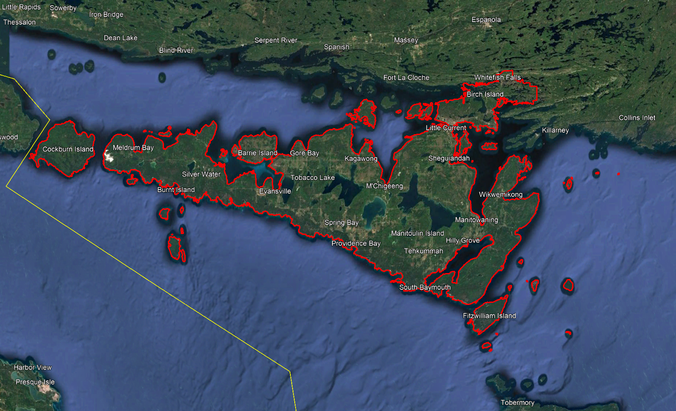

Project Schedule & Personnel
The ground control occurred during the spring of 2024. The surveyor collecting ground truth points during this period was Ryan Gemmel. The Lidar data was collected in seven missions. See table below for a list of missions.
A typical Lidar acquisition crew consisted of one Lidar Operator and one Pilot.

LiDAR System & Flight Parameters
One Riegl VQ-1560ii and one Riegl VQ-1560ii-S were used to collect the Lidar data. The systems were installed in Revolution Flight’ Cessna Caravan call sign N108RF and N331RF.
Below is a table of the lifts with their flight parameters.
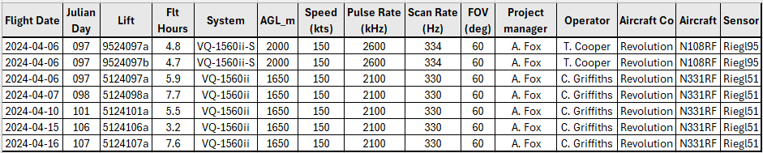
Table 1: Project Parameters for the Manitoulin area.
Riegl VQ1560-ii-S | Flight plan
Altitude | 2000m AGL
Field of View (FOV) | 60°
Air Speed | 150 Kts
Pulse Rate | 2600 kHz
Sidelap | 20%
Point Density | > 8 pts/m²

Riegl VQ1560-ii | Flight plan
Altitude | 1650m AGL
Field of View (FOV) | 60°
Air Speed | 150 Kts
Pulse Rate | 2100 kHz
Sidelap | 20%
Point Density | > 8 pts/m²

The flight lines were designed optimally to maximize time online versus time in turn.

Below is a map of the flight lines including cross-ties.
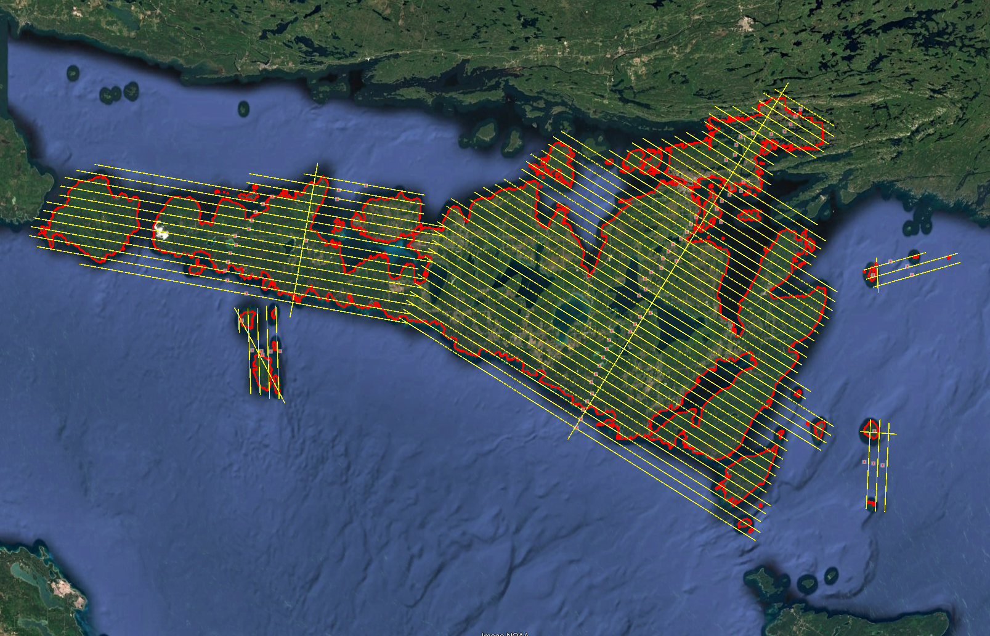

Below is a map of the flight line footprints colored by sensor model.
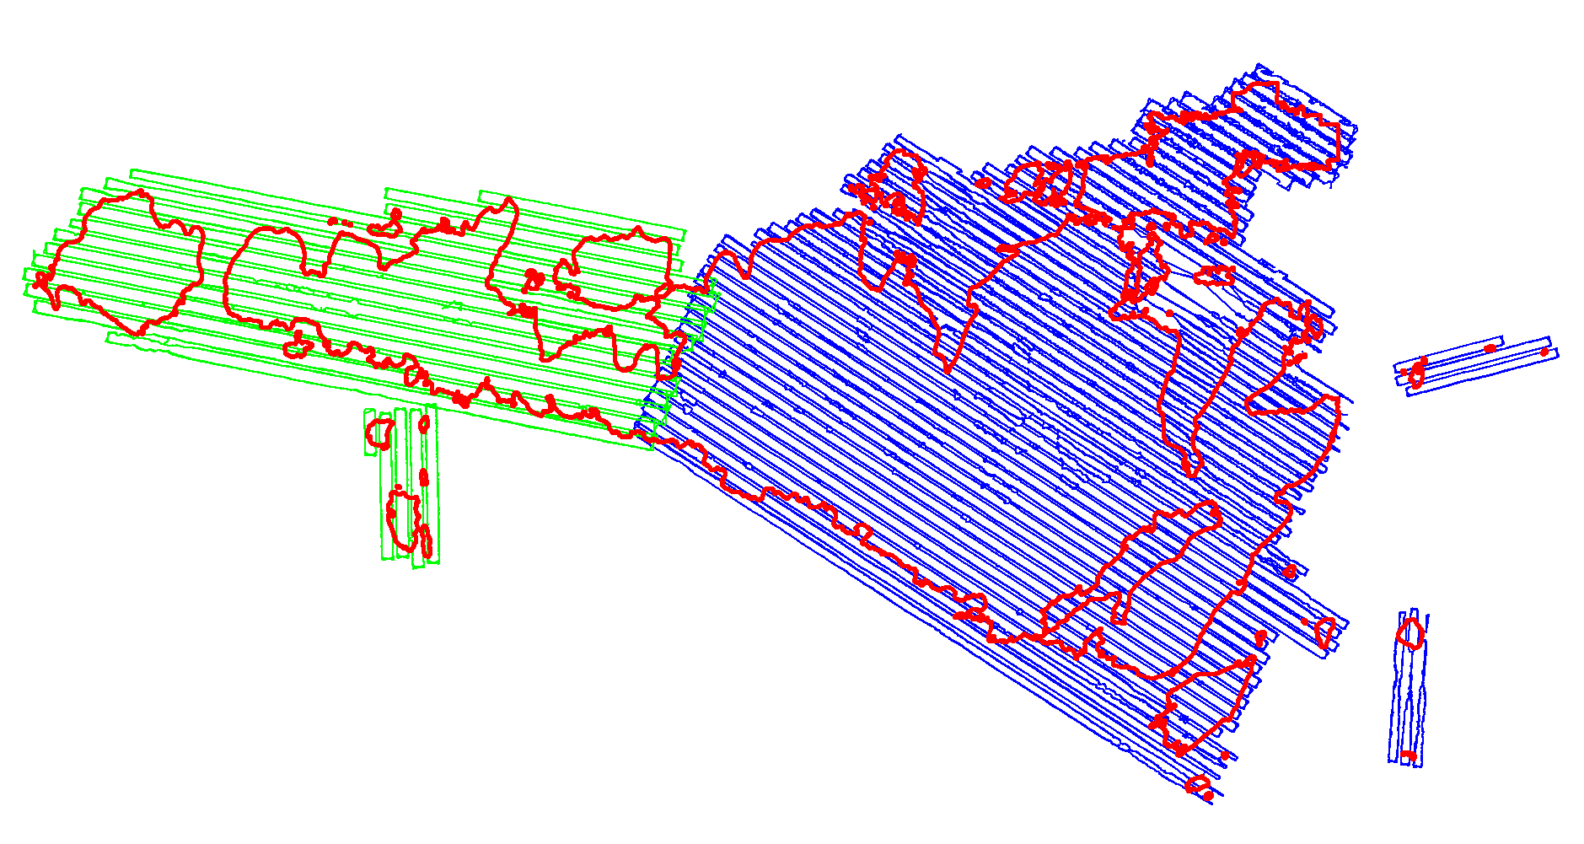
Riegl VQ1560-ii (Blue)
Riegl VQ1560-ii-S (Green)

Project Control / Datum
Several baselines were measured by GPS static occupation between NRCan Canadian Active Control System (CACS) stations, existing NRCan 3D Passive Control Monuments, and Ontario COSINE control points, as well as newly established points by Airborne Imaging. The existing control used for the Manitoulin area consisted of one CACS station and two NRCan passive stations.
Appendix A contains a list of Control Points and their published coordinates.
Appendix B shows the coordinate list of deliverable check points.
Appendix C shows the published station coordinate sheets.
The datum used for processing the Ground Control and all subsequent Lidar data are based on the Nad83 CSRS (epoch 2010.0) horizontal datum and the CGVD2013 vertical datum (CGG2013 undulation model).
Below is an overview map of the control stations.
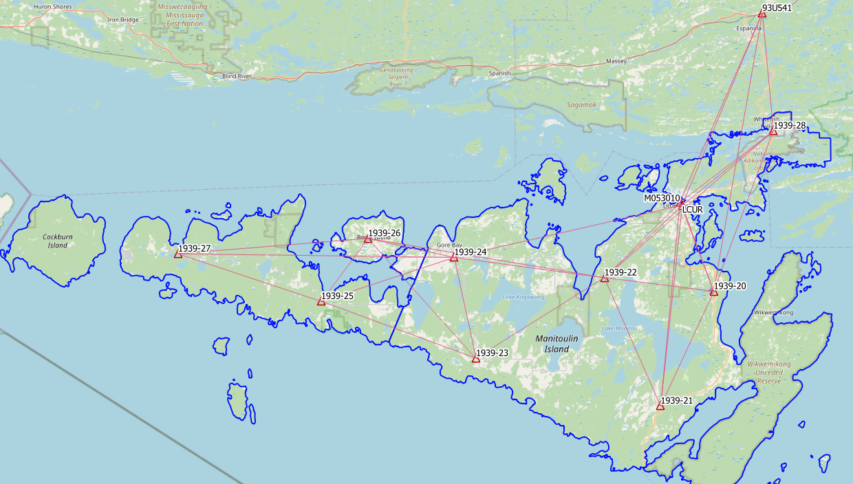
Figure 1 Manitoulin Control Network

Check Points
RTK GPS
In order to meet the recommended ASPRS minimum number of points for a 3622.3 square kilometer project, RTK points were surveyed in areas distributed throughout the project. A minimum of 62 NVA and 49 VVA points were required to meet ASPRS standards. Real Time Kinematic points are individual points surveyed on open terrain. Our surveyor collected GPS data mounted on a pole while receiving real time differential corrections from the GPS receiver positioned over a nearby control point.
155 points were surveyed on the Manitoulin project. Of these, 67 points were over non-vegetated ground conditions for NVA accuracy reporting and 88 of them were over vegetated areas for VVA accuracy reporting. Pictures of these RTK points (as well as the existing control) are provided with this report in the folder labeled “Pictures\Manitoulin”. These points are used just for the vertical accuracy assessment of the Lidar point cloud and were not used to determine any vertical shift applied to the point cloud.
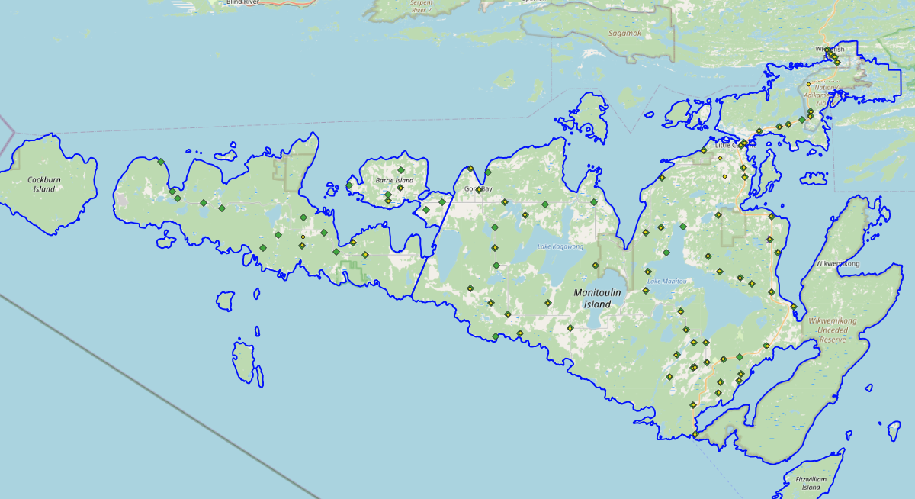
Figure 2 NVA (Yellow) and VVA (Green) Check Points

Trajectory Processing
The aircraft trajectory positioning for the missions over the Manitoulin area were processed using the Precise Point Positioning (PPP) technique.
PPP is a positioning technique that removes and models GNSS system errors via precise satellite orbit data and clock corrections that are applied to the trajectory post mission, providing centimeter level positional accuracy without the use of ground base stations.
The TerraPOS software by Terratec was used to postprocess the PPP solutions to produce final kinematic trajectories accurate to 5 centimeters for each flight mission.
The horizontal datum used is Nad83 CSRS UTM zone 17 with the CGVD2013 vertical datum (CGG2013 undulation model).

LiDAR Data Processing

Calibration Procedures
After each mission, the field project manager creates the preliminary calibrated point cloud with each sensor’s set boresight values for each mission. Proprietary QC tools using the Lastools software are run on each mission to check for coverage, relative accuracy, point density, etc… If any data is found to be not meeting specifications, or coverage missing, the field crew is immediately notified and the areas affected reflown as soon as possible.
This preliminary calibrated point cloud is inspected in conjunction with the kinematic ground truth points to apply bulk shifts if necessary and further refine the calibration by applying corrections to the preliminary calibrated strips. The refined calibration is done using Bayesmap’s StripAlign software. Intensity values are also normalized by mission to be 16 bits (0 to 65535).

Data Tiling and Classification
The raw LiDAR data is processed into calibrated point cloud strips corresponding to flight lines. For ease of data manipulation, the strips are combined and saved in tiles of 1 km by 1 km. The format the strips and tiles are saved in is .Laz version 1.4. The tiling scheme is based on the UTM17 projection at the even kilometers.
The tiled point cloud is then processed with a series of algorithms to separate the “most-likely” ground returns from other returns. The point classification is done using a product by the TerraSolid software running on MicroStation Connect called TerraScan and TerraModeler.
In addition to our regular field QC and calibration procedures, we also generate various raster products using the Lastools software to assess coverage and calibration accuracy.

Point Cloud Manipulation
The TerraScan software uses macros that are set-up to measure the angles and distances between points to determine what classification a point should be: ground, vegetation, noise, other. The angle and distance values in the macros can be adjusted to be more or less aggressive with the classification of points by varying the incidence angles and estimated distances among neighboring points. The lower points are generally classified as ground returns, with the points above classified as undefined (class 1). Outliers and noise described in the table below are normally clouds, outliers or atmospheric noise in the data that are separated into above or below the ground level (high point or low points).
After the automated macro is run to determine classes, a systematic visual inspection is performed to fine tune the ground definition. To better understand areas for improvement for the ground surface, the points that are classified as ground are used to create viewable TINs and grid surfaces. These surfaces are inspected for areas that appear rough, artificially flattened or truncated, no data areas, or have other viewable errors.
In cleaning up ground points, the focus is concentrated in areas where few ground points have been left in the bare earth model and the ground appears rough or lower and flatter than it may be in reality. The scarcity of ground points may be a result from no penetration through a dense vegetation layer, water bodies, low reflectivity objects, or too aggressive values with the macro. A manual/visual inspection of these areas plays a major role in resolving any issues or irregularities with the bare earth model.
Once the first edits are completed, a one-meter grid of the ground surface is re-exported and hill shade images produced to QC the edited ground surface. This QC step is done iteratively as many times as necessary. Once the point cloud data has reached a satisfactory level of classification accuracy, the final deliverables are produced.

Water Classification & Hydro-Flattening
Once the ground class has reached the final level of classification accuracy, the water delineation process is initiated. The rivers and water bodies are digitized as break lines according to USGS specifications of a minimum of 8000 m² for water bodies and 30 m nominal width for streams and rivers. Ponds and lakes have their elevations set constant to just below ground. Stream and river hydro lines are collected using the downstream method. Once all hydro lines have been collected for an area, the ground points inside the hydro lines are classified to class 9 – Water. The ground points outside of the hydro lines but within 35 cm are classified to class 20 – Ignored ground (near breaklines). Using the TIN of class 2 (ground points), the hydro lines are used as constraints to generate the final 50 cm hydro-flattened DEMs in ESRI Ascii format, then converted to 32bit GeoTIFF format with the Global Mapper software.

Class definitions
The classification follows the ASPRS classification codes. The table below shows the classes for the delivered point cloud.

Table 2: ASPRS Point Classes
Classification Value | Description
1 | Unclassified
2 | Ground
6 | Building
7 | Low Points
9 | Water
17 | Bridge Decks
18 | High Points
20 | Ignored Ground (breakline proximity)
21 | Snow
22 | Temporal exclusion

Deliverables
Since the project was collected over two seasons, multiple deliverables were made as the data was ready. The eastern portion of the Manitoulin area was collected in the spring of 2023 and delivered in October 2023. The western portion was collected in the spring of 2024 and delivered in October 2024.
See below for a table of the folder structure and description of each deliverable.
DIFF
50cm rasters of flight lines differences, 1 X 1 km tiles in 32bit GeoTIFF format
e.g. 1km173050508502024LMANITOULINISLAND_diff.tif
DTM
Hydro-flattened 50cm Bare Earth DEMs, 1 X 1 km tiles in 32bit GeoTIFF format
e.g. 1km173050508502024LMANITOULINISLAND.tif
METADATA
Metadata files for Breaklines, DEM, LAS and Project in .XML format
e.g. MANITOULINISLAND_2024_Lidar_metadata_LAS.xml
POINTCLOUD
Point cloud data, 1 X 1 km tiles in .LAZ format 1.4
e.g. 1km173050508502024LMANITOULINISLAND.laz
PROJECT_POLYGON
Shape files of: Lift_metadata, Hydro_breaklines, Project_extent & Tile_index
e.g. Mission_5124097a_z17.shp

Vertical Accuracy Assessment

Non-Vegetated Vertical Accuracy (NVA)
Below is a summary of the statistics between the point cloud TIN from the ground class and the NVA points surveyed on flat hard surfaces:
Number of points: | 67
Average dz: | 0.035 | m
Minimum dz: | -0.030 | m
Maximum dz: | +0.066 | m
Average magnitude: | 0.037 | m
Root mean square: | 0.042 | m
Std deviation: | 0.024 | m
NVA Vertical Accuracy (95%): | 0.082 | m

For a complete listing of the RTK points and their differences, please refer to the provided spreadsheet named "Manitoulin_NVA_Accuracy_z17_Final.xlsx".
As seen in the NVA comparison above, the accuracy observed of 0.082 m meets the project requirement of QL0 NVA vertical accuracy of 9.8 cm (95%).

Vegetated Vertical Accuracy (VVA)
The elevations of the points surveyed in various vegetated land cover types were compared to the Lidar ground surface. Since the elevation differences for this type of accuracy does not follow a normal distribution, the percentile method is used and not the 95% confidence level. For the 88 VVA points surveyed, sorting the absolute differences from the smallest to the largest gives the accuracy at the 95th percentile (using the linear interpolation between closest ranks method). For this sample, the 83rd and 84th largest difference are respectively 10.6 and 10.7 cm.
For this project, the VVA accuracy is therefore 10.67 cm.
This meets the required specifications of 15.0 cm (the QL0 VVA specification).
For a complete listing of the kinematic points and their differences, please refer to the provided spreadsheet named "Manitoulin_VVA_Accuracy_z17_Final.xlsx".

Conclusion
This is the final report covering the Manitoulin Lidar project. Topics such as field operations, control, data processing and final accuracy results were explained. Both the non-vegetated and vegetated vertical accuracies meet the QL0 requirement.

Appendix A - Control Points – Published Coordinates
Manitoulin Island - Control Station Coordinates
Station | Easting | Northing | h | H (CGVD2013) | Status | Comments
1939-20 | 433878.277 | 5076811.423 | 224.702 | 261.445 | Temporary | Airborne Intermediate Control
1939-21 | 424073.712 | 5056327.302 | 171.073 | 207.867 | Temporary | Airborne Intermediate Control
1939-22 | 414243.435 | 5079494.152 | 228.462 | 264.978 | Temporary | Airborne Intermediate Control
1939-23 | 390894.185 | 5065382.279 | 170.063 | 206.700 | Temporary | Airborne Intermediate Control
1939-24 | 387287.998 | 5083568.923 | 179.146 | 215.794 | Temporary | Airborne Intermediate Control
1939-25 | 363201.739 | 5076176.282 | 153.729 | 190.471 | Temporary | Airborne Intermediate Control
1939-26 | 371891.219 | 5087277.918 | 150.865 | 187.604 | Temporary | Airborne Intermediate Control
1939-27 | 337691.979 | 5085314.579 | 170.701 | 207.560 | Temporary | Airborne Intermediate Control
1939-28 | 444871.668 | 5105447.856 | 140.702 | 177.172 | Temporary | Airborne Intermediate Control
93U541 | 443083.317 | 5126426.113 | 171.846 | 207.872 | Published | NRCan 3D Passive Control
M053010 | 427990.831 | 5092879.845 | 141.900 | 178.410 | Published | NRCan 3D Passive Control
LCUR | 428392.053 | 5092299.723 | 144.477 | 180.996 | Published | NRCan CACS Station

Nad83(CSRS), epoch 2010
UTM Zone 17

Appendix B – RTK Survey & Control Check
Point | Julian Day | Northing | Easting | H (CGVD2013) | Description
1939-28 | 81 | 5105447.849 | 444871.665 | 177.167 | 12 INCH SPIKE WWAF
4050 | 81 | 5097522.525 | 440463.679 | 181.138 | NVA - PAINT MARK - PAVED ROAD
4051 | 81 | 5105394.755 | 444892.127 | 177.421 | NVA - GRAVEL ROAD
4073 | 81 | 5107415.802 | 443241.121 | 191.672 | NVA - PAVED ROAD
4074 | 81 | 5106336.251 | 444354.170 | 190.753 | NVA - PAINT MARK - PAVED ROAD
4087 | 81 | 5096716.068 | 440399.915 | 180.724 | NVA - PAVED ROAD
4088 | 81 | 5106763.330 | 443842.949 | 184.321 | NVA - PAVED ROAD
4089 | 81 | 5101919.252 | 440221.757 | 199.440 | NVA - PAVED ROAD
5050 | 81 | 5097542.332 | 440470.814 | 179.790 | VVA - LOW BRUSH
5051 | 81 | 5105352.633 | 444877.289 | 177.713 | VVA - LOW GRASS
5073 | 81 | 5107402.801 | 443236.303 | 190.219 | VVA - TALL GRASS
5074 | 81 | 5096757.817 | 440433.116 | 181.632 | VVA - LOW GRASS
5087 | 81 | 5106263.326 | 444426.686 | 182.202 | VVA - LOW BRUSH
5088 | 81 | 5106736.677 | 443878.301 | 183.333 | VVA - LOW GRASS
1939-22 | 88 | 5079494.136 | 414243.426 | 264.983 | 12 INCH SPIKE WWAF
4001 | 88 | 5095469.312 | 436848.982 | 192.130 | NVA - PAVED ROAD
4003 | 88 | 5094421.044 | 432116.237 | 179.364 | NVA - PAVED ROAD
4005 | 88 | 5092492.070 | 429699.805 | 179.671 | NVA - SE PAINT LINE - PAVED ROAD
4008 | 88 | 5088569.041 | 429546.512 | 186.479 | NVA - NW PAINT MARK - PAVED ROAD
4010 | 88 | 5087094.971 | 426412.276 | 275.220 | NVA - GRAVEL ROAD
4012 | 88 | 5091404.251 | 423066.483 | 183.651 | NVA - PAVED ROAD
4026 | 88 | 5078353.544 | 413509.881 | 267.941 | NVA - GRAVEL PARKING LOT
4029 | 88 | 5071952.850 | 413789.568 | 233.355 | NVA - PAVED ROAD
4030 | 88 | 5068928.171 | 413352.132 | 227.325 | NVA - PAVED ROAD
4032 | 88 | 5073106.889 | 405265.210 | 223.865 | NVA - PAVED ROAD
4066 | 88 | 5080968.307 | 425369.266 | 242.517 | NVA - PAVED ROAD
4069 | 88 | 5074323.938 | 423594.133 | 246.230 | NVA - PAVED ROAD
4075 | 88 | 5090102.399 | 425699.811 | 224.764 | NVA - GRAVEL ROAD
4090 | 88 | 5095078.658 | 435377.543 | 186.423 | NVA - PAVED ROAD
4092 | 88 | 5092169.448 | 429134.502 | 183.427 | NVA - GRAVEL PULL OUT
4093 | 88 | 5086999.387 | 429688.611 | 216.734 | NVA - GRAVEL ROAD
4094 | 88 | 5087149.280 | 416264.243 | 187.276 | NVA - NW PAINT MARK - PAVED ROAD
4095 | 88 | 5079089.891 | 415939.954 | 255.407 | NVA - PAVED ROAD
5001 | 88 | 5095477.337 | 436878.580 | 193.610 | VVA - LOW BRUSH
5003 | 88 | 5094415.754 | 432104.983 | 178.890 | VVA - SHORT GRASS
5005 | 88 | 5092550.343 | 429689.128 | 179.647 | VVA - TALL GRASS
5008 | 88 | 5088532.840 | 429513.157 | 187.031 | VVA - LOW GRASS
5012 | 88 | 5091398.162 | 423082.664 | 183.801 | VVA - LOW GRASS
5026 | 88 | 5078282.041 | 413502.150 | 271.886 | VVA - LOW BRUSH - UNDER CANOPY
5027 | 88 | 5075002.087 | 416877.997 | 232.525 | VVA - LOW GRASS
5029 | 88 | 5071964.394 | 413802.859 | 233.635 | VVA - LOW BRUSH
5030 | 88 | 5068941.016 | 413362.951 | 226.356 | VVA - TALL GRASS
5032 | 88 | 5073117.017 | 405240.415 | 225.254 | VVA - LOW GRASS
5034 | 88 | 5083255.598 | 405208.978 | 221.203 | VVA - LOW GRASS
5066 | 88 | 5080987.606 | 425362.547 | 241.937 | VVA - TALL GRASS
5069 | 88 | 5074320.964 | 423601.867 | 245.617 | VVA - LOW BRUSH
5090 | 88 | 5095080.509 | 435413.979 | 185.195 | VVA - TALL GRASS
5091 | 88 | 5096160.016 | 439108.507 | 179.587 | VVA - LOW BRUSH
5092 | 88 | 5092169.342 | 429119.502 | 183.667 | VVA - LOW GRASS
5093 | 88 | 5087027.948 | 429672.747 | 216.911 | VVA - LOW GRASS
5094 | 88 | 5087079.873 | 416190.904 | 186.206 | VVA - LOW BRUSH
5095 | 88 | 5079070.502 | 415953.702 | 254.503 | VVA - LOW GRASS
5096 | 88 | 5079116.706 | 419577.719 | 225.350 | VVA - LOW GRASS
1939-21 | 89 | 5056327.295 | 424073.692 | 207.854 | 12 INCH SPIKE WWAF - BASE
4013 | 89 | 5059732.027 | 433019.395 | 195.741 | NVA - SW PAINT MARK - PAVED ROAD
4017 | 89 | 5054140.741 | 428384.046 | 205.724 | NVA - PAVED ROAD
4018 | 89 | 5052221.981 | 424986.386 | 180.844 | NVA - PAVED ROAD
4019 | 89 | 5056244.951 | 420955.929 | 216.967 | NVA - GRAVEL PULL OUT
4020 | 89 | 5050261.000 | 420857.297 | 201.181 | NVA - PAVED ROAD
4021 | 89 | 5054919.829 | 417092.022 | 205.750 | NVA - PAVED ROAD
4022 | 89 | 5058423.088 | 418160.672 | 231.780 | NVA - GRAVEL ROAD
4023 | 89 | 5060376.118 | 423040.268 | 247.051 | NVA - PAVED PULL OUT
4024 | 89 | 5065434.116 | 418978.611 | 241.070 | NVA - GRAVEL ROAD
4065 | 89 | 5080633.719 | 433944.866 | 270.174 | NVA - PAVED ROAD
4068 | 89 | 5068401.624 | 433792.181 | 203.863 | NVA - SE PAINT MARK - PAVED ROAD
4070 | 89 | 5074828.373 | 434929.532 | 209.941 | NVA - GRAVEL ROAD
4097 | 89 | 5057618.767 | 425891.112 | 235.381 | NVA - PAVED ROAD
4098 | 89 | 5062456.892 | 419820.177 | 250.100 | NVA - GRAVEL ROAD
4099 | 89 | 5060403.847 | 421070.847 | 233.785 | NVA - GRAVEL ROAD
4100 | 89 | 5057179.596 | 423174.428 | 207.615 | NVA - NE PAINT MARK - PAVED ROAD
4101 | 89 | 5056376.997 | 421174.848 | 215.172 | NVA - GRAVEL PARKING LOT
4102 | 89 | 5045471.390 | 421047.822 | 178.271 | NVA - SW PAINT MARK - PAVED ROAD
4103 | 89 | 5053825.393 | 425326.803 | 207.088 | NVA - GRAVEL ROAD
4104 | 89 | 5055184.509 | 428698.032 | 209.320 | NVA - PAVED ROAD
4105 | 89 | 5066019.999 | 437361.490 | 192.109 | NVA - PAVED ROAD
4106 | 89 | 5076919.781 | 433669.577 | 261.682 | NVA - PAVED PARKING LOT
5013 | 89 | 5059692.580 | 432846.680 | 197.136 | VVA - LOW GRASS
5014 | 89 | 5057975.082 | 428521.117 | 223.024 | VVA - LOW GRASS
5017 | 89 | 5054134.149 | 428386.304 | 205.597 | VVA - LOW GRASS
5018 | 89 | 5052206.219 | 424989.002 | 180.164 | VVA - LOW BRUSH
5019 | 89 | 5056266.418 | 420948.354 | 217.046 | VVA - LOW GRASS
5020 | 89 | 5050260.177 | 420843.271 | 200.685 | VVA - LOW GRASS
5021 | 89 | 5054906.656 | 417089.086 | 205.158 | VVA - LOW GRASS
5022 | 89 | 5058421.892 | 418332.042 | 219.692 | VVA - LOW GRASS
5023 | 89 | 5060360.125 | 423051.745 | 246.839 | VVA - LOW GRASS
5024 | 89 | 5065420.620 | 418995.518 | 239.797 | VVA - LOW GRASS
5065 | 89 | 5080602.313 | 433963.390 | 270.096 | VVA - LOW GRASS
5068 | 89 | 5068412.267 | 433807.871 | 203.398 | VVA - TALL GRASS
5070 | 89 | 5074824.143 | 434950.043 | 208.709 | VVA - LOW BRUSH - UNDER CANOPY
5097 | 89 | 5057618.799 | 425867.288 | 234.862 | VVA - LOW GRASS
5098 | 89 | 5062456.255 | 419840.304 | 249.845 | VVA - LOW GRASS
5099 | 89 | 5060363.469 | 421047.530 | 233.772 | VVA - LOW BRUSH - UNDER CANOPY
5100 | 89 | 5057159.971 | 423176.686 | 206.675 | VVA - LOW GRASS
5101 | 89 | 5056398.782 | 421191.344 | 214.947 | VVA - LOW GRASS
5102 | 89 | 5045454.309 | 421123.241 | 179.008 | VVA - LOW GRASS
5103 | 89 | 5053831.044 | 425351.290 | 207.052 | VVA - LOW GRASS
5104 | 89 | 5055188.375 | 428704.705 | 209.251 | VVA - LOW GRASS
5105 | 89 | 5066009.417 | 437351.423 | 192.416 | VVA - LOW GRASS
5106 | 89 | 5076920.584 | 433651.902 | 261.810 | VVA - LOW GRASS
1939-24 | 90 | 5083568.932 | 387287.999 | 215.793 | 12I SPIKE WWAF - BASE
4037 | 90 | 5083651.433 | 390730.883 | 231.384 | NVA - SE PAINT MARK - PAVED ROAD
4039 | 90 | 5089100.355 | 385307.749 | 178.218 | NVA - PAVED ROAD
4041 | 90 | 5076202.217 | 388991.342 | 237.294 | NVA - PAVED ROAD
4076 | 90 | 5062997.426 | 400983.161 | 204.621 | NVA - PAVED ROAD
4077 | 90 | 5062307.141 | 392862.438 | 189.818 | NVA - PAVED ROAD
4078 | 90 | 5081436.558 | 394013.184 | 228.358 | NVA - PAVED ROAD
4080 | 90 | 5067300.773 | 388189.694 | 200.878 | NVA - GRAVEL ROAD
4081 | 90 | 5069696.537 | 384867.942 | 205.748 | NVA - PAVED ROAD
4108 | 90 | 5086201.176 | 373903.027 | 183.527 | NVA - PAVED ROAD
4109 | 90 | 5084111.953 | 371830.484 | 182.743 | NVA - GRAVEL ROAD
4113 | 90 | 5085648.786 | 386567.746 | 177.532 | NVA - SE PAINT MARK - CLAY COURT
4114 | 90 | 5065379.342 | 390910.834 | 206.723 | NVA - PAVED ROAD
4115 | 90 | 5067134.791 | 397443.240 | 208.688 | NVA - PAVED ROAD
5035 | 90 | 5083036.904 | 397299.489 | 231.554 | VVA - LOW BRUSH
5037 | 90 | 5083611.417 | 390753.043 | 228.853 | VVA - LOW GRASS
5038 | 90 | 5088376.675 | 388045.033 | 254.958 | VVA - LOW GRASS
5039 | 90 | 5089104.851 | 385279.694 | 179.039 | VVA - LOW GRASS
5040 | 90 | 5079529.539 | 388995.001 | 235.101 | VVA - GRAVEL ROAD - UNDER CANOPY
5041 | 90 | 5076194.676 | 388977.675 | 236.024 | VVA - LOW GRASS
5042 | 90 | 5073380.416 | 389164.585 | 218.623 | VVA - LOW GRASS
5044 | 90 | 5083691.503 | 380523.564 | 198.648 | VVA - LOW GRASS
5076 | 90 | 5062984.091 | 400972.979 | 204.224 | VVA - LOW GRASS
5077 | 90 | 5062294.596 | 392870.962 | 189.122 | VVA - LOW BRUSH
5078 | 90 | 5081410.958 | 394061.274 | 225.423 | VVA - LOW GRASS
5079 | 90 | 5061882.788 | 388829.765 | 180.637 | VVA - LOW BRUSH
5080 | 90 | 5067314.380 | 388187.926 | 200.489 | VVA - LOW CROP
5081 | 90 | 5069690.794 | 384853.098 | 205.150 | VVA - LOW GRASS
5083 | 90 | 5085181.310 | 371868.142 | 183.464 | VVA - HIGH BRUSH
5085 | 90 | 5088995.591 | 374021.223 | 207.015 | VVA - LOW GRASS
5108 | 90 | 5086193.342 | 373880.754 | 182.513 | VVA - LOW GRASS
5109 | 90 | 5084122.689 | 371820.656 | 183.032 | VVA - TALL GRASS
5110 | 90 | 5086817.678 | 365548.581 | 180.000 | VVA - TALL GRASS
5112 | 90 | 5082510.095 | 377905.035 | 187.854 | VVA - LOW GRASS
5113 | 90 | 5085630.498 | 386568.445 | 177.416 | VVA - LOW GRASS
5114 | 90 | 5065395.882 | 390894.831 | 207.123 | VVA - LOW GRASS
5115 | 90 | 5067113.768 | 397466.953 | 207.128 | VVA - LOW GRASS
1939-27 | 91 | 5085314.588 | 337691.983 | 207.571 | BASE - 12IS WWAF
4046 | 91 | 5075486.175 | 368014.573 | 189.999 | NVA - PAVED PAD
4047 | 91 | 5077527.605 | 366014.844 | 195.547 | NVA - PAVED ROAD
4050 | 91 | 5081706.252 | 359619.353 | 210.522 | NVA - PAVED ROAD
4052 | 91 | 5077245.747 | 357680.627 | 194.100 | NVA - PAVED ROAD
4121 | 91 | 5078645.073 | 357905.400 | 209.679 | NVA - PAVED ROAD
5046 | 91 | 5075444.328 | 367912.498 | 188.667 | VVA - LOW GRASS
5047 | 91 | 5077533.727 | 365991.222 | 194.911 | VVA - LOW GRASS
5049 | 91 | 5079191.776 | 361326.619 | 220.049 | VVA - LOW GRASS
5050 | 91 | 5081703.081 | 359602.939 | 209.847 | VVA - LOW BRUSH
5052 | 91 | 5077244.558 | 357704.692 | 193.902 | VVA - LOW GRASS
5054 | 91 | 5078958.167 | 353807.147 | 205.644 | VVA - LOW BRUSH
5057 | 91 | 5083591.140 | 344835.091 | 189.923 | VVA - LOW GRASS - UNDER CANOPY
5058 | 91 | 5084454.580 | 341864.567 | 201.242 | VVA - LOW GRASS
5060 | 91 | 5086487.001 | 336869.268 | 184.448 | VVA - LOW GRASS
5062 | 91 | 5091287.875 | 335087.016 | 193.539 | VVA - TALL GRASS
5086 | 91 | 5085302.549 | 337689.851 | 206.834 | VVA - LOW GRASS
5116 | 91 | 5076141.084 | 363196.197 | 190.065 | VVA - LOW GRASS
5118 | 91 | 5081781.914 | 358046.992 | 239.146 | VVA - LOW BRUSH
5120 | 91 | 5076929.213 | 351368.301 | 202.083 | VVA - LOW GRASS
1939-20 | 92 | 5076811.422 | 433878.277 | 261.446 | RTK - BASE - 12IS WWAF
4067 | 92 | 5070742.947 | 428701.957 | 237.335 | NVA - PAVED ROAD
4122 | 92 | 5069787.746 | 430700.972 | 235.093 | NVA - PAVED ROAD
4123 | 92 | 5071816.005 | 425342.286 | 236.663 | NVA - PAVED ROAD
5067 | 92 | 5070742.746 | 428742.740 | 237.334 | VVA - LOW BRUSH - UNDER CANOPY
5122 | 92 | 5069780.941 | 430680.230 | 234.456 | VVA - LOW GRASS
5123 | 92 | 5071800.842 | 425392.249 | 235.819 | VVA - TALL GRASS

Appendix C – Published Station Coordinate Sheets
