Final Report
For project:
Northeast Ontario LiDAR
Prepared for:
Ontario Ministry of Natural Resources
2nd floor, North Tower, 300 Water Street,
Peterborough, ON, K9J 3C7
Prepared by:

Airborne Imaging
2700 – 61 Avenue SE
Calgary, AB T2C 4V2
February 2026

Contents
Contents 2
Introduction 1
Project Schedule & Personnel 2
LiDAR System & Flight Parameters 2
Project Control / Datum 5
Control Network 5
Check Points 8
LiDAR Data Processing 11
Calibration Procedures 11
Data Tiling and Classification 11
Point Cloud Manipulation 12
Water Classification & Hydro-Flattening 12
Class definitions 13
Deliverables 14
Vertical Accuracy Assessment 15
Conclusion 16
Appendix A - Control Points – Published Coordinates 17
Appendix B – PPP Solutions 33
Appendix C - RTK Survey & Control Check 40
NVA Points 40
VVA Points 43

Introduction
The Ontario Ministry of Natural Resources and Forests contracted Airborne Imaging to acquire and deliver digital elevation data derived from airborne LiDAR (Light Detection and Ranging) to cover various regions in Ontario.
This report covers the Northeast Ontario area, collected during the Fall of 2024, and in the Spring of 2025. The report focuses on LiDAR acquisition details, such as flight parameters, project control, ground truthing results, data processing technique and deliverables.
The contracted area for the Northeast Ontario area is 9,058 km².
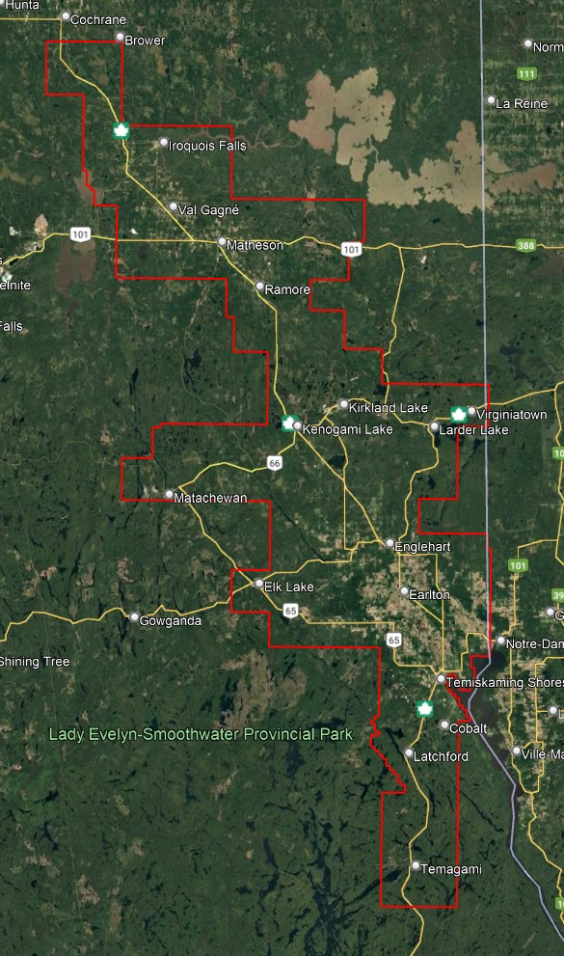
Figure 1: Map of Northeast Ontario project area

Project Schedule & Personnel
The ground control occurred in August – September 2024. The surveyor collecting ground truth points during this period was Alistair Lorne. The Lidar data was collected in ten missions on November 9, 2024 and from May 8, 2025 to June 2, 2025. See table below for the mission’s flight parameters.
A typical Lidar acquisition crew consisted of one Lidar Operator and one Pilot.

LiDAR System & Flight Parameters
A Riegl VQ-1560ii and VQ-1560ii-S were used to collect the Lidar data. The systems were installed in a Cessna 208 with call sign N133RF operated by Revolution Flight, and Piper Navajo aircraft with call sign C-GMEC operated by Kasi Aviation, respectively.

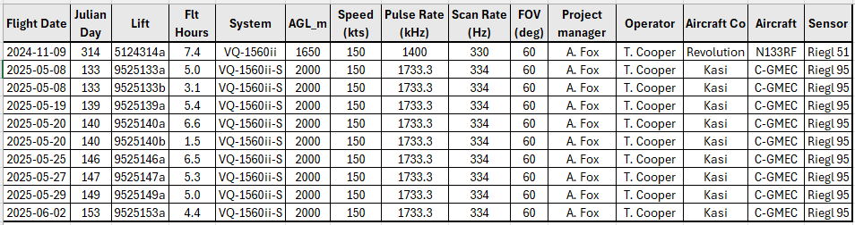
Table 1: lifts with their flight parameters.

Riegl VQ1560-ii | Flight plan | Riegl VQ1560-ii-S | Flight plan
Altitude | 1650m AGL | Altitude | 2000m AGL
Field of View (FOV) | 60° | Field of View (FOV) | 60°
Air Speed | 150 Kts | Air Speed | 150 Kts
Pulse Rate | 1400 kHz | Pulse Rate | 1733.3 kHz
Sidelap | 20% | Sidelap | 20%
Point Density | > 8 pts/m² | Point Density | > 8 pts/m²

Table 2: Project Parameters for the Northeast Ontario area.
The flight lines were designed optimally to maximize time online versus time in turns.
Below is a map of the flight lines including cross-ties.
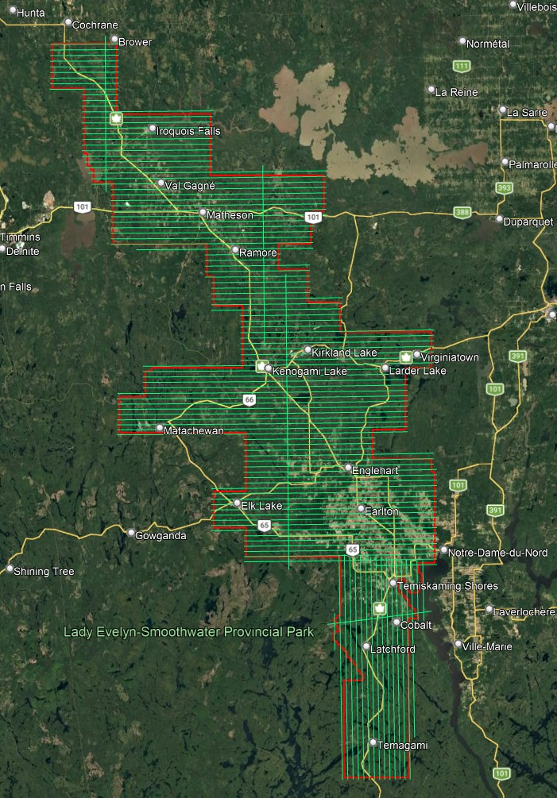
Figure 2: A map of the Northeast Ontario flightlines
Below is a map of the flight line footprints.
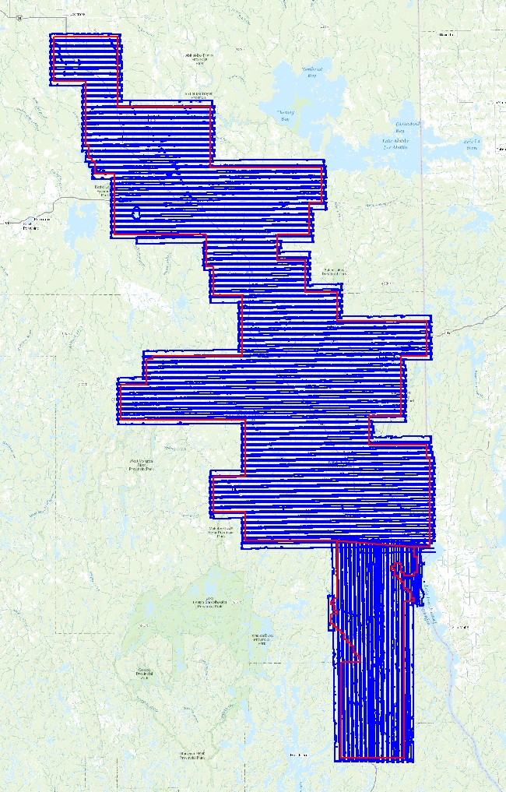
Figure 3: A map of the Northeast Ontario flight line footprints

Project Control / Datum
Several baselines were measured by GPS static occupation between Can-Net Continuously Operating Reference Stations (CORS), existing NRCan 3D Passive Control Monuments, as well as newly established points by Airborne Imaging. The existing control used for the Northeast Ontario area consisted of four Can-Net stations and six NRCan passive stations.
Appendix A shows the published station coordinate sheets.
Appendix B shows the PPP Solutions.
Appendix C contains a list of Control Points and their published coordinates.
The datum used for processing the Ground Control and all subsequent Lidar data are the Nad83 CSRS (epoch 2010.0) horizontal datum and the CGVD2013 vertical datum (CGG2013 undulation model).

Control Network
The ground control survey was collected using a combination of Trimble R8 Model 3 receivers and Hemisphere S631 receivers. The Trimble receivers were employed in establishing control and collecting kinematic cross sections and the Hemisphere receivers were used for RTK collection. The ground control data was processed using the NovAtel Waypoint software GraftNet and GrafNav.
First, to establish control in the area, baselines were measured via GPS observations between a network of NRCan 3D Passive Control Monuments, CanNet Continuously Operating Reference Stations (CORS), and Airborne’s intermediate bases which were established by the ground crew during collection. Baselines were observed for a minimum of 4 hours, and no baselines exceeded a length of 50km. The coordinates of the intermediate bases were established through a rigorous least-squares adjustment, tied to the established control monuments.
Datasheets for the published control monuments can be found in Appendix A at the end of this report. PPP Solutions for the intermediate bases were computed using NRCan’s PPP service and used as a-priori values for processing the network. They are included in Appendix B.
Below is an overview map of the control stations.

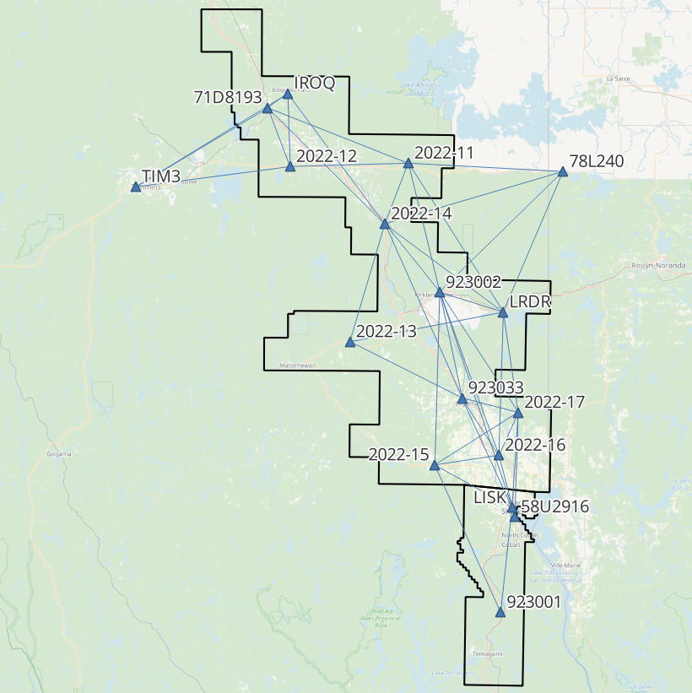
Figure 4: Northeast Ontario Control Network

Northeast Ontario - Control Station Coordinates
Station | Easting | Northing | Elevation | Description
2022-11 | 562857.879 | 5377528.949 | 363.505 | Airborne Intermediate Base
2022-12 | 523535.432 | 5376107.498 | 267.336 | Airborne Intermediate Base
2022-13 | 543868.099 | 5317776.833 | 322.209 | Airborne Intermediate Base
2022-14 | 555261.965 | 5357273.570 | 321.760 | Airborne Intermediate Base
2022-15 | 572984.147 | 5276607.765 | 280.535 | Airborne Intermediate Base
2022-16 | 594580.918 | 5280169.617 | 250.569 | Airborne Intermediate Base
2022-17 | 600903.017 | 5294713.693 | 211.973 | Airborne Intermediate Base
58U2916 | 600354.709 | 5259561.472 | 181.895 | NRCan 3D Passive Control
71D8193 | 516046.759 | 5395568.770 | 292.539 | NRCan 3D Passive Control
78L240 | 614453.590 | 5375545.561 | 301.368 | NRCan 3D Passive Control
923001 | 596089.963 | 5226945.700 | 317.800 | NRCan 3D Passive Control
923002 | 573862.116 | 5334712.978 | 343.832 | NRCan 3D Passive Control
923033 | 581893.651 | 5299256.392 | 200.234 | NRCan 3D Passive Control
IROQ | 522669.589 | 5400355.682 | 284.485 | CanNet CORS Station
LISK | 599354.150 | 5262655.971 | 205.978 | CanNet CORS Station
LRDR | 595300.679 | 5328352.175 | 301.499 | CanNet CORS Station
TIM3 | 472065.562 | 5369403.464 | 289.587 | CanNet CORS Station

Table 3: Control Station Coordinates
Horizontal Datum: Nad83(CSRS) UTM Zone 17 (epoch 2010)
Vertical Datum: CGVD2013 (Geoid CGG2013a)

Check Points
RTK GPS
The NVA and VVA control points were collected via Real-Time Kinematic Survey, using Hemisphere S631 GNSS receivers. The Real Time Kinematic method uses 30 second observations of individual points. It achieves high accuracy by receiving real time differential corrections from the GPS reference base, positioned over a nearby control point. The RTK points are used for the vertical accuracy assessment of the Lidar point cloud and were not used to determine any vertical shift applied to the point cloud.
The ground crews collected a total of 107 NVA points and 98 VVA points. A full coordinate list of the NVA and VVA Check Points is included in Appendix C at the end of this report.
See below for a map of the collected NVA and VVA ground control points.
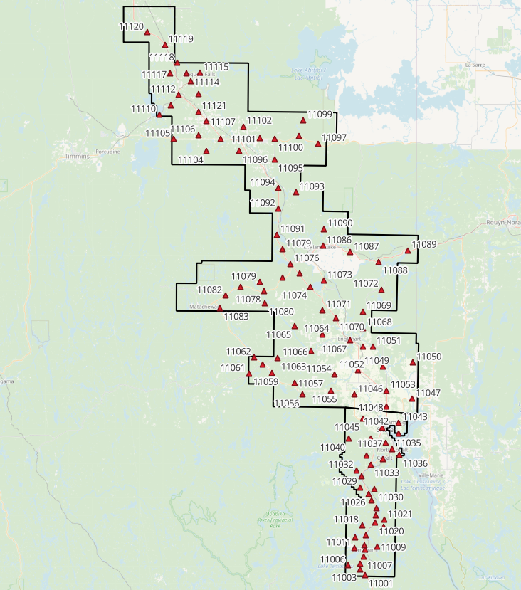
Figure 5: Northeast Ontario NVA points
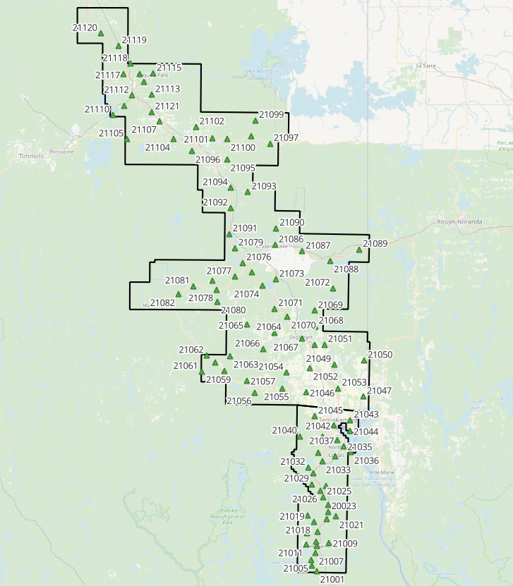
Trajectory Processing
Figure 6: Northeast Ontario VVA points

The aircraft trajectory positioning for the missions over the Northeast Ontario area were processed using the Precise Point Positioning (PPP) technique.
PPP is a positioning technique that removes and models GNSS system errors via precise satellite orbit data and clock corrections that are applied to the trajectory post mission, providing centimeter level positional accuracy without the use of ground base stations.
The TerraPOS software by Terratec was used to postprocess the PPP solutions to produce final kinematic trajectories accurate to 5 centimeters for each flight mission.
The horizontal datum used is Nad83 CSRS UTM zone 17 with the CGVD2013 vertical datum (CGG2013 undulation model).

LiDAR Data Processing

Calibration Procedures
After each mission, the field project manager creates the preliminary calibrated point cloud with each sensor’s set boresight values for each mission. Proprietary QC tools using the Lastools software are run on each mission to check for coverage, relative accuracy, point density, etc… If any data is found to be not meeting specifications, or coverage missing, the field crew is immediately notified and the areas affected reflown as soon as possible.
This preliminary calibrated point cloud is inspected in conjunction with the kinematic ground truth points to apply bulk shifts if necessary and further refine the calibration by applying corrections to the preliminary calibrated strips. The refined calibration is done using Bayesmap’s StripAlign software. Intensity values are also normalized by mission to be 16 bits (0 to 65535).

Data Tiling and Classification
The raw LiDAR data is processed into calibrated point cloud strips corresponding to flight lines. For ease of data manipulation, the strips are combined and saved in tiles of 1 km by 1 km. The format the strips and tiles are saved in is .Laz version 1.4. The tiling scheme is based on the UTM17 projection at the even kilometers.
The tiled point cloud is then processed with a series of algorithms to separate the “most-likely” ground returns from other returns. The point classification is done using a product by the TerraSolid software running on MicroStation Connect called TerraScan and TerraModeler.
In addition to our regular field QC and calibration procedures, we also generate various raster products using the Lastools software to assess coverage and calibration accuracy.

Point Cloud Manipulation
The TerraScan software uses macros that are set-up to measure the angles and distances between points to determine what classification a point should be: ground, vegetation, noise, other. The angle and distance values in the macros can be adjusted to be more or less aggressive with the classification of points by varying the incidence angles and estimated distances among neighboring points. The lower points are generally classified as ground returns, with the points above classified as undefined (class 1). Outliers and noise described in the table below are normally clouds, outliers or atmospheric noise in the data that are separated into above or below the ground level (high point or low points).
After the automated macro is run to determine classes, a systematic visual inspection is performed to fine tune the ground definition. To better understand areas for improvement for the ground surface, the points that are classified as ground are used to create viewable TINs and grid surfaces. These surfaces are inspected for areas that appear rough, artificially flattened or truncated, no data areas, or have other viewable errors.
In cleaning up ground points, the focus is concentrated in areas where few ground points have been left in the bare earth model and the ground appears rough or lower and flatter than it may be in reality. The scarcity of ground points may be a result from no penetration through a dense vegetation layer, water bodies, low reflectivity objects, or too aggressive values with the macro. A manual/visual inspection of these areas plays a major role in resolving any issues or irregularities with the bare earth model.
Once the first edits are completed, a one-meter grid of the ground surface is re-exported and hill shade images produced to QC the edited ground surface. This QC step is done iteratively as many times as necessary. Once the point cloud data has reached a satisfactory level of classification accuracy, the final deliverables are produced.

Water Classification & Hydro-Flattening
Once the ground class has reached the final level of classification accuracy, the water delineation process is initiated. The rivers and water bodies are digitized as break lines according to USGS specifications of a minimum of 8000 m² for water bodies and 30 m nominal width for streams and rivers. Ponds and lakes have their elevations set constant to just below ground. Stream and river hydro lines are collected using the downstream method. Once all hydro lines have been collected for an area, the ground points inside the hydro lines are classified to class 9 – Water. The ground points outside of the hydro lines but within 35 cm are classified to class 20 – Ignored ground (near breaklines). Using the TIN of class 2 (ground points), the hydro lines are used as constraints to generate the final 50 cm hydro-flattened DEMs in ESRI Ascii format, then converted to 32bit Geotiff format with the Global Mapper software.

Class definitions
The classification follows the ASPRS classification codes. The table below shows the classes for the delivered point cloud.

Classification Value | Description
1 | Unclassified
2 | Ground
6 | Building
7 | Low Points
9 | Water
17 | Bridge Decks
18 | High Points
20 | Ignored Ground (breakline proximity)
21 | Snow
22 | Temporal exclusion

Table 4: ASPRS Point Classes

Deliverables
The data was delivered in November 2025.
See below for a table of the folder structure and description of each deliverables.
DIFF
50cm rasters of flight lines differences, 1 X 1 km tiles in 32bit Geotiff format
e.g. 1km173850494302025LNEONTARIO_diff.tif
DTM
Hydro-flattened 50cm Bare Earth DEMs, 1 X 1 km tiles in 32bit Geotiff format
e.g. 1km173850494302025LNEONTARIO.tif
METADATA
Metadata files for Breaklines, DEM, LAS and Project in .XML format
e.g. NEONTARIO_2025_Lidar_metadata_Breaklines.xml
POINTCLOUD
Point cloud data, 1 X 1 km tiles in .LAZ format 1.4
e.g. 1km173850494302025LNEONTARIO.laz
PROJECT_POLYGON
Shape files of: Lift_metadata, Hydro_breaklines, Project_extent & Tile_index
e.g. Mission_9525133a_z17.shp

Vertical Accuracy Assessment

Non-Vegetated Vertical Accuracy (NVA)
Below is a summary of the statistics between the point cloud TIN from the ground class and the NVA points surveyed on flat hard surfaces:
Number of points: | 107
Average dz: | 0.000 | m
Minimum dz: | -0.103 | m
Maximum dz: | 0.102 | m
Average magnitude: | 0.034 | m
Root mean square: | 0.043 | m
Std deviation: | 0.043 | m
NVA Vertical Accuracy (95%): | 0.084 | m

For a complete listing of the NVA points and their differences, please refer to the provided spreadsheet named " NE_Ontario_NVA_Accuracy_z17_Final.xlsx".
As seen in the NVA comparison above, the accuracy observed of 0.084 m meets the project requirement of QL0 NVA vertical accuracy of 9.8 cm (95%).

Vegetated Vertical Accuracy (VVA)
The elevations of the points surveyed in various vegetated land cover types were compared to the Lidar ground surface. Since the elevation differences for this type of accuracy does not follow a normal distribution, the percentile method is used and not the 95% confidence level. For the 98 VVA points surveyed, sorting the absolute differences from the smallest to the largest gives the accuracy at the 95th percentile (using the linear interpolation between closest ranks method). For this sample, the 93rd and 94th largest differences are 9.2 and 10.7 cm, respectively.
For this project, the VVA accuracy is therefore 9.42 cm.
This is within the required specifications of 15.0 cm (the QL0 VVA specification).
For a complete listing of the VVA points and their differences, please refer to the provided spreadsheet named "NE_Ontario_VVA_Accuracy_z17_Final.xlsx".

Conclusion
This is the final report covering the Northeast Ontario Lidar project. Topics such as field operations, control, data processing and final accuracy results were explained. The project went well despite acquisition being spread across two seasons due to weather conditions. The non-vegetated vertical accuracy meets specifications, and the vegetated accuracy is within the QL0 requirement.

Appendix A - Control Points – Published Coordinates
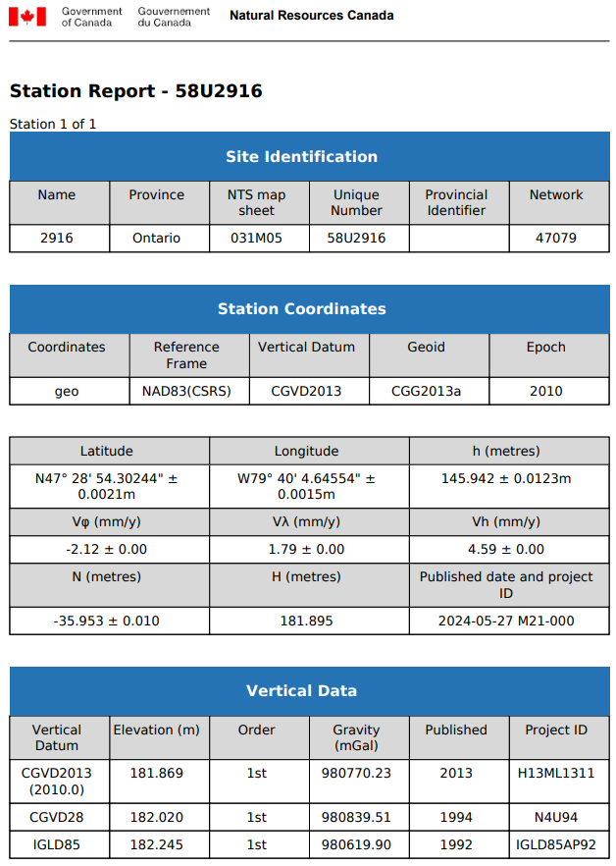
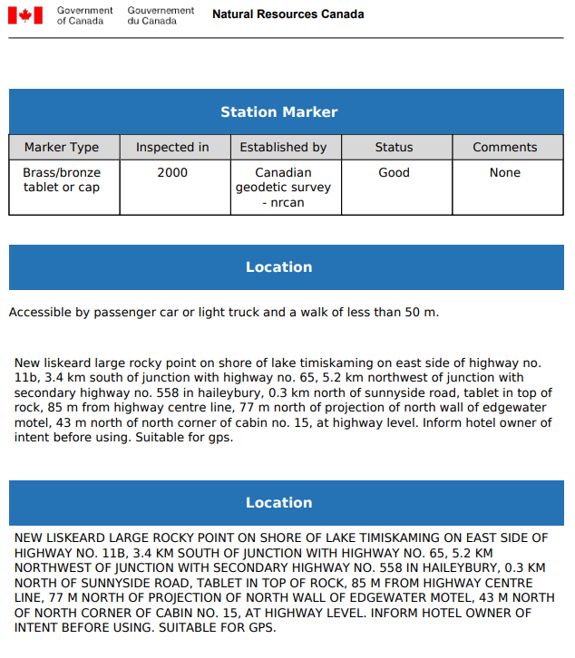
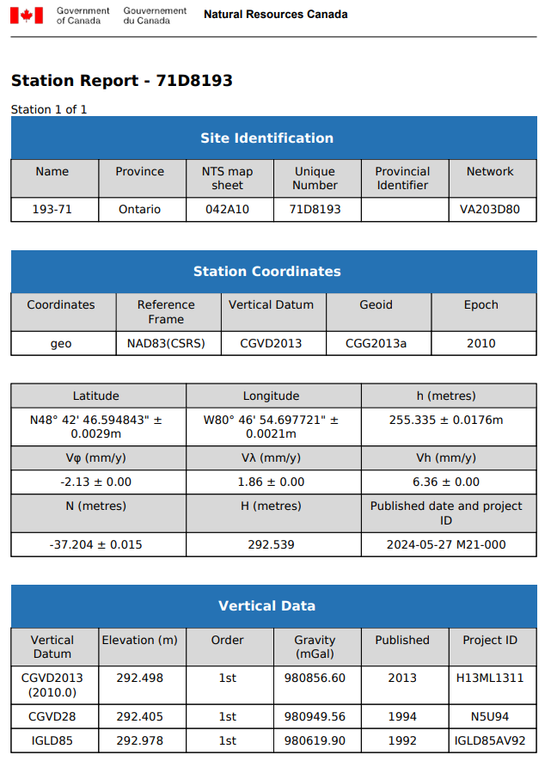
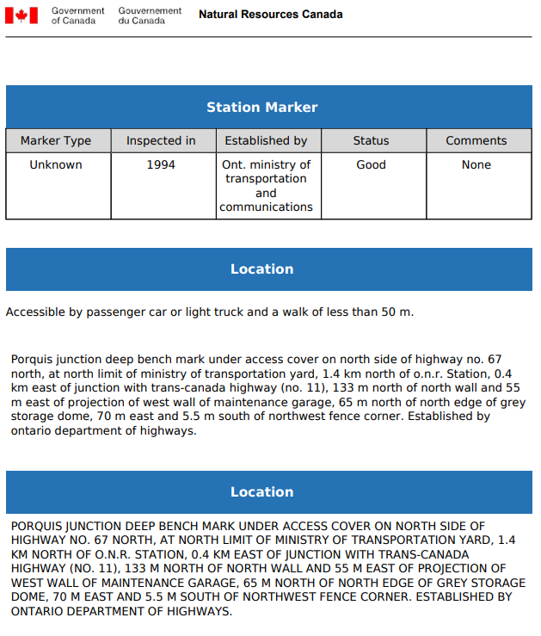
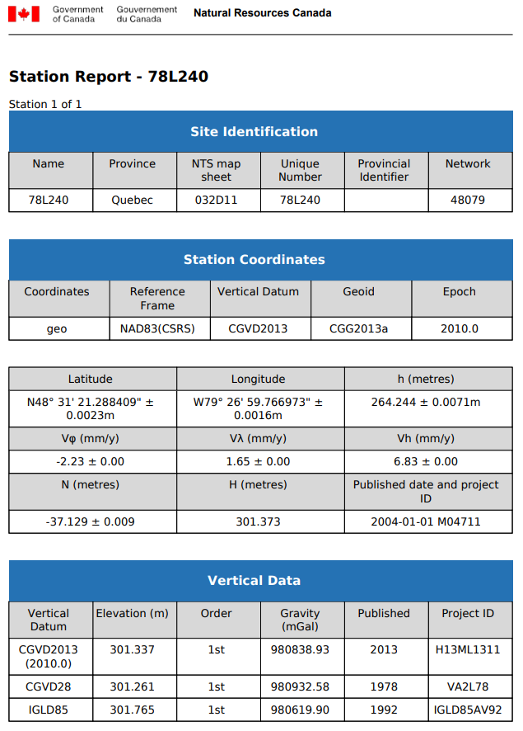
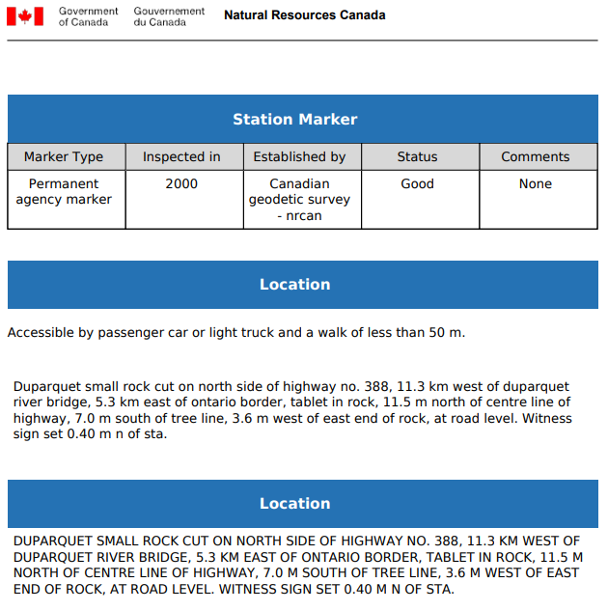
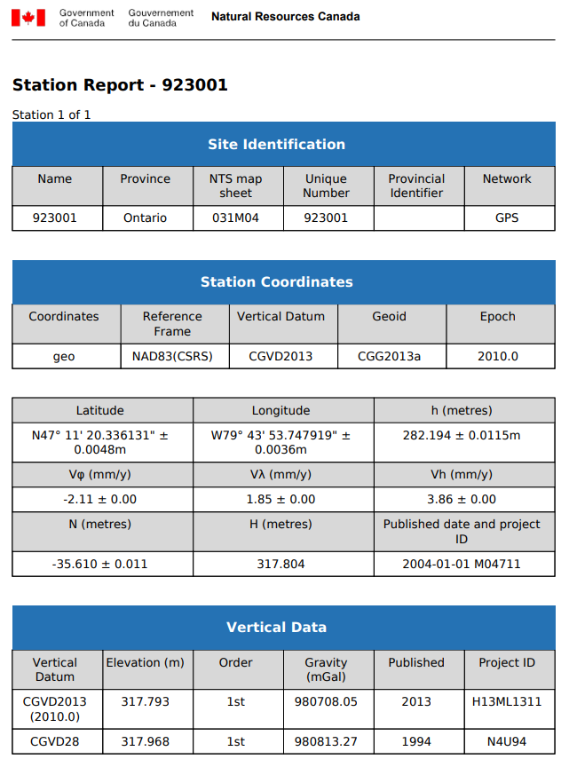
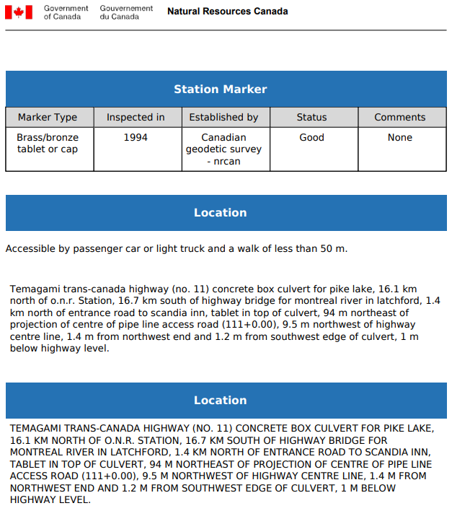
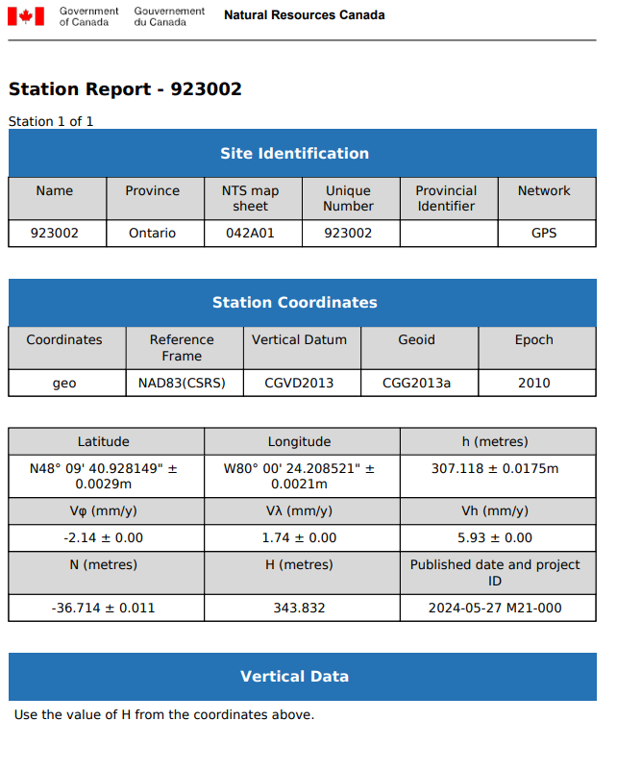
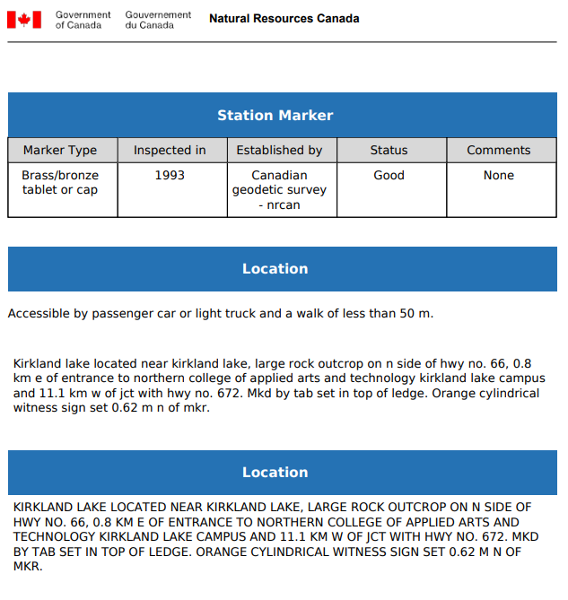
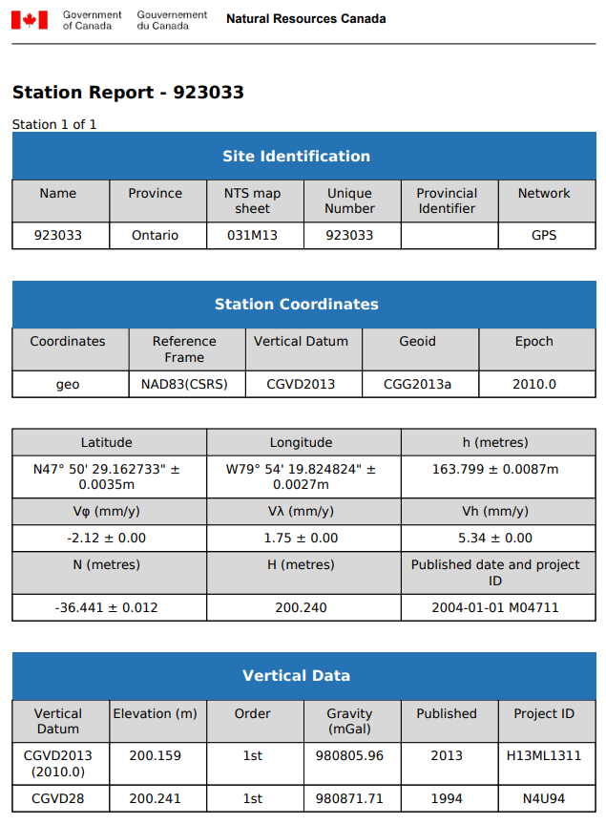
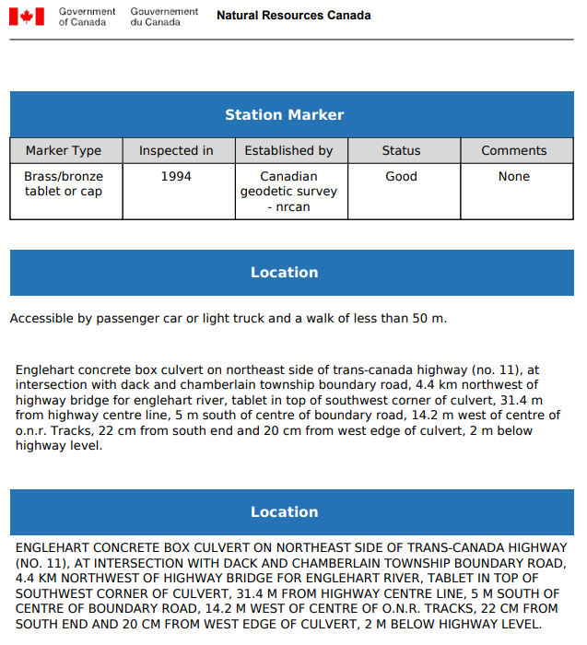
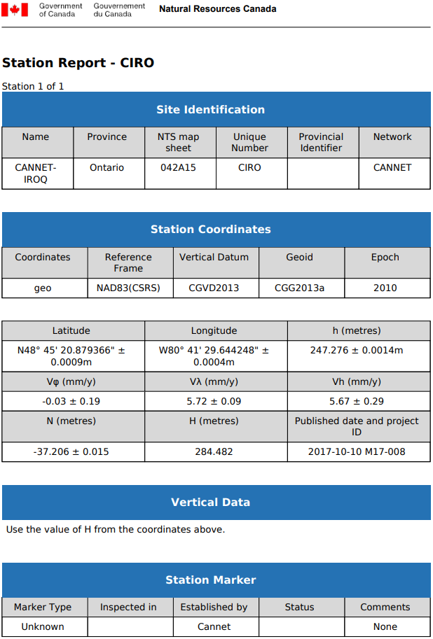
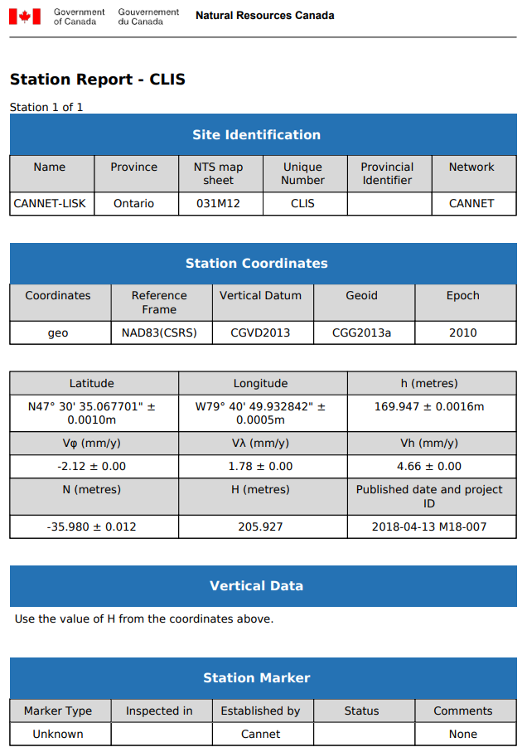
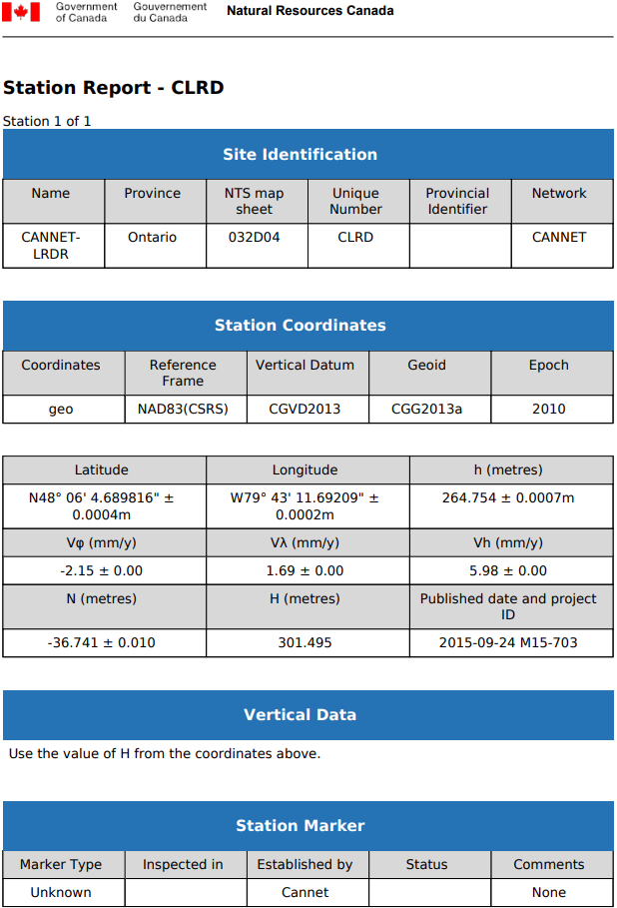
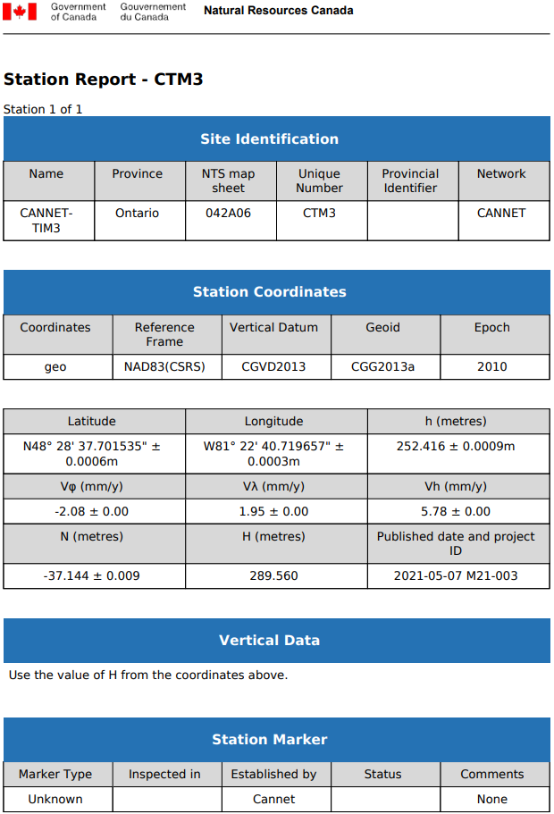

Appendix B – PPP Solutions
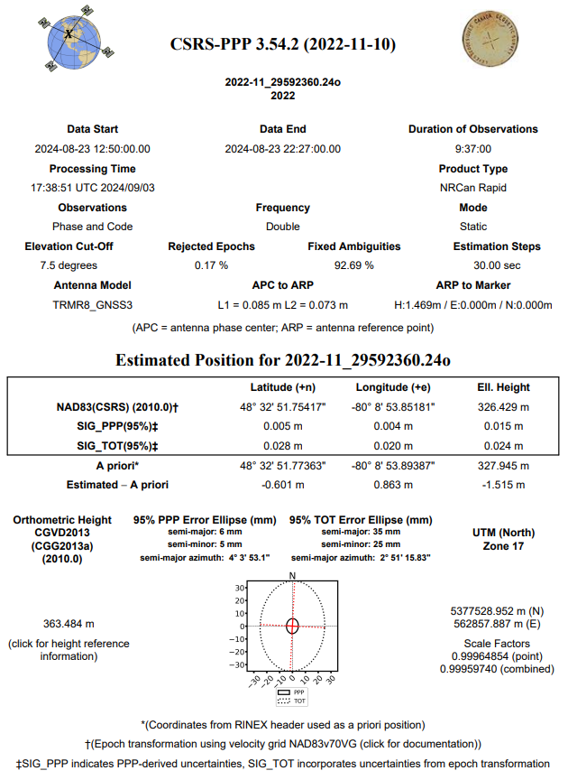
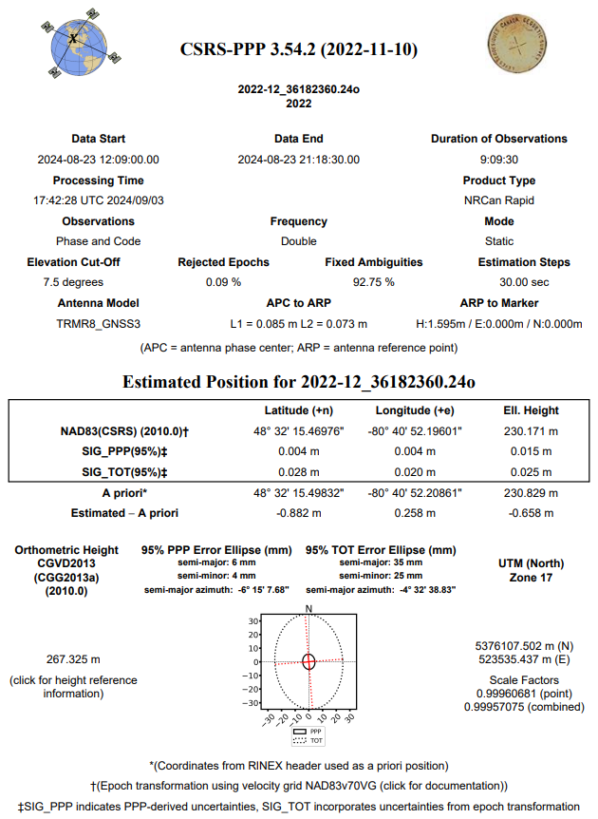
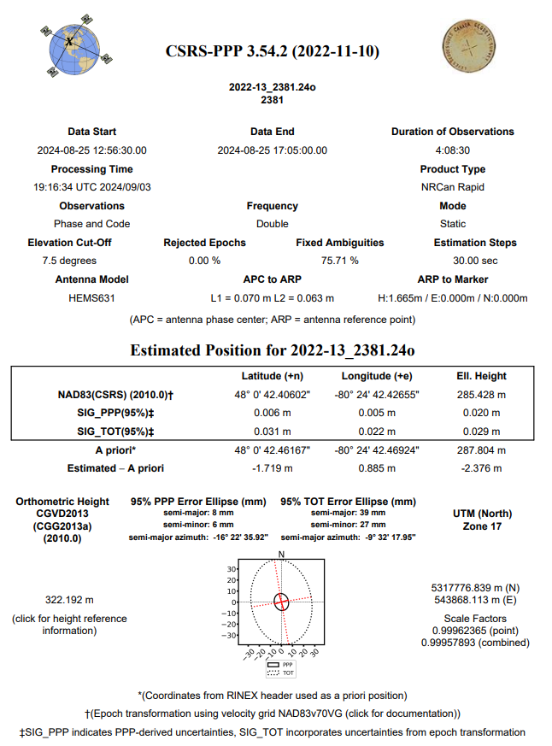
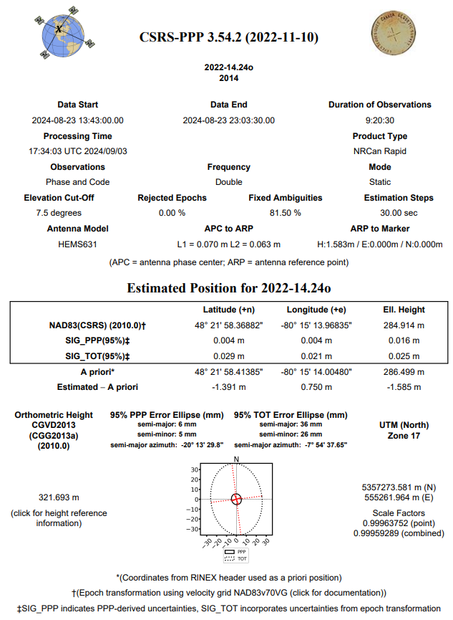
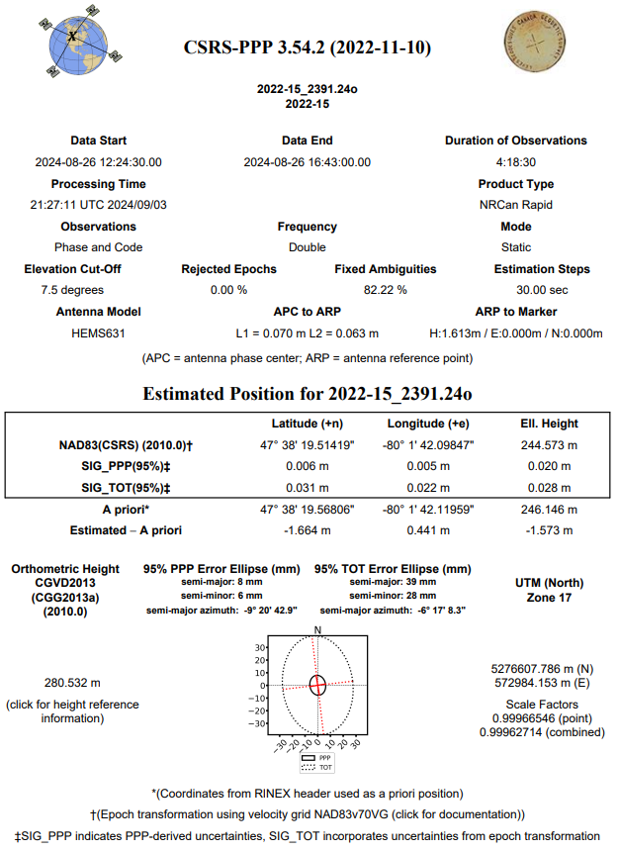
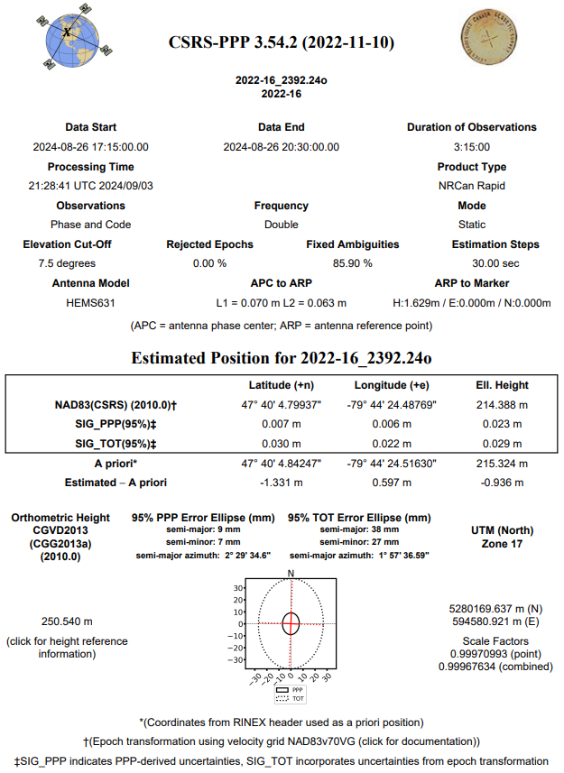
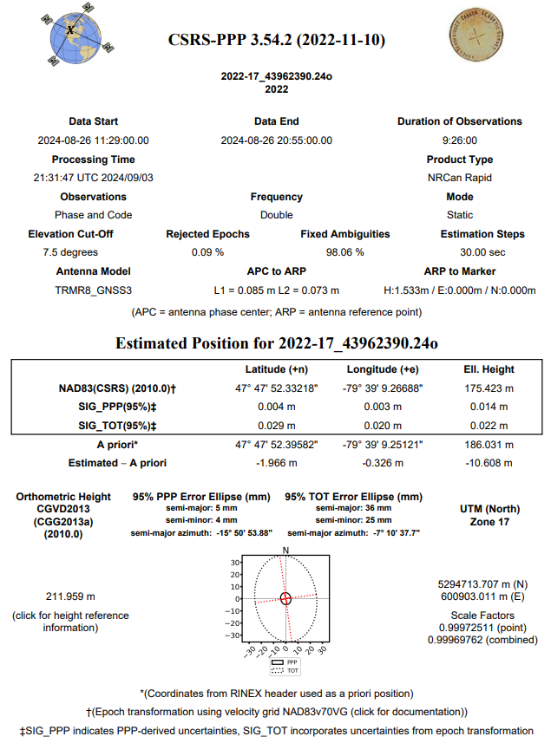

Appendix C - RTK Survey & Control Check

NVA Points
Point | Northing | Easting | Height
11001 | 5202582 | 591896.2 | 320.155
11003 | 5204894 | 589933.1 | 337.656
11005 | 5207039 | 589799.1 | 338.469
11006 | 5206413 | 585161.3 | 313.287
11007 | 5210000 | 591282.3 | 308.298
11008 | 5212959 | 591944.6 | 299.985
11009 | 5214191 | 596784.3 | 296.281
11011 | 5213378 | 587569 | 329.001
11012 | 5214725 | 591676.4 | 310.883
11015 | 5217872 | 587878.9 | 310.311
11016 | 5218609 | 592079.6 | 299.057
11018 | 5222685 | 590566.5 | 319.856
11019 | 5225199 | 588056.3 | 311.295
11020 | 5223778 | 595822.9 | 312.32
11021 | 5224974 | 599376.5 | 338.827
11022 | 5222214 | 599107.4 | 344.74
11023 | 5226837 | 596095.2 | 319.372
11024 | 5229705 | 596089.1 | 339.164
11025 | 5232831 | 594185.2 | 376.369
11026 | 5235425 | 593027.6 | 371.02
11029 | 5237889 | 589552.5 | 312.21
11030 | 5237515 | 595244.3 | 337.7
11031 | 5242522 | 589856.4 | 291.71
11032 | 5244800 | 588001.7 | 282.934
11033 | 5247257 | 593592.4 | 287.527
11034 | 5249409 | 598619.9 | 301.734
11035 | 5253698 | 602242.1 | 253.557
11036 | 5251249 | 605003.4 | 243.424
11037 | 5256083 | 599574.5 | 279.121
11039 | 5250828 | 591818.8 | 292.927
11040 | 5257438 | 584441.5 | 323.851
11041 | 5257572 | 593472.8 | 279.174
11042 | 5262085 | 598010.9 | 245.042
11043 | 5264213 | 604538.8 | 244.782
11044 | 5259887 | 604604.8 | 195.07
11045 | 5265643 | 590155.1 | 259.863
11046 | 5275188 | 586561.4 | 245.724
11047 | 5273903 | 609733.6 | 182.019
11048 | 5270562 | 599674.6 | 228.741
11049 | 5286639 | 597816.1 | 189.305
11050 | 5288461 | 609841.6 | 245.168
11051-241 | 5294536 | 589613.6 | 215.947
11051-252 | 5294595 | 593669.6 | 198.166
11052 | 5284971 | 587811.9 | 242.049
11053 | 5276942 | 599597.2 | 266.707
11054 | 5283117 | 578579.1 | 272.99
11055 | 5276652 | 577013 | 287.108
11057 | 5279688 | 562499.4 | 287.089
11059 | 5283357 | 553407.5 | 287.702
11060 | 5286852 | 549523.5 | 291.507
11061 | 5283121 | 544092.4 | 320.704
11062 | 5289621 | 546269.7 | 292.996
11063 | 5289477 | 555565 | 296.829
11064 | 5299140 | 573518.2 | 286.081
11065 | 5302251 | 562216.6 | 289.575
11066 | 5292387 | 568993.7 | 278.751
11067 | 5296801 | 584540.7 | 209.422
11068 | 5301936 | 589770 | 234.392
11069 | 5308344 | 589423.4 | 273.108
11070 | 5305580 | 578648.7 | 255.753
11071 | 5308792 | 573392.8 | 292.149
11072 | 5317369 | 596848 | 311.196
11073 | 5320551 | 573654.5 | 278.153
11074 | 5317960 | 568313.9 | 291.647
11075 | 5323176 | 563950 | 301.593
11076 | 5327018 | 560390.4 | 322.036
11077 | 5321428 | 557177.1 | 304.564
11078 | 5316203 | 549906.9 | 312.112
11079-241 | 5319667 | 548199.5 | 319.583
11079-254 | 5332865 | 557092.8 | 318.831
11080 | 5311308 | 550261 | 308.704
11081 | 5317583 | 540507 | 318.313
11083 | 5309278 | 532404.5 | 315.975
11086 | 5334335 | 573208.2 | 326.196
11087 | 5331924 | 584095.1 | 352.128
11088 | 5328311 | 595467.7 | 291.817
11089 | 5333121 | 607041.5 | 288.912
11090 | 5341027 | 573530 | 344.967
11091 | 5338524 | 554745.2 | 319.087
11092 | 5348860 | 555413.5 | 315.923
11093 | 5355400 | 562156.9 | 292.114
11094 | 5356967 | 555322.9 | 325.358
11095 | 5368233 | 553567.9 | 293.226
11096 | 5371425 | 539563.6 | 293.493
11097 | 5374754 | 570731.2 | 350.238
11098 | 5377529 | 563081 | 365.289
11099 | 5383876 | 564782.4 | 343.872
11100 | 5376324 | 553519.1 | 303.038
11101 | 5376518 | 547619.6 | 291.487
11102 | 5381055 | 541111.1 | 280.119
11103 | 5376177 | 532170.7 | 274.209
11104 | 5371305 | 526727.9 | 275.491
11105 | 5376092 | 513697.5 | 284.43
11106 | 5377720 | 523537.7 | 264.235
11107 | 5383255 | 526755.2 | 281.093
11110 | 5385602 | 508009.3 | 289.533
11111 | 5389391 | 512527.3 | 302.765
11112 | 5393414 | 515766.2 | 291.425
11113 | 5393731 | 523486.2 | 275.463
11114 | 5398773 | 520336.7 | 278.223
11115 | 5402136 | 524042.5 | 257.52
11116 | 5401753 | 518569.6 | 274.936
11117 | 5401779 | 512221.5 | 296.218
11118 | 5405944 | 515168.7 | 297.768
11119 | 5413038 | 510148.3 | 278.481
11120 | 5417873 | 503202.5 | 270.466
11121 | 5386895 | 523381.2 | 268.863

VVA Points
Point | Northing | Easting | Height
21001 | 5202569 | 591910.4 | 320.263
21005 | 5207068 | 589776.6 | 337.606
21007 | 5209954 | 591268.3 | 310.145
21008 | 5213007 | 591972.6 | 300.476
21009 | 5214205 | 596772.7 | 295.584
21011 | 5213350 | 587601.6 | 327.717
21012 | 5214741 | 591663.1 | 311.791
21015 | 5217877 | 587867.7 | 311.066
21016 | 5218600 | 592064.6 | 299.261
21018 | 5222688 | 590575.6 | 320.096
21020 | 5223779 | 595815.4 | 311.977
21021 | 5224971 | 599385.4 | 338.648
21024 | 5229714 | 596089.7 | 338.683
21025 | 5232841 | 594178.5 | 376.352
21026 | 5235412 | 593032.9 | 371.039
21029 | 5237878 | 589602.9 | 310.344
21030 | 5237528 | 595244.8 | 338.341
21031 | 5242509 | 589848.5 | 291.585
21032 | 5244809 | 587993.9 | 282.921
21033 | 5247274 | 593596.2 | 287.727
21034 | 5249406 | 598643.5 | 301.736
21035 | 5253691 | 602232.7 | 253.55
21036 | 5251236 | 605008 | 243.383
21037 | 5256094 | 599564.2 | 279.13
21039 | 5250842 | 591817.8 | 292.062
21040 | 5257430 | 584434 | 323.87
21041 | 5257549 | 593477 | 278.576
21042 | 5262097 | 598030 | 244.725
21043 | 5264223 | 604546.2 | 244.85
21044 | 5259899 | 604596.6 | 194.334
21045 | 5265592 | 590144.9 | 257.693
21046 | 5275206 | 586568.3 | 245.206
21047 | 5273898 | 609748.2 | 182.121
21049 | 5286648 | 597802.3 | 188.511
21050 | 5288467 | 609841.4 | 245.02
21051-241 | 5294516 | 589636.6 | 214.445
21051-252 | 5294609 | 593668.8 | 197.594
21052 | 5284989 | 587815.6 | 242.038
21053 | 5276947 | 599584.7 | 266.403
21054 | 5283117 | 578569.6 | 273.121
21055 | 5276668 | 577003.3 | 286.685
21056 | 5274897 | 565780.5 | 291.323
21057 | 5279680 | 562505.2 | 286.834
21060 | 5286846 | 549540 | 291.363
21061 | 5283140 | 544079.7 | 321.273
21062 | 5289610 | 546263.4 | 293.196
21063 | 5289477 | 555572 | 296.661
21064 | 5299142 | 573576.8 | 284.203
21065 | 5302240 | 562229.4 | 289.143
21066 | 5292399 | 568986.3 | 278.284
21067 | 5296786 | 584578 | 208.583
21068 | 5301938 | 589783 | 233.916
21069 | 5308209 | 589430 | 271.482
21070 | 5305571 | 578618.8 | 254.693
21071 | 5308813 | 573403.1 | 291.528
21072 | 5317342 | 596862.6 | 309.81
21073 | 5320529 | 573663 | 277.49
21074 | 5317942 | 568308.2 | 290.99
21075 | 5323163 | 564020.1 | 297.626
21076 | 5327034 | 560365 | 320.483
21077 | 5321417 | 557188.5 | 303.688
21078 | 5316218 | 549901.2 | 312.186
21079-241 | 5319678 | 548187.6 | 319.131
21079-254 | 5332861 | 557086.3 | 317.555
21080 | 5311312 | 550271.6 | 308.068
21082 | 5314169 | 534498.8 | 362.982
21086 | 5334329 | 573234.1 | 324.516
21087 | 5331943 | 584087.1 | 351.235
21088 | 5328324 | 595479 | 292.122
21089 | 5333086 | 607042.3 | 288.068
21090 | 5341041 | 573537.3 | 344.708
21091 | 5338511 | 554754.3 | 318.565
21092 | 5348852 | 555425.5 | 315.44
21093 | 5355379 | 562138 | 291.306
21094 | 5356984 | 555328.2 | 323.182
21095 | 5368221 | 553570.9 | 292.617
21096 | 5371423 | 539574.2 | 293.558
21097 | 5374758 | 570717 | 349.509
21098 | 5377520 | 563064.7 | 365.178
21099 | 5383883 | 564799.5 | 343.325
21100 | 5376310 | 553532.5 | 301.926
21101 | 5376524 | 547605.8 | 291.157
21102 | 5381042 | 541114 | 279.818
21104 | 5376189 | 532162.3 | 273.607
21105 | 5376110 | 513698.9 | 284.212
21107 | 5383254 | 526743.5 | 280.926
21110 | 5385601 | 508029.4 | 289.84
21111 | 5389395 | 512533.1 | 302.41
21112 | 5393384 | 515774.5 | 291.739
21113 | 5393741 | 523470.8 | 274.754
21114 | 5398793 | 520323.8 | 277.736
21115 | 5402140 | 524022.4 | 257.62
21116 | 5401755 | 518584.7 | 274.303
21117 | 5401773 | 512236.1 | 295.822
21118 | 5405951 | 515170 | 297.265
21119 | 5413027 | 510150.8 | 278.229
21120 | 5417879 | 503168.6 | 269.301
21121 | 5386896 | 523397.8 | 269.04

