Final Report
For project:
Rainy River LiDAR
Prepared for:
Ontario Ministry of Natural Resources
2nd floor, North Tower, 300 Water Street,
Peterborough, ON, K9J 3C7
Prepared by:

Airborne Imaging
2700 – 61 Avenue SE
Calgary, AB T2C 4V2
March 2026

Contents
Introduction 2
Project Schedule & Personnel 3
LiDAR System & Flight Parameters 3
Project Control / Datum 5
Control Network 6
Check Points 8
Trajectory Processing 9
LiDAR Data Processing 10
Calibration Procedures 10
Data Tiling and Classification 10
Point Cloud Manipulation 11
Water Classification & Hydro-Flattening 11
Class definitions 12
Deliverables 13
Vertical Accuracy Assessment 14
Conclusion 15
Appendix A - Control Points – Published Coordinates 16
Appendix B – PPP Solutions 24
Appendix C - RTK Survey & Control Check 26

Introduction
The Ontario Ministry of Natural Resources and Forests contracted Airborne Imaging to acquire and deliver digital elevation data derived from airborne LiDAR (Light Detection and Ranging) to cover various regions in Ontario.
This report covers the Rainy River area, collected during the Spring of 2025. The report focuses on LiDAR acquisition details, such as flight parameters, project control, ground truthing results, data processing technique and deliverables.
The contracted area for the Rainy River area is 3,139 km².
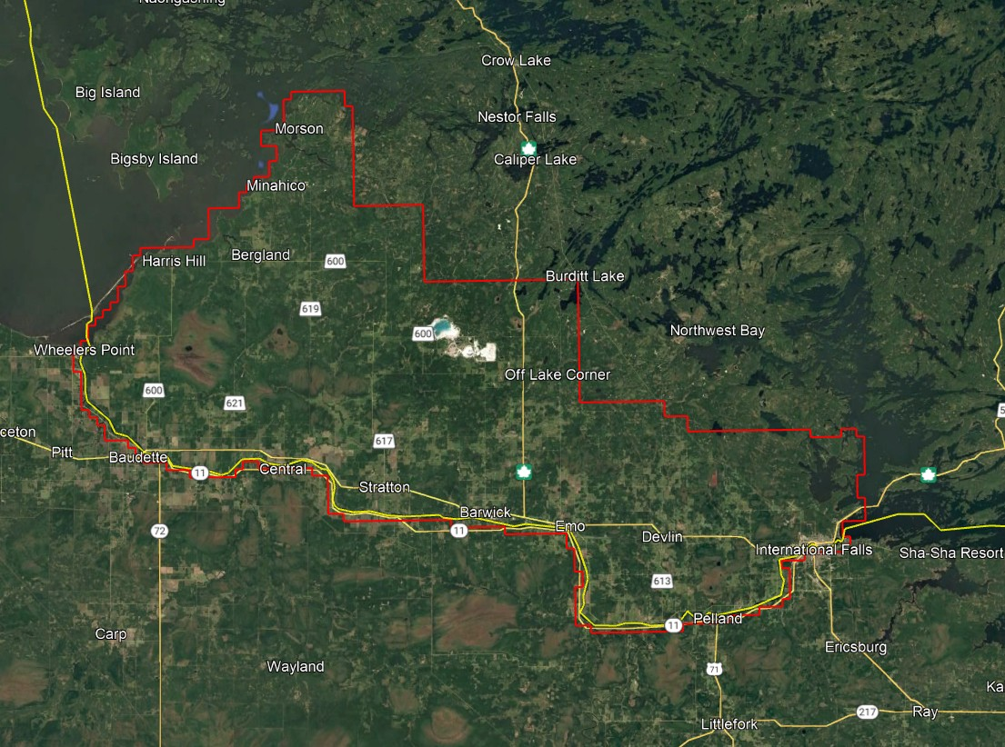
Figure 1 Rainy River Project Area

Project Schedule & Personnel
The ground control occurred in May 2025. The surveyor collecting ground truth points during this period was Don Tarr. The Lidar data was collected in eight missions from May 5 to June 3, 2025. See table below for the mission’s flight parameters.
A typical Lidar acquisition crew consisted of one Lidar Operator and one Pilot.

LiDAR System & Flight Parameters
A Riegl VQ-1560ii was used to collect the Lidar data. The system was installed in a Cessna 206 aircraft with call sign N-916WC operated by Barr Air Patrol.

Below is a table of the lifts with their flight parameters.
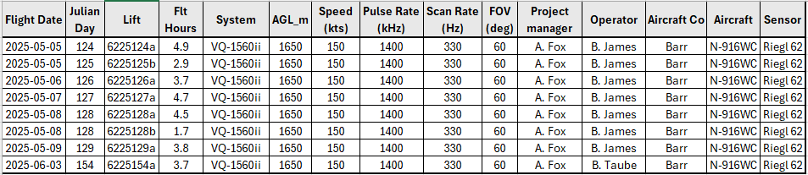
Table 1: Lifts with their flight parameters.
Riegl VQ1560-ii | Flight plan
Altitude | 1650m AGL
Field of View (FOV) | 60°
Air Speed | 150 Kts
Pulse Rate | 1400 kHz
Sidelap | 20%
Point Density | > 8 pts/m²

Table 2: Project Parameters for the Rainy River area.
The flight lines were designed optimally to maximize time online versus time in turn.

Below is a map of the flight lines including cross-ties.
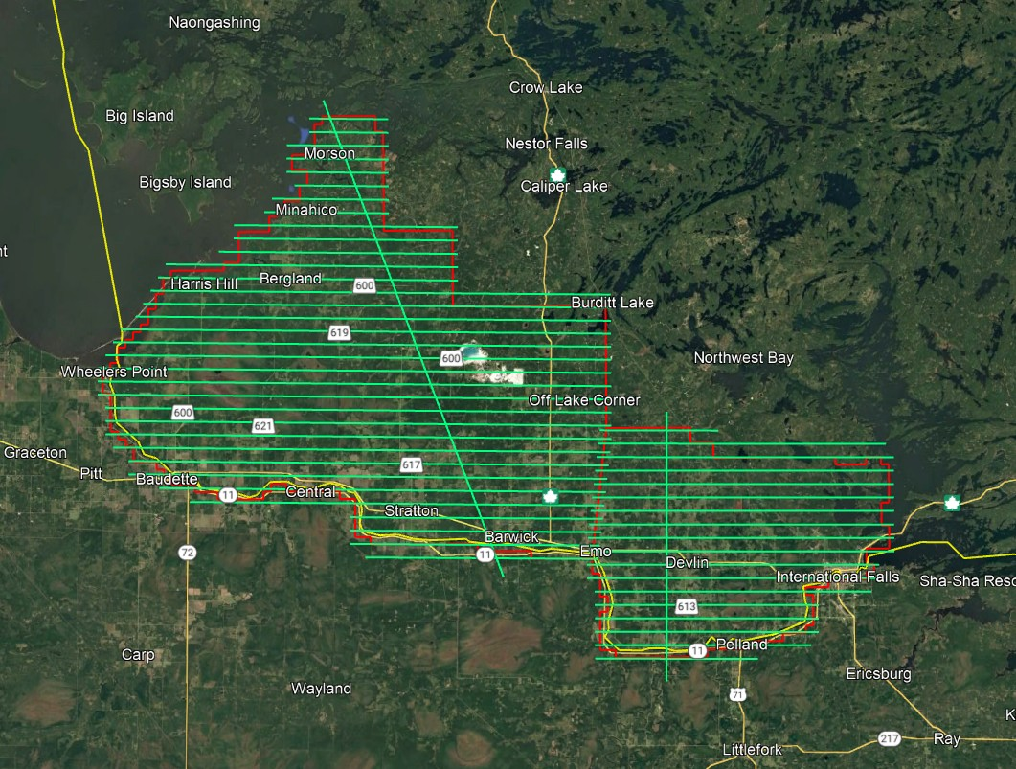
Figure 2 Rainy River Flight Lines

Below is a map of the flight line footprints.
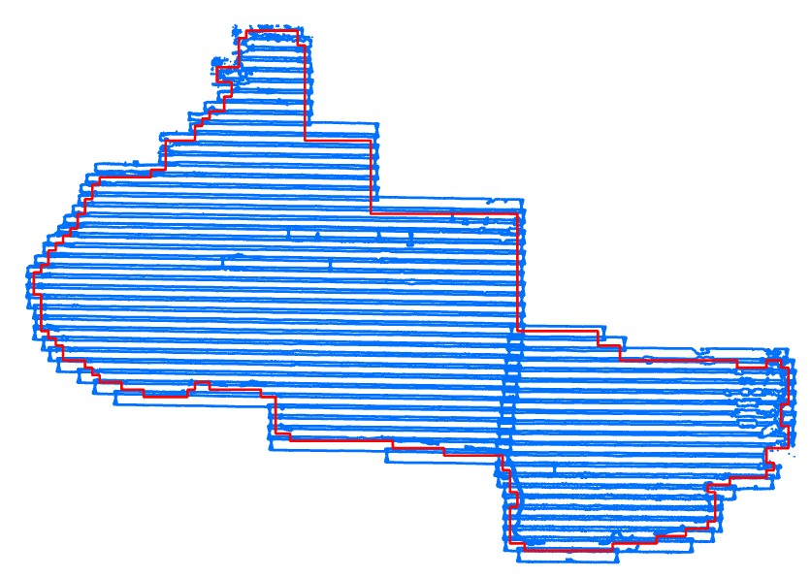
Figure 3 Rainy River Flightline footprints

Project Control / Datum
Several baselines were measured by GPS static occupation between Can-Net Continuously Operating Reference Stations (CORS), existing NRCan 3D Passive Control Monuments, as well as newly established points by Airborne Imaging. The existing control used for the Rainy River area consisted of four Can-Net stations and three NRCan passive stations.
Appendix A shows the published station coordinate sheets.
Appendix B shows the PPP Solutions.
Appendix C contains a list of Control Points and their published coordinates.
The datum used for processing the Ground Control and all subsequent Lidar data are the Nad83 CSRS (epoch 2010.0) horizontal datum and the CGVD2013 vertical datum (CGG2013 undulation model).

Control Network
The ground control survey was collected using a combination of Trimble R8 Model 3 receivers and Hemisphere S631 receivers. The Trimble receivers were employed in establishing control and collecting kinematic cross sections and the Hemisphere receivers were used for RTK collection. The ground control data was processed using the NovAtel Waypoint software GraftNet and GrafNav.
First, to establish control in the area, baselines were measured via GPS observations between a network of NRCan 3D Passive Control Monuments and Airborne’s intermediate bases, which were established by the ground crew on the day of collection. Baselines were observed for a minimum of 4 hours and no baselines exceeded a length of 50km. The coordinates of the intermediate bases were established through a rigorous least-squares adjustment, tied to the established control monuments. See below for the control network established in the Rainy River AOI.
Datasheets for the published control monuments can be found in Appendix A at the end of this report. Note that control monuments 79U121 and 673221 were included in the original control plan, but the ground crews were unable to find them during collection. PPP Solutions for the observed bases 2065-41, 2065-42, and 2065-43 were computed using NRCan’s PPP service and used as a-priori values for processing the network. They are included in Appendix B.
Airborne Imaging collected ground control to provide a vertical accuracy assessment for the deliverable LiDAR outputs. Following ASPRS guidelines, there is a minimum requirement of 59 Non-Vegetated Vertical Accuracy (NVA) points, and 48 Vegetated Vertical Accuracy (VVA) points to be collected throughout the AOI. Additionally, kinematic cross-sections were collected to calibrate the LiDAR data in preliminary processing and assess the need for applying vertical shifts. Pictures of the NVA and VVA control points are included with the submission of this report.
Below is an overview map of the control stations.
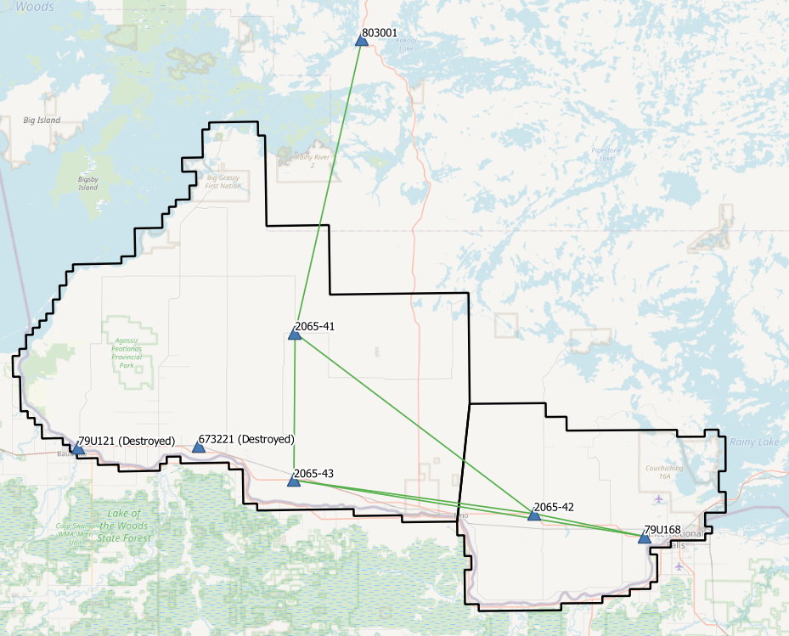
Figure 4 Rainy River Control Network

Rainy River - Control Station Coordinates
Station | Easting | Northing | Height | Description
2065-41 | 414885.301 | 5413552.254 | 363.932 | Airborne Intermediate Base
2065-42 | 449177.485 | 5387030.865 | 360.717 | Airborne Intermediate Base
2065-43 | 414386.797 | 5392307.260 | 338.566 | Airborne Intermediate Base
79U168 | 465152.502 | 5383636.003 | 345.794 | NRCan 3D Passive Control
803001 | 425130.015 | 5455553.863 | 392.709 | NRCan 3D Passive Control

Horizontal Datum: Nad83(CSRS) UTM Zone 15 (epoch 2010)
Vertical Datum: CGVD2013 (Geoid CGG2013a)

Check Points
RTK GPS
The NVA and VVA control points were collected via Real-Time Kinematic Survey, using Hemisphere S631 GNSS receivers. The Real Time Kinematic method uses 30 second observations of individual points. It achieves high accuracy by receiving real time differential corrections from the GPS reference base, positioned over a nearby control point. The RTK points are used for the vertical accuracy assessment of the Lidar point cloud and were not used to determine any vertical shift applied to the point cloud.
The ground crews collected a total of 65 NVA points and 65 VVA points. A full coordinate list of the NVA and VVA Check Points is included in Appendix C at the end of this report. Pictures of the final delivered RTK points (as well as the existing control) are provided in a folder included with the submission of this report.
See below for a map of the collected NVA and VVA ground control points.
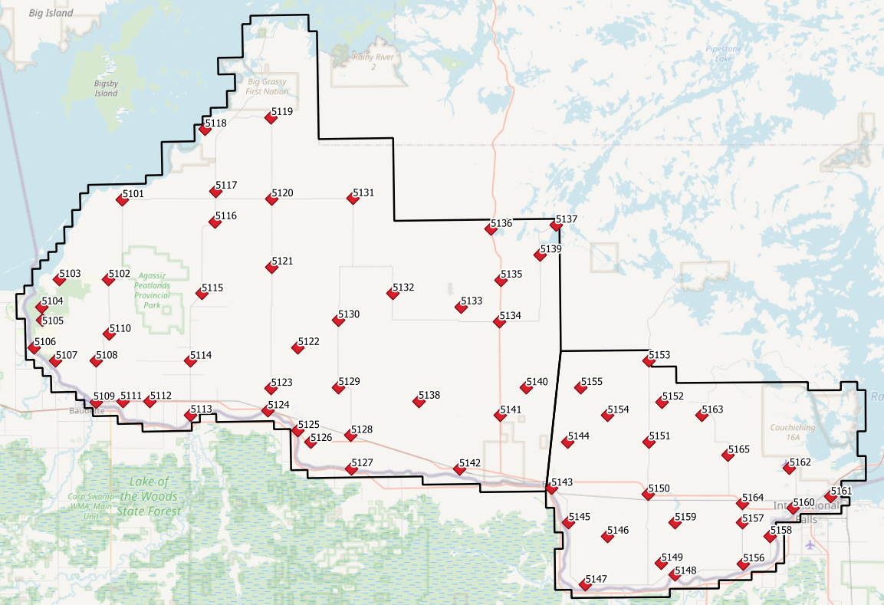
Figure 5 Rainy River NVA points
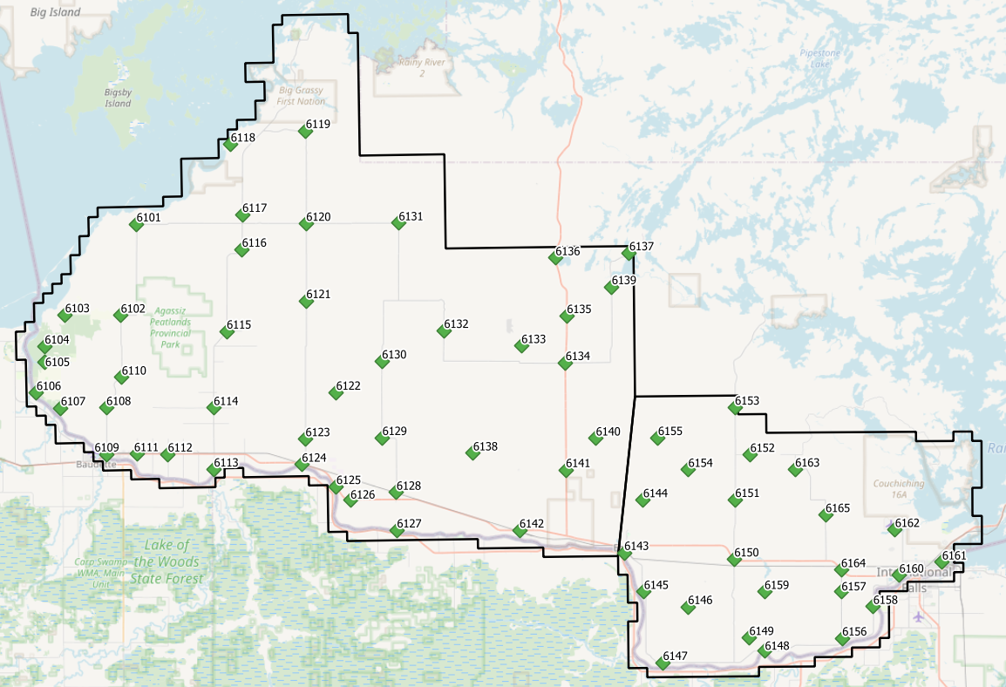
Figure 6 Rainy River VVA points

Trajectory Processing
The aircraft trajectory positioning for the missions over the Rainy River area were processed using the Precise Point Positioning (PPP) technique.
PPP is a positioning technique that removes and models GNSS system errors via precise satellite orbit data and clock corrections that are applied to the trajectory post mission, providing centimeter level positional accuracy without the use of ground base stations.
The TerraPOS software by Terratec was used to postprocess the PPP solutions to produce final kinematic trajectories accurate to 5 centimeters for each flight mission.
The horizontal datum used is Nad83 CSRS UTM zone 15 with the CGVD2013 vertical datum (CGG2013 undulation model).

LiDAR Data Processing

Calibration Procedures
After each mission, the field project manager creates the preliminary calibrated point cloud with each sensor’s set boresight values for each mission. Proprietary QC tools using the Lastools software are run on each mission to check for coverage, relative accuracy, point density, etc… If any data is found to be not meeting specifications, or coverage missing, the field crew is immediately notified and the areas affected reflown as soon as possible.
This preliminary calibrated point cloud is inspected in conjunction with the kinematic ground truth points to apply bulk shifts if necessary and further refine the calibration by applying corrections to the preliminary calibrated strips. The refined calibration is done using Bayesmap’s StripAlign software. Intensity values are also normalized by mission to be 16 bits (0 to 65535).

Data Tiling and Classification
The raw LiDAR data is processed into calibrated point cloud strips corresponding to flight lines. For ease of data manipulation, the strips are combined and saved in tiles of 1 km by 1 km. The format the strips and tiles are saved in is .Laz version 1.4. The tiling scheme is based on the UTM15 projection at the even kilometers.
The tiled point cloud is then processed with a series of algorithms to separate the “most-likely” ground returns from other returns. The point classification is done using a product by the TerraSolid software running on MicroStation Connect called TerraScan and TerraModeler.
In addition to our regular field QC and calibration procedures, we also generate various raster products using the Lastools software to assess coverage and calibration accuracy.

Point Cloud Manipulation
The TerraScan software uses macros that are set-up to measure the angles and distances between points to determine what classification a point should be: ground, vegetation, noise, other. The angle and distance values in the macros can be adjusted to be more or less aggressive with the classification of points by varying the incidence angles and estimated distances among neighboring points. The lower points are generally classified as ground returns, with the points above classified as undefined (class 1). Outliers and noise described in the table below are normally clouds, outliers or atmospheric noise in the data that are separated into above or below the ground level (high point or low points).
After the automated macro is run to determine classes, a systematic visual inspection is performed to fine tune the ground definition. To better understand areas for improvement for the ground surface, the points that are classified as ground are used to create viewable TINs and grid surfaces. These surfaces are inspected for areas that appear rough, artificially flattened or truncated, no data areas, or have other viewable errors.
In cleaning up ground points, the focus is concentrated in areas where few ground points have been left in the bare earth model and the ground appears rough or lower and flatter than it may be in reality. The scarcity of ground points may be a result from no penetration through a dense vegetation layer, water bodies, low reflectivity objects, or too aggressive values with the macro. A manual/visual inspection of these areas plays a major role in resolving any issues or irregularities with the bare earth model.
Once the first edits are completed, a one-meter grid of the ground surface is re-exported and hill shade images produced to QC the edited ground surface. This QC step is done iteratively as many times as necessary. Once the point cloud data has reached a satisfactory level of classification accuracy, the final deliverables are produced.

Water Classification & Hydro-Flattening
Once the ground class has reached the final level of classification accuracy, the water delineation process is initiated. The rivers and water bodies are digitized as break lines according to USGS specifications of a minimum of 8000 m² for water bodies and 30 m nominal width for streams and rivers. Ponds and lakes have their elevations set constant to just below ground. Stream and river hydro lines are collected using the downstream method. Once all hydro lines have been collected for an area, the ground points inside the hydro lines are classified to class 9 – Water. The ground points outside of the hydro lines but within 35 cm are classified to class 20 – Ignored ground (near breaklines). Using the TIN of class 2 (ground points), the hydro lines are used as constraints to generate the final 50 cm hydro-flattened DEMs in ESRI Ascii format, then converted to 32bit Geotiff format with the Global Mapper software.

Class definitions
The classification follows the ASPRS classification codes. The table below shows the classes for the delivered point cloud.
Classification Value | Description
1 | Unclassified
2 | Ground
6 | Building
7 | Low Points
9 | Water
17 | Bridge Decks
18 | High Points
20 | Ignored Ground (breakline proximity)
21 | Snow
22 | Temporal exclusion

Table 3: ASPRS Point Classes

Deliverables
The data was delivered in September 2025.
See below for a table of the folder structure and description of each deliverables.
DIFF
50cm rasters of flight lines differences, 1 X 1 km tiles in 32bit Geotiff format
e.g. 1km153850494302025LRAINYRIVER_diff.tif
DTM
Hydro-flattened 50cm Bare Earth DEMs, 1 X 1 km tiles in 32bit Geotiff format
e.g. 1km153850494302025LRAINYRIVER.tif
METADATA
Metadata files for Breaklines, DEM, LAS and Project in .XML format
e.g. RAINYRIVER_2025_Lidar_metadata_Breaklines.xml
POINTCLOUD
Point cloud data, 1 X 1 km tiles in .LAZ format 1.4
e.g. 1km153850494302025LRAINYRIVER.laz
PROJECT_POLYGON
Shape files of: Lift_metadata, Hydro_breaklines, Project_extent & Tile_index
e.g. Mission_6225125a_z15.shp

Vertical Accuracy Assessment
Non-Vegetated Vertical Accuracy (NVA)
Below is a summary of the statistics between the point cloud TIN from the ground class and the NVA points surveyed on flat hard surfaces:
Number of points: | 65
Average dz: | 0.027 | m
Minimum dz: | -0.028 | m
Maximum dz: | 0.089 | m
Average magnitude: | 0.031 | m
Root mean square: | 0.038 | m
Std deviation: | 0.027 | m
NVA Vertical Accuracy (95%): | 0.074 | m

For a complete listing of the RTK points and their differences, please refer to the provided spreadsheet named "RainyRiver_NVA_Accuracy_z15_Final.xlsx".
As seen in the NVA comparison above, the accuracy observed of 0.074 m meets the project requirement of QL0 NVA vertical accuracy of 9.8 cm (95%).
Vegetated Vertical Accuracy (VVA)
The elevations of the points surveyed in various vegetated land cover types were compared to the Lidar ground surface. Since the elevation differences for this type of accuracy does not follow a normal distribution, the percentile method is used and not the 95% confidence level. For the 64 VVA points surveyed, sorting the absolute differences from the smallest to the largest gives the accuracy at the 95th percentile (using the linear interpolation between closest ranks method). For this sample, the 60th and 61st largest difference are respectively 12.7 and 13.0 cm.
For this project, the VVA accuracy is therefore 12.96 cm.
This is within the required specifications of 15.0 cm (the QL0 VVA specification).
For a complete listing of the kinematic points and their differences, please refer to the provided spreadsheet named "RainyRiver_VVA_Accuracy_z15_Final.xlsx".

Conclusion
This is the final report covering the Rainy River Lidar project. Topics such as field operations, control, data processing and final accuracy results were explained. The project went well, acquired in one season and delivered on schedule. The non-vegetated vertical accuracy meets specifications and the vegetated accuracy is within the QL0 requirement.

Appendix A - Control Points – Published Coordinates
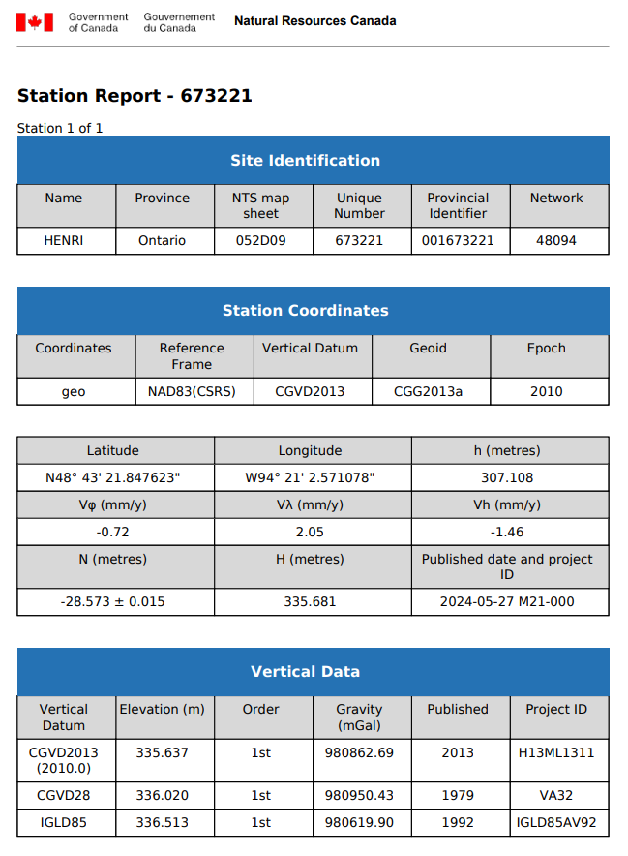

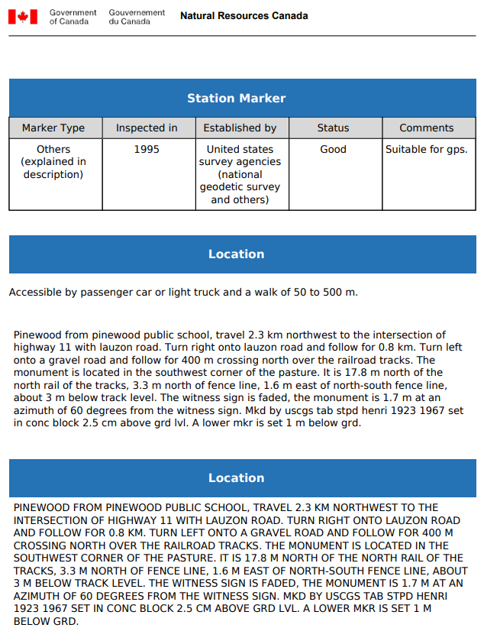

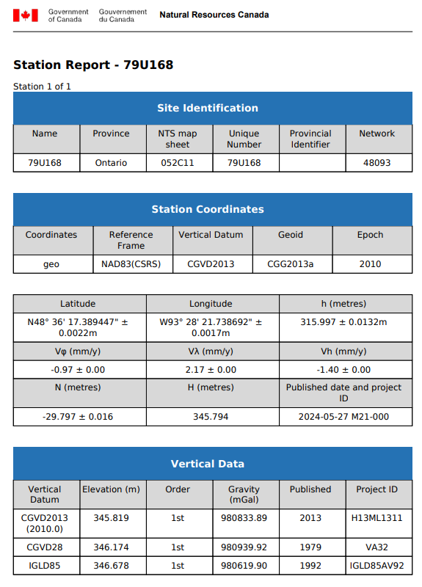
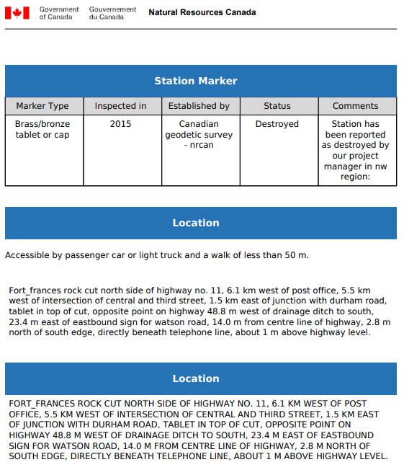
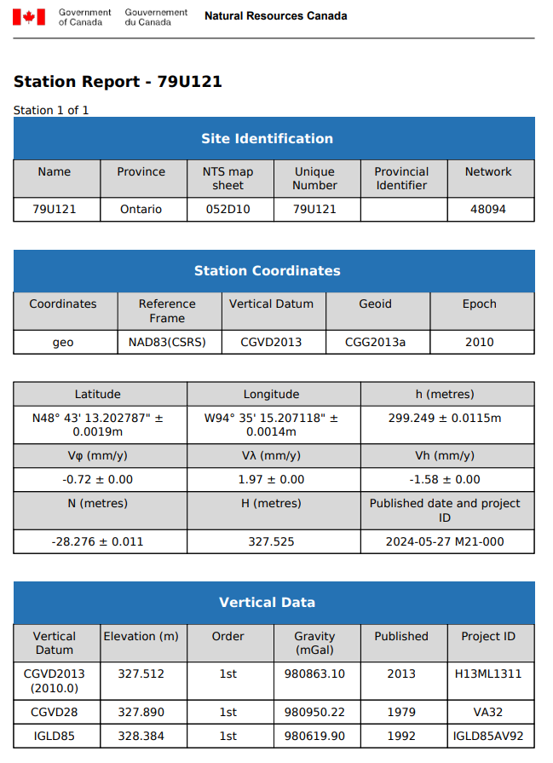

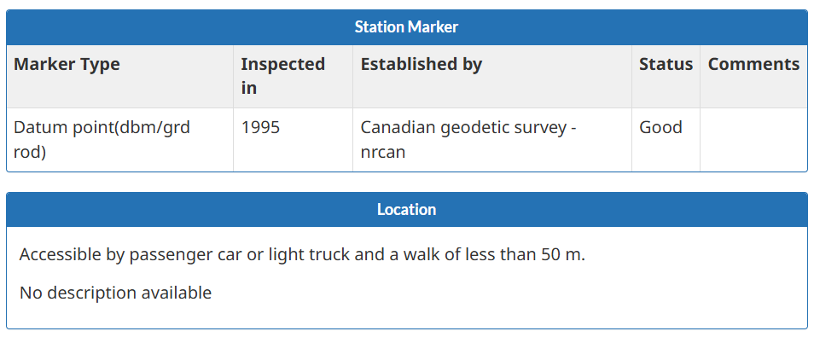
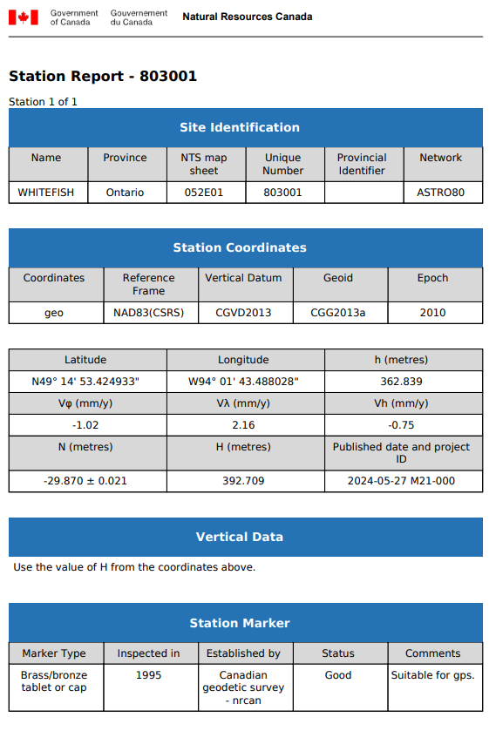
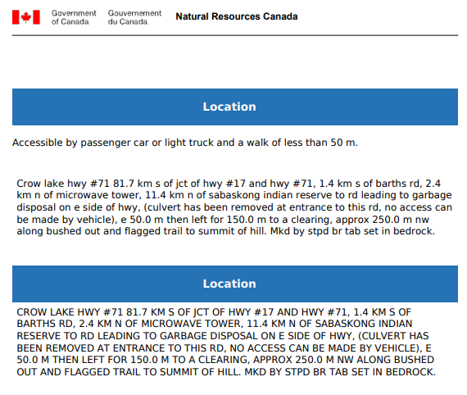

Appendix B – PPP Solutions
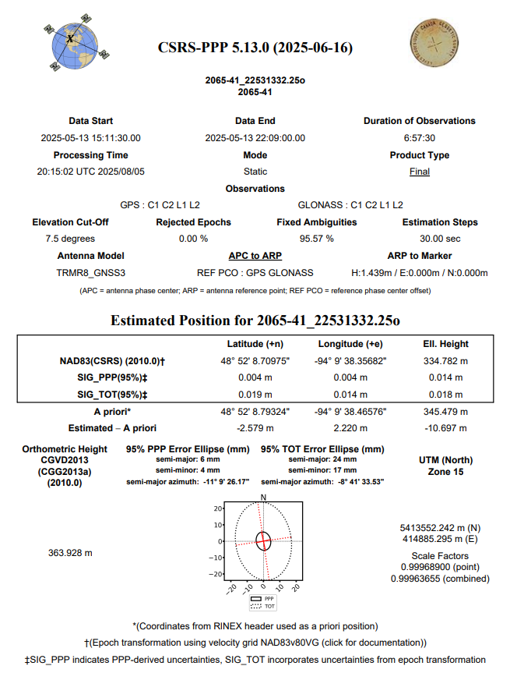
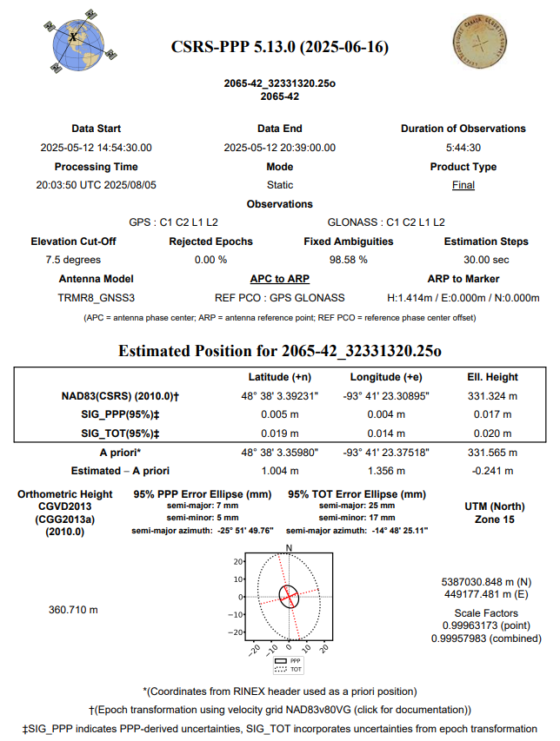
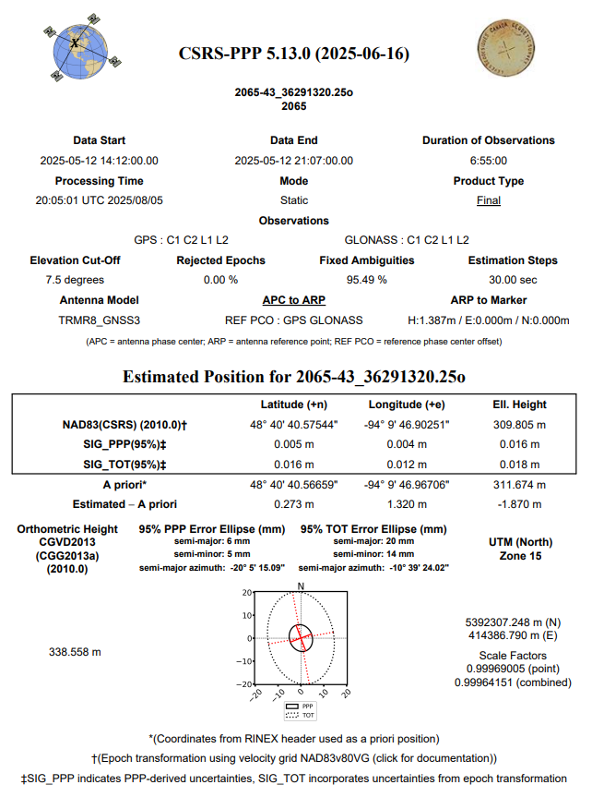

Appendix C - RTK Survey & Control Check
NVA Points
Point | Northing | Easting | Elevation |  | Point | Northing | Easting | Elevation
5101 | 5422132.208 | 387144.893 | 330.188 |  | 5134 | 5406660.852 | 432613.975 | 373.312
5102 | 5412513.456 | 385263.186 | 334.105 |  | 5135 | 5411684.529 | 432820.802 | 383.414
5103 | 5412653.345 | 379276.977 | 325.693 |  | 5136 | 5417840.295 | 431676.300 | 390.288
5104 | 5409381.087 | 377061.871 | 335.904 |  | 5137 | 5418251.691 | 439570.394 | 356.974
5105 | 5407734.345 | 377084.794 | 327.139 |  | 5138 | 5397153.482 | 422648.025 | 364.146
5106 | 5404473.858 | 376071.234 | 326.138 |  | 5139 | 5414669.525 | 437642.353 | 360.156
5107 | 5402789.677 | 378633.982 | 328.236 |  | 5140 | 5398617.632 | 435778.891 | 357.780
5108 | 5402695.767 | 383525.053 | 342.558 |  | 5141 | 5395270.272 | 432543.695 | 351.996
5109 | 5397713.753 | 383420.341 | 327.023 |  | 5142 | 5388851.264 | 427481.033 | 338.397
5110 | 5405895.089 | 385224.467 | 345.280 |  | 5143 | 5386383.442 | 438679.515 | 336.378
5111 | 5397714.287 | 386712.588 | 334.065 |  | 5144 | 5391974.478 | 440754.461 | 368.337
5112 | 5397648.474 | 389997.163 | 336.226 |  | 5145 | 5382172.932 | 440753.963 | 341.688
5113 | 5395922.498 | 394889.260 | 334.008 |  | 5146 | 5380487.525 | 445435.562 | 348.758
5114 | 5402449.084 | 394954.382 | 345.290 |  | 5147 | 5374567.371 | 442716.288 | 335.506
5115 | 5410587.578 | 396511.151 | 342.814 |  | 5148 | 5375702.494 | 453646.869 | 337.041
5116 | 5419261.424 | 398312.799 | 331.358 |  | 5149 | 5377125.271 | 452007.886 | 343.973
5117 | 5422957.869 | 398415.107 | 327.657 |  | 5150 | 5385525.116 | 450483.409 | 362.430
5118 | 5430449.907 | 397294.588 | 324.026 |  | 5151 | 5391898.113 | 450631.785 | 360.784
5119 | 5431712.465 | 405326.151 | 338.328 |  | 5152 | 5396702.971 | 452278.585 | 366.176
5120 | 5421890.908 | 405201.716 | 338.238 |  | 5153 | 5401713.184 | 450686.611 | 369.913
5121 | 5413668.811 | 405070.857 | 351.675 |  | 5154 | 5395147.120 | 445614.388 | 358.143
5122 | 5403876.847 | 408089.655 | 335.412 |  | 5155 | 5398564.292 | 442422.397 | 373.993
5123 | 5398973.380 | 404733.079 | 334.912 |  | 5156 | 5376980.527 | 461971.215 | 342.275
5124 | 5396262.981 | 404304.350 | 330.118 |  | 5157 | 5381997.048 | 461915.429 | 347.210
5125 | 5393809.127 | 407929.497 | 332.811 |  | 5158 | 5380338.718 | 465332.697 | 344.282
5126 | 5392396.715 | 409433.975 | 341.524 |  | 5159 | 5382042.144 | 453685.350 | 343.178
5127 | 5389075.694 | 414362.953 | 329.924 |  | 5160 | 5383694.667 | 468119.830 | 340.430
5128 | 5393109.716 | 414374.291 | 341.715 |  | 5161 | 5385058.660 | 472724.543 | 340.068
5129 | 5398961.932 | 412933.591 | 340.318 |  | 5162 | 5388574.592 | 467709.927 | 340.104
5130 | 5407108.829 | 413013.170 | 341.820 |  | 5163 | 5395056.833 | 457079.842 | 364.992
5131 | 5421767.013 | 415034.976 | 365.472 |  | 5164 | 5384320.174 | 461914.482 | 350.523
5132 | 5410251.159 | 419687.476 | 355.122 |  | 5165 | 5390187.272 | 460260.593 | 360.568
5133 | 5408506.634 | 427945.411 | 361.937

VVA Points
Point | Northing | Easting | Elevation |  | Point | Northing | Easting | Elevation
6101 | 5422151.728 | 387120.666 | 329.199 |  | 6134 | 5406671.600 | 432631.199 | 372.350
6102 | 5412493.914 | 385250.494 | 333.334 |  | 6135 | 5411667.558 | 432835.524 | 381.945
6103 | 5412656.684 | 379306.492 | 325.459 |  | 6136 | 5417832.228 | 431699.179 | 388.981
6104 | 5409358.773 | 377059.782 | 335.996 |  | 6137 | 5418260.915 | 439564.446 | 357.054
6105 | 5407721.989 | 377074.196 | 327.191 |  | 6138 | 5397168.696 | 422632.593 | 363.985
6106 | 5404455.790 | 376072.561 | 326.006 |  | 6139 | 5414684.882 | 437655.866 | 359.481
6107 | 5402767.989 | 378645.685 | 327.621 |  | 6140 | 5398591.328 | 435780.778 | 357.468
6108 | 5402686.354 | 383507.937 | 342.623 |  | 6141 | 5395259.535 | 432529.239 | 352.085
6109 | 5397738.064 | 383441.313 | 326.597 |  | 6142 | 5388864.844 | 427481.855 | 338.576
6110 | 5405898.070 | 385216.079 | 345.289 |  | 6143 | 5386348.757 | 438683.270 | 335.506
6111 | 5397696.607 | 386697.210 | 333.175 |  | 6144 | 5391956.327 | 440764.545 | 368.036
6112 | 5397596.255 | 389980.473 | 335.011 |  | 6145 | 5382157.416 | 440747.347 | 340.901
6113 | 5395899.183 | 394877.002 | 333.458 |  | 6146 | 5380496.436 | 445452.372 | 347.976
6114 | 5402453.747 | 394974.004 | 344.377 |  | 6147 | 5374542.024 | 442708.956 | 334.491
6115 | 5410566.938 | 396512.585 | 342.648 |  | 6148 | 5375715.018 | 453659.323 | 336.532
6117 | 5422946.351 | 398409.836 | 327.645 |  | 6150 | 5385537.290 | 450466.636 | 362.662
6118 | 5430426.781 | 397313.189 | 323.699 |  | 6151 | 5391885.439 | 450612.227 | 359.704
6119 | 5431721.836 | 405319.681 | 338.601 |  | 6152 | 5396688.865 | 452267.363 | 365.515
6120 | 5421876.545 | 405188.228 | 337.548 |  | 6153 | 5401729.357 | 450675.080 | 369.061
6121 | 5413664.107 | 405061.356 | 351.423 |  | 6154 | 5395141.707 | 445622.439 | 357.511
6122 | 5403854.599 | 408083.489 | 334.975 |  | 6155 | 5398572.360 | 442424.340 | 373.924
6123 | 5398962.652 | 404725.706 | 334.087 |  | 6156 | 5376993.713 | 461975.803 | 341.457
6124 | 5396248.909 | 404289.323 | 329.186 |  | 6157 | 5382004.551 | 461933.400 | 346.453
6125 | 5393808.712 | 407944.651 | 332.637 |  | 6158 | 5380352.197 | 465325.315 | 343.449
6126 | 5392417.263 | 409433.426 | 340.911 |  | 6159 | 5382030.997 | 453671.912 | 341.953
6127 | 5389062.717 | 414354.233 | 329.479 |  | 6160 | 5383689.529 | 468129.247 | 340.422
6128 | 5393092.030 | 414369.326 | 341.564 |  | 6161 | 5385057.639 | 472738.477 | 340.267
6129 | 5398952.201 | 412945.048 | 339.952 |  | 6162 | 5388562.283 | 467712.807 | 340.085
6130 | 5407105.699 | 413030.747 | 341.345 |  | 6163 | 5395071.480 | 457061.646 | 365.337
6131 | 5421769.865 | 415045.704 | 365.206 |  | 6164 | 5384308.693 | 461912.622 | 350.429
6132 | 5410263.485 | 419707.710 | 354.423 |  | 6165 | 5390201.462 | 460279.518 | 360.552
6133 | 5408534.942 | 427943.613 | 361.598

