Final Report
For project:
Sault Ste Marie LiDAR
Prepared for:
Ontario Ministry of Natural Resources
2nd floor, North Tower, 300 Water Street,
Peterborough, ON, K9J 3C7
Prepared by:

Airborne Imaging
2700 – 61 Avenue SE
Calgary, AB T2C 4V2
February 24, 2025

Contents
Introduction 1
Project Schedule & Personnel 1
LiDAR System & Flight Parameters 2
Project Control / Datum 4
Check Points 5
Trajectory Processing 6
LiDAR Data Processing 7
Calibration Procedures 7
Data Tiling and Classification 7
Point Cloud Manipulation 7
Water Classification & Hydro-Flattening 8
Class definitions 8
Deliverables 9
Vertical Accuracy Assessment 10
Conclusion 11
Appendix A - Control Points – Published Coordinates 12
Appendix B – RTK Survey & Control Check 14
Appendix C – Published Station Coordinate Sheets 22

Introduction
The Ontario Ministry of Natural Resources and Forests contracted Airborne Imaging to acquire and deliver digital elevation data derived from airborne LiDAR (Light Detection and Ranging) to cover various regions in Ontario.
This report covers the Sault Ste Marie area, collected over two seasons: the eastern portion during the spring of 2023 and the western portion during the spring of 2024. Poor weather in the fall of 2023 prevented us from collecting in this season. The report focuses on LiDAR acquisition details, such as flight parameters, project control, ground truthing results, data processing technique and deliverables.
The contracted area for the Sault Ste Marie area is 7,209 km².
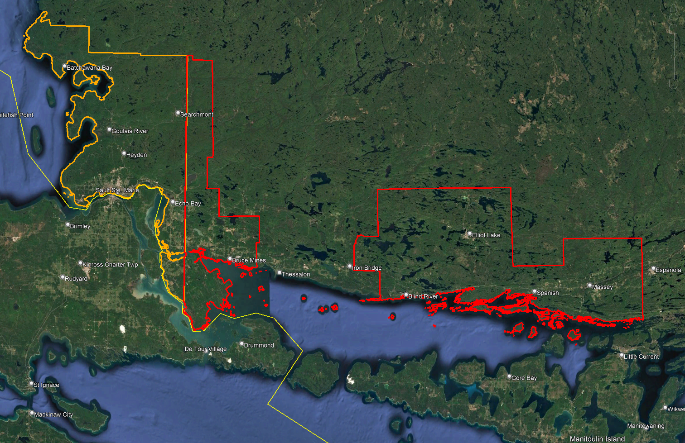
The orange portion on the west side is the area delivered in the UTM 16 projection. The red portion on the east side is the area delivered in the UTM 17 projection.

Project Schedule & Personnel
Ryan Gemmel collected some ground control during the spring of 2023 and Alistair Lornie collected more during the spring of 2024. The Lidar data was collected in thirteen missions, five during the spring of 2023 and eight during the spring of 2024. See table below for a list of missions.
A typical Lidar acquisition crew consisted of one Lidar Operator and one Pilot.

LiDAR System & Flight Parameters
Two Riegl VQ-1560ii-S were used to collect the Lidar data. The systems were installed in KASI Aviation’s Piper Navajo call signs C-GKSX and C-GMEC for the spring 2023 missions and in Revolution Flight’ Cessna Caravan call sign N108RF and N124RF for the Spring 2024 missions.
Below is a table of the lifts with their flight parameters.
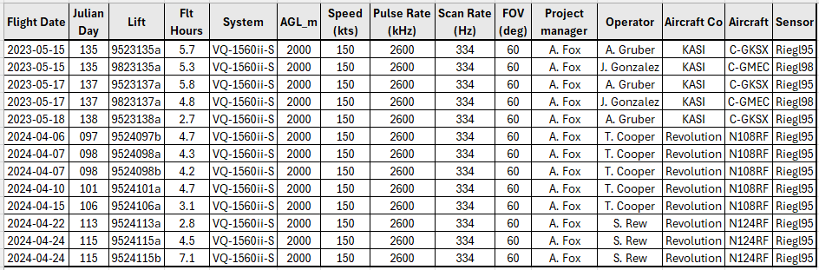
Table 1: Project Parameters for the Sault Ste Marie area.
Riegl VQ1560-ii-S | Flight plan
Altitude | 2000m AGL
Field of View (FOV) | 60°
Air Speed | 150 Kts
Pulse Rate | 2600 kHz
Sidelap | 20%
Point Density | > 8 pts/m²

The flight lines were designed optimally to maximize time online versus time in turn.

Below is a map of the flight lines including cross-ties.
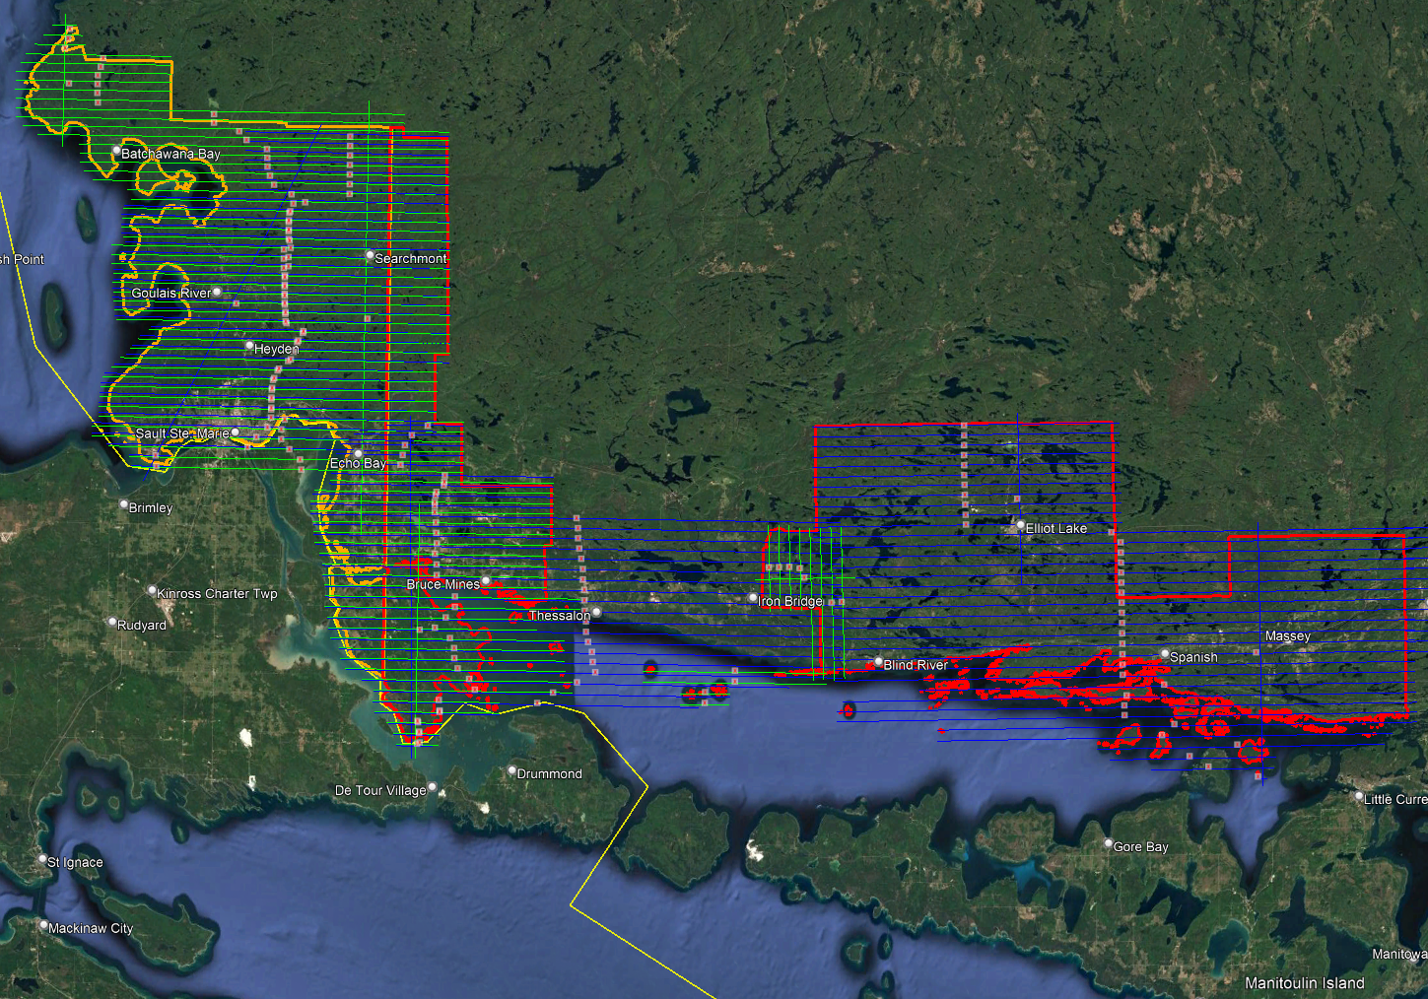
Only the eastern blue lines were flown in the spring of 2023. The western green lines were flown in the spring of 2024.

Below is a map of the flight line footprints colored by season of acquisition.
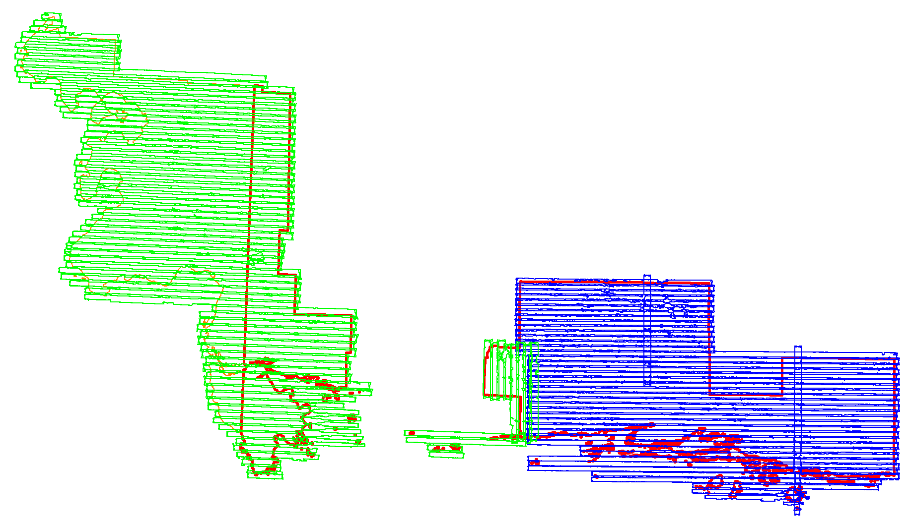
Spring 2023 (Blue)
Spring 2024 (Green)

Project Control / Datum
Several baselines were measured by GPS static occupation between Can-Net Continuously Operating Reference Stations (CORS), existing NRCan 3D Passive Control Monuments, and Ontario COSINE control points, as well as newly established points by Airborne Imaging. The existing control used for the Sault Ste. Marie area consisted of one Can-Net station, eight NRCan passive stations, and seven COSINE monuments.
Appendix A contains a list of Control Points and their published coordinates.
Appendix B shows the coordinate list of deliverable check points.
Appendix C shows the published station coordinate sheets.
The datum used for processing the Ground Control and all subsequent Lidar data are the Nad83 CSRS (epoch 2010.0) horizontal datum and the CGVD2013 vertical datum (CGG2013 undulation model).

Below is an overview map of the control stations.
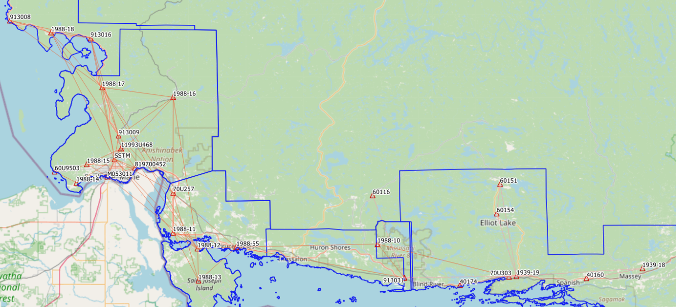
Figure 1 Sault Ste. Marie Control Network

Check Points
RTK GPS
In order to meet the recommended ASPRS minimum number of points for a 7738.3 square kilometer project, RTK points were surveyed in areas distributed throughout the project. A minimum of 103 NVA and 74 VVA points were required to meet ASPRS standards. Real Time Kinematic points are individual points surveyed on open terrain. Our surveyor collected GPS data mounted on a pole while receiving real time differential corrections from the GPS receiver positioned over a nearby control point.
278 points were surveyed on the Sault Ste. Marie project. Of these, 147 points were over non-vegetated ground conditions for NVA accuracy reporting and 131 of them were over vegetated areas for VVA accuracy reporting. Pictures of these RTK points (as well as the existing control) are provided with this report in the folder labeled “Pictures\SSM”. These points are used just for the vertical accuracy assessment of the Lidar point cloud and were not used to determine any vertical shift applied to the point cloud.
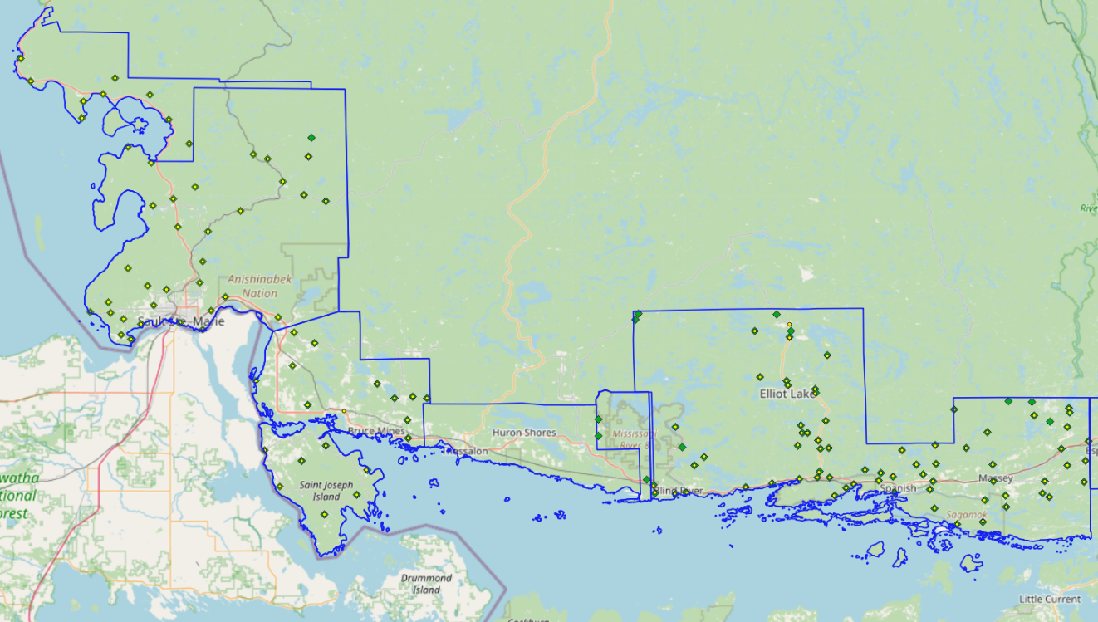
Figure 2 NVA (Yellow) and VVA (Green) Check Points

Trajectory Processing
The aircraft trajectory positioning for the missions over the Sault Ste Marie area were processed using the Precise Point Positioning (PPP) technique.
PPP is a positioning technique that removes and models GNSS system errors via precise satellite orbit data and clock corrections that are applied to the trajectory post mission, providing centimeter level positional accuracy without the use of ground base stations.
The TerraPOS software by Terratec was used to postprocess the PPP solutions to produce final kinematic trajectories accurate to 5 centimeters for each flight mission.
The horizontal datum used is Nad83 CSRS UTM zones 16 and 17 with the CGVD2013 vertical datum (CGG2013 undulation model).

LiDAR Data Processing

Calibration Procedures
After each mission, the field project manager creates the preliminary calibrated point cloud with each sensor’s set boresight values for each mission. Proprietary QC tools using the Lastools software are run on each mission to check for coverage, relative accuracy, point density, etc… If any data is found to be not meeting specifications, or coverage missing, the field crew is immediately notified and the areas affected reflown as soon as possible.
This preliminary calibrated point cloud is inspected in conjunction with the kinematic ground truth points to apply bulk shifts if necessary and further refine the calibration by applying corrections to the preliminary calibrated strips. The refined calibration is done using Bayesmap’s StripAlign software. Intensity values are also normalized by mission to be 16 bits (0 to 65535).

Data Tiling and Classification
The raw LiDAR data is processed into calibrated point cloud strips corresponding to flight lines. For ease of data manipulation, the strips are combined and saved in tiles of 1 km by 1 km. The format the strips and tiles are saved in is .Laz version 1.4. The tiling scheme is based on the UTM16 and 17 projections at the even kilometers.
The tiled point cloud is then processed with a series of algorithms to separate the “most-likely” ground returns from other returns. The point classification is done using a product by the TerraSolid software running on MicroStation Connect called TerraScan and TerraModeler.
In addition to our regular field QC and calibration procedures, we also generate various raster products using the Lastools software to assess coverage and calibration accuracy.

Point Cloud Manipulation
The TerraScan software uses macros that are set-up to measure the angles and distances between points to determine what classification a point should be: ground, vegetation, noise, other. The angle and distance values in the macros can be adjusted to be more or less aggressive with the classification of points by varying the incidence angles and estimated distances among neighboring points. The lower points are generally classified as ground returns, with the points above classified as undefined (class 1). Outliers and noise described in the table below are normally clouds, outliers or atmospheric noise in the data that are separated into above or below the ground level (high point or low points).
After the automated macro is run to determine classes, a systematic visual inspection is performed to fine tune the ground definition. To better understand areas for improvement for the ground surface, the points that are classified as ground are used to create viewable TINs and grid surfaces. These surfaces are inspected for areas that appear rough, artificially flattened or truncated, no data areas, or have other viewable errors.
In cleaning up ground points, the focus is concentrated in areas where few ground points have been left in the bare earth model and the ground appears rough or lower and flatter than it may be in reality. The scarcity of ground points may be a result from no penetration through a dense vegetation layer, water bodies, low reflectivity objects, or too aggressive values with the macro. A manual/visual inspection of these areas plays a major role in resolving any issues or irregularities with the bare earth model.
Once the first edits are completed, a one-meter grid of the ground surface is re-exported and hill shade images produced to QC the edited ground surface. This QC step is done iteratively as many times as necessary. Once the point cloud data has reached a satisfactory level of classification accuracy, the final deliverables are produced.

Water Classification & Hydro-Flattening
Once the ground class has reached the final level of classification accuracy, the water delineation process is initiated. The rivers and water bodies are digitized as break lines according to USGS specifications of a minimum of 8000 m² for water bodies and 30 m nominal width for streams and rivers. Ponds and lakes have their elevations set constant to just below ground. Stream and river hydro lines are collected using the downstream method. Once all hydro lines have been collected for an area, the ground points inside the hydro lines are classified to class 9 – Water. The ground points outside of the hydro lines but within 35 cm are classified to class 20 – Ignored ground (near breaklines). Using the TIN of class 2 (ground points), the hydro lines are used as constraints to generate the final 50 cm hydro-flattened DEMs in ESRI Ascii format, then converted to 32bit GeoTIFF format with the Global Mapper software.

Class definitions
The classification follows the ASPRS classification codes. The table below shows the classes for the delivered point cloud.

Table 2: ASPRS Point Classes
Classification Value | Description
1 | Unclassified
2 | Ground
6 | Building
7 | Low Points
9 | Water
17 | Bridge Decks
18 | High Points
20 | Ignored Ground (breakline proximity)
21 | Snow
22 | Temporal exclusion

Deliverables
Since the project was collected over two seasons, multiple deliverables were made as the data was ready. The eastern portion of the Sault Ste Marie area was collected in the spring of 2023 and delivered in October 2023. The western portion was collected in the spring of 2024 and delivered in October 2024.
See below for a table of the folder structure and description of each deliverable.
DIFF
50cm rasters of flight lines differences, 1 X 1 km tiles in 32bit GeoTIFF format
e.g. 1km174370512902023LSAULTSTEMARIE_diff.tif
DTM
Hydro-flattened 50cm Bare Earth DEMs, 1 X 1 km tiles in 32bit GeoTIFF format
e.g. 1km174370512902023LSAULTSTEMARIE.tif
METADATA
Metadata files for Breaklines, DEM, LAS and Project in .XML format
e.g. SAULTSTEMARIE2024_z16_Lidar_metadata_LAS.xml
POINTCLOUD
Point cloud data, 1 X 1 km tiles in .LAZ format 1.4
e.g. 1km174370512902023LSAULTSTEMARIE.laz
PROJECT_POLYGON
Shape files of: Lift_metadata, Hydro_breaklines, Project_extent & Tile_index
e.g. Mission_9523135a.shp

Vertical Accuracy Assessment

Non-Vegetated Vertical Accuracy (NVA)
Below is a summary of the statistics between the point cloud TIN from the ground class and the NVA points surveyed on flat hard surfaces:
Number of points: | 145
Average dz: | -0.002 | m
Minimum dz: | -0.102 | m
Maximum dz: | +0.074 | m
Average magnitude: | 0.024 | m
Root mean square: | 0.029 | m
Std deviation: | 0.029 | m
NVA Vertical Accuracy (95%): | 0.057 | m

For a complete listing of the RTK points and their differences, please refer to the provided spreadsheet named "SaultSteMarie_2023_2024_UTM16_UTM17_NVA_Final.xlsx".
As seen in the NVA comparison above, the accuracy observed of 0.057 m meets the project requirement of QL0 NVA vertical accuracy of 9.8 cm (95%).

Vegetated Vertical Accuracy (VVA)
The elevations of the points surveyed in various vegetated land cover types were compared to the Lidar ground surface. Since the elevation differences for this type of accuracy does not follow a normal distribution, the percentile method is used and not the 95% confidence level. For the 130 VVA points surveyed, sorting the absolute differences from the smallest to the largest gives the accuracy at the 95th percentile (using the linear interpolation between closest ranks method). For this sample, the 123rd and 124th largest differences are respectively 8.7 and 9.5 cm.
For this project, the VVA accuracy is therefore 9.14 cm.
This meets the required specifications of 15.0 cm (the QL0 VVA specification).
For a complete listing of the kinematic points and their differences, please refer to the provided spreadsheet named "SaultSteMarie_2023_2024_UTM16_UTM17_VVA_Final.xlsx".

Conclusion
This is the final report covering the Sault Ste Marie Lidar project. Topics such as field operations, control, data processing and final accuracy results were explained. Both the non-vegetated and vegetated vertical accuracies meet the QL0 requirement.

Appendix A - Control Points – Published Coordinates
Sault Ste. Marie - Control Station Coordinates
Station | Easting | Northing | h | H (CGVD2013) | Status | Comments
60U9503 | 225268.930 | 5158923.035 | 148.034 | 184.039 | Published | NRCan 3D Passive Monument
70U257 | 264434.372 | 5150241.338 | 151.427 | 187.709 | Published | NRCan 3D Passive Monument
70U303 | 376146.246 | 5118724.221 | 146.363 | 182.807 | Published | NRCan 3D Passive Monument
913008 | 212731.622 | 5209992.167 | 165.319 | 201.268 | Published | NRCan 3D Passive Monument
913009 | 247077.598 | 5169987.451 | 292.663 | 328.823 | Published | NRCan 3D Passive Monument
913016 | 239160.030 | 5202898.889 | 155.168 | 191.209 | Published | NRCan 3D Passive Monument
913031 | 341014.219 | 5119131.189 | 150.355 | 187.060 | Published | NRCan 3D Passive Monument
M053011 | 242729.168 | 5156515.632 | 148.027 | 184.188 | Published | NRCan 3D Passive Monument
SSTM | 245435.302 | 5162236.920 | 213.523 | 249.706 | Published | Can-Net CORS Station
0011993U468 | 247712.125 | 5165761.704 | 271.745 | 307.930 | Published | Ontario COSINE Monument
00819700452 | 252063.601 | 5159091.134 | 153.297 | 189.569 | Published | Ontario COSINE Monument
00820140160 | 402272.879 | 5117650.275 | 187.475 | 223.787 | Published | Ontario COSINE Monument
00820140174 | 359612.070 | 5116195.892 | 162.914 | 199.527 | Published | Ontario COSINE Monument
00820160116 | 331167.539 | 5147050.792 | 270.771 | 307.026 | Published | Ontario COSINE Monument
00820160151 | 373831.693 | 5149807.244 | 336.927 | 372.559 | Published | Ontario COSINE Monument
00820160154 | 372526.339 | 5139975.268 | 263.744 | 299.575 | Published | Ontario COSINE Monument
1939-18 | 421064.185 | 5120709.694 | 157.704 | 193.879 | Temporary | Airborne Intermediate Control
1939-19 | 378770.910 | 5118851.728 | 162.161 | 198.587 | Temporary | Airborne Intermediate Control
1988-10 | 332326.025 | 5130734.564 | 176.163 | 212.744 | Temporary | Airborne Intermediate Control
1988-11 | 263939.945 | 5136816.885 | 171.942 | 208.133 | Temporary | Airborne Intermediate Control
1988-12 | 271990.281 | 5131095.493 | 145.735 | 181.973 | Temporary | Airborne Intermediate Control
1988-13 | 271868.392 | 5120342.826 | 292.111 | 328.290 | Temporary | Airborne Intermediate Control
1988-14 | 232309.655 | 5154868.874 | 160.324 | 196.365 | Temporary | Airborne Intermediate Control
1988-15 | 236138.217 | 5160899.821 | 193.126 | 229.194 | Temporary | Airborne Intermediate Control
1988-16 | 265744.940 | 5182123.618 | 195.680 | 231.820 | Temporary | Airborne Intermediate Control
1988-17 | 242262.082 | 5186390.255 | 207.752 | 243.858 | Temporary | Airborne Intermediate Control
1988-18 | 226230.015 | 5205313.195 | 178.951 | 214.953 | Temporary | Airborne Intermediate Control
1988-55 | 284995.304 | 5131140.824 | 141.345 | 177.740 | Temporary | Airborne Intermediate Control

Nad83(CSRS), epoch 2010
UTM Zone 17

Appendix B – RTK Survey & Control Check
Sault Ste. Marie – NVA Check Point List
UTM zone | Season of Collection | Station | Easting | Northing | H (CGV2013)
17 | Spring 2023 | 4001 | 436877.267 | 5125750.872 | 208.888
17 | Spring 2023 | 4002 | 430986.218 | 5124259.804 | 200.103
17 | Spring 2023 | 4003 | 432882.262 | 5131890.974 | 290.168
17 | Spring 2023 | 4004 | 432724.144 | 5132905.551 | 287.727
17 | Spring 2023 | 4005 | 424758.386 | 5134221.680 | 315.601
17 | Spring 2023 | 4006 | 419776.685 | 5134533.368 | 307.803
17 | Spring 2023 | 4007 | 428689.221 | 5130109.219 | 277.042
17 | Spring 2023 | 4008 | 436202.627 | 5121658.555 | 200.637
17 | Spring 2023 | 4009 | 432280.530 | 5120721.388 | 196.530
17 | Spring 2023 | 4010 | 435709.649 | 5117069.600 | 198.062
17 | Spring 2023 | 4011 | 427414.187 | 5117406.244 | 195.185
17 | Spring 2023 | 4012 | 428247.467 | 5113903.791 | 213.975
17 | Spring 2023 | 4013 | 426848.392 | 5114770.602 | 215.479
17 | Spring 2023 | 4014 | 418983.337 | 5111948.355 | 196.566
17 | Spring 2023 | 4015 | 418997.022 | 5114461.262 | 211.886
17 | Spring 2023 | 4016 | 416403.203 | 5117545.429 | 187.415
17 | Spring 2023 | 4017 | 416272.520 | 5120992.162 | 213.845
17 | Spring 2023 | 4018 | 410623.809 | 5124702.462 | 255.341
17 | Spring 2023 | 4019 | 415207.561 | 5127955.097 | 277.067
17 | Spring 2023 | 4020 | 408277.376 | 5132949.310 | 302.954
17 | Spring 2023 | 4021 | 404075.924 | 5125320.447 | 275.999
17 | Spring 2023 | 4022 | 404171.396 | 5121313.128 | 241.754
17 | Spring 2023 | 4023 | 403527.899 | 5117629.080 | 216.584
17 | Spring 2023 | 4024 | 414485.181 | 5113555.775 | 182.159
17 | Spring 2023 | 4025 | 413971.709 | 5108920.229 | 246.963
17 | Spring 2023 | 4026 | 408433.237 | 5108422.775 | 181.346
17 | Spring 2023 | 4027 | 403749.331 | 5111898.947 | 200.103
17 | Spring 2023 | 4028 | 402782.797 | 5116005.573 | 184.121
17 | Spring 2023 | 4029 | 401400.744 | 5119152.941 | 218.361
17 | Spring 2023 | 4030 | 399963.840 | 5121252.952 | 225.241
17 | Spring 2023 | 4031 | 396943.412 | 5124425.883 | 245.604
17 | Spring 2023 | 4032 | 394955.858 | 5118868.471 | 214.326
17 | Spring 2023 | 4033 | 395205.764 | 5115437.079 | 177.492
17 | Spring 2023 | 4034 | 386557.045 | 5117291.035 | 180.306
17 | Spring 2023 | 4035 | 384953.608 | 5116576.351 | 186.616
17 | Spring 2023 | 4036 | 391793.092 | 5118003.214 | 217.858
17 | Spring 2023 | 4037 | 392334.486 | 5119638.976 | 187.923
17 | Spring 2023 | 4038 | 389025.836 | 5120276.988 | 229.034
17 | Spring 2023 | 4039 | 374892.055 | 5118736.765 | 181.412
17 | Spring 2023 | 4040 | 382372.007 | 5114944.211 | 185.462
17 | Spring 2023 | 4041 | 381353.667 | 5118932.238 | 192.302
17 | Spring 2023 | 4042 | 379257.377 | 5120184.893 | 237.688
17 | Spring 2023 | 4043 | 379555.379 | 5125045.477 | 264.968
17 | Spring 2023 | 4044 | 381326.379 | 5125143.952 | 268.455
17 | Spring 2023 | 4045 | 379093.431 | 5126800.748 | 274.496
17 | Spring 2023 | 4046 | 369051.177 | 5117920.271 | 197.314
17 | Spring 2023 | 4047 | 375716.308 | 5128451.386 | 257.705
17 | Spring 2023 | 4048 | 375486.284 | 5130145.093 | 288.615
17 | Spring 2023 | 4049 | 374727.609 | 5125729.147 | 251.977
17 | Spring 2023 | 4050 | 380764.925 | 5130881.928 | 299.388
17 | Spring 2023 | 4051 | 378800.200 | 5118894.511 | 199.085
17 | Spring 2023 | 4052 | 378738.413 | 5137668.021 | 338.888
17 | Spring 2023 | 4053 | 378803.954 | 5136914.538 | 357.712
17 | Spring 2023 | 4054 | 372623.535 | 5139614.429 | 301.042
17 | Spring 2023 | 4055 | 373495.769 | 5148817.994 | 361.256
17 | Spring 2023 | 4056 | 381383.364 | 5144815.269 | 360.273
17 | Spring 2023 | 4057 | 366175.466 | 5150377.041 | 378.205
17 | Spring 2023 | 4058 | 373823.715 | 5150187.178 | 359.948
17 | Spring 2023 | 4059 | 370891.465 | 5153680.442 | 408.695
17 | Spring 2023 | 4060 | 340813.250 | 5153331.191 | 252.048
17 | Spring 2023 | 4061 | 340862.303 | 5153309.790 | 252.196
17 | Spring 2023 | 4062 | 341489.042 | 5154534.159 | 254.780
17 | Spring 2023 | 4063 | 348724.099 | 5130423.805 | 239.574
17 | Spring 2023 | 4064 | 350124.168 | 5126028.482 | 182.788
17 | Spring 2023 | 4065 | 354761.484 | 5123867.119 | 233.511
17 | Spring 2023 | 4066 | 352619.196 | 5122094.174 | 205.730
17 | Spring 2023 | 4067 | 363441.340 | 5117124.508 | 189.463
17 | Spring 2023 | 4068 | 348324.025 | 5116151.989 | 182.409
17 | Spring 2023 | 4070 | 344067.531 | 5116414.333 | 178.905
17 | Spring 2023 | 4105 | 432388.032 | 5128902.909 | 250.960
17 | Spring 2023 | 4106 | 425238.511 | 5131349.236 | 274.251
17 | Spring 2023 | 4145 | 379084.980 | 5126803.445 | 274.208
17 | Spring 2023 | 4146 | 376914.543 | 5128471.347 | 258.991
17 | Spring 2023 | 4154 | 372957.718 | 5138668.753 | 302.978
17 | Spring 2023 | 4162 | 366961.756 | 5140565.472 | 317.338
17 | Spring 2023 | 4168 | 350741.282 | 5116347.259 | 192.454
17 | Spring 2024 | 2001 | 343771.408 | 5118049.812 | 180.440
17 | Spring 2024 | 2002 | 342280.117 | 5119239.960 | 181.163
17 | Spring 2024 | 2003 | 332280.803 | 5128950.801 | 220.835
17 | Spring 2024 | 2006 | 296023.629 | 5137984.937 | 232.957
17 | Spring 2024 | 2007 | 291681.335 | 5133480.740 | 220.477
17 | Spring 2024 | 2008 | 289030.431 | 5138268.581 | 195.072
17 | Spring 2024 | 2015 | 285429.249 | 5141419.805 | 205.795
17 | Spring 2024 | 2022 | 272437.127 | 5150613.123 | 210.070
17 | Spring 2024 | 2071 | 276029.901 | 5180553.461 | 367.121
17 | Spring 2024 | 2073 | 272697.777 | 5190040.531 | 269.149
17 | Spring 2024 | 2075 | 273467.325 | 5194010.777 | 288.642
17 | Spring 2024 | 2080 | 270564.101 | 5137471.833 | 191.244
17 | Spring 2024 | 2083 | 274046.886 | 5128662.823 | 214.647
17 | Spring 2024 | 2084 | 268789.418 | 5125696.524 | 217.096
17 | Spring 2024 | 2091 | 282642.779 | 5123187.204 | 185.085
17 | Spring 2024 | 2092 | 280223.772 | 5117960.189 | 210.322
17 | Spring 2024 | 2094 | 273207.127 | 5114029.034 | 205.347
17 | Spring 2024 | 2095 | 332366.112 | 5132345.762 | 189.494
17 | Spring 2024 | 2112 | 271377.698 | 5181883.680 | 323.107
17 | Spring 2024 | 2500 | 292897.058 | 5138408.712 | 249.115
17 | Spring 2024 | 2501 | 291671.489 | 5129650.813 | 198.245
16 | Spring 2024 | 2018 | 720853.648 | 5142341.144 | 184.266
16 | Spring 2024 | 2020 | 728522.042 | 5145818.534 | 179.326
16 | Spring 2024 | 2023 | 728688.684 | 5152866.621 | 211.000
16 | Spring 2024 | 2027 | 725252.416 | 5155846.679 | 190.271
16 | Spring 2024 | 2028 | 704365.076 | 5154106.127 | 178.165
16 | Spring 2024 | 2029 | 710840.129 | 5156781.494 | 189.987
16 | Spring 2024 | 2030 | 709258.370 | 5152872.585 | 182.071
16 | Spring 2024 | 2033 | 708307.969 | 5162726.629 | 287.507
16 | Spring 2024 | 2035 | 701202.756 | 5161008.047 | 273.802
16 | Spring 2024 | 2038 | 698558.168 | 5157549.258 | 210.886
16 | Spring 2024 | 2040 | 685235.340 | 5155651.312 | 185.217
16 | Spring 2024 | 2041 | 689509.814 | 5155640.143 | 208.479
16 | Spring 2024 | 2042 | 691953.317 | 5151088.531 | 187.847
16 | Spring 2024 | 2043 | 692349.000 | 5154483.132 | 200.530
16 | Spring 2024 | 2046 | 708771.481 | 5167225.219 | 321.190
16 | Spring 2024 | 2047 | 709538.573 | 5173504.984 | 330.599
16 | Spring 2024 | 2050 | 703102.847 | 5174336.233 | 203.300
16 | Spring 2024 | 2053 | 700462.222 | 5196874.493 | 189.720
16 | Spring 2024 | 2055 | 713750.988 | 5159896.262 | 190.143
16 | Spring 2024 | 2057 | 696432.924 | 5201919.199 | 222.166
16 | Spring 2024 | 2058 | 686473.402 | 5201801.406 | 185.018
16 | Spring 2024 | 2060 | 671063.673 | 5204084.025 | 187.808
16 | Spring 2024 | 2064 | 668919.809 | 5208678.307 | 196.927
16 | Spring 2024 | 2067 | 716353.090 | 5178199.901 | 333.217
16 | Spring 2024 | 2072 | 725125.261 | 5184678.616 | 237.510
16 | Spring 2024 | 2074 | 721717.063 | 5189342.160 | 288.801
16 | Spring 2024 | 2076 | 718563.654 | 5190204.283 | 326.414
16 | Spring 2024 | 2077 | 702008.662 | 5180158.632 | 223.340
16 | Spring 2024 | 2084 | 731315.441 | 5125700.493 | 217.096
16 | Spring 2024 | 2086 | 722616.544 | 5132103.612 | 180.144
16 | Spring 2024 | 2087 | 723326.446 | 5127558.446 | 180.285
16 | Spring 2024 | 2088 | 726835.839 | 5120064.731 | 184.277
16 | Spring 2024 | 2099 | 692058.169 | 5190890.596 | 188.065
16 | Spring 2024 | 2100 | 697172.728 | 5187738.184 | 184.427
16 | Spring 2024 | 2101 | 696099.695 | 5153459.493 | 184.005
16 | Spring 2024 | 2102 | 694116.617 | 5150135.453 | 185.412
16 | Spring 2024 | 2104 | 697153.119 | 5161606.282 | 336.320
16 | Spring 2024 | 2105 | 692943.014 | 5165109.850 | 333.935
16 | Spring 2024 | 2107 | 688908.245 | 5157850.999 | 301.491
16 | Spring 2024 | 2109 | 700754.971 | 5175847.229 | 193.693
16 | Spring 2024 | 2110 | 697828.553 | 5178607.239 | 186.746
16 | Spring 2024 | 2111 | 694622.639 | 5181352.087 | 192.999
16 | Spring 2024 | 2112 | 729630.579 | 5181922.169 | 323.107
16 | Spring 2024 | 2113 | 706510.877 | 5182861.894 | 275.628
16 | Spring 2024 | 2114 | 705045.445 | 5191898.024 | 334.303
16 | Spring 2024 | 2115 | 688852.168 | 5205189.845 | 238.277
16 | Spring 2024 | 2116 | 680062.109 | 5205204.955 | 257.778
16 | Spring 2024 | 2119 | 682109.879 | 5196515.867 | 196.379
16 | Spring 2024 | 2121 | 682450.213 | 5200160.231 | 185.505
16 | Spring 2024 | 2555 | 706851.063 | 5159401.173 | 227.381

Sault Ste. Marie – VVA Check Point List
UTM zone | Season | Station | Easting | Northing | Known Z
17 | Spring 2023 | 5001 | 436889.310 | 5125766.845 | 206.761
17 | Spring 2023 | 5002 | 430980.116 | 5124308.528 | 200.568
17 | Spring 2023 | 5003 | 432884.160 | 5131897.322 | 289.867
17 | Spring 2023 | 5004 | 432730.573 | 5132900.020 | 287.530
17 | Spring 2023 | 5005 | 432398.827 | 5128902.099 | 250.326
17 | Spring 2023 | 5006 | 425229.366 | 5131354.781 | 274.150
17 | Spring 2023 | 5008 | 436194.730 | 5121670.474 | 200.362
17 | Spring 2023 | 5009 | 432274.217 | 5120743.662 | 196.232
17 | Spring 2023 | 5010 | 435721.284 | 5117060.416 | 197.979
17 | Spring 2023 | 5011 | 427423.244 | 5117428.619 | 194.629
17 | Spring 2023 | 5012 | 428248.241 | 5113895.110 | 213.851
17 | Spring 2023 | 5013 | 426847.935 | 5114746.414 | 216.457
17 | Spring 2023 | 5014 | 418992.429 | 5111953.172 | 196.702
17 | Spring 2023 | 5015 | 419007.096 | 5114438.708 | 211.485
17 | Spring 2023 | 5016 | 416388.195 | 5117493.392 | 187.047
17 | Spring 2023 | 5017 | 416251.316 | 5120985.705 | 213.805
17 | Spring 2023 | 5018 | 410620.400 | 5124717.281 | 255.229
17 | Spring 2023 | 5019 | 415221.350 | 5127950.706 | 276.822
17 | Spring 2023 | 5020 | 408257.412 | 5132924.217 | 302.700
17 | Spring 2023 | 5021 | 404063.930 | 5125310.706 | 275.742
17 | Spring 2023 | 5022 | 404162.843 | 5121331.030 | 241.804
17 | Spring 2023 | 5023 | 403552.917 | 5117629.635 | 216.939
17 | Spring 2023 | 5024 | 414423.403 | 5113460.980 | 182.537
17 | Spring 2023 | 5025 | 414004.486 | 5108941.530 | 246.428
17 | Spring 2023 | 5026 | 408435.327 | 5108413.616 | 181.147
17 | Spring 2023 | 5027 | 403757.381 | 5111895.804 | 199.847
17 | Spring 2023 | 5028 | 402766.386 | 5116000.203 | 184.205
17 | Spring 2023 | 5029 | 401387.993 | 5119152.376 | 217.771
17 | Spring 2023 | 5030 | 399947.059 | 5121255.312 | 225.457
17 | Spring 2023 | 5031 | 396947.829 | 5124453.602 | 246.443
17 | Spring 2023 | 5032 | 394949.397 | 5118895.649 | 214.070
17 | Spring 2023 | 5033 | 395182.690 | 5115388.552 | 177.269
17 | Spring 2023 | 5034 | 386571.828 | 5117287.974 | 179.925
17 | Spring 2023 | 5035 | 384934.657 | 5116587.570 | 186.744
17 | Spring 2023 | 5036 | 391788.572 | 5117970.299 | 216.920
17 | Spring 2023 | 5037 | 392343.839 | 5119638.515 | 188.005
17 | Spring 2023 | 5038 | 389013.140 | 5120292.875 | 230.703
17 | Spring 2023 | 5039 | 374902.119 | 5118741.495 | 181.375
17 | Spring 2023 | 5040 | 382366.892 | 5114953.680 | 185.072
17 | Spring 2023 | 5041 | 381373.521 | 5118859.051 | 192.359
17 | Spring 2023 | 5042 | 379234.651 | 5120117.042 | 237.140
17 | Spring 2023 | 5043 | 379571.982 | 5125068.729 | 265.192
17 | Spring 2023 | 5044 | 381360.547 | 5125134.084 | 267.594
17 | Spring 2023 | 5045 | 379117.973 | 5126804.586 | 273.551
17 | Spring 2023 | 5046 | 369009.698 | 5118005.321 | 195.119
17 | Spring 2023 | 5047 | 375691.506 | 5128471.404 | 256.876
17 | Spring 2023 | 5048 | 375498.247 | 5130156.406 | 289.206
17 | Spring 2023 | 5049 | 374745.004 | 5125854.159 | 257.385
17 | Spring 2023 | 5050 | 380767.564 | 5130890.448 | 299.129
17 | Spring 2023 | 5051 | 378783.417 | 5118910.376 | 198.784
17 | Spring 2023 | 5052 | 378757.015 | 5137668.038 | 338.494
17 | Spring 2023 | 5053 | 378641.054 | 5136752.333 | 352.704
17 | Spring 2023 | 5054 | 372618.692 | 5139618.436 | 300.952
17 | Spring 2023 | 5055 | 373419.474 | 5148657.616 | 369.158
17 | Spring 2023 | 5056 | 381396.927 | 5144808.429 | 360.459
17 | Spring 2023 | 5057 | 366150.668 | 5150388.473 | 378.646
17 | Spring 2023 | 5058 | 373520.700 | 5151673.889 | 349.533
17 | Spring 2023 | 5063 | 348711.461 | 5130429.658 | 240.421
17 | Spring 2023 | 5065 | 354755.378 | 5123893.442 | 233.249
17 | Spring 2023 | 5066 | 352616.864 | 5122081.140 | 205.800
17 | Spring 2023 | 5067 | 363411.710 | 5117128.076 | 188.652
17 | Spring 2023 | 5068 | 348314.555 | 5116117.562 | 182.221
17 | Spring 2023 | 5070 | 344092.278 | 5116424.128 | 178.643
17 | Spring 2023 | 5146 | 376912.264 | 5128524.447 | 261.364
17 | Spring 2023 | 5154 | 372941.972 | 5138674.142 | 302.640
17 | Spring 2023 | 5162 | 366967.292 | 5140570.532 | 317.242
17 | Spring 2023 | 5168 | 350751.518 | 5116329.340 | 192.382
17 | Spring 2024 | 3001 | 343772.827 | 5118040.575 | 180.078
17 | Spring 2024 | 3006 | 296014.547 | 5137977.715 | 232.859
17 | Spring 2024 | 3007 | 291663.097 | 5133496.760 | 221.969
17 | Spring 2024 | 3008 | 289022.348 | 5138260.247 | 195.272
17 | Spring 2024 | 3009 | 278135.017 | 5135916.459 | 180.802
17 | Spring 2024 | 3012 | 278121.504 | 5135910.557 | 179.965
17 | Spring 2024 | 3015 | 285404.761 | 5141465.613 | 205.834
17 | Spring 2024 | 3022 | 272423.469 | 5150602.077 | 208.047
17 | Spring 2024 | 3071 | 276047.241 | 5180555.802 | 365.499
17 | Spring 2024 | 3073 | 272685.744 | 5190062.391 | 269.239
17 | Spring 2024 | 3080 | 270573.425 | 5137471.620 | 191.165
17 | Spring 2024 | 3083 | 274038.885 | 5128670.149 | 213.406
17 | Spring 2024 | 3084 | 268796.985 | 5125713.344 | 216.847
17 | Spring 2024 | 3091 | 282631.738 | 5123192.419 | 184.980
17 | Spring 2024 | 3092 | 280227.220 | 5118027.911 | 209.131
17 | Spring 2024 | 3094 | 273209.523 | 5114038.829 | 205.297
17 | Spring 2024 | 3112 | 271382.706 | 5181909.773 | 323.320
17 | Spring 2024 | 3500 | 292891.671 | 5138417.058 | 248.113
17 | Spring 2024 | 3501 | 291678.121 | 5129620.182 | 197.020
16 | Spring 2024 | 3018 | 720851.465 | 5142349.332 | 184.027
16 | Spring 2024 | 3020 | 728531.863 | 5145825.059 | 178.949
16 | Spring 2024 | 3023 | 728693.788 | 5152875.490 | 210.895
16 | Spring 2024 | 3027 | 725245.620 | 5155868.531 | 189.691
16 | Spring 2024 | 3028 | 704371.265 | 5154103.546 | 178.246
16 | Spring 2024 | 3029 | 710835.471 | 5156775.345 | 190.299
16 | Spring 2024 | 3030 | 709268.888 | 5152865.368 | 181.881
16 | Spring 2024 | 3033 | 708307.742 | 5162716.079 | 287.216
16 | Spring 2024 | 3035 | 701192.417 | 5160990.780 | 273.868
16 | Spring 2024 | 3038 | 698578.892 | 5157554.674 | 210.989
16 | Spring 2024 | 3040 | 685238.509 | 5155665.595 | 185.549
16 | Spring 2024 | 3041 | 689515.716 | 5155657.780 | 208.321
16 | Spring 2024 | 3042 | 691964.234 | 5151095.607 | 187.560
16 | Spring 2024 | 3043 | 692336.319 | 5154473.430 | 200.313
16 | Spring 2024 | 3046 | 708769.164 | 5167233.955 | 320.829
16 | Spring 2024 | 3047 | 709555.234 | 5173522.822 | 330.342
16 | Spring 2024 | 3050 | 703108.863 | 5174354.163 | 202.439
16 | Spring 2024 | 3053 | 700452.397 | 5196852.696 | 189.491
16 | Spring 2024 | 3055 | 713756.713 | 5159883.114 | 189.764
16 | Spring 2024 | 3057 | 696426.715 | 5201906.001 | 220.679
16 | Spring 2024 | 3058 | 686476.750 | 5201781.100 | 185.103
16 | Spring 2024 | 3060 | 671081.289 | 5204078.227 | 186.816
16 | Spring 2024 | 3064 | 668912.312 | 5208661.139 | 196.695
16 | Spring 2024 | 3067 | 716334.771 | 5178191.897 | 333.123
16 | Spring 2024 | 3072 | 725124.796 | 5184707.231 | 236.998
16 | Spring 2024 | 3074 | 721716.459 | 5189352.293 | 288.575
16 | Spring 2024 | 3076 | 718558.779 | 5190206.694 | 326.589
16 | Spring 2024 | 3077 | 702001.344 | 5180153.716 | 223.576
16 | Spring 2024 | 3084 | 731321.714 | 5125717.837 | 216.847
16 | Spring 2024 | 3087 | 723340.354 | 5127541.055 | 179.380
16 | Spring 2024 | 3088 | 726856.070 | 5120067.961 | 183.796
16 | Spring 2024 | 3099 | 692061.432 | 5190885.323 | 187.789
16 | Spring 2024 | 3100 | 697173.201 | 5187750.765 | 184.240
16 | Spring 2024 | 3101 | 696090.074 | 5153456.510 | 183.675
16 | Spring 2024 | 3102 | 694093.533 | 5150135.032 | 185.184
16 | Spring 2024 | 3104 | 697162.371 | 5161610.149 | 336.461
16 | Spring 2024 | 3105 | 692924.094 | 5165134.518 | 333.363
16 | Spring 2024 | 3107 | 688916.298 | 5157848.146 | 300.605
16 | Spring 2024 | 3110 | 697809.655 | 5178575.589 | 186.619
16 | Spring 2024 | 3112 | 729633.584 | 5181948.568 | 323.320
16 | Spring 2024 | 3113 | 706527.852 | 5182863.392 | 273.671
16 | Spring 2024 | 3114 | 705044.768 | 5191904.602 | 333.993
16 | Spring 2024 | 3115 | 688869.556 | 5205207.921 | 238.417
16 | Spring 2024 | 3119 | 682119.162 | 5196515.782 | 196.271
16 | Spring 2024 | 3120 | 682457.885 | 5200153.180 | 184.766

Appendix C – Published Station Coordinate Sheets
