Final Report
For project:
Sudbury LiDAR
Prepared for:
Ontario Ministry of Natural Resources
2nd floor, North Tower, 300 Water Street,
Peterborough, ON, K9J 3C7
Prepared by:

Airborne Imaging
2700 – 61 Avenue SE
Calgary, AB T2C 4V2
February 24, 2025

Contents
Contents 2
Introduction 1
Project Schedule & Personnel 1
LiDAR System & Flight Parameters 2
Project Control / Datum 4
Check Points 5
Trajectory Processing 6
LiDAR Data Processing 7
Calibration Procedures 7
Data Tiling and Classification 7
Point Cloud Manipulation 8
Water Classification & Hydro-Flattening 8
Class definitions 9
Deliverables 10
Vertical Accuracy Assessment 10
Conclusion 11
Appendix A - Control Points – Published Coordinates 12
Appendix B – RTK Survey & Control Check 13
Appendix C – Published Station Coordinate Sheets 18

Introduction
The Ontario Ministry of Natural Resources and Forests contracted Airborne Imaging to acquire and deliver digital elevation data derived from airborne LiDAR (Light Detection and Ranging) to cover various regions in Ontario.
This report covers the Sudbury area, collected over two seasons: the majority during the spring of 2023 and two flight lines in the spring of 2024. Poor weather in the fall of 2023 prevented us from collecting the two flight lines not originally acquired. The report focuses on LiDAR acquisition details, such as flight parameters, project control, ground truthing results, data processing technique and deliverables.
The contracted area for the Sudbury area is 5,067 km².
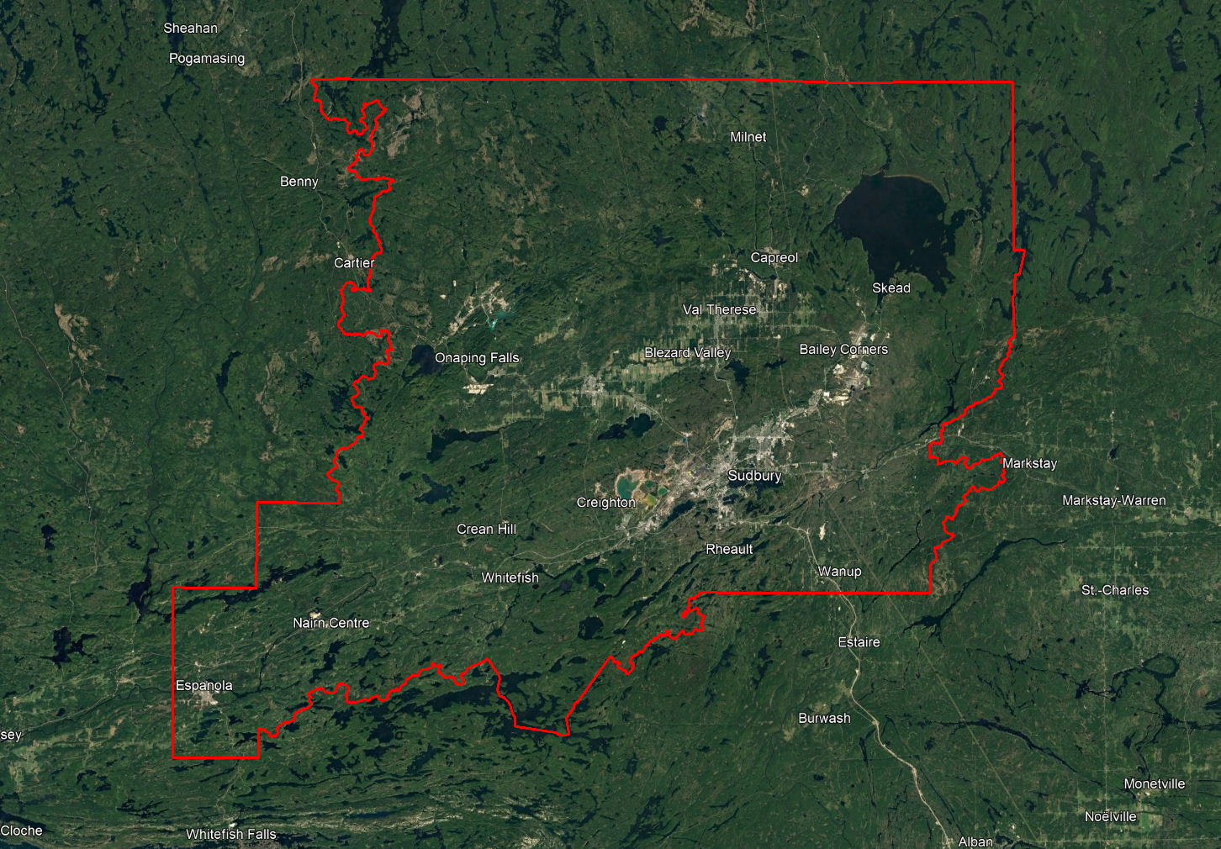

Project Schedule & Personnel
The ground control occurred during the spring of 2023. The surveyor collecting ground truth points during this period was Ryan Gemmel. The Lidar data was collected in six missions, five during the spring of 2023 and one during the spring of 2024. See table below for a list of missions.

A typical Lidar acquisition crew consisted of one Lidar Operator and one Pilot.

LiDAR System & Flight Parameters
Either a Riegl VQ-1560ii or VQ-1560ii-S was used to collect the Lidar data. The systems were installed in KASI Aviation’s Piper Navajo call signs C-GKSX and C-KMEC, and Revolution Flight’s Cessna Caravan call sign N331RF.
Below is a table of the lifts with their flight parameters.
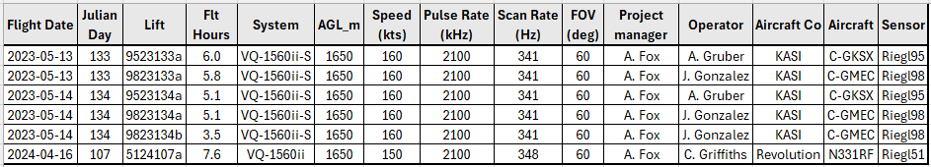
Table 1: Project Parameters for the Sudbury area.
 | Flight plan
Altitude | 1600m AGL
Field of View (FOV) | 60°
Air Speed | 150 or 160 Kts
Pulse Rate | 2100 kHz
Sidelap | 20%
Point Density | > 8 pts/m²

The flight lines were designed optimally to maximize time online versus time in turn.

Below is a map of the flight lines including cross-ties.
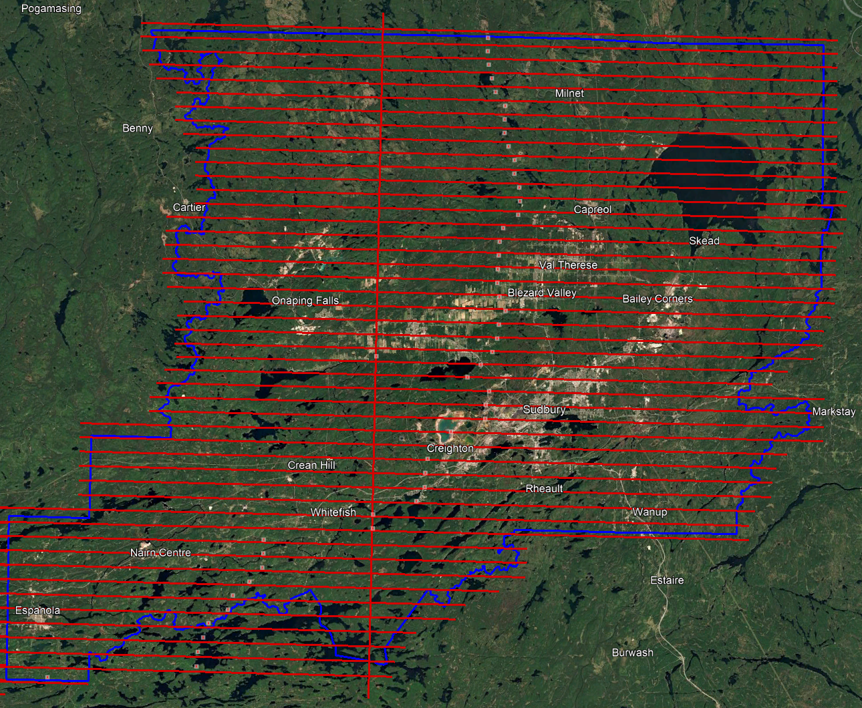

Below is a map of the flight line footprints colored by season of acquisition.
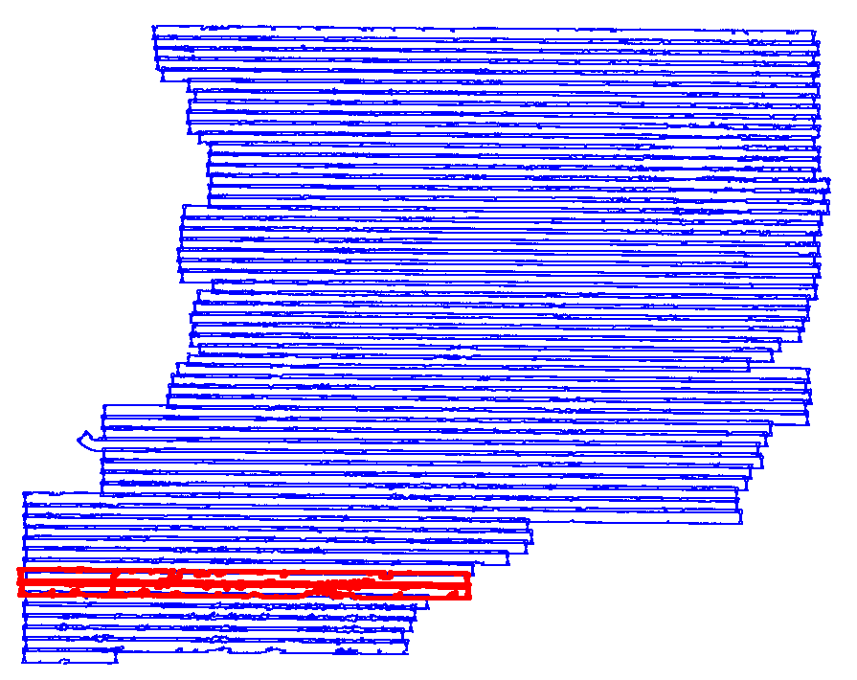
Spring 2023 (BLUE)
Spring 2024 (RED)

Project Control / Datum
Several baselines were measured by GPS static occupation between NRCan-Approved TopNet Continuously Operating Stations (CORS), existing NRCan 3D Passive Control Monuments, and Ontario COSINE control points, as well as newly established points by Airborne Imaging. The existing control used consisted of one TopNet station, four NRCan passive monument, and six Cosine point.
Appendix A contains a list of Control Points and their published coordinates.
Appendix B shows the coordinate list of deliverable check points.
Appendix C shows the published station coordinate sheets.
The datum used for processing the Ground Control and all subsequent Lidar data are based on the Nad83 CSRS (epoch 2010.0) horizontal datum and the CGVD2013 vertical datum (CGG2013 undulation model).
Below is an overview map of the control stations.
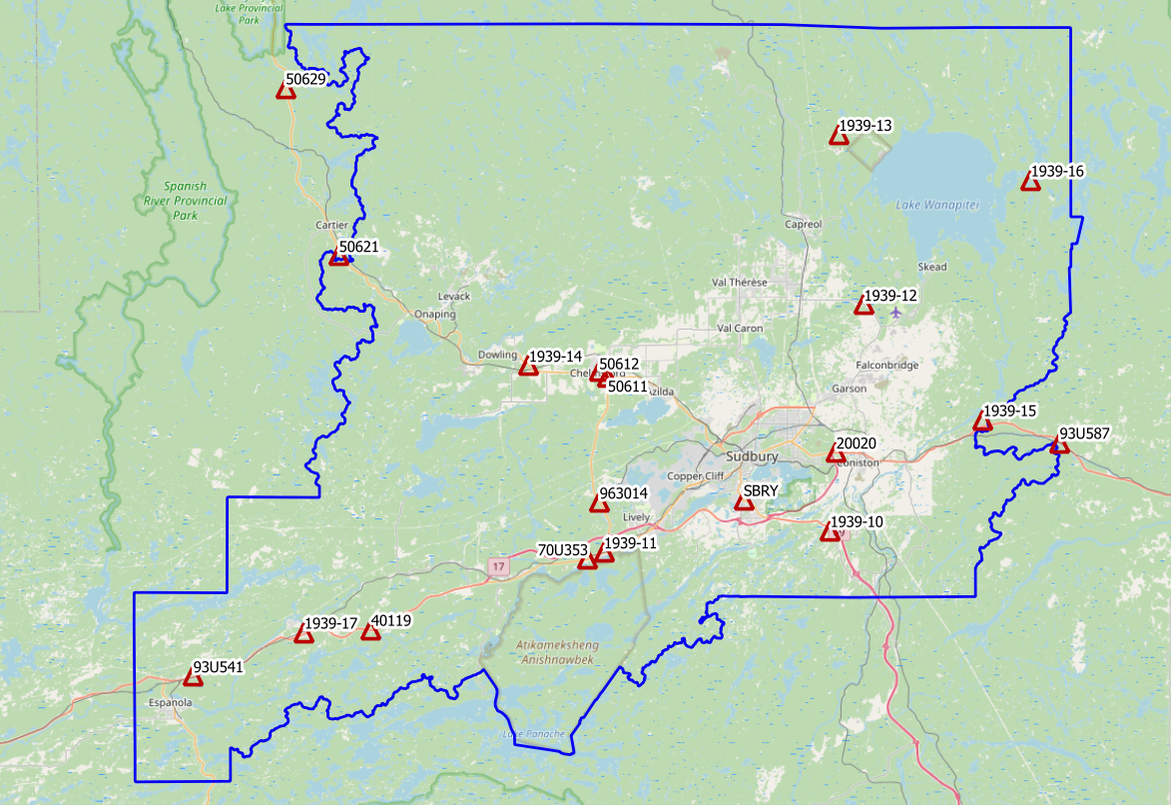
Figure 1 Control Points for MNRF Sudbury

Check Points
RTK GPS
In order to meet the recommended ASPRS minimum number of points for a 5067 square kilometer project, RTK points were surveyed in areas distributed throughout the project. A minimum of 70 NVA and 55 VVA points were required to meet ASPRS standards. Real Time Kinematic points are individual points surveyed on open terrain. Our surveyor collected GPS data mounted on a pole while receiving real time differential corrections from the GPS receiver positioned over a nearby control point.

166 points were surveyed on the Sudbury project. Of these, 83 points were over non-vegetated ground conditions for NVA accuracy reporting and 83 of them were over vegetated areas for VVA accuracy reporting. Pictures of these RTK points (as well as the existing control) are provided with this report in a folder called “Sudbury_Control_Point_Pictures”. These points are used just for the vertical accuracy assessment of the Lidar point cloud and were not used to determine any vertical shift applied to the point cloud.

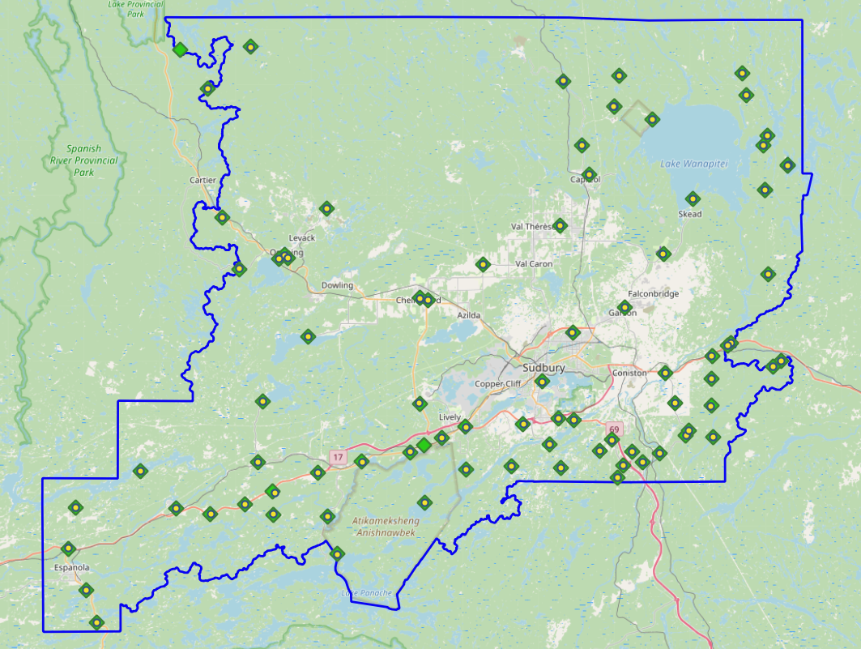
Trajectory Processing
Figure 2 NVA (Yellow) and VVA (Green) Check Points
The aircraft trajectory positioning for the missions over the Sudbury area were processed using the Precise Point Positioning (PPP) technique.
PPP is a positioning technique that removes and models GNSS system errors via precise satellite orbit data and clock corrections that are applied to the trajectory post mission, providing centimeter level positional accuracy without the use of ground base stations.
The TerraPOS software by Terratec was used to postprocess the PPP solutions to produce final kinematic trajectories accurate to 5 centimeters for each flight mission.
The horizontal datum used is Nad83 CSRS UTM zone 17 with the CGVD2013 vertical datum (CGG2013 undulation model).

LiDAR Data Processing

Calibration Procedures
After each mission, the field project manager creates the preliminary calibrated point cloud with each sensor’s set boresight values for each mission. Proprietary QC tools using the Lastools software are run on each mission to check for coverage, relative accuracy, point density, etc… If any data is found to be not meeting specifications, or coverage missing, the field crew is immediately notified and the areas affected reflown as soon as possible.
This preliminary calibrated point cloud is inspected in conjunction with the kinematic ground truth points to apply bulk shifts if necessary and further refine the calibration by applying corrections to the preliminary calibrated strips. The refined calibration is done using Bayesmap’s StripAlign software. Intensity values are also normalized by mission to be 16 bits (0 to 65535).

Data Tiling and Classification
The raw LiDAR data is processed into calibrated point cloud strips corresponding to flight lines. For ease of data manipulation, the strips are combined and saved in tiles of 1 km by 1 km. The format the strips and tiles are saved in is .Laz version 1.4. The tiling scheme is based on the UTM17 projection at the even kilometers.
The tiled point cloud is then processed with a series of algorithms to separate the “most-likely” ground returns from other returns. The point classification is done using a product by the TerraSolid software running on MicroStation Connect called TerraScan and TerraModeler.
In addition to our regular field QC and calibration procedures, we also generate various raster products using the Lastools software to assess coverage and calibration accuracy.

Point Cloud Manipulation
The TerraScan software uses macros that are set-up to measure the angles and distances between points to determine what classification a point should be: ground, vegetation, noise, other. The angle and distance values in the macros can be adjusted to be more or less aggressive with the classification of points by varying the incidence angles and estimated distances among neighboring points. The lower points are generally classified as ground returns, with the points above classified as undefined (class 1). Outliers and noise described in the table below are normally clouds, outliers or atmospheric noise in the data that are separated into above or below the ground level (high point or low points).
After the automated macro is run to determine classes, a systematic visual inspection is performed to fine tune the ground definition. To better understand areas for improvement for the ground surface, the points that are classified as ground are used to create viewable TINs and grid surfaces. These surfaces are inspected for areas that appear rough, artificially flattened or truncated, no data areas, or have other viewable errors.
In cleaning up ground points, the focus is concentrated in areas where few ground points have been left in the bare earth model and the ground appears rough or lower and flatter than it may be in reality. The scarcity of ground points may be a result from no penetration through a dense vegetation layer, water bodies, low reflectivity objects, or too aggressive values with the macro. A manual/visual inspection of these areas plays a major role in resolving any issues or irregularities with the bare earth model.
Once the first edits are completed, a one-meter grid of the ground surface is re-exported and hill shade images produced to QC the edited ground surface. This QC step is done iteratively as many times as necessary. Once the point cloud data has reached a satisfactory level of classification accuracy, the final deliverables are produced.

Water Classification & Hydro-Flattening
Once the ground class has reached the final level of classification accuracy, the water delineation process is initiated. The rivers and water bodies are digitized as break lines according to USGS specifications of a minimum of 8000 m² for water bodies and 30 m nominal width for streams and rivers. Ponds and lakes have their elevations set constant to just below ground. Stream and river hydro lines are collected using the downstream method. Once all hydro lines have been collected for an area, the ground points inside the hydro lines are classified to class 9 – Water. The ground points outside of the hydro lines but within 35 cm are classified to class 20 – Ignored ground (near breaklines). Using the TIN of class 2 (ground points), the hydro lines are used as constraints to generate the final 50 cm hydro-flattened DEMs in ESRI Ascii format, then converted to 32bit Geotiff format with the Global Mapper software.

Class definitions
The classification follows the ASPRS classification codes. The table below shows the classes for the delivered point cloud.

Table 2: ASPRS Point Classes
Classification Value | Description
1 | Unclassified
2 | Ground
6 | Building
7 | Low Points
9 | Water
17 | Bridge Decks
18 | High Points
20 | Ignored Ground (breakline proximity)
21 | Snow
22 | Temporal exclusion

Deliverables
Since the project was collected over two seasons, multiple deliverables were made as the data was ready. The majority of the Sudbury area was collected in the spring of 2023 and delivered in October 2023. The areas over the two missing flight lines were collected in the spring of 2024 and delivered in October 2024.
See below for a table of the folder structure and description of each deliverables.
DIFF
50cm rasters of flight lines differences, 1 X 1 km tiles in 32bit Geotiff format
e.g. 1km175110518802023LSUDBURY_diff.tif
DTM
Hydro-flattened 50cm Bare Earth DEMs, 1 X 1 km tiles in 32bit Geotiff format
e.g. 1km175110518802023LSUDBURY.tif
METADATA
Metadata files for Breaklines, DEM, LAS and Project in .XML format
e.g. SUDBURY2023_Lidar_metadata_LAS.xml
POINTCLOUD
Point cloud data, 1 X 1 km tiles in .LAZ format 1.4
e.g. 1km175110518802023LSUDBURY.laz
PROJECT_POLYGON
Shape files of: Lift_metadata, Hydro_breaklines, Project_extent & Tile_index
e.g. Mission_9523133a.shp

Vertical Accuracy Assessment
Non Vegetated Vertical Accuracy (NVA)
Below is a summary of the statistics between the point cloud TIN from the ground class and the NVA points surveyed on flat hard surfaces:
Number of points: | 83
Average dz: | 0.000 | m
Minimum dz: | -0.133 | m
Maximum dz: | +0.129 | m
Average magnitude: | 0.034 | m
Root mean square: | 0.046 | m
Std deviation: | 0.046 | m
NVA Vertical Accuracy (95%): | 0.090 | m

For a complete listing of the RTK points and their differences, please refer to the provided spreadsheet named "Sudbury_NVA_Accuracy_Final.xlsx".
As seen in the NVA comparison above, the accuracy observed of 0.090 m meets the project requirement of QL0 NVA vertical accuracy of 9.8 cm (95%).
Vegetated Vertical Accuracy (VVA)
The elevations of the points surveyed in various vegetated land cover types were compared to the Lidar ground surface. Since the elevation differences for this type of accuracy does not follow a normal distribution, the percentile method is used and not the 95% confidence level. For the 83 VVA points surveyed, sorting the absolute differences from the smallest to the largest gives the accuracy at the 95th percentile (using the linear interpolation between closest ranks method). For this sample, the 78th and 79th largest difference are respectively 10.7 and 11.0 cm.
For this project, the VVA accuracy is therefore 10.97 cm.
This is below the required specifications of 15.0 cm (the QL0 VVA specification).
For a complete listing of the kinematic points and their differences, please refer to the provided spreadsheet named "Sudbury_VVA_Accuracy_Final.xlsx ".

Conclusion
This is the final report covering the Sudbury Lidar project. Topics such as field operations, control, data processing and final accuracy results were explained. The acquisition for this leaf off, snow off project was acquired over two seasons due to two problematic flight lines that required reflights. A short weather window in the fall of 2023 prevented us to collect data for this area. Both the vegetated and non-vegetated vertical accuracies meet the QL0 requirement.

Appendix A - Control Points – Published Coordinates
Station | Easting | Northing | h | H (CGVD2013) | Status | Comments
1939-10 | 508764.986 | 5141084.384 | 225.831 | 261.340 | Temporary | Airborne Intermediate Control
1939-11 | 485479.699 | 5138905.383 | 211.456 | 247.097 | Temporary | Airborne Intermediate Control
1939-12 | 512198.437 | 5164241.033 | 266.971 | 302.284 | Temporary | Airborne Intermediate Control
1939-13 | 509596.708 | 5181585.819 | 289.236 | 324.514 | Temporary | Airborne Intermediate Control
1939-14 | 477817.666 | 5158045.405 | 239.975 | 275.492 | Temporary | Airborne Intermediate Control
1939-15 | 524471.472 | 5152492.598 | 250.280 | 285.542 | Temporary | Airborne Intermediate Control
1939-16 | 529243.900 | 5176999.417 | 251.745 | 286.954 | Temporary | Airborne Intermediate Control
1939-17 | 454572.851 | 5130820.449 | 181.904 | 217.842 | Temporary | Airborne Intermediate Control
20020 | 509381.177 | 5149120.394 | 221.399 | 256.823 | Published | COSINE Ontario ‘00820120200’
40119 | 461459.782 | 5131061.149 | 196.355 | 232.273 | Published | COSINE Ontario ‘00820140119’
50611 | 485913.5 | 5156801.08 | 234.6 | 270.074 | Published | COSINE Ontario ‘00820150611’
50612 | 485026.15 | 5157494.08 | 234.65 | 270.12 | Published | COSINE Ontario ‘00820150612’
50621 | 458413.49 | 5169368.4 | 387.12 | 422.75 | Published | COSINE Ontario ‘00820150621’
50629 | 453082.87 | 5186491.68 | 362.32 | 397.856 | Published | COSINE Ontario ‘00820150629’
70U353 | 483817.83 | 5138202.49 | 205.75 | 241.406 | Published | NRCan 3D Passive Monument
93U541 | 443083.33 | 5126426.09 | 171.87 | 207.892 | Published | NRCan 3D Passive Monument
93U587 | 532335.84 | 5150211.68 | 191.43 | 226.623 | Published | NRCan 3D Passive Monument
963014 | 485045.24 | 5144010.79 | 279.27 | 314.814 | Published | NRCan 3D Passive Monument
SBRY | 499862.98 | 5144257.9 | 243.04 | 278.565 | Non-Compliant | TopNet CORS station
SUDBURY - Control Station Coordinates

Appendix B – RTK Survey & Control Check
Point | Easting | Northing | Ellips | H (CGVD2013) | Julian day | Comment
1939-12 | 512198.437 | 5164241.033 | 266.971 | 302.283 | 148 | Aii Control - Base
2070 | 504373.384 | 5153137.325 | 241.802 | 277.207 | 148 | Paint line
3070 | 504398.757 | 5153176.185 | 243.166 | 278.571 | 148 | Short grass
2069 | 510939.972 | 5156364.993 | 265.765 | 301.116 | 148 | Paint line
3069 | 510965.532 | 5156354.337 | 266.94 | 302.291 | 148 | Short grass
3068 | 515840.265 | 5163066.667 | 309.992 | 345.281 | 148 | Short grass
2068 | 515802.853 | 5163088.645 | 310.472 | 345.761 | 148 | Paint line
2067 | 519532.76 | 5169992.333 | 232.686 | 267.984 | 148 | Hard surface
3067 | 519512.695 | 5169980.772 | 232.97 | 268.267 | 148 | Short grass
2006 | 529152.101 | 5160542.089 | 227.521 | 262.738 | 148 | Hard surface
3006 | 529144.038 | 5160545.983 | 227.6 | 262.817 | 148 | Low brush
3005 | 528689.506 | 5171156.32 | 238.221 | 273.447 | 148 | Low brush
2005 | 528678.081 | 5171144.355 | 238.529 | 273.756 | 148 | Hard surface
2060 | 502731.407 | 5166634.766 | 258.178 | 293.553 | 148 | Paint line - H Park
3060 | 502732.001 | 5166656.019 | 258.25 | 293.626 | 148 | Short grass
3061 | 506433.905 | 5173007.499 | 271.461 | 306.788 | 148 | Short grass
2061 | 506415.556 | 5173035.682 | 272.28 | 307.607 | 148 | Paved road
2062 | 505501.006 | 5176702.7 | 277.819 | 313.135 | 148 | Paved road
3062 | 505513.148 | 5176698.198 | 277.299 | 312.615 | 148 | Low brush
Point | Easting | Northing | Ellips | H (CGVD2013) | Julian day | Comment
1939-10 | 508764.986 | 5141084.384 | 225.831 | 261.34 | 149 | Aii Control - Base
3009 | 522034.949 | 5150221.716 | 224.952 | 260.247 | 149 | Short grass
2009 | 522020.099 | 5150230.562 | 225.421 | 260.716 | 149 | Paved road
2013 | 517355.73 | 5144304.141 | 220.416 | 255.787 | 149 | Hard surface
3013 | 517330.508 | 5144315.377 | 220.694 | 256.066 | 149 | Short grass - UC
2014 | 521932.972 | 5143879.507 | 204.294 | 239.617 | 149 | Hard surface
3014 | 521944.597 | 5143929.284 | 203.511 | 238.834 | 149 | Short grass
2012 | 516132.051 | 5148056.01 | 203.813 | 239.183 | 149 | Paint line
3012 | 516122.115 | 5148097.426 | 203.637 | 239.007 | 149 | Short grass
3011 | 521947.029 | 5147353.358 | 216.992 | 252.293 | 149 | Short grass
2011 | 521955.518 | 5147352.19 | 217.179 | 252.48 | 149 | Hard surface
2017 | 519086.066 | 5140766.503 | 202.956 | 238.335 | 149 | Hard surface
3017 | 519085.494 | 5140773.712 | 202.944 | 238.324 | 149 | Tall grass
2016 | 518820.644 | 5140143.276 | 201.584 | 236.972 | 149 | Hard surface
3016 | 518740.908 | 5140196.951 | 201.703 | 237.092 | 149 | Tall grass
3015 | 522189.637 | 5139983.426 | 189.666 | 225.025 | 149 | Short grass
2015 | 522181.878 | 5139987.073 | 190.044 | 225.403 | 149 | Hard surface
2018 | 515476.043 | 5137925.196 | 192.181 | 227.636 | 149 | Paint line
3018 | 515460.051 | 5137883.692 | 191.232 | 226.687 | 149 | Short grass
3020 | 513234.503 | 5136753.085 | 191.298 | 226.798 | 149 | Tall grass
2020 | 513251.951 | 5136761.358 | 191.272 | 226.77 | 149 | Paved road
2019 | 510840.56 | 5136396.627 | 209.512 | 245.051 | 149 | Hard surface
3019 | 510821.634 | 5136383.208 | 209.135 | 244.675 | 149 | Tall grass
3024 | 510095.122 | 5134867.898 | 193.604 | 229.177 | 149 | Short grass
2024 | 510104.727 | 5134866.499 | 193.523 | 229.095 | 149 | Hard surface
2022 | 509340.211 | 5139568.049 | 206.694 | 242.214 | 149 | Paint line
3022 | 509351.5 | 5139610.019 | 205.749 | 241.268 | 149 | Low brush
3023 | 507784.674 | 5138172.138 | 215.133 | 250.691 | 149 | Tall grass
2023 | 507785.867 | 5138181.897 | 215.724 | 251.282 | 149 | Hard surface
2025 | 504501.392 | 5142048.861 | 197.409 | 232.95 | 149 | Pavement
3025 | 504509.81 | 5142086.546 | 197.04 | 232.58 | 149 | Short grass
3026 | 502590.611 | 5142294.914 | 226.234 | 261.782 | 149 | Tall grass
2026 | 502597.875 | 5142306.202 | 227.243 | 262.792 | 149 | Parking lot
2027 | 501445.106 | 5139022.384 | 199.233 | 234.842 | 149 | Paved road
3027 | 501440.161 | 5139013.966 | 197.93 | 233.54 | 149 | Tall grass
3160 | 502883.634 | 5136031.244 | 226.507 | 262.157 | 149 | Tall grass
2160 | 502877.704 | 5136032.886 | 226.789 | 262.439 | 149 | Hard surface
Point | Easting | Northing | Ellips | H (CGVD2013) | Julian day | Comment
1939-11 | 485479.699 | 5138905.383 | 211.456 | 247.097 | 150 | Aii Control - Base
2051 | 484952.526 | 5144221.485 | 269.696 | 305.241 | 150 | Paint line
3051 | 484979.278 | 5144205.928 | 270.522 | 306.067 | 150 | Low brush - UC
1003 | 477808.005 | 5139177.632 | 246.178 | 281.844 | 150 | Cosine 70686
2039 | 472063.885 | 5135538.521 | 222.929 | 258.687 | 150 | Parking lot
3039 | 472033.094 | 5135509.914 | 221.726 | 257.485 | 150 | Tall grass
2036 | 473258.334 | 5129996.245 | 204.748 | 240.654 | 150 | Paved road
3036 | 473265.183 | 5129988.766 | 204.561 | 240.467 | 150 | Tall grass
2035 | 474459.921 | 5125170.414 | 195.803 | 231.823 | 150 | Hard surface
3035 | 474455.909 | 5125209.781 | 199.051 | 235.07 | 150 | Short grass
3038 | 477632.923 | 5136880.74 | 201.383 | 237.098 | 150 | Short grass
2038 | 477660.398 | 5136851.082 | 200.78 | 236.496 | 150 | Paint line - H Park
2037 | 483795.429 | 5138084.884 | 204.075 | 239.741 | 150 | Hard surface
3037 | 483802.844 | 5138051.36 | 203.617 | 239.283 | 150 | Short grass
2034 | 485598.73 | 5131650.022 | 189.822 | 225.64 | 150 | Hard surface
3034 | 485581.748 | 5131653.978 | 189.527 | 225.344 | 150 | Tall grass - UC
3033 | 487751.764 | 5139837.005 | 209.272 | 244.893 | 150 | Tall grass
2033 | 487760.298 | 5139863.381 | 209.05 | 244.669 | 150 | Paint line
3031 | 490809.345 | 5141282.739 | 223.115 | 258.704 | 150 | Short grass
2031 | 490883.206 | 5141209.507 | 221.23 | 256.82 | 150 | Paved road
2032 | 490871.212 | 5135858.7 | 204.202 | 239.916 | 150 | Paved road
3032 | 490849.682 | 5135846.757 | 202.574 | 238.289 | 150 | Low brush
2029 | 496603.773 | 5136225.519 | 236.869 | 272.56 | 150 | Paved road
3029 | 496631.87 | 5136254.308 | 235.558 | 271.248 | 150 | Short grass
2030 | 498186.233 | 5141609.725 | 251.206 | 286.783 | 150 | Hard surface
3030 | 498113.882 | 5141571.204 | 244.022 | 279.6 | 150 | Short grass
2071 | 500547.173 | 5146941.003 | 226.372 | 261.86 | 150 | Hard surface
3071 | 500537.53 | 5146958.519 | 229.415 | 264.903 | 150 | Short grass
Point | Easting | Northing | Ellips | H (CGVD2013) | Julian day | Comment
1939-13 | 509596.708 | 5181585.819 | 289.236 | 324.514 | 151 | Aii Control - Base - Static
2001 | 525724.483 | 5185833.945 | 282.424 | 317.624 | 151 | Hard surface
3001 | 5257076.209 | 5185835.923 | 283.129 | 318.33 | 151 | Low grass
Point | Easting | Northing | Ellips | H (CGVD2013) | Julian day | Comment
1939-13 | 509596.708 | 5181585.819 | 289.236 | 324.514 | 152 | Aii Control - Base
2063 | 514455.09 | 5179960.671 | 236.727 | 272.017 | 152 | Paved road
3063 | 514378.654 | 5180006.226 | 236.817 | 272.107 | 152 | Low grass
2066 | 510213.864 | 5185472.505 | 317.028 | 352.308 | 152 | Hard surface
3066 | 510209.875 | 5185491.135 | 316.897 | 352.178 | 152 | Low grass
2065 | 503134.052 | 5184790.588 | 294.441 | 329.787 | 152 | Hard surface
3065 | 503148.86 | 5184790.06 | 294.667 | 330.013 | 152 | Low grass
2165 | 503145.069 | 5184802.949 | 294.888 | 330.234 | 152 | Paved road
2064 | 509589.899 | 5181575.453 | 290.106 | 325.383 | 152 | Paved road
2164 | 509550.56 | 5181590.654 | 291.042 | 326.32 | 152 | Hard surface
3064 | 509569.665 | 5181593.679 | 290.887 | 326.165 | 152 | Low brush
3164 | 509575.404 | 5181553.884 | 289.546 | 324.824 | 152 | Low brush
Point | Easting | Northing | Ellips | H (CGVD2013) | Julian day | Comment
1939-16 | 529243.9 | 5176999.417 | 251.745 | 286.955 | 156 | Aii Control - Base
2101 | 526210.318 | 5183084.683 | 253.146 | 288.359 | 156 | Hard surface
3101 | 526202.987 | 5183097.005 | 253.663 | 288.875 | 156 | Short grass - UC
2002 | 528872.287 | 5177978.411 | 236.383 | 271.594 | 156 | Hard surface
3002 | 528866.82 | 5177973.543 | 236.47 | 271.68 | 156 | Tall grass
2003 | 528426.071 | 5176800.122 | 237.405 | 272.624 | 156 | Hard surface
3003 | 528448.872 | 5176800.796 | 236.24 | 271.458 | 156 | Short grass
2105 | 528686.562 | 5171132.826 | 238.355 | 273.581 | 156 | Hard surface
3105 | 528689.535 | 5171156.319 | 238.099 | 273.326 | 156 | Low brush
3004 | 531456.366 | 5174201.959 | 241.791 | 276.985 | 156 | Short grass
2104 | 531439.821 | 5174209.611 | 241.666 | 276.86 | 156 | Hard surface
2004 | 531545.818 | 5174328.767 | 249.237 | 284.43 | 156 | Hard surface
3104 | 531524.055 | 5174354.179 | 249.154 | 284.348 | 156 | Short grass
Point | Easting | Northing | Ellips | H (CGVD2013) | Julian day | Comment
1939-15 | 524471.472 | 5152492.598 | 250.28 | 285.542 | 157 | Aii Control - Base
3007 | 524402.015 | 5151909.658 | 229.791 | 265.053 | 157 | Short grass
2007 | 524418.842 | 5151881.944 | 232.282 | 267.545 | 157 | Paint line
3010 | 530843.256 | 5149682.978 | 224.866 | 260.07 | 157 | Short grass
2010 | 530827.337 | 5149675.505 | 225.33 | 260.535 | 157 | Hard surface
3121 | 529782.033 | 5148906.077 | 235.367 | 270.586 | 157 | Short grass
2121 | 529753.34 | 5148950.944 | 234.542 | 269.76 | 157 | Hard surface
2008 | 523971.687 | 5151595.585 | 228.101 | 263.369 | 157 | Paved road
3008 | 523979.799 | 5151573.447 | 227.691 | 262.959 | 157 | Tall grass
2021 | 511889.831 | 5138062.784 | 209.498 | 245.002 | 157 | Paved road
3021 | 511901.653 | 5138065.084 | 208.744 | 244.247 | 157 | Low brush
Point | Easting | Northing | Ellips | H (CGVD2013) | Julian day | Comment
820150629 | 453082.867 | 5186491.677 | 362.32 | 397.856 | 159 | Cosine BM - Base
2054 | 460095.061 | 5167818.506 | 381.579 | 417.189 | 159 | Paved road
3054 | 460119.399 | 5167814.836 | 381.607 | 417.218 | 159 | Short grass
2173 | 458379.025 | 5183957.762 | 395.988 | 431.537 | 159 | Hard surface
3173 | 458428.727 | 5183995.426 | 396.838 | 432.387 | 159 | Short grass
3072 | 454919.444 | 5188864.971 | 371.567 | 407.093 | 159 | Short grass
2072 | 454935.941 | 5188860 | 370.633 | 406.159 | 159 | Paved road
Point | Easting | Northing | Ellips | H (CGVD2013) | Julian day | Comment
820150629 | 453082.867 | 5186491.677 | 362.32 | 397.856 | 159 | Cosine BM - Base - Static
2073 | 463875.136 | 5189132.794 | 383.649 | 419.183 | 159 | Hard surface
3073 | 463857.527 | 5189184.007 | 383.153 | 418.686 | 159 | Short grass
Point | Easting | Northing | Ellips | H (CGVD2013) | Julian day | Comment
1939-14 | 477817.666 | 5158045.405 | 239.975 | 275.492 | 160 | Aii Control - Base
2053 | 467970.736 | 5162969.753 | 338.863 | 374.389 | 160 | Hard surface
3053 | 467971.775 | 5163011.02 | 338.834 | 374.361 | 160 | Short grass
2153 | 467228.744 | 5162506.582 | 312.845 | 348.378 | 160 | Paint line
3153 | 467237.101 | 5162496.209 | 311.872 | 347.405 | 160 | Low brush
2055 | 462220.71 | 5161296.21 | 373.094 | 408.679 | 160 | Paved road
3055 | 462246.641 | 5161268.119 | 373.594 | 409.179 | 160 | Low brush
2058 | 465093.887 | 5144558.869 | 281.39 | 317.058 | 160 | Paved road
3058 | 465095.765 | 5144586.417 | 280.997 | 316.665 | 160 | Low brush - UC
3057 | 470896.337 | 5152703.633 | 222.595 | 258.18 | 160 | Short grass
2057 | 470908.572 | 5152687.067 | 222.486 | 258.071 | 160 | Hard surface
2056 | 473305.002 | 5168826.821 | 333.516 | 368.998 | 160 | Paved road
3056 | 473298.137 | 5168850.317 | 333.033 | 368.515 | 160 | Tall brush
3152 | 485053.956 | 5157561.455 | 234.826 | 270.301 | 160 | Short grass
2152 | 485049.847 | 5157429.604 | 235.455 | 270.929 | 160 | Paint line - H Park
2052 | 486041.735 | 5157291.772 | 237.263 | 272.732 | 160 | Paved road
3052 | 486043.781 | 5157248.478 | 236.006 | 271.475 | 160 | Short grass
3059 | 493036.271 | 5161717.638 | 245.336 | 280.767 | 160 | Short grass
2059 | 493059.851 | 5161706.108 | 246.007 | 281.437 | 160 | Paint line
3154 | 468419.665 | 5162621.25 | 348.138 | 383.662 | 160 | Short grass
2154 | 468394.903 | 5162628.294 | 348.134 | 383.658 | 160 | Paint line
Point | Easting | Northing | Ellips | H (CGVD2013) | Julian day | Comment
1939-17 | 454572.851 | 5130820.449 | 181.904 | 217.842 | 161 | Aii Control - Base
2050 | 464441.168 | 5136879.116 | 200.179 | 235.952 | 161 | Paved road
3050 | 464427.275 | 5136877.439 | 199.017 | 234.79 | 161 | Low brush
3040 | 466298.967 | 5133141.584 | 197.634 | 233.481 | 161 | Short grass
2040 | 466600.544 | 5132996.921 | 195.816 | 231.664 | 161 | Hard surface
3041 | 466331.969 | 5130245.489 | 200.255 | 236.175 | 161 | Short grass
2041 | 466324.306 | 5130255.872 | 200.849 | 236.77 | 161 | Hard surface
2042 | 462803.657 | 5131546.622 | 203.805 | 239.707 | 161 | Paint line
3042 | 462811.02 | 5131530.1 | 203.04 | 238.941 | 161 | Low brush
2043 | 458415.828 | 5130340.692 | 176.509 | 212.454 | 161 | Hard surface
3043 | 458368.405 | 5130357.2 | 173.977 | 209.922 | 161 | Tall grass
2044 | 454025.914 | 5131136.214 | 183.251 | 219.182 | 161 | Paved road
3044 | 454059.403 | 5131073.364 | 183.244 | 219.177 | 161 | Short grass
2049 | 449495.091 | 5135877.537 | 227.532 | 263.387 | 161 | Hard surface
3049 | 449484.475 | 5135899.307 | 227.73 | 263.584 | 161 | Short grass
2048 | 441271.994 | 5131342.818 | 226.802 | 262.717 | 161 | Paved road
3048 | 441272.699 | 5131305.832 | 226.273 | 262.188 | 161 | Short grass
2045 | 440241.855 | 5126147.313 | 170.762 | 206.791 | 161 | Paint line
3045 | 440241.255 | 5126125.48 | 170.674 | 206.704 | 161 | Short grass
2046 | 442507.198 | 5120785.032 | 190.069 | 226.242 | 161 | Parking lot
3046 | 442462.368 | 5120844.828 | 187.658 | 223.83 | 161 | Short grass
2047 | 443824.565 | 5116711.544 | 188.843 | 225.121 | 161 | Paint line
3047 | 443832.576 | 5116734.866 | 187.375 | 223.653 | 161 | Short grass

Appendix C – Published Station Coordinate Sheets
