Final Report
For project:
Thunder Bay LiDAR
Prepared for:
Ontario Ministry of Natural Resources
2nd floor, North Tower, 300 Water Street,
Peterborough, ON, K9J 3C7
Prepared by:

Airborne Imaging
2700 – 61 Avenue SE
Calgary, AB T2C 4V2
February 24, 2025

Contents
Introduction 1
Project Schedule & Personnel 1
LiDAR System & Flight Parameters 2
Project Control / Datum 4
Trajectory Processing 6
LiDAR Data Processing 7
Calibration Procedures 7
Data Tiling and Classification 7
Point Cloud Manipulation 7
Water Classification & Hydro-Flattening 8
Class definitions 8
Deliverables 9
Vertical Accuracy Assessment 10
Conclusion 11
Appendix A - Control Points – Published Coordinates 12
Appendix B – RTK Survey & Control Check 13
Appendix C – Published Station Coordinate Sheets 17

Introduction
The Ontario Ministry of Natural Resources and Forests contracted Airborne Imaging to acquire and deliver digital elevation data derived from airborne LiDAR (Light Detection and Ranging) to cover various regions in Ontario.
This report covers the Thunder Bay area, collected over two seasons: the majority during the fall of 2023 and two flights in the spring of 2024. Poor weather in the fall of 2023 prevented us from collecting the full area. The report focuses on LiDAR acquisition details, such as flight parameters, project control, ground truthing results, data processing technique and deliverables.
The contracted area for the Thunder Bay area is 3,896 km².
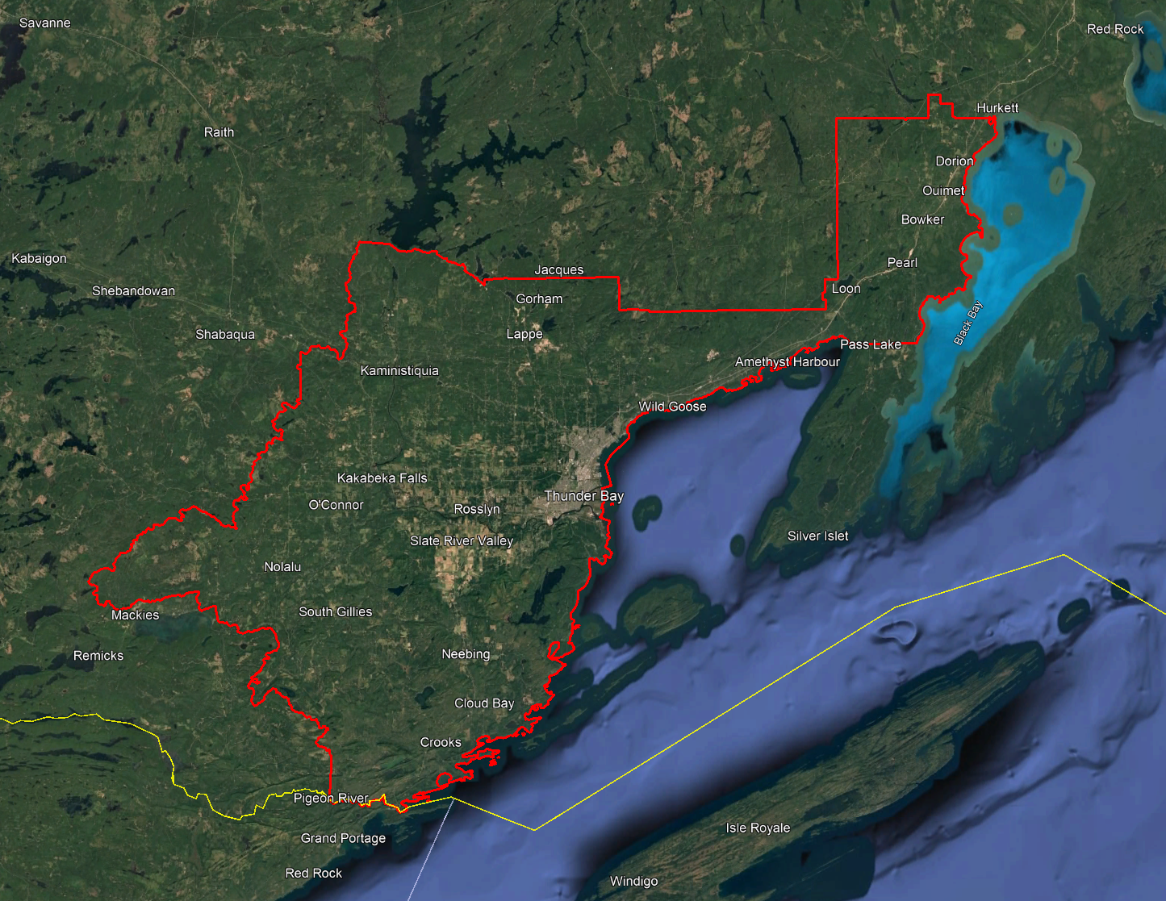

Project Schedule & Personnel
The ground control occurred during the fall of 2023. The surveyor collecting ground truth points during this period was Alistair Lornie. The Lidar data was collected in eight missions, six during the fall of 2023 and two during the spring of 2024. See table below for a list of missions.
A typical Lidar acquisition crew consisted of one Lidar Operator and one Pilot.

LiDAR System & Flight Parameters
Either a Riegl VQ-1560ii or VQ-1560ii-S was used to collect the Lidar data. The systems were installed in KASI Aviation’s Piper Navajo call signs C-GKSX for the fall 2023 missions and in Revolution Flight’ Cessna Caravan call sign N124RF for the Spring 2024 missions.
Below is a table of the lifts with their flight parameters.
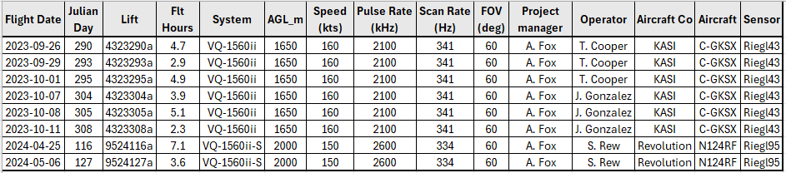
Table 1: Project Parameters for the Thunder Bay area.
Riegl VQ1560-ii | Flight plan
Altitude | 1650m AGL
Field of View (FOV) | 60°
Air Speed | 160 Kts
Pulse Rate | 2100 kHz
Sidelap | 20%
Point Density | > 8 pts/m²

Riegl VQ1560-ii-S | Flight plan
Altitude | 2000m AGL
Field of View (FOV) | 60°
Air Speed | 150 Kts
Pulse Rate | 2600 kHz
Sidelap | 20%
Point Density | > 8 pts/m²

The flight lines were designed optimally to maximize time online versus time in turn.
Below is a map of the flight lines including cross-ties.
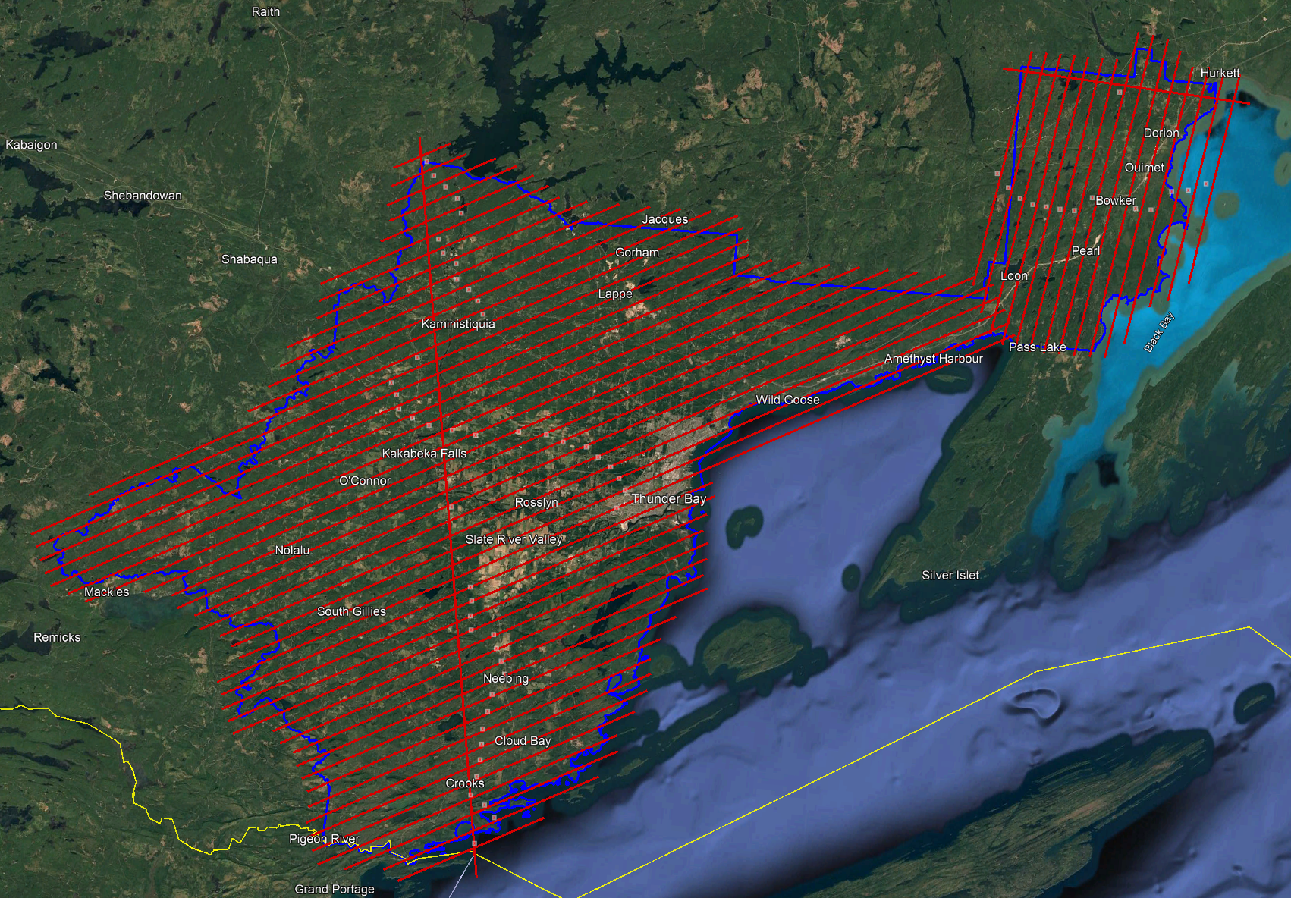

Below is a map of the flight line footprints colored by season of acquisition.
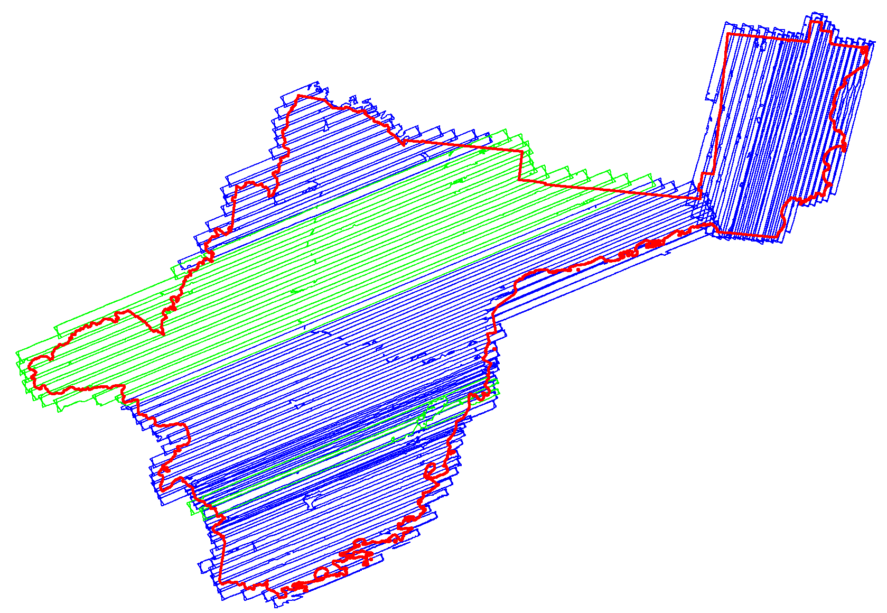
Fall 2023 (Blue)
Spring 2024 (Green)

Project Control / Datum
Several baselines were measured by GPS static occupation between Can-Net Continuously Operating Reference Stations (CORS), existing NRCan 3D Passive Control Monuments, and Ontario COSINE control points, as well as newly established points by Airborne Imaging. The existing control used for the Thunder Bay area consisted of one Can-Net station and three NRCan passive stations.
Appendix A contains a list of Control Points and their published coordinates.
Appendix B shows the coordinate list of deliverable check points.
Appendix C shows the published station coordinate sheets.
The datum used for processing the Ground Control and all subsequent Lidar data are the Nad83 CSRS (epoch 2010.0) horizontal datum and the CGVD2013 vertical datum (CGG2013 undulation model).
Below is an overview map of the control stations.
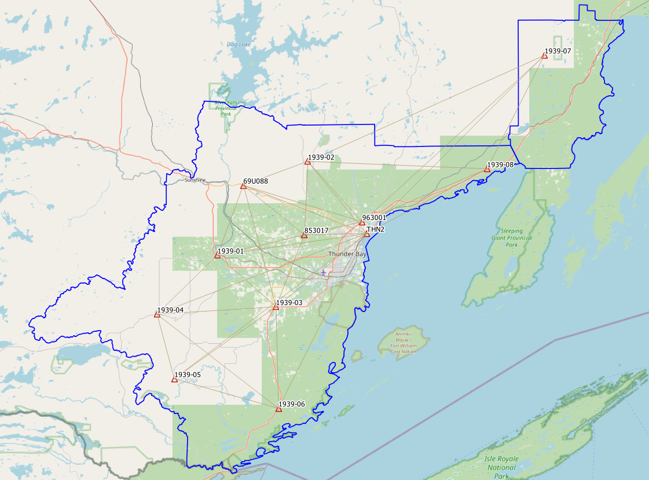
Check Points
Figure 1 Thunder Bay Control Network
RTK GPS
In order to meet the recommended ASPRS minimum number of points for a 3895.1 square kilometer project, RTK points were surveyed in areas distributed throughout the project. A minimum of 63 NVA and 51 VVA points were required to meet ASPRS standards. Real Time Kinematic points are individual points surveyed on open terrain. Our surveyor collected GPS data mounted on a pole while receiving real time differential corrections from the GPS receiver positioned over a nearby control point.
156 points were surveyed on the Thunder Bay project. Of these, 82 points were over non-vegetated ground conditions for NVA accuracy reporting and 74 of them were over vegetated areas for VVA accuracy reporting. Pictures of these RTK points (as well as the existing control) are provided with this report in the folder labeled “Pictures\Thunder Bay”. These points are used just for the vertical accuracy assessment of the Lidar point cloud and were not used to determine any vertical shift applied to the point cloud.
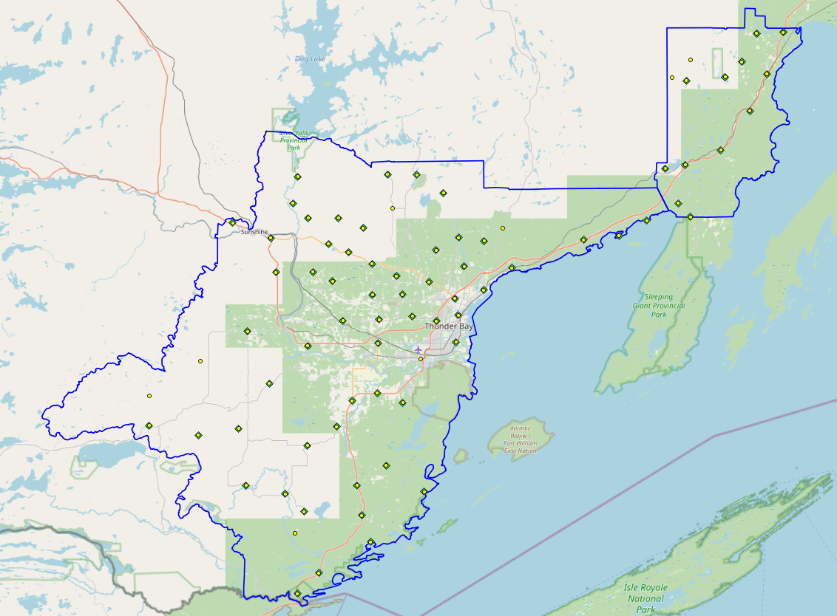
Figure 3 NVA (Yellow) and VVA (Green) Check Points

Trajectory Processing
The aircraft trajectory positioning for the missions over the Thunder Bay area were processed using the Precise Point Positioning (PPP) technique.
PPP is a positioning technique that removes and models GNSS system errors via precise satellite orbit data and clock corrections that are applied to the trajectory post mission, providing centimeter level positional accuracy without the use of ground base stations.
The TerraPOS software by Terratec was used to postprocess the PPP solutions to produce final kinematic trajectories accurate to 5 centimeters for each flight mission.
The horizontal datum used is Nad83 CSRS UTM zone 16 with the CGVD2013 vertical datum (CGG2013 undulation model).

LiDAR Data Processing

Calibration Procedures
After each mission, the field project manager creates the preliminary calibrated point cloud with each sensor’s set boresight values for each mission. Proprietary QC tools using the Lastools software are run on each mission to check for coverage, relative accuracy, point density, etc… If any data is found to be not meeting specifications, or coverage missing, the field crew is immediately notified and the areas affected reflown as soon as possible.
This preliminary calibrated point cloud is inspected in conjunction with the kinematic ground truth points to apply bulk shifts if necessary and further refine the calibration by applying corrections to the preliminary calibrated strips. The refined calibration is done using Bayesmap’s StripAlign software. Intensity values are also normalized by mission to be 16 bits (0 to 65535).

Data Tiling and Classification
The raw LiDAR data is processed into calibrated point cloud strips corresponding to flight lines. For ease of data manipulation, the strips are combined and saved in tiles of 1 km by 1 km. The format the strips and tiles are saved in is .Laz version 1.4. The tiling scheme is based on the UTM17 projection at the even kilometers.
The tiled point cloud is then processed with a series of algorithms to separate the “most-likely” ground returns from other returns. The point classification is done using a product by the TerraSolid software running on MicroStation Connect called TerraScan and TerraModeler.
In addition to our regular field QC and calibration procedures, we also generate various raster products using the Lastools software to assess coverage and calibration accuracy.

Point Cloud Manipulation
The TerraScan software uses macros that are set-up to measure the angles and distances between points to determine what classification a point should be: ground, vegetation, noise, other. The angle and distance values in the macros can be adjusted to be more or less aggressive with the classification of points by varying the incidence angles and estimated distances among neighboring points. The lower points are generally classified as ground returns, with the points above classified as undefined (class 1). Outliers and noise described in the table below are normally clouds, outliers or atmospheric noise in the data that are separated into above or below the ground level (high point or low points).
After the automated macro is run to determine classes, a systematic visual inspection is performed to fine tune the ground definition. To better understand areas for improvement for the ground surface, the points that are classified as ground are used to create viewable TINs and grid surfaces. These surfaces are inspected for areas that appear rough, artificially flattened or truncated, no data areas, or have other viewable errors.
In cleaning up ground points, the focus is concentrated in areas where few ground points have been left in the bare earth model and the ground appears rough or lower and flatter than it may be in reality. The scarcity of ground points may be a result from no penetration through a dense vegetation layer, water bodies, low reflectivity objects, or too aggressive values with the macro. A manual/visual inspection of these areas plays a major role in resolving any issues or irregularities with the bare earth model.
Once the first edits are completed, a one-meter grid of the ground surface is re-exported and hill shade images produced to QC the edited ground surface. This QC step is done iteratively as many times as necessary. Once the point cloud data has reached a satisfactory level of classification accuracy, the final deliverables are produced.

Water Classification & Hydro-Flattening
Once the ground class has reached the final level of classification accuracy, the water delineation process is initiated. The rivers and water bodies are digitized as break lines according to USGS specifications of a minimum of 8000 m² for water bodies and 30 m nominal width for streams and rivers. Ponds and lakes have their elevations set constant to just below ground. Stream and river hydro lines are collected using the downstream method. Once all hydro lines have been collected for an area, the ground points inside the hydro lines are classified to class 9 – Water. The ground points outside of the hydro lines but within 35 cm are classified to class 20 – Ignored ground (near breaklines). Using the TIN of class 2 (ground points), the hydro lines are used as constraints to generate the final 50 cm hydro-flattened DEMs in ESRI Ascii format, then converted to 32bit GeoTIFF format with the Global Mapper software.

Class definitions
The classification follows the ASPRS classification codes. The table below shows the classes for the delivered point cloud.

Table 2: ASPRS Point Classes
Classification Value | Description
1 | Unclassified
2 | Ground
6 | Building
7 | Low Points
9 | Water
17 | Bridge Decks
18 | High Points
20 | Ignored Ground (breakline proximity)
21 | Snow
22 | Temporal exclusion

Deliverables
Since the project was collected over two seasons, multiple deliverables were made as the data was ready. The majority of the Thunder Bay area was collected in the spring of 2023 and delivered in October 2023. The areas over the two missing flight lines were collected in the spring of 2024 and delivered in October 2024.
See below for a table of the folder structure and description of each deliverable.
DIFF
50cm rasters of flight lines differences, 1 X 1 km tiles in 32bit GeoTIFF format
e.g. 1km175110518802023LTHUNDERBAY_diff.tif
DTM
Hydro-flattened 50cm Bare Earth DEMs, 1 X 1 km tiles in 32bit GeoTIFF format
e.g. 1km175110518802023LTHUNDERBAY.tif
METADATA
Metadata files for Breaklines, DEM, LAS and Project in .XML format
e.g. THUNDER BAY2023_Lidar_metadata_LAS.xml
POINTCLOUD
Point cloud data, 1 X 1 km tiles in .LAZ format 1.4
e.g. 1km175110518802023LTHUNDERBAY.laz
PROJECT_POLYGON
Shape files of: Lift_metadata, Hydro_breaklines, Project_extent & Tile_index
e.g. Mission_9523133a.shp

Vertical Accuracy Assessment

Non-Vegetated Vertical Accuracy (NVA)
Below is a summary of the statistics between the point cloud TIN from the ground class and the NVA points surveyed on flat hard surfaces:
Number of points: | 82
Average dz: | 0.014 | m
Minimum dz: | -0.069 | m
Maximum dz: | +0.202 | m
Average magnitude: | 0.032 | m
Root mean square: | 0.045 | m
Std deviation: | 0.043 | m
NVA Vertical Accuracy (95%): | 0.088 | m

For a complete listing of the RTK points and their differences, please refer to the provided spreadsheet named " ThunderBay_NVA_Accuracy_Final_Entire_area_z16.xlsx".
As seen in the NVA comparison above, the accuracy observed of 0.088 m meets the project requirement of QL0 NVA vertical accuracy of 9.8 cm (95%).

Vegetated Vertical Accuracy (VVA)
The elevations of the points surveyed in various vegetated land cover types were compared to the Lidar ground surface. Since the elevation differences for this type of accuracy does not follow a normal distribution, the percentile method is used and not the 95% confidence level. For the 74 VVA points surveyed, sorting the absolute differences from the smallest to the largest gives the accuracy at the 95th percentile (using the linear interpolation between closest ranks method). For this sample, the 70th and 71st largest difference are respectively 16.6 and 18.0 cm.
For this project, the VVA accuracy is therefore 17.09 cm.
This is slightly above the required specifications of 15.0 cm (the QL0 VVA specification).
For a complete listing of the kinematic points and their differences, please refer to the provided spreadsheet named " ThunderBay_VVA_Accuracy_Final_Entire_area_z16.xlsx ".

Conclusion
This is the final report covering the Thunder Bay Lidar project. Topics such as field operations, control, data processing and final accuracy results were explained. The acquisition for this leaf off, snow off project was acquired over two seasons due to an early snow fall in the fall of 2023. The non-vegetated vertical accuracy meets specifications and the vegetated accuracy is slightly above the QL0 requirement.

Appendix A - Control Points – Published Coordinates
Thunder Bay - Control Station Coordinates
Station | Easting | Northing | h | H (CGVD2013) | Status | Comments
69U088 | 311713.560 | 5378709.885 | 326.156 | 360.880 | Published | NRCan 3D Passive Monument
853017 | 324044.943 | 5368108.567 | 244.734 | 279.879 | Published | NRCan 3D Passive Monument
963001 | 336104.849 | 5370413.640 | 221.274 | 256.746 | Published | NRCan 3D Passive Monument
THU2 | 336942.592 | 5367954.489 | 166.882 | 202.395 | Published | Can-Net CORS Station
1939-01 | 305865.826 | 5364437.393 | 229.171 | 263.797 | Temporary | Airborne Intermediate Control
1939-02 | 325232.332 | 5383204.705 | 401.240 | 436.286 | Temporary | Airborne Intermediate Control
1939-03 | 317668.623 | 5353359.441 | 192.164 | 227.036 | Temporary | Airborne Intermediate Control
1939-04 | 292899.321 | 5352675.311 | 328.647 | 362.706 | Temporary | Airborne Intermediate Control
1939-05 | 296007.752 | 5339133.473 | 332.503 | 366.225 | Temporary | Airborne Intermediate Control
1939-06 | 317504.656 | 5332286.733 | 175.800 | 210.132 | Temporary | Airborne Intermediate Control
1939-07 | 374660.194 | 5403758.049 | 330.646 | 366.573 | Temporary | Airborne Intermediate Control
1939-08 | 362248.365 | 5380641.338 | 233.063 | 268.935 | Temporary | Airborne Intermediate Control

Nad83(CSRS), epoch 2010
UTM Zone 16

Appendix B – RTK Survey & Control Check
Point | Julian Day | Northing | Easting | Height | Description
963015 | 106 | 5374569.535 | 460128.674 | 325.294 | Base
2040 | 106 | 5375347.065 | 472060.651 | 278.617 | NVA
2009 | 106 | 5359552.724 | 458902.296 | 309.980 | NVA
2012 | 106 | 5364348.958 | 466128.404 | 290.763 | NVA
2014 | 106 | 5366496.877 | 462461.375 | 307.970 | NVA
2015 | 106 | 5366578.620 | 449773.970 | 327.992 | NVA
2025 | 106 | 5368919.459 | 464823.760 | 282.605 | NVA
2026 | 106 | 5371211.007 | 462554.863 | 288.796 | NVA
2027 | 106 | 5375825.200 | 460009.061 | 364.078 | NVA
2029 | 106 | 5379064.666 | 454520.113 | 287.616 | NVA
2030 | 106 | 5381253.711 | 453436.408 | 289.495 | NVA
2031 | 106 | 5368926.865 | 470244.805 | 287.554 | NVA
2033 | 106 | 5371432.160 | 470467.706 | 277.224 | NVA
2037 | 106 | 5371777.041 | 474435.053 | 282.568 | NVA
2042 | 106 | 5375335.596 | 467247.585 | 285.461 | NVA
2057 | 106 | 5367602.938 | 475579.075 | 301.956 | NVA
2091 | 106 | 5386775.269 | 453387.748 | 296.773 | NVA
2092 | 106 | 5383691.151 | 447006.780 | 302.970 | NVA
2093 | 106 | 5389625.613 | 448777.448 | 317.010 | NVA
2094 | 106 | 5393551.274 | 451177.943 | 283.969 | NVA
2107 | 106 | 5361478.713 | 461993.599 | 302.377 | NVA
2108 | 106 | 5366591.831 | 455927.733 | 322.003 | NVA
2600 | 106 | 5390224.588 | 452370.082 | 311.125 | NVA
3009 | 106 | 5359546.422 | 458888.508 | 309.044 | VVA
3012 | 106 | 5364379.028 | 466112.612 | 290.451 | VVA
3014 | 106 | 5366512.763 | 462451.291 | 306.885 | VVA
3016 | 106 | 5366592.572 | 449773.687 | 327.488 | VVA
3025 | 106 | 5368910.942 | 464834.796 | 282.699 | VVA
3026 | 106 | 5371209.559 | 462541.633 | 288.747 | VVA
3027 | 106 | 5375849.617 | 460014.614 | 365.864 | VVA
3029 | 106 | 5379076.408 | 454503.226 | 286.724 | VVA
3030 | 106 | 5381265.187 | 453434.020 | 289.613 | VVA
3031 | 106 | 5368918.154 | 470243.420 | 287.484 | VVA
3033 | 106 | 5371504.670 | 470417.091 | 274.381 | VVA
3037 | 106 | 5371787.934 | 474467.903 | 283.965 | VVA
3040 | 106 | 5375333.730 | 472067.073 | 277.981 | VVA
3042 | 106 | 5375339.063 | 467255.422 | 284.973 | VVA
3058 | 106 | 5367598.008 | 475592.419 | 302.143 | VVA
3091 | 106 | 5386779.484 | 453400.309 | 296.102 | VVA
3092 | 106 | 5383677.025 | 447013.085 | 302.711 | VVA
3093 | 106 | 5389630.060 | 448763.896 | 317.512 | VVA
3094 | 106 | 5393588.415 | 451162.529 | 284.607 | VVA
3106 | 106 | 5371355.310 | 467228.530 | 287.982 | VVA
3107 | 106 | 5361527.395 | 461960.770 | 302.926 | VVA
3108 | 106 | 5366583.774 | 455929.633 | 321.431 | VVA
3600 | 106 | 5390234.820 | 452370.171 | 310.424 | VVA
1988-34 | 107 | 5355563.614 | 476209.285 | 304.606 | Base
2059 | 107 | 5363657.409 | 475214.728 | 298.535 | NVA
2060 | 107 | 5360007.445 | 476496.076 | 309.128 | NVA
2095 | 107 | 5353497.202 | 475565.278 | 303.209 | NVA
2097 | 107 | 5349598.213 | 476719.167 | 315.542 | NVA
2098 | 107 | 5355382.631 | 479007.693 | 306.676 | NVA
2099 | 107 | 5352287.148 | 479811.331 | 312.252 | NVA
3060 | 107 | 5360018.599 | 476506.180 | 309.435 | VVA
3061 | 107 | 5363643.492 | 475226.638 | 298.802 | VVA
3095 | 107 | 5353508.534 | 475539.349 | 302.979 | VVA
3098 | 107 | 5355356.956 | 479014.763 | 306.303 | VVA
3099 | 107 | 5352296.207 | 479809.832 | 310.778 | VVA
1988-33 | 107 | 5359066.825 | 457754.108 | 311.681 | BASE
2001 | 107 | 5353131.143 | 446845.451 | 337.185 | NVA
2003 | 107 | 5353511.719 | 449159.822 | 332.600 | NVA
2004 | 107 | 5356136.223 | 451763.873 | 327.743 | NVA
2006 | 107 | 5349803.871 | 457350.109 | 318.652 | NVA
2008 | 107 | 5355414.322 | 458321.140 | 317.087 | NVA
2016 | 107 | 5357943.408 | 467878.986 | 297.742 | NVA
2017 | 107 | 5354823.559 | 464976.965 | 306.333 | NVA
3001 | 107 | 5353107.190 | 446864.355 | 335.745 | VVA
3003 | 107 | 5353527.928 | 449146.565 | 332.464 | VVA
3004 | 107 | 5356133.476 | 451754.508 | 327.508 | VVA
3005 | 107 | 5357203.108 | 454489.504 | 333.740 | VVA
3006 | 107 | 5349816.726 | 457351.618 | 317.519 | VVA
3016 | 107 | 5357949.714 | 467880.305 | 297.514 | VVA
3017 | 107 | 5354829.102 | 465003.134 | 306.913 | VVA
3096 | 107 | 5354471.796 | 470703.623 | 319.828 | VVA
653050 | 108 | 5379248.454 | 472635.122 | 292.075 | BASE
2045 | 108 | 5378652.104 | 472638.437 | 284.238 | NVA
2049 | 108 | 5374439.772 | 478046.280 | 297.853 | VVA
2050 | 108 | 5377951.759 | 479740.725 | 296.721 | NVA
2052 | 108 | 5387289.596 | 476341.824 | 293.068 | NVA
2053 | 108 | 5388794.069 | 475655.317 | 288.723 | NVA
2056 | 108 | 5395029.424 | 474522.716 | 288.472 | NVA
2061 | 108 | 5383487.285 | 478253.751 | 285.807 | NVA
2062 | 108 | 5365932.146 | 480589.937 | 309.777 | NVA
2063 | 108 | 5369539.192 | 478959.170 | 320.751 | NVA
2068 | 108 | 5366095.695 | 486374.128 | 335.115 | NVA
2101 | 108 | 5361734.955 | 490887.137 | 283.096 | NVA
3045 | 108 | 5378665.352 | 472627.637 | 283.515 | VVA
3049 | 108 | 5374419.331 | 478046.429 | 298.026 | VVA
3050 | 108 | 5377928.172 | 479736.877 | 297.408 | VVA
3052 | 108 | 5387291.490 | 476373.016 | 292.852 | NVA
3053 | 108 | 5388764.292 | 475640.345 | 287.977 | VVA
3056 | 108 | 5395044.386 | 474527.487 | 288.971 | VVA
3061 | 108 | 5383475.034 | 478267.948 | 285.194 | VVA
3062 | 108 | 5365935.715 | 480583.050 | 309.184 | VVA
3063 | 108 | 5369544.687 | 478973.597 | 319.963 | VVA
3068 | 108 | 5366078.720 | 486385.858 | 334.472 | VVA
3101 | 108 | 5361725.119 | 490876.199 | 282.863 | VVA
1988-36 | 108 | 5377597.781 | 495556.100 | 289.043 | BASE
2069 | 108 | 5371066.619 | 485507.272 | 290.040 | NVA
2072 | 108 | 5376574.849 | 487292.619 | 288.976 | NVA
2077 | 108 | 5377640.452 | 495204.837 | 292.358 | NVA
2078 | 108 | 5380842.323 | 499126.937 | 294.877 | NVA
2079 | 108 | 5383170.048 | 502599.254 | 289.899 | NVA
2083 | 108 | 5375945.300 | 504165.174 | 284.214 | NVA
2084 | 108 | 5372832.951 | 502504.333 | 284.594 | NVA
2086 | 108 | 5375439.593 | 511218.355 | 277.398 | NVA
2088 | 108 | 5379917.477 | 507984.252 | 295.213 | NVA
2100 | 108 | 5385738.455 | 499345.668 | 289.693 | NVA
2103 | 108 | 5392658.767 | 498399.520 | 337.034 | NVA
3078 | 108 | 5380855.466 | 499141.346 | 294.298 | VVA
3079 | 108 | 5383175.875 | 502608.085 | 289.072 | VVA
3080 | 108 | 5371164.921 | 489759.044 | 290.819 | VVA
3083 | 108 | 5375920.449 | 504155.980 | 283.388 | VVA
3084 | 108 | 5372837.670 | 502511.177 | 284.618 | VVA
3088 | 108 | 5379911.775 | 507971.361 | 295.335 | VVA
3090 | 108 | 5385588.844 | 508001.337 | 289.376 | NVA
3104 | 108 | 5373607.672 | 493768.747 | 287.227 | VVA

Appendix C – Published Station Coordinate Sheets
