Final Report
For project:
Upper Thames Grand River LiDAR
Prepared for:
Ontario Ministry of Natural Resources
2nd floor, North Tower, 300 Water Street,
Peterborough, ON, K9J 3C7
Prepared by:

Airborne Imaging
2700 – 61 Avenue SE
Calgary, AB T2C 4V2
February 2026

Contents
Contents 2
Introduction 2
Project Schedule & Personnel 3
LiDAR System & Flight Parameters 3
Project Control / Datum 6
Control Network 6
Check Points 9
LiDAR Data Processing 12
Calibration Procedures 12
Data Tiling and Classification 12
Point Cloud Manipulation 13
Water Classification & Hydro-Flattening 13
Class definitions 14
Deliverables 15
Vertical Accuracy Assessment 16
Conclusion 17
Appendix A - Control Points – Published Coordinates 18
Appendix B – PPP Solutions 42
Appendix C – NVA / VVA Ground Control Points 47

Introduction
The Ontario Ministry of Natural Resources and Forests contracted Airborne Imaging to acquire and deliver digital elevation data derived from airborne LiDAR (Light Detection and Ranging) to cover various regions in Ontario.
This report covers the Upper Thames Grand River area, collected during the Spring and Fall of 2025. The report focuses on LiDAR acquisition details, such as flight parameters, project control, ground truthing results, data processing technique and deliverables.
The contracted area for the Upper Thames / Grand River area is 7,779 km².
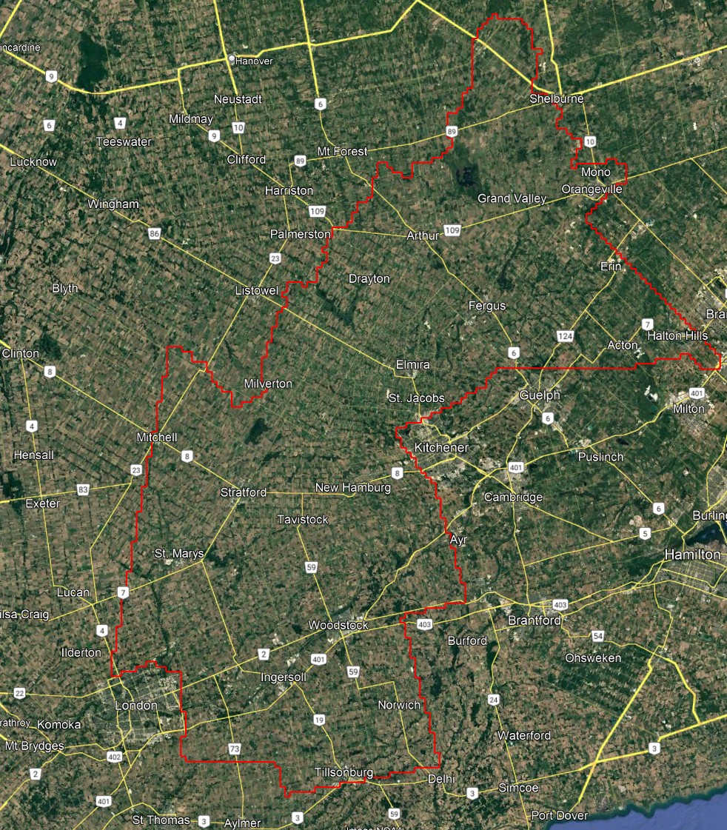
Figure 1: Map of Upper Thames Grand River project area

Project Schedule & Personnel
The ground control occurred in March-April 2025. The Lidar data was collected in nine missions from April 24 to May 9, 2025 and one final mission on November 14, 2025. See table below for the mission’s flight parameters.
A typical Lidar acquisition crew consisted of one Lidar Operator and one Pilot.

LiDAR System & Flight Parameters
A Riegl VQ-1560ii and VQ-1560ii-S were used to collect the Lidar data. The systems were installed in a Piper Navajo aircraft with call sign C-GMEC operated by Kasi Aviation.

Below is a table of the lifts with their flight parameters.
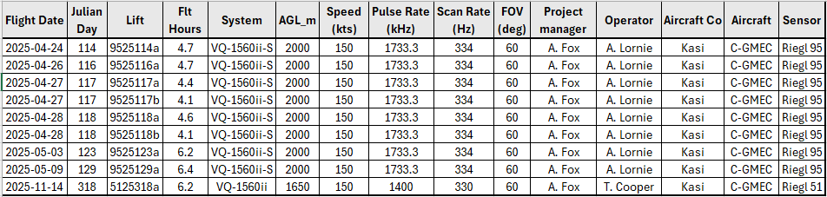
Table 1: Project Parameters for the Upper Thames Grand River area.
Riegl VQ1560-ii | Flight plan | Riegl VQ1560-ii-S | Flight plan
Altitude | 1650m AGL | Altitude | 2000m AGL
Field of View (FOV) | 60° | Field of View (FOV) | 60°
Air Speed | 150 Kts | Air Speed | 150 Kts
Pulse Rate | 1400 kHz | Pulse Rate | 1733.3 kHz
Sidelap | 20% | Sidelap | 20%
Point Density | > 8 pts/m² | Point Density | > 8 pts/m²

The flight lines were designed optimally to maximize time online versus time in turns.

Below is a map of the flight lines including cross-ties.
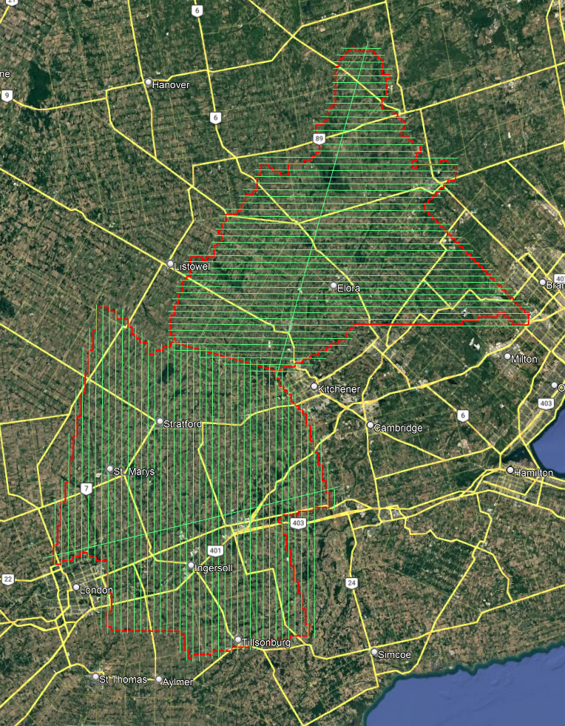
Figure 2: A map of the Upper Thames Grand River flightlines

Below is a map of the flight line footprints.
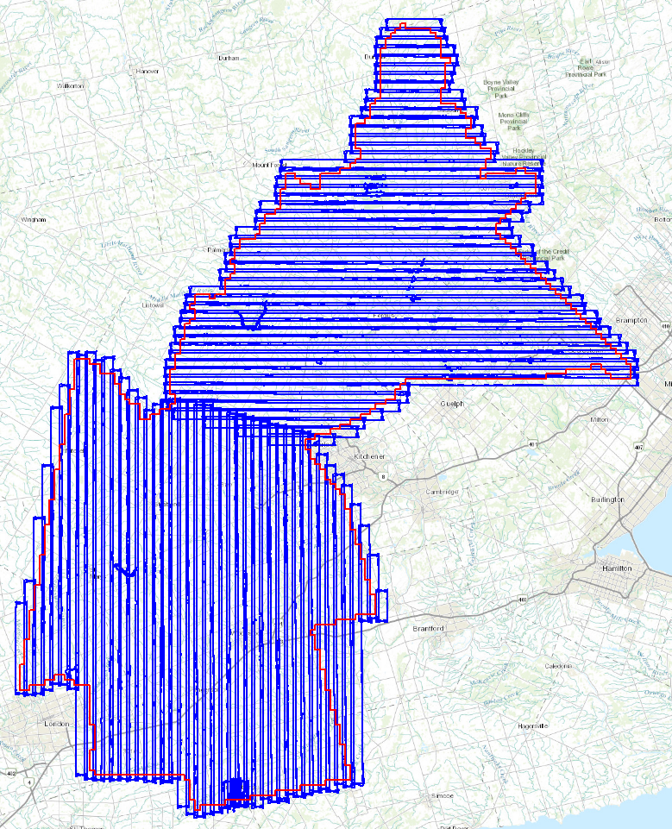
Figure 3: A map of the Upper Thames Grand River flight line footprints

Project Control / Datum
Several baselines were measured by GPS static occupation between Can-Net Continuously Operating Reference Stations (CORS), existing NRCan 3D Passive Control Monuments, as well as newly established points by Airborne Imaging. The existing control used for the Grand River / Upper Thames area consisted of four Can-Net stations and three NRCan passive stations.
Appendix A shows the published station coordinate sheets.
Appendix B shows the PPP Solutions.
Appendix C contains a list of Control Points and their published coordinates.
The datum used for processing the Ground Control and all subsequent Lidar data are the Nad83 CSRS (epoch 2010.0) horizontal datum and the CGVD2013 vertical datum (CGG2013 undulation model).

Control Network
The ground control survey was collected using a combination of Trimble R8 Model 3 receivers and Hemisphere S631 receivers. The Trimble receivers were employed in establishing control and collecting kinematic cross sections and the Hemisphere receivers were used for RTK collection. The ground control data was processed using the NovAtel Waypoint software GraftNet and GrafNav.
First, to establish control in the area, baselines were measured via GPS observations between a network of NRCan 3D Passive Control Monuments, CanNet Continuously Operating Reference Stations (CORS), and Airborne’s intermediate bases which were established by the ground crew during collection. Baselines were observed for a minimum of 4 hours, and no baselines exceeded a length of 50km. The coordinates of the intermediate bases were established through a rigorous least-squares adjustment, tied to the established control monuments.
Datasheets for the published control monuments can be found in Appendix A at the end of this report. PPP Solutions for the intermediate bases were computed using NRCan’s PPP service and used as a-priori values for processing the network. They are included in Appendix B.

Station | Easting | Northing | Elevation | Description
2065-31 | 554147.349 | 4866305.787 | 464.995 | Airborne Intermediate Base
2065-32 | 551191.261 | 4841221.055 | 429.897 | Airborne Intermediate Base
2065-33 | 525835.160 | 4803703.738 | 344.897 | Airborne Intermediate Base
2065-34 | 498458.759 | 4783428.974 | 384.762 | Airborne Intermediate Base
2065-35 | 518229.705 | 4757087.036 | 290.803 | Airborne Intermediate Base
883063A | 557080.144 | 4885077.462 | 508.424 | Airborne Intermediate Base
673007A | 499295.982 | 4798572.910 | 363.401 | Reference Marker A for  NRCan Passive Monument 673007
73D8006 | 516506.445 | 4879258.199 | 374.771 | NRCan 3D Passive Control
813041 | 479502.185 | 4747826.809 | 271.495 | NRCan 3D Passive Control
843025 | 538924.957 | 4821168.710 | 337.145 | NRCan 3D Passive Control
84U149 | 524396.797 | 4776271.189 | 298.688 | NRCan 3D Passive Control
883050 | 575079.980 | 4831266.867 | 363.975 | NRCan 3D Passive Control
883063 | 557073.201 | 4885072.009 | 508.033 | NRCan 3D Passive Control
883066 | 531789.751 | 4737003.660 | 230.686 | NRCan 3D Passive Control
BTFD | 554535.603 | 4778845.008 | 251.174 | CanNet CORS Station
FLSH | 539535.283 | 4900727.808 | 487.857 | CanNet CORS Station
GLP2 | 556066.783 | 4821156.745 | 350.537 | CanNet CORS Station
INGR | 509438.641 | 4765022.083 | 288.324 | CanNet CORS Station
LOND | 481419.705 | 4758233.049 | 249.906 | CanNet CORS Station
LSW2 | 504329.097 | 4843266.883 | 394.488 | CanNet CORS Station
SMCO | 553065.341 | 4743051.293 | 238.923 | CanNet CORS Station
STFD | 503007.702 | 4801423.867 | 367.846 | CanNet CORS Station

Table 2: Grand River Upper Thames - Control Station Coordinates

Horizontal Datum: Nad83(CSRS) UTM Zone 17 (epoch 2010)
Vertical Datum: CGVD2013 (Geoid CGG2013a)
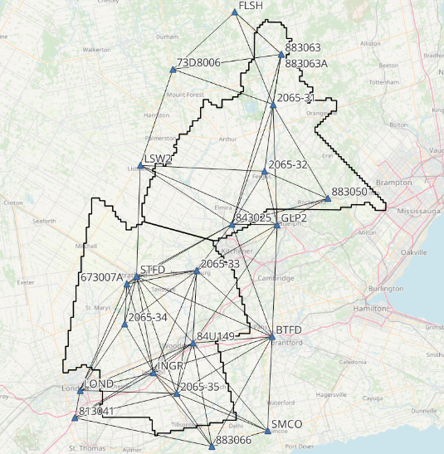
Figure 4: Upper Thames Grand River Control Network

Check Points
RTK GPS
The NVA and VVA control points were collected via Real-Time Kinematic Survey, using Hemisphere S631 GNSS receivers. The Real Time Kinematic method uses 30 second observations of individual points. It achieves high accuracy by receiving real time differential corrections from the GPS reference base, positioned over a nearby control point. The RTK points are used for the vertical accuracy assessment of the Lidar point cloud and were not used to determine any vertical shift applied to the point cloud.
The ground crews collected a total of 88 NVA points and 85 VVA points. A full coordinate list of the NVA and VVA Check Points is included in Appendix C at the end of this report. Pictures of the final delivered RTK points (as well as the existing control) are provided in a folder included with the submission of this report.
See below for a map of the collected NVA and VVA ground control points.

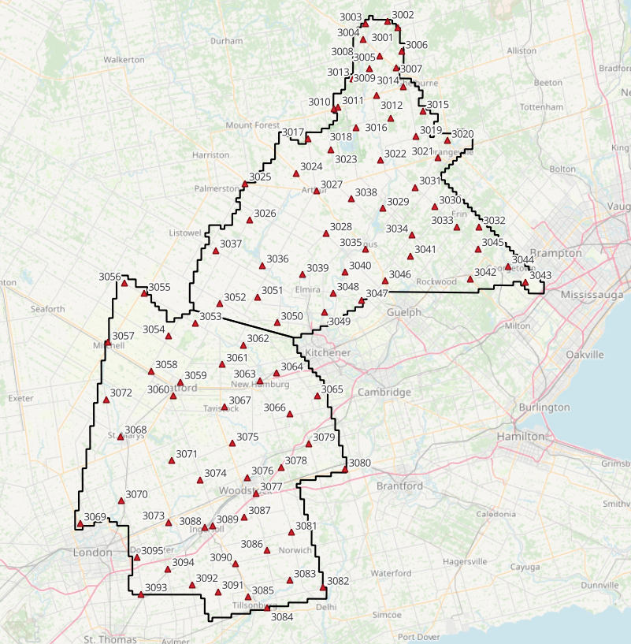
Figure 5: Grand River / Upper Thames NVA points
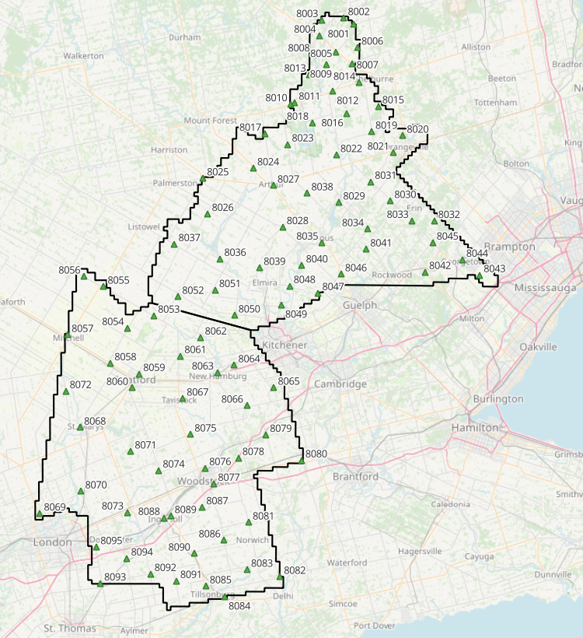
Trajectory Processing
Figure 6: Upper Thames / Grand River VVA points

The aircraft trajectory positioning for the missions over the Upper Thames / Grand River area were processed using the Precise Point Positioning (PPP) technique.
PPP is a positioning technique that removes and models GNSS system errors via precise satellite orbit data and clock corrections that are applied to the trajectory post mission, providing centimeter level positional accuracy without the use of ground base stations.
The TerraPOS software by Terratec was used to postprocess the PPP solutions to produce final kinematic trajectories accurate to 5 centimeters for each flight mission.
The horizontal datum used is Nad83 CSRS UTM zone 17 with the CGVD2013 vertical datum (CGG2013 undulation model).

LiDAR Data Processing

Calibration Procedures
After each mission, the field project manager creates the preliminary calibrated point cloud with each sensor’s set boresight values for each mission. Proprietary QC tools using the Lastools software are run on each mission to check for coverage, relative accuracy, point density, etc… If any data is found to be not meeting specifications, or coverage missing, the field crew is immediately notified and the areas affected reflown as soon as possible.
This preliminary calibrated point cloud is inspected in conjunction with the kinematic ground truth points to apply bulk shifts if necessary and further refine the calibration by applying corrections to the preliminary calibrated strips. The refined calibration is done using Bayesmap’s StripAlign software. Intensity values are also normalized by mission to be 16 bits (0 to 65535).

Data Tiling and Classification
The raw LiDAR data is processed into calibrated point cloud strips corresponding to flight lines. For ease of data manipulation, the strips are combined and saved in tiles of 1 km by 1 km. The format the strips and tiles are saved in is .Laz version 1.4. The tiling scheme is based on the UTM17 projection at the even kilometers.
The tiled point cloud is then processed with a series of algorithms to separate the “most-likely” ground returns from other returns. The point classification is done using a product by the TerraSolid software running on MicroStation Connect called TerraScan and TerraModeler.
In addition to our regular field QC and calibration procedures, we also generate various raster products using the Lastools software to assess coverage and calibration accuracy.

Point Cloud Manipulation
The TerraScan software uses macros that are set-up to measure the angles and distances between points to determine what classification a point should be: ground, vegetation, noise, other. The angle and distance values in the macros can be adjusted to be more or less aggressive with the classification of points by varying the incidence angles and estimated distances among neighboring points. The lower points are generally classified as ground returns, with the points above classified as undefined (class 1). Outliers and noise described in the table below are normally clouds, outliers or atmospheric noise in the data that are separated into above or below the ground level (high point or low points).
After the automated macro is run to determine classes, a systematic visual inspection is performed to fine tune the ground definition. To better understand areas for improvement for the ground surface, the points that are classified as ground are used to create viewable TINs and grid surfaces. These surfaces are inspected for areas that appear rough, artificially flattened or truncated, no data areas, or have other viewable errors.
In cleaning up ground points, the focus is concentrated in areas where few ground points have been left in the bare earth model and the ground appears rough or lower and flatter than it may be in reality. The scarcity of ground points may be a result from no penetration through a dense vegetation layer, water bodies, low reflectivity objects, or too aggressive values with the macro. A manual/visual inspection of these areas plays a major role in resolving any issues or irregularities with the bare earth model.
Once the first edits are completed, a one-meter grid of the ground surface is re-exported and hill shade images produced to QC the edited ground surface. This QC step is done iteratively as many times as necessary. Once the point cloud data has reached a satisfactory level of classification accuracy, the final deliverables are produced.

Water Classification & Hydro-Flattening
Once the ground class has reached the final level of classification accuracy, the water delineation process is initiated. The rivers and water bodies are digitized as break lines according to USGS specifications of a minimum of 8000 m² for water bodies and 30 m nominal width for streams and rivers. Ponds and lakes have their elevations set constant to just below ground. Stream and river hydro lines are collected using the downstream method. Once all hydro lines have been collected for an area, the ground points inside the hydro lines are classified to class 9 – Water. The ground points outside of the hydro lines but within 35 cm are classified to class 20 – Ignored ground (near breaklines). Using the TIN of class 2 (ground points), the hydro lines are used as constraints to generate the final 50 cm hydro-flattened DEMs in ESRI Ascii format, then converted to 32bit Geotiff format with the Global Mapper software.

Class definitions
The classification follows the ASPRS classification codes. The table below shows the classes for the delivered point cloud.
Table 2: ASPRS Point Classes
Classification Value | Description
1 | Unclassified
2 | Ground
6 | Building
7 | Low Points
9 | Water
17 | Bridge Decks
18 | High Points
20 | Ignored Ground (breakline proximity)
21 | Snow
22 | Temporal exclusion

Deliverables
The data was delivered in November 2025.
See below for a table of the folder structure and description of each deliverables.
DIFF
50cm rasters of flight lines differences, 1 X 1 km tiles in 32bit Geotiff format
e.g. 1km173850494302025LUPPERTHAMESGRANDRIVER_diff.tif
DTM
Hydro-flattened 50cm Bare Earth DEMs, 1 X 1 km tiles in 32bit Geotiff format
e.g. 1km173850494302025LUPPERTHAMESGRANDRIVER.tif
METADATA
Metadata files for Breaklines, DEM, LAS and Project in .XML format
e.g. UPPERTHAMESGRANDRIVER_2025_Lidar_metadata_Breaklines.xml
POINTCLOUD
Point cloud data, 1 X 1 km tiles in .LAZ format 1.4
e.g. 1km173850494302025L UPPERTHAMESGRANDRIVER.laz
PROJECT_POLYGON
Shape files of: Lift_metadata, Hydro_breaklines, Project_extent & Tile_index
e.g. Mission_9525118a_z17.shp

Vertical Accuracy Assessment
Non-Vegetated Vertical Accuracy (NVA)
Below is a summary of the statistics between the point cloud TIN from the ground class and the NVA points surveyed on flat hard surfaces:
Number of points: | 88
Average dz: | 0.005 | m
Minimum dz: | -0.093 | m
Maximum dz: | 0.112 | m
Average magnitude: | 0.027 | m
Root mean square: | 0.037 | m
Std deviation: | 0.036 | m
NVA Vertical Accuracy (95%): | 0.073 | m

For a complete listing of the RTK points and their differences, please refer to the provided spreadsheet named " UpperThames_NVA_Accuracy_z17_Final".
As seen in the NVA comparison above, the accuracy observed of 0.073 m meets the project requirement of QL0 NVA vertical accuracy of 9.8 cm (95%).
Vegetated Vertical Accuracy (VVA)
The elevations of the points surveyed in various vegetated land cover types were compared to the Lidar ground surface. Since the elevation differences for this type of accuracy does not follow a normal distribution, the percentile method is used and not the 95% confidence level. For the 85 VVA points surveyed, sorting the absolute differences from the smallest to the largest gives the accuracy at the 95th percentile (using the linear interpolation between closest ranks method). For this sample, the 80th and 81st largest difference are respectively 10.8 and 11.3 cm.
For this project, the VVA accuracy is therefore 11.2 cm.
This is within the required specifications of 15.0 cm (the QL0 VVA specification).
For a complete listing of the kinematic points and their differences, please refer to the provided spreadsheet named "UpperThames_VVA_Accuracy_z17_Final.xlsx".

Conclusion
This is the final report covering the Grand River Upper Thames Lidar project. Topics such as field operations, control, data processing and final accuracy results were explained. The project went well, acquired in one season and delivered on schedule. The non-vegetated vertical accuracy meets specifications and the vegetated accuracy is within the QL0 requirement.

Appendix A - Control Points – Published Coordinates
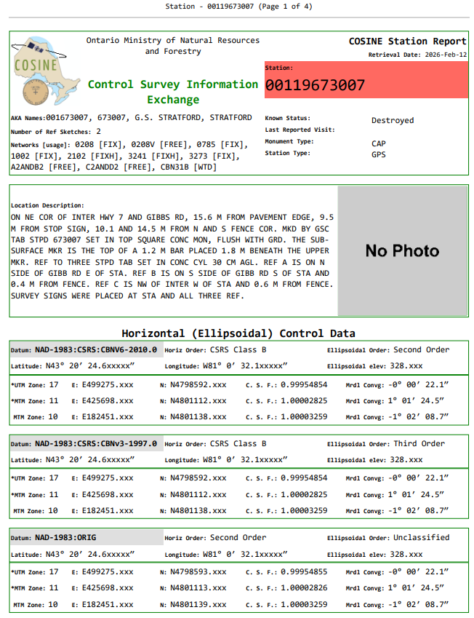
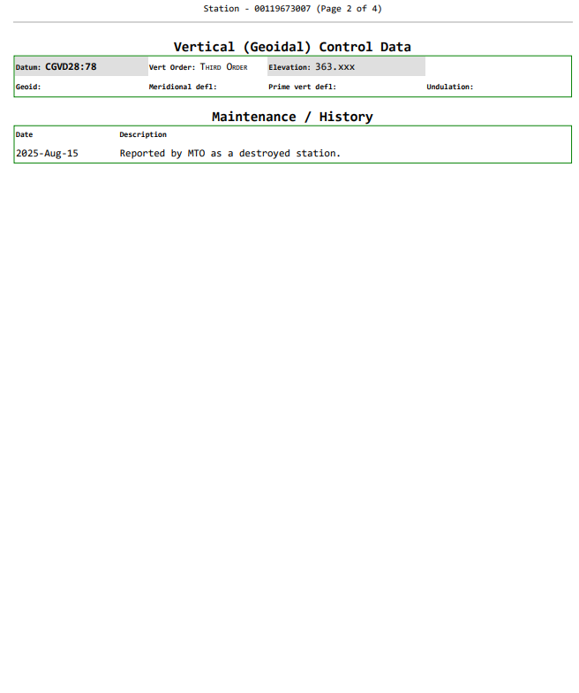
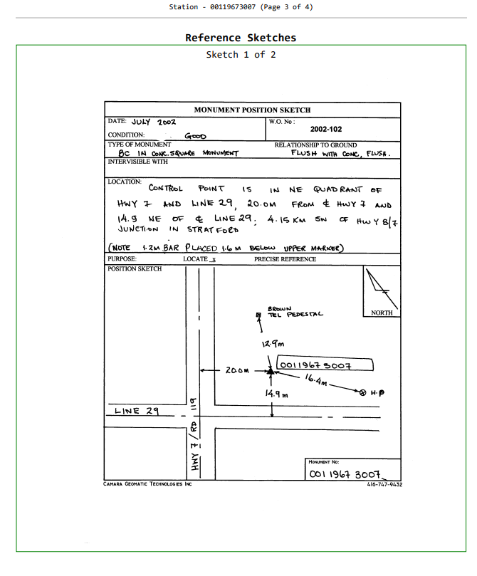
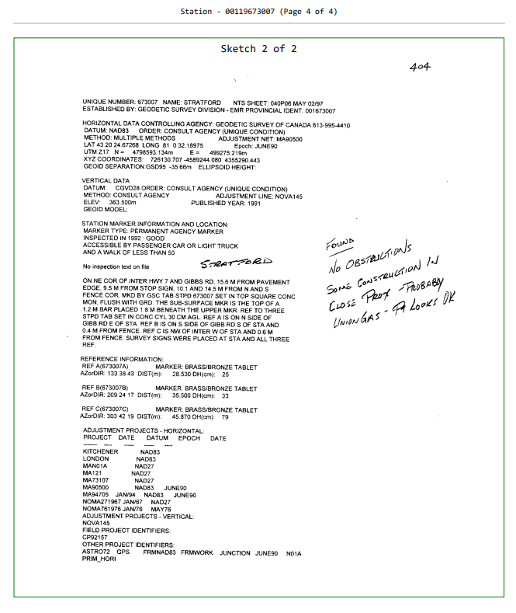
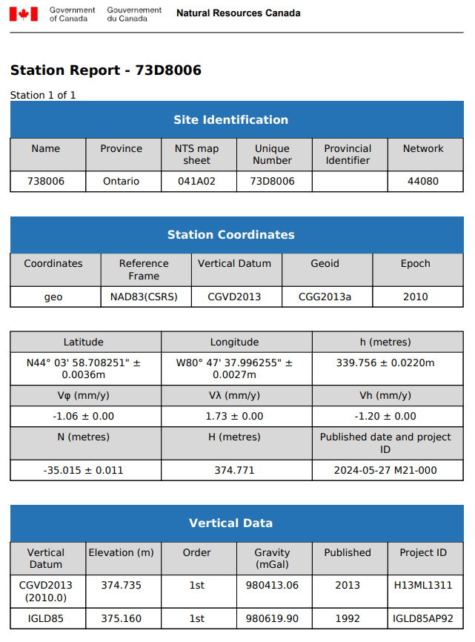
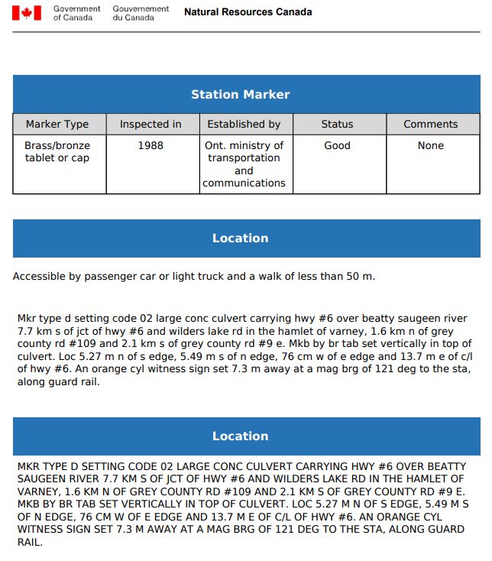
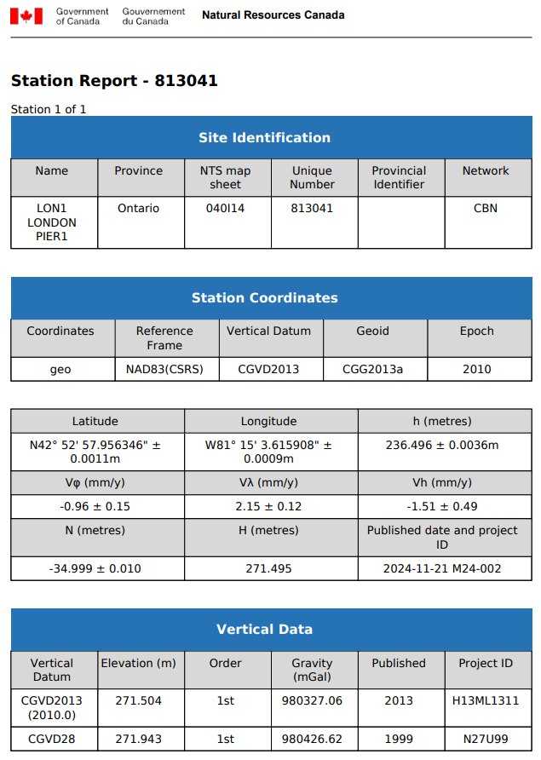
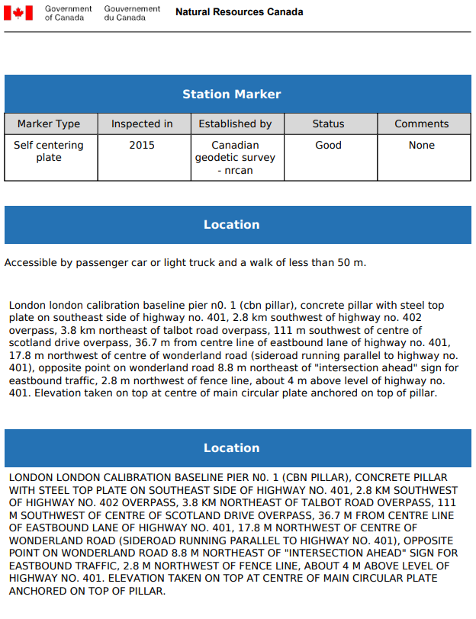
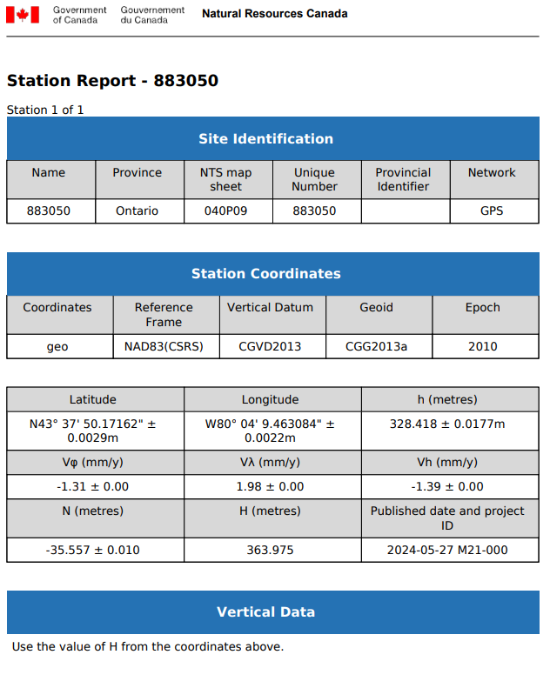
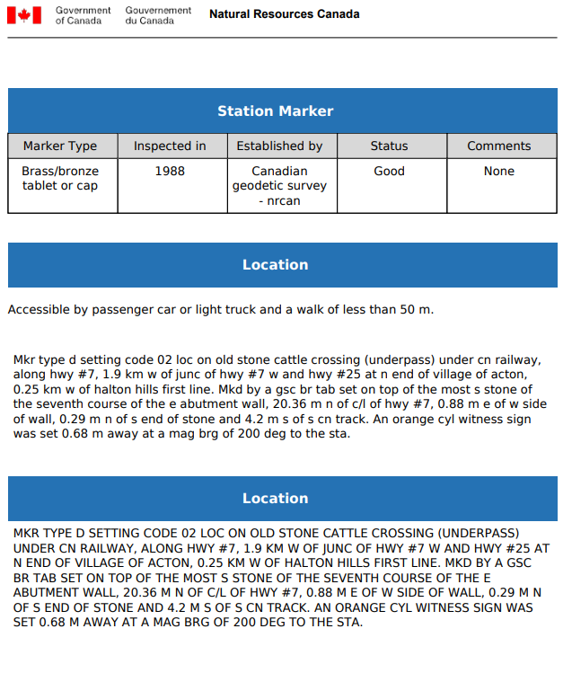
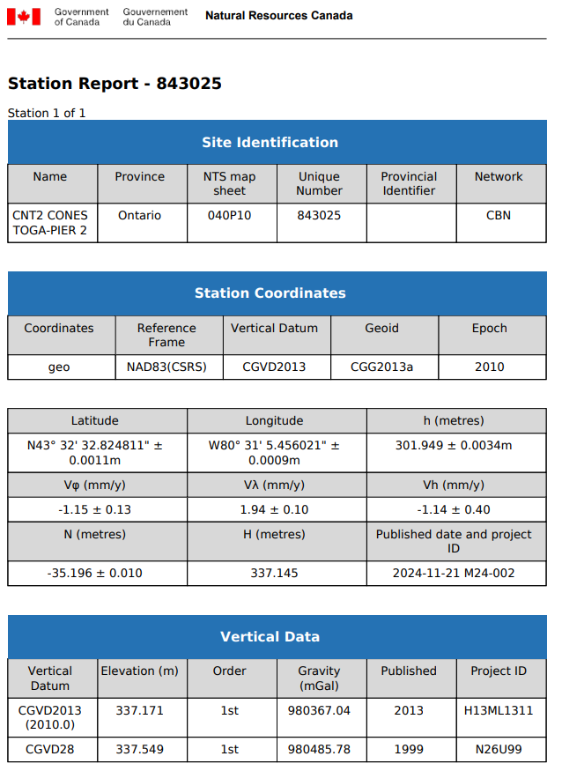
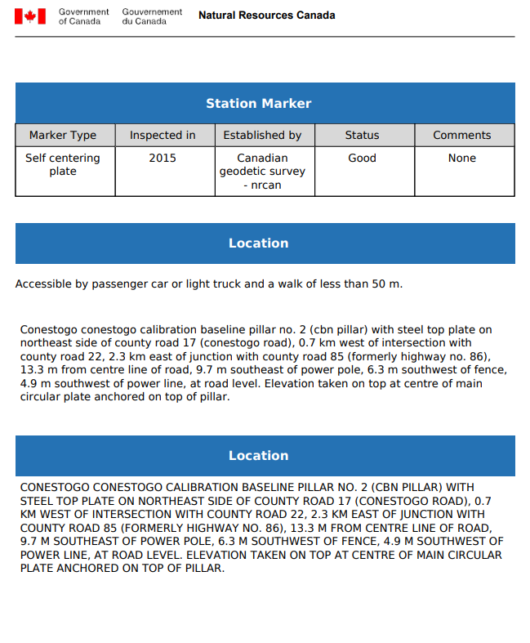
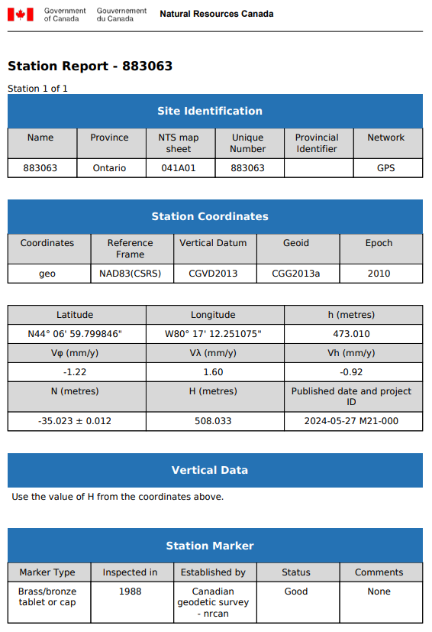
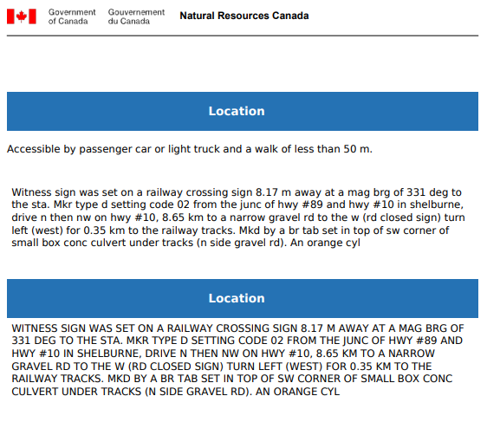
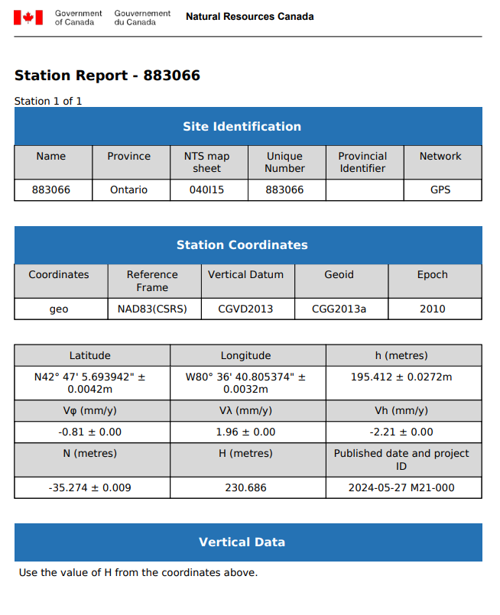
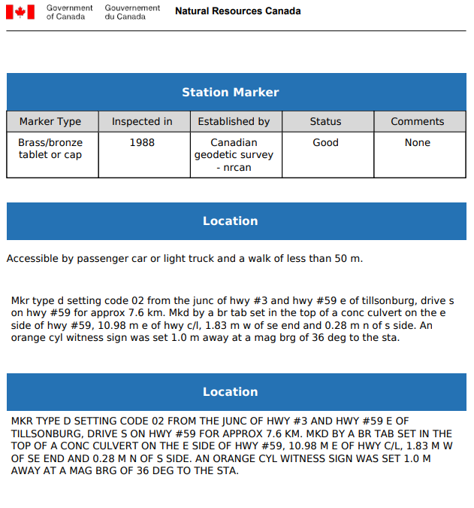
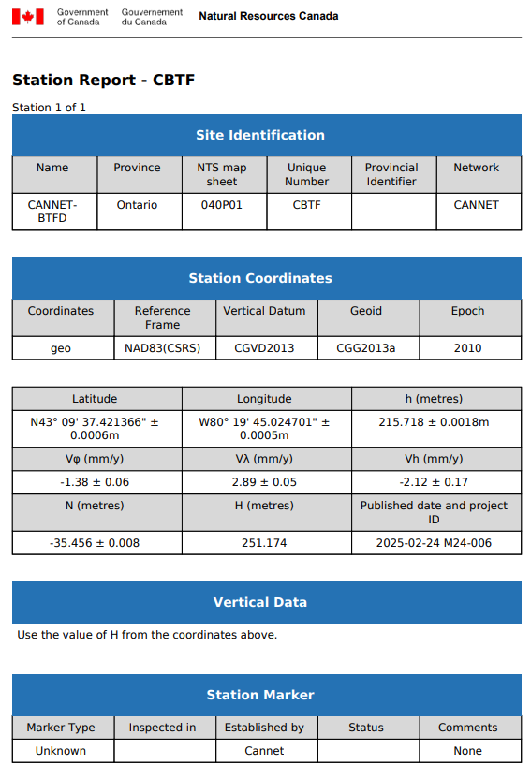
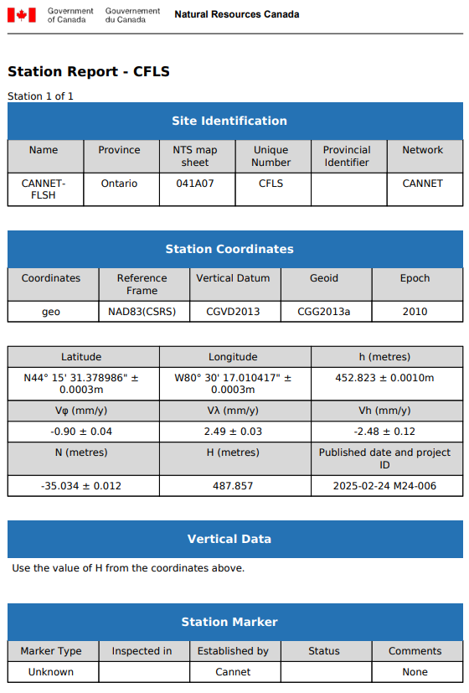
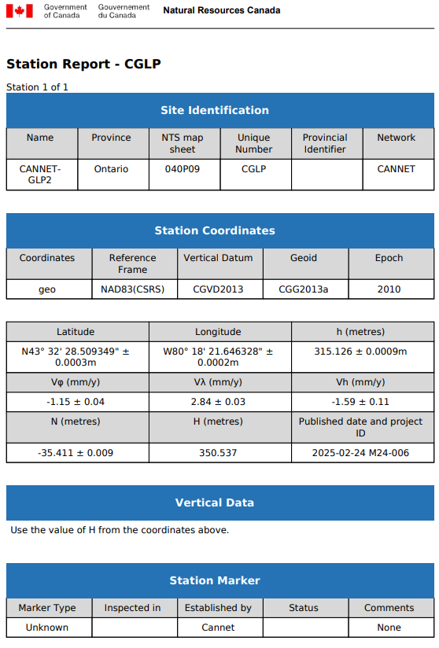
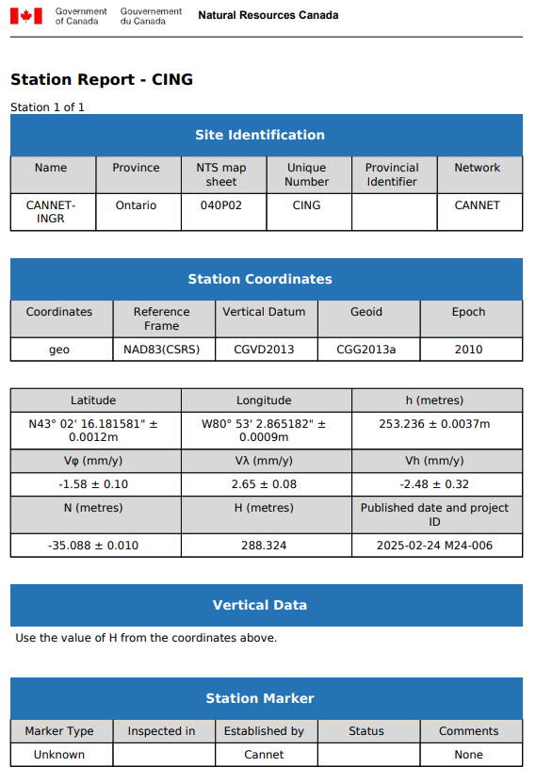
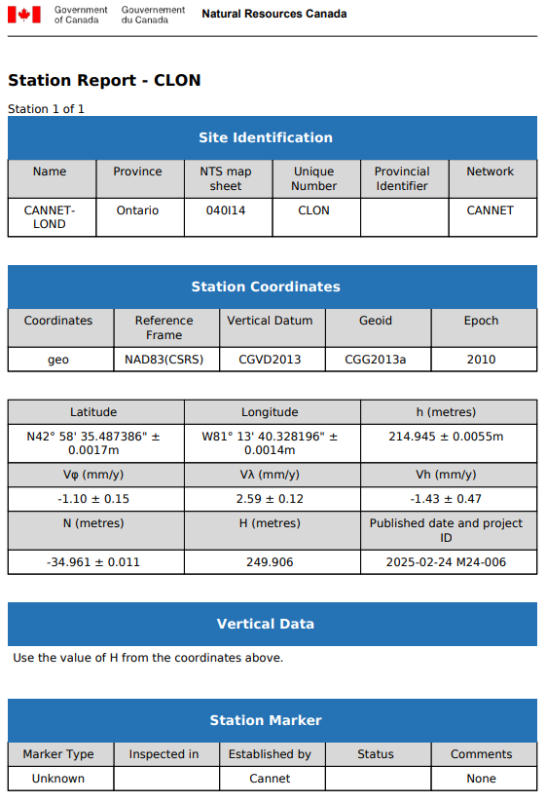
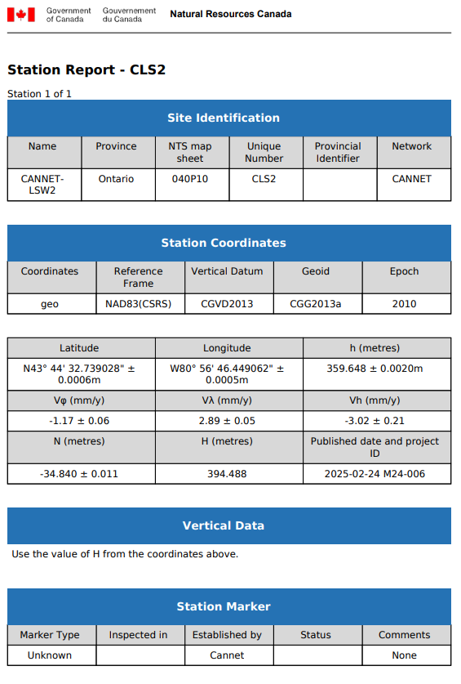
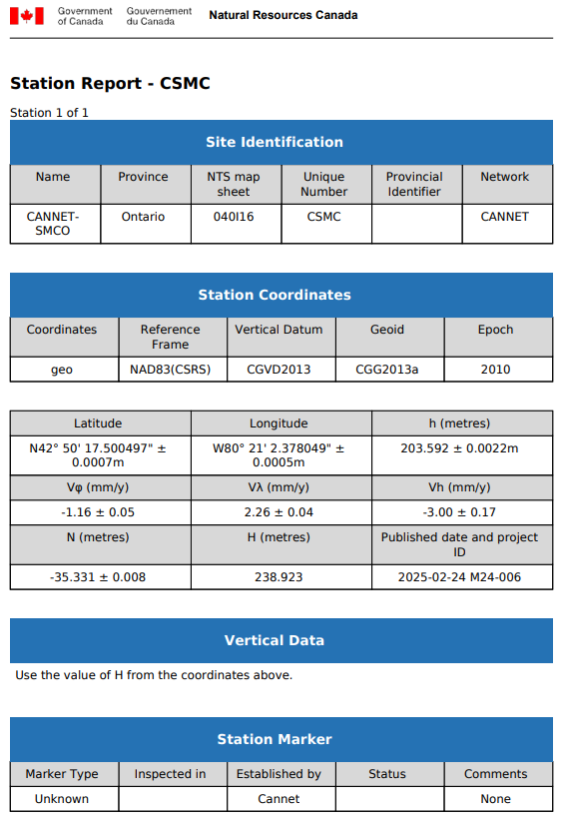
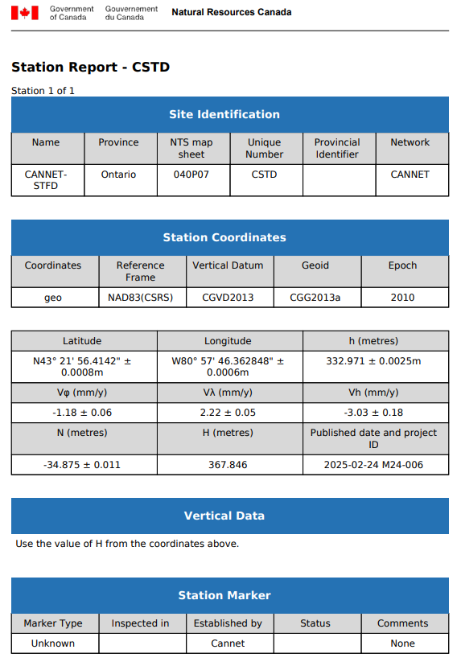

Appendix B – PPP Solutions
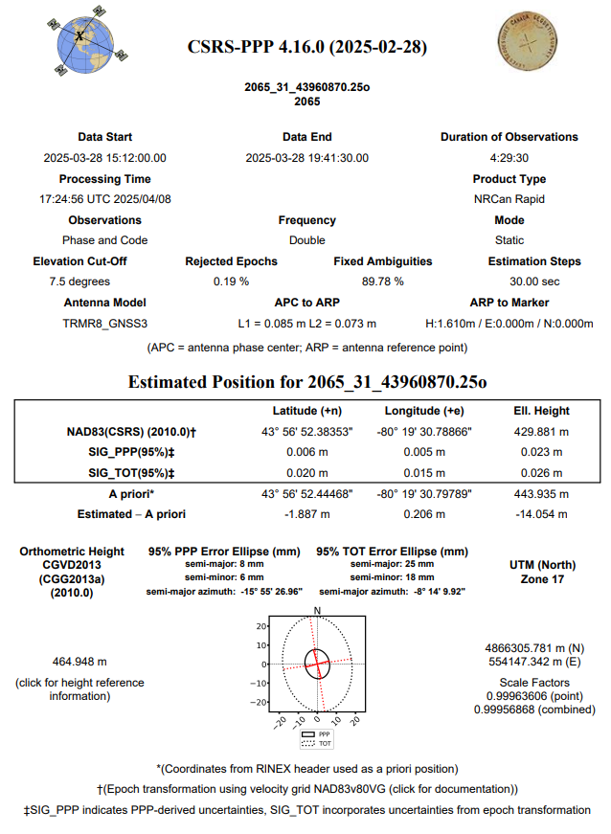
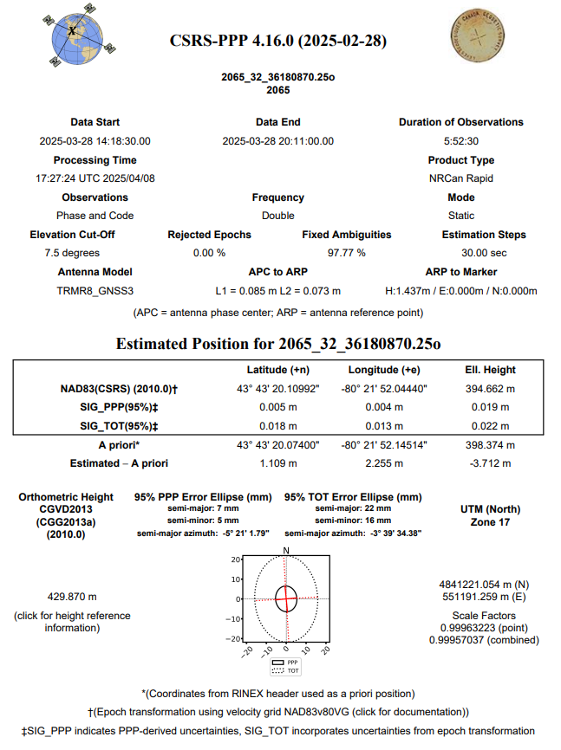
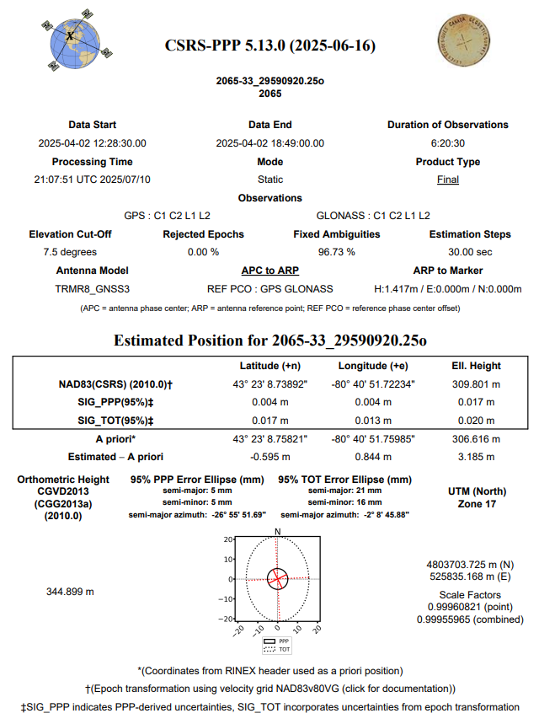
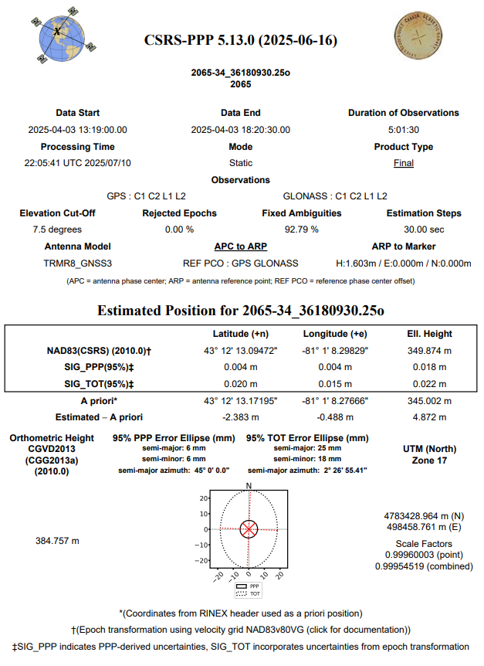
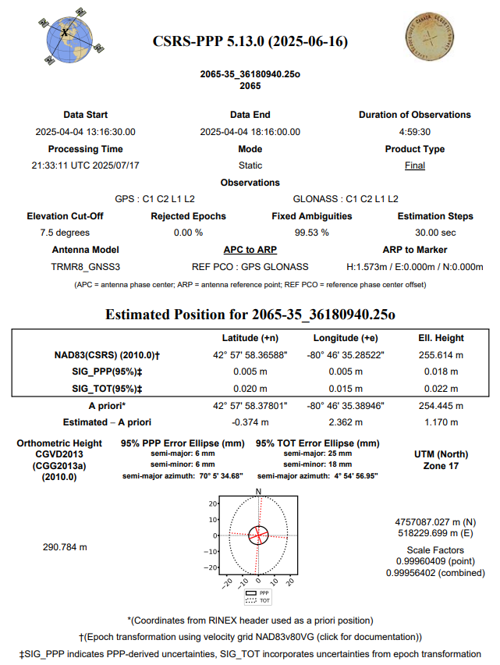

Appendix C – NVA / VVA Ground Control Points
NVA Points
Point | Easting | Northing | Elevation
3001 | 558364.36 | 4894939.05 | 521.937
3002 | 555883.789 | 4896604.209 | 523.963
3003 | 550143.521 | 4896001.217 | 526.253
3004 | 549583.202 | 4892018.093 | 523.433
3005 | 553850.250 | 4887635.028 | 507.790
3006 | 559468.4 | 4888951.3 | 517.69
3007 | 558095.570 | 4884699.868 | 510.304
3008 | 548061.225 | 4887117.783 | 504.262
3009 | 551329.821 | 4884457.745 | 503.724
3010 | 542223.538 | 4874078.884 | 495.447
3011 | 543237.273 | 4874547.533 | 497.771
3012 | 553135.335 | 4877602.267 | 497.052
3013 | 547055.137 | 4881855.012 | 492.710
3014 | 559993.018 | 4879809.105 | 493.485
3015 | 565068.259 | 4873681.519 | 485.284
3016 | 556914.01 | 4871808.62 | 488.158
3017 | 535467.171 | 4866371.486 | 482.322
3018 | 547834.813 | 4869334.980 | 491.385
3019 | 563357.783 | 4867097.046 | 492.464
3020 | 571564.955 | 4866174.008 | 445.183
3021 | 569033.020 | 4861717.013 | 491.981
3022 | 554205.008 | 4860940.993 | 475.605
3023 | 541462.600 | 4863528.463 | 490.616
3024 | 532526.834 | 4857406.293 | 450.262
3025 | 519305.360 | 4854712.234 | 420.203
3026 | 520596.886 | 4845393.272 | 411.801
3027 | 537794.984 | 4852890.503 | 453.737
3028 | 540286.263 | 4842024.381 | 443.277
3029 | 555020.997 | 4848591.068 | 442.602
3030 | 568498.072 | 4849106.730 | 449.086
3031 | 563321.156 | 4854069.280 | 491.108
3032 | 580013.583 | 4844007.538 | 397.636
3033 | 574300.134 | 4843982.272 | 395.252
3034 | 562530.862 | 4841694.634 | 411.886
3035 | 550606.147 | 4838044.047 | 410.467
3036 | 523892.712 | 4833656.732 | 369.574
3037 | 511753.153 | 4837512.368 | 402.084
3038 | 546725.138 | 4850931.005 | 460.123
3039 | 534285.191 | 4831330.400 | 373.688
3040 | 545309.02 | 4832029.23 | 354.043
3041 | 562274.458 | 4836356.912 | 389.886
3042 | 577817.95 | 4830613.56 | 352.555
3043 | 592179.595 | 4829893.088 | 237.762
3045 | 579679.472 | 4838356.489 | 366.772
3046 | 555684.67 | 4829827.93 | 373.892
3047 | 549731.529 | 4824848.729 | 346.403
3048 | 542192.858 | 4826525.891 | 332.894
3049 | 540023.8 | 4821672.8 | 323.112
3050 | 527673.95 | 4818860.62 | 376.348
3051 | 522604.18 | 4825502.68 | 388.798
3052 | 512859.531 | 4823688.543 | 377.028
3053 | 506497.69 | 4818736.24 | 378.173
3054 | 499527.23 | 4815371.36 | 366.886
3058 | 495025.15 | 4806239.04 | 356.276
3059 | 502630.95 | 4803421.1 | 361.371
3060 | 500694.11 | 4799761.12 | 361.783
3061 | 513518.057 | 4808016.887 | 356.066
3062 | 518878.206 | 4813052.831 | 355.389
3063 | 523223.9 | 4803867.44 | 341.509
3064 | 527718.653 | 4805772.021 | 354.894
3065 | 538229.715 | 4799940.479 | 317.822
3066 | 531073.558 | 4795164.487 | 313.296
3067 | 514091.680 | 4796958.066 | 342.024
3068 | 486983.932 | 4789307.168 | 317.985
3069 | 476281.38 | 4766653.75 | 275.845
3070 | 487188.994 | 4772488.643 | 292.418
3071 | 500377.706 | 4782994.028 | 364.435
3072 | 483184.94 | 4798934.17 | 335.288
3074 | 507819.848 | 4778010.188 | 321.073
3075 | 516202.565 | 4787487.723 | 329.402
3076 | 520126.23 | 4778560.14 | 303.337
3077 | 522459.443 | 4774525.159 | 301.429
3078 | 528870.319 | 4781339.802 | 296.915
3079 | 536155.337 | 4787465.448 | 304.991
3080 | 545584.812 | 4780839.542 | 259.726
3081 | 531692.258 | 4764331.195 | 273.075
3082 | 540073.81 | 4749970.93 | 236.861
3083 | 531341.726 | 4751820.009 | 245.100
3084 | 525374.187 | 4744651.755 | 238.788
3085 | 520325.925 | 4747404.575 | 257.269
3086 | 525236.670 | 4759572.026 | 280.147
3087 | 519391.53 | 4768311.16 | 312.826
3090 | 517162.314 | 4756036.499 | 291.688
3091 | 512485.28 | 4748798.13 | 273.801
3092 | 505615.275 | 4750611.726 | 282.215
3093 | 492243.254 | 4748129.815 | 262.078
3094 | 499377.380 | 4754742.987 | 293.690
3095 | 491259.581 | 4757772.221 | 269.941

VVA Points
Number | Easting | Northing | Elevation
8001 | 558342.174 | 4894938.097 | 520.315
8002 | 555886.640 | 4896587.030 | 523.543
8003 | 550139.890 | 4896032.826 | 524.853
8004 | 549574.413 | 4892004.092 | 523.411
8005 | 553859.922 | 4887627.947 | 507.513
8006 | 559483.370 | 4888970.900 | 516.492
8007 | 558128.371 | 4884709.735 | 510.970
8008 | 548050.390 | 4887102.629 | 502.857
8009 | 551358.034 | 4884456.843 | 502.526
8010 | 542239.189 | 4874101.025 | 494.819
8011 | 543217.114 | 4874530.002 | 497.168
8012 | 553138.482 | 4877564.107 | 495.947
8013 | 547080.807 | 4881851.763 | 491.741
8014 | 559971.098 | 4879821.904 | 492.205
8015 | 565057.664 | 4873664.418 | 484.153
8016 | 556895.788 | 4871802.921 | 487.946
8017 | 535480.839 | 4866384.877 | 481.212
8018 | 547848.837 | 4869333.327 | 490.502
8019 | 563342.891 | 4867104.727 | 492.433
8020 | 571577.528 | 4866166.303 | 445.370
8021 | 569024.770 | 4861706.610 | 492.496
8022 | 554218.423 | 4860958.520 | 475.670
8023 | 541492.240 | 4863538.356 | 489.664
8024 | 532479.455 | 4857368.687 | 450.193
8025 | 519300.451 | 4854690.507 | 419.515
8026 | 520611.469 | 4845399.396 | 412.102
8027 | 537794.114 | 4852880.801 | 454.044
8028 | 540264.728 | 4842039.618 | 443.404
8029 | 555045.519 | 4848585.895 | 444.020
8030 | 568480.154 | 4849107.687 | 449.302
8031 | 563305.780 | 4854065.735 | 490.612
8033 | 574295.915 | 4843973.159 | 395.378
8034 | 562545.073 | 4841683.088 | 411.851
8035 | 550605.885 | 4838068.079 | 410.537
8036 | 523901.474 | 4833669.767 | 368.269
8037 | 511756.985 | 4837486.737 | 400.235
8038 | 546689.548 | 4850925.279 | 458.951
8039 | 534282.004 | 4831345.540 | 373.743
8040 | 545307.162 | 4832048.425 | 353.693
8041 | 562271.357 | 4836383.240 | 390.547
8042 | 577817.893 | 4830625.047 | 352.696
8043 | 592189.047 | 4829891.141 | 237.701
8045 | 579693.232 | 4838344.915 | 366.061
8046 | 555700.487 | 4829825.371 | 372.627
8047 | 549741.490 | 4824837.344 | 345.599
8048 | 542184.817 | 4826539.849 | 333.152
8049 | 540009.646 | 4821668.242 | 323.217
8050 | 527687.755 | 4818852.808 | 376.265
8051 | 522590.009 | 4825492.811 | 388.727
8052 | 512846.416 | 4823683.949 | 376.731
8053 | 506487.703 | 4818732.219 | 378.194
8054 | 499526.774 | 4815381.704 | 366.695
8057 | 483725.666 | 4813688.082 | 347.389
8058 | 495037.473 | 4806229.799 | 356.075
8059 | 502615.458 | 4803413.538 | 361.310
8060 | 500679.148 | 4799749.239 | 361.841
8061 | 513506.200 | 4808035.662 | 354.969
8062 | 518876.793 | 4813020.486 | 353.558
8063 | 523246.577 | 4803858.316 | 341.484
8064 | 527701.362 | 4805761.776 | 355.011
8065 | 538212.460 | 4799913.861 | 318.095
8066 | 531079.976 | 4795165.297 | 313.323
8067 | 514109.817 | 4796956.313 | 341.756
8068 | 486963.092 | 4789310.098 | 317.414
8069 | 476257.785 | 4766654.188 | 275.344
8070 | 487206.553 | 4772488.986 | 292.330
8071 | 500385.891 | 4782997.442 | 363.885
8072 | 483178.007 | 4798922.043 | 334.335
8074 | 507802.551 | 4778004.969 | 321.865
8076 | 520134.220 | 4778556.196 | 303.333
8077 | 522454.910 | 4774515.161 | 301.893
8078 | 528888.077 | 4781348.155 | 296.826
8079 | 536160.583 | 4787484.970 | 304.425
8080 | 545598.320 | 4780830.772 | 259.139
8081 | 531705.193 | 4764326.889 | 272.636
8082 | 540085.190 | 4749982.132 | 236.705
8083 | 531329.960 | 4751818.331 | 244.857
8084 | 525370.895 | 4744637.949 | 238.743
8085 | 520336.121 | 4747388.524 | 256.781
8087 | 519368.955 | 4768300.234 | 312.421
8090 | 517175.495 | 4756047.577 | 291.721
8092 | 505627.075 | 4750616.223 | 282.140
8093 | 492244.936 | 4748111.445 | 262.110
8094 | 499388.923 | 4754742.068 | 293.825
8095 | 491259.916 | 4757747.770 | 269.621

