
Land Information Ontario (LIO) Warehouse
Data Class Name: MNR District
Documentation
Produced by: Information Access and Information Management Policy Unit
Ministry of Natural Resources and Forestry
Date: Sept 20, 2016

Purpose

This document provides additional information to support the use of geospatial data. The Physical Model Diagram provides a visual representation of the relationships in the data class. The Data Change History lists all the modelling and access changes that have occurred during the lifecycle of the data class. A data description identifying table and field names is available upon request.

Need Assistance?
Please contact LIO Support at lio@ontario.ca or 705-755-1878 if you require help.

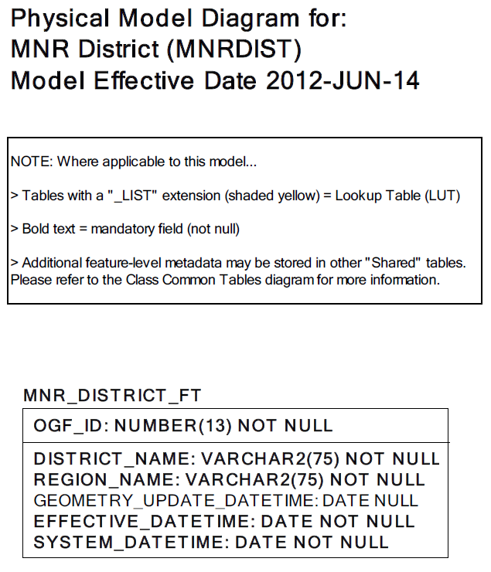
Data Class Change History

Data Class Name: MNR District
Data Class Short Name: MNRDIST
Date  YYYY-MM-DD | Details of Change
2015-10-14 | Data Class, tables and columns descriptions updated to MNRF as a few descriptions were missing (blank) in Class Catalog.
2012-06-14 | Converted to new GAAR structure – merging of selected GEOG_UNIT table columns with main feature class table.
2008 | GUT and Data Class Description updated. Received new description from BDI
1997 | NEW Data Class
Data Description
Please refer to the metadata record for the data description.

