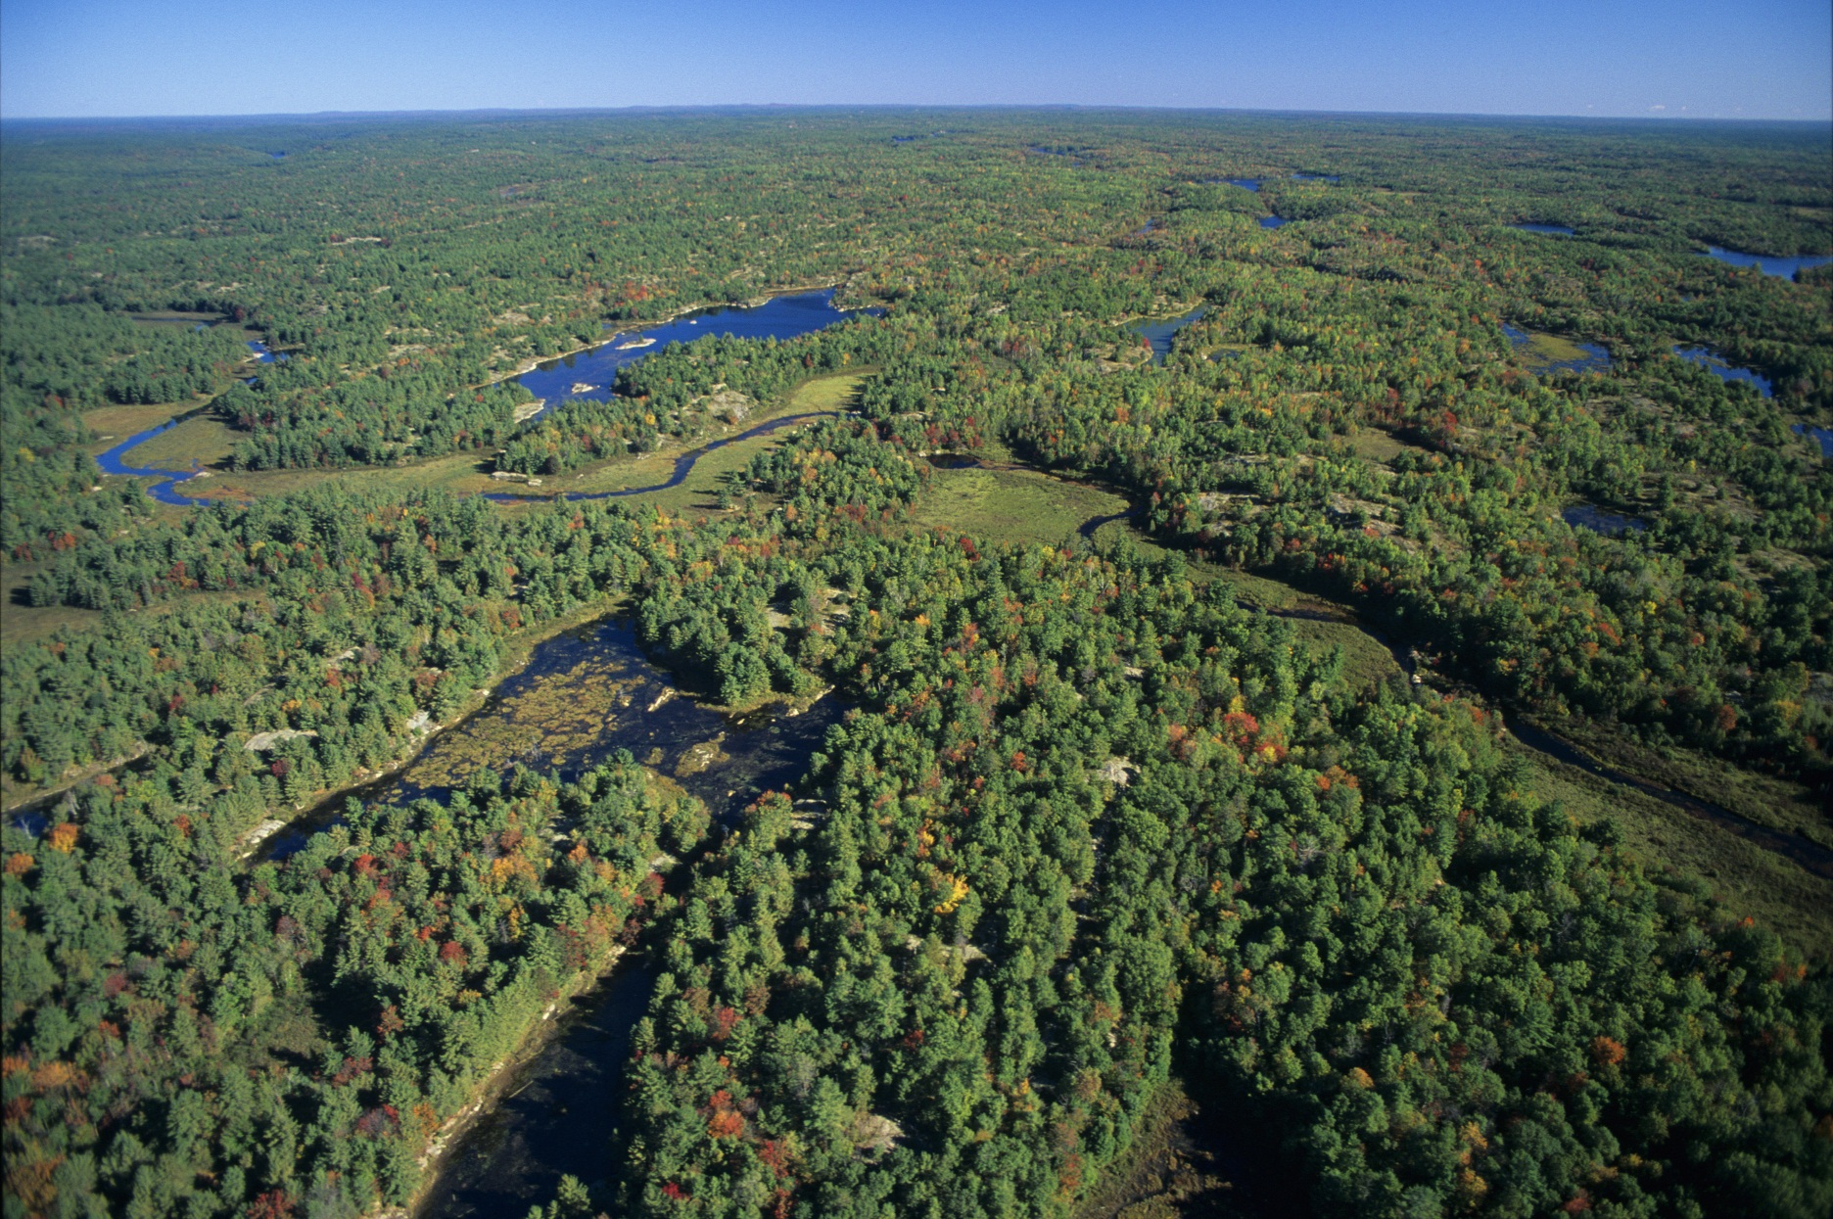


Map Design Considerations for Accessibility
Ministry of Natural Resources and Forestry
Mapping & Information Resources Branch
April 6, 2017

Map Design Considerations for Accessibility
In August of 2015 a committee was established between multiple Government of Ontario Ministries (MNRF, MTO, OMAFRA, MOECC, CSC, MEDEI/MRI, MCSS) to investigate and provide recommendations on how to best design maps so they are accessible to as wide an audience as possible. This document is the result of that investigation. It is intended for information purposes for individuals who design and create map products.
Date: January 10, 2017
Committee Members:
- Aliyev, Zaur (MNRF)
- Britton, James (MNRF)
- Chadee, Balliram (TBS)
- Chan, Michael Y (MCSS)
- Clowater, Christopher (MNRF)
- David, David (MNRF)
- Holm, Doug (CSC)
- Houston, Connor (MEDEI/MRI)
- Leney, Steve (MNRF)
- Martin, Lori Anne (MTO)
- Ramwa, Zachary (MOECC)
- Rennick, Randal (MNRF)
- Sharma, Namita (CAB)
- Sikma, Greg (MNRF)
- Steiss, Bob (OMAFRA)
Content Contributors:
- Aliyev, Zaur (MNRF)
- Houston, Connor (MEDEI/MRI)
- Martin, Lori Anne (MTO)
- Ramwa, Zachary (MOECC)
- Sikma, Greg (MNRF)
- Steiss, Bob (OMAFRA)
Author: Sikma, Greg (MNRF)
Endorsements:
- GIS in the OPS Director Manager Working Group (DMWG) - 2016
- I&IT Accessibility Centre of Excellence - 2017

Contents
Map Design Considerations for Accessibility 3
Contents 5
Introduction 11
Document Scope 11
Background Cartographic and Map Design Information 12
Cartography 12
Map Purpose & Audience 12
Essential Map Content 13
Contextual Map Content 13
Map Design 13
Types of Maps 14
General Purpose or Reference Maps 14
Thematic Maps 14
Potential Accessibility Challenges 16
Background 16
Colour Blindness 17
Types of Colour Blindness 17
Low Vision 18
Symptoms of Low Vision 18
Common Causes of Low Vision 18
Moderately Low Vision 18
Considerations for Accessible Map Design 19
1. Contrast 20
Background 20
Contrast and Accessibility 20
Contrast and Type 21
WCAG Contrast Compliance for Text 22
WCAG Contrast Guidelines for Text 23
Examples of Contrast Ratios for Greyscale Text and Backgrounds 24
Contrast and Type Size for Maps 24
Map Examples 25
Contrast for Lines and Areas 27
Contrast for Lines Over Background Colours 27
Examples of Contrast Ratios for Greyscale Lines on White Backgrounds 28
Recommended Guidelines for Contrast 29
Contrast Resources: 30
Understanding WCAG 2.0 30
Colour Contrast Analyser 30
Colour Contrast Check 30
2. Colour 31
Background 31
Colour Accessibility 31
Recommended Guidelines for Colour: 34
Colour Resources and Tools 34
ColorBrewer 34
Color Oracle 35
Vischeck 35
Colour-Deficient Colour Palette 35
Colour Verification Techniques 35
Greyscale Test 35
3. Style and Patterns 36
Background 36
Qualitative Information 37
Quantitative Information 38
Point Symbols 38
Line Symbology 39
Pattern Symbology 39
Recommended Guidelines for Style and Patterns: 40
4. Font Selection 41
Background 41
Legibility and Readability 41
Complexity 41
Shape and Weight 42
Upper and Lowercase 44
Italics 45
Scale 45
Size 46
Examples of point Sizes 47
Letter and Word Spacing 48
Colour and Contrast 48
Recommended Guidelines for Font Selection 49
Examples of Accessible Typefaces 50
Recommended Sans-Serif Fonts 50
5. Annotation and Labelling 52
Background 52
Annotation, Labels and Accessibility 52
Recommended Guidelines for Annotation and Labelling 53
6. Simplicity and Consistency 54
Background 54
Simplicity 55
Consistency 56
Recommended Guidelines for Simplicity and Consistency 57
7. Alternative Formats and Map Descriptions 59
Background 59
Equivalent Access 59
Alternative Access 59
Map Descriptions 60
Recommendations for Creating Effective Map Descriptions 60
Audience 60
Context 60
Brevity and Clarity 61
Drill-Down Organization – General to Specific 61
Appendix A: Summary of Recommended Guidelines 64
Recommended Guidelines for Contrast 64
Recommended Guidelines for Colour: 65
Recommended Guidelines for Style and Patterns: 65
Recommended Guidelines for Font Selection 66
Recommended Guidelines for Annotation and Labelling 67
Recommended Guidelines for Simplicity and Consistency 67
Recommendations for Creating Effective Map Descriptions 68
Audience 68
Context 68
Brevity and Clarity 68
Drill-Down Organization – General to Specific 69
Appendix B: Types of Colour Blindness 72
Trichromacy 72
Anomalous Trichromacy 72
Protanomaly 72
Deuteranomaly 72
Tritanomaly 72
Dichromacy 72
Protanopia 72
Deuteranopia 72
Tritanopia 73
Monochromacy 73
Appendix C: Text / Background Contrast Ratio Examples 74
Greyscale Contrast Ratio Examples 74
Colour Contrast Ratio Examples 75
Appendix D: Comparison of Sans-Serif Stroke Widths at Various Font Sizes 76
Appendix E: Type Glossary: 77
Visual Glossary 77
Glossary Definitions 78
Ascender 78
Baseline 78
Counter 78
Cross Stroke 78
Descender 78
Font 78
Glyph 78
Italics 78
Lowercase 79
Roman 79
Sans-Serif 79
Serif 79
Stem 79
Stroke 79
Typeface 79
Uppercase 79
X-height 79
Appendix F: Map Description Examples 80
1. Simple Locational or Key Map Example 80
Map Audience: 80
Map Context: 80
Map Screenshot: 80
Map Description (45 words): 80
2. Area and Area Office Map Example 81
Map Audience: 81
Map Screenshot: 81
Map Context: 81
Map Description (374 words): 82
3. Statistical Thematic Map Example 84
Map Audience: 84
Map Context: 84
Map Screenshot: 84
Map Description (590 words): 84
4. Analytical thematic map example 89
Map Audience: 89
Map Context: 89
Map Screenshot: 89
Map Description (475 words): 89
5. Wall Map Example 92
Map Audience: 92
Map Context: 92
Map Screenshot: 92
Map Description (320 words): 92
6. General purpose topographic map example 94
Map Audience: 94
Map Context: 94
Map Screenshot: 94
Map Description (403 words): 94
Works Cited 97

Introduction
In August of 2015 a committee was established between multiple Government of Ontario Ministries (MNRF, MTO, OMAFRA, MOECC, CSC, MEDEI/MRI, MCSS) to investigate and provide recommendations on how to best design maps so they are accessible to as wide an audience as possible. To achieve this, it was critical to consider the challenges that persons with disabilities could have when interacting with and interpreting maps.
As a first step, the committee completed a jurisdictional scan of other organizations and individuals who generate map content. This information was compiled with regards to how map products are designed with accessibility in mind. Over 100 items were collected and reviewed from various levels of government, the private sector, universities, individuals and other sources.
Once the information from the jurisdictional scan was compiled, a number of considerations for accessible map design were identified and examined in detail and include: contrast, colour, style & pattern, font selection, annotation or labels for clarity, simplicity and consistency and alternative formats & map descriptions. The results of this investigation are outlined in this document. Each of the seven considerations for accessible map design has a section in this document and includes relevant information, recommendations and additional resources if applicable. Appendix A incudes all the recommended guidelines contained within this document. The guidelines will help increase the accessibility of map products; however, they do not guarantee accessibility.
Of the many challenges people deal with, impaired vision is one of the biggest challenges that faces potential map readers. This document will provide background information on cartographic design practices and some of the potential accessibility challenges that should be considered when designing maps. It will also provide recommendations for the design of accessible, inclusive map products.

Document Scope
Although there are new and emerging technologies for creating maps for users with disabilities, the majority of this document is intended to assist designers creating map content for a range of users who have full sight to those with moderately low vision who do not use assistive technology.
This document does not address the technology or medium used to generate or publish the final map product, or the accessibility concerns that arise out of any technology, such as those outlined in Web Content Accessibility Guidelines published by the World Wide Web Consortium for content published on the web.
The concepts described within this document are applicable to map design, regardless of how a map is created, produced, or delivered. Consult with your Ministry's Accessibility Coordinator for assistance in these and other areas of accessibility considerations.
Due to technological, economic and other limitations, not all maps can be completely accessible, from a visual design standpoint, for all people. However, this document does include an Alternative Formats and Map Descriptions section with guidelines for creating alternate content and descriptions suitable for people who are unable to access visual maps designed for the majority of the population.

Background Cartographic and Map Design Information

Cartography
Cartography can be defined as the art, science and technology of making maps together with their study of scientific documents and works of art (Dent, 1993, p. 4). Because cartography is a visual medium, it is based on principles of graphic communication that are critical to good visual composition (Robinson, 1995, p. 317).
The reason that maps are a popular, efficient means of disseminating information is that the basis of cartography is the visual simplification of complex data, which is what makes maps a useful tool (IACG, 2011, p. 18).
Maps visually communicate multiple themes and layers of spatial information. Depending on the complexity of these themes and information, they have the potential to require a significant amount of interpretation.
“If a picture is worth a thousand words, then a map is worth a million.”
Ordinance Survey, Great Britain

Map Purpose & Audience
Maps give people the ability to understand a great deal of information in a relatively short amount of time. The cartographer guides the reader to a specific interpretation of the data presented through the use of visual cues; colour, texture, text. When creating a map, it is important to consider the purpose of the map and who the intended audience will be. Understanding the intended map user, and how, where and under what conditions the map is intended to be used will enable the map maker to make decisions on what information to include, and what level of detail to show on a map.
For a map to achieve maximum clarity it should be designed with its final display medium in mind (e.g. print, screen). The purpose for which a map is made is essential in determining its final form. All design decisions should be based on the map’s purpose (Robinson, 1995, p. 330).
When designing a map to meet its purpose divide the content into essential map content and contextual map content. This will help with decisions of what to include, or omit, from the overall map design.

Essential Map Content
Essential Map Content is information that is absolutely necessary or extremely important for illustrating the intended message or purpose of a map. In most cases essential map content will be thematic in nature.

Contextual Map Content
Contextual Map Content is information that helps explain the purpose of the map by setting the necessary content into perspective. It is information that can enhance the overall understanding of the essential map content. In most cases this can be described as the base information presented on a map.
Designing maps to meet their purpose achieves effective communication and a better user experience.

Map Design
Cartography, like many fields, has developed traditions and conventions. To disregard these traditions and conventions would be poor design (Robinson, 1995, p. 317). Many of these traditions also align well with accessible design principles.
Map design relies on visual stimuli to communicate its message and people react differently to visual stimuli than they do to written and spoken communication (Robinson, 1995, p. 322). Most design choices are compromises, since it is normal for intellectual and visual objectives to be in conflict. Map design choices involve a combination of intuition and rational choices (Robinson, 1995, p. 317).
To create a well-designed map, the cartographer should consider the following principles of design: legibility, visual contrast, figure ground and hierarchical structure.
- Legibility, for mapping purposes, ensures graphic symbols are easy to read and understand. This relies on a number of characteristics including: size, contrasting colours, shapes or patterns and familiarity (Robinson, 1995, p. 324).
- Visual contrast is very important as it is the basis of seeing. Elements of greater contrast are noticed before those with little or no contrast (Robinson, 1995, p. 325).
- The figure-ground phenomenon is a perceptual tendency for people to organize the visual field into categories: figures (important objects) and grounds (less important objects) (Dent, 1993, p. 254).
- Hierarchical structure is the process of determining relative importance by organizing meaningful characteristics so that differences, likenesses and interrelationships can be effectively communicated. Features of importance should be visually dominant (Robinson, 1995, p. 327).
The ultimate goal of good map design is to communicate geographic information, in an easy-to-understand way, to as many people as possible. A map should be aesthetically pleasing, thought-provoking, and communicative (Robinson, 1995, p. 318).
Good map design should also be inclusive. Accessibility should be taken into consideration when designing a map to ensure it can reach as large an audience as possible, while still conveying its intended message.

Types of Maps
There are many types of maps that are designed to meet a variety of purposes. Most maps can be divided into two categories General Purpose or Reference Maps, and Thematic Maps.

General Purpose or Reference Maps
General-purpose maps show many types of information on one map and emphasize the location of both natural (physical) and human-made (cultural) features. The emphasis is on location and the purpose is to show a variety of features within the world or a part of it (Dent, 1993, p. 6). These maps often symbolize many features including: lakes, rivers, coastlines, political boundaries, populated places, roads, buildings, etc. Many features are also identified by geographical names and labels.
General Purpose maps are produced at various scales and are often available as part of a series. Because General Purpose maps are multi-purpose, they often contain a great deal of information and are usually designed so that no particular feature stands out more than another. They tend to be well-balanced in terms of their design.

Thematic Maps
Thematic maps, or special-purpose maps, illustrate the geographical distribution of a particular subject, idea or phenomenon for a particular geographic area. They are designed to answer a specific question or be the output of a particular kind of analysis and are usually limited to one or two main themes. Thematic maps depict both qualitative and quantitative information.

Qualitative Thematic Maps
The main purpose of qualitative thematic maps is to show the location or spatial distribution of kind or nominal data (Dent, 1993, p. 7).
Examples include maps showing the locations of public facilities in a municipality, the locations of cities, maps of resorts, geology maps, soil maps, vegetation maps etc.

Quantitative Thematic Maps
Quantitative thematic maps display spatial aspects of numerical data such as ordinal (less than/greater than) scale or the interval/ratio (how much different) scale (Dent, 1993, p. 7). There are many different methods of depicting quantitative data on a map.
Examples of quantitative thematic maps include, but are not limited to, the following:

Choropleth Maps
Choropleth maps use graded differences (shaded or patterned) to visualize measured variability across a geographic area.

Proportional Symbol Maps
Proportional symbol maps use symbols (circles, squares, etc.) to represent particular features and are portrayed proportional to the measured data they represent.

Graduated Proportional Symbol Maps
Graduated symbol maps use symbols (circles, squares, etc.) to represent particular features. Symbols are divided into a number of clearly distinguishable classes to simplify the measured data they represent. Care should be taken to ensure the classes are not misleading.

Cartogram Maps
Cartograms show geographic areas proportional to the measured data they represent such as population by province map. Areas often appear distorted from what a map user may expect to see.

Multivariate Maps
Multivariate maps display multiple sets of information or variables in different ways. They increase the amount of information a map carries and facilitate variable comparison. There are many ways to combine variables to tell a story when making a multivariate map. An example could be a cartogram with choropleth colouring to represent different types of information about a single area. Unfortunately, readability of complex multivariable maps can suffer if symbology is too diverse and densely packed (Robinson, 1995, p. 556).
Thematic maps usually include some form of generalized reference data (settlements, lakes, roads, political boundaries etc.) to assist the map user with spatial orientation and data interpretation. Reference, or context, data is usually depicted in a muted way so that the thematic data stands out, as it is the main purpose of the map.

Potential Accessibility Challenges

Background
Maps are complex symbolic visualizations that can be delivered in many ways including, static printed, static electronic and dynamic and interactive forms to name a few. Because they are visual products that require interpretation they can present accessibility challenges for people with visual, perceptual, cognitive, learning, physical, or developmental disabilities.
This document relates to the visual design process of creating maps, not the delivery method of maps. It will focus mainly on accessibility challenges related to vision impairments such as colour blindness and moderately low vision.
This document does include an Alternative Formats and Map Descriptions section with guidelines for creating alternate content and descriptions suitable for people who are unable to access visual maps designed for the majority of the population.

Colour Blindness
Not everyone is able to perceive colour the same way. Many people with a colour vision deficiency (CVD) are unable to distinguish certain shades of colour or, in more severe cases, see colours at all. This condition is sometimes called “colour blindness”, but very few people are completely colour blind. Most people with colour blindness can see colours, but have difficulty differentiating between them. Approximately 8% of men and 0.5% of women have some form of colour blindness (NEI, 2015).
The human eye contains a type of light-sensitive cell called cones. Individual cone cells are sensitive to one of three wavelengths of light: long (red), medium (green), or short (blue) (NEI, 2015). The colour of light is determined by its wavelength or frequency.
Cone cells allow the brain to perceive a continuous range of colour. Normal colour vision uses all three types of cone cells correctly and is known as trichromacy (Colour Blind Awareness, n.d.). If one of the types of cone cells is abnormal or missing, the eye will perceive a narrower spectrum of colour when compared to a person with normal colour vision (Colblindor, n.d.). In some rare cases more than one cone can be affected.

Types of Colour Blindness
The most common types of colour blindness are inherited. They are the result of defects in the genes that contain the instructions for making cone cells. The most common types of hereditary colour blindness are due to the loss or limited function of red cone (protan) or green cone (deutran) cells. This kind of colour blindness is commonly referred to as red-green colour blindness.
Blue-yellow colour blindness is a result of limited function or loss of blue-cone (tritan) cells and is far less common than red-green colour blindness (NEI, 2015). Also very rare are people with complete colour blindness. These individuals do not experience colour at all and the clearness of their vision (visual acuity) may also be affected (NEI, 2015).
See Appendix B: Types of Colour Blindness for specific information about different types of colour blindness.

Low Vision
Low vision is a visual impairment, not correctable by standard glasses, contact lenses, medicine, or surgery, that interferes with a person’s ability to perform everyday activities (NEI, n.d.). It is not the same as blindness. Unlike a person who is blind, a person with low vision has some useful sight. However, low vision usually interferes with the performance of daily activities, such as reading or driving (KEC, n.d.). Low vision can result from a variety of diseases, disorders, and injuries that affect the eye (NEI, n.d.).

Symptoms of Low Vision
A person with low vision may have difficulty with the following (KEC, n.d.):
- Recognizing objects at a distance (street signs, billboards etc.)
- Differentiating colours (particularly in the green-blue-violet range)
- Seeing well up close (reading or cooking)

Common Causes of Low Vision
Although low vision can occur at any stage in life, it primarily affects the elderly, but is not a natural part of aging. Most people develop low vision because of eye diseases (KEC, n.d.). Common causes of low vision, particularly with older adults, include: Diabetic Retinopathy, Dominant Optic Nerve Atrophy, Glaucoma and Macular Degeneration.

Moderately Low Vision
For this document, people with moderately low vision will be considered those individuals who do not use contrast-enhancing assistive technology to read content (W3C, 2015). The design principles in this document are intended to meet the needs of moderately low vision map users.

Considerations for Accessible Map Design
After reviewing the documents acquired during the jurisdictional scan, the following considerations for accessible map design were identified:
- Contrast
- Colour
- Style and Patterns
- Font Selection
- Annotation and Labelling
- Simplicity and Consistency
- Alternative Formats and Descriptions
Each of the items listed above has its own section in this document and is examined in detail. Recommended guidelines are also provided to assist those who design map products.
While it is extremely difficult to design a map that will be accessible to all people, it is possible to design maps that can reach as large an audience as possible. Carefully weighing each of the considerations for accessible map design in this document against the intended audience and purpose of the planned map will help map makers focus on the considerations that will best result in a meaningful, inclusive product.

Contrast

Background
Visual contrast in map design leads to perceptual differentiation, or the ability of the eye to distinguish differences (Dent, 1993, p. 255). Elements of greater contrast are noticed before those with little or no contrast (Robinson, 1995, p. 325). A well-designed map with a high degree of visual contrast can result in a crisp, clean, sharp-looking map (Robinson, 1995, p. 325). The higher the contrast between features, the more different elements will stand out, usually the feature that is darker or brighter (Buckley, 2011). Contrast must be a major goal of the designer (Dent, 1993, p. 255).

Contrast and Accessibility
Visual contrast is very important as it is the basis of seeing (Robinson, 1995, p. 325). Contrast for individuals with any form of low vision plays a crucial role in accessibility and understanding. Contrast can be achieved through several design mechanisms including: style, pattern and colour. Colour is a major consideration in the development of contrast in map design and can be used to differentiate areas of a map for a variety of purposes (Dent, 1993, p. 257). Accessibility recommendations related to Colour can be found in the Colour section of this document.
Adequate contrast of important map features is essential for designing inclusive map products. Care must be taken to ensure that essential map content has enough visual contrast of colour between foreground and background features for map users with low vision. Essential map content can be described as the content that communicates the main message, or intent, of the map. Objects on the map that are most important intellectually should be rendered with the greatest contrast to their surroundings (Dent, 1993, p. 264).
The graphic below shows examples of both inadequate and acceptable contrast for essential map content. The first map lacks contrast and figure ground. The second map clearly defines the extents of Ontario and it is seen as the main focus of the map.
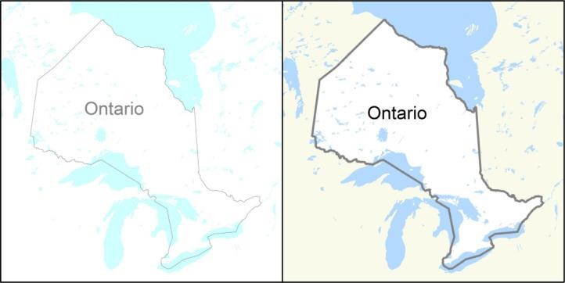
Contrast can be measured using a formula that will compare two colours and provide the result as a ratio. Contrast ratios can range from 1 to 21 (commonly written 1:1 to 21:1). Black objects on a black background would have a contrast ratio of 1:1, while black objects on a white background will have a contrast ratio of 21:1.
There are a number of resources available online to determine the contrast ratio between two colours. See the Contrast Resources section below for example resources.
In general terms, a map designer should carefully consider what the map is communicating to ensure that this information is successfully differentiated from the supporting, or context, information. Contrast is an important design consideration in achieving this.

Contrast and Type
The legibility of lettering on a map depends on the amount of visual contrast between type and its background. As mentioned above, black objects, or text, on a white background will have the highest contrast ratio. Other colour combinations will also result in acceptable contrast ratios. Regardless of the colour of the print and of the ground, if the value contrast is great, the lettering will be visible (Robinson, 1995, p. 414).
Five-point type is the lower limit of visibility for the average person (Robinson, 1995, p. 412) and cartographers will often use 5.5 point or 6.0 point type as a lower limit.
- An example of 5 point type.
- An example of 6 point type.
- An example of 8 point type.
- An example of 10 point type.
For people with vision impairments five-point font may not be sufficient even before contrast is considered. This can create a challenge for the map designer because traditionally maps use small font sizes as a way of including relevant information a map.
The American Printing House for the Blind lists the following type sizes in the AHP Guidelines for Print Document Design (Kitchel & APH, APH Guidelines for Print Document Design, n.d.):
- 12 point type is considered regular print
- 14-16 point type is considered “enlarged” print (not large print)
- 18 point type and larger is considered large print
- 18 point and larger type, with other formatting changes is considered enhanced print
It will be difficult for map designers to create detailed maps with 12 point type and larger. Typefaces with larger x-heights will appear more legible at smaller sizes. See the section on Font Selection for detailed information and accessibility recommendations related to fonts.
People with low vision often have difficulty reading text that does not contrast with its background. This can be exacerbated if the person has a color vision deficiency that lowers the contrast even further. Providing a minimum luminance contrast ratio between the text and its background can make the text more readable even if the person does not see the full range of colors. It also works for the rare individuals who see no color (WCAG 2.0, n.d.).

WCAG Contrast Compliance for Text
Most standards only have one level of compliance to meet standards. The Web Content Accessibility Guidelines 2.0 (WCAG 2.0), however, uses three different levels of compliance to accommodate different situations that may require or allow greater levels of accessibility than others. For contrast, the intent of the WCAG 2.0 guidelines is to provide enough contrast between text and its background so that it can be read by people with moderately low vision. The three levels of compliance within the standard are defined as follows:
Level A - 3:1 contrast ratio
- A contrast ratio of 3:1 is the minimum level recommended by [ISO-9241-3] and [ANSI-HFES-100-1988] for standard text and vision.
Level AA - 4.5:1 contrast ratio
- The contrast ratio of 4.5:1 was chosen for level AA because it compensated for the loss in contrast sensitivity usually experienced by users with vision loss equivalent to approximately 20/40 vision. (20/40 calculates to approximately 4.5:1.) 20/40 is commonly reported as typical visual acuity of elders at roughly age 80.
Level AAA - 7:1 contrast ratio
- The contrast ratio of 7:1 was chosen for level AAA because it compensated for the loss in contrast sensitivity usually experienced by users with vision loss equivalent to approximately 20/80 vision.

WCAG Contrast Guidelines for Text
The World Wide Web Consortium (W3C) recommends in the WCAG 2.0 guidelines that the visual presentation of critical text and images of text have the following text to background contrast ratios (WCAG 2.0, n.d.):
WCAG 2.0 Guideline 1.4.3 Contrast (Minimum)
- Use a contrast ratio of 4.5:1 for regular sized text
  - The WCAG 2.0 guidelines do not define regular sized text in points.
  - The American Printing House for the Blind defines 12 point text as regular print.
- Use a contrast ratio of 3:1 for large text at least 18 point or 14 point bold or font size
  - Text that is larger and has wider character strokes is easier to read at lower contrast. The contrast requirement for larger text is therefore lower. A contrast ratio of 3:1 for large text is judged to be large enough to require a lower minimum contrast ratio.
WCAG 2.0 Guideline 1.4.6 Contrast (Enhanced)
- Use a contrast ratio of 7:1 for regular sized text
  - The WCAG 2.0 guidelines do not define regular sized text in points.
  - The American Printing House for the Blind defines 12 point text as regular print.
- Use a contrast ratio of 4.5:1 for large text (at least 18 point or 14 point bold or font size)
  - Text that is larger and has wider character strokes is easier to read at lower contrast. The contrast requirement for larger text is therefore lower. A contrast ratio of 4.5:1 for large text is judged to be large enough to require a lower enhanced contrast ratio.

Examples of Contrast Ratios for Greyscale Text and Backgrounds
The following graphic table illustrates different ranges of contrast ratios for greyscale text on greyscale backgrounds. The examples illustrated use the CMYK colour model.
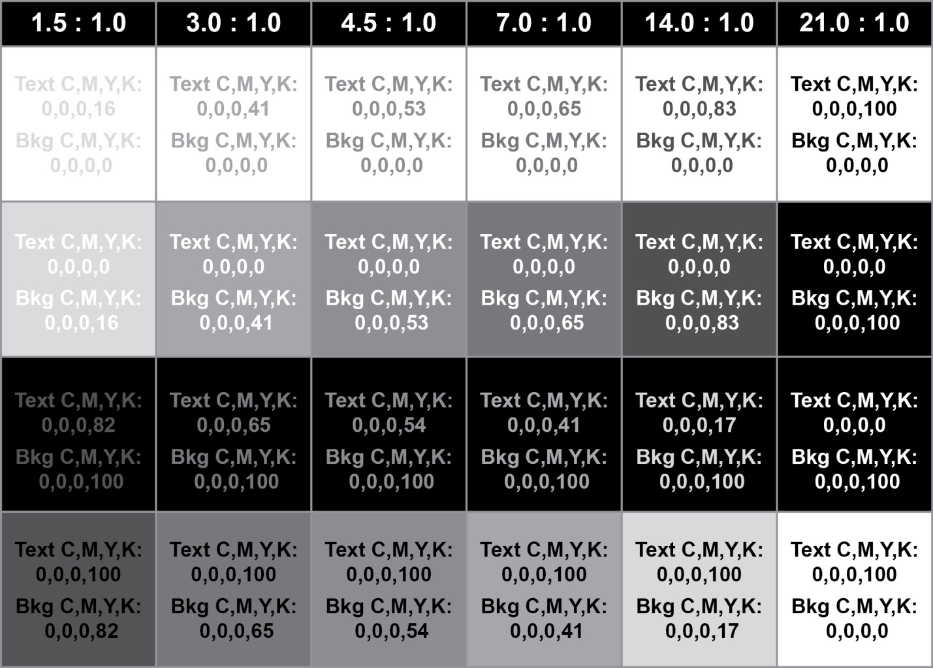
See Appendix C for additional tables illustrating both greyscale and colour examples of text and background colour when calculated for compliance against the three different levels of contrast as defined by WGAG 2.0.

Contrast and Type Size for Maps
Map designers should use the largest type sizes possible, consistent with good design. This will vary from map to map depending on the amount of detail required and space available for text placement. Because of this, it is recommended that non-essential features be labelled selectively, or sparingly, to ensure that crucial features can be labelled as large as possible. Map designer should try to achieve an appropriate contrast ratio between essential text and backgrounds. Smaller text requires a higher contrast ratio than larger text.
- Text greater than 12 points in size may have a contrast ratio of 3:1
- A contrast ratio of 4.5:1 or greater should be used for regular sized text between 7 and 12 points.
- Contrast ratios greater than 7:1 are best for small text, less than 7 points in size that, relate to essential map content.
Non-essential map content may not require the contrast ratio to be as high as the contrast ratio recommendations listed above for essential content. The map designer will have to use good judgement to determine the difference between essential and non-essential map content.
Meeting contrast ratio criteria to ensure labels and annotation meet WCAG 2.0 standards could be a challenge for the cartographer. However, there are design techniques that can aid the cartographer in creating legible maps including: halos, highlights, spacing, and figure/ground adjustments.
Using a halo around text to provide the necessary contrast ratio is a method that can be used if the background colour is not sufficiently different in relative luminance (WCAG 2.0, n.d.). Halos around text are used to provide emphasis or increase legibility, particularly on highly saturated and complex backgrounds (Peterson, 2012).

Map Examples
The following is an example of Label text on a complex background without a text halo. The label is difficult to read because of the multi-coloured background has areas of insufficient contrast and the label gets lost in the complex background.
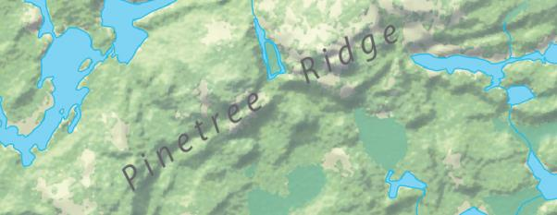
Using a halo for text overlaying complex backgrounds or patterns can improve accessibility, but can also detract from the overall design of the map and must be used with care. Halos should be as small as possible, but sufficient enough to provide appropriate contrast. The white halo in the example below is too small and the label is still difficult to read.
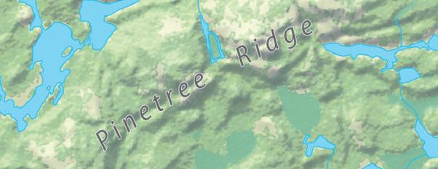
The white halo in the example below gives the label sufficient contrast, but the halo is too large and distracting. The contrast ratio between the text and the halo colour in this example is 10.5:1.
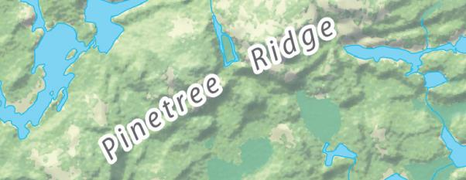
The colour of the halo should also be considered. The white halo in the example below has an acceptable weight, but the white colour stands out too much from the background and is somewhat distracting.
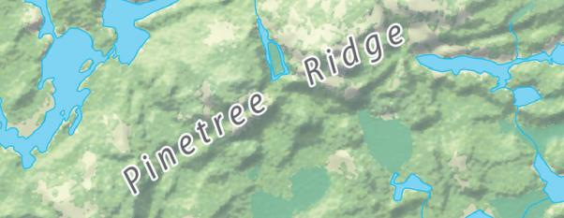
Matching the halo to a colour in the background, without changing the meaning of the data shown is preferable as in the example below. The contrast ratio in this example is 9.3:1.
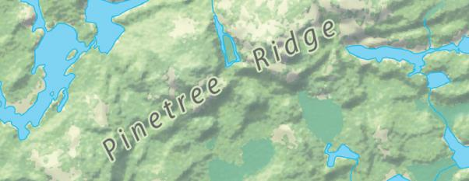
The alternative to using halos is to lighten the background and not use a halo as in the example below. The contrast ratio in this example is approximately 9.9:1.
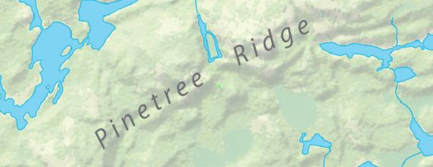
The letter spacing on the examples above has also been adjusted to aid legibility. Not crowding labels and annotation on an appropriate coloured background, makes text more readable and useful because it provides contrast and creates luminance around the text (Kitchel & APH, APH Guidelines for Print Document Design, n.d.).

Contrast for Lines and Areas
Much like type, lines and areas will also require sufficient contrast to communicate the intended message. Using the WCAG 2.0 Guidelines will ensure lines over background colours or adjacent areas will have appropriate contrast ratios. However, in some cases using these guidelines will unnecessarily limit the map designer. The WCAG 2.0 Guidelines for contrast were created for text on backgrounds, not lines over areas. The guidelines state that large text is judged to be large enough to require a lower minimum contrast ratio. This would also be the case for lines and areas over a certain size.

Contrast for Lines Over Background Colours
Although no resources were found relating to colour contrast between lines and areas during the jurisdictional scan, contrast must still be considered. Stroke widths for a number of accessible sans-serif fonts were compared at various point sizes to help estimate reasonable contrast ratios for line work based on the WGAG 2.0 guidelines. One point is equal to 0.35 mm or 1/72 inch. See Appendix D for details. The results were as follows:
- The average stoke width of the 12 point fonts was approximately 1.0 points
- The average stoke width of the 14 point bold fonts was approximately 2.0 points
- The average stoke width of the 18 point fonts was approximately 1.5 points
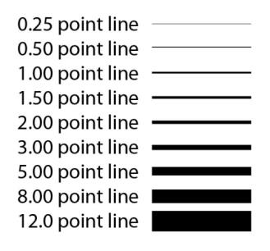

Contrast Ratio for Lines
Using the average font stoke widths and font point sizes, contrast ratios for essential map content were determined based on the WGAC 2.0 guidelines. Non-essential content may not require the contrast ratio to be as high as the following recommendations:
- A contrast ratio of 7:1 should be used for essential content lines under 1.0 point in thickness.
- A contrast ratio of 4.5:1 should be used for essential content lines between 1.0 and 2.0 points in thickness.
- A contrast ratio of 3:1 should be used for essential content lines greater than 2.0 points in thickness.

Examples of Contrast Ratios for Greyscale Lines on White Backgrounds
The following graphic table illustrates different ranges of contrast ratios for greyscale line on a white background. The examples illustrated use the CMYK colour model.
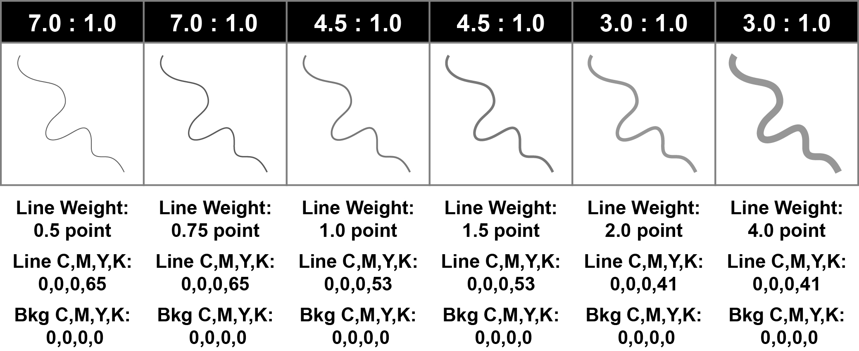

Recommended Guidelines for Contrast
- Visual colour contrast, between foreground and background features is vital. Ensure that essential map content has a greater contrast ratio to its surroundings than contextual map content.
- Try to achieve an appropriate contrast ratio between essential text and backgrounds. Smaller text requires a higher contrast ratio than larger text.
  - Text greater than 12 points in size should have a contrast ratio of 3:1
  - A contrast ratio of 4.5:1 or greater should be used for regular-sized text considered to be between 7 and 12 points.
  - Contrast ratios of 7:1 or greater are best for smaller text less than 7 points in size that relate to essential map content.
  - If necessary, use a halo around the text to achieve an appropriate contrast ratio. Matching the halo to the background, without changing the meaning of the data shown is preferable.
  - Contextual or non-essential map content does not require the contrast ratio to be as high as the contrast ratio recommendations for essential content.
- When placing text, use the largest type sizes possible, consistent with good design.
  - Typefaces with larger x-heights will appear more legible at smaller sizes.
  - Label non-essential features sparingly to ensure that crucial features can be labelled as large as possible.
  - Certain digital formats of maps, such as PDF or SVG will allow users to enlarge, or zoom into the map content without losing resolution.
- Try to achieve at least an appropriate contrast ratio between lines depicting essential content and the backgrounds they overlap. Thin lines require a higher contrast ratio than thick lines.
  - A contrast ratio of 7:1 should be used for essential content lines under 1.0 point in thickness.
  - A contrast ratio of 4.5:1 should be used for essential content lines between 1.0 and 2.0 points in thickness.
  - A contrast ratio of 3:1 should be used for essential content lines greater than 2.0 points in thickness.
  - Non-essential content may not require the contrast ratio to be as high as the contrast ratio recommendations for essential content.

Contrast Resources:

Understanding WCAG 2.0
This resource is a guide to understanding and implementing the Web Content Accessibility Guidelines version 2.0. Guideline 1.4, Distinguishable, has information about understanding and testing contrast for the visual presentation of text and images of text.

Colour Contrast Analyser
The Colour Contrast Analyser helps determine the legibility of text and the contrast of visual elements. The tool provides a pass/fail assessment against WCAG 2.0 colour contrast success criteria and a simulation of certain visual conditions, including dichromatic colour-blindness and cataracts, to demonstrate how content appears to people with less than 20/20 vision.

Colour Contrast Check
The Colour Contrast Check Tool allows users to determine if a specified foreground and background colour provide enough of a contrast when viewed by someone having colour deficits or when viewed on a black and white screen.

Colour

Background
For many years, colour has been a very useful attribute for depicting different features within a map and improving the comprehension of mapped information (Robinson, 1995, p. 381). Displaying spatial data in different hues can greatly affect the understanding or overall impression that a map communicates. In some instances, colours used on a map will have a relationship to the object or feature that they represent. For example, blue is almost always used for hydrographic or water features (Rosenberg, n.d.). When various features on a map are carefully colour coded a map can become much easier to interpret (Robinson, 1995, p. 381).
Creators of map content should also ensure that the colours used to depict different key features are also as distinguishable as possible for individuals with vision disabilities. Both individuals with colour vision deficiency (CVD), or colour blindness, and those with low vision will have difficulty with perception of certain aspects of colour and colour combinations.

Colour Accessibility
Colour accessibility ensures that information is legible for as wide an audience as possible. Where and how colour is used is important. A map that has areas, lines, point symbols and text of hastily chosen colour hues can be very difficult to interpret by most map users regardless of ability. It is important for the map designer to consider how different coloured features could appear to someone with a vision disability. Designing maps for people who are partially sighted or for people with colour deficient vision is an interesting cartographic challenge centered on judicious colour and pattern selection (Robinson, 1995, p. 400).
Adjusting colour schemes to meet the needs of the widest audience possible is not always simple and forces the cartographer to reassess well-established conventions (Jenny, 2007, p. 67). In some circumstances map designers may be unable to change a colour scheme where pre-defined colours or standards have been established. In these instances, additional techniques can be used to great effect for overcoming colour accessibility challenges (DPCD, 2011), such as annotating the map directly where users with vision disabilities might be confused. (Jenny, 2007, p. 67).
When adjusting a color scheme, the cartographer has to find a balance: On one side, the minority of people who are vision impaired have the right of equal access to information. On the other side, the majority of the population with normal vision has the right for pleasant maps that are easy to read. It is the cartographer’s responsibility to adjust colours where judged appropriate (Jenny, 2007, p. 67).
Cynthia Brewer, in Designing Better Maps: A Guide for GIS Users, suggests colour combinations that are less confusing for people with the most common types of colour blindness. The actual colour used is not important except where an actual meaning is attached to the colour (Brewer, 2005).
Hue pairs, as suggested by Brewer, which are not confused by people with the most common type of colour blindness (red-green) are:
- red and blue
- red and purple
- orange and blue
- orange and purple
- brown and blue
- brown and purple
- yellow and blue
- yellow and purple
- yellow and gray
- blue and gray
Brewer makes the following suggestions for accommodating readers with red-green colour blindness:
- Vary the lightness on the red-orange-yellow end of the rainbow;
- Omit yellow-green to avoid confusion with orange; and
- For bipolar data, omit green and use a scheme with red, orange, yellow, light blue and dark blue and align the yellow-blue transition with the pivot point of the diverging data range.
Colours such as red/green and blue/purple are easily confused by people with colour blindness; however, other colour combinations can also be problematic. Testing for colour legibility is important.
There are a number of tools and techniques available that assist the map maker in choosing colour combinations.
The following examples used the Vischeck Photoshop plugin in Photoshop CS2 to simulate protanopia, deuteranopia and tritanopia using the default settings:
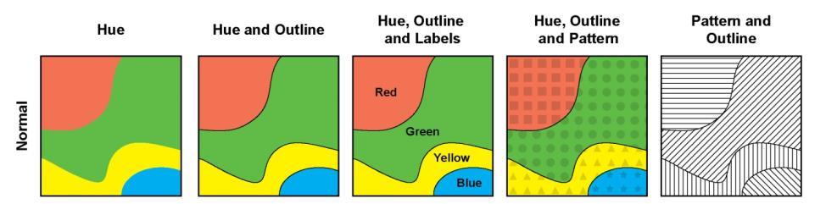
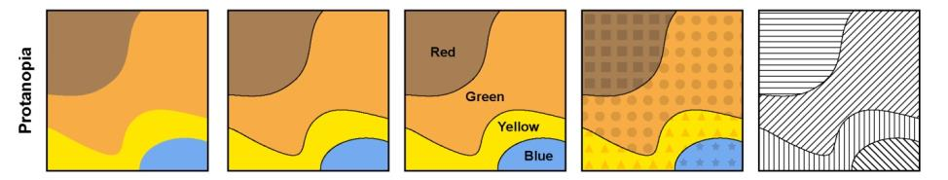
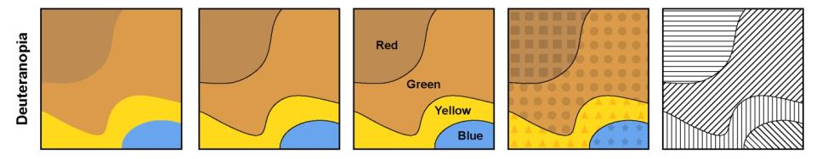
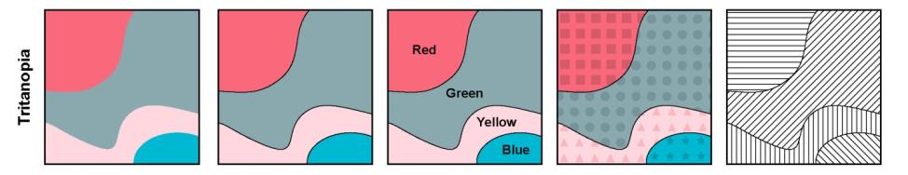
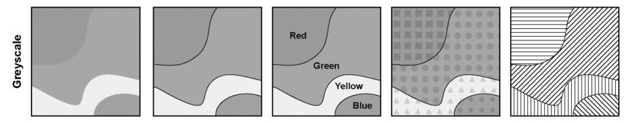
See the Colour Resources and Tools section below for other resources.
It is important to select colours that vary significantly in lightness, since all individuals with a colour vision deficiency can perceive lightness differences (Robinson, 1995). Using a colour contrast analyser would also be useful especially when placing text. See the Contrast section for details and resources.
In cases where the complexity of the map prevents it from being colour accessible, ensure colour is not the sole means of distinguishing the feature. The World Wide Web Consortium (W3C) also recommends that colour is not used as the only visual means of conveying information, or distinguishing a visual element (WCAG 2.0, n.d.). To avoid problematic colour combinations, the cartographer should use colours with strong contrast and supplemental visual variables, such as shape, size, and pattern variations to allow all readers to discern and directly interpret a symbol without consulting a legend (Jenny, 2007, p. 67).
Simplification of the map design and limiting the use of colour to key components of the map’s intended message will also improve comprehension.
Alternative formats of sharing the key information should be considered if a map is too complex to be fully accessible. See the Alternative Formats and Map Descriptions and Colour Verification Techniques sections of this document for more details.

Recommended Guidelines for Colour:
- Keep map design simple and limit the use of colour to key components of the map’s intended message.
- Select colours that vary significantly in lightness (contrast), since individuals with a colour vision deficiency can perceive lightness differences.
- To avoid problematic colour combinations, use colours with strong contrast and supplemental visual variables, such as shape, size, and pattern variations to allow all users to discern different features.
- Consider annotating the map directly where users with vision disabilities might be confused.
- Testing for colour legibility is important. There are many techniques and resources available online for testing and simulating colour legibility.
- If the complexity of the map prevents it from being colour accessible use an alternative format or method of sharing the information, or consider presenting the information in multiple maps.

Colour Resources and Tools

ColorBrewer
ColorBrewer, created by Cynthia Brewer, is a tool for selecting colour schemes for thematic maps. It lists colour specs for a scheme so the cartographer is able to create the colours in the mapping software being used. ColorBrewer provides an option to show “colour blind safe” colour schemes that will not confuse people with red-green colour blindness, “photocopy safe” colour schemes that withstand black and white photocopying and “LCD projector friendly” colour schemes that indicate successful colour schemes that can stand up to the washed-out appearance of projected images.

Color Oracle
Color Oracle is a free colour blindness simulator for Windows, Mac and Linux. It shows, in real time, what people with common forms of colour blindness will see. It provides a full-screen colour filter to what the map you are designing on your screen – independently of the software used. “Color Oracle simulates deuteranopia, protanopia, and tritanopia which are the “pure” forms of color vision impairment. While there are varying degrees of colour blindness it is accepted that results would be similar to those of the pure forms. Color Oracle does not choose colours either but allows users to verify that colours on a map are legible.

Vischeck
Vischeck is also a colour simulator available online by uploading an image or as an application that you can download to run on your computer. Vischeck allows you to see your colour choices as a colour blind person would.

Colour-Deficient Colour Palette
Through the Mapping Centre, Esri has made available a colour palette for the colour-deficient that is in compliance with the Americans with Disabilities Act (ADA). The colour palette helps in making accessible map colour choices keeping in mind the needs of the colour blind user or viewer. This is mainly applicable to maps shown in digital displays.

Colour Verification Techniques

Greyscale Test
Doing a greyscale test may help determine if a map can be read by people who are colour blind. If a map is clear when either printed in gray-scale or photocopied, chances of it being colour accessible are relatively high. Use of this resource is appropriate when other tools are not available or only a hard copy of a map is available.

Style and Patterns

Background
Map features, both base and thematic, can be symbolized in a variety of ways. Style and pattern are two considerations when developing map symbology. Style refers to the physical characteristics of a symbol. Pattern is how these physical characteristics are used together.
How a symbol is constructed will play an important role in how information is interpreted. Point, line and area features are the basic graphic elements used to build pictorial representations for all visual designs. Points mark location; lines mark location and direction; areas mark location, direction and extent.
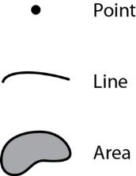
There are a number of visual variables that can be used to create map symbology. These include: hue, value (lightness), chroma (colour purity), shape, size, orientation, texture and arrangement (Robinson, 1995, pp. 319-321). Examples of visual variables are shown below for point, line and area features:
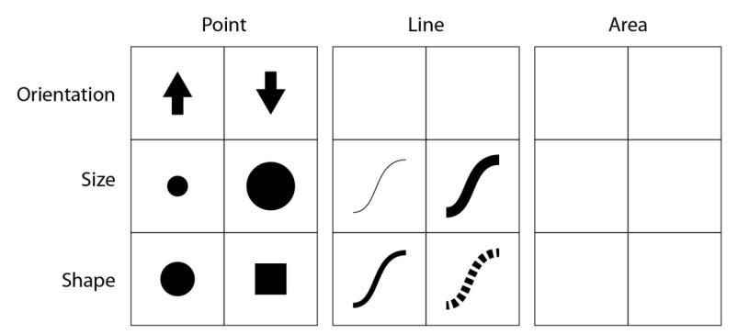
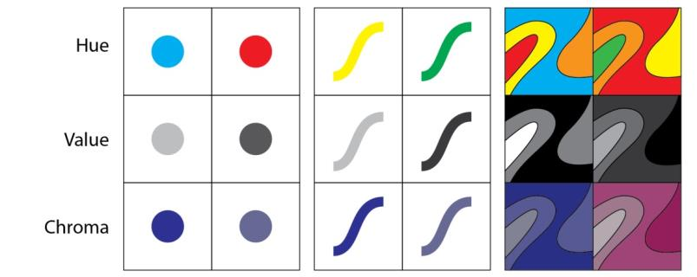
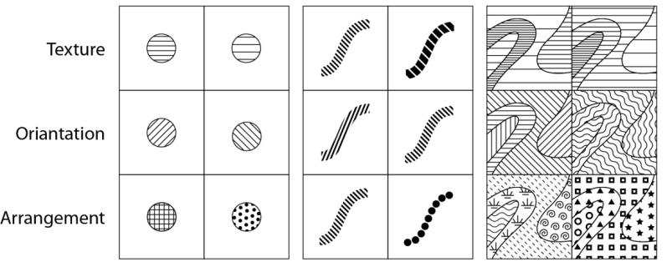
Style includes form (shape of a symbol), orientation and dimension. Whether or not thematic data being symbolized is qualitative or quantitative is an importation consideration. Quantitative thematic maps portray numerical information and qualitative thematic maps show the location or spatial distribution of information. Quantitative or qualitative information can affect how symbology is developed.

Qualitative Information
Nominal visual variables are effective for emphasizing differences in kind, or qualitative differences. The four visual variables that illustrate nominal differences are: hue, shape, arrangement and orientation.
Considerations for symbolizing qualitative or nominal information include:
- Ensure size, density or colour of marker symbols, lines or area patterns do not create an implied visual hierarchy. For example, a graduated colour ramp may imply value which would not be appropriate when only showing location of features or spatial distribution
- Use different shapes or icons for point data

Quantitative Information
Ordinal visual variables are effective for depicting differences in amount, or quantitative differences. The visual variables that illustrate ordinal differences are: value, chroma, size and spacing.
Considerations for symbolizing quantitative or ordinal information include:
- Keep symbol design simple.
- When using marker symbols, show value by adjusting size, density or colour.
- Colour can be used. For example, a graduated colour ramp implies value.
- Test colours for accessibility using the guidelines in this document.

Point Symbols
Point or marker symbols can be used alone or they can create a line or area pattern. A point symbol can be a simple marker (geometric shape), character glyph, arrow or a picture. When used alone, marker symbols should be simple and clear.
Considerations for point symbols include:
- Symbols should be easily distinguished from the background and other symbols.
- Use size to ensure symbols are clear and obvious.
- If colour is used, the recommended guidelines for colour apply and the symbol should be tested for accessibility with regard to users with colour visual impairment.
- The symbol should be simple, particularly for picture symbols.
- Take into account how a symbol looks when zooming in and out.
- Design of a symbol set should not imply value or a hierarchy unless it is intended.
- A halo can be applied to provide clarity, although creating a layered symbol should be considered before using a halo. Halos should be considered a last resort.
- If the orientation of a symbol is used to depict classes or types, the difference should be great enough to be clear. Similar (but different) symbols may be difficult for users with cognitive impairment to interpret.

Line Symbology
Point or marker symbols can also be used to create a line symbol. This involves repeating the symbol along a line or throughout an area. The symbol can be a simple marker, character glyph, arrow or a picture.
Considerations for line symbology include:
- They should be easily distinguished from the background and other symbols.
- Use size to ensure symbols are clear and obvious.
- Layering can be used to create different line symbols.
- If colour is used, the recommended guidelines for colour apply and the symbol should be tested for accessibility with regard to users with colour visual impairment.
- The symbol should be simple, particularly when it includes a picture symbol.
- Design of a symbol set should not imply value or a hierarchy unless it is intended.
- When line weight is used to depict different classes or types, they should be different enough to be clear and obvious.
- Line styles created from repeating marker symbols (i.e. dots, dashes, pictures) should be simple. The marker symbol should be clear and obvious.
- How the line appears when zooming in and out should be considered.
- Consider the line as a whole and assess how the components that make up the line work together.
- Pay particular attention to short line segments.
- Simple is best when developing a line style.

Pattern Symbology
Point, or marker symbols and lines can be used to create a pattern. Patterns are often used for area features. Area patterns can be used to symbolize area features with varying degrees of success. Area patterns can be noisy and result in a lack of clarity. They often do not work well on more complex maps or when symbolizing smaller areas.
Considerations for patterns include:
- Patterns should not take away from the overall message of the map.
- When creating an area pattern using marker symbols, consider the complexity of the symbol, its size, colour and spacing.
- If colour is used, the recommended guidelines for colour apply and the symbol should be tested for accessibility with regard to users with colour visual impairment.
- When using lines to create an area pattern, consider line weight, size, spacing and colour.
- Make sure the pattern is scalable.
- Keep the pattern as simple as possible, especially when symbolizing small areas.
- Consider how the pattern interacts with the rest of the map elements.
- The “look” of an area pattern can imply a value or hierarchy unintentionally especially when zooming in and out. Be aware of this when symbolizing quantitative data.

Recommended Guidelines for Style and Patterns:
- Symbology should be easily distinguishable from backgrounds and other symbols.
- Point, line and area symbols should not imply a hierarchy unless intended.
- If colour is used, the recommended guidelines for colour apply and the symbol should be tested for accessibility with regard to users with colour visual impairment.
- Styles created using marker symbols should be simple and scalable.
- Keep the pattern as simple as possible, especially when symbolizing small areas. Patterns should not take away from the overall message of the map.

Font Selection

Background
The selection of typefaces and fonts used on a map product play an important role in the communication of information. Labels, annotation and blocks of text within a map enhance the ability of a map user to understand information and distinguish features.
A well-chosen font will ensure that characters and words can be read quickly and effectively by as large an audience as possible. The anatomy of type can greatly affect the readability or accessibility of a font or typeface. This section concludes with Recommended Sans-Serif Fonts. Refer to Appendix E for a glossary of type anatomy terms with descriptions.

Legibility and Readability
Legibility and readability affect the accessibility of content. The legibility of a font is determined by the specific typographic traits which affect the recognition of letters and words. For accessibility the upper case “I”, the numeral “1”, and the lower case “l”, ideally should all look different from one another.
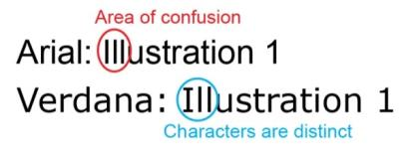
The legibility of individual letters is important in cartography because the map may use different backgrounds, textures, or colours that can make letters difficult to distinguish (Dent, 1993, p. 289).
Readability refers to the clarity and speed with which content can be digested over an expanse of text, such as a paragraph or a page (RGD Ontario, 2010). However, reading type in continuously, spaced lines is very different from reading isolated names on a map (Robinson, 1995, p. 411). How a typeface is designed will impact legibility, readability and influence overall accessibility.

Complexity
Complexity in typography creates noise and confusion for low vision audiences. For text, a readable typeface means a sans-serif typeface (or font) made up of mainly straight lines. A serif is a short stroke that projects from the ends of the main strokes that make up a character.
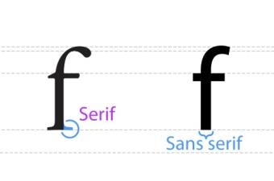
Traditionally, cartographic design has used both serif and sans-serif fonts for different applications. Although there is some debate over the general readability of serif versus sans-serif typefaces for people without vision impairments (Poole, 2008), the simplicity of sans-serif typefaces are widely preferred over typefaces with serifs (AIGA, 2006) (MNRF, 2015), including people with dyslexia (iansyst Ltd., n.d.) (UXM, 2011).
The map designer should avoid complicated, cursive and decorative fonts (WebAIM, n.d.) and choose typefaces that have easily recognizable letterforms (CNIB).

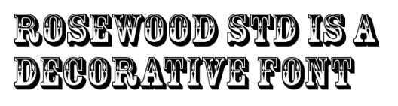

Shape and Weight
Letterforms are created with positive and negative shapes. The positive shape is referred to as the form or stroke; the negative shape is called the counterform or counter. For accessibility, letters with closed counters, such as b, o, d, g, and others should have plenty of space inside the counter.
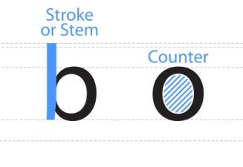
The relationship between stroke and counter determines letter recognition. If a letter has extremely thick strokes with small counters, it takes longer for the eye to decode.
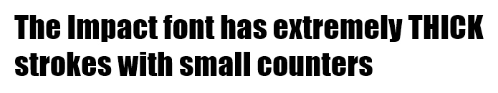
The same is true if it has thin strokes with large counters.
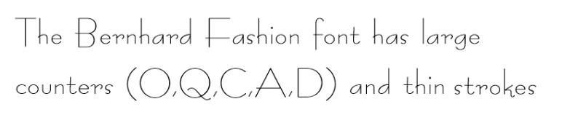
Typefaces with consistent stroke widths, open counterforms, pronounced ascenders and descenders and slightly wider horizontal proportions and distinct forms for each character will improve legibility for people with vision impairments.
Extended horizontal strokes for certain letterforms (such as the arm of the lowercase letter “r” or the crossbar of the lowercase letter “t”) will also improve overall legibility.
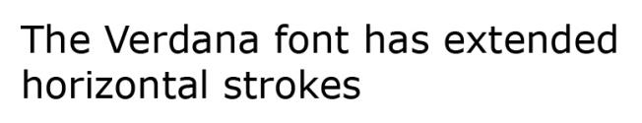
The most legible fonts have a well-balanced proportion of form, or stroke, and counterform. Regular or medium font weight will generally be preferable to an extra bold or ultra-light font (RGD Ontario, 2010).
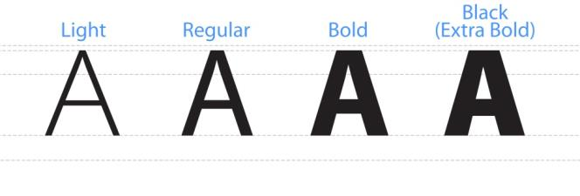
Fonts with extraordinarily thin strokes or unusual features and characteristics that reduce the familiarity of their letter forms are harder to read, especially at lower contrast levels (W3C, 2015).

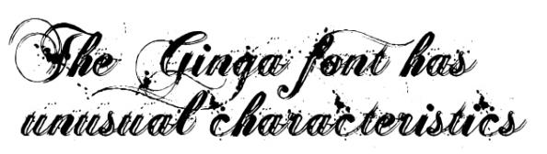

Upper and Lowercase
Many users rely on the shape of words, rather than parsing individual letters. The ascenders and descenders found in lower-case letters provide word shape, causing mental reading clues to speed up the comprehension process (MNRF, 2015). However, type on maps is mainly used for unfamiliar names which must fit in given spaces (Robinson, 1995, p. 411). The use of mixed-case letters for segments of map annotation and labels with multiple words, or blocks of text, should improve overall readability. Continuous text in large caps is difficult to read (WebAIM, n.d.) for any length of time, due to the crowding effect (Kitchel & APH, APH Guidelines for Print Document Design, n.d.). For mapping, however, capitalized content can help distinguish different types of features (e.g., ID codes, primary/secondary features), but should be used only if necessary. For accessibility, choose standard, readily-available fonts with easily recognizable upper- and lower-case characters (CNIB).
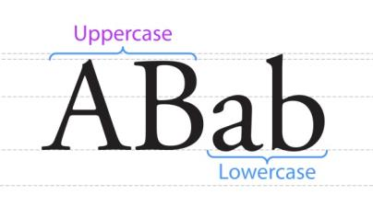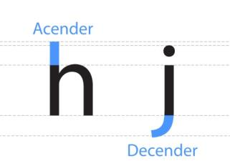
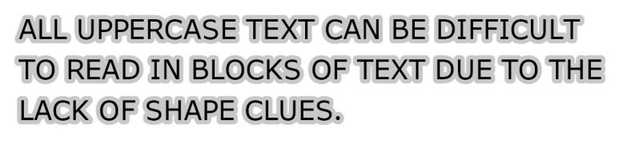
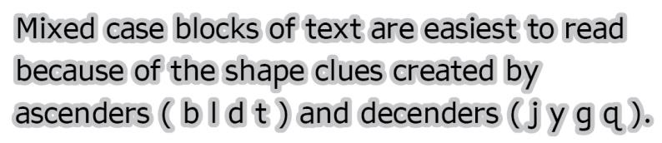

Italics
While roman or normal fonts are upright, italic fonts slant to the right. But rather than being just a slanted or tilted version of the roman font, a true or pure italic font is drawn from scratch and has unique features not found in the roman face (TypeDecon, n.d.).
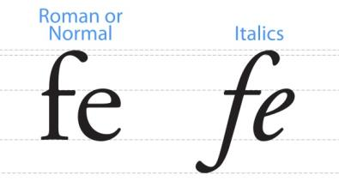
The italic character style can be more difficult to read (CNIB) (UXM, 2011) than regular, or roman fonts. Italicized letters lean into the territories of their neighbors making them more difficult to read (Kitchel & APH, APH Guidelines for Print Document Design, n.d.). The output of angled characters on a digital screen with poor resolution can also make words difficult to read (MNRF, 2015). The illustration below shows examples of enlarged screen output of both roman and italic fonts.
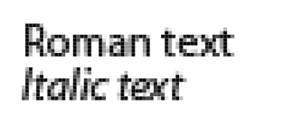
However, cartographic convention traditionally uses italic fonts to add emphasis or distinguish different features (ICSM, n.d.). Traditionally hydrography, landform and other natural features have been labelled in italic or slant, while cultural features, created by humans, are labelled in upright or roman forms (Robinson, 1995, p. 409). Using Italics to label water features is clearly a strong cartographic convention (Robinson, 1995, pp. 409,410).
For accessibility purposes italics should be limited, if possible. If italic fonts are used, ensure that they have significant shape, weight, scale, size and are not overly crowded.

Scale
The scale of a letterform is defined by a number of proportional factors. The relative size of a typeface can be described in terms of its x-height, or by taking the lowercase "x" as a measure of all lowercase letters, excluding ascenders and descenders (RGD Ontario, 2010). Generally speaking, the higher the x-height in relation to a capital letter, the more legible the font is likely to be (PennState, n.d.). Accessible typefaces usually have a medium to large x-height. Typefaces with larger x-heights will appear more legible at smaller sizes.
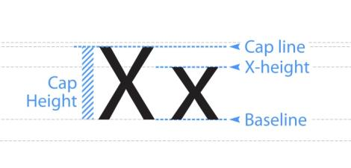
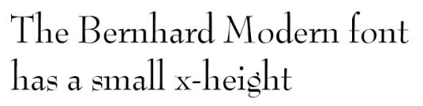
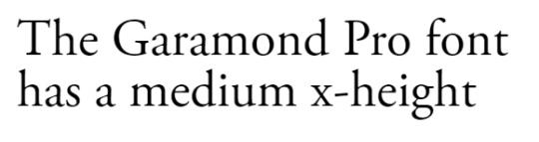
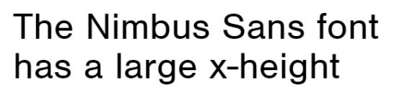

Size
When it comes to type size for accessibility bigger is usually better (CNIB). The size of type, which refers to its height on a printed page, is commonly designated by points. One point is about 0.35 mm or 1/72 inch (Robinson, 1995, p. 410). For standard documents it is recommended that a font point size between 12 and 18 (CNIB) be used. The American Printing House for the Blind lists the following type sizes in the AHP Guidelines for Print Document Design (Kitchel & APH, APH Guidelines for Print Document Design, n.d.):
- 12 point is considered regular print
- 14-16 point is considered “enlarged” print (not large print)
- 18 point and larger is considered large print
- 18 point and larger, with other formatting changes is considered enhanced print
This can be a challenge when designing cartographic products at a given map scale that can require text to be limited to a specific area. Five-point type is the lower limit of visibility for the average person (Robinson, 1995, p. 412) and cartographers often used 5.5 point or 6.0 point type as a lower limit. For people with vision impairments five-point font may not be sufficient.
Font point size should be as large as possible, while ensuring that text can still be associated with the features they describe and be consistent with good design (Robinson, 1995, p. 413). This will vary from map to map depending on the amount of detail required and space available for text placement. Size can also imply a hierarchy in the data and the message the map designer wants to convey. Keep this in mind when planning label sizes. It is recommended that non-essential features be labelled selectively, or sparingly, to ensure that crucial features can be labelled as large as possible.

Examples of point Sizes
One point is approximately 0.35 mm or 1/72 inch.
5 Point Arial Normal
6 Point Arial Normal
8 Point Arial Normal
10 Point Arial Normal
12 Point Arial Normal
14 point Arial Bold
16 point Arial Normal
18 Point Arial Normal
20 Point Arial Normal
28 Point Arial Normal
Certain electronic formats of maps, such as Portable Document Format (PDF) or Scalable Vector Graphics (SVG) will allow users to enlarge, or zoom into the map content without losing resolution, which will be beneficial for accessibility purposes.
The following example illustrates the difference when zooming into a vector file format, such as a PDF file, versus zooming into a raster file format, such as a JPG file. The vector file format maintains the sharpness and quality of the product while the clarity of raster file format begins to degrade.
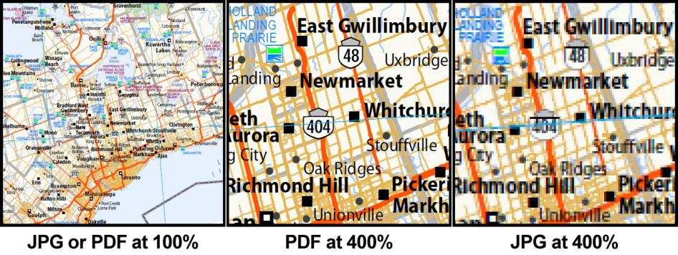

Letter and Word Spacing
Text that has crowded letter spacing is more difficult to read (CNIB). Spacing of both letters and words is especially important in cartography because lettering can be stretched across map spaces to occupy geographical areas (Dent, 1993, p. 284). Ensure that letter spacing is adequate when adding text to a map and do not crowd letters or words.
This is an example of
normal letter spacing.
This is an example of
stretched letter spacing.
This is an example stretched letter and word spacing.
This is an example of crowded, condensed
letter spacing that is difficult to read.

Colour and Contrast
Colour and contrast will also play a part in how well text can communicate and be interpreted by those individuals with visual impairments. Try to achieve at least a 4.5:1 contrast ratio between text and backgrounds. Using a halo around the text or labels to achieve an appropriate contrast ratio, if necessary, is acceptable. See the respective sections of this document for more information on these two considerations.

Recommended Guidelines for Font Selection
- Choose a sans-serif typeface that is simple with well-proportioned, easily recognizable letterforms.
  - The simplicity of sans-serif typefaces are widely preferred over typefaces with serifs for most vision impairments.
  - Use serif typefaces sparingly. Adjust size, letter spacing and weight to improve legibility.
  - Avoid complicated, decorative or handwriting fonts.
- Limit the use of italics.
  - Cartographic convention traditionally uses italic fonts to add emphasis or distinguish different features.
  - Ensure that any italic fonts used have appropriate shape, weight, scale, size and are not overly crowded.
- Choose a regular or medium weight typeface which will generally be more legible than an extra-bold or ultra-light typeface.
- Choose a typeface with consistent stroke widths, open counterforms, pronounced ascenders and descenders, slightly wider horizontal proportions and distinct forms for each character.
- Use the largest type sizes possible, consistent with good design.
  - Type size will vary from map to map depending on the amount of detail required and space available for text placement.
  - Non-essential features should be labelled selectively, or sparingly, to ensure that crucial features can be labelled as large as possible.
- Choose a typeface with a medium to large x-height.
  - The higher the x-height in relation to a capital letter, the more legible the font is likely to be.
  - Typefaces with larger x-heights will appear more legible at smaller sizes.
- Try to achieve at least a 4.5:1 contrast ratio between essential text and backgrounds.
  - Using a halo around the text or labels to achieve an appropriate contrast ratio if necessary is acceptable.
  - Matching the halo to the background, without changing the meaning of the data shown is preferable.
- If colour is used, the recommended guidelines for colour apply and the symbol should be tested for accessibility with regard to users with colour visual impairment.

Examples of Accessible Typefaces
The following is a table of fonts that have been recommended on various websites relating to accessibility (CNIB) (PennState, n.d.) (WebAIM, n.d.) (iansyst Ltd., n.d.) (Kitchel & APH, APH Guidelines for Print Document Design, n.d.). This is not an exhaustive list and there are other fonts that will meet accessibility guidelines.

Recommended Sans-Serif Fonts
Recommended Font Name | CNIB | APH | WebAIM | Penn State | dyslexic.com
Andika |  |  |  | Yes
Antique Olive |  | Yes
APHont* |  | Yes
Arial | Yes |  | Yes | Yes | Yes
Calibri |  |  |  | Yes | Yes
Candara |  |  |  | Yes
Century Gothic |  |  |  | Yes | Yes
Courier New |  |  | Yes
Fs Me* |  |  |  |  | Yes
Geneva |  |  |  |  | Yes
Helvetica |  | Yes |  | Yes
Lucida Sans (PC), Lucida Grande (Mac) |  |  |  | Yes
Myriad Pro |  |  |  |  | Yes
Tahoma |  | Yes | Yes | Yes
Trebuchet MS |  |  | Yes |  | Yes
Verdana | Yes | Yes | Yes | Yes
* font designed specifically for accessibility.

Annotation and Labelling

Background
Labels, or annotation, on a map can be described as text that provides information to the map reader. They may identify or describe a specific map entity, provide general information about an area on the map, or supply information about the map itself. Some cartographers have claimed that names on maps are a “necessary evil” because they crowd and complicate the representation. But maps are designed to show where things are, and labels are an important part of the visual display (Robinson, 1995, p. 404). Direct labelling of information can help the audience interpret the data and help minimize ambiguity between elements. General placement of labels and annotation is significant regardless of the use. Aligning text with a feature’s orientation, such as a north-south running road or contoured along a river, creates a connection between the label and the feature.

Annotation, Labels and Accessibility
For accessibility purposes annotation, or labelling, is also crucial. In fact, an accessible map could require more labels than a standard map depending on the symbology used. In some circumstances map designers may be unable to change a colour scheme where pre-defined colours or standards have been established. In these instances, additional techniques can be used to great effect for overcoming colour accessibility problems (DPCD, 2011), such as annotating the map directly where users with vision disabilities might be confused. (Jenny, 2007, p. 67). For instance, it could be difficult, or impossible, for an individual who is colour-blind to distinguish a geological or planning map that uses only colour to distinguish unique areas.
The World Wide Web Consortium (W3C) recommends that colour not be used as the only visual means of conveying information, or distinguishing a visual element (WCAG 2.0). Adding a unique label will meet this requirement and ensure visually-impaired users can understand the intended message. However, be careful to ensure to annotate in such a way that features are not obscured.
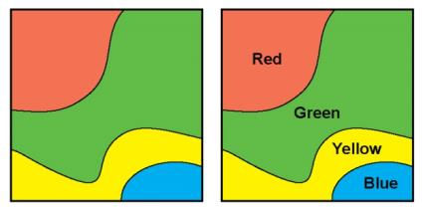
Label size, style, colour and contrast are important to consider when designing accessible map products for individuals with vision impairments. See the Font Selection section for information about size and style; The Colour section and Contrast section of this document contains detailed information regarding these topics.

Recommended Guidelines for Annotation and Labelling
- Use labels to assist users with visual impairments when colour alone is used to distinguish areas. Direct labelling of information will help users interpret the data and help minimize ambiguity between elements.
- Use cartographic placement rules for aligning text with features, such as a parallel to a road or contoured along a river. This creates a connection between the label and the feature.
- Label size, style, colour and contrast are important to consider when designing accessible map products for individuals with vision impairments. Ensure labels use legible fonts and are of sufficient size and colour contrast.

Simplicity and Consistency

Background
Simplicity and consistency play an important role in how a map communicates its message. The cartographic process itself is an exercise in simplifying information in a consistent way that can be portrayed on a map and then be understood by the intended user.
In the cartographic process a map designer takes an environment, real or imagined, and abstracts and translates it into a map. The map user then takes the map and decodes the information to retrieve the intended message.
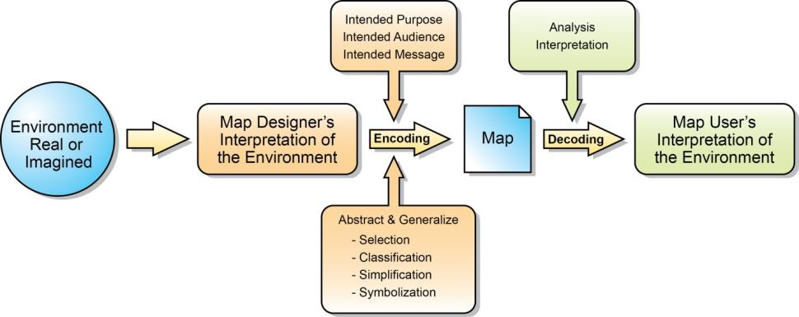
To complete the process a map designer must consider the intended purpose, audience and message of the map to best determine a way to convey the information. Encoding information is accomplished through the abstraction and generalization of data to reduce the amount of detail on a map to create a simple visual image. This is achieved through the careful selection, classification, simplification and symbolization of data. The map user will analyse the map to decode and interpret the information. If done well, the map user will comprehend the intended message with little confusion.
Selection involves decisions regarding what geographic area to be mapped, map scale, map projection and which variables are appropriate for the map’s purpose (Dent, 1993, p. 15).
Classification reduces the complexity of the map and organizes the mapped information enhancing communication (Dent, 1993, p. 16).
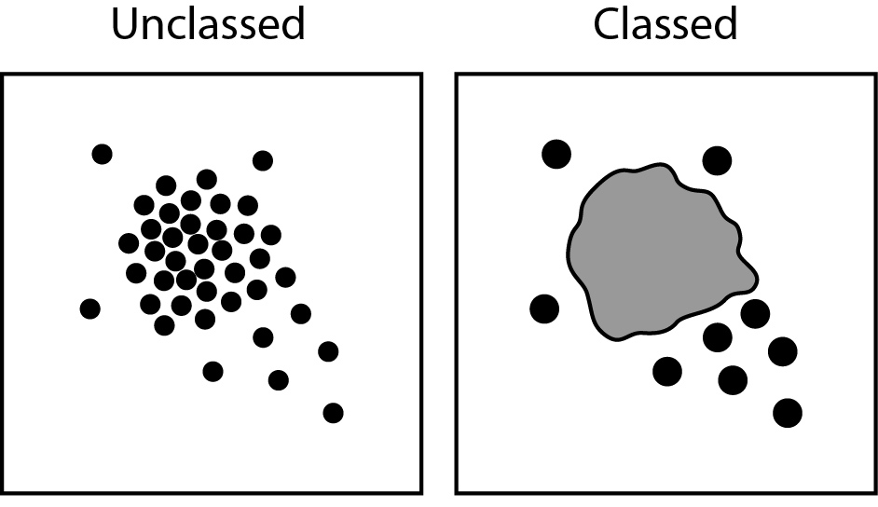
Simplification removes detail or information through selection, classification and smoothing (Dent, 1993, p. 16) to make it easier to understand.
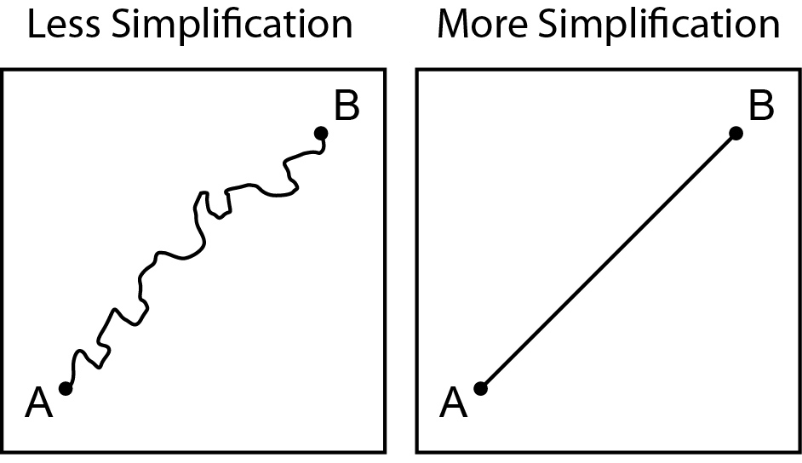
Symbolization is the creation of a set of marks (symbols) using graphic elements to represent real world things (Dent, 1993, p. 16).
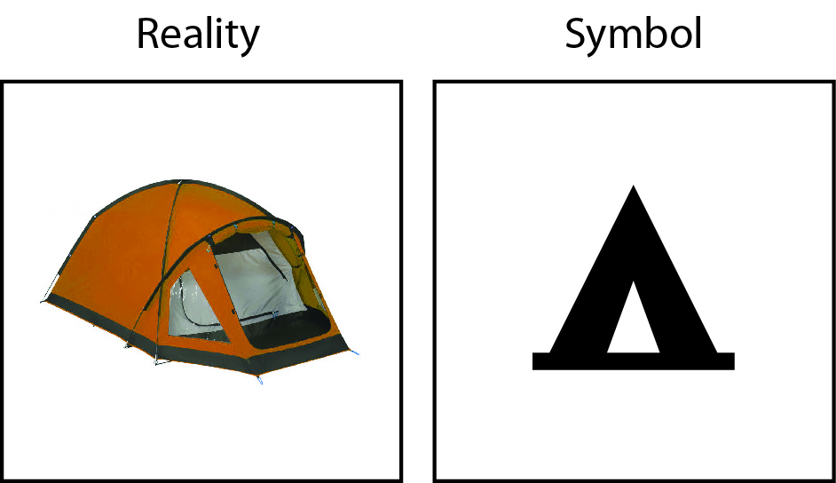

Simplicity
Simplicity is the state or quality of being simple. Something which is not complex, easy to understand or explain is simple. Cartographic simplification determines important characteristics of features and attributes and eliminates unwanted detail (Robinson, 1995, p. 453). Selection and classification of features are forms of cartographic simplification, but so is smoothing, or generalizing, natural or man-made lines on a map to eliminate detail (Dent, 1993, p. 16).
Below are two maps of the same area with (A) simplified and (B) un-simplified spatial information. Maps should be simplified to meet their purpose and reduce confusion.
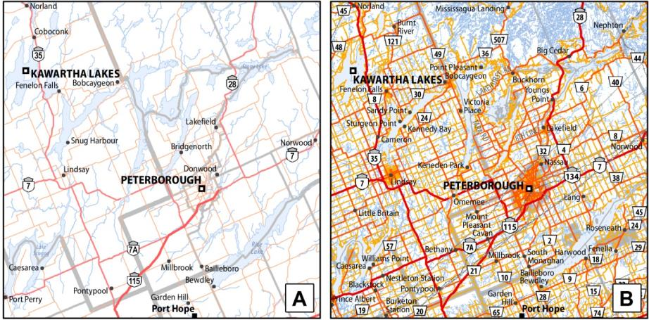
Content may determine scale or scale may determine content, and each determines the level of generalization (Krygier, 2008).
Cartography aims to portray spatial information in an appropriate way in order to transform information into knowledge. The inclusion of unnecessary information makes the process less effective. Map designers should always assess the information’s value to the user against map clutter and confusion (Ordnance Survey, 2015). Great map design tends towards simplicity. It’s not what is included that makes a great map but what is removed (Krygier, 2008). Designing a map for its intended purpose with careful thought and consideration should help the map maker with decisions regarding what to include on a map.
Although certain features may be less important to the overall purpose of the map they may still be required (i.e. reference information like lakes and rivers). If features do not relate to the purpose of the map, they should be removed. Only necessary map features and elements should be included.
Unnecessary graphical effects also tend to distract the user’s eye (Ordnance Survey, 2015). Strive to communicate as much as possible with as little as possible.

Consistency
In order for something to be consistent it must be marked by harmony, regularity, or steady continuity. A well-designed balanced symbol set will not only make a map look better, but it will also communicate better. For example, using point symbols of vastly different detail and size can make a map distracting and confusing to understand and take away from the overall message.
When designing map products, it is important to be consistent through the use of universally accepted symbols and cartographic conventions whenever possible. This will aid the user by making the product more intuitive, and thus easier to understand. Providing a recognizable product and consistency among different mapping products will improve familiarity and understanding. The goal of symbolization is to assign a visual marker to represent the spatial phenomenon being mapped.
When designing point symbols for a map, use shapes that are easily recognizable and intuitive to understand. For example, a triangle will better represent a backcountry campsite than a circle because of cartographic convention and tradition.
It is acceptable to use a variation of a convention as long as it still easily recognisable.
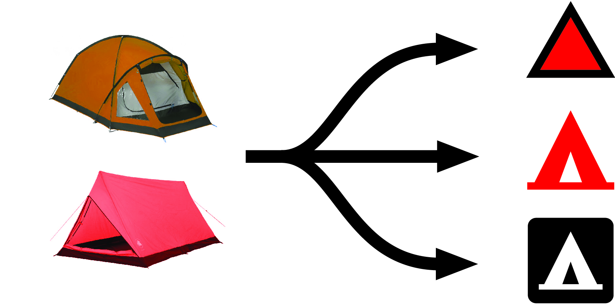
Cartographic conventions can also be in the form of colour. A number of common cartographic conventions are listed below:
- The colour blue for water (Dent, 1993, p. 319)
- The colour brown for land surfaces such as uplands and contours (Dent, 1993, p. 319)
- The colour green for thick lush vegetation (Dent, 1993, p. 319)
- The colour yellow and tan for dry or little vegetation (Dent, 1993, p. 319)

Recommended Guidelines for Simplicity and Consistency
- Design a map for its purpose and only include relevant information and eliminate unwanted detail. The simpler a map is the more accessible it will be. Less is more.
- When designing a map use data appropriate for the scale of the map. Content may determine scale or scale may determine content, and each will determine the level of generalization or sacrifice to use.
- Do not use unnecessary graphical effects; they tend to distract the user’s eye from the purpose of the map.
- Use intuitive, simple, well-balanced symbology to portray information.
- Use cartographic conventions (blue for water, green for vegetation etc.) and universally accepted symbology whenever possible. Familiarity makes information easier to understand.

Alternative Formats and Map Descriptions

Background
There are a number of current and emerging adaptable technologies that enable map content to be accessible for people with visual and other impairments. Some of these alternative formats use equipment and tools to deliver content through the following:
- Tactile (i.e., braille documents)
- Enhanced Tactile (i.e., touch with recorded content triggered by an assistive device)
- Three Dimensional (i.e., products generated using 3D printers)
- Haptic Feedback (i.e. device feedback relating to the sense of touch)
In many cases, however, creators of map content face technological and financial limitations that make it difficult to make map products fully accessible.
When considering accessibility of map content, it is important to understand the differences between two types of access: equivalent and alternative.

Equivalent Access
Equivalent Access provides the disabled user with content identical to that used by the non-disabled user. However, such content is presented in a different manner (NCAM, 2009). An example of equivalent access is an audio recording of a book.

Alternative Access
Alternative Access provides the disabled user with content that differs from the content provided for the non-disabled user, but should achieve the same communication objectives (NCAM, 2009). An example of alternative access is a written description for a map.
The focus of this section is to assist map designers with providing alternative content for map products.
The visual nature of a map contradicts the task of presenting a textual equivalent to the complex, multi-layered visual information overlaid on a map. Producing text equivalents for information conveyed by a topographic or geological map constitutes a rigorous challenge (IACG, 2011).
While it is impossible to describe every spatial relationship that can be interpreted from the features on a map, in many cases it is possible to provide alternative access in the form of a detailed description to convey critical information.

Map Descriptions
Where visuals cannot be adequately reproduced due to size or other limitations, written descriptions should be added. A map description is a text alternative used to make visual information accessible by describing the information or content presented within a map. It is easy enough to provide turn by turn text directions if the purpose of a map is to illustrate navigation from one point to another, but often maps are used for other purposes. Many maps are complex visualizations that are highly context sensitive (Snow-Weaver, Cragun, & IBM, 2011). Some maps may require more than a couple of simple sentences to be adequately described with words. Providing a well-structured detailed description is one way to make map content accessible. When map designers face technological limitations related to accessibility, detailed descriptions may be the best way of providing alternative access content. Once completed, map descriptions can be modified or adapted to best suit the delivery method of the alternative content (e.g. HTML web page, a separate text document etc.).
Writing good map descriptions is as much an art as it is a science. Different types of maps will require unique descriptions based on audience and context. The Recommendations for Creating Effective Map Descriptions section will assist creators of map descriptions with the creation of appropriate alternative content. See Appendix F for examples of map descriptions created using the recommendations.

Recommendations for Creating Effective Map Descriptions
Both the National Center for Accessible Media (NCAM) and the Digital Image and Graphics Resources for Accessible Materials (DIAGRAM) Center have produced guidelines for creating effective complex graphic descriptions (NCAM, 2010) (DIAGRAM, n.d.). These guidelines have been adapted below for creating alternative access complex map descriptions.

Audience
- Know the target audience (e.g. age, culture, subject-matter expertise).
- Use vocabulary and phrases appropriate for the map user.
- Reference examples and details that the map user will understand.

Context
  - The context in which a map is used must be considered before creating a description. Context will help the author determine what information should be included in the description.
- If a map is part of a document or report, look at any text surrounding it to understand how it fits into the bigger picture, and then decide which concepts and terms have already been defined to avoid repetition of explanations. Describe general trends in the map, refer to large areas at once and direct map users to existing descriptions in other parts of the document, where applicable.
  - If the map is a standalone product it should be described as thoroughly as possible to ensure critical information and concepts are adequately explained.

Brevity and Clarity
- Keep descriptions as concise, clear and easy-to-read as possible. Reading extremely long descriptions will create an unnecessary time burden for those accessing the alternative content. More is not necessarily better – be succinct.
- Describe the main purpose of the map using facts and non-emotional language.
- If a map is part of a report or document don’t repeat information presented in the main or adjacent texts. Instead, direct map users to the existing descriptions.
- For context information focus on the place names and labels that are most relevant to the map and the concept it is depicting.
- The elements in the map key or legend can be folded in to the description of the map itself and do not need to be described separately.
- Don’t describe extraneous visual elements or design features. Only describe the core content.
- Include colour only when it is meaningful (e.g. arbitrary colours assigned for map elements need not be specified).
- Simple locator maps may only require a short description. (e.g. a key map showing the point location of a place or thing within the province)

Drill-Down Organization – General to Specific
- Present information in a consistent and logical order.
- Start with high-level general context information, and then drill down to specific details that enhance understanding. This provides the map user with options about how much information to read.
- If a map is extremely complex and made up of several separate maps and/or graphical components, break it down into parts and create a separate description for each part. A list or brief summary of all the parts at the beginning may be useful for navigation.
- Arrange content into logical, digestible portions and consider structuring a detailed description using the following parts: Title Statement, Construction Statement, Overview Statement, and Detailed Data if applicable.

Recommended Parts of a Map Description
- Title Statement
A title statement contains the title of the map product within a single sentence. This provides the user with a general understanding of what the map content is about.
- Construction Statement
A construction statement provides a brief description of the map content in context. This can include general information about the geographic extent if applicable.
- Overview Statement
An overview statement provides the map user with an understanding of any major general trends and outliers depicted by the content. Including labeled landmarks and labeled bodies of water where applicable can be useful, but focus on the place names and labels that are most relevant to the map. For general purpose maps the overview statement could also include information about the types of features included within the map.
- Detailed Data
Detailed data should be included if applicable. Provide actual data in a format that will best allow the user to gain a detailed understanding of the critical content depicted within the map. Detailed data should be formatted in a way that will make the information easy to understand. Publication details, such as date, data currency, map size and scale etc., can also be included in this part of the description if they are applicable.

Formatting Detailed Data
  - Whenever possible, provide properly formatted digital text. This enables quick and independent access to information through assistive devices.
  - Focus on the data represented on the map and don’t describe extraneous visual elements. Focus on the core data.
  - Depending on the type and theme of the map there may be different ways to present the information depicted. Consider formatting the data in a way that is concise, easy to understand and navigate. Determine if a list or table will be a more accessible format than using prose or a written description to provide specific data.

Ways to Format Detailed Data for Complex Map Descriptions
- Data List
If possible, use bulleted lists to format detailed data in a way that is as simple as possible. Bullets make lists more readable, and more memorable. Put the most important or relevant data at the beginning of the list so it can be accessed first.
- Data Table
Conveying complex map information in a data table can also be used as a method to deliver detailed data. Ensure data tables are properly formatted for accessibility.
- Written Descriptions
Some maps will include a great deal of detailed information or types of data that cannot be reduced into a few sentences, a list or a data table. In these cases, provide the description in a written way in a concise that best makes sense.

Appendix A: Summary of Recommended Guidelines
This appendix collects all the recommended guidelines in this document.
Essential Map Content is information that is absolutely necessary or extremely important for illustrating the intended message or purpose of a map. In most cases essential map content will be thematic in nature.
Contextual Map Content is information that helps explain the purpose of the map by setting the necessary content into perspective. It is information that can enhance the overall understanding of the essential map content. In most cases this can be described as the base information presented on a map.

Recommended Guidelines for Contrast
- Visual colour contrast, between foreground and background features is vital. Ensure that essential map content has a greater contrast ratio to its surroundings than contextual map content.
- Try to achieve an appropriate contrast ratio between essential text and backgrounds. Smaller text requires a higher contrast ratio than larger text.
  - Text greater than 12 points in size should have a contrast ratio of 3:1
  - A contrast ratio of 4.5:1 or greater should be used for regular-sized text considered to be between 7 and 12 points.
  - Contrast ratios of 7:1 or greater are best for smaller text less than 7 points in size that relate to essential map content.
  - If necessary, use a halo around the text to achieve an appropriate contrast ratio. Matching the halo to the background, without changing the meaning of the data shown is preferable.
  - Contextual or non-essential map content does not require the contrast ratio to be as high as the contrast ratio recommendations for essential content.
- When placing text, use the largest type sizes possible, consistent with good design.
  - Typefaces with larger x-heights will appear more legible at smaller sizes.
  - Label non-essential features sparingly to ensure that crucial features can be labelled as large as possible.
  - Certain digital formats of maps, such as PDF or SVG will allow users to enlarge, or zoom into the map content without losing resolution.
- Try to achieve at least an appropriate contrast ratio between lines depicting essential content and the backgrounds they overlap. Thin lines require a higher contrast ratio than thick lines.
  - A contrast ratio of 7:1 should be used for essential content lines under 1.0 point in thickness.
  - A contrast ratio of 4.5:1 should be used for essential content lines between 1.0 and 2.0 points in thickness.
  - A contrast ratio of 3:1 should be used for essential content lines greater than 2.0 points in thickness.
  - Non-essential content may not require the contrast ratio to be as high as the contrast ratio recommendations for essential content.

Recommended Guidelines for Colour:
- Keep map design simple and limit the use of colour to key components of the map’s intended message.
- Select colours that vary significantly in lightness (contrast), since individuals with a colour vision deficiency can perceive lightness differences.
- To avoid problematic colour combinations, use colours with strong contrast and supplemental visual variables, such as shape, size, and pattern variations to allow all users to discern different features.
- Consider annotating the map directly where users with vision disabilities might be confused.
- Testing for colour legibility is important. There are many techniques and resources available online for testing and simulating colour legibility.
- If the complexity of the map prevents it from being colour accessible use an alternative format or method of sharing the information, or consider presenting the information in multiple maps.

Recommended Guidelines for Style and Patterns:
- Symbology should be easily distinguishable from backgrounds and other symbols.
- Point, line and area symbols should not imply a hierarchy unless intended.
- If colour is used, the recommended guidelines for colour apply and the symbol should be tested for accessibility with regard to users with colour visual impairment.
- Styles created using marker symbols should be simple and scalable.
- Keep the pattern as simple as possible, especially when symbolizing small areas. Patterns should not take away from the overall message of the map.

Recommended Guidelines for Font Selection
- Choose a sans-serif typeface that is simple with well-proportioned, easily recognizable letterforms.
  - The simplicity of sans-serif typefaces are widely preferred over typefaces with serifs for most vision impairments.
  - Use serif typefaces sparingly. Adjust size, letter spacing and weight to improve legibility.
  - Avoid complicated, decorative or handwriting fonts.
- Limit the use of italics.
  - Cartographic convention traditionally uses italic fonts to add emphasis or distinguish different features.
  - Ensure that any italic fonts used have appropriate shape, weight, scale, size and are not overly crowded.
- Choose a regular or medium weight typeface which will generally be more legible than an extra-bold or ultra-light typeface.
- Choose a typeface with consistent stroke widths, open counterforms, pronounced ascenders and descenders, slightly wider horizontal proportions and distinct forms for each character.
- Use the largest type sizes possible, consistent with good design.
  - Type size will vary from map to map depending on the amount of detail required and space available for text placement.
  - Non-essential features should be labelled selectively, or sparingly, to ensure that crucial features can be labelled as large as possible.
- Choose a typeface with a medium to large x-height.
  - The higher the x-height in relation to a capital letter, the more legible the font is likely to be.
  - Typefaces with larger x-heights will appear more legible at smaller sizes.
- Try to achieve at least a 4.5:1 contrast ratio between essential text and backgrounds.
  - Using a halo around the text or labels to achieve an appropriate contrast ratio if necessary is acceptable.
  - Matching the halo to the background, without changing the meaning of the data shown is preferable.
- If colour is used, the recommended guidelines for colour apply and the symbol should be tested for accessibility with regard to users with colour visual impairment.

Recommended Guidelines for Annotation and Labelling
- Use labels to assist users with visual impairments when colour alone is used to distinguish areas. Direct labelling of information will help users interpret the data and help minimize ambiguity between elements.
- Use cartographic placement rules for aligning text with features, such as a parallel to a road or contoured along a river. This creates a connection between the label and the feature.
- Label size, style, colour and contrast are important to consider when designing accessible map products for individuals with vision impairments. Ensure labels use legible fonts and are of sufficient size and colour contrast.

Recommended Guidelines for Simplicity and Consistency
- Design a map for its purpose and only include relevant information and eliminate unwanted detail. The simpler a map is the more accessible it will be. Less is more.
- When designing a map use data appropriate for the scale of the map. Content may determine scale or scale may determine content, and each will determine the level of generalization or sacrifice to use.
- Do not use unnecessary graphical effects; they tend to distract the user’s eye from the purpose of the map.
- Use intuitive, simple, well-balanced symbology to portray information.
- Use cartographic conventions (blue for water, green for vegetation etc.) and universally accepted symbology whenever possible. Familiarity makes information easier to understand.

Recommendations for Creating Effective Map Descriptions
Both the National Center for Accessible Media (NCAM) and the Digital Image and Graphics Resources for Accessible Materials (DIAGRAM) Center have produced guidelines for creating effective complex graphic descriptions (NCAM, 2010) (DIAGRAM, n.d.). These guidelines have been adapted below for creating alternative access complex map descriptions.

Audience
- Know the target audience (e.g. age, culture, subject-matter expertise).
- Use vocabulary and phrases appropriate for the map user.
- Reference examples and details that the map user will understand.

Context
  - The context in which a map is used must be considered before creating a description. Context will help the author determine what information should be included in the description.
- If a map is part of a document or report, look at any text surrounding it to understand how it fits into the bigger picture, and then decide which concepts and terms have already been defined to avoid repetition of explanations. Describe general trends in the map, refer to large areas at once and direct map users to existing descriptions in other parts of the document, where applicable.
  - If the map is a standalone product it should be described as thoroughly as possible to ensure critical information and concepts are adequately explained.

Brevity and Clarity
- Keep descriptions as concise, clear and easy-to-read as possible. Reading extremely long descriptions will create an unnecessary time burden for those accessing the alternative content. More is not necessarily better – be succinct.
- Describe the main purpose of the map using facts and non-emotional language.
- If a map is part of a report or document don’t repeat information presented in the main or adjacent texts. Instead, direct map users to the existing descriptions.
- For context information focus on the place names and labels that are most relevant to the map and the concept it is depicting.
- The elements in the map key or legend can be folded in to the description of the map itself and do not need to be described separately.
- Don’t describe extraneous visual elements or design features. Only describe the core content.
- Include colour only when it is meaningful (e.g. arbitrary colours assigned for map elements need not be specified).
- Simple locator maps may only require a short description. (e.g. a key map showing the point location of a place or thing within the province)

Drill-Down Organization – General to Specific
- Present information in a consistent and logical order.
- Start with high-level general context information, and then drill down to specific details that enhance understanding. This provides the map user with options about how much information to read.
- If a map is extremely complex and made up of several separate maps and/or graphical components, break it down into parts and create a separate description for each part. A list or brief summary of all the parts at the beginning may be useful for navigation.
- Arrange content into logical, digestible portions and consider structuring a detailed description using the following parts: Title Statement, Construction Statement, Overview Statement, and Detailed Data if applicable.

Recommended Parts of a Map Description
- Title Statement
A title statement contains the title of the map product within a single sentence. This provides the user with a general understanding of what the map content is about.
- Construction Statement
A construction statement provides a brief description of the map content in context. This can include general information about the geographic extent if applicable.
- Overview Statement
An overview statement provides the map user with an understanding of any major general trends and outliers depicted by the content. Including labeled landmarks and labeled bodies of water where applicable can be useful, but focus on the place names and labels that are most relevant to the map. For general purpose maps the overview statement could also include information about the types of features included within the map.
- Detailed Data
Detailed data should be included if applicable. Provide actual data in a format that will best allow the user to gain a detailed understanding of the critical content depicted within the map. Detailed data should be formatted in a way that will make the information easy to understand. Publication details, such as date, data currency, map size and scale etc., can also be included in this part of the description if they are applicable.

Formatting Detailed Data
  - Whenever possible, provide properly formatted digital text. This enables quick and independent access to information through assistive devices.
  - Focus on the data represented on the map and don’t describe extraneous visual elements. Focus on the core data.
  - Depending on the type and theme of the map there may be different ways to present the information depicted. Consider formatting the data in a way that is concise, easy to understand and navigate. Determine if a list or table will be a more accessible format than using prose or a written description to provide specific data.

Ways to Format Detailed Data for Complex Map Descriptions
- Data List
If possible, use bulleted lists to format detailed data in a way that is as simple as possible. Bullets make lists more readable, and more memorable. Put the most important or relevant data at the beginning of the list so it can be accessed first.
- Data Table
Conveying complex map information in a data table can also be used as a method to deliver detailed data. Ensure data tables are properly formatted for accessibility.
- Written Descriptions
Some maps will include a great deal of detailed information or types of data that cannot be reduced into a few sentences, a list or a data table. In these cases, provide the description in a written way in a concise that best makes sense.

Appendix B: Types of Colour Blindness
There are different types of colour blindness depending on the severity of the abnormality within the cone cells of the human eye.

Trichromacy
Trichromacy is normal vision and all three types of cone cells function correctly (Colour Blind Awareness, n.d.).

Anomalous Trichromacy
Anomalous Trichromacy is the most common category of colour blindness. It is an impairment of normal colour vision, not a complete loss (Colour Blind Awareness, n.d.).

Protanomaly
Protanomaly is a condition where red cone (protan) cells are defective. Red, orange, and yellow appear greener and colors are not as bright (NEI, 2015).

Deuteranomaly
Deuteranomaly is a condition where green cone (deutran) cells are defective. Yellow and green appear redder and it is difficult to tell violet from blue (NEI, 2015).

Tritanomaly
Tritanomaly is a condition where blue cone (tritan) cells are defective and is extremely rare. Blue appears greener and it can be difficult to tell yellow and red from pink (NEI, 2015).

Dichromacy
Dichromacy is a type of colour vision where only two types of cones are able to perceive colour. People with dichromatic vision have a total absence of function of one cone type (Colour Blind Awareness, n.d.).

Protanopia
Protanopia is a condition where red cone (protan) cells are missing or do not function. Red appears as black. Certain shades of orange, yellow, and green all appear as yellow (NEI, 2015).

Deuteranopia
Deuteranopia is a condition where green cone (deutran) cells are missing or do not function. Reds tend to be seen as brownish-yellow and greens as beige (NEI, 2015).

Tritanopia
Tritanopia is a condition where blue cone (tritan) cells are missing or do not function. This condition is extremely rare. Blue appears green and yellow appears violet or light grey (NEI, 2015).

Monochromacy
Monochromacy is a complete loss of colour vision. People with monochromatic vision can see no colour at all and their world consists of different shades of grey ranging from black to white.

Appendix C: Text / Background Contrast Ratio Examples
The following examples are provided as a visual illustration of text and background colour when tested against the three different levels of compliance for contrast as defined by WGAG 2.0.
Notes: CMYK: Cyan Magenta Yellow Black, the base colours of the subtractive colour model. RGB: Red Green Blue, the base colours of the additive colour model

Greyscale Contrast Ratio Examples
Example | Contrast Ratio | Level AAA - 7:1 Contrast Criteria | Level AA - 4.5:1 Contrast Criteria | Level A - 3:1 Contrast Criteria | Text CMYK | Background CMYK | Text RGB | Background  RGB
Arial 12 pt | 21:1 | Pass | Pass | Pass | 0,0,0,100 | 0,0,0,0 | 0,0,0 | 255,255,255
Arial 12 pt | 17.6:1 | Pass | Pass | Pass | 0,0,0,90 | 0,0,0,0 | 25,25,25 | 255,255,255
Arial 12 pt | 12.8:1 | Pass | Pass | Pass | 0,0,0,80 | 0,0,0,0 | 50,50,50 | 255,255,255
Arial 12 pt | 8.6:1 | Pass | Pass | Pass | 0,0,0,70 | 0,0,0,0 | 76,76,76 | 255,255,255
Arial 12 pt | 5.7:1 | Fail | Pass | Pass | 0,0,0,60 | 0,0,0,0 | 102,102,102 | 255,255,255
Arial 12 pt | 4.0:1 | Fail | Fail | Pass | 0,0,0,50 | 0,0,0,0 | 127,127,127 | 255,255,255
Arial 12 pt | 2.8:1 | Fail | Fail | Fail | 0,0,0,40 | 0,0,0,0 | 153,153,153 | 255,255,255
Arial 12 pt | 2.1:1 | Fail | Fail | Fail | 0,0,0,30 | 0,0,0,0 | 178,178,178 | 255,255,255
Arial 12 pt | 1.6:1 | Fail | Fail | Fail | 0,0,0,20 | 0,0,0,0 | 204,204,204 | 255,255,255
Arial 12 pt | 1.3:1 | Fail | Fail | Fail | 0,0,0,10 | 0,0,0,0 | 229,229,229 | 255,255,255
Arial 12 pt | 21:1 | Pass | Pass | Pass | 0,0,0,0 | 0,0,0,100 | 255,255,255 | 0,0,0
Arial 12 pt | 17.6:1 | Pass | Pass | Pass | 0,0,0,0 | 0,0,0,90 | 255,255,255 | 25,25,25
Arial 12 pt | 12.8:1 | Pass | Pass | Pass | 0,0,0,0 | 0,0,0,80 | 255,255,255 | 50,50,50
Arial 12 pt | 8.6:1 | Pass | Pass | Pass | 0,0,0,0 | 0,0,0,70 | 255,255,255 | 76,76,76
Arial 12 pt | 5.7:1 | Fail | Pass | Pass | 0,0,0,0 | 0,0,0,60 | 255,255,255 | 102,102,102
Arial 12 pt | 4.0:1 | Fail | Fail | Pass | 0,0,0,0 | 0,0,0,50 | 255,255,255 | 127,127,127
Arial 12 pt | 2.8:1 | Fail | Fail | Fail | 0,0,0,0 | 0,0,0,40 | 255,255,255 | 153,153,153
Arial 12 pt | 2.1:1 | Fail | Fail | Fail | 0,0,0,0 | 0,0,0,30 | 255,255,255 | 178,178,178
Arial 12 pt | 1.6:1 | Fail | Fail | Fail | 0,0,0,0 | 0,0,0,20 | 255,255,255 | 204,204,204
Arial 12 pt | 1.3:1 | Fail | Fail | Fail | 0,0,0,0 | 0,0,0,10 | 255,255,255 | 229,229,229

Colour Contrast Ratio Examples
Example | Contrast Ratio | Level AAA - 7:1 Contrast Criteria | Level AA - 4.5:1 Contrast Criteria | Level A - 3:1 Contrast Criteria | Text CMYK Colour | Background CMYK Colour | Text RGB Colour | Background RGB Colour
Arial 12 pt | 18.9:1 | Pass | Pass | Pass | 0,0,0,100 | 25,0,0,0 | 0,0,0 | 191,255,255
Arial 12 pt | 7.8:1 | Pass | Pass | Pass | 100,100,0,0 | 25,0,0,0 | 0,0,255 | 191,255,255
Arial 12 pt | 6.0:1 | Fail | Pass | Pass | 100,75,0,0 | 25,0,0,0 | 0,63,255 | 191,255,255
Arial 12 pt | 3.5:1 | Fail | Fail | Pass | 100,50,0,0 | 25,0,0,0 | 0,127,255 | 191,255,255
Arial 12 pt | 1.7:1 | Fail | Fail | Fail | 100,20,0,0 | 25,0,0,0 | 0,204,255 | 191,255,255
Arial 12 pt | 19.0:1 | Pass | Pass | Pass | 0,0,0,100 | 15,0,25,0 | 0,0,0 | 216,255,191
Arial 12 pt | 9.9:1 | Pass | Pass | Pass | 15,0,25,75 | 15,0,25,0 | 54,63,47 | 216,255,191
Arial 12 pt | 5.6:1 | Fail | Pass | Pass | 15,0,25,60 | 15,0,25,0 | 86,102,76 | 216,255,191
Arial 12 pt | 3.9:1 | Fail | Fail | Pass | 15,0,25,50 | 15,0,25,0 | 108,127,95 | 216,255,191
Arial 12 pt | 2.8:1 | Fail | Fail | Fail | 15,0,25,40 | 15,0,25,0 | 130,153,114 | 216,255,191
Arial 12 pt | 20.2:1 | Pass | Pass | Pass | 0,0,0,100 | 0,0,30,0 | 0,0,0 | 255,255,178
Arial 12 pt | 6.3:1 | Fail | Pass | Pass | 0,100,100,25 | 0,0,30,0 | 191,0,0 | 255,255,178
Arial 12 pt | 3.8:1 | Fail | Fail | Pass | 0,100,100,0 | 0,0,30,0 | 255,0,0 | 255,255,178
Arial 12 pt | 2.4:1 | Fail | Fail | Fail | 0,50,75,0 | 0,0,30,0 | 255,127,63 | 255,255,178
Arial 12 pt | 14.1:1 | Pass | Pass | Pass | 0,0,0,100 | 0,25,0,0 | 0,0,0 | 255,191,255
Arial 12 pt | 5.3:1 | Fail | Pass | Pass | 75,100,0,0 | 0,25,0,0 | 63,0,255 | 255,191,255
Arial 12 pt | 4.2:1 | Fail | Fail | Pass | 50,100,0,0 | 0,25,0,0 | 127,0,255 | 255,191,255
Arial 12 pt | 3.0:1 | Fail | Fail | Pass | 25,100,0,0 | 0,25,0,0 | 191,0,255 | 255,191,255
Arial 12 pt | 2.1:1 | Fail | Fail | Fail | 0,100,0,0 | 0,25,0,0 | 255,0,255 | 255,191,255

Appendix D: Comparison of Sans-Serif Stroke Widths at Various Font Sizes
Stroke widths for a number of accessible sans-serif fonts were compared at various point sizes to help determine reasonable contrast ratios for line work based on the WGAG 2.0 guidelines. The results were as follows:
- The average stoke width of 12-point font was approximately 1.0 points
- The average stoke width of 14-point bold font was approximately 2.0 points
- The average stoke width of 18-point font was approximately 1.5 points
Font | font size (pt) | Stroke width in (pt) | Stroke width (mm) | Stroke width (in) | bold font size (pt) | Stroke width in (pt) | Stroke width (mm) | Stroke width (in) | font size (pt) | Stroke width in (pt) | Stroke width (mm) | Stroke width (in)
Arial Regular | 12 | 1.05 | 0.37 | 0.01 | 14 | 1.95 | 0.69 | 0.03 | 18 | 1.60 | 0.56 | 0.02
Calibri Regular | 12 | 0.97 | 0.34 | 0.01 | 14 | 1.75 | 0.62 | 0.02 | 18 | 1.50 | 0.53 | 0.02
Lucida Sans Regular | 12 | 1.17 | 0.41 | 0.02 | 14 | 2.05 | 0.72 | 0.03 | 18 | 1.75 | 0.62 | 0.02
Myriad Pro Regular | 12 | 1.07 | 0.38 | 0.01 | 14 | 2.15 | 0.76 | 0.03 | 18 | 1.60 | 0.56 | 0.02
Tahoma Regular | 12 | 1.12 | 0.40 | 0.02 | 14 | 2.40 | 0.85 | 0.03 | 18 | 1.65 | 0.58 | 0.02
Trebuchet MS Regular | 12 | 1.12 | 0.40 | 0.02 | 14 | 1.75 | 0.62 | 0.02 | 18 | 1.70 | 0.60 | 0.02
Verdana Regular | 12 | 1.12 | 0.40 | 0.02 | 14 | 2.50 | 0.88 | 0.03 | 18 | 1.65 | 0.58 | 0.02
Average | 12 | 1.09 | 0.38 | 0.02 | 14 | 2.08 | 0.73 | 0.03 | 18 | 1.64 | 0.58 | 0.02
Min | 12 | 0.97 | 0.34 | 0.01 | 14 | 1.75 | 0.62 | 0.02 | 18 | 1.50 | 0.53 | 0.02
Max | 12 | 1.17 | 0.41 | 0.02 | 14 | 2.50 | 0.88 | 0.03 | 18 | 1.75 | 0.62 | 0.02
Variation | 12 | 0.20 | 0.07 | 0.00 | 14 | 0.75 | 0.26 | 0.01 | 18 | 0.25 | 0.09 | 0.00

- Using the average font stoke widths and font point sizes contrast ratios for essential map content were determined based on the WGAC 2.0 guidelines. None essential content may not require the contrast ratio to be as high as the following recommendations:
- A contrast ratio of 7:1 should be used for essential content lines under 1.0 point in thickness.
- A contrast ratio of 4.5:1 should be used for essential content lines between 1.0 and 2.0 points in thickness.
- A contrast ratio of 3:1 should be used for essential content lines greater than 2.0 points in thickness.

Appendix E: Type Glossary:

Visual Glossary

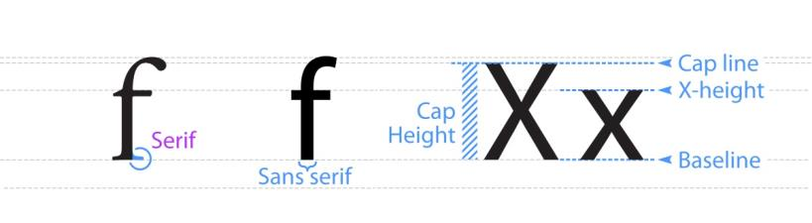
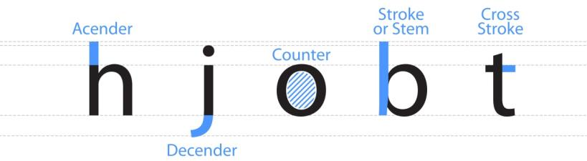
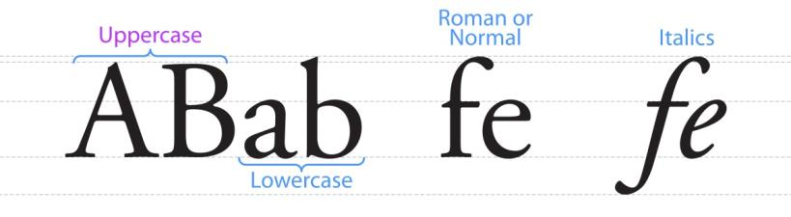
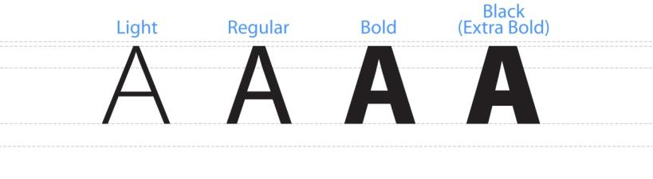

Glossary Definitions

Ascender
An ascender is the upward vertical stem on some lowercase letters, such as h and b, which extends above the x-height is the ascender (TypeDecon, n.d.).

Baseline
A baseline is imaginary line upon which a line of text rests. In most typefaces, the descenders on characters such as g or p extend down below the baseline while curved letters such as c or o extend ever-so-slightly below the baseline. The baseline is the point from which other elements of type are measured including x-height and leading (TypeDecon, n.d.).

Counter
A counter is the enclosed or partially enclosed circular or curved negative space (white space) of some letters such as d, o, and s (TypeDecon, n.d.).

Cross Stroke
A cross stroke is the horizontal stroke across the stem of a lowercase t or f (TypeDecon, n.d.).

Descender
A descender is the portion of some lowercase letters, such as g, j, q and y, which extends or descends below the baseline (TypeDecon, n.d.).

Font
A font is a family member of a typeface that has a specific weight, style, condensation, width, slant, italicization, ornamentation etc. (Wikipedia, n.d.).

Glyph
A glyph is an elemental symbol within an agreed set of symbols, intended to represent a readable character for the purposes of writing and thereby expressing thoughts, ideas and concepts (Wikipedia, n.d.).

Italics
While roman fonts are upright, italic fonts slant to the right. But rather than being just a slanted or tilted version of the roman font, a true or pure italic font is drawn from scratch and has unique features not found in the roman face (TypeDecon, n.d.).

Lowercase
The little letters or non-capital letters of the alphabet are lowercase glyphs. They make up the bulk of written text, with uppercase or capital letters used primarily only to start sentences or proper names (TypeDecon, n.d.).

Roman
Roman typefaces are the normal typography style. They are upright and the glyphs have no angle or slant to the vertical strokes of letterforms.

Sans-Serif
Typefaces that do not use serifs or small lines at the ends of some letterforms are sans-serif.

Serif
A serif is the little extra stroke found at the end of main vertical and horizontal strokes of some letterforms (TypeDecon, n.d.).

Stem
The stem is the main, usually vertical stroke of a letterform (TypeDecon, n.d.).

Stroke
A stoke is the main diagonal portion of a letterform (TypeDecon, n.d.).

Typeface
A typeface, also known as font family, is a set of one or more fonts each composed of glyphs that share common design features (Wikipedia, n.d.).

Uppercase
The capital letters of the alphabet are uppercase glyphs. Uppercase letters are normally used at the beginning of sentences and as the first letter of proper names (TypeDecon, n.d.).

X-height
The x-height is the distance between the baseline of a line of type and tops of the main body of lower case letters, excluding ascenders or descenders (TypeDecon, n.d.).

Appendix F: Map Description Examples
Below are several examples of map descriptions that were created using the recommendations outlined in this document. Please note the maps used for description examples were existing map products and may not have been designed with accessibility in mind. They are used in this context to demonstrate how to write an appropriate map description.

Simple Locational or Key Map Example
Simple locator maps only require a short explanation to describe the general location of a place or thing.

Map Audience:
General and nonspecific.

Map Context:
A small (3.75” x 3.75”) simple map used to highlight the location of a city within the province of Ontario.

Map Screenshot:
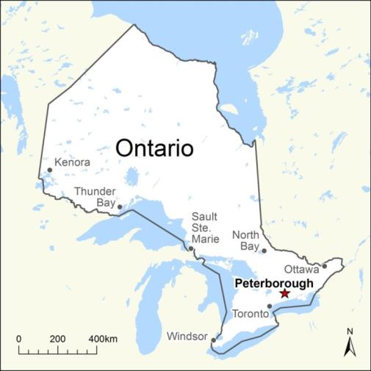

Map Description (45 words):
This is a small simple map showing the location of the City of Peterborough within the province of Ontario. Peterborough is located in south central Ontario approximately 100 kilometres northeast of the City of Toronto and approximately 250 kilometres southwest of the City of Ottawa.

Area and Area Office Map Example
If the purpose of a map is to show the area boundaries and locations of a specific type for a geographic area, a text-based list of the features and their locations would be an appropriate part of the alternative access content.

Map Audience:
General MNR or OPS internal use.

Map Screenshot:

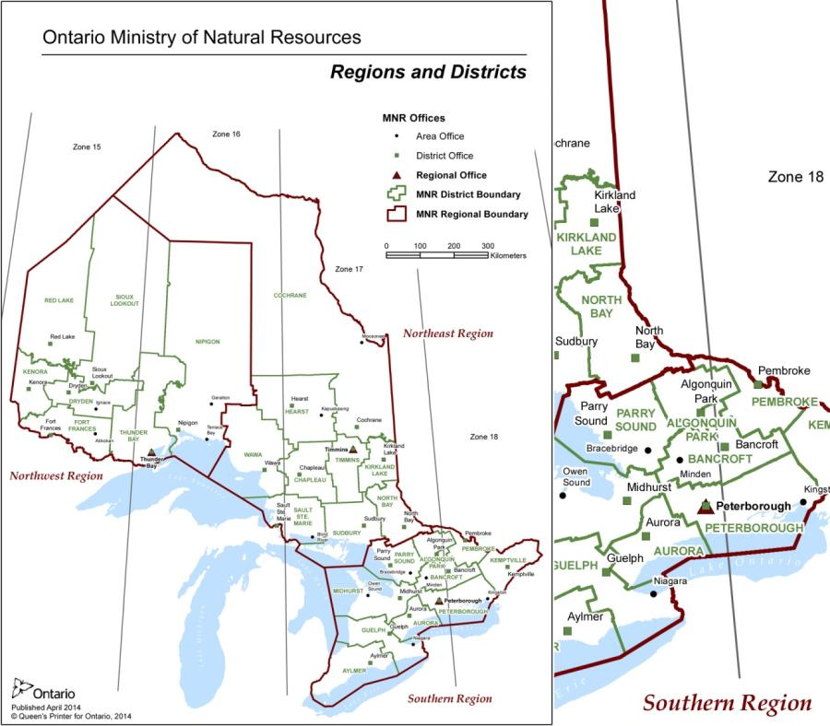

Map Context:
The product is a letter size (8.5” x 11”) map, in PDF file format, containing MNR administrative features. The map is an internal product used to highlight MNR administrative boundaries and office locations throughout the province. The map is posted on a limited-access intranet site.

Map Description (374 words):
This map is entitled “Ontario Ministry of Natural Resources (MNR) Regions and Districts”.
The map shows the complete extents for the province of Ontario and emphasizes MNR administrative boundaries and office locations throughout the province.
Thematic features on the map include: MNR regional area boundaries, MNR district area boundaries, MNR regional office locations, MNR district office locations and MNR area office locations. Other reference features on the map include the Great Lakes and Universal Transverse Mercator (UTM) reference lines for UTM Zones 15, 16, 17 and 18.
There are 3 MNR regions in the province: Northwest, Northeast and Southern Region. Region names are derived from their general geographic location within the province. There is one regional office for each of the regions. There are a total of 26 MNR districts within the province spread throughout the 3 regions. Each district has a corresponding district office. District names are derived from the location of the district offices. Some locations have both regional and district offices. Eleven of the districts also have area offices.
The 3 MNR regions with corresponding regional office locations are as follows:
- Northwest Region, Thunder Bay
- Northeast Region, Timmins
- Southern Region, Peterborough
The northwest region has the following 7 districts and corresponding district office locations:
- Dryden
- Fort Frances
- Kenora
- Nipigon
- Red Lake
- Sioux Lookout
- Thunder Bay
The northeast region has the following 9 districts and corresponding district office locations:
- Chapleau
- Cochrane
- Hearst
- Kirkland Lake
- North Bay
- Sault Ste. Marie
- Sudbury
- Timmins
- Wawa
Southern region has the following 10 districts and corresponding district office locations:
- Algonquin Park
- Aurora
- Aylmer
- Bancroft
- Guelph
- Kemptville
- Midhurst
- Parry Sound
- Pembroke
- Peterborough
The 11 districts with associated area office locations are as follows:
- Bancroft, Minden
- Cochrane, Moosonee
- Dryden, Ignace
- Fort Frances, Atikokan
- Guelph, Niagara
- Hearst, Kapuskasing
- Midhurst, Owen Sound
- Nipigon, Terrace Bay
- Parry Sound, Bracebridge
- Peterborough, Kingston
- Sault Ste. Marie, Blind River
The map was published in April 2014 by the Provincial Geomatics Service Centre (PGSC) at the Ministry of Natural Resources (MNR). The map is 8.5 inches by 11 inches in size and has a scale of approximately 1 centimetre being equal to 80 kilometres. For further information, please contact the Provincial Geomatics Service Centre at email@emailaddress.ca

Statistical Thematic Map Example
If the purpose of a map is to display numerical statistical information for given areas or features, it should be possible to provide text-based bulleted or tabular data for critical information, that can be part of the descriptive text.

Map Audience:
Individuals interested in sheep and lamb agricultural statistics for the province of Ontario

Map Context:
The map is intended for use on a government website

Map Screenshot:
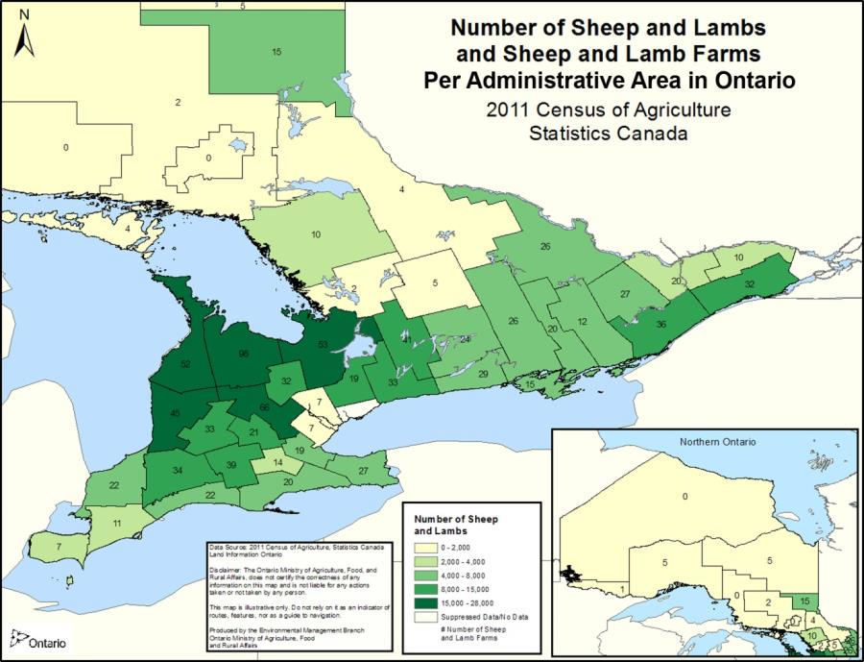

Map Description (590 words):
This map is entitled “Number of Sheep and Lambs and Sheep and Lamb Farms Per Administrative Area in Ontario, 2011 Census of Agriculture Statistics Canada”.
The map focuses on southern Ontario, but also contains a smaller inset map of northern Ontario. The sheep and lamb statistics on the map are associated with administrative areas including territorial districts in northern Ontario as well as upper-tier and single-tier municipalities in southern Ontario. Other reference features on the map include the Great Lakes.
Over 30 percent of the sheep and lamb farms and total number of animals are located in Southwestern to Central Ontario in the County of Grey, County of Wellington, County of Simcoe, County of Bruce and County of Huron. Approximately another 30 percent of the farms and animals are located throughout Southern Ontario. There are very few farms and animals in northern Ontario; with the exception of the District of Timiskaming which has a moderate number of farms and animals. The most farms (98) are located in Bruce. There is no data or information available for the City of Toronto.
The following table incudes the statistics depicted on the map and is sorted from highest to lowest by the number of sheep and lamb farms within a municipality or district:
Municipality or District | Number of Sheep and Lamb Farms | Number of Sheep and Lambs (range)
County of Grey | 98 | 15,000-28,000
County of Wellington | 66 | 15,000-28,000
County of Simcoe | 53 | 15,000-28,000
County of Bruce | 52 | 15,000-28,000
County of Huron | 45 | 15,000-28,000
City of Kawartha Lakes | 41 | 8,000-15,000
County of Oxford | 39 | 8,000-15,000
United Counties of Leeds and Grenville | 36 | 8,000-15,000
County of Middlesex | 34 | 8,000-15,000
County of Perth | 33 | 8,000-15,000
Regional Municipality of Durham | 33 | 8,000-15,000
County of Dufferin | 32 | 8,000-15,000
United Counties of Stormont, Dundas and Glengarry | 32 | 8,000-15,000
County of Northumberland | 29 | 4,000-8,000
County of Lanark | 27 | 4,000-8,000
Regional Municipality of Niagara | 27 | 4,000-8,000
County of Hastings | 26 | 4,000-8,000
County of Renfrew | 26 | 4,000-8,000
County of Peterborough | 24 | 4,000-8,000
County of Elgin | 22 | 4,000-8,000
County of Lambton | 22 | 4,000-8,000
Regional Municipality of Waterloo | 21 | 8,000-15,000
County of Lennox and Addington | 20 | 4,000-8,000
Norfolk County and Haldimand County | 20 | 4,000-8,000
City of Ottawa | 20 | 2,000-4,000
Regional Municipality of York | 19 | 8,000-15,000
City of Hamilton | 19 | 4,000-8,000
County of Prince Edward County | 15 | 4,000-8,000
District of Timiskaming | 15 | 4,000-8,000
County of Brant | 14 | 2,000-4,000
County of Frontenac | 12 | 4,000-8,000
Municipality of Chatham-Kent | 11 | 2,000-4,000
District of Parry Sound | 10 | 2,000-4,000
United Counties of Prescott and Russell | 10 | 2,000-4,000
County of Essex | 7 | 2,000-4,000
Regional Municipality of Halton | 7 | 0-2,000
Regional Municipality of Peel | 7 | 0-2,000
County of Haliburton | 5 | 0-2,000
District of Cochrane | 5 | 0-2,000
District of Thunder Bay | 5 | 0-2,000
District of Manitoulin | 4 | 0-2,000
District of Nipissing | 4 | 0-2,000
District Municipality of Muskoka | 2 | 0-2,000
District of Sudbury | 2 | 0-2,000
District of Rainy River | 1 | 0-2,000
City of Greater Sudbury | 0 | 0-2,000
District of Algoma | 0 | 0-2,000
District of Kenora | 0 | 0-2,000
City of Toronto | Suppressed Data / No data | Suppressed Data / No data

The map is approximately 11 inches by 8.5 inches in size. The map was published by the Environment Management Branch of the Ontario Ministry of Agriculture, Food and Rural Affairs (OMAFRA) using 2011 Census of Agriculture data from Statistics Canada and base data from Land Information Ontario (LIO). OMAFRA does not certify the correctness of any information included on the map and is not liable for any actions taken or not taken by any person. The information included is for illustration purposes only.

Analytical thematic map example
A thematic map depicting results of analysis would require a description to communicate content.

Map Audience:
Individuals or groups interested in climate change

Map Context:
The map will be posted to a website or included as part of a report. The map is part of a series created to illustrate how climate change could affect the temperature and precipitation within the province of Ontario over the next 100 years.

Map Screenshot:
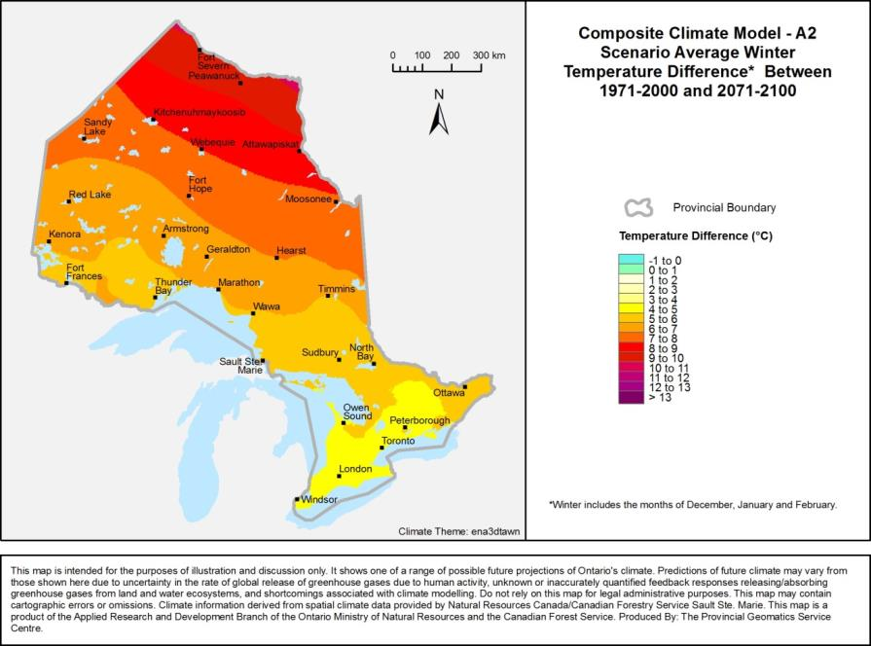

Map Description (475 words):
This map is entitled “Composite Climate Model - A2 Scenario Average Winter Temperature Difference Between 1971-2000 and 2071-2100”. Winter includes the months of December, January and February. Possible future climate change differences are based on a composite climate model for the A2 greenhouse gas scenario.

The map shows the complete extents for the province of Ontario and illustrates the difference in temperature between historic and future time periods. Other reference features on the map include settlements, the Great Lakes and the provincial boundary.
Temperature differences range from an increase of 4 to 10 degrees in Celsius throughout the province. In general, areas in the southern part of the province are least affected by temperature change, while areas in the far-north will experience the greatest amount of temperature change.
Southern Ontario from the City of Windsor extending north past the City of Peterborough shows the smallest increase in temperature change of between 4 and 5 degrees Celsius. The largest increase in temperature change of between 9 and 10 degrees Celsius is found around the northern communities of Fort Severn and Peawanuck in the far-north.
Locations with a projected temperature change of between 4 and 5 degrees Celsius from south to north are as follows:
- Windsor
- London
- Toronto
- Peterborough
- Owen Sound
Locations with a projected temperature change of between 5 and 6 degrees Celsius from south to north are as follows:
- Ottawa
- North Bay
- Sudbury
- Sault Ste. Marie
- Wawa
- Thunder Bay
- Timmins
- Fort Frances
Locations with a projected temperature change of between 6 and 7 degrees Celsius from south to north are as follows:
- Marathon
- Hearst
- Geraldton
- Kenora
- Armstrong
- Red Lake
Locations with a projected temperature change of between 7 and 8 degrees Celsius from south to north are as follows:
- Moosonee
- Fort Hope
- Webequie
- Sandy Lake
Locations with a projected temperature change of between 8 and 9 degrees Celsius from south to north are as follows:
- Atawapiskat
- Kitchenuhmaykoosib
Locations with a projected temperature change of between 9 and 10 degrees Celsius from south to north are as follows:
- Peawanuck
- Fort Severn
Predictions of future climate may vary from those described due to uncertainty in the rate of global release of greenhouse gases due to human activity, unknown or inaccurately quantified feedback responses releasing/absorbing greenhouse gases from land and water ecosystems, and shortcomings associated with climate modelling. Do not rely on the information for legal administrative purposes.
Climate information was derived from spatial climate data provided by Natural Resources Canada/Canadian Forestry Service Sault Ste. Marie.
The map is 7 inches by 5.5 inches in size and has a scale of approximately 1 centimetre being equal to 150 kilometres. The map is a product of the Applied Research and Development Branch (ARDB) of the Ontario Ministry of Natural Resources (MNR) and the Canadian Forest Service. The map was produced by the Provincial Geomatics Service Centre (PGSC).

Wall Map Example
General purpose maps could have a less detailed description than a thematic map because it would be impossible to anticipate all the possible uses.

Map Audience:
General and nonspecific.

Map Context:
A large (42 inches by 48 inches) general-purpose wall map of Ontario used to emphasize the location of both natural and human-made features. The emphasis is on location and the purpose is to show a variety of features within the province.

Map Screenshot:
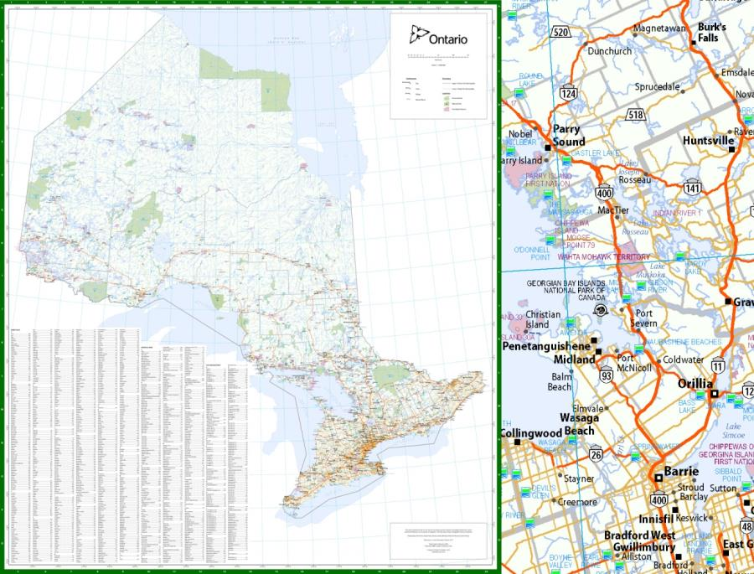

Map Description (320 words):
This map is entitled “Ontario” and is a general purpose wall map of the province of Ontario. The map includes the complete extents for the province. All the Great Lakes that border Ontario to the south are shown. Hudson Bay and James Bay are visible to the north.

The map depicts a variety of common base features within the province and emphasizes labelled settlements, parks and First Nation reserves. Settlements are classified into cities, towns, villages and named places. Parks include both provincial parks and national parks. The map also contains district, upper-tier, single-tier and lower-tier municipal boundaries. Other features on the map include labelled waterbodies, watercourses and road network.

The majority of the larger settlements and road network are located in the southern half of the province. The largest concentration of settlements and roads is located in southern Ontario and wraps around the western side of Lake Ontario. This populated area includes places like Oshawa, Toronto, Mississauga, Burlington, Hamilton, St. Catharines and Niagara Falls. Settlements in the north are smaller and spread out. Parks and First Nation reserves are located throughout the province.
A detailed alphabetical index of over 1,500 features is provided for settlements, provincial parks and First Nation reserves. A reference grid for the alphabetical index of features corresponds to a graticule grid of 1 degree meridians and 1 degree parallels. Ontario falls within the coordinates of 41 degrees north, 74 degrees west and 57 degrees north, 96 degrees west.
The map was published in June 2015 by the Provincial Geomatics Service Centre (PGSC) at the Ministry of Natural Resources and Forestry (MNRF). The map is 42 inches by 48 inches in size and has a scale of 1 to 1,600,000. The geographic information depicted on the map was acquired from Land Information Ontario in 2015. For further information, please contact the PGSC at email@emailaddress.ca.

General purpose topographic map example
General purpose maps, such as a topographic map, would require a detailed description to communicate content such as the general map extents or location and a list of the types of features displayed. If there are too many labels, focus on the labels that are most relevant to the map.

Map Audience:
General and nonspecific.

Map Context:
A large (42 inch by 35 inch) general purpose topographic map of the area around Belleville Ontario used to emphasize the location of both cultural and physical features. The emphasis is on location and the purpose is to show a variety of features.

Map Screenshot:
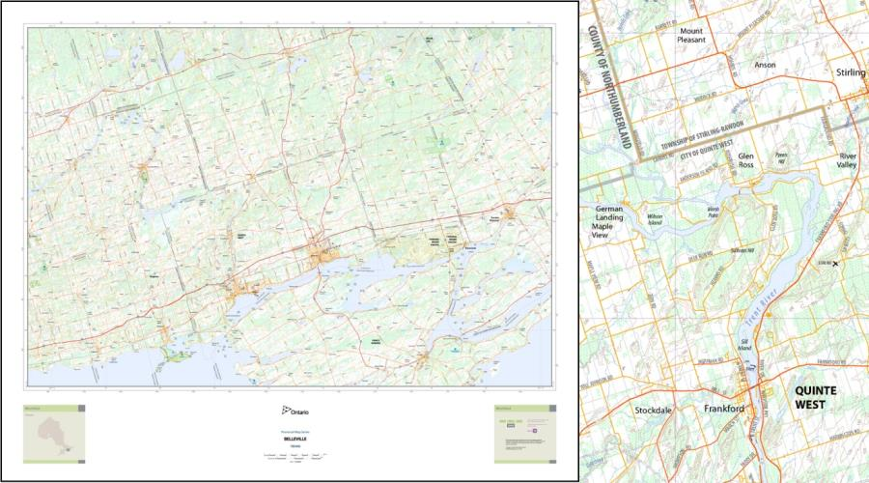

Map Description (403 words):
This is a map entitled, “Belleville” and is tile “780440” of a general purpose topographic map series for the province of Ontario. The map focuses on the area around the City of Belleville in south-eastern Ontario.
The extents of the map include parts of Prince Edward County, including Picton, to the south, Newburgh to the east, Roseneath to the west and Madoc to the north. Prominent places on the map include, Campbellford, Brighton, Trenton, Napanee and the Tyendinaga Mohawk Territory First Nation Reserve. The Bay of Quinte and a portion of the Trent River are also shown.
The topographic map series depicts a variety of cultural and physical features. Prominent cultural features include: settlements; administrative boundaries and transportation features. Major physical features include: waterbodies, watercourses, wetlands, wooded areas and elevation contours.
The maps in the series are 42 inches by 35 inches in size and have a scale of 1 to 100,000, or 1 centimetre equal to 1 kilometre. The border of the map series includes 5-minute graticule markers for both lines of latitude and longitude. A 10,000 metre Universal Transverse Mercator (UTM) reference grid is also visible.
The following is a detailed list of the features included in the map series:
- Settlements including: cities, towns, villages and unincorporated areas or places
- District, upper-tier, single-tier and lower-tier municipal boundaries
- Provincial and international boundaries
- First Nation reserve boundaries
- Federal military base boundaries
- Regulated provincial park boundaries
- National park boundaries
- Conservation reserve boundaries
- Classified road network including: freeways, expressways, highways, arterial roads, collector roads, local roads, resource and recreation roads, winter roads and ferry connections
- Classified airports including: airports, heliports and seaplane bases
- Railway tracks and stations
- Tunnels, for both roads and railways
- Trails
- Built up areas
- Buildings, both to scale and as a symbol
- Transmission lines including: hydro, communication and unknown types
- Pipelines including: gas, water and unknown types
- Waterbodies and watercourses including: lakes, rivers, bays and channels
- Hydrographic features including: dams, hydro walls, lock-gates, rapids and falls
- Wetlands
- Wooded areas
- Geographic features including: islands, capes, beaches, shoals, points, valleys, hills, mountains, caves, cliffs, springs, and plains
- Contours with 10 metre elevation intervals
The map was published in October 2014 by the Provincial Geomatics Service Centre (PGSC) at the Ontario Ministry of Natural Resources (MNR). The geographic information depicted on the map was acquired from Land Information Ontario (LIO) in 2014. For further information, please contact the PGSC at email@emailaddress.ca.

Works Cited
AHP. (2007, November 13). The Essential Characteristics of large Print Maps. (L. P. Group, Ed.) Retrieved January 4, 2016, from American Printing House for the Blind Inc.: https://www.google.com/url?q=http://www.aph.org/files/research/mapguidelines.doc&sa=U&ved=0ahUKEwjU8_D83KTKAhXKGx4KHUXAD3QQFggEMAA&client=internal-uds-cse&usg=AFQjCNGqJYsE_6C2cktGRNAe-yi0B7nryw
AIGA. (2006, January 23). Typography and the Aging Eye: Typeface Legibility for Older Viewers with Vision Problems. Retrieved October 26, 2015, from American Institute of Graphic Arts (AIGA): http://www.aiga.org/typography-and-the-aging-eye/
Brewer, C. A. (2005). Designing Better Maps; A Guide for GIS Users. Redlands, California: ESRI Press.
Buckley, A. (2011, October 28). Design principles for cartography. Retrieved October 26, 2015, from ArcGIS Resources: http://blogs.esri.com/esri/arcgis/2011/10/28/design-principles-for-cartography/
CNIB. (n.d.). Clear Print Accessibility Guidelines. Retrieved October 26, 2015, from Canadian National Institute for the Blind: http://www.cnib.ca/en/services/resources/Clearprint/Documents/CNIB%20Clear%20Print%20Guide.pdf
Colblindor. (n.d.). Learn here all about Color Blindness. Retrieved December 09, 2015, from Colblindor: http://www.color-blindness.com/
Colour Blind Awareness. (n.d.). Types of Colour Blindness. Retrieved December 08, 2015, from Colour Blind Awareness: http://www.colourblindawareness.org/colour-blindness/types-of-colour-blindness/
Dent, B. D. (1993). Cartography Thematic Map Design (3rd ed.). Dubuque, Iowa - Melborne, Australia - Oxford, England: Wm. C. Brown Publishers. Retrieved December 8, 2015
DIAGRAM. (n.d.). Image Description Guidelines. Retrieved 12 9, 2015, from Digital Image and Graphics Resources for Accessible Materials: http://diagramcenter.org/table-of-contents-2.html
DPCD. (2011). Communicating Data with Colour, A DPCD Guide To Producing Colour Accessible Maps And Visual Data. Department of Planning and Community Developement (DPCD), State Government, Victoria, Australia.
IACG. (2011). Web Mapping Accessibility, Guide to Best Practices, Version 1.0. Federal Government of Canada, Web Mapping and Accessibility Sub Group. Inter Agency Committee on Geomatics (IACG). Retrieved October 2015
iansyst Ltd. (n.d.). Typefaces For Dyslexia. Retrieved October 26, 2015, from dyslexic.com: http://www.dyslexic.com/fonts
ICSM, T. I. (n.d.). Fundamentals of Mapping - Cartographic Considerations. Retrieved December 09, 2015, from The Intergovernmental Committee on Surveying and Mapping: http://www.icsm.gov.au/mapping/cartographic.html
Jenny, B. (2007). Color Design for the Color Vision Impaired. Cartographic Perspectives, The Journal of the North American Cartographic Information Society (NACIS), 61-67.
KEC. (n.d.). Low Vision. Retrieved December 15, 2015, from Kellog Eye Center: http://www.kellogg.umich.edu/patientcare/conditions/lowvision.html
Kitchel, J., & APH. (n.d.). APH Guidelines for Print Document Design. (American Printing House for the Blind Inc.) Retrieved December 21, 2015, from American Printing House for the Blind Inc.: http://www.aph.org/research/design-guidelines/
Kitchel, J., & APH, A. P. (n.d.). APH Guidelines for Print Document Design. (American Printing House for the Blind Inc.) Retrieved December 21, 2015, from http://www.aph.org/research/design-guidelines/
Krygier, J. (2008, February 8). More Principles of Map Design. Retrieved from Making Maps: DIY Cartography - Resources and Ideas for Making Maps: http://makingmaps.net/2008/02/05/more-principles-of-map-design/
MNRF. (2015). Basics of Creating Accessible Documents. Ontario Ministry of Natural Resources. Retrieved December 9, 2015
NCAM. (2009). Accessible Digital Media Guidelines, Tools for Access. Retrieved from The National Center for Accessible Media (NCAM): http://ncam.wgbh.org/invent_build/web_multimedia/accessible-digital-media-guide/tools-for-access
NCAM. (2010). Describing Science Images for Learners with Disabilities. Retrieved December 10, 2015, from The National Center for Accessible Media (NCAM): http://ncam.wgbh.org/file_download/109
NEI. (2015, February). Facts About Color Blindness. Retrieved December 12, 2015, from The National Eye Institute (NEI): https://nei.nih.gov/health/color_blindness/facts_about
NEI. (n.d.). Diabetic Eye Disease FAQ. Retrieved December 8, 2015, from The National Eye Institute (NEI): https://nei.nih.gov/diabetes/content/english/faq
NEI. (n.d.). Facts About Diabetic Eye Disease. Retrieved December 8, 2015, from The National Eye Institute (NEI): https://nei.nih.gov/health/diabetic/retinopathy
NEI. (n.d.). Low Vision FAQs. Retrieved December 08, 2015, from The National Eye Institute (NEI): https://nei.nih.gov/lowvision/content/faq
NEI. (n.d.). Low Vision Glossary. Retrieved December 8, 2015, from The National Eye Institute (NEI): https://nei.nih.gov/lowvision/content/glossary
Ordnance Survey. (2015). Simplicity. Retrieved from Ordnance Survey: https://www.ordnancesurvey.co.uk/resources/carto-design/simplicity.html
PennState. (n.d.). Accessibility and Usability at Penn State. Retrieved October 26, 2015, from Pennsylvania State University: http://accessibility.psu.edu/
Peterson, G. N. (2012, November 14). HALOS ARE EVIL*. Retrieved from A Cartographer's Toolkit: http://www.gretchenpeterson.com/blog/archives/2511
Poole, A. (2008, February 17). Which Are More Legible: Serif or Sans Serif Typefaces? Retrieved December 9, 2015, from Alex Poole, User Expierience Consultant: http://alexpoole.info/blog/which-are-more-legible-serif-or-sans-serif-typefaces/
RGD Ontario, T. A. (2010). ACCESS ABILITY. A Practical Handbook on Accessible Graphic Design. Toronto, Ontario, Canada. Retrieved October 26, 2015, from http://rgd-accessibledesign.com/wp-content/uploads/2015/03/RGD_AccessAbility_Handbook1.pdf
Robinson, A. H. (1995). Elements of Cartography (6th ed.). New York, Chichester, Brisbane, Toronto, Singapore: John Wiley & Sons, Inc. Retrieved December 8, 2015
Rosenberg, M. (n.d.). The Role of Color on Maps. Retrieved October 26, 2015, from About.com: http://geography.about.com/od/understandmaps/a/mapcolors.htm
Snow-Weaver, A., Cragun, B., & IBM. (2011). Accessible Analytics - Complex Charts, Large Datasets, and Node Diagrams. Retrieved December 12, 2015, from IBM Human Ability and Accessibility Center: http://www-03.ibm.com/able/news/accessibleanalyticsfull.html
TypeDecon. (n.d.). Typography Deconstructed - Type-Glossary. Retrieved October 26, 2015, from Typography Deconstructed, A comprehensive guide to the anatomy of type: http://www.typographydeconstructed.com/category/type-glossary/
UXM, U. E. (2011, January 23). 6 Surprising Bad Practices That Hurt Dyslexic Users. Retrieved from UX Movement: http://uxmovement.com/content/6-surprising-bad-practices-that-hurt-dyslexic-users/
W3C. (2015, February 26). A guide to understanding and implementing Web Content Accessibility Guidelines 2.0. Retrieved from World Wide Web Consortium(W3C), Web Accessibility Initiative (WAI), Web Content Accessibility Guidelines (WCAG): http://www.w3.org/TR/UNDERSTANDING-WCAG20/Overview.html
WCAG 2.0. (n.d.). Web Content Accessibility Guidelines (WCAG) 2.0. Retrieved 10 26, 2015, from W3C Recommendation: http://www.w3.org/TR/WCAG20/
WebAIM, W. A. (n.d.). Fonts. Retrieved October 26, 2015, from WebAIM, Web Accessibility in Mind: http://webaim.org/techniques/fonts/
Wikipedia. (n.d.). Retrieved December 09, 2015, from Wikipedia: https://en.wikipedia.org/

