User Guide
for
OBM-DTM
(Retired)
LIO Data Class
  - Provincial Mapping Unit
  - Mapping and Information Resources Branch
  - Corporate Management and Information Division
  - Ministry of Natural Resources and Forestry
2020-03-04

Disclaimer
This technical documentation has been prepared by Her Majesty the Queen in right of Ontario as represented by the Ministry of Natural Resources and Forestry (the “Ministry”). No warranties or representations, express or implied, statutory or otherwise shall apply or are being made by the Ministry with respect to the documentation, its accuracy or its completeness. In no event will the Ministry be liable or responsible for any lost profits, loss of revenue or earnings, claims by third parties or for any economic, indirect, special, incidental, consequential or exemplary damage resulting from any errors, inaccuracies or omissions in this documentation; and in no event will the Ministry’s liability for any such errors, inaccuracies or omissions on any particular claim, proceeding or action, exceed the actual consideration paid by the claimant involved to the Ministry for the materials to which this instructional documentation relates. Save and except for the liability expressly provided for above, the Ministry shall have no obligation, duty or liability whatsoever in contract, tort or otherwise, including any liability or negligence. The limitations, exclusions and disclaimers expressed above shall apply irrespective of the nature of any cause of action, demand or action, including but not limited to breach of contract, negligence, strict liability, tort or any other legal theory, and shall survive any fundamental breach or breaches.
Cette publication spécialisée n’est disponible qu’en anglais.

Additional Information
For more information about this document, please contact the Provincial Mapping Unit at pmu@ontario.ca
For metadata and further information view the official LIO metadata record for the Ontario Mass Points and Breaklines in the Ontario GeoHub (https://geohub.lio.gov.on.ca).

Executive Summary

Key Words
Transportation, Land Use Planning, Land Management, Municipal Planning, Planning/Development, Roads, Ontario Basic Mapping, OBM, Topography, Base Mapping, Base Data, DTM (Theme), Elevation, Mass Points, Breaklines

Abstract
This user guide details the specifications for the OBM-DTM Land Information Ontario (LIO) Data Class.
The OBM-DTM LIO Data Class contains point features identifying variations in elevation on the earth's surface (x, y and z values). Includes:
- Hydrographic Break Lines
- Transportation Break Lines
- Physical Break Lines
- Mass Points
OBM-DTM is not available for all areas of the province.
OBM-DTM has been retired. The data is no longer maintained or supported and future maintenance will not occur.

Table of Contents
Disclaimer 2
Additional Information 2
Executive Summary 3
Key Words 3
Abstract 3
Table of Contents 4
List of Figures 4
List of Acronyms 5
Introduction 6
Additional Time Period Information 6
Extent 7
Packages 8
Tiling 8
Data Format 8
Projection 8
Fields 9
Quality of Attributes 9
FCODE 9
DTM_TYPE 9
ZVALUE 10

List of Figures
Figure 1: OBM-DTM Tiles and Extent for Northern Ontario 7
Figure 2: Tiles and Extent for Southern Ontario 7
Figure 3: OBM-DTM attributes and their descriptions. 9
Figure 4: Tiles and Extent for the Province of Ontario 10

List of Acronyms
DEM: Digital Elevation Model
DSM: Digital Surface Model
DTM: Digital Terrain Model
GIS: Geographic Information System
LIO: Land Information Ontario
OBM: Ontario Base Mapping
PMU: Provincial Mapping Unit

Introduction
The OBM-DTM LIO Data Class contains point features identifying variations in elevation on the earth's surface (x, y and z values), and includes:
- Hydrographic Break Lines
- Transportation Break Lines
- Physical Break Lines
- Mass Points
Derived from the Ontario Base Mapping (OBM) program OBM-DTM cover entities were only collected for those photogrammetric map sheets compiled on or about 1985. DTM coverage is not available for all areas of the province.
Mass points were collected approximately every 60 metres for the 1:10,000 scale and 100 metres for the 1:20,000.
Breaklines were collected at a density to accurately reflect the shape of the feature if plotted at compilation scale, typically more than 3 times the density of the mass points.
Legislated or Legal Authority for Collection: None

Additional Time Period Information
As specified in the description, the OBM-DTM cover entities were only collected for those photogrammetric map sheets compiled on or about 1993.
OBM-DTM is not available for all areas of the province.
OBM-DTM has been retired. The data is no longer maintained or supported and future maintenance will not occur.
For more information on OBM-DTM contact the Provincial Mapping Unit at pmu@ontario.ca.

Extent
The following figures show the extent of the OBM-DTM in the Province of Ontario. The areas highlighted in orange are the footprints of the OBM-DTM capture. Two diagrams were used to highlight the two separate packaged products.
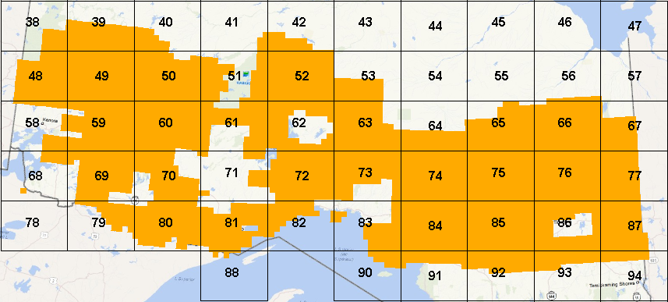
Figure 1: OBM-DTM Tiles and Extent for Northern Ontario
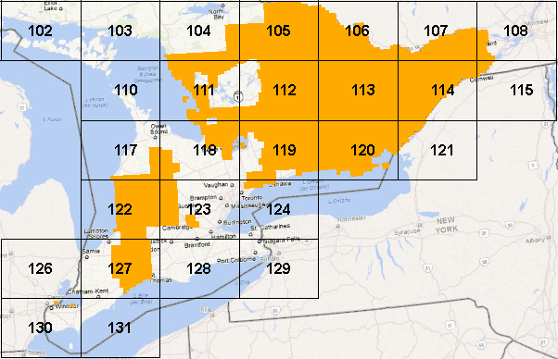
Figure 2: Tiles and Extent for Southern Ontario

Packages
The OBM-DTM is packaged into two separate packages, one for Northern Ontario and one for Southern Ontario. The Northern Ontario package contains all the OBM-DTM points that were captured in the OBM 1:20,000 scale maps. The Southern Ontario package contains all the OBM-DTM points that were captured in the OBM 1:10,000 scale maps.
Even though there are more tiles in the north, the density of points is much less than in the south. The north package contains 50 tiles containing a total of approximately 82 million points and the south package contains 19 tiles and approximately 87 million points.

Tiling
The tiling system matches the tiling system that was used in the Ontario Provincial DEM product. It is a Lambert Conformal tiling system with dimensions of 120km by 90km. This tiles the entire province into 131 tiles. Only 69 of these tiles will contain OBM-DTM.

Data Format
All OBM-DTM datasets are stored in shapefile format to provide access for more users. Shapefiles are usable by both ESRI products as well as other vender GIS products. It is also well used in open source GIS packages.

Projection
All shapefiles will use the following projection: NAD_1983_Ontario_MNR_Lambert
The original OBM source data was in NAD27 may 76 adjustment with a -4,000,000 offset. This is not an easy projection to work with. To provide a standard projection, Lambert Conformal was chosen to provide one single projection for the entire province as well as matching the projection that was used in the Ontario Provincial DEM raster product and Ontario Radar DSM product.

Fields
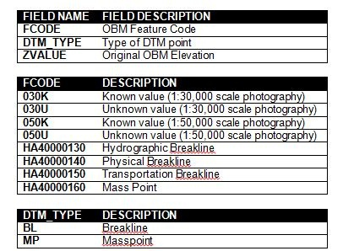
Figure 3: OBM-DTM attributes and their descriptions.

Quality of Attributes

FCODE
Originally there only existed 4 codes (030K, 030U, 050K and 050U) and in later years, it was expanded to have the other codes (HA40000130, HA40000140, HA40000150 and HA40000160). The consistency of the coding varied from contractor to contractor and even varied from one operator to the next.

DTM_TYPE
Due to the inability to rely on the original FCODE values, it was not possible to guarantee the breakdown between the mass points and the breakline points. It was determined that a more successful approach for was to assign by spatially overlaying the original OBM linework for drainage, and transport with the DTM points to identify where breaklines exist. These are identified in the DTM_TYPE field as “BL”. All other DTM points are assigned as “MP” for masspoints.

ZVALUE
Z value is the elevation of the 3-D surface above the vertical datum at designated x/y locations.
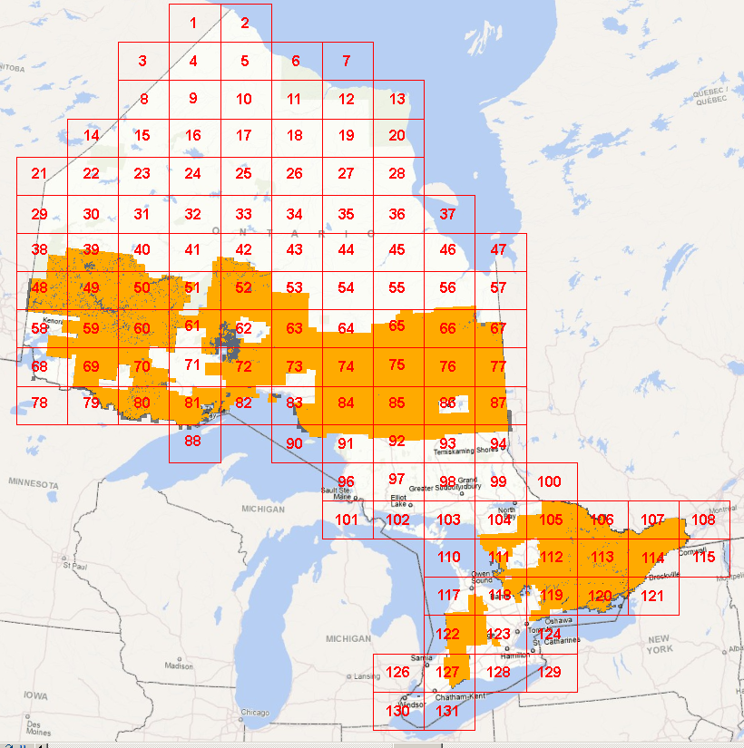
Figure 4: Tiles and Extent for the Province of Ontario
Version 1516.1

