Data Capture Specifications
For Hydrographic Features
Medium Scale
Provincial Mapping Unit
  - Ministry of Natural Resources and Forestry
  - Corporate Management and Information Division
  - Ministry of Natural Resources and Forestry

2020-04-20

Disclaimer
This technical documentation has been prepared by Her Majesty the Queen in right of Ontario as represented by the Ministry of Natural Resources and Forestry (the “Ministry”). No warranties or representations, express or implied, statutory or otherwise shall apply or are being made by the Ministry with respect to the documentation, its accuracy or its completeness. In no event will the Ministry be liable or responsible for any lost profits, loss of revenue or earnings, claims by third parties or for any economic, indirect, special, incidental, consequential or exemplary damage resulting from any errors, inaccuracies or omissions in this documentation; and in no event will the Ministry’s liability for any such errors, inaccuracies or omissions on any particular claim, proceeding or action, exceed the actual consideration paid by the claimant involved to the Ministry for the materials to which this instructional documentation relates. Save and except for the liability expressly provided for above, the Ministry shall have no obligation, duty or liability whatsoever in contract, tort or otherwise, including any liability or negligence. The limitations, exclusions and disclaimers expressed above shall apply irrespective of the nature of any cause of action, demand or action, including but not limited to breach of contract, negligence, strict liability, tort or any other legal theory, and shall survive any fundamental breach or breaches.
Cette publication spécialisée n’est disponible qu’en anglais.

Additional Information
This document does not comply with all the applicable guidelines for accessible digital documents. For an alternative format please email the Provincial Mapping Unit at pmu@ontario.ca.
For more information about this document, please contact Provincial Mapping Unit at pmu@ontario.ca.

Table of Contents
Disclaimer 2
Additional Information 2
Table of Contents 3
List of Figures 5
List of Tables 6
1. Scope 7
2. Hydrographic Features 9
3. Scale considerations 10
3.1 Accuracy and Scale 10
3.2 Feature Dimensions and Scale 11
4. Generic Capture Rules 13
4.1 General 13
4.2 Simplification 15
4.3 Feature Interaction 17
5. Feature Specific Capture Rules 20
5.1 Watercourse and Waterbody Features 20
5.2 Hydrographic Point, Line and Polygon Features 25
5.2.1 Falls 25
5.2.2 Rapids 25
5.2.3 Sea Lamprey Barrier 26
5.2.4 Dam 26
5.2.5 Lock Gate 27
5.2.6 Hydro Wall 27
5.2.7 Wreck 28
5.2.8 Rocks 28
6. Water Flow Connectivity and Direction 30
6.1 General 30
6.2 Virtual Flow 32
6.3 Divergent Water Flow 36
Appendix A – Feature Definitions 41
Watercourse Features 41
Waterbody Features 41
Hydrographic Point, Line and Polygon Features 42
Appendix B – Derivation of Scale and Feature Dimension Relationships 44
Appendix C – Polygon Definition 49
Appendix D – Case Examples of Water Flow Editing in the Far North 51
Introduction 51
NHN Virtual Segment Overview 52
Virtual Flow Specifications 54

List of Figures
Figure 4.1: Complex polygons 14
Figure 4.2: Example of water feature not captured in a wetland 15
Figure 4.3: Douglas Peucker simplification 16
Figure 4.4: Small angle errors 17
Figure 4.5: Example of features being combined (in this case, several islands become a single hole in a waterbody) 18
Figure 4.6: Example of where lake feature polygon ends and river polygon begins 19
Figure 4.7: Maintaining all tributaries as part of river system and not part of lake polygon 19
Figure 5.1: Exclusion of headwater features having a length less than variable c while preserving as much geometry as possible 20
Figure 5.2: Headwater separation 21
Figure 5.3: Waterbody intersections: (a) original version; (b) two corrected versions 22
Figure 5.4: Waterbody sharp points: (a) end of waterbody inlet is too narrow 23
Figure 5.5: Multiple watercourse intersections 24
Figure 6.1: Flow direction for watercourse line in a loop 31
Figure 6.2: Virtual flow segments through lake polygons. (Note that they are all primary segments) 32
Figure 6.3: Orientation of virtual flow segments and minimum distance separation rules 33
Figure 6.4: Polygon with multiple outlets; (a) or (b) correct; (c) incorrect 35
Figure 6.5: Flow gaps as delineated within waterbodies as virtual flow 37
Figure 6.6: Other criteria for defining the main channel in order of precedence 38
Figure 6.7: Other criteria for defining the main channel in order of precedence 39
Figure 6.8: Braided system order scenarios 40
Figure A.1: Feature Examples 43
Figure B.1: Feature Spacing 45
Figure B.2: Various stream vector feature scenarios and how they translate to the raster environment. 48
Figure C.1: Examples of polygons with 1, 2 and 3 rings respectively. 50
Figure C.2: Examples of objects violating polygon geometry assertions 50

Figure D.1: Example of NHN features identifying areas of concern. 53
Figure D.2: (Examples a-b): Flow editing scenarios 56
Figure D.3: (Examples c-e): Flow editing scenarios 57
Figure D.4: (Examples f-g): Flow editing scenarios 58
Figure D.5: (Examples h-i) Flow editing scenarios 59

List of Tables
Table 1: Hydrographic features 9
Table 2: Scale and accuracy criteria 10
Table 3: Scale and feature dimensions criteria 11
Table 4: Graphical representation of hydrographic point, line and polygon rules 29
Table B.1: Feature Separation Calculations 45
Table D.1: Terminology 51

- Scope
This specification covers only the data capture of hydrographic features at the medium scale within the Ministry of Natural Resources and Forestry (MNRF) Ontario Hydro Network (OHN) and associated datasets. A ‘hydrographic feature’ in the context of this document generally refers to features that directly define the boundary interface between land and surface water. These features should be collected in such a way to serve both cartographic and analytical needs of the Province.
The scale of a digital mapping product is generally defined by the accuracy, and resolution where distinct features can be reasonably distinguished at a given map distance. ‘Medium scale’ is defined, for use by the Government of Ontario, as corresponding to a cartographic scale between 1:10,000 and 1:50,000.
The rationale for the Province supporting medium scale products includes developing a standard product which:
- is spatially consistent and covers the entire Province,
- can be used efficiently for multiple applications at the regional level, and
- can form the basis of communicating up to the national level as well as down to the local agency level meeting the majority of our stakeholder needs.
Data capture includes the process of attribution and digitizing specific features as polygons, lines and points from various sources such as raster imagery, GPS or LiDAR. Separate specifications cover the acquisition of this source data, as well as the modelling of these features. This specification will support and be consistent with any Provincial medium scale modelling criteria that may be required.
Captured data is a “snapshot in time”. It should accurately represent features as they exist when the information was collected, but may not be accurate at a later date due to physical changes to the feature. Collecting and documenting metadata about the source information is critical.
The hydrographic features are limited to the extents of visible surface water and associated features. Therefore, subsurface or groundwater features are generally out of scope except where they directly link surface water features together for flow purposes (such as culverts).
Wetlands are not covered by this specification. However, due to the integral relationship between wetlands and surface water features, reference is made to wetlands within this document. For more information on wetlands, search Ontario GeoHub for “Wetland”.
Islands are not considered to be hydrographic features. Islands are treated as holes in waterbodies.
This specification applies only to new data capture projects. Existing products may not meet or may exceed these specifications at their stated scale, but will continue to be presented for use at that scale without adjustment or modification, until such time as replacement products are verified and attributed.
This document is meant to serve as a living document and will be updated on a continual basis. The most current version is available for download by searching the Ontario GeoHub for “Data Capture Specification for Hydrographic Features (Medium Scale)”.
For an associated Large Scale - Data Capture Specifications for Hydrographic Features search the Ontario GeoHub for “Data Capture Specifications for Hydrographic Features (Large Scale)”.
- Hydrographic Features
The hydrographic features that are to be captured are listed in Table 1 below. Definitions are given in Appendix A.
Table 1: Hydrographic features
Feature Class | Feature Type
Watercourse (line) | Stream (default), Ditch, Virtual connector, Virtual flow
Waterbody (polygon) | Lake (default), Beaver Pond, Kettle Lake, Pond, Reservoir, Canal, River, Ocean
Hydrographic Point | Falls, Rapids, Rocks, Wreck, Sea Lamprey Barrier
Hydrographic Line | Falls, Rapids, Dam, Lock gate, Hydro Wall, Sea Lamprey Barrier, Wreck
Hydrographic Poly | Dam, Rapids, Hydro Wall, Wreck
These feature classes and types correspond to the official Ministry of Natural Resources and Forestry (MNRF) model for medium-scale hydrographic features. As this is a plane (2 dimensional) model, elevation data (Z values) are not collected.
The main hydrographic classes are Watercourse and Waterbody. Water features that meet minimum width requirements are captured as Waterbodies (polygons); otherwise they are captured as Watercourses (lines). In addition, most Waterbodies have one or more Watercourse (Virtual Flow) features within them, to provide continuity to the flow network.
The other three feature classes (Hydrographic Point, Line and Polygon) are not water classes themselves, but may pose impediments or hazards to water flow or navigation. These features always occur on top of Waterbody or Watercourse features, which continue underneath them.
- Scale considerations
  - Accuracy and Scale
Table 2 details the relationship between the data accuracy and map scale. The accuracy parameter is only statistically valid when specified at a specific confidence level. For this specification, a confidence level of 90% or above is required. (A confidence level of 90% means that 90% of the measured points will be located within the accuracy distance of their specified location). “Absolute” refers to the positional accuracy of features relative to their true-world coordinates. “Relative” refers to the positional accuracy of features relative to near-by features.
Table 2: Scale and accuracy criteria
Absolute Accuracy (90% confidence) | Relative Accuracy (90% confidence) | Map Scale
5 m | 2 m | 1:10,000
10 m | 4 m | 1:20,000
25 m | 10 m | 1: 50,000
In general, source data collected or corrected to a given horizontal accuracy can be used for feature extraction at the corresponding scale (or smaller) in the table. Attempting to generate a larger scale product from this data will likely produce inaccurate and/or unreliable results.
Source accuracy is determined from the acquisition specifications and quality assurance testing associated with the data used.
At any given scale, features produced according to this specification should be accurate to within the limits given in Table 2. This would normally be expected if the source data meets these requirements and feature extraction is done appropriately. However, a given accuracy can only be established by statistical analysis of the feature data. Comprehensive QA/QC (quality assurance / quality control) processes need to be built into any feature extraction project, if the resulting data is to be trusted.
Although meeting these accuracy criteria may be required for data used for legal and/or navigational purposes, this will not by itself qualify the data for these purposes. Any products derived from this data must meet additional requirements and authorization before being used for any purpose that would incur liability.
  - Feature Dimensions and Scale
Table 3 details the relationships between the map scale and feature dimensions. These relationships are used to set various tolerances used in the following sections. The variables a to d in the table are referenced in the rules in these sections. The appropriate distances are then selected from the table for the scale being captured.
Table 3: Scale and feature dimensions criteria
Map Scale | Vertex Simplification Tolerance  Variable: a | Feature Separation (Minimum)  Variable: b | Closed Line Length (Min.)  Variable: b | Open Line Length (Min.)  Variable: c | Polygon Width (Minimum)  Variable: d
1:10,000 | 1 m | 15 m | 15 m | 60 m | 10 m
1:20,000 | 2 m | 30 m | 30 m | 120 m | 20 m
1:50,000 | 5 m | 75 m | 75 m | 300 m | 50 m
The map scale and the minimum feature separation (variable b) are closely linked. The map scale describes the physical representation of the product (such as on a paper map) and the minimum feature separation describes the corresponding digital representation. This controls the level of detail and the appearance of the product. The minimum feature separation is referenced throughout the remainder of this document.
The minimum vertex density (variable a) refers to the spacing of the vertices defining a single line or polygon. The objective is to have as few vertices as possible, while still preserving the accuracy of the feature at an appropriate level. Section 4.2 describes the process for achieving this objective.
The minimum closed and open line lengths (variables b and c) determine whether a line feature is long enough to be captured. ‘Closed’ refers to line features connected to other features at both ends (such as a line feature connecting a headwater waterbody to another waterbody), while ‘Open’ refers to line features connected at only one end (such as a headwater stream) or un-connected (such as a sink hole). This is addressed primarily in section 5.2.
The minimum polygon width (variable d) is used to determine whether a feature is captured as a polygon or a line (or perhaps not captured). Section 5 deals with this determination.
For further information on the derivation of these relationships, see Appendix B.
- Generic Capture Rules
  - General
- Each dataset will have appropriate metadata attached. Please refer to the Ontario GeoHub.
- For each feature, the following attributes must be recorded (using the format specified in the Data Description within the appropriate metadata record from the Ontario GeoHub.
  - Feature class and type – see Section 2
  - Permanency (watercourses and waterbodies only) – see Section 5.1
  - Flow classification (watercourses only) – see Section 6.1
  - Flow direction verification status (watercourses only)
  - Other relevant information may also be collected for features using the “General Comments attribute.
- ‘Z’ geometry (elevation values) will not be stored as part of a water feature.
- Features must not overlap, either with themselves or with other features. This means that feature segments must be split and snapped together to share a node where they join.
- All polygons must conform to the polygon definition given in Appendix C.
- Islands are considered to be land features, and thus are not captured as hydrographic features. Islands will be depicted as holes in waterbodies.
- All point, line and polygon features should be single part features. Multipart features, which have two or more parts associated with one attribute record, are not allowed – see Figure 4.1. Single part features each have their own attribute record.
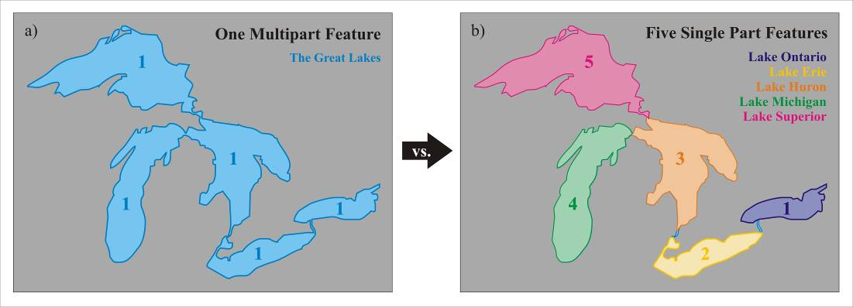
Figure 4.1: Complex polygons
- Wetland features are not to be compiled or attributed and their capture will not be addressed in this document search the Ontario GeoHub for “Wetland”.
- Small open water areas in wetlands should not be captured, unless they are part of a flow network or connected to another water feature. Figure 4.2 presents an example of an area that should not be captured as a water feature.
Figure 4.2: Example of water feature not captured in a wetland
  - Simplification
- Care should be taken to ensure that unnecessary vertices are not captured. For example, a straight line segment needs only two vertices – at its start and at its end. Capturing additional vertices at a higher density is not useful, and makes datasets larger and harder to use.
- To ensure that line segments do not include unnecessary vertices, simplification should be applied, subject to the restriction that at no point along a segment is the separation between the segment and the feature outline greater than the vertex simplification tolerance specified in Table 3 (variable a). Simplification removes extraneous bends and small intrusions and extrusions from a line or polygon boundary without destroying its essential shape. Visually, the object remains unchanged.
- The recommended simplification method is the Douglas Peucker algorithm. (This description is adapted from the ESRI ArcGIS documentation). The algorithm keeps the so-called critical points that depict the essential shape of a line and removes all other points. The algorithm connects the end nodes of a line with a "trend line". The distance of each vertex to the trend line is measured perpendicularly. Vertices closer to the line than the tolerance are eliminated. The line is divided by the vertex farthest from the trend line, which makes two new trend lines. The remaining vertices are measured against these lines, and the process continues until all vertices within the tolerance are eliminated (see Figure 4.3). Note that the jaggedness that appears in the figure will not be visible during normal viewing, due to the very small value of the simplification tolerance (equivalent to about 0.1 mm on a physical map).
Figure 4.3: Douglas Peucker simplification
- Very small angles in line and polygon features, such as spikes, zigzags or sliver polygons, are typically errors in the captured data. (See figure 4.4 for examples). These artefacts are particularly common in un-processed GPS data. Where spikes, zigzags, or other angles of less than approximately 10 degrees appear in features, the data should be re-examined and any errors eliminated.
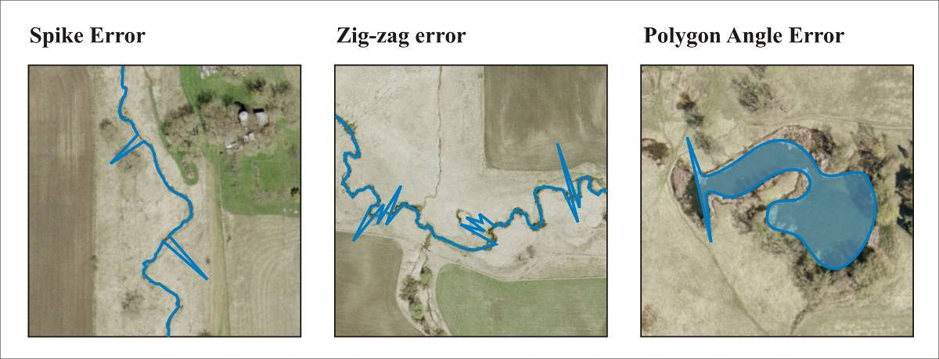
Figure 4.4: Small angle errors
  - Feature Interaction
- Adjacent, non-connecting features should be separated by at least the minimum feature separation specified in Table 3 (variable b), if possible. (Note that in certain circumstances the complex nature of the local hydrology may require a smaller separation to ensure the integrity of the flow network).
- If features do not meet the separation criteria, spacing may be corrected by:
  - combining the features, if they are similar types and it makes sense to combine them (see Figure 4.5), otherwise
  - having the features share nodes or line segments if practical, by adjusting the spacing equally towards each other, otherwise
  - moving both features equally away from each other, until the required separation is achieved.
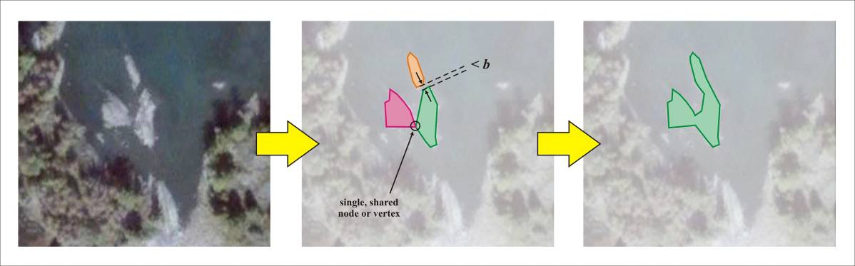
Figure 4.5: Example of features being combined (in this case, several islands become a single hole in a waterbody)
- At the point(s) where two features connect, the features should have common nodes or vertices. This applies to features of different types, as well as features of the same type (e.g. a waterbody vertex and a connecting watercourse node share the same location).
- There should be no overlapping or duplicated features within the same feature class.
- Where rivers flow into lakes and vice versa, one feature’s polygon will end where the other feature begins to narrow or widen respectively (see Figure 4.6 below – middle figure).
- Where a river flows first into a widening bay and then into a lake system, the bay will be considered to be part of the lake system.
- Where a river and lake meet, the virtual flow must be broken at the same location where the polygons intersect (see Figure 4.6 – right figure).
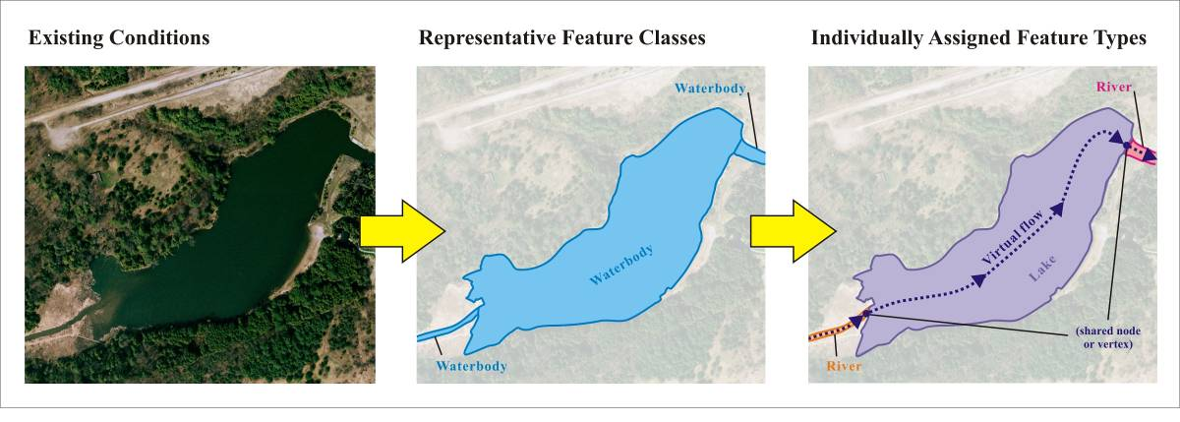
Figure 4.6: Example of where lake feature polygon ends and river polygon begins
- In complex cases where a waterbody polygon splits into multiple tributaries (see Figure 4.7) the intent will be to maintain all tributaries as part of the river system and not included as part of the lake polygon.
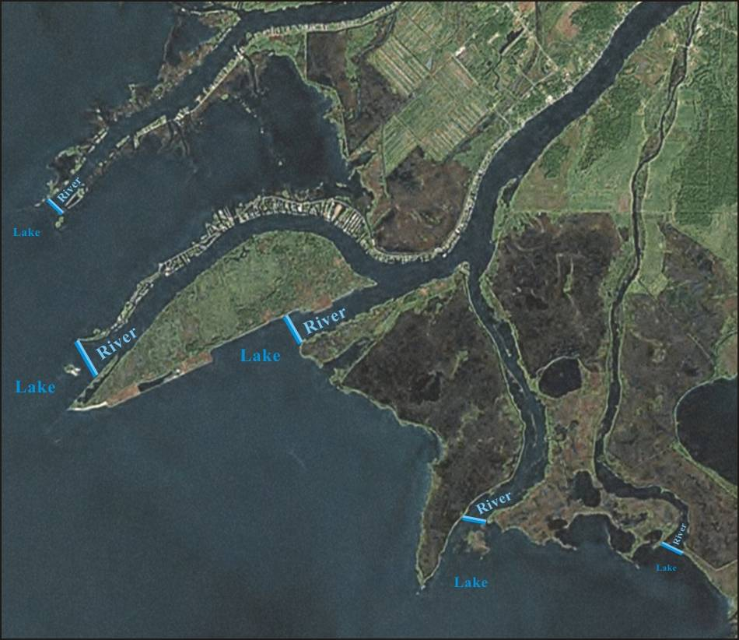
Figure 4.7: Maintaining all tributaries as part of river system and not part of lake polygon
- Feature Specific Capture Rules
  - Watercourse and Waterbody Features
- By default, all water features will be considered permanent, unless otherwise determined (permanent/intermittent attribute). Water features that are known to exist for less than 9 months per year will be considered intermittent.
- By default, all virtual flow segments in watercourse should be assigned the permanency attribute value of ‘permanent’.
- A watercourse feature that does not connect two other waterbody/watercourse features and is less than the minimum open line length in Table 3 (variable c) will be excluded. This includes headwater segments with no upstream connections, and isolated water features (see Figure 5.1).
Figure 5.1: Exclusion of headwater features having a length less than variable c while preserving as much geometry as possible
- A watercourse feature that is less than the minimum closed line length in Table 3 (variable b) will be excluded, even if it connects two other waterbody/watercourse features. (The two adjoining features will be joined together to maintain water flow connectivity).
- Where two watercourses start from a single point source (for example, two streams starting from a spring or wetland), there should be a break between the two watercourses at that point, with a separation equal to the minimum feature separation (variable b in Table 3 – see Figure 5.2).
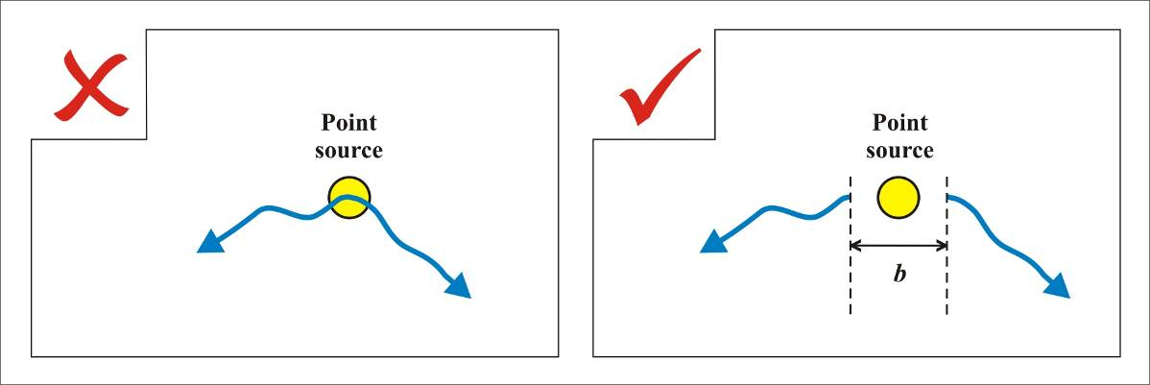
Figure 5.2: Headwater separation
- When the smallest dimension of a water feature exceeds the minimum polygon width in Table 3 (variable d), it is classified as a Waterbody. Otherwise, the feature may be classified as a watercourse (as a line through the centre of the feature – as applicable).
- A water feature such as a river may, along its length, at some points be wide enough to be classified as a Waterbody and at other points narrow and fit the classification of Watercourse. It is undesirable for such a feature to switch back and forth repeatedly between the two classifications.
- There is no hard rule for dealing with a water feature that has sections where the width is both less and greater than the width threshold in Table 3 (variable d). The objective is to adjust the boundaries of the feature so as to minimize the number of line to polygon transitions within the feature.
- Attention should be given to the trend within the water feature. If the majority of the feature is narrower than variable d, the feature should be captured as a watercourse. If the majority of the feature is wider than variable d, it should be captured as a waterbody.
- If it is not possible to distinguish the width that best captures the feature, it is recommended to use a watercourse delineation.
- Notwithstanding the above, a canal will always be captured as a waterbody polygon.
- Adjacent waterbody polygons should not touch at only a single point, with one shared vertex (see Figure 5.3). If the polygons are separate features, they should be separated, with the gap equal to the minimum feature separation in Table 3 (variable b). If the polygons are part of the same feature, they should be merged together, with the width where they join equal to the minimum polygon width in Table 3 (variable d).
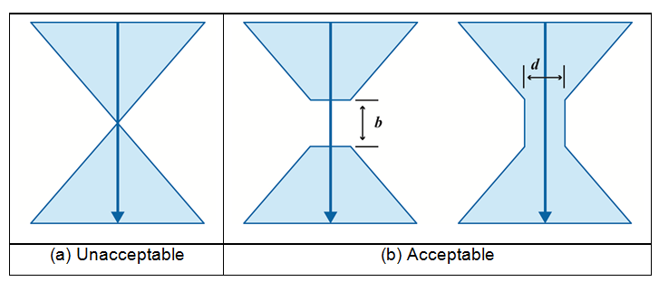
Figure 5.3: Waterbody intersections: (a) original version; (b) two corrected versions
- A waterbody outline should not come to a sharp point (less than a suggested angle of 10 degrees), particularly where it meets another water feature. In the left image below, the waterbody has a very small angle where the watercourse enters. This situation may cause the virtual flow segment to overlap the shoreline. By adding one or two vertices to the waterbody (see Figure 5.4) the angles are much larger and the virtual flow segment is clear of the shoreline. The separation at the end should be the minimum feature separation width (variable b in Table 3).
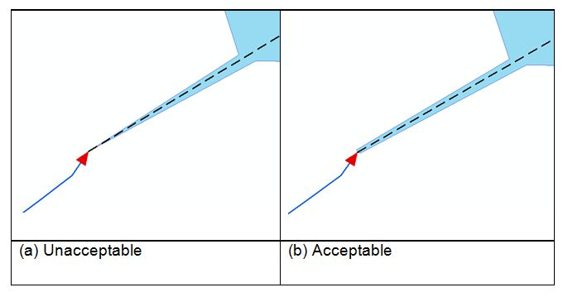
Figure 5.4: Waterbody sharp points: (a) end of waterbody inlet is too narrow
- Only one watercourse line may connect with either a waterbody polygon or another watercourse line at a given point. (This minimizes confusion with multi-directional flow in the raster flow modelling environment). The closest a second watercourse line may be to that given point is the minimum feature separation in Table 3 (variable b). An exception may be made for anthropogenic influenced drainage (e.g. artificial roadside ditches), where four watercourse lines meet at right angles. In this case, the angles between segments are sufficiently spaced and will not cause problems in the raster environment. Figure 5.5 presents examples of acceptable and unacceptable scenarios.
- Watercourse and waterbody features must intersect at a single point (that is, the watercourse must not follow the edge of a waterbody feature).
Figure 5.5: Multiple watercourse intersections
  - Hydrographic Point, Line and Polygon Features
Hydrographic point, line and polygon features must be associated with a waterbody or watercourse. The form of these hydrographic features will be determined by whether they are on a waterbody or a watercourse, and will be different for different feature types. These forms are described in the rules below and are shown graphically in Table 4 which follows.
    - Falls
- Falls occurring on a waterbody will be mapped on the waterbody as a line stretching from one shore to the other of the waterbody. The line should follow the shape of the falls.
- Falls will be mapped on a watercourse as a point.
- Falls may either occur in the middle of a river or stream water feature or at the edge of a river or stream water feature where it connects to another water feature such as a lake.
- Water flow should be through the falls.
    - Rapids
- Rapids occurring on a waterbody and having a length greater than the minimum polygon width (variable d in Table 3) will be mapped on the waterbody as a polygon. The polygon should follow the outer extent of the rapids, connecting to the shores of the water feature.
- Rapids occurring on a waterbody but not meeting the above restriction will be mapped as a line stretching from one shore to the other of the waterbody. The line should follow the shape of the rapids.
- Rapids occurring on a watercourse and having a length greater than the minimum polygon width (variable d in Table 3) will be mapped on the watercourse as a line along the watercourse. The rapids must occupy the same space as the underlying watercourse feature (that is, not on land) and will represent the extent of the rapids.
- Rapids occurring on a watercourse but not meeting the above restriction will be mapped as a point.
- Rapids may occur either in the middle of a river or stream water feature or at the edge of a river or stream water feature where it connects to another water feature such as a lake.
- Water flow should be through the rapids.
    - Sea Lamprey Barrier
- A sea lamprey barrier will be mapped on a waterbody as a line stretching from one shore to the other of the waterbody.
- A sea lamprey barrier will be mapped on a watercourse as a point.
- A sea lamprey barrier may occur in the middle of a river or stream water feature or at the edge of a river or stream water feature where it connects to another water feature such as a lake.
- Water flow should be through the sea lamprey barrier.
    - Dam
- Dams are only captured on waterbodies as polygons or lines. Dams exist as point features in the Ontario Dam Inventory (ODI) feature class and will not be replicated in these hydrographic classes. For more information on the ODI, search the Ontario GeoHub for “Ontario Dam Inventory”.
- A dam at the intersection of a waterbody with a watercourse will be considered to be occurring on the waterbody.
- A dam occurring on a waterbody and having a length greater than the minimum polygon width (variable d in Table 3) will be mapped on the waterbody as a polygon. The polygon should follow the shape of the dam and may extend beyond the shores of the water feature.
- A dam occurring on a waterbody but not meeting the above restriction will be mapped as a line stretching across the waterbody. The line should follow the shape of the dam and may extend beyond the shores of the waterbody.
- Only human-made dams are captured. Beaver dams and other natural blockages are not captured, although they may form part of the shoreline of a water feature.
    - Lock Gate
- Lock gates will be mapped on a waterbody as a line stretching from one shore to the other of the waterbody. The line should follow the shape of the closed lock gates (generally in the shape of a ‘V’).
- Since the canals which contain locks can only be represented as a waterbody (not a watercourse), lock gates are not found on watercourses.
    - Hydro Wall
- A hydro wall is a structure built in a waterbody and possibly extending onshore, or built along a waterbody forming the shoreline. It does not allow water to pass under it, but allows water to pass around it. Hydro walls are not captured on watercourses.
- A hydro wall that forms the shoreline will also be captured separately in the waterbody layer.
- A hydro wall that has a length greater than the minimum open line length (variable c in Table 3) and a width greater than the minimum polygon width (variable d in Table 3) will be mapped as a polygon.
- A hydro wall that has a length greater than the minimum open line length (variable c in Table 3) and a width less than the minimum polygon width (variable d in Table 3) will be mapped as a line extending into the water.
  - A hydro wall that does not meet either of the above criteria will not be mapped.
    - Wreck
- Wrecks only exist in waterbodies, not on watercourses.
- A wreck that has a length greater than the minimum open line length (variable c in Table 3) and a width greater than the minimum polygon width (variable d in Table 3) will be mapped as a polygon.
- A wreck that has a length greater than the minimum open line length (variable c in Table 3) and a width less than the minimum polygon width (variable d in Table 3) will be mapped as a line.
- A wreck that does not meet either of the above criteria will be mapped as a point.
    - Rocks
- Rocks are only captured on waterbodies, and are mapped as point features.
- Rocks are only captured if they are smaller than the minimum polygon width (variable d in Table 3). Rocks larger than this size are considered to be islands and are not captured as hydrographic obstructions.
- Rocks are not captured if they are completely underwater, even if they are visible.
Table 4: Graphical representation of hydrographic point, line and polygon rules
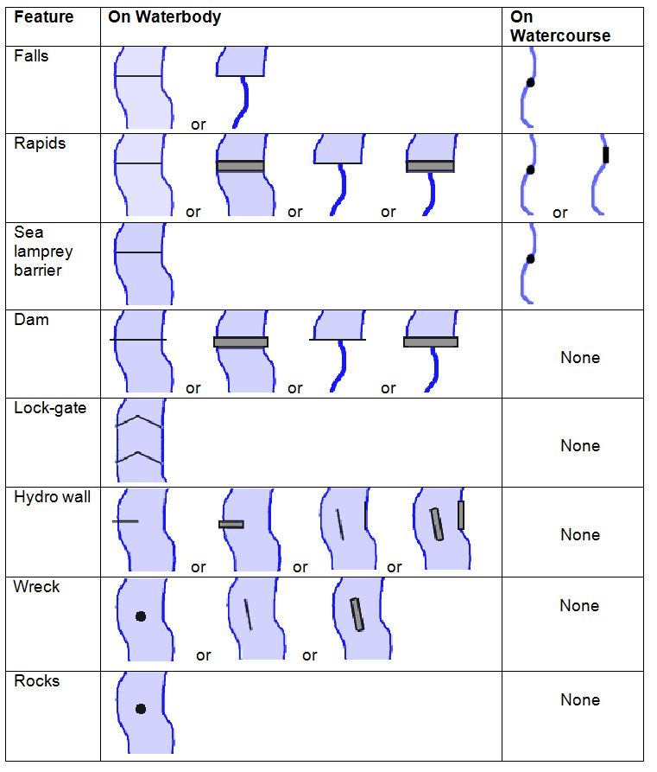

- Water Flow Connectivity and Direction
  - General
- There must be a watercourse line feature wherever there is water flow. This includes water features that are too small to be captured as polygons as well as virtual flow segments through polygons.
- To ensure connectivity, features should extend through areas where visibility is obscured (through culverts, under bridges, etc.), using virtual segments if necessary.
- All watercourse lines should be digitized in a down-stream direction. That is, the ordering of vertices for line features with water-flow should be in the direction of the flow. Flow direction can be determined by observing the elevation drop between the extents or delimiters of the feature, or from other interpretive techniques.
- Flow direction verification must be recorded for all water flow features. This will indicate whether the flow is known to have been digitized in the down-stream direction, as described in the bullet above.
- Flow classification must be recorded for all water flow features. This classification defines the primary (main) and secondary (alternate) routes of a water flow network. Secondary streams are indicative of divergent flow where there are multiple routes traversing through a system (e.g. a braided stream network or delta). Refer to section 6.3 for more information on how to deal with these scenarios.
- Secondary routes are ‘separated’ from primary routes on the upstream end where the streams diverge using a special type of secondary segment called a “flow gap”. A flow gap is a water flow segment which represents proper flow routing but can be removed to break loops in divergent flow. Flow gaps can exist on land as stream centre lines or in waterbodies as virtual segments.
- When used on land, the recommended length is the closed line length (variable b in Table 3). The remaining segment downstream to the next feature (e.g. stream confluence or waterbody) would be attributed as a secondary route.
- In waterbodies, the flow gap should still honour the variable b length when possible followed by a secondary segment to the shoreline outlet. An exception to this rule would be if the distance from the waterbody centreline to the shoreline is less than 2 times the closed line length (variable b in Table 3), then the entire virtual flow segment to the shoreline outlet would be identified as a flow gap (refer to section 6.2 for more information).
- A watercourse loop may first diverge and converge later downstream (see Figure 6.1). A watercourse loop should not converge first and diverge later downstream. This will cause a circular flow effect which creates issues with network analysis.
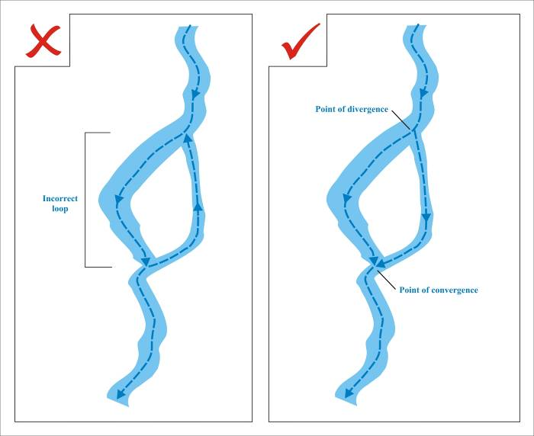
Figure 6.1: Flow direction for watercourse line in a loop
- The general workflow for water flow capture should begin with capturing the primary network which consists of major routes or pathways only. Secondary routes are then added to complete the network with flow gaps on the upstream end of each diverging segment (refer to section 6.3).
  - Virtual Flow
- Virtual flow segments should be captured separately as centrelines for all polygon features which have both input and output connections with other water features. Virtual flow segments should not exist in polygon features that have only outlets and no inlet. Isolated polygon features will not have virtual flow segments.
- Virtual flow segments should enter and exit polygon features as close to perpendicular to the shoreline as practical. When possible, the virtual flow segment should extend in perpendicular from the shoreline a distance of 100 m before changing direction when the waterbody width is greater than 200 m (see Figure 6.2 inset a). Otherwise, the perpendicular virtual flow segment should extend to the mid-line of the waterbody.
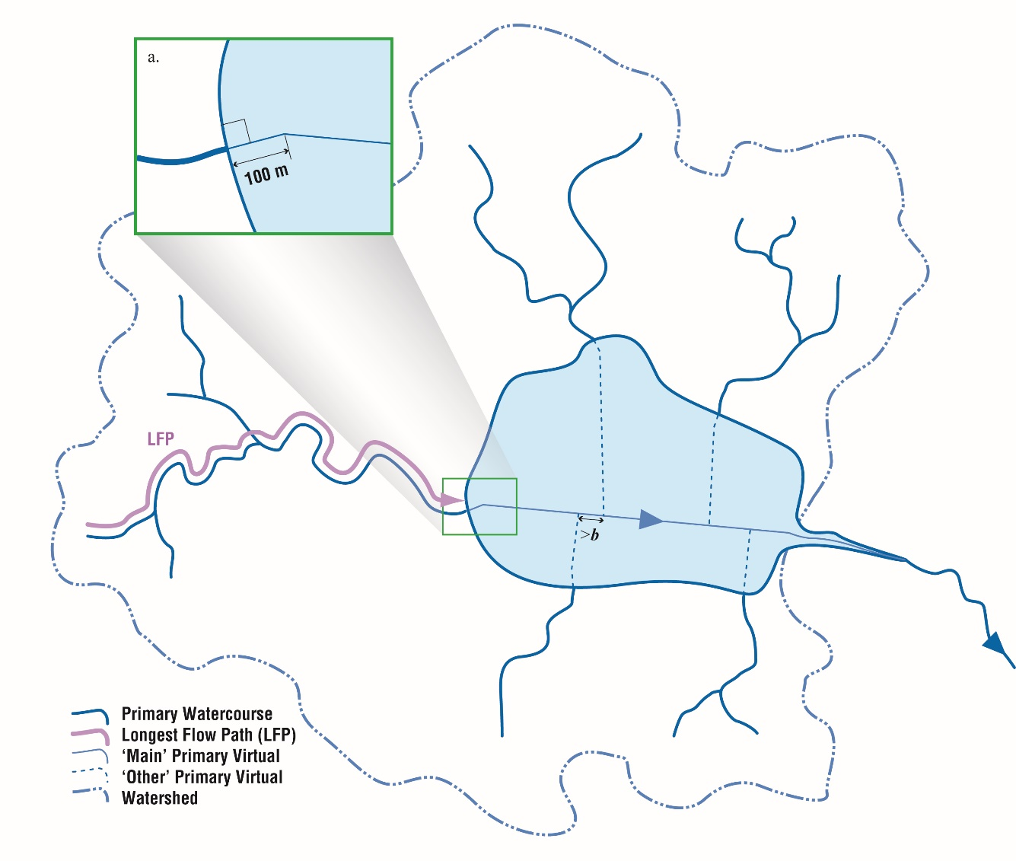
Figure 6.2: Virtual flow segments through lake polygons. (Note that they are all primary segments)
- Virtual flow segments should not touch the shoreline of a polygon feature except where they enter and exit. They should be at least 100 m away from the shoreline where possible. They do not need to follow the centre of the polygon except when the polygon width falls below 200 m (see Figure 6.3).
- For polygon features with multiple inputs and/or multiple outputs, one main primary virtual flow segment should join one input to one output. All other inputs and outputs (primary and/or secondary) should have separate virtual flow segments that join individually to the main virtual flow segment. This is to reduce stream ordering and flow direction routing issues.
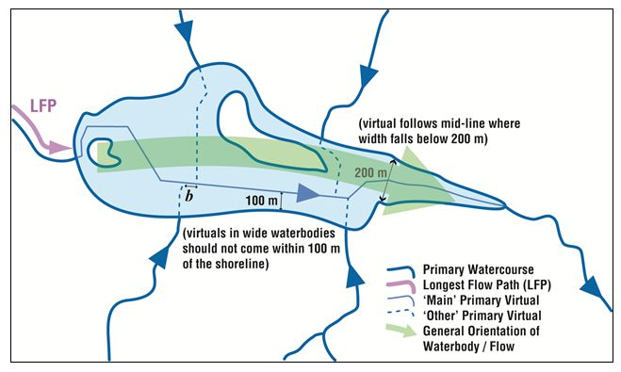
Figure 6.3: Orientation of virtual flow segments and minimum distance separation rules
- Normally, individual virtual flow segments should be separated by the minimum feature separation value (variable b from Table 3). However, where short virtual flow segments are needed to connect to an existing virtual flow, the virtual flow segment must be kept, even if it is below the minimum feature separation value (variable b from Table 3).
- Determining the inlet for the main virtual flow segment should ideally be based on the Longest Flow Path (LFP) upstream of the waterbody or the shape/flow orientation of the waterbody itself (e.g. if the double-line feature is a river, the main virtual flow segment should follow the mid-line of the river’s shape or morphology in the direction of flow – see Figure 6.3).
- A visual determination is usually sufficient to determine LFP if the area is not too large or complex. However, when this is not possible, quickly summing the number of segments or the total length of all segments upstream of a waterbody inlet and comparing this to other inlets should be sufficient. The highest value would define the main stream inlet.
- Determining the outlet for the main virtual segment should normally be based on the largest outlet exiting the waterbody (imagery may help discern this if double-line features are not present). If this cannot be determined, the LFP between the main inlet and outlet should be chosen. All other outlets would be connected to flow gaps, which would branch off from the main primary virtual.
- If the distance from the main primary virtual flow segment to the outlet falls below 2 times the minimum closed line length (2 × variable b in Table 3), the entire segment to the outlet should be captured as a flow gap (see Figure 6.4.a).
- Optionally, a secondary virtual flow segment can be introduced adjacent to and downstream of the flow gap if the total distance exceeds 2 times the minimum closed line length (2 × variable b in Table 3 – see Figure 6.4.b).
- There should be no more than one primary virtual segment exiting a waterbody (see Figure 6.4.c). An exception may be virtuals running through complex braided systems (see Figure 6.8)
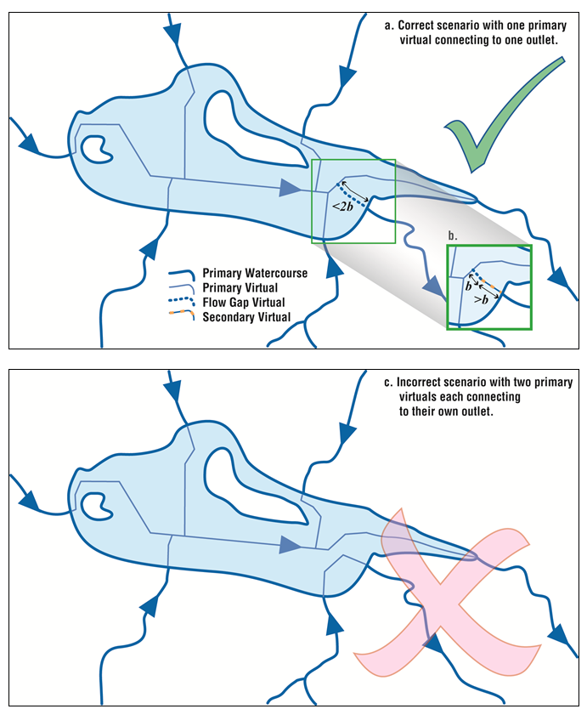
Figure 6.4: Polygon with multiple outlets; (a) or (b) correct; (c) incorrect

  - Divergent Water Flow
Some general rules or guiding principles for divergent water flow editing in order of precedence are as follows (each of these principles are described further throughout this section and in Appendix D):
- Stream width should ultimately define the number and location of primary and secondary pathways where possible.
- The channel with the greater number of incoming tributaries should be defined as the primary pathway.
- The shortest path principle should define the primary pathway in the absence of the above two conditions.
- The bounding extents of a braided system or delta should be defined. They can either be primary pathways (following the above principles or when an incoming tributary is encountered) or secondary pathways (until the next feature is encountered).
- Secondary segments will not be captured for islands having a length dimension falling below the open line length distance (variable c in Table 3), which should be measured parallel to the general direction of flow. An exception to this rule is if the island is participating in an island ‘cluster’ with a total dimension exceeding variable c in Table 3.
- Secondary segments will not be captured for islands having a width falling below the minimum closed line length distance (variable b in Table 3).
- Secondary segments in braided systems will not be captured for channels going contrary or perpendicular to the general direction of flow.
Where flow through a waterbody is divided (e.g. by an island or braided stream system), virtual flow will be captured in the following ways:
- The primary or main channel(s) should typically be captured first. The best method of determining the main channel would be to compare the proportion of flow in each channel. However, this is often difficult to determine remotely. Therefore, stream width can be used as the main criteria especially in the presence of double line river features or supporting imagery (see Figure 6.5).
- If stream width is not possible to determine, then the channel with the greatest number of incoming tributaries should be selected as the main channel (see Figure 6.6.a). If there is an equal number of incoming tributaries on each branch or no incoming tributaries (see Figure 6.7), then the shortest flow path principle should be considered. In some cases, the presence of a constructed canal or dam would also be an indicator for determining the main channel of a braided system.
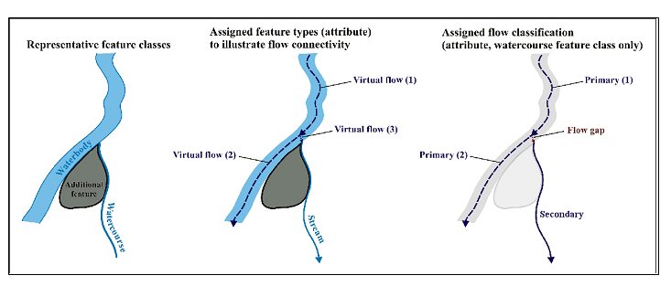
Figure 6.5: Flow gaps as delineated within waterbodies as virtual flow
- Secondary channel(s) should be captured with an attributed flow gap segment introduced at the upstream end of the diverging segment (depicted as dotted lines in Figures 6.4 through 6.6). The length of the flow gap should be based on the minimum closed line segment length (variable b in Table 3). In some cases, capturing secondary channels may be optional or not required depending on the scenarios described below.
- For large lakes where there is no apparent defined flow, virtual segments will be captured where they are required only for connectivity purposes. The primary channel path would be defined by the largest ‘channel’ width as you travel downstream (such as the wider opening around an island). Secondary channel virtual segments should not be captured for this scenario. Virtual segments would only be captured on both sides of an island if they both start from separate inland inlets. In this case, both virtuals would be considered as primary segments (see Figures 6.3 and 6.4).
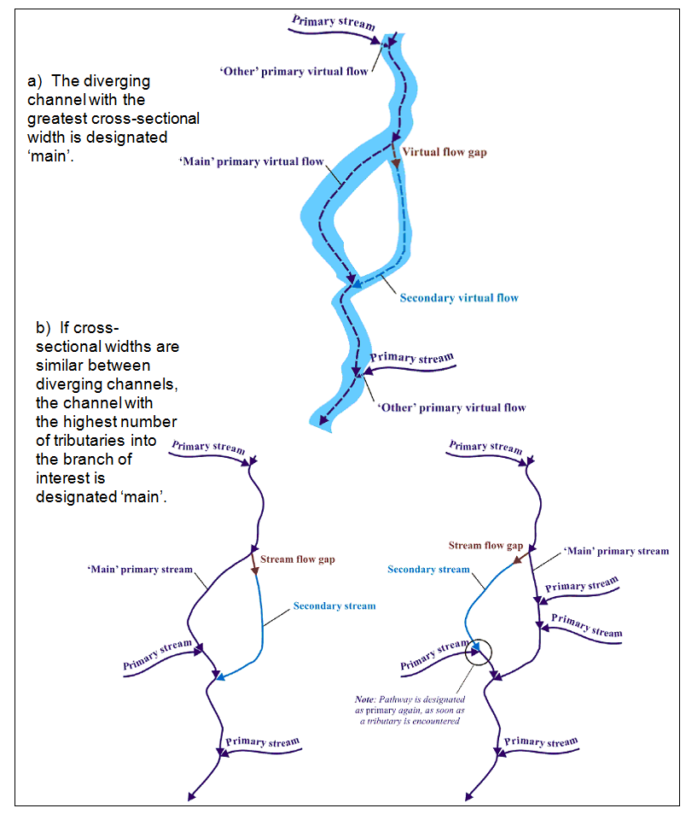
Figure 6.6: Other criteria for defining the main channel in order of precedence
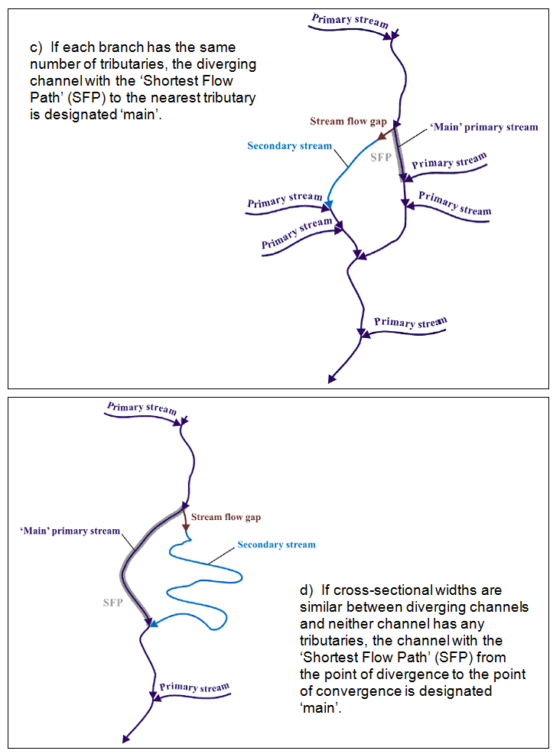
Figure 6.7: Other criteria for defining the main channel in order of precedence
- For simple braided streams (of 1st or 2nd order complexity – see Figure 6.7 ), segments will be captured on both sides where there is divergent flow. One side will be defined as the main or primary channel and the other as a secondary channel with a flow gap segment (as described in section as described in the Third bullet of 6.3).
- For complex braided systems (3rd order complexity or above) and deltas, primary channels should be established first based on the principles defined in section 6.3.1. The complex system would typically be captured as a waterbody or wetland polygon feature and therefore, not all secondary paths would be necessary to capture unless they are verified on site. Because of the complexity of these systems, it may not be possible to accurately determine proper flow direction for all secondary segments and therefore the inclusion of these features is optional (see Figure 6.7). If there are multiple inputs and/or outlets, the same principles apply as described in sections 5.2.10 and 6.2.4. (See Figure 6. for acceptable scenarios).
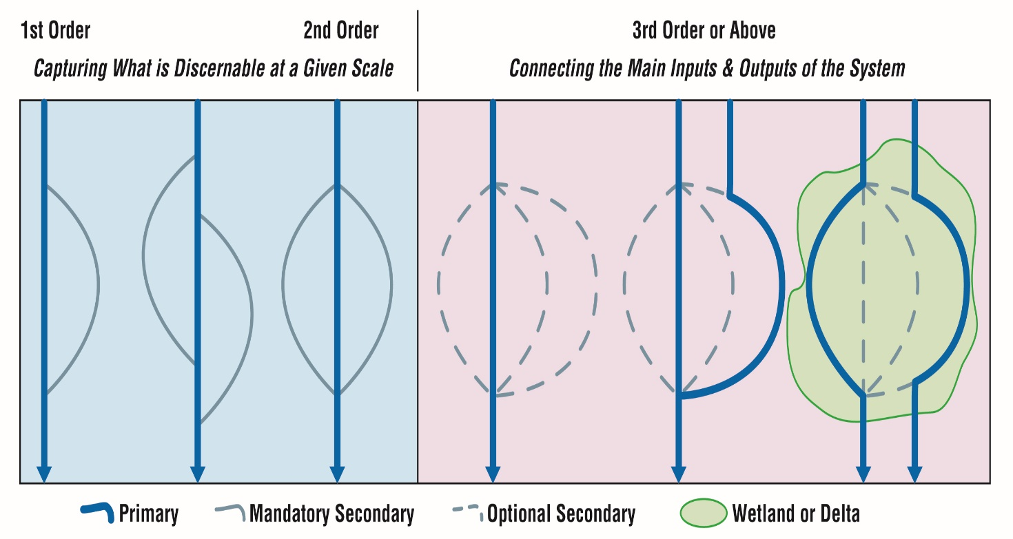
Figure 6.8: Braided system order scenarios

Appendix A – Feature Definitions

Watercourse Features
Watercourses are line features (natural or constructed) that can be defined as: a single linear feature describing the centreline path of a narrow flow of water on the Earth’s surface. A digitized watercourse can also be a virtual flow that traces the movement of water in a one dimensional water flow route within a waterbody.
Stream – A natural body of water (such as a river, stream or creek) through which water flows – see Figure A.1.
Ditch – A small, open constructed channel for the purpose of conveying water – see Figure A.1. Open conduits, constructed drains, irrigation channels, aqueducts, penstocks, flumes and sluices are included.
Virtual Flow – An inferred watercourse feature inside a waterbody, needed to maintain the continuity of water flow within polygon water features. These will be lines through a waterbody that connect all adjacent water features – see Figure A.1.
Virtual Connector – An inferred watercourse feature outside of a waterbody, needed to maintain the continuity of water flow between water features. These will be lines outside of waterbodies where flow is known to exist but is not directly mapped, such as underground conduits – see Figure A.1.

Waterbody Features
Waterbodies are polygon features (natural and constructed) that describe various realizations of surface water.
River – A natural body of water (such as a river, stream or creek) through which water may flow – see Figure A.1.
Canal – An artificial watercourse serving as a navigable waterway or to channel water – see Figure A.1.
Lake – A natural, usually flat, open body of water, which excludes wetlands, islands, surface rocks or other hazards to water flow and/or navigation – see Figure A.1.
Kettle Lake – A shallow, sediment-filled lake formed by retreating glaciers or draining floodwaters.
Pond – A body of standing water, usually smaller than a lake. This feature type is used to differentiate non-lake features from lakes, including: irrigation ponds, reservoirs, flooded gravel pits and quarries.
Beaver Pond – A pond that is created by a beaver dam.
Reservoir – A wholly or partially human-made body of water for storing and/ or regulating and controlling water – see Figure A.1.
Ocean – A coastal waterbody (Hudson Bay and James Bay).

Hydrographic Point, Line and Polygon Features
The natural and constructed features described below may occur on waterbodies and/or watercourses and may pose hazards or impediments to water flow and/or navigation. They may fall into one of three feature classes – Hydrographic Point, Hydrographic Line, or Hydrographic Polygon – depending on their size and extent; although a given feature might not exist in all three classes. See Table 4 for typical configurations.
Falls (point/line only) – A perpendicular or steep drop in a body of water over which water flows.
Rapids (point/line/poly) – A fast-flowing, often turbulent, section of a body of water, generally containing exposed rocks or boulders.
Hydro Wall (line/poly only) – A human-made structure built in a waterbody and possibly extending onshore, or built along a waterbody forming the shoreline, that does not allow water to pass under it, but allows water to pass around it – see Figure A.1. Hydro walls may extend along and/or may be contained within a waterbody, and may include wharfs, docks, piers, jetties, headwalls, groynes, locks, berms or embankments.
Dam (line/poly only) – A feature representing an obstacle that disturbs or impedes the flow of surface water, excluding beaver dams, water-crossings and culverts – see Figure A.1.
Lock gate (line only) – A gate on a navigable canal used to raise or lower the water level so that boats may pass from one level to another – see Figure A.1.
Rocks (point only) – A rock or earthen formation that is always visible above the water surface.
Sea Lamprey Barrier (point/line only) – A feature on a watercourse or waterbody that forms a barrier (either electrical or physical) to the migration of Sea Lamprey.
Wreck (point/line/poly) – The remains of a grounded ship that is partially above the water surface.
Figure A.1: Feature Examples

Appendix B – Derivation of Scale and Feature Dimension Relationships
The concept of ‘scale’ for a digital geographic product is derived from the corresponding physical cartographic product; a map on paper. Scale for a paper map is quite simple – a scale of 1:10,000 means that a distance of 10 cm on the paper corresponds to a distance of 1 km in the real world.
Translating scale to the digital realm is more complicated, because the physical dimension of the paper is lost, and because there is often more information in the digital product which allows analysis as well as simple mapping. The common application of scale to digital products is that they look similar to the paper products at the same scale. This means that characteristics such as feature density, spacing and accuracy are roughly the same.
To relate a scale to a specific digital product, such as those captured using the specifications in this document, it is necessary to define the corresponding feature characteristics, as is done in Table 3. Chief among these are the minimum feature separation and the minimum closed line length, which are closely related. The feature separation determines how close together two un-connected objects can be, while the closed line length determines how close together two connected (by the line) objects can be.
Typically, a cartographer might place objects no closer than 1 mm to each other on a paper map. This distance is related to the width of a line as printed on the paper. (This value is quite arbitrary; another cartographer might use a different value). At a scale of 1:10,000, this corresponds to a real-world separation of 10 m.
A complication is that digital vector products, such as those captured using the specifications in this document, must be compatible with various raster products at the same nominal scale. These “derivative raster products” are typically products derived from base or raw data information. Note that raster products in this context exclude sensor-based imagery and cell size should not be confused with imagery resolution. For example, common derivative raster products used in analysis would include digital elevation models, slope, flow direction, flow accumulation and various other derivatives.
The raster products generally use the same basic relationship to assign scale, with cells corresponding to a 1 mm grid on paper. At a scale of 1:10,000 this corresponds to 10 m squares on the ground. But the 10 m spacing between squares only applies when moving in line with the grid – when moving on the diagonal the spacing is increased to approximately 14.1 m (see Figure B.1).
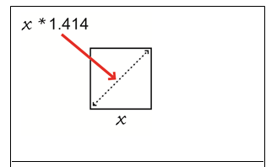
Figure B.1: Feature Spacing
This must be taken into account when determining feature separation, so the value specified in Table 3 has been increased accordingly, to 15 m (rounded up from 14.1) for 1:10,000. In general, the values for other scales should be considered proportional (30 m at 1:20,000 and 75 m at 1:50,000). Below are the calculations from which these values were derived:
Table B.1: Feature Separation Calculations
Map Scale | Raster Cell Size | Multiplying Factor | Calculated Result | Rounded-up Value
1:10,000 | 10 m | 1.414 | 14.14 m | 15 m
1:20,000 | 20 m | 1.414 | 28.28 m | 30 m
1:50,000 | 50 m | 1.414 | 70.70 m | 75 m
The values listed above for the 1:50,000 scale follow linearly from the values listed for the other scales. In practice, however, a smaller value of 30 m has typically been used for the1:50,000 raster cell size, for various reasons. Most notable is that the level of detail historically captured in certain areas of the province actually exceeds the specifications at 1:50,000 scale. In some cases, it is considered to be a 1:30,000 scale product instead of the stated 1:50,000. Also, the vector-to-raster conversion may result in a product that may be too coarse at a given scale resulting in a loss of detail in the derived product. As a result, a smaller value may sometimes be preferred.
The above paragraph highlights an important consideration in controlling the feature dimensions at various scales: there is no firm relationship between the scale and the feature dimensions. The numbers detailed in this document are an attempt to introduce consistency in these relationships – both consistency with existing products and consistency between newly captured products at different scales.
Figure B.2 below explains the rationale for this minimum distance criterion in terms of how successfully the vectors translate into the raster environment. Cells which contain multiple stream vectors flowing in opposing directions will produce flow direction errors in the raster environment. The data analyst involved in stream network data capture needs to be cognisant of the following raster flow direction principles:
- Each cell must have a single out-flowing vector segment.
- Multiple in-flowing segments are acceptable (such as where stream confluences occur) within a given cell.
- Divergences in a single cell are not acceptable, but can be handled by the removal of the “Flow Gap” segment when necessary.
The other criteria in Table 3 are related to the feature separation values. Open line segments are connected at only one end (such as a headwater stream) or un-connected (such as a sink hole). The open line length is specified in Table 3 as 4 times the minimum feature separation. This also relates back to the production of paper maps, corresponding to a distance on paper of 6 mm. An open line shorter than this would not be considered significant on a paper map.
The minimum polygon width specified in Table 3 provides a threshold for determining when the feature should be represented as a polygon or a line. This threshold is a guide and should not be applied rigidly to features such as rivers that constantly vary in width. If the varying width is near to this value, rigid application of the threshold would cause the feature to repeatedly snap back and forth between a line and a polygon along its course, which would be undesirable.
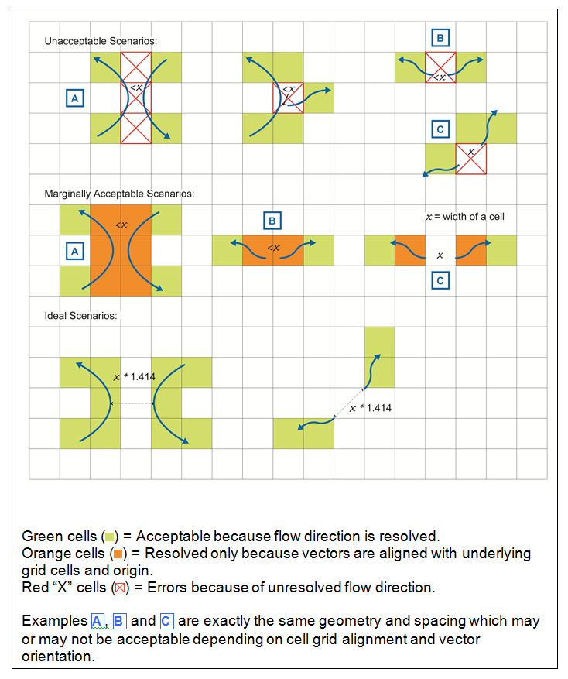
Figure B.2: Various stream vector feature scenarios and how they translate to the raster environment.

Appendix C – Polygon Definition
The following definition was extracted from “OpenGIS Simple Features Specification For SQL Revision 1.1”, OpenGIS Project Document 99-049, Release Date: May 5, 1999, Open GIS Consortium (http://portal.opengeospatial.org/files/?artifact_id=829).
A Polygon is a planar Surface, defined by 1 exterior boundary and 0 or more interior boundaries. Each interior boundary defines a hole in the Polygon.
The assertions for polygons (the rules that define valid polygons) are:
- Polygons are topologically closed.
- The boundary of a Polygon consists of a set of Linear Rings that make up its exterior and interior boundaries.
- No two rings in the boundary cross, the rings in the boundary of a Polygon may intersect at a Point but only as a tangent.
- A Polygon may not have cut lines, spikes or punctures.
- The Interior of every Polygon is a connected point set.
- The Exterior of a Polygon with 1 or more holes is not connected. Each hole defines a connected component of the Exterior.
In the above assertions, Interior, Closure and Exterior have the standard topological definitions. The combination of 1 and 3 make a Polygon a Regular Closed point set.
Polygons are simple geometries.
Figure C.1 shows some examples of Polygons. Figure C.2 shows some examples of geometric objects that violate the above assertions and are not representable as single instances of Polygon. The objects shown in Figure C.2 upper left and lower right can be represented as 2 separate Polygons.
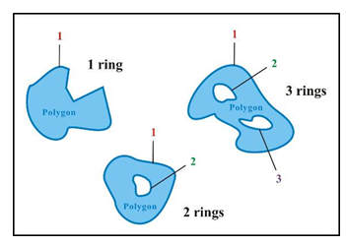
Figure C.1: Examples of polygons with 1, 2 and 3 rings respectively.
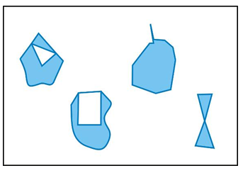
Figure C.2: Examples of objects violating polygon geometry assertions

Appendix D – Case Examples of Water Flow Editing in the Far North

Introduction
The following is a modified excerpt from the “Far North Hydrology Network Editing Guidelines” developed by Spatial Data Infrastructure (SDI). These guidelines were developed concurrently during the same period as these data capture specifications were being drafted. Every effort was taken to comply with the specifications. However, there will be some variation in interpretation in some cases, and some concepts described here extend beyond what is presented in the specifications to deal with complex terrain in the Far North.
The main intent of this appendix is to provide some real life examples of water flow editing and a view into the implementation of the specifications. This section also briefly highlights some data linkages or inferred relationships with Natural Resources Canada’s National Hydro Network (NHN) dataset, the original source for much of this information in the Far North. (For a description of the NHN, please refer to: National Hydro Network) Elements of the NHN data model were considered among others in the development of the OHN model including connectivity, flow direction and other aspects.
In this appendix, there is reference to ‘priority’, which is similar to OHN’s ‘flow classification’ concept. Key similarities and differences are highlighted in the following table:
Table D.1: Terminology
NRCan-NHN Terminology | MNR-OHN Terminology
Level Priority | Flow Classification
-1 = Unknown | (‘Unknown’ value is excluded from model)
1 = Primary | Primary
2 = Secondary | Secondary
Not applicable | Flow Gap* (a special secondary segment which represents proper flow routing but can be removed to break loops in divergent flow. This serves to preserve as much geometry as possible on the hydrology network)
* Flow Gaps are dissolved and converted to Secondary segments in the delivery to NHN in order to meet the federal specification.

NHN Virtual Segment Overview
LIO Waterline Segment features in the area of Ontario’s Far North, originated from the National Hydro Network (NHN) produced by NRCan. The virtual segments in the NHN were generated using a “skeletonizer” tool. Creation of the NHN is an iterative process and the resulting virtual segments generated from this tool were at a CL1 or CL2 completeness level. For descriptions of the NHN completeness levels serach the National Hydro Network. A number of issues to be addressed to meet the Ontario Hydro Network (OHN) specifications are:
- Head water lakes contain virtual segments (see Figure D.1, area a).
- Virtual segments cross seasonally inundated waterbodies (see Figure D.1, area b).
- Some virtual segments flowing around islands that are too small
(see Figure D.1, area c).
- Virtual segment where flow direction can not be defined (see Figure D.1, area d).
- Direction of virtual segments opposite flow of waterbody (see Figure D.1, area e).
All of these concerns must be addressed in order to produce a standardized water flow network that can be used for hydrologic analysis.
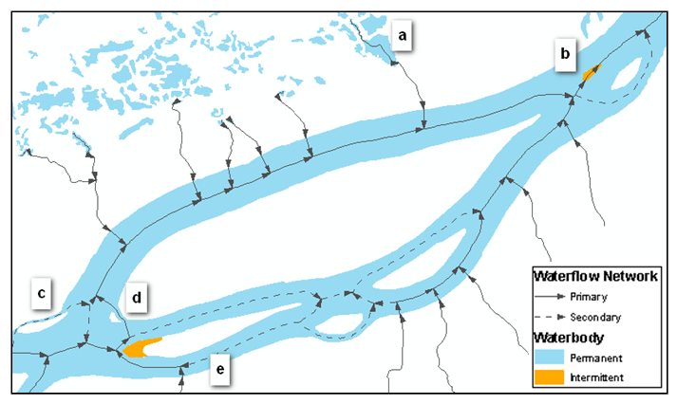
Figure D.1: Example of NHN features identifying areas of concern.
It is important to note that Ontario’s relationship with NHN extends beyond simply using their data as a source for working in the Far North. The flow of data is also happening in the other direction as well from the Province to the federal government. To illustrate, other federal-provincial cooperative efforts include:
- the delivery of medium scale hydrology products to NRCan’s NHN framework,
- working together on the integration of data with the international Data Harmonization Initiative led by the International Joint Commission (IJC).
The importance of defining a standard specification becomes very clear when successfully dealing and communicating with these other agencies.

Virtual Flow Specifications
The following specifications provide guidance when editing braided water flow network, specifically in the Far North. Large waterbodies containing multiple island features can potentially have areas of complex braided virtual segments, some with undetermined flow direction.
- Primary virtual segments should always follow the main channel of a waterbody where the majority of water will flow. The main channel will most always be the widest path. However, the channel with the most tributaries must also be taken into consideration as it could accumulate the majority of flow. It may be difficult to determine which one to use in some cases so practicing best judgement is acceptable. If neither of these two options is clear, then choosing the shortest path can also be used as a last resort.
- Where flow diverges around an island, secondary virtual segments should be added if the island meets the following criteria; the length of the island parallel to flow must be greater than the mininum open line length (variable c in Table 3) and the width of the island perpendicular to flow must be greater than the minimum feature separation (variable b in Table 3). This will create a secondary channel.
- The first segment that flows away from a divergence should be classified as “Flow Gap”. The flow gap can be removed before analysis in order to break loops (cycles). The length of the flow gap will typically be set to the minimum closed line length (variable b in Table 3). The next segment should be classified as “Secondary”. If there are tributaries or waterbodies present on this channel then the secondary segment will end at the confluence of the tributary or waterbody. Downstream from the confluence or waterbody, all segments should be classified as “Primary”.
- If there are a cluster of islands then virtual segments may flow around the cluster and re-join at the downstream end. The distance between the islands must be less than the minimum feature separation (variable b in Table 3). A cluster can include islands that do not individually meet the criteria in specification ‘2’). The cluster as a whole must meet the criteria in specification ‘2’).
- Virtual segments should not be present if flow direction can not be determined. This would include areas in between islands where the channel is perpendicular to flow. Exceptions to this rule include instances where it is required to connect a tributary stream to the main channel, or to connect an out-flowing stream to the main channel.
- Virtual segments should start at the outlet of a tributary or the beginning of a divergence. Virtual segments should only end at a confluence or at the upstream end of a stream segment.
- Virtual segments should always be oriented in the general direction of flow.
- Where possible, all virtual segments should not cross the boundary of seasonally-inundated waterbody polygons. Virtual segments should be located in permanent waterbody polygons and generally follow the centre of the channel.
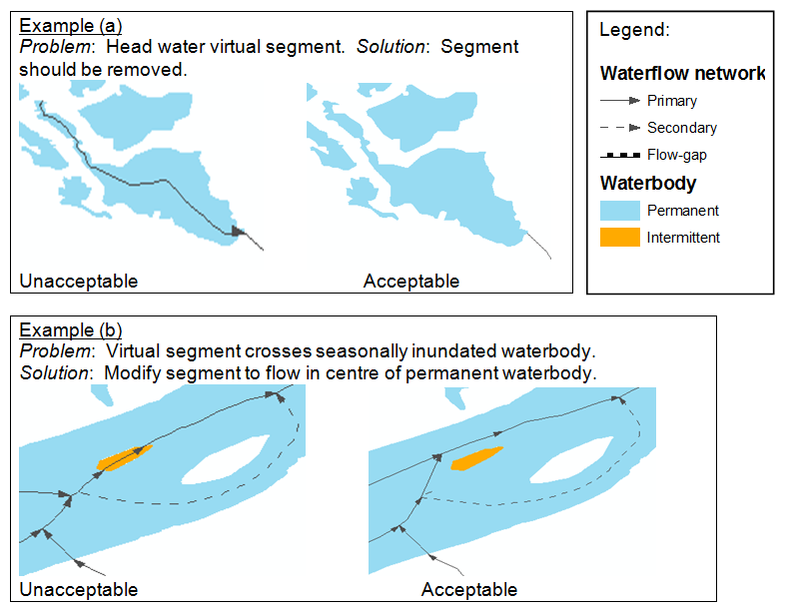
Figure D.2: (Examples a-b): Flow editing scenarios
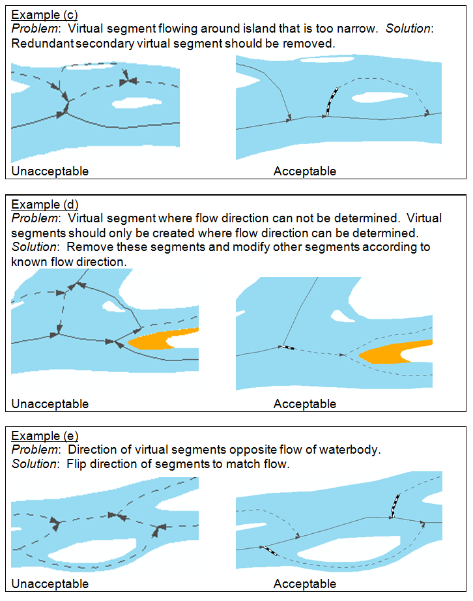
Figure D.3: (Examples c-e): Flow editing scenarios
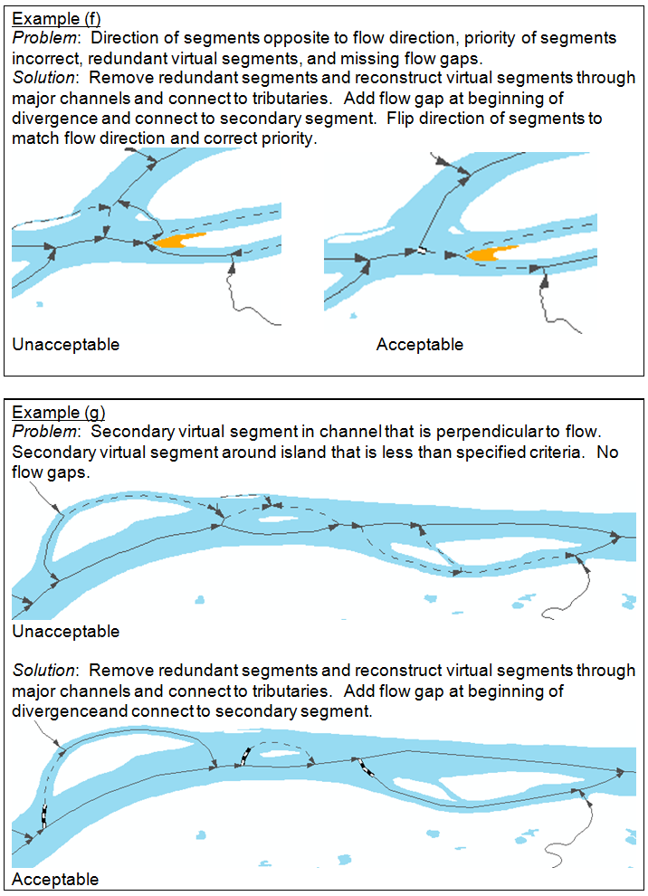
Figure D.4: (Examples f-g): Flow editing scenarios
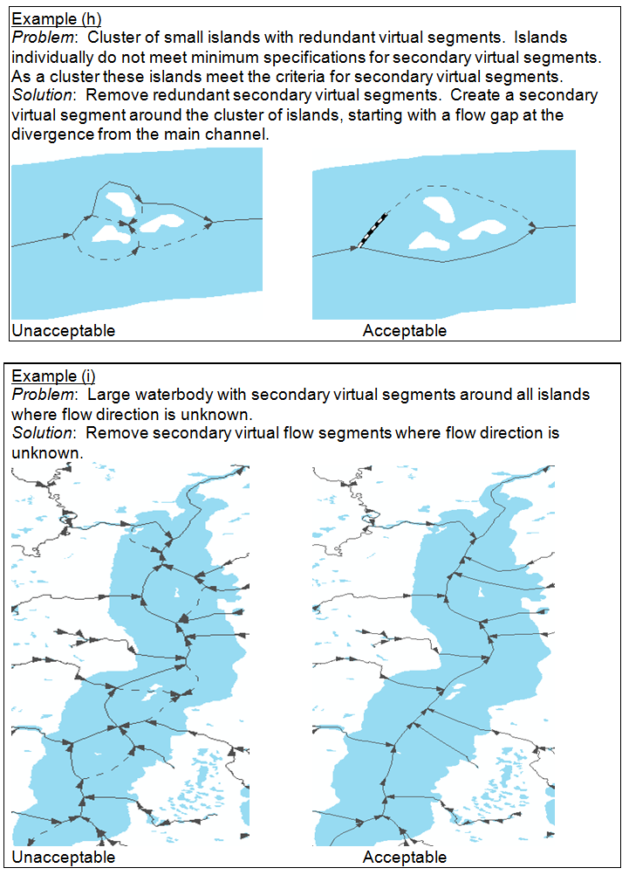
Figure D.5: (Examples h-i) Flow editing scenarios

Version 1920.1

Douglas, David H. and Thomas K. Peucker, "Algorithms for the Reduction of the Number of Points Required to Represent a Digitized Line or Its Caricature," Canadian Cartographer, 10, No. 2 (December 1973).
ArcGIS Desktop Help © 1999-2006 ESRI.
Any reference in this section text and diagrams to ‘main’ or ‘other’ segments do not infer actual attributes that are stored on the dataset, but only describe the logic and workflow in establishing primary flow segments

