Ontario Hydro Network (OHN)
Status Map
  - Provincial Geospatial Data unit
  - Digital, Data, Information and Business Services Branch
  - Corporate Management and Information Division
  - Ministry of Natural Resources
2025-03-13

Disclaimer
This technical documentation has been prepared by His Majesty the King in right of Ontario as represented by the Ministry of Natural Resources (the “Ministry”). No warranties or representations, express or implied, statutory or otherwise shall apply or are being made by the Ministry with respect to the documentation, its accuracy or its completeness. In no event will the Ministry be liable or responsible for any lost profits, loss of revenue or earnings, claims by third parties or for any economic, indirect, special, incidental, consequential or exemplary damage resulting from any errors, inaccuracies or omissions in this documentation; and in no event will the Ministry’s liability for any such errors, inaccuracies or omissions on any particular claim, proceeding or action, exceed the actual consideration paid by the claimant involved to the Ministry for the materials to which this instructional documentation relates. Save and except for the liability expressly provided for above, the Ministry shall have no obligation, duty or liability whatsoever in contract, tort or otherwise, including any liability or negligence. The limitations, exclusions and disclaimers expressed above shall apply irrespective of the nature of any cause of action, demand or action, including but not limited to breach of contract, negligence, strict liability, tort or any other legal theory, and shall survive any fundamental breach or breaches.
Cette publication spécialisée n’est disponible qu’en anglais.

Additional Information
For more information about this document, please contact Geospatial@ontario.ca.

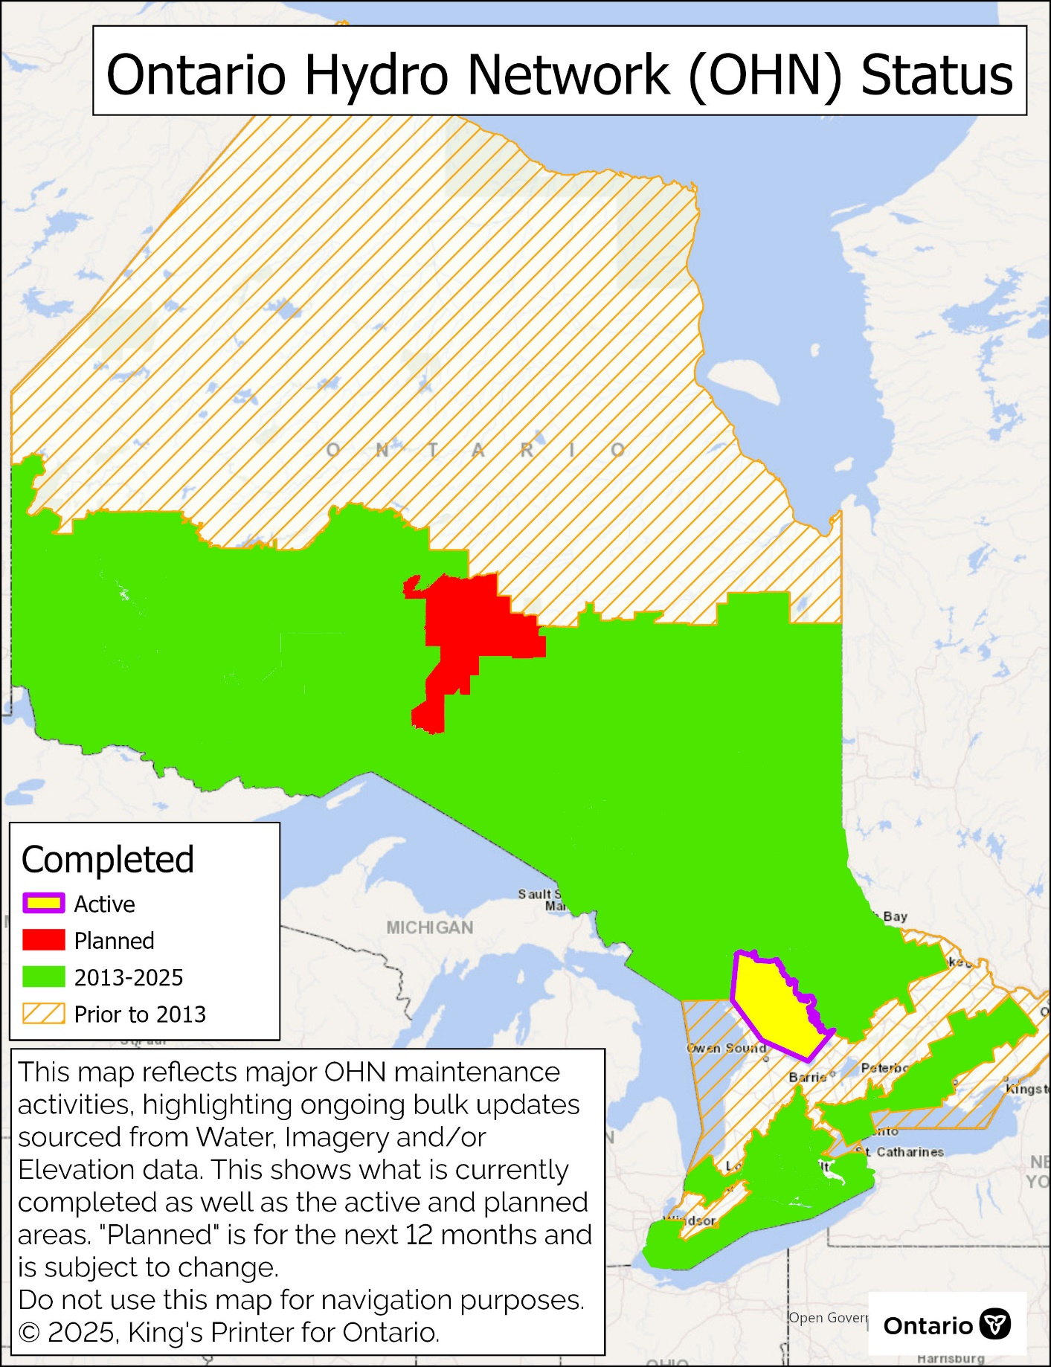Ontario Hydro Network (OHN) – Status Map
To view the Metadata records for OHN – Watercourse and OHN – Waterbody navigate to:
OHN - Watercourse
https://geohub.lio.gov.on.ca/datasets/mnrf::ontario-hydro-network-ohn-watercourse
OHN - Waterbody
https://geohub.lio.gov.on.ca/datasets/mnrf::ontario-hydro-network-ohn-waterbody

Version 1617.1

