User Guide
for
Ontario Hydro Network
Land Information Ontario Data Class
  - Provincial Mapping
  - Mapping and Information Resources Branch
  - Corporate Management and Information Division
  - Ministry of Natural Resources and Forestry
2024-05-24

Disclaimer
This technical documentation has been prepared by His Majesty the King in right of Ontario as represented by the Ministry of Natural Resources and Forestry (the “Ministry”). No warranties or representations, express or implied, statutory or otherwise shall apply or are being made by the Ministry with respect to the documentation, its accuracy or its completeness. In no event will the Ministry be liable or responsible for any lost profits, loss of revenue or earnings, claims by third parties or for any economic, indirect, special, incidental, consequential or exemplary damage resulting from any errors, inaccuracies or omissions in this documentation; and in no event will the Ministry’s liability for any such errors, inaccuracies or omissions on any particular claim, proceeding or action, exceed the actual consideration paid by the claimant involved to the Ministry for the materials to which this instructional documentation relates. Save and except for the liability expressly provided for above, the Ministry shall have no obligation, duty or liability whatsoever in contract, tort or otherwise, including any liability or negligence. The limitations, exclusions and disclaimers expressed above shall apply irrespective of the nature of any cause of action, demand or action, including but not limited to breach of contract, negligence, strict liability, tort or any other legal theory, and shall survive any fundamental breach or breaches.
Cette publication spécialisée n’est disponible qu’en anglais.

Additional Information
This document does not comply with all the applicable guidelines for accessible digital documents. For an alternative format please email Provincial Mapping at pmu@ontario.ca.
For more information about this document, please contact Provincial Mapping at pmu@ontario.ca.

Executive Summary

Key Words
Canals, Creeks, Drainage, Hydrography, Hydrology, Lakes, OHN, Ontario Hydro Network, Rivers, Shorelines, Streams, Water, Water Flow, Water Management, Waterbody, Watercourse

Abstract
This user guide details the specifications for the Ontario Hydro Network (OHN) Geospatial Ontario (GEO) Data Class. The OHN consists of 6 provincial data classes and 21 small scale cartographic data classes. The 6 OHN provincial data classes, which have their own distinct metadata record, are:
• OHN Waterbody
• OHN Watercourse
• OHN Shoreline
• OHN Hydrographic Point
• OHN Hydrographic Line
• OHN Hydrographic Poly
The OHN small scale cartographic products consist of 3 distinct data classes (Waterbody, Watercourse and Shoreline) and corresponding 3 metadata records for each of the following 7 scales:
• 1:100,000 (100K)
• 1:200,000 (200K)
• 1:500,000 (500K)
• 1:1,000,000 (1M)
• 1:2,000,000 (2M)
• 1:5,000,000 (5M)
• 1:10,000,000 (10M)

Table of Contents
Disclaimer 2
Additional Information 2
Executive Summary 3
Key Words 3
Abstract 3
Table of Contents 4
List of Figures 7
List of Tables 7
List of Acronyms 8
1. Introduction 10
2. Objectives 11
3. Data Classes: 11
OHN – Waterbody 11
OHN – Watercourse 12
OHN – Shoreline 17
OHN – Hydrographic Point, Line, Polygon 18
OHN – Common Attributes 19
OHN – Small Scale Cartographic Products 19
4. Model Diagrams: 22
OHN 22
OHN – Waterbody 22
OHN – Watercourse 23
OHN – Shoreline 24
OHN – Hydrographic Poly 25
OHN – Hydrographic Line 26
OHN – Hydrographic Point 27
OHN – Small Scale Cartographic Products 28
OHN – Small Scale Waterbody 28
OHN – Small Scale Watercourse 29
OHN – Small Scale Shoreline 30
5. Data Description 31
OHN 31
OHN – Waterbody 31
OHN – Watercourse 32
OHN – Shoreline 35
OHN – Hydrographic Poly 35
OHN – Hydrographic Line 36
OHN – Hydrographic Point 37
OHN – Small Scale Cartographic Products 38
OHN – Small Scale Waterbody 38
OHN – Small Scale Watercourse 39
OHN – Small Scale Shoreline 40
6. Links to Additional Information 42
APPENDIX A: GEO Lookup Tables and Values 43
OHN 43
OHN – Waterbody 43
OHN – Watercourse 47
OHN – Hydrographic Poly 48
OHN – Hydrographic Line 50
OHN – Hydrographic Point 52
OHN – Small Scale Cartographic Products 53
OHN – Small Scale Waterbody 53
OHN – Small Scale Watercourse 58
OHN – Small Scale Shoreline 58
APPENDIX B: Table Key Dependency and Relationship Index 59
APPENDIX C: Frequently Asked Questions 61
How can I extract Islands from the OHN? 61
How are Wetland data related to the OHN? 62
How are Constructed Drains data related to the OHN? 62
Does the OHN support network analysis? 63
Where did the names come from? 63
How authoritative is the OHN Official Name Label? 63
How is the Official Name and Official Alternate Name attribute used for labeling? 63
Why are all water names not included in the OHN? 64
Why is the OHN geometry different from the GEL? 64
Are there other dam layers? 64

List of Figures
Figure 1: Examples of watercourse line symbology. 13
Figure 2: Virtual Flow line symbology. 14
Figure 3: Flow Classifications – Primary and Flow Gap. 16
Figure 4: Virtual Flow gap and Flow gap examples. 16
Figure 5: Example of shoreline symbology that demonstrates the differences between OHN-Waterbody polygon outlines and OHN-Shoreline. 18
Figure 6: Primary Key example 60
Figure 7: Foreign Key example 60
Figure 8: Alternate Key example 60
Figure 9: Example of an Identifying Relationship 61
Figure 10: Example of a Non-identifying Relationship 61
Figure 11: Model Diagram Relationship Symbology Table 61
Figure 12: OHN Waterbody with holes that represent islands 62
Figure 13: Polygon around the lake and the resulting island polygons after erasing the lake 63

List of Tables
Table 1: Feature types found as a point, line or polygon marked by ‘X’. 18
Table 2: List of the 21 OHN small scale cartographic data classes 21

List of Acronyms
CGNDB: Canadian Geographical Names Data Base
GIS: Geographic Information System
GEO: Geospatial Ontario
GNO: Geographic Names Ontario
LUT: Lookup Table
MIRB: Mapping and Information Resources Branch
MNR: Ontario Ministry of Natural Resources
NHN: National Hydro Network
NRCan: Natural Resources Canada
OBM: Ontario Base Maps
ODI: Ontario Dam Inventory
OGF: Ontario Geospatial Feature
OGNB: Ontario Geographic Names Board
OHN: Ontario Hydro Network
OHNHLN: OHN – Hydrographic Line
OHNHPOLY: OHN – Hydrographic Poly
OHNHPT: Hydrographic Point
OHNSLIN: OHN - Shoreline
OHNWBDY: OHN – Waterbody
OHNWCRS: OHN - Watercourse
OIH: Ontario Integrated Hydrology
OPS: Ontario Public Service
OWES: Ontario Wetland Evaluation System
PM: Provincial Mapping
ROD: Regional Operations Division

1. Introduction
The User Guide for the Ontario Hydro Network (OHN) contains an overview of all the OHN data classes and highlights details of which users of hydro data should be aware. Hydro data is defined as surface water information including lakes, rivers, streams, barriers, and obstacles. The OHN data is distributed through Geospatial Ontario (GEO). The OHN is continually updated.
The OHN is a provincial data product that is maintained following a specification for feature capture. As the OHN is updated with improved source data, along with improvements to its currency and accuracy, feature-capture is also improving. Many areas that were originally captured from sources at 1:20,000 or 1:50,000 scales are now being represented with feature dimensions criteria equivalent to 1:10,000, or better.
The OHN consists of the following six data classes:
- OHN - Watercourse – Line features that represent flowing surface water (natural or constructed).
- OHN - Waterbody – Polygon features that represent bodies of surface water (natural or constructed).
- OHN - Shoreline – Lines that represent the shorelines of waterbodies. The shoreline is derived from the OHN - Waterbody data.
- OHN - Hydrographic Point – Point features (natural or constructed) that occur on waterbodies or watercourses which may pose hazards or impediments to water flow or navigation.
- OHN - Hydrographic Line – Line features (natural or constructed) that occur on waterbodies or watercourses which may pose hazards or impediments to water flow or navigation.
- OHN - Hydrographic Poly – Polygon features (natural or constructed) that occur on waterbodies or watercourses which may pose hazards or impediments to water flow or navigation.
The OHN data is provided to Natural Resources Canada (NRCan) for incorporation into the National Hydro Network (NHN). The NHN specifications differ from the OHN and therefore the NHN geometry and attributes may differ from the OHN.
Geographic names on the NHN data posted to Geogratis for Ontario are sourced from the Canadian Geographical Names Data Base (CGNDB). As a result, geographic names on the NHN product for Ontario may differ from the Geographic Names Ontario (Geonames or GNO).
The official names of geographic features (for example, lakes, bays, rivers, creeks, islands, etc.) and unincorporated places (for example, villages, hamlets, etc.) in Ontario as authorized through the Ontario Geographic Names Board (OGNB) Act, can be obtained from the Geographic Names Ontario (Geonames or GNO) data by searching the Ontario GeoHub for “Geonames”.
The OHN data class layers are the authoritative source for water geometry for Ontario.

2. Objectives
This guide is intended for users with a general interest in the OHN GEO Data Class. The remainder of this document describes the extent and context of the information collected for the data class.

3. Data Classes:

OHN – Waterbody
Waterbody Type
Mandatory attribute. The nature of a body of water defined according to its water velocity and usage. Available values are:
- Lake (default value) - A natural, usually flat, open body of water, which excludes wetlands, islands, surface rocks or other hazards to water flow and/or navigation.
- River - A natural body of water usually narrower than a lake through which water may flow.
- Canal - An artificial watercourse serving as a navigable waterway or to channel water.
- Reservoir - A wholly or partially human-made body of water for storing and/ or regulating and controlling water.
- Kettle Lake - A shallow, sediment-filled lake formed by retreating glaciers or draining floodwaters.
- Pond - A body of standing water, usually smaller than a lake. This feature type is used to differentiate non-lake features from lakes, including: irrigation ponds, reservoirs, flooded aggregate pits and quarries.
- Beaver Pond - A pond that is created by a beaver dam.
- Ocean - A coastal waterbody (Hudson Bay and James Bay).
Permanency
An indication of the permanency of the water feature.
- Permanent (default value) - A waterbody is considered permanent if it contains water at least 9 months of the year.
- Intermittent - A waterbody is considered intermittent if it contains water less than 9 months of the year.

OHN – Watercourse
Watercourse features are line features (natural or constructed) that represent the location of flowing water. The OHN Watercourse features may be used for cartographic or network analysis purposes. The bullets below explain some options to consider depending on the use of the data.
- Flow direction – The watercourse lines are oriented in the direction that water normally flows across the landscape. The direction is usually governed by changes in ground elevation – water flows downhill. However, dams and other structures may redirect the flow.
Cartographic products typically symbolize streams as blue lines and are not concerned with the flow direction (Figure 1: a).
For network analysis the flow direction is crucial for tracing up or down stream, stream ordering, creating watersheds, etc. The watercourse lines may be symbolized as lines with arrows to display the direction of water flow (Figure 1: b).
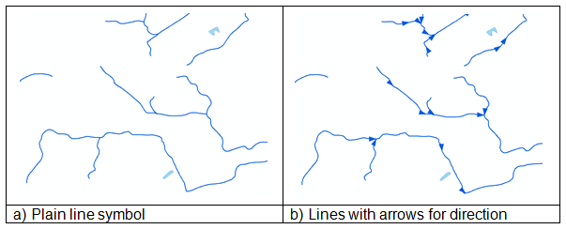
Figure 1: Examples of watercourse line symbology.
- Connectivity – Connectivity is crucial for network analysis. Streams entering and exiting waterbodies are connected with virtual flow lines that occur on the waterbody polygons.
Cartographic products typically ignore the virtual flow lines so that they are not displayed in the waterbodies (Figure 2: a). Alternatively, the virtual flow line may be symbolized as a dashed line or as a different colour (Figure 2: b).
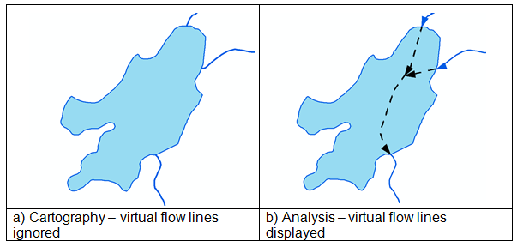
Figure 2: Virtual Flow line symbology.

Watercourse Type
Watercourses are line features (natural or constructed) that can be defined as flowing water within a defined channel with beds or banks and usually discharges itself into some other watercourse or waterbody. A digitized watercourse can also be virtual, inferring water flow within a waterbody or inferring water flow over land where a defined channel is absent.
- Stream (default) - A natural body of water (such as a river, stream or creek) through which water flows.
- Ditch - A small, open constructed channel for the purpose of conveying water. Open conduits, constructed drains, irrigation channels, aqueducts, penstocks, flumes and sluices are included.
- Virtual Flow - An inferred watercourse feature inside a waterbody needed to maintain the continuity of water flow between adjacent water features. These will be lines through a waterbody that connect all adjacent water features.
- Virtual Connector - An inferred watercourse feature outside of a waterbody needed to maintain the continuity of water flow between adjacent water features. These will be lines where flow is known to exist but is not directly mapped, such as underground conduits.
Flow Direction Verified
An indicator of known correct geometry direction. This is a Yes/No field with a default value of ‘No’.
Permanency
An indication of the permanency of the water feature.
- Permanent – (default) A watercourse is considered permanent if it contains flowing water at least 9 months of the year.
- Intermittent – A watercourse is considered intermittent if it contains flowing water less than 9 months of the year.
Note: Virtual Flow segments must be assigned the permanency value of ‘Permanent’.
Flow Classification
The Flow Classification attribute is used to identify the different pieces of a loop (sometimes referred to as a ‘cycle’). A loop is created when one watercourse line diverges into two lines and further downstream converges back into one line (Figure 3: a). Loops may occur inside (with virtual flow lines) or outside of waterbodies. The following bullets explain the three pieces of a loop.
- Primary (default) – All watercourse lines are initially considered to be primary. Only inside of a loop are some of the lines classified otherwise.

- Flow Gap – Loops need to have a piece removed (to break the loop) for some network analysis processes. The Flow Gap value is assigned to the first watercourse line on the secondary segment of the divergence at no less than 43 m measured in a straight line from the divergence (Figure 3: c). The Flow Gap value may also be assigned to virtual flows where there is a divergence. If the Flow Gap intersects the shoreline, it will continue on land for no less than 43 m measured in a straight line (Figure 4). If required, the Flow Gap lines can be removed before performing network analysis.
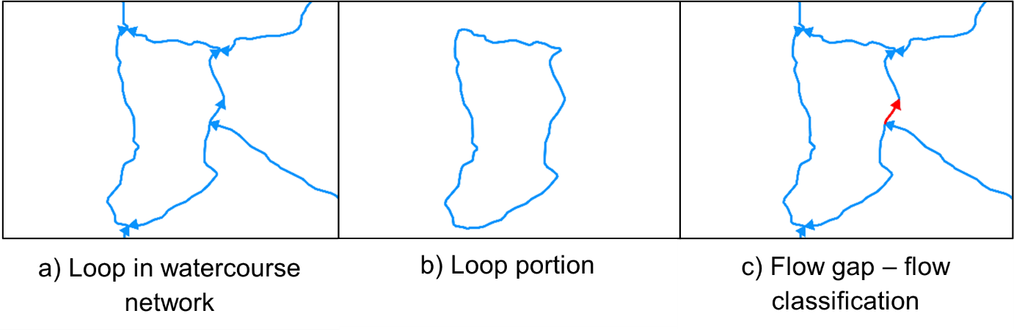
Figure 3: Flow Classifications – Primary and Flow Gap.
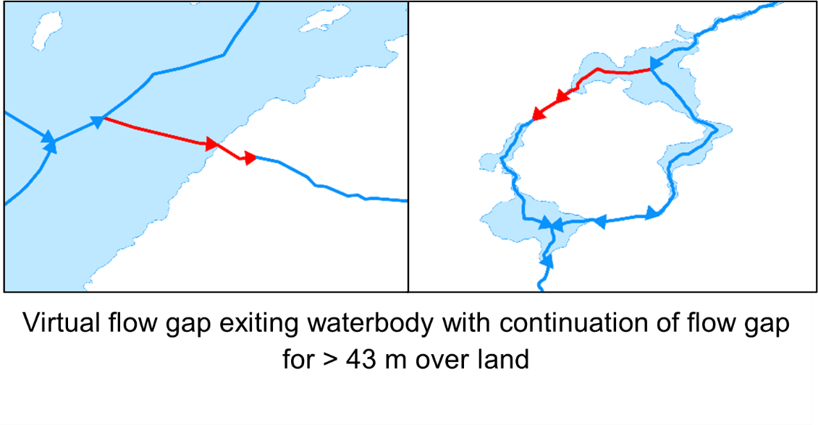
Figure 4: Virtual Flow gap and Flow gap examples.
Note: Watercourse segments that are isolated from the flow network may form incomplete loops. They may diverge into two or more streams and not converge back together. In these cases, the same rules already explained will apply for primary and flow gap.
This attribute is typically used for network analysis purposes and may be ignored for most cartographic purposes.
Secondary – currently there are watercourse segments classified as secondary flow downstream from flow gaps. This is in the process of being discontinued.

OHN – Shoreline
The OHN Shoreline data class is derived from the OHN Waterbody data class. It can be used to cartographically display the line where water meets the land.
The shoreline can differ from the outline of waterbody polygons. For example, a large lake may be divided into several polygons which would result in outlines passing through the lake. Another example would be where a lake polygon is adjacent to a river polygon. The adjacent outlines would appear to run through the water (Figure 4: a).
The cartographic solution is to symbolize the OHN - Shoreline as a dark line and leave the OHN - Waterbody outlines transparent (Figure 4: b).
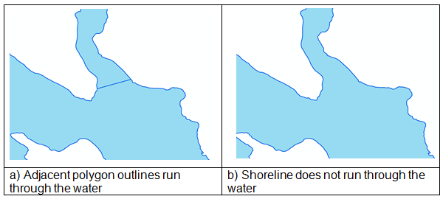

Figure 5: Example of shoreline symbology that demonstrates the differences between OHN-Waterbody polygon outlines and OHN-Shoreline.

OHN – Hydrographic Point, Line, Polygon
The natural or constructed features that occur on waterbodies and/or watercourses and may pose hazards or impediments to water flow and/or navigation. See Table 1 for details.
Feature Type | Point | Line | Polygon
Falls | X | X | Not Applicable
Rapids | X | X | X
Rocks | X | Not Applicable | Not Applicable
Dam | Not Applicable | X | X
Hydro Wall | Not Applicable | X | X
Lock-Gate | Not Applicable | X | Not Applicable
Sea Lamprey Barrier | X | X | Not Applicable
Table 1: Feature types found as a point, line or polygon marked by ‘X’.
Hydrographic Types
- Falls - A perpendicular or steep drop in a body of water over which water flows.
- Rapids - A fast-flowing, often turbulent, section of a body of water, generally containing exposed rocks or boulders.
- Rocks - A rock or earthen formation always visible above the water surface.
- Dam - A feature representing an obstacle that disturbs or impedes the flow of surface water, excluding beaver dams, water-crossings and culverts.
- Hydro Wall - A human-made structure built in a waterbody and possibly extending onshore, or built along a waterbody forming the shoreline, that does not allow water to pass under it, but allows water to pass around it. Hydro walls may extend along and/or may be contained within a waterbody, and may include wharfs, docks, piers, jetties, headwalls, groynes, locks, berms or embankments.
- Lock-Gate - A gate on a navigable canal used to raise or lower the water level so that boats may pass from one level to another.
- Sea Lamprey Barrier - A feature on a watercourse or waterbody that forms a barrier (either electrical or physical) to the migration of Sea Lamprey.

OHN – Common Attributes
The attributes listed in this section are found on all OHN data classes except for Shoreline. Attributes that are specific to data classes can be found in earlier sections.
OGF ID – A unique numeric provincial identifier assigned to each object.
Location Accuracy - The degree of conformity or closeness of a measurement within the database to its true value in the world.
Verification Status - An indication as to whether a qualified employee has verified the existence of the feature.
Verification Status Date - The date that the geographic unit was verified/validated.
General Comments - A 2000-character field for general comments about the feature.
Source Detail - A 254-character field that contains what part of the source pertains to the feature. Examples: Summary data from a database, pages in a book or atlas, figure number and page from a publication, a section of a map, or record in a database.
Effective Date/Time - Date/time that the record was created in the GEO database.

OHN – Small Scale Cartographic Products
The OHN small scale consists of 3 distinct data classes (Waterbody, Watercourse and Shoreline) and 3 corresponding metadata records for each of the following 7 scales:
- 1:100,000 (100K)
- 1:200,000 (200K)
- 1:500,000 (500K)
- 1:1,000,000 (1M)
- 1:2,000,000 (2M)
- 1:5,000,000 (5M)
- 1:10,000,000 (10M)
Watercourse | Waterbody | Shoreline
OHN_100K_Watercourse | OHN_100K_Waterbody | OHN_100K_Shoreline
OHN_200K_Watercourse | OHN_200K_Waterbody | OHN_200K_Shoreline
OHN_500K_Watercourse | OHN_500K_Waterbody | OHN_500K_Shoreline
OHN_1M_Watercourse | OHN_1M_Waterbody | OHN_1M_Shoreline
OHN_2M_Watercourse | OHN_2M_Waterbody | OHN_2M_Shoreline
OHN_5M_Watercourse | OHN_5M_Waterbody | OHN_5M_Shoreline
OHN_10M_Watercourse | OHN_10M_Waterbody | OHN_10M_Shoreline
Table 2: List of the 21 OHN small scale cartographic data classes
The small scale OHN products are intended to support cartographic and web mapping services. This data is not designed for analytical purposes. Users that require OHN data for analytical purposes should use the provincial specification OHN data classes.
It should be noted that the OHN small scale cartographic products contain data that extends beyond the Ontario provincial boundary and includes additional data sourced from NRCan (for adjacent provinces and territories) and from the United States Geologic Service (for selected US states). Please refer to the OHN small scale metadata records for further details on these sources.

4. Model Diagrams:

OHN

OHN – Waterbody
Physical Model Diagram for OHN - Waterbody (OHNWBDY)
Model Effective Date 2012-JUN-14
Note: Where applicable to this model:
- Tables with a “_LIST” extension (shaded yellow) = Lookup Table (LUT)
- Additional feature-level metadata may be stored in other ‘Shared’ tables. Please refer to the Class Common Tables diagram for more information.
- For table key dependency and relationships, see Appendix B

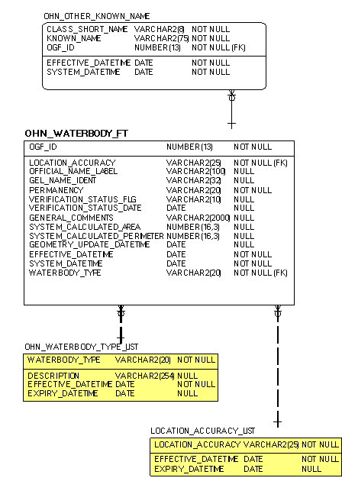

OHN – Watercourse
Physical Model Diagram for OHN - Watercourse (OHNWCRS)
Model Effective Date 2012-JUN-14
Note: Where applicable to this model:
- Tables with a “_LIST” extension (shaded yellow) = Lookup Table (LUT)
- Additional feature-level metadata may be stored in other ‘Shared’ tables. Please refer to the Class Common Tables diagram for more information.
- For table key dependency and relationships, see Appendix B

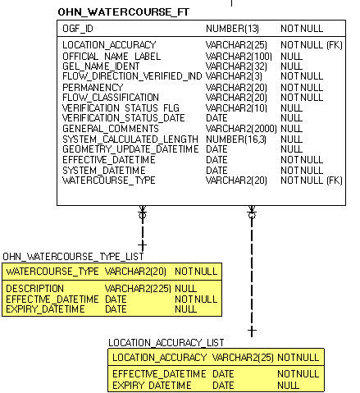

OHN – Shoreline
Physical Model Diagram for OHN – Shoreline (OHNSLIN)
Model Effective Date 2012-JUN-14
Note: Where applicable to this model:
- Tables with a “_LIST” extension (shaded yellow) = Lookup Table (LUT)
- Additional feature-level metadata may be stored in other ‘Shared’ tables. Please refer to the Class Common Tables diagram for more information.

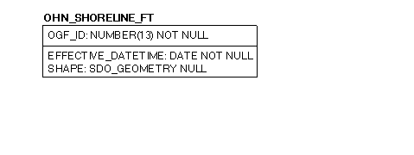

OHN – Hydrographic Poly
Physical Model Diagram for OHN – Hydrographic Poly (OHNHPOLY)
Model Effective Date 2012-JUN-14
Note: Where applicable to this model:
- Tables with a “_LIST” extension (shaded yellow) = Lookup Table (LUT)
- Additional feature-level metadata may be stored in other ‘Shared’ tables. Please refer to the Class Common Tables diagram for more information.
- For table key dependency and relationships, see Appendix B

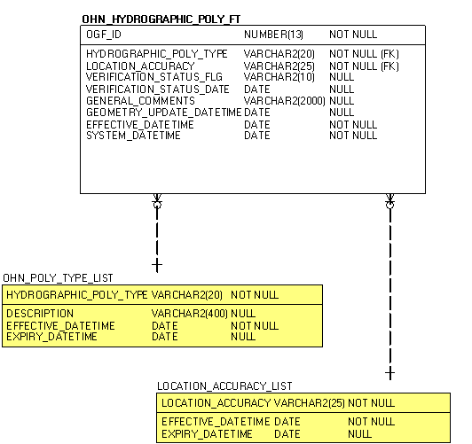

OHN – Hydrographic Line
Physical Model Diagram for OHN – Hydrographic Line (OHNHLN)
Model Effective Date 2012-JUN-14
Note: Where applicable to this model:
- Tables with a “_LIST” extension (shaded yellow) = Lookup Table (LUT)
- Additional feature-level metadata may be stored in other ‘Shared’ tables. Please refer to the Class Common Tables diagram for more information.
- For table key dependency and relationships, see Appendix B

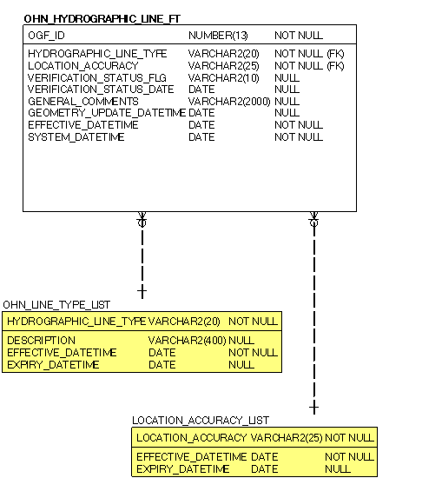

OHN – Hydrographic Point
Physical Model Diagram for OHN – Hydrographic Point (OHNHPT)
Model Effective Date 2012-JUN-14
Note: Where applicable to this model:
- Tables with a “_LIST” extension (shaded yellow) = Lookup Table (LUT)
- Additional feature-level metadata may be stored in other ‘Shared’ tables. Please refer to the Class Common Tables diagram for more information.
- For table key dependency and relationships, see Appendix B

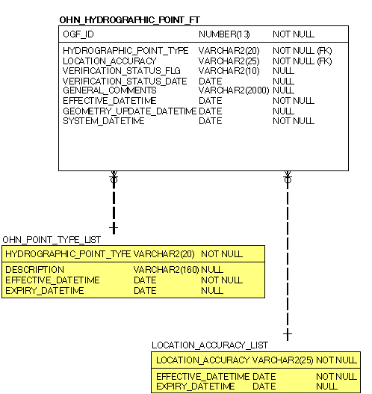

OHN – Small Scale Cartographic Products

OHN – Small Scale Waterbody
Physical Model Diagram for OHN Small Scale Class – Waterbody
(OHN100WB, OHN200WB, OHN500WB, OHN1MWB, OHN2MWB, OHN5MWB, OHN10MWB)
Model Effective Date 2012-JUN-14
Note: Where applicable to this model:
- Tables with a “_LIST” extension (shaded yellow) = Lookup Table (LUT)
- Additional feature-level metadata may be stored in other ‘Shared’ tables. Please refer to the Class Common Tables diagram for more information.
- For table key dependency and relationships, see Appendix B

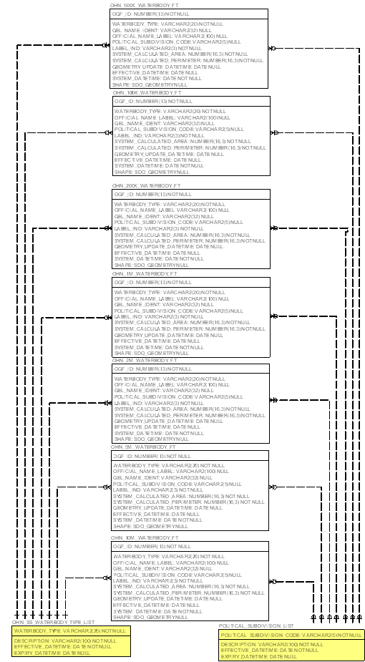

OHN – Small Scale Watercourse
Physical Model Diagram for OHN Small Scale Class – Watercourse
(OHN100WC, OHN200WC, OHN500WC, OHN1MWC, OHN2MWC, OHN5MWC, OHN10MWC)
Model Effective Date 2012-JUN-14
Note: Where applicable to this model:
- Tables with a “_LIST” extension (shaded yellow) = Lookup Table (LUT)
- Additional feature-level metadata may be stored in other ‘Shared’ tables. Please refer to the Class Common Tables diagram for more information.
- For table key dependency and relationships, see Appendix B

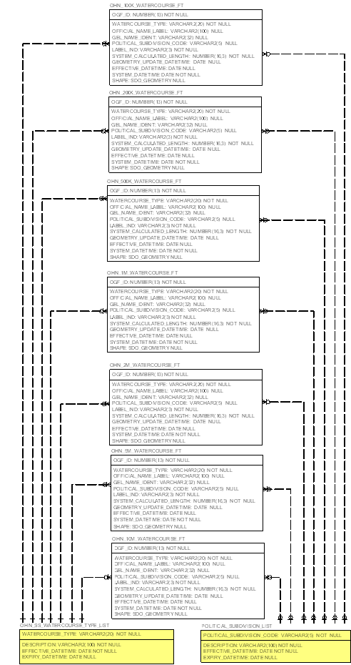

OHN – Small Scale Shoreline
Physical Model Diagram for OHN Small Scale Class – Shoreline
(OHN100SL, OHN200SL, OHN500SL, OHN1MSL, OHN2MSL, OHN5MSL, OHN10MSL)
Model Effective Date 2012-JUN-14
Note: Where applicable to this model:
- Tables with a “_LIST” extension (shaded yellow) = Lookup Table (LUT)
- Additional feature-level metadata may be stored in other ‘Shared’ tables. Please refer to the Class Common Tables diagram for more information.
- For table key dependency and relationships, see Appendix B

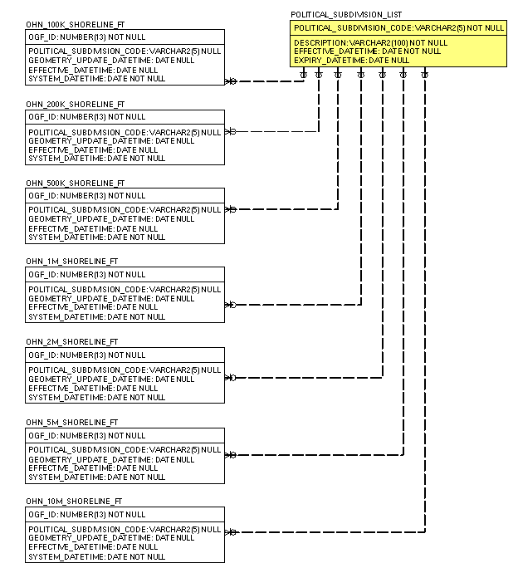

5. Data Description
The main business area table(s) for this model can be found below. Associated lookup tables will be listed in Appendix A of this document and are hyperlinked where referenced in this section.

OHN

OHN – Waterbody

OHN_WATERBODY_FT
Waterbodies are polygon features (natural and constructed) that describe various realizations of surface water.
Column Name | Column Type | Mandatory | Short Name | Description
OGF_ID | NUMBER(13) | Yes | OGF_ID | System generated identifier, unique at the application level.
WATERBODY_TYPE | VARCHAR2(20) | Yes | WBDY_TYPE | The nature of a body of water defined according to its water velocity and usage.  Default = Lake
OFFICIAL_NAME_LABEL | VARCHAR2(100) | No | OFF_NAME | This field is a concatenation of the Geographic Name Extent Fields "Official Name" and "Alternate Name".
GEL_NAME_IDENT | VARCHAR2(32) | No | GEL_IDENT | A unique, 32 length, alpha-numeric identifier used to distinguish an object.
PERMANENCY | VARCHAR2(20) | Yes | PERMANENCY | An indication of the permanency of a water feature.  Default = Permanent  Permanent - Permanent water features are known to exist for at least 9 months a year.  Intermittent - Intermittent water features are known to exist for less than 9 months a year.  VALID VALUES: Permanent, Intermittent
LOCATION_ACCURACY | VARCHAR2(25) | Yes | ACCURACY | The accuracy of the location of the feature at an OBM scale. The degree of conformity or closeness of a measurement to the true value.
VERIFICATION_STATUS  _FLG | VARCHAR2(10) | No | VERISTT_FL | An indication as to whether a qualified employee has verified the existence of the geographic unit.  VALID VALUES: Verified, Unverified
VERIFICATION_STATUS  _DATE | DATE | No | VERISTT_DT | Date that the geographic unit was verified/validated.
GENERAL_COMMENTS | VARCHAR2(2000) | No | COMMENTS | General comments.
SYSTEM_CALCULATED  _AREA | NUMBER(16,3) | No | SYS_AREA | The area of a polygon measured in square metres.
SYSTEM_CALCULATED  _PERIMETER | NUMBER(16,3) | No | SYS_PERIM | The perimeter of a polygon measured in metres.
GEOMETRY_UPDATE_DATETIME | DATE | No | GEO_UPD_DT | Date/time the geometry was created or last modified in the source database.
EFFECTIVE_DATETIME | DATE | Yes | EFF_DATE | Date/time the record was created or last modified in the source database.
SYSTEM_DATETIME | DATE | Yes | SYS_DATE | Date/time the record was loaded into or last modified in the GEO database.

OHN – Watercourse

OHN_WATERCOURSE_FT
Watercourses are line features (natural and constructed) that describe various realizations of surface water.
Column Name | Column Type | Mandatory | Short Name | Description
OGF_ID | NUMBER(13) | Yes | OGF_ID | A unique numeric provincial identifier assigned to each object.
WATERCOURSE_TYPE | VARCHAR2(20) | Yes | WCRS_TYPE | The type of watercourse.  Default = Stream
OFFICIAL_NAME_LABEL | VARCHAR2(100) | No | OFF_NAME | This field is a concatenation of the Geographic Name Extent Fields "Official Name" and "Alternate Name".
GEL_NAME_IDENT | VARCHAR2(32) | No | GEL_IDENT | A unique, 32 length, alpha-numeric identifier used to distinguish an object.
FLOW_DIRECTION  _VERIFIED_IND | VARCHAR2(3) | Yes | FLOW_VERIF | An indicator of known correct geometry direction.  Default = No  VALID VALUES: Yes, No
PERMANENCY | VARCHAR2(20) | Yes | PERMANENCY | An indication of the permanency of a water feature.  Default = Permanent  Permanent - Permanent water features are known to exist for at least 9 months a year.  Intermittent - Intermittent water features are known to exist for less than 9 months a year.  VALID VALUES: Permanent, Intermittent
FLOW_CLASSIFICATION | VARCHAR2(20) | Yes | FLOW_CLASS | This classification defines the primary (main) and secondary (alternate) routes of a water flow network. Secondary streams are indicative of divergent flow where there are multiple routes traversing through a system (eg. a braided stream network or delta).  Default = Primary  Primary - The main route of a water flow network.  Secondary - The alternate route of a water flow network.  Flow Gap - A secondary flow segment which exists to represent proper flow routing but can be removed to break loops in divergent flow.  VALID VALUES: Primary, Secondary, Flow Gap
LOCATION_ACCURACY | VARCHAR2(25) | Yes | ACCURACY | The accuracy of the location of the feature at an OBM scale. The degree of conformity or closeness of a measurement to the true value.
VERIFICATION_STATUS  _FLG | VARCHAR2(10) | No | VERISTT_FL | An indication as to whether a qualified employee has verified the existence of the geographic unit.  VALID VALUES: Verified, Unverified
VERIFICATION_STATUS  _DATE | DATE | No | VERISTT_DT | Date that the geographic unit was verified/validated.
GENERAL_COMMENTS | VARCHAR2(2000) | No | COMMENTS | General comments.
SYSTEM_CALCULATED  _LENGTH | NUMBER(16,3) | No | SYS_LENGTH | The length of a line measured in metres.
GEOMETRY_UPDATE  _DATETIME | DATE | No | GEO_UPD_DT | Date/time the geometry was created or last modified in the source database.
EFFECTIVE_DATETIME | DATE | Yes | EFF_DATE | Date/time the record was created or last modified in the source database.
SYSTEM_DATETIME | DATE | Yes | SYS_DATE | Date/time the record was loaded into or last modified in the GEO database.

OHN – Shoreline

OHN_SHORELINE_FT
The derived line between water and land.
Column Name | Column Type | Mandatory | Short Name | Description
OGF_ID | NUMBER(13) | Yes | OGF_ID | A unique numeric provincial identifier assigned to each object.
EFFECTIVE_DATETIME | DATE | Yes | EFF_DATE | Date/time the record was created or last modified in the source database.
SHAPE | SDO_GEOMETRY | No | SHAPE | Geometry attribute.
Model Subject Area does not have any business area tables.

OHN – Hydrographic Poly

OHN_HYDROGRAPHIC_POLY_FT
Natural and constructed features which occur on waterbodies and/or watercourses and may pose hazards or impediments to water flow and/or navigation.
Column Name | Column Type | Mandatory | Short Name | Description
OGF_ID | NUMBER(13) | Yes | OGF_ID | A unique numeric provincial identifier assigned to each object.
HYDROGRAPHIC_POLY  _TYPE | VARCHAR2(20) | Yes | POLY_TYPE | The type of natural or constructed features that occur on waterbodies or watercourses which may pose hazards or impediments to water flow and/or navigation.
LOCATION_ACCURACY | VARCHAR2(25) | Yes | ACCURACY | The accuracy of the location of the feature at an OBM scale. The degree of conformity or closeness of a measurement to the true value.
VERIFICATION_STATUS  _FLG | VARCHAR2(10) | No | VERISTT_FL | An indication as to whether a qualified employee has verified the existence of the geographic unit.  VALID VALUES: Verified, Unverified
VERIFICATION_STATUS  _DATE | DATE | No | VERISTT_DT | Date that the geographic unit was verified/validated.
GENERAL_COMMENTS | VARCHAR2(2000) | No | COMMENTS | General comments.
GEOMETRY_UPDATE  _DATETIME | DATE | No | GEO_UPD_DT | Date/time the geometry was created or last modified in the source database.
EFFECTIVE_DATETIME | DATE | Yes | EFF_DATE | Date/time the record was created or last modified in the source database.
SYSTEM_DATETIME | DATE | Yes | SYS_DATE | Date/time the record was loaded into or last modified in the GEO database.
Model Subject Area does not have any business area tables.

OHN – Hydrographic Line

OHN_HYDROGRAPHIC_LINE_FT
Natural and constructed features which occur on waterbodies and/or watercourses and may pose hazards or impediments to water flow and/or navigation.
Column Name | Column Type | Mandatory | Short Name | Description
OGF_ID | NUMBER(13) | Yes | OGF_ID | A unique numeric provincial identifier assigned to each object.
LOCATION_ACCURACY | VARCHAR2(25) | Yes | ACCURACY | The accuracy of the location of the feature at an OBM scale. The degree of conformity or closeness of a measurement to the true value.
HYDROGRAPHIC_LINE  _TYPE | VARCHAR2(20) | Yes | LINE_TYPE | The type of natural or constructed features that occur on waterbodies or watercourses which may pose hazards or impediments to water flow and/or navigation.
VERIFICATION_STATUS  _FLG | VARCHAR2(10) | No | VERISTT_FL | An indication as to whether a qualified employee has verified the existence of the geographic unit.  VALID VALUES: Verified, Unverified
VERIFICATION_STATUS  _DATE | DATE | No | VERISTT_DT | Date that the geographic unit was verified/validated.
GENERAL_COMMENTS | VARCHAR2(2000) | No | COMMENTS | General comments.
GEOMETRY_UPDATE  _DATETIME | DATE | No | GEO_UPD_DT | Date/time the geometry was created or last modified in the source database.
EFFECTIVE_DATETIME | DATE | Yes | EFF_DATE | Date/time the record was created or last modified in the source database.
SYSTEM_DATETIME | DATE | Yes | SYS_DATE | Date/time the record was loaded into or last modified in the GEO database.
Model Subject Area does not have any business area tables.

OHN – Hydrographic Point

OHN_HYDROGRAPHIC_POINT_FT
Natural and constructed features which occur on waterbodies and/or watercourses and may pose hazards or impediments to water flow and/or navigation.
Column Name | Column Type | Mandatory | Short Name | Description
OGF_ID | NUMBER(13) | Yes | OGF_ID | A unique numeric provincial identifier assigned to each object.
LOCATION_ACCURACY | VARCHAR2(25) | Yes | ACCURACY | The accuracy of the location of the feature at an OBM scale. The degree of conformity or closeness of a measurement to the true value.
HYDROGRAPHIC_POINT  _TYPE | VARCHAR2(20) | Yes | POINT_TYPE | The type of natural or constructed features that occur on waterbodies or watercourses which may pose hazards or impediments to water flow and/or navigation.
VERIFICATION_STATUS  _FLG | VARCHAR2(10) | No | VERISTT_FL | An indication as to whether a qualified employee has verified the existence of the geographic unit.  VALID VALUES: Verified, Unverified
VERIFICATION_STATUS  _DATE | DATE | No | VERISTT_DT | Date that the geographic unit was verified/validated.
GENERAL_COMMENTS | VARCHAR2(2000) | No | COMMENTS | General comments.
EFFECTIVE_DATETIME | DATE | Yes | EFF_DATE | Date/time the record was created or last modified in the source database.
GEOMETRY_UPDATE  _DATETIME | DATE | No | GEO_UPD_DT | Date/time the geometry was created or last modified in the source database.
SYSTEM_DATETIME | DATE | Yes | SYS_DATE | Date/time the record was loaded into or last modified in the GEO database.
Model Subject Area does not have any business area tables.

OHN – Small Scale Cartographic Products

OHN – Small Scale Waterbody
OHN_100K_WATERBODY_FT, OHN_200K_WATERBODY_FT, OHN_500K_WATERBODY_FT, OHN_1M_WATERBODY_FT, OHN_2M_WATERBODY_FT, OHN_5M_WATERBODY_FT, OHN_10M_WATERBODY_FT
Waterbodies are polygon features (natural and constructed) that describe various realizations of surface water.
Column Name | Column Type | Mandatory | Short Name | Description
OGF_ID | NUMBER(13) | Yes | OGF_ID | A unique numeric provincial identifier assigned to each object.
WATERBODY_TYPE | VARCHAR2(20) | Yes | WBDY_TYPE | The nature of a body of water defined according to its water velocity and usage.
OFFICIAL_NAME_LABEL | VARCHAR2(100) | No | OFF_NAME | This field is a concatenation of the Geographic Names Ontario Fields "Official Name" and "Alternate Name".
GEL_NAME_IDENT | VARCHAR2(32) | No | GEL_IDENT | An identifier from the Geographic Names Ontario (Geonames or GNO). This is a unique, 32 length, alpha-numeric identifier used to distinguish an object.
POLITICAL_SUBDIVISION  _CODE | VARCHAR2(5) | No | POL_SUBDIV | ISO codes for the representation of countries and their sub-divisions.
LABEL_IND | VARCHAR2(3) | Yes | LABEL_IND | Used to identify if the feature is to be labelled  Default = No  VALID VALUES: Yes, No
SYSTEM_CALCULATED  _AREA | NUMBER(16,3) | Yes | SYS_AREA | The area of a polygon measured in square metres.
SYSTEM_CALCULATED  _PERIMETER | NUMBER(16,3) | Yes | SYS_PERIM | The perimeter of a polygon or length of a line measured in metres.
GEOMETRY_UPDATE  _DATETIME | DATE | No | GEO_UPD_DT | Date/time the geometry was created or last modified in the source database.
EFFECTIVE_DATETIME | DATE | No | EFF_DATE | Date/time the record was created or last modified in the source database.
SYSTEM_DATETIME | DATE | Yes | EXP_DATE | Date/time the record was loaded into or last modified in the GEO database.
Model Subject Area does not have any business area tables.

OHN – Small Scale Watercourse
OHN_100K_WATERCOURSE_FT, OHN_200K_WATERCOURSE_FT, OHN_500K_WATERCOURSE_FT, OHN_1M_WATERCOURSE_FT, OHN_2M_WATERCOURSE_FT, OHN_5M_WATERCOURSE_FT, OHN_10M_WATERCOURSE_FT
Watercourses are line features (natural and constructed) that describe various realizations of flowing water.
Column Name | Column Type | Mandatory | Short Name | Description
OGF_ID | NUMBER(13) | Yes | OGF_ID | A unique numeric provincial identifier assigned to each object.
WATERCOURSE_TYPE | VARCHAR2(20) | Yes | WCRS_TYPE | The type of watercourse.
OFFICIAL_NAME_LABEL | VARCHAR2(100) | No | OFF_NAME | This field is a concatenation of the Geographic Names Ontario Fields "Official Name" and "Alternate Name".
GEL_NAME_IDENT | VARCHAR2(32) | No | GEL_IDENT | An identifier from the Geographic Names Ontario (Geonames or GNO). This is a unique, 32 length, alpha-numeric identifier used to distinguish an object.
POLITICAL_SUBDIVISION  _CODE | VARCHAR2(5) | No | POL_SUBDIV | ISO codes for the representation of countries and their sub-divisions.
LABEL_IND | VARCHAR2(3) | Yes | LABEL_IND | Used to identify if the feature is to be labelled  Default = No  VALID VALUES: Yes, No
SYSTEM_CALCULATED  _LENGTH | NUMBER(16,3) | Yes | SYS_LENGTH | The perimeter of a polygon or length of a line measured in metres.
GEOMETRY_UPDATE  _DATETIME | DATE | No | GEO_UPD_DT | Date/time the geometry was created or last modified in the source database.
EFFECTIVE_DATETIME | DATE | No | EFF_DATE | Date/time the record was created or last modified in the source database.
SYSTEM_DATETIME | DATE | Yes | SYS_DATE | Date/time the record was loaded into or last modified in the GEO database.
Model Subject Area does not have any business area tables.

OHN – Small Scale Shoreline
OHN_100K_SHORELINE_FT, OHN_200K_SHORELINE_FT, OHN_500K_SHORELINE_FT, OHN_1M_SHORELINE_FT, OHN_2M_SHORELINE_FT, OHN_5M_SHORELINE_FT, OHN_10M_SHORELINE_FT
The derived line between water and land.
Column Name | Column Type | Mandatory | Short Name | Description
OGF_ID | NUMBER(13) | Yes | OGF_ID | A unique numeric provincial identifier assigned to each object.
POLITICAL_SUBDIVISION_CODE | VARCHAR2(5) | No | POL_SUBDIV | ISO codes for the representation of countries and their sub-divisions.
GEOMETRY_UPDATE  _DATETIME | DATE | No | GEO_UPD_DT | Date/time the geometry was created or last modified in the source database.
EFFECTIVE_DATETIME | DATE | No | EFF_DATE | Date/time the record was created or last modified in the source database.
SYSTEM_DATETIME | DATE | Yes | SYS_DATE | Date/time the record was loaded into or last modified in the GEO database.

6. Links to Additional Information
- Access the official Metadata Record by searching Ontario GeoHub for “Ontario Hydro Network, OHN, Waterbody, Watercourse, Shoreline, Hydrographic Poly, Hydrographic Line, Hydrographic Point, Hydrographic, Small Scale Cartographic Products, Small Scale”

APPENDIX A: GEO Lookup Tables and Values

OHN

OHN – Waterbody

LOCATION_ACCURACY_LIST
Column Name | Column Type | Mandatory | Short Name | Description
LOCATION_ACCURACY | VARCHAR2(25) | Yes | ACCURACY | The accuracy of the location of the feature at an OBM scale. The degree of conformity or closeness of a measurement to the true value.
EFFECTIVE_DATETIME | DATE | Yes | EFF_DATE | Date/time the record was created or last modified in the source database.  DEFAULT: SYSDATE
EXPIRY_DATETIME | DATE | No | EXP_DATE | Date/time that the record was expired from use.
LOCATION_ACCURACY_LIST Permissible Values
LOCATION ACCURACY | EXPIRY DATETIME
Not Applicable | Not applicable
Over 10,000 metres | Not applicable
Within 1 metre | Not applicable
Within 10 metres | Not applicable
Within 10,000 metres | Not applicable
Within 100 metres | Not applicable
Within 1000 metres | Not applicable
Within 2 metres | Not applicable
Within 20 metres | Not applicable
Within 200 metres | Not applicable
Within 2000 metres | Not applicable
Within 5 metres | Not applicable
Within 50 metres | Not applicable
Within 500 metres | Not applicable
Within 5000 metres | Not applicable
AC Accurate (to 10m) | 01/12/2007
AP Approximate (to 500m) | 01/12/2007
GE General (to 10,000m) | 01/12/2007
MO Moderate (to 1000m) | 01/12/2007
RE Reliable (to 100m) | 01/12/2007
VA Very Accurate (to 2m) | 01/12/2007
VG Vague (to 100,000m) | 01/12/2007
^ Data Load | 01/12/2007

OHN_WATERBODY_TYPE_LIST
Column Name | Column Type | Mandatory | Short Name | Description
WATERBODY_TYPE | VARCHAR2(20) | Yes | WBDY_TYPE | The nature of a body of water defined according to its water velocity and usage.
DESCRIPTION | VARCHAR2(254) | No | TYPE_DESCR | Describes the Waterbody Type
EFFECTIVE_DATETIME | DATE | Yes | EFF_DATE | Date/time the record was created or last modified in the source database.  DEFAULT: SYSDATE
EXPIRY_DATETIME | DATE | No | EXP_DATE | Date/time that the record was expired from use.
OHN_WATERBODY_TYPE_LIST Permissible Values
WATERBODY TYPE | DESCRIPTION | EXPIRY DATETIME
Beaver Pond | A pond that is created by a beaver dam. | Not applicable
Canal | An artificial watercourse serving as a navigable waterway or to channel water. | Not applicable
Kettle Lake | A shallow, sediment-filled lake formed by retreating glaciers or draining floodwaters. | Not applicable
Lake | A natural, usually flat, open body of water, which excludes wetlands, islands, surface rocks or other hazards to waterflow and/or navigation. | Not applicable
Ocean | A coastal waterbody (Hudson Bay and James Bay). | Not applicable
Pond | A body of standing water, usually smaller than a lake. This feature type is used to differentiate non-lake features from lakes, including: irrigation ponds, reservoirs, flooded gravel pits and quarries. | Not applicable
Reservoir | A wholly or partially human-made body of water for storing and/ or regulating and controlling water. | Not applicable
River | A natural body of water (such as a river, stream or creek) through which water may flow. | Not applicable

OHN – Watercourse

LOCATION_ACCURACY_LIST
See table under OHN Waterbody

OHN_WATERCOURSE_TYPE_LIST
Column Name | Column Type | Mandatory | Short Name | Description
WATERCOURSE_TYPE | VARCHAR2(20) | Yes | WCRS_TYPE | The type of watercourse.
DESCRIPTION | VARCHAR2(225) | No | TYPE_DESCR | Describes the Watercourse Type
EFFECTIVE_DATETIME | DATE | Yes | EFF_DATE | Date/time the record was created or last modified in the source database.  DEFAULT: SYSDATE
EXPIRY_DATETIME | DATE | No | EXP_DATE | Date/time that the record was expired from use.
OHN_WATERCOURSE_TYPE_LIST Permissible Values
WATERCOURSE TYPE | DESCRIPTION | EXPIRY DATETIME
Ditch | A small, open constructed channel for the purpose of conveying water. Open conduits, constructed drains, irrigation channels, aqueducts, penstocks, flumes and sluices are included. | Not applicable
Stream | A natural body of water (such as a river, stream or creek) through which water flows. | Not applicable
Virtual Connector | An inferred watercourse feature needed to maintain the continuity of water flow between adjacent water features. These will be lines where flow is known to exist but is not directly mapped, such as underground conduits. | Not applicable
Virtual Flow | An inferred watercourse feature needed to maintain the continuity of water flow between adjacent water features. These will be lines through a waterbody that connect all adjacent water features. | Not applicable

OHN – Hydrographic Poly

LOCATION_ACCURACY_LIST
See table under OHN Waterbody

OHN_POLY_TYPE_LIST
Describes the Hydrographic Poly Type.
Column Name | Column Type | Mandatory | Short Name | Description
HYDROGRAPHIC_POLY_TYPE | VARCHAR2(20) | Yes | POLY_TYPE | The type of natural or constructed features that may occur on waterbodies or watercourses which may pose hazards or impediments to water flow and/or navigation.
DESCRIPTION | VARCHAR2(400) | No | DESCR | Describes the Hydrographic Poly Type.
EFFECTIVE_DATETIME | DATE | Yes | EFF_DATE | Date/time the record was created or last modified in the source database.  DEFAULT: SYSDATE
EXPIRY_DATETIME | DATE | No | EXP_DATE | Date/time that the record was expired from use.

OHN_POLY_TYPE_LIST Permissible Values
HYDROGRAPHIC POLY TYPE | DESCRIPTION | EXPIRY DATETIME
Dam | A feature representing an obstacle that disturbs or impedes the flow of surface water, excluding beaver dams, water-crossings and culverts. | Not applicable
Hydro Wall | A human-made structure built in a waterbody and possibly extending onshore, or built along a waterbody forming the shoreline, that does not allow water to pass under it, but allows water to pass around it. Hydro walls may extend along and/or may be contained within a waterbody, and may include wharfs, docks, piers, jetties, headwalls, groynes, locks, berms or embankments. | Not applicable
Rapids | A fast-flowing, often turbulent, section of a body of water, generally containing exposed rocks or boulders. | Not applicable

OHN – Hydrographic Line

LOCATION_ACCURACY_LIST
See table under OHN Waterbody

OHN_LINE_TYPE_LIST
Column Name | Column Type | Mandatory | Short Name | Description
HYDROGRAPHIC_LINE_TYPE | VARCHAR2(20) | Yes | LINE_TYPE | The type of natural or constructed features that may occur on waterbodies or watercourses which may pose hazards or impediments to water flow and/or navigation.
DESCRIPTION | VARCHAR2(400) | No | TYPE_DESCR | Describes the Hydrographic Line Type.
EFFECTIVE_DATETIME | DATE | Yes | EFF_DATE | Date/time the record was created or last modified in the source database.  DEFAULT: SYSDATE
EXPIRY_DATETIME | DATE | No | EXP_DATE | Date/time that the record was expired from use.
OHN_LINE_TYPE_LIST Permissible Values
HYDROGRAPHIC LINE TYPE | DESCRIPTION | EXPIRY DATETIME
Dam | A feature representing an obstacle that disturbs or impedes the flow of surface water, excluding beaver dams, water-crossings and culverts. | Not applicable
Falls | A perpendicular or steep drop in a body of water over which water flows. | Not applicable
Hydro Wall | A human-made structure built in a waterbody and possibly extending onshore, or built along a waterbody forming the shoreline, that does not allow water to pass under it, but allows water to pass around it. Hydro walls may extend along and/or may be contained within a waterbody, and may include wharfs, docks, piers, jetties, headwalls, groynes, locks, berms or embankments. | Not applicable
Lock-Gate | A gate on a navigable canal used to raise or lower the water level so that boats may pass from one level to another. | Not applicable
Rapids | A fast-flowing, often turbulent, section of a body of water, generally containing exposed rocks or boulders. | Not applicable
Sea Lamprey Barrier | A feature on a watercourse or waterbody that forms a barrier (either electrical or physical) to the migration of Sea Lamprey. | Not applicable

OHN – Hydrographic Point

LOCATION_ACCURACY_LIST
See table under OHN Waterbody

OHN_POINT_TYPE_LIST
Column Name | Column Type | Mandatory | Short Name | Description
HYDROGRAPHIC_POINT_TYPE | VARCHAR2(20) | Yes | POINT_TYPE | The type of natural or constructed features that may occur on waterbodies or watercourses which may pose hazards or impediments to water flow and/or navigation.
DESCRIPTION | VARCHAR2(160) | No | TYPE_DESCR | Describes the Hydrographic Point Type
EFFECTIVE_DATETIME | DATE | Yes | EFF_DATE | Date/time the record was created or last modified in the source database.  DEFAULT: SYSDATE
EXPIRY_DATETIME | DATE | No | EXP_DATE | Date/time that the record was expired from use.
OHN_POINT_TYPE_LIST Permissible Values
HYDROGRAPHIC POINT TYPE | DESCRIPTION | EXPIRY DATETIME
Falls | A perpendicular or steep drop in a body of water over which water flows. | Not applicable
Rapids | A fast-flowing, often turbulent, section of a body of water, generally containing exposed rocks or boulders. | Not applicable
Rocks | A rock or earthen formation always visible above the water surface. | Not applicable
Sea Lamprey Barrier | A feature on a watercourse or waterbody that forms a barrier (either electrical or physical) to the migration of Sea Lamprey. | Not applicable

OHN – Small Scale Cartographic Products

OHN – Small Scale Waterbody

OHN_SS_WATERBODY_TYPE_LIST
The nature of a body of water defined according to its water velocity and usage.
Column Name | Column Type | Mandatory | Short Name | Description
WATERBODY_TYPE | VARCHAR2(20) | Yes | WBDY_TYPE | The nature of a body of water defined according to its water velocity and usage.
DESCRIPTION | VARCHAR2(100) | Yes | DESCR | Describes the Waterbody Type
EFFECTIVE_DATETIME | DATE | Yes | EFF_DATE | Date/time the record was created or last modified in the source database.  DEFAULT: SYSDATE
EXPIRY_DATETIME | DATE | No | EXP_DATE | Date/time that the record was expired from use.
OHN_SS_WATERBODY_TYPE_LIST Permissible. Values
WATERBODY TYPE | DESCRIPTION | EXPIRY DATETIME
Lake | A natural body of water that is localized to the bottom of basin and moves slowly if it moves at all. | Not applicable
Ocean | A coastal waterbody (Hudson Bay and James Bay). | Not applicable
River | A natural body of water (such as a river, stream or creek) through which water may flow. | Not applicable

POLITICAL_SUBDIVISION_LIST
ISO code list for the countries and their sub-divisions.
Column Name | Column Type | Mandatory | Short Name | Description
POLITICAL_SUBDIVISION_CODE | VARCHAR2(5) | Yes | POL_SUBDIV | ISO codes for the representation of countries and their sub-divisions.
DESCRIPTION | VARCHAR2(100) | Yes | DESCR | Describes the Subdivision Code
EFFECTIVE_DATETIME | DATE | Yes | EFF_DATE | Date/time the record was created or last modified in the source database.  DEFAULT: SYSDATE
EXPIRY_DATETIME | DATE | No | EXP_DATE | Date/time that the record was expired from use.
POLITICAL_SUBDIVISION_LIST Permissible Values
POLITICAL SUBDIVISION CODE | DESCRIPTION | EXPIRY DATETIME
CA-AB | Canada - Alberta | Not applicable
CA-BC | Canada - British Columbia | Not applicable
CA-MB | Canada - Manitoba | Not applicable
CA-NB | Canada - New Brunswick | Not applicable
CA-NL | Canada - Newfoundland and Labrador | Not applicable
CA-NS | Canada - Nova Scotia | Not applicable
CA-NT | Canada - Northwest Territories | Not applicable
CA-NU | Canada - Nunavut | Not applicable
CA-ON | Canada - Ontario | Not applicable
CA-PE | Canada - Prince Edward Island | Not applicable
CA-QC | Canada - Quebec | Not applicable
CA-SK | Canada - Saskatchewan | Not applicable
CA-YT | Canada - Yukon Territory | Not applicable
US-AK | United States - Alaska | Not applicable
US-AL | United States - Alabama | Not applicable
US-AR | United States - Arkansas | Not applicable
US-AZ | United States - Arizona | Not applicable
US-CA | United States - California | Not applicable
US-CO | United States - Colorado | Not applicable
US-CT | United States - Connecticut | Not applicable
US-DE | United States - Delaware | Not applicable
US-FL | United States - Florida | Not applicable
US-GA | United States - Georgia | Not applicable
US-HI | United States - Hawaii | Not applicable
US-IA | United States - Iowa | Not applicable
US-ID | United States - Idaho | Not applicable
US-IL | United States - Illinois | Not applicable
US-IN | United States - Indiana | Not applicable
US-KS | United States - Kansas | Not applicable
US-KY | United States - Kentucky | Not applicable
US-LA | United States - Louisiana | Not applicable
US-MA | United States - Massachusetts | Not applicable
US-MD | United States - Maryland | Not applicable
US-ME | United States - Maine | Not applicable
US-MI | United States - Michigan | Not applicable
US-MN | United States - Minnesota | Not applicable
US-MO | United States - Missouri | Not applicable
US-MS | United States - Mississippi | Not applicable
US-MT | United States - Montana | Not applicable
US-NC | United States - North Carolina | Not applicable
US-ND | United States - North Dakota | Not applicable
US-NE | United States - Nebraska | Not applicable
US-NH | United States - New Hampshire | Not applicable
US-NJ | United States - New Jersey | Not applicable
US-NM | United States - New Mexico | Not applicable
US-NV | United States - Nevada | Not applicable
US-NY | United States - New York | Not applicable
US-OH | United States - Ohio | Not applicable
US-OK | United States - Oklahoma | Not applicable
US-OR | United States - Oregon | Not applicable
US-PA | United States - Pennsylvania | Not applicable
US-RI | United States - Rhode Island | Not applicable
US-SC | United States - South Carolina | Not applicable
US-SD | United States - South Dakota | Not applicable
US-TN | United States - Tennessee | Not applicable
US-TX | United States - Texas | Not applicable
US-UT | United States - Utah | Not applicable
US-VA | United States - Virginia | Not applicable
US-VT | United States - Vermont | Not applicable
US-WA | United States - Washington | Not applicable
US-WI | United States - Wisconsin | Not applicable
US-WV | United States - West Virginia | Not applicable
US-WY | United States - Wyoming | Not applicable

OHN – Small Scale Watercourse

OHN_SS_WATERCOURSE_TYPE_LIST
The type of watercourse.
Column Name | Column Type | Mandatory | Short Name | Description
WATERCOURSE_TYPE | VARCHAR2(20) | Yes | WCRS_TYPE | The type of watercourse.
DESCRIPTION | VARCHAR2(100) | Yes | DESCR | Describes the Watercourse Type
EFFECTIVE_DATETIME | DATE | Yes | EFF_DATE | Date/time the record was created or last modified in the source database.  DEFAULT: SYSDATE
EXPIRY_DATETIME | DATE | No | EXP_DATE | Date/time that the record was expired from use.
OHN SS_WATERCOURSE_TYPE_LIST Permissible Values
WATERCOURSE TYPE | DESCRIPTION | EXPIRY DATETIME
Stream | A natural body of water (such as a river, stream or creek) through which water flows. | Not applicable
Virtual Flow | An inferred watercourse feature needed to maintain the continuity of water flow. | Not applicable

POLITICAL_SUBDIVISION_LIST
See table under OHN Small Scale Waterbody

OHN – Small Scale Shoreline

POLITICAL_SUBDIVISION_LIST
See table under OHN Small Scale Waterbody

APPENDIX B: Table Key Dependency and Relationship Index
Keys are used to link or make relationships between tables through one or more columns. A Parent Table is the source of unique key columns used by a Child Table. The main key types are described below.
Primary Key (PK):
A Primary Key (PK) is a column that uniquely identifies each record in a table. There can be more than one PK defined for a table when additional rules for record uniqueness are needed. Primary Keys cannot contain null values.
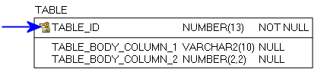
Figure 6: Primary Key example

Foreign Key (FK):
When a Primary Key from a Parent Table appears as a column in the Child Table it is referred to as a Foreign Key (FK). The FK may retain the same name of the Parent Table column, or it may be renamed.
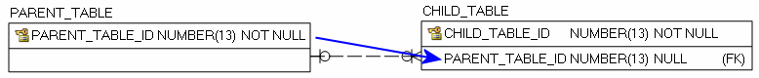
Figure 7: Foreign Key example
Alternate Key (AK):
Alternate Keys (AK) are secondary unique identifiers in a Parent Table. A Child Table can link to a Parent Table AK and use it as a Foreign Key (FK). The FK may retain the same name of the Parent Table column, or it may be renamed. Alternate Keys allow null values.

Figure 8: Alternate Key example

There are two relationship type options, identifying and non-identifying, which are described below.
An Identifying Relationship occurs when a column from the Parent Table is added to the key section of the Child Table. Though technically a Foreign Key (FK) in the child table, it now forms part of the Primary Key (PK). Identifying Relationships are symbolized with a solid line.
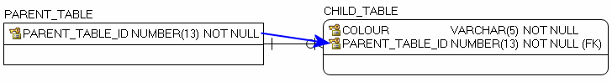

Figure 9: Example of an Identifying Relationship
A Non-identifying Relationship occurs when a column from the Parent Table is added to the main body of the Child Table where it is treated as a Foreign Key (FK). Non-identifying Relationships are symbolized with a dashed line.
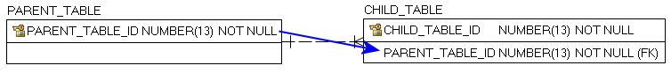

Figure 10: Example of a Non-identifying Relationship
The relationships between tables are set up with cardinality rules describing if the feature record in the Parent Table can relate to zero, one or more records in the associated Child Table and vice versa. These rules are symbolized in the model diagram as follows.
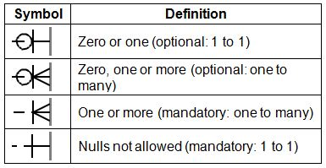

Figure 11: Model Diagram Relationship Symbology Table

APPENDIX C: Frequently Asked Questions

How can I extract Islands from the OHN?
The OHN does not contain island polygons. Islands are represented as holes in waterbodies.
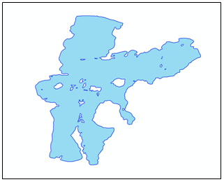

Figure 12: OHN Waterbody with holes that represent islands
The following steps are an example of how to create island polygons from waterbody polygons that have holes.
- Create a polygon larger than the extent of the lakes being used
- Erase the lakes from the large polygon
- Convert the result from a multi-part feature to single-part features
- Delete the outer feature which was the outer part of the large polygon and that will leave the island polygons
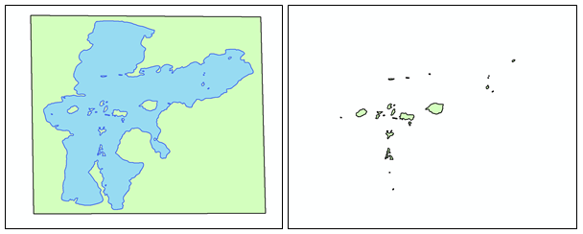

Figure 13: Polygon around the lake and the resulting island polygons after erasing the lake

How are Wetland data related to the OHN?
The Wetland data are managed independently from other hydro data classes and may overlap waterbodies or other hydro data.
Wetland data is not part of the OHN. The Wetland data class is available from GEO.
The Wetland data class provides the spatial representation and basic information for wetlands in Ontario. The attributes identify which wetlands have been evaluated through the Ontario Wetland Evaluation System (OWES), and of those evaluated wetlands which ones have been designated as Provincially Significant.

How are Constructed Drains data related to the OHN?
Constructed Drains are watercourses in the form of ditches, natural watercourses that have been modified to improve drainage, or buried tile systems.
The Constructed Drains data class is not part of the OHN. It is disseminated from the GEO warehouse and is maintained by the Ontario Ministry of Agriculture, Food and Rural Affairs for monitoring modifications and new construction.
Some Constructed Drain features will overlap or duplicate OHN Watercourse features. It cannot be incorporated into the OHN Watercourse layer because their data model contains different attributes and their data specifications are for a larger scale product.

Does the OHN support network analysis?
Yes, the OHN Watercourse data class contains directionality and connectivity to support a geometric network for hydrological analysis.
For details on how to create a geometric network, see your GIS software documentation or contact support for your GIS software.
The Ontario Integrated Hydrology‘s Enhanced Watercourse layer is an example of a geometric network derived from a dated copy of the OHN Watercourse. Search Ontario GeoHub for “Ontario Integrated Hydrology Data”.

Where did the names come from?
Within the OHN_Waterbody and OHN_Watercourse data classes the official names were extracted from the Geographic Names Ontario (Geonames or GNO) data class.
The small scale OHN layers source names from several contributing datasets.
- Ontario: OHN (GNO)
- Manitoba, Nunavut, Quebec: National Hydro Network (NHN) – Names in the NHN come from the Canadian Geographic Names Data Base (CGNDB)
- USA: The names and geometry come from the National Hydrography Dataset (NHD)

How authoritative is the OHN Official Name Label?
The source of OFFICIAL_NAME_LABEL and GEL_NAME_IDENT attributes on the OHN - Waterbody and OHN - Watercourse features is GNO. Users should not use the OHN as the authoritative source for official water names. Refer to the GNO data class to verify official names.
Note: Due to duplicate OFFICIAL_NAME_LABEL values, to select an entire named feature, select all waterbodies and watercourse features that share the same GEL_NAME_IDENT. In the Geographic Names Ontario data class, the named extent will be one feature but the OHN segmentation may require the name to span multiple features in multiple layers. A single name may be attached to more than one waterbody as well as multiple watercourse features.

How is the Official Name and Official Alternate Name attribute used for labeling?
If an OHN feature has an official name and an official alternate name, then the OFFICIAL_NAME_LABEL will contain the official name and the official alternate in parenthesis, e.g. Lake Ontario (lac Ontario). Very few named extents will have an official alternate name.

Why are all water names not included in the OHN?
The OHN only supports one name per water feature. For more detailed water name information see the GNO.
A group of OHN features such as a group of lakes may be considered as one extent in the GNO and would then be represented as one multi-part feature in the GNO data class (e.g. Kawartha Lakes). Some multi-part GNO features (e.g. a group of lake polygons with a single name, like “Kawartha Lakes”) will have individual GNO features for each part (e.g. Pigeon Lake, Stony Lake, etc.). In these cases the OHN feature will only store one official name in the Official Name Label field. The more detailed name (e.g. Pigeon Lake) will be stored on the OHN feature. However, channels, bays and other similar more detailed GNO feature names will NOT be stored on the OHN feature.

Why is the OHN geometry different from the GNO?
In many instances, the geometry found in the GEL was copied from the OHN data classes. When the OHN is updated with new geometry, the geometry in GNO remains unchanged. Staff in the Parcel Mapping and Georeferencing Unit must review the changes in the OHN before adopting any changes to the GNO.

Are there other dam layers?
The Ontario Dam Inventory (ODI) is a point layer with basic attributes such as dam name and ownership. Search Ontario GeoHub for “Ontario Dam Inventory”.

