User Guide
for
Ontario Integrated
Hydrology
Geospatial Ontario Data Class
  - Geospatial Ontario
  - Digital Data Information Business Services Branch
  - Corporate Management and Information Division
  - Ministry of Natural Resources
2026-03-10

Disclaimer
This technical documentation has been prepared by His Majesty the King in right of Ontario as represented by the Ministry of Natural Resources (the “Ministry”). No warranties or representations, express or implied, statutory or otherwise shall apply or are being made by the Ministry with respect to the documentation, its accuracy or its completeness. In no event will the Ministry be liable or responsible for any lost profits, loss of revenue or earnings, claims by third parties or for any economic, indirect, special, incidental, consequential or exemplary damage resulting from any errors, inaccuracies or omissions in this documentation; and in no event will the Ministry’s liability for any such errors, inaccuracies or omissions on any particular claim, proceeding or action, exceed the actual consideration paid by the claimant involved to the Ministry for the materials to which this instructional documentation relates. Save and except for the liability expressly provided for above, the Ministry shall have no obligation, duty or liability whatsoever in contract, tort or otherwise, including any liability or negligence. The limitations, exclusions and disclaimers expressed above shall apply irrespective of the nature of any cause of action, demand or action, including but not limited to breach of contract, negligence, strict liability, tort or any other legal theory, and shall survive any fundamental breach or breaches.

Additional Information
This document does not comply with all the applicable guidelines for accessible digital documents. For an alternative format please email Geospatial Ontario at geospatial@ontario.ca.
For more information about this document, please contact Geospatial Ontario at geospatial@ontario.ca.

Executive Summary

Key Words
integrated, hydrology, digital elevation model, flow direction, enhanced, watershed, watercourse, elevation, interpolation, accuracy assessment

Abstract
The Ontario Integrated Hydrology (OIH) provides a collection of related elevation and mapped water features that are used in combination for provincial-scale hydrology applications, such as the creation of watersheds and application to hydrology models. By integrating mapped vector water features, such as lakes and rivers, together with raster elevation and flow direction datasets, it is possible to accurately create watersheds and represent several key parts of the water cycle. Integrated hydrology data is complete for the entire province making it possible to create a watershed for any location in Ontario.
This data provides the foundation datasets that can be used together for watershed delineation. By managing the data as one larger data package, all datasets required for generating watersheds are available at one time. The structure of the data package also allows for easier integration into other hydrology tools, such as Arc Hydro.
The following document provides a full description of the data sources used to create the data packages, the structure of the data packages as well as data use and limitation considerations.

Revision History
Date | Edition/  Version | Description
2012-11-13 | 1.0 | Initial Public Release
2013-02-01 | 1.1 | Updated Package Extent Map
2015-03-30 | 2.0 | Updated for new packages and data processing methods.
2015-10-01 | 2.1 | Updated Source Data Map and references in document to elevation source data
2016-07-26 | 3.0 | Updated sections for new MNR Terrain Processing Tools
2020-04-08 | 3.1 | Document and hyperlink references updated
2020-11-24 | 3.2 | Updated to reflect raster data format conversion to GeoTIFF, and raster data use considerations in QGIS including the Enhanced Flow Direction grid
2022-08-03 | 3.3 | MNR references updated. OWIT references updated. Content changes to OWIT related sections
2025-01-22 | 4.0 | Template update and French translation, replaced all Land Information Ontario references with Geospatial Ontario, spatial reference and datum updates, and other text revisions
2026-03-10 | 4.1 | Minor text revisions and French translation completed

Table of Contents
Disclaimer 2
Additional Information 2
Executive Summary 3
Key Words 3
Abstract 3
Revision History 4
Table of Contents 6
List of Figures 9
List of Tables 9
List of Acronyms 10
1. Ontario Integrated Hydrology – An Overview 11
1.1. What is Ontario Integrated Hydrology? 11
1.2. Why is Ontario Integrated Hydrology Data Produced? 12
1.3. What is Included in an Ontario Integrated Hydrology Data Package? 12
1.4. How is Ontario Integrated Hydrology Data Created? 13
1.4.1. Enhanced Watercourse 15
1.4.2. Integrated Waterbody 15
1.4.3. Unconditioned DEM 16
1.4.4. Enforced DEM 16
1.4.5. Filled DEM 17
1.4.6. Enhanced Flow Direction 17
1.4.7. Flow Accumulation 19
1.4.8. Stream Grid 19
1.4.9. IH Status Index 20
1.5. Versions and Updates 20
1.6. Geographic Extent 20
1.7. Horizontal Reference System 21
1.7.1. Horizontal Datum and Coordinate System 21
1.7.2. Horizontal Unit of Measure (coordinate system axis units) 21
1.8. Vertical Reference System 22
1.8.1. Vertical Coordinate System 22
1.8.2. Vertical Unit of Measure (coordinate system axis units) 22
1.9. Spatial Resolution 23
1.10. Void Areas 23
2. Ontario Integrated Hydrology Data Packages 24
Data Delivery 24
2.1. Data Package Contents 24
3. MNR Terrain Processing Tools 27
3.1. Overview 27
4. Enforced DEM 27
4.1. Overview 27
4.2. Hydro Enforcement Process 28
4.2.1. Hydro Enforcement Overview 28
4.2.2. Hydro Enforcement Using MNR Terrain Processing Spot Burning 29
4.2.3. Hydro Enforcement Using ANUDEM Software 30
4.3. Elevation Source Data 30
4.3.1. Elevations 31
4.3.2. Accuracy Assessment 31
5. Enhanced Watercourse 31
5.1. Overview 31
5.2. Hydrologic Geometric Network 32
5.3. Field Definitions 34
6. Enhanced Flow Direction 38
7. Recommended Data Uses and Considerations 41
7.1. Recommended Data Uses 41
7.1.1. Watershed Delineation and Analysis using OWIT 41
7.1.2. Watershed Delineation and Analysis using GIS Software 41
7.1.3. ArcToolbox Watershed Function 41
7.1.4. Arc Hydro Tools 42
7.1.5. Watercourse Network Analysis 45
7.2. Considerations 45
7.2.1. OWIT Overview 45
7.2.2. Raster Merging and Mosaicking 45
7.2.3. Projecting a Raster Dataset 46
7.2.4. Raster Resampling 46
7.2.5. DEM Sink Filling 46
8. Definitions 47
9. References 49
9.1. General References 49
9.2. Guideline References 49
9.3. Metadata References 50

List of Figures
Figure 1: A data product flow diagram illustrating relationships and inter-layer dependencies between the vector and raster datasets that are used to create an Ontario Integrated Hydrology package. 14
Figure 2: Example of contents within the Ontario Integrated Hydrology Far North East (FNE) data package. 24
Figure 3: Illustration of the spot burning process showing a profile of the original versus modified dropped and burned elevations along the watercourse network. 29
Figure 4: An example of an upstream trace using the Enhanced Watercourse geometric network. 33
Figure 5: An example of a downstream trace performed using the Enhanced Watercourse geometric network. Highlighted segments in purple represent features selected from the network below a stream junction (green box). 33
Figure 6: Types of features in the Enhanced Watercourse geometric network. 34
Figure 7: Examples of stream ordering available as data attributes in the Enhanced Watercourse. 38
Figure 8: The common D8 flow direction technique. 39
Figure 9: Brief overview of the Enhanced Flow Direction methodology. 39

List of Tables
Table 1. Features included in the Ontario Integrated Hydrology data packages. Feature names below pertain to the Far North East (FNE) package. 24
Table 2. Ontario Integrated Hydrology features to be used in place of Arc Hydro feature tags in the Arc Hydro Data Model. Functions listed are part of the Arc Hydro Terrain Pre-processing tools. 40

List of Acronyms
ANUDEM: Australian National University Digital Elevation Model software
CGVD28: Canadian Geodetic Vertical Datum of 1928
CGVD 2013a: Canadian Geodetic Vertical Datum of 2013 Version A
DEM: Digital Elevation Model
DSM: Digital Surface Model
DTM: Digital Terrain Model
EFDIR: Enhanced Flow Direction
EPSG: European Petroleum Survey Groups
GEO: Geospatial Ontario
GIS: Geographic Information System
IH: Integrated Hydrology
MNR: (Ontario) Ministry of Natural Resources
NAD83: North American Datum of 1983
OBM: Ontario Basic Mapping
OWIT: Ontario Watershed Information Tool
OIH: Ontario Integrated Hydrology
OHN: Ontario Hydro Network
PDEM: Provincial Digital Elevation Model
WRIP: Water Resources Information Program
- Ontario Integrated Hydrology – An Overview
  - What is Ontario Integrated Hydrology?
Ontario Integrated Hydrology (OIH) is a collection of related elevation and mapped water features that are used in combination for generating watersheds and to support hydrology applications. Specific GIS and remote sensing tools and methods have been developed to represent water flow in 3-dimensional space using digital elevation models (DEMs) and using flow routing algorithms (Jenson and Domingue, 1988; Maidment, 2002). Advancements have also been made in the methods used to construct integrated hydrology datasets. These methods ensure that 3-dimensional elevation data conforms with mapped water bodies and streams, and that water systems flow in a downstream direction (Kenny and Matthews, 2005). A number of GIS tools have also been developed over the last decade, such as Arc Hydro (Esri, 2012), which leverage integrated hydrology information for further analysis.
A series of data packages, known collectively as Ontario Integrated Hydrology data, can be used in combination for provincial-scale hydrology applications, such as watershed generation and hydrologic modelling. This data provides the following benefits:
- All the key water datasets required for provincial-scale hydrology applications (e.g. stream network, DEM, flow direction grid) are available in a single data package.
- By integrating the data into a series of common data packages, the data can be more easily used and referenced in GIS software as well as other hydrology tools, such as Arc Hydro and the Ontario Watershed Information Tool (OWIT).
- Data packages provide seamless coverage across the province using one common map projection and a consistent 30m raster grid resolution. Previous regional-level datasets have not allowed for analysis in the far north of Ontario which is now included.
- Complete watersheds can be generated for any location across the province including neighbouring areas draining into Ontario.
  - Why is Ontario Integrated Hydrology Data Produced?
OIH allows for a number of legislative, regulatory and operational requirements to be addressed within the province of Ontario. Examples of these requirements include:
- regulatory watershed boundaries
- land use planning boundaries
- watershed characteristics for emergency management
- support for hydrology tools such as OWIT
- support for Provincial Watershed data classes in Geospatial Ontario (GEO)
- nutrient modeling
- forest management planning
- mining and aggregate studies
- aquatic ecosystem classification and analysis
- renewable energy potential assessment
- land cover mapping
  - What is Included in an Ontario Integrated Hydrology Data Package?
Five key datasets are represented in each data package: i) a time-stamped copy of the stream network (Enhanced Watercourse), ii) a time-stamped copy of water bodies (Integrated Waterbody), iii) a hydrologically conditioned DEM (Enforced DEM), iv) a flow direction grid (Enhanced Flow Direction or EFDIR), and v) a raster representation of the stream network (Stream Grid). These datasets allow the user to perform surface water analysis, including watershed or sub-watershed analysis, up to the secondary watershed level across Ontario. The overall extents and structure of the data are explained in depth in Section 2. All these datasets will be described in more detail in the following sections.
The OIH datasets are constructed and distributed as static datasets due to the inter-layer dependencies between the vector and raster data products. In this respect, the data package is a ‘time stamped’ product and should be recognized as being distinctly separate from the other dynamically maintained base datasets available from GEO, such as the Ontario Hydro Network (OHN) Watercourse or OHN Waterbody data classes.
  - How is Ontario Integrated Hydrology Data Created?
Hydrology is a fundamental component of the landscape and is directly influenced by the surrounding terrain and how water accumulates and travels downslope and downstream. As a result, streams and lakes cannot be viewed in isolation from elevation and flow direction products because there is a strong and tightly “integrated” relationship between them. Figure 1 provides an illustration of some of the inter-layer dependencies involved in the creation of the OIH datasets and other interim datasets developed as part of the production process. The proceeding sections of this document provide a description of the datasets illustrated in Figure 1.
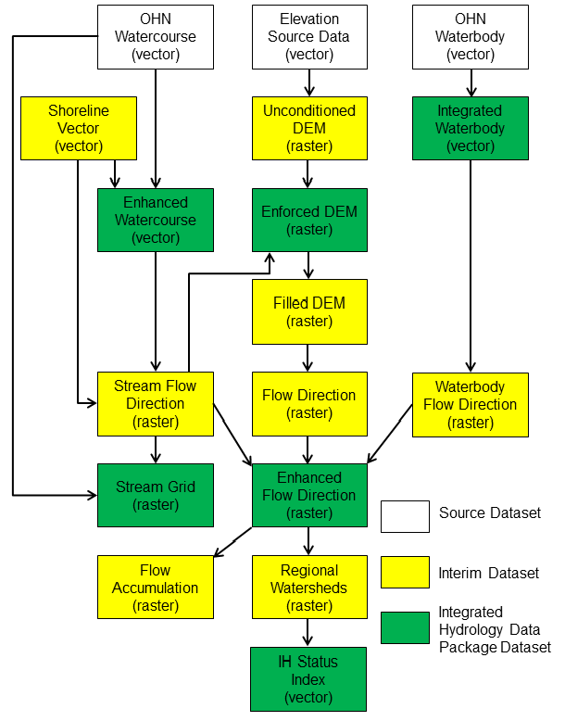
Figure 1: A data product flow diagram illustrating relationships and inter-layer dependencies between the vector and raster datasets that are used to create an Ontario Integrated Hydrology package.

    - Enhanced Watercourse
The Enhanced Watercourse dataset is a hydrologic network based on a time-stamped version of OHN Watercourse data class (MNR, 2020c) which was developed in accordance with the provincial medium-scale data capture specifications for hydrographic features (MNR, 2020a). Only connected watercourse features are included in the Enhanced Watercourse dataset as the accuracy and directionality of disconnected segments are not known. Disconnected segments can be obtained by referencing the OHN Watercourse data class available through GEO.
A new feature included in the Enhanced Watercourse dataset is a shoreline component for areas bordering large bodies of water including the Great Lakes, Hudson Bay-James Bay, St. Lawrence River, and Ottawa River. This shoreline feature connects all inland watercourses flowing to these water bodies and introduces a barrier to open water so that watersheds can be properly delineated for areas draining directly to the shoreline.
A rasterized version of the Enhanced Watercourse dataset is used to hydrologically enforce the Enforced DEM and is a key component of the Enhanced Flow Direction. Hydrologic attributes are generated for the Enhanced Watercourse including stream order. More details on the attributes and the use of the dataset are provided in Section 0. Enhanced Watercourse is available through GEO as part of the OIH data packages.
    - Integrated Waterbody
Similar to the Enhanced Watercourse, the Integrated Waterbody dataset is based on a time-stamped version of the OHN Waterbody data class (MNR, 2020b), and includes all on-network water bodies within a given package and a subset of key OHN attributes for reference purposes. Water bodies were used to create the Enhanced Flow Direction dataset. Having a time-stamped version can be useful in understanding how the derivatives were created and for troubleshooting potential anomalies in watershed creation. Integrated Waterbody is available through GEO as part of the OIH data packages.

    - Unconditioned DEM
An Unconditioned DEM is a representation of the terrain surface unaltered by hydrology enforcement or other terrain post-processing. The Unconditioned DEM is primarily based on the Provincial DEM (PDEM) for Ontario. The PDEM is a multi-sourced raster elevation surface representing ground where possible. For more information, refer to the PDEM GEO metadata record (MNR, 2026).
The Unconditioned DEM is used to create the Enforced DEM, a key raster dataset found within the OIH dataset package (see next section).
For more information on the spatial extents of the elevation data sources that were incorporated into OIH, please refer to the “ElevationSource” feature class stored within the “IH_ReferenceData.gdb” geodatabase available through the OIH GEO metadata record (see Section 4.3).
    - Enforced DEM
The Enforced DEM is a hydrologically conditioned raster elevation surface which is created using the PDEM and the Enhanced Watercourse network. The Enhanced Watercourse was used in the hydrologic conditioning process to essentially burn or channelize watercourse features into the surface of the DEM in a downstream direction to follow the morphology of stream features as much as possible within the limitations of the raster environment. The watercourse layer may contain ‘virtual flow’ through water bodies and ‘virtual connectors’ where water is known to flow but cannot be accurately mapped. Water can also flow through barriers, culverts and conduits, and this behaviour is honoured by enforcing these connections into the DEM. It should be noted that elevation values at or adjacent to watercourse features have been altered and may not reflect true ground elevation. Values away from watercourse features have not been altered. The OIH uses the MNR Terrain Processing Tools to create the Enforced DEM. More details on the DEM hydrologic enforcement process are provided in Section 4.2.
    - Filled DEM
The Filled DEM is a derivative product based on the Enforced DEM. The process of filling eliminates depressions in the DEM surface that could not be resolved by hydrologic conditioning during interpolation. This is essential in assuring all areas of the DEM flow downstream. The Filled DEM is the key input dataset for the Enhanced Flow Direction. The filling process for the Filled DEM was unconditional meaning all sinks were filled. This allows for the creation of complete and continuous watersheds without gaps (resulting from sinks) across the landscape.
In some cases, conditions can be used for selective filling where only sinks that meet a certain criterion will be filled. This would be useful for areas where there are known sinks that need to be preserved. Because of the scale of the OIH and the lack of known sink data, no sinks were preserved. If selective filling is required for a certain area, the Enforced DEM can be used to create a new Filled DEM. Subsequently, all products based on the Filled DEM (Enhanced Flow Direction, watersheds) would also need to be re-processed.
The Filled DEM is produced internally as an interim data product and is not distributed; however it can be re-created easily using the Enforced DEM in any standard GIS software package. See Section 7.2.5 for more details.
    - Enhanced Flow Direction
A typical flow direction raster represents the direction of water flow across the surface of the landscape (Jensen and Domingue, 1988). The Enhanced Flow Direction is based on this principle, but also incorporates and honours directionality sourced from mapped hydrology features (Kenny and Matthews, 2005). This is an enhancement in the quality of the dataset, where mapped features are present, as flow direction can be assigned using more accurate or known directionality as opposed to just relying on elevation. Using the Enhanced Flow Direction ensures mapped features are reliably incorporated into any derived watershed boundaries. To create the Enhanced Flow Direction, other datasets developed in the OIH data package are used in combination:
- The Enforced DEM is filled to resolve all sinks in the DEM surface and then a standard D8 flow direction grid is produced.
- The Enhanced Watercourse is used to direct flow values in a downstream direction using the accuracy of the mapped stream network.
- Integrated Waterbody features are then selected where they intersect the Enhanced Watercourse network. This sub-set of features is then used to improve flow direction values within the intersecting water bodies.
More details can be found in Section 6. Enhanced Flow Direction is available through GEO as part of the OIH data packages.

    - Flow Accumulation
Flow Accumulation is derived from the Enhanced Flow Direction product. The flow accumulation process records the total number of cells draining into each individual cell in a grid. In a physical sense, the flow accumulation value represents the drainage area measured in grid cell units (Maidment, 2002). For example, since the Enforced DEM has a cell size of 30 metres x 30 metres, or 900 square metres, a cell with a flow accumulation value of 100 would represent a drainage area of 90000 square metres draining to that particular cell. The Flow Accumulation raster is useful for determining the concentration of overland flow across the DEM surface, for stream thresholding, and in the creation of area-based catchments or watersheds.
This dataset is produced internally as an interim data product and is not distributed; however it can be re-created easily using the Enhanced Flow Direction in any standard GIS software package.
    - Stream Grid
A raster layer called Stream Grid has been created from the Enhanced Watercourse data for constructing the Enhanced Flow Direction and for watershed generation purposes. The ‘Create Drainage Structures’ command in Arc Hydro was used to convert the Enhanced Watercourse to a raster representation complete with flow direction values assigned to each cell to honour flow on the stream network. See Sections 1.4.6 and 6 for more information. The Stream Grid version supplied has been reclassified to a simple binary interpretation: the value of “1” referencing a cell on the stream network, and “NoData” referencing a cell off the stream network. It should be noted that in the raster conversion some raster cells along the vector hydrology network may not be represented in order to optimize the flow direction of features in the raster environment. This generalization is mitigated by applying a buffer to incorporate adjacent cells in the enforcement process described in Section 4.2.1. Stream Grid is available through GEO as part of the OIH data packages.
    - IH Status Index
The IH Status Index is a polygon feature class with attributes describing the date an area of the province has been last updated and what updates have been made. It can also be used to illustrate the OIH regional package boundaries. The regional boundaries are based on watersheds created using a raster version of the Enhanced Watercourse and the Enhanced Flow Direction. This index can be used to identify the package(s) that intersect a given area of interest. The “IH Status Index” feature class is available through the OIH GEO metadata record as part of the “IH_ReferenceData.gdb”.
  - Versions and Updates
A text file named “Version.txt” can be found in the root folder of the packaged data. This text file provides a history of versions including version dates and version notes. A version date is based on the date a package was loaded into GEO. Version notes describe what types of updates have been made to a package. Version notes can also be found in the “IH Status Index” feature class which is available through the OIH GEO metadata record as part of the “IH_ReferenceData.gdb”.
  - Geographic Extent
The horizontal extent of the data provides continuous spatial coverage for the entire Province of Ontario. The bounding extent for all data layers is:
- West-bounding coordinate: -95⁰ longitude
- East-bounding coordinate: -74⁰ longitude
- North-bounding coordinate: 56⁰ latitude
- South-bounding coordinate: 41⁰ latitude
The vertical extent of the dataset is expressed in metres. The lowest vertical extent is along the coast of James Bay and Hudson Bay which reaches the elevation of mean sea level. The highest vertical extent is 689.59 metres, located at Ishpatina Ridge (47.320N, 80.750W) in Lady Evelyn-Smoothwater Wilderness Park located approximately 70 kilometres west of the town of Latchford.
  - Horizontal Reference System
    - Horizontal Datum and Coordinate System
The horizontal datum and coordinate system used for the data is North American Datum of 1983 (NAD83) / Ontario MNR Lambert. This datum and coordinate system are defined within the European Petroleum Survey Group (EPSG) Geodetic Parameter Registry as Code 3161. The following parameters are used in association with the coordinate system:
False Easting: 930000.00
False Northing: 6430000.00
Central Meridian: -85.00
1st Standard Parallel: 44.50
2nd Standard Parallel: 53.50
Latitude of Origin: 0.00
Linear Unit: Metres

This dataset will soon undergo a transformation to the newly adopted spatial reference standards for Ontario. The new horizontal standard is as follows:
North American Datum of 1983 (NAD83) - Canadian Spatial Reference System (CSRS) otherwise known as NAD83-CSRS (GO-IT Standard 541TES)
For more information, please consult the Ontario Geodesy website: https://www.ontario.ca/page/geodesy
    - Horizontal Unit of Measure (coordinate system axis units)
The horizontal unit of measure is metres (m).
  - Vertical Reference System
    - Vertical Coordinate System
The vertical datum of the Enforced DEM is based on the Canadian Geodetic Vertical Datum of 1928 (CGVD28) of the Geodetic Survey Division and is measured in metres above mean sea level. This datum is defined within the European Petroleum Survey Group (EPSG) Geodetic Parameter Registry as Code 5713.
This dataset will soon undergo a transformation to the newly adopted spatial reference standards for Ontario. The new vertical standard is as follows:
Canadian Geodetic Vertical Datum of 2013 referencing the Canadian Gravimetric Geoid – 2013 Version A (GO-IT Standard 544TES) and epoch realization of 2010 (short form: CVGD 2013 (CGG 2013a) epoch 2010)
For more information, please consult the Ontario Geodesy website: https://www.ontario.ca/page/geodesy
    - Vertical Unit of Measure (coordinate system axis units)
The vertical unit of measure for all raster grid cells in the Enforced DEM is metres (m). One single vertical elevation value represents each raster grid cell in the Enforced DEM.

  - Spatial Resolution
The grid spacing is based on the Lambert Conformal Conic projection with a raster cell resolution of 30 metres across the entire extent of the OIH packages. A common grid reference has been used for all raster datasets used when developing the OIH using the following lower-left cell centre reference point:
Lower-left X: 180000 m
Lower-left Y: 1780000 m
  - Void Areas
Portions of raster data extending beyond the provincial boundary may contain no information (i.e. have been classified as null or no data values). In some areas where source elevation data was not available the official provincial boundary was used to buffer and clip raster data.
- Ontario Integrated Hydrology Data Packages

Data Delivery
The OIH data packages and metadata are currently stored and distributed through Geospatial Ontario (https://www.ontario.ca/page/geospatial-ontario). Metadata for OIH can be accessed through the Ontario GeoHub. (https://geohub-fr.lio.gov.on.ca/search?q=OIH)
The physical data is distributed as data packages which are assembled by watershed region. Each watershed region is based on one or more secondary watersheds across Ontario and can also include watersheds flowing in from Manitoba and Quebec. Basing the OIH data packages on watershed regions allows for seamless, complete watershed analysis. To view the physical extent of each OIH data package, and for a listing of secondary watersheds associated with each watershed region refer to ‘OntarioIntegratedHydrologyExtentDataPackages.pdf’ document in the OIH metadata record.
  - Data Package Contents
Each package includes an Esri File Geodatabase and a set of GeoTIFF rasters specific to each watershed region. Figure 2 and Table 1 describe the datasets within each Geodatabase using the watershed region ‘FNE’ as an example.
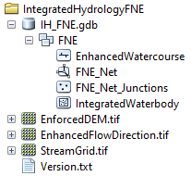
Figure 2: Example of contents within the Ontario Integrated Hydrology Far North East (FNE) data package.
When using GeoTIFF for the first time, building an overview pyramid file (extension .OVR) is recommended for significantly faster viewing and rendering in GIS software applications. For ArcGIS users, under ArcCatalog, simply right-click the raster, select Build Pyramids… and accept the default options for best performance. It should take only a couple moments to generate. ArcMap/Pro may also prompt you to build pyramids or do it automatically when first adding the raster to the project. If you proceed, pyramids will be built based on how your Raster Storage options are set under the Environment Settings. If you are unsure of these settings, click Cancel, check your settings and build manually as described above.
Pyramid Setting Tips:
- “NEAREST” resampling is preferred for non-discrete data since this technique is the fastest for generating pyramids. The other resampling methods employ a weighting or averaging based on neighbouring values, which is not necessary if the primary use for pyramids here is display performance.
- You may choose to further compress the pyramid file, but little advantage will be gained for floating point data and rendering may in fact be slower accessing highly compressed pyramid files.
- For other GIS software, please consult the appropriate help documentation for properly generating an overview pyramid file.
In ArcMap, we also recommend building statistics for the Enforced DEM to accurately display the elevation range in the symbology. Changing the settings Symbology > Statistics to “From Current Display Extent”, and Symbology > Stretch to “Percent Clip” will give the best contrast dynamically at any scale. You can also use the Image Analysis Window to dynamically create hill shades or other derivatives if you desire.
In QGIS, when adding a raster to a new map, it may ask you to transform the data to the default projection. Make sure to cancel out of this dialog before you continue to preserve the raster projection. By default, all the rasters will display as “Singleband Gray” under Layer Styling, which may be fine for the Enforced DEM. For discrete data like the Enhanced Flow Direction grid, you should change the symbology to “Paletted/Unique Values”, click Classify, and then modify the colours according to your preferences. Further modification of the Enhanced Flow Direction grid will be required before using in QGIS or other GIS software. Refer to Section 6 for more information.
Consult your specific software package help documentation for the appropriate optimum display settings.
Table 1. Features included in the Ontario Integrated Hydrology data packages. Feature names below pertain to the Far North East (FNE) package.
Feature Name | Description
FNE | Feature dataset containing geometric network of vector watercourse and water body feature classes. The name corresponds to the watershed region of the package (e.g. FNE, FNW, FNC1, FNC2, NC, NE, NW, SE or SW).
EnhancedWatercourse | Polyline feature class of vector watercourse for one watershed region. Source data from OHN watercourse. Associated with geometric network as network edges.
FNE_Net | Geometric network for watershed which contains the Enhanced Watercourse and FNE_Net_Junctions.
FNE_Net_Junctions | Network junctions associated with geometric network. Junctions define locations of inlets, outlets, and confluences.
IntegratedWaterbody | Polygon feature class of vector water bodies for one watershed region. Source data from OHN Waterbody.
EnhancedFlowDirection | Flow direction raster covering data package region enhanced with flow directed watercourse and water body features.
EnforcedDEM | Hydrologically conditioned raster DEM covering data package region.
StreamGrid | A raster representation of the stream network that can be used as a guide for placing a watershed outlet.

- MNR Terrain Processing Tools
  - Overview
The OIH datasets including Enhanced Watercourse, Integrated Waterbody, Enforced DEM, Enhanced Flow Direction, and Stream Grid are all created using the MNR Terrain Processing Tools. The MNR Terrain Processing Tools include a set of Python tools, in the form of an ArcGIS toolbox, for creating the hydrology derivative components necessary for watershed and surface water related terrain analysis. While these tools are designed for MNR's OIH data compilation, they can be tailored to other applications. All tools were developed with as much transparency as possible to allow for further modifications / improvements in the future.
This toolbox is the latest in a series of tools developed by MNR dating back to 2001. Customized methods for reflecting water flow direction in the raster environment were developed over the years, including the ‘Enhanced Flow Direction’ technique of honouring directionality based on mapped hydrology features (Kenny and Matthews, 2005). Similar concepts that have been adopted in Arc Hydro tools developed by Esri (Djokic, 2008) have been leveraged in this toolbox.
For more details on the MNR Terrain Processing Tools refer to Section 4.2.
- Enforced DEM
  - Overview
DEMs are used for a broad range of studies including projects tied to the fields of hydrology, forestry, ecology and climatology. Specific to the field of hydrology, a DEM is frequently used for mapping hydrologic features, such as watercourses and water bodies, and is a reference dataset for surface water and groundwater flow modelling. By comparison, the Enforced DEM is a hydrologically conditioned product where elevations descend in relation to the direction of flow along mapped water features.

  - Hydro Enforcement Process
    - Hydro Enforcement Overview
There are currently two methods of hydro enforcement used in the OIH: the new method known as ‘Spot Burning’ (part of the MNR Terrain Processing Tools), and the old method of using ANUDEM (Australian National University Digital Elevation Model) software (now available as TOPOGRID or ‘Topo to Raster’ in Esri software). Both methods recondition existing elevation data for hydrologic analysis. Deficiencies in existing DEM enforcement techniques (including ANUDEM / TOPOGRID, TARBOTON and AGREE) prompted an investigation of new customized solutions for handling enforcement. Some deficiencies include the following:
- ANUDEM sink straddling feature creates unnatural valley burning across watershed divides. In areas lacking elevation detail, stream burning can produce exaggerated valleys or even raised berms in some cases.
- ANUDEM produces inconsistent results when spot improvements are made. A small change in a watercourse, for example, can significantly alter the entire DEM, making it difficult to duplicate results and stitch data together.
- AGREE applies a simple elevation drop algorithm that does not account for flow direction within the channel which can lead to incorrect filling results especially near stream confluences in flat areas.
- ANUDEM and TARBOTON are ‘black box’ tools which give the user little control over processing, customization and further enhancements. Input parameters also require an in-depth knowledge of how they operate to produce desirable results.
Details of each OIH hydro enforcement method can be found in Sections 4.2.2 and 0. As the OIH is updated more packages will incorporate the new ‘Spot Burning’ method. The OIH metadata record and the version text file in each package will indicate what hydro enforcement method was used.

    - Hydro Enforcement Using MNR Terrain Processing Spot Burning
The MNR Terrain Processing Tools employ a new method for DEM enforcement known as ‘Spot Burning’ to create the Enforced DEM. The ‘Spot Burning’ method alters elevations only where barriers occur along a mapped watercourse network. A slight drop in elevation is applied to all network cells and adjacent cells to ensure flow directions are oriented properly in relation to line features in the network. Then elevation enforcement is performed only through barriers along the network ensuring that every cell flows downhill (see Figure 3).
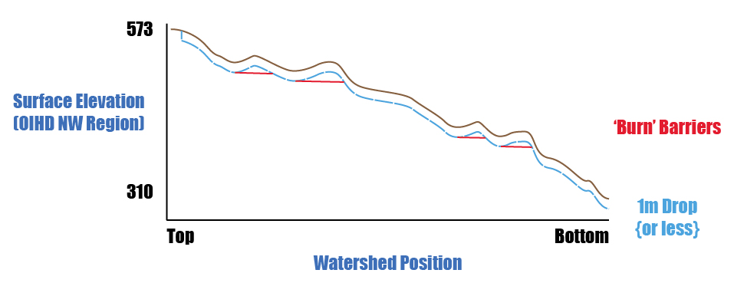
Figure 3: Illustration of the spot burning process showing a profile of the original versus modified dropped and burned elevations along the watercourse network.
This enforcement method provides several advantages over other interpolation methods, which include the following:
- The original elevation values are honoured as much as possible which makes the Enforced DEM useful for other types of analysis such as calculating slope along channel systems.
- Processing results are repeatable which makes it possible to create identical catchment boundaries between study areas. This in turn allows for seamless incorporation into larger regional datasets.
- ‘Out-of-the-box’ Esri functionality is leveraged, and the tools represent an entire workflow from the raw data extraction stage through to the compilation of the final derivative hydrology data products.
    - Hydro Enforcement Using ANUDEM Software
The Enforced DEM in the OIH packages was historically created using ANUDEM software to hydrologically enforce stream features and remove spurious sinks. ANUDEM is a software package that calculates values on a regular grid of a discretized smooth surface fitted to large numbers of irregularly spaced elevation data points, contour line data and stream line data (Hutchinson, 1989). The program imposed a global drainage condition which automatically removes sinks where possible and produced reasonable results using contour and spot height data sources.
As OIH packages are updated using newer data sources like lidar and satellite data, the new OIH ‘Spot Burning’ method will be used, and data created using ANUDEM will be phased out. For information on the limitations of the ANUDEM software refer to Section 4.2.1.
  - Elevation Source Data
The Enforced DEM was created using elevations primarily from the unconditioned PDEM as well as other sources for watersheds flowing into Ontario. It is important to consider the elevation sources when evaluating the Enforced DEM. The Enforced DEM was constructed using multiple data sources due to the lack of a single source of elevation data which represented ground surface for the entire OIH extent. Further enhancements to the PDEM are ongoing to deal with areas of inadequate accuracy related to contour and spot height data sources. To capture these changes, an “ElevationSource” feature class was created which includes spatial metadata information regarding the elevation data sources used across Ontario and adjacent areas bordering the province. The boundaries between data sources reflect how the different areas were mosaicked together.
For more information on source elevation used in the Enforced DEM refer to the “ElevationSource” feature class available through the OIH GEO metadata record as part of the “IH_ReferenceData.gdb”. For more information on how the PDEM was created see the PDEM GEO metadata record (MNR, 2026).
    - Elevations
Elevations of the Enforced DEM are orthometric and expressed in reference to metres above Mean Sea Level.
    - Accuracy Assessment
The accuracy of the Enforced DEM is primarily dependant on the accuracy of the source elevation data (see Section 4.3). The accuracy of the Enforced DEM varies spatially because of the range in data sources used. The Enforced DEM accuracy is also dependant on the changes that occur due to the hydrologic enforcement process. In areas along mapped stream channels the enforcement process will lower elevation values in order to ensure elevations consistently drop in the direction in which water is flowing.
- Enhanced Watercourse
  - Overview
The Enhanced Watercourse dataset is an improvement over past hydrologic based geometric networks such as the WRIP Waterflow – the initial geometric stream network dataset developed by MNR. The Enhanced Watercourse is the only province wide hydrology network, including full coverage in Ontario’s Far North. The data product is based on a static copy of the OHN Watercourse, allowing better integration with other related datasets in the OHN and other datasets in GEO. Extensive improvements have been made across the province using several quality control techniques involving elevation, flow direction, imagery, and local knowledge.
As mentioned previously the Enhanced Watercourse was used to hydrologically enforce the Enforced DEM and to create the Enhanced Flow Direction. To achieve the most consistent and desirable results, several important enhancements to the OHN Watercourse were made. They include:
- the introduction of hydrology-based attributes (e.g., Shreve and Strahler Order),
- the removal of flow gaps and stranded segments,
- the incorporation of shoreline connecting geometry along major water bodies,
- further enhancements to handle divergences in the network,
- the creation of a geometric network,
- and the assignment of flow direction for network tracing tasks.
These enhancements are not available as part of the OHN Watercourse because they are specific to hydrology and watershed analysis. The justification for creating the Enhanced Watercourse as a time-stamped dataset relate to the complexity and feasibility of maintaining such enhancements in a live (or actively maintained) and structured dataset such as the OHN Watercourse.
  - Hydrologic Geometric Network
A hydrologic geometric network is a connected series of water features to which topological directionality can be applied. Note that Esri ArcMap Desktop must be used to leverage the full capabilities of the geometric network. The geometric network has been replaced by the new trace network functionality in Esri ArcGIS Pro. Future versions of OIH may migrate to the trace network which is currently under evaluation.
The Enhanced Watercourse geometric network was established using virtual segmentation, allowing connectivity of the network to be maintained through double-lined water bodies such as lakes and large rivers. The network allows users to perform several advanced spatial analysis tasks. Users can query or trace upstream and downstream features, query connectivity, find outlets to major river systems, and select contributing upstream features to a point of interest on the network, helping to identify headwater areas. See Figure 4 and Figure 5 for examples of tracing.
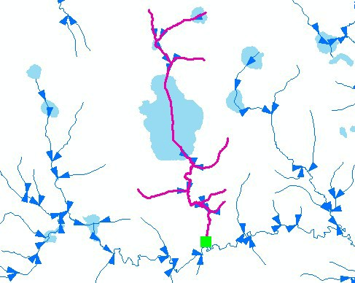
Figure 4: An example of an upstream trace using the Enhanced Watercourse geometric network.
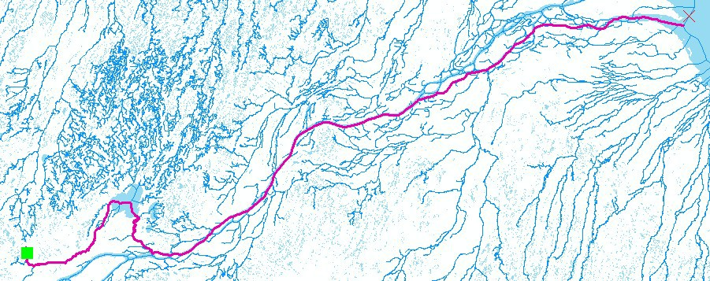
Figure 5: An example of a downstream trace performed using the Enhanced Watercourse geometric network. Highlighted segments in purple represent features selected from the network below a stream junction (green box).
There are two feature types associated with the Enhanced Watercourse geometric network: line features and point junctions. Line features represent watercourse features such as streams, small rivers, virtual flow through water bodies, and virtual connectors. More details on these feature types can be found in the OHN Watercourse GEO metadata record (MNR, 2020c). Junctions are located at start and end points of each watercourse line feature. Junctions can represent watercourse inlets (headwaters), watercourse outlets (mouth of streams/rivers), and watercourse confluences (area where two watercourse channels converge into one channel). The different feature types are illustrated in Figure 6.
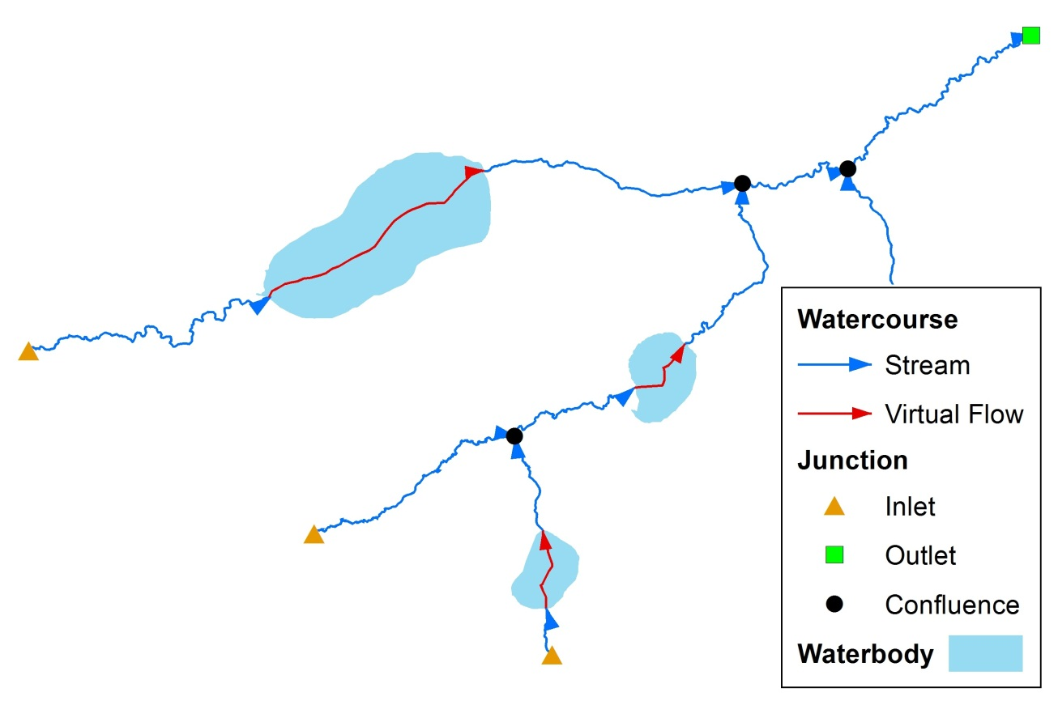
Figure 6: Types of features in the Enhanced Watercourse geometric network.
  - Field Definitions
The following provides descriptions of attribute information provided with the Enhanced Watercourse dataset. Some fields have been carried over from the OHN Watercourse. More details on OHN related fields can be found in the OHN Watercourse GEO metadata record (MNR, 2020c).
- OGF_ID:
  - Reference unique identifier assigned to OHN Watercourse (see OHN metadata for more detail). Identifiers labeled as -1 are new features added to the Enhanced Watercourse layer that do not exist in OHN.
- WCRS_TYPE:
  - The type of watercourse. Default = Stream (see OHN metadata for more detail). There are two new feature types introduced in the Enhanced Watercourse which do not exist in OHN. These feature types are:
    - Shoreline – an arc that represents a shoreline barrier that is usually coincidental with a water body edge. Some features creating sharp changes in direction were smoothed out in the generalization process and therefore, there will be cases where the shoreline deviates from the water body edge. The direction of shoreline segments is set to the direction of the prevailing current in the lake or river feature.
    - Waterbody Outlet – an arc that represents a straight-line delimiter of the outlet of a major river feature at the shoreline. Areas lacking this attribute are simply classed as ‘Shoreline’.
- FLOW_CLASS:
  - This classification defines the primary (main) and secondary (alternate) routes of a water flow network. Secondary streams are indicative of divergent flow where there are multiple routes traversing through a system (e.g. a braided stream network or delta) (see OHN metadata for more detail).
- OFF_NAME (or Official Name Label):
  - This field is a concatenation of the Geographic Named Extent Fields "Official Name" and "Alternate Name" (see OHN metadata for more detail).
- EFF_DATE (or Effective Date/Time):
  - Date/time the record was created or last modified in the source database (see OHN metadata for more detail).
- GEO_UPD_DT (or Geometry Update Date/Time):
  - Date/time the geometry was created or last modified in the source database (see OHN metadata for more detail).
- FNODE (or From-Node):
  - Numeric topology attribute representing the starting node of a watercourse segment.
- TNODE (or To-Node):
  - Numeric topology attribute representing the ending node of a watercourse segment.
- STRAHLER:
  - Strahler stream order measure. Values increment downstream where converging streams have equal value (See Figure 7).
- SHREVE:
  - Shreve stream order measure. Values increment downstream where all streams converge regardless of value (See Figure 7).
- SHAPE_LENGTH:
  - ArcGIS Geodatabase system generated field. Length in metres of feature (segment).
- ENABLED:
  - ArcGIS geometric network system generated field. Identifies whether a feature is enabled or disabled for network analysis.
    - 1 = enabled
    - 0 = disabled
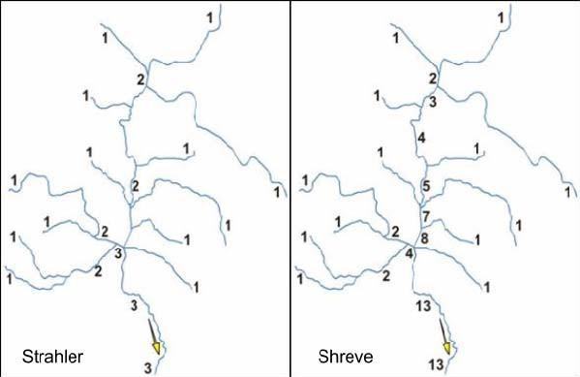
Figure 7: Examples of stream ordering available as data attributes in the Enhanced Watercourse.
- Enhanced Flow Direction
The requirement to digitally delineate accurate watershed boundaries is a routine task necessary in numerous natural science disciplines. The Enhanced Flow Direction grid is a key dataset designed to create these accurate watershed boundaries with minimal effort required by the user. A common eight-direction (D8) flow direction grid is derived solely from a DEM where flow directions are determined by examining grid elevation values surrounding any one cell, and assigning the flow direction to the steepest down-slope neighbour in one of eight directions as shown in Figure 8 (Jenson and Domingue, 1988). The Enhanced Flow Direction grid includes photogrammetrically mapped, flow directed hydrology, or known hydrology, which the derived watershed boundaries are forced to honour. Its application is meant for medium to large-scale applications and is regarded as a significant improvement over the regular flow direction method.
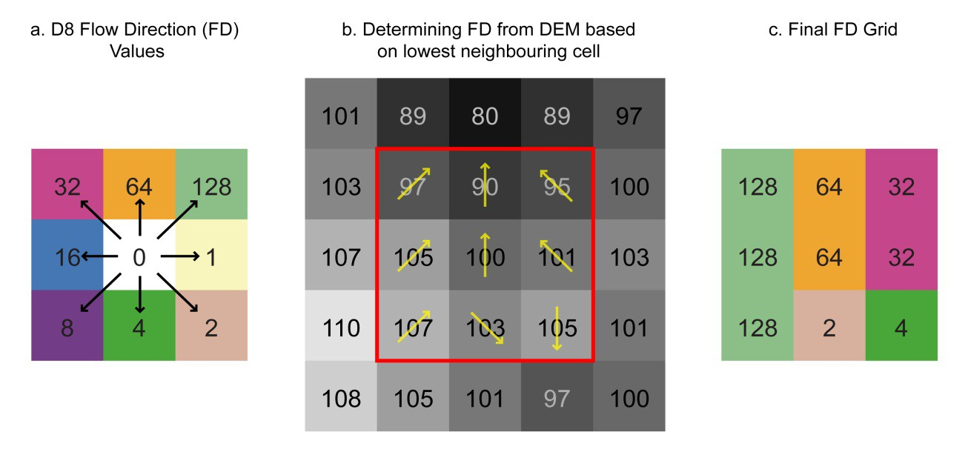
Figure 8: The common D8 flow direction technique.
Creating an Enhanced Flow Direction Grid involves 3 stages as outlined in Kenny and Matthews, 2005: 1) Creating raster flow directed water flow from input vector water course data; 2) Creating raster flow within water bodies oriented towards water course virtual segments and 3) Merging the results from the previous steps to a flow direction grid created from a filled DEM. Because the process initially creates three independent raster layers, each Enhanced Flow Direction component must be computed using a constant origin and resolution. These properties propagate from input DEMs. See Figure 9 for a visual overview of the process.
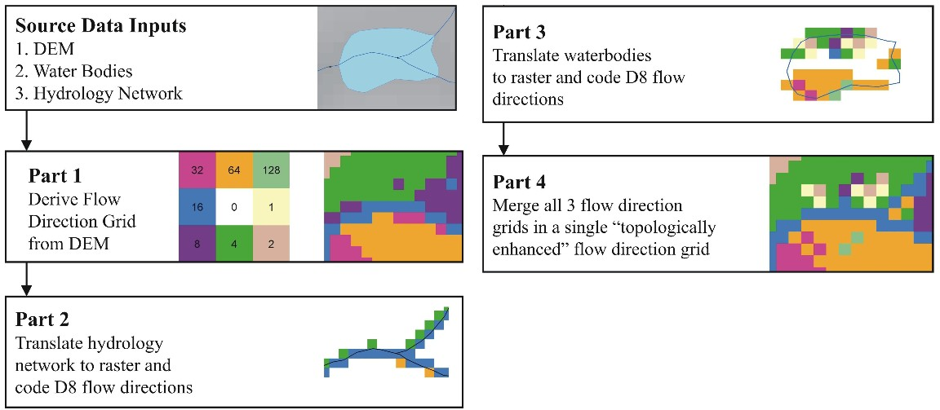
Figure 9: Brief overview of the Enhanced Flow Direction methodology.
These processes have since been adopted by Esri as functions available in the Arc Hydro Toolset. These functions include:
- Create Drainage Line Structures – the outputs are a drainage line, a link grid uniquely identifying each stream segment, and a stream grid with D8 flow directions.
- Adjust Flow Direction in Lakes – the output is a ‘bowled’ flow direction grid where values within lakes are oriented to the nearest virtual segment.
The MNR Terrain Processing Tools leverage these key functions in the Enhanced Flow Direction processing workflow. For more information, refer to the available Arc Hydro documentation or tool help (Djokic, 2008; Esri, 2014).
In QGIS, Whitebox and other software, the D8 model follows different numbering schemes and single / multi-path options requiring the appropriate translation. Some further conversion may be required to convert from unsigned 8-bit raster to a greater bit depth for complete operability. Please consult the appropriate software documentation or help resources to determine the best approach for converting or remapping flow direction values. Note if you generate your own flow directions from the Unconditioned DEM, you will lose the benefits of the Enhanced Flow Direction grid described above.
- Recommended Data Uses and Considerations
  - Recommended Data Uses
    - Watershed Delineation and Analysis using OWIT
For medium scale applications the OIH can be used to delineate watersheds anywhere in Ontario. If a user intends to solely create single watershed boundaries it is recommended that the OWIT web-based application is used (see Section 7.2.1) instead of obtaining a copy of the OIH data package. Watershed data and tools incorporated into OWIT directly reference OIH and do not require advanced knowledge of GIS software and functions. For more information on OWIT refer to the Ontario website (MNR, 2022).
    - Watershed Delineation and Analysis using GIS Software
For more advanced tasks such as batch watershed, sub-watershed or catchment delineation, and stream network analysis, users will need to obtain a copy of an OIH data package. These tasks can be performed using the out-of-the-box hydrology tools available in Esri’s ArcToolbox.
    - ArcToolbox Watershed Function
Esri ArcGIS software includes several built-in hydrology functions that can be used to generate watersheds and perform other hydrologic functions. The Watershed function is available as part of Esri’s Spatial Analyst extension (http://webhelp.esri.com/arcgisdesktop/9.3/index.cfm?TopicName=watershed). The Enhanced Flow Direction grid can be referenced for the flow direction raster. A few options are available for a pour point dataset including selecting portions of the Enhanced Watercourse or manually creating a new point dataset by snapping points to the Enhanced Watercourse.
    - Arc Hydro Tools
Esri’s Arc Hydro toolset plug-in is a geospatial and temporal data model for water resources which utilizes a set of tools to create and support a comprehensive water resources framework for hydrologic and related geospatial data analysis (Maidment, 2002).
A series of Terrain Pre-processing functions are used to create the main reference datasets in the Arc Hydro data model. A number of these functions produce similar outputs to datasets in OIH. The Enforced DEM, Enhanced Flow Direction, Enhanced Watercourse and Stream Grid, can be plugged directly into the Terrain Pre-processing functions. Note that a raw or Unconditioned DEM, which is the initial dataset used in the Arc Hydro Terrain Pre-Processing tools, is not required as the Enforced DEM eliminates the need for all functions prior to the sink filling function. Use table 2 as a guide to populate the inputs under the Data Management Terrain Processing tool settings.

Table 2. Ontario Integrated Hydrology features to be used in place of Arc Hydro feature tags in the Arc Hydro Data Model. Functions listed are part of the Arc Hydro Terrain Pre-processing tools.
Arc Hydro Feature Tag | OIH Feature | Arc Hydro Output From [function] | Arc Hydro Input To [function]
Raw DEM | N/A (stored separately as the PDEM) | *See Note 1 | DEM conditioning
DEM | Enforced DEM | *See Note 2 | Additional DEM conditioning like Fill Sinks
Hydro DEM | Enforced DEM | Fill Sinks | Flow Direction
Flow Direction Grid | Enhanced Flow Direction Grid (EFDIR) | *See Note 3 | Flow Accumulation,  Stream Segmentation,  Catchment Grid Delineation,  Drainage Line Processing
Flow Accumulation Grid | Derived from the EFDIR using the Flow Accumulation command | Flow Accumulation | Drainage Point Processing
Stream Grid | Stream Grid | Stream Definition | Stream Segmentation
Stream Link Grid | Derived from Stream Grid and EFDIR | Stream Segmentation | Drainage Line Processing
Catchment Grid | Derived from Stream Grid and EFDIR | Catchment Grid Delineation | Catchment Polygon Processing
Catchment | Derived from Stream Grid and EFDIR | Catchment Polygon Processing | Adjoint Catchment Processing
Drainage Line | Derived from Stream Grid and EFDIR | Drainage Line Processing | Adjoint Catchment Processing
Note 1. Not required. OIH Enforced DEM can be used as conditioned DEM once it has been sink filled.
Note 2. To meet the requirements of a Hydro DEM, the Enforced DEM needs to be sink filled. See Esri on-line help documentation for more information on sink filling.
Note 3. Unless there is additional information like stream culverts, barriers or some other features to be incorporated into the DEM, the Arc Hydro DEM Conditioning and Flow Direction functions are not necessary to run when using the Enhanced Flow Direction Grid.

    - Watercourse Network Analysis
There are many questions that can be answered by analyzing a watercourse network. Identifying flow paths, outlets, and total steam length are examples that can be achieved using network tools. For more information on network analysis consult the Esri online help documentation.
  - Considerations
    - OWIT Overview
The Ontario Watershed Information Tool (OWIT) (MNR, 2022) is a web-based mapping application with custom watershed delineation and characterization capabilities. The OWIT underlying data is based on the OIH. Anyone with a web-browser and access to the internet can use OWIT without the need to access GIS software or data. Users can delineate a watershed for anywhere in Ontario. They can calculate several watershed characteristics for the watershed such as total area, maximum elevation, and length of main channel. All results produced by OWIT can be downloaded allowing users to conduct further analysis or present results. Anyone needing to perform these tasks should consider using OWIT before accessing an OIH data package.
    - Raster Merging and Mosaicking
When two or more hydrology-based raster datasets need to be assembled to cover a specific study area a raster mosaic function must be used. There should be no overlap between OIH data packages and therefore no blending or interpolation is required when combining raster datasets. It is recommended to use the Mosaic tool with the LAST option when mosaicking raster data between several OIH data packages. Make sure to snap to one of the raster inputs to ensure proper cell alignment.
    - Projecting a Raster Dataset
When a raster dataset is projected, it is transformed using one of three user specified interpolation methods (nearest neighbour, bilinear, cubic convolution). These interpolation methods will change the cell values in a raster and have the potential to disrupt hydrological conditioning. Projecting any of the raster datasets in the OIH data package is not recommended if the data is to be used later for hydrologic analysis. Instead, conduct your analysis first and then project the results as a final step.
    - Raster Resampling
In some instances, it may be desirable to change the cell resolution of a raster. Like projecting a raster, the resample function uses one of three user specified interpolation methods (nearest neighbour, bilinear, cubic convolution). These interpolation methods will change the cell values in a raster and have the potential to disrupt hydrological conditioning. If a raster is being used for hydrologic analysis resampling is not recommended.
    - DEM Sink Filling
The Filled DEM used to create OIH products was essentially an unconditionally filled DEM, meaning all sinks in the DEM surface have been filled. This allows for complete drainage of the DEM surface. In conditional filing known sinks are preserved with the use of a sink dataset. Conditions can be applied for selective filling where only sinks that meet certain criteria will be filled. This functionality can be useful when a DEM is being conditioned in an area where there are known sinks that need to be preserved. Because of the regional scale of the PDEM, the complexity of the landscape especially in northern Ontario, and the lack of referencing for valid sinks, no sinks were preserved in the Filled DEM. For more information on sink filling consult the Esri online help documentation.
- Definitions
Contours
A contour is a linear vector feature representing isolines, or lines of equal elevation, in metres above sea level.
Digital Elevation Model
A generic term for digital topographic and/or bathymetric data in all its various forms. Unless specifically referenced as a Digital Surface Model (DSM), the generic DEM normally implies x/y coordinates and z-values of the bare-earth terrain, void of vegetation and manmade features.
Digital Terrain Model
A composite dataset comprised of 3D mass points and 3D breaklines that are constructed with interlayer dependency and consistency (both 2D and 3D) which captures sufficient detail to model the earth (ground) surface at a defined accuracy level. Data density may vary to support the changes in terrain in order to meet a defined accuracy level.
Digital Surface Model
Similar to DEMs or DTMs, with the exception of depicting surface elevations for the top of buildings, trees, towers, and other features elevated above the bare earth.
Hydrologic Enforcement
Hydrologic enforcement is the process of conditioning a DEM to allow each cell to drain in a downward direction with barriers to flow being removed, where possible. The two main functions of hydrologic enforcement include clearing spurious sinks and ensuring that cells along streams decrease with elevation in a downstream direction.

Interpolation
The process of deriving elevations for a location on the Earth’s surface based on points where elevations have been measured. Many interpolation algorithms exist including spline, inverse distance weighting, and kriging.
Sinks
A cell or series of cells in a DEM that is lower than all neighbouring cells, resulting in cells that cannot flow to the edge of the raster dataset. Sinks are the result of either natural topography or interpolation artefacts.
- References
  - General References
Djokic, 2008. Comprehensive Terrain Preprocessing Using Arc Hydro Tools, 61p. (http://www.arcgis.com/home/item.html?id=41c96fadd2bf49ff8851002042c0495f)
Environmental Science Research Institute (Esri). 2012. Hydro Resource Center, (http://resources.arcgis.com/en/communities/hydro/).
Esri, 2014. Arc Hydro Overview Document #1: Arc Hydro Tools Overview. Esri Water Resources Team. AHOV1 1.10.1.2.
(http://downloads.esri.com/archydro/archydro/Doc/)
Hutchinson, M.F., 1989. A new procedure for gridding elevation and stream line data with automatic removal of pits. Journal of Hydrology 106: 211-232.
Jenson, S.K., Domingue, J.O., 1988. Extracting topographic structure from digital elevation data for geographic information system analysis. Photogrammetric Engineering and Remote Sensing 54 (11), 1593–1600.
Kenny, F. and Matthews, B. 2005. A methodology for aligning raster flow direction data with photogrammetrically mapped hydrology, Computers and Geoscience 31 (6), 768-779.
Maidment, D.R. 2002. Arc Hydro: GIS for Water Resources, Redlands, USA: Esri Press Inc., 208p.
  - Guideline References
Ministry of Natural Resources and Forestry (MNR), 2020a. Data Capture Specifications for Hydrographic Features – Medium Scale, Geospatial Ontario, Digital, Data, Information and Business Services Branch, Corporate Management and Information Division.
(http://www.google.ca/search?q="Data Capture Specifications for Hydrographic Features: Medium Scale")
  - Metadata References
MNR, 2020b. Ontario Hydro Network – Waterbody Data Class, Metadata record, Geospatial Ontario, Digital, Data, Information and Business Services Branch, Corporate Management and Information Division. (https://geohub.lio.gov.on.ca/search?q=OHNWB_en)
MNR, 2020c. Ontario Hydro Network – Watercourse Data Class, Metadata record, Geospatial Ontario, Digital, Data, Information and Business Services Branch, Corporate Management and Information Division. (https://geohub.lio.gov.on.ca/search?q=OHNWC_en)
MNR, 2020d. Ontario Radar DSM, Metadata record, Spatial Data Support Unit, Digital, Data, Information and Business Services Branch, Corporate Management and Information Division. (https://geohub.lio.gov.on.ca/search?q=ORDSM_en)
MNR, 2022. Ontario Watershed Information Tool. Geospatial Ontario, Digital, Data, Information and Business Services Branch, Corporate Management and Information Division. (https://www.ontario.ca/page/ontario-watershed-information-tool-owit)
MNR, 2026. Provincial Digital Elevation Model. Geospatial Ontario, Digital, Data, Information and Business Services Branch, Corporate Management and Information Division. (https://geohub.lio.gov.on.ca/search?q=PDEM_en
Version 2324.1

