User Guide
for
Ontario Railway Network (ORWN)
LIO Data Classes
  - Provincial Mapping Unit
  - Mapping and Information Resources Branch
  - Corporate Management and Information Division
  - Ministry of Natural Resources and Forestry
2020-03-06

Disclaimer
This technical documentation has been prepared by Her Majesty the Queen in right of Ontario as represented by the Ministry of Natural Resources and Forestry (the “Ministry”). No warranties or representations, express or implied, statutory or otherwise shall apply or are being made by the Ministry with respect to the documentation, its accuracy or its completeness. In no event will the Ministry be liable or responsible for any lost profits, loss of revenue or earnings, claims by third parties or for any economic, indirect, special, incidental, consequential or exemplary damage resulting from any errors, inaccuracies or omissions in this documentation; and in no event will the Ministry’s liability for any such errors, inaccuracies or omissions on any particular claim, proceeding or action, exceed the actual consideration paid by the claimant involved to the Ministry for the materials to which this instructional documentation relates. Save and except for the liability expressly provided for above, the Ministry shall have no obligation, duty or liability whatsoever in contract, tort or otherwise, including any liability or negligence. The limitations, exclusions and disclaimers expressed above shall apply irrespective of the nature of any cause of action, demand or action, including but not limited to breach of contract, negligence, strict liability, tort or any other legal theory, and shall survive any fundamental breach or breaches.
Cette publication spécialisée n’est disponible qu’en anglais.

Additional Information
This document does not comply with all the applicable guidelines for accessible digital documents. For an alternative format please email Provincial Mapping Unit at pmu@ontario.ca.
Unless noted otherwise: All photo and graphic examples are credited to James Gratton, Land and Resources Cluster, Ministry of Natural Resources and Forestry.
Map examples were created from MNRF’s Make a Topographic Map or LIO Mapper using Topographic Cache.
Aerial imagery examples sourced from Northern Ontario Forest Cover 2005-2010 Aerial Photography.
For more information about this document, please contact Provincial Mapping Unit at pmu@ontario.ca.

Executive Summary

Key Words
Railroad, Railway, Trains, Tracks

Abstract
This user guide details the specifications for the Ontario Railway Network (ORWN) Land Information Ontario (LIO) Data Classes.

Table of Contents
Disclaimer 2
Additional Information 3
Executive Summary 4
Key Words 4
Abstract 4
Table of Contents 5
List of Figures 7
List of Tables 7
List of Acronyms 8
1. Introduction 9
2. Objectives 10
3. General Overview of the National Railway Network (NRWN) 11
Diagram Summary of NRWN Business Rules 11
Diagram Notes 11
Note to Ontario Railway Network (ORWN) Users 12
About Railway Subdivisions 13
Track Segmentation Rules 14
Track and Subdivision References by Other ORWN Layer Features 16
ORWN and LIO Common Metadata 18
4. Data Classes: ORWN 21
ORWN Track (ORWNTRK) 21
ORWN Structure Line (ORWNSTLN) 21
ORWN Structure Point (ORWNSTPT) 22
ORWN Crossing (ORWNCROS) 22
ORWN Station (ORWNSTN) 24
ORWN Marker Post (ORWNMKPO) 24
ORWN Junction (ORWNJUNC) 25
5. General Overview of ORWN Models 26
6. Data Description 27
ORWN_TRACK_FT 27
ORWN_STRUCTURE_LINE_FT 34
ORWN_STRUCTURE_POINT_FT 35
ORWN_CROSSING_FT 36
ORWN_STATION_FT 40
ORWN_MARKER_POST_FT 42
ORWN_JUNCTION_FT 42
7. Links to Additional Information 44
APPENDIX A: ORWN Feature Examples 45
ORWN_TRACK_FT 45
TRACKCLASS 45
ORWN_STRUCTURE_LINE_FT 47
STRUCID 47
STRUCTYPE 47
ORWN_CROSSING_FT 48
CROSSINGID 48
LEVELCROSS 49
WARNINGSYS 50
CROSACCES 53
ORWN_JUNCTION_FT 53
TRAJUNCTYP 53

List of Figures
Figure 1: Diagram demonstrating inter-relationship of NRWN/ORWN layer features 10
Figure 2: NRWN Business Rules diagram 11
Figure 3: Extent of the Webbwood Subdivision of the Huron Central Railway in Northern Ontario 13
Figure 4: Example of a Track as defined by National Railway Network GeoGratis standards 14
Figure 5: Example of a Track made up of 4 segments – a segment is created every time there is a difference in one or more Track attribute values between adjacent segments. 15
Figure 6: (Right) Railway level crossing on Huron St., Sault Ste. Marie, on the Algoma Central Railway line, Soo Subdivision. (Left) MNRF Make a Topographic Map location reference. 23
Figure 7: (Left) Signal control box showing subdivision mile reference and emergency contact telephone numbers. (Right) Subdivision mile reference written on the back of a crossing sign. 23
Figure 8: Algoma Central Railway passenger station in Sault Ste. Marie, Ontario. 24
Figure 9: Marker post found along the Huron Central Railway in Algoma Mills, Ontario 24

List of Tables
Table 1: ORWN data class default values 12
Table 2: Information about a Subdivision in NRWN 13

List of Acronyms
LIO: Land Information Ontario
LIOW: Land Information Ontario (data) Warehouse
LUT: Lookup Table
MNRF: Ontario Ministry of Natural Resources and Forestry
NRWN: National Railway Network
OGF: Ontario Geospatial Feature
ORWN: Ontario Railway Network (derivative of NRWN)
SDI: Spatial Data Infrastructure
WMS: Web Mapping Service
- Introduction
In 2009, the Ontario Ministry of Natural Resources and Forestry (MNRF), along with other Canadian Provincial counterparts were invited to participate in a Natural Resources Canada (NRCAN) initiative to define the National Railway Network (NRWN) to be stored and maintained in GeoGratis. The project’s goal was to define a national standard for railway network spatial and attribute information.
The NRWN project involved extensive consultation with information owners of railway geospatial datasets from both Private and Public sectors. At the same time, the MNRF’s Spatial Data Infrastructure (SDI) program re-examined the business needs for their own LIO railway-themed information. As crucial internal business requirements were reflected in the proposed NRWN data standards, SDI launched a project to adapt these into LIO Warehouse Database versions of the NRWN geospatial layers.
As a result of this exercise, seven Ontario Railway Network (ORWN) LIO data classes were implemented to reflect active railway information:
- ORWN Track (line segment)
- ORWN Structure Line (line segment)
- ORWN Structure Point (point feature)
- ORWN Crossing (point feature)
- ORWN Station (point feature)
- ORWN Marker Post (point feature)
- ORWN Junction (point feature)
It should be noted that NRWN is not comprehensive and it is expected that as NRWN geospatial layers are revised by NRCAN, the ORWN will be updated shortly thereafter.
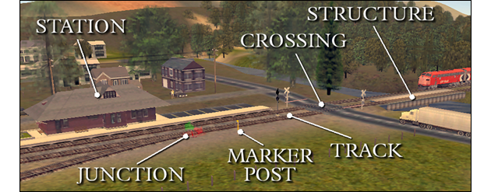
Figure 1: Diagram demonstrating inter-relationship of NRWN/ORWN layer features
- Objectives
This user guide is intended for the users of the ORWN collection of data classes. The remainder of this document describes the extent and context of the information collected for these data classes.
Additional information about GeoGratis datasets can be found on the Natural Resources Canada GeoGratis website.
Note: The examples in this guide are provided for context only and may not reflect the actual information collected for the features. Any errors belong to the authors.

- General Overview of the National Railway Network (NRWN)

Diagram Summary of NRWN Business Rules
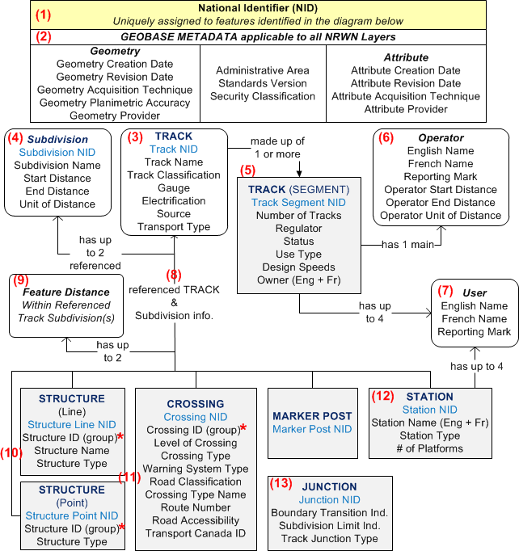
Figure 2: NRWN Business Rules diagram

Diagram Notes
- A unique National Identifier (NID) is assigned to every Track, Track Segment, Subdivision, Crossing, Marker Post, Structure (Line and Point), Station and Junction layer feature.
- Common metadata about the feature is captured for all NRWN layers mentioned in (1).
- TRACK is the basic highest level starting point of the NRWN.
- Each TRACK feature has up to two Subdivision references
- A TRACK is made up of 1 or more Track Segments that share the same characteristics.
- Each Track Segment has 1 Owner and 1 main Operator.
- Each Track Segment may have up to 4 Users.
- NRWN Crossing, Marker Post, Structure (Line + Point) and Station layers reference a TRACK (and Subdivisions) that the feature is associated with. These attribute values are associated via the Track NID.
- Each feature also has a documented distance within a referenced Track Subdivision that it is located within with. A distance can be documented for both referenced Subdivisions.
- Railway Structures are represented as either a linear (line) or point feature.
- Structure and Crossing features from the same layer can form an amalgamated (grouped) feature that is assigned a unique National Identifier (NID - identified with an asterisk in the diagram).
- A Station can have up to 4 companies (users) working out of the facility.
- To simplify maintenance, NRCAN has deliberately omitted Junction-to-Track associations for Junctions in GeoGratis as their locations are mostly derived.

Note to Ontario Railway Network (ORWN) Users
At this time, Natural Resources Canada GeoGratis does not have plans to create a normalized geodatabase for their implemented NRWN dataset. NRWN will, in the interim be maintained as denormalized (flattened attributes) layers by GeoGratis staff. As a consequence, the Ontario Railway Network (ORWN) version of the NRWN model has been implemented in the LIO database in the same denormalized fashion. NRWN physical table column names were also retained in the ORWN model. This simple design will facilitate ORWN Data Class updates derived from NRWN data exports. If and when work proceeds to normalize the NRWN database, the ORWN version of the model will be updated.
ORWN layers will be loaded into the Land Information Ontario (LIO) Warehouse with pre-populated data derived from denormalized GeoGratis NRWN data layer exports.
With the exception of date fields associated with data revisions, all fields in the NRWN/ORWN dataset are assigned values, even when there is no attribute information available about the feature. The default values are listed in Table 1.
Table 1: ORWN data class default values
Value | Description
-1 | This value is common in numeric fields where information is not available or applicable for the feature. “-1” is used in these instances as “0” (zero) can be a legitimate value e.g. Subdivision Start Distance.
None | Found mostly in free-text fields (e.g. English names) where information is not available or is not applicable. A value of “Aucun” (None) will be present in French name versions.

The NRWN geodatabase stores numeric code lookup values instead of text for all permissible values. To make the dataset more user-friendly, the ORWN version differs by storing the full text value description instead of the numeric code.
Before we review ORWN layers in detail, the following section provides readers with a primer about other associated information which will be referred to in the ORWN data.

About Railway Subdivisions
A Subdivision is an administrative unit of a national or regional network of tracks used to transport freight and/or passengers. A Subdivision is identified by a name or number, and/or a colour and is delimited by a Junction point at each extremity.
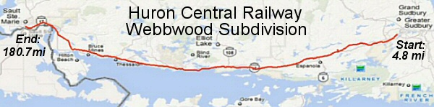
Figure 3: Extent of the Webbwood Subdivision of the Huron Central Railway in Northern Ontario
Several railway Subdivisions are often interconnected to form a greater administrative Railway Division. In railway practice, the Subdivision Start Distance always begins at 0.00 (Mile or Kilometre).
Table 2: Information about a Subdivision in NRWN
Attribute Name | Description | Example (using diagram above)
Subdivision NID | Unique National Identifier (NID) assigned to every Subdivision in GeoGratis. | 1867ddb0dc2b17df937b1204350c4a66
Subdivision Name | Name, number or colour associated to the Subdivision. | Webbwood
Subdivision Start Distance | Location where the Subdivision starts (expressed as a distance). | 4.8
Subdivision End Distance | Location where the Subdivision ends (expressed as a distance). | 180.7
Subdivision Unit Of Distance | Unit of distance for the Subdivision Start and End points expressed as either Mile or Kilometre. | Mile (Many Canadian railway companies still use miles to identify Subdivision distances)

In ORWN, Subdivision Start and End Distance points are represented in the Junction layer where the field value for Subdivision Limit Indicator = “Yes”. Where a Subdivision limit is not defined by a switch, diamond or end junction, a virtual Junction feature is created at the Subdivision’s transition point with a Junction Type of “Administrative”.
Subdivisions often have Marker Posts affixed to the side of the rail at regular intervals whose markings generally increase in value as the line progresses westward or northward. For additional information, refer to the Marker Post section of this document.
Subdivision associations will be primarily made through the ORWN Track layer, where each feature must be associated to one (1) and in rare cases two (2) Subdivisions. Likewise, each Subdivision is associated to one or more track segments.

Track Segmentation Rules
How track and track segment features are defined by NRWN/ORWN.
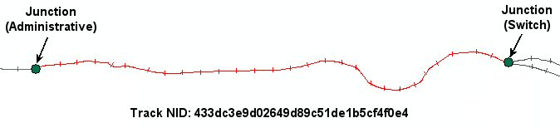
Figure 4: Example of a Track as defined by National Railway Network GeoGratis standards
A “Track” is defined by the presence of a Junction at both ends as illustrated in the diagram above. Each Track is assigned a unique National Identifier (NID). This value is stored in the Track NID field.
A “Track” is made up of one or more track segments, with a new feature created whenever there is a change in one or more of the track attributes e.g. a different Track Operator, Status, Design Speeds etc.
Rules:
- A separate feature is created for each track segment in the ORWN Track layer.
- Each track segment is assigned a unique NID and this value is stored in the Track Segment NID field.
- A grouping of unique segments defined for a “Track” can all share the same Track NID, as demonstrated in the diagram below.
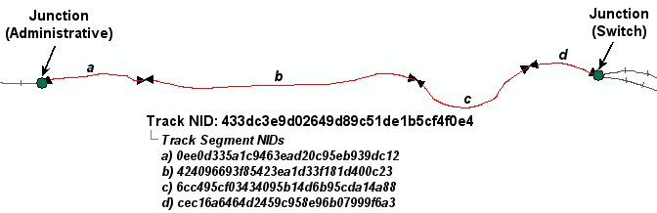
Figure 5: Example of a Track made up of 4 segments – a segment is created every time there is a difference in one or more Track attribute values between adjacent segments.

Track and Subdivision References by Other ORWN Layer Features
ORWN layer features (Marker Post, Structure Line, Structure Point, Crossing, and Station) reference the parent Track and Subdivision with which they are associated. These associations are made through the Track NID, though no hard interlayer relationships have been implemented in either NRWN or ORWN models.
The following Track and Subdivision information is carried across for all ORWN features (with the exception of ORWN Junctions).
Column Name | Column Type | Mandatory | Short Name | Description
TRACKNID | VARCHAR2(32) | Yes | TRACKNID | National Identifier (NID) assigned to every Track feature in the National Railway Network (NRWN) geodatabase.  Each Track feature is defined by a junction at both ends and is made up of one or more uniquely identified Track segments (See Track Segment ID description).
TRACKNAME | VARCHAR2(100) | Yes | TRACKNAME | Name associated to the track by a national or sub national agency.  Note: A value of "None" will be stored in this field when information is either not applicable or not available.
TRACKCLASS | VARCHAR2(20) | Yes | TRACKCLASS | Functional classification based on the importance of the role that the track performs in the connectivity of the rail network.  Permissible Values: See ORWN Track Data Description
SUBDI1NID | VARCHAR2(32) | Yes | SUBDI1NID | Subdivision reference 1:  National Identifier (NID) assigned to the subdivision.  A subdivision is an administrative unit of a national or regional network of tracks used to transport freight and/or passengers. A Subdivision is identified by a name or a number, and/or a colour and is delimited by a junction point at each extremity.  Note: A value of "None" will be stored in this field when information is either not applicable or not available.
SUBDI1NAME | VARCHAR2(100) | Yes | SUBDI1NAME | Subdivision reference 1:  Name, number or colour associated to the subdivision.  Note: A value of "None" will be stored in this field when information is either not applicable or not available.
SUBD1DIST | NUMBER(5,2) | Yes | SUBD1DIST | Subdivision reference 1:  Distance at which the ORWN feature is positioned along the subdivision. The unit of measurement is identified in the associated Unit of Distance field for the Subdivision.  Note: A value of -1 will be stored in this field if distance information is not available or applicable.
SUB1UNITDI | VARCHAR2(9) | Yes | SUB1UNITDI | Subdivision reference 1:  The unit of distance used by a railway company for associated subdivision distance values expressed as Mile, Kilometre or Unknown.
SUB1DISTY | VARCHAR2(15) | No | SUB1UNITDI | Subdivision reference 1:  A qualifier about the value stored in the Subdivision 1 Distance field. It describes the type of distance associated to a track feature.  Permissible Values:  - Calculated: Distance value was a calculated length from a given point of reference.  - Interpolated: Distance value was interpolated between two distances posted on track events.  - None: No value applies.  - Posted: Distance value is posted at the track event location “in the real world”.  - Unknown: Value used when it is impossible to determine the distance associated to the track event.
SUBDI2NID | VARCHAR2(32) | No | SUBDI2NID | Subdivision reference 2:  See description for SUBDI1NID.
SUBDI2NAME | VARCHAR2(100) | No | SUBDI2NAME | Subdivision reference 2:  See description for SUBDI1NAME
SUBD2DIST | NUMBER(5,2) | No | SUBD2DIST | Subdivision reference 2:  See description for SUBD1DIST
SUB2UNITDI | VARCHAR2(9) | No | SUB2UNITDI | Subdivision reference 2:  See description for SUB1UNITDI
SUB2DISTY | VARCHAR2(15) | No | SUB2UNITDI | Subdivision reference 2:  See description for SUB1DISTY

ORWN and LIO Common Metadata
The following NRWN/ORWN and LIO metadata are common to all ORWN data class features.
Column Name | Column Type | Mandatory | Short Name | Description
ADMINAREA | VARCHAR2(7) | Yes | ADMINAREA | The Administrative Area covered by this dataset. Limited to the extents of the Province of Ontario for the Ontario Railway Network (ORWN) data.
SPECVERS | VARCHAR2(5) | Yes | SPECVERS | Version number of the GeoGratis standards used to create this dataset.
SECURCLASS | VARCHAR2(12) | Yes | SECURCLASS | The security classification of the dataset as determined by Natural Resources Canada for the National Railway Network (NRWN) information.  All data for the NRWN derived Ontario Railway Network (ORWN) are deemed to be "Unclassified".
GEOCREDATE | VARCHAR2(8) | Yes | GEOCREDATE | The character date that the spatial data was created (Format: YYYYMMDD).  Note: If the month or day is not known, the corresponding characters are left blank.
GEOREVDATE | VARCHAR2(8) | No | GEOREVDATE | The character date that the spatial data was revised (Format: YYYYMMDD).  Note: If the month or day is not known, the corresponding characters are left blank.
GEOACQTECH | VARCHAR2(25) | Yes | GEOACQTECH | The type of data source or technique used to populate (create or revise) the geometry (spatial) data.  Permissible Values:  - Aerial Photo: Aerial photography not orthorectified.  - Computed: Geometric information that has been computed (not captured).  - Digital Elevation Model: Data coming from a Digital Elevation Model (DEM).  - Field Completion: Information gathered from people directly in the field.  - GPS: Data collected using a Global Positioning System (GPS) device.  - None: No value applies.  - Orthoimage: Orthorectified satellite imagery.  - Orthophoto: Orthorectified aerial photo.  - Other: Other value than those listed.  - Paper Map: Conventional source of information like a map or plan.  - Raster Data: Data resulting from a scanning process.  - Raw Imagery: Satellite imagery not orthorectified.  - Unknown: Value used when it is impossible to determine the type of data source or technique used to populate the object.  - Vector Data: Digital vector data.
GEOACCURA | NUMBER(3) | Yes | GEOACCURA | The planimetric accuracy of the represented feature expressed in (whole) metres as a circular map accuracy standard (CMAS).  The value in this field represents the accuracy difference between the mapped feature against its real-world location. For example, a value of 10 metres for a mapped feature suggests that a person should be able to find the represented real-world feature within 10 metres of its mapped coordinates.
GEOPROVIDE | VARCHAR2(25) | Yes | GEOPROVIDE | The affiliation of the organization that generated (created or revised) the geometry (spatial) data.  Permissible Values:  - Federal: Federal department or agency.  - Municipal: Municipal department or agency.  - Other: Other value than those listed.  - Private: Private sector organization or agency.  - Provincial/Territorial: Provincial/territorial department or agency.  - Unknown: Value used when it is impossible to determine the feature’s provider.
ATTCREDATE | VARCHAR2(8) | Yes | ATTCREDATE | The character date that the attribute data was created (Format: YYYYMMDD).  Note: If the month or day is not known, the corresponding characters are left blank.
ATTREVDATE | VARCHAR2(8) | No | ATTREVDATE | The character date that the attribute data was revised (Format: YYYYMMDD).  Note: If the month or day is not known, the corresponding characters are left blank.
ATTACQTECH | VARCHAR2(25) | Yes | ATTACQTECH | The type of data source or technique used to populate (create or revise) the attribute data.  Permissible Values: Same as GEOACQTECH
ATTPROVIDE | VARCHAR2(25) | Yes | ATTPROVIDE | The affiliation of the organization that generated (created or revised) the attribute data.  Permissible Values: Same as GEOPROVIDE
EFFECTIVE_DATETIME | DATE | Yes | EFF_DATE | LIO Attribute: Date/time the record was created or last modified in the source database.
SYSTEM_DATETIME | DATE | Yes | SYS_DATE | LIO Attribute: Date/time the record was loaded into or last modified in the LIO database.  DEFAULT: SYSDATE
SHAPE | SDO_GEOMETRY | No | SHAPE | LIO Geometry attribute.

- Data Classes: ORWN

ORWN Track (ORWNTRK)
A Track provides a guide for the movement of trains and other equipment. In general, one linear feature represents the two rails of a track. A track is bounded by two junction points and is segmented at each change in attributes along its course.
Note: A Track
- Has one (1) Owner and one (1) main Operator (e.g. Canadian National)
- Has up to four (0-4) Users (e.g. VIA)
- Belongs to up to two (1-2) associated administrative Subdivisions
ORWN Track segments are represented as linear (line) features in this layer.
ORWN Track is the core building block of the ORWN. Other track-related features such as stations, structures and marker posts are linked to ORWN through the unique TRACKNID.ORWN_TRACK_FT.
In the real world, a track provides a guide for the movement of trains and other equipment. In general, one linear feature represents the two rails of a track. A track is bounded by two junction points and is segmented at each change in attributes along its course.
This layer is part of the Ontario Railway Network (ORWN) suite of Data Classes that have been adapted from Natural Resources Canada GeoGratis National Railway Network (NRWN) standards.

ORWN Structure Line (ORWNSTLN)
A Linear (line) representation of a structure built to support or protect a track.
Note:
- Track Structures are represented as a linear (line) feature in this layer
- Features in this layer should not be duplicated in the ORWN Structure Point layer.

ORWN Structure Point (ORWNSTPT)
Point representation of a structure built to support or protect a track.
Notes and Caveat:
- Track Structures (mostly culverts) are represented as point features in this layer.
- Features in this layer should not be duplicated in the ORWN Structure Line layer.
Caveat:
- At this time, the NRWN-ORWN inventory of culvert types does not include hydrographic (water) crossings. Culvert structure types in this layer only represent trail and tertiary traffic passages beneath railway lines.
The ORWN_STRUCTURE_POINT_FT model structure is identical to that of ORWN_STRUCTURE_LINE_FT except that the point version features do not have assigned English or French names.

ORWN Crossing (ORWNCROS)
The location along the rail network where a track crosses another network. It identifies the location and type of crossing that traverses either on, above or below a track. A crossing includes any structure supporting that part of the track or facilitating the crossing. Crossings are often equipped with public warning signs and audio/visual signalling safeguards to control and protect vehicular and pedestrian traffic.
Crossings are stored and represented in the LIO ORWN Crossing layer as point features.
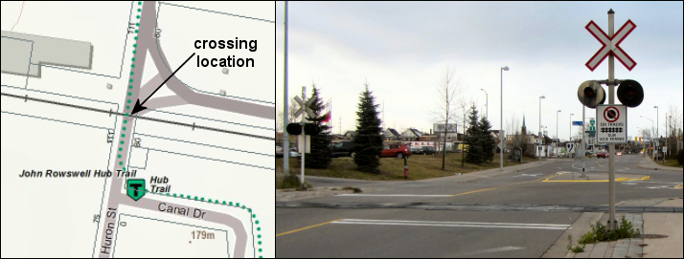
Figure 6: (Right) Railway level crossing on Huron St., Sault Ste. Marie, on the Algoma Central Railway line, Soo Subdivision. (Left) MNRF Make a Topographic Map location reference.
Note: The distance that the Crossing is located along the Subdivision is often written behind the Crossing’s warning sign (see photo: bottom right) and on nearby automated warning signal control boxes (photo: bottom left). Emergency contact telephone numbers are also prominently displayed on signal control boxes – as seen in the photo below.
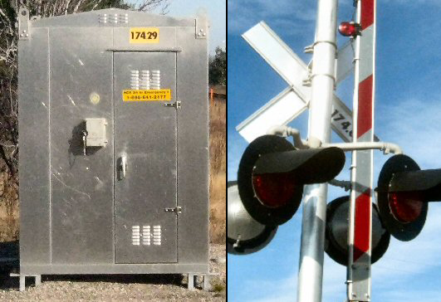
Figure 7: (Left) Signal control box showing subdivision mile reference and emergency contact telephone numbers. (Right) Subdivision mile reference written on the back of a crossing sign.

ORWN Station (ORWNSTN)
Location identified by a station name sign and designated by that name in a time table (schedule listing the time at which certain events, such as arrivals and departures at a station are expected to take place).

Figure 8: Algoma Central Railway passenger station in Sault Ste. Marie, Ontario.
Note: A station or stop does not necessarily have to be a building (Refer to the Federal Geographic Data Committee’s Geographic Information Framework Data Content Standard Part 7b: Transportation – Rail for further information). Stations are represented in the ORWN Station layer as point features.

ORWN Marker Post (ORWNMKPO)
Sign indicating the distance along the network. For example, signs are often posted at intervals along a railway Subdivision indicating the distance from its point of origin in miles or kilometres. Marker posts are represented as point features in this layer.
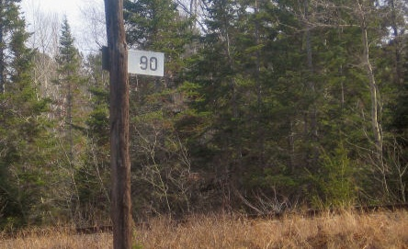
Figure 9: Marker post found along the Huron Central Railway in Algoma Mills, Ontario
Railway marker posts can be found affixed to poles or stakes beside a track line. They are used by railway company staff as reference points for time-table progress, track maintenance work orders and for reporting rail conditions and incidents. Marker posts are often used by railway crews and the MNRF to report and/or respond to the location of trackside fires.
For example, the marker post shown in Figure 27 is located at Mile 90 of the Webbwood Subdivision on the Huron Central Railway. Railway companies typically denote distances along Subdivisions with values increasing from east to west or south to north.
Caveat: At this time, the NRWN-ORWN inventory of marker posts only includes data for lines operated by Canadian National Railways.

ORWN Junction (ORWNJUNC)
Virtual connector point feature of the National Railway Network (NRWN). A Junction may be located:
- at the intersection of three or more sets of tracks;
- at the track end;
- at the transition of a national, provincial, or territorial boundary;
- at the beginning and end of a Track Subdivision
Junctions are stored and represented in the LIO ORWN Junction layer as point features.
Note: NRWN did not make Track/Subdivision references because junction location features are mostly derived and are sometimes virtual (not visible on the ground).
- General Overview of ORWN Models
Model Name: Ontario Railway Network (ORWN). Adapted from the GEOBASE National Railway Line Network (NRWN) standards.
Model Revision Date: 2013-JUN-19
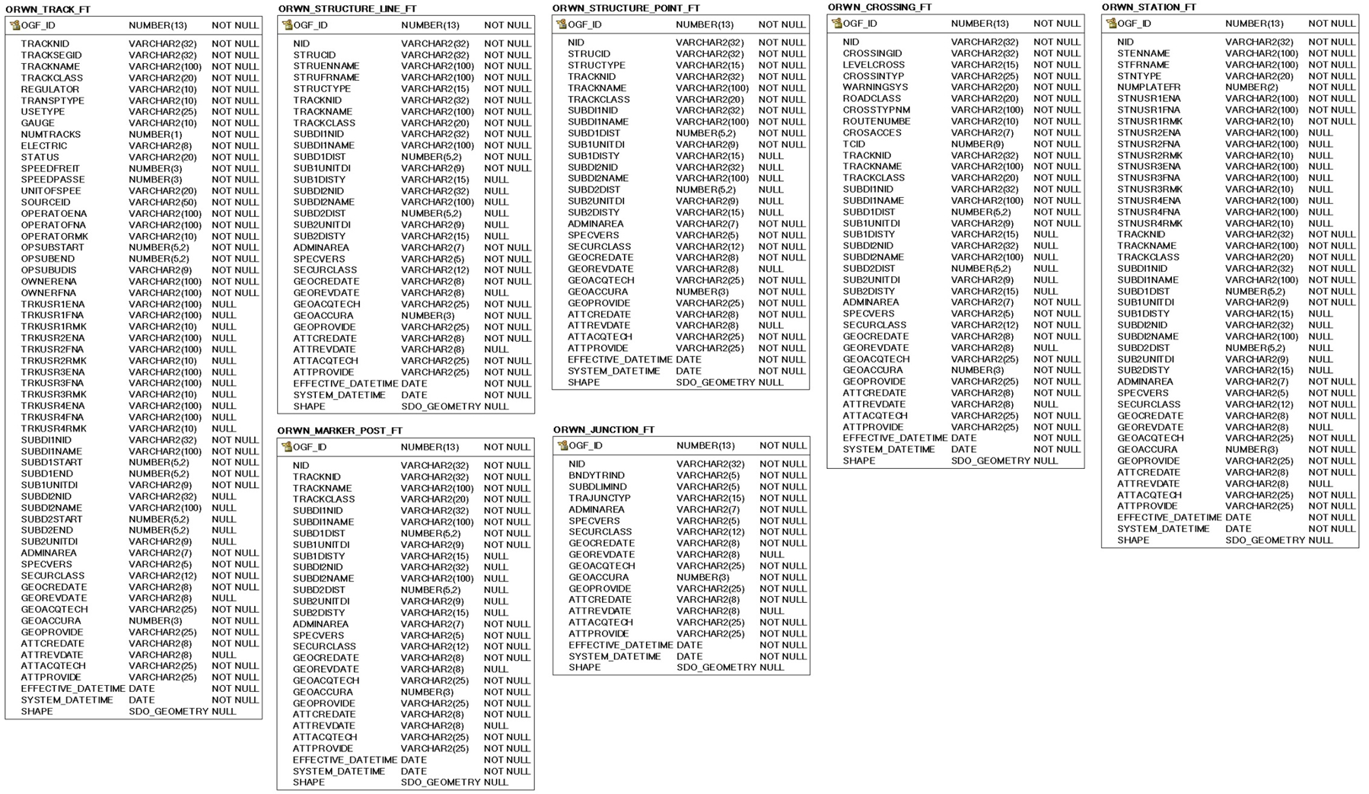

- Data Description
This section describes the extent of data collected for ORWN data classes.

ORWN_TRACK_FT
In the real world, a track provides a guide for the movement of trains and other equipment. In general, one linear feature represents the two rails of a track. A track is bounded by two junction points and is segmented at each change in attributes along its course.
This layer is part of the Ontario Railway Network (ORWN) suite of Data Classes that have been adapted from Natural Resources Canada GeoGratis National Railway Network (NRWN) standards.
Column Name | Column Type | Mandatory | Short Name | Description
OGF_ID | NUMBER(13) | Yes | OGF_ID | Ontario Geographic Feature (OGF) Id. System-generated object identifier, unique at the application level.
TRACKNID | VARCHAR2(32) | Yes | TRACKNID | National Identifier (NID) assigned to every Track feature in the National Railway Network (NRWN) geodatabase.  Each Track feature is defined by a junction at both ends and is made up of one or more uniquely identified Track segments (See Track Segment ID description).
TRACKSEGID | VARCHAR2(32) | Yes | TRACKSEGID | A unique National Identifier (NID) assigned to every Track segment with uniform characteristics.  Note: Each Track segment will be assigned a unique identifier, and a group of Track segments may reference the same Track NID (See TRACKNID description).
TRACKNAME | VARCHAR2(100) | Yes | TRACKNAME | Name associated to the track by a national or sub national agency.  Note: A value of "None" will be stored in this field when information is either not applicable or not available.
TRACKCLASS | VARCHAR2(20) | Yes | TRACKCLASS | Functional classification based on the importance of the role that the track performs in the connectivity of the rail network.  Permissible Values:  - Connecting: Track which branches off a Subdivision that establishes a connection to another Subdivision.  - Crossover: Short connecting track between two or more other tracks. Refer to Figure A1 for an example of a Crossover.  - Ferry Route: Average route a ferry boat takes over a waterbody when transporting trains between two fixed locations on the rail network.  - Main: Main track of the network.  - Siding: Track of lower rank that comes off the main track. It is double-ended to rejoin the main track.  - Spur: Track of lower rank that comes off the main track. It is single-ended and does not rejoin the main track. Refer to Figure A2 for an example of a Spur.  - Unknown: Value used when it is impossible to determine the track classification.  - Wye: Track arranged in the form of the letter “Y”. This track formation is often used by trains to reverse the locomotive’s direction. Refer to Figure A3 for an example of a Wye.  - Yard: Complex series of railway tracks for storing, sorting, or loading/unloading rolling stock and/or locomotives. Railway yards have many tracks in parallel for keeping rolling stock stored off of the main line, so that they do not obstruct the flow of rail traffic. Refer to Figure A4 for an example of a Yard.
REGULATOR | VARCHAR2(10) | Yes | REGULATOR | Level of authority that issued the certificate of fitness to the Track Operator.  Permissible Values:  - Federal: Federal government.  - Municipal: Municipal government.  - Other: Other value than those listed.  - Provincial: Provincial Government.  - Unknown: Value used when it is impossible to determine the regulator type.
TRANSPTYPE | VARCHAR2(10) | Yes | TRANSPTYPE | The type of railway transport used on the track.  Permissible Values:  - Monorail: Railway transport based on a single rail (track) which acts as its only support and guideway.  - Train: Railway transport usually consisting of two parallel rails (tracks) on which a powered vehicle or locomotive pulls or pushes connected rolling stock along a rail line in order to transport freight or passengers from one destination to another.  - Tramway: Railway transport system used in urban areas, which often runs at street level, sharing road space with motor traffic and pedestrians. Tramways are usually electrically powered (e.g. Toronto Transit Commission Tramway)  - Subway: Railway transport system used in large urban areas which runs on separate track from other transport systems; is usually electrically powered and mostly runs underground.  - Suspended: Railway transport based on a single overhead rail (track), acting as support and guideway, from which a vehicle is suspended beneath to move along the railway.  - Unknown: Value used when it is impossible to determine the transport type.
USETYPE | VARCHAR2(25) | Yes | USETYPE | Identification of what is transported on the track.  Permissible Values:  - Freight: Track is used solely for the transport of freight.  - Freight and Passenger: Track is used for freight and passenger service.  - Freight and Tourist: Track is used for freight and tourist service.  - Passenger: Track is used solely for passenger service.  - Tourist: Track used solely by a tourist operator (e.g. South Simcoe Railway)  - Unknown: Value used when it is impossible to determine the type of track use.
GAUGE | VARCHAR2(10) | Yes | GAUGE | The nominal distance between the two outer rails (gauge) of a railway track.  Permissible Values:  - Other: Other type (value) of gauge not defined or listed.  - Narrow: Rails are 0.967 metres apart.  - Standard: Rails are 1.435 metres apart.  - Unknown: Value used when it is impossible to determine the gauge of the track.
NUMTRACKS | NUMBER(1) | Yes | NUMTRACKS | The number of tracks represented by the track geometry.
ELECTRIC | VARCHAR2(8) | Yes | ELECTRIC | Indication whether the railway is provided with an electric system to power vehicles moving along it.  Permissible Values:  - Absence: Railway is not electrified.  - Presence: Railway is powered by electricity.  - Unknown: Value used when it is impossible to determine the railway is electrified.
STATUS | VARCHAR2(20) | Yes | STATUS | The status of the Track feature.  Permissible Values:  - Discontinued: Track is still present but is no longer in use.  - Operational: Track is operational  - Seasonal: Track is operational for a limited time (season).  - Under Construction: Track system is currently being built.  - Unknown: Value used when it is impossible to determine the track’s status.
SPEEDFREIT | NUMBER(3) | Yes | SPEEDFREIT | Maximum allowable operating speed for freight trains (as measured in the "Unit of Speed" field).  Note: A value of -1 will be stored in this field if the speed information is not available or applicable.
SPEEDPASSE | NUMBER(3) | Yes | SPEEDPASSE | Maximum allowable operating speed for passenger trains (as measured in the "Unit of Speed" field).  Note: A value of -1 will be stored in this field if the speed information is not available or applicable.
UNITOFSPEE | VARCHAR2(20) | Yes | UNITOFSPEE | Units of measure applied to the value stored in the Design Speed fields (Miles Per Hour OR Kilometres Per Hour OR Unknown).  The ORWN User-Guide provides the context of permissible values used in this field.
SOURCEID | VARCHAR2(50) | Yes | SOURCEID | Unique identifier (ID), usually a number, assigned to the track and used internally by a national or sub-national agency.  Note: A value of "None" will be stored in this field when information is either not applicable or not available.
OPERATOENA | VARCHAR2(100) | Yes | OPERATOENA | The English name of the rail company that operates the track.  Note 1: A track operator is a railway company responsible for maintaining the track, signaling system, bridges, tunnels, stations, depots, wharfs, and other infrastructures connected with the track.  Note 2: A value of "None" will be stored in this field when information is either not applicable or not available.
OPERATOFNA | VARCHAR2(100) | Yes | OPERATOFNA | The French name of the rail company that operates the track.  Note: A value of "Aucun" (None) will be stored in this field when information is either not applicable or not available.
OPERATORMK | VARCHAR2(10) | Yes | OPERATORMK | The reporting mark associated to the Operator or Carrier as assigned by a national or sub national agency. The reporting mark usually represents the company acronym. For example, the reporting mark for Canadian National is CN.  Note: A value of "None" will be stored in this field when information is either not applicable or not available.
OPSUBSTART | NUMBER(5,2) | Yes | OPSUBSTART | Location where the operator portion of the Subdivision starts (expressed as a distance). The unit of measure is identified in the Operator Unit of Distance field.
OPSUBEND | NUMBER(5,2) | Yes | OPSUBEND | Location where the operator portion of the Subdivision ends (expressed as a distance). The unit of measure is identified in the Operator Unit of Distance field.
OPSUBUDIS | VARCHAR2(9) | Yes | OPSUBUDIS | Unit of distance used by the operator for their operating start and end distances expressed as Mile, Kilometre or Unknown.
OWNERENA | VARCHAR2(100) | Yes | OWNERENA | The English name of the company that owns railway equipment and/or facilities.
OWNERFNA | VARCHAR2(100) | Yes | OWNERFNA | The French name of the company that owns railway equipment and/or facilities.
TRKUSR1ENA | VARCHAR2(100) | No | TRKUSR1ENA | Track User reference 1:  The English Name of the company that uses railway equipment and/or facilities. A track may have up to four users.  Note: A value of "None" will be stored in this field when information is either not applicable or not available.
TRKUSR1FNA | VARCHAR2(100) | No | TRKUSR1FNA | Track User reference 1:  The French Name of the company that uses railway equipment and/or facilities. A track may have up to four users.  Note: A value of “Aucun” (None) will be stored in this field when information is either not applicable or not available.
TRKUSR1RMK | VARCHAR2(10) | No | TRKUSR1RMK | Track User reference 1:  The reporting mark associated to the User as assigned by a national or sub national agency. The reporting mark usually represents the company acronym. For example, the reporting mark for Canadian National is CN.  Note: A value of "None" will be stored in this field when information is either not applicable or not available.
TRKUSR2ENA | VARCHAR2(100) | No | TRKUSR2ENA | Track User reference 2: See description for TRKUSR1ENA.
TRKUSR2FNA | VARCHAR2(100) | No | TRKUSR2FNA | Track User reference 2: See description for TRKUSR1FNA.
TRKUSR2RMK | VARCHAR2(10) | No | TRKUSR2RMK | Track User reference 2: See description for TRKUSR1RMK.
TRKUSR3ENA | VARCHAR2(100) | No | TRKUSR3ENA | Track User reference 3: See description for TRKUSR1ENA.
TRKUSR3FNA | VARCHAR2(100) | No | TRKUSR3FNA | Track User reference 3: See description for TRKUSR1FNA.
TRKUSR3RMK | VARCHAR2(10) | No | TRKUSR3RMK | Track User reference 3: See description for TRKUSR1RMK.
TRKUSR4ENA | VARCHAR2(100) | No | TRKUSR4ENA | Track User reference 4: See description for TRKUSR1ENA.
TRKUSR4FNA | VARCHAR2(100) | No | TRKUSR4FNA | Track User reference 4: See description for TRKUSR1FNA.
TRKUSR4RMK | VARCHAR2(10) | No | TRKUSR4RMK | Track User reference 4: See description for TRKUSR1RMK.
SUBDI1NID | VARCHAR2(32) | Yes | SUBDI1NID | Subdivision reference 1:  National Identifier (NID) assigned to the subdivision.  A subdivision is an administrative unit of a national or regional network of tracks used to transport freight and/or passengers. A Subdivision is identified by a name or a number, and/or a colour and is delimited by a junction point at each extremity.  Note: A value of "None" will be stored in this field when information is either not applicable or not available.
SUBDI1NAME | VARCHAR2(100) | Yes | SUBDI1NAME | Subdivision reference 1:  Name, number or colour associated to the subdivision.  Note: A value of "None" will be stored in this field when information is either not applicable or not available.
SUBD1START | NUMBER(5,2) | Yes | SUBD1START | Subdivision reference 1:  Location where the subdivision starts (expressed as a distance).  Note: A value of -1 will be stored in this field if distance information is not available or applicable.
SUBD1END | NUMBER(5,2) | Yes | SUBD1END | Subdivision reference 1:  Location where the subdivision ends (expressed as a distance).  Note: A value of -1 will be stored in this field if distance information is not available or applicable.
SUB1UNITDI | VARCHAR2(9) | Yes | SUB1UNITDI | Subdivision reference 1:  The unit of distance used by a railway company for associated subdivision distance values expressed as Mile, Kilometre or Unknown.
SUBDI2NID | VARCHAR2(32) | No | SUBDI2NID | Subdivision reference 2:  See description for SUBDI1NID.
SUBDI2NAME | VARCHAR2(100) | No | SUBDI2NAME | Subdivision reference 2:  See description for SUBDI1NAME.
SUBD2START | NUMBER(5,2) | No | SUBD2END | Subdivision reference 2:  See description for SUBD1START.
SUBD2END | NUMBER(5,2) | No | SUBD2END | Subdivision reference 2:  See description for SUBD1END.
SUB2UNITDI | VARCHAR2(9) | No | SUB2UNITDI | Subdivision reference 2:  See description for SUB1UNITDI.
For columns shared in all tables refer to NRWN and LIO Common Metadata columns.

ORWN_STRUCTURE_LINE_FT
Linear (line) representation of a structure used to support or protect a track.
Note: Features in this layer should not be duplicated in the ORWN Structure Point layer.
Column Name | Column Type | Mandatory | Short Name | Description
OGF_ID | NUMBER(13) | Yes | OGF_ID | System-generated object identifier, unique at the application level.
NID | VARCHAR2(32) | Yes | NID | National Identifier (NID) assigned to every Structure feature in the National Railway Network (NRWN) geodatabase.
STRUCID | VARCHAR2(32) | Yes | STRUCID | Unique identifier assigned to the structure when it is part of a set of separate adjoining structures grouped to form one common structure. This identifier allows for the reconstitution of a structure feature that is fragmented by junctions. Refer to Figure A5 for an example of a grouped structure.
STRUENNAME | VARCHAR2(100) | Yes | STRUENNAME | The English language version of the railway structure name as assigned by a national or sub national agency.  Notes:  - A value of "None" will be stored in this field when information is either not applicable or not available.  - The point feature version of this data class does not include this attribute.
STRUFRNAME | VARCHAR2(100) | Yes | STRIFRNAME | The French language version of the railway structure name as assigned by a national or sub national agency.  Notes:  - A value of "Aucun" (None) will be stored in this field when information is either not applicable or not available.  - The point feature version of this data class does not include this attribute.
STRUCTYPE | VARCHAR2(15) | Yes | STRUCTYPE | The type of structure used to support or protect the track.  Permissible Values:  - Bridge: Manmade construction that supports track(s) on a raised structure and spans an obstacle such as a depression, water, a road or other tracks. Refer to Figure A6 for an example of a Bridge.  - Bridge Moveable: Manmade construction that supports track(s) on a moveable raised structure and spans an obstacle such as a river, a road or other tracks.  - Culvert: Device used to channel water or as a passage for a trail or road under track(s). Note: Because of their size and orientation beneath tracks, the majority of culverts are represented as point features in the ORWN Structure Point layer.  - Dam: Manmade linear structure built along a waterway or floodway to control the flow of water and supporting track(s). Example: Seguin River Dam in Parry Sound, Ontario.  - Snow Shed: Manmade roofed structure that protects Track(s) from snow or rock slides. Note: There are no snow sheds on any of Ontario’s railway networks.  - Tunnel: Enclosed manmade construction built to get track(s) through or below a natural feature or other obstructions. Refer to Figure A7 for an example of a Tunnel.  - Unknown: Value used when it is impossible to determine the structure type.
For shared track and subdivision information refer to Track and Subdivision Reference columns.
For columns shared in all tables refer to NRWN and LIO Common Metadata columns.

ORWN_STRUCTURE_POINT_FT
Point representation of a structure used to support or protect a track.
The ORWN_STRUCTURE_POINT_FT model structure is identical to that of ORWN_STRUCTURE_LINE_FT except that the point version features do not have assigned English or French names.

ORWN_CROSSING_FT
The location along the rail network where a track crosses another network. It identifies the location and type of crossing that traverses either on, above or below a track. A crossing includes any structure supporting that part of the track or facilitating the crossing. Crossings are often equipped with public warning signs and audio/visual signaling safeguards to control and protect vehicular and pedestrian traffic.
Column Name | Column Type | Mandatory | Short Name | Description
OGF_ID | NUMBER(13) | Yes | OGF_ID | Ontario Geographic Feature (OGF) Id. System-generated object identifier, unique at the application level.
NID | VARCHAR2(32) | Yes | NID | National Identifier (NID) assigned to every Crossing feature in the National Railway Network (NRWN) geodatabase.
CROSSINGID | VARCHAR2(32) | Yes | CROSSINGID | Unique National Identifier (NID) assigned to the crossing when it is part of a set of neighbouring points forming an amalgamated crossing.  Note: A value of "None" will be stored in this field when information is either not applicable or not available.  Refer to Figure A8 for an example of a grouped crossing.
LEVELCROSS | VARCHAR2(15) | Yes | LEVELCROSS | Level of Crossing. Indicates the grade level of the crossing.  Permissible Values:  - At Grade: The Crossing is at the same grade as the Track. Refer to Figure A9 for an example of an At Grade crossing.  - Over: Track passes OVER the infrastructure. Refer to Figure A10 for an example of an Over crossing.  - Under: Track passes UNDER the infrastructure. Refer to Figure A11 for an example of an Under crossing.  - Combination: Track passes UNDER the infrastructure and OVER another one.  - Unknown: Value used when it is impossible to determine the crossing level at the track.
CROSSINTYP | VARCHAR2(25) | Yes | CROSSINTYP | The type of feature that intersects with the crossing.  Permissible Values:  - Electrical Power Line: Live line used to transmit electricity.  - Hydrographic: Hydrographic feature such as a river, stream, lake, wetland etc. Note: this crossing type is mostly represented for bridges (ORWN Structure Line).  - Pipeline: water, sewage, oil, or natural gas pipeline.  - Road: Any public or private way or course available for vehicle or pedestrian use.  - Other: Another type of crossing not listed.  - Track: Grade separated track that crosses another track.  - Trail: Trail for motorized or non-motorized recreational vehicles, or pedestrians.
WARNINGSYS | VARCHAR2(20) | Yes | WARNINGSYS | Type of warning signal installation at the crossing.  Permissible Values:  - Closed Gate: Gate that is closed when crossing is not in use.  - FLB: Flashing Lights and Bell activated by railway equipment/employee. Refer to Figure A12 for an example of a FLB.  - Other: Other type of traffic control device than those listed.  - None: No signage or traffic control device present at the crossing.  - FLBG: Flashing Lights, Bell and Gate Arms activated by railway equipment/employee. Refer to Figure A13 for an example of a FLBG.  - SRCS: Standard Reflectorized Railway Crossing Sign. Refer to Figure A14 for an example of a SRCS.  - STOP: Stop Sign. Refer to Figure A15 for an example of a stop.  - SRCS and STOP: Railway Crossing Sign and Stop Sign. Refer to Figure A16 for an example of a SRCS and Stop.  - Traffic Signal: Highway Traffic Signals activated by railway equipment/employee.  - Walk Don’t Walk: Signals indicating whether it is safe or not safe for pedestrians to use the crossing.  - Unknown: Value used when it is impossible to determine the type of warning installation at the crossing.
ROADCLASS | VARCHAR2(20) | Yes | ROADCLASS | The functional classification of the road feature that crosses the track in relation to the road network it belongs to.  Permissible Values:  - Alleyway/Lane: A high-speed thoroughfare dedicated to provide access to the rear of properties.  - Arterial: A major thoroughfare with medium to large traffic capacity.  - Collector: A minor thoroughfare mainly used to access properties and to feed traffic with right of way.  - Expressway/Highway: A high-speed thoroughfare with a combination of controlled access intersections at any grade.  - Farm: A stretch of road that is located in a farm field.  - Freeway: An unimpeded, high-speed controlled access thoroughfare for through traffic with typically no at-grade intersections, usually with no property access or direct access, and which is accessed by a ramp. Pedestrians are prohibited.  - Local/Strata: A low-speed thoroughfare dedicated to provide access to properties with potential public restriction such as: trailer parks, First Nations, strata, private estates, seasonal residences.  - Local/Street: A low-speed thoroughfare dedicated to provide full access to the front of properties.  - Local/Unknown: A low-speed thoroughfare dedicated to provide access to the front of properties but for which the access regulations are unknown.  - None: No value applies.  - Ramp: A system of interconnecting roadways providing for the controlled movement between two or more roadways.  - Rapid Transit: A thoroughfare restricted to public transit buses.  - Resource/Recreation: A narrow passage whose primary function is to provide access for resource extraction and may also have served in providing public access to the backcountry.  - Service Lane: A stretch of road permitting vehicles to come to a stop along a freeway or highway. Scale, service lane, emergency lane, lookout, and rest area.  - Unknown: Value used when it is impossible to determine the road classification.  - Winter: A road that is only useable during the winter when conditions allow for passage over lakes, rivers, and wetlands.
CROSSTYPNM | VARCHAR2(100) | Yes | CROSSTYPNM | The name of the feature that crosses the track.  Note: A value of "None" will be stored in this field when information is either not applicable or not available.
ROUTENUMBE | VARCHAR2(10) | Yes | ROUTENUMBE | Number assigned to the route crossing the track.  Notes:  - Defined as a character field to accommodate alphanumeric Route Number values such as “17b".  - A value of "None" will be stored in this field when information is either not applicable or not available.
CROSACCES | VARCHAR2(7) | Yes | CROSACCES | The accessibility of the road or trail at the crossing.  Permissible Values:  - Private: Access by road or trail at the crossing is not public. Refer to Figure A17 for an example of Private access.  - Public: Unrestricted access at the crossing by a road or trail that is opened or maintained by a road authority.  - Unknown: Value used when it is impossible to determine the type of accessibility of the road or trail at the crossing.
TCID | NUMBER(9) | Yes | TCID | Unique number assigned to the crossing by Transport Canada.  Note: A value of -1 will be stored in this field if information is not available or applicable.
For shared track and subdivision information refer to Track and Subdivision Reference columns.
For columns shared in all tables refer to NRWN and LIO Common Metadata columns.

ORWN_STATION_FT
Location identified by a Station name sign and designated by that name in a time table (schedule listing the time at which certain events, such as arrivals and departures at a Station, are expected to take place).
Note: A station or stop does not necessarily have to be a building.
Rule: A station serves from one (1) up to four (4) Users (railway carrier companies).
Column Name | Column Type | Mandatory | Short Name | Description
OGF_ID | NUMBER(13) | Yes | OGF_ID | Ontario Geographic Feature (OGF) Id. System-generated object identifier, unique at the application level.
NID | VARCHAR2(32) | Yes | NID | National Identifier (NID) assigned to every Station feature in the National Railway Network (NRWN) geodatabase.
STENNAME | VARCHAR2(100) | Yes | STENNAME | The English language version of the station name as assigned by a national or sub national agency.
STFRNAME | VARCHAR2(100) | Yes | STFRNAME | The French language version of the station name as assigned by a national or sub national agency.
STNTYPE | VARCHAR2(20) | Yes | STNTYPE | Identifies the type of station.  Permissible Values:  - Freight: Scheduled stop along a Subdivision where infrastructure in present for the management of freight cars.  - Intermodal: Station providing a service that allows for the movement of intermodal freight containers to other transportation type networks.  - Maintenance: Stop along the Subdivision where operating business occurs.  - Mixed: Station providing both passenger and freight services.  - Other: Other station type than those listed.  - Passenger Station: Scheduled stop along a Subdivision where passengers may board or disembark.  - Unknown: Value used when it is impossible to determine the station type.
NUMPLATEFR | NUMBER(2) | Yes | NUMPLATEFR | A value indicating the number of platforms available at the station.  Note: A value of -1 will be stored in this field if information is not available or applicable.
STNUSR1ENA | VARCHAR2(100) | Yes | STNUSR1ENA | Station User Reference 1:  The English language version of the company name using the facility.  Note: A value of "None" will be stored in this field when information is either not applicable or not available.
STNUSR1FNA | VARCHAR2(100) | Yes | STNUSR1FNA | Station User Reference 1:  The French language version of the company name using the facility.  Note: A value of "Aucun" (None) will be stored in this field when information is either not applicable or not available.
STNUSR1RMK | VARCHAR2(10) | Yes | STNUSR1RMK | Station User Reference 1:  The reporting mark associated to the User as assigned by a national or sub national agency. The reporting mark usually represents the company acronym. For example, the reporting mark for Canadian National is CN.  Note: A value of "None" will be stored in this field when information is either not applicable or not available.
STNUSR2ENA | VARCHAR2(100) | No | STNUSR2ENA | Track User reference 2:  See description for STNUSR1ENA.
STNUSR2FNA | VARCHAR2(100) | No | STNUSR2FNA | Track User reference 2:  See description for STNUSR1FNA.
STNUSR2RMK | VARCHAR2(10) | No | STNUSR2RMK | Track User reference 2:  See description for STNUSR1RMK.
STNUSR3ENA | VARCHAR2(100) | No | STNUSR3ENA | Track User reference 3:  See description for STNUSR1ENA.
STNUSR3FNA | VARCHAR2(100) | No | STNUSR3FNA | Track User reference 3:  See description for STNUSR1FNA.
STNUSR3RMK | VARCHAR2(10) | No | STNUSR3RMK | Track User reference 3:  See description for STNUSR1RMK.
STNUSR4ENA | VARCHAR2(100) | No | STNUSR4ENA | Track User reference 4:  See description for STNUSR1ENA.
STNUSR4FNA | VARCHAR2(100) | No | STNUSR4FNA | Track User reference 4:  See description for STNUSR1FNA.
STNUSR4RMK | VARCHAR2(10) | No | STNUSR4RMK | Track User reference 4:  See description for STNUSR1RMK.
For shared track and subdivision information refer to Track and Subdivision Reference columns.
For columns shared in all tables refer to NRWN and LIO Common Metadata columns.

ORWN_MARKER_POST_FT
Sign indicating the distance along the network. For example, signs are often posted at intervals along a railway Subdivision indicating the distance from its point of origin in miles or kilometres.
Column Name | Column Type | Mandatory | Short Name | Description
OGF_ID | NUMBER(13) | Yes | OGF_ID | Ontario Geographic Feature (OGF) Id. System-generated object identifier, unique at the application level.
NID | VARCHAR2(32) | Yes | NID | National Identifier (NID) assigned to every Marker Post feature in the National Railway Network (NRWN) geodatabase.
For shared track and subdivision information refer to Track and Subdivision Reference columns. Note: Marker post values (the number written on the sign) are stored in SUBD1DIST and SUBD2DIST columns which are qualified by SUB1UNITDI, SUB1DISTY and SUB2UNITDI, SUB2DISTY columns.
For columns shared in all tables refer to NRWN and LIO Common Metadata columns.

ORWN_JUNCTION_FT
Virtual connector point feature of the National Railway Network (NRWN). A Junction may be located at the intersection of three or more sets of tracks; at the track end; at the transition of a national, provincial, or territorial boundary; and at the beginning and end of a track subdivision.
Column Name | Column Type | Mandatory | Short Name | Description
OGF_ID | NUMBER(13) | Yes | OGF_ID | Ontario Geographic Feature (OGF) Id. System-generated object identifier, unique at the application level.
NID | VARCHAR2(32) | Yes | NID | National Identifier (NID) assigned to every Junction feature in the National Railway Network (NRWN) geodatabase.
BNDYTRIND | VARCHAR2(5) | Yes | BNDYTRIND | Boundary Transition Indicator: A true or false indicator if the junction is a point of transition at a National, Provincial or Territorial border.  Permissible Values:  - True  - False
SUBDLIMIND | VARCHAR2(5) | Yes | SUBDLIMIND | Subdivision Limit Indicator: A true or false indicator if the junction is a point of transition between track subdivisions.  Permissible Values:  - True  - False
TRAJUNCTYP | VARCHAR2(15) | Yes | TRAJUNCTYP | The type of junction connection located at the end, along or at an interconnection between three or more tracks at grade level.  Permissible Values:  - Administrative: Position of an administrative transition. E.g. Subdivision and/or Provincial/Territorial boundary when a physical junction type such as a switch, diamond or end is not present at the point of transition.  - Diamond: Track configuration which allows a train to cross over another track at grade level in order to pursue its path. Refer to Figure A18 for an example of a Diamond junction.  - End: Connection to a single track leading to a dead end (Track terminates). Refer to Figure A19 for an example of an End junction.  - Switch: A device used to route equipment from one set of tracks to another. Refer to Figure A20 for an example of a Switch junction.  - Other: Mechanical installation not listed enabling railway trains to be guided from one track to another.  - Unknown: Value used when it is impossible to determine the type of track junction.
For columns shared in all tables refer to NRWN and LIO Common Metadata columns.

- Links to Additional Information
- Official LIO metadata record for Ontario Railway Network (OWRN) (Web Map)
  - ORWN Track (line segment)
  - ORWN Structure Line (line segment)
  - ORWN Structure Point (point feature)
  - ORWN Crossing (point feature)
  - ORWN Station (point feature)
  - ORWN Junction (point feature)
  - ORWN Marker Post (point feature)

- MNRF Make a Topographic Map application

- Natural Resources Canada, Transport Networks in Canada: National Railway Network (NRWN)

APPENDIX A: ORWN Feature Examples

ORWN_TRACK_FT

TRACKCLASS

Crossover
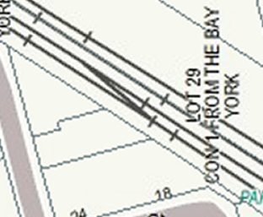
Figure A1: Example of a Crossover in the Greater Toronto Area (near Noble Street).

Spur
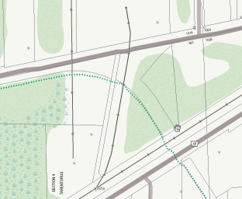
Figure A2: Example of a Spur off the Huron Central Railway on Trunk Road in Sault Ste. Marie, Ontario. This spur is used to offload fuel at a tank farm.

Wye
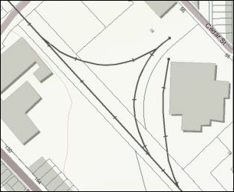
Figure A3: Example of a Wye on the Huron Central Railway in Sault Ste. Marie, Ontario.

Yard
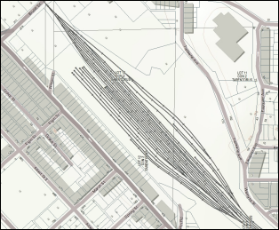
Figure A4: Example of a Yard on the Huron Central Railway in Sault Ste. Marie, Ontario.

ORWN_STRUCTURE_LINE_FT

STRUCID

Structure Line feature set in NRWN/ORWN
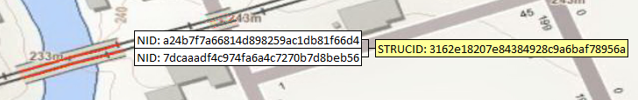
Figure A5: Example of Structure Line feature grouping in NRWN/ORWN
In the example above, the railway bridge is represented as two uniquely numbered features (NID) in ORWN, one on each main track line segment. The bridge is assigned a unique Structure ID that is referenced by both features to indicate that they belong to the same structure.

STRUCTYPE

Bridge
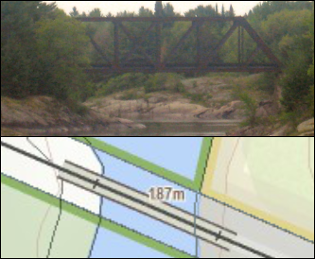
Figure A6: (Top) Railway bridge spanning the Mississagi River west of Blind River, Cobden Twp., Ontario. (Bottom) Same bridge symbolized in the MNRF Make a Topographic Map web application.

Tunnel
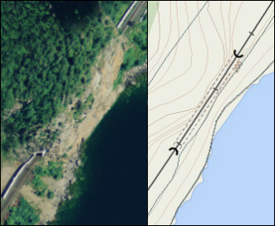
Figure A7: (Left) Aerial view of tunnel near Red Sucker Cove, west of the Red Sucker Point Nature Reserve. (Right) Tunnel symbolized in the MNRF Make a Topographic Map web application.

ORWN_CROSSING_FT

CROSSINGID

Crossing feature set in NRWN/ORWN
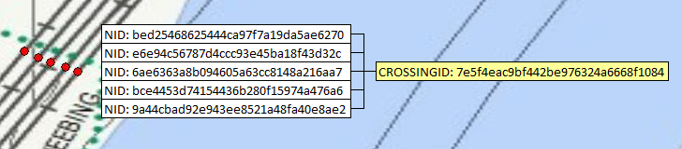
Figure A8: Grouping of five separate crossings for the Parkway Trail passing under the rail lines through a large culvert in Thunder Bay, Ontario.
Crossings are represented on each track segment they intersect with and are uniquely identified. They can be grouped under one crossing identifier (CROSSINGID) to indicate to the user that it is the same crossing.
In the example above, the Parkway Trail in Thunder Bay, Ontario passes beneath five separate rail line segments. The crossing location is replicated for each track segment it crosses in the ORWN Crossing layer, but all five mapped point locations are considered to be the same crossing through the crossing identifier.

LEVELCROSS

At Grade
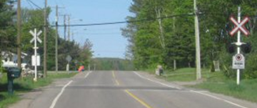
Figure A9: ‘At Grade’ or level crossing at the intersection of 5th Line road and Algoma Central Railway in Sault Ste. Marie, Ontario.

Over
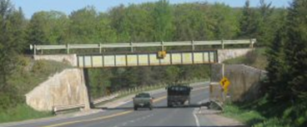
Figure A10: The Algoma Central Railway line crossing over Hwy. 17 north of Sault Ste. Marie, Ontario.

Under
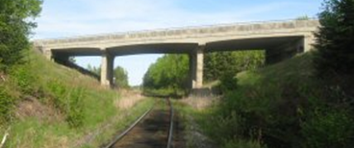
Figure A11: Huron Central Railway crossing UNDER the Hwy. 17 overpass east of Thessalon, Ontario.

WARNINGSYS

FLB
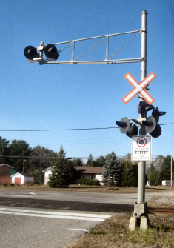
Figure A12: FLB on Frontenac St. and Huron Central Railway crossing, Sault Ste. Marie, Ontario. It is located at mile 174.29 on the Webbwood Subdivision.

FLBG
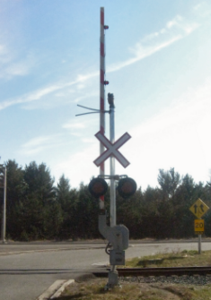
Figure A13: FLBG at the Huron Central Railway and Hwy. 17 bypass crossing in Sault Ste. Marie, Ontario. It is located at mile 174.29 on the Webbwood Subdivision.

SRCS
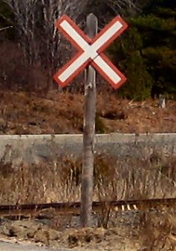
Figure A14: SRCS at a private crossing along the Huron Central Railway and old King’s Highway, Algoma Mills, Ontario.

STOP
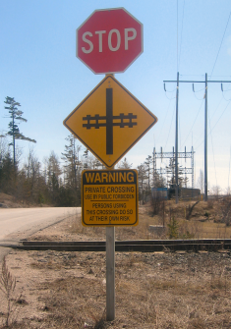
Figure A15: Stop Sign at a private crossing (Lafarge Lime), Huron Central Railway, Algoma Mills, Ontario.

SRCS and STOP
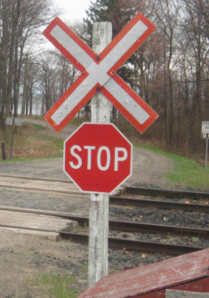
Figure A16: Standard Reflectorized Railway Crossing Sign and Stop Sign, located at mile 101.9 of the Huron Central Railway, Webbwood Subdivision, Blind River, Ontario.

CROSACCES

Private
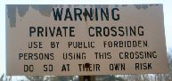
Figure A17: Typical signage erected at a private crossing.

ORWN_JUNCTION_FT

TRAJUNCTYP

Diamond
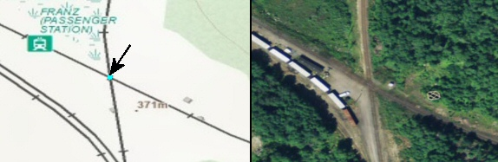
Figure A18: (Right) Example of a 'diamond' junction type in Franz, Ontario, where the north-south Canadian National Railway crosses the east-west Canadian Pacific Railway. (Left) Diamond symbolized in the MNRF Make a Topographic Map web application.

End
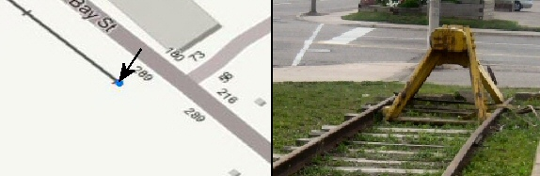
Figure A19: (Right) Example of an end junction type on the Algoma Central Railway in Sault Ste. Marie, Ontario. (Left) End junction symbolized in the MNRF Make a Topographic Map web application.

Switch
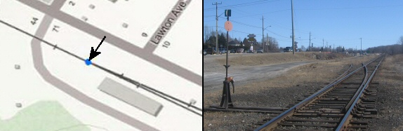
Figure A20: (Right) Example of a switch junction type on the Huron Central Railway in Blind River, Ontario. (Left) Switch symbolized in the MNRF Make a Topographic Map web application.

Version 1920.1

