User Guide for
Ontario Watershed Boundaries (OWB)
Geospatial Ontario Data Classes:
OWB, Main
OWB, Primary
OWB, Secondary
OWB, Tertiary
OWB, Quaternary
  - Geospatial Ontario
  - Digital, Data, Information and Business Services Branch
  - Corporate Management and Information Division
  - Ministry of Natural Resources
2026-03-16

Disclaimer
This technical documentation has been prepared by His Majesty the King in right of Ontario as represented by the Ministry of Natural Resources (the “Ministry”). No warranties or representations, express or implied, statutory or otherwise shall apply or are being made by the Ministry with respect to the documentation, its accuracy or its completeness. In no event will the Ministry be liable or responsible for any lost profits, loss of revenue or earnings, claims by third parties or for any economic, indirect, special, incidental, consequential or exemplary damage resulting from any errors, inaccuracies or omissions in this documentation; and in no event will the Ministry’s liability for any such errors, inaccuracies or omissions on any particular claim, proceeding or action, exceed the actual consideration paid by the claimant involved to the Ministry for the materials to which this instructional documentation relates. Save and except for the liability expressly provided for above, the Ministry shall have no obligation, duty or liability whatsoever in contract, tort or otherwise, including any liability or negligence. The limitations, exclusions and disclaimers expressed above shall apply irrespective of the nature of any cause of action, demand or action, including but not limited to breach of contract, negligence, strict liability, tort or any other legal theory, and shall survive any fundamental breach or breaches.

Additional Information
This document does not comply with all the applicable guidelines for accessible digital documents. For an alternative format please email Geospatial Ontario at geospatial@ontario.ca.
For more information about this document, please contact Geospatial Ontario at geospatial@ontario.ca.

Executive Summary

Key Words
Ontario Integrated Hydrology, Water, Elevation, MNR, Ministry of Natural Resources, Ontario Hydro Network, Provincial DEM, Hydrography, Water Management, Drainage, Catchment, Watershed, Water Analysis

Abstract
This user guide details the specifications for the five Ontario Watershed Boundary (OWB) Data Classes stored in the Geospatial Ontario (GEO) warehouse:
- OWB, Main (OWB)
- OWB, Primary (OWBPRIM)
- OWB, Secondary (OWBSEC)
- OWB, Tertiary (OWBTERT)
- OWB, Quaternary (OWBQUAT)
These data classes replace the four original Watershed Data Classes known as:
- Watershed, Primary (WTRSHPRI)
- Watershed, Secondary (WTRSHSEC)
- Watershed, Tertiary (WTRSHTER)
- Watershed, Quaternary (WTRSHQUA)
And the Packaged Product known as:
- Far North Quaternary Watershed (FNQUA)
The OWB Data Classes follow new internationally adopted watershed principles for Canada and the United States and include watersheds draining into Ontario from neighbouring provinces and states. Several other new enhancements are described herein.

Document History
Date | Edition/  Version | Description
2020-04-06 | 0.1 | Limited draft release
2020-05-08 | 1.0 | Public release
2021-05-19 | 1.1 | Figure and text updates to include the stateside portion of the Great Lakes basin.
2022-08-03 | 1.2 | MNR references updated
2025-01-23 | 2.0 | Template update and French translation
2026-03-16 | 2.1 | Minor text revisions and French translation completed

Table of Contents
Disclaimer 2
Additional Information 2
Executive Summary 3
Key Words 3
Abstract 3
Document History 4
Table of Contents 5
List of Figures 7
List of Tables 8
List of Acronyms 9
1. Introduction 11
2. A Brief History of Quaternary Watersheds in Ontario 13
3. Data Sources 15
4. OWB Data Classes 19
4.1 Ontario Watershed Boundary, Main (OWB) – Parent 20
4.2 Ontario Watershed Boundary, Primary (OWBPRIM) – Derived 24
4.3 Ontario Watershed Boundary, Secondary (OWBSEC) – Derived 26
4.4 Ontario Watershed Boundary, Tertiary (OWBTERT) – Derived 27
4.5 Ontario Watershed Boundary, Quaternary (OWBQUAT) – Derived 29
5. Watershed Name and Code Primer 30
5.1 Watershed Naming Principles 30
5.2 Watershed Coding Considerations 32
5.3 Downstream Watershed Code 36
6. Model Diagram: Ontario Watershed Boundaries 37
7. Data Description 39
ONT_WSHED_BDRY_FT 39
Short Name: OWB 39
ONT_WSHED_BDRY_PRI_DERIVED_FT 42
Short Name: OWBPRIM 42
ONT_WSHED_BDRY_SEC_DERIVED_FT 43
Short Name: OWBSEC 43
ONT_WSHED_BDRY_TERT_DERIVED_FT 44
Short Name: OWBTERT 44
ONT_WSHED_BDRY_QUAT_DERIVED_FT 45
Short Name: OWBQUAT 45
8. Links to Additional Information 46
9. References 47
APPENDIX A: Table Key Dependency and Relationship Index 49
Main Business Area Tables 51

List of Figures
Figure 1: OWB data sources. Ontario including northern areas draining into the province were interpolated using OIH data. The remaining watershed units were derived from the OHN, USGS WBD, NRCan NHN and Quebec DEH data. Inset shows the expanded WBD area added in 2021 to include the entire Great Lakes Basin stateside. 18
Figure 2: OWB Main data class showing all watershed levels combined. Some areas outside of the province like the Rainy River in Minnesota and Ottawa River in Quebec only go down to the tertiary level division. Note the Great Lakes watershed polygon stateside has not been differentiated beyond the primary level division. 20
Figure 3: Two depictions of Ontario’s primary watersheds depicting (A) the natural flow state and (B) the diverted flow state. (A) also shows the primary 2-digit coding for Nelson (05), Southwestern Hudson Bay (04) and Great Lakes – St. Lawrence River (02). Note the stateside portion of the Great Lakes – St. Lawrence River basin outside of the transboundary areas is not shown here, but it is now part of the OWB Primary watershed data class. Please refer to Figure 2 for the full extents. 25
Figure 4: Ontario’s secondary watersheds and their corresponding codes. 26
Figure 5: Ontario’s tertiary watersheds. Note the state side Great Lake units have been excluded because they were not sub-divided at the tertiary level. 27
Figure 6: Tertiary names and codes for the Canadian side of Lake Superior. Portions of the shoreline in between inland tertiary watersheds and the lake now belong to the new lake units. 28
Figure 7: Ontario’s quaternary watersheds. Note these units do not extend into the Great Lakes, Hudson Bay, Quebec and Minnesota beyond the IJC transboundary area of concern. 29
Figure 8: Stylized example of a nested watershed scenario with naming at the 5th level (HUC 12) watershed level for a hypothetical quaternary (HUC 10) watershed. 31
Figure 9: A comparison of watershed coding levels between Ontario, Canada and the United States. 32
Figure 10: This example illustrates the quaternary units making up the Lower Madawaska (02KE) tertiary watershed. The red line is the main river channel which continues upstream into the Upper Madawaska (02KD). The 4 units the main river channel traverses have the lowest numbers because of the area upstream (02KD) draining into them. All units were ordered by the inverse of flow accumulation. 34
Figure 11: Examples of 5th level (blue units) and 6th level (orange-red units) along the Northwest Lake Superior Shoreline (021A) near Thunder Bay. Tertiary codes (black) and quaternary codes (green) are also shown for context. Note the quaternary code for the shoreline ends in ‘00’ meaning no quaternaries are currently defined in this region. 35
Figure 12: Illustrates the upstream quaternaries of the Magnetawan River watershed in orange that drain to the Magnetawan River Outlet highlighted in red. The 6th Level Watershed Codes are in green and the Downstream Watershed Code each unit drains to is shown in red. 36
Figure 13: Primary Key example 49
Figure 14: Foreign Key example 49
Figure 15: Alternate Key example 49
Figure 16: Example of an Identifying Relationship 50
Figure 17: Example of a Non-identifying Relationship 50
Figure 18: Model Diagram Relationship Symbology Table 50

List of Tables
Table 1. OWB Main or Parent Attribute Table. 41
Table 2: OWB Primary Watershed Attribute Table. 42
Table 3: OWB Secondary Watershed Attribute Table. 43
Table 4: OWB Tertiary Watershed Attribute Table. 44
Table 5: OWB Quaternary Watershed Attribute Table. 45

List of Acronyms
CBLUP: Community Based Land Use Planning
DEH: Direction de l’Expertise Hydrique (Gouvernement du Québec)
DEM: Digital Elevation Model
DSM: Digital Surface Model
ECCC: Environment and Climate Change Canada
FDA: Fundamental Drainage Areas
IJC: International Joint Commission
GEO: Geospatial Ontario
MNR: (Ontario) Ministry of Natural Resources and Forestry
NRCan: Natural Resources Canada
OBM: Ontario Basic Mapping
OGF: Ontario Geospatial Feature
OWB: Ontario Watershed Boundary
OWBPRIM: Short Name for Ontario Watershed Boundary, Primary Data Class
OWBSEC: Short Name for Ontario Watershed Boundary, Secondary Data Class
OWBTERT: Short Name for Ontario Watershed Boundary, Tertiary Data Class
OWBQUAT: Short Name for Ontario Watershed Boundary, Quaternary Data Class
PDEM: Provincial Digital Elevation Model
PMU: Provincial Mapping Unit
SDI: Spatial Data Infrastructure
WBD: Watershed Boundary Dataset, USGS
WRIIF: Water Resources Index Inventory Filing System
WSC: Water Survey of Canada, division of Natural Resources Canada
WTRSHPRI: Short Name for Watershed, Primary Data Class
WTRSHSEC: Short Name for Watershed, Secondary Data Class
WTRSHTER: Short Name for Watershed, Tertiary Data Class
WTRSHQUA: Short Name for Watershed, Quaternary Data Class
USGS: United States Geological Survey

- Introduction
A watershed, also known as a catchment basin or catchment area, includes all the land that is drained by a watercourse and its tributaries. Watersheds are used for many types of landscape analysis. They are the fundamental units by which we can understand the water on our landscape, including water quantity (flows, levels, etc.) and quality (contamination, source protection, etc.).
Watershed divisions in Ontario were originally based on the Water Survey of Canada 'Drainage Area' hierarchical reporting framework once known as the Water Resources Index Inventory Filing System (WRIIF).
“The Water Survey of Canada (or, as it was known then, the Department of the Interior, Dominion Water Power Branch) first developed, in 1922, a Water Resources Index Inventory as a convenient and logical system for recording and filing water resources data. It was designed for the storage of such information as the location of waterpower sites, waterpower developments, storage reservoirs, stream measurement stations, and meteorological stations. The Water Survey of Canada delineations involved the division, sub-division and sub-sub-division of Canada into suitably sized areas based on the drainage, for administrative purposes. Although the boundaries are based on drainage, the intent was to include all of Canada's land mass and waters within this drainage area hierarchy to facilitate the identification of hydrometeorological sites. Therefore, the WSC drainage areas do not necessarily define individual river basins but can represent intervening areas along the coast or include islands.” (NRCan, 2003).
In 2002, the MNR Water Resources Information Program (WRIP) published the first version of Ontario Watersheds including Primary, Secondary and Tertiary divisions based on the federal WSC system, plus a new finer Quaternary level for southern and central Ontario which covered the Ontario Basic Mapping (OBM) Program Area of Undertaking (MNR, 2002). These watersheds were initially developed to support regional applications including MNR Forest Management Planning and various water resource initiatives across provincial ministries. A second version was published in 2008 based on refined base data and watershed delineation processes, which remained as the authoritative dataset for Ontario until 2019.
In 2010, MNR entered a multi-year partnership with international, federal and provincial/state partners involved in data harmonization between Canada and the United States. Partner agencies included:
- International Joint Commission (IJC)
- United States Geological Survey (USGS)
- Water Survey of Canada (WSC) / Natural Resources Canada (NRCan)
- Environment and Climate Change Canada (ECCC)
- Agriculture and Agri-Food Canada (AAFC)
- Ontario Ministry of Natural Resources and Forestry (MNR)
- Other provincial and state-side authorities depending on region of focus.
Collaboration with data harmonization partners began with a broad-scale review of all Tertiary-level transboundary watersheds that straddled the International Border and the Great Lakes. The next phase focused on creating finer Quaternary and 5th level watersheds for the Rainy River basin, Pigeon River watershed, St. Lawrence River corridor, and finally the Great Lakes Connecting Channels and shoreline regions. Data harmonization activities concluded in the fall of 2019 with the incorporation of new watershed units into the USGS Watershed Boundary Dataset (WBD). This initiative began with WRIP and continued under the Spatial Data Infrastructure Unit (SDI) and later the Provincial Mapping Unit (PMU).
During this time, the MNR realized the value of extending these new watershed principles to the rest of Ontario. Several significant developments soon followed:
- 2015 – SDI created the Far North Quaternary Watersheds (FNQUA) dataset which leveraged the new Ontario Integrated Hydrology (OIH) data product to complete watershed coverage for all of Ontario at the quaternary level. The FNQUA dataset was created specifically to support Community Based Land Use Planning (CBLUP) and other initiatives in the Far North. It was considered an interim product until updates were reflected in a future version of the “Watershed, Quaternary” (WTRSHQUA) dataset.
- 2017-18 – PMU created a draft version of single-pour point watersheds along the Great Lakes shoreline.
- 2018-19 – PMU commenced a data modeling exercise to create a new version of watersheds for Ontario which resulted in the creation of the new OWB.
- 2019 – PMU evaluated watershed units along the Ottawa River which resulted in brand new straddling Quaternary units between Ontario and Quebec.
The old Ontario Watersheds have been replaced by the new OWB datasets, but these older datasets will be retained for historical purposes.
For more information on the creation of OWB please contact pmu@ontario.ca.
- A Brief History of Quaternary Watersheds in Ontario
The history of quaternary level watersheds in Ontario dates to the late 1960’s. The need for a fourth level watershed was first identified by the Fish and Wildlife Branch of the Department of Lands and Forests in 1965 (MNR, 2011). Preliminary mapping was produced and described in the report entitled “The Canada Land Inventory Sport Fish Capability Survey in Ontario” (Maher, 1969). Quaternary watersheds were spatially nested within the tertiary watersheds defined much earlier by the Water Resources Index Inventory Filing (WRIIF) system (Johnston, 1922). Maher stated:
“When the Canada Land Inventory used this [WRIIF] system for inventory purposes, it was found that even the smaller subdivisions were too large for convenient use on the 1:250,000 maps. The smaller [tertiary] watersheds were therefore subdivided again into smaller units by Canada Land Inventory draftsmen in Ottawa and given number designations…The watersheds with their code numbers were drawn in clear plastic overlays for each map and sent to us as they were produced.” (Maher, 1969)
In 1973, a revised series of small-scale wall maps were created by the Surveys and Mapping Branch of the Ministry of Natural Resources depicting quaternary units at a scale of approximately 1:500000. This mapping was based on the original mapped hard copy boundaries prepared by Maher. Further revisions at larger scales were prepared by the Fisheries Branch with mapping support by the Surveys and Mapping Branch. This work culminated in the release of “The Counts and Measurements of Ontario Lakes” report in 1978. This project also assigned preliminary names to each of the coded quaternary watersheds and a total of 2070 units for Ontario were identified. (Cox, 1978; MNR, 2011)
In an evaluation conducted by the River and Stream Ecology Lab in 2011, it became apparent that the delineation process, although meticulous in its attempt to create accurate watershed boundaries, did not use a standardized set of rules and criteria at the provincial scale. Even though many expert opinions informed the delineation process, a certain degree of latitude was given to the teams tasked with delineation. (MNR, 2011)
Some standardization and further refinements were conducted by the Water Resources Information Program (WRIP) in their digital interpretation of watersheds released in 2002. (WRIP, 2002) These units were initially created to support forest management planning in Ontario, but their value was also realized in several other activities such as fisheries management, aquatic research, water resource monitoring, source water protection, parks planning and far north planning.
Even though WRIP made strides to improve the quaternary watersheds based on current hydrology and elevation mapping sources, the units still varied significantly in size and the location of their outlets appeared arbitrary. The Quaternary Watershed dataset mapped approximately 1058 of the 2070 recorded in the Counts and Measurements project and covered only southern and central Ontario to the northern extent of the Forest Management Area of Undertaking.
Digital quaternary coverage was later completed in 2015 for all of northern Ontario to support community-based land use planning in the far north. This data resided in a separate dataset called the “Far North Quaternary Watersheds” (FNQUA) primarily because it represented a first attempt at adopting standardized watershed principles for areas outside of the transboundary International Watersheds Initiative (IWI) led by the International Joint Commission (IJC, 2009). There was a fair amount of overlap between the FNQUA dataset and the traditional Quaternary Watershed data created much earlier. Discrepancies between datasets were not reconciled until the start of the Ontario Watershed Boundaries project in 2018 led by the Provincial Mapping Unit. The collaborative work under IWI between USGS, ECCC, NRCan and Ontario also found a home in the new OWB datasets, while addressing some long-standing data issues in the Great Lakes and shared borders between Quebec, Manitoba and the United States.
The OWB project was completed in December 2019 which included a total of 2005 new quaternary watershed units for the entire province and two finer level units for select areas described later in this document.
- Data Sources
The watershed boundaries have been created based on the recent Ontario Integrated Hydrology (OIH) data produced in the spring/fall of 2019 for areas within Ontario and northern regions flowing into the province (MNR, 2026a). The generation of the boundaries involved some enhanced interpolation and smoothing techniques to produce a final product that is consistent with the current regional hydrology available for Ontario. Other areas outside Ontario were incorporated using data derived from other sources maintained by various levels of government including:
- Natural Resources Canada (NRCan) – National Hydro Network (NHN) Watershed Work Units (2019) and Fundamental Drainage Area (FDA) Version 6 (2008).
- United States Geological Survey (USGS) – Watershed Boundary Dataset (WBD) (2018-2021).
- Direction de l’Expertise Hydrique (DEH), Gouvernement du Québec – Bassins Hydrographiques Multiéchelles Du Québec, Niveau 2 (2011).
Ontario’s version of watersheds in these areas are considered just snap-shots and are not actively maintained. Please refer to the authoritative datasets managed by the groups above for the most current interpretation.
The horizontal positional accuracy of the boundaries is variable depending on the nature and spatial distribution of the data used in OIH including the Provincial DEM (PDEM) and OHN data sources. Actual accuracy cannot be quantified without on-site investigation and verification but generally it is a function of scale including cell resolution (in the raster realm) and feature density (in the vector realm). Assuming the underlying data properly reflects the true flow behavior of the terrain, southern Ontario up to the southern extent of the French River draining into Georgian Bay would be typically accurate within 100m, and the area from the French River up to approximately the 50th parallel is anticipated to be within 400m.
Watersheds north of the 50th parallel were derived from the NASA Shuttle Radar 1-arc second DSM (which roughly translates to a 30m cell size resolution). Because this is a coarse surface model, true ground was not always represented especially in dense vegetation cover. Also, much of the land in the far north is considered wetland in nature with very little channelized water flow (e.g. according to the OHN, the stream density is typically much less in the north than it is in southern Ontario), which makes discerning proper flow direction a challenge. These limitations will affect the accuracy of the watershed boundaries produced, and therefore the actual watershed divide versus mapped could deviate greater than 1km in some cases. However, these watersheds are still considered a significant improvement over the previous versions of Ontario watersheds which formerly used the very coarse Water Survey of Canada Sub Sub Drainage Areas (WSCSSDA) and Atlas of Canada Fundamental Drainage Areas (FDA) at a scale of 1:1 Million as the primary data sources. For more information on current data sources used to compile OWB, please refer to OIH (MNR, 2026a), PDEM (MNR, 2026b) and OHN (MNR, 2020) documentation.
These watersheds are suitable for regional-wide applications only. In cases of boundary disputes, verify the boundary locations using large scale mapping if available or investigate further using survey-grade expertise and technology.
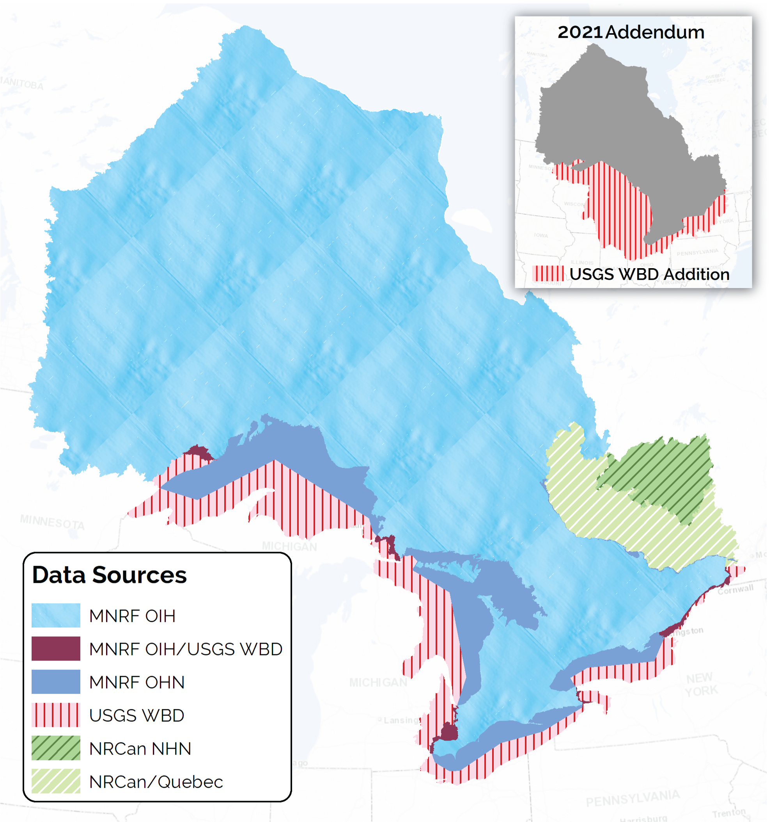
Figure 1: OWB data sources. Ontario including northern areas draining into the province were interpolated using OIH data. The remaining watershed units were derived from the OHN, USGS WBD, NRCan NHN and Quebec DEH data. Inset shows the expanded WBD area added in 2021 to include the entire Great Lakes Basin stateside.
- OWB Data Classes
The OWB data classes are classified as Abstract Spatial Multi-Non-Tessellating-Polygon User Objects, or SPMNTPOLY. In general, this means polygon overlaps are not allowed and at times multi-part polygons are required particularly concerning how multiple shoreline regions and island areas are handled.
There are five OWB data classes including one parent (or main) data class and 4 derived data classes. The parent OWB data class will be maintained in the GEO Editor environment by approved data editors in the Provincial Mapping Unit. Whenever changes are made to the parent data class, these changes will be automatically reflected in the derived data classes. Each derived data class represents a different watershed level ‘view’ of the parent OWB data class and they include primary, secondary, tertiary and quaternary views. The parent OWB data class also includes finer 5th and 6th level watershed divisions in select areas of the province, mainly in transboundary IJC areas, the Great Lakes shoreline regions and a few inland lake shorelines. There are currently no views available for these additional watershed levels because they are non-continuous. Users are encouraged to download the parent OWB data class to view these finer levels properly in the context of surrounding watersheds.

  - Ontario Watershed Boundary, Main (OWB) – Parent
The OWB Main is the parent data class containing all watershed levels in Ontario including drainage areas inflowing from neighbouring provinces or the United States except the Great Lakes Basin stateside outside of IJC transboundary areas (Figure 2).

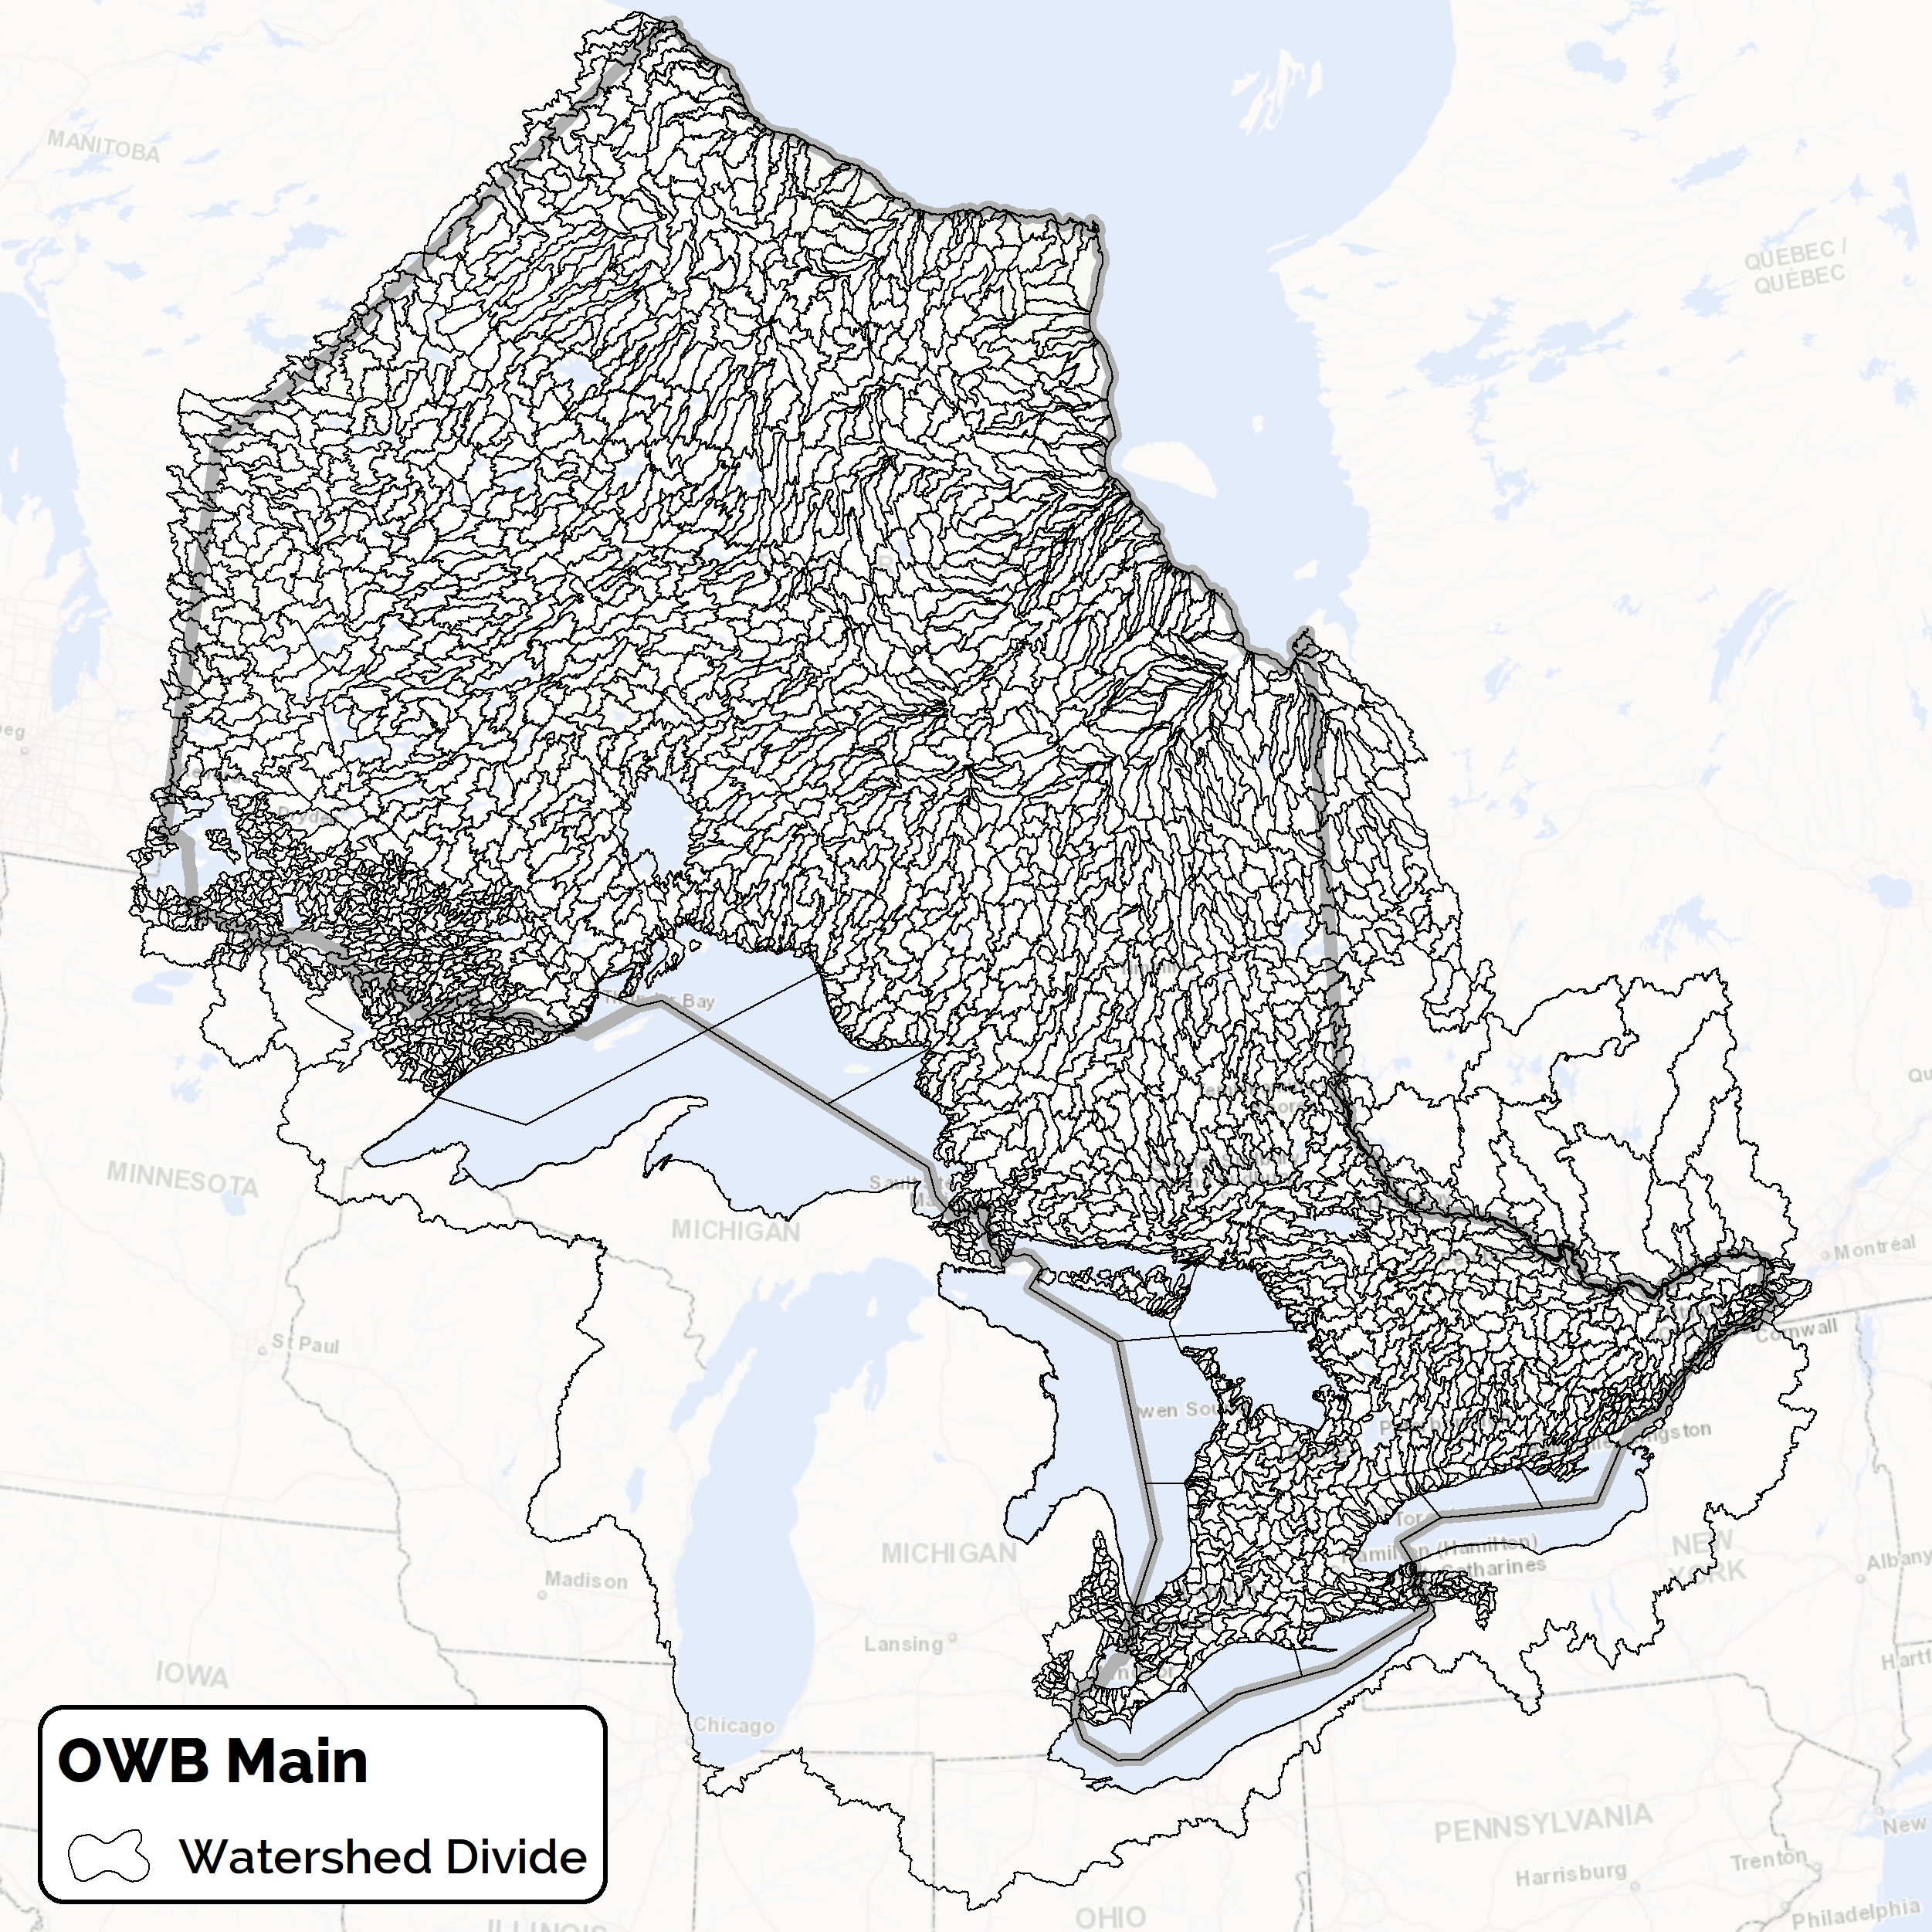
Figure 2: OWB Main data class showing all watershed levels combined. Some areas outside of the province like the Rainy River in Minnesota and Ottawa River in Quebec only go down to the tertiary level division. Note the Great Lakes watershed polygon stateside has not been differentiated beyond the primary level division.

The first three watershed levels are consistent with NRCan’s drainage area framework (NRCan, 2017):
- Primary – like Major River Basins or Major Drainage Areas (MDA) for Canada. There are three primary divisions in Ontario including Great Lakes - St. Lawrence, Southwestern Hudson Bay, and Nelson River.
- Secondary – like Sub-Basins or Sub Drainage Areas (SDA) for Canada. There are 37 secondary subdivisions of primary watersheds draining Ontario. Most secondary divisions are either large river systems or groupings of small coastal streams.
- Tertiary – like Sub-Sub-Basins or Sub-Sub-Drainage Areas (SSDA) for Canada. There are 218 tertiary subdivisions of secondary watersheds that influence Ontario, not including stateside Great Lake units and some stateside rivers flowing into the St. Lawrence River corridor. 201 of these watersheds directly intersect the provincial border and the remaining 17 are upstream watersheds flowing into Ontario including the Ottawa River system in Quebec, Rainy River basin in Minnesota, and Clinton River in Michigan.
The next three levels are unique to Ontario, except for transboundary watershed regions that were peer reviewed and approved by IJC partners. These approved IJC units have been incorporated into the latest USGS Watershed Boundary Dataset (WBD) and will be considered in a future version of NRCan’s Drainage Basins. These finer levels also honour the area threshold guidelines recommended by the United States Hydrologic Unit Code (HUC) system (Seaber et al., 1994):
- Quaternary – like the 10-digit HUC Watershed Level (or HUC 10) for United States. The unit name reference of “Watershed” may refer to hydrologic units that are not actually watersheds but sub-units of a greater watershed, where they can be situated downstream of headwater areas (DCR, 2019). They will typically have one outflow or pour point, whereas the higher levels stated above may contain multiple river systems and outflows. These units have the recommended range of 40000 to 250000 acres. There are 2005 quaternary subdivisions of tertiary watersheds with a maximum of 26 quaternaries per tertiary watershed. Some of these watersheds are outside of Ontario particularly for transboundary U.S. – Canada areas and watersheds flowing in from Quebec in the far north.
- 5th Level – like the 12-digit HUC Subwatershed Level (or HUC 12) for United States. These units have the recommended range of 10000 to 40000 acres, and are currently limited to IJC transboundary areas, Great Lakes shoreline areas and certain other large inland lake shorelines (see section 5 for visual examples with names and codes).
- 6th Level – like the 14-digit HUC Subwatershed Level (or HUC 14) implemented in some state level organizations. These units are typically less than 10000 acres and some states such as Indiana recognize a lower limit of 5 square miles or 3200 acres (USGS, 1991). Others use different area thresholds where 12-digit HUC’s are not used. For example, in South Carolina, HUC 14 units range in size from 3000 to 40000 acres (Bower et al., 1999). There are no plans currently to define levels finer than the 6th level in Ontario, therefore some units at this level may fall below 3000 acres. Examples of 6th level units are currently limited to large inland lakes in Ontario, including some small tributaries draining to the Lake Superior shoreline near the Pigeon River transboundary area (see section 5), and units draining into Lake Nipigon and Lake Nipissing. There is also one unit that is defined as a sink where there is no known outflow. This sink is located at the large pit owned by St. Marys Cement Quarry near Oshawa, Ontario.
Note the term ‘like’ has been used above when comparing the OWB to other watershed systems because they are not necessarily equivalent. These units are only guidelines for watershed level determination. Both the NRCan and USGS systems do not always follow the scientific single-pour point principle for watershed delineation. By contrast, Ontario’s quaternary and finer level watersheds drain to single pour points on the landscape where possible. Exceptions may include diverted flow, like braided channels or deltas and lakes with multiple outflows.

  - Ontario Watershed Boundary, Primary (OWBPRIM) – Derived
The OWB Primary data class is a view derived from the parent OWB data class containing polygons dissolved by ‘Primary Watershed Name’ and ‘Primary Watershed Code’ (Figure 3).
A unique feature of this data class is that it can be portrayed in two different ways. There are 3 significant hydro diversions in Ontario – Lake St. Joseph, Ogoki River and Long Lake – which divert water over primary watershed divides. In their natural flow state (Figure 3A), they would flow north into the Albany River system which drains to Hudson Bay – James Bay. In their diverted flow state (Figure 3B), the Ogoki River and Long Lake watersheds drain south into the Great Lakes – St. Lawrence River primary watershed, and the Lake St. Joseph unit drains into the Nelson River. These diversions are left undissolved in the OWB Primary data class allowing the user to portray both scenarios either by ‘Primary Watershed Name’ which represents the diverted flow state or by ‘Primary Watershed Code’ which represents the natural flow state.
Also note the OWB now includes the Great Lakes and the Ottawa River as part of the watershed system, which is an improvement over the previous version of Ontario’s watersheds. The stateside portion of the Great Lakes and St. Lawrence River outside of IJC transboundary areas has been included in the spring of 2021 at the primary watershed level to indicate the entire drainage extents of the basin to the point where the eastern edge of Ontario meets the north shore of the St. Lawrence River. Finer watershed levels stateside can be obtained directly from the USGS Watershed Boundary Dataset (WBD).
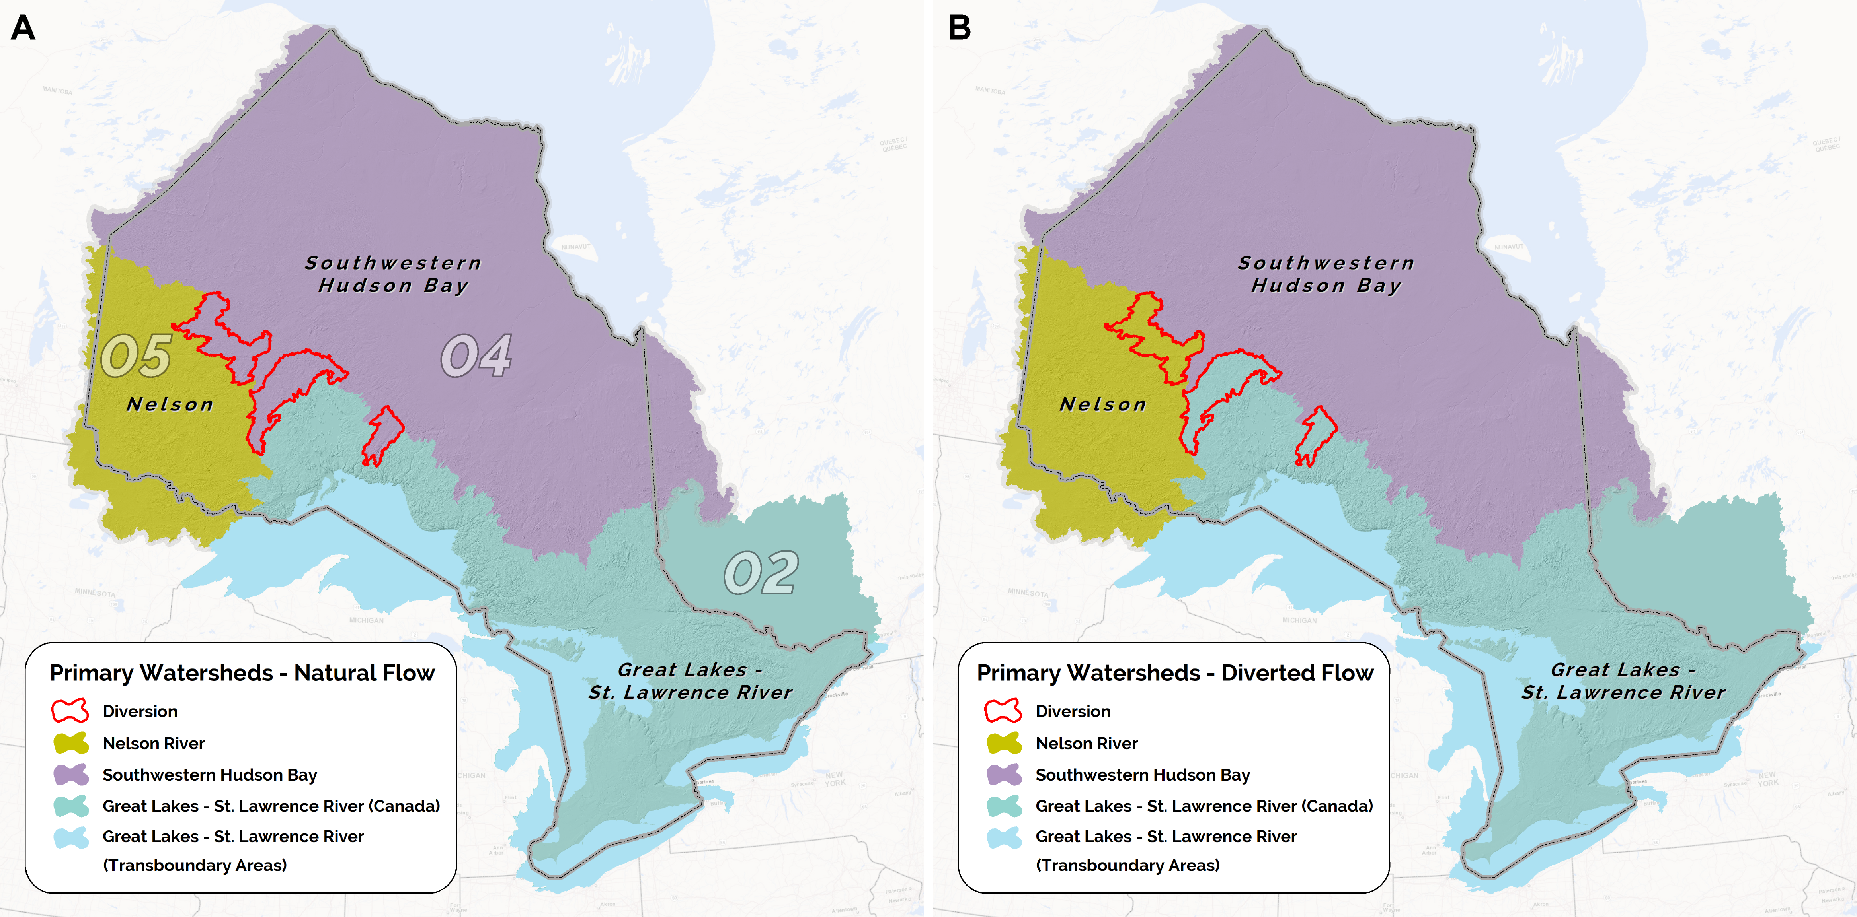
Figure 3: Two depictions of Ontario’s primary watersheds depicting (A) the natural flow state and (B) the diverted flow state. (A) also shows the primary 2-digit coding for Nelson (05), Southwestern Hudson Bay (04) and Great Lakes – St. Lawrence River (02). Note the stateside portion of the Great Lakes – St. Lawrence River basin outside of the transboundary areas is not shown here, but it is now part of the OWB Primary watershed data class. Please refer to Figure 2 for the full extents.

  - Ontario Watershed Boundary, Secondary (OWBSEC) – Derived
The OWB Secondary data class is a view derived from the parent OWB data class containing polygons dissolved by ‘Secondary Watershed Name’ and ‘Secondary Watershed Code’ (Figure 4).
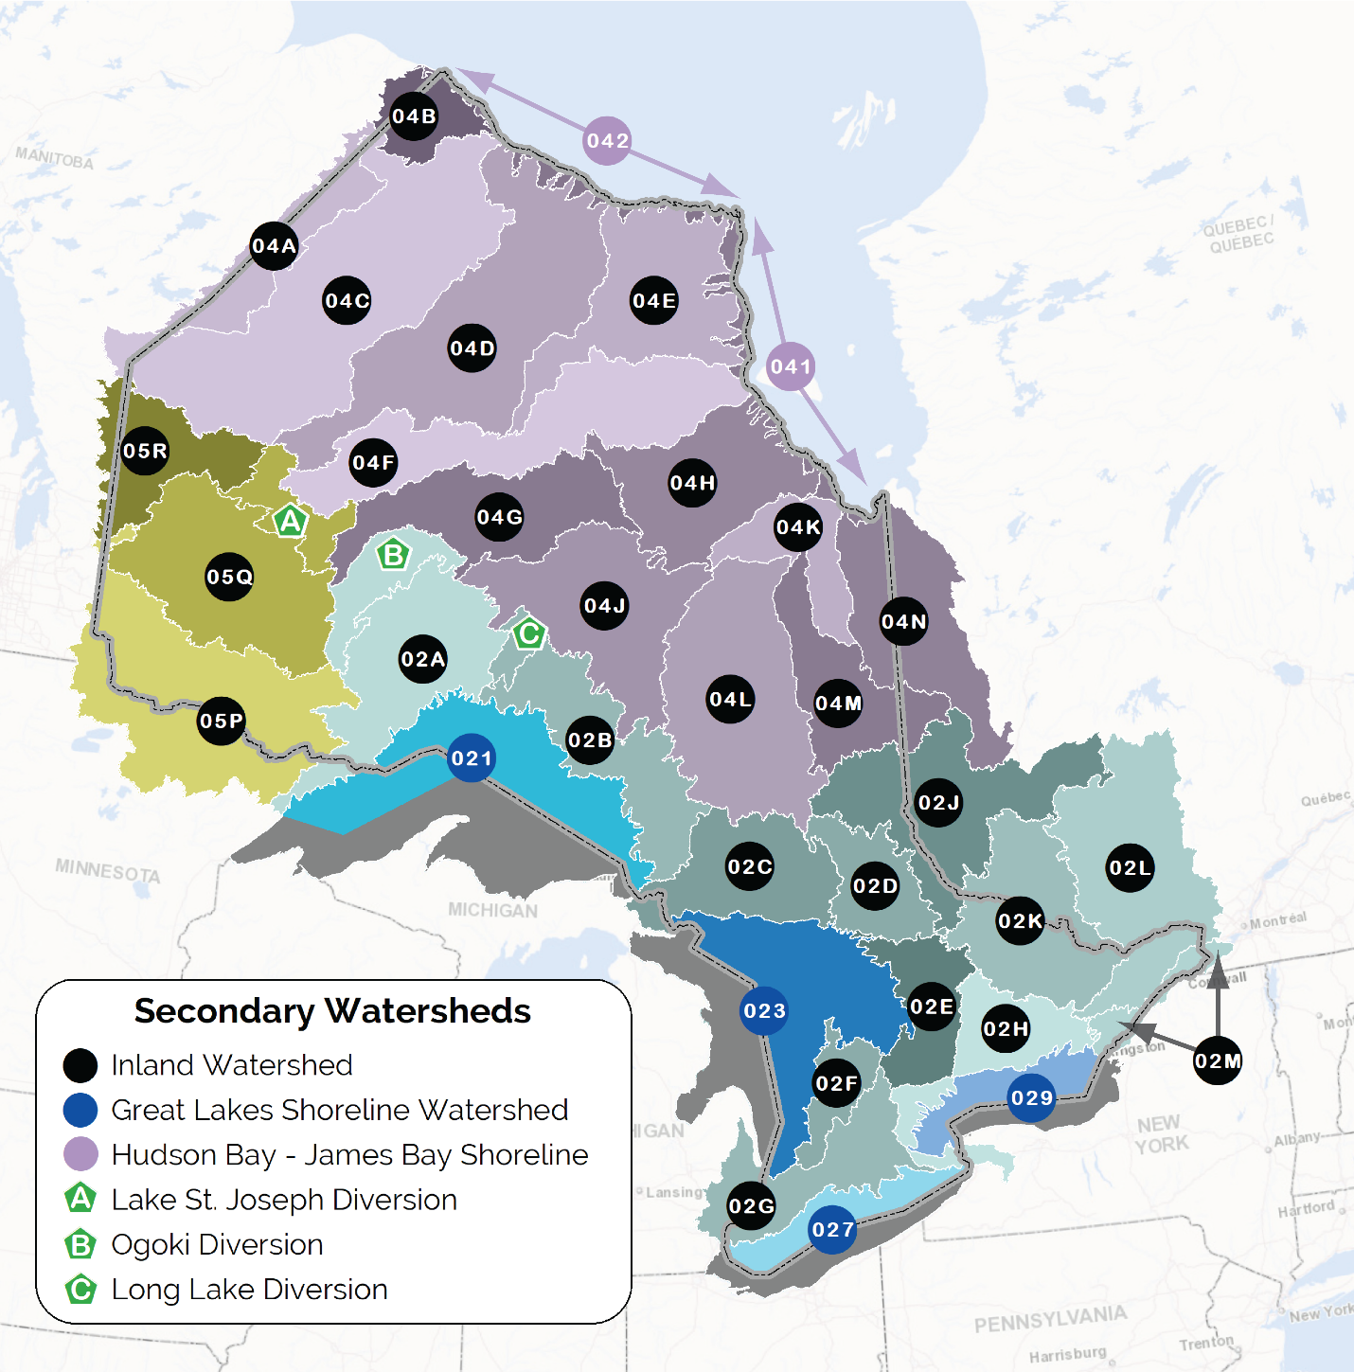
Figure 4: Ontario’s secondary watersheds and their corresponding codes.

  - Ontario Watershed Boundary, Tertiary (OWBTERT) – Derived
The OWB Tertiary data class is a view derived from the parent OWB data class containing polygons dissolved by ‘Tertiary Watershed Name’ and ‘Tertiary Watershed Code’ (Figure 5).
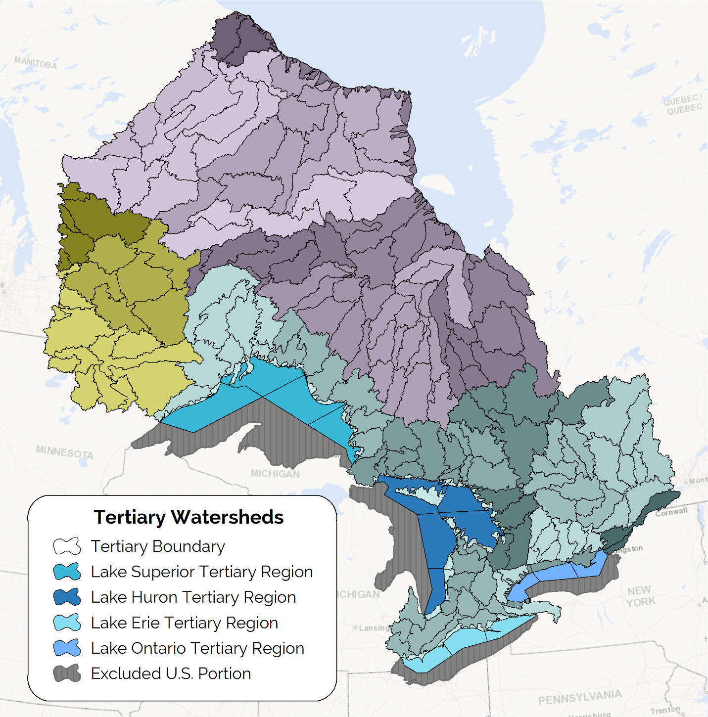
Figure 5: Ontario’s tertiary watersheds. Note the state side Great Lake units have been excluded because they were not sub-divided at the tertiary level.
Figure 6 illustrates a sample of the names and codes at the tertiary watershed level including new lake shoreline regions at the tertiary level. The old watersheds for Ontario excluded the Great Lakes from the watershed framework. Note that some codes are 4 digits long while others are 5-digit codes. The 5th digit is used to handle hydro diversions like the Ogoki Diversion and Long Lake Diversion shown below. It is also used to sub-divide very large tertiary units so that the number of quaternaries does not exceed the federal coding limitations (see section 5 for more details). Examples of these are the Lake Nipigon units below which were formerly a single unit called Lake Nipigon 02AD under the old federal watershed system.
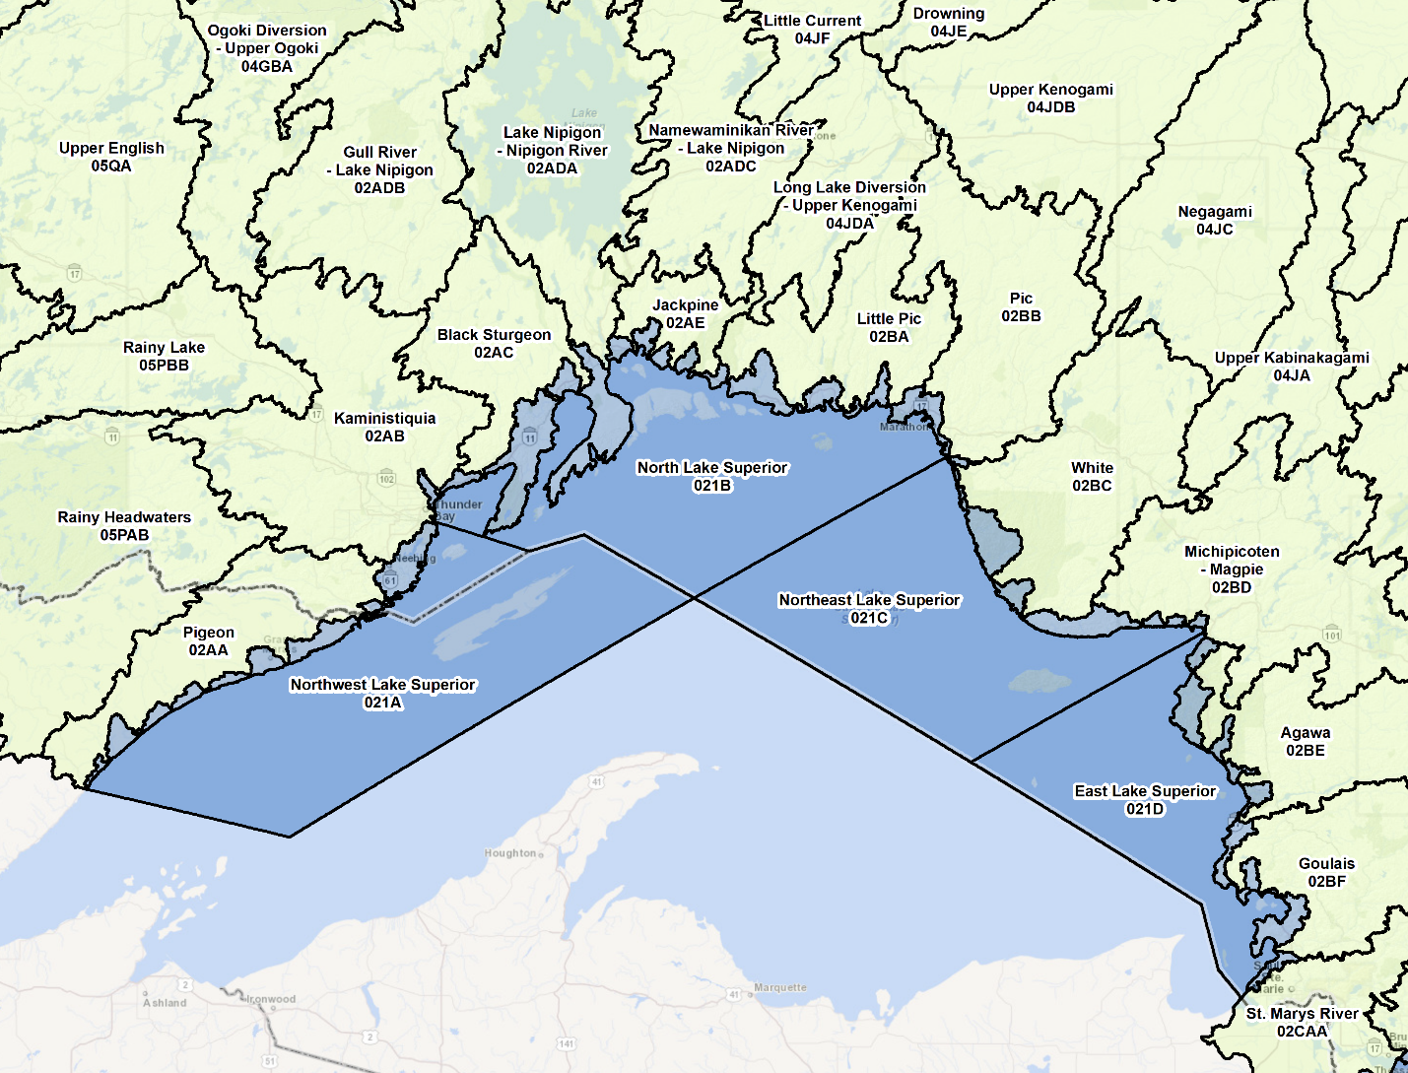
Figure 6: Tertiary names and codes for the Canadian side of Lake Superior. Portions of the shoreline in between inland tertiary watersheds and the lake now belong to the new lake units.

  - Ontario Watershed Boundary, Quaternary (OWBQUAT) – Derived
The OWB Quaternary data class is a view derived from the parent OWB data class containing polygons dissolved by ‘Quaternary Watershed Name’ and ‘Quaternary Watershed Code’ (Figure 7). Refer to section 5 for examples of quaternary coding.
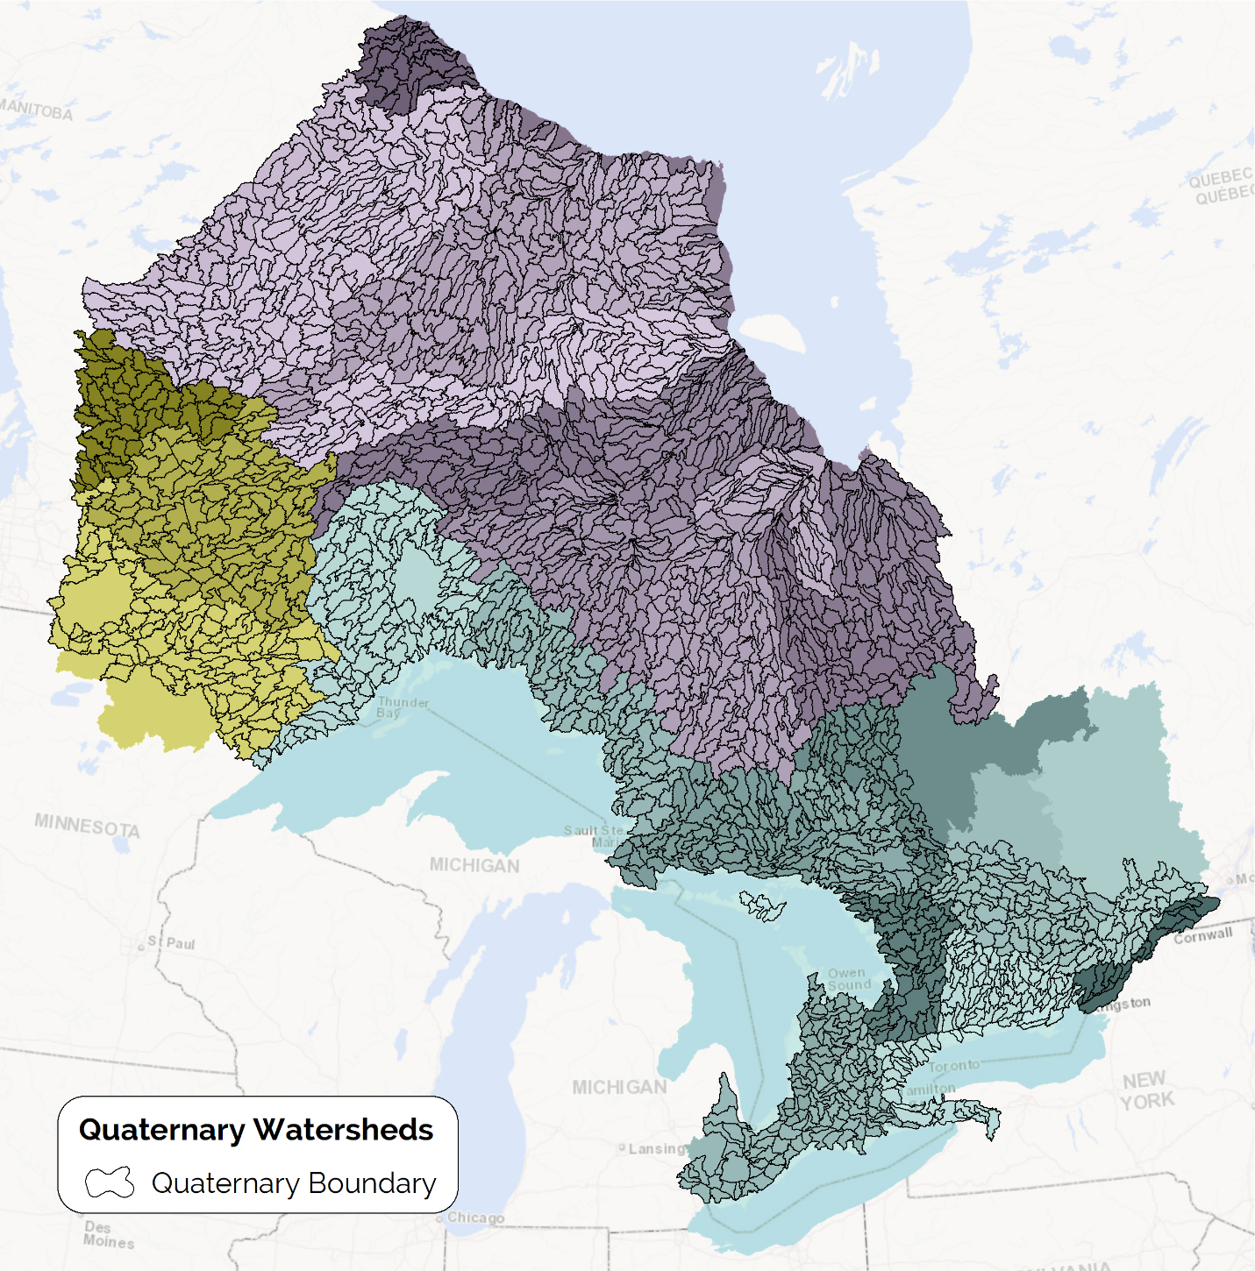
Figure 7: Ontario’s quaternary watersheds. Note these units do not extend into the Great Lakes, Hudson Bay, Quebec and Minnesota beyond the IJC transboundary area of concern.
- Watershed Name and Code Primer
  - Watershed Naming Principles
OWB watershed names and codes have been re-aligned to meet current naming standards and principles.
Watershed naming conventions from the primary to tertiary watershed levels generally align with federal names where appropriate. Some exceptions include hydro diversions and special cases where some units needed to be subdivided to meet IJC watershed area criteria.
Quaternary and finer level watershed names generally follow IJC recommendations including the following:
- Names should be based on official names of significant and permanent natural features usually at the downstream outlet of the watershed. In Ontario, official names were derived from a spatial database of official geographic features and unincorporated place names maintained by the MNR (MNR, 2024). If no name exists at the outlet, the name can be based on the most prominent feature within the watershed, or other notable features such as dams, community names or lot/concession at the outlet if available.
- Names can have two descriptors or ‘elements’ separated by a hyphen if a series of watersheds are nested or related to a greater system. The first element references a local feature within the watershed unit and the second element references the parent feature in a nested watershed scenario. The most downstream unit of a large nested river system could have a single element referencing the large river name followed by the word ‘Outlet’ if there is no other significant local feature in that unit.
Figure 8 illustrates these basic naming principles for 5th level units within a quaternary watershed. The same principle should apply to other watershed levels except for some higher-level legacy names managed by Natural Resources Canada.
Ontario aims to have every watershed named within the OWB datasets. Unfortunately, some areas lack official names or even other sources for names especially in remote areas of the far north. In these cases, a watershed will either be given a temporary name surrounded by parentheses or if no sources exist, they will simply be assigned “No Name” surrounded by parentheses until a better source can be obtained. Some outreach to communities in the far north may be one approach for obtaining relevant local names of natural features within these watersheds.
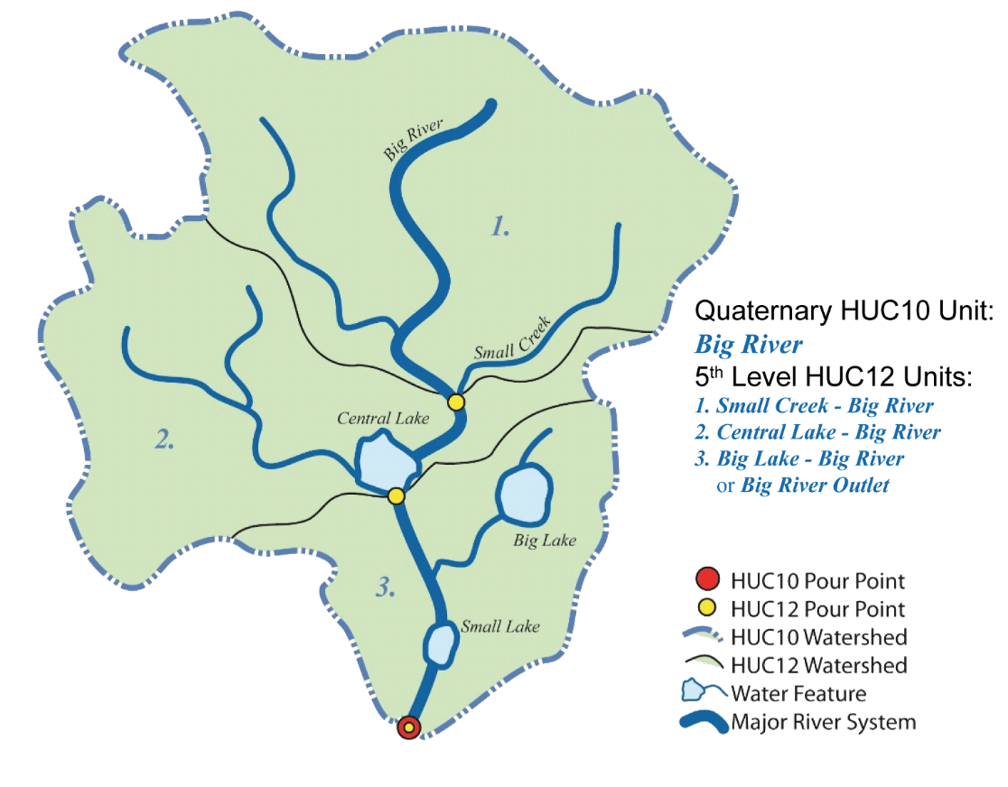
Figure 8: Stylized example of a nested watershed scenario with naming at the 5th level (HUC 12) watershed level for a hypothetical quaternary (HUC 10) watershed.

  - Watershed Coding Considerations
The data harmonization work conducted by IJC partners aimed to create standardized watershed information across jurisdictions so everyone could speak a common language when dealing with international water resource issues. This was a success for the most part at the geometry and naming level, but each jurisdiction still had their own watershed coding system to consider. Each system has their own advantages, shortcomings and ties to various operational programs and initiatives. IJC members agreed to let each agency maintain their own coding systems understanding they all should share some common characteristics: the codes are hierarchical in nature; each level is consistent in size across jurisdiction; and each level is represented by 1 or 2-digit codes. Figure 9 shows how each coding system effectively translates across levels.
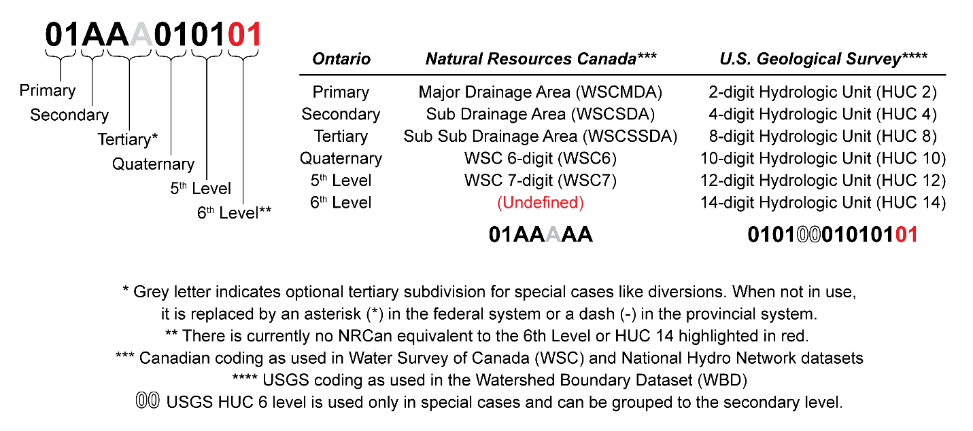
Figure 9: A comparison of watershed coding levels between Ontario, Canada and the United States.
However, there are some key differences in the provincial coding system which sets it apart from both federal systems. The provincial coding system closely honours the NRCan Water Survey of Canada (WSC) nomenclature for the first 3 levels from primary down to the tertiary level. The differences start at the quaternary level and finer where they better resemble the stateside Hydrologic Unit Code (HUC) system. After the primary level, each level in the WSC code is represented by a single letter whereas the HUC code uses 2 numeric digits for each level. As a result, the WSC system only allows 26 values per level (A to Z) whereas the HUC system allows 100 possible values (0 to 99). This becomes especially important at finer watershed levels if there are more than 26 child units within a given parent watershed unit. For this reason, Ontario follows the HUC approach at the quaternary level and finer.
Another key difference between systems is how the code value increments within a given parent watershed unit. For a given tertiary watershed that drains to a single pour point, the provincial system increments the quaternary code as you traverse from the mouth of the tertiary watershed upstream to its headwaters, whereas the WSC and HUC systems increment in the opposite direction downstream. The advantage of the provincial approach is that the lowest number of ‘01’ will always represent the quaternary unit outlet of a tertiary watershed (Figure 10). If the tertiary watershed has multiple outlets, all outlets will have lower numbers than units upstream draining to them. This incrementing approach can be automated using the flow accumulation concept (Jenson and Domingue, 1988) when new watersheds are created. Since there are thousands of watersheds in Ontario and possibly more that may be introduced in the future, an automated approach makes it easier to maintain while giving the system some inherent logical structure.
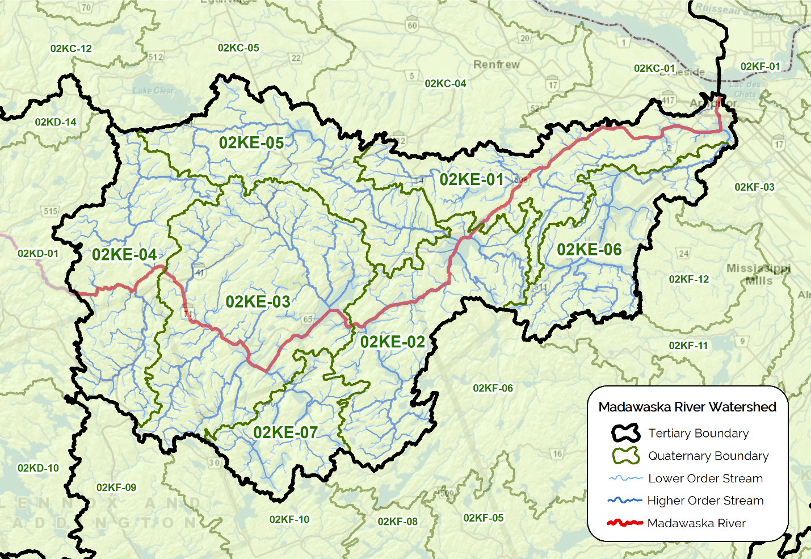
Figure 10: This example illustrates the quaternary units making up the Lower Madawaska (02KE) tertiary watershed. The red line is the main river channel which continues upstream into the Upper Madawaska (02KD). The 4 units the main river channel traverses have the lowest numbers because of the area upstream (02KD) draining into them. All units were ordered by the inverse of flow accumulation.
A watershed code ending in ‘00’ means no watershed exists at that level within the parent watershed of interest. This happens often at the 5th and 6th watershed levels because only select areas in Ontario are currently populated at these levels. This also happens at the quaternary level only within the Great Lakes tertiary shoreline regions where 5th and 6th level units are not nested within any quaternaries (Figure 11) and areas outside the province defined down to the tertiary watershed level (parts of the Rainy River in Minnesota and Ottawa River basin in Quebec – see Figure 7).
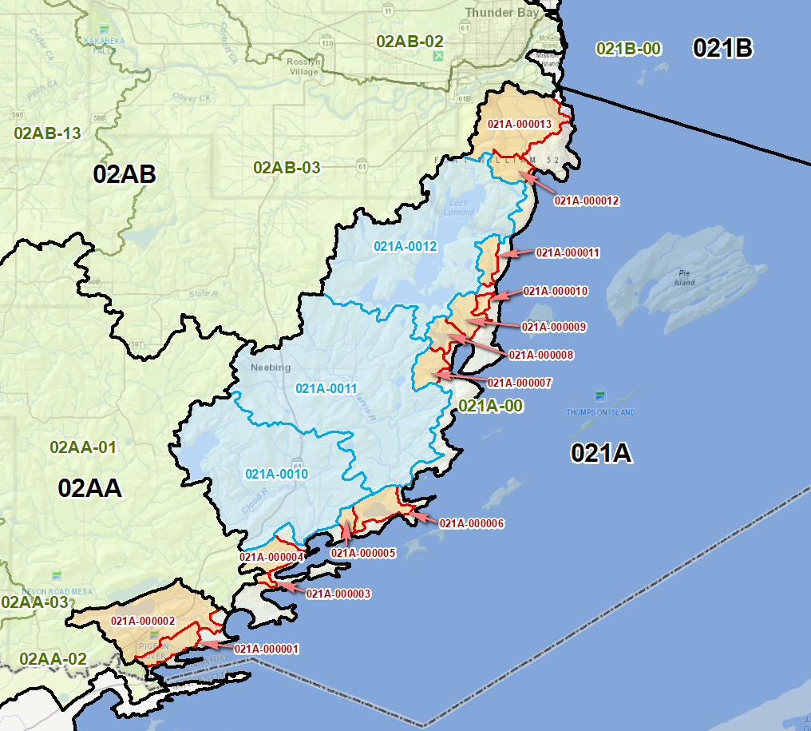
Figure 11: Examples of 5th level (blue units) and 6th level (orange-red units) along the Northwest Lake Superior Shoreline (021A) near Thunder Bay. Tertiary codes (black) and quaternary codes (green) are also shown for context. Note the quaternary code for the shoreline ends in ‘00’ meaning no quaternaries are currently defined in this region.

  - Downstream Watershed Code
A new feature of the parent OWB data class is the inclusion of a Downstream Watershed Code, which establishes a relationship between a watershed of interest and the watershed it flows to downstream. This allows you to ‘trace’ watersheds downstream and upstream similar to stream network tracing. The Downstream Watershed Code is based on the 6th Level Watershed Code – the finest level of division in the parent OWB data class.
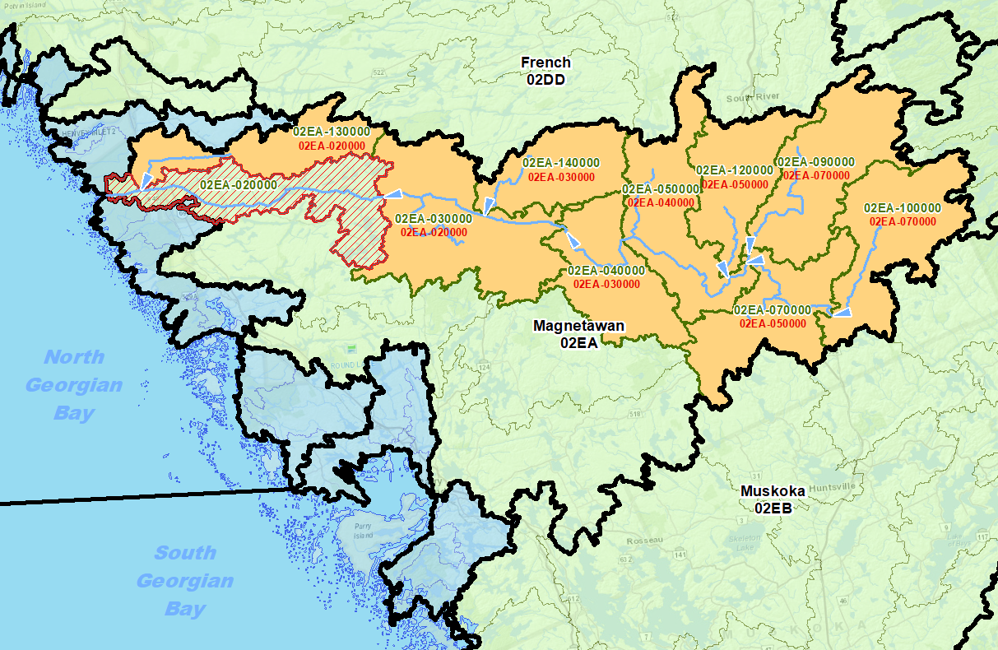
Figure 12: Illustrates the upstream quaternaries of the Magnetawan River watershed in orange that drain to the Magnetawan River Outlet highlighted in red. The 6th Level Watershed Codes are in green and the Downstream Watershed Code each unit drains to is shown in red.

- Model Diagram: Ontario Watershed Boundaries
Model Effective Date: 2020-01-02
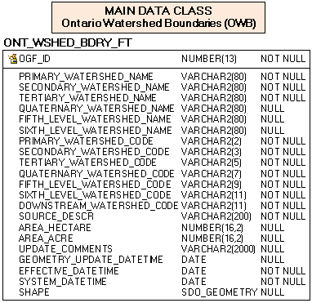
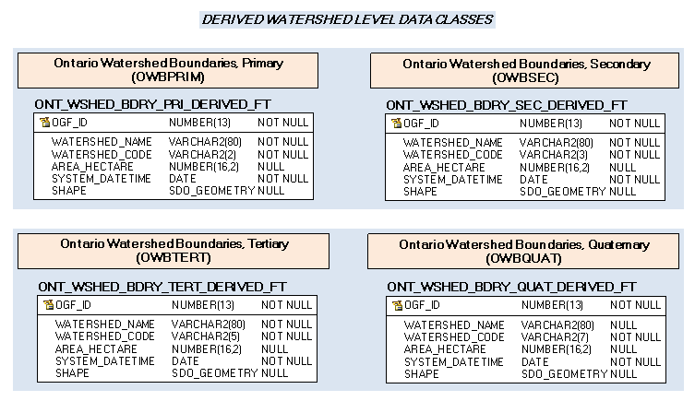

- Data Description
The main business area tables for this model can be found below. Associated relationships will be listed in Appendix A of this document and are hyperlinked where referenced in this section.

ONT_WSHED_BDRY_FT

Short Name: OWB
Official dataset for mapped watersheds in the Province of Ontario. This layer consolidates the first four watershed levels (Primary down to Quaternary), with an additional two sub-levels (5th and 6th Level) reserved for select areas of the Province.
# | ATTRIBUTE/COLUMN NAME | DATATYPE | REQ | DESCRIPTION
1 | OGF ID  OGF_ID | NUMBER(13) | Yes | Ontario Geospatial Feature Identifier (OGF_ID). Unique system-generated identifier assigned to every record/feature in the GEO Editor and/or GEO Warehouse databases.
2 | Primary Watershed Name  PRIMARY_WATERSHED_NAME | VARCHAR2(80) | Yes | Primary Watershed Name, similar to a Major Drainage Area (Natural Resources Canada).
3 | Secondary Watershed Name  SECONDARY_WATERSHED_NAME | VARCHAR2(80) | Yes | Secondary Watershed Name, similar to a Sub-Drainage Area (Natural Resources Canada).
4 | Tertiary Watershed Name  TERTIARY_WATERSHED_NAME | VARCHAR2(80) | Yes | Tertiary Watershed Name, similar to a Sub-Sub Drainage Area (Natural Resources Canada).
5 | Quaternary Watershed Name  QUATERNARY_WATERSHED_NAME | VARCHAR2(80) | No | Quaternary Watershed Name. A quaternary watershed is defined as having an area between 40000 to 250000 acres, equivalent to a HUC10 unit in the United States (HUC = Hydrologic Unit Code). If a valid quaternary unit has no known name, it will be called "(No Name)". If there is an alternate name or a name has not been verified, it will be surrounded by parentheses. If the valid polygon represents a smaller level unit that does not reside within a quaternary watershed, this attribute will be set to NULL. It will also be NULL if it is a tertiary shoreline region polygon with no quaternary sub-division.
6 | Fifth-Level Watershed Name  FIFTH_LEVEL_WATERSHED_NAME | VARCHAR2(80) | No | 5th Level Watershed Name. A 5th level watershed is defined as having an area between 10000 to 40000 acres, equivalent to a HUC12 unit in the United States. If a valid 5th level unit has no known name, it will be called "(No Name)". If there is an alternate name or a name has not been verified, it will be surrounded by parentheses. If the valid polygon represents a smaller level unit that does not reside within a 5th level watershed, this attribute will be set to NULL. It will also be NULL if it is a tertiary shoreline region polygon with no 5th level sub-division.
7 | Sixth-Level Watershed Name  SIXTH_LEVEL_WATERSHED_NAME | VARCHAR2(80) | No | 6th Level Watershed Name. A 6th level watershed is defined as any watershed generally less than 10000 acres and are typically limited to shoreline regions only. If a valid 6th level unit has no known name, it will be called "(No Name)". If there is an alternate name or a name has not been verified, it will be surrounded by parentheses. This attribute will be NULL if it is a tertiary shoreline region polygon with no 6th level sub-division.
8 | Primary Watershed Code  PRIMARY_WATERSHED_CODE | VARCHAR2(2) | Yes | Primary Watershed Code. Based on federal Water Survey of Canada Major Drainage Area (WSCMDA) Code (e.g. "04").
9 | Secondary Watershed Code  SECONDARY_WATERSHED_CODE | VARCHAR2(3) | Yes | Secondary Watershed Code. Based on federal Water Survey of Canada Sub Drainage Area (WSCSDA) Code. (e.g. "04J").
10 | Tertiary Watershed Code  TERTIARY_WATERSHED_CODE | VARCHAR2(5) | Yes | Tertiary Watershed Code. Based on federal Fundamental Drainage Area (FDA) Code (e.g. "04JDA" where the 5th digit is optional and denotes a diversion or transboundary sub-division).
11 | Quaternary Watershed Code  QUATERNARY_WATERSHED_CODE | VARCHAR2(7) | Yes | Quaternary Watershed Code. (e.g. "04JDA01" or "02HA-01" where the 5th digit is a dash "-" if no special tertiary sub-division exists, and the last 2 digits are numeric denoting the quaternary level - up to 26 divisions). If there are no quaternary watersheds within a given tertiary shoreline or lake region, the code will end in "00".
12 | Fifth-Level Watershed Code  FIFTH_LEVEL_WATERSHED_CODE | VARCHAR2(9) | Yes | 5th Level Watershed Code. (e.g. "02GGB0101" for an inland transboundary watershed or "029D-0001" for a shoreline region watershed, where 5th digit is a dash "-" if no special tertiary sub-division exists. The last 4 digits are numeric, where the last pair of digits represent the 5th level - up to 26 divisions). If there are no 5th level watersheds within a given tertiary or quaternary watershed unit, the code will end in "00".
13 | Sixth-Level Watershed Code  SIXTH_LEVEL_WATERSHED_CODE | VARCHAR2(11) | Yes | 6th Level Watershed Code. (e.g. "021D-000001". Same as Code5, except the last 6 digits are numeric, where the last pair of digits represent the 6th level - up to 99 divisions). If there are no 6th level watersheds within a given tertiary, quaternary or 5th level watershed unit, the code will end in "00".
14 | Downstream Watershed Code  DOWNSTREAM_WATERSHED_CODE | VARCHAR2(11) | Yes | Downstream Watershed Code. 6th level code identifying the downstream watershed the current watershed unit drains to. A default value of "Undefined" will be used when the downstream watershed code is not available or has not been defined.  DEFAULT: 'Undefined'
15 | Source Description  SOURCE_DESCR | VARCHAR2(200) | Yes | The data source and package (if applicable) that was used to compile watersheds (e.g. "OIH 2019, SW Package").
16 | Area (Hectare)  AREA_HECTARE | NUMBER(16,2) | No | User-calculated area (Canada Albers Equal Area Conic projection) in hectares of the watershed feature. Values are stored to 2-decimal place precision.
17 | Area (Acre)  AREA_ACRE | NUMBER(16,2) | No | User-calculated area (Canada Albers Equal Area Conic projection) in acres of the watershed feature. Used operationally to distinguish between watershed levels as prescribed by the American Hydrologic Unit Code (HUC) system (https://water.usgs.gov/GIS/huc.html) where acre values are used for analysis. Values are stored to 2-decimal place precision.
18 | Update Comments  UPDATE_COMMENTS | VARCHAR2(2000) | No | Describes the nature of the last update (whether geometry and/or attribute) along with a rationale for the change if applicable.
19 | Geometry Update Datetime  GEOMETRY_UPDATE_DATETIME | DATE | No | Date/time the geometry was created or last modified in the source database.
20 | Effective Datetime  EFFECTIVE_DATETIME | DATE | Yes | Date/time the record was created or last modified in the source database.
21 | System Datetime  SYSTEM_DATETIME | DATE | Yes | Date/time the record was loaded into or last modified in the GEO database.  DEFAULT: SYSDATE
22 | Shape  SHAPE | SDO_GEOMETRY | No | Geometry attribute.
Table 1. OWB Main or Parent Attribute Table.

ONT_WSHED_BDRY_PRI_DERIVED_FT

Short Name: OWBPRIM
DERIVED DATA CLASS: Official dataset for mapped primary-level watersheds in the Province of Ontario. A Primary Watershed is similar to a Major Drainage Area (Natural Resources Canada). The features in this layer are derived from the parent Ontario Watershed Boundaries (OWB) data class.
# | ATTRIBUTE/COLUMN NAME | DATATYPE | REQ | DESCRIPTION
1 | OGF ID  OGF_ID | NUMBER(13) | Yes | Ontario Geospatial Feature Identifier (OGF_ID). Unique system-generated identifier assigned to every record/feature in the GEO Editor and/or GEO Warehouse databases. Source: ONT_WATERSHED_BOUNDARY_FT.OGF_ID
2 | Watershed Name  WATERSHED_NAME | VARCHAR2(80) | Yes | Primary Watershed Name, similar to a Major Drainage Area (Natural Resources Canada). Source: ONT_WATERSHED_BOUNDARY_FT.PRIMARY_WATERSHED_NAME
3 | Watershed Code  WATERSHED_CODE | VARCHAR2(2) | Yes | Primary Watershed Code. Based on federal Water Survey of Canada Major Drainage Area (WSCMDA) Code (e.g. "04"). Source: ONT_WATERSHED_BOUNDARY_FT.PRIMARY_WATERSHED_CODE
4 | Area (Hectare)  AREA_HECTARE | NUMBER(16,2) | No | User-calculated area (Canada Albers Equal Area Conic projection) in hectares of the watershed feature. Values are stored to 2-decimal place precision. Source: ONT_WATERSHED_BOUNDARY_FT.AREA_HECTARE
6 | System Datetime  SYSTEM_DATETIME | DATE | Yes | Date/time the record was loaded into or last modified in the GEO database. Source: ONT_WATERSHED_BOUNDARY_FT.SYSTEM_DATETIME  DEFAULT: SYSDATE
7 | Shape  SHAPE | SDO_GEOMETRY | No | Geometry attribute.
Table 2: OWB Primary Watershed Attribute Table.

ONT_WSHED_BDRY_SEC_DERIVED_FT

Short Name: OWBSEC
DERIVED DATA CLASS: Official dataset for mapped secondary-level watersheds in the Province of Ontario. A Secondary Watershed is similar to a Sub-Drainage Area (Natural Resources Canada). The features in this layer are derived from the parent Ontario Watershed Boundaries (OWB) data class.
# | ATTRIBUTE/COLUMN NAME | DATATYPE | REQ | DESCRIPTION
1 | OGF ID  OGF_ID | NUMBER(13) | Yes | Ontario Geospatial Feature Identifier (OGF_ID). Unique system-generated identifier assigned to every record/feature in the GEO Editor and/or GEO Warehouse databases. Source: ONT_WATERSHED_BOUNDARY_FT.OGF_ID
2 | Watershed Name  WATERSHED_NAME | VARCHAR2(80) | Yes | Secondary Watershed Name, similar to a Sub-Drainage Area (Natural Resources Canada). Source: ONT_WATERSHED_BOUNDARY_FT.SECONDARY_WATERSHED_NAME
3 | Watershed Code  WATERSHED_CODE | VARCHAR2(3) | Yes | Secondary Watershed Code. Based on federal Water Survey of Canada Sub Drainage Area (WSCSDA) Code. (e.g. "04J"). Source: ONT_WATERSHED_BOUNDARY_FT.SECONDARY_WATERSHED_CODE
4 | Area (Hectare)  AREA_HECTARE | NUMBER(16,2) | No | User-calculated area (Canada Albers Equal Area Conic projection) in hectares of the watershed feature. Values are stored to 2-decimal place precision. Source: ONT_WATERSHED_BOUNDARY_FT.AREA_HECTARE
6 | System Datetime  SYSTEM_DATETIME | DATE | Yes | Date/time the record was loaded into or last modified in the GEO database. Source: ONT_WATERSHED_BOUNDARY_FT.SYSTEM_DATETIME  DEFAULT: SYSDATE
7 | Shape  SHAPE | SDO_GEOMETRY | No | Geometry attribute.
Table 3: OWB Secondary Watershed Attribute Table.

ONT_WSHED_BDRY_TERT_DERIVED_FT

Short Name: OWBTERT
DERIVED DATA CLASS: Official dataset for mapped tertiary-level watersheds in the Province of Ontario. A Tertiary Watershed is similar to a Sub-Sub Drainage Area (Natural Resources Canada). The features in this layer are derived from the parent Ontario Watershed Boundaries (OWB) data class.
# | ATTRIBUTE/COLUMN NAME | DATATYPE | REQ | DESCRIPTION
1 | OGF ID  OGF_ID | NUMBER(13) | Yes | Ontario Geospatial Feature Identifier (OGF_ID). Unique system-generated identifier assigned to every record/feature in the GEO Editor and/or GEO Warehouse databases. Source: ONT_WATERSHED_BOUNDARY_FT.OGF_ID
2 | Watershed Name  WATERSHED_NAME | VARCHAR2(80) | Yes | Tertiary Watershed Name, similar to a Sub-Sub Drainage Area (Natural Resources Canada). Source: ONT_WATERSHED_BOUNDARY_FT.TERTIARY_WATERSHED_NAME
3 | Watershed Code  WATERSHED_CODE | VARCHAR2(5) | Yes | Tertiary Watershed Code. Based on federal Fundamental Drainage Area (FDA) Code (e.g. "04JDA" where the 5th digit is optional and denotes a diversion or transboundary sub-division). Source: ONT_WATERSHED_BOUNDARY_FT.TERTIARY_WATERSHED_CODE
4 | Area (Hectare)  AREA_HECTARE | NUMBER(16,2) | No | User-calculated area (Canada Albers Equal Area Conic projection) in hectares of the watershed feature. Values are stored to 2-decimal place precision. Source: ONT_WATERSHED_BOUNDARY_FT.AREA_HECTARE
6 | System Datetime  SYSTEM_DATETIME | DATE | Yes | Date/time the record was loaded into or last modified in the GEO database. Source: ONT_WATERSHED_BOUNDARY_FT.SYSTEM_DATETIME  DEFAULT: SYSDATE
7 | Shape  SHAPE | SDO_GEOMETRY | No | Geometry attribute.
Table 4: OWB Tertiary Watershed Attribute Table.

ONT_WSHED_BDRY_QUAT_DERIVED_FT

Short Name: OWBQUAT
DERIVED DATA CLASS: Official dataset for mapped quaternary-level watersheds in the Province of Ontario. A Quaternary Watershed is defined as having an area between 40000 to 250000 acres, equivalent to a HUC10 unit in the United States (HUC = Hydrologic Unit Code). The features in this layer are derived from the parent Ontario Watershed Boundaries (OWB) data class.
# | ATTRIBUTE/COLUMN NAME | DATATYPE | REQ | DESCRIPTION
1 | OGF ID  OGF_ID | NUMBER(13) | Yes | Ontario Geospatial Feature Identifier (OGF_ID). Unique system-generated identifier assigned to every record/feature in the GEO Editor and/or GEO Warehouse databases. Source: ONT_WATERSHED_BOUNDARY_FT.OGF_ID
2 | Watershed Name  WATERSHED_NAME | VARCHAR2(80) | No | Quaternary Watershed Name. A quaternary watershed is defined as having an area between 40000 to 250000 acres, equivalent to a HUC10 unit in the United States (HUC = Hydrologic Unit Code). If a valid quaternary unit has no known name, it will be called "(No Name)". If there is an alternate name or a name has not been verified, it will be surrounded by parentheses. If the valid polygon represents a smaller level unit that does not reside within a quaternary watershed, this attribute will be set to NULL. It will also be NULL if it is a tertiary shoreline region polygon with no quaternary sub-division. Source: ONT_WATERSHED_BOUNDARY_FT.QUATENARY_WATERSHED_NAME
3 | Watershed Code  WATERSHED_CODE | VARCHAR2(7) | Yes | Quaternary Watershed Code. (e.g. "04JDA01" or "02HA-01" where the 5th digit is a dash "-" if no special tertiary sub-division exists, and the last 2 digits are numeric denoting the quaternary level - up to 26 divisions). If there are no quaternary watersheds within a given tertiary shoreline or lake region, the code will end in "00". Source: ONT_WATERSHED_BOUNDARY_FT.QUATERNARY_WATERSHED_CODE
4 | Area (Hectare)  AREA_HECTARE | NUMBER(16,2) | No | User-calculated area (Canada Albers Equal Area Conic projection) in hectares of the watershed feature. Values are stored to 2-decimal place precision. Source: ONT_WATERSHED_BOUNDARY_FT.AREA_HECTARE
6 | System Datetime  SYSTEM_DATETIME | DATE | Yes | Date/time the record was loaded into or last modified in the GEO database. Source: ONT_WATERSHED_BOUNDARY_FT.SYSTEM_DATETIME  DEFAULT: SYSDATE
7 | Shape  SHAPE | SDO_GEOMETRY | No | Geometry attribute.
Table 5: OWB Quaternary Watershed Attribute Table.
- Links to Additional Information
- Official GEO Metadata Record for Ontario Watershed Boundaries
(https://geohub.lio.gov.on.ca/datasets/MNR::ontario-watershed-boundaries-owb)
- Alternative Search Link
(https://geohub.lio.gov.on.ca/search?q=OWB)
- Atlas of Canada Fundamental Drainage Areas
(http://lwbin-datahub.ad.umanitoba.ca/dataset/atlca-funddra)
- USGS Watershed Boundary Dataset
(https://www.usgs.gov/core-science-systems/ngp/national-hydrography/watershed-boundary-dataset?qt-science_support_page_related_con=4#qt-science_support_page_related_con)
- Natural Resources Canada Watershed Boundaries
(https://www.nrcan.gc.ca/science-data/science-research/earth-sciences/geography/topographic-information/geobase-surface-water-program-ge/watershed-boundaries/20973)
- Multi-scale Hydrographic Basins of Quebec
(https://www.donneesquebec.ca/recherche/fr/dataset/bassins-hydrographiques-multi-echelles-du-quebec/resource/183c65a7-acb7-4e51-b3c5-5d34e5014771)

- References
Bower, D.E., Lowry, C., Jr., Lowery, M.A., and Hurley, N.M., Jr., 1999. Development of a 14-digit hydrologic unit code numbering system for South Carolina. U.S. Geological Survey, Water-Resources Investigations Report 99-4015, Sheet 1 of 2. (https://pubs.usgs.gov/wri/1999/4015/wri19994015_sheet1.pdf)
Cox, E. T., 1978. Counts and Measurements of Ontario Lakes. Watershed Unit Summaries based on Maps of Various Scales by Watershed Unit. Fisheries Policy Development Section, Fisheries Branch, Ontario Ministry of Natural Resources.
DCR, 2019. Hydrologic Unit Geography. Virginia Department of Conservation and Recreation. (https://www.dcr.virginia.gov/soil-and-water/hu)
IJC, 2009. The International Watersheds Initiative: Implementing a New Paradigm for Transboundary Basins. 3rd Report. International Joint Commission. ISBN: 978-1-100-12002-7.
Jenson, S. K., and J. O. Domingue. 1988. Extracting Topographic Structure from Digital Elevation Data for Geographic Information System Analysis. Photogrammetric Engineering and Remote Sensing, 54 (11): 1593–1600.
Johnston, J. T., 1922. Water Resources Index Inventory Filing System for Recording, collating and Analysing Water Resources Data. Excerpts from Water Resources Paper No. 32. Dominion Waterpower Branch, Department of the Interior, Canada.
Maher, F.P., 1969. The Canada Land Inventory Sport Fish Capability Survey in Ontario. Fish and Wildlife Branch, Ontario Ministry of Natural Resources. Unpublished Report. pp. 6, 13.
Ministry of Natural Resources (MNR), 2002. A Guide to the Provincial Watershed Project. 2nd Ed. Water Resources Information Program, Ontario Ministry of Natural Resources.
MNR, 2011. A Brief History of Ontario’s Quaternary Watersheds. River and Stream Ecology Lab, Aquatic Research and Development Section, Ontario Ministry of Natural Resources. Unpublished Report.
MNR, 2020. Data Capture Specifications for Hydrographic Features: Medium Scale. Provincial Mapping Unit, Mapping and Information Resources Branch, Corporate Management and Information Division.
(http://www.google.ca/search?q="Data Capture Specifications for Hydrographic Features: Medium Scale")
MNR, 2024. Geographic names. Ontario Geographic Names Board, Divisional Support Branch, Regional Operations Division. (https://www.ontario.ca/page/geographic-names)
MNR, 2026a. User Guide for Ontario Integrated Hydrology: Elevation and Mapped Water Features for Provincial Scale Hydrology Applications. Geospatial Ontario, Digital, Data, Information and Business Services Branch, Corporate Management and Information Division. (https://geohub.lio.gov.on.ca/search?q=OIH_en)
MNR, 2026b. Provincial Digital Elevation Model (PDEM) User Guide. Geospatial Ontario, Digital, Data, Information and Business Services Branch, Corporate Management and Information Division. (https://geohub.lio.gov.on.ca/search?q=PDEM_en)
NRCan, 2003. National Scale Frameworks HYDROLOGY Version 5.0: A practical guide to the datasets. Canadian Centre for Remote Sensing, GeoAccess Division, Natural Resources Canada.
NRCan, 2017. Drainage Basins. GeoBase Surface Water Program, Natural Resources Canada, GeoGratis website.
(https://open.canada.ca/data/en/dataset/dc475fb0-8893-11e0-9ab7-6cf049291510)
USGS, 1991. Subwatersheds – 14-digit Hydrologic Units. U.S. Geological Survey, Indiana.
(https://pubs.usgs.gov/fs/1999/fs143-99/pdf/fs143-99.pdf)

APPENDIX A: Table Key Dependency and Relationship Index
Keys are used to link or make relationships between tables through one or more columns. A Parent Table is the source of unique key columns used by a Child Table. The main key types are described below.
Primary Key (PK):
A Primary Key (PK) is a column that uniquely identifies each record in a table. There can be more than one PK defined for a table when additional rules for record uniqueness are needed. Primary Keys cannot contain null values.
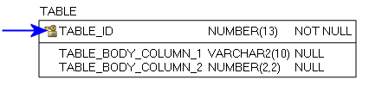
Figure 13: Primary Key example
Foreign Key (FK):
When a Primary Key from a Parent Table appears as a column in the Child Table it is referred to as a Foreign Key (FK). The FK may retain the same name of the Parent Table column, or it may be renamed.
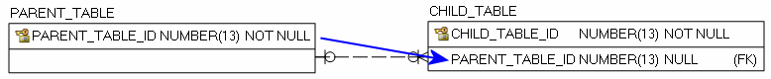
Figure 14: Foreign Key example
Alternate Key (AK):
Alternate Keys (AK) are secondary unique identifiers in a Parent Table. A Child Table can link to a Parent Table AK and use it as a Foreign Key (FK). The FK may retain the same name of the Parent Table column, or it may be renamed. Alternate Keys allow null values.
Figure 15: Alternate Key example

There are two relationship type options, identifying and non-identifying, which are described below.
An Identifying Relationship occurs when a column from the Parent Table is added to the key section of the Child Table. Though technically a Foreign Key (FK) in the child table, it now forms part of the Primary Key (PK). Identifying Relationships are symbolized with a solid line.
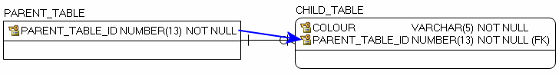
Figure 16: Example of an Identifying Relationship
A Non-identifying Relationship occurs when a column from the Parent Table is added to the main body of the Child Table where it is treated as a Foreign Key (FK). Non-identifying Relationships are symbolized with a dashed line.
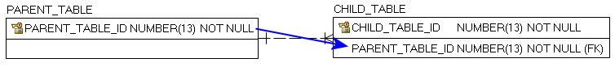
Figure 17: Example of a Non-identifying Relationship
The relationships between tables are set up with cardinality rules describing if the feature record in the Parent Table can relate to zero, one or more records in the associated Child Table and vice versa. These rules are symbolized in the model diagram as follows.
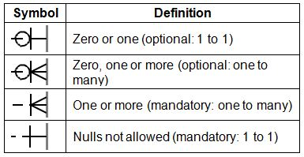
Figure 18: Model Diagram Relationship Symbology Table
The following section is an index of parent table primary keys identifying, where applicable, associated child table dependencies that have been implemented for the OWB data class.

Main Business Area Tables
Index of main business area table primary and associated foreign keys.
Note: Relationship type reference is either Identifying (I) or Non-Identifying (NI).
Parent Table: ONT_WSHED_BDRY_FT
Primary Key(s): PRIMARY_WATERSHED_NAME and PRIMARY_WATERSHED_CODE
Data Type: Text
Child Table | Migrated Foreign Key | Rel. Type | Parent to Child Relationship | Child to Parent Relationship
ONT_WSHED_BDRY_PRI_DERIVED_FT | WATERSHED_NAME / WATERSHED CODE | NI | Optional: Many to 1 | Mandatory: 1 to Many
Parent Table: ONT_WSHED_BDRY_FT
Primary Key(s): SECONDARY_WATERSHED_NAME and SECONDARY_WATERSHED_CODE
Data Type: NUMBER (13)
Child Table | Migrated Foreign Key | Rel. Type | Parent to Child Relationship | Child to Parent Relationship
ONT_WSHED_BDRY_SEC_DERIVED_FT | WATERSHED_NAME / WATERSHED CODE | NI | Optional: Many to 1 | Mandatory: 1 to Many
Parent Table: ONT_WSHED_BDRY_FT
Primary Key(s): TERTIARY_WATERSHED_NAME and TERTIARY_WATERSHED_CODE
Data Type: Text
Child Table | Migrated Foreign Key | Rel. Type | Parent to Child Relationship | Child to Parent Relationship
ONT_WSHED_BDRY_TERT_DERIVED_FT | WATERSHED_NAME / WATERSHED CODE | NI | Optional: Many to 1 | Mandatory: 1 to Many
Parent Table: ONT_WSHED_BDRY_FT
Primary Key(s): QUATERNARY_WATERSHED_NAME and QUATERNARY_WATERSHED_CODE
Data Type: Text
Child Table | Migrated Foreign Key | Rel. Type | Parent to Child Relationship | Child to Parent Relationship
ONT_WSHED_BDRY_QUAT_DERIVED_FT | WATERSHED_NAME / WATERSHED CODE | NI | Optional: Many to 1 | Mandatory: 1 to Many

Version 2324.1

Second order watershed classification in Quebec.

