Watershed Delineation Principles and Guidelines for Ontario
Technical Guide
  - Geospatial Ontario
  - Digital Data Information Business Services Branch
  - Corporate Management and Information Division
  - Ministry of Natural Resources
2026-03-17

Disclaimer
This technical documentation has been prepared by His Majesty the King in right of Ontario as represented by the Ministry of Natural Resources (the “Ministry”). No warranties or representations, express or implied, statutory or otherwise shall apply or are being made by the Ministry with respect to the documentation, its accuracy or its completeness. In no event will the Ministry be liable or responsible for any lost profits, loss of revenue or earnings, claims by third parties or for any economic, indirect, special, incidental, consequential or exemplary damage resulting from any errors, inaccuracies or omissions in this documentation; and in no event will the Ministry’s liability for any such errors, inaccuracies or omissions on any particular claim, proceeding or action, exceed the actual consideration paid by the claimant involved to the Ministry for the materials to which this instructional documentation relates. Save and except for the liability expressly provided for above, the Ministry shall have no obligation, duty or liability whatsoever in contract, tort or otherwise, including any liability or negligence. The limitations, exclusions and disclaimers expressed above shall apply irrespective of the nature of any cause of action, demand or action, including but not limited to breach of contract, negligence, strict liability, tort or any other legal theory, and shall survive any fundamental breach or breaches.

Additional Information
This document does not comply with all the applicable guidelines for accessible digital documents. For an alternative format please email Geospatial Ontario at geospatial@ontario.ca.
For more information about this document, please contact Geospatial Ontario at geospatial@ontario.ca.

Revision History
Date | Edition/  Version | Description
2014-07-02 | 0.1 | Initial IJC Rainy River draft
2020-04-16 | 0.2 | Limited draft release
2020-05-25 | 1.0 | Public release
2020-06-03 | 1.1 | Table 1 revisions
2022-08-03 | 1.2 | MNRF references updated
2025-03-10 | 2.0 | French translation, new template, Figure 2 revised, and MNR references updated
2026-03-17 | 3.0 | Document references and hyperlinks updated, and French translation completed

Table of Contents
Disclaimer 2
Additional Information 2
Table of Contents 4
List of Acronyms 5
1. Introduction 7
2. List of Watershed Principles 10
Watershed Definition 11
Area Threshold 12
Watershed Outlets 14
Watershed Naming 17
Headwater Scenarios 23
Rivershed Scenario 27
Lakeshed Scenario 29
Other Considerations 32
3. Interlayer Dependency and Impacts of Hydrology Changes in the IJC Project: Implications on Maintenance and Data Sharing 33
4. References 35
APPENDIX A - Dragon-back Approach in Ontario 36
APPENDIX B – Complex Watershed Scenario 38
APPENDIX C – Watershed Comparison 42
Watershed Coverage Extents 42
Great Lakes Shoreline 44
Niagara River Watershed 46

List of Acronyms
AAFC/S&TB: Agriculture and Agri-Food Canada, Science and Technology Branch
DNR: (Minnesota) Department of Natural Resources, United States
ECCC: Environment and Climate Change Canada
ENDM: (Ministry of) Energy, Northern Development and Mines
FDA: Fundamental Drainage Area, Atlas Canada and Natural Resources Canada
GIS: Geographic Information System
HUC: Hydrologic Unit Code
HYDAT: ECCC Hydrometric Database (National Water Data Archive)
IJC: International Joint Commission
IWI: International Watersheds Initiative
IWM: Integrated Watershed Management
LIO: Land Information Ontario
MECP: (Ontario) Ministry of Environment, Conservation and Parks
MNR: (Ontario) Ministry of Natural Resources
NRCan: Natural Resources Canada
OGF: Ontario Geospatial Feature
OHN: Ontario Hydro Network
OWB: Ontario Watershed Boundaries
USGS: United States Geological Survey
WSC: Water Survey of Canada, Natural Resources Canada
USGS: United States Geological Survey

- Introduction
The International Watersheds Initiative (IWI) led by the International Joint Commission (IJC) was a cooperative and holistic approach to watershed information management focusing on all trans-boundary watersheds shared by Canada and the United States. A major objective of the IWI was to establish a harmonized watershed data framework for supporting international concerns around water. This cooperative data framework would help to enable Integrated Watershed Management (IWM) practices including broad-scale monitoring of water quality and quantity issues and emerging environmental, economic and social challenges across Canada and the United States (IJC, 2009). In the case of Ontario, this would involve the entire Great Lakes – St. Lawrence and Rainy River Basins.
This document evolved from Ontario’s involvement with the initiative and observations made in various workshops, meetings and online correspondence between IJC Task Force partners to support ongoing data harmonization efforts. Ontario’s involvement in this initiative began in 2010 with a high-level review of the Great Lakes Basin tertiary watershed and lake units, followed by a more focused review of the Rainy River and St. Lawrence River systems. A fair amount of work was conducted by the IJC in the Great Lakes Basin to align watersheds internationally at the tertiary watershed level, including areas draining to the Connecting Channels, and shoreline watersheds draining directly to the Great Lakes.
Watershed principles were discussed at length during a workshop held at the Department of Natural Resources (DNR) in St. Paul, Minnesota by the IJC in late February 2012. The focus of this workshop pertained to the Rainy River Basin data harmonization phase of the IWI initiative. At the Minnesota workshop, the IJC Task Force in attendance focused on creating new watershed units based on the USGS Hydrologic Unit Coding (HUC) system at the HUC-10 and 12 levels for Canadian-American transboundary basins. In Canada, work was based on the existing Water Survey of Canada (WSC) Sub-Sub-Drainage Areas (WSCSSDA) and the Atlas of Canada Fundamental Drainage Area (FDA) datasets, which are comparable to our tertiary watersheds for Ontario, and the HUC-8 level in the United States.
The HUC-10 level was like Ontario’s quaternary watershed level, but the American system honoured a strict area range criterion which Ontario’s watersheds lacked. Therefore, the Ontario Ministry of Natural Resources (MNR) perceived the work resulting from this initiative would set a precedent for a broad-scale update or replacement of the existing quaternaries for the rest of the province, as well as impact the tertiary and higher levels to a lesser degree. Meanwhile, the province would continue to honour and build upon the Canadian watershed hierarchy as set out in the current federal datasets.
The HUC-12 division was finer than the quaternaries, and at the time of adoption, there was nothing comparable to this level in Ontario or federally. The province decided to adopt this level (termed ‘5th level watershed’ in Ontario, and 6-digit drainage area in the federal classification) only for the transboundary areas outlined by the IJC and some select shoreline areas of major lakes including the Great Lakes, Simcoe, Nipigon and Nipissing.
Furthermore, Ontario has adopted a 6th level watershed for even smaller units which are like the HUC-14 level units in the United States. Starting at the quaternary level, each level down is based on a certain area range or threshold. These thresholds are examples of scientific principles that are explained in the next section.
Several watershed principles were discussed over the course of the project. These principles went largely undocumented, but they evolved based on the collective experience of the participants and the work conducted to date. As a result, MNR set out to capture these principles for future reference and to adopt them for watershed development in Ontario. This document has been and will continue to be particularly useful in the re-evaluation and continued maintenance of the province’s watersheds, known collectively as the Ontario Watershed Boundaries (OWB) released in the spring/summer of 2020. For visual examples of each layer that exists within the OWB and more details concerning this product, please refer to the user guide available in Ontario GeoHub (MNR, 2026).

During the Rainy River project, an initial set of principles were drafted for review by the IJC Task Force and were used in the creation of new watershed units in the Rainy River Basin. This document expands on many of these principles with an emphasis on Ontario’s perspective. Under this light, some ‘exceptions’ to the IJC principles are expressed throughout the document, portrayed as bulleted sub-points under each general principle. They often depend on the type of watersheds being delineated and various other issues. Therefore, it is important to note that these principles should be treated as guidelines to follow in the creation of new watersheds because each situation is unique, and the outcome may differ depending on the user-specific application or objective. For the most part, these principles focus primarily on scientific or ‘repeatable process’ criteria, in addition to considering the Ontario Data Capture Specification for Hydrographic Features (MNR, 2020), the USGS Watershed Boundary Dataset (WBD) (USGS, 2013), and some cartographic design and existing nomenclature criteria.

- List of Watershed Principles
The following principles are in no particular order because some or all can apply to a given scenario at different stages of watershed delineation. For example, some existing named features (e.g., Geonames) can be considered very early on in the creation of new watershed units, but the actual watershed naming phase would typically happen near the end of the watershed creation process.
In the far north of Ontario, input from First Nation communities may continue to play an important role in the final watershed units established for this region – work that began with the release of the interim Far North Quaternary Watersheds dataset published in 2015. Various other government partners including the Far North Branch (MNR), the Applied Research and Development Branch (MNR), the Ontario Geographic Names Board (MNR), the Environmental Monitoring and Reporting Branch (MECP), and Ontario Geological Survey (ENDM) may also have important roles to play in the review of these watersheds. An online watershed survey was conducted in 2019 to gather input from these groups and others within the Ontario Public Service, which helped to further refine the principles contained herein. In the future, there may be interest federally to adopt finer watersheds outside of transboundary watersheds including areas in the far north of Ontario.
The watershed principles outlined here focus on the creation of new watershed units. It is important to note that the existing historical watersheds down to the tertiary level will be honoured as much as possible, but they may also be impacted by the work conducted by IJC to varying degrees as this document will attempt to illustrate. The nested nature of our watersheds (primary down to the quaternary level) may understandably result in impacts at all levels of the watershed hierarchy.
The identified watershed principles to date are as follows:

Watershed Definition
- A watershed is typically described as an area of land drained by a water body (e.g., a watercourse or lake) and its associated tributaries upstream. Watershed boundaries are defined by heights of land, where water flows away from these boundaries to the nearest watercourse or water body downstream. A true or ‘classic’ watershed includes the entire area upstream and normally ends or drains through a single river or lake outlet.
  - There are several exceptions to this general principle (e.g., a lake or river delta with several outlets, a dam and its associated spillways, nested sub-watersheds, grouped watersheds at the tertiary or higher level, etc.), which are described throughout this document.
  - An alternative approach is to consider the morphology or ‘shape’ of the main channel or feature for locating natural divides in the system that are within the acceptable area-size criteria for the watershed level you are working in. This may work well in very large sinuous river or large lake scenarios. Please see the ‘rivershed’ principle in section 12 and the ‘lakeshed’ principle in section 13.
  - Other exceptions include non-contributing areas like kettle lakes, karst topography and other areas that do not have a defined overland outflow. In Ontario, these features have not been evaluated to date from a watershed standpoint but could theoretically be captured at the finer 5th or 6th watershed levels described in section 3 below.
- Large watershed units are generally based on a major named waterway system and / or a collection of river systems draining to a large lake, bay or ocean system. Also, they more often consider the total contributing area upstream. This is increasingly evident in tertiary level divisions or larger. However, smaller watershed units tend to be nested drainage units or ‘sub-watersheds’ because they usually have other watersheds or sub-watersheds upstream draining into them.

Area Threshold
- Smaller watersheds created beyond the tertiary watershed level will comply where possible with the USGS area-size criteria as defined by their HUC watershed system. Conversely larger watersheds do not have specific area criteria as they vary from region to region and how they have been mapped over time. Table 1 below compares all the watershed levels defined for Ontario and North America. For more information on the HUC system, refer to the USGS federal standards and procedures for the national WBD (USGS, 2013). For visual examples of each watershed level described here for Ontario, please refer to the Ontario Watershed Boundaries (OWB) user guide (MNR, 2026).
Ontario Divisions | Canadian Divisions | American Divisions | Area Range (Acres / Square Kilometres)
Primary | Major Drainage Area | HUC-2 | Not explicitly defined
Secondary | Sub-Drainage Area | HUC-4 | Not explicitly defined
Tertiary | Sub Sub-Drainage Area | HUC-8 | Not explicitly defined
Quaternary | 6-Digit Area | HUC-10 | 40000 to 250000 ac.  162 to 1012 sq.km.
5th Level | 7-Digit Area | HUC-12 | 10000 to 40000 ac.  40 to 162 sq.km.
6th Level | Not Defined | HUC-14 | Up to 10000 ac.  Up to 40 sq.km.
Table 1. Comparing watershed levels between Ontario, Canada and the United States.
  - The lower threshold for a 6th level watershed in Ontario differs from the U.S. recommendation of 100 acres. Instead, it will be closer to 250 acres or 1 square kilometre.
  - An exception to the area threshold criteria occurs where a named feature or large continuous water body system cannot be reasonably subdivided into smaller units (for example, the Lake of the Woods). However, according to the MNR’s findings in the far north of Ontario, this exception can be minimized by subdividing the system where 'narrows’ or bay inlets occur. See Figure 1.

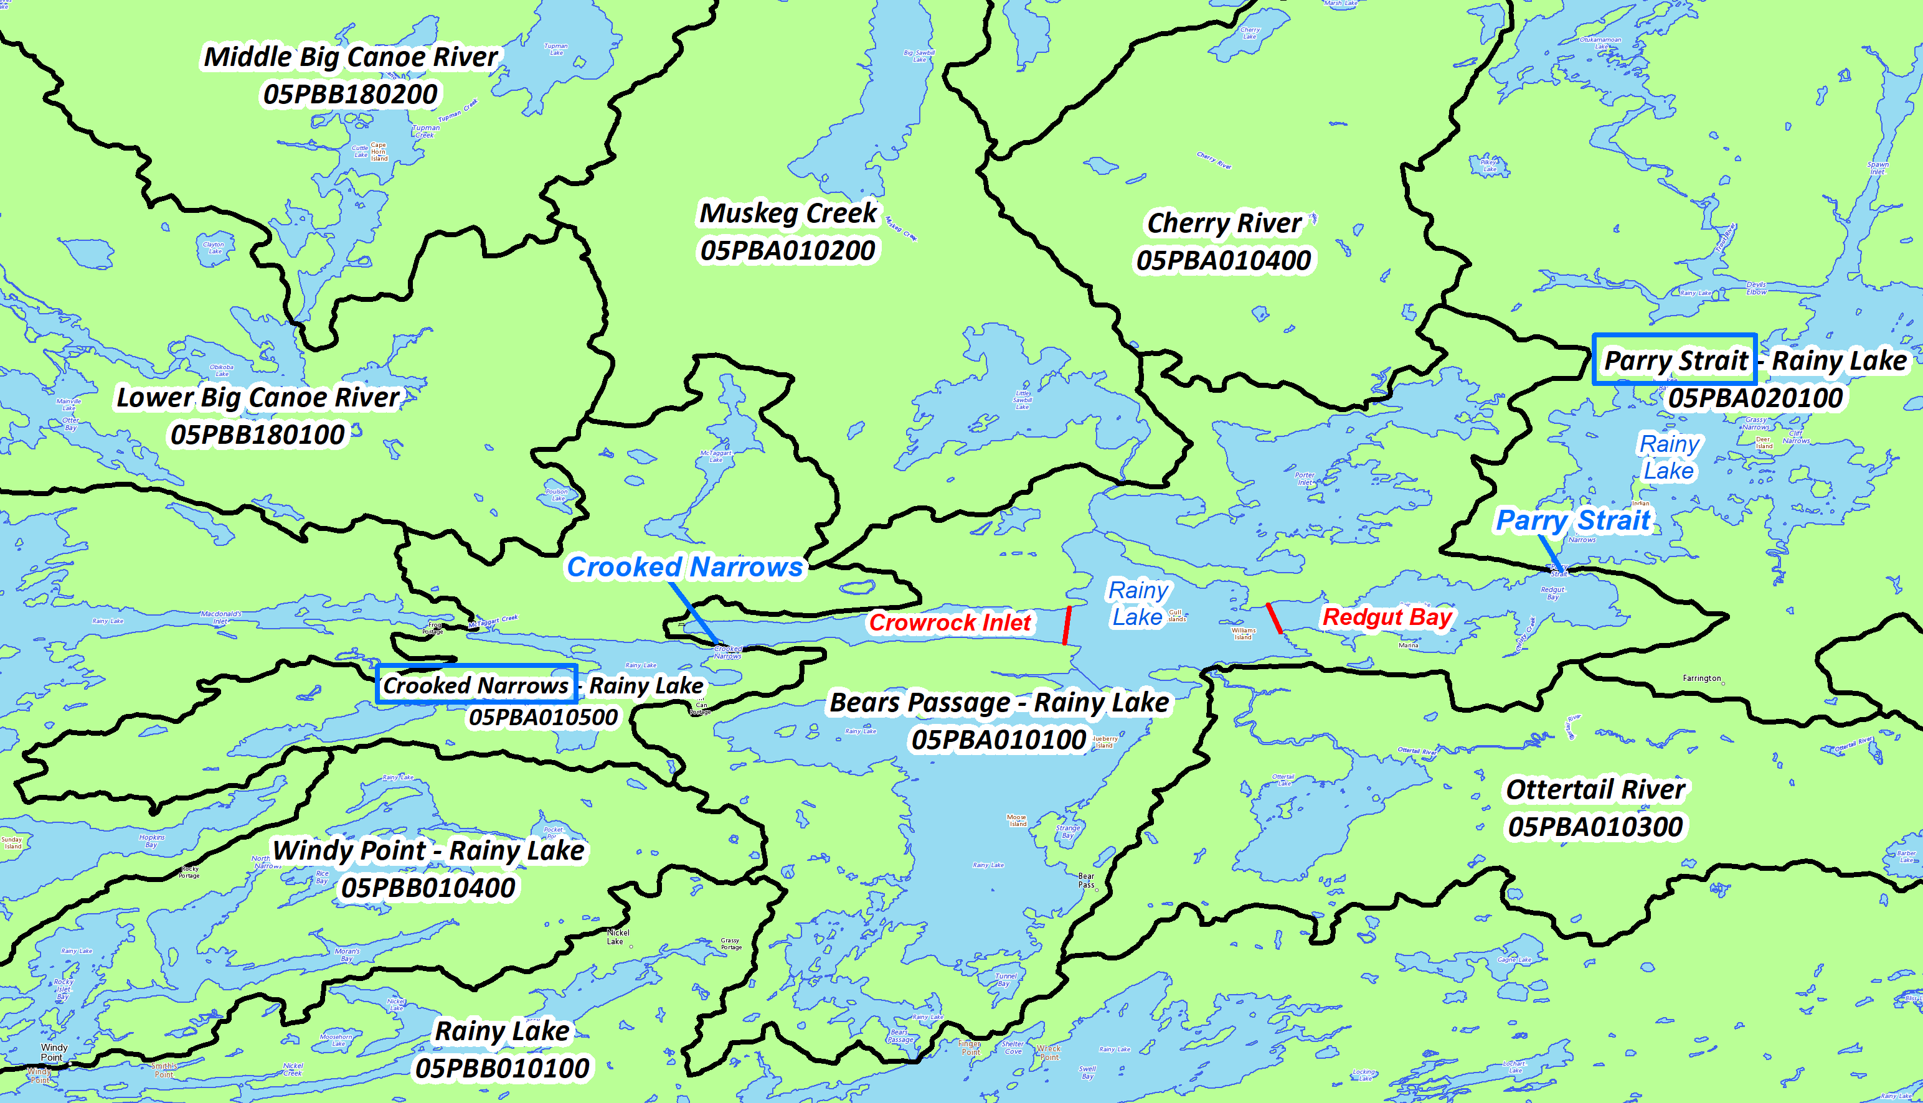
Figure 1: A HUC-12 or 5th level watershed example dividing the Rainy Lake system at the narrow points which are named features (Crooked Narrows and Parry Strait) as opposed to crossing at the wide bay inlets in red. These named features are incorporated into the names of the HUC-12 units draining into Bears Passage – Rainy Lake (refer to text highlighted by blue boxes). 5th level names are shown in black along with their corresponding watershed codes.

  - Similar to the HUC system, there can be exceptions to the area-size criteria where some units may fall under or exceed the acceptable range for a given level. Variances are up to 10 percent in the American system (USGS, 2013).

Watershed Outlets
- A watershed unit should typically drain to one outlet if possible.
  - Suitable exceptions would include dams and spillways, or multiple outlets from a lake (see Figure 2).
  - In some cases, small adjacent tributaries, which individually do not meet the HUC area criteria, could be lumped together as one unit draining to a common water feature ‘downstream’. This feature could be a large lake system (e.g., Great Lakes) or a very large river system (e.g., Moose or Albany River in the far north). See Figure 4 for a hypothetical example.
  - In more complex large river-delta systems, you may encounter multiple outflows or pour points at the river mouth to properly define the watershed unit. See Figure 10 and Figure 11 for an example of a river watershed having two outlets.
- For single line features, the outlet would be represented as a ‘pour point’ (see Figure 3). For double line features, it should be portrayed as a straight line ‘delimiter’ traversing from one edge of the outlet to the opposite edge usually at visually definable points (e.g., a confluence or lake outlet) along the stream-lake network (see Figure 2). To be classified as a suitable outlet, the location should be constrained by a river system (located on the known network) and exhibit flow properties that can be reliably measured. Delimiters across open bays are not suitable candidates for watershed divides.
  - A delimiter must be a straight line snapped between two nodes, one on each bank with one additional vertex where the linear flow path line intersects the delimiter without a change in direction.
    - An exception to this ‘straight line’ rule is if the delimiter follows a known physical feature (e.g., distinct edge of a waterfall where a change in elevation is observed) or barrier (e.g., upstream side of a dam. In the OHN, note the water body portion lying underneath a dam polygon is removed from the OHN-Waterbody layer).
  - Practically all foundational hydrology datasets and derivatives are considered and ‘integrated’ into the location of a delimiter. In other words, they should be directly coincidental across all these datasets whenever possible. These datasets include double-line water bodies, watercourse centrelines (e.g., single line features and virtual segments) at the point of intersection with water bodies, and watershed pour points or delimiters. Where possible, there should also be coincidental nodes across various related hydrographic layers including named features, dams and barriers, and OHN Hydrographic Point / Line / Area data classes. Figure 2 below highlights the ‘coincidental node’ rule, as well as some OHN-Watercourse and OHN-Waterbody segmentation rules (MNR, 2020).
  - Ancillary datasets which could have a bearing on the location of delimiters can include but are not limited to road crossings, dams and barriers, and falls and rapids, or significant changes in elevation.
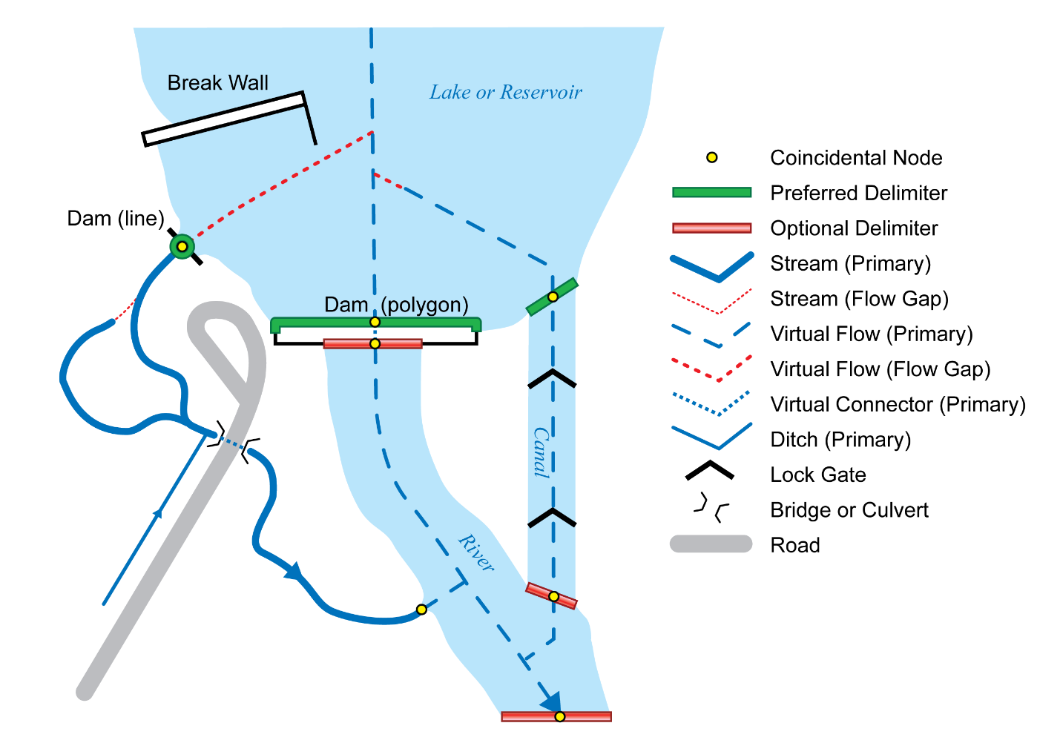
Figure 2: Illustrates several hydrographic features and concepts, including delimiter placement, coincidental nodes between water features and primary versus flow gap stream classification. Note some delimiters are captured from bank-to-bank for double-line features, and others are captured as points or circle geometry for single-line features. Preferred delimiters typically capture outlets uniformly for a single feature (in this example, a lake). The optional delimiters indicate areas downstream of the feature of interest which may be chosen if the feature complexity makes ideal placement impossible or not practical.
- Watershed outlets will be defined based on the downstream official named extent of a river system whenever possible.
  - An exception might be the overriding area criteria imposed on certain watershed units which may require splitting a named system.
- Watershed outlets can be located at the downstream end of lakes where no named stream exists or when splitting a named river system.
  - Particularly in the case of smaller features like named brooks or creeks that are divided by multiple lake systems, it may make more hydrological sense to base the natural watershed divide or outlet on a more prominent feature like the downstream end of a lake, resulting in a split of the smaller named stream feature.

Watershed Naming
- New watershed names should be based on the official names of features at the downstream outlet including lakes, streams, wetlands, dams and rapids. If no name exists or if the outlet feature is a brook or creek, the name can be based on the most prominent water feature within the watershed.
  - Some historically defined watersheds or local interpretations by First Nations may not follow this principle. In the absence of any provincially named water features, these alternative sources could be used.
  - If no prominent named water feature exists, other notable features could be referenced such as community names, prominent forests or parks, regional or NTS sheet names etc.
- Naming conventions for watersheds vary across federal and provincial jurisdictions, largely stemming from historical differences which have evolved over time. Ontario will make every effort to align existing and new watersheds with federal or international names wherever possible. The following are some exceptions:
  - The use of alternate names based on local community or First Nations preference. If this is the case, these local names should still be passed on to the Geonames group whenever possible so that they may be included in their database.
  - The use of the term ‘headwater’ in the national fabric should be avoided. The definition of this term varies with jurisdiction and organization, but the basic premise is a headwater region can exist anywhere within a watershed where water is deemed to originate. There is also interest in protecting these areas for drinking water purposes, biodiversity and other concerns. Therefore, for the purpose of clarity and avoiding potential bias, the province of Ontario has opted out of using this term in the naming of watersheds.
  - Ontario will always include references to the type of hydrology feature(s) (e.g., ‘Lake’, ‘River’, 'Creek’ etc.) used in watershed names, whereas federal names currently do not.
    - This principle has been implemented for all levels except the tertiary watershed level for the time being. Concerns have been expressed for changing these names because of various existing
government monitoring (e.g., ECCC HYDAT) and permitting (e.g., MECP Permit to Take Water) programs referencing this level. However, Ontario still plans to standardize this level in the near future because the watershed code can be used as a common linking identifier for both old and new names where watersheds have not fundamentally changed spatially.
  - The use of the terms ‘Upper’, ‘Middle’, and ‘Lower’ is acceptable only if there are no other significant named features in these sub-watersheds. The higher federal levels from tertiary up to primary have used this nomenclature on occasion.
- Watershed names can typically have 2 descriptors or ‘elements’ separated by a hyphen or ‘element1 – element2’. The first descriptor references the feature ending at the downstream outlet of the watershed, the second descriptor references the ‘parent’ feature in a nested watershed scenario. In other words, where a river system extends over a large distance and is interrupted by several lakes, in order to meet the area threshold criteria, the system can be divided into a series of nested watersheds, each ending at a lake outlet or tributary confluence along the same river reach. For example, in the Lower Attawapiskat 04FC watershed, you could have several watersheds nested along the major river system, each having a name with 2 descriptors. Suppose we have ‘Lake One’ and ‘Lake Two’ along the river system where we want to introduce watershed units. The resulting names would be ‘Lake One – Attawapiskat River’ and ‘Lake Two – Attawapiskat River’. See watersheds ‘1’ and ‘2’ in Figure 3 below for some visual examples. (e.g., A real world example would be “Makokibatan River – Upper Albany River”, which is the name for tertiary watershed 04GD).
  - An exception to the above scenario typically happens at the downstream end of the river system extent. To clarify, the feature at the outlet is not a lake but is the main river mouth itself. In this case, there are two options:
    - The first descriptor would be based on the most significant feature within that watershed upstream of the outlet. For example, this could be a lake upstream or a tributary draining to the main stem (e.g., watershed ‘3’ in Figure 3 below).
    - In the absence of other features, simply referencing the parent feature followed by ‘Outlet’ is also acceptable. For example, “Attawapiskat River Outlet”.
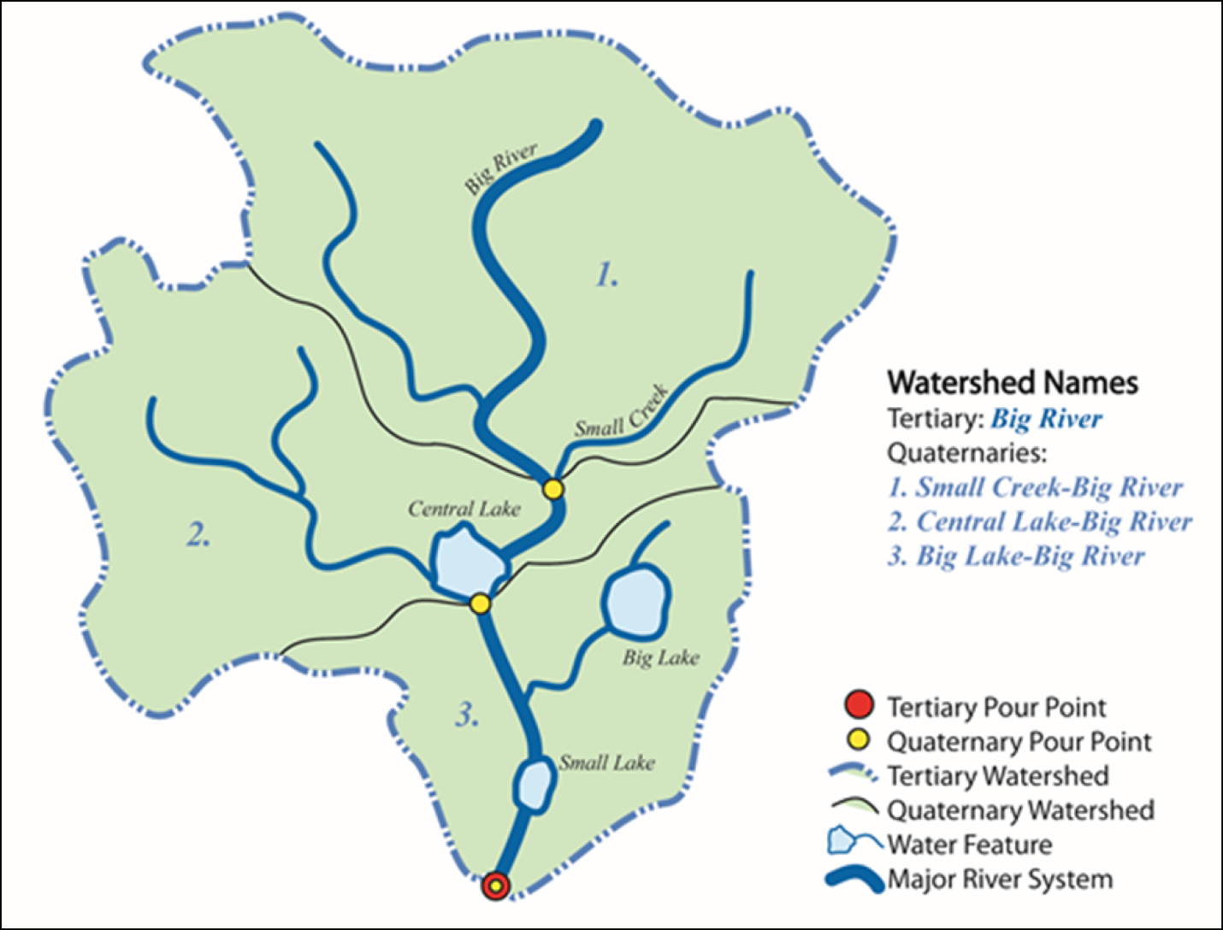
Figure 3: Hypothetical scenario illustrating proper watershed naming conventions.
  - An exception to 10.1 would be in the case of smaller river systems like brooks and creeks, where it would make more sense to follow hydrologic principles rather than named extent principles. In this case, the watershed should be based on the most prominent feature in the area (e.g., a large lake would take precedence over a small brook or creek the lake drains into). Instead of ending the most downstream unit at the outlet of the named stream feature, you could take the delineation upstream to the nearest lake outlet (e.g., in this case, it would be to the outlet of Small Lake in Figure 3). The stream segment downstream would then become a ‘headwater’ contributing segment to the next watershed downstream.
  - Watershed units having multiple outlets draining to a shoreline often occur in the stateside WBD dataset. Examples of this are common along the Great Lakes shoreline where the ‘dragon-back’ approach has been adopted. This approach lumps all tributaries sharing inland boundaries together to form a grouped watershed unit at any level in the watershed hierarchy (see Figure 4.a. By contrast, this only happens at the tertiary or higher level in the Ontario system where quaternary shoreline watersheds that share inland boundaries can be lumped together to form a tertiary watershed unit (Figure 4.b). The larger unit can be named according to the named features at these major outlets, each element separated by a hyphen. The order of the naming should be based on the general direction of the prevailing current of the water body the watershed drains to (e.g., ‘upstream name first – downstream name second’). The upstream and downstream named feature outlets (those outlets that are closest to the shoreline extents of the watershed unit) can be combined to create the watershed name. Optionally a third element could be added if it provides a better description of the watershed unit (see the APPENDIX A for more historical detail concerning the dragon-back approach in Ontario). This option is available to support the ‘dragon-back’ approach for Great Lake units stateside. However, in Ontario, this naming convention is limited to tertiary or higher-level watersheds that drain to major shorelines like the Great Lakes or Hudson Bay. Quaternary and smaller level units will always follow the classic single pour-point watershed definition wherever possible as described in section 1.

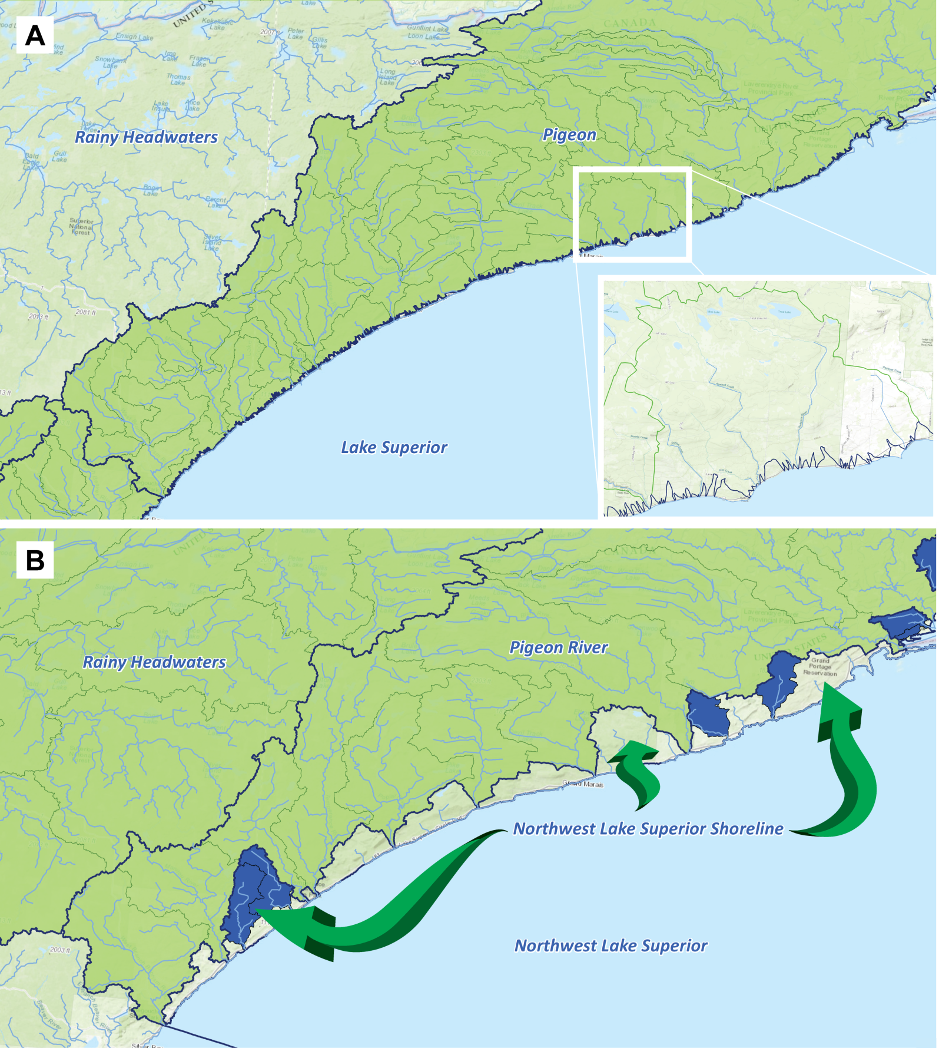
Figure 4.a: The dragon-back approach implemented stateside for the Great Lakes lumps all tributaries that have shared inland drainage boundaries together to meet the appropriate area threshold criteria. Inset figure shows every tributary large and small is captured in the delineation. This approach does not follow the classic watershed definition because each ‘lumped container’ has multiple outflows draining to the lake shoreline. Figure 4.b: The Ontario approach lumps classic quaternary watersheds that have shared inland drainage boundaries together to create higher level inland watershed units. Tertiary watersheds along the shoreline are still like containers if they drain to several points on the shoreline but they are fully nested within the hierarchy and each point can be monitored at the quaternary level. This is not possible with the U.S. dragon-back approach. The dark blue watersheds satisfy the 5th level size criteria and belong to the Northwest Lake Superior Shoreline unit.
  - Watershed names will not be duplicated as you navigate through the watershed level hierarchy. This especially becomes an issue as you go beyond the quaternary into smaller 5th or 6th level units, which sometimes occurs in the United States system. If finer units are adopted in the future, a re-evaluation of the quaternary names may be required if they do not represent the water feature at the outlet, and the name may be more suitable at the finer level. This approach will provide as much locational information or ‘intelligence’ to the watershed names as you go down levels.

Headwater Scenarios
- In the case where a headwater lake shares multiple outlets into diverging watersheds, a primary outlet will be defined, and the rest classified as secondary. In the context of watershed delineation, the lake would be lumped with the primary outlet and the delineation would go around the lake and ‘touch’ where the secondary outlet(s) leave the lake into neighbouring watersheds.
  - If the headwater feature intersects a distinct ridge, the location of the ridge in relation to the outlets of the lake could influence where the watershed is delineated.
  - In the case of headwater wetlands with well-defined elevation characteristics, the DEM can drive the delineation and intersect through the wetland.
  - In the absence of distinct height of land divides especially around large headwater lakes, there are usually other visual cues to help determine primary and secondary outlets out of headwater lakes or wetlands including: stream width; the presence of rapids; or sharp elevation changes like what occurs at a falls or dam location.
  - However, when there is: 1) no viewable outlet on either side of the feature or no distinct difference between them as portrayed on available imagery; and 2) no discernable change in elevation can be determined at each outlet; then the following principles can apply:
    - First consider the features downstream. If one outlet stream feeds directly into a double-line feature (river or lake) and all other outlet streams feed into single-line confluences downstream, then an assumption can be made that a greater quantity of water flows through the outlet feeding to the double-line feature. In this case, then this stream would be tagged as the primary outflow.
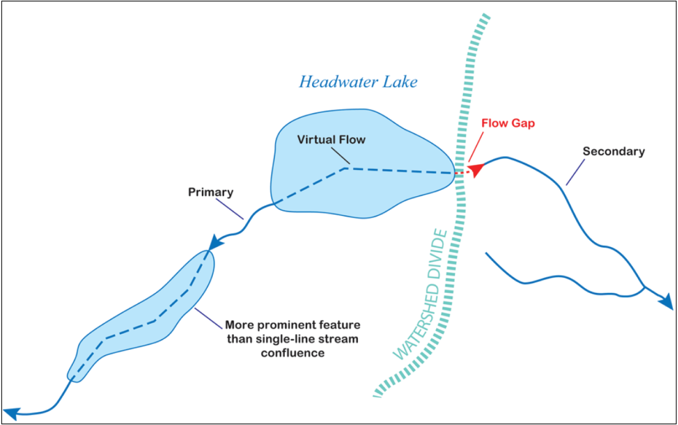
Figure 5: Headwater scenario where one outlet feeds to a double-line feature downstream, and the other feeds to a single-line confluence. Note the virtual flow segment identified may no longer exist in the current OHN data, where all outflows may simply touch the edge of the headwater lake.
    - If some or all outlet streams feed into double-line features downstream, then the length of each out-flowing stream to the next waterbody should be considered. In the case of double-line features, the shortest reach would be considered the primary outlet, and the longer reaches would be secondary. Rationale: More water is likely to flow through the feature feeding a double-line feature in close proximity downstream (AAFC/S&TB).
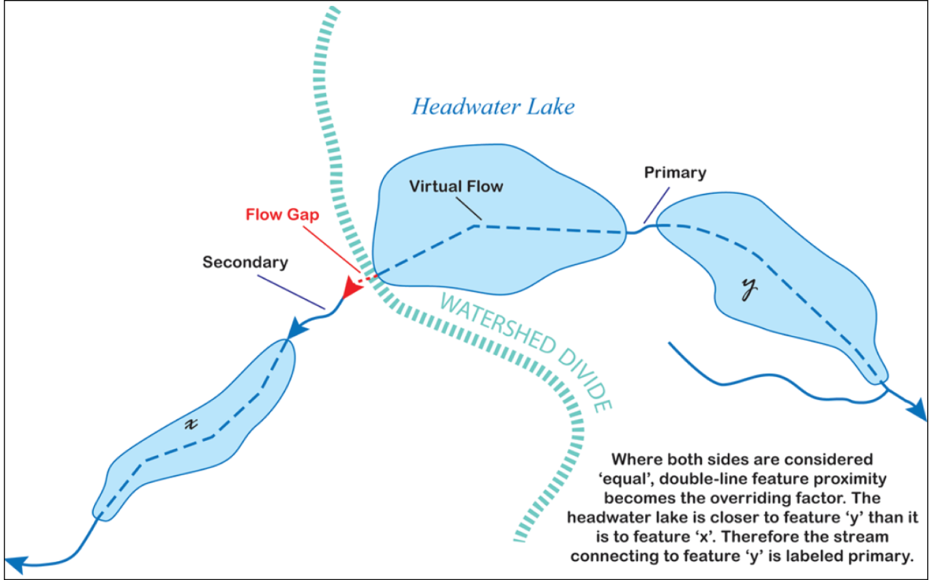
Figure 6: Headwater scenario where both outlets feed to double line features downstream.
    - However, if all outlets feed to single-line confluences downstream, the opposite would be true where the longest reach would be considered primary, and all others are secondary. The reason for the reversal relates to the quantity of water flowing through these features. Rationale: With both or all outlets being single-line streams feeding into confluences downstream, the longest stream segment would contain more water assuming the rate of flow is equal for all outlets. Therefore, feature length would take precedence in defining the primary (rather than feature proximity in the previous points).
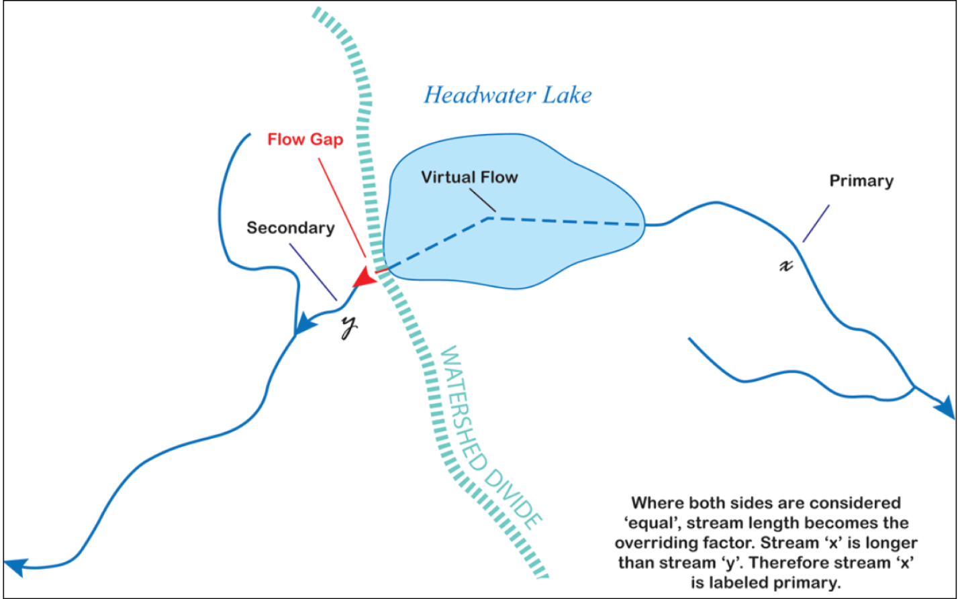
Figure 7: Headwater scenario where both outlets feed into single-line confluences downstream.

Rivershed Scenario
- River sub-watersheds (or ‘riversheds’) will be created to define the upper inlet and lower outlet extents of Connecting Channels (which are rivers ‘connecting’ the Great Lakes along the International Boundary including St. Marys, St. Clair, Detroit and Niagara Rivers - see example in Figure 8), and other similar large river systems or certain sections along them (like the St. Lawrence and Ottawa rivers).
  - Whether small tributaries off the main stem should be lumped with a quaternary rivershed or a tributary watershed is normally dependent on whether its drainage area meets the size threshold of a quaternary level watershed. In the absence of stream reach catchments or surveyed information defining the catchment area, the stream length of 20 km can be used as the threshold criteria. If the tributary falls below this threshold, it is lumped with the rivershed. If the tributary exceeds this threshold (e.g., larger than the minimum quaternary threshold), it can have its own unique watershed delineated.
  - Exception to threshold size rule: If the tributary follows the morphology of its parent river system (e.g., Running parallel within the flood plain, participates as a segment of a braided river system, or oxbow tributaries), it can be lumped with a rivershed unit even though it may exceed the stated threshold criteria.
  - This principle was tested in the far north where major named rivers can extend for 100’s of kilometres. Many examples of riversheds can be found in the older Far North Quaternary Watersheds dataset. However, dividing the system this way resulted in unnatural tributary watershed groupings, which caused some confusion with First Nation communities and planners. PMU decided to revert to a classic watershed / sub-watershed definition for these inland areas in the newer OWB dataset.

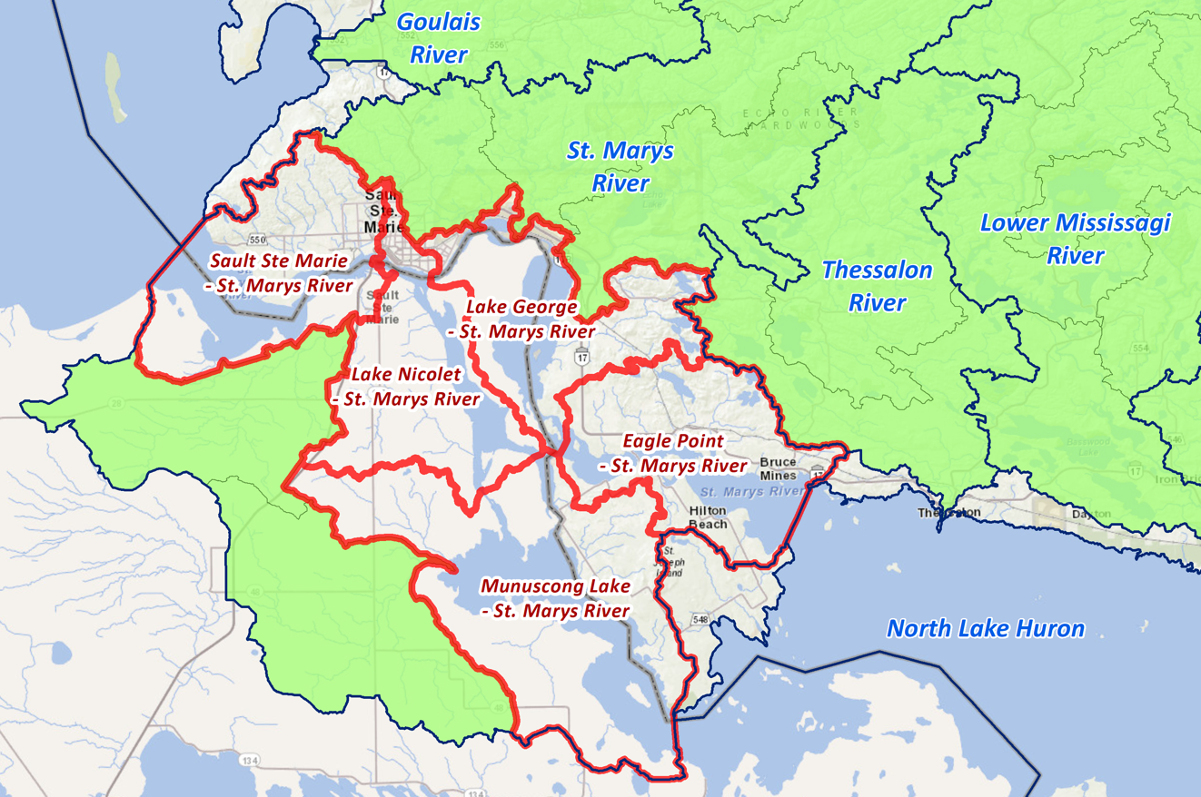
Figure 8: A series of riversheds outlined in red that make up the St. Marys River corridor. Note the green inland areas to the north in Ontario and south stateside which also drain to St. Marys River.

Lakeshed Scenario
- ‘Lakesheds’ define the sub-watershed area which drains directly to a lake shoreline excluding major upstream river systems. For a 6th level unit, only small tributaries and shorelines between them which drain an area of less than 1 sq.km (criteria established in the MNR Aquatic Ecologic Land Classification project – PGSC, 2014) would be incorporated into the lakeshed unit. For a higher-level unit, the shoreline drainage area threshold would be governed by the upper limit of the next watershed level below it (see Figure 9 below for an example of a quaternary lakeshed). To distinguish lakesheds from ‘lake watersheds’, the total upstream area draining to a lake (including all nearshore interfluves and tributaries) would be referred to as a lake watershed unit (or an example of a ‘true watershed’).
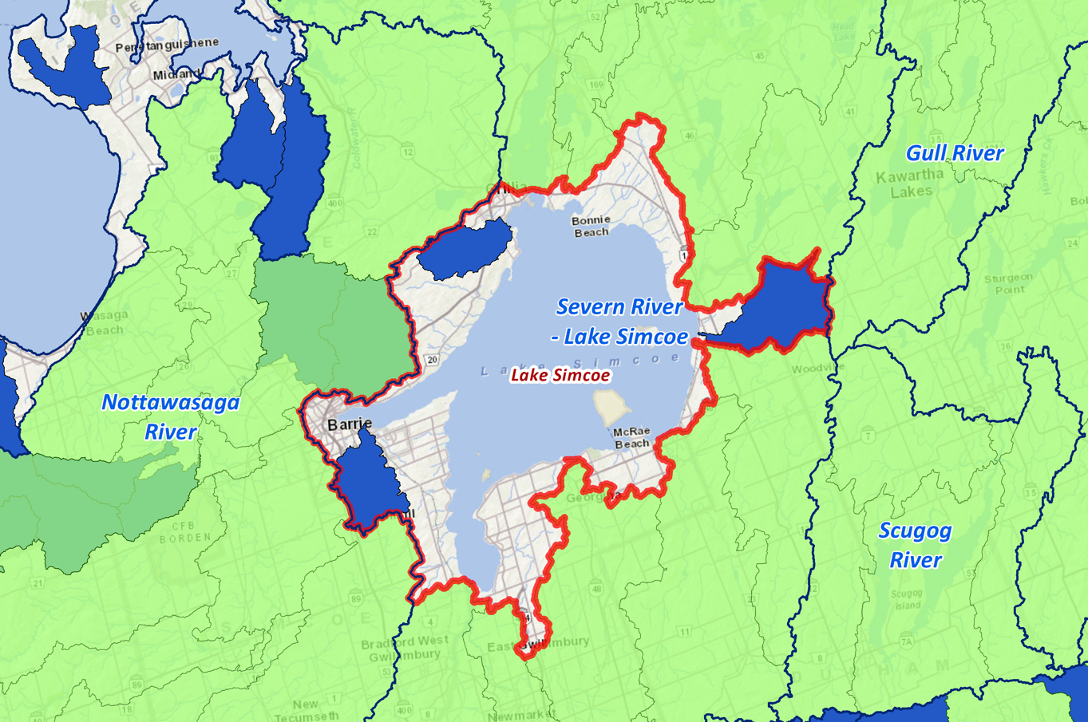
Figure 9: Lake Simcoe is an example of an inland quaternary lakeshed shown in red, along with three 5th level watersheds within it in dark blue that drain to the shore of the lake. Other quaternary lakeshed examples in Ontario include Lake Nipissing, Lake Nipigon and Lake of the Woods. Green fill and outlines are other inland quaternaries, and black outlines are tertiary divisions. Some blue areas overlaid with a green transparency in Nottawasaga River watershed indicate where some inland quaternaries have been sub-divided to the 5th level.
  - An example of a large lakeshed system is Lake Ontario (029), a portion of which is shown in Figure 10 below. At this scale, the lakeshed is divided up into a series of tertiary ‘regions’ where only isolated quaternaries (not sharing an inland boundary with another quaternary draining to the same lake) and all smaller tributaries are lumped to the greater lakeshed unit. There are two types of regions – shoreline regions and in-lake regions – which make up the greater lakeshed unit. The lakeshed concept is being applied federally at the secondary watershed level (HUC-6) across the entire Great Lakes Basin as part of the IJC initiative.
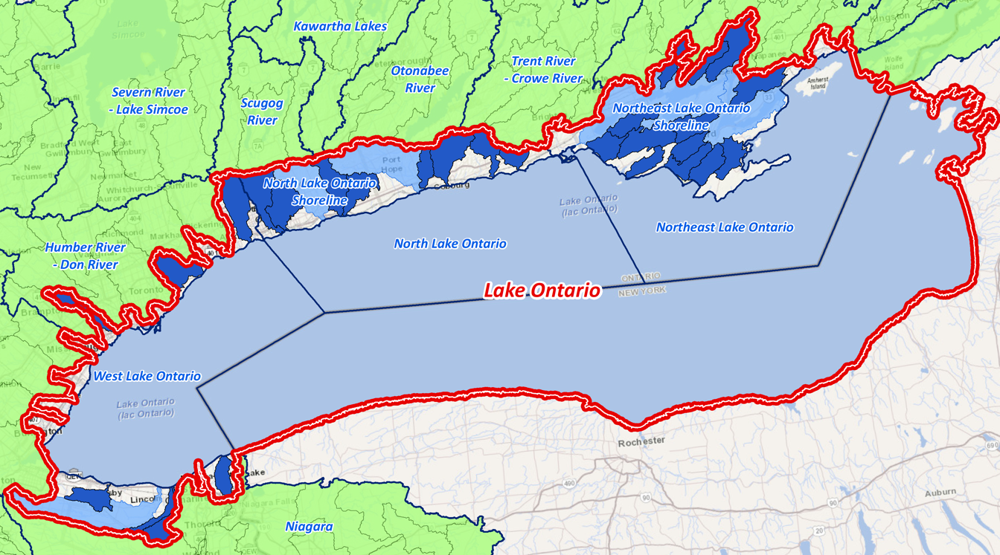
Figure 10: This figure illustrates the lakeshed for Lake Ontario as a thick red outline. New lakesheds at the secondary level were introduced for each Great Lake and were sub-divided into tertiary watershed regions outlined in black cutting through the lake. Areas draining overland directly to the lake shoreline are lumped with the Lake Ontario secondary lakeshed unit including some isolated quaternary watersheds like the Ganaraska River and Bowmanville Creek, a series of darker fifth level watersheds and the remaining areas in white. By contrast, the stateside ‘dragon-back’ version tightly hugs the shoreline because all inland tributaries both large and small are lumped together to form tertiary ‘containers.’ Because containers are contrary to the ‘true watershed’ concept, Ontario chose not to adopt this approach.

Other Considerations
- For more complex systems (e.g., braided channels and deltas occurring at the mouths of river watersheds), rather than just considering the water body or named extent in the placement of delimiters, you should also consider the morphological characteristics of a river system, which includes not only the channel itself but the surrounding floodway or floodplain, or similarly the observed high-water mark during springtime flood conditions. Other data sources like elevation and imagery become important to assist in determining the proper location for watershed delimiters. See APPENDIX B for an example scenario in the far north of Ontario.
- For the purpose of differentiating specific hydrology characteristics within watersheds, the “wetland fringe” concept can be used to describe the interface between the mainland and large lake or bay systems. For the most part, this concept has not been applied to date in the Ontario Watershed Boundary dataset except for what is noted below. The wetland fringe is defined as a lake or ocean shoreline area directly influenced by fluctuating seasonal or tidal water levels where the normally observed high-water mark defines the upper extent of the zone. This high-water mark can be used to differentiate between an upland sub-watershed unit and an adjacent lake (or "water basin") sub-watershed unit. (MNDNR, 2012)
  - In Ontario’s Far North, this division would be comparable to the upper extent of the intertidal zone along the Hudson / James Bay shoreline. The wetland fringe concept would also have merit in the Great Lakes and Hudson / James Bay systems where coastal wetlands or seasonally inundated areas are predominant. Verifying with recent coastal land cover and elevation information may help to refine the definition of these areas. This concept may also work well on some smaller lake systems in boreal regions but is not recommended in areas with floating vegetation like fen or peatland-dominated areas. Currently there are no plans to adopt this type of delineation in Ontario.
  - In the Rainy River basin, the wetland fringe concept was applied to stateside portions of the Lake of the Woods complex.

- Interlayer Dependency and Impacts of Hydrology Changes in the IJC Project: Implications on Maintenance and Data Sharing
Updating watercourse geometry and flow direction concurrently while the conceptual watersheds were being drafted for the Rainy River and Great Lakes basins had a direct and immediate impact on the derivative products needed to create the final version of watersheds for the IJC IWI project. Each issue and the related interdependencies were dealt with ‘on-the-fly’ and the key groups involved – including MNR at the provincial level; NRCan and ECCC at the federal level; and IJC and USGS at the international level – were notified of updates where necessary along the way. The response, uptake and cooperation between agencies was generally immediate and very positive. However, this relationship was only short-term without much consideration over the long-term maintenance or governance strategies beyond the scope of the project. After the IJC project’s conclusion, the Task Force members expected that each government agency would continue to be custodian over the data in their jurisdiction but an actual centralized home for a truly ‘harmonized dataset’ was never realized. A truly harmonized dataset would not only include the final watershed boundaries, but the source watercourse, water body and elevation information used to compile these boundaries. This outcome would require extensive resources and a coordinated effort between agencies to continually maintain and update the data over time. Some argued this role could rest at the IJC level as a coordinating body, however they lack the funding and support for any consideration of a long-term commitment. These issues were raised early on, but no clear direction was given beyond the scope of IWI. Therefore, the best alternative objective would be each agency to maintain the currency of their own data and make their data openly available for future needs and data sharing as they arise.
In the operational sense from MNR’s perspective, there are many contingencies, business processes, best practices, funding and resource realities to consider which may hinder our responsiveness to updating our hydrology information. These layers are all interdependent and when we change a feature (add, delete or modify), our derived and analytical data will also require updating or risk becoming out of sync with the latest changes in the foundational geospatial data products ~ not to mention all the third party interests who leverage our data in policy and science applications.
Therefore, a trigger-based maintenance workflow needed to be developed to manage change over time. MNR continues to resolve its own workflow processes so that the ministry is better able to address the needs of provincial mandates including forestry and fishery management, renewable energy, flood forecasting and watershed planning related activities. It is important to note the ability to respond to changes over time will depend on the ministry’s current priorities and the resources that are available.
In the context of the IJC project, MNR considered the watercourse changes in a 'conceptual' fashion particularly in the early stages of the project (e.g., the Rainy River phase). Geometry issues were logged for future implementation, and then the necessary changes to the IJC watershed layers were accounted for up-front using the anticipated watercourse changes and re-creating interim products and derivatives manually on-the-fly. The downside here is that you may come up with a watershed fabric which does not comply with the current foundational geospatial data but is expected to in the long term. The reality behind the IJC related work is that much of the analysis was performed using interim data or snapshots and using different hydrology techniques than practiced at the provincial level. These issues were alleviated somewhat when the focus shifted to the Great Lakes basin, where MNR was able to provide updates based on newly updated base data instead of conceptual manual interpretation. The final watershed data was re-interpolated provincially using our business-approved methods and best practices established for maintaining our medium-scale data products (e.g., OHN, PDEM and OIH). All this shared knowledge and lessons learned went into the creation of the new Ontario Watershed Boundaries (OWB) dataset released in 2020.
- References
Biotactic, 2001. Movement and Behaviour of White Suckers at the Old Welland Canal Siphons: Impacts of Flow Reversal. Biotactic Incorporated, Kitchener, Ontario.
Hogue, Tom, 2014. A Bend in the River: A journey down the Welland River from its headwaters in Hamilton. The Hamilton Spectator Archives.
(Contact source: https://www.thespec.com/newspapers/
Originally posted: https://stories.thespec.io/2014/09/17/hello-world/)
IJC, 2009. The International Watersheds Initiative: Implementing a New Paradigm for Transboundary Basins. 3rd Report. International Joint Commission. ISBN: 978-1-100-12002-7. (https://www.ijc.org/sites/default/files/ID1627.pdf)
Ministry of Natural Resources and Forestry (MNR), 2020. Data Capture Specifications for Hydrographic Features: Medium Scale. Geospatial Ontario, Digital, Data, Information and Business Services Branch, Corporate Management and Information Division.
(http://www.google.ca/search?q="Data Capture Specifications for Hydrographic Features: Medium Scale")
MNR, 2026. User Guide for Ontario Watershed Boundaries (OWB). Geospatial Ontario, Digital, Data, Information and Business Services Branch, Corporate Management and Information Division.
(https://geohub.lio.gov.on.ca/search?q= OWB)
USGS, 2013. Federal Standards and Procedures for the National Watershed Boundary Dataset (WBD). 4th ed. United States Geological Survey. Chapter 3 of Section A, Federal Standards: Book 11, Collection and Delineation of Spatial Data.
(https://pubs.usgs.gov/tm/11/a3/pdf/tm11-a3_4ed.pdf)

APPENDIX A - Dragon-back Approach in Ontario
Early in the evaluation of the Great Lakes basin system up until 2015, Ontario attempted to implement the U.S. ‘dragon-back’ approach for establishing quaternary watersheds along the shoreline. The figure below is a stylized version of this approach and some initial guidelines for naming that were followed at that time. This concept was also applied to some rivershed scenarios in the far north, examples of which can be found in the Far North Quaternary Watersheds packaged product in LIO.
However, several issues arose from this implementation including the fact these units were not classic watershed definitions and several small tributaries could not be included because their inland boundaries were not coincident with any neighbouring boundaries, resulting in isolated units or multi-part features. For these reasons, this approach has since been abandoned in favour of single pour-point quaternary definitions for all watersheds where possible.
However, the naming conventions illustrated below may still have some merit concerning the naming of higher-level watersheds (e.g., tertiary and higher) along the Great Lakes and Hudson Bay shorelines. To date, these conventions have already been adopted for some tertiary level watersheds.
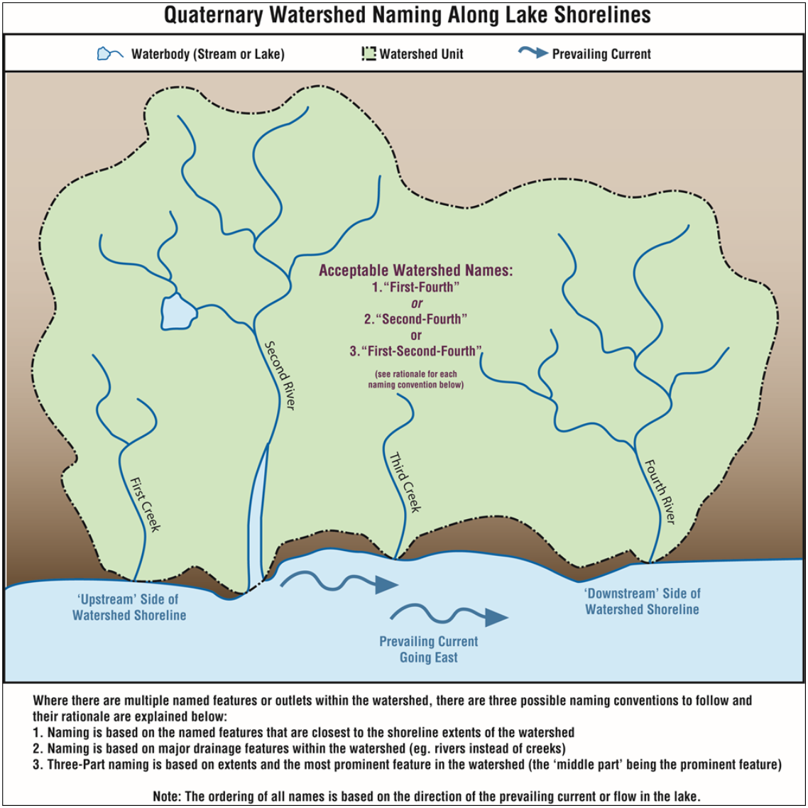
Figure 11: Quaternary watershed naming criteria for lake shoreline watersheds.

APPENDIX B – Complex Watershed Scenario
The figures below illustrate a braided river confluence where the Cheepash River meets the Moose River in northeast Ontario, and some varying watershed interpretations, each with their own advantages and drawbacks. Complex scenarios like this make it difficult to determine the perfect outflow in every situation. The rationale or issue for each delineation shown is also explained.
The Moose River floodplain and the braided streams at the outlet of Cheepash River complicate where the delimiters for the watershed should be placed. A different watershed delineation can result depending on the prevailing criteria that drive the creation of watershed delimiters.
The best interpretations of outflow should take hydrologic, morphological and practical considerations into account especially with larger flowing systems. Not only should we consider the water feature itself which is a snapshot of water levels at a certain time of year, but the immediate surrounding area that has the capability to convey water in periods of flooding. This would typically include the floodplain or high water mark as determined by elevation, which may influence where a watershed should be delineated.
The solid yellow line in the figures below indicates the chosen delineation for Cheepash River which can be found in the new OWB dataset and is delineated from the outlets at locations ‘A’ and ‘B’.
Both ‘A’ and ‘C’ represent the true morphological outlets of Cheepash River when considering the floodplain extent of Moose River (represented as the thick blue-white line), which is evidenced by the emergent wetland vegetation (light green zone in the imagery) in this area. Notice the yellow line delimiter for ‘A’ and the green point delimiter for ‘C’ are coincident with the floodplain line or observed high water mark of the Moose River.
Outlet ‘B’ was preferred over ‘C because it can be argued that the northern branch may not flow all year and may pinch off and outflow via just the main channel (Outlet ‘A’) during periods of low flow. Placing the second outlet at ‘B’ allows us to constrain flow to one side of the river channel for monitoring purposes. Depending on user needs, Outlet ‘C’ could also be adopted as an acceptable delineation, but it may be hard to pinpoint in the field which plays into the practical considerations.
The red and purple interpretations both conflict with the high-water mark or floodway concepts where we may be lumping portions that belong to the Moose River system into an upstream watershed. Scenario ‘D’ introduces a third outlet at the red point delimiter, and scenario ‘E’ would have four outlets caused by the diverting delta. These decisions are made strictly based on the waterbody and watercourse geometry which do not always give the complete picture. In the case of the red delineation, it is also based on the Geoname extent of Cheepash River. When observing the imagery or DEM in the next figure, the problems become evident. The purple delineation is especially problematic when inspecting the watercourse geometry which only captures the northern side of the delta. Both watercourses and elevation are important inputs to watershed delineation. If the flow only represents the main channel at the outlet, it makes delineating a proper watershed difficult at both outflows.
Finally, scenario ‘F’ (in orange) could be an alternative simplified outlet for Cheepash River if the primary objective was to establish a single pour point for the watershed being delineated. However, this would be significantly upstream of the Moose River floodway.
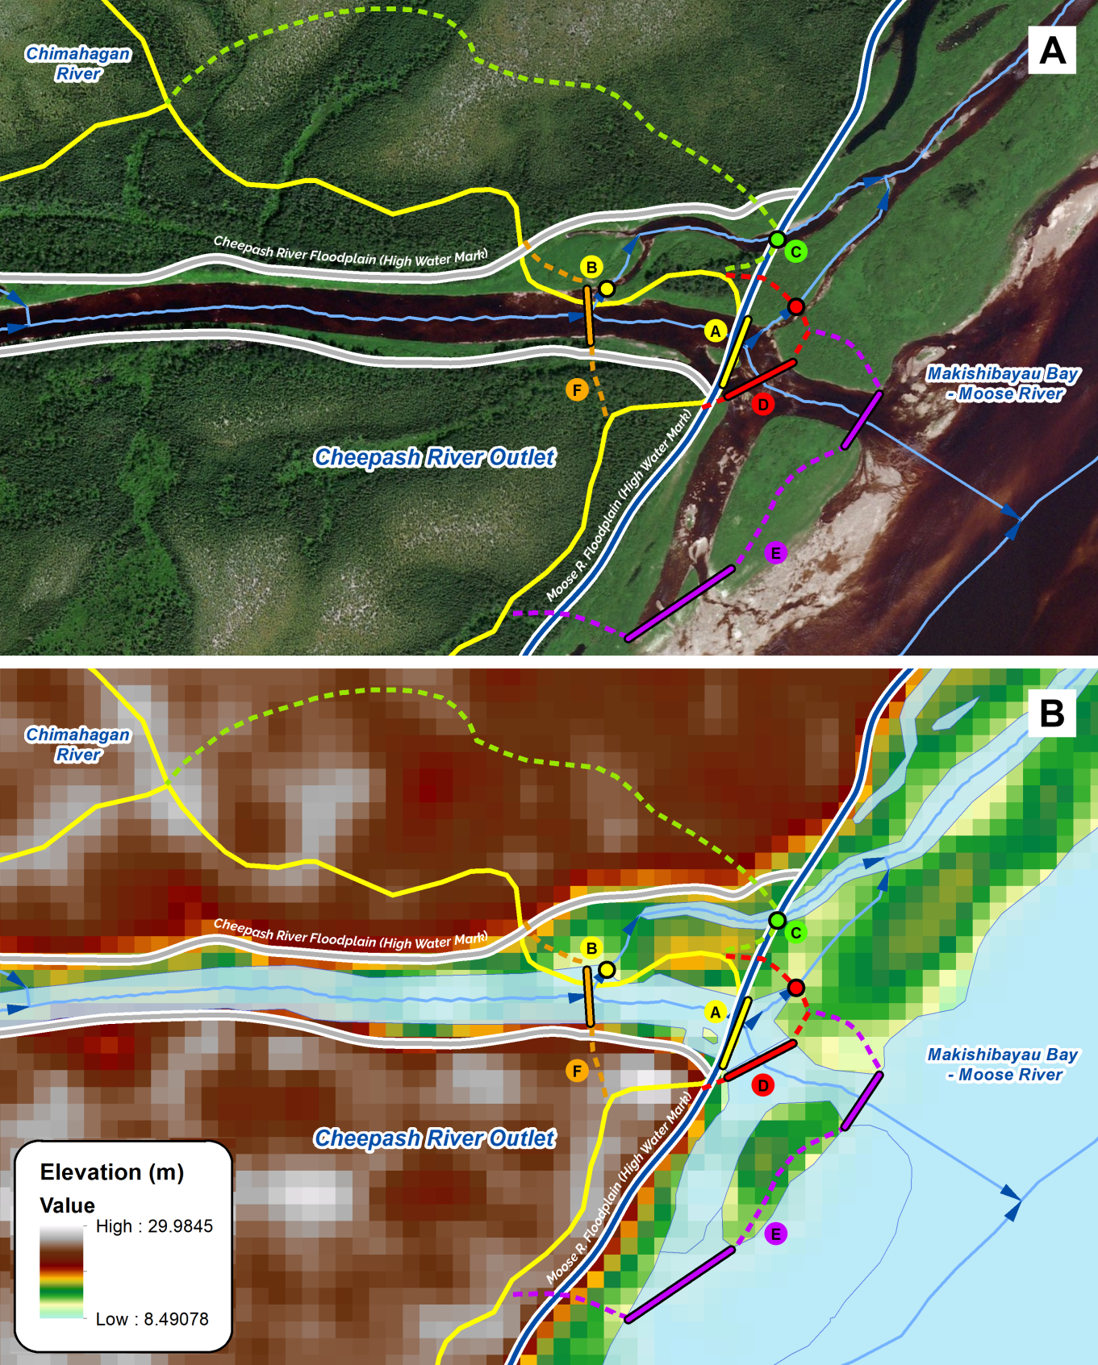
Figure 12: Possible watershed delimiter interpretations for Cheepash River Outlet.
12.a Illustrates the Esri World Imagery for the site and 12.b Includes the Ontario Radar DSM and OHN Waterbody layers. Both figures show the OHN Watercourses (blue arrow lines), Moose River high water mark (blue and white line), Cheepash River high water mark (grey and white line), final quaternary watersheds (yellow lines), and various other possible delineations.
Similar evaluations were conducted province-wide over recent years which have resulted in the release of the new OWB dataset. The work was extensive and based on the best available data at the time of review. The data quality varies across the province and usually cannot be verified on site due to remoteness of the locations and the extensive resources required for conducting such a survey. Therefore, some delineations decided upon for the OWB may raise issues in some cases and input from those with local expertise is encouraged. If there are serious concerns, they should be reported back to PMU for further review and consideration. If there is justification or rationale for adjusting any outflow locations, PMU could entertain them in a future update.

APPENDIX C – Watershed Comparison
This section provides some visual examples of differences between the old watersheds for Ontario and the new Ontario Watershed Boundaries (OWB). The old watersheds were more cartographic in nature and behaved more like ‘containers’ for water features stopping at the provincial border and the shorelines of major water bodies. The new watersheds consider the total upstream contributing area except for areas that fall completely within the United States in the Great Lakes Basin. For these watersheds, users can refer to the USGS Watershed Boundary Dataset (WBD) which will line up seamlessly with the OWB watersheds as of 2019.

Watershed Coverage Extents
Figure 13 highlights the additional watershed area that is now captured in the new OWB dataset including inflowing areas from Quebec, Manitoba, Minnesota, and the Connecting Channels of the Great Lakes system.
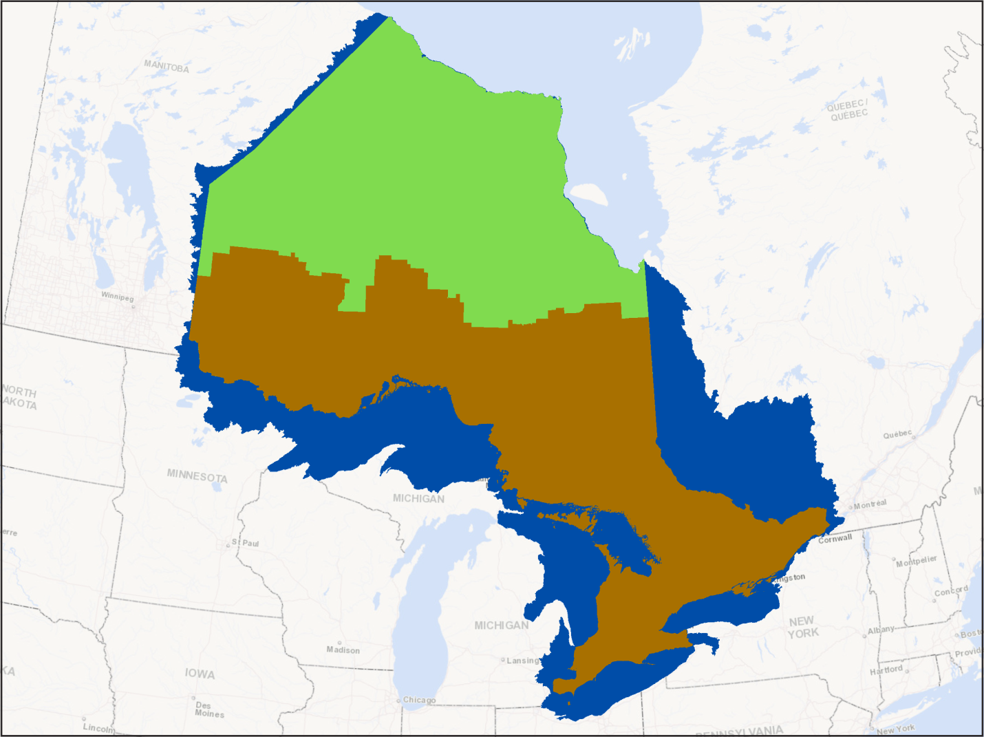
Figure 13: Current watershed coverage for Ontario. Brown area is the area covered by the old quaternary watershed layer. The lighter green area to the north plus the brown area indicates the area covered by the old tertiary and higher-level watersheds. The dark blue region highlights the additional area covered by the new OWB data.

Great Lakes Shoreline
Figure 14 below illustrates an example for Northwest Lake Superior near Thunder Bay. The left image depicts the old watersheds along the Lake Superior shoreline and the ‘container’ concept where a series of tributaries are grouped together as a single unit (e.g., 02AA-01). Small islands are arbitrarily grouped together as multipart polygons and given a single code (02AA-06), and larger islands may be assigned a separate code (02AA-05). The right image shows the new watersheds for the same area. 02AA-01 now drains inland to a single pour point on the shoreline and the rest of the area now belongs to the Lake Superior secondary watershed (021). New smaller single pour point watersheds have been created at the 5th level (in blue) and 6th level (in orange) which constitute direct shoreline drainage to the lake. Island polygons in the old layers were dissolved and now belong to the greater lake polygons at the tertiary level in the new watershed product. These new watersheds now comply with the classic watershed principles described in the Watershed Definition and Area Threshold sections of this document.

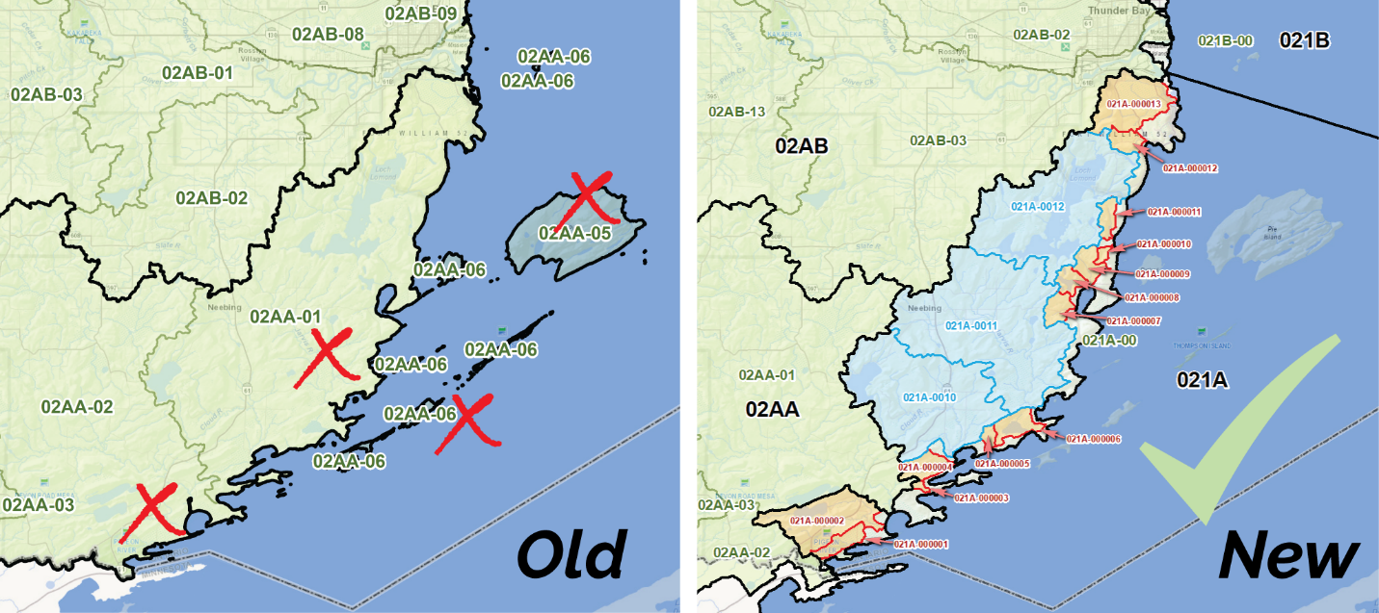
Figure 14: Comparing the old watersheds with the new OWB watersheds for the northwest portion of Lake Superior.
.

Niagara River Watershed
The Niagara River watershed is a special case in Ontario as it has some unique characteristics which were not reflected in the old dataset.
First, the Niagara River is a tertiary transboundary watershed meaning its water contributing area straddles the international border between Canada and the United States (Figure 15B). The old watershed layers stopped at the international border and did not consider stateside drainage (Figure 15A). The development of this unit and its sub-watersheds has been the result of mutual collaboration between the United States, Canada, and the International Joint Commission to support shared management of water resources and related issues.
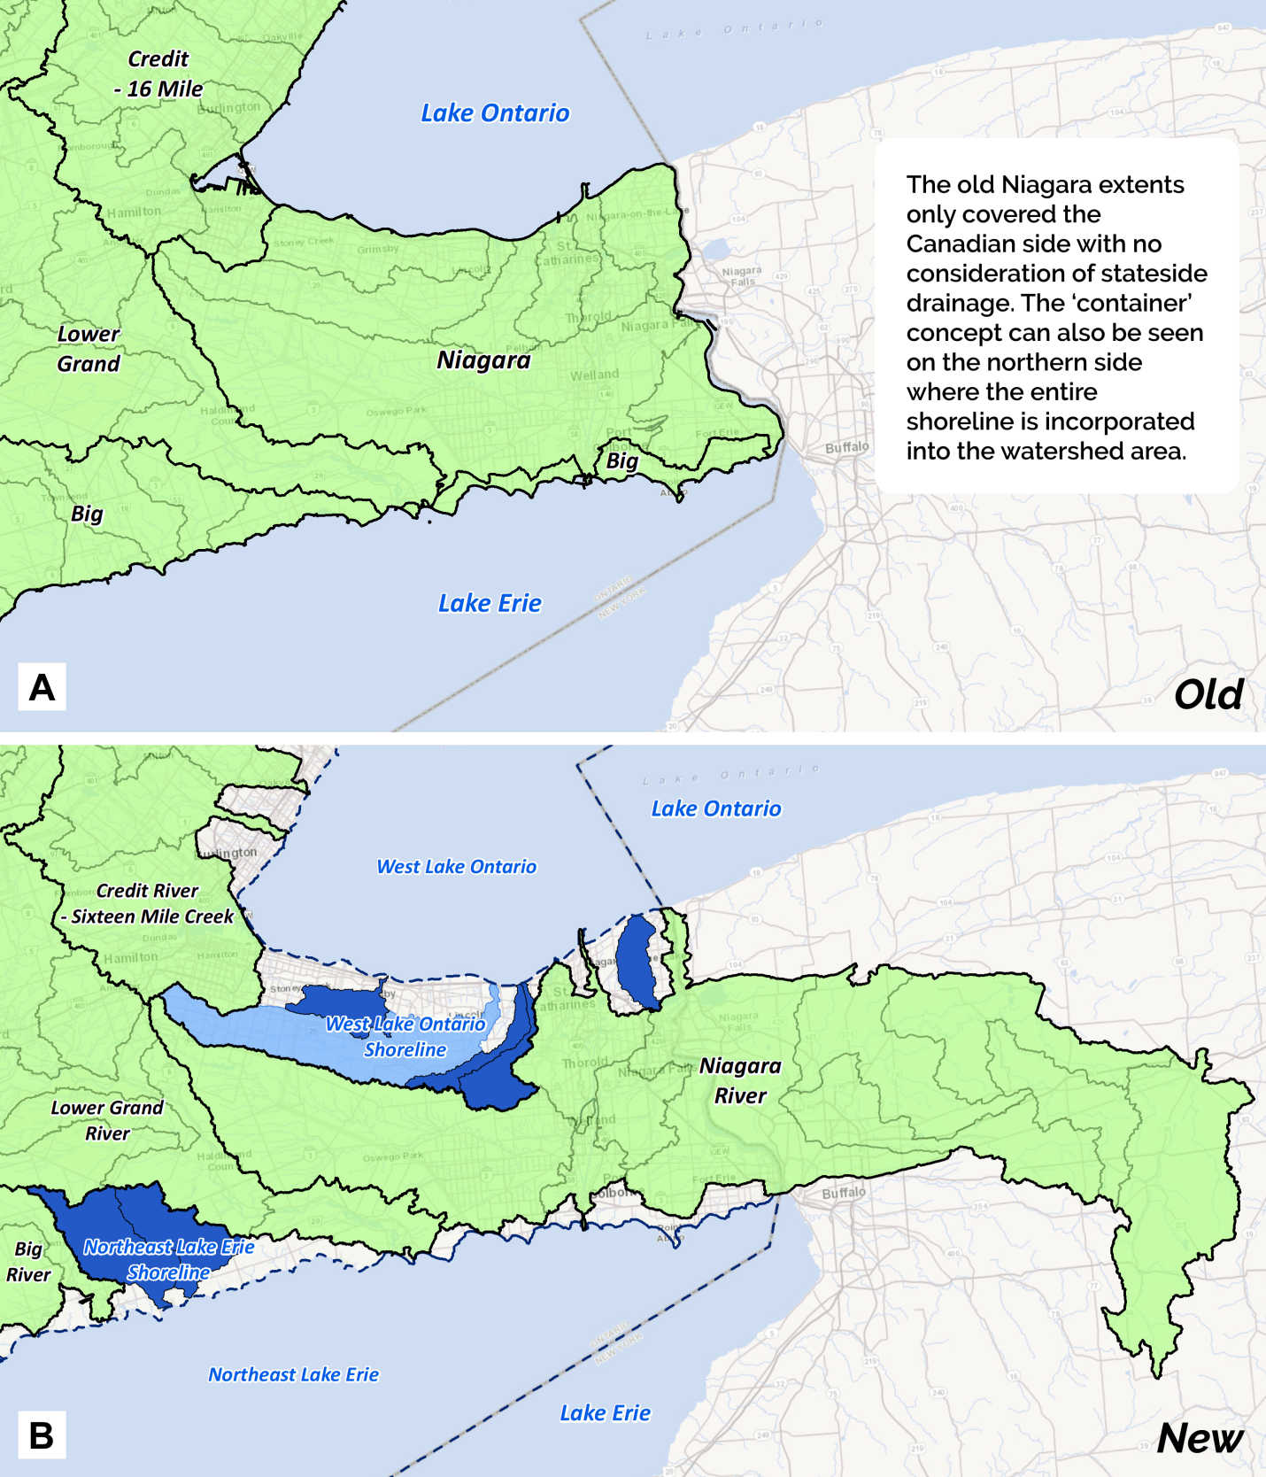
Figure 15: A comparison of the Niagara River region. 15A. The old watershed acted like a container for all inland water flow only on the Canadian side. 15B. The new layer considers the total drainage area on either side of the river. The Lake Ontario and Lake Erie shorelines have been separated out and now belong to their respective Great Lake watershed regions (polygons outlined in a black dash line). Also note the feature types ‘River’, ‘Creek’, ‘Lake’ and ‘Shoreline’ are now included in the watershed names.
Second, the Niagara River watershed is influenced by major water diversions which create three outflows into Lake Ontario:
- The main and natural outflow of the watershed is the mouth of the Niagara River (Outlet ‘1’ in Figure 16 below).
- The Welland Canal system is a key section of the Great Lakes Waterway which allows for circumnavigation around Niagara Falls to allow shipping access to the upper Great Lakes basin. The canal is considered a primary water diversion which starts from Port Colborne, Lake Erie, and crosses north over the Welland River and terminates at Port Weller, Lake Ontario to the north. Note there are six siphon tube connections which direct flow in the Welland River underneath the canal which can affect flow behaviour in the river because the conduits have the ability to shunt some water from the canal to the river if necessary. Hydroelectric activities at Niagara Falls can also affect flow behaviour in the Welland River and the siphons to the point that it experiences a flow reversal where it flows upstream for a few hours in the day and reverses downstream for the remainder (Hogue, 2014; Biotactic, 2001). These bypass connections to and from the natural system make the canal an integral part of the Niagara River watershed. Flow is generally controlled by the lock system. However, the canal predominantly flows north from Lake Erie to Lake Ontario bypassing the natural flowing system and therefore the northern end of the canal is regarded as the second outlet of the Niagara River watershed. (Outlet ‘2’ in Figure 16).
- The Welland Canal itself has a secondary diversion which serves as an overflow bypass into the headwaters of Twelve Mile Creek which flows north and drains into Lake Ontario west of the canal outlet. This makes the creek mouth the third outlet from the Niagara River watershed. (Outlet ‘3’ in Figure 16).
Each of these outlets and their corresponding drainage areas can be monitored separately at the quaternary or 5th watershed levels in the OWB watershed hierarchy as shown in Figure 16. Even though there are multiple outlets at the higher levels, it is generally possible to select out a single pour point watershed at the finer levels in the OWB dataset. A few exceptions would include large river deltas, sinkholes and other complex phenomenon described previously in this document.
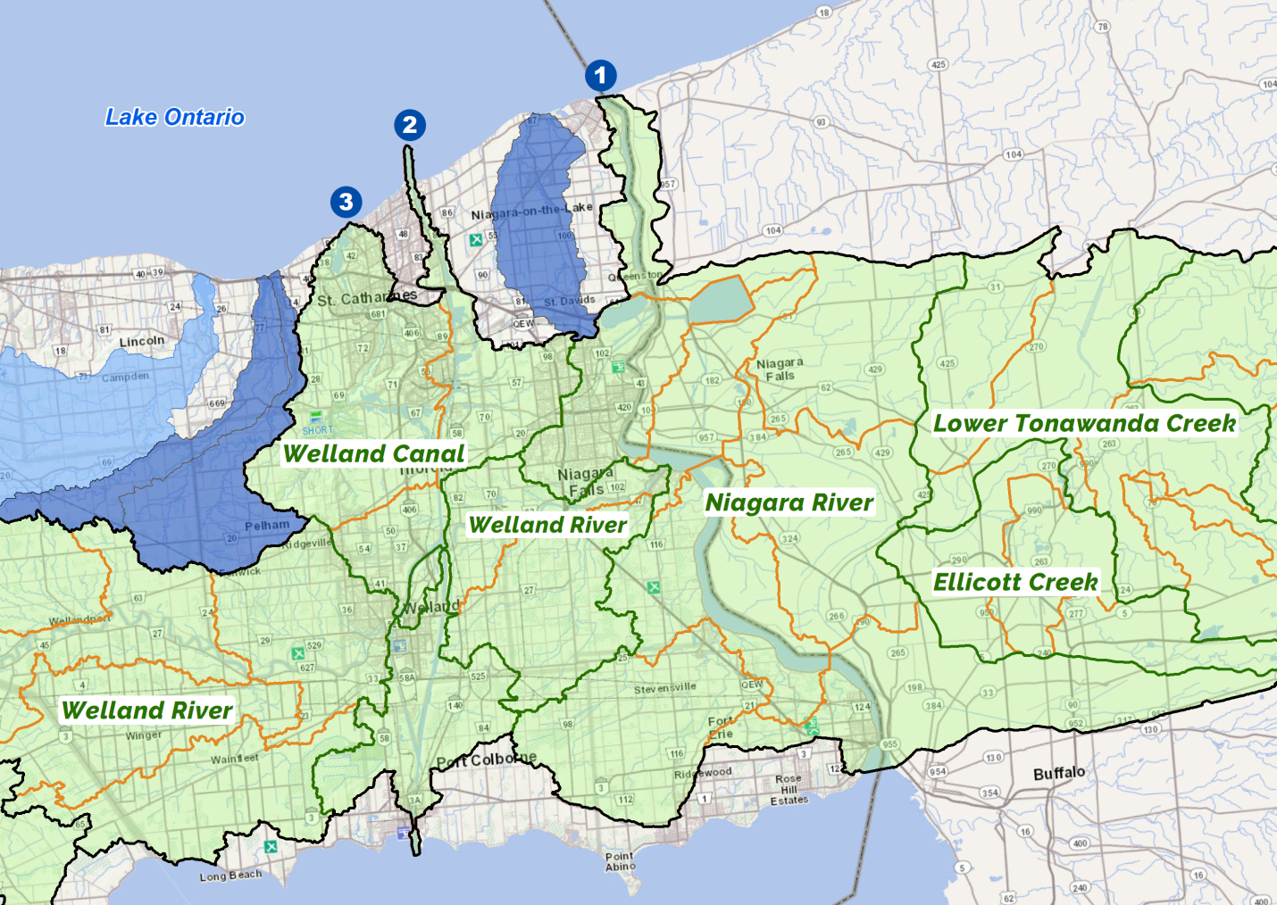
Figure 16: Zoom-in showing outlets of the Niagara River watershed. The green outlines and names are the quaternary watersheds and the orange outlines are the newly introduced 5th level divisions. Notice how the Welland Canal intersects the Welland River watershed creating multi-part polygons for each unit.
Version 1920.1

The watershed principles outlined herein are by no means exhaustive and may change or be updated from time to time as new issues come to light. However, every effort has been made to document pertinent issues that are applicable in most cases.
There will be variations in interpretation of boundaries between Ontario, Canada and U.S. over time as new data sources are collected on either side of the border. However, pour points used for shared boundary areas should remain consistent between jurisdictions for as long as the watershed systems are supported.
Since the original publication in 2020, the entire primary watershed draining the Great Lakes and St. Lawrence River stateside was also recently included into the OWB dataset without any further subdivisions. This data was adapted from the USGS WBD dataset in 2022.

