User Guide
for
Ontario Watershed Information Tool (OWIT)
  - Provincial Mapping
  - Mapping and Information Resources Branch
  - Corporate Management and Information Division
  - Ministry of Natural Resources and Forestry
2024-04-10

Disclaimer
This technical documentation has been prepared by His Majesty the King in right of Ontario as represented by the Ministry of Natural Resources and Forestry (the “Ministry”). No warranties or representations, express or implied, statutory or otherwise shall apply or are being made by the Ministry with respect to the documentation, its accuracy or its completeness. In no event will the Ministry be liable or responsible for any lost profits, loss of revenue or earnings, claims by third parties or for any economic, indirect, special, incidental, consequential or exemplary damage resulting from any errors, inaccuracies or omissions in this documentation; and in no event will the Ministry’s liability for any such errors, inaccuracies or omissions on any particular claim, proceeding or action, exceed the actual consideration paid by the claimant involved to the Ministry for the materials to which this instructional documentation relates. Save and except for the liability expressly provided for above, the Ministry shall have no obligation, duty or liability whatsoever in contract, tort or otherwise, including any liability or negligence. The limitations, exclusions and disclaimers expressed above shall apply irrespective of the nature of any cause of action, demand or action, including but not limited to breach of contract, negligence, strict liability, tort or any other legal theory, and shall survive any fundamental breach or breaches.
Cette publication spécialisée n’est disponible qu’en anglais.

Additional Information
This document does not comply with all the applicable guidelines for accessible digital documents. For an alternative format please email Provincial Mapping at pmu@ontario.ca.
This document contains detailed help for using OWIT and provides specifics around input data OWIT uses to produce the generated outputs.
Please refer to the original documentation or speak with an expert in this area before using the information for decision-making purposes.
For more information about this document, or if persistent problems occur with the application or the data that OWIT uses, or if anything is omitted from this Help document, please contact Provincial Mapping at pmu@ontario.ca.

Executive Summary

Key Words
Ontario Watershed Information Tool

Abstract
Ontario Watershed Information Tool version (OWIT) is an online spatially based application which automates several technical and labour-intensive hydrology tasks. Using a base map for reference, the OWIT user defines a watershed drainage point on a mapped hydrology feature such as a stream, river, or lake anywhere within the land boundary of Ontario, including Ontario’s Far North. The resulting watershed polygon can then be used within OWIT to summarize key watershed characteristics.
The user can view all spatial and tabular outputs online and download the outputs for further specialized viewing or analysis. A standard Internet browser is required to use OWIT.

Table of Contents
Disclaimer 2
Additional Information 2
Executive Summary 4
Key Words 4
Abstract 4
Table of Contents 5
List of Figures 6
List of Tables 6
List of Acronyms 7
1. Overview of OWIT 8
1.1 Background 8
1.2 Use and limitations of OWIT 9
1.3 Data history 10
1.4 Website 11
2. OWIT Interface 12
2.1 OWIT Legend descriptions 13
3. Watershed Toolset 15
3.1 Create Watershed 15
3.1.1 Steps to run the Create Watershed tool 16
3.1.2 Notes about watershed generation 17
3.2 Watershed Characterization 19
3.2.1 Steps to run the Watershed Characterization tool 19
3.3 Find Watershed 21
3.3.1 Steps to run the Find Watershed tool 22
4. Exporting Watershed Information 23
4.1 Steps to export watershed information 23
4.2 Contents of the Download Package 24
4.3 Field Descriptions for Exported Tables 24
4.4 Viewing Options for Exported Files 27
5. Metadata 28
5.1 Ontario Integrated Hydrology Data 28
5.2 Data Used in Watershed Delineation 29
5.3 Data Used in Watershed Characterization 29
5.4 Data Used in Watershed Land Cover Summary 32
6. References 33

List of Figures
Figure 1: OWIT Interface 12
Figure 2: OWIT Map Legend 14
Figure 3: Create Watershed Tool 16
Figure 4: Watershed Characterization Tool 19
Figure 5: Find Watershed Tool 21
Figure 6: Exporting Watershed Information 23
Figure 7: Additional sources of wetland data used in OWIT 31

List of Tables
Table 1: Descriptions of pour point fields in PourPoint.dbf. 25
Table 2: Descriptions of watershed polygon fields in Watershed.dbf. 25
Table 3: Descriptions of characterization fields in CharacterizationTable.dbf. 25
Table 4: Descriptions of landcover fields in Landcovertable.dbf. 27
Table 5: Viewing options for export file types. 27
Table 6: Additional sources of wetland data 30

List of Acronyms
ARN: Assessment Roll Number
DEM: Digital Elevation Model
GIS: Geographic Information Systems
HYDAT: Environment Canada’s Hydrometric database
LCC: Lambert Conformal Conic
MNR: Ministry of Natural Resources
MNRF: Ontario Ministry of Natural Resources and Forestry
MPAC: Municipal Property Assessment Corporation
NESI: North East Science and Information
OFAT: Ontario Flow Assessment Tool
OIH: Ontario Integrated Hydrology
OPG: Ontario Power Generation
OWIT: Ontario Watershed Information Tool
PM: Provincial Mapping
UTM: Universal Transverse Mercator
WRIP: Water Resources Information Program

- Overview of OWIT
  - Background
The Ontario Flow Assessment Tool (OFAT) was relaunched in 2022 as the Ontario Watershed Information Tool (OWIT). The fundamental function of the application; generating a watershed from a pour point, remains the core part of the application. The creation of a custom spatial watershed boundary and its associated characteristics continue to provide nearly instant, accurate results that otherwise could be a significant undertaking. The re-launched application no longer contains flow prediction hydrology models or flow statistics.
This document focuses on the functionality of the Ontario Watershed Information Tool (OWIT); however, it is important to also provide the following background of its predecessor, the Ontario Flow Assessment Tool (OFAT).
When initially released in 2002, the Ontario Flow Assessment Techniques 1 (OFAT 1), developed by the Ministry of Natural Resources’ North East Science and Information (NESI), was a system ahead of its time. OFAT 1 was visionary, providing automated implementation of existing, very labour intensive, manual hydrology calculations (Chang et al. 2002). This system provided users with the potential to estimate flow regimes representing low flows (e.g., 7Q2, 7Q10, 7Q20, etc.), flood flows (e.g., Q2, Q10, Q25, Q100, etc.), mean annual flows, minimum instream flow requirements, and bankfull flows for watersheds in Ontario excluding the far north of the province. This functionality allowed users to compare and explore obtained results across regional models with the confidence of standardized Geographic Information System (GIS) processes and attribute handling.
OFAT 1 was a customized add-on to proprietary GIS software. Updates to newer versions of GIS software necessitated a re-work of OFAT. In 2003, work began on OFAT 2, but was never completed. A major innovation with OFAT 2 was the inclusion of a “Daily Flow Toolkit”. Using the refined and quality-controlled time-series flow data from Environment Canada’s Hydrometric (HYDAT) database, this Toolkit contained the functionality to derive six daily flow calculations.
The provincial need for “OFAT-like” functionality across Ontario has not diminished over the intervening years, evidenced by regular requests for OFAT and OFAT outputs. In the far north of Ontario, this need was heightened with the initiation of land use planning activities across this zone. These factors led the MNR’s Water Resources Information Program (WRIP), with support from the Far North Branch, Integration Branch, and the Land and Resources Cluster, to build the web based OFAT application which became available in 2012.
  - Use and limitations of OWIT
The most fundamental function of OWIT is to generate a watershed from a pour point within 90 metres (m) of a watercourse in Ontario. Watersheds can be included in a wide variety of planning and analysis activities.
Most often streamflow statistics are required in areas where streamflow gauges do not exist. OWIT generates custom watersheds and characteristics for any mapped stream reach in Ontario, which can be used in modeling applications. Depending on the use of the output, field verification may be appropriate.
Among other applications, baseline flow information is needed to:
- Design hydraulic structures such as culverts, bridges, dams, etc.
- Protect or enhance fish habitat.
- Support an ecosystem approach to land and water management.
- Analyze information for water use and wastewater permitting.
- Support various academic studies.
All data generated in OWIT can be downloaded for further analysis. The spatial watershed boundary and its associated physical characteristics that are implemented in OWIT provide nearly instant, accurate results that otherwise could be a significant undertaking.
  - Data history
As OFAT was first being developed in 2000, base data projects were underway to create the provincial hydrology, elevation, and derivative GIS datasets necessary to support spatial hydrology analysis. In the absence of yet established provincial datasets WRIP developed a full suite of required data layers as “one-off” products strictly to support OFAT and OFAT users. While this was a practical response to the data gap, it was not optimal in terms of data quality, data updating, and longer-term ability to integrate with other data. Since the initial OFAT development, these required datasets have been produced in Universal Transverse Mercator (UTM) projections in a more rigorously standardized and quality-controlled environment (Kenny and Matthews 2005; Kenny et al. 2008; WRIP 2008a, 2008b, 2008c; Zhao et al. in press). These data products were substantially refined and were made openly available to Ontario’s water management community.
As refined and useful as these hydrology and elevation data holdings were, there were still several limitations to using these data uniformly across the province in a modelling environment that might encompass watersheds that span more than half the province. These challenges include:
- The scale of provincial base data and derived data was variable. The base data was 1:10,000 scale in southern Ontario and 1:20,000 scale in northern Ontario.
- The raster hydrology, elevation and derivative data layers were developed in a UTM projection (four zones) which critically limited spatial watershed representation across UTM zones.
- The data holdings were not Provincial in scope (a usable hydrology base in the far north was absent).
A major undertaking to address these issues was completed by producing GIS hydrology, elevation, and hydrology derivative datasets in a seamless, standardized, Lambert Conformal Conic (LCC) projection for the entire province. The base hydrology data in this projection allows users to work in a seamless data environment. To address base data scale differences all developed raster data layers have been created at a uniform 30 metre grid resolution. This seamless LCC data is employed as the backbone of OWIT.
A detailed data description and links to metadata are provided in Section 5.
  - Website
The current OWIT release is a spatial web application. Deployment in a web environment offers numerous advantages over that of a desktop application or GIS extension including:
- Only a web browser is needed to use OWIT. The user doesn’t need GIS software.
- Updates and additions to the tools can be implemented without the need for any action from the user group.
- Improved data can be updated on the web server. No need for users to handle large amounts of input data.
- Output data can be downloaded for those that wish to analyze further.
- Metadata is available in the online user guide.

- OWIT Interface
Only an internet browser is required to run OWIT. No GIS software is needed. Upon starting OWIT the user is presented with a full view of Ontario, along with the surrounding provinces and states. The OWIT tools are functional only within the Ontario portion of the map display. Seven Tabs are placed horizontally across the screen below the OWIT banner. Each tab has a set of associated tools.
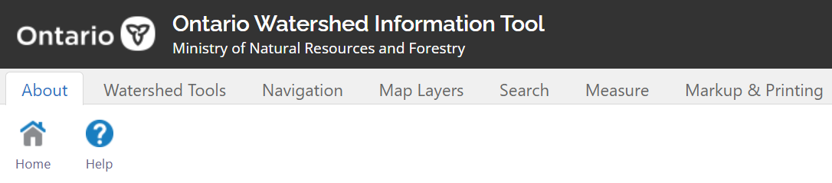
Figure 1: OWIT Interface
Tools associated with the Navigation, Map Layers, Search, Measure, and Markup & Printing tabs are briefly explained below. More detailed explanations can be found in the Make a Topographic Map (https://www.publicdocs.mnr.gov.on.ca/mirb/Make%20A%20Topo%20Map%20Online%20Help%20English.docx) quick start guide.
Watershed Tools tab: The OWIT toolset is explained in Section 3.
Navigation tab: Zoom and pan around the map and manage bookmarks.
Map Layers tab: Turn map layers on and off or view the legends. There are two legends. There is a toggle button at the bottom of the legend to switch between the OWIT and Base Data legends. Add reference data to the map using the Upload Data tool. Large or complex spatial data may impact browser performance. The tool is limited to a maximum upload size of 10 MB.
Search tab: Search by text, coordinates, address, assessment parcel, or township/lot/ concession, and zoom to location.
Measure tab: Tools for measuring distance or area.
Markup and Printing tab: Various options for scale and adding text or basic drawings to the map to highlight information. Tools to print a map with a surround including a title, legend, scale bar, north arrow, etc.
  - OWIT Legend descriptions
Some layers have a maximum zoom scale set. They will draw when the map is zoomed to a scale where the layer name is not greyed out in the table of contents.
Assessment Parcel: Identify areas defined by a boundary and an assessment roll number (ARN), for property assessment purposes, as determined by Municipal Property Assessment Corporation (MPAC). Source: Ontario Parcel (https://geohub.lio.gov.on.ca/documents/ontario-parcel/explore)
Watersheds: Represent the authoritative watershed boundaries for Ontario at four levels which are quaternary, tertiary, secondary and the primary watersheds of the Great Lakes – St. Lawrence Basin, Hudson – James Bay Basin and Nelson River Basin. Source: Ontario Watershed Boundaries (https://geohub.lio.gov.on.ca/maps/mnrf::ontario-watershed-boundaries-owb/about)
Hydrometric Monitoring Station: Locations of water monitoring stations used to assess flood and drought conditions across Ontario. Source: Ontario water and weather monitoring stations, filtered for hydrometric stations (https://geohub.lio.gov.on.ca/datasets/lio::ontario-water-and-weather-monitoring-stations/about)
Diversion: Identifies a location where water is being diverted from the natural flow. This may be a dam that is blocking flow or a location where water is now flowing through.
Waterbody Outlet: Identifies where water is flowing out of a lake or river. This can aid in deciding where to create a pour point for a watershed by identifying the direction of flow.
Dam: Dams have been categorized into five ownership classes which are Conservation Authority, Provincial, Federal, Ontario Power Generation (OPG), and Other. Source: Ontario Dam Inventory (https://geohub.lio.gov.on.ca/datasets/mnrf::ontario-dam-inventory/about)
Virtual Flow Segment: Represent the flow path used to provide a continuous stream network connection through water bodies.
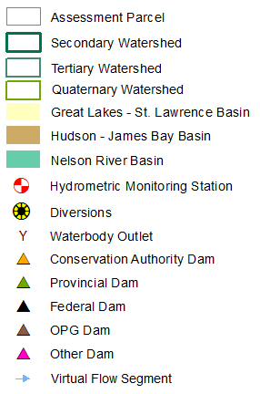
Figure 2: OWIT Map Legend

- Watershed Toolset
This section explains how to use the watershed tools, and limitations that users should be aware of.
  - Create Watershed
OWIT can delineate a watershed from any user defined point in Ontario that satisfies certain criteria. Generating a watershed is the initial point of the workflow for many of the functions. A watershed is required to perform the subsequent operations in the workflow such as generating watershed characteristics and extracting land cover.
A watershed is created in OWIT by defining a pour point (a point through which all overland flow of the watershed will drain). A pour point must be created on a mapped hydrology feature (lake or stream) and must exist within the land boundary of Ontario. A point within the Great Lakes, St. Lawrence River, Ottawa River, Lake St. Clair, Hudson Bay, James Bay, or similar area will not generate a watershed.
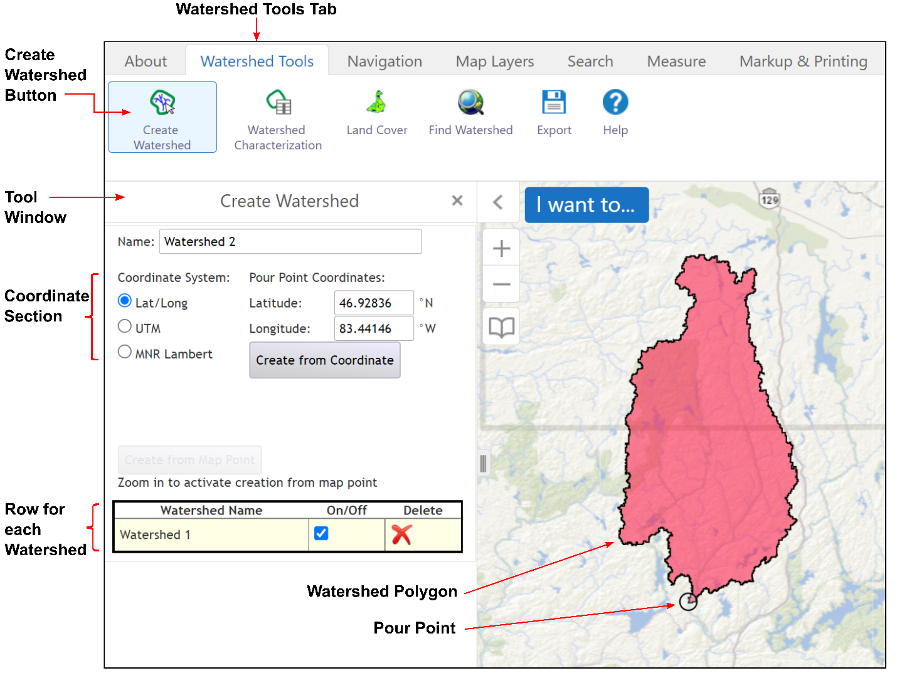
Figure 3: Create Watershed Tool
    - Steps to run the Create Watershed tool
- Click the Watershed Tools tab.
- Click the Create Watershed button.
- The Create Watershed tool window will appear on the left side of the screen. A default name of Watershed 1 will appear in the text box. This can be changed at this time if desired. The name cannot be changed after the watershed is created.
- Create a pour point with one of two methods:
  - Enter the coordinates of the pour point in the text boxes of the coordinate section of the tool window. One of three coordinate systems can be specified. The entered coordinates must be within 90 metres of a mapped watercourse feature. Click the Create button.
  - Create a pour point by a mouse click on a mapped hydrology feature. To do this, zoom in until the Create from Map Point button becomes enabled (turns from grey to black). The mouse click must be within 90 metres of a mapped stream or lake. Failure to be within 90 metres of a mapped hydrology feature will return a warning message.
  - The watercourse virtual flow segments draw at the scale where the Create Watershed button becomes active to assist in choosing pour points within lakes and large rivers.
- The generated watershed is added to the bottom row of the tool window and the map display zooms to the watershed extent.
- Multiple watersheds can be created. Each additional watershed will be added to a new row at the bottom of the tool window and to the map.
- Several options are available for each watershed row.
- Click on a row to select (The selected watershed row will be highlighted.) The map display will zoom to the selected watershed.
- The watershed can be turned on and off in the map display by clicking the On/Off checkbox. This is useful when there are multiple overlapping watersheds in the map display.
- The watershed and pour point can be deleted by clicking the Delete icon.
- The watershed and pour point can be downloaded by clicking the Export button See Section 4 Exporting Watershed Information for details on how to export and download.
    - Notes about watershed generation
Each watershed generated in OWIT is independent of any other watershed generated. This allows watersheds to overlap (e.g., nested sub-watersheds).
Caution should be taken when placing a pour point near a stream confluence (where two streams meet and merge into one stream) to achieve desirable results. OWIT uses a 30-metre cell resolution raster Enhanced Flow Direction Grid in generating the watershed. Due to the 30-metre raster resolution, stream confluences within the grid are ‘in the area’ of the stream confluence that is shown on the base map. Place the pour point at least 30 metres downstream of the confluence to include the stream junction and all contributing streams in the watershed delineation. Place the pour point at least 30 metres upstream of the confluence to delineate a watershed for only one of the contributing streams.
OWIT can generate a watershed from a pour point within a waterbody (lake or large river). The underlying stream network contains virtual flow segments that connect flow through waterbodies. The virtual flow segments become visible on the map at the scale where the Create Watershed button becomes active. The user-defined pour point must fall within 90 metres of a virtual flow segment to generate a watershed.
Water flow does not start or stop at the borders of Ontario. The input data that OWIT uses to generate watersheds does not always extend beyond the borders of Ontario. Full watersheds will be created along the Quebec border in the area north of the Ottawa River, along the Minnesota border and along the Manitoba border. Watersheds along the Ottawa River and the United States (other than Minnesota) will only represent the Ontario portion.

  - Watershed Characterization
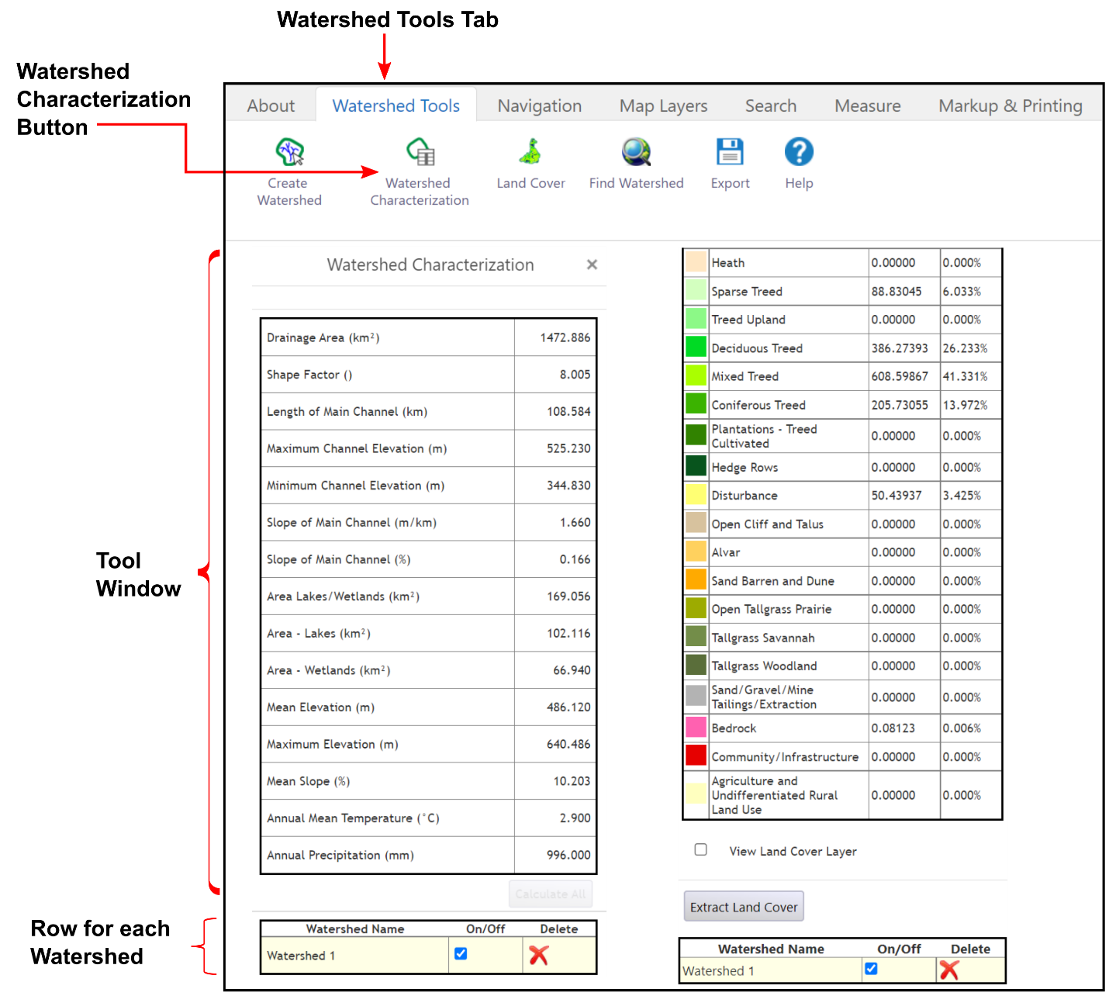
Figure 4: Watershed Characterization Tool
    - Steps to run the Watershed Characterization tool
- At least one watershed must be generated before using the Watershed Characterization tool.
- Click the Watershed Tools tab.
- Click the Watershed Characterization button to open the tool window.
Physiographic Characterization
Fifteen physiographic characterizations can be computed for each generated watershed.
- Click the desired watershed row in the bottom section of the tool window to calculate watershed characterizations. (The selected watershed row will be highlighted.)
- Click the Calculate button next to the desired characterization or click the Calculate All button.
The resulting values are displayed next to the characterization name. To calculate and view the characterizations for a different watershed, repeat the steps above for the desired watershed row in the tool window. The values will be updated with the values of the selected (highlighted) watershed row.
For processing efficiency, some characterizations will be calculated at the same time. Clicking Calculate for one characterization may trigger the calculation of others.
Land Cover Classification
Twenty-nine land cover classes can be extracted and summarized for each generated watershed.
- Click the Land Cover button to open the tool window.
- Click the desired watershed row in the bottom section of the tool window to summarize on land cover type. (The selected watershed row will be highlighted.)
- Click the Extract Land Cover button.
The resulting values are displayed next to each land cover type summarized by area (km²) and percent coverage within the watershed. To calculate and view the characterizations for a different watershed, repeat the steps above for the desired watershed row in the tool window. The values will be updated with the values of the selected (highlighted) watershed row.
The extraction could take several minutes depending on the size of the watershed.
The land cover can be viewed on the map by clicking the View Land Cover Layer checkbox. The viewable layer is for the entire province, not just the watershed.
Export/Download and Metadata
- See Section 4 Exporting Watershed Information for details on how to export and download characterization results.
- See Section 5 Metadata for descriptions of the individual characterizations and data used in calculating the values.
  - Find Watershed
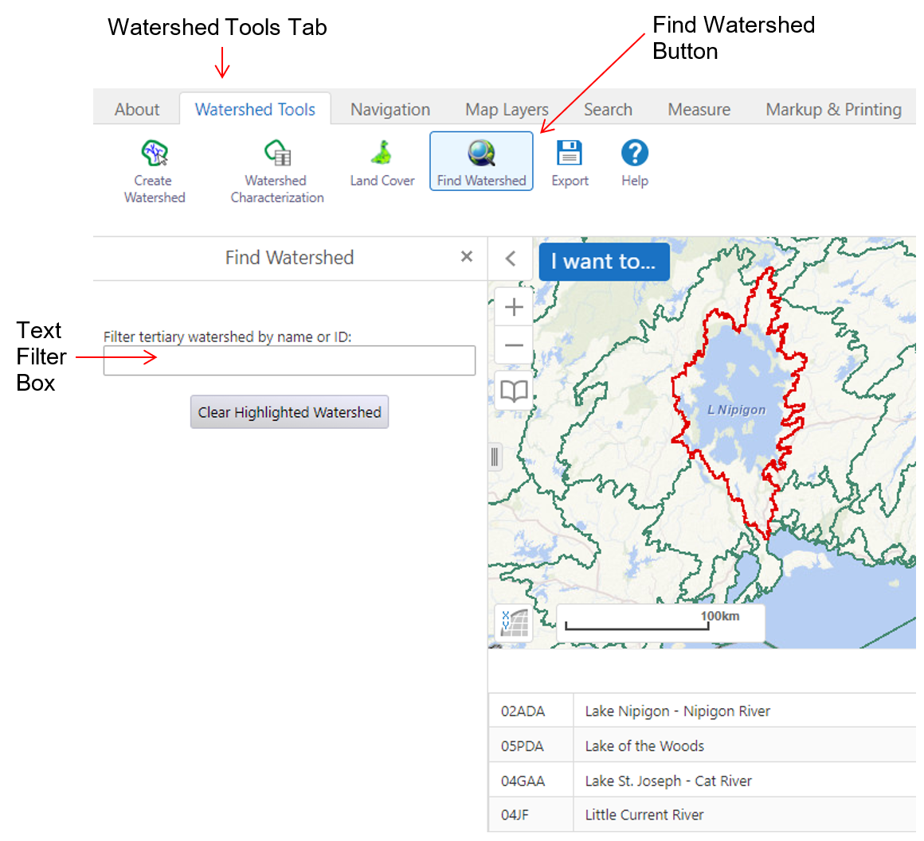
Figure 5: Find Watershed Tool
    - Steps to run the Find Watershed tool
- Click the Watershed Tools tab.
- Click the Find Watershed button to open the tool window.
- Click the desired tertiary watershed name or ID in the table to have the map zoom to the watershed.
- Optionally you can enter part of a tertiary watershed name or ID in the text box to filter the list.
The map will zoom to and highlight the selected watershed. Click the Clear Highlighted Watershed button to remove the highlight.

- Exporting Watershed Information
All watersheds, watershed characterizations, and extracted land cover can be exported (downloaded) from the OWIT website. Lines in the export list that are grey and not selectable have not had the outputs created. Run the characterization and land cover extraction tools to produce outputs available for export.
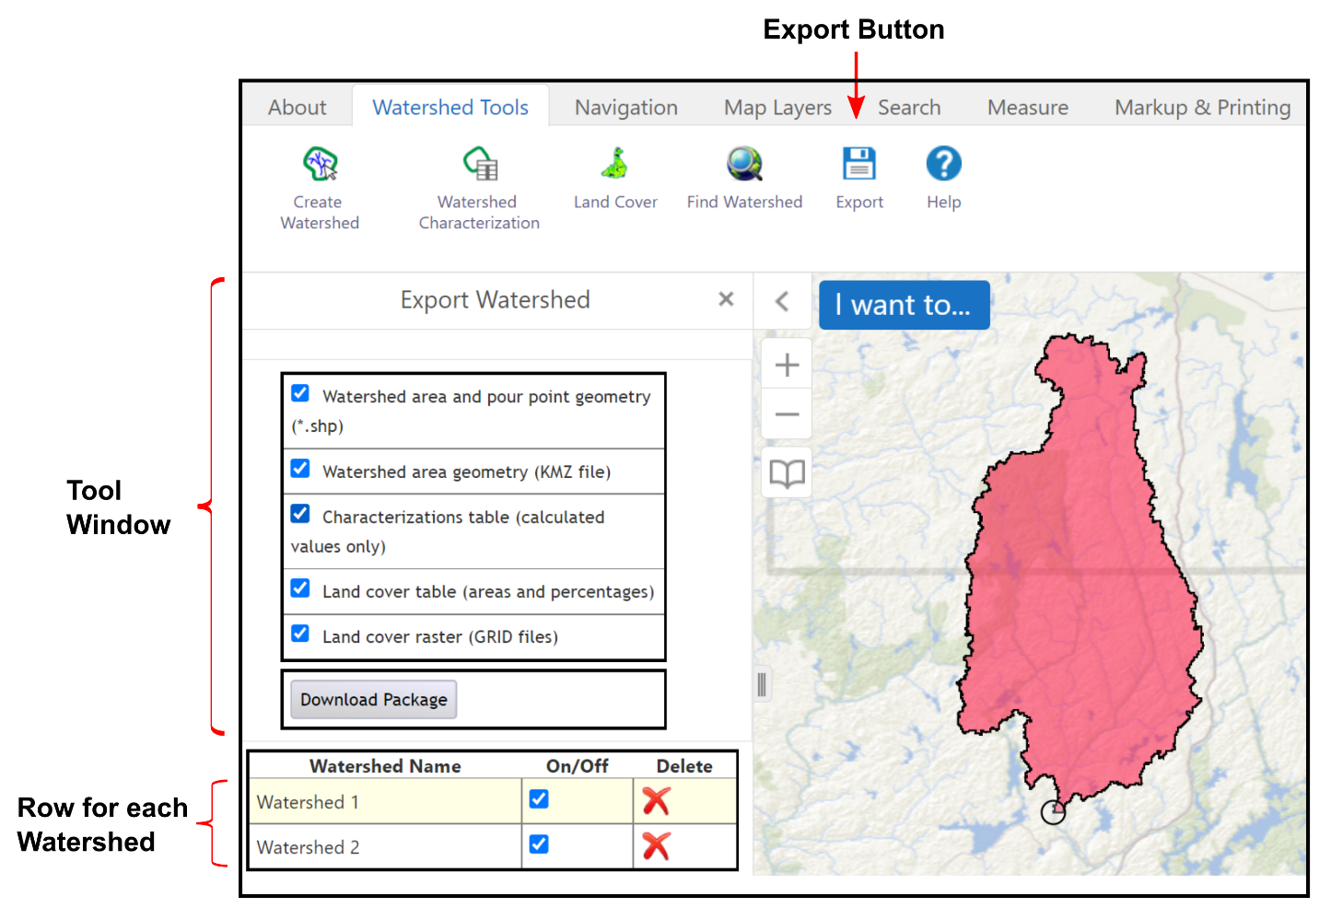
Figure 6: Exporting Watershed Information
  - Steps to export watershed information
- Click the Export button to open the Export Watershed window.
- Click a watershed row, if you have created more than one watershed, to export the data for that watershed.
- Check each checkbox for desired items to include in the export.
- Click the Download Package button.
  - Contents of the Download Package
The contents of the download package are in a compressed ZIP file. The following list describes the folders and files that can be downloaded.
- kmz (folder)
  - Watershed1.kmz – Google Earth kmz file
- landcoverGRID (folder)
  - info – this folder is required for GIS software
  - landcovr – landcover raster in Esri GRID format
  - OntarioLandcover.lyr – GIS layer file to be used as a legend file in ArcGIS
- shape (folder)
  - PourPoint shapefile (five files) – user defined watershed pour point GIS file
  - Watershed shapefile (five files) – watershed GIS file
- CharacterizationTable.dbf – watershed characterization results table
- landcovertable.dbf – summary by area of the land cover within the watershed table
  - Field Descriptions for Exported Tables
Most tables will contain the OFATID attribute which is automatically generated when the user defines a pour point. The ID is carried through to the watershed, characterizations, and land cover outputs. The OFATID can be used to organize or link tables and geometries. The following tables contain field names and descriptions for each of the OWIT output tables.

Table 1: Descriptions of pour point fields in PourPoint.dbf.
Field Name | Description
Shape | Geometry of the GIS file. The value will be Point.
OFATID | Auto-generated unique ID for each watershed
WTertiary | Tertiary watershed identifier where the pour point is located
Latitude | Latitude in decimal degrees (NAD 83)
Longitude | Longitude in decimal degrees (NAD 83)
X_LCC | X coordinate in Lambert Conformal Conic (NAD 83)
Y_LCC | Y coordinate in Lambert Conformal Conic (NAD 83)
Table 2: Descriptions of watershed polygon fields in Watershed.dbf.
Field Name | Description
Shape | Geometry of the GIS file. The value will be Polygon.
OFATID | Auto-generated unique ID for each watershed
Table 3: Descriptions of characterization fields in CharacterizationTable.dbf.
Field Name | Description
OFATID | Auto-generated unique ID for each watershed
AreaKm | Area of the watershed in square kilometres
ShapFactr | Watershed Shape Factor: square of the length of the main channel divided by the drainage area  The Main Channel is the longest upslope distance along the flow path, from the pour point cell to the top of the drainage divide
MeanElevM | Average elevation value of the Digital Elevation Model (DEM) within the delineated watershed
MaxElevM | Maximum elevation value of the DEM within the delineated watershed
MeanSlpPc | Watershed Mean Slope: average Slope Percent grid value within the watershed. The slope percent grid was created with Esri’s Spatial Analyst Slope function on the Ontario Integrated Hydrology (OIH) DEM  Each grid cell has a percent slope value. This is the average of all cell values.
LeOMChKm | Length of Main Channel: Upstream Flow Length grid value at the pour point. The Upstream Flow Length grid was created with Esri’s Spatial Analyst Flow Length function on the OIH Enhanced Flow Direction (EFD) grid.  Length of the main channel (or longest flow path) in kilometres.  The Main Channel is the longest upslope distance along the flow path, from the pour point cell to the top of the drainage divide.
MaxChElvM | Maximum channel elevation in metres (at the most upstream point of the flow path)  Maximum Channel Elevation: OIH DEM elevation value at the most upstream point along the main flow path.  The Main Channel is the longest upslope distance along the flow path, from the pour point cell to the top of the drainage divide.
MinChElvM | Minimum channel elevation in metres (at the pour point)  Minimum Channel Elevation: OIH DEM elevation value at the pour point.
ChSlp_M_Km | Channel slope in metres/kilometre (most upstream point of flow path to the pour point)  Slope of the Main Channel (m/km): Rise divided by run. The difference in the OIH DEM elevation values at the pour point and the most upstream point along the main flow path determine the rise. The Upstream Flow Length as determined in Length of the Main Channel is the run.  The Main Channel is the longest upslope distance along the flow path, from the pour point cell to the top of the drainage divide.
ChSlp_Pcnt | Channel slope in percent (most upstream point of flow path to the pour point)  Slope of the Main Channel (%): The slope of the main channel (m/km) divided by 1,000 metres to get common units and then multiplied by 100 for percent.  The Main Channel is the longest upslope distance along the flow path, from the pour point cell to the top of the drainage divide.
WatrAreaKm | Area covered by Lakes, Rivers, and Wetlands within the watershed in square kilometres
OpWAreaKm | Area in the watershed covered by open rivers and lakes
WetlAreaKm | Area in the watershed covered by wetlands
MeanTemp | Annual Mean Temperature
AnnPrecipt | Annual Precipitation
Table 4: Descriptions of landcover fields in Landcovertable.dbf.
Field Name | Description
Value | Grid cell value
Area | Area of the land cover classification within the watershed in m²
Percentage | Percentage of area of the land cover classification within the watershed
Class_Name | Land cover classification
  - Viewing Options for Exported Files
The following table contains suggested viewing options for the various export package file types.
Table 5: Viewing options for export file types.
File Type | Viewing Options and Notes
.kmz | Open the .kmz file from Windows explorer to view in Google Earth. Must have Google Earth installed on computer.
.shp | Shapefiles can be viewed in many GIS packages. QGIS is a free and open-source GIS software. ArcGIS Explorer is a free GIS viewer that can load shapefiles. Do not alter the associated files that have the same name with different extensions (.dbf, .prj, .shx) to prevent corrupting the GIS file collection.
.dbf | Database File can be opened by database, GIS, or spreadsheet software.
GRID | Esri GRIDs are raster files that are opened by GIS software. The Land Cover is extracted in OWIT without the generation of pyramids. Pyramids can be generated for the Land Cover Grid with ArcCatalog for faster viewing in ArcMap.
.lyr | An Esri Layer file used to colour code the Land Cover Raster for map display. Add the layer file into ArcMap and set the data source as the land cover GRID.
- Metadata
This section contains the metadata for the datasets used in OWIT analysis operations. Where possible, metadata links, and document references are provided rather than duplicating published material in this guide.
The base map (cache) displayed in OWIT is made up of a variety of data from the Land Information Ontario (LIO) Data Warehouse. For more information about the LIO Topographic Data Cache see the Ontario GeoHub. (https://geohub.lio.gov.on.ca/search?q=lio%20topographic%20data%20cache)
The imagery displayed in OWIT is provided through the Ontario Imagery Web Map Service. See the Ontario GeoHub record for that product to access metadata such as acquisition dates and the type of sensor used to acquire the imagery. (https://geohub. lio.gov.on.ca/search?q=ontario%20imagery%20web%20map%20service)
For more information about LIO data visit Land Information Ontario's webpage. (https://www.ontario.ca/page/land-information-ontario)
  - Ontario Integrated Hydrology Data
The Ontario Integrated Hydrology (OIH) data is a collection of related elevation and mapped water features that are used in combination for generating watersheds and to support hydrology applications.
Because the amount of data for the province is so large, the OIH has been subdivided into nine separate packages. Each package covers a different part of the province and the data in each package can be updated independent of the others.
Search for the OIH metadata record on the Ontario GeoHub for more information. (https://geohub.lio.gov.on.ca/search?q=ontario%20integrated%20hydrology%20data)
The OIH metadata record contains transfer (download) options for:
- Packages Map and Watersheds Table. Map illustrating the nine data packages as well as a table listing the watersheds in each package.
- Package Index Shapefile.
- OIH User Guide. Provides a detailed description of OIH data including creation, specifications, uses, limitations, considerations, etc.
- Nine separate data packages.
  - Data Used in Watershed Delineation
The OIH Enhanced Watercourse geometric network and Enhanced Flow Direction grid are used for watershed delineation in OWIT.
  - Data Used in Watershed Characterization
Watershed Shape Factor: square of the length of the main channel divided by the drainage area.
Watershed Mean Elevation: average of the OIH DEM values within the watershed.
Watershed Maximum Elevation: maximum OIH DEM value within the watershed.
Watershed Mean Slope: average Slope Percent grid value within the watershed. The slope percent grid was created with Esri’s Spatial Analyst Slope function on the OIH DEM.
Length of Main Channel: Upstream Flow Length grid value at the pour point. The Upstream Flow Length grid was created with Esri’s Spatial Analyst Flow Length function on the OIH Enhanced Flow Direction (EFD) grid.
Maximum Channel Elevation: OIH DEM elevation value at the most upstream point along the main flow path.
Minimum Channel Elevation: OIH DEM elevation value at the pour point.
Slope of the Main Channel (m/km): Rise divided by run. The difference in the OIH DEM elevation values at the pour point and the most upstream point along the main flow path determine the rise. The Upstream Flow Length as determined in Length of the Main Channel is the run.
Slope of the Main Channel (%): The slope of the main channel (m/km) divided by 1,000 metres to get common units and then multiplied by 100 for percent.
Area of Lakes and Wetlands: Area of lakes and rivers, and wetlands within the watershed.
The Ontario Hydro Network (OHN) – Waterbody data is the source for lakes and rivers. See OHN Waterbody in the Ontario GeoHub for more details. The National Hydrography Dataset (NHD) produced by the U.S. Geological Survey was used as the source within the state of Minnesota. (https://geohub.lio.gov.on.ca/datasets/mnrf::ontario-hydro-network-ohn-waterbody/about)
The Wetlands data from the Ontario GeoHub is the primary source for wetlands. (https://geohub.lio.gov.on.ca/datasets/mnrf::wetlands/about) Additional sources of wetland data were used to complete coverage for watersheds outside Ontario, as described in Table 6 and Figure 7.
The waterbody and wetland datasets were converted from vector polygons to 30 metre cell rasters. The rasters were then merged into a single integer raster. In areas where the original datasets overlapped the lakes and major rivers take precedence over wetlands.
Table 6: Additional sources of wetland data
Data provider | Area of coverage | Data source | Notes
Minnesota Department of Natural Resources | Rainy River watershed within Minnesota | National Wetland Inventory for Minnesota  https://gisdata.mn.gov/dataset/water-nat-wetlands-inv-2009-2014 | Excluded ‘wetland_type’ Freshwater Pond, Lake or Riverine
Manitoba Land Initiative | Southern portion of Manitoba border | Southern Peatlands Inventory 2013  https://mli2.gov.mb.ca/landuse/index.html | Excluded ‘CLASS_ENG’ Shallow/Open Water
Manitoba Land Initiative | Central portion of Manitoba border | Forest Inventory Maps  https://mli2.gov.mb.ca/forestry/index.html | Used ‘LAND_ID’ 700-704, 822-823, 830-835
Ontario MNRF | Northern Manitoba and Quebec border | Far North Land Cover https://geohub.lio.gov.on.ca/documents/lio::far-north-land-cover/about | Use Classes 4-6, 8-14
Agriculture and Agri-Food Canada | Quebec outside coverage of Ontario FN LC | Annual Crop Inventory 2018 https://open.canada.ca/data/en/dataset/1f2ad87e-6103-4ead-bdd5-147c33fa11e6 | Code 80 (Wetland)
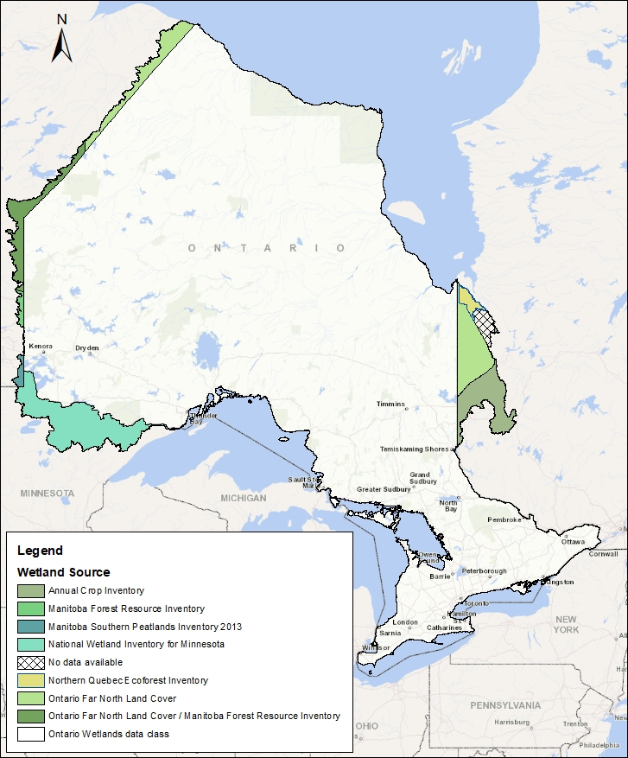
Figure 7: Additional sources of wetland data used in OWIT
Annual Mean Temperature: The data source is Environment Canada historic normal data from 1981 – 2010 in an 8.2-kilometre cell resolution raster. The median of the cell values is reported if 20 or more cells fall within the watershed. The mean of the cell values is reported if less than 20 cells fall within the watershed. (https://climate.weather.gc.ca/climate_normals/index_e.html)
Annual Precipitation: (See description for Annual Mean Temperature)
  - Data Used in Watershed Land Cover Summary
The Ontario Land Cover Compilation v2.0 serves as a consistent land cover map for the entire province to meet regional - to - landscape level analysis (1:50,000 – 1:100,000). This product is comprised of three separate land cover databases, each with separate class structures and which have been rationalized into a single classification.
The Ontario Land Cover Compilation combines the Provincial Land Cover Database, Far North Land Cover, and the Southern Ontario Land Resource Information System. Each of these separate land cover databases were resampled to a common pixel spacing (15 metres), re-projected to a common projection (NAD83 Lambert Conformal Conic) and reclassified into a common class structure.
Data Specification documentation is available by searching for Ontario Land Cover Compilation in the Ontario GeoHub. (https://geohub.lio.gov.on.ca/search?q=ontario%20land%20cover%20compilation)

- References
This help document contains some content from the original User Manual for Ontario Flow Assessment Techniques (OFAT) where applicable.
Chang, C., F. Ashenhurst, S. Damaia, and W. Mann (2002). “Ontario Flow Assessment Techniques (OFAT)”, Hydraulic Information Management, Editors, Brebbia, C.A., and W.R. Blain, WIT Press, Ashurst, Southampton, U.K., pp. 421-431.
Kenny, F.M., Matthews, B., 2005. A methodology for aligning raster flow direction data with photogrammetrically mapped hydrology. Computers & Geoscience 31(6), 768-779.
Kenny, F.M, Matthews, B., and Todd K. 2008. Routing Overland Flow through Sinks and Flats in Interpolated Raster Terrain Surfaces. Computers & Geoscience. 34 (2008), pp. 1417-1430 DOI information: 10.1016/j. cageo.2008.02.019.
WRIP Technical Release 2012. Ontario Integrated Hydrology Data: Elevation and Mapped Water Features for Provincial Scale Hydrology Applications.
Zhao, J., Todd, K., Hogg, A., and Kenny, F. 2008 Improving Ontario’s Provincial Digital Elevation Model. Internal Report, Water Resources Information Program, Ministry of Natural Resources 90p.

Version 2324.1

