User Guide
for
Ontario Radar Digital Surface Model
LIO Data Class
  - Provincial Mapping Unit
  - Mapping and Information Resources Branch
  - Corporate Management and Information Division
  - Ministry of Natural Resources and Forestry
2020-03-03

Disclaimer
This technical documentation has been prepared by Her Majesty the Queen in right of Ontario as represented by the Ministry of Natural Resources and Forestry (the “Ministry”). No warranties or representations, express or implied, statutory or otherwise shall apply or are being made by the Ministry with respect to the documentation, its accuracy or its completeness. In no event will the Ministry be liable or responsible for any lost profits, loss of revenue or earnings, claims by third parties or for any economic, indirect, special, incidental, consequential or exemplary damage resulting from any errors, inaccuracies or omissions in this documentation; and in no event will the Ministry’s liability for any such errors, inaccuracies or omissions on any particular claim, proceeding or action, exceed the actual consideration paid by the claimant involved to the Ministry for the materials to which this instructional documentation relates. Save and except for the liability expressly provided for above, the Ministry shall have no obligation, duty or liability whatsoever in contract, tort or otherwise, including any liability or negligence. The limitations, exclusions and disclaimers expressed above shall apply irrespective of the nature of any cause of action, demand or action, including but not limited to breach of contract, negligence, strict liability, tort or any other legal theory, and shall survive any fundamental breach or breaches.
Cette publication spécialisée n’est disponible qu’en anglais.

Additional Information
This document does not comply with all the applicable guidelines for accessible digital documents. For an alternative format please email Provincial Mapping Unit at pmu@ontario.ca.
For more information about this document, please contact Provincial Mapping Unit at pmu@ontario.ca.

Executive Summary

Key Words
Ontario Radar Digital Surface Model, ORDSM, Digital Surface Model, DSM, Digital Elevation Model, DEM, Digital Terrain Model, DTM, Elevation, Spaceborne, Interferometric Radar, C-Band, IFSAR, Shuttle Radar Topography Mission, SRTM.

Abstract
This user guide details the specifications for the Ontario Radar Digital Surface Model (DSM). The Ontario Radar DSM is reconstructed using radar data collected during an eleven-day mission in February 2000 from the Space Shuttle Endeavour.

Table of Contents
Disclaimer 2
Additional Information 2
Executive Summary 3
Key Words 3
Abstract 3
Table of Contents 4
List of Figures 5
List of Acronyms 6
1. Product Description 7
1.1 Geographic Extent 8
1.2 Horizontal Reference System 8
1.3 Vertical Reference System 8
2. Product Details 9
2.1 Data Processing 9
2.2 Elevations 12
2.3 Product Limitations 13
2.4 Accuracy Assessment 13
3. Data Delivery Format 13
4. Product Use Restrictions 15
5. References 16
APPENDIX A: Geostatistics 17
APPENDIX B: Ontario Radar DSM Tile Index 19

List of Figures
Figure 1: SRTM Collection 7
Figure 2: SRTM Tiles Used to Create the Ontario Radar DSM 10
Figure 3: Sub-regional Raster Datasets 11
Figure 4: Elevation Distortion between CGVD28 and EGM96 12
Figure 5: North and South Tiles Available for Download 14
Figure 6: Package Structure 15

List of Acronyms
CVGD28: Canadian Vertical Geodetic Datum 1928
DEM: Digital Elevation Model
DSM: Digital Surface Model
DTM: Digital Terrain Model
EGM96: Earth Gravitational Model 1996
GCS: Geographic Coordinate System
IfSAR : Interferometric Synthetic Aperture Radar
LCC: Lambert Conformal Conic
LIO: Land Information Ontario
LPI: Local Polynomial Interpolation
MNRF: Ministry of Natural Resources & Forestry
MSL: Mean Sea Level
NAD83: North American Datum of 1983
SDI: Spatial Data Infrastructure
SRTM: Shuttle Radar Topography Mission
USGS: United States Geological Survey
- Product Description
The source data used for generating the Ontario Radar DSM was from Shuttle Radar Topography Mission (SRTM), which collected Interferometric Synthetic Aperture Radar (IfSAR). The mission performed a single pass radar interferometry from two antennae mounted 60 m apart with the swath width of 225 km, which cover 80% of earth, and 95% of residential area of the world (Fig. 1). A more detailed description of the SRTM mission including publicly available data can be found on the USGS website: USGS.gov.
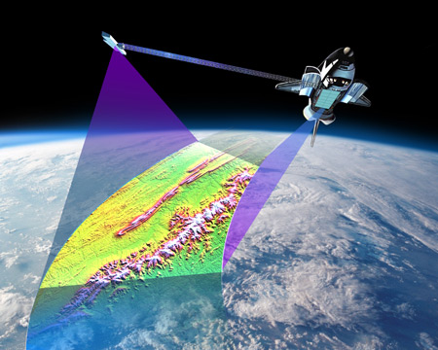
Figure 1: SRTM Collection

  - Geographic Extent
The horizontal extent of the Ontario Radar DSM provides continuous spatial coverage between the southern-most extent in the province and north to 57 degrees latitude. The bounding extent for the Ontario Radar DSM in the province is:
- West-bounding coordinate: -96 degree longitude
- East-bounding coordinate: -74 degree longitude
- North-bounding coordinate: 57 degree latitude
- South-bounding coordinate: 41 degree latitude
  - Horizontal Reference System
The horizontal coordinate system of the Ontario Radar DSM is converted from Geographic Coordinate System to MNR Lambert Conformal Conic projection. The horizontal datum of the Ontario Radar DSM is North American Datum of 1983 (NAD83). Projection parameters are as follows:
- False Easting: 930000
- False Northing: 6430000
- Central Meridian: -85.00
- 1st Standard Parallel: 44.50
- 2nd Standard Parallel: 53.50
- Latitude of Origin: 0.00
- Linear Unit: meters
  - Vertical Reference System
The elevation vertical datum of the Ontario Radar DSM is based on two different systems, separately:
- Canadian Geodetic Vertical Datum 1928 (CGVD28), which is the current national and provincial elevation data standard. GRS80 for NAD83 is used as the reference ellipsoid.
- Earth Gravitational Model 1996 (EGM96), which is used by the source data. WGS84 reference ellipsoid is used.
- Product Details
The Ontario Radar DSM has been interpolated at a consistent linear spatial resolution and geospatial coordinate system similar to other MNRF elevation products, which allows for seamless integration. The elevation vertical datum was transformed from EGM96 to CGVD28 to make the Ontario Radar DSM conform to the national and provincial elevation data standard.
  - Data Processing
A Digital Elevation Model (DEM) measures the heights of the bare earth’s surface at a given x/y location. Numerous technical approaches have been created and used to capture the average topography and generalized geomorphology (Junlin Zhao, Kent Todd, Adam Hogg and Frank Kenny, 2008). The SRTM data used in this project attempts to acquire earth coordinates of the reflective surface, resulting in a DSM. The SRTM tiles were then used to create the Ontario Radar DSM (Fig. 2).
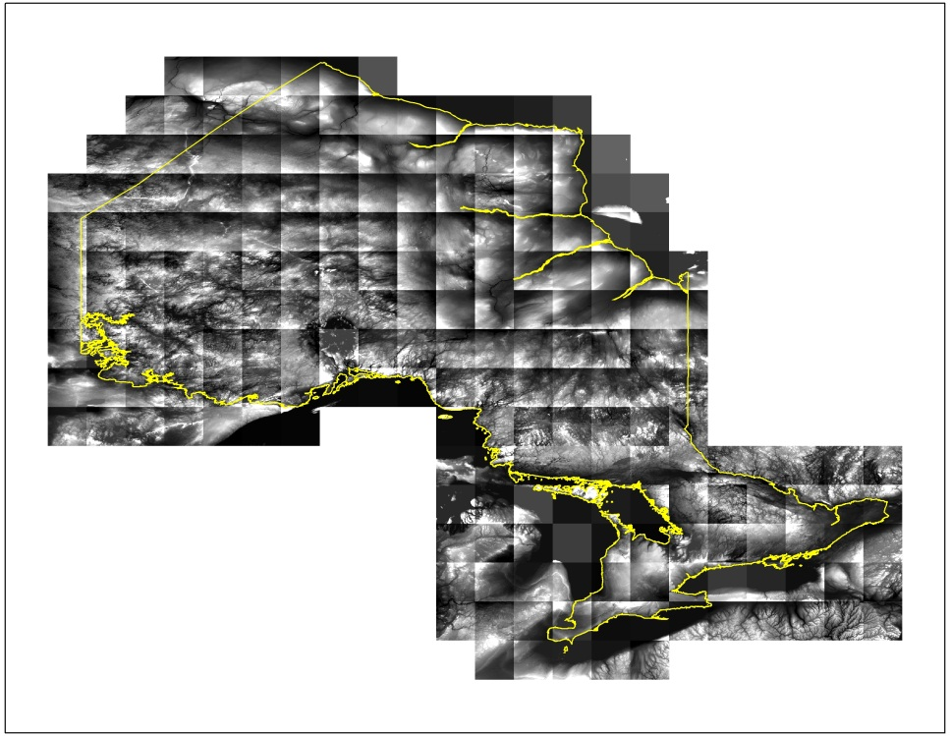
Figure 2: SRTM Tiles Used to Create the Ontario Radar DSM
The steps to generate the Ontario Radar DSM are as follows:
- Extract elevation vector points from raster SRTM. In order to keep full precision of original SRTM data, the raster data is converted to vector points before projection.
- Mosaic 211 tiles of vector point into three shape files based on the hardware and software processing capacities.
- Project the vector point shape files from Geographic Coordinate System (GCS) to MNR standard Lambert Conformal Conic (LCC) projection.
- Interpolate the projected point data into raster grids using ESRI Local Polynomial Interpolation (LPI) algorithm. For more detail on this process see Appendix A
- Control cell origin to align up with current provincial DEM standard.
- Merge three sub-region raster data together to form a one-piece provincial elevation model. There is a one degree overlapping in latitude to avoid edge effect and ensure the data consistency. Figure 3 shows the three sub-regional raster datasets in their own grey scales respectively.
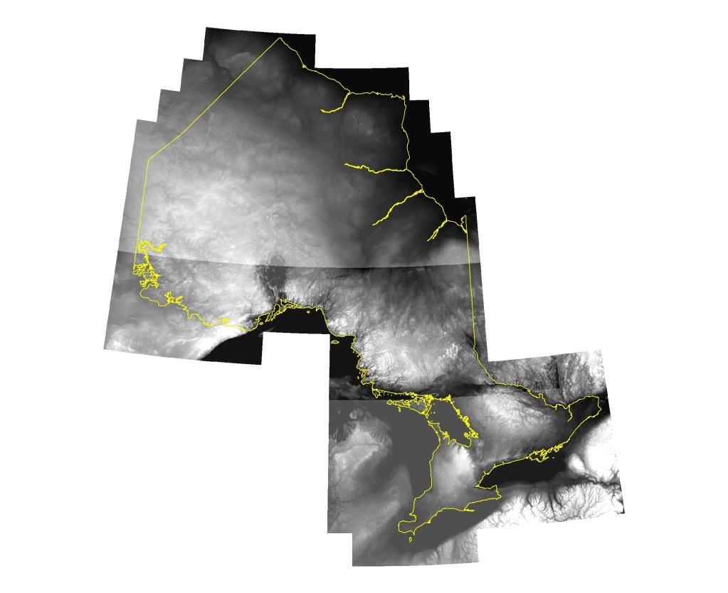
Figure 3: Sub-regional Raster Datasets
- Convert the elevation vertical datum from EGM96 to CGVD28.
A 30-meter spatial resolution elevation distortion surface was created for elevation vertical datum transformation. The elevation distortion between CGVD28 and EGM96 elevation datum (Fig. 4) indicates the elevation distortion range is about 2 meters across the province.
This elevation distortion surface can be used to transform elevation vertical datum between CGVD28 and EGM96 bi-directionally. The CGVD28 product has only been packaged for distribution; however, the EGM96 product and the elevation distortion surface are available upon request.
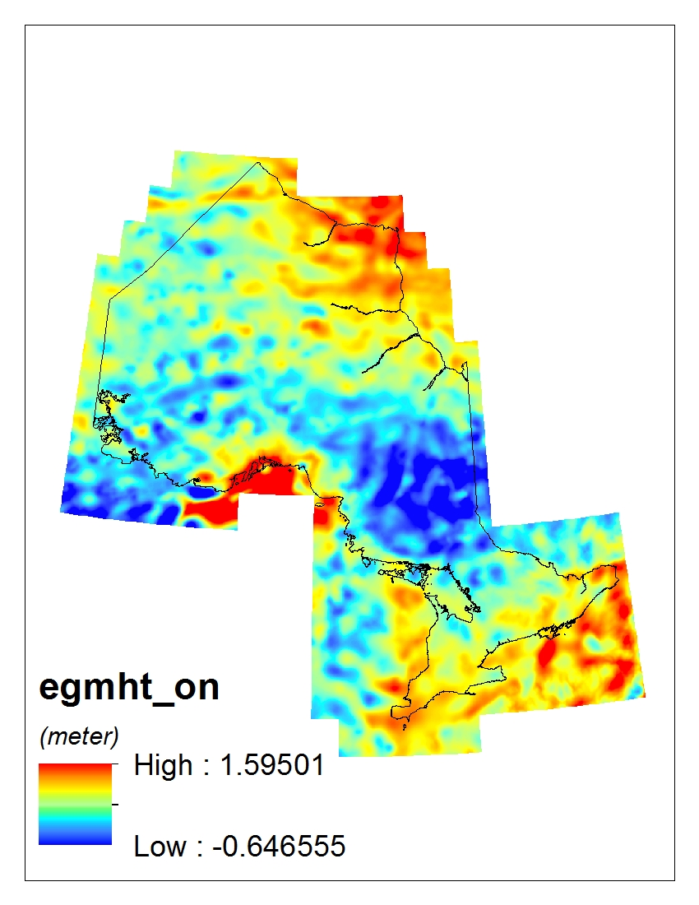
Figure 4: Elevation Distortion between CGVD28 and EGM96
  - Elevations
Elevations are orthometric and expressed in reference to Mean Sea Level (MSL). Both vertical and horizontal units of measure (coordinate system axis units) for all raster cells in the Ontario Radar DSM are meters (m).

  - Product Limitations
Elevation values in the original SRTM data represent the reflective surface of earth. It is a DSM and should not be considered as a true bare earth DEM. Northern Ontario is heavily forested including deciduous forest, coniferous forest, mixed forest, sparse forest, treed fen and treed bog. Elevation values will be influenced by the vegetative cover in these respective areas.
  - Accuracy Assessment
An accuracy assessment has been conducted on the Ontario Radar DSM to better understand the limitations and suitability of use for the product. This accuracy report seeks to create accuracy metrics for the DSM based on the United States National Digital Elevation Program (US NDEP) guidelines and discuss the suitability and limitations of the elevation data. You can download a copy of the accuracy assessment report from the Ontario Radar DSM record on Ontario GeoHub here.
- Data Delivery Format
The Ontario Radar DSM is available to be downloaded on the metadata record. It is split into two packages (North/South).
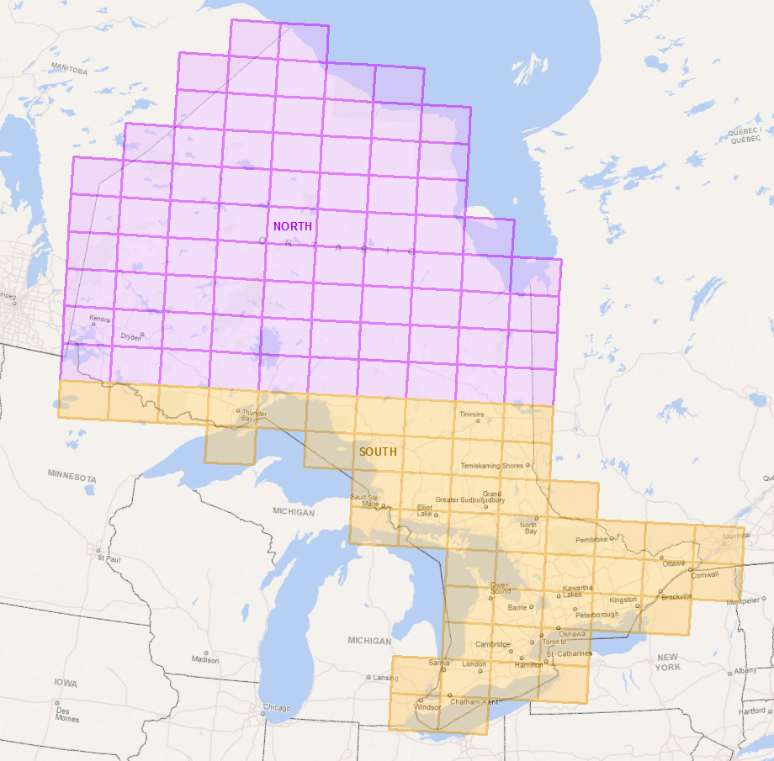
Figure 5: North and South Tiles Available for Download
Each package contains 32-bit ESRI GRID format files:
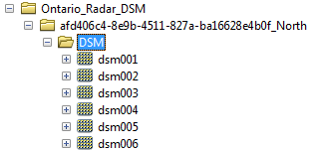
Figure 6: Package Structure
The north package contains 77 tiles and the south package contains 59 tiles. Please refer to Appendix B for the Ontario Radar DSM tiling index. For tiles beyond the index system, requests can be made to Land Information Ontario.
- Product Use Restrictions
The Ontario Radar DSM is Open Data and has no restrictions.

- References
ESRI, Feb. 11, 2011: How local polynomial interpolation works: (http://help.arcgis.com/en/arcgisdesktop/10.0/help/index.html#//003100000027000000.htm)
Kevin Johnston, Jay M. Ver Hoef, Konstantin Krivoruchko, and Neil Lucas, 2001: Using ArcGIS Geostatistical Analyst, ESRI (http://downloads2.esri.com/support/documentation/ao_/Using_ArcGIS_Geostatistical_Analyst.pdf).

APPENDIX A: Geostatistics
Geostatistical algorithms are often used for advanced surface modeling (Kevin Johnston, et al, 2001). In general, surface fitting using Geostatistical method involves three key steps:
- Exploratory analysis of spatial data
- Structural analysis of spatial properties of source data
- Surface interpolation and assessment
Global Polynomial Interpolation is usually used to identify long-range trends in the dataset and to create a smooth surface across the entire area of interest using a single polynomial. However, in the situation of simulating a terrain surface, the variation of earth surface elevation usually has short-range variation in addition to long-range trend.
To capture the short-range elevation variation, Local Polynomial Interpolation is used to re-construct the SRTM based DSM. Local Polynomial Interpolation fits many polynomials, each using points only within the specified overlapping neighborhoods. The search neighborhoods overlap with each other, and the interpolated elevation value used for each prediction is the value of the fitted polynomial at the center of the neighborhood (ESRI, Feb. 11, 2011).
Two assumptions are made when re-constructing the SRTM based DSM using Local Polynomial Interpolation:
- The elevation points of the SRTM data are equally spaced;
- The elevation values, within the searching neighborhood, are normally distributed.
The first assumption is true in the space of the Geographic Coordinate System, as elevation points of the source data are posted at the spatial resolution of 1 arc second by 1 arc second for the area below 50-degree latitude, and 1 arc second by 2 arc second above 50 degree latitude. However, in this project, the local polynomial interpolation is applied in the space of Lambert Conformal Conic (LCC) Projection System. The elevation points of the source data in LCC space is not perfectly equal spaced, but still can be considered evenly distributed. The second assumption is hard to conform too strictly. However, the elevation values are roughly normal-distributed.
The output of Local Polynomial Interpolation algorithm is heavily dependent on the search neighborhood, which can be defined by using the size and shape, number of neighbors, and sector configuration. There is a consideration here for defining the search neighborhood. If the search neighborhood is too large, the output will be less sensitive to short-range elevation variation. If the search neighborhood is too small, the output will be less representative to elevation variation trend, and even create empty areas (voids) in the prediction surface. In this project, both major semi axis and minor semi axis are set to 150 m with angle setting 0. Gaussian distribution is used as kernel function with power setting 2 and smooth factor 0.5.
The software used to generate elevation surface was ESRI ArcGIS 9.4 beta version. Two different Beta versions of ArcGIS 9.4 were available, and both were used in this project.

APPENDIX B: Ontario Radar DSM Tile Index
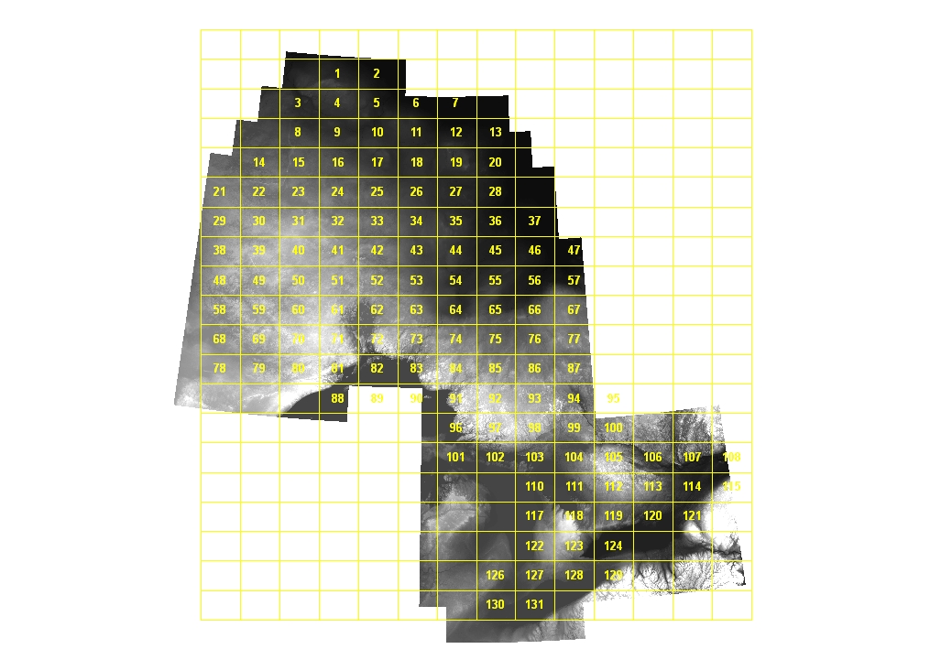
Version 1920.1

