User Guide
Ontario Digital Elevation Model (Imagery-Derived)
LIO Dataset
  - Provincial Mapping Unit
  - Mapping and Information Resources Branch
  - Corporate Management and Information Division
  - Ministry of Natural Resources and Forestry
2022-02-24

Disclaimer
This technical documentation has been prepared by Her Majesty the Queen in right of Ontario as represented by the Ministry of Natural Resources and Forestry (the “Ministry”). No warranties or representations, express or implied, statutory or otherwise shall apply or are being made by the Ministry with respect to the documentation, its accuracy or its completeness. In no event will the Ministry be liable or responsible for any lost profits, loss of revenue or earnings, claims by third parties or for any economic, indirect, special, incidental, consequential or exemplary damage resulting from any errors, inaccuracies or omissions in this documentation; and in no event will the Ministry’s liability for any such errors, inaccuracies or omissions on any particular claim, proceeding or action, exceed the actual consideration paid by the claimant involved to the Ministry for the materials to which this instructional documentation relates. Save and except for the liability expressly provided for above, the Ministry shall have no obligation, duty or liability whatsoever in contract, tort or otherwise, including any liability or negligence. The limitations, exclusions and disclaimers expressed above shall apply irrespective of the nature of any cause of action, demand or action, including but not limited to breach of contract, negligence, strict liability, tort or any other legal theory, and shall survive any fundamental breach or breaches.
Cette publication spécialisée n’est disponible qu’en anglais.

Additional Information
This document does not comply with all the applicable guidelines for accessible digital documents. For an alternative format please email Provincial Mapping Unit at pmu@ontario.ca.
For more information about this document, please contact Provincial Mapping Unit at pmu@ontario.ca.

Document History
Date | Description
2019-09-26 | First release
2020-03-04 | Updated hyperlinks

Executive Summary

Key Words
Digital Elevation Model (DEM), Provincial Mapping Unit, Elevation, South Central Ontario Orthophotography Project, SCOOP, Digital Raster Acquisition Project Eastern Ontario, DRAPE, Southwestern Ontario Orthophotography Project, SWOOP, Central Ontario Orthophotography Project, COOP, Northwestern Ontario Orthophotography Project, NWOOP.

Abstract
This user guide is intended to go beyond metadata and give data users a sense of the purpose for which the data was collected, the technical processes, software, and applicable standards involved, suggested applications for the data (and general approaches to how to use it), and other details that will help data users. As such, this user guide details the acquisition specifications for the Ontario Digital Elevation Model (Imagery-Derived) Land Information Ontario (LIO) dataset and how it relates to the overall imagery project dataset.
The Ontario Digital Elevation Model (Imagery-Derived) is a 2-m raster elevation product that represents a generalized representation of both surface and ground features. The product was generated by Ontario Ministry of Natural Resources and Forestry (MNRF) staff for some project areas or the imagery contractor for ortho-rectifying the photography acquired for the Land Information Ontario (LIO) imagery program.

Table of Contents
Disclaimer 2
Additional Information 2
Document History 3
Executive Summary 4
Key Words 4
Abstract 4
Table of Contents 5
List of Figures 7
List of Tables 8
List of Acronyms 9
List of Definitions 10
Mass Points 10
Digital Elevation Model (DEM) 10
Digital Terrain Model (DTM) 10
Digital Surface Model (DSM) 11
1. Product Description 12
1.1 Acquisition 12
1.2 DEM Product 14
1.3 Geographic Extent 16
1.4 Reference System 23
1.4.1 Horizontal Reference System 23
1.4.2 Vertical Reference System 23
1.5 Accuracy Assessment 24
1.6 Resolution 24
1.6.1 Spatial Resolution 24
2. Product Details 25
2.1 Data Delivery Format 25
2.2 Use Restrictions 28
3. Links to Additional Information 28
4. References 28
Appendix A: Getting Started: Display and Use of DEM Data 29
Opening and viewing the DEM 29
Creation of Contour Lines from DEM 30
Assembly, viewing and analysis of multiple DEM tiles: new dataset vs virtual 31
Appendix B: Common DEM Analysis Functions 33
Slope 33
Aspect 33
Curvature 34
Appendix C: Detailed DEM Processing Workflow 35
Process Output Workflow 35
Appendix D: Limitations of the Ontario DEM (Imagery-Derived) 39

List of Figures
Figure 1: SCOOP Products 14
Figure 2: COOP 2016 Point Cloud Ground Post Spacing 15
Figure 3: Extents of the LIO Imagery Acquisition Program projects 16
Figure 4: SCOOP 2013 DEM tiles 17
Figure 5: DRAPE 2014 DEM tiles 18
Figure 6: SWOOP 2015 DEM extent 19
Figure 7: Algonquin 2015 DEM tiles 20
Figure 8: COOP 2016 DEM extent 21
Figure 9: NWOOP 2017 DEM extent 22
Figure 10: Tile names reflect tile size, UTM zone, Easting, Northing, Project and Year 25
Figure 11: Ontario DEM (Imagery-Derived) distribution package boundaries 27
Figure 12: Unzipped DEM package contents 29
Figure 13: DEM tile 29
Figure 14: DEM tile displayed as a hillshade and colour-shaded relief 30
Figure 15: Smoothed contour lines generated from a DEM tile at 5-m interval 31
Figure 16: Examples of Slope and Aspect 33
Figure 12: COOP 2016 DEM development process 36
Figure 13: Ground classified point cloud posts after filtering vegetation surface features 37
Figure 14: Resulting Triangular Irregular Network (TIN) produced from ground posts 37
Figure 15: Interpolated DEM hillshade from TIN aligned to point cloud ground posts 38
Figure 16: Area of dense coniferous vegetation adjacent a wetland with a profile window (red) drawn overtop 39
Figure 17: Shaded relief view of the same area as in Figure 16 with a profile window 40
Figure 18: Profile view of point cloud from the area outlined in Figure 16. Ground posts (red) are visible just below unclassified points (green) representing the tree canopy 40
Figure 19: Oblique 3D view of point cloud showing ground classified points (red) in the same area as the profile in Figure 18. 40

List of Tables
Table 1: Acquisition details for the LIO Imagery Acquisition Program projects 13
Table 2: UTM Zone for each project of the LIO Imagery Acquisition Program 23
Table 3: Ontario DEM (Imagery-Derived) Distribution Packages and Size 25

List of Acronyms
ADS: Airborne Digital Sensor
AMT: Above Mean Terrain
CGVD: Canadian Geodetic Vertical Datum
COOP: Central Ontario Orthophotography Project
DEM: Digital Elevation Model
DRAPE: Digital Raster Acquisition Project Eastern Ontario
DSM: Digital Surface Model
DTM: Digital Terrain Model
GSD: Ground Sample Distance
IMU: Inertial Measuring Unit
LAS: Laser File Exchange Format
LIO: Land Information Ontario
MNRF: Ministry of Natural Resources and Forestry
NAD: North American Datum
NIR: Near Infrared
PMU: Provincial Mapping Unit
NWOOP: Northwestern Ontario Orthophotography Project
RGB: Red Green Blue
SCOOP: South Central Ontario Orthophotography Project
SWOOP: Southwestern Ontario Orthophotography Project
TIN: Triangular Irregular Networks
UTM: Universal Transverse Mercator

List of Definitions

Mass Points
Mass points are irregularly spaced points, each with x/y location coordinates and z-values, typically (but not always) used to form a TIN. When generated manually, mass points are ideally chosen to depict the most significant variations in the slope or aspect of TIN triangles. However, for the Ontario Classified Point Cloud (Imagery-Derived) the mass point spacing and patterns depend upon the GSD (ground sampling distance) of the photography that was used as the data source for generating the mass points. See Appendix C for more details.

Digital Elevation Model (DEM)
Digital Elevation Model (DEM) is a generic term for digital topographic and/or bathymetric data that is comprised of x/y coordinates and z-values to represent an elevation surface.
The terms ‘DTM’ and ‘DSM’ should be used over the term ‘DEM’ to more specifically reference ‘bare-earth’ or ‘surface elevation’ model products when possible.
The term ‘DEM’ is to be used as a broader term when referencing a generic elevation data product. The Provincial DEM is an example of a generic elevation product given that it has been constructed using a combination of both ‘DTM’ and ‘DSM’ elevation datasets to achieve Provincial coverage.

Digital Terrain Model (DTM)
The bare earth surface (lowest surface) represents the surface of the "bare-earth" terrain, after removal of vegetation and constructed features.
Photogrammetry has traditionally generated DTMs when elevations are generated by manual compilation techniques. Unless specified to the contrary, the bare-earth surface includes the top surface of water bodies, rather than the submerged surface of underwater terrain.
Like a DSM, a DTM can be structured either as a vector dataset (comprised of mass points and optionally 3D breaklines) to model bare-earth elevations or a raster dataset that is interpolated from the vector elevation data to model bare-earth terrain elevations.
Using modern elevation point cloud classification algorithms and file formats, such as LAS, a DTM can represent a mass point dataset that has been classified for ‘bare-earth’ terrain elevations.

Digital Surface Model (DSM)
A DSM is the highest reflective surface of ground features captured by the sensor. The DSM may include treetops, rooftops, and tops of towers, telephone poles, and other natural or constructed features; or it may include the ground surface if there is no vegetative ground cover. Photogrammetry can provide this type of surface, yet characteristics such as accuracy and degree of detail (ability to resolve desired surface features) may vary significantly across technologies and even within the same technology. With photogrammetry the reflective surface may include any artifact present when the sensor mapped the area, including passing cars and trucks and similar features not normally considered to be part of a digital terrain model.
Like a DTM, a DSM can be structured either as a vector dataset (comprised of mass points and optionally 3D break lines) to model surface elevations or a raster dataset that is interpolated from the vector elevation data to model surface elevations.
Using modern elevation point cloud classification algorithms and file formats, such as LAS, a DSM can represent a mass point dataset that has been classified for ‘surface’ elevation features.

- Product Description
  - Acquisition
The Ontario Classified Point Cloud (Imagery-Derived) is sourced from data acquired through the LIO Imagery Program. Fugro was contracted to acquire and process the digital imagery for the 2013-2017 projects. Imagery was acquired by the contractor in five project areas, each acquired in a different year in leaf-off conditions. Leica Digital Camera systems, including inertial measuring unit (IMU) and dual frequency airborne GPS receivers were used for the digital image acquisition. The products generated from the LIO imagery program include: stereo imagery and 1-km by 1-km orthophotography tiles in both GeoTIFF and JPEG2000 formats with red, green, blue and near-infrared bands.

Table 1: Acquisition details for the LIO Imagery Acquisition Program projects
Project Area | Acquisition Period | Project Area (sq. km) | Camera System | Flight Altitude Above Mean Terrain (AMT) | Additional Notes
South Central Ontario Orthophotography Project (SCOOP) 2013 | Apr 26th to May 7th 2013 | 35,762 | Leica ADS 80 | 1,920 m | 40 funding partners were involved in SCOOP
Digital Raster Acquisition Project Eastern Ontario (DRAPE) 2014 | Apr 28th to Jun 7th 2014 | 37,290 | Leica ADS 100 | 2,377 m | 60 funding partners were involved in DRAPE
Southwestern Ontario Orthophotography Project (SWOOP) / Algonquin 2015 | Apr 12th to May 23rd 2015 | 49,167 | Leica ADS 100 | 2,506 to 2,535 m | 40 funding partners were involved in SWOOP
Central Ontario Orthophotography Project (COOP) 2016 | May 6th to Jun 10th 2016 | 53,729 | Leica ADS 100 | 2,377 m | Private and government entities collaborated on COOP under the coordination of MNRF
Northwestern Ontario Orthophotography Project (NWOOP) 2017 | May 7th to May 19th 2017 | 27,911 | Leica ADS 100 | 2,437 m | Private and government entities collaborated on NWOOP under the coordination of MNRF

  - DEM Product
After releasing the SCOOP 2013, DRAPE 2014 and SWOOP 2015 Raw Point Cloud, MNRF staff worked with the raw point cloud LAS data to create a Classified Point Cloud, Digital Surface Model (DSM) and a Digital Elevation Model (DEM) as seen in Figure 1 in an example for the SCOOP 2013 project.
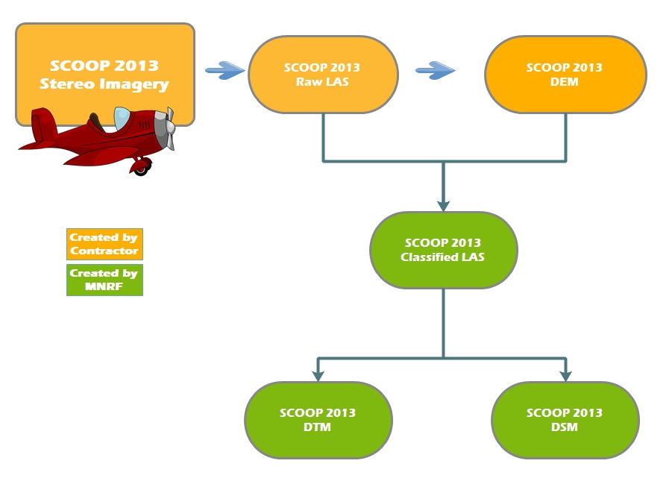
Figure 1: SCOOP Products
The raw point cloud from the overlapping flight lines were resampled to 50-cm spacing and retiled into 1-km by 1-km tiles and reassembled back into LAS format. This reduces redundant points and the volume of data. During the retiling, a comparison with the DEM delivered by the contractor was done to automatically assign the LAS classification. If the DEM was within 50-cm vertically, it was assigned a LAS classification code of 2 (Ground) otherwise it was assigned a LAS code of 0 (Unassigned). This point cloud has been published as the Ontario Classified Point Cloud (Imagery-Derived). For more information, search for that product name in the Ontario GeoHub (https://geohub.lio.gov.on.ca).
The DSM raster was created by using all the points (Ground and Unclassified) from the Classified Point Cloud to create a raster product.
The DEM raster was produced from the ground classified points, and then compared with the DSM to ensure that no point would be higher than the DSM.
The DEM for COOP 2016 and NWOOP 2017 was delivered to MNRF as a derivative product of the LIO Imagery Acquisition Project, as it was produced for use in the process of image orthorectification. The product is being distributed in the original state delivered by the imagery contractor without modification.
The DEM is a 2-m resolution raster product that has been generated by the contractor from a classified point cloud elevation dataset consisting of Ground, Noise, and Unassigned classes, where the points not classified as Ground have been removed and interpolation has occurred across the resulting voids. This point cloud has been included in the Ontario Classified Point Cloud (Imagery-Derived).
It is important to note that the DEM does not represent a full ‘bare-earth’ elevation surface. Although the source point cloud data has a post spacing of 1.2-m, not all points identified as Ground in the classified point cloud are spaced at 1.2-m (yellow point features in Figure 2). Also points that are classified as Ground have not been assessed for accuracy to determine if they represent true ground features. Some features are still raised above ground surface, such as larger buildings, larger forest stands and other raised features. Appendix D provides further description of these limitations of the DEM.
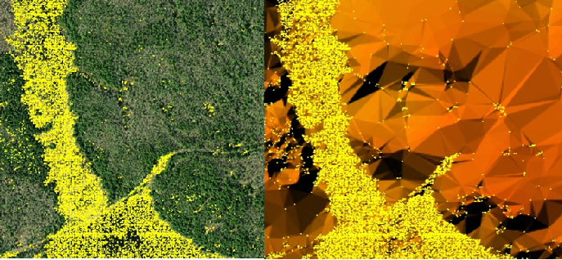
Figure 2: COOP 2016 Point Cloud Ground Post Spacing
  - Geographic Extent
The Land Information Ontario Acquisition Program provides high-resolution leaf-off imagery on a five-year cycle for southern Ontario and parts of the near north. See Figure 3 for extents of imagery projects.
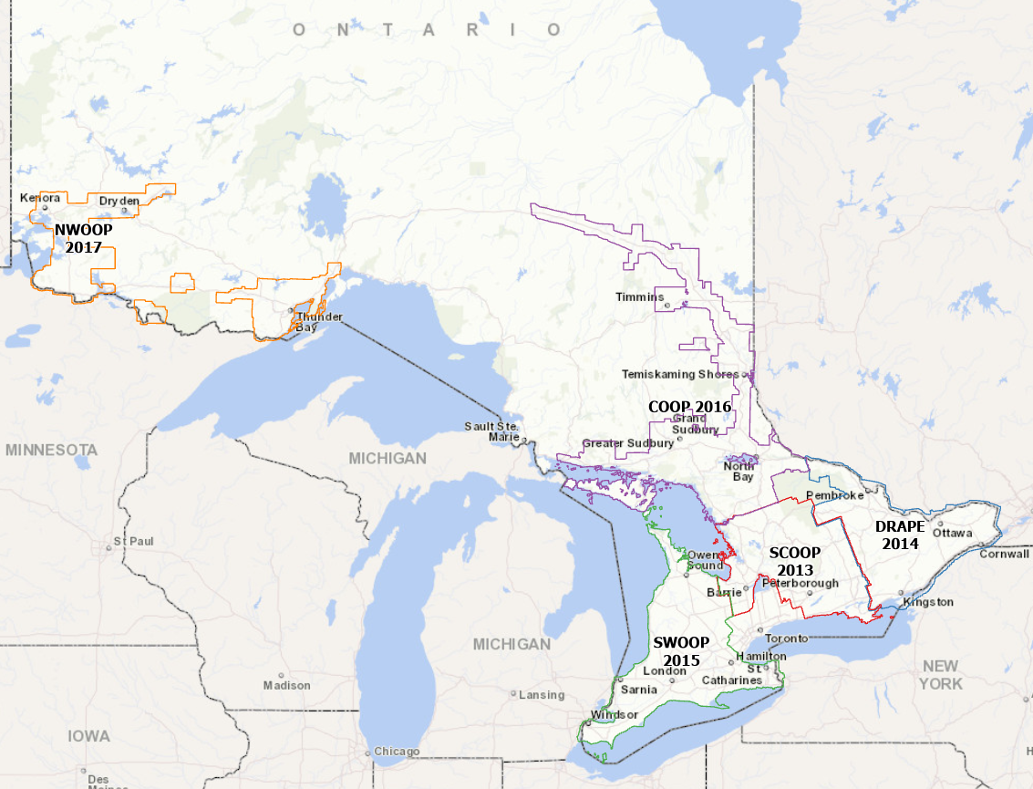
Figure 3: Extents of the LIO Imagery Acquisition Program projects

The SCOOP 2013 project area contains 35,921 tiles (1-km by 1-km). These tiles are non-overlapping except between UTM Zones 17 and 18 (see Figure 4). The product covers South Central Ontario including southern Algonquin Park, the Counties of Haliburton, Hastings, Northumberland, Peterborough, Prince Edward County, and Simcoe, the District of Muskoka and the southern portion of Parry Sound and the Cities of Barrie, Belleville, Kawartha Lakes, Orillia, Peterborough, and Quinte West.
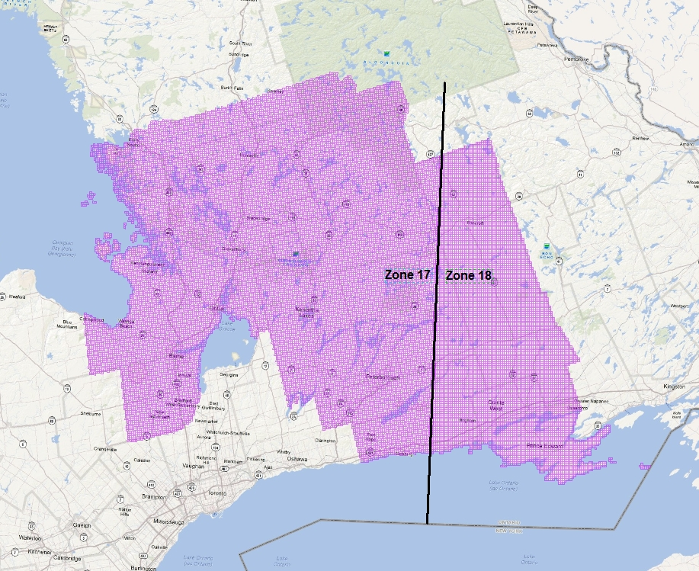
Figure 4: SCOOP 2013 DEM tiles

The DRAPE 2014 project area contains 37,226 non-overlapping tiles (1-km by 1-km) covering the Counties of Frontenac, Lanark, Lennox and Addington, Renfrew, the United Counties of Leeds and Grenville, Prescott and Russell, Stormont, Dundas and Glengarry, the Towns of Prescott, Gananoque and Smith Falls, the Township of South Algonquin and the Cities of Cornwall, Brockville, Kingston, Ottawa and Pembroke (Figure 5).
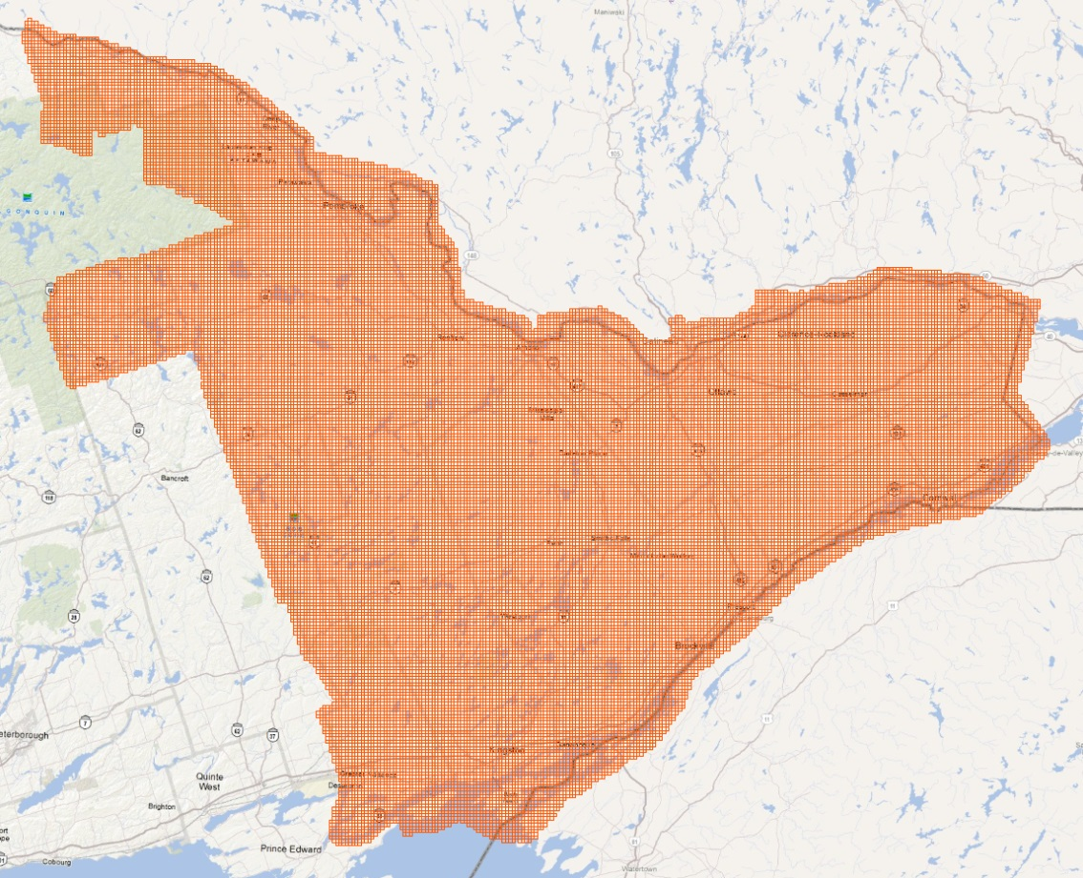
Figure 5: DRAPE 2014 DEM tiles

The SWOOP 2015 project area contains 37,226 non-overlapping tiles (1-km by 1-km) covering Southwestern Ontario including Owen Sound, Lambton Shores, Chatham-Kent, Windsor, London, St. Thomas, Woodstock, Waterloo, Kitchener, Brantford, Hamilton, Niagara Falls, Stratford, Cambridge, Welland, Port Colborne, St. Catharines and surrounding areas (Figure 6).
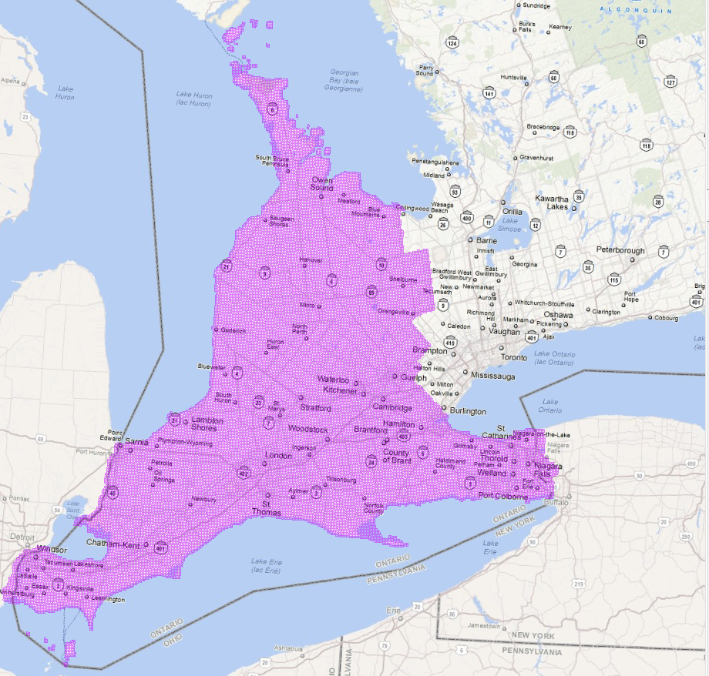
Figure 6: SWOOP 2015 DEM extent

The Algonquin 2015 DEM contains 4,536 non-overlapping tiles (1-km by 1-km) covering a large portion of Algonquin Provincial Park (Figure 7). The Algonquin imagery was acquired as part of the SWOOP 2015 project.
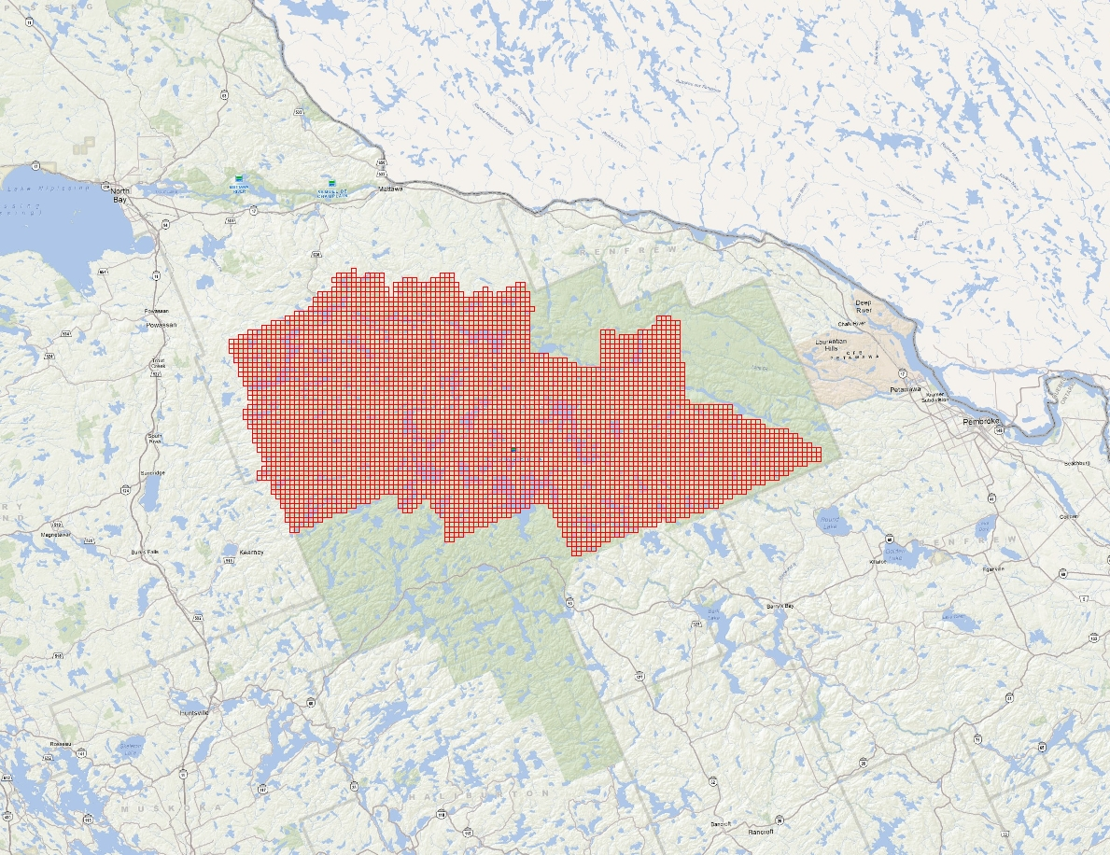
Figure 7: Algonquin 2015 DEM tiles

The COOP 2016 project area contains 53,729 non-overlapping tiles (1-km by 1-km) covering areas in Central and Northeastern Ontario and including select areas of Cochrane, Algoma, Manitoulin, Nipissing, Parry Sound, Sudbury, and Timiskaming (Figure 8).
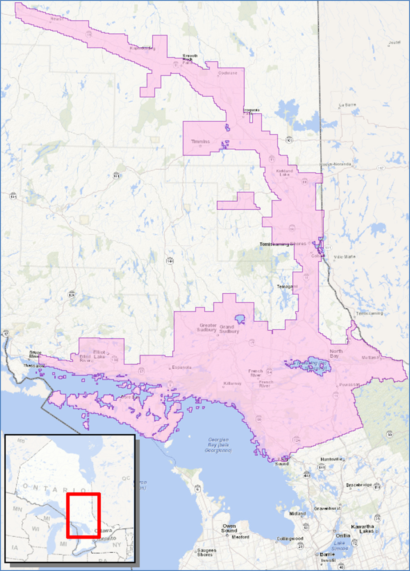
Figure 8: COOP 2016 DEM extent

The NWOOP 2017 project area contains 27,911 non-overlapping tiles (1-km by 1-km) covering areas in Northwestern Ontario and including select areas of Atikokan, Dryden, Fort Frances, Kenora, Rainy River, Sioux Lookout and Thunder Bay (Figure 9).
Figure 9: NWOOP 2017 DEM extent

  - Reference System
    - Horizontal Reference System
The horizontal coordinate system of the Ontario DEM (Imagery-Derived) is Universal Transverse Mercator (UTM) with zone varying by project area (Table 2). The horizontal datum is the North American Datum of 1983 Canadian Spatial Reference System (https://www.nrcan.gc.ca/earth-sciences/geomatics/geodetic-reference-systems/9052).
The horizontal unit of measure (coordinate system axis units) for all raster grid cells in the DEM is metres (m).
Table 2: UTM Zone for each project of the LIO Imagery Acquisition Program
Project Area | UTM Zone
SCOOP 2013 | 17 & 18
DRAPE 2014 | 18
SWOOP 2015 | 17
Algonquin 2015 | 17
COOP 2016 | 17
NWOOP 2017 | 15 & 16

    - Vertical Reference System
The vertical coordinate system of the Ontario DEM (Imagery-Derived) is the Canadian Geodetic Vertical Datum 1928 (CGVD28) of the Geodetic Survey Division and is measured in metres above mean sea level. For more information please see the Height Reference System Modernization of Natural Resources Canada (https://www.nrcan.gc.ca/height-reference-system-modernization/9054#_Canadian_Geodetic_Vertical_1).
The vertical unit of measure (coordinate system axis units) for all raster grid cells in the DEM is metres (m). One single vertical elevation value represents each raster grid cell in the DEM.

  - Accuracy Assessment
The Ontario Public Service Elevation Coordination and Consultation Committee has published Elevation Accuracy Guidelines (2016) which explain and provide guidelines for assessing the accuracy of digital elevation data, which has been drafted to be consistent with the 2014 American Society for Photogrammetry and Remote Sensing (ASPRS) Positional Accuracy Standards for Digital Geospatial Data.
An assessment has been conducted to evaluate the vertical accuracy of SCOOP 2013 Digital Surface Model (DSM) and SCOOP 2013 Digital Terrain Model (DTM). To date, there has not been an assessment done specific to the DEMs for the other imagery project areas, but the SCOOP products share many similarities with the other projects. The results of the SCOOP assessment, including the data, can be downloaded on the metadata record of the Ontario DEM (Imagery-Derived) (https://geohub.lio.gov.on.ca/datasets/1ce266ee55c44ffca2d457bc5db13b92).
  - Resolution
    - Spatial Resolution
The grid spacing is based on Universal Transverse Mercator (UTM) projection with a raster cell resolution of 2 metres.

- Product Details
  - Data Delivery Format
The Ontario DEM (Imagery-Derived) is stored in .IMG (ERDAS-Imagine) format raster files in 1-km by 1-km tiles and grouped into packages of tiles compressed using the .ZIP archive file format. The standard file naming format is explained in Figure 10.
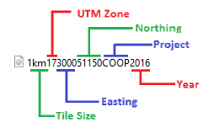
Figure 10: Tile names reflect tile size, UTM zone, Easting, Northing, Project and Year
The DEM is currently stored and distributed through the Ontario GeoHub (https://geohub.lio.gov.on.ca/). Data packages can be downloaded by clicking on features in the map interface of the record for the Ontario Digital Elevation Model (Imagery-Derived) (https://geohub.lio.gov.on.ca/datasets/1ce266ee55c44ffca2d457 bc5db13b92) or from the list of data packages. For additional information on working with the DEM see Appendix A.
As detailed in Table 3 and Figure 11, the DEM is divided into packages for distribution.
Table 3: Ontario DEM (Imagery-Derived) Distribution Packages and Size
Package | Compressed Size (GB) | Number of Tiles | Horizontal Reference
SCOOP 2013 A | 2.68 | 4,322 | NAD83(CSRS) UTM 17N
SCOOP 2013 B | 2.76 | 4,410 | NAD83(CSRS) UTM 17N
SCOOP 2013 C | 2.79 | 4,353 | NAD83(CSRS) UTM 17N
SCOOP 2013 D | 2.83 | 4,452 | NAD83(CSRS) UTM 17N
SCOOP 2013 E | 2.84 | 4,415 | NAD83(CSRS) UTM 17N
SCOOP 2013 F | 2.83 | 4,414 | NAD83(CSRS) UTM 17N
SCOOP 2013 G | 3.06 | 4,765 | NAD83(CSRS) UTM 18N
SCOOP 2013 H | 2.95 | 4,790 | NAD83(CSRS) UTM 18N
DRAPE 2014 A | 2.97 | 4,412 | NAD83(CSRS) UTM 18N
DRAPE 2014 B | 2.66 | 3,986 | NAD83(CSRS) UTM 18N
DRAPE 2014 C | 2.44 | 3,850 | NAD83(CSRS) UTM 18N
DRAPE 2014 D | 2.55 | 4,078 | NAD83(CSRS) UTM 18N
DRAPE 2014 E | 2.75 | 4,358 | NAD83(CSRS) UTM 18N
DRAPE 2014 F | 2.51 | 4,161 | NAD83(CSRS) UTM 18N
DRAPE 2014 G | 2.39 | 4,007 | NAD83(CSRS) UTM 18N
DRAPE 2014 H | 2.37 | 4,192 | NAD83(CSRS) UTM 18N
DRAPE 2014 I | 2.38 | 4,173 | NAD83(CSRS) UTM 18N
SWOOP 2015 A | 3.17 | 5,541 | NAD83(CSRS) UTM 17N
SWOOP 2015 B | 3.00 | 5,115 | NAD83(CSRS) UTM 17N
SWOOP 2015 C | 2.98 | 5,338 | NAD83(CSRS) UTM 17N
SWOOP 2015 D | 2.94 | 6,047 | NAD83(CSRS) UTM 17N
SWOOP 2015 E | 3.00 | 5,791 | NAD83(CSRS) UTM 17N
SWOOP 2015 F | 2.89 | 5,335 | NAD83(CSRS) UTM 17N
SWOOP 2015 G | 3.06 | 5,579 | NAD83(CSRS) UTM 17N
SWOOP 2015 H | 3.12 | 5,881 | NAD83(CSRS) UTM 17N
Algonquin 2015 | 1.92 | 4,536 | NAD83(CSRS) UTM 17N
COOP 2016 A | 2.34 | 6,900 | NAD83(CSRS) UTM 17N
COOP 2016 B | 2.88 | 7,153 | NAD83(CSRS) UTM 17N
COOP 2016 C | 2.95 | 5,226 | NAD83(CSRS) UTM 17N
COOP 2016 D | 2.82 | 5,634 | NAD83(CSRS) UTM 17N
COOP 2016 E | 2.83 | 4,680 | NAD83(CSRS) UTM 17N
COOP 2016 F | 2.81 | 5,859 | NAD83(CSRS) UTM 17N
COOP 2016 G | 2.97 | 6,538 | NAD83(CSRS) UTM 17N
COOP 2016 H | 2.66 | 7,163 | NAD83(CSRS) UTM 17N
COOP 2016 I | 1.68 | 4,576 | NAD83(CSRS) UTM 17N
NWOOP 2017 A | 0.85 | 2,150 | NAD83(CSRS) UTM 16N
NWOOP 2017 B | 2.39 | 6,216 | NAD83(CSRS) UTM 16N
NWOOP 2017 C | 1.19 | 3,406 | NAD83(CSRS) UTM 15N
NWOOP 2017 D | 2.52 | 7,596 | NAD83(CSRS) UTM 15N
NWOOP 2017 E | 1.62 | 4,573 | NAD83(CSRS) UTM 15N
NWOOP 2017 F | 1.29 | 3,970 | NAD83(CSRS) UTM 15N

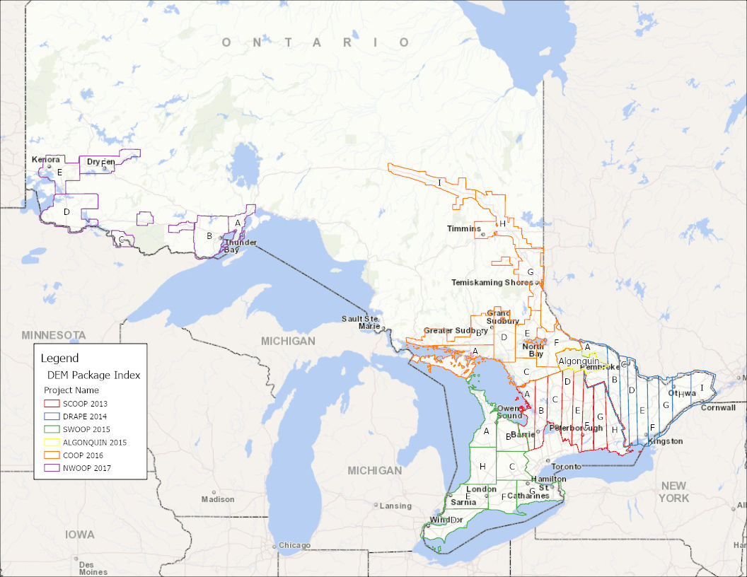
Figure 11: Ontario DEM (Imagery-Derived) distribution package boundaries

  - Use Restrictions
The Ontario DEM (Imagery-Derived) is considered Open Data. You are free to copy, modify, publish, translate, adapt, distribute or otherwise use the Information in any medium, mode or format for any lawful purpose. If you do any of the above you must use the following attribution statement “Contains information licensed under the Open Government Licence – Ontario”. See Open Government Licence (https://www.ontario.ca/page/open-government-licence-ontario).
- Links to Additional Information
Natural Resources Canada 2019 “Height Reference System Modernization” (https://www.nrcan.gc.ca/height-reference-system-modernization/9054#_Canadian_Geodetic_Vertical_1)
Natural Resources Canada 2016 “The Canadian Spatial Reference System (CSRS)” (https://www.nrcan.gc.ca/earth-sciences/geomatics/geodetic-reference-systems/9052)
- References
Ontario, Elevation Coordination and Consultation Committee 2016 “Elevation Accuracy Guidelines” (Queens Printer for Ontario. Retrieved from: https://www.sdc.gov.on.ca/sites/MNRF-PublicDocs/EN/CMID/Elevation%20Accuracy%20Guidelines%20-%20User%20Guide.pdf)

Appendix A: Getting Started: Display and Use of DEM Data

Opening and viewing the DEM
The DEM packages must be unzipped and will produce a folder corresponding to the name of the package, which contains the .IMG raster files (Figure 12).
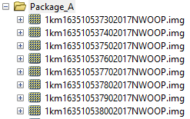
Figure 12: Unzipped DEM package contents
The DEM tiles can be used for viewing or analysis using any one of the many GIS software packages capable of using .IMG raster files. The DEM represents a continuous surface of 2-m cells containing elevation (z) values in metres (Figure 13).
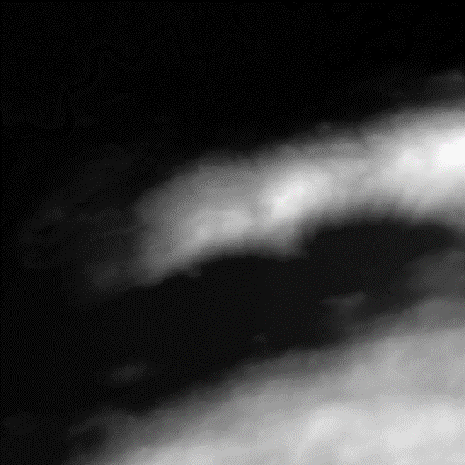
Figure 13: DEM tile
DEM tiles can be used as-is for topographic elevation analysis, but for visualization it is better to derive and display the DEM using a hillshade or a colour-shaded relief function. A hillshade is a grayscale image that represents a DEM in three-dimensional appearance as the human eye would interpret it with the sun set at a specified direction (azimuth) and altitude. A colour-shaded relief expands on this by adding color gradient based on cell z-values. Figure 14 depicts examples of a hillshade (left) with properties applied such that it is illuminated from 210° (Southwest), and a colour-shaded relief illuminated from 315° (Northwest).
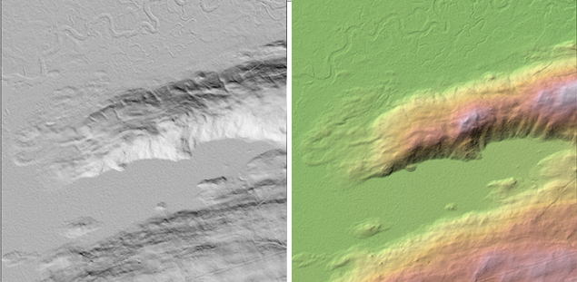
Figure 14: DEM tile displayed as a hillshade and colour-shaded relief

Creation of Contour Lines from DEM
Contour lines are lines connecting points of equal elevation. Traditionally used to display elevation changes on topographic maps, contour lines are of little value today for automated analysis purposes but can be an effective method to convey three-dimensional information on two-dimensional cartographic products for visual interpretation. Contour lines can be generated directly from a DEM and smoothed or otherwise modified to meet user needs using processes available in many GIS software packages (Figure 15).
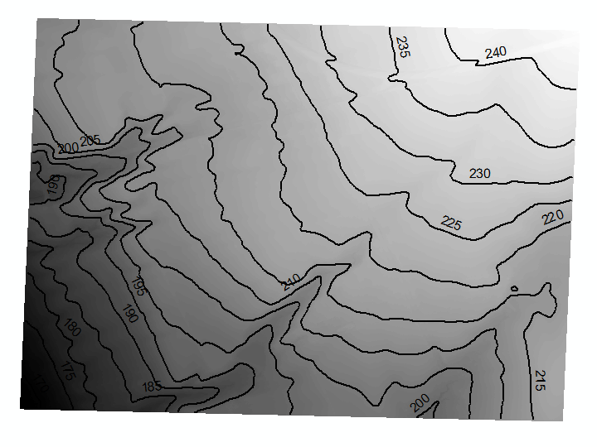
Figure 15: Smoothed contour lines generated from a DEM tile at 5-m interval

Assembly, viewing and analysis of multiple DEM tiles: new dataset vs virtual
As with many other imagery and raster products delivered through LIO, the DEM product is provided in 1km² non-overlapping tiles and grouped into packages. There are several advantages to this method of storage and distribution including maintenance of metadata, storage considerations and the flexibility to allow clients to request the data they need for their study area, without requiring custom data extracts to client supplied boundaries.
If your study area covers multiple DEM tiles, these individual tiles can be viewed simultaneously, but for the purposes of analysis, or simply for faster and less complicated viewing, it is usually better to put all tiles in your study area together as one. This can be done in several different ways.
The traditional method is to assemble or merge all the individual tiles into a new raster covering your entire study area. This method can allow for faster display and may be necessary for some analysis operations but has the disadvantage that a separate new dataset must be produced which has implications for storage space. Being a new dataset, the naming and metadata of the individual tile structure used as a source will be lost as well.
Raster data takes up a great deal of storage space, so it is often a preferred approach to make use of a virtual representation of multiple tiles as one entity. These methods can include raster mosaic datasets, and virtual raster catalogs. Most of these methods have the advantage that the original files, metadata, folder structure and locations are preserved and the data for contributing tiles or groups of tiles can even be stored in separate different locations as storage space requirements dictate.
The exact methods and options available will depend on the software being used, and the requirements of the analysis. Please consult the documentation of the GIS software you are using for specific details about the options available to you.

Appendix B: Common DEM Analysis Functions
The DEM raster can be used as an input for a variety of surface geometry analysis functions such as calculations of slope, aspect and curvature. The actual algorithms used for any of these calculations may vary depending on the software used to perform the calculation.

Slope
Slope is a calculation based on difference between the rise and the run along a specified path. The output value assigned to a cell is usually based on the maximum difference in elevation values compared to adjacent cells and is commonly expressed in degrees or percent.

Aspect
Aspect is a calculation that applies a numeric value to a cell based upon the bearing that the slope of the cell is facing, in degrees. These values can be further categorized into compass directions of north, south, southeast, etc. For instance, in Figure 16, the aspect of the landscape is predominantly facing to the south and southwest.
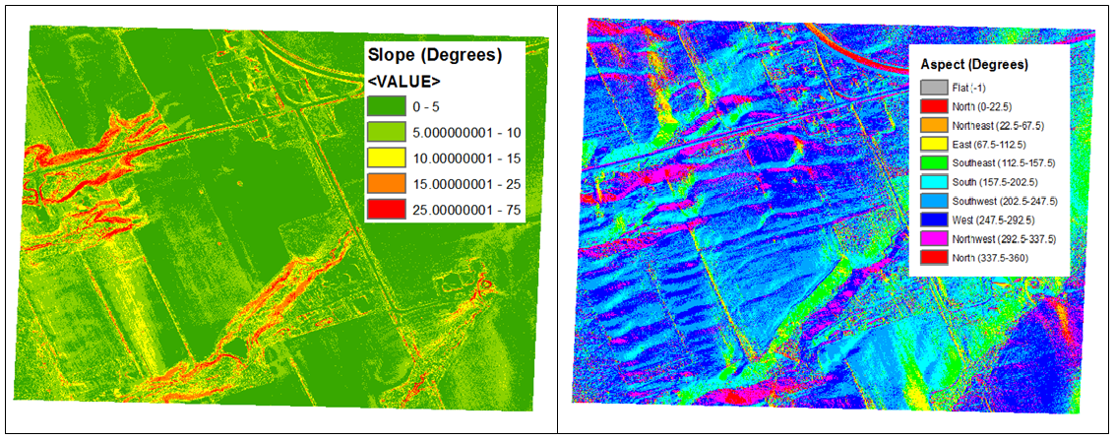
Figure 16: Examples of Slope and Aspect

Curvature
Curvature is a calculation based upon the shape of the surfaces which is calculated for each cell based compared to neighbouring cells. Positive curvature values indicate a convex surface, while negative values indicate a concave surface. It is also possible to extract the profile curvature of the slope, or the plan (horizontal) curvature values.

Appendix C: Detailed DEM Processing Workflow
The DSM point cloud was extracted at GSD (grid) resolution from stereo pairs using Leica XPro 6.x SGM module and then filtered, triangulated and gridded to create a 2m raster grid product, in some minor instances an alternate autocorrelation process was used however the general process follows:
- Flight lines of DSM were seamed together
- Editing of DSM where required (edge of tree lines, water, bridges, etc.)
- Final DSM was used for orthorectification
- Final DSM was saved *.IMG for delivery to OMNR
In the absence of an existing DEM, the BAE Automatic Terrain Extraction (ATE) program was used to process the ADS L1 stereo models to produce ortho suitable DEM’s. Once the aerotriangulation was complete, the DSM point cloud was generated at the desired orthophoto scale. The data was then processed through an algorithm computing the X, Y, Z value for each DSM post in the point cloud. This process includes the stereo pairs along the flight line from the backward, forward, and nadir panchromatic channels available from the collected data over the project area. The DSM generated is a “reflective-surface DSM”, providing elevation data on open ground as well as above-ground features including buildings, trees and vegetation. To produce the DEM the above-ground features were removed.
To do this, an automated filtering routine was used to create an ortho-quality DEM using commercial software SimActive and TerraScan/TerraModeler. The automated filtering routine identifies and removes most above-ground features, including vegetation and buildings.
Contractor technicians then performed a QC check to ensure quality of the surface met orthorectification requirements. Any filtering issues that impact ortho quality were corrected through manual editing of the point cloud. The DSM point cloud ground posts were then triangulated and interpolated into a raster DEM product. The final DEM produced is used in the differential rectification of the raw imagery. An accuracy assessment has not been performed on the final DEM against check points.

Process Output Workflow
The DEM development process is essentially a five-step process:
- Acquire imagery
- Perform pixel autocorrelation Semi Global Matching (SGM) using overlapping images to produce DSM point cloud posts
- Filter, edit, modify and otherwise process the DSM point cloud to produce an edited point cloud consisting of points classified as ground, unassigned and noise.
- Triangulate the point cloud posts into TIN format
- Interpolate the TIN to a gridded raster DEM in IMG format
This process can be conceptualized visually by the following set of images (See Figure 12). The final image is a simulated hillshade 3D view of the DEM.
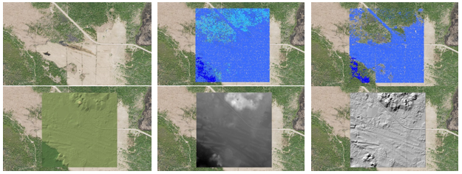
Figure 12: COOP 2016 DEM development process

At a 1:500 scale the process can be visualized in more detail (see Figures 13 to 15).
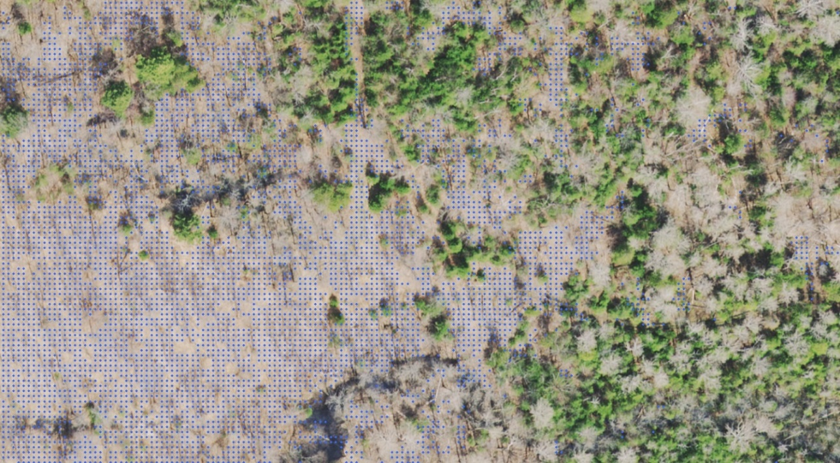
Figure 13: Ground classified point cloud posts after filtering vegetation surface features
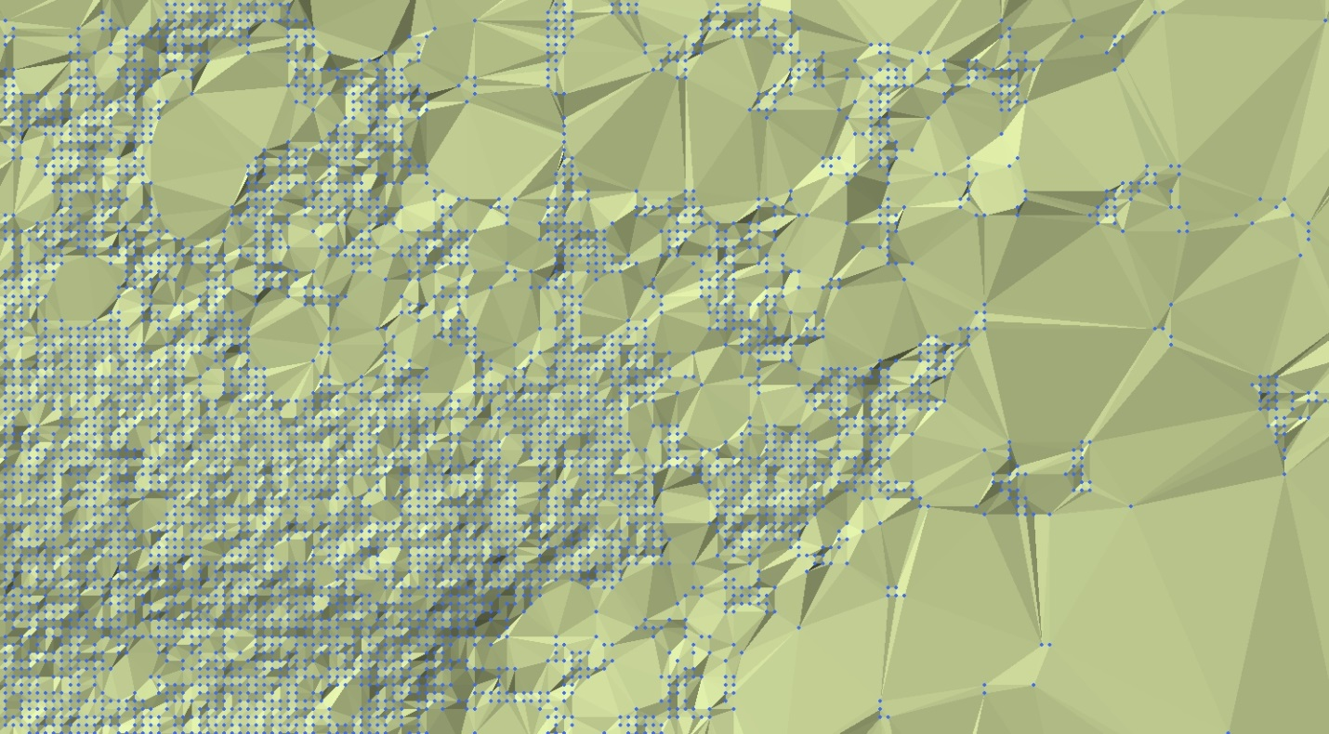
Figure 14: Resulting Triangular Irregular Network (TIN) produced from ground posts
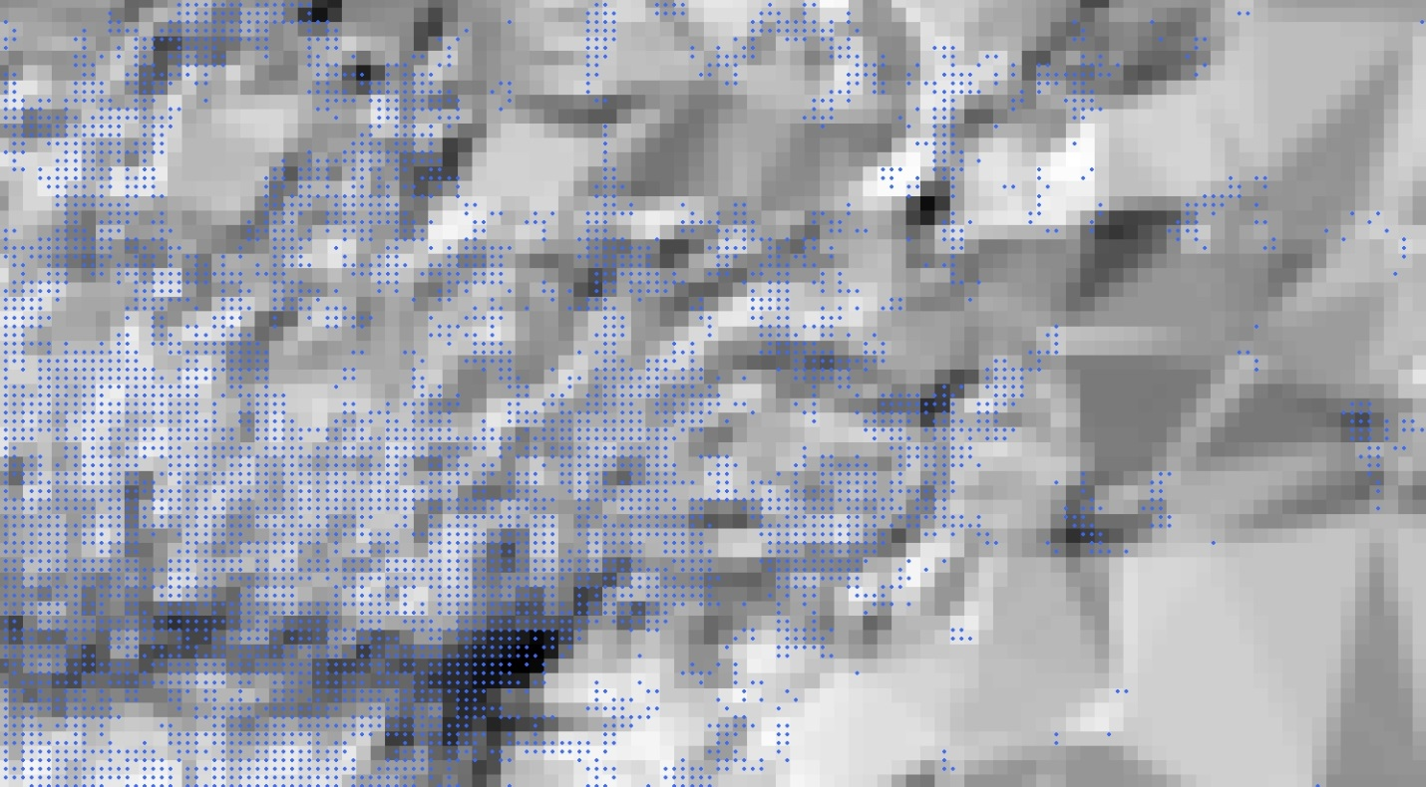
Figure 15: Interpolated DEM hillshade from TIN aligned to point cloud ground posts

Appendix D: Limitations of the Ontario DEM (Imagery-Derived)
In areas of dense coniferous vegetation, the Ontario DEM (Imagery-Derived) may not represent ground elevation values. If ground is not visible in the imagery, then the SGM process cannot produce ground points. During the point cloud classification process low points within the forest canopy may be incorrectly classified as ground. An example is shown below (See Figures 16 to 19). This is the reason the Ontario DEM (Imagery-Derived) cannot be considered a true bare-earth Digital Terrain Model (DTM).
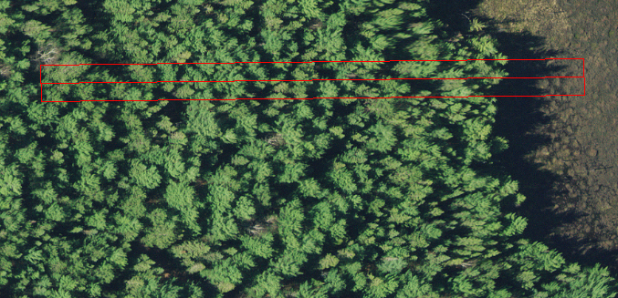
Figure 16: Area of dense coniferous vegetation adjacent a wetland with a profile window (red) drawn overtop
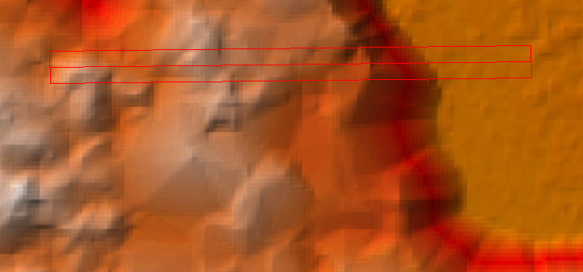
Figure 17: Shaded relief view of the same area as in Figure 16 with a profile window
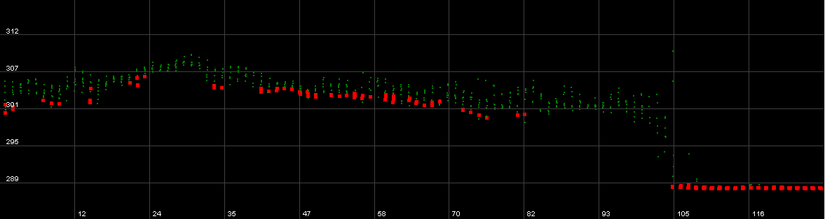
Figure 18: Profile view of point cloud from the area outlined in Figure 16. Ground posts (red) are visible just below unclassified points (green) representing the tree canopy
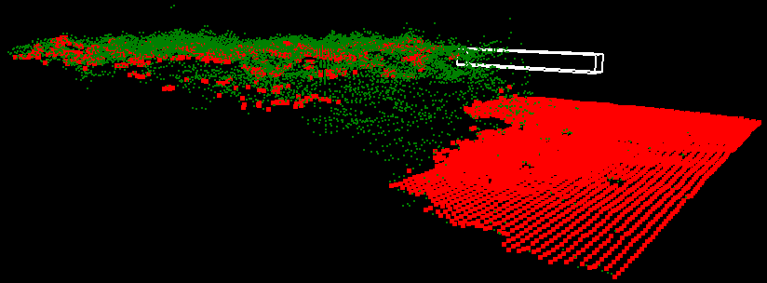
Figure 19: Oblique 3D view of point cloud showing ground classified points (red) in the same area as the profile in Figure 18.
Version 1617.1

