User Guide
for
Ontario Digital Surface Model (Imagery-Derived)
Geospatial Ontario Dataset
  - Geospatial Ontario
  - Digital, Data, Information and Business Services Branch
  - Corporate Management and Information Division
  - Ministry of Natural Resources
2025-10-06

Disclaimer
This technical documentation has been prepared by His Majesty the King in right of Ontario as represented by the Ministry of Natural Resources (the “Ministry”). No warranties or representations, express or implied, statutory or otherwise shall apply or are being made by the Ministry with respect to the documentation, its accuracy or its completeness. In no event will the Ministry be liable or responsible for any lost profits, loss of revenue or earnings, claims by third parties or for any economic, indirect, special, incidental, consequential or exemplary damage resulting from any errors, inaccuracies or omissions in this documentation; and in no event will the Ministry’s liability for any such errors, inaccuracies or omissions on any particular claim, proceeding or action, exceed the actual consideration paid by the claimant involved to the Ministry for the materials to which this instructional documentation relates. Save and except for the liability expressly provided for above, the Ministry shall have no obligation, duty or liability whatsoever in contract, tort or otherwise, including any liability or negligence. The limitations, exclusions and disclaimers expressed above shall apply irrespective of the nature of any cause of action, demand or action, including but not limited to breach of contract, negligence, strict liability, tort or any other legal theory, and shall survive any fundamental breach or breaches.

Additional Information
This document does not comply with all the applicable guidelines for accessible digital documents. For an alternative format please email Geospatial Ontario at geospatial@ontario.ca.
For more information about this document, please contact Geospatial Ontario at geospatial@ontario.ca.

Document History
Date | Description
2019-09-26 | First release
2020-03-03 | Update for the release of SCOOP 2018
2020-12-16 | Addition of data production and vertical reference system for SCOOP 2018
2021-12-20 | Addition of the DRAPE 2019 and SWOOP 2020 projects
2022-12-19 | Addition of the COOP 2021 project
2023-10-30 | Addition of the NWOOP 2022 project

Executive Summary

Key Words
Digital Surface Model (DSM), Geospatial Ontario, Elevation, South Central Ontario Orthophotography Project, SCOOP, Digital Raster Acquisition Project Eastern Ontario, DRAPE, Southwestern Ontario Orthophotography Project, SWOOP, Central Ontario Orthophotography Project, COOP, Northwestern Ontario Orthophotography Project, NWOOP.

Abstract
This user guide is intended to go beyond metadata and give data users a sense of the purpose for which the data was collected, the technical processes, software, and applicable standards involved, suggested applications for the data (and general approaches to how to use it), and other details that will help data users. As such, this user guide details the acquisition specifications for the Ontario Digital Surface Model (Imagery-Derived) Geospatial Ontario (GEO) dataset and how it relates to the overall imagery project dataset.
The Ontario Digital Surface Model (Imagery-Derived) is a raster elevation product that represents a generalized representation of both surface and ground features. The product was generated by Ontario Ministry of Natural Resources (MNR) staff from the Ontario Classified Point Cloud (Imagery-Derived) or Ontario Raw Point Cloud (Imagery-Derived).

Table of Contents
Disclaimer 2
Additional Information 2
Document History 3
Executive Summary 4
Key Words 4
Abstract 4
Table of Contents 5
List of Figures 7
List of Tables 7
List of Acronyms 8
List of Definitions 9
Mass Points 9
Digital Elevation Model (DEM) 9
Digital Terrain Model (DTM) 9
Digital Surface Model (DSM) 10
1. Product Description 11
1.1 Acquisition 11
1.2 Data Production 13
1.3 Geographic Extent 15
1.4 Reference System 17
1.4.1 Horizontal Reference System 17
1.4.2 Vertical Reference System 17
1.5 Accuracy Assessment 18
1.6 Spatial Resolution 18
2. Product Details 19
2.1 Data Delivery Format 19
2.2 Use Restrictions 21
3. Links to Additional Information 22
4. References 22
Appendix A: Getting Started - Display and Use of DSM Data 23
Opening and viewing the DSM 23
Assembly, viewing and analysis of multiple DSM tiles: new dataset vs virtual 25
Appendix B: Common DEM Analysis Functions 26
Slope 26
Aspect 26
Curvature 27
Appendix C: Data Package Details 28
Appendix D: Detailed DEM Processing Workflow 40
Process Output Workflow 41

List of Figures
Figure 1: SCOOP Products 13
Figure 2: Extents of the GEO Imagery Acquisition Program projects in the DSM from 2010 to 2015 15
Figure 3: Extents of the GEO Imagery Acquisition Program projects in the DSM from 2018 to 2022 16
Figure 4: Tile names reflect tile size, UTM zone, Easting, Northing, Project, and Year 19
Figure 5: Ontario DSM (Imagery-Derived) distribution package boundaries for projects from 2010 to 2015 20
Figure 6: Ontario DSM (Imagery-Derived) distribution package boundaries for projects from 2018 to 2022 21
Figure 7: Unzipped DSM package contents 23
Figure 8: DSM tile in Kingston, ON 23
Figure 9: DSM tile displayed as a hillshade and colour-shaded relief in Kingston, ON 24
Figure 10: Examples of Slope and Aspect 26
Figure 11: COOP 2016 DEM development process 41
Figure 12: Ground classified point cloud posts after filtering vegetation surface features 42
Figure 13: Resulting Triangular Irregular Network (TIN) produced from ground posts 42
Figure 14: Interpolated DEM hillshade from TIN aligned to point cloud ground posts 43

List of Tables
Table 1: Acquisition details for the GEO Imagery Acquisition Program projects 12
Table 2: UTM Zone for each project in the DSM 17
Table 3: Vertical datums by projects 17
Table 4: Raster cell resolution for each imagery project 18
Table 5: Ontario DSM (Imagery-Derived) Distribution Packages and Size 28

List of Acronyms
ADS: Airborne Digital Sensor
AMT: Above Mean Terrain
CGVD: Canadian Geodetic Vertical Datum
COOP: Central Ontario Orthophotography Project
DEM: Digital Elevation Model
DRAPE: Digital Raster Acquisition Project Eastern Ontario
DSM: Digital Surface Model
DTM: Digital Terrain Model
GEO: Geospatial Ontario
GSD: Ground Sample Distance
IMU: Inertial Measuring Unit
LAS: Laser File Exchange Format
MNR: Ministry of Natural Resources
NAD: North American Datum
NIR: Near Infrared
NWOOP: Northwestern Ontario Orthophotography Project
RGB: Red Green Blue
SCOOP: South Central Ontario Orthophotography Project
SWOOP: Southwestern Ontario Orthophotography Project
TIN: Triangular Irregular Networks
UTM: Universal Transverse Mercator

List of Definitions

Mass Points
Mass points are irregularly spaced points, each with x/y location coordinates and z-values, typically (but not always) used to form a TIN. When generated manually, mass points are ideally chosen to depict the most significant variations in the slope or aspect of TIN triangles. However, for the Ontario Classified Point Cloud (Imagery-Derived) the mass point spacing and patterns depend upon the GSD (ground sampling distance) of the photography that was used as the data source for generating the mass points. See Appendix D for more details.

Digital Elevation Model (DEM)
Digital Elevation Model (DEM) is a generic term for digital topographic and/or bathymetric data that is comprised of x/y coordinates and z-values to represent an elevation surface.
The terms ‘DTM’ and ‘DSM’ should be used over the term ‘DEM’ to more specifically reference ‘bare-earth’ or ‘surface elevation’ model products when possible.
The term ‘DEM’ is to be used as a broader term when referencing a generic elevation data product. The Provincial DEM is an example of a generic elevation product given that it has been constructed using a combination of both ‘DTM’ and ‘DSM’ elevation datasets to achieve Provincial coverage.

Digital Terrain Model (DTM)
The bare earth surface (lowest surface) represents the surface of the "bare-earth" terrain, after removal of vegetation and constructed features.
Photogrammetry has traditionally generated DTMs when elevations are generated by manual compilation techniques. Unless specified to the contrary, the bare-earth surface includes the top surface of water bodies, rather than the submerged surface of underwater terrain.
Like a DSM, a DTM can be structured either as a vector dataset (comprised of mass points and optionally 3D breaklines) to model bare-earth elevations or a raster dataset that is interpolated from the vector elevation data to model bare-earth terrain elevations.
Using modern elevation point cloud classification algorithms and file formats, such as LAS, a DTM can represent a mass point dataset that has been classified for ‘bare-earth’ terrain elevations.

Digital Surface Model (DSM)
A DSM is the highest reflective surface of ground features captured by the sensor. The DSM may include treetops, rooftops, and tops of towers, telephone poles, and other natural or constructed features; or it may include the ground surface if there is no vegetative ground cover. Photogrammetry can provide this type of surface, yet characteristics such as accuracy and degree of detail (ability to resolve desired surface features) may vary significantly across technologies and even within the same technology. With photogrammetry the reflective surface may include any artifact present when the sensor mapped the area, including passing cars and trucks and similar features not normally considered to be part of a digital terrain model.
Like a DTM, a DSM can be structured either as a vector dataset (comprised of mass points and optionally 3D break lines) to model surface elevations or a raster dataset that is interpolated from the vector elevation data to model surface elevations.
Using modern elevation point cloud classification algorithms and file formats, such as LAS, a DSM can represent a mass point dataset that has been classified for ‘surface’ elevation features.

1. Product Description

1.1 Acquisition
The Ontario Digital Surface Model (Imagery-Derived) is sourced from data acquired through the GEO Imagery Program. For details on the acquisitions of the GEO Imagery Program see the Imagery User Guide (https://www.publicdocs.mnr.gov.on.ca/mirb/ Ontario_Imagery_User_Guide.docx). The products generated from the GEO Imagery Program include stereo imagery and 1-km by 1-km orthophotography tiles in both GeoTIFF and JPEG2000 formats with red, green, blue, and near-infrared bands.
The DSM has been generated for the South Central Ontario Orthophotography Project (SCOOP) 2013, Digital Raster Acquisition Project Eastern Ontario (DRAPE) 2014, Southwestern Ontario Orthophotography Project (SWOOP) 2015, SCOOP 2018, DRAPE 2019, SWOOP 2020, COOP 2021 and NWOOP 2022 project areas, as well as portions of the SWOOP 2010 project.

Table 1: Acquisition details for the GEO Imagery Acquisition Program projects
Project Name | Acquisition Period | Project Area (sq. km) | Camera System | Flight Altitude Above Mean Terrain (AMT) | Additional Notes
SWOOP 2010 | Mar 18 to Apr 23, 2010 | 20,920 | Vexcel UltraCam X or Xp | 2,457 m | The point cloud was only generated for a portion of SWOOP2010. These stats apply to that area.
SCOOP 2013 | Apr 26 to May 7, 2013 | 35,762 | Leica ADS 80 | 1,920 m | 40 funding partners were involved in SCOOP 2013
DRAPE 2014 | Apr 28 to Jun 7, 2014 | 37,290 | Leica ADS 100 | 2,377 m | 60 funding partners were involved in DRAPE 2014
SWOOP 2015 | Apr 12 to May 23, 2015 | 49,167 | Leica ADS 100 | 2,506 to 2,535 m | 40 funding partners were involved in SWOOP 2015
SCOOP 2018 | Mar 22 to May 23, 2018 and May 6 to 27, 2019 | 38,920 | Vexcel UltraCam X or UltraCamEagle
DRAPE 2019 | Apr 25, 2019 to May 22 2020 | 36,103 | Vexcel UltraCam X or UltraCamEagle |  | 42 funding partners were involved in DRAPE 2019
SWOOP 2020 | Mar 7 to Jun 20 2020 | 44,828 | Vexcel UCX and UCX Prime |  | 67 funding partners were involved in SWOOP 2020
COOP 2021 | Apr 2 to Jun 1 2021 | 49,540 | Vexcel UCX-SX or UC-E
NWOOP 2022 | May 15 to Nov 2, 2022 | 40,675 | Vexcel UCX-SX or UC-E

1.2 Data Production
After releasing the SCOOP 2013, DRAPE 2014 and SWOOP 2015 Raw Point Cloud, MNR staff worked with the raw point cloud LAS data to create a Classified Point Cloud, Digital Surface Model (DSM) and a Digital Elevation Model (DEM) as seen in Figure 1 in an example for the SCOOP 2013 project.
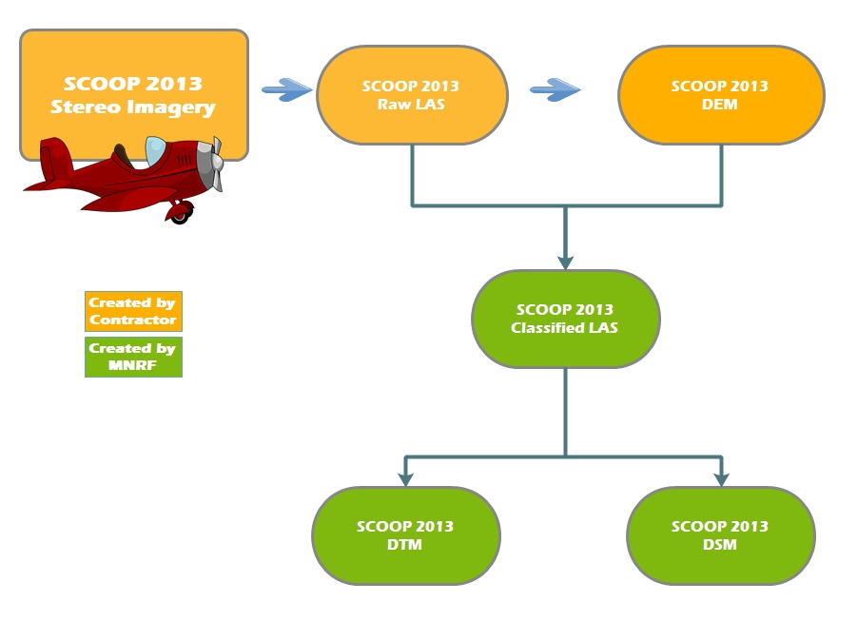
Figure 1: SCOOP Products
The raw point cloud from the overlapping flight lines were resampled to 50-cm spacing and retiled into 1-km by 1-km tiles and reassembled back into LAS format. This reduces redundant points and the volume of data. During the retiling, a comparison with the DEM delivered by the contractor was done to automatically assign the LAS classification. If the DEM was within 50-cm vertically, it was assigned a LAS classification code of 2 (Ground) otherwise it was assigned a LAS code of 0 (Unassigned). This point cloud has been published as the Ontario Classified Point Cloud (Imagery-Derived) (https://geohub.lio.gov.on.ca/datasets/febf17330adb4100a22738e1684b5feb).
The DSM raster was created by using all the points (Ground and Unclassified) from the Classified Point Cloud to create a raster product. This is a 2-m resolution product matching the same tiling and resolution as the DEM. In the production of this raster, the adjacent 8 tiles are also used to prevent any edge effects.
The DEM raster was produced from the ground classified points, and then compared with the DSM to ensure that no point would be higher than the DSM.
The point clouds for the acquisitions since 2018 were provided by the imagery contractor for the acquisition. It was created as an output from UltraMap photogrammetry post-processing software used to produce the orthophotography. A 50 cm resolution raster DSM was then produced by MNR staff.

1.3 Geographic Extent
The Geospatial Ontario Acquisition Program provides high-resolution leaf-off imagery on a five-year cycle for southern Ontario and parts of the near north. See Figure 2 and 3 for extents of the imagery projects included in the Ontario DSM (Imagery-Derived).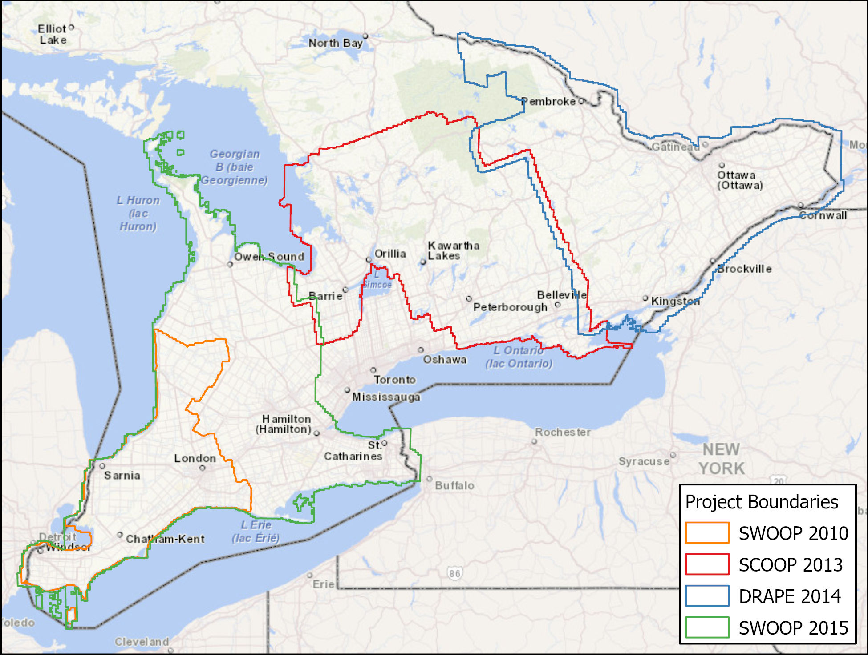
Figure 2: Extents of the GEO Imagery Acquisition Program projects in the DSM from 2010 to 2015
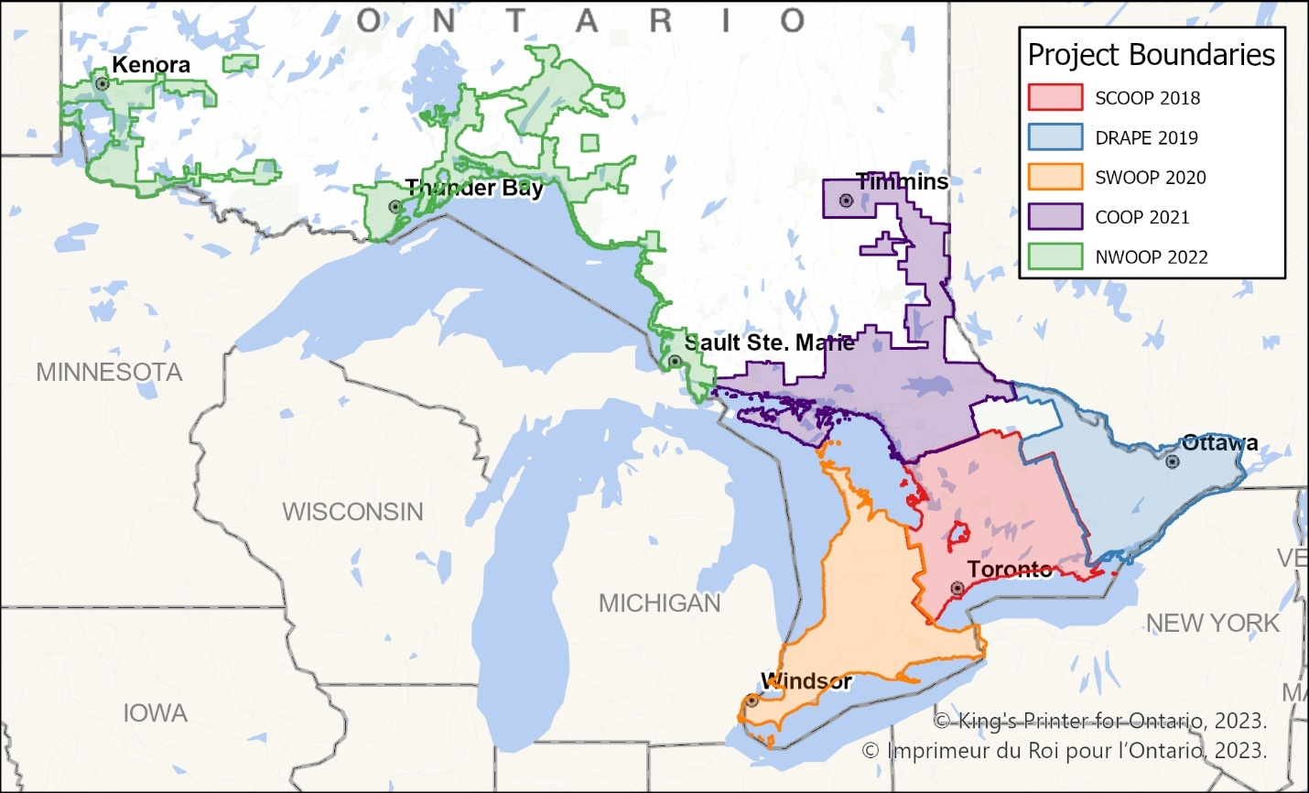
Figure 3: Extents of the GEO Imagery Acquisition Program projects in the DSM from 2018 to 2022

1.4 Reference System

1.4.1 Horizontal Reference System
The horizontal coordinate system of the Ontario DSM (Imagery-Derived) is Universal Transverse Mercator (UTM) with zone varying by project area (Table 2). The horizontal datum is the North American Datum of 1983 Canadian Spatial Reference System (https://www.nrcan.gc.ca/earth-sciences/geomatics/geodetic-reference-systems/9052), NAD83 (CSRS).
The horizontal unit of measure (coordinate system axis units) for all raster grid cells in the DSM is metres (m).
Table 2: UTM Zone for each project in the DSM
Project Area | UTM Zone
SCOOP 2013/2018 | 17 & 18
DRAPE 2014/2019 | 18
SWOOP 2010/2015/2020 | 17
COOP 2021 | 17
NWOOP 2022 | 15 & 16

1.4.2 Vertical Reference System
The vertical coordinate system of the Ontario Digital Surface Model (Imagery-Derived) varies by acquisition project (Table 3). For more information on Canadian vertical datums see the Height Reference System Modernization of Natural Resources Canada (https://www.nrcan.gc.ca/maps-tools-publications/maps/height-reference-system-modernization/9054#_Canadian_Geodetic_Vertical).
The vertical unit of measure (coordinate system axis units) for all raster grid cells in the DSM is metres (m). One single vertical elevation value represents each raster grid cell in the DSM.
Table 3: Vertical datums by projects
Project Areas | Vertical Datum
SCOOP 2013, DRAPE 2014, SWOOP 2010/2015 | CGVD28
SCOOP 2018, DRAPE 2019, SWOOP 2020, COOP 2021, NWOOP 2022 | CGVD2013

1.5 Accuracy Assessment
The Ontario Public Service Elevation Coordination and Consultation Committee has published Elevation Accuracy Guidelines (2016) which explain and provide guidelines for assessing the accuracy of digital elevation data, which has been drafted to be consistent with the 2014 American Society for Photogrammetry and Remote Sensing (ASPRS) Positional Accuracy Standards for Digital Geospatial Data.
An assessment has been conducted to evaluate the vertical accuracy of SCOOP 2013 Digital Surface Model (DSM) and SCOOP 2013 Digital Terrain Model (DTM). To date, there has not been an assessment done specific to the DSMs for the other imagery project areas, but the SCOOP products share many similarities with the other projects. The results of the SCOOP assessment, including the data, can be downloaded on the metadata record of the Ontario DSM (Imagery-Derived) (https://geohub.lio.gov.on.ca/datasets/02e849bac00943d6a69c1488b9edb185).

1.6 Spatial Resolution
The grid spacing is based on Universal Transverse Mercator (UTM) projection with a raster cell resolution varying by project area (Table 4).
Table 4: Raster cell resolution for each imagery project
Project Area | Raster Resolution (m)
SWOOP 2010 | 2
SCOOP 2013 | 2
DRAPE 2014 | 2
SWOOP 2015 | 2
SCOOP 2018 | 0.5
DRAPE 2019 | 0.5
SWOOP 2020 | 0.5
COOP 2021 | 0.5
NWOOP 2022 | 0.5

2. Product Details

2.1 Data Delivery Format
The Ontario DSM (Imagery-Derived) is stored in IMG (ERDAS-Imagine) or TIFF format raster files in 1-km by 1-km tiles and grouped into packages of tiles compressed using the ZIP archive file format. The standard file naming format is explained in Figure 4.
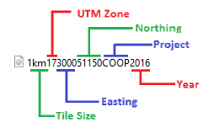
Figure 4: Tile names reflect tile size, UTM zone, Easting, Northing, Project, and Year
The DSM is currently stored and distributed through the Ontario GeoHub (https://geohub.lio.gov.on.ca/). Data packages can be downloaded by clicking on features in the map interface of the record for the Ontario Digital Surface Model (Imagery-Derived) (https://geohub.lio.gov.on.ca/datasets/02e849bac00943d6a69c 1488b9edb185) or from the list of data packages. For additional information on working with the DSM see Appendix A. For details on the file sizes and contents of each data package see Appendix C.
Note that the products from the SWOOP 2010 project are not currently tiled or packaged for download. They are stored in Esri GRID format. To order data from this project see LIO Support – Large Data Ordering Instructions (https://www.publicdocs.mnr.gov.on.ca/mirb/LIO-LargeData-OrderingInstructions.docx).

As detailed in the figures below, the DSM is divided into packages for distribution.
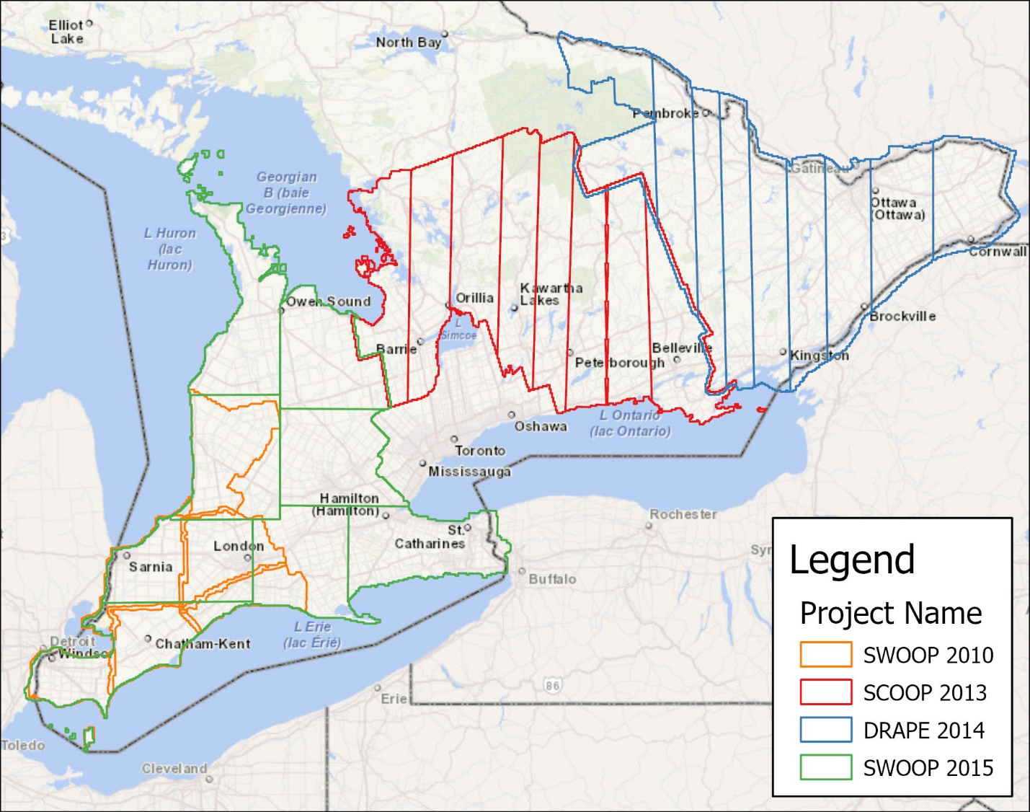
Figure 5: Ontario DSM (Imagery-Derived) distribution package boundaries for projects from 2010 to 2015
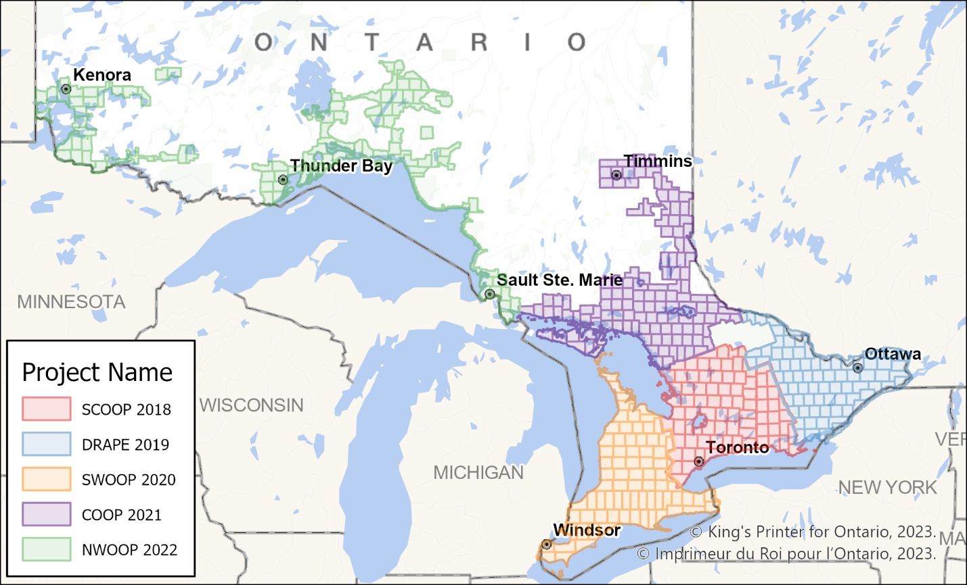
Figure 6: Ontario DSM (Imagery-Derived) distribution package boundaries for projects from 2018 to 2022

2.2 Use Restrictions
The Ontario DSM (Imagery-Derived) is considered Open Data. You are free to copy, modify, publish, translate, adapt, distribute or otherwise use the Information in any medium, mode or format for any lawful purpose. If you do any of the above you must use the following attribution statement “Contains information licensed under the Open Government Licence – Ontario”. See Open Government Licence (https://www.ontario.ca/page/open-government-licence-ontario).

3. Links to Additional Information
Natural Resources Canada 2019 “Height Reference System Modernization” (https://natural-resources.canada.ca/maps-tools-and-publications/geodetic-reference-systems/height-reference-system-modernization/9054)
Natural Resources Canada 2016 “The Canadian Spatial Reference System (CSRS)” (https://natural-resources.canada.ca/maps-tools-and-publications/geodetic-reference-systems/canadian-spatial-reference-system-csrs/9052#csrs)

4. References
Ontario, Elevation Coordination and Consultation Committee 2016 “Elevation Accuracy Guidelines” (King’s Printer for Ontario. Retrieved from: https://www.publicdocs.mnr.gov.on.ca/mirb/Elevation%20Accuracy%20Guidelines%20-%20User%20Guide.docx)

Appendix A: Getting Started - Display and Use of DSM Data

Opening and viewing the DSM
The DSM packages must be unzipped and will produce a folder corresponding to the name of the package, which contains the IMG or TIF raster files (Figure 7).
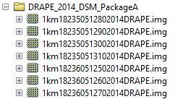
Figure 7: Unzipped DSM package contents
The DSM tiles can be used for viewing or analysis using any one of the many GIS software packages capable of using IMG and TIF raster files. The DSM represents a continuous surface of cells containing elevation (z) values in metres (Figure 8). A DSM can have advantages over a DEM when there is interest in understanding features above ground such as forest canopy or built infrastructure such as buildings and for analyses such as viewshed analysis.
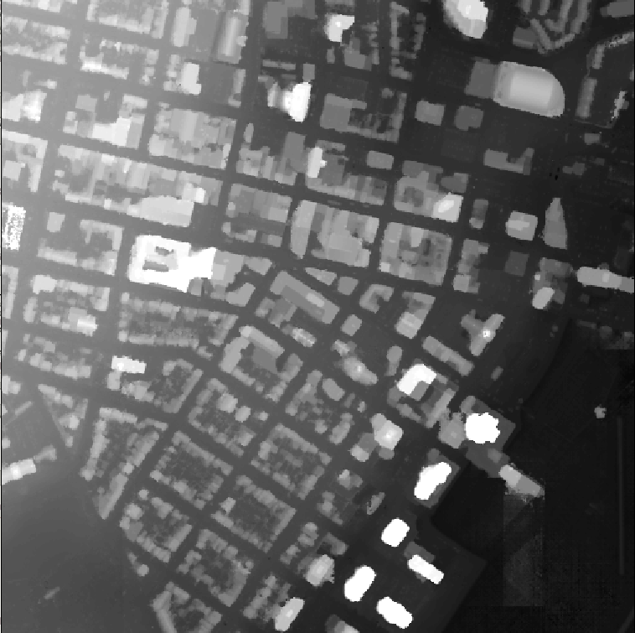
Figure 8: DSM tile in Kingston, ON
DSM tiles can be used as-is for topographic elevation analysis, but for visualization it is better to derive and display the DSM using a hillshade or a colour-shaded relief function. A hillshade is a grayscale image that represents a DSM in three-dimensional appearance as the human eye would interpret it with the sun set at a specified direction (azimuth) and altitude. A colour-shaded relief expands on this by adding color gradient based on cell z-values. Figure 9 depicts examples of a hillshade (left) with properties applied such that it is illuminated from 210° (Southwest), and a colour-shaded relief illuminated from 315° (Northwest).
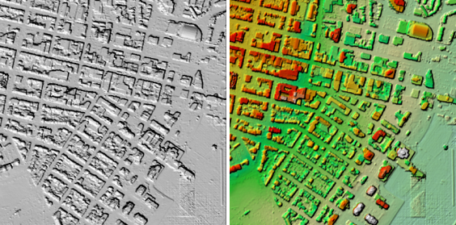
Figure 9: DSM tile displayed as a hillshade and colour-shaded relief in Kingston, ON

Assembly, viewing and analysis of multiple DSM tiles: new dataset vs virtual
As with many other imagery and raster products delivered through GEO, the DSM product is provided in 1km² non-overlapping tiles and grouped into packages. There are several advantages to this method of storage and distribution including maintenance of metadata, storage considerations and the flexibility to allow clients to request the data they need for their study area, without requiring custom data extracts to client supplied boundaries.
If your study area covers multiple DSM tiles, these individual tiles can be viewed simultaneously, but for the purposes of analysis, or simply for faster and less complicated viewing, it is usually better to put all tiles in your study area together as one. This can be done in several ways.
The traditional method is to assemble or merge all the individual tiles into a new raster covering your entire study area. This method can allow for faster display and may be necessary for some analysis operations but has the disadvantage that a separate new dataset must be produced which has implications for storage space. Being a new dataset, the naming and metadata of the individual tile structure used as a source will be lost as well.
Raster data takes up a great deal of storage space, so it is often a preferred approach to make use of a virtual representation of multiple tiles as one entity. These methods can include raster mosaic datasets, and virtual raster catalogs. Most of these methods have the advantage that the original files, metadata, folder structure and locations are preserved and the data for contributing tiles or groups of tiles can even be stored in separate locations as storage space requirements dictate.
The exact methods and options available will depend on the software being used, and the requirements of the analysis. Please consult the documentation of the GIS software you are using for specific details about the options available to you.

Appendix B: Common DEM Analysis Functions
The DEM raster can be used as an input for a variety of surface geometry analysis functions such as calculations of slope, aspect, and curvature. The actual algorithms used for any of these calculations may vary depending on the software used to perform the calculation.

Slope
Slope is a calculation based on difference between the rise and the run along a specified path. The output value assigned to a cell is usually based on the maximum difference in elevation values compared to adjacent cells and is commonly expressed in degrees or percent.

Aspect
Aspect is a calculation that applies a numeric value to a cell based upon the bearing that the slope of the cell is facing, in degrees. These values can be further categorized into compass directions of north, south, southeast, etc. For instance, in Figure 10, the aspect of the landscape is predominantly facing to the south and southwest.
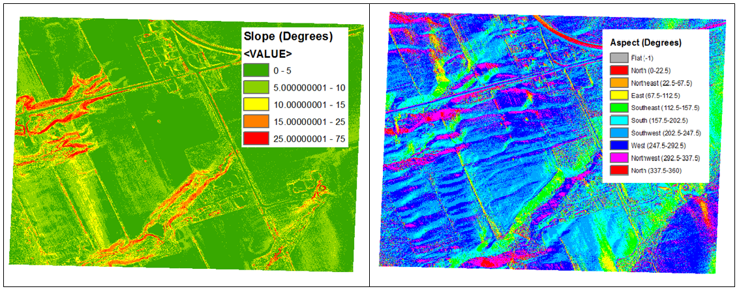
Figure 10: Examples of Slope and Aspect

Curvature
Curvature is a calculation based upon the shape of the surfaces which is calculated for each cell based compared to neighbouring cells. Positive curvature values indicate a convex surface, while negative values indicate a concave surface. It is also possible to extract the profile curvature of the slope, or the plan (horizontal) curvature values.

Appendix C: Data Package Details
Table 5: Ontario DSM (Imagery-Derived) Distribution Packages and Size
Package | Compressed Size (GB) | Number of Tiles | Horizontal Reference
SWOOP 2010 Chatham-Kent | 2.63 | 1 | NAD83(CSRS) UTM 17N
SWOOP 2010 Elgin | 4.96 | 1 | NAD83(CSRS) UTM 17N
SWOOP 2010 Essex | 5 | 1 | NAD83(CSRS) UTM 17N
SWOOP 2010 Huron | 7.55 | 1 | NAD83(CSRS) UTM 17N
SWOOP 2010 Middlesex |  | 1 | NAD83(CSRS) UTM 17N
SCOOP 2013 A | 2.65 | 4,322 | NAD83(CSRS) UTM 17N
SCOOP 2013 B | 2.72 | 4,410 | NAD83(CSRS) UTM 17N
SCOOP 2013 C | 2.75 | 4,353 | NAD83(CSRS) UTM 17N
SCOOP 2013 D | 2.76 | 4,452 | NAD83(CSRS) UTM 17N
SCOOP 2013 E | 2.77 | 4,415 | NAD83(CSRS) UTM 17N
SCOOP 2013 F | 2.76 | 4,414 | NAD83(CSRS) UTM 17N
SCOOP 2013 G | 2.98 | 4,765 | NAD83(CSRS) UTM 18N
SCOOP 2013 H | 2.87 | 4,790 | NAD83(CSRS) UTM 18N
DRAPE 2014 A | 2.89 | 4,412 | NAD83(CSRS) UTM 18N
DRAPE 2014 B | 2.57 | 3,986 | NAD83(CSRS) UTM 18N
DRAPE 2014 C | 2.39 | 3,850 | NAD83(CSRS) UTM 18N
DRAPE 2014 D | 2.5 | 4,082 | NAD83(CSRS) UTM 18N
DRAPE 2014 E | 2.71 | 4,363 | NAD83(CSRS) UTM 18N
DRAPE 2014 F | 2.47 | 4,161 | NAD83(CSRS) UTM 18N
DRAPE 2014 G | 2.33 | 4,007 | NAD83(CSRS) UTM 18N
DRAPE 2014 H | 2.33 | 4,192 | NAD83(CSRS) UTM 18N
DRAPE 2014 I | 2.33 | 4,173 | NAD83(CSRS) UTM 18N
SWOOP 2015 A | 3.18 | 5,541 | NAD83(CSRS) UTM 17N
SWOOP 2015 B | 2.96 | 5,115 | NAD83(CSRS) UTM 17N
SWOOP 2015 C | 2.95 | 5,338 | NAD83(CSRS) UTM 17N
SWOOP 2015 D | 2.98 | 6,047 | NAD83(CSRS) UTM 17N
SWOOP 2015 E | 2.96 | 5,791 | NAD83(CSRS) UTM 17N
SWOOP 2015 F | 2.88 | 5,335 | NAD83(CSRS) UTM 17N
SWOOP 2015 G | 3.02 | 5,579 | NAD83(CSRS) UTM 17N
SWOOP 2015 H | 3.09 | 5,881 | NAD83(CSRS) UTM 17N
SCOOP 2018 01 | 3.19 | 618 | NAD83(CSRS) UTM 17N
SCOOP 2018 02 | 2.99 | 619 | NAD83(CSRS) UTM 17N
SCOOP 2018 03 | 3.18 | 620 | NAD83(CSRS) UTM 17N
SCOOP 2018 04 | 3.21 | 620 | NAD83(CSRS) UTM 17N
SCOOP 2018 05 | 3.12 | 625 | NAD83(CSRS) UTM 17N
SCOOP 2018 06 | 3.23 | 618 | NAD83(CSRS) UTM 17N
SCOOP 2018 07 | 3.1 | 624 | NAD83(CSRS) UTM 17N
SCOOP 2018 08 | 2.8 | 610 | NAD83(CSRS) UTM 17N
SCOOP 2018 09 | 2.94 | 624 | NAD83(CSRS) UTM 17N
SCOOP 2018 10 | 3.25 | 624 | NAD83(CSRS) UTM 17N
SCOOP 2018 11 | 3.11 | 624 | NAD83(CSRS) UTM 17N
SCOOP 2018 12 | 3.19 | 630 | NAD83(CSRS) UTM 17N
SCOOP 2018 13 | 3.17 | 605 | NAD83(CSRS) UTM 17N
SCOOP 2018 14 | 3.24 | 607 | NAD83(CSRS) UTM 17N
SCOOP 2018 15 | 3.03 | 618 | NAD83(CSRS) UTM 17N
SCOOP 2018 16 | 2.95 | 616 | NAD83(CSRS) UTM 17N
SCOOP 2018 17 | 3.05 | 623 | NAD83(CSRS) UTM 17N
SCOOP 2018 18 | 2.9 | 594 | NAD83(CSRS) UTM 17N
SCOOP 2018 19 | 2.79 | 621 | NAD83(CSRS) UTM 17N
SCOOP 2018 20 | 3.05 | 621 | NAD83(CSRS) UTM 17N
SCOOP 2018 21 | 3.22 | 618 | NAD83(CSRS) UTM 17N
SCOOP 2018 22 | 3.14 | 601 | NAD83(CSRS) UTM 17N
SCOOP 2018 23 | 2.93 | 600 | NAD83(CSRS) UTM 17N
SCOOP 2018 24 | 3.07 | 593 | NAD83(CSRS) UTM 17N
SCOOP 2018 25 | 2.83 | 607 | NAD83(CSRS) UTM 17N
SCOOP 2018 26 | 3.1 | 575 | NAD83(CSRS) UTM 17N
SCOOP 2018 27 | 3.12 | 550 | NAD83(CSRS) UTM 17N
SCOOP 2018 28 | 3.32 | 578 | NAD83(CSRS) UTM 17N
SCOOP 2018 29 | 3.14 | 575 | NAD83(CSRS) UTM 17N
SCOOP 2018 30 | 3.24 | 575 | NAD83(CSRS) UTM 17N
SCOOP 2018 31 | 3.18 | 575 | NAD83(CSRS) UTM 17N
SCOOP 2018 32 | 3.14 | 506 | NAD83(CSRS) UTM 17N
SCOOP 2018 33 | 3.25 | 504 | NAD83(CSRS) UTM 17N
SCOOP 2018 34 | 3.11 | 528 | NAD83(CSRS) UTM 17N
SCOOP 2018 35 | 3.2 | 501 | NAD83(CSRS) UTM 17N
SCOOP 2018 36 | 2.9 | 465 | NAD83(CSRS) UTM 17N
SCOOP 2018 37 | 3.22 | 529 | NAD83(CSRS) UTM 17N
SCOOP 2018 38 | 3.31 | 529 | NAD83(CSRS) UTM 17N
SCOOP 2018 39 | 3.25 | 529 | NAD83(CSRS) UTM 17N
SCOOP 2018 40 | 3.29 | 529 | NAD83(CSRS) UTM 17N
SCOOP 2018 41 | 3.28 | 529 | NAD83(CSRS) UTM 17N
SCOOP 2018 42 | 3.22 | 516 | NAD83(CSRS) UTM 17N
SCOOP 2018 43 | 3.21 | 514 | NAD83(CSRS) UTM 17N
SCOOP 2018 44 | 3.24 | 529 | NAD83(CSRS) UTM 17N
SCOOP 2018 45 | 3.19 | 506 | NAD83(CSRS) UTM 17N
SCOOP 2018 46 | 3.22 | 506 | NAD83(CSRS) UTM 17N
SCOOP 2018 47 | 3.31 | 506 | NAD83(CSRS) UTM 17N
SCOOP 2018 48 | 3.28 | 506 | NAD83(CSRS) UTM 17N
SCOOP 2018 49 | 3.16 | 506 | NAD83(CSRS) UTM 17N
SCOOP 2018 50 | 3.24 | 520 | NAD83(CSRS) UTM 17N
SCOOP 2018 51 | 3.23 | 525 | NAD83(CSRS) UTM 17N
SCOOP 2018 52 | 3.21 | 517 | NAD83(CSRS) UTM 17N
SCOOP 2018 53 | 3.27 | 506 | NAD83(CSRS) UTM 17N
SCOOP 2018 54 | 3.3 | 506 | NAD83(CSRS) UTM 17N
SCOOP 2018 55 | 3.25 | 506 | NAD83(CSRS) UTM 17N
SCOOP 2018 56 | 3.28 | 506 | NAD83(CSRS) UTM 17N
SCOOP 2018 57 | 3.25 | 515 | NAD83(CSRS) UTM 17N
SCOOP 2018 58 | 3.21 | 506 | NAD83(CSRS) UTM 17N
SCOOP 2018 59 | 3.26 | 490 | NAD83(CSRS) UTM 17N
SCOOP 2018 60 | 2.16 | 324 | NAD83(CSRS) UTM 17N
SCOOP 2018 61 | 1.76 | 268 | NAD83(CSRS) UTM 17N
SCOOP 2018 62 | 2.78 | 528 | NAD83(CSRS) UTM 18N
SCOOP 2018 63 | 2.56 | 519 | NAD83(CSRS) UTM 18N
SCOOP 2018 64 | 2.5 | 518 | NAD83(CSRS) UTM 18N
SCOOP 2018 65 | 2.6 | 528 | NAD83(CSRS) UTM 18N
SCOOP 2018 66 | 2.57 | 510 | NAD83(CSRS) UTM 18N
SCOOP 2018 67 | 2.72 | 528 | NAD83(CSRS) UTM 18N
SCOOP 2018 68 | 2.47 | 506 | NAD83(CSRS) UTM 18N
SCOOP 2018 69 | 2.69 | 513 | NAD83(CSRS) UTM 18N
SCOOP 2018 70 | 2.95 | 506 | NAD83(CSRS) UTM 18N
SCOOP 2018 71 | 2.8 | 506 | NAD83(CSRS) UTM 18N
SCOOP 2018 72 | 2.8 | 508 | NAD83(CSRS) UTM 18N
SCOOP 2018 73 | 3.17 | 510 | NAD83(CSRS) UTM 18N
SCOOP 2018 74 | 2.94 | 483 | NAD83(CSRS) UTM 18N
SCOOP 2018 75 | 2.41 | 408 | NAD83(CSRS) UTM 18N
SCOOP 2018 76 | 3.27 | 512 | NAD83(CSRS) UTM 18N
SCOOP 2018 77 | 3.3 | 504 | NAD83(CSRS) UTM 18N
SCOOP 2018 78 | 3.27 | 511 | NAD83(CSRS) UTM 18N
SCOOP 2018 79 | 3.1 | 471 | NAD83(CSRS) UTM 18N
SCOOP 2018 80 | 3.17 | 485 | NAD83(CSRS) UTM 18N
DRAPE 2019 01 | 3.33 | 514 | NAD83(CSRS) UTM 18N
DRAPE 2019 02 | 3.12 | 482 | NAD83(CSRS) UTM 18N
DRAPE 2019 03 | 3.17 | 483 | NAD83(CSRS) UTM 18N
DRAPE 2019 04 | 3.19 | 451 | NAD83(CSRS) UTM 18N
DRAPE 2019 05 | 3.19 | 490 | NAD83(CSRS) UTM 18N
DRAPE 2019 06 | 3.2 | 506 | NAD83(CSRS) UTM 18N
DRAPE 2019 07 | 3.34 | 506 | NAD83(CSRS) UTM 18N
DRAPE 2019 08 | 3.36 | 508 | NAD83(CSRS) UTM 18N
DRAPE 2019 09 | 3.26 | 433 | NAD83(CSRS) UTM 18N
DRAPE 2019 10 | 3.23 | 440 | NAD83(CSRS) UTM 18N
DRAPE 2019 11 | 3.31 | 440 | NAD83(CSRS) UTM 18N
DRAPE 2019 12 | 3.22 | 439 | NAD83(CSRS) UTM 18N
DRAPE 2019 13 | 3.21 | 483 | NAD83(CSRS) UTM 18N
DRAPE 2019 14 | 3.23 | 512 | NAD83(CSRS) UTM 18N
DRAPE 2019 15 | 3.29 | 488 | NAD83(CSRS) UTM 18N
DRAPE 2019 16 | 3.34 | 432 | NAD83(CSRS) UTM 18N
DRAPE 2019 17 | 3.3 | 440 | NAD83(CSRS) UTM 18N
DRAPE 2019 18 | 3.24 | 418 | NAD83(CSRS) UTM 18N
DRAPE 2019 19 | 3.2 | 418 | NAD83(CSRS) UTM 18N
DRAPE 2019 20 | 3.19 | 440 | NAD83(CSRS) UTM 18N
DRAPE 2019 21 | 3.19 | 483 | NAD83(CSRS) UTM 18N
DRAPE 2019 22 | 3.23 | 473 | NAD83(CSRS) UTM 18N
DRAPE 2019 23 | 3.33 | 530 | NAD83(CSRS) UTM 18N
DRAPE 2019 24 | 3.25 | 409 | NAD83(CSRS) UTM 18N
DRAPE 2019 25 | 3.34 | 418 | NAD83(CSRS) UTM 18N
DRAPE 2019 26 | 3.32 | 418 | NAD83(CSRS) UTM 18N
DRAPE 2019 27 | 3.26 | 418 | NAD83(CSRS) UTM 18N
DRAPE 2019 28 | 3.3 | 462 | NAD83(CSRS) UTM 18N
DRAPE 2019 29 | 3.23 | 483 | NAD83(CSRS) UTM 18N
DRAPE 2019 30 | 3.22 | 462 | NAD83(CSRS) UTM 18N
DRAPE 2019 31 | 3.21 | 548 | NAD83(CSRS) UTM 18N
DRAPE 2019 32 | 3.18 | 508 | NAD83(CSRS) UTM 18N
DRAPE 2019 33 | 3.2 | 468 | NAD83(CSRS) UTM 18N
DRAPE 2019 34 | 3.16 | 504 | NAD83(CSRS) UTM 18N
DRAPE 2019 35 | 3.28 | 410 | NAD83(CSRS) UTM 18N
DRAPE 2019 36 | 3.2 | 396 | NAD83(CSRS) UTM 18N
DRAPE 2019 37 | 3.27 | 395 | NAD83(CSRS) UTM 18N
DRAPE 2019 38 | 3.18 | 394 | NAD83(CSRS) UTM 18N
DRAPE 2019 39 | 3.34 | 440 | NAD83(CSRS) UTM 18N
DRAPE 2019 40 | 3.28 | 484 | NAD83(CSRS) UTM 18N
DRAPE 2019 41 | 3.34 | 506 | NAD83(CSRS) UTM 18N
DRAPE 2019 42 | 3.26 | 528 | NAD83(CSRS) UTM 18N
DRAPE 2019 43 | 3.2 | 616 | NAD83(CSRS) UTM 18N
DRAPE 2019 44 | 3.23 | 594 | NAD83(CSRS) UTM 18N
DRAPE 2019 45 | 3.18 | 522 | NAD83(CSRS) UTM 18N
DRAPE 2019 46 | 3.24 | 405 | NAD83(CSRS) UTM 18N
DRAPE 2019 47 | 3.31 | 417 | NAD83(CSRS) UTM 18N
DRAPE 2019 48 | 3.23 | 418 | NAD83(CSRS) UTM 18N
DRAPE 2019 49 | 3.21 | 440 | NAD83(CSRS) UTM 18N
DRAPE 2019 50 | 3.21 | 455 | NAD83(CSRS) UTM 18N
DRAPE 2019 51 | 3.2 | 506 | NAD83(CSRS) UTM 18N
DRAPE 2019 52 | 3.2 | 514 | NAD83(CSRS) UTM 18N
DRAPE 2019 53 | 3.24 | 478 | NAD83(CSRS) UTM 18N
DRAPE 2019 54 | 3.21 | 492 | NAD83(CSRS) UTM 18N
DRAPE 2019 55 | 3.21 | 550 | NAD83(CSRS) UTM 18N
DRAPE 2019 56 | 3.06 | 594 | NAD83(CSRS) UTM 18N
DRAPE 2019 57 | 3.19 | 581 | NAD83(CSRS) UTM 18N
DRAPE 2019 58 | 3.24 | 512 | NAD83(CSRS) UTM 18N
DRAPE 2019 59 | 3.12 | 545 | NAD83(CSRS) UTM 18N
DRAPE 2019 60 | 2.16 | 381 | NAD83(CSRS) UTM 18N
DRAPE 2019 61 | 3.29 | 413 | NAD83(CSRS) UTM 18N
DRAPE 2019 62 | 3.29 | 405 | NAD83(CSRS) UTM 18N
DRAPE 2019 63 | 3.22 | 394 | NAD83(CSRS) UTM 18N
DRAPE 2019 64 | 3.32 | 409 | NAD83(CSRS) UTM 18N
DRAPE 2019 65 | 3.26 | 425 | NAD83(CSRS) UTM 18N
DRAPE 2019 66 | 3.22 | 426 | NAD83(CSRS) UTM 18N
DRAPE 2019 67 | 3.15 | 477 | NAD83(CSRS) UTM 18N
DRAPE 2019 68 | 3.22 | 481 | NAD83(CSRS) UTM 18N
DRAPE 2019 69 | 3.2 | 405 | NAD83(CSRS) UTM 18N
DRAPE 2019 70 | 3.3 | 459 | NAD83(CSRS) UTM 18N
DRAPE 2019 71 | 3.15 | 471 | NAD83(CSRS) UTM 18N
DRAPE 2019 72 | 3.13 | 408 | NAD83(CSRS) UTM 18N
DRAPE 2019 73 | 3.15 | 428 | NAD83(CSRS) UTM 18N
DRAPE 2019 74 | 3.18 | 401 | NAD83(CSRS) UTM 18N
DRAPE 2019 75 | 3.18 | 386 | NAD83(CSRS) UTM 18N
DRAPE 2019 76 | 2.5 | 303 | NAD83(CSRS) UTM 18N
DRAPE 2019 77 | 2.4 | 294 | NAD83(CSRS) UTM 18N
SWOOP 2020 01 | 2.95 | 589 | NAD83(CSRS) UTM 17N
SWOOP 2020 02 | 3.02 | 556 | NAD83(CSRS) UTM 17N
SWOOP 2020 03 | 3.17 | 631 | NAD83(CSRS) UTM 17N
SWOOP 2020 04 | 3.16 | 772 | NAD83(CSRS) UTM 17N
SWOOP 2020 05 | 3.12 | 676 | NAD83(CSRS) UTM 17N
SWOOP 2020 06 | 3.25 | 684 | NAD83(CSRS) UTM 17N
SWOOP 2020 07 | 3.24 | 736 | NAD83(CSRS) UTM 17N
SWOOP 2020 08 | 3.16 | 634 | NAD83(CSRS) UTM 17N
SWOOP 2020 09 | 3.05 | 570 | NAD83(CSRS) UTM 17N
SWOOP 2020 10 | 3.25 | 656 | NAD83(CSRS) UTM 17N
SWOOP 2020 11 | 3.17 | 728 | NAD83(CSRS) UTM 17N
SWOOP 2020 12 | 3.27 | 650 | NAD83(CSRS) UTM 17N
SWOOP 2020 13 | 3.19 | 598 | NAD83(CSRS) UTM 17N
SWOOP 2020 14 | 3.24 | 581 | NAD83(CSRS) UTM 17N
SWOOP 2020 15 | 3.23 | 583 | NAD83(CSRS) UTM 17N
SWOOP 2020 16 | 3.18 | 560 | NAD83(CSRS) UTM 17N
SWOOP 2020 17 | 3.17 | 548 | NAD83(CSRS) UTM 17N
SWOOP 2020 18 | 3.18 | 524 | NAD83(CSRS) UTM 17N
SWOOP 2020 19 | 3.16 | 595 | NAD83(CSRS) UTM 17N
SWOOP 2020 20 | 3.19 | 582 | NAD83(CSRS) UTM 17N
SWOOP 2020 21 | 3.24 | 558 | NAD83(CSRS) UTM 17N
SWOOP 2020 22 | 3.13 | 522 | NAD83(CSRS) UTM 17N
SWOOP 2020 23 | 3.15 | 615 | NAD83(CSRS) UTM 17N
SWOOP 2020 24 | 3.18 | 637 | NAD83(CSRS) UTM 17N
SWOOP 2020 25 | 3.17 | 612 | NAD83(CSRS) UTM 17N
SWOOP 2020 26 | 3.24 | 612 | NAD83(CSRS) UTM 17N
SWOOP 2020 27 | 3.3 | 576 | NAD83(CSRS) UTM 17N
SWOOP 2020 28 | 3.19 | 576 | NAD83(CSRS) UTM 17N
SWOOP 2020 29 | 3.29 | 576 | NAD83(CSRS) UTM 17N
SWOOP 2020 30 | 3.27 | 576 | NAD83(CSRS) UTM 17N
SWOOP 2020 31 | 3.11 | 576 | NAD83(CSRS) UTM 17N
SWOOP 2020 32 | 3.14 | 540 | NAD83(CSRS) UTM 17N
SWOOP 2020 33 | 3.15 | 540 | NAD83(CSRS) UTM 17N
SWOOP 2020 34 | 3.24 | 560 | NAD83(CSRS) UTM 17N
SWOOP 2020 35 | 3.23 | 598 | NAD83(CSRS) UTM 17N
SWOOP 2020 36 | 3.2 | 550 | NAD83(CSRS) UTM 17N
SWOOP 2020 37 | 3.22 | 616 | NAD83(CSRS) UTM 17N
SWOOP 2020 38 | 3.17 | 609 | NAD83(CSRS) UTM 17N
SWOOP 2020 39 | 3.18 | 588 | NAD83(CSRS) UTM 17N
SWOOP 2020 40 | 3.2 | 525 | NAD83(CSRS) UTM 17N
SWOOP 2020 41 | 3.22 | 504 | NAD83(CSRS) UTM 17N
SWOOP 2020 42 | 3.2 | 491 | NAD83(CSRS) UTM 17N
SWOOP 2020 43 | 3.18 | 576 | NAD83(CSRS) UTM 17N
SWOOP 2020 44 | 3.14 | 638 | NAD83(CSRS) UTM 17N
SWOOP 2020 45 | 3.17 | 594 | NAD83(CSRS) UTM 17N
SWOOP 2020 46 | 3.18 | 528 | NAD83(CSRS) UTM 17N
SWOOP 2020 47 | 3.07 | 484 | NAD83(CSRS) UTM 17N
SWOOP 2020 48 | 3.2 | 471 | NAD83(CSRS) UTM 17N
SWOOP 2020 49 | 3.19 | 527 | NAD83(CSRS) UTM 17N
SWOOP 2020 50 | 3.14 | 572 | NAD83(CSRS) UTM 17N
SWOOP 2020 51 | 3.22 | 594 | NAD83(CSRS) UTM 17N
SWOOP 2020 52 | 3.2 | 572 | NAD83(CSRS) UTM 17N
SWOOP 2020 53 | 3.26 | 520 | NAD83(CSRS) UTM 17N
SWOOP 2020 54 | 3.16 | 543 | NAD83(CSRS) UTM 17N
SWOOP 2020 55 | 3.21 | 525 | NAD83(CSRS) UTM 17N
SWOOP 2020 56 | 3.16 | 525 | NAD83(CSRS) UTM 17N
SWOOP 2020 57 | 3.15 | 567 | NAD83(CSRS) UTM 17N
SWOOP 2020 58 | 3.15 | 552 | NAD83(CSRS) UTM 17N
SWOOP 2020 59 | 3.17 | 454 | NAD83(CSRS) UTM 17N
SWOOP 2020 60 | 3.13 | 587 | NAD83(CSRS) UTM 17N
SWOOP 2020 61 | 3.2 | 528 | NAD83(CSRS) UTM 17N
SWOOP 2020 62 | 3.19 | 504 | NAD83(CSRS) UTM 17N
SWOOP 2020 63 | 3.14 | 480 | NAD83(CSRS) UTM 17N
SWOOP 2020 64 | 3.17 | 552 | NAD83(CSRS) UTM 17N
SWOOP 2020 65 | 3.25 | 520 | NAD83(CSRS) UTM 17N
SWOOP 2020 66 | 3.19 | 558 | NAD83(CSRS) UTM 17N
SWOOP 2020 67 | 3.22 | 550 | NAD83(CSRS) UTM 17N
SWOOP 2020 68 | 3.09 | 440 | NAD83(CSRS) UTM 17N
SWOOP 2020 69 | 3.14 | 462 | NAD83(CSRS) UTM 17N
SWOOP 2020 70 | 3.05 | 465 | NAD83(CSRS) UTM 17N
SWOOP 2020 71 | 3.2 | 523 | NAD83(CSRS) UTM 17N
SWOOP 2020 72 | 3.19 | 504 | NAD83(CSRS) UTM 17N
SWOOP 2020 73 | 3.05 | 459 | NAD83(CSRS) UTM 17N
SWOOP 2020 74 | 3.02 | 464 | NAD83(CSRS) UTM 17N
SWOOP 2020 75 | 3.19 | 493 | NAD83(CSRS) UTM 17N
SWOOP 2020 76 | 3.12 | 457 | NAD83(CSRS) UTM 17N
SWOOP 2020 77 | 3.16 | 467 | NAD83(CSRS) UTM 17N
SWOOP 2020 78 | 3.16 | 422 | NAD83(CSRS) UTM 17N
SWOOP 2020 79 | 1.47 | 188 | NAD83(CSRS) UTM 17N
COOP 2021 001 | 3.3 | 432 | NAD83(CSRS) UTM 17N
COOP 2021 002 | 3.31 | 470 | NAD83(CSRS) UTM 17N
COOP 2021 003 | 3.28 | 462 | NAD83(CSRS) UTM 17N
COOP 2021 004 | 3.3 | 477 | NAD83(CSRS) UTM 17N
COOP 2021 005 | 3.32 | 468 | NAD83(CSRS) UTM 17N
COOP 2021 006 | 2.54 | 357 | NAD83(CSRS) UTM 17N
COOP 2021 007 | 2.32 | 321 | NAD83(CSRS) UTM 17N
COOP 2021 008 | 2.28 | 300 | NAD83(CSRS) UTM 17N
COOP 2021 009 | 3.03 | 403 | NAD83(CSRS) UTM 17N
COOP 2021 010 | 2.99 | 399 | NAD83(CSRS) UTM 17N
COOP 2021 011 | 3.13 | 409 | NAD83(CSRS) UTM 17N
COOP 2021 012 | 3.25 | 405 | NAD83(CSRS) UTM 17N
COOP 2021 013 | 3.08 | 391 | NAD83(CSRS) UTM 17N
COOP 2021 014 | 2.82 | 360 | NAD83(CSRS) UTM 17N
COOP 2021 015 | 3.06 | 398 | NAD83(CSRS) UTM 17N
COOP 2021 016 | 2.95 | 368 | NAD83(CSRS) UTM 17N
COOP 2021 017 | 2.86 | 370 | NAD83(CSRS) UTM 17N
COOP 2021 018 | 2.62 | 344 | NAD83(CSRS) UTM 17N
COOP 2021 019 | 3.01 | 384 | NAD83(CSRS) UTM 17N
COOP 2021 020 | 3.24 | 429 | NAD83(CSRS) UTM 17N
COOP 2021 021 | 2.68 | 347 | NAD83(CSRS) UTM 17N
COOP 2021 022 | 3.22 | 411 | NAD83(CSRS) UTM 17N
COOP 2021 023 | 3.13 | 398 | NAD83(CSRS) UTM 17N
COOP 2021 024 | 2.94 | 380 | NAD83(CSRS) UTM 17N
COOP 2021 025 | 2.93 | 382 | NAD83(CSRS) UTM 17N
COOP 2021 026 | 3.17 | 399 | NAD83(CSRS) UTM 17N
COOP 2021 027 | 3.04 | 380 | NAD83(CSRS) UTM 17N
COOP 2021 028 | 3.12 | 380 | NAD83(CSRS) UTM 17N
COOP 2021 029 | 3.12 | 392 | NAD83(CSRS) UTM 17N
COOP 2021 030 | 3.1 | 400 | NAD83(CSRS) UTM 17N
COOP 2021 031 | 3.02 | 400 | NAD83(CSRS) UTM 17N
COOP 2021 032 | 3.27 | 399 | NAD83(CSRS) UTM 17N
COOP 2021 033 | 3.08 | 399 | NAD83(CSRS) UTM 17N
COOP 2021 034 | 2.63 | 379 | NAD83(CSRS) UTM 17N
COOP 2021 035 | 3.23 | 396 | NAD83(CSRS) UTM 17N
COOP 2021 036 | 3.19 | 392 | NAD83(CSRS) UTM 17N
COOP 2021 037 | 2.87 | 357 | NAD83(CSRS) UTM 17N
COOP 2021 038 | 3.15 | 385 | NAD83(CSRS) UTM 17N
COOP 2021 039 | 2.9 | 389 | NAD83(CSRS) UTM 17N
COOP 2021 040 | 2.94 | 382 | NAD83(CSRS) UTM 17N
COOP 2021 041 | 2.83 | 391 | NAD83(CSRS) UTM 17N
COOP 2021 042 | 3.11 | 400 | NAD83(CSRS) UTM 17N
COOP 2021 043 | 2.89 | 378 | NAD83(CSRS) UTM 17N
COOP 2021 044 | 2.98 | 393 | NAD83(CSRS) UTM 17N
COOP 2021 045 | 3.07 | 399 | NAD83(CSRS) UTM 17N
COOP 2021 046 | 3 | 387 | NAD83(CSRS) UTM 17N
COOP 2021 047 | 2.79 | 398 | NAD83(CSRS) UTM 17N
COOP 2021 048 | 3.09 | 399 | NAD83(CSRS) UTM 17N
COOP 2021 049 | 3.07 | 399 | NAD83(CSRS) UTM 17N
COOP 2021 050 | 3.02 | 399 | NAD83(CSRS) UTM 17N
COOP 2021 051 | 3.11 | 399 | NAD83(CSRS) UTM 17N
COOP 2021 052 | 3 | 390 | NAD83(CSRS) UTM 17N
COOP 2021 053 | 3.14 | 395 | NAD83(CSRS) UTM 17N
COOP 2021 054 | 2.91 | 400 | NAD83(CSRS) UTM 17N
COOP 2021 055 | 3.07 | 400 | NAD83(CSRS) UTM 17N
COOP 2021 056 | 2.31 | 400 | NAD83(CSRS) UTM 17N
COOP 2021 057 | 3 | 400 | NAD83(CSRS) UTM 17N
COOP 2021 058 | 3.05 | 400 | NAD83(CSRS) UTM 17N
COOP 2021 059 | 2.76 | 360 | NAD83(CSRS) UTM 17N
COOP 2021 060 | 2.61 | 333 | NAD83(CSRS) UTM 17N
COOP 2021 061 | 3.08 | 395 | NAD83(CSRS) UTM 17N
COOP 2021 062 | 2.95 | 400 | NAD83(CSRS) UTM 17N
COOP 2021 063 | 3.01 | 400 | NAD83(CSRS) UTM 17N
COOP 2021 064 | 3.01 | 391 | NAD83(CSRS) UTM 17N
COOP 2021 065 | 3.03 | 387 | NAD83(CSRS) UTM 17N
COOP 2021 066 | 2.84 | 390 | NAD83(CSRS) UTM 17N
COOP 2021 067 | 3.12 | 398 | NAD83(CSRS) UTM 17N
COOP 2021 068 | 3.11 | 385 | NAD83(CSRS) UTM 17N
COOP 2021 069 | 2.51 | 313 | NAD83(CSRS) UTM 17N
COOP 2021 070 | 3.04 | 392 | NAD83(CSRS) UTM 17N
COOP 2021 071 | 3.07 | 400 | NAD83(CSRS) UTM 17N
COOP 2021 072 | 2.85 | 400 | NAD83(CSRS) UTM 17N
COOP 2021 073 | 2.6 | 385 | NAD83(CSRS) UTM 17N
COOP 2021 074 | 2.92 | 381 | NAD83(CSRS) UTM 17N
COOP 2021 075 | 3.04 | 399 | NAD83(CSRS) UTM 17N
COOP 2021 076 | 3.18 | 400 | NAD83(CSRS) UTM 17N
COOP 2021 077 | 3.15 | 396 | NAD83(CSRS) UTM 17N
COOP 2021 078 | 2.89 | 400 | NAD83(CSRS) UTM 17N
COOP 2021 079 | 3.16 | 400 | NAD83(CSRS) UTM 17N
COOP 2021 080 | 3.13 | 400 | NAD83(CSRS) UTM 17N
COOP 2021 081 | 3.09 | 400 | NAD83(CSRS) UTM 17N
COOP 2021 082 | 3.13 | 396 | NAD83(CSRS) UTM 17N
COOP 2021 083 | 3 | 390 | NAD83(CSRS) UTM 17N
COOP 2021 084 | 3.2 | 391 | NAD83(CSRS) UTM 17N
COOP 2021 085 | 3.04 | 395 | NAD83(CSRS) UTM 17N
COOP 2021 086 | 2.96 | 359 | NAD83(CSRS) UTM 17N
COOP 2021 087 | 3.21 | 396 | NAD83(CSRS) UTM 17N
COOP 2021 088 | 3.06 | 378 | NAD83(CSRS) UTM 17N
COOP 2021 089 | 2.95 | 365 | NAD83(CSRS) UTM 17N
COOP 2021 090 | 2.96 | 363 | NAD83(CSRS) UTM 17N
COOP 2021 091 | 3.22 | 391 | NAD83(CSRS) UTM 17N
COOP 2021 092 | 3.27 | 391 | NAD83(CSRS) UTM 17N
COOP 2021 093 | 3.05 | 375 | NAD83(CSRS) UTM 17N
COOP 2021 094 | 3.22 | 390 | NAD83(CSRS) UTM 17N
COOP 2021 095 | 3.24 | 390 | NAD83(CSRS) UTM 17N
COOP 2021 096 | 3.15 | 375 | NAD83(CSRS) UTM 17N
COOP 2021 097 | 3.03 | 380 | NAD83(CSRS) UTM 17N
COOP 2021 098 | 3.26 | 400 | NAD83(CSRS) UTM 17N
COOP 2021 099 | 3.08 | 399 | NAD83(CSRS) UTM 17N
COOP 2021 100 | 2.51 | 376 | NAD83(CSRS) UTM 17N
COOP 2021 101 | 2.28 | 375 | NAD83(CSRS) UTM 17N
COOP 2021 102 | 2.92 | 381 | NAD83(CSRS) UTM 17N
COOP 2021 103 | 2.64 | 400 | NAD83(CSRS) UTM 17N
COOP 2021 104 | 2.49 | 385 | NAD83(CSRS) UTM 17N
COOP 2021 105 | 3.27 | 399 | NAD83(CSRS) UTM 17N
COOP 2021 106 | 3.12 | 397 | NAD83(CSRS) UTM 17N
COOP 2021 107 | 3.05 | 401 | NAD83(CSRS) UTM 17N
COOP 2021 108 | 3.02 | 405 | NAD83(CSRS) UTM 17N
COOP 2021 109 | 3.05 | 384 | NAD83(CSRS) UTM 17N
COOP 2021 110 | 3.16 | 398 | NAD83(CSRS) UTM 17N
COOP 2021 111 | 3.03 | 398 | NAD83(CSRS) UTM 17N
COOP 2021 112 | 3.01 | 379 | NAD83(CSRS) UTM 17N
COOP 2021 113 | 3.02 | 393 | NAD83(CSRS) UTM 17N
COOP 2021 114 | 2.99 | 385 | NAD83(CSRS) UTM 17N
COOP 2021 115 | 3.04 | 389 | NAD83(CSRS) UTM 17N
COOP 2021 116 | 2.91 | 374 | NAD83(CSRS) UTM 17N
COOP 2021 117 | 3.03 | 390 | NAD83(CSRS) UTM 17N
COOP 2021 118 | 3.12 | 400 | NAD83(CSRS) UTM 17N
COOP 2021 119 | 2.92 | 400 | NAD83(CSRS) UTM 17N
COOP 2021 120 | 2.98 | 390 | NAD83(CSRS) UTM 17N
COOP 2021 121 | 2.94 | 385 | NAD83(CSRS) UTM 17N
COOP 2021 122 | 2.81 | 387 | NAD83(CSRS) UTM 17N
COOP 2021 123 | 2.79 | 372 | NAD83(CSRS) UTM 17N
COOP 2021 124 | 2.78 | 369 | NAD83(CSRS) UTM 17N
COOP 2021 125 | 2.81 | 381 | NAD83(CSRS) UTM 17N
COOP 2021 126 | 2.31 | 316 | NAD83(CSRS) UTM 17N
NWOOP 2022 Z15 01 | 3.21 | 493 | NAD83(CSRS) UTM 15N
NWOOP 2022 Z15 02 | 3.30 | 486 | NAD83(CSRS) UTM 15N
NWOOP 2022 Z15 03 | 3.31 | 473 | NAD83(CSRS) UTM 15N
NWOOP 2022 Z15 04 | 3.13 | 463 | NAD83(CSRS) UTM 15N
NWOOP 2022 Z15 05 | 3.41 | 431 | NAD83(CSRS) UTM 15N
NWOOP 2022 Z15 06 | 3.41 | 438 | NAD83(CSRS) UTM 15N
NWOOP 2022 Z15 07 | 3.23 | 410 | NAD83(CSRS) UTM 15N
NWOOP 2022 Z15 08 | 3.34 | 420 | NAD83(CSRS) UTM 15N
NWOOP 2022 Z15 09 | 3.28 | 413 | NAD83(CSRS) UTM 15N
NWOOP 2022 Z15 10 | 3.18 | 430 | NAD83(CSRS) UTM 15N
NWOOP 2022 Z15 11 | 3.45 | 464 | NAD83(CSRS) UTM 15N
NWOOP 2022 Z15 12 | 3.40 | 451 | NAD83(CSRS) UTM 15N
NWOOP 2022 Z15 13 | 3.37 | 436 | NAD83(CSRS) UTM 15N
NWOOP 2022 Z15 14 | 3.20 | 424 | NAD83(CSRS) UTM 15N
NWOOP 2022 Z15 15 | 3.10 | 404 | NAD83(CSRS) UTM 15N
NWOOP 2022 Z15 16 | 2.87 | 371 | NAD83(CSRS) UTM 15N
NWOOP 2022 Z15 17 | 3.38 | 430 | NAD83(CSRS) UTM 15N
NWOOP 2022 Z15 18 | 3.37 | 419 | NAD83(CSRS) UTM 15N
NWOOP 2022 Z15 19 | 3.36 | 415 | NAD83(CSRS) UTM 15N
NWOOP 2022 Z15 20 | 3.25 | 419 | NAD83(CSRS) UTM 15N
NWOOP 2022 Z15 21 | 3.26 | 408 | NAD83(CSRS) UTM 15N
NWOOP 2022 Z15 22 | 3.26 | 410 | NAD83(CSRS) UTM 15N
NWOOP 2022 Z15 23 | 3.40 | 420 | NAD83(CSRS) UTM 15N
NWOOP 2022 Z15 24 | 3.41 | 425 | NAD83(CSRS) UTM 15N
NWOOP 2022 Z15 25 | 3.47 | 434 | NAD83(CSRS) UTM 15N
NWOOP 2022 Z15 26 | 2.47 | 323 | NAD83(CSRS) UTM 15N
NWOOP 2022 Z15 27 | 3.24 | 426 | NAD83(CSRS) UTM 15N
NWOOP 2022 Z15 28 | 3.24 | 414 | NAD83(CSRS) UTM 15N
NWOOP 2022 Z15 29 | 2.95 | 374 | NAD83(CSRS) UTM 15N
NWOOP 2022 Z15 30 | 2.78 | 356 | NAD83(CSRS) UTM 15N
NWOOP 2022 Z16 01 | 3.33 | 418 | NAD83(CSRS) UTM 16N
NWOOP 2022 Z16 02 | 3.57 | 439 | NAD83(CSRS) UTM 16N
NWOOP 2022 Z16 03 | 3.18 | 404 | NAD83(CSRS) UTM 16N
NWOOP 2022 Z16 04 | 3.02 | 406 | NAD83(CSRS) UTM 16N
NWOOP 2022 Z16 05 | 3.23 | 414 | NAD83(CSRS) UTM 16N
NWOOP 2022 Z16 06 | 3.17 | 415 | NAD83(CSRS) UTM 16N
NWOOP 2022 Z16 07 | 3.29 | 409 | NAD83(CSRS) UTM 16N
NWOOP 2022 Z16 08 | 3.32 | 408 | NAD83(CSRS) UTM 16N
NWOOP 2022 Z16 09 | 3.19 | 400 | NAD83(CSRS) UTM 16N
NWOOP 2022 Z16 10 | 3.39 | 421 | NAD83(CSRS) UTM 16N
NWOOP 2022 Z16 11 | 3.39 | 421 | NAD83(CSRS) UTM 16N
NWOOP 2022 Z16 12 | 3.39 | 426 | NAD83(CSRS) UTM 16N
NWOOP 2022 Z16 13 | 3.44 | 422 | NAD83(CSRS) UTM 16N
NWOOP 2022 Z16 14 | 3.47 | 430 | NAD83(CSRS) UTM 16N
NWOOP 2022 Z16 15 | 3.17 | 455 | NAD83(CSRS) UTM 16N
NWOOP 2022 Z16 16 | 3.43 | 423 | NAD83(CSRS) UTM 16N
NWOOP 2022 Z16 17 | 3.38 | 415 | NAD83(CSRS) UTM 16N
NWOOP 2022 Z16 18 | 3.35 | 410 | NAD83(CSRS) UTM 16N
NWOOP 2022 Z16 19 | 3.40 | 417 | NAD83(CSRS) UTM 16N
NWOOP 2022 Z16 20 | 3.41 | 426 | NAD83(CSRS) UTM 16N
NWOOP 2022 Z16 21 | 3.35 | 418 | NAD83(CSRS) UTM 16N
NWOOP 2022 Z16 22 | 3.47 | 424 | NAD83(CSRS) UTM 16N
NWOOP 2022 Z16 23 | 3.36 | 425 | NAD83(CSRS) UTM 16N
NWOOP 2022 Z16 24 | 3.27 | 405 | NAD83(CSRS) UTM 16N
NWOOP 2022 Z16 25 | 3.25 | 409 | NAD83(CSRS) UTM 16N
NWOOP 2022 Z16 26 | 3.28 | 402 | NAD83(CSRS) UTM 16N
NWOOP 2022 Z16 27 | 3.20 | 410 | NAD83(CSRS) UTM 16N
NWOOP 2022 Z16 28 | 3.19 | 404 | NAD83(CSRS) UTM 16N
NWOOP 2022 Z16 29 | 3.23 | 399 | NAD83(CSRS) UTM 16N
NWOOP 2022 Z16 30 | 3.30 | 400 | NAD83(CSRS) UTM 16N
NWOOP 2022 Z16 31 | 3.27 | 402 | NAD83(CSRS) UTM 16N
NWOOP 2022 Z16 32 | 3.21 | 400 | NAD83(CSRS) UTM 16N
NWOOP 2022 Z16 33 | 3.38 | 404 | NAD83(CSRS) UTM 16N
NWOOP 2022 Z16 34 | 3.03 | 406 | NAD83(CSRS) UTM 16N
NWOOP 2022 Z16 35 | 3.30 | 404 | NAD83(CSRS) UTM 16N
NWOOP 2022 Z16 36 | 3.16 | 407 | NAD83(CSRS) UTM 16N
NWOOP 2022 Z16 37 | 3.42 | 408 | NAD83(CSRS) UTM 16N
NWOOP 2022 Z16 38 | 3.18 | 421 | NAD83(CSRS) UTM 16N
NWOOP 2022 Z16 39 | 3.19 | 399 | NAD83(CSRS) UTM 16N
NWOOP 2022 Z16 40 | 3.25 | 401 | NAD83(CSRS) UTM 16N
NWOOP 2022 Z16 41 | 3.03 | 408 | NAD83(CSRS) UTM 16N
NWOOP 2022 Z16 42 | 3.17 | 417 | NAD83(CSRS) UTM 16N
NWOOP 2022 Z16 43 | 3.04 | 395 | NAD83(CSRS) UTM 16N
NWOOP 2022 Z16 44 | 3.27 | 408 | NAD83(CSRS) UTM 16N
NWOOP 2022 Z16 45 | 3.22 | 399 | NAD83(CSRS) UTM 16N
NWOOP 2022 Z16 46 | 3.35 | 415 | NAD83(CSRS) UTM 16N
NWOOP 2022 Z16 47 | 3.23 | 404 | NAD83(CSRS) UTM 16N
NWOOP 2022 Z16 48 | 3.27 | 418 | NAD83(CSRS) UTM 16N
NWOOP 2022 Z16 49 | 3.16 | 399 | NAD83(CSRS) UTM 16N
NWOOP 2022 Z16 50 | 3.12 | 411 | NAD83(CSRS) UTM 16N
NWOOP 2022 Z16 51 | 3.22 | 404 | NAD83(CSRS) UTM 16N
NWOOP 2022 Z16 52 | 3.25 | 408 | NAD83(CSRS) UTM 16N
NWOOP 2022 Z16 53 | 3.23 | 409 | NAD83(CSRS) UTM 16N
NWOOP 2022 Z16 54 | 3.35 | 418 | NAD83(CSRS) UTM 16N
NWOOP 2022 Z16 55 | 3.16 | 401 | NAD83(CSRS) UTM 16N
NWOOP 2022 Z16 56 | 3.26 | 421 | NAD83(CSRS) UTM 16N
NWOOP 2022 Z16 57 | 3.19 | 418 | NAD83(CSRS) UTM 16N
NWOOP 2022 Z16 58 | 3.29 | 418 | NAD83(CSRS) UTM 16N
NWOOP 2022 Z16 59 | 3.12 | 410 | NAD83(CSRS) UTM 16N
NWOOP 2022 Z16 60 | 3.18 | 407 | NAD83(CSRS) UTM 16N
NWOOP 2022 Z16 61 | 2.99 | 400 | NAD83(CSRS) UTM 16N
NWOOP 2022 Z16 62 | 3.09 | 399 | NAD83(CSRS) UTM 16N
NWOOP 2022 Z16 63 | 2.95 | 380 | NAD83(CSRS) UTM 16N
NWOOP 2022 Z16 64 | 2.35 | 310 | NAD83(CSRS) UTM 16N
NWOOP 2022 Z16 65 | 3.06 | 392 | NAD83(CSRS) UTM 16N
NWOOP 2022 Z16 66 | 2.81 | 368 | NAD83(CSRS) UTM 16N
NWOOP 2022 Z16 67 | 2.26 | 292 | NAD83(CSRS) UTM 16N
NWOOP 2022 Z16 68 | 2.10 | 273 | NAD83(CSRS) UTM 16N
NWOOP 2022 Z16 69 | 3.28 | 418 | NAD83(CSRS) UTM 16N

Appendix D: Detailed DEM Processing Workflow
Note that this workflow applies to the projects from the first GEO 5-year GEO Imagery Program acquisition cycle, those being SCOOP 2013, DRAPE 2014, SWOOP 2015.
The DSM point cloud was extracted at GSD (grid) resolution from stereo pairs using Leica XPro 6.x SGM module and then filtered, triangulated, and gridded to create a 2m raster grid product, in some minor instances an alternate autocorrelation process was used however the general process follows:
- Flight lines of DSM were seamed together
- Editing of DSM where required (edge of tree lines, water, bridges, etc.)
- Final DSM was used for orthorectification
- Final DSM was saved *.IMG for delivery to MNR
In the absence of an existing DEM, the BAE Automatic Terrain Extraction (ATE) program was used to process the ADS L1 stereo models to produce ortho suitable DEM’s. Once the aerotriangulation was complete, the DSM point cloud was generated at the desired orthophoto scale. The data was then processed through an algorithm computing the X, Y, Z value for each DSM post in the point cloud. This process includes the stereo pairs along the flight line from the backward, forward, and nadir panchromatic channels available from the collected data over the project area. The DSM generated is a “reflective-surface DSM”, providing elevation data on open ground as well as above-ground features including buildings, trees, and vegetation. To produce the DEM the above-ground features were removed.
To do this, an automated filtering routine was used to create an ortho-quality DEM using commercial software SimActive and TerraScan/TerraModeler. The automated filtering routine identifies and removes most above-ground features, including vegetation and buildings.
Contractor technicians then performed a QC check to ensure quality of the surface met orthorectification requirements. Any filtering issues that impact ortho quality were corrected through manual editing of the point cloud. The DSM point cloud ground posts were then triangulated and interpolated into a raster DEM product. The final DEM produced is used in the differential rectification of the raw imagery. An accuracy assessment has not been performed on the final DEM against check points.

Process Output Workflow
The DEM development process is essentially a five-step process:
- Acquire imagery
- Perform pixel autocorrelation Semi Global Matching (SGM) using overlapping images to produce DSM point cloud posts
- Filter, edit, modify, and otherwise process the DSM point cloud to produce an edited point cloud consisting of points classified as ground, unassigned and noise.
- Triangulate the point cloud posts into TIN format
- Interpolate the TIN to a gridded raster DEM in IMG format
This process can be conceptualized visually by the following set of images (See Figure 11). The final image is a simulated hillshade 3D view of the DEM.
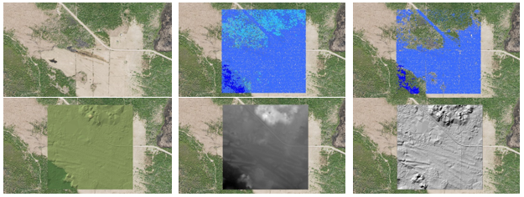
Figure 11: COOP 2016 DEM development process
At a 1:500 scale the process can be visualized in more detail (see Figure 12 to Figure 14).
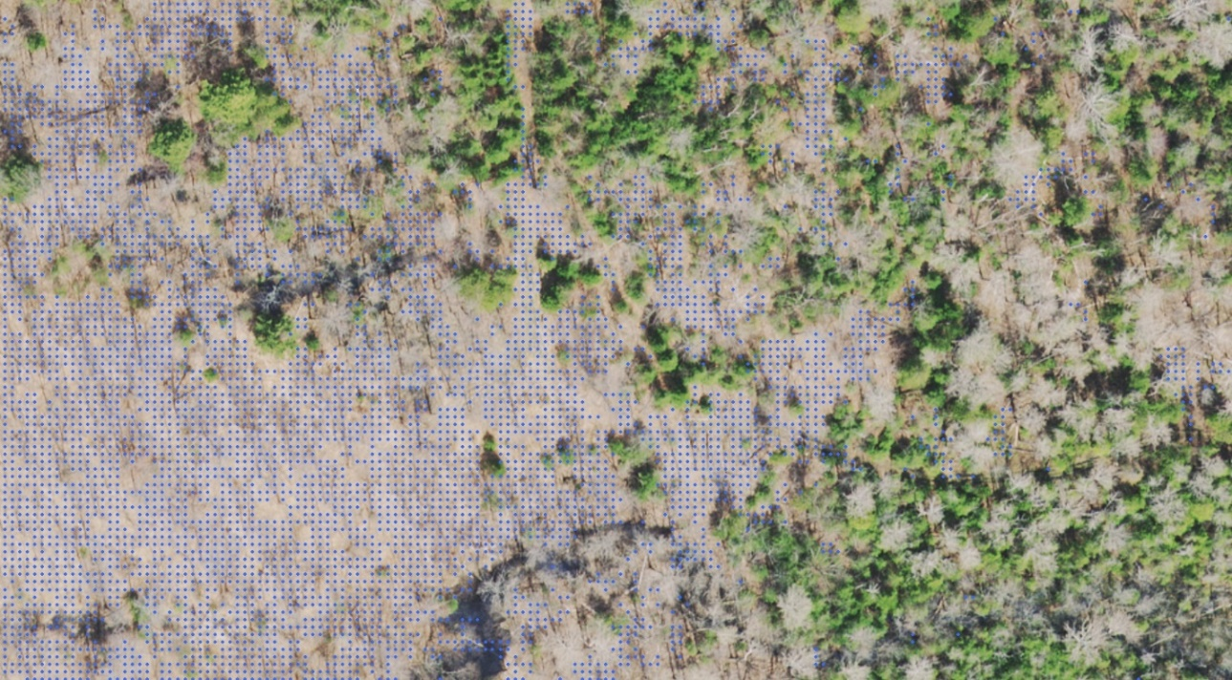
Figure 12: Ground classified point cloud posts after filtering vegetation surface features
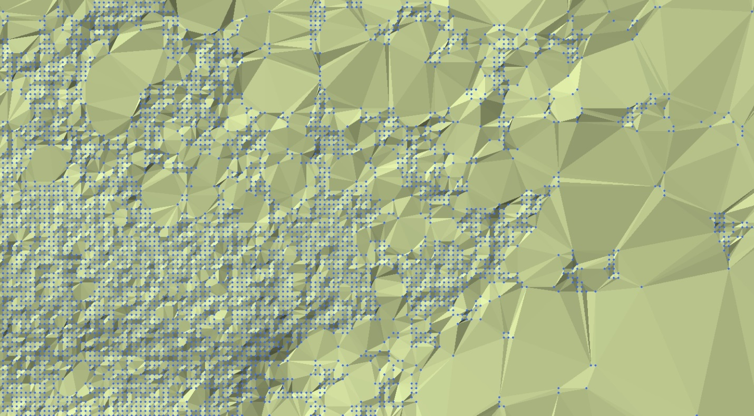
Figure 13: Resulting Triangular Irregular Network (TIN) produced from ground posts
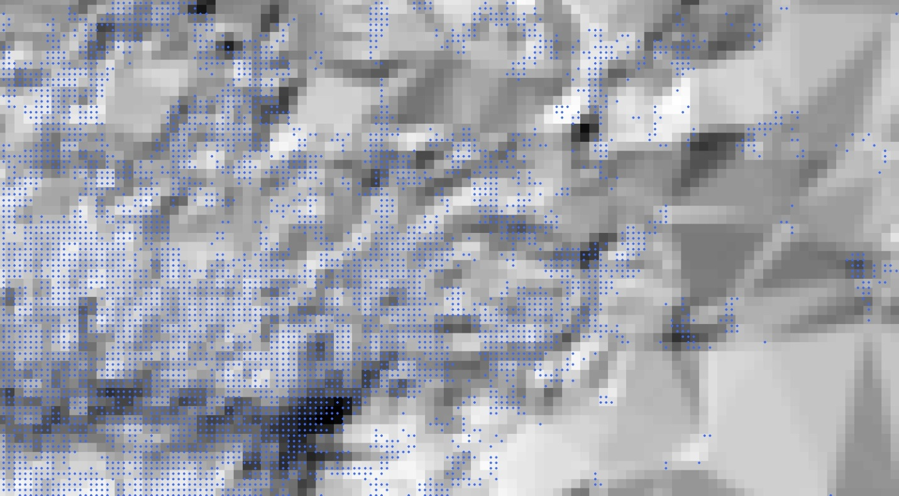
Figure 14: Interpolated DEM hillshade from TIN aligned to point cloud ground posts

Version 2324.1

