User Guide
for
Ontario Digital Terrain Model (Lidar-Derived)
Geospatial Ontario Dataset
  - Geospatial Ontario
  - Digital, Data, Information and Business Services Branch
  - Corporate Management and Information Division
  - Ministry of Natural Resources
2026-06-05

Disclaimer
This technical documentation has been prepared by His Majesty the King in right of Ontario as represented by the Ministry of Natural Resources (the “Ministry”). No warranties or representations, express or implied, statutory or otherwise shall apply or are being made by the Ministry with respect to the documentation, its accuracy or its completeness. In no event will the Ministry be liable or responsible for any lost profits, loss of revenue or earnings, claims by third parties or for any economic, indirect, special, incidental, consequential or exemplary damage resulting from any errors, inaccuracies or omissions in this documentation; and in no event will the Ministry’s liability for any such errors, inaccuracies or omissions on any particular claim, proceeding or action, exceed the actual consideration paid by the claimant involved to the Ministry for the materials to which this instructional documentation relates. Save and except for the liability expressly provided for above, the Ministry shall have no obligation, duty or liability whatsoever in contract, tort or otherwise, including any liability or negligence. The limitations, exclusions and disclaimers expressed above shall apply irrespective of the nature of any cause of action, demand or action, including but not limited to breach of contract, negligence, strict liability, tort or any other legal theory, and shall survive any fundamental breach or breaches.

Additional Information
This document does not comply with all the applicable guidelines for accessible digital documents. For an alternative format please email Geospatial Ontario at geospatial@ontario.ca.
For more information about this document, please contact Geospatial Ontario at geospatial@ontario.ca.

Executive Summary

Key Words
OMAFRA Lidar, Lidar Eastern Acquisition Project, LEAP, Airborne Topographic Lidar, Digital Elevation Model, DEM, Digital Terrain Model, DTM, Elevation, Light Detection and Ranging, lidar, terrain, and topography.

Abstract
This user guide is intended to go beyond metadata and give data users a sense of the purpose for which the data was collected, the technical processes, software, and applicable standards involved, suggested applications for the data (and general approaches to how to use it), and other details that will help data users. As such, this user guide details the specifications for the Ontario Digital Terrain Model (Lidar-Derived) Geospatial Ontario (GEO) Dataset.
The Ontario Digital Terrain Model (Lidar-Derived) is a compilation of raster digital elevation data from multiple acquisition projects within the Province of Ontario.
The Digital Terrain Model is a gridded raster data product representing the bare-earth terrain, that has been generated from a classified lidar point cloud. Most, but not all the datasets incorporated into the Ontario Digital Terrain Model (Lidar-Derived) have been hydro-flattened using water body breaklines.
This data is intended for GIS and remote sensing applications that require a high resolution, high accuracy 3D elevation model. These elevation models are invaluable for agricultural soil mapping, infrastructure assessment and development, forest modelling and management, land hazard/erosion mapping and flood control amongst other applications.

Document History
Date | Description
2019-09-30 | First release
2020-01-10 | CLOCA and SNC acquisition areas added. Merged index maps by region. Updated abstract.
2020-02-11 | GTA acquisitions added.
2022-01-31 | Lake Nipissing, Ottawa River, and York Region – Lake Simcoe acquisitions added.
2022-07-28 | Ottawa-Gatineau acquisition added.
2022-08-19 | Hamilton-Niagara acquisition added.
2023-01-19 | OMAFRA 2022 acquisitions added.
2023-07-25 | Eastern Ontario and Belleville acquisitions added.
2023-09-22 | DEDSFM Huron-Georgian Bay 2022 project area added.
2023-12-01 | DEDSFM Huron-Georgian Bay 2023 project area added.
2023-12-20 | DEDSFM Kawartha Lakes 2023 project area added.
2024-01-17 | Huron Shores 2021 project added.
2024-05-06 | DEDSFM Sudbury & Sault Ste Marie 2023 and Muskoka projects added.
2024-09-03 | Added the final part of the Huron-Georgian Bay project covering the northern Bruce Peninsula and missing flight lines from the Sudbury project.
2025-01-17 | Added the Thunder Bay 2023-24 project, Timmins 2024 and the 2024 part of the Sault Ste Marie project.
2025-02-25 | Added the GTA 2023 project.
2025-09-09 | Added the DEDSFM Fall 2024 projects: Atikokan, Cataraqui, Chapleau, Dryden, Ignace, Northeastern Ontario and Sioux Lookout.
2025-12-01 | Added the Manitoulin 2024 project.
2026-03-24 | Added the DEDSFM Spring 2025 projects: Central East, Kenora, Northeastern Ontario, Rainy River, and Upper Thames-Grand River.
2026-06-05 | Added the Haliburton 2019 project and the DEDSFM Fall 2025 projects: Lower Thames and Wasauksing-Parry Sound

Table of Contents
Disclaimer 2
Additional Information 2
Executive Summary 3
Key Words 3
Abstract 3
Document History 4
Table of Contents 5
List of Figures 7
List of Tables 8
List of Acronyms 9
List of Definitions 11
Mass Points 11
Digital Elevation Model (DEM) 11
Digital Terrain Model (DTM) 11
Digital Surface Model (DSM) 12
1. Product Description 13
1.1 Ontario Digital Terrain Model (Lidar-Derived) 13
1.2 Lidar Acquisitions 15
1.2.1 Acquisition Projects 15
1.2.2 Acquisition Details and Parameters 19
1.3 Geographic Extent* 24
1.4 Reference System 27
1.4.1 Horizontal Reference System 27
1.4.2 Vertical Reference System 28
1.5 Accuracy Assessment 29
1.5.1 Vertical Accuracy 29
1.5.3 Calculated Horizontal Accuracy 32
1.6 Spatial Resolution 32
2. Product Details 33
2.1 Data Delivery Format 33
2.2 Use Restrictions 34
3. Links to Additional Information 35
4. References 36
Appendix A: Getting Started – Display and use of DTM data 40
Opening and viewing the DTM 40
Creation of contour lines from DTM 42
Assembly, viewing and analysis of multiple DTM tiles: new dataset vs virtual 43
Appendix B: Common DTM Analysis Functions 44
Slope 44
Aspect 44
Curvature 45
Appendix C: Important Considerations and Product Limitations 46
Removal of vegetations and structures 46
Bare-ground flattening in areas of vegetations and/or steep terrain 48
Flattening of water 49
Scan line artefacts 53
Tile boundaries extend beyond the collection area boundary 55

List of Figures
Figure 1: DTM viewed as a hillshade 13
Figure 2: Extent of Lidar Derived data for Southern Ontario 24
Figure 3: Extent of Lidar Derived data for Northern Ontario 26
Figure 4: Tile names reflect tile size, UTM zone, easting, northing, year, and project 33
Figure 5: Unzipped DTM package contents 40
Figure 6: Raw DTM tile 40
Figure 7: DTM tile displayed as a hillshade and colour-shaded relief 41
Figure 8: Smoothed contour lines generated from a DTM tile at 5-m interval 42
Figure 9: Examples of Slope and Aspect 44
Figure 10: Example of trees, buildings and a bridge being excluded from the DTM. 46
Figure 11: DTM elevation values that have been interpolated across a void 47
Figure 12: Aerial photograph of shoreline with treed slope. 48
Figure 13: Coarse interpolation effects in DTM on vegetated slope near overlap 49
Figure 14: Views of a flattened pond with breaklines indicated as dotted red lines. 50
Figure 15: Pond that has not been flattened. 50
Figure 16: Shaded relief view of flattened water surface as represented in DTM 51
Figure 17: Digitized breaklines on source lidar derived intensity image, Fall 2016 52
Figure 18: Digitized breaklines contrasted with aerial photograph from Spring, 2013. 52
Figure 19: Scan line artefacts with profile location and profile elevation values 53
Figure 20: Chart of elevation values along the profile 54
Figure 21: Detail comparing raw data collection, project, and package extents 55

List of Tables
Table 1: Acquisition details for the Ontario DTM (Lidar-Derived) source projects 19
Table 2: Lidar system specifications and flight parameters by sensor system 21
Table 3: Lidar project areas by UTM zone 27
Table 4: Vertical datums by projects 28
Table 5: Airborne lidar non-vegetated vertical accuracy 29
Table 6: Airborne lidar vegetated vertical accuracy 31
Table 7: Airborne lidar horizontal accuracy 32

List of Acronyms
AGL: Above Ground Level
ASPRS: American Society for Photogrammetry and Remote Sensing
ATL: Airborne Topographic LIDAR
CGVD: Canadian Geodetic Vertical Datum
CLOCA: Central Lake Ontario Conservation Authority
CSRS: Canadian Spatial Reference System
DEDSFM: Digital Elevation Data to Support Flood Mapping
DEM: Digital Elevation Model
DSM: Digital Surface Model
DTM: Digital Terrain Model
FHIMP: Flood Hazard Identification and Mapping Program
GEO: Geospatial Ontario
GIS: Geographic Information System
GTA: Greater Toronto Area
LEAP: Lidar Eastern Acquisition Project
LIDAR: Light Detection and Ranging
MNR: Ontario Ministry of Natural Resources
MTO: Ontario Ministry of Transportation
NAD: North American Datum
NDMP: National Disaster Mitigation Program
NRCan: Natural Resources Canada
OMAFRA: Ontario Ministry of Agriculture, Food and Rural Affairs
OWIS: Ontario Web Image Services
SNC: South Nation Conservation
URL: Uniform Resource Locator
USGS: United States Geological Survey
UTM: Universal Transverse Mercator

List of Definitions

Mass Points
Mass points are irregularly spaced points, each with x/y location coordinates and z-values, typically (but not always) used to form a TIN. When generated manually, mass points are ideally chosen to depict the most significant variations in the slope or aspect of TIN triangles. However, when generated automatically, e.g., by lidar or IfSAR scanner, mass point spacing and patterns depend upon the characteristics of the technologies used to acquire the data.

Digital Elevation Model (DEM)
DEM is a generic term for digital topographic and/or bathymetric data that is comprised of x/y coordinates and z-values to represent an elevation surface.
The term ‘DTM’ and ‘DSM’ should be used over the term ‘DEM’ to more specifically reference ‘bare-earth’ or ‘surface elevation’ model products when possible.
The term ‘DEM’ is to be used as a broader term when referencing a generic elevation data product. The Provincial DEM is an example of a generic elevation product given that it has been constructed using a combination of both ‘DTM’ and ‘DSM’ elevation datasets to achieve Provincial coverage.

Digital Terrain Model (DTM)
The bare earth surface (lowest surface, last reflective surface, or lidar last-return) represents the surface of the "bare-earth" terrain, after removal of vegetation and constructed features.
Photogrammetry has traditionally generated DTMs when elevations are generated by manual compilation techniques. Unless specified to the contrary, the bare-earth surface includes the top surface of water bodies, rather than the submerged surface of underwater terrain.
Like a DSM, a DTM can be structured either as a vector dataset (comprised of mass points and optionally 3D breaklines) to model bare-earth elevations or a raster dataset that is interpolated from the vector elevation data to model bare-earth terrain elevations.
Using modern elevation point cloud classification algorithms and file formats, such as LAS, a DTM can represent a mass point dataset that has been classified for ‘bare-earth’ terrain elevations.

Digital Surface Model (DSM)
A DSM is the highest reflective surface of ground features captured by the sensor. This surface may also be referred to as the first reflective surface or lidar first-return. The DSM may include treetops, rooftops, and tops of towers, telephone poles, and other natural or manmade features; or it may include the ground surface if there is no vegetative ground cover. Photogrammetry, IFSAR, lidar and sonar can all provide this type of surface, yet characteristics such as accuracy and degree of detail (ability to resolve desired surface features) may vary significantly across technologies and even within the same technology. With sonar, the DSM may include sunken vessels and other artifacts, whereas the bathymetric surface reflects the natural underwater terrain. Similarly, with photogrammetry, lidar, and IFSAR the reflective surface may include any artifact present when the sensor mapped the area, including passing cars and trucks and similar features not normally considered to be part of a digital terrain model.
Like a DTM, a DSM can be structured either as a vector dataset (comprised of mass points and optionally 3D breaklines) to model surface elevations or a raster dataset that is interpolated from the vector elevation data to model surface elevations.
Using modern elevation point cloud classification algorithms and file formats, such as LAS, a DSM can represent a mass point dataset that has been classified for ‘surface’ elevation features.

1. Product Description

1.1 Ontario Digital Terrain Model (Lidar-Derived)
The purpose of each Airborne Topographic Lidar acquisition was to acquire classified lidar digital elevation data and derivative products for selected geographic areas in Ontario. This data is intended for GIS and remote sensing applications that require a high resolution, high accuracy elevation model. These elevation models, known as Digital Elevation Models (DEMs), are invaluable for agricultural soil mapping, infrastructure assessment and development, forest modelling and management, land hazard/erosion mapping and flood control amongst other applications.
The Ontario Digital Terrain Model (Lidar-Derived) is a bare-earth gridded raster data product that has been generated from a classified point cloud. Resolution and hydro-flattening depends on the acquisition project. Figure 1 shows a sample hillshade of the DTM.
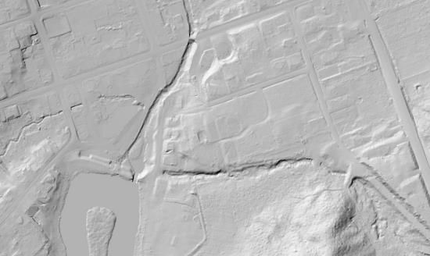
Figure 1: DTM viewed as a hillshade

In addition to the DTM, the following products which contributed to the production of the DTM were delivered by the contractor:
- Classified Point Cloud: Available as the Ontario Classified Point Cloud (Lidar-Derived) (https://geohub.lio.gov.on.ca/datasets/adf19376eecd4440a4579a73 abe490f5).
CLOCA, DEDSFM, Eastern Ontario, Muskoka, OMAFRA, Ottawa-Gatineau and SNC Lidar projects only:
- Breaklines: Hard breaklines representing interruptions to the surface defined by water bodies with surface area of 8,000 m² or greater or rivers greater than 30 m wide at the time of collection (USGS LIDAR Base Specifications (V 1.2). The breaklines are available for download from the Ontario DTM (Lidar-Derived) record in the Ontario GeoHub.
A DSM has also been created for each lidar project:
- Available as the Ontario Digital Surface Model (Lidar-Derived) (https://geohub.lio.gov.on.ca/maps/mnrf::ontario-digital-surface-model-lidar-derived/about)

1.2 Lidar Acquisitions

1.2.1 Acquisition Projects
The Ontario DTM (Lidar-Derived) is a compilation of lidar data from multiple acquisition projects, as such specifications, parameters, accuracy, and sensors may vary by project. See Tables 1 and 2 for a summary of acquisition details.
The Digital Elevation Data to Support Flood Mapping (DEDSFM) 2022-26 project was initiated by the Ontario Ministry of Natural Resources’ (MNR) Ontario Elevation Mapping Program in response to Ontario’s 2020 Flooding Strategy. The project is acquiring lidar data to support flood mapping and other uses across targeted areas of Ontario from 2022 to 2025.
The Greater Toronto Area (GTA) 2023 lidar project was acquired by Airborne Imaging Inc. for a partnership of Greater Toronto Area (GTA) conservation authorities, Halton Region Conservation Authority, Lake Simcoe Region Conservation Authority, and Toronto and Region Conservation Authority¹.
The Muskoka 2018, 2021 and 2023 lidar projects were acquired by Hatch Ltd. for the District of Muskoka to support the Muskoka Floodline Mapping Project. See Muskoka’s Lidar Discovery story map for more details. These projects were delivered to the Muskoka in the CGVD28 vertical datum. They have been transformed to CGVD2013 by MNR. Both versions have been made available for download.
The Belleville 2022 lidar project was acquired by Airborne Imaging Inc. for the Government of Canada as part of the FHIMP.
The Eastern Ontario 2021-22 lidar project was acquired by Airborne Imaging Inc. for a partnership of Eastern Ontario Conservation Authorities, Municipalities, Counties and Conservation Ontario with Natural Resources Canada (NRCan) under FHIMP. The full list of partners includes:
- Cataraqui Region Conservation Authority
- Mississippi Valley Conservation
- Quinte Conservation
- South Nation Conservation
- Raisin Region Conservation Authority
- Rideau Valley Conservation Authority
- City of Cornwall
- City of Kingston
- Municipality of South Dundas
- Township of Loyalist
- Township of North Dundas
- Township of North Glengarry
- Township of North Stormont
- Township of South Glengarry
- Township of South Stormont
- County of Frontenac
- County of Lanark
- United Counties of Leeds and Grenville
- United Counties of Prescott and Russell
- United Counties of Stormont, Dundas and Glengarry
- Natural Resources Canada
- Conservation Ontario
The OMAFRA 2022 lidar project was acquired by Airborne Imaging Inc. for the Ministry of Agriculture, Food and Rural Affairs (OMAFRA) to cover two project areas, the southern portion of the Lake Huron watershed and the northern part of the Lake Simcoe watershed. Funding for the project was provided through the Canadian Agricultural Partnership, a five-year, $3 billion investment by federal-provincial and territorial governments to encourage innovation, competitiveness and sustainability in Canada’s agriculture industry. Review and quality control support of the data deliveries were provided by the MNR as in-kind contributions.
The Huron Shores 2021 lidar was acquired by Tulloch to support a flood plain mapping project by Hatch Ltd for the Municipality of Huron Shores. Matching funding was provided by Public Safety Canada through the National Disaster Mitigation Program (NDMP).
The Hamilton-Niagara Region lidar project was acquired by Leading Edge Geomatics for NRCan with emergency management funding from Public Safety Canada.
The Ottawa-Gatineau lidar project was acquired by Perron Hudon Belanger Inc. as a partnership between the City of Gatineau, the City of Ottawa, and the National Capital Commission. Review and quality control support of the data deliveries were provided by MNR as in-kind contributions. The horizontal projection of the data was originally in NAD83 CSRS MTM Zone 09 and was reprojected to NAD83 CSRS UTM Zone 18 by MNR.
The North Bay-Mattawa and Lake Nipissing lidar project was acquired by Eagle Mapping Ltd for Natural Resources Canada (NRCan) with emergency management funding from Public Safety Canada.
The Ottawa River lidar project was acquired by Groupe Info Consult Inc. for NRCan with emergency management funding from Public Safety Canada.
The Haliburton 2019 project was acquired by Airborne Imaging Inc. for the County of Haliburton to support flood plain mapping studies. Matching funding was provided by Public Safety Canada through the NDMP.
The York Region – Lake Simcoe Watershed project was acquired from Airborne Imaging Inc. by OMAFRA with funding through the Lake Simcoe Protection Plan delivery program. Review and quality control support of the data deliveries were provided by MNR as in-kind contributions.
The South Nation Conservation (SNC) and Central Lake Ontario Conservation Authority (CLOCA) airborne topographic lidar acquisitions were flown by Airborne Imaging Inc. under a project initiated by the respective Conservation Authorities with matching funding from the NDMP. Review and quality control support of the data deliveries were provided by Ontario MNR as in-kind contributions.
The GTA 2014-18 lidar acquisitions were flown as six separate projects by Airborne Imaging Inc. For extents of each of the acquisition projects see Figure 3 in Section 1.3. The data was purchased by NRCan and made available as open data through the High Resolution Digital Elevation Model (HRDEM). The HRDEM is at 1 metre resolution, whereas the GTA lidar data has been interpolated to 0.5 metre resolution for the Ontario DTM (Lidar-Derived).
The OMAFRA airborne topographic lidar acquisition was collected through a collaborative partnership with OMAFRA, MNR and a private contractor; it covers selected areas in Southern Ontario and portions of Northern Ontario. A contract was awarded to Airborne Imaging Incorporated for the collection of lidar for the three project areas: Cochrane, Peterborough, and the Lake Erie watershed. This project was funded in part through Growing Forward 2 (GF2), a federal-provincial-territorial initiative.
The LEAP Airborne Topographic Lidar data was funded through a collaborative partnership consisting of the MNR, Ministry of Transportation (MTO), City of Kingston, Cataraqui Region Conservation Authority, Prince Edward County, and the Municipality of Quinte West. A contract was awarded to Géomatique EMCO Inc. for the acquisition of lidar across the project area.
An extensive technical review of the LEAP deliverables conducted by MNR’s Southern Region identified several quality issues in the data based on the project’s Technical Guidelines and specifications. It was determined that the lidar deliverables did not meet the specifications within the Agreement. MNR staff subsequently made extensive quality control improvements using the deliverables to produce a fully modified, edited, and reformatted set of derivative products.
Refer to the project metadata documents for more details. To see the exact acquisition date for a particular location and the sensor system used refer to the Lift Metadata shapefile attached to the LIO metadata record for the Ontario Classified Point Cloud (Lidar-Derived).

1.2.2 Acquisition Details and Parameters
Table 1: Acquisition details for the Ontario DTM (Lidar-Derived) source projects
Project Area | Acquisition Period | Project Area (km²) | Vertical Accuracy Class | Pulse Density (Pulses/m²) | Flight Altitude AGL (m) | Additional Notes
LEAP | May to Dec 2009 | 4,245 | 15 cm | 1.3 | 1900
GTA (2014) | Apr to May 2014 | 1,251 | 10 cm | 10.3 | 1300
GTA (2015) | Apr 2015 | 1,475 | 10 cm | 8.96 | 1300
GTA (Brampton) | Nov 2015 | 96 | 10 cm | 15.1 | 1100
GTA (Peel) | May 2016 | 556 | 10 cm | 15.1 | 950
OMAFRA Lidar  Cochrane | Oct to Nov 2016, May to Jun and Sep 2017 | 6,124 | 5 cm | 8 | 1000 | See Airborne Imaging (2018a) for more details
OMAFRA Lidar  Peterborough | Nov to Dec 2016, Apr to May and Oct 2017 | 6,836 | 5 cm | 8 | 1000 | See Airborne Imaging (2018b) for more details
GTA (Milton) | Nov to Dec 2017 | 217 | 10 cm | 15.8 | 950
OMAFRA Lidar  Lake Erie | Mar to May 2017, Oct to Dec 2017 and Mar to May 2018 | 23,029 | 5 cm | 8 | 1000 (Leica)  700 (Riegl) | See Airborne Imaging (2019a) for more details
GTA (Halton) | Mar to Jun 2018 | 1,080 | 10 cm | 12.8 | 1200
Muskoka 2018 | May 18-24, 2018 | 1,508 | 10 / 15 cm | 2.5 / 10.4 | 1250 / 1550
CLOCA Lidar | Dec. 9–10, 2018 | 386 | 5 cm | 8 | 1000 | See Airborne Imaging (2019b) for more details
SNC Lidar | Nov. 11-14, 2018 & Apr. 4-22, 2019 | 798 | 5 cm | 8 |  | See Airborne Imaging (2019c) for more details
York Region-Lake Simcoe | Aug 2 to Sep 20, 2019 | 990 | 10 cm | 10 | 1000
Haliburton 2019 | Sep 21 to Oct 9, 2019 | 503 | 10 cm | 5.4 | 1400
Ottawa River | Oct 5-25, 2019 & Apr 24 to May 22, 2020 | 5,969 | 10 cm | 6 | 800
Ottawa-Gatineau | May 3-22 & Oct 9-26, 2019 & Apr 18 - May 2, 2020 | 4,353 | 5 cm | 8 | 1150
North Bay & Lake Nipissing | Jun 1-19, 2020 | 5,975 | 10 cm | 11 | 1650
Hamilton-Niagara | Apr 5 to May 25, 2021 | 2,983 | 5 cm | 26.4 | 1300
Huron Shores | Oct 28, 2021 | 539 | 5 cm | 7.43 | 1800
Muskoka 2021 | Nov 9-10, 2021 | 1,205 | 10 cm | 4 | 1900 / 950
Eastern Ontario | Nov 5-27, 2021 &  Apr 18-30, 2022 | 14,825 | 5 cm | 8 | 1400 / 1600
OMAFRA 2022 Lake Huron | Apr 12-24, 2022 | 4,373 | 5 cm | 8 | 1600 | See Airborne Imaging (2022a) for more details
OMAFRA 2022 Lake Simcoe | May 5-7, 2022 | 2,088 | 5 cm | 8 | 1600 | See Airborne Imaging (2022b) for more details
Belleville 2022 | Oct 1-25, 2022 | 7,517 | 5 cm | ≥ 8 | 1600
DEDSFM  Huron-Georgian Bay | Oct 24 to Nov 10, 2022, Apr 27 to Jun 10 & Nov 15-16, 2023 | 16,968 | 5 cm | 13.55 | 900 / 1650 / 2050 | See Airborne Imaging (2024) for more details
GTA 2023 | Apr 9 to May 11, 2023 | 5,253 | 5 cm | 16 | 1800
DEDSFM Kawartha Lakes | May 6-10, 2023 | 3,375 | 5 cm | 11.51 | 1650 | See Airborne Imaging (2025e) for more details
DEDSFM Sudbury | May 13-14, 2023 & Apr 16, 2024 | 5,067 | 5 cm | 12 | 1650 | See Airborne Imaging (2025h) for more details
DEDSFM Sault Ste Marie | May 15-18, 2023 & Apr 6-24, 2024 | 7,172 | 5 cm | UTM16: 15.6  UTM17: 12.5 | 1650 / 2000 | See Airborne Imaging (2025g) for more details
Muskoka 2023 | May 25-27, 2023 | 1,913 | 10 cm | 8 | 1600
DEDSFM Thunder Bay | Sep 26 to Oct 11, 2023 & Apr 25 to May 6, 2024 | 3,897 | 5 cm | 15.34 | 1650 / 2000 | See Airborne Imaging (2025i) for more details
DEDSFM Manitoulin | Apr 6-16, 2024 | 3,624 | 5 cm | 11.98 | 1650 / 2000 | See Airborne Imaging (2025f) for more details
DEDSFM Timmins | May 4-9, 2024 | 3,194 | 5 cm | 12.29 | 1650 | See Airborne Imaging (2025j) for more details
DEDSFM Dryden | Oct 27-31, 2024 | 1,899 | 5 cm | 11.72 | 2000 | See Airborne Imaging (2025d) for more details
DEDSFM Sioux Lookout | Oct 31 to Nov 8, 2024 | 1,049 | 5 cm | 11.53 | 2000 | See Airborne Imaging (2025d) for more details
DEDSFM Atikokan | Nov 1, 2024 | 600 | 5 cm | 11.7 | 2000 | See Airborne Imaging (2025a) for more details
DEDSFM Ignace | Nov 1, 2024 | 110 | 5 cm | 11.4 | 2000 | See Airborne Imaging (2025d) for more details
DEDSFM Cataraqui | Nov 3, 2024 | 570 | 5 cm | 12.15 | 1650 | See Airborne Imaging (2025b) for more details
DEDSFM Chapleau | Nov 9, 2024 | 1,120 | 5 cm | 11.67 | 2000 | See Airborne Imaging (2025c) for more details
DEDSFM Northeastern Ontario | Nov 9, 2024 & May 8 to Jun 2, 2025 | 9,058 | 5 cm | 13.12 | 1650 / 2000 | See Airborne Imaging (2026c) for more details
DEDSFM Central East | Apr 7-23, 2025 | 5,577 | 5 cm | 13.1 | 2000 | See Airborne Imaging (2026a) for more details
DEDSFM Upper Thames-Grand River | Apr 24 to May 9 and Nov 14, 2025 | 7,779 | 5 cm | 14.6 | 1650 / 2000 | See Airborne Imaging (2026e) for more details
DEDSFM Kenora | May 5, 2025 | 476 | 5 cm | 12.7 | 1650 | See Airborne Imaging (2026b) for more details
DEDSFM Rainy River | May 5 to Jun 3, 2025 | 3,139 | 5 cm | 15.01 | 1650 | See Airborne Imaging (2026d) for more details
DEDSFM Wasauksing-Parry Sound | Oct 28, 2025 | 437 | 5 cm | 8.43 | 2000
DEDSFM Lower Thames | Nov 13-19, 2025 | 3,571 | 5 cm | 12.7 | 1650 | This is the first 2,733 tile delivery of a project to be completed in 2026

Table 2: Lidar system specifications and flight parameters by sensor system
Project Area | Sensor System | Speed (kn) | Flightline Spacing (m) | Single Pass Swath Width (m) | Scan Angle or Field of View | Scan Freq (Hz) | Scan Pulse Rate (kHz) | Overlap
Belleville 2022 | Riegl-VQ1560ii | 160 |  | 1445 | 50° | 252 | 1100 | 50%
CLOCA & SNC Lidar | Riegl LMS-Q1560 | 150 | 930 |  | 58° effective | 313 | 800 | ≤ 60%
DEDSFM Atikokan, Chapleau, Dryden, Ignace, and Sioux Lookout | Riegl VQ1560ii-S | 150 |  | ~2100 | 60° | 334 | 2600 | 40%
DEDSFM Cataraqui | Riegl VQ1560ii-S | 150 |  | 1780 | 60° | 330 | 2100 | 40%
DEDSFM Central East and Wasauksing-Parry Sound | Riegl VQ1560ii-S | 150 |  | ~2100 | 60° | 334 | 1733.3 | 40%
DEDSFM Huron-Georgian Bay | Riegl-VQ1560ii / VQ1560ii-S | 160 / 200 |  | 1445 | 60° | 300 / 340 / 342 | 2000 / 2100 / 2600 | 40%
DEDSFM Kawartha Lakes | Riegl VQ1560ii-S | 160 |  | ~1730 | 60° | 320 | 2100 | 40%
DEDSFM Kenora, and Rainy River | Riegl VQ1560ii | 150 |  | 1800 | 60° | 330 | 1400 | 40%
DEDSFM Lower Thames | Riegl VQ1560ii | 150 |  | 1800 | 60° | 140 / 330 | 1400 | 40%
DEDSFM Manitoulin | Riegl VQ1560ii / VQ1560ii-S | 150 |  | ~1700 / ~2100 | 60° | 330 / 334 | 2100 / 2600 | 40%
DEDSFM Northeastern Ontario | Riegl VQ1560ii / VQ1560ii-S | 150 |  | 1700 | 60° | 330 / 334 | 1400 / 1733.3 | 40%
DEDSFM Sault Ste Marie | Riegl VQ1560ii-S | 150 / 200 |  | ~1700 | 60° | 300 / 334 | 2000 / 2600 | 40%
DEDSFM Sudbury | Riegl VQ1560ii / VQ1560ii-S | 200 |  | ~1700 | 60° | 300 | 2000 | 40%
DEDSFM Thunder Bay | Riegl VQ1560ii / VQ1560ii-S | 160 / 150 |  | ~1700 | 60° | 341 / 334 | 2100 / 2600 | 40%
DEDSFM Timmins | Riegl VQ1560ii | 150 |  | ~1700 | 60° | 332 | 2200 | 40%
DEDSFM Upper Thames-Grand River | Riegl VQ1560ii / VQ1560ii-S | 150 |  | 1700 | 60° | 330 / 334 | 1400 / 1733.3 | 40%
Eastern Ontario | Riegl VQ1560ii | 160 |  | 1445 | 60° | 202 | 1250 | 50%
GTA 2014 & 2015 | Leica ALS70 | 160 |  | 1283.4 | 40° | 52 | 400 | 50%
GTA (Brampton) | Leica ALS70 | 140 |  | 1283.4 | 40° | 53 | 480 | 50%
GTA (Halton, Milton & Peel) | Leica ALS70 | 160 |  | 1283.4 | 40° | 52.1 | 440 | 50%
GTA 2023 | Riegl LMS-VQ1560ii / Riegl LMS-VQ1560ii-S | 160 |  | 1445 | 60° | 334 | 2200 | 50%
Haliburton 2019 | Leica ALS70 | 160 |  | variable | 50° | 53 | 375 | 50%
Hamilton-Niagara | Riegl VQ1560i | 130 |  | 1212 | 50° | 105 | 700 | 50%
Huron Shores | Riegl VQ1560ii | 160 |  |  | 60° |  | 700
LEAP | Optech ALTM 3100, Optech ALTM Gemini 167 | 120 | 864 | 1235 | 36° | 35 | 100 | 30%
Muskoka 2018 | Leica ALS70 | 140 / 160 |  |  | 40° | 53 | 300 / 400 | 40% / 100%
Muskoka 2021 | Riegl VQ1560ii | 160 |  |  | 60° | 128/ 142 | 650 / 400 | 40%
Muskoka 2023 | Riegl VQ1560ii-S | 160 |  |  | 60° | 456 | 3600 | 40%
North Bay & Lake Nipissing | Riegl LMS-Q1560 | 125 |  | 1539 | 50° | 187 | 800 | 60%
OMAFRA Lidar 2016-18 | Leica ALS70-HP | 140 | 550 | 690 | 38° effective | 53 | 500 | ≤ 40%
OMAFRA Lidar Lake Erie | Riegl LMS-Q1560 | 150 | 930 |  | 58° effective | 313 | 800 | ≤ 60%
OMAFRA 2022 | Riegl VQ1560ii | 160 |  | 1675 | 60° | 175 | 2100 | 40%
Ottawa-Gatineau | Optech ALTM Galaxy | 155 |  | 837 | 40° | 85 | 450 | 56%
Ottawa River | Optech ATLM Galaxy | 137 |  | 582 | 40° | 91 | 450 | 20%
York Region-Lake Simcoe | Riegl LMS-VQ1560 / Leica ALS 70 | 160 / 160 |  |  | 60° / 50° | 135 / 50 | 800 / 500

1.3 Geographic Extent*
Detailed boundaries of individual lidar projects can be viewed in the Ontario Lidar Coverage map. (https://mnrf.maps.arcgis.com/apps/mapviewer/index.html?webmap=275b5248fd3c4b5caccd224e9e020afc)

Figure 2: Extent of Lidar Derived data for Southern Ontario
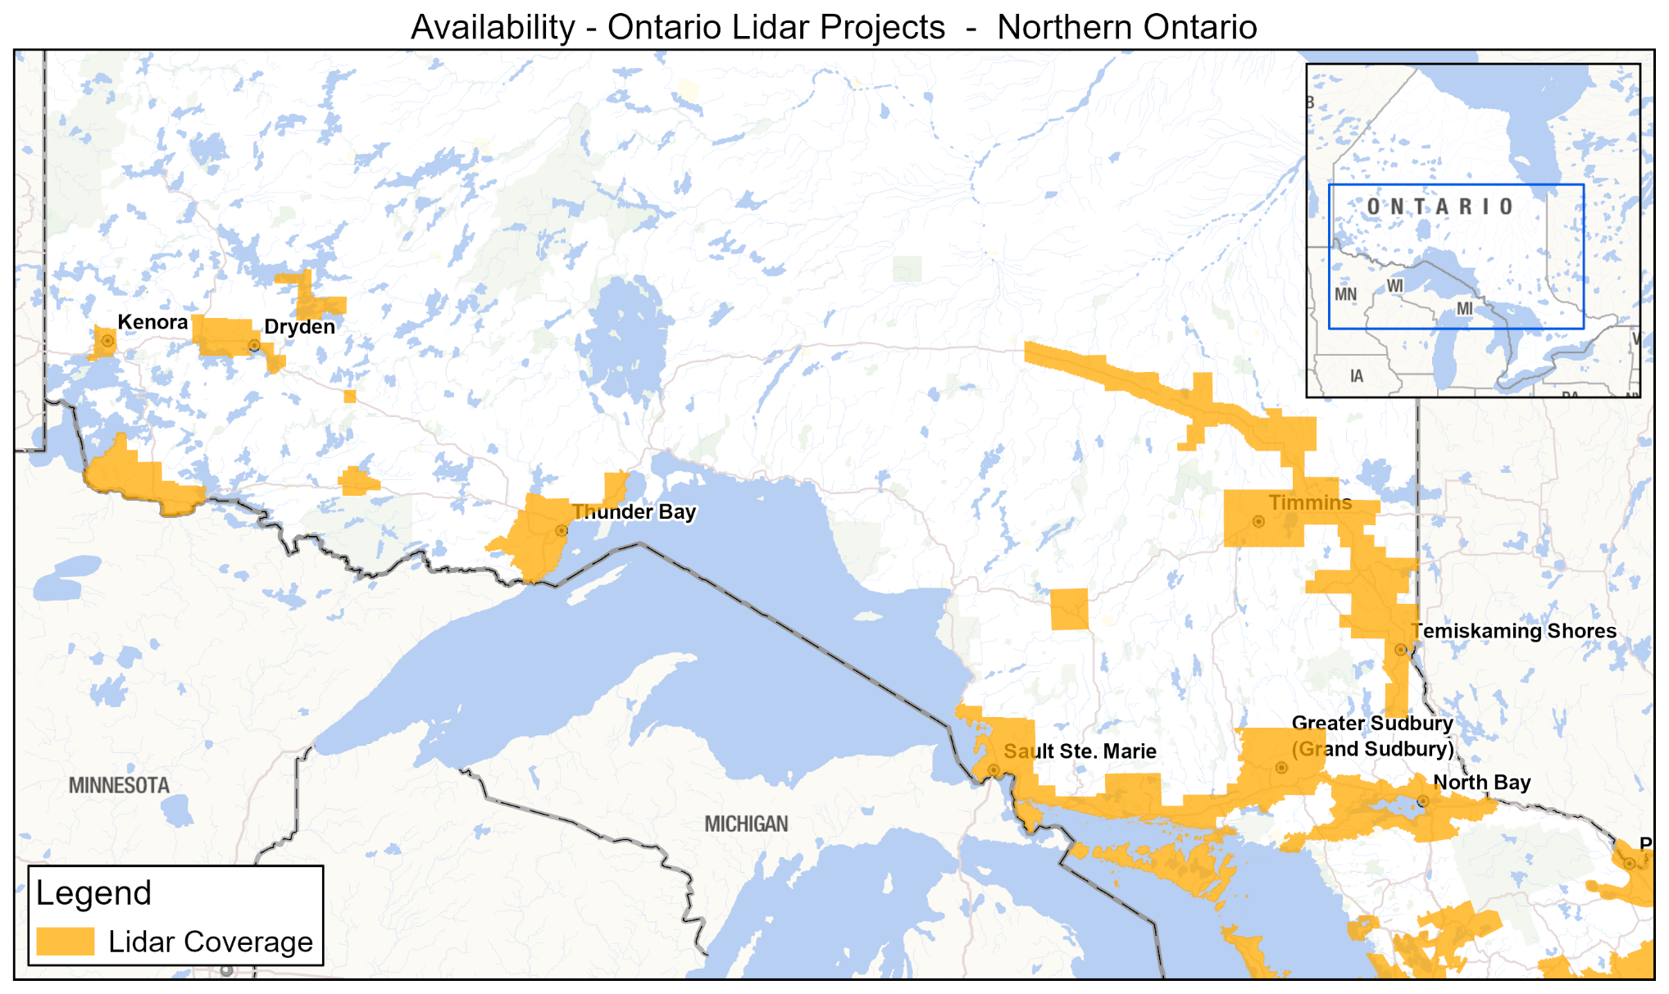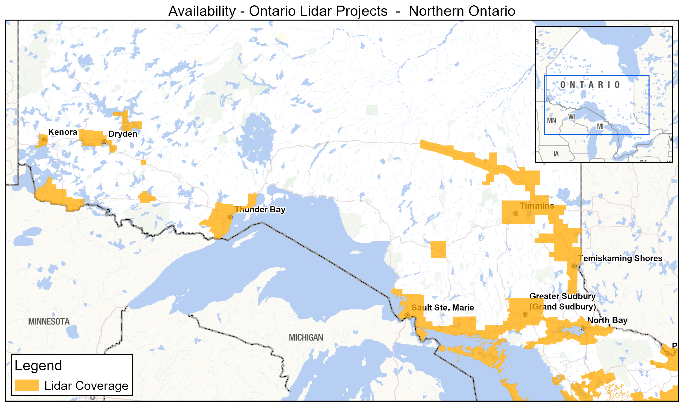
Figure 3: Extent of Lidar Derived data for Northern Ontario
*Note: Raw point cloud data may extend beyond boundaries of the project area. See the Ontario Classified Point Cloud (Lidar-Derived) user guide for more details.

1.4 Reference System

1.4.1 Horizontal Reference System
The horizontal coordinate system of the Ontario Digital Terrain Model (Lidar-Derived) is Universal Transverse Mercator (UTM) with zone varying by project (Table 3). The horizontal datum of the products is the North American Datum of 1983 Canadian Spatial Reference System epoch 2010 (NAD83 (CSRS)).
The horizontal unit of measure (coordinate system axis units) for all raster grid cells is metres (m).
Table 3: Lidar project areas by UTM zone
UTM Zone | Project Areas
15 | - DEDSFM Atikokan, Dryden, Ignace, Kenora, Rainy River, and Sioux Lookout
16 | - DEDSFM Sault Ste Marie and Thunder Bay
17 | - CLOCA  - DEDSFM Cataraqui, Central East, Chapleau, Huron-Georgian Bay, Kawartha Lakes, Lower Thames, Manitoulin, Northeastern Ontario, Sault Ste Marie, Sudbury, Timmins, Upper Thames-Grand River, and Wasauksing-Parry Sound  - GTA 2014-18  - GTA 2023  - Haliburton 2019  - Hamilton-Niagara  - Huron Shores 2021  - Muskoka 2018, 2021 & 2023  - North Bay-Mattawa & Lake Nipissing  - OMAFRA 2016-18 (Cochrane, Lake Erie, Peterborough)  - OMAFRA 2022 (Lake Huron & Lake Simcoe)  - York-Lake Simcoe 2019
18 | - Belleville 2022  - Eastern Ontario 2021-2022  - LEAP  - Ottawa-Gatineau  - Ottawa River  - South Nation Conservation

1.4.2 Vertical Reference System
The vertical coordinate system of the Ontario Digital Terrain Model (Lidar-Derived) varies by acquisition project (Table 4). For more information on Canadian vertical datums see the Height Reference Systems of Natural Resources Canada (https://natural-resources.canada.ca/science-data/science-research/geomatics/geodetic-reference-systems/canadian-spatial-reference-system-csrs#hrs).
The vertical unit of measure (coordinate system axis units) for all raster grid cells in the products is metres (m). One single vertical elevation value represents each raster grid cell in the DTM.
Table 4: Vertical datums by projects
Vertical Datum | Project Areas
CGVD28 | - LEAP  - Muskoka 2018, 2021 & 2023
CGVD2013 | - Belleville 2022  - CLOCA  - DEDSFM 2022-26  - Eastern Ontario 2021-22  - GTA 2014-18  - GTA 2023  - Haliburton 2019  - Hamilton-Niagara  - Huron Shores 2021  - Muskoka 2018, 2021 & 2023  - North Bay-Mattawa & Lake Nipissing  - OMAFRA 2016-18 (Cochrane, Lake Erie, Peterborough)  - OMAFRA 2022 (Lake Huron & Lake Simcoe)  - Ottawa-Gatineau  - Ottawa River  - South Nation Conservation  - York-Lake Simcoe 2019

1.5 Accuracy Assessment
The Ontario Public Service Elevation Coordination and Consultation Committee (EC³) has published Elevation Accuracy Guidelines which explains and provided guidelines for assessing the accuracy of digital elevation data, which has been drafted to be consistent with the 2014 American Society for Photogrammetry and Remote Sensing (ASPRS) Positional Accuracy Standards for Digital Geospatial Data.

1.5.1 Vertical Accuracy
Vendor supplied vertical accuracy assessment reports are available for some project areas and are attached to the GeoHub record for the Ontario DTM (Lidar-Derived). These reports contain additional details about the method by which the vendor calibrated the data and quantified the accuracy of the data.
For the LEAP 2009 project additional details about the method by which the contractor has calibrated the data and quantified the accuracy of the data and included in Appendices D and E of the User Guide for the Ontario Classified Point Cloud (Lidar-Derived).

Non-vegetated Vertical Accuracy
Table 5: Airborne lidar non-vegetated vertical accuracy
Lidar Project | Fast Static Vertical Accuracy (95%) | RTK Vertical Accuracy (95%)
Belleville 2022 | N/A | 4.7 cm / 105 points
CLOCA | N/A | 4.1 cm / 26 points
DEDSFM Atikokan | N/A | 9 cm / 22 points
DEDSFM Cataraqui | N/A | 5.3 cm / 17 points
DEDSFM Central East | N/A | 5.9 cm / 79 points
DEDSFM Chapleau | N/A | 7.1 cm / 34 points
DEDSFM Dryden | N/A | 5.8 cm / 48 points
DEDSFM Huron-Georgian Bay | N/A | 8.3 cm / 151 points
DEDSFM Ignace | N/A | 5.3 cm / 21 points
DEDSFM Kawartha Lakes | N/A | 7.2 cm / 173 points
DEDSFM Kenora | N/A | 5.9 cm / 24 points
DEDSFM Lower Thames | N/A | To be completed in 2026
DEDSFM Manitoulin | N/A | 8.2 cm / 67 points
DEDSFM Northeastern Ontario | N/A | 8.4 cm / 107 points
DEDSFM Rainy River | N/A | 7.4 cm / 65 points
DEDSFM Sault Ste Marie | N/A | 5.7 cm / 145 points
DEDSFM Sioux Lookout | N/A | 6.6 cm / 31 points
DEDSFM Sudbury | N/A | 9.0 cm / 83 points
DEDSFM Thunder Bay | N/A | 8.8 cm / 82 points
DEDSFM Timmins | N/A | 7.3 cm / 57 points
DEDSFM Upper Thames-Grand River | N/A | 7.3 cm / 88 points
DEDSFM Wasauksing-Parry Sound | N/A | 3.7 cm / 25 points
Eastern Ontario 2021-22 | 7.5 cm / 69 points | 7.6 cm / 142 points
GTA 2014-18 | N/A | 7.25 cm / 33,196 points
GTA 2023 | N/A | 5.68 cm / 82 points
Haliburton 2019 | N/A | 7.4 cm / 32 points
Hamilton-Niagara | N/A | 3 cm / 268 points
Huron Shores 2021 | N/A | 6.6 cm / 182 points
Lake Nipissing | N/A | 8.4 cm / 1,147 points
LEAP 2009 | N/A | 20.76 cm / 1,552 points
Muskoka 2018 | 8.0 cm / 3757 points | 5.5 cm / 63 points
Muskoka 2021 | N/A | 2.9 cm / 406 points
Muskoka 2023 | N/A | 9.8 cm / 1219 points
OMAFRA Cochrane | 6.6 cm / 129 points | 6.9 cm / 152 points
OMAFRA Lake Erie | 12.0 cm / 371 points | 6.9 cm / 813 points
OMAFRA Peterborough | 8.6 cm / 127 points | 9.4 cm / 223 points
OMAFRA 2022 Lake Huron | 5.3 cm / 8247 points | 8.0 cm / 97 points
OMAFRA 2022 Lake Simcoe | 6.1 cm / 2009 points | 5.1 cm / 122 points
Ottawa-Gatineau | N/A | 7.4 cm / 366 points
Ottawa River | N/A | 5.38 cm / 399 points
SNC | N/A | 4.5 cm / 70 points
York-Lake Simcoe 2019 | N/A | 7.89 cm / 2,668 points

Vegetated Vertical Accuracy
To establish the VVA the contractor compared elevations of points surveyed in selected vegetated land cover types to the lidar ground surface represented in the DTM.
Table 6: Airborne lidar vegetated vertical accuracy
Lidar Project | Vegetated Vertical Accuracy (95th percentile)
Belleville 2022 | 13.94 cm / 75 points
CLOCA | 15.8 cm / 19 points
DEDSFM Atikokan | 12.13 cm / 16 points
DEDSFM Cataraqui | 23.7 cm / 10 points
DEDSFM Central East | 9.6 cm / 66 points
DEDSFM Chapleau | 17.2 cm / 22 points
DEDSFM Dryden | 12.5 cm / 38 points
DEDSFM Huron-Georgian Bay | 15.92 cm / 97 points
DEDSFM Ignace | 9 cm / 17 points
DEDSFM Kawartha Lakes | 14.95 cm / 171 points
DEDSFM Kenora | 8.94 cm / 24 points
DEDSFM Lower Thames | To be completed in 2026
DEDSFM Manitoulin | 10.67 cm / 88 points
DEDSFM Northeastern Ontario | 9.42 cm / 98 points
DEDSFM Rainy River | 12.96 cm / 64 points
DEDSFM Sault Ste Marie | 9.14 cm / 130 points
DEDSFM Sioux Lookout | 9.8 cm / 22 points
DEDSFM Sudbury | 10.97 cm / 83 points
DEDSFM Thunder Bay | 17.09 cm / 74 points
DEDSFM Timmins | 10.88 cm / 54 points
DEDSFM Upper Thames-Grand River | 11.2 cm / 85 points
DEDSFM Wasauksing-Parry Sound | 13.73 cm / 15 points
Eastern Ontario 2021-22 | 14.66 cm / 149 points
GTA 2023 | 12.48 cm / 98 points
Haliburton 2019 | 11.86 cm / 12 points
Lake Nipissing | 21.6 cm / 598 points
Muskoka 2023 | 22.89 cm / 1282 points
OMAFRA Cochrane | 14.7 cm / 152 points
OMAFRA Lake Erie | 18.3 cm / 659 points
OMAFRA Peterborough | 17.4 cm / 208 points
OMAFRA 2022 Lake Huron | 14.34 cm / 47 points
OMAFRA 2022 Lake Simcoe | 14.95 cm / 94 points
Ottawa-Gatineau | 12.8 cm / 165 points
Ottawa River | 14.8 cm / 168 points
South Nation Conservation | 14.8 cm / 139 points
LEAP 2009 / GTA 2014-18 / York-Lake Simcoe 2019/ Huron Shores 2021 / Muskoka 2018 & 2021 | Not assessed

1.5.3 Calculated Horizontal Accuracy
The calculated horizontal accuracy was determined from the parameters of the lidar system used in acquisition and the altitude the project was flown at.
Table 7: Airborne lidar horizontal accuracy
Lidar Project | Horizontal Accuracy (95%)
Belleville 2022 | 15 cm
CLOCA | 29.7 cm
DEDSFM 2022-26 | 30 cm
Eastern Ontario 2021-22 | 30 cm
GTA 2014-18 | 28 – 37 cm
GTA 2023 | 15 cm
Haliburton 2019 | 50 cm
Muskoka 2018 | 35 cm
OMAFRA Cochrane | 30 cm
OMAFRA Lake Erie | 30 cm
OMAFRA Peterborough | 30 cm
OMAFRA 2022 Lake Huron | 30 cm
OMAFRA 2022 Lake Simcoe | 30 cm
Ottawa River | 15 cm
South Nation Conservation | 30 cm
York-Lake Simcoe 2019 | 30 cm
Hamilton-Niagara / Huron Shores /  Lake Nipissing / Muskoka 2021 & 2023 / Ottawa-Gatineau | Not assessed

1.6 Spatial Resolution
The grid spacing of the DTM is based on the UTM projection with a standard raster resolution of 0.5m. The LEAP and Muskoka (2018, 2021 & 2023) datasets are the only exception with a cell resolution of 1m.

2. Product Details

2.1 Data Delivery Format
The Ontario DTM (Lidar-Derived) is stored and distributed through the Ontario GeoHub (https://geohub.lio.gov.on.ca/). Data packages can be downloaded by clicking on features in the map interface of the record for the Ontario Digital Terrain Model (Lidar-Derived) (https://geohub.lio.gov.on.ca/maps/mnrf::ontario-digital-terrain-model-lidar-derived/about) or from the list of data packages. For additional information on working with the DTM see Appendix A.
The 1-km tiles are stored in IMG (ERDAS-Imagine) or TIFF format raster files and grouped into packages of tiles compressed using the ZIP archive file format. The standard file naming format of the tiles is explained in Figure 4.
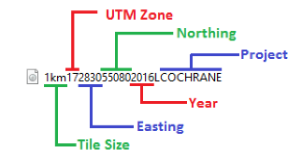
Figure 4: Tile names reflect tile size, UTM zone, easting, northing, year, and project
Since the release of the Ontario Web Image Services (OWIS) in the fall of 2022, the lidar DTM is also available through an image service which exposes the data for visualization and geoprocessing.
The service is best accessed through the ArcGIS REST API, either directly or by setting up an ArcGIS server connection using the REST endpoint URL, which can be found in the GeoHub record linked above. The service draws using the WGS84 Web Mercator projection.
For more information on what functionality is available and how to work with the service, please refer to the Ontario Web Image Services User Guide. If you have questions about how to use the service, email Geospatial Ontario (GEO) at geospatial@ontario.ca.

2.2 Use Restrictions
The Ontario Digital Terrain Model (Lidar-Derived) is Open Data. You are free to copy, modify, publish, translate, adapt, distribute or otherwise use the Information in any medium, mode or format for any lawful purpose. If you do any of the above, you must use the following attribution statement “Contains information licensed under the Open Government Licence – Ontario”. See Open Government Licence (https://www.ontario.ca/page/open-government-licence-ontario).

3. Links to Additional Information
Heidemann, H. K. 2014 “LIDAR base specification”. Ver. 1.3. February 2018 U.S. Geological Survey Techniques and Methods, book 11, chap. B4. https://pubs.er.usgs.gov/publication/tm11B4
Canada. Natural Resources Canada. 2025. “Spatial reference system updates”. https://natural-resources.canada.ca/science-data/science-research/geomatics/geodetic-reference-systems/spatial-reference-system-updates
Canada. Natural Resources Canada. 2025. “About the Canadian Spatial Reference System”. https://natural-resources.canada.ca/science-data/science-research/geomatics/geodetic-reference-systems/canadian-spatial-reference-system-csrs
Renslow, M. S. (ed.) 2012. “Manual of Airborne Topographic LIDAR”. American Society for Photogrammetry and Remote Sensing. ISBN 1-57083-097-5, ASPRS Stock # 4587
Whitebox Geospatial AT Project (https://www.whiteboxgeo.com)

4. References
Airborne Imaging 2018a. “Final Report for project: Cochrane LiDAR”. Report prepared for Ontario Ministry of Natural Resources and Forestry, Provincial Mapping Unit. https://www.publicdocs.mnr.gov.on.ca/mirb/Lidar%20-%20Cochrane%20-%20Additional%20Metadata.pdf
Airborne Imaging 2018b. “Final Report for project: Peterborough LiDAR”. Report prepared for Ontario Ministry of Natural Resources and Forestry, Provincial Mapping Unit. https://www.publicdocs.mnr.gov.on.ca/mirb/Lidar%20-%20Peterborough%20-%20Additional%20Metadata.pdf
Airborne Imaging 2019a. “Final Report for project: Lake Erie LiDAR”. Report prepared for Ontario Ministry of Natural Resources and Forestry, Provincial Mapping Unit. https://www.publicdocs.mnr.gov.on.ca/mirb/Lidar%20-%20Lake%20Erie%20-%20Additional%20Metadata.pdf
Airborne Imaging 2019b. “Final Survey Report: 15221 South Central Durham Lidar Survey for Central Lake Ontario Conservation Authority” https://www.publicdocs.mnr.gov.on.ca/mirb/Lidar%20-%20CLOCA%20-%20Additional%20Metadata.pdf
Airborne Imaging 2019c. “Final Report for project: St Lawrence Hazard Mapping LiDAR”. Report prepared for South Nation River Conservation Authority. https://www.publicdocs.mnr.gov.on.ca/mirb/Lidar%20-%20South%20Nation%20-%20Additional%20Metadata.pdf
Airborne Imaging 2022a. “Final Report for project: Lake Huron LiDAR” https://www.publicdocs.mnr.gov.on.ca/mirb/LakeHuron %20Lidar%20Final%20Report%20October%202022.pdf
Airborne Imaging 2022b. “Final Report for project: Lake Simcoe LiDAR” https://www.publicdocs.mnr.gov.on.ca/mirb/LakeSimcoe %20Lidar%20Final%20Report%20October%202022.pdf
Airborne Imaging 2024. “Final Report for project: Huron Georgian Bay LiDAR” https://www.publicdocs.mnr.gov.on.ca/mirb/Huron-GeorgianBay-Lidar-Report-Final-August-2024.docx
Airborne Imaging 2025a. “Final Report for project: Atikokan LiDAR” https://www.publicdocs.mnr.gov.on.ca/mirb/Lidar-Atikokan-Additional-Contractor-Metadata.docx
Airborne Imaging 2025b. “Final Report for project: Cataraqui LiDAR” https://www.publicdocs.mnr.gov.on.ca/mirb/Lidar-Cataraqui-Additional-Contractor-Metadata.docx
Airborne Imaging 2025c. “Final Report for project: Chapleau LiDAR” https://www.publicdocs.mnr.gov.on.ca/mirb/Lidar-Chapleau-Additional-Contractor-Metadata.docx
Airborne Imaging 2025d. “Final Report for project: Dryden/Ignace/Sioux Lookout LiDAR” https://www.publicdocs.mnr.gov.on.ca/mirb/Lidar-Dryden-Ignace-SiouxLookout-Additional-Contractor-Metadata.docx
Airborne Imaging 2025e. “Final Report for project: Kawartha Lakes LiDAR” https://www.publicdocs.mnr.gov.on.ca/mirb/Lidar-KawarthaLakes-Additional-Contractor-Metadata.docx
Airborne Imaging 2025f. “Final Report for project: Manitoulin LiDAR” https://www.publicdocs.mnr.gov.on.ca/mirb/Lidar-Manitoulin-Additional-Contractor-Metadata.docx
Airborne Imaging 2025g. “Final Report for project: Sault Ste Marie LiDAR” https://www.publicdocs.mnr.gov.on.ca/mirb/Lidar-SaultSteMarie-Additional-Contractor-Metadata.docx
Airborne Imaging 2025h. “Final Report for project: Sudbury LiDAR” https://www.publicdocs.mnr.gov.on.ca/mirb/Lidar-Sudbury-Additional-Contractor-Metadata.docx
Airborne Imaging 2025i. “Final Report for project: Thunder Bay LiDAR” https://www.publicdocs.mnr.gov.on.ca/mirb/Lidar-ThunderBay-Additional-Contractor-Metadata.docx
Airborne Imaging 2025j. “Final Report for project: Timmins LiDAR” https://www.publicdocs.mnr.gov.on.ca/mirb/Lidar-Timmins-Additional-Contractor-Metadata.docx
Airborne Imaging 2026a. “Final Report for project: Central East LiDAR” https://www.publicdocs.mnr.gov.on.ca/mirb/LidarDTM-CentralEast-Additional-Contractor-Metadata.docx
Airborne Imaging 2026b. “Final Report for project: Kenora LiDAR” https://www.publicdocs.mnr.gov.on.ca/mirb/Lidar-Kenora-Additional-Contractor-Metadata.docx
Airborne Imaging 2026c. “Final Report for project: Northeastern Ontario LiDAR” https://www.publicdocs.mnr.gov.on.ca/mirb/Lidar-NE-Ontario-Additional-Contractor-Metadata.docx
Airborne Imaging 2026d. “Final Report for project: Rainy River LiDAR” https://www.publicdocs.mnr.gov.on.ca/mirb/Lidar-RainyRiver-Additional-Contractor-Metadata.docx
Airborne Imaging 2026e. “Final Report for project: Upper Thames-Grand River” https://www.publicdocs.mnr.gov.on.ca/mirb/Lidar-UpperThames-GrandRiver-Additional-Contractor-Metadata.docx
Airborne Imaging 2026f. “Final Report for project: Parry Sound LiDAR” https://www.publicdocs.mnr.gov.on.ca/mirb/Lidar-ParrySound-Additional-Contractor-Metadata.docx
American Society for Photogrammetry & Remote Sensing. “LAS SPECIFICATION”. Version 1.4 – R13. 15 July 2013. http://www.asprs.org/wp-content/uploads/2010/12/LAS_1_4_r13.pdf
American Society for Photogrammetry and Remote Sensing. “Positional Accuracy Standards for Digital Geospatial Data”. Version 1.0. November 2014. http://www.asprs.org/wp-content/uploads/2015/01/ASPRS_Positional_Accuracy_Standards_Edition1_Version100_November2014.pdf
Ontario. Elevation Coordination and Consultation Committee. “Elevation Accuracy Guidelines.” Version 1.1. Peterborough: King’s Printer for Ontario. 17 December 2020. https://www.publicdocs.mnr.gov.on.ca/mirb/Elevation%20Accuracy%20Guidelines%20-%20User%20Guide.docx
Ontario. Elevation Coordination and Consultation Committee. “Ontario Specifications for Lidar Acquisition”. Version 1.2. Peterborough: King’s Printer for Ontario. 23 December 2020. https://www.publicdocs.mnr.gov.on.ca/mirb/OntarioSpecificationsForLidarAcquisition.docx

Appendix A: Getting Started – Display and use of DTM data

Opening and viewing the DTM
The DTM packages must be unzipped and will produce a folder corresponding to the name of the package, which contains the raster files (Figure 5).
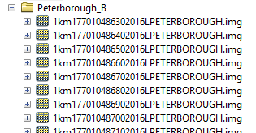
Figure 5: Unzipped DTM package contents
The DTM tiles can be used for viewing or analysis using any one of the many GIS software packages capable of using IMG or TIFF raster files. The DTM represents a continuous surface of cells containing elevation (z) values in metres (Figure 6).
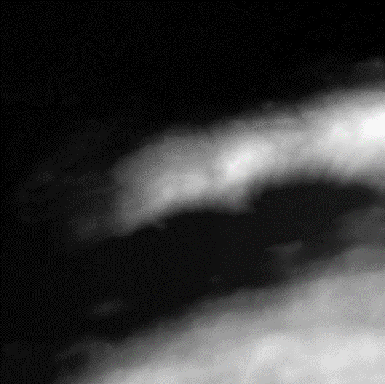
Figure 6: Raw DTM tile
DTM tiles can be used as-is for topographic elevation analysis, but for visualization it is better to derive and display the DTM using a hillshade or a colour-shaded relief function. A hillshade is a grayscale image that represents a DEM in three-dimensional appearance as the human eye would interpret it with the sun set at a specified direction (azimuth) and altitude. A colour-shaded relief expands on this by adding color gradient based on cell z-values. Figure 7 depicts examples of a hillshade (left) with properties applied such that it is illuminated from 210° (Southwest), and a colour-shaded relief illuminated from 315° (Northwest).
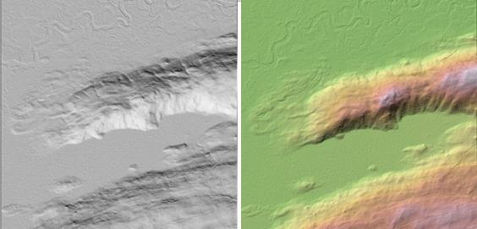
Figure 7: DTM tile displayed as a hillshade and colour-shaded relief

Creation of contour lines from DTM
Contour lines are lines connecting points of equal elevation. Traditionally used to display elevation changes on topographic maps, contour lines are of little value today for automated analysis purposes but can be an effective method to convey three-dimensional information on two-dimensional cartographic products for visual interpretation. Contour lines can be generated directly from a DTM and smoothed or otherwise modified to meet user needs using processes available in many GIS software packages (Figure 8).
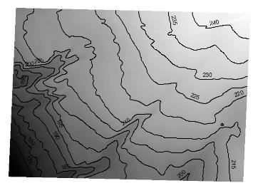
Figure 8: Smoothed contour lines generated from a DTM tile at 5-m interval

Assembly, viewing and analysis of multiple DTM tiles: new dataset vs virtual
As with many other imagery and raster products delivered through GEO, the DTM product is provided in 1-km² non-overlapping tiles and grouped into packages. There are several advantages to this method of storage and distribution including maintenance of Metadata, storage considerations and the flexibility to allow clients to request the data they need for their study area, without requiring custom data extracts to client supplied boundaries.
If your study area covers multiple DTM tiles, these individual tiles can be viewed simultaneously, but for the purposes of analysis, or simply for faster and less complicated viewing, it is usually better to put all tiles in your study area together as one. This can be done in several different ways.
The traditional method is to assemble or merge all the individual tiles into a new raster covering your entire study area. This method can allow for faster display and may be necessary for some analysis operations but has the disadvantage that a separate new dataset must be produced which has implications for storage space. Being a new dataset, the naming and metadata of the individual tile structure used as a source will be lost as well.
Raster data takes up a great deal of storage space, so it is often a preferred approach to make use of a virtual representation of multiple tiles as one entity. These methods can include raster mosaic datasets, and virtual raster catalogs. Most of these methods have the advantage that the original files, metadata, folder structure and locations are preserved and the data for contributing tiles or groups of tiles can even be stored in separate different locations as storage space requirements dictate.
The exact methods and options available will depend on the software being used, and the requirements of the analysis. Please consult the documentation of the GIS software you are using for specific details about the options available to you.

Appendix B: Common DTM Analysis Functions
The DTM raster can be used as an input for a variety of surface geometry analysis functions such as calculations of slope, aspect, and curvature. The actual algorithms used for any of these calculations may vary depending on the software used to perform the calculation.

Slope
Slope is a calculation based on difference between the rise and the run along a specified path. The output value assigned to a cell is usually based on the maximum difference in elevation values compared to adjacent cells and is commonly expressed in degrees or percent. See the left side of Figure 9 for an example.

Aspect
Aspect is a calculation that applies a numeric value to a cell based upon the bearing that the slope of the cell is facing, in degrees. These values can be further categorized into compass directions of North, South, Southeast, etc. For instance, in Figure 9 (right), the aspect of the landscape is predominately facing to the South and Southwest.
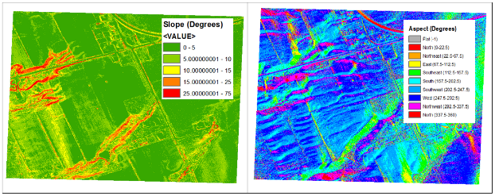
Figure 9: Examples of Slope and Aspect

Curvature
Curvature is a calculation based upon the shape of the surfaces which is calculated for each cell based compared to neighbouring cells. Positive curvature values indicate a convex surface, while negative values indicate a concave surface. It is also possible to extract the profile curvature of the slope, or the plan (horizontal) curvature values.

Appendix C: Important Considerations and Product Limitations

Removal of vegetations and structures
As per the product specifications, non-ground features such as vegetation and structures are not represented in the DTM. Figure 10 illustrates the removal of a highway overpass, trees, and buildings clearly visible in an aerial photo of the same location.
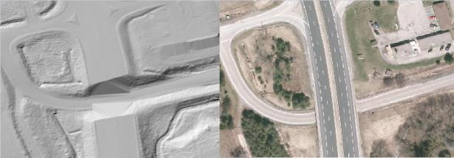
Figure 10: Example of trees, buildings and a bridge being excluded from the DTM.
Greater Toronto Area (GTA) Orthophotography Project 2013 Source: Data provided by Ontario Ministry of Natural Resource and Forestry © Copyright: 2013 First Base Solutions Inc. All Rights Reserved.

It should be noted that although returns classified as being derived from non-ground features were excluded when calculating the DTM, the resulting voids between ground returns can occasionally produce flattened areas in the output DTM due to interpolation. For example, elevation values may be interpolated across the voids where tall bridges or overpasses with particularly short spans have been removed. As seen in the example shown in Figure 11, this has caused the false appearance of a partial bridge deck in the DTM.
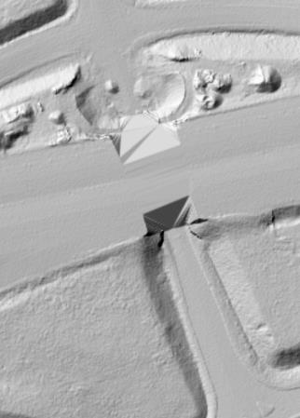
Figure 11: DTM elevation values that have been interpolated across a void

Bare-ground flattening in areas of vegetations and/or steep terrain
In rare instances, in areas of steep and heavily vegetated terrain, the DTM may display coarse flattening where vegetation is present and was removed to produce the bare-ground DTM. Examples may be visible along shoreline bluffs and slopes where conifer vegetation is present (Figure 12).
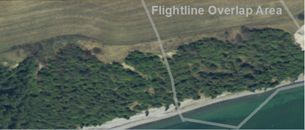
Figure 12: Aerial photograph of shoreline with treed slope.

Digital Raster Acquisition Project Eastern Ontario (2014). Source: Data provided by Ontario Ministry of Natural Resources and Forestry. © Copyright: King’s Printer of Ontario All Rights Reserved.
This effect is a result of fewer laser pulses penetrating the dense vegetation in these areas. The aspect and angle of the steep slope in relation to the aircraft flight pattern may also be a contributing factor that limits penetration of the laser to ground in certain areas. As can be observed in Figure 13, locations further from the centre of the flight lines can sometimes reveal more of these effects than areas closer to nadir or locations that benefit from an increased density of returns due to overlaps in the flight lines. Such areas are considered low confidence areas where lidar penetration to the bare-earth surface is substandard but either expected or accepted based on the conditions of the collection area.

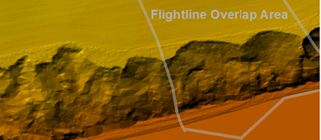
Figure 13: Coarse interpolation effects in DTM on vegetated slope near overlap

Flattening of water
Following the USGS LIDAR Base Specification, inland ponds and lakes with 8,000 m² (2 acres) surface area and rivers with a nominal width greater than 30-m at the time of collection are flattened to improve the application of the DTM for cartographic purposes. As such, the DTM should not be used as-is for hydrological analysis or applications. Figures 14 and 15 depict the differences between flattened and non flattened water bodies in the DTM compared with aerial photographs of the same location.
Note that the LEAP DTM has not been hydro-flattened.
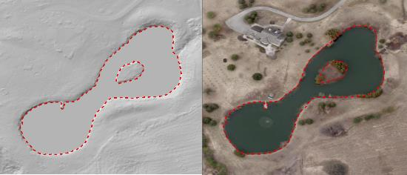
Figure 14: Views of a flattened pond with breaklines indicated as dotted red lines.
Greater Toronto Area (GTA) Orthophotography Project 2013 Source: Data provided by Ontario Ministry of Natural Resource and Forestry © Copyright: 2013 First Base Solutions Inc. All Rights Reserved.

A pure lidar DEM has no breaklines to constrain the water surface and results in triangulation artifacts, or “tinning” across water surfaces because water surfaces provide fewer lidar returns. In a hydro-flattened DEM, water bodies are considered to have a single elevation that is estimated from adjacent terrain, as a result, triangulation artifacts across water surfaces can be removed.
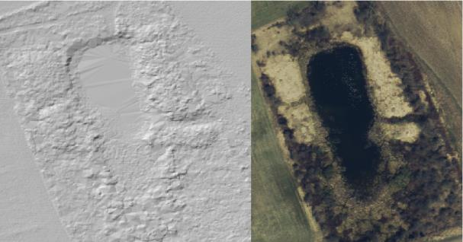
Figure 15: Pond that has not been flattened.
Digital Raster Acquisition Project Eastern Ontario (2014). Source: Data provided by Ontario Ministry of Natural Resources and Forestry. © Copyright: King’s Printer of Ontario All Rights Reserved.
The elevation of the water surface is estimated from adjacent terrain and is not representative of any measured water surface elevation and should not be used for hydrologic or hydraulic modeling. Hydrologic DEMs (i.e., hydro-enforced and hydro-conditioned DEMs) are like hydro-flattened DEMs but have additional surface modifications and treatments to allow continuous surface water flow. The breaklines used to create the DTM were digitized based on an interpretation of the water body boundaries at a scale of 1:250 and 1:1000 using the intensity returns from the lidar point cloud. Comparisons with other data sources and scales or data collected at different dates may result in different interpretations of shoreline locations. An example of this can be observed at Bowmanville Creek near Port Darlington, as illustrated in figures 16 through 18.
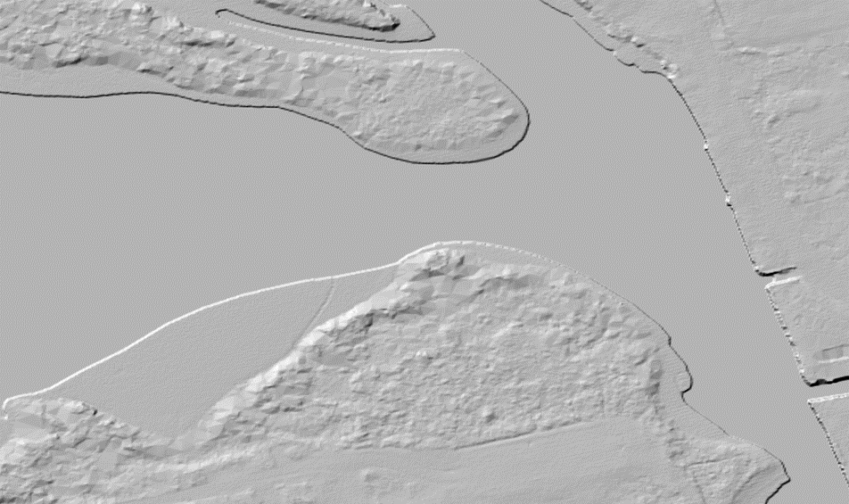
Figure 16: Shaded relief view of flattened water surface as represented in DTM
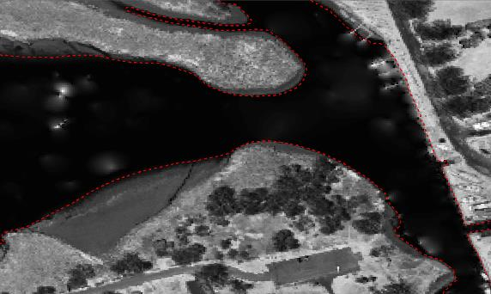
Figure 17: Digitized breaklines on source lidar derived intensity image, Fall 2016
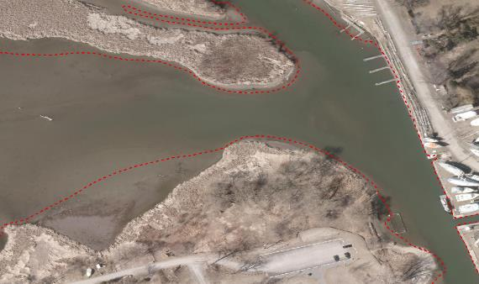
Figure 18: Digitized breaklines contrasted with aerial photograph from Spring, 2013.
Greater Toronto Area (GTA) Orthophotography Project 2013 Source: Data provided by Ontario Ministry of Natural Resource and Forestry © Copyright: 2013 First Base Solutions Inc. All Rights Reserved.

Scan line artefacts
In some parts of the DTM a ripple effect has been observed that corresponds with the swath overlap, spacing and angle of the scan lines from the lidar point cloud and has been introduced as a result of the DTM interpolation process. As seen in Figure 19, the effect can be noticeable in hillshade views of some areas depending on the parameters used, however the elevation differences in samples that have been examined in cross-section have been quite marginal (Figure 20).
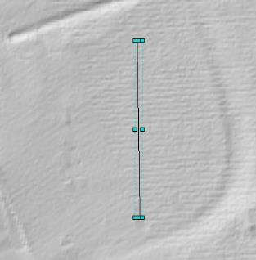
Figure 19: Scan line artefacts with profile location and profile elevation values
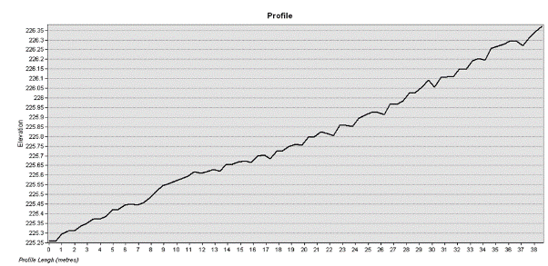
Figure 20: Chart of elevation values along the profile
If this artefact poses an issue for user applications, some workarounds may include:
- Display of DTM hillshade with different illumination parameters.
- Resampling or aggregating the DTM to a coarser resolution.
- Ensuring derivative products are mapped to appropriate scales/ resolutions to minimize the effect.
- Creation of a custom DTM from the point cloud using different resolution or interpolation method settings.

Tile boundaries extend beyond the collection area boundary
Tile cells outside of the project extent area are recorded with a value of No Data however some raw point cloud data was collected that extends a short distance beyond the project boundary (Figure 21). If analysis is required in these boundary areas skilled users may consider deriving a DTM using the raw lidar point cloud data after editing and classification is performed.
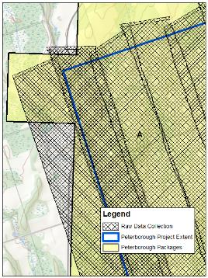
Figure 21: Detail comparing raw data collection, project, and package extents

Version 2324.1

This project is funded in part by the Government of Canada through the Flood Hazard Identification and Mapping Program. 
Accuracy classes as described in the Ontario Specifications for Lidar Acquisition

