User Guide
for
Ontario Raw Point Cloud (Imagery-Derived)
Land Information Ontario Dataset
  - Provincial Mapping
  - Mapping and Information Resources Branch
  - Corporate Management and Information Division
  - Ministry of Natural Resources and Forestry
2023-10-30

Disclaimer
This technical documentation has been prepared by His Majesty the King in right of Ontario as represented by the Ministry of Natural Resources and Forestry (the “Ministry”). No warranties or representations, express or implied, statutory or otherwise shall apply or are being made by the Ministry with respect to the documentation, its accuracy or its completeness. In no event will the Ministry be liable or responsible for any lost profits, loss of revenue or earnings, claims by third parties or for any economic, indirect, special, incidental, consequential or exemplary damage resulting from any errors, inaccuracies or omissions in this documentation; and in no event will the Ministry’s liability for any such errors, inaccuracies or omissions on any particular claim, proceeding or action, exceed the actual consideration paid by the claimant involved to the Ministry for the materials to which this instructional documentation relates. Save and except for the liability expressly provided for above, the Ministry shall have no obligation, duty or liability whatsoever in contract, tort or otherwise, including any liability or negligence. The limitations, exclusions and disclaimers expressed above shall apply irrespective of the nature of any cause of action, demand or action, including but not limited to breach of contract, negligence, strict liability, tort or any other legal theory, and shall survive any fundamental breach or breaches.
Cette publication spécialisée n’est disponible qu’en anglais.

Additional Information
This document does not comply with all the applicable guidelines for accessible digital documents. For an alternative format please email Provincial Mapping at pmu@ontario.ca.
For more information about this document, please contact Provincial Mapping at pmu@ontario.ca.

Document History
Date | Description
2019-09-26 | First release
2020-03-04 | Updated hyperlinks
2021-11-05 | Updated guidance for working with LAZ files
2022-02-09 | Release of SWOOP 2020 point cloud
2022-04-14 | Release of SCOOP 2018 and DRAPE 2019 point clouds
2022-12-19 | Release of COOP 2021 point cloud
2023-10-30 | Release of NWOOP 2022 point cloud

Executive Summary

Key Words
Provincial Mapping, Elevation, Vector, Mass Points, Point Cloud, Softcopy Photogrammetry, COOP, Central Ontario Orthophotography Project, South Central Ontario Orthophotography Project, SCOOP, Digital Raster Acquisition Project Eastern Ontario, DRAPE, Southwestern Ontario Orthophotography Project, SWOOP, Northwestern Ontario Orthophotography Project, NWOOP.

Abstract
This user guide is intended to go beyond metadata and give data users a sense of the purpose for which the data was collected, the technical processes, software, and applicable standards involved, suggested applications for the data (and general approaches to how to use it), and other details that will help data users. As such, this user guide details the acquisition specifications for the Ontario Raw Point Cloud (Imagery-Derived) Land Information Ontario (LIO) dataset and how it relates to the overall imagery project dataset.
Note: The Ontario Raw Point Cloud (Imagery-Derived) is not Lidar data, but rather based on pixel autocorrelation using aerial photography. See Appendix C for more information about the differences between this product and lidar data.
The Ontario Raw Point Cloud (Imagery-Derived) is a product that is a generalized representation of both surface and ground features. The product was generated by an imagery contractor for ortho-rectifying the photography acquired for the Land Information Ontario (LIO) Imagery Program.

Table of Contents
Disclaimer 2
Additional Information 2
Document History 3
Executive Summary 4
Key Words 4
Abstract 4
Table of Contents 5
List of Figures 7
List of Tables 8
List of Acronyms 9
List of Definitions 10
Mass Points 10
Digital Elevation Model (DEM) 10
Digital Terrain Model (DTM) 10
Digital Surface Model (DSM) 11
1. Product Description 12
1.1 Acquisition Details 12
1.2 Raw Point Cloud Product 14
1.3 Geographic Extent 15
1.4 Reference System 17
1.4.1 Horizontal Reference System 17
1.4.2 Vertical Reference System 17
2. Product Details 18
2.1 Data Delivery Format 18
2.1.1 Data Format 18
2.2 Use Restrictions 19
Appendix A: Display and use of Raw Point Cloud Data 20
Opening and viewing the Raw Point Cloud 20
Appendix B: Raw Point Cloud Derivative Products 23
Classified Point Cloud 23
Digital Elevation Model 23
Digital Surface Model 24
Appendix C: Important Considerations and Product Limitations 26
This data is Not a Lidar Point Cloud 26
Effects of vegetation on point cloud profiles and derivative products 28
Appendix D: Detailed Vendor-Supplied Processing Information 30
Process Output Workflow 31

List of Figures
Figure 1: Perspective view of the SCOOP 2013 raw point cloud displayed by RGB 14
Figure 2: Extents of the LIO Imagery Acquisition Program acquisition projects from 2010 to 2015 with raw point cloud data 15
Figure 3: Extents of the 2018-2022 acquisition project with raw point cloud data 16
Figure 4: Decompressing LAZ files with LASzip. 20
Figure 5: Creating LAS dataset using ArcToolbox 21
Figure 6: Viewing LAS dataset in ArcMap 21
Figure 7: Display of classified points in 3D and Profile View 22
Figure 8: Sample of the DEM hillshade derived from the Classified Point Cloud in the COOP 2016 project area 23
Figure 9: Sample DSM hillshade generated from the Classified Point Cloud in the COOP 2016 project area 24
Figure 10: Lidar is an active sensor that sends narrow light beams between foliage and can record multiple returns. 27
Figure 11: Pixel correlated data from aerial photography contains single returns based on reflected sunlight 27
Figure 12: Profiles of Peterborough Classified Point Cloud (Lidar-Derived) (middle) compared with SCOOP 2013 Classified Point Cloud (Imagery-Derive) (bottom) along the same 10 x 200m transect. 28
Figure 13: Profiles of Cochrane Classified Point Cloud (Lidar-Derived) (middle) compared with COOP 2016 Classified Point Cloud (bottom) along the same 10 x 200m transect. 29
Figure 14: COOP 2016 DEM development process 32
Figure 15: Ground classified point cloud posts after filtering vegetation surface features 32
Figure 16: Resulting Triangular Irregular Network (TIN) produced from ground posts 33
Figure 17: DEM hillshade interpolated from TIN aligned to point cloud ground posts 33

List of Tables
Table 1: Acquisition details for the LIO Imagery Acquisition Program projects 13
Table 2: UTM Zone for each imagery project area 17
Table 3: Vertical datums by projects 17
Table 4: Ontario Raw Point Cloud (Imagery-Derived) Size, Tiles and Format 18

List of Acronyms
ADS: Airborne Digital Sensor
CGVD: Canadian Geodetic Vertical Datum
COOP: Central Ontario Orthophotography Project
DEM: Digital Elevation Model
DRAPE: Digital Raster Acquisition Project Eastern Ontario
DSM: Digital Surface Model
DTM: Digital Terrain Model
GIS: Geographic Information Systems
GPS: Global Positioning System
GSD: Ground Sampling Distance
IMU: Inertial Measuring Unit
LAS: Laser File Exchange Format
LIO: Land Information Ontario
NAD: North American Datum
MNRF: Ontario Ministry of Natural Resources and Forestry
NWOOP: Northwestern Ontario Orthophotography Project
PMU: Provincial Mapping Unit
RGB: Red Green Blue
SCOOP: South Central Ontario Orthophotography Project
SGM: Semi-Global Matching
SWOOP: Southwestern Ontario Orthophotography Project
TIFF: Tagged Image File Format
TIN: Triangular Irregular Networks
UTM: Universal Transverse Mercator

List of Definitions

Mass Points
Mass points are irregularly spaced points, each with x/y location coordinates and z-values, typically (but not always) used to form a TIN. When generated manually, mass points are ideally chosen to depict the most significant variations in the slope or aspect of TIN triangles. However, for the Ontario Raw Point Cloud (Imagery-Derived) the mass point spacing and patterns depend on the GSD (ground sampling distance) of the photography that was used as the data source for generating the mass points.

Digital Elevation Model (DEM)
A generic term for digital topographic and/or bathymetric data that is comprised of x/y coordinates and z-values to represent an elevation surface.
The terms ‘DTM’ and ‘DSM’ should be used over the term ‘DEM’ to more specifically reference ‘bare-earth’ or ‘surface elevation’ model products when possible.
The term “DEM” is to be used as a broader term when referencing a generic elevation data product. The Provincial DEM is an example of a generic elevation product, given that it has been constructed using a combination of both ‘DTM’ and ‘DSM’ elevation datasets to achieve Provincial coverage.

Digital Terrain Model (DTM)
The bare earth surface (lowest surface) represents the surface of the "bare-earth" terrain, after removal of vegetation and constructed features.
Photogrammetry has traditionally generated DTMs when elevations are generated by manual compilation techniques. Unless specified to the contrary, the bare-earth surface includes the top surface of water bodies, rather than the submerged surface of underwater terrain.
Like a DSM, a DTM can be structured either as a vector dataset (comprised of mass points and optionally 3D break lines) to model bare-earth elevations or a raster dataset that is interpolated from the vector elevation data to model bare-earth terrain elevations.
Using modern elevation point cloud classification algorithms and file formats, such as LAS, a DTM can represent a mass point dataset that has been classified for ‘bare-earth’ terrain elevations.

Digital Surface Model (DSM)
A DSM is the highest reflective surface of ground features captured by the sensor. The DSM may include treetops, rooftops, and tops of towers, telephone poles, and other natural or constructed features; or it may include the ground surface if there is no vegetative ground cover. Photogrammetry can provide this type of surface, yet characteristics such as accuracy and degree of detail (ability to resolve desired surface features) may vary significantly across technologies and even within the same technology. With photogrammetry the reflective surface may include any artifact present when the sensor mapped the area, including passing cars and trucks and similar features not normally considered to be part of a digital terrain model
Like a DTM, a DSM can be structured either as a vector dataset (comprised of mass points and optionally 3D break lines) to model surface elevations or a raster dataset that is interpolated from the vector elevation data to model surface elevations.
Using modern elevation point cloud classification algorithms and file formats, such as LAS, a DSM can represent a mass point dataset that has been classified for ‘surface’ elevation features.

1. Product Description

1.1 Acquisition Details
The Ontario Raw Point Cloud (Imagery-Derived) is sourced from data acquired through the LIO Imagery Program. For details on the acquisitions of the LIO Imagery Program see the Imagery User Guide (https://www.publicdocs.mnr.gov.on.ca/mirb/ Ontario_Imagery_User_Guide.docx). The products generated from the LIO imagery program include stereo imagery and 1-km by 1-km orthophotography tiles in both GeoTIFF and JPEG2000 formats with red, green, blue, and near-infrared bands.

Table 1: Acquisition details for the LIO Imagery Acquisition Program projects
Project Area | Acquisition Period | Project Area (sq. km) | Camera System | Flight Altitude Above Mean Terrain (AMT) | Additional Notes
SWOOP 2010 | Mar 18 to Apr 23, 2010 | 7,696 | Vexcel UltraCam X or Xp | 2,459 m | The point cloud was only generated for a portion of SWOOP2010. These stats apply to that area.
SCOOP 2013 | Apr 26 to May 7, 2013 | 35,762 | Leica ADS 80 | 1,920 m | 40 funding partners were involved in SCOOP
DRAPE 2014 | Apr 28 to Jun 7, 2014 | 37,290 | Leica ADS 100 | 2,377 m | 60 funding partners were involved in DRAPE
SWOOP / Algonquin 2015 | Apr 12 to May 23, 2015 | 49,167 | Leica ADS 100 | 2,506 to 2,535 m | 40 funding partners were involved in SWOOP
SCOOP 2018 | Mar 22 to May 23, 2018 and May 6 to 27, 2019 | 38,920 | Vexcel UltraCam X or UltraCamEagle
DRAPE 2019 | Apr 25, 2019 to May 22, 2020 | 36,103 | Vexcel UltraCam X or UltraCamEagle |  | 42 funding partners were involved in DRAPE 2019
SWOOP 2020 | Mar 7 to Jun 20, 2020 | 44,828 | Vexcel UCX and UCX Prime |  | 67 funding partners were involved in SWOOP 2020
COOP 2021 | Apr 2 to Jun 1, 2021 | 49,540 | Vexcel UltraCam X or UltraCam Eagle
NWOOP 2022 | May 15 to Nov 2, 2022 | 40,675 | Vexcel UCX-SX or UC-E

1.2 Raw Point Cloud Product
The Ontario Raw Point Cloud (Imagery-Derived) is not Lidar data, but rather based on pixel autocorrelation using aerial photography. See Appendix C for more information about the differences between this product and lidar data.
The point clouds were produced from the stereo imagery through a Semi-Global Matching (SGM) process by the imagery contractor and are being distributed as delivered, except in the case of SWOOP 2010 which was produced by MNRF staff. Refer to Appendix D for more information on the contractor’s data production process. No classification has been applied to the point cloud, so all points are in Class 0: Never Classified. The points are encoded with colour (RGB) values from the source photography (Figure 1). The point cloud is structured in overlapping tiles since they were created from the overlapping strips of stereo photography.
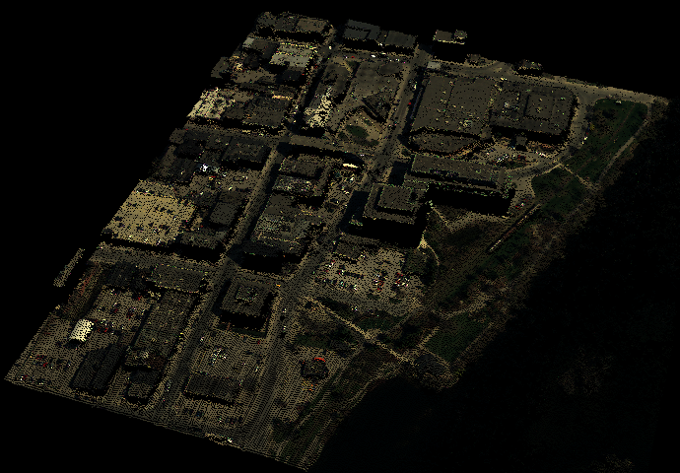
Figure 1: Perspective view of the SCOOP 2013 raw point cloud displayed by RGB

1.3 Geographic Extent
The Land Information Ontario Acquisition Program provides high-resolution leaf-off imagery on a five-year cycle for southern Ontario and parts of the near north. Raw, unclassified point cloud data was delivered by the imagery contractor. In addition, point cloud data was generated for portions of the SWOOP 2010 project by MNRF staff. See Figure 2 and 3 for extents of imagery projects.
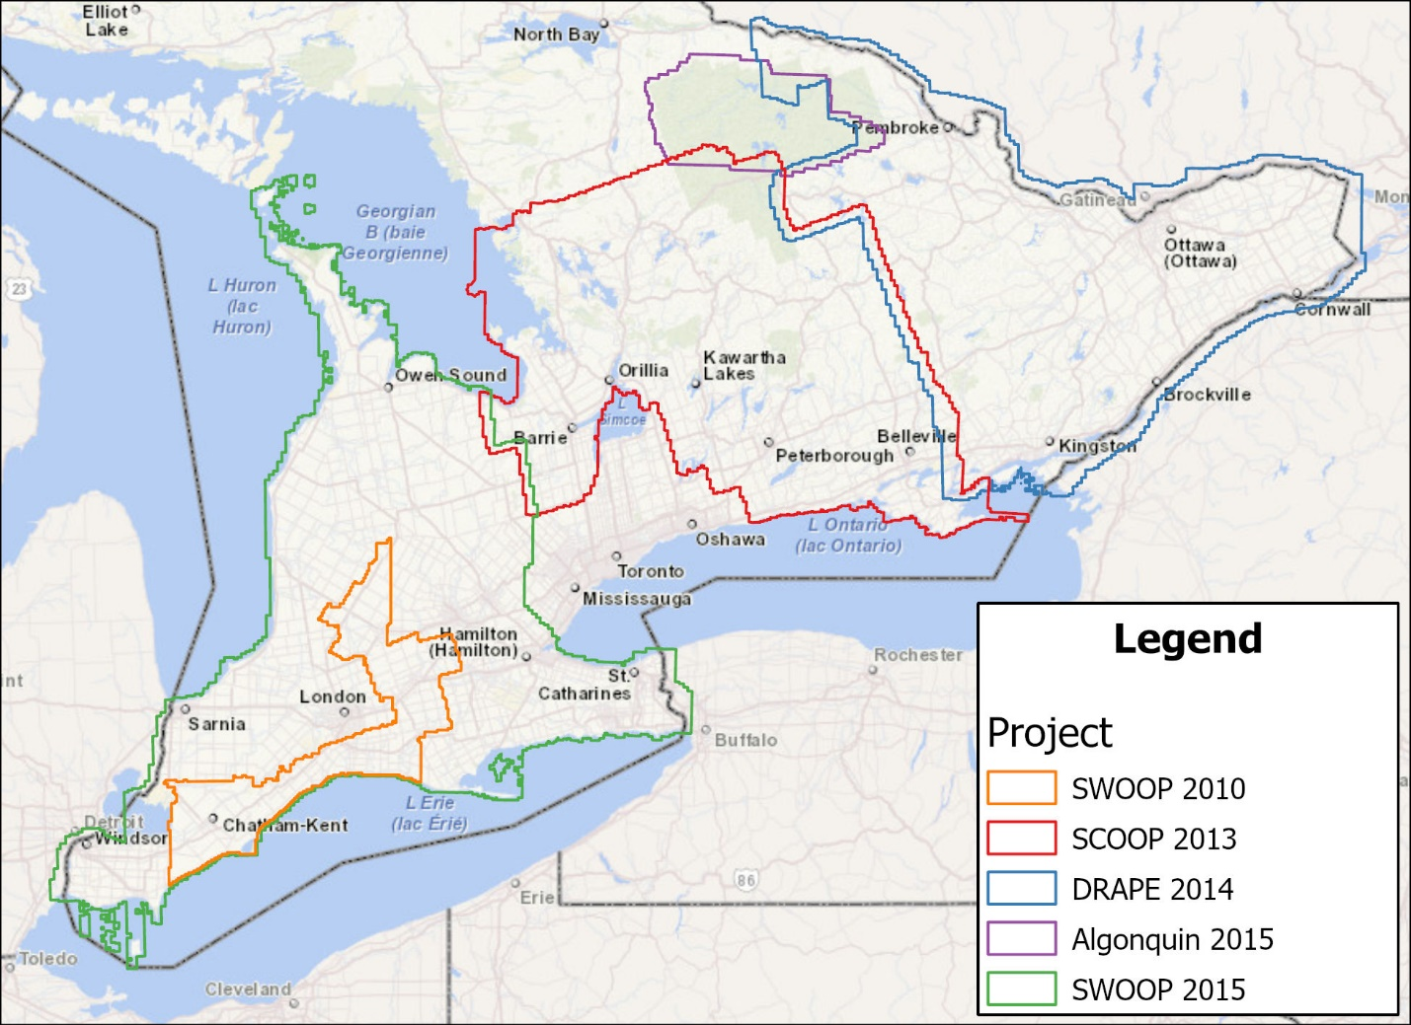
Figure 2: Extents of the LIO Imagery Acquisition Program acquisition projects from 2010 to 2015 with raw point cloud data
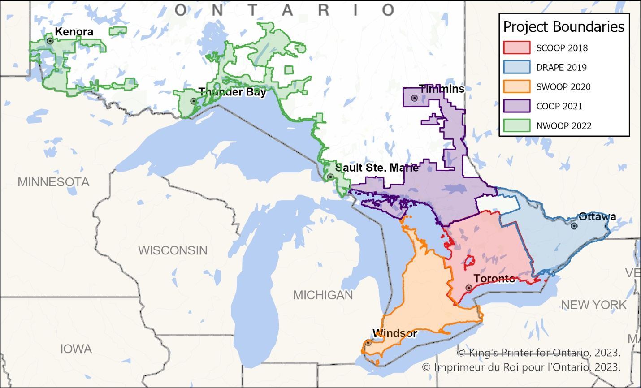
Figure 3: Extents of the 2018-2022 acquisition project with raw point cloud data

1.4 Reference System

1.4.1 Horizontal Reference System
The horizontal coordinate system of the Ontario Raw Point Cloud (Imagery-Derived) is Universal Transverse Mercator (UTM) with zone varying by project area (Table 2). The horizontal datum is the North American Datum of 1983 Canadian Spatial Reference System (https://natural-resources.canada.ca/maps-tools-and-publications/geodetic-reference-systems/canadian-spatial-reference-system-csrs/9052).
The horizontal unit of measure (coordinate system axis units) is metres (m).
Table 2: UTM Zone for each imagery project area
Project Area | UTM Zone
SCOOP 2013/2018 | 17 & 18
DRAPE 2014/2019 | 18
Algonquin 2015 | 17
SWOOP 2010/2015/2020 | 17
COOP 2021 | 17
NWOOP 2022 | 15 & 16

1.4.2 Vertical Reference System
The vertical coordinate system of the Ontario Raw Point Cloud (Imagery-Derived) varies by acquisition project (Table 3). For more information on Canadian vertical datums see the Height Reference System Modernization of Natural Resources Canada (https://natural-resources.canada.ca/maps-tools-and-publications/geodetic-reference-systems/height-reference-system-modernization/9054#_Canadian_Geodetic_Vertical_1).
Table 3: Vertical datums by projects
Project Areas | Vertical Datum
SCOOP 2013, DRAPE 2014, Algonquin 2015, SWOOP 2015 | CGVD28
SCOOP 2018, DRAPE 2019, SWOOP 2020, COOP 2021, NWOOP 2022 | CGVD2013

2. Product Details

2.1 Data Delivery Format
Ontario Raw Point Cloud (Imagery-Derived) is 8.68 Terabytes total in size. Due to the size of the data and technical constraints for publishing datasets of this size online the classified point cloud dataset is currently only available by request. If you are interested in obtaining data, see LIO Support - Large Data Ordering Instructions (https://www.publicdocs.mnr.gov.on.ca/mirb/LIO-LargeData-OrderingInstructions.docx). Data can be requested by project area or a selection of tiles. Project extents can be viewed through the map in the metadata record (https://geohub.lio.gov.on.ca/datasets/08f1a39395e04803ace0225c 1fc196a0). The metadata record contains a link to a shapefile index of tiles. For large data orders you will need to provide a hard drive for the data transfer.
Table 4: Ontario Raw Point Cloud (Imagery-Derived) Size, Tiles and Format
Project Area | Compressed Size (GB) | Number of Tiles | File Format
SWOOP 2010 | 522 | 13,221 | LAS
SCOOP 2013 | 1,520 | 13,823 | LAZ
DRAPE 2014 | 2,000 | 12,686 | LAZ
Algonquin 2015 | 269 | 2,467 | LAZ
SWOOP 2015 | 2,460 | 19,493 | LAZ
SCOOP 2018 | 409 | 43,293 | LAZ
DRAPE 2019 | 327 | 36,103 | LAZ
SWOOP 2020 | 329 | 43,875 | LAZ
COOP 2021 | 451 | 49,059 | LAZ
NWOOP 2022 | 389 | 40,627 | LAZ

2.1.1 Data Format
The Ontario Raw Point Cloud (Imagery-Derived) comes in LAZ format, which is a lossless compressed format of LAS, a file format for the interchange of 3-dimensional point cloud data. For more information on working with data in LAZ format see Appendix A.

2.2 Use Restrictions
The Ontario Raw Point Cloud (Imagery-Derived) is considered Open Data. You are free to copy, modify, publish, translate, adapt, distribute or otherwise use the Information in any medium, mode or format for any lawful purpose. If you do any of the above you must use the following attribution statement “Contains information licensed under the Open Government Licence – Ontario.” See Open Government Licence (https://www.ontario.ca/page/open-government-licence-ontario).

Appendix A: Display and use of Raw Point Cloud Data

Opening and viewing the Raw Point Cloud
LAZ is a format for compression of LAS files. There are various tools available that can read from the LAZ format. To make any changes to the file, such as reclassifying points, the data must be extracted from LAZ to LAS format. This can be done using the LASzip tool (https://downloads.rapidlasso.de/laszip.exe).
The following describes a sample method to extract and display the .LAZ files using LASzip and ArcGIS:
- Run laszip.exe by double-clicking the file.
- Select the location of the LAZ files and decompress to LAS format (Figure 4). The resulting LAS files will be saved in the same folder as the source LAZ files. Note: LASzip will not notify you when it is finished. It is best to count the number of files to know when it is done. Note that when run on single tiles LASzip is extremely fast.
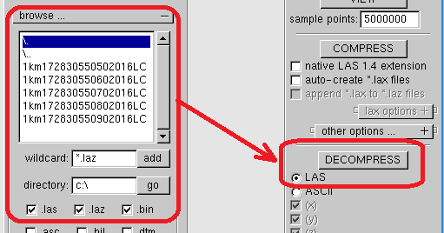
Figure 4: Decompressing LAZ files with LASzip.
- Use the Create LAS Dataset tool from ArcToolbox (Figure 5). A LAS dataset does not hold the LAS data but rather is a format that allows you to reference the LAS files. Note: the output coordinate system will duplicate that of the first tile processed. This is important to note if you are working with data from more than one project or a project containing multiple UTM Zones (SCOOP).
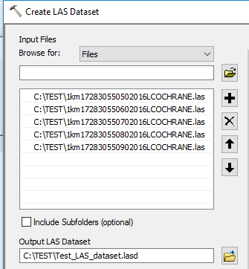
Figure 5: Creating LAS dataset using ArcToolbox
- Open the LAS Dataset in ArcMap and zoom to a tile outline for viewing (Figure 6).
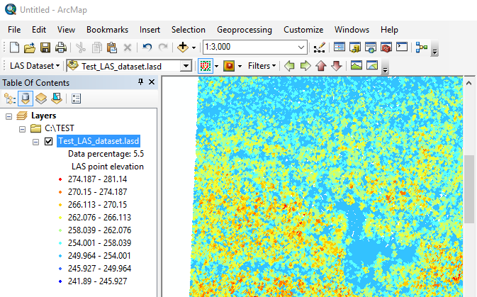
Figure 6: Viewing LAS dataset in ArcMap
- Portions of the LAS dataset may be selected for display in 3D or in Profile View using the LAS Dataset Toolbar (Figure 7).
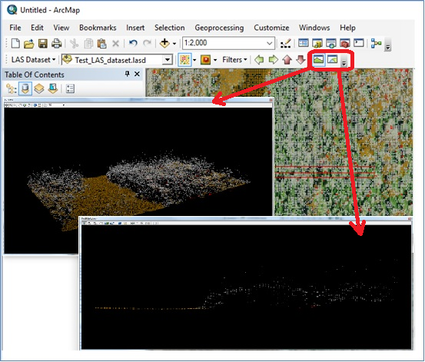
Figure 7: Display of classified points in 3D and Profile View

Appendix B: Raw Point Cloud Derivative Products

Classified Point Cloud
MNRF staff resampled the raw point cloud to a 50-cm point spacing and applied a ground classification for SCOOP 2013, DRAPE 2014 and SWOOP 2015 and portions of the SWOOP 2010 project to produce the Ontario Classified Point Cloud (Imagery-Derived) (https://geohub.lio.gov.on.ca/datasets/febf17330adb4100a22738e1684b5feb).

Digital Elevation Model
MNRF staff created a DEM for the SCOOP 2013, DRAPE 2014 and SWOOP 2015 project areas. The contractor provided a Digital Elevation Model (DEM) based on the COOP 2016 and NWOOP 2017 project areas. The DEMs were created by excluding points not classified as Ground (Figure 8). For more information about this product please see the associated metadata record. (https://geohub.lio.gov.on.ca/datasets/1ce266ee55c44ffca2d457bc5db13b92).
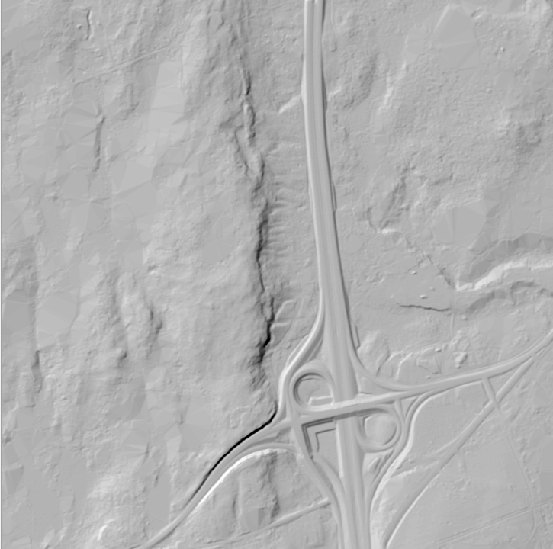
Figure 8: Sample of the DEM hillshade derived from the Classified Point Cloud in the COOP 2016 project area

Digital Surface Model
MNRF staff created a Digital Surface Model (DSM) from the point cloud for each acquisition project. For more information about this product see the associated metadata record (https://geohub.lio.gov.on.ca/datasets/02e8 49bac00943d6a69c1488b9edb185). A DSM is based on the highest reflective surface of features captured by the sensor. The DSM may include treetops, rooftops, tops of towers, telephone poles, and other natural or artificial features; or it may include the ground surface if there is no vegetative ground cover. The reflective surface may include any artifact present when the sensor mapped the area, including passing cars and trucks or similar features not normally considered to be part of a digital terrain model. Figure 9 provides an example of a DSM hillshade generated from the COOP 2016 Classified Point Cloud and shows the surface of tree canopy and structures not visible in the DEM.
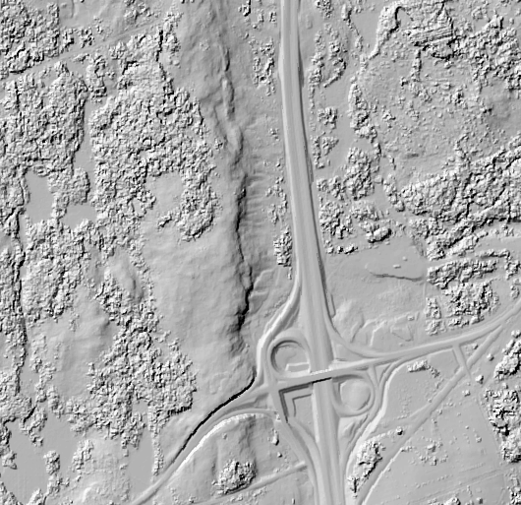
Figure 9: Sample DSM hillshade generated from the Classified Point Cloud in the COOP 2016 project area
A DSM can be structured either as a vector dataset (comprised of mass points and optionally 3D breaklines) to model surface elevations or a raster dataset that is interpolated from the vector elevation data to model surface elevations. Using modern elevation point cloud classification algorithms and file formats, such as LAS, a DSM can represent a mass point dataset that has been classified for ‘surface’ elevation features.
Note: Given the point spacing and the fact that the LIO imagery program photography was collected in leaf-off conditions, DSMs produced with this data may not fully represent the density and height of deciduous forest or sparse vegetation. This should be kept in mind if one wishes to produce canopy height models or viewsheds based on this data.

Appendix C: Important Considerations and Product Limitations

This data is Not a Lidar Point Cloud
The LAS point cloud is a data format that is often associated with lidar data. It is important to understand that the Ontario Raw Point Cloud (Imagery-Derived) is not lidar data, but rather created using pixel autocorrelation with aerial photography.
The differences between these collection methods and different properties of data collected by lidar versus automated pixel autocorrelation can have a significant impact on how the data can be used.
Lidar is an active sensor that uses narrow beams of directed light energy (laser) that can penetrate through small gaps in foliage. Lidar systems can register multiple returns and have increasingly high densities of returns (elevation measurements) per m². Lidar is capable of measuring elevation values throughout vegetation canopy, usually to ground level, even in some of the densest vegetation (Figure 10).
In contrast, automated pixel autocorrelation is a computerized technique to match the similarities of pixels in one digital image with comparable pixels in its digital stereo image pair to automate or semi-automate photogrammetric compilation. Elevations are derived by calculations that take account factors such as the location of the aircraft and the angles of the images. To measure a point, it must therefore be visible from multiple angles which makes it difficult to measure points at ground level where these lines of sight may be obstructed by dense tree canopy, steep slope, tall buildings or mist/haze. Since the imagery is collected using a passive, optical camera system dependant on reflected light from the sun, the angle of the sun and shadow may also affect the collection of data in locations under canopy (Figure 11).
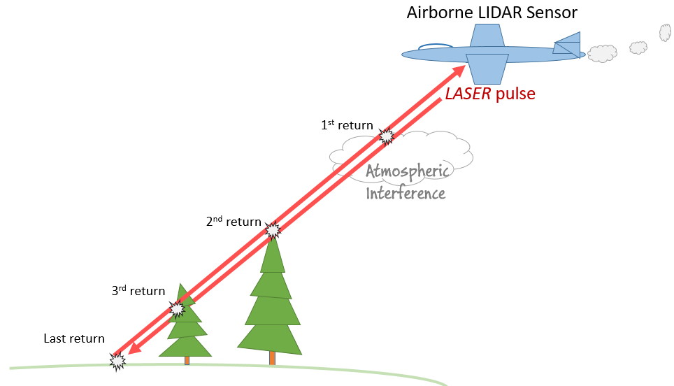
Figure 10: Lidar is an active sensor that sends narrow light beams between foliage and can record multiple returns.
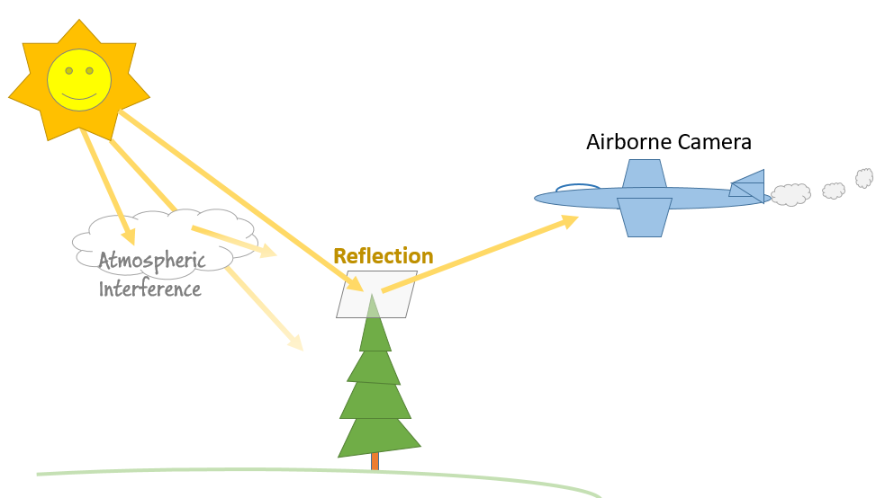
Figure 11: Pixel correlated data from aerial photography contains single returns based on reflected sunlight

Effects of vegetation on point cloud profiles and derivative products
Due to the properties of the data collection process previously described, a classified point cloud derived from Automated Pixel autocorrelation can contain many ground points in open, sparsely vegetated, or deciduous forest (leaf-off) areas, and many points representing treetops in densely vegetated (leaf-on) or coniferous forest areas. Valid ground points will often be entirely absent in these areas. A comparison of classified point cloud profiles from a pixel correlated product (SCOOP 2013) where lidar data is also available illustrates the lack of ground points under canopy (Figure 12). These differences will affect the types and accuracy of derivative products that can be created.
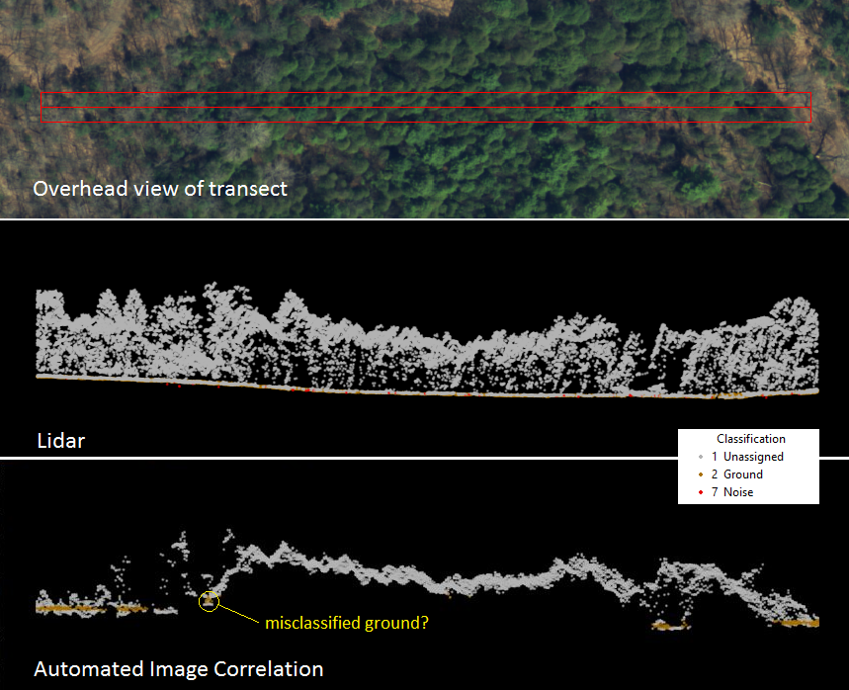
Figure 12: Profiles of Peterborough Classified Point Cloud (Lidar-Derived) (middle) compared with SCOOP 2013 Classified Point Cloud (Imagery-Derive) (bottom) along the same 10 x 200m transect.
The northern portion of the COOP 2016 Classified Point Cloud (Imagery-Derived) overlaps the Cochrane project area of the Ontario Classified Point Cloud (Lidar-Derived). Although the forest in this area is often not as dense as that shown above in Figure 16, one can see that even in a profile where point elevations occur throughout the canopy, valid ground points remain scarce in wooded areas and the vegetation is not as well represented as with the Lidar (Figure 13).
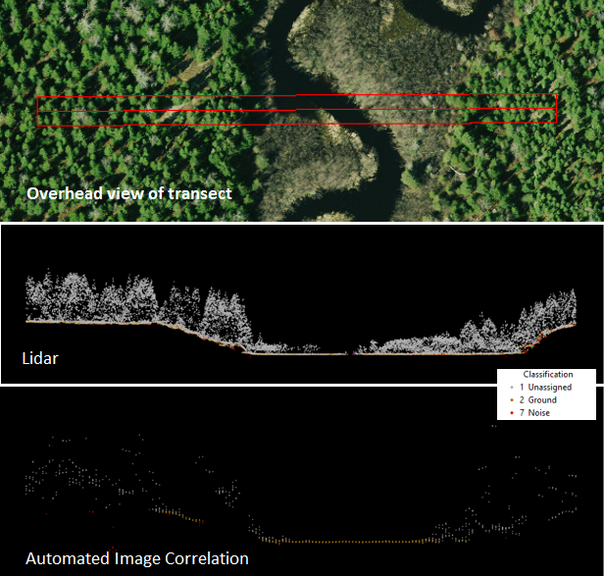
Figure 13: Profiles of Cochrane Classified Point Cloud (Lidar-Derived) (middle) compared with COOP 2016 Classified Point Cloud (bottom) along the same 10 x 200m transect.

Appendix D: Detailed Vendor-Supplied Processing Information
This process applied to the SCOOP 2013, DRAPE 2014 and SWOOP 2015 imagery projects.
The Leica Geosystems XPro software was used for downloading and preparing imagery collected with the ADS100 Airborne Digital Sensor for softcopy photogrammetric use. The raw image was downloaded in the field with XPro to a portable workstation. This enabled a quick look at image quality and coverage. Using the Leica Geosystems IPAS software package, the GPS data was differentially processed against a base station. After the differential GPS solution was checked and verified the Leica Geosystems IPAS program was used to compute an integrated GPS/IMU navigation solution at one-second intervals. Using the GPS/IMU trajectory computed by the Leica Geosystems IPAS software and the camera calibration, XPro computed a full x, y, z, omega, phi, kappa exterior orientation of each scan line. Using the orientation data file produced the L0 imagery was resampled. The resampling removes most aircraft motion and provides epipolar geometry imagery for stereo viewing, automated aerotriangulation and automated DEM extraction.
The Level 1 epipolar- resampled and georeferenced imagery usually will provide a pixel’s true ground location to within a few pixels without any additional processing. To improve accuracy, a fully automatic aerotriangulation process was performed to minimize the residual errors in the GPS/IMU derived exterior orientations. The aerotriangulation also allowed the introduction of ground control and checkpoints to ensure the accuracy specifications were achieved. Automated aerotriangulation of ADS100 imagery was performed with the XPro. A digital elevation model (DEM) was required for orthophoto production. DEM was auto correlated and used to generate the ortho-rectification imagery. The orthorectified imagery was created utilizing Leica Geosystem XPro software. The orthophotos were mosaicked together using a proprietary image database and mosaicking software. The database was edited for seam lines, and other artifacts. The imagery was clipped out of the database into the sheet layout generated based on client use requirements. In the clipping stage, the coordinate system and georeferencing was embedded into the header of the TIFF file. The stereo and orthorectified imagery were quality controlled and delivered on external hard drives.
GPS phase data was post processed with continuous kinematic survey techniques using "On the Fly" (OTF) integer ambiguity resolution. The GPS data was processed with forward and reverse processing algorithms. The results from each process, using the data collected at the airport, were combined to yield a single fixed integer phase differential solution of the aircraft trajectory. The differences between the forward to reverse solution within the project area were within project specifications (<10cm) in both the horizontal and vertical components, indicating a valid and accurate solution. An IMU was used to record precise changes in position and orientation of the ADS100 Digital Camera System. All IMU data was processed post flight with a filter to integrate inertial measurements and precise phase differential GPS positions. The resulting solution contains geodetic position, omega, phi, kappa, and time for digital image processing.

Process Output Workflow
The DEM development process is essentially a five-step process:
- Acquire imagery
- Perform pixel autocorrelation Semi Global Matching (SGM) using overlapping images to produce DSM point cloud posts
- Filter, edit, modify, and otherwise process the DSM point cloud to produce an edited point cloud consisting of points classified as ground, unassigned and noise.
- Triangulate the point cloud posts into TIN format
- Interpolate the TIN to a gridded raster DEM in IMG format
This process can be conceptualized visually by the following set of images (See Figure 14). The final image is a simulated hillshade 3D view of the DEM.
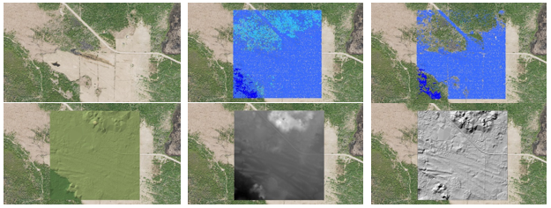
Figure 14: COOP 2016 DEM development process
At a 1:500 scale the process can be visualized in more detail (see Figures 15 to 17).
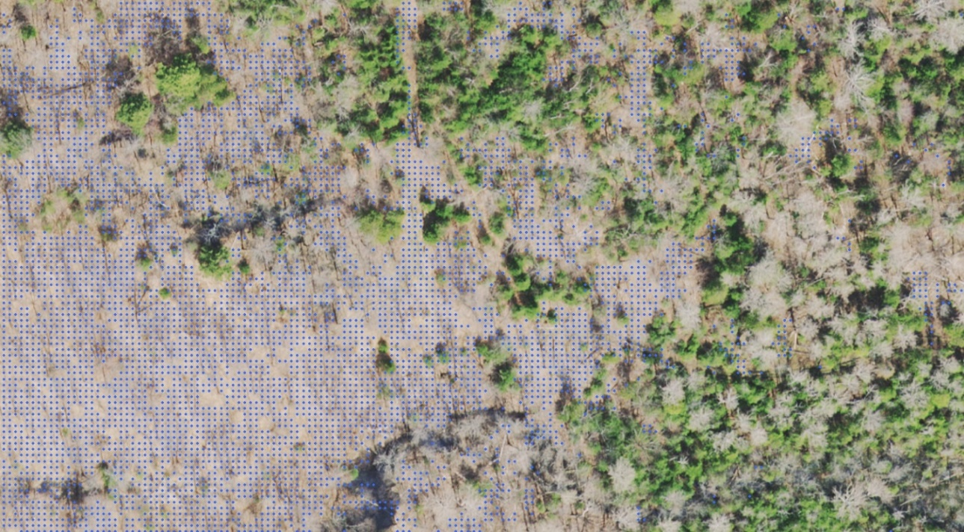
Figure 15: Ground classified point cloud posts after filtering vegetation surface features
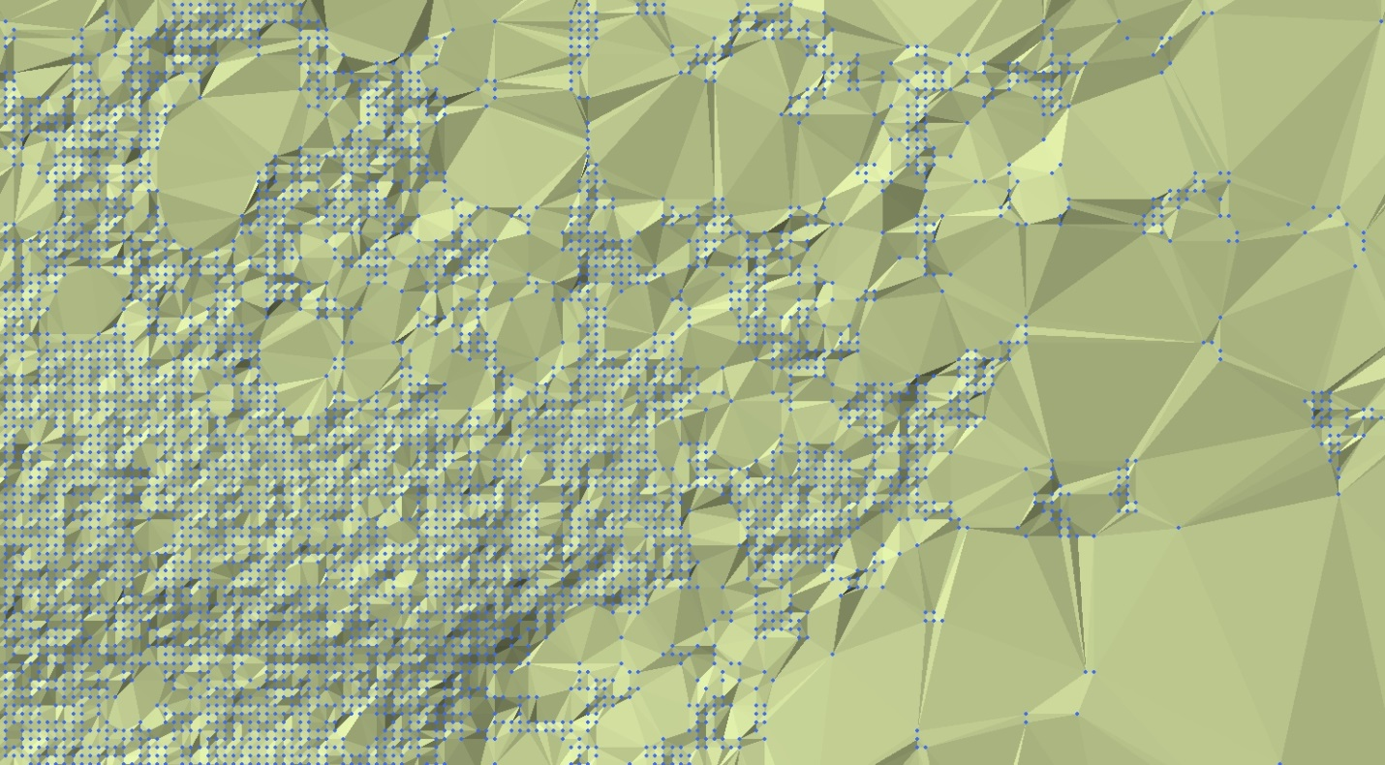
Figure 16: Resulting Triangular Irregular Network (TIN) produced from ground posts
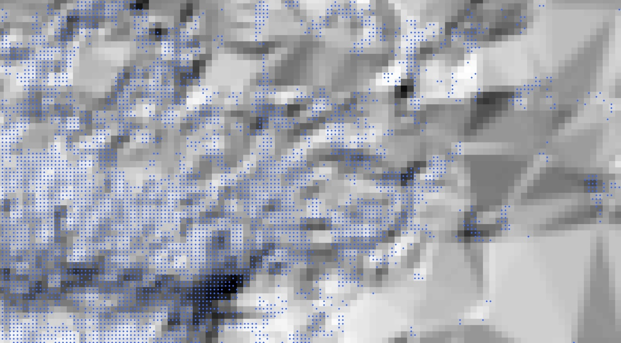
Figure 17: DEM hillshade interpolated from TIN aligned to point cloud ground posts

Version 2324.1

