User Guide
for
Ontario Vector Topographic Data Cache
Geospatial Ontario Data Class
  - Geospatial Services
  - Digital, Data, Information and Business Services Branch
  - Corporate Management and Information Division
  - Ministry of Natural Resources
2026-09-02

Disclaimer
This technical documentation has been prepared by His Majesty the King in right of Ontario as represented by the Ministry of Natural Resources (the “Ministry”). No warranties or representations, express or implied, statutory or otherwise shall apply or are being made by the Ministry with respect to the documentation, its accuracy or its completeness. In no event will the Ministry be liable or responsible for any lost profits, loss of revenue or earnings, claims by third parties or for any economic, indirect, special, incidental, consequential or exemplary damage resulting from any errors, inaccuracies or omissions in this documentation; and in no event will the Ministry’s liability for any such errors, inaccuracies or omissions on any particular claim, proceeding or action, exceed the actual consideration paid by the claimant involved to the Ministry for the materials to which this instructional documentation relates. Save and except for the liability expressly provided for above, the Ministry shall have no obligation, duty or liability whatsoever in contract, tort or otherwise, including any liability or negligence. The limitations, exclusions and disclaimers expressed above shall apply irrespective of the nature of any cause of action, demand or action, including but not limited to breach of contract, negligence, strict liability, tort or any other legal theory, and shall survive any fundamental breach or breaches.

Additional Information
This document does not comply with all the applicable guidelines for accessible digital documents. For an alternative format please email Geospatial Services at geospatial@ontario.ca.
For more information about this document, please contact Geospatial Services at geospatial@ontario.ca.

Executive Summary
    - Key Words
Ontario Vector Topographic Data Cache, Geospatial Ontario

Abstract
This user guide provides information about the Geospatial Ontario (GEO) Ontario Vector Topographic Data Cache. The cache is a collection of topographic data that has been preprocessed for fast, seamless display at predefined scales.

Table of Contents
Disclaimer 2
Additional Information 2
Executive Summary 3
1.1.1 Key Words 3
Abstract 3
Table of Contents 4
List of Acronyms 5
2. Introduction 6
3. Objectives 6
4. Ontario Vector Topographic Data Cache 6
4.1 Layers 7
4.2 Adding the Ontario Vector Topographic Data Cache 10
4.2.1 ArcGIS Pro 10
4.2.2 QGIS 10
4.3 Customizing the Vector Cache Symbology 10
5. Links to Additional Information 11
APPENDIX A: Ontario Vector Topographic Data Cache Legend 12

List of Acronyms
GIS: Geographic Information Systems
GEO: Geospatial Ontario
MNR: Ontario Ministry of Natural Resources
NHPN: National Highway Planning Network
OHN: Ontario Hydro Network
ORN: Ontario Road Network
ORWN: Ontario Railway Network
OTN: Ontario Trail Network
- Introduction
The Ontario Vector Topographic Data Cache is a visually appealing cartographic product provided for use as a base map of Ontario’s features. The cache contains authoritative data for features such as road names, township boundaries and water features. Forty-three data layers make up the Ontario Vector Topographic Data Cache.
- Objectives
This user guide is intended for users of the Ontario Vector Topographic Data Cache. The remainder of this document describes the cache and the data layers used in its creation.
- Ontario Vector Topographic Data Cache
The Ontario Vector Topographic Data Cache is a collection of topographic data that has been preprocessed for fast, seamless display at predefined scales. The topographic data consists of constructed and natural features that make up the landscape of the Province of Ontario. The cache provides limited data from areas outside the province's boundaries, i.e. the United States and adjacent provinces and territories.
The cache uses a Web Mercator projection and standard scales (ESRI ArcGIS Online, Google) for familiarity. For more information, refer to ArcGIS Online moving to Google / Bing tiling scheme: What does this mean for you? Having the same projection, zoom levels and tiling scheme makes it easier for users to mash-up their own maps with other caches. The legend for the cache is shown in Appendix A.
The vector cache is updated semi-annually. The contributing data layers may have different maintenance and update cycles. Some cache layers have been processed to optimize their display in a cartographic product. Other layers are unchanged from the authoritative data and simply symbolized. The cartographic symbology used in the cache is intentionally muted to allow users to showcase their data. Since the Ontario Vector Topographic Data Cache is a derived product, users are directed to download the authoritative data from the Ontario GeoHub.
The Ontario Vector Topographic Data Cache allows for printing at higher resolutions. It allows for the creation of maps in different projections without distorting features or labels. The legend for the vector cache is shown in Appendix A. The Vector cache can be added to most modern GIS software.
Note that the Vector cache can not be added to ArcMap.
Data was acquired from the following sources:
- GEO
- MNR
- GeoGratis
- United States - Department of Transportation - Research and Innovative Technology Administration's Bureau of Transportation Statistics
The cache is stored as files and generates your map on the fly, allowing the symbology to be customized. It is approximately 5GB in total size and can be downloaded from ArcGIS Online.
  - Layers
The following layers are included in the Ontario Vector Topographic Data Cache:
- Airport Official
- Building as Symbol
- Building to Scale
- Canadian Geographic Names
- Conservation Reserve Regulated
- Contour
- Federal Land, Other
- Federal Protected Area
- Geographic Names Ontario
- Frist Nation Reserve
- Large scale data, 1:10m
- Lot Fabric Improved
- Municipal Boundary – Upper Tier and District
- Municipal Boundary – Lower and Single Tier
- National Highway Planning Network (NHPN)
- National Road Network – Manitoba
- National Road Network – Nunavut
- National Road Network – Quebec
- North American Atlas – Boundaries
- North American Atlas – Hydrography
- North American Atlas – Populated Places
- OHN – Hydrographic Line
- OHN – Hydrographic Point
- OHN – Hydrographic Poly
- OHN – Small Scale Shoreline
- OHN – Small Scale Waterbody
- OHN – Small Scale Watercourse
- OHN – Waterbody
- OHN – Watercourse
- Ontario 30m Hillshade
- Ontario Road Network (ORN) Composite
- ORWN Junction
- ORWN Station
- ORWN Structure Line
- ORWN Track
- OTN Segment
- OTN Access Point
- Province
- Provincial Park Regulated
- Spot Height
- Utility Line
- Wetland
- Wooded Area

  - Adding the Ontario Vector Topographic Data Cache
    - ArcGIS Pro
The Vector Cache can be added just as any other layer from ArcGIS Online. A search for “Ontario Vector Topographic Data Cache” in ArcGIS Online will find the Service, then add the cache and start creating your map. The Vector Cache can also be added by using the ArcGIS Pro layer file.
    - QGIS
The Vector Cache can be added to QGIS as a “New ArcGIS Vector Tile Service Connection”. For more information on adding vector tile layers please consult QGIS help files. The vector cache can also be added by using the QGIS layer file.
Note: Some QGIS users may see a warning about unavailable fonts. The labels will be drawn in the absence of these fonts but for viewing the map as it was intended to appear, it is recommended to download and install the fonts that are listed in the warning messages onto your system.
  - Customizing the Vector Cache Symbology
When using the Vector Cache, you can modify the Style file that defines the symbology and labels and save the new style to an ArcGIS Online account. Please see ESRI’s support documents for further details on how to modify the style file.

- Links to Additional Information
- Geospatial Ontario (GEO)
(https://www.ontario.ca/page/geospatial-ontario)
- The Make a Topographic Map application
(https://www.ontario.ca/page/topographic-maps)
- Ontario Ministry of Natural Resources (https://www.ontario.ca/page/ministry-natural-resources)
- Ontario GeoHub: Ontario Vector Topographic Data Cache (https://geohub.lio.gov.on.ca/maps/mnrf::ontario-vector-topographic-data-cache)
For more information on the Ontario Topographic Data Cache contact geospatial@ontario.ca.
We want your feedback. Please email a screen capture of the missing data or error to geospatial@ontario.ca. Submissions will be reviewed and considered where appropriate.

APPENDIX A: Ontario Vector Topographic Data Cache Legend
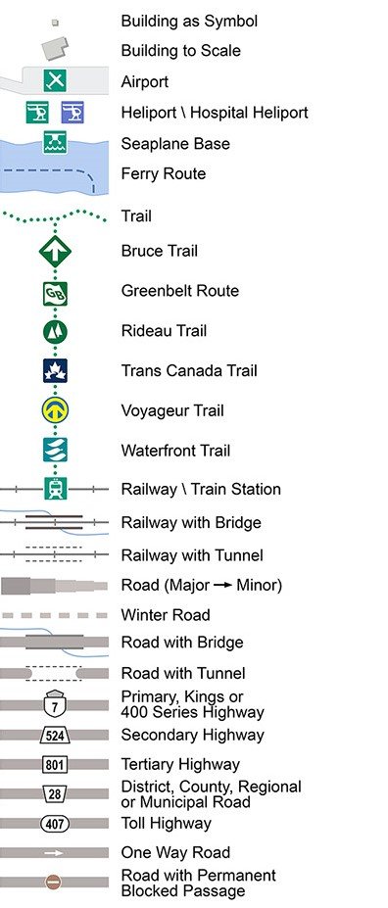
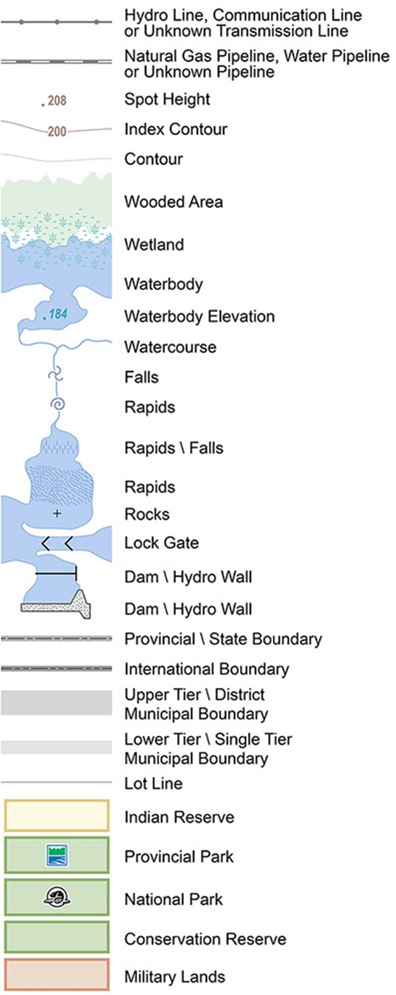
Version 2526.1

