User Guide
for
ORN Composite
Geospatial Ontario Data Class
Geospatial Ontario
Digital, Data, Information and Business Services Branch
Corporate Management and Information Division
Ministry of Natural Resources
2025-04-23

Disclaimer
This technical documentation has been prepared by His Majesty the King in right of Ontario as represented by the Ministry of Natural Resources and Forestry (the “Ministry”). No warranties or representations, express or implied, statutory or otherwise shall apply or are being made by the Ministry with respect to the documentation, its accuracy or its completeness. In no event will the Ministry be liable or responsible for any lost profits, loss of revenue or earnings, claims by third parties or for any economic, indirect, special, incidental, consequential or exemplary damage resulting from any errors, inaccuracies or omissions in this documentation; and in no event will the Ministry’s liability for any such errors, inaccuracies or omissions on any particular claim, proceeding or action, exceed the actual consideration paid by the claimant involved to the Ministry for the materials to which this instructional documentation relates. Save and except for the liability expressly provided for above, the Ministry shall have no obligation, duty or liability whatsoever in contract, tort or otherwise, including any liability or negligence. The limitations, exclusions and disclaimers expressed above shall apply irrespective of the nature of any cause of action, demand or action, including but not limited to breach of contract, negligence, strict liability, tort or any other legal theory, and shall survive any fundamental breach or breaches.

Additional Information
This document does not comply with all the applicable guidelines for accessible digital documents. For an alternative format please email Geospatial Ontario at geospatial@ontario.ca.
For more information about this document, please contact Geospatial Ontario at geosptatial@ontario.ca.

Executive Summary

Key Words
Ontario Road Network, ORN

Abstract
This user guide details the specifications for the ORN Composite Geospatial Ontario Data Class. With a positional accuracy of 10 metres or better the ORN is the authoritative source of roads data for Ontario. ORN Composite is derived from the ORN Road Net Element (ORNELEM) data class and is suitable for creating products and services including mapping, analysis and geocoding applications.
The ORN is a Government of Ontario Information Technology Standard (GO-ITS 29). Refer to Links to Additional Information for more information.

Table of Contents
Disclaimer 2
Additional Information 2
Executive Summary 3
Key Words 3
Abstract 3
Table of Contents 4
List of Figures 6
List of Tables 7
List of Acronyms 8
1. Introduction 9
2. Objectives 9
3. Data Class: ORN Composite 9
4. Model Diagram: ORN Composite 11
5. Data Description 13
ORN_SEGMENT_FT 13
ORN_BLOCKED_PASSAGE 18
ORN_STRUCTURE 18
ORN_TOLL_POINT 19
ORN_UNDERPASS 20
6. Links to Additional Information 21
APPENDIX A: GEO Lookup Tables and Values 22
ORN_BLOCKED_PASSAGE_TYPE_LIST 22
ORN_DIR_OF_TRAFFIC_FLOW_LIST 23
ORN_STREET_DIRECTION_LIST 24
ORN_STREET_TYPE_LIST 26
ORN_HOUSE_NUM_STRUCTURE_LIST 35
ORN_JURISDICTION_LIST 37
ORN_PAVEMENT_STATUS_LIST 60
ORN_ROAD_CLASS_LIST 61
ORN_ROAD_ELEMENT_TYPE_LIST 62
ORN_SHIELD_TYPE_LIST 63
ORN_STANDARD_MUNICIPALITY_LIST 65
ORN_STRUCTURE_TYPE_LIST 87
ORN_TOLL_POINT_TYPE_LIST 88
ORN_UNDERPASS_LIST 89
APPENDIX B: Table Key Dependency and Relationship Index 91
APPENDIX C: Frequently Asked Questions 94
What is the difference between ORN Road Net Element (ORNELEM) and ORN Composite? 94
What is a Linear Reference System (LRS)? 96
Where do I find 911 addresses? 96
What is the difference between 911 and civic addresses? 96
What is the difference between shield type and road class? 96
What is the difference between the Jurisdiction, Agency Name, and Road Net Element Source tables? 97
What projection is used to calculate LENGTH in ORN? 97
I have an issue or disagreement with a road name in the ORN. Are you able to rename the road or remove the name? 98
I still need help! 98
APPENDIX D: Creating a Network with ORN Composite 99
Introduction 99
Creating the Network 99
Steps to Create the Network Dataset 99
Steps to Define the Network Attributes 105
Steps to Establish Driving Directions 125
Steps to Finish Building the Network Dataset 127

List of Figures
Figure 1: Primary Key Example 91
Figure 2: Foreign Key Example 91
Figure 3: Alternate Key Example 92
Figure 4: Example of an Identifying Relationship 92
Figure 5: Example of a Non-identifying Relationship 93
Figure 6: Model Diagram Relationship Symbology Table 93
Figure 7: Accessing ArcGIS Pro Settings 99
Figure 8: Configure Your Data Licensing 100
Figure 9: Enable Network Analyst Extension 100
Figure 10: Create New Catalog Project 101
Figure 11: Create New Feature Dataset 101
Figure 12: Create New Feature Dataset Parameters 102
Figure 13: Create New Network Dataset 103
Figure 14: Create Network Dataset Parameters 104
Figure 15: Open Network Dataset Properties 105
Figure 16: Network Dataset Properties Window 106
Figure 17: Creating a New Restriction 107
Figure 18: Restriction Properties and Evaluators 109
Figure 19: Field Script Window for One Way Restrictions 109
Figure 20. Blocked Passage Evaluators for Permanent Barrier Only Restriction 112
Figure 21. Field Script Window for Permanent Blocked Passage Restrictions 112
Figure 22: Add Hierarchy Attribute 113
Figure 23: Hierarchy Ranges and Evaluators 114
Figure 24: Hierarchy Evaluators Field Script 116
Figure 25: Create New Descriptor 117
Figure 26: Descriptor Properties and Evaluators 119
Figure 27: Speed Limit Field Script 119
Figure 28: Create New Restriction 121
Figure 29: Costs Properties and Evaluators 123
Figure 30: Time Calculation Field Script 123
Figure 31: Create New Travel Mode 125
Figure 32: Network Dataset Properties - Directions 125
Figure 33: Field Mapping Window for Directions 126
Figure 34: Build Network Dataset 127
Figure 35: The Network Dataset 128
Figure 36: The Network Analyst tools. 129

List of Tables
Table 1 – Possible values in the “DIRECTION” field 106
Table 2 – Expressions for enforcing traffic flow directions 109

List of Acronyms
CPC: Canada Post Corporation
GEO: Geospatial Ontario
GO-ITS: Government of Ontario Information Technology Standard
LUT: Lookup Table
MMAH: Ontario Ministry of Municipal Affairs and Housing
MNR: Ontario Ministry of Natural Resources
MTO: Ontario Ministry of Transportation
NRN: National Road Network
OGF: Ontario Geospatial Feature
ORN: Ontario Road Network
WFS: Web Feature Service

1. Introduction
The Ontario Road Network (ORN) is a province-wide geographic database of over 250,000 kilometres of municipal roads, provincial highways and resource and recreational roads. With a positional accuracy of 10 metres or better the ORN is the authoritative source of roads data for Ontario.
The ORN is a national, provincial and municipal initiative that supports the creation, maintenance and sharing of a standard road database. Geospatial Ontario (GEO) maintains the ORN using data from the road authorities with legislative responsibility: Ontario Municipalities, Ontario Ministry of Transportation (MTO) and Ontario Ministry of Natural Resources (MNR). Road data and information is collected, standardized and integrated into a seamless road mapping product.
Users can access current ORN data through a Web Feature Service (WFS) or an open data license to create products and services including mapping, analysis and geocoding applications. Up-to-date data is available at no cost to public and private organizations, saving time, resources and money.
For more information on the ORN contact geospatial@ontario.ca.

2. Objectives
This guide is intended for users with a general interest in the ORN Composite Data Class. The remainder of this document describes the extent and context of the information collected for the data class.

3. Data Class: ORN Composite
The Ontario Road Network (ORN) composite is a segmented derivative of the ORN Road Net Element (ORNELEM) data class. Road segment information includes addressing, speed limit, number of lanes, pavement status, road class, jurisdiction, route number and direction of traffic flow information. Address ranges span intersection to intersection or may be interpolated across intersections.
Additional road feature layers include blocked passage, underpass, toll point and structure.
For more detailed information refer to the ORN Composite data model diagram and Appendix B: Table Key Dependency and Relationship Index.

4. Model Diagram: ORN Composite
Physical Model Diagram for ORN Composite
Model Effective Date: 2025-January-24
Note: Where applicable to this model: Tables with a “_LIST” extension (shaded yellow) = Lookup Table (LUT)
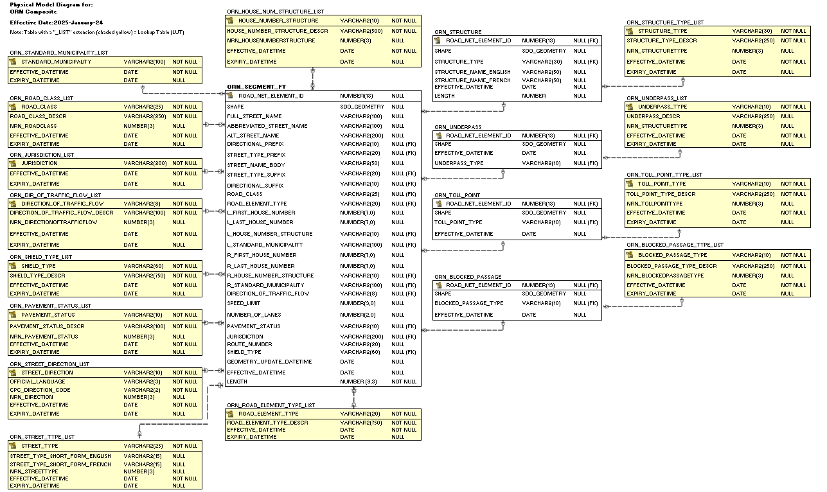

5. Data Description
The main business area table(s) for this model can be found below. Associated lookup tables will be listed in Appendix A of this document and are hyperlinked where referenced in this section.

ORN_SEGMENT_FT
A road segment that represents a centreline network.
Column Name | Column Type | Mandatory | Short Name | Description
ROAD_NET_ELEMENT_ID | NUMBER(13) | No | ELEMENT_ID | Ontario Geospatial Feature Identifier (OGF_ID) reference to parent ORN_ROAD_NET_ELEMENT feature table record.
SHAPE | SDO_GEOMETRY | No | SHAPE | Geometry attribute.
FULL_STREET_NAME | VARCHAR2(100) | No | FULL_NAME | Street name composed of individual street name components where present, including directional prefix, street type prefix, street name body, street type suffix and directional suffix.
ABBREVIATED_STREET_NAME | VARCHAR2(100) | No | ABBR_NAME | Abbreviated street name is composed of the individual street name components, where present, including directional prefix, street type prefix, street name body, street type suffix and directional suffix. Street name components are abbreviated with the exception of street name body.
ALTERNATE_STREET_NAME | VARCHAR2(100) | No | ALT_NAME | Alternate name attached to a road segment not associated to an established route.
DIRECTIONAL_PREFIX | VARCHAR2(10) | No | DIR_PREFIX | A geographic direction preceding either the street type prefix or the street name body.  Permissible Values: (See ORN_STREET_DIRECTION_LIST lookup table in appendix)
STREET_TYPE_PREFIX | VARCHAR2(25) | No | ST_TYPE_P | A street type preceding the street name body.  Permissible Values: (See ORN_STREET_TYPE_LIST lookup table in appendix)
STREET_NAME_BODY | VARCHAR2(50) | Yes | NAME_BODY | The identifying named component of a street name. Street segment must have a street name body and can never be abbreviated.
STREET_TYPE_SUFFIX | VARCHAR2(25) | No | ST_TYPE_S | A street type following the street name body.  Permissible Values: (See ORN_STREET_TYPE_LIST lookup table in appendix)
DIRECTIONAL_SUFFIX | VARCHAR2(10) | No | DIR_SUFFIX | A geographic direction following either the street name body or the street type suffix.  Permissible Values: (See ORN_STREET_DIRECTION_LIST lookup table in appendix)
ROAD_CLASS | VARCHAR2(25) | No | ROAD_CLASS | The functional classification of the road segment.  Permissible Values: (see ORN_ROAD_CLASS_LIST lookup table in appendix)
ROAD_ELEMENT_TYPE | VARCHAR2(20) | No | ELEM_TYPE | An attribute describing the type of road segment. Valid values:  Permissible Values: (See ORN_ROAD_ELEMENT_TYPE_LIST lookup table in appendix)
L_FIRST_HOUSE_NUMBER | NUMBER(7,0) | No | L_FIRST | The first house number of the address range on the left side of a road segment.
L_LAST_HOUSE_NUMBER | NUMBER(7,0) | No | L_LAST | The last house number of the address range on the left side of a road segment.
L_HOUSE_NUMBER_STRUCTURE | VARCHAR2(10) | No | L_STRUCT | The type of addressing method applied to the left side of a road segment.  Permissible Values: (See ORN_HOUSE_NUM_STRUCTURE_LIST lookup table in appendix)
L_STANDARD_MUNICIPALITY | VARCHAR2(100) | No | L_STD_MUN | The standardized municipality applied to the left side of the road segment as provided by the Ministry of Municipal Affairs and Housing (MMAH) and Indian Reserves.  Permissible Values: (See ORN_STANDARD_MUNICIPALITY_LIST lookup table in appendix)
R_FIRST_HOUSE_NUMBER | NUMBER(7,0) | No | R_FIRST | The first house number of the address range on the right side of a road segment.
R_LAST_HOUSE_NUMBER | NUMBER(7,0) | No | R_LAST | The last house number of the address range.
R_HOUSE_NUMBER_STRUCTURE | VARCHAR2(10) | No | R_STRUCT | The type of addressing method applied to the right side of a road segment.  Permissible Values: (See ORN_HOUSE_NUM_STRUCTURE_LIST lookup table in appendix)
R_STANDARD_MUNICIPALITY | VARCHAR2(100) | No | R_STD_MUN | The standardized municipality applied to the right side of the road segment as provided by the Ministry of Municipal Affairs and Housing (MMAH) and Indian Reserves.  Permissible Values: (See ORN_STANDARD_MUNICIPALITY_LIST lookup table in appendix)
DIRECTION_OF_TRAFFIC_FLOW | VARCHAR2(8) | No | DIRECTION | The direction of traffic flow applied to the road segment.  Permissible Values: (See ORN_DIR_OF_TRAFFIC_FLOW_LIST lookup table in appendix)
SPEED_LIMIT | NUMBER(3,0) | No | LIMIT | The maximum speed limit assigned to a road element in kilometres per hour in accordance with Municipal By-Laws or Provincial Law.
NUMBER_OF_LANES | NUMBER(2,0) | No | NUM_LANES | The number of lanes of a road.
PAVEMENT_STATUS | VARCHAR2(10) | No | PAVEMENT_S | The surface type of a road element.  Permissible Values: (PAVED, UNPAVED)
JURISDICTION | VARCHAR2(200) | No | JURIS | An indication of who has the jurisdictional, or custodianship responsibility for a road net element. The custodian would have the responsibility to ensure maintenance occurs, but is not necessarily the one who undertakes the maintenance directly. A single value represents jurisdiction for both sides of a road element. Two concatenated values represent jurisdiction as left and right side of a road element.  Permissible Values: (See ORN_JURISDICTION_LIST lookup table in appendix)
ROUTE_NUMBER | VARCHAR2(20) | No | RTE_NUM | The route number(s) represented by a numeric and/or an alphanumeric character associated with a provincial highway, secondary highway, county road or regional road.
SHIELD_TYPE | VARCHAR2(60) | No | SHIELD_T | The shield type classified by a route and used for cartographic purposes.  Permissible Values: (See ORN_SHIELD_TYPE_LIST lookup table in appendix)
GEOMETRY_UPDATE_DATETIME | DATE | No | GEO_UPD_DT | Date/time the geometry was created or last modified in the source database.
EFFECTIVE_DATETIME | DATE | No | EFF_DATE | Date/time the record was created or last modified in the source database.
LENGTH | NUMBER(9,3) | Yes | LENGTH | The length of the segment in metres.
GEOMETRY_UPDATE_DATETIME | DATE | No | GEO_UPD_DT | Date/time the geometry was created or last modified in the source database.
EFFECTIVE_DATETIME | DATE | No | EFF_DATE | Date/time the record was created or last modified in the source database.

ORN_BLOCKED_PASSAGE
A point event on a road element identifying the existence of an access barrier or an obstruction, either man-made or natural, which controls or limits access to a road element.
Column Name | Column Type | Mandatory | Short Name | Description
ORN_ROAD_NET_ELEMENT_ID | NUMBER(13,0) | No | ELEMENT_ID | Foreign Key (FK) OGF_ID reference to parent ORN_ROAD_NET_ELEMENT_FT feature table record.
SHAPE | SDO_GEOMETRY | No | SHAPE | Geometry attribute.
BLOCKED_PASSAGE_TYPE | VARCHAR2(10) | No | BLOCKED_T | A man-made or natural barrier or access restriction placed on a road net element to control or limit access to a road net element.  Permissible Values: (See ORN_BLOCKED_PASSAGE_TYPE_LIST lookup table in appendix)
EFFECTIVE_DATETIME | DATE | No | EFF_DATE | Date/time the record was created or last modified in the source database.

ORN_STRUCTURE
The classification of a structure, that exists on a road element and is managed as a linear event. The types are mutually exclusive.
Column Name | Column Type | Mandatory | Short Name | Description
ORN_ROAD_NET_ELEMENT_ID | NUMBER(13,0) | No | ELEMENT_ID | Foreign Key (FK) OGF_ID reference to parent ORN_ROAD_NET_ELEMENT_FT feature table record.
SHAPE | SDO_GEOMETRY | No | SHAPE | Geometry attribute.
STRUCTURE_TYPE | VARCHAR2(30) | No | STRUCT_T | The classification of a structure, that exists on a road element and is managed as a linear event.  Permissible Values: See ORN_STRUCTURE_TYPE_LIST lookup table in appendix)
STRUCTURE_NAME_ENGLISH | VARCHAR2(50) | No | NAME_ENG | The English name provided by a Municipality, Provincial Ministry or Federal Agency. A structure has only one English name.
STRUCTURE_NAME_FRENCH | VARCHAR2(50) | No | NAME_FRE | The French name provided by a Municipality, Provincial Ministry or Federal Agency. A structure has only one French name.
EFFECTIVE_DATETIME | DATE | No | EFF_DATE | Date/time the record was created or last modified in the source database.

ORN_TOLL_POINT
A point event along a road element indicating the presence of a toll point.
Column Name | Column Type | Mandatory | Short Name | Description
ORN_ROAD_NET_ELEMENT_ID | NUMBER(13,0) | No | ELEMENT_ID | Foreign Key (FK) OGF_ID reference to parent ORN_ROAD_NET_ELEMENT_FT feature table record.
SHAPE | SDO_GEOMETRY | No | SHAPE | Geometry attribute.
TOLL_POINT_TYPE | VARCHAR2(10) | No | TOLL_PT_T | A point event indicating the type of a toll point that may exist along a road element.  Permissible Values: (See ORN_TOLL_POINT_TYPE_LIST lookup table in appendix)
EFFECTIVE_DATETIME | DATE | No | EFF_DATE | Date/time the record was created or last modified in the source database.

ORN_UNDERPASS
A point event on a road element identifying the existence of an underpass. An underpass occurs where the road element runs underneath a passage accommodating the movement of water, a building, road, rail, pedestrian or wildlife.
Column Name | Column Type | Mandatory | Short Name | Description
ORN_ROAD_NET_ELEMENT_ID | NUMBER(13,0) | No | ELEMENT_ID | Foreign Key (FK) OGF_ID reference to parent ORN_ROAD_NET_ELEMENT_FT feature table record.
SHAPE | SDO_GEOMETRY | No | SHAPE | Geometry attribute.
UNDERPASS_TYPE | VARCHAR2(10) | No | TOLL_PT_T | Identifies the type of underpass present at this road location.  Permissible Values: (See ORN_UNDERPASS_LIST lookup table in appendix)
EFFECTIVE_DATETIME | DATE | No | EFF_DATE | Date/time the record was created or last modified in the source database.

6. Links to Additional Information
- Access the official Metadata Record by searching Ontario GeoHub for Ontario Road Network, ORN
- ORN Composite on Ontario’s GeoHub (https://geohub.lio.gov.on.ca/maps/7c00e0fef49a41b9b708986dba5ce241/about)
- Geospatial Ontario (GEO) (https://www.ontario.ca/page/geospatial-ontario)
- Canadian Federal Government’s GeoGratis: National Road Network (https://open.canada.ca/data/en/dataset/3d282116-e556-400c-9306-ca1a3cada77f)
- GO-ITS 29: Ontario Road Network (https://www.ontario.ca/government/go-its-29-ontario-road-network)

APPENDIX A: GEO Lookup Tables and Values

ORN_BLOCKED_PASSAGE_TYPE_LIST
List of valid blocked passage types.
Column Name | Column Type | Mandatory | Short Name | Description
BLOCKED_PASSAGE_  TYPE | VARCHAR2(10) | Yes | BLOCKED_T | The type of man-made or natural barrier or access restriction placed on a road element to control or limit access to a road net element.
BLOCKED_PASSAGE_  TYPE_DESCR | VARCHAR2(750) | Yes | BLOCKED_D | A description of the blocked passage type.
NRN_BLOCKED  PASSAGETYPE | NUMBER(3,0) | No | NRN_CODE | Blocked passage type assigned to support the National Road Network (NRN).
EFFECTIVE_  DATETIME | DATE | Yes | EFF_DATE | Date/time the record was created or last modified in the source database.
EXPIRY_DATETIME | DATE | No | EXP_DATE | Date/time that the record was expired from use.

ORN_BLOCKED_PASSAGE_TYPE_LIST Permissible Values
BLOCKED PASSAGE TYPE | BLOCKED PASSAGE TYPE DESCR | NRN BLOCKED PASSAGE TYPE | EXPIRY  DATETIME
Permanent | An obstacle placed across a road element that has to be removed or destroyed to free the entrance to the other side of the road that it is blocking. Examples include: concrete blocks, mound of earth or culvert or bridge removed. | 1 | Not applicable
Removable | A man-made barrier designed to block the entrance to the other side of the road element. An example is a locked gate. | 2 | Not applicable

ORN_DIR_OF_TRAFFIC_FLOW_LIST
List of valid direction of traffic flows.
Column Name | Column Type | Mandatory | Short Name | Description
DIRECTION_OF_  TRAFFIC_FLOW | VARCHAR2(8) | Yes | DIRECTION_ | The direction(s) of vehicular or motor traffic flow. All road elements must have a direction of traffic flow assigned.
DIR_OF_TRAFFIC_  FLOW_DESCR | VARCHAR2(100) | Yes | DESCR | A description of the direction of traffic flow.
NRN_DIRECTIONOF  TRAFFICFLOW | NUMBER(3,0) | No | NRN_CODE | Direction of traffic flow assigned to support the National Road Network (NRN).
EFFECTIVE_  DATETIME | DATE | Yes | EFF_DATE | Date/time the record was created or last modified in the source database.
EXPIRY_DATETIME | DATE | No | EXP_DATE | Date/time that the record was expired from use.

ORN_DIR_OF_TRAFFIC_FLOW_LIST Permissible Values
DIRECTION OF TRAFFIC FLOW | DIR OF TRAFFIC FLOW DESCR | NRN DIRECTIONOF  TRAFFICFLOW | EXPIRY  DATETIME
Both | Traffic is allowed in both directions. | 1 | Not applicable
Negative | Traffic is opposite to the direction of the geometry. | 3 | Not applicable
Positive | Traffic is in the same direction as the geometry. | 2 | Not applicable

ORN_STREET_DIRECTION_LIST
List of valid street directions.
Column Name | Column Type | Mandatory | Short Name | Description
STREET_DIRECTIONS | VARCHAR2(10) | Yes | STREET_DIR | The direction of the street.
OFFICIAL_LANGUAGE | VARCHAR2(3) | Yes | OFF_LANG | A code identifying the official language.
CPC_DIRECTION_  CODE | VARCHAR2(2) | Yes | CPC_DIRECT | The short form of the street direction as defined by Canada Post Corporation (CPC).
NRN_DIRECTION | NUMBER(3,0) | No | NRN_DIRECT | Direction assigned to support the National Road Network (NRN).
EFFECTIVE_  DATETIME | DATE | Yes | EFF_DATE | Date/time the record was created or last modified in the source database.
EXPIRY_DATETIME | DATE | No | EXP_DATE | Date/time that the record was expired from use.

ORN_STREET_DIRECTION_LIST Permissible Values
STREET DIRECTION | OFFICIAL LANGUAGE | CPC DIRECTION CODE | NRN DIRECTION | EXPIRY  DATETIME
East | ENG | E | 5 | Not applicable
Est | FRE | E | 6 | Not applicable
Nord Est | FRE | NE | 12 | Not applicable
Nord Ouest | FRE | NO | 10 | Not applicable
Nord | FRE | N | 2 | Not applicable
North East | ENG | NE | 11 | Not applicable
North West | ENG | NW | 9 | Not applicable
North | ENG | N | 1 | Not applicable
Ouest | FRE | O | 8 | Not applicable
South East | ENG | SE | 15 | Not applicable
South West | ENG | SW | 13 | Not applicable
South | ENG | S | 3 | Not applicable
Sud Est | FRE | SE | 16 | Not applicable
Sud Ouest | FRE | SO | 14 | Not applicable
Sud | FRE | S | 4 | Not applicable
West | ENG | W | 7 | Not applicable

ORN_STREET_TYPE_LIST
List of valid street types.
Column Name | Column Type | Mandatory | Short Name | Description
STREET_TYPE | VARCHAR2(25) | Yes | STREET_TYP | A description of the street type.
STREET_TYPE_SHORT_  FORM_ENGLISH | VARCHAR2(15) | No | ST_TYPE_EN | A short form of the street type in English.
STREET_TYPE_SHORT_  FORM_FRENCH | VARCHAR2(15) | No | ST_TYPE_FR | A short form of the street type in French.
NRN_STREETTYPE | NUMBER(3,0) | No | NRN_STREET | Street type assigned to support the National Road Network (NRN).
EFFECTIVE_DATETIME | DATE | Yes | EFF_DATE | Date/time the record was created or last modified in the source database.
EXPIRY_DATETIME | DATE | No | EXP_DATE | Date/time that the record was expired from use.
ORN_STREET_TYPE_LIST Permissible Values
STREET TYPE | STREET TYPE SHORT FORM ENGLISH | STREET TYPE SHORT FORM FRENCH | NRN STREETTYPE | EXPIRY DATETIME
Abbey | ABBEY | Not applicable | Not applicable | Not applicable
Access | ACCESS | Not applicable | Not applicable | Not applicable
Acres | ACRES | Not applicable | Not applicable | Not applicable
Aire | AIRE | Not applicable | Not applicable | Not applicable
Alley | ALLEY | Not applicable | Not applicable | Not applicable
Allée | Not applicable | ALLÉE | Not applicable | Not applicable
Arm | ARM | Not applicable | Not applicable | Not applicable
Autoroute | AUT | Not applicable | Not applicable | Not applicable
Avenue | AVE | AV | Not applicable | Not applicable
Bank | BK | Not applicable | Not applicable | Not applicable
Barrage | Not applicable | BRGE | Not applicable | Not applicable
Baseline | BASELINE | Not applicable | Not applicable | Not applicable
Bay | BAY | Not applicable | Not applicable | Not applicable
Beach | BEACH | Not applicable | Not applicable | Not applicable
Bend | BEND | Not applicable | Not applicable | Not applicable
Bloc | BLOC | Not applicable | Not applicable | Not applicable
Block | BLOCK | Not applicable | Not applicable | Not applicable
Bluff | BLUFF | Not applicable | Not applicable | Not applicable
Bottom | BTM | Not applicable | Not applicable | Not applicable
Boulevard | BLVD | BOUL | Not applicable | Not applicable
Bourg | Not applicable | BOURG | Not applicable | Not applicable
Bourne | BRNE | Not applicable | Not applicable | Not applicable
Branch | BRANCH | Not applicable | Not applicable | Not applicable
Bridge | BRIDGE | Not applicable | Not applicable | Not applicable
Brook | BROOK | Not applicable | Not applicable | Not applicable
Burn | BURN | Not applicable | Not applicable | Not applicable
Bush | BUSH | Not applicable | Not applicable | Not applicable
Bypass | BYPASS | Not applicable | Not applicable | Not applicable
Byroad | BYROAD | Not applicable | Not applicable | Not applicable
Byway | BYWAY | Not applicable | Not applicable | Not applicable
Camp | CAMP | Not applicable | Not applicable | Not applicable
Campus | CAMPUS | Not applicable | Not applicable | Not applicable
Cape | CAPE | Not applicable | Not applicable | Not applicable
Carrefour | Not applicable | CARREF | Not applicable | Not applicable
Carré | Not applicable | CAR | Not applicable | Not applicable
Causeway | CSWY | Not applicable | Not applicable | Not applicable
Centre | CTR | C | Not applicable | Not applicable
Cercle | Not applicable | CERCLE | Not applicable | Not applicable
Chart | CHART | Not applicable | Not applicable | Not applicable
Chase | CHASE | Not applicable | Not applicable | Not applicable
Chemin | Not applicable | CH | Not applicable | Not applicable
Circle | CIR | Not applicable | Not applicable | Not applicable
Circuit | CIRCT | Not applicable | Not applicable | Not applicable
Cliffs | CLFS | Not applicable | Not applicable | Not applicable
Close | CLOSE | Not applicable | Not applicable | Not applicable
Club | CLUB | Not applicable | Not applicable | Not applicable
Common | COMMON | Not applicable | Not applicable | Not applicable
Concession Road | CON RD | Not applicable | Not applicable | Not applicable
Concession | CONC | Not applicable | Not applicable | Not applicable
Copse | COPSE | Not applicable | Not applicable | Not applicable
Corner | COR | Not applicable | Not applicable | Not applicable
Corners | CRNRS | Not applicable | Not applicable | Not applicable
County Road | COUNTY RD | Not applicable | Not applicable | Not applicable
Cour | Not applicable | COUR | Not applicable | Not applicable
Course | CRSE | Not applicable | Not applicable | Not applicable
Court | CRT | Not applicable | Not applicable | Not applicable
Courts | CTS | Not applicable | Not applicable | Not applicable
Cove | COVE | Not applicable | Not applicable | Not applicable
Creek | CK | Not applicable | Not applicable | Not applicable
Crescent | CRES | Not applicable | Not applicable | Not applicable
Crest | CREST | Not applicable | Not applicable | Not applicable
Croft | CROFT | Not applicable | Not applicable | Not applicable
Croissant | Not applicable | CROIS | Not applicable | Not applicable
Cross | CX | Not applicable | Not applicable | Not applicable
Crossing | CROSS | Not applicable | Not applicable | Not applicable
Crossroad | CROSRD | Not applicable | Not applicable | Not applicable
Crossroads | CRSSRD | Not applicable | Not applicable | Not applicable
Cul De Sac | CDS | Not applicable | Not applicable | Not applicable
Curve | CURVE | Not applicable | Not applicable | Not applicable
Cut | CUT | Not applicable | Not applicable | Not applicable
Côte | Not applicable | CÔTE | Not applicable | Not applicable
Dale | DALE | Not applicable | Not applicable | Not applicable
Dell | DELL | Not applicable | Not applicable | Not applicable
Desserte | Not applicable | DESSTE | Not applicable | Not applicable
Development | DEVELP | Not applicable | Not applicable | Not applicable
Diversion | DIVERS | Not applicable | Not applicable | Not applicable
Downs | DOWNS | Not applicable | Not applicable | Not applicable
Drive | DR | Not applicable | Not applicable | Not applicable
Driveway | DRWY | Not applicable | Not applicable | Not applicable
Droit De Passage | Not applicable | DRPASS | Not applicable | Not applicable
Easement | EASEMT | Not applicable | Not applicable | Not applicable
End | END | Not applicable | Not applicable | Not applicable
Esplanade | ESPL | Not applicable | Not applicable | Not applicable
Estates | ESTATE | Not applicable | Not applicable | Not applicable
Expressway | EXPY | Not applicable | Not applicable | Not applicable
Extension | EXTEN | Not applicable | Not applicable | Not applicable
Fairway | FAWY | Not applicable | Not applicable | Not applicable
Farm | FARM | Not applicable | Not applicable | Not applicable
Field | FIELD | Not applicable | Not applicable | Not applicable
Fields | FIELDS | Not applicable | Not applicable | Not applicable
Fire Route | FR | Not applicable | Not applicable | Not applicable
Forest | FOREST | Not applicable | Not applicable | Not applicable
Freeway | FWY | Not applicable | Not applicable | Not applicable
Front | FRONT | Not applicable | Not applicable | Not applicable
Garden | GN | Not applicable | Not applicable | Not applicable
Gardens | GDNS | Not applicable | Not applicable | Not applicable
Gate | GATE | Not applicable | Not applicable | Not applicable
Gateway | GTWY | Not applicable | Not applicable | Not applicable
Glade | GLADE | Not applicable | Not applicable | Not applicable
Glen | GLEN | Not applicable | Not applicable | Not applicable
Green | GREEN | Not applicable | Not applicable | Not applicable
Greenway | GREENWAY | Not applicable | Not applicable | Not applicable
Grounds | GRNDS | Not applicable | Not applicable | Not applicable
Grove | GROVE | Not applicable | Not applicable | Not applicable
Harbour | HARBR | Not applicable | Not applicable | Not applicable
Haven | HAVEN | Not applicable | Not applicable | Not applicable
Heath | HEATH | Not applicable | Not applicable | Not applicable
Height | HT | Not applicable | Not applicable | Not applicable
Heights | HTS | Not applicable | Not applicable | Not applicable
Highlands | HGHLDS | Not applicable | Not applicable | Not applicable
Highway | HWY | Not applicable | Not applicable | Not applicable
Hill | HILL | Not applicable | Not applicable | Not applicable
Hills | HS | Not applicable | Not applicable | Not applicable
Hollow | HOLLOW | Not applicable | Not applicable | Not applicable
Impasse | Not applicable | IMP | Not applicable | Not applicable
Inamo | INAMO | Not applicable | Not applicable | Not applicable
Inlet | INLET | Not applicable | Not applicable | Not applicable
Intersection | INTERSN | Not applicable | Not applicable | Not applicable
Island | ISLAND | Not applicable | Not applicable | Not applicable
Islands | ISS | Not applicable | Not applicable | Not applicable
Isle | ISLE | Not applicable | Not applicable | Not applicable
Jardin | Not applicable | JARDIN | Not applicable | Not applicable
Junction | JNC | Not applicable | Not applicable | Not applicable
Keep | KEEP | Not applicable | Not applicable | Not applicable
Key | KEY | Not applicable | Not applicable | Not applicable
Knoll | KNOLL | Not applicable | Not applicable | Not applicable
Lake | LK | Not applicable | Not applicable | Not applicable
Lakes | LKS | Not applicable | Not applicable | Not applicable
Lakeway | LKWY | Not applicable | Not applicable | Not applicable
Land | LAND | Not applicable | Not applicable | Not applicable
Landing | LANDNG | Not applicable | Not applicable | Not applicable
Lane | LANE | Not applicable | Not applicable | Not applicable
Lanes | LANES | Not applicable | Not applicable | Not applicable
Laneway | LANEWY | Not applicable | Not applicable | Not applicable
Lawn | LAWN | Not applicable | Not applicable | Not applicable
Limits | LMTS | Not applicable | Not applicable | Not applicable
Line | LINE | Not applicable | Not applicable | Not applicable
Link | LINK | Not applicable | Not applicable | Not applicable
Lock | LOCK | Not applicable | Not applicable | Not applicable
Locks | LOCKS | Not applicable | Not applicable | Not applicable
Lookout | LKOUT | Not applicable | Not applicable | Not applicable
Loop | LOOP | Not applicable | Not applicable | Not applicable
Mall | MALL | Not applicable | Not applicable | Not applicable
Manor | MANOR | Not applicable | Not applicable | Not applicable
Market | MKT | Not applicable | Not applicable | Not applicable
Maze | MAZE | Not applicable | Not applicable | Not applicable
Meadow | MEADOW | Not applicable | Not applicable | Not applicable
Mews | MEWS | Not applicable | Not applicable | Not applicable
Millway | MILLWAY | Not applicable | Not applicable | Not applicable
Montée | Not applicable | MONTÉE | Not applicable | Not applicable
Moor | MOOR | Not applicable | Not applicable | Not applicable
Mount | MOUNT | Not applicable | Not applicable | Not applicable
Mountain | MTN | Not applicable | Not applicable | Not applicable
Orchard | ORCH | Not applicable | Not applicable | Not applicable
Outlook | OUTLOOK | Not applicable | Not applicable | Not applicable
Oval | OVAL | Not applicable | Not applicable | Not applicable
Overpass | OVERPASS | Not applicable | Not applicable | Not applicable
Parade | PARADE | Not applicable | Not applicable | Not applicable
Parc | PARC | Not applicable | Not applicable | Not applicable
Park | PK | Not applicable | Not applicable | Not applicable
Parkway | PKY | Not applicable | Not applicable | Not applicable
Pass | PS | Not applicable | Not applicable | Not applicable
Passage | PASS | Not applicable | Not applicable | Not applicable
Path | PATH | Not applicable | Not applicable | Not applicable
Pathway | PTWAY | Not applicable | Not applicable | Not applicable
Peak | PEAK | Not applicable | Not applicable | Not applicable
Pier | PIER | Not applicable | Not applicable | Not applicable
Pike | PIKE | Not applicable | Not applicable | Not applicable
Pines | PINES | Not applicable | Not applicable | Not applicable
Place | PL | PLACE | Not applicable | Not applicable
Plateau | PLAT | Not applicable | Not applicable | Not applicable
Plaza | PLAZA | Not applicable | Not applicable | Not applicable
Point | PT | Not applicable | Not applicable | Not applicable
Pointe | Not applicable | POINTE | Not applicable | Not applicable
Pool | POOL | Not applicable | Not applicable | Not applicable
Port | PORT | Not applicable | Not applicable | Not applicable
Private | PVT | Not applicable | Not applicable | Not applicable
Promenade | PROM | Not applicable | Not applicable | Not applicable
Quai | Not applicable | QUAI | Not applicable | Not applicable
Quay | QUAY | Not applicable | Not applicable | Not applicable
Ramp | RAMP | Not applicable | Not applicable | Not applicable
Rang | Not applicable | RANG | Not applicable | Not applicable
Range | RG | Not applicable | Not applicable | Not applicable
Reach | REACH | Not applicable | Not applicable | Not applicable
Regional Road | REG RD | Not applicable | Not applicable | Not applicable
Ridge | RIDGE | Not applicable | Not applicable | Not applicable
Right Of Way | RTOFWY | Not applicable | Not applicable | Not applicable
Rise | RISE | Not applicable | Not applicable | Not applicable
River | RIVER | Not applicable | Not applicable | Not applicable
Road | RD | Not applicable | Not applicable | Not applicable
Roadway | RDWY | Not applicable | Not applicable | Not applicable
Rond Point | RDPT | Not applicable | Not applicable | Not applicable
Roundabout | RBT | Not applicable | Not applicable | Not applicable
Route | ROUTE | RTE | Not applicable | Not applicable
Row | ROW | Not applicable | Not applicable | Not applicable
Rue | Not applicable | RUE | Not applicable | Not applicable
Ruelle | Not applicable | RUELLE | Not applicable | Not applicable
Ruisseau | Not applicable | RUIS | Not applicable | Not applicable
Run | RUN | Not applicable | Not applicable | Not applicable
Section | SECTN | Not applicable | Not applicable | Not applicable
Sentier | Not applicable | SENT | Not applicable | Not applicable
Service | SERV | Not applicable | Not applicable | Not applicable
Shoal | SHOAL | Not applicable | Not applicable | Not applicable
Shore | SHORE | Not applicable | Not applicable | Not applicable
Shores | SHORES | Not applicable | Not applicable | Not applicable
Side | SIDE | Not applicable | Not applicable | Not applicable
Sideline | SLINE | Not applicable | Not applicable | Not applicable
Sideroad | SIDERD | Not applicable | Not applicable | Not applicable
Skyway | SKYWY | Not applicable | Not applicable | Not applicable
Spur | SPUR | Not applicable | Not applicable | Not applicable
Square | SQ | Not applicable | Not applicable | Not applicable
Street | ST | Not applicable | Not applicable | Not applicable
Strip | STRIP | Not applicable | Not applicable | Not applicable
Stroll | STROLL | Not applicable | Not applicable | Not applicable
Subdivision | SUBDIV | Not applicable | Not applicable | Not applicable
Summit | SUM | Not applicable | Not applicable | Not applicable
Surf | SURF | Not applicable | Not applicable | Not applicable
Terrace | TERR | Not applicable | Not applicable | Not applicable
Terrasse | Not applicable | TSSE | Not applicable | Not applicable
Thicket | THICK | Not applicable | Not applicable | Not applicable
Towers | TOWERS | Not applicable | Not applicable | Not applicable
Townline | TLINE | Not applicable | Not applicable | Not applicable
Trace | TRACE | Not applicable | Not applicable | Not applicable
Track | TRACK | Not applicable | Not applicable | Not applicable
Trafficway | TRAFFICWAY | Not applicable | Not applicable | Not applicable
Trail | TRAIL | Not applicable | Not applicable | Not applicable
Trunk | TRUNK | Not applicable | Not applicable | Not applicable
Tunnel | TUN | Not applicable | Not applicable | Not applicable
Turnabout | TRNABT | Not applicable | Not applicable | Not applicable
Turnpike | TPIKE | Not applicable | Not applicable | Not applicable
Vale | VALE | Not applicable | Not applicable | Not applicable
Valley | VALLEY | Not applicable | Not applicable | Not applicable
Via | VIA | Not applicable | Not applicable | Not applicable
View | VIEW | Not applicable | Not applicable | Not applicable
Village | VILLGE | Not applicable | Not applicable | Not applicable
Villas | VILLAS | Not applicable | Not applicable | Not applicable
Vista | VISTA | Not applicable | Not applicable | Not applicable
Voie | Not applicable | VOIE | Not applicable | Not applicable
Walk | WALK | Not applicable | Not applicable | Not applicable
Walkway | WALKWAY | Not applicable | Not applicable | Not applicable
Waterway | WATERWAY | Not applicable | Not applicable | Not applicable
Way | WAY | Not applicable | Not applicable | Not applicable
Wharf | WHARF | Not applicable | Not applicable | Not applicable
Wold | WOLD | Not applicable | Not applicable | Not applicable
Wood | WOOD | Not applicable | Not applicable | Not applicable
Woods | WOODS | Not applicable | Not applicable | Not applicable
Wynd | WYND | Not applicable | Not applicable | Not applicable
Échangeur | Not applicable | ÉCH | Not applicable | Not applicable
Île | Not applicable | ÎLE | Not applicable | Not applicable

ORN_HOUSE_NUM_STRUCTURE_LIST
List of valid house number structures.
Column Name | Column Type | Mandatory | Short Name | Description
HOUSE_NUMBER_  STRUCTURE | VARCHAR2(10) | Yes | NUM_STRUCT | The type of house or property numbering system that is applied to the address range.
HOUSE_NUMBER_  STRUCTURE_DESCR | VARCHAR2(500) | Yes | NUM_STR_D | A description of the house number structure.
NRN_HOUSENUMBER  STRUCTURE | NUMBER(3,0) | No | NRN_CODE | House number structure assigned to support the National Road Network (NRN).
EFFECTIVE_  DATETIME | DATE | Yes | EFF_DATE | Date/time the record was created or last modified in the source database.
EXPIRY_DATETIME | DATE | No | EXP_DATE | Date/time that the record was expired from use.

ORN_HOUSE_NUM_STRUCTURE_LIST Permissible Values
HOUSE NUMBER STRUCTURE | HOUSE NUMBER STRUCTURE DESCR | NRN HOUSE NUMBER STRUCTURE | EXPIRY  DATETIME
Even | The house numbers appear as even numbers in a sequential sorted order (ascending or descending) when moving from one end of an address information event to the other. Numeric completeness of the series is not a requirement. | 1 | Not applicable
Irregular | The house numbers do not occur in any sorted order. | 4 | Not applicable
Mixed | The house numbers are odd and even on the same side of an address information event in sequential order (asc or desc) when moving from one end of the address information event to the other. Numeric completeness of the series is not a requirement. | 3 | Not applicable
None | No house numbers at all. There are no houses (or addressed dwellings) along a particular side of an address information event. | 0 | Not applicable
Odd | The house numbers appear as odd numbers in a sequential sorted order (ascending or descending) when moving from one end of the address information event to the other. Numeric completeness of the series is not a requirement. | 2 | Not applicable

ORN_JURISDICTION_LIST
List of valid road jurisdictions as maintained by the Municipality, Provincial Ministries, and Federal Agencies and is subject to change. Jurisdiction may be based on street side.
Column Name | Column Type | Mandatory | Short Name | Description
JURISDICTION | VARCHAR2(80) | Yes | JURIS | An indication of who has the jurisdictional, or custodianship responsibility for a road net element. The custodian would have the responsibility to ensure maintenance occurs, but is not necessarily the one who undertakes the maintenance directly.
EFFECTIVE_  DATETIME | DATE | Yes | EFF_DATE | Date/time the record was created or last modified in the source database.
EXPIRY_DATETIME | DATE | No | EXP_DATE | Date/time that the record was expired from use.
ORN_JURISDICTION_LIST Permissible Values
JURISDICTION | EXPIRY DATETIME
407 Etr | Not applicable
Abitibi 70 | Not applicable
Agency 1 | Not applicable
Agency 30 | Not applicable
Akwesasne 59 | Not applicable
Alderville First Nation | Not applicable
Assabaska | Not applicable
Attawapiskat 91 | Not applicable
Attawapiskat 91A | Not applicable
Bear Island 1 | Not applicable
Bearskin Lake | Not applicable
Big Grassy River 35G | Not applicable
Big Island 31D | Not applicable
Big Island 31E | Not applicable
Big Island 31F | Not applicable
Big Island 37 | Not applicable
Big Island Mainland 93 | Not applicable
Caldwell First Nation | Not applicable
Cape Croker Hunting Grounds 60B | Not applicable
Cat Lake 63C | Not applicable
Cfb Borden | Not applicable
Chapleau Cree Fox Lake | Not applicable
Chapleau 61 | Not applicable
Chapleau 61A | Not applicable
Chapleau 74 | Not applicable
Chapleau 74A | Not applicable
Chapleau 75 | Not applicable
Chief's Point 28 | Not applicable
Chippewa Island | Not applicable
Chippewas of Georgina Island First Nation | Not applicable
Chippewas of Georgina Island First Nation 33A | Not applicable
Chippewas of the Thames First Nation 42 | Not applicable
Christian Island 30 | Not applicable
Christian Island 30A | Not applicable
City of Barrie | Not applicable
City of Belleville | Not applicable
City of Brampton | Not applicable
City of Brant County | Not applicable
City of Brantford | Not applicable
City of Brockville | Not applicable
City of Burlington | Not applicable
City of Cambridge | Not applicable
City of Clarence-Rockland | Not applicable
City of Cornwall | Not applicable
City of Dryden | Not applicable
City of Elliot Lake | Not applicable
City of Greater Sudbury | Not applicable
City of Guelph | Not applicable
City of Hamilton | Not applicable
City of Kawartha Lakes | Not applicable
City of Kenora | Not applicable
City of Kingston | Not applicable
City of Kitchener | Not applicable
City of London | Not applicable
City of Markham | Not applicable
City of Mississauga | Not applicable
City of Niagara Falls | Not applicable
City of North Bay | Not applicable
City of Orillia | Not applicable
City of Oshawa | Not applicable
City of Ottawa | Not applicable
City of Owen Sound | Not applicable
City of Pembroke | Not applicable
City of Peterborough | Not applicable
City of Pickering | Not applicable
City of Port Colborne | Not applicable
City of Richmond Hill | Not applicable
City of Quinte West | Not applicable
City of Sarnia | Not applicable
City of Sault Ste. Marie | Not applicable
City of St. Catharines | Not applicable
City of St. Thomas | Not applicable
City of Stratford | Not applicable
City of Temiskaming Shores | Not applicable
City of Thorold | Not applicable
City of Thunder Bay | Not applicable
City of Timmins | Not applicable
City of Toronto | Not applicable
City of Vaughan | Not applicable
City of Waterloo | Not applicable
City of Welland | Not applicable
City of Windsor | Not applicable
City of Woodstock | Not applicable
Constance Lake 92 | Not applicable
Couchiching 16A | Not applicable
County of Brant | Not applicable
County of Bruce | Not applicable
County of Dufferin | Not applicable
County of Elgin | Not applicable
County of Essex | Not applicable
County of Frontenac | Not applicable
County of Grey | Not applicable
County of Haliburton | Not applicable
County of Hastings | Not applicable
County of Huron | Not applicable
County of Lambton | Not applicable
County of Lanark | Not applicable
County of Lennox and Addington | Not applicable
County of Middlesex | Not applicable
County of Northumberland | Not applicable
County of Oxford | Not applicable
County of Perth | Not applicable
County of Peterborough | Not applicable
County of Prince Edward | Not applicable
County of Renfrew | Not applicable
County of Simcoe | Not applicable
County of Wellington | Not applicable
Curve Lake 35 | Not applicable
Curve Lake 35A | Not applicable
Deer Lake | Not applicable
District Municipality of Muskoka | Not applicable
District of Algoma | Not applicable
District of Cochrane | Not applicable
District of Kenora | Not applicable
District of Manitoulin | Not applicable
District of Nipissing | Not applicable
District of Parry Sound | Not applicable
District of Rainy River | Not applicable
District of Sudbury | Not applicable
District of Thunder Bay | Not applicable
District of Timiskaming | Not applicable
Dokis 9 | Not applicable
Duck Lake 76B | Not applicable
Eagle Lake 27 | Not applicable
East Luther Grand Valley | Not applicable
English River 21 | Not applicable
English River 66 | Not applicable
Factory Island 1 | Not applicable
Federal | Not applicable
Flying Post 73 | Not applicable
Fort Albany 67 | Not applicable
Fort Hope 64 | Not applicable
Fort Severn 89 | Not applicable
Fort William 52 | Not applicable
French River 13 | Not applicable
Garden River 14 | Not applicable
Ginoogaming First Nation | Not applicable
Glebe Farm 40B | Not applicable
Goulais Bay 15A | Not applicable
Greater Toronto Airport Authority | Not applicable
Gros Cap 49 | Not applicable
Gros Cap Indian Village 49A | Not applicable
Gull River 55 | Not applicable
Haldimand County | Not applicable
Henvey Inlet 2 | Not applicable
Hiawatha First Nation 36 | Not applicable
Indian River 1 | Not applicable
Islands in the Trent Waters 36A | Not applicable
Kasabonika Lake | Not applicable
Keewaywin | Not applicable
Kenora 38B | Not applicable
Kettle Point 44 | Not applicable
Kingfisher 2A | Not applicable
Kingfisher 3A | Not applicable
Kingfisher Lake 1 | Not applicable
Kitchenuhmaykoosib Aaki 84 | Not applicable
Lac Des Mille Lacs 22A1 | Not applicable
Lac Des Mille Lacs 22A2 | Not applicable
Lac Seul 28 | Not applicable
Lake Helen 53A | Not applicable
Lake Nipigon Reserve | Not applicable
Lake of the Woods 31B | Not applicable
Lake of the Woods 31C | Not applicable
Lake of the Woods 31G | Not applicable
Lake of the Woods 31H | Not applicable
Lake of the Woods 34 | Not applicable
Lake of the Woods 35J | Not applicable
Lake of the Woods 37 | Not applicable
Lake of the Woods 37B | Not applicable
Local Roads Board | Not applicable
Long Lake 58 | Not applicable
Long Sault 12 | Not applicable
Magnetawan 1 | Not applicable
Manitou Rapids 11 | Not applicable
Marten Falls 65 | Not applicable
Matachewan 72 | Not applicable
Mattagami 71 | Not applicable
M'Chigeeng 22 | Not applicable
Ministry of Natural Resources | Not applicable
Ministry of Transportation | Not applicable
Missanabie 62 | Not applicable
Missanabie Cree First Nation | Not applicable
Mississagi River 8 | Not applicable
Mississaugas of Scugog Island | Not applicable
Mnjikaning First Nation 32 | Not applicable
Moose Factory 68 | Not applicable
Moose Point 79 | Not applicable
Moravian 47 | Not applicable
Mountbatten 76A | Not applicable
Municipality of Arran-Elderslie | Not applicable
Municipality of Bayham | Not applicable
Municipality of Bluewater | Not applicable
Municipality of Brighton | Not applicable
Municipality of Brockton | Not applicable
Municipality of Brooke-Alvinston | Not applicable
Municipality of Callander | Not applicable
Municipality of Calvin | Not applicable
Municipality of Casselman | Not applicable
Municipality of Central Elgin | Not applicable
Municipality of Central Huron | Not applicable
Municipality of Central Manitoulin | Not applicable
Municipality of Centre Hastings | Not applicable
Municipality of Charlton and Dack | Not applicable
Municipality of Chatham-Kent | Not applicable
Municipality of Clarington | Not applicable
Municipality of Dutton/Dunwich | Not applicable
Municipality of Dysart Et Al | Not applicable
Municipality of French River | Not applicable
Municipality of Gordon / Barrie Island | Not applicable
Municipality of Greenstone | Not applicable
Municipality of Grey Highlands | Not applicable
Municipality of Hastings Highlands | Not applicable
Municipality of Highlands East | Not applicable
Municipality of Huron East | Not applicable
Municipality of Huron Shores | Not applicable
Municipality of Killarney | Not applicable
Municipality of Kincardine | Not applicable
Municipality of Lambton Shores | Not applicable
Municipality of Leamington | Not applicable
Municipality of Magnetawan | Not applicable
Municipality of Markstay-Warren | Not applicable
Municipality of Marmora and Lake | Not applicable
Municipality of Mattawan | Not applicable
Municipality of Meaford | Not applicable
Municipality of Middlesex Centre | Not applicable
Municipality of Mississippi Mills | Not applicable
Municipality of Morris-Turnberry | Not applicable
Municipality of Neebing | Not applicable
Municipality of North Grenville | Not applicable
Municipality of North Middlesex | Not applicable
Municipality of North Perth | Not applicable
Municipality of Northern Bruce Peninsula | Not applicable
Municipality of Oliver Paipoonge | Not applicable
Municipality of Port Hope | Not applicable
Municipality of Powassan | Not applicable
Municipality of Red Lake | Not applicable
Municipality of Shuniah | Not applicable
Municipality of Sioux Lookout | Not applicable
Municipality of South Bruce | Not applicable
Municipality of South Dundas | Not applicable
Municipality of South Huron | Not applicable
Municipality of Southwest Middlesex | Not applicable
Municipality of Strathroy-Caradoc | Not applicable
Municipality of St.-Charles | Not applicable
Municipality of Temagami | Not applicable
Municipality of Thames Centre | Not applicable
Municipality of Trent Hills | Not applicable
Municipality of Trent Lakes | Not applicable
Municipality of Tweed | Not applicable
Municipality of Wawa | Not applicable
Municipality of West Elgin | Not applicable
Municipality of West Grey | Not applicable
Municipality of West Nipissing | Not applicable
Municipality of West Perth | Not applicable
Municipality of Whitestone | Not applicable
Munsee-Delaware Nation 1 | Not applicable
Muskrat Dam Lake | Not applicable
Naiscoutaing 17A | Not applicable
Naongashing 31A & 35A | Not applicable
Neguaguon Lake 25D | Not applicable
Neskantaga | Not applicable
New Credit 40A | Not applicable
New Post 69 | Not applicable
New Post 69A | Not applicable
Neyaashiinigmiing | Not applicable
Niagara Parks Commission | Not applicable
Nipissing 10 | Not applicable
Norfolk County | Not applicable
North Spirit Lake | Not applicable
Northwest Angle 33B | Not applicable
Northwest Angle 34C & 37B | Not applicable
Obabikong 35B | Not applicable
Obadjiwan 15E | Not applicable
Ojibway Nation of Saugeen | Not applicable
One Man Lake 29 | Not applicable
Oneida 41 | Not applicable
Ontario Parks | Not applicable
Osnaburgh 63A | Not applicable
Osnaburgh 63B | Not applicable
Parry Island First Nation | Not applicable
Pays Plat 51 | Not applicable
Pic Mobert Reserve North | Not applicable
Pic Mobert Reserve South | Not applicable
Pic River 50 | Not applicable
Pikangikum 14 | Not applicable
Pikwakanagan | Not applicable
Private | Not applicable
Provincial | Not applicable
Point Grondine 3 | Not applicable
Poplar Hill | Not applicable
Rainy Lake 17A | Not applicable
Rainy Lake 17B | Not applicable
Rainy Lake 18C | Not applicable
Rainy Lake 26A | Not applicable
Rainy Lake 26B | Not applicable
Rainy Lake 26C | Not applicable
Rainy River First Nations 1 | Not applicable
Rainy River First Nations 2 | Not applicable
Rainy River First Nations 3 | Not applicable
Rainy River First Nations 4 | Not applicable
Rankin Location 15D | Not applicable
Rat Portage 38A | Not applicable
Red Rock 53 | Not applicable
Regional Municipality of Durham | Not applicable
Regional Municipality of Halton | Not applicable
Regional Municipality of Niagara | Not applicable
Regional Municipality of Peel | Not applicable
Regional Municipality of Waterloo | Not applicable
Regional Municipality of York | Not applicable
Rocky Bay 1 | Not applicable
Sabaskong Bay 32C | Not applicable
Sabaskong Bay 35C | Not applicable
Sabaskong Bay 35D | Not applicable
Sabaskong Bay 35F | Not applicable
Sabaskong Bay 35H | Not applicable
Sachigo Lake 1 | Not applicable
Sachigo Lake 2 | Not applicable
Sachigo Lake 3 | Not applicable
Sagamok | Not applicable
Sand Point First Nation Reserve | Not applicable
Sandy Lake 88 | Not applicable
Sarnia 45 | Not applicable
Saug-A-Gaw-Sing 1 | Not applicable
Saugeen 29 | Not applicable
Saugeen and Cape Croker Fishing Islands 1 | Not applicable
Saugeen Hunting Grounds 60A | Not applicable
Seine River 23A | Not applicable
Seine River 23B | Not applicable
Serpent River 7 | Not applicable
Shawanaga 17 | Not applicable
Shawanaga 17B | Not applicable
Sheguiandah 24 | Not applicable
Sheshegwaning 20 | Not applicable
Shoal Lake 31J | Not applicable
Shoal Lake 34B1 | Not applicable
Shoal Lake 34B2 | Not applicable
Shoal Lake 37A | Not applicable
Shoal Lake 39 | Not applicable
Shoal Lake 39A | Not applicable
Shoal Lake 40 | Not applicable
Sugar Island 37A | Not applicable
Six Nations 40 | Not applicable
Slate Falls Nation Reserve | Not applicable
Sturgeon Falls 23 | Not applicable
Sucker Creek 23 | Not applicable
Swan Lake 29 | Not applicable
The Dalles 38C | Not applicable
The Nation Municipality | Not applicable
Thessalon 12 | Not applicable
Town of Ajax | Not applicable
Town of Amherstburg | Not applicable
Town of Arnprior | Not applicable
Town of Atikokan | Not applicable
Town of Aurora | Not applicable
Town of Aylmer | Not applicable
Town of Bancroft | Not applicable
Town of Blind River | Not applicable
Town of Bracebridge | Not applicable
Town of Bradford West Gwillimbury | Not applicable
Town of Bruce Mines | Not applicable
Town of Caledon | Not applicable
Town of Carleton Place | Not applicable
Town of Cobalt | Not applicable
Town of Cobourg | Not applicable
Town of Cochrane | Not applicable
Town of Collingwood | Not applicable
Town of Deep River | Not applicable
Town of Deseronto | Not applicable
Town of East Gwillimbury | Not applicable
Town of Englehart | Not applicable
Town of Erin | Not applicable
Town of Espanola | Not applicable
Town of Essex | Not applicable
Town of Fort Erie | Not applicable
Town of Fort Frances | Not applicable
Town of Gananoque | Not applicable
Town of Georgina | Not applicable
Town of Goderich | Not applicable
Town of Gore Bay | Not applicable
Town of Grand Valley | Not applicable
Town of Gravenhurst | Not applicable
Town of Greater Napanee | Not applicable
Town of Grimsby | Not applicable
Town of Halton Hills | Not applicable
Town of Hanover | Not applicable
Town of Hawkesbury | Not applicable
Town of Hearst | Not applicable
Town of Huntsville | Not applicable
Town of Ingersoll | Not applicable
Town of Innisfil | Not applicable
Town of Iroquois Falls | Not applicable
Town of Kapuskasing | Not applicable
Town of Kearney | Not applicable
Town of Kingsville | Not applicable
Town of Kirkland Lake | Not applicable
Town of Lakeshore | Not applicable
Town of Lasalle | Not applicable
Town of Latchford | Not applicable
Town of Laurentian Hills | Not applicable
Town of Lincoln | Not applicable
Town of Marathon | Not applicable
Town of Mattawa | Not applicable
Town of Midland | Not applicable
Town of Milton | Not applicable
Town of Minto | Not applicable
Town of Mono | Not applicable
Town of New Tecumseth | Not applicable
Town of Newmarket | Not applicable
Town of Niagara-On-The-Lake | Not applicable
Town of Northeastern Manitoulin and the Islands | Not applicable
Town of Oakville | Not applicable
Town of Orangeville | Not applicable
Town of Parry Sound | Not applicable
Town of Pelham | Not applicable
Town of Penetanguishene | Not applicable
Town of Perth | Not applicable
Town of Petawawa | Not applicable
Town of Petrolia | Not applicable
Town of Plympton-Wyoming | Not applicable
Town of Prescott | Not applicable
Town of Rainy River | Not applicable
Town of Renfrew | Not applicable
Town of Saugeen Shores | Not applicable
Town of Shelburne | Not applicable
Town of Smiths Falls | Not applicable
Town of Smooth Rock Falls | Not applicable
Town of South Bruce Peninsula | Not applicable
Town of Spanish | Not applicable
Town of St. Marys | Not applicable
Town of Tecumseh | Not applicable
Town of the Blue Mountains | Not applicable
Town of Thessalon | Not applicable
Town of Tillsonburg | Not applicable
Town of Wasaga Beach | Not applicable
Town of Whitby | Not applicable
Town of Whitchurch-Stouffville | Not applicable
Township of Addington Highlands | Not applicable
Township of Adelaide-Metcalfe | Not applicable
Township of Adjala-Tosorontio | Not applicable
Township of Admaston/Bromley | Not applicable
Township of Alberton | Not applicable
Township of Alfred and Plantagenet | Not applicable
Township of Algonquin Highlands | Not applicable
Township of Alnwick/Haldimand | Not applicable
Township of Amaranth | Not applicable
Township of Armour | Not applicable
Township of Armstrong | Not applicable
Township of Ashfield-Colborne-Wawanosh | Not applicable
Township of Asphodel-Norwood | Not applicable
Township of Assiginack | Not applicable
Township of Athens | Not applicable
Township of Augusta | Not applicable
Township of Baldwin | Not applicable
Township of Barrie Island | Not applicable
Township of Beckwith | Not applicable
Township of Billings | Not applicable
Township of Black River-Matheson | Not applicable
Township of Blandford-Blenheim | Not applicable
Township of Bonfield | Not applicable
Township of Bonnechere Valley | Not applicable
Township of Brethour | Not applicable
Township of Brock | Not applicable
Township of Brudenell, Lyndoch and Raglan | Not applicable
Township of Burpee and Mills | Not applicable
Township of Carling | Not applicable
Township of Carlow/Mayo | Not applicable
Township of Casey | Not applicable
Township of Cavan Monaghan | Not applicable
Township of Central Frontenac | Not applicable
Township of Centre Wellington | Not applicable
Township of Chamberlain | Not applicable
Township of Champlain | Not applicable
Township of Chapleau | Not applicable
Township of Chapple | Not applicable
Township of Chatsworth | Not applicable
Township of Chisholm | Not applicable
Township of Clearview | Not applicable
Township of Coleman | Not applicable
Township of Conmee | Not applicable
Township of Cramahe | Not applicable
Township of Dawn-Euphemia | Not applicable
Township of Dawson | Not applicable
Township of Dorion | Not applicable
Township of Douro-Dummer | Not applicable
Township of Drummond/North Elmsley | Not applicable
Township of Dubreuilville | Not applicable
Township of Ear Falls | Not applicable
Township of East Ferris | Not applicable
Township of East Garafraxa | Not applicable
Township of East Hawkesbury | Not applicable
Township of East Zorra-Tavistock | Not applicable
Township of Edwardsburgh/Cardinal | Not applicable
Township of Elizabethtown-Kitley | Not applicable
Township of Emo | Not applicable
Township of Enniskillen | Not applicable
Township of Essa | Not applicable
Township of Evanturel | Not applicable
Township of Faraday | Not applicable
Township of Fauquier-Strickland | Not applicable
Township of Front of Yonge | Not applicable
Township of Frontenac Islands | Not applicable
Township of Gauthier | Not applicable
Township of Georgian Bay | Not applicable
Township of Georgian Bluffs | Not applicable
Township of Gillies | Not applicable
Township of Greater Madawaska | Not applicable
Township of Guelph/Eramosa | Not applicable
Township of Hamilton | Not applicable
Township of Harley | Not applicable
Township of Harris | Not applicable
Township of Havelock-Belmont-Methuen | Not applicable
Township of Head, Clara and Maria | Not applicable
Township of Hilliard | Not applicable
Township of Hilton | Not applicable
Township of Hornepayne | Not applicable
Township of Horton | Not applicable
Township of Howick | Not applicable
Township of Hudson | Not applicable
Township of Huron-Kinloss | Not applicable
Township of Ignace | Not applicable
Township of James | Not applicable
Township of Jocelyn | Not applicable
Township of Johnson | Not applicable
Township of Joly | Not applicable
Township of Kerns | Not applicable
Township of Killaloe, Hagarty and Richards | Not applicable
Township of King | Not applicable
Township of La Vallee | Not applicable
Township of Laird | Not applicable
Township of Lake of Bays | Not applicable
Township of Lake of the Woods | Not applicable
Township of Lanark Highlands | Not applicable
Township of Larder Lake | Not applicable
Township of Laurentian Valley | Not applicable
Township of Leeds and the Thousand Islands | Not applicable
Township of Limerick | Not applicable
Township of Loyalist | Not applicable
Township of Lucan Biddulph | Not applicable
Township of MacDonald, Meredith and Aberdeen Additional | Not applicable
Township of Machar | Not applicable
Township of Machin | Not applicable
Township of Madawaska Valley | Not applicable
Township of Madoc | Not applicable
Township of Malahide | Not applicable
Township of Manitouwadge | Not applicable
Township of Mapleton | Not applicable
Township of Matachewan | Not applicable
Township of Mattice-Val Côté | Not applicable
Township of Mcdougall | Not applicable
Township of McGarry | Not applicable
Township of McKellar | Not applicable
Township of McMurrich/Monteith | Not applicable
Township of McNab/Braeside | Not applicable
Township of Melancthon | Not applicable
Township of Minden Hills | Not applicable
Township of Montague | Not applicable
Township of Moonbeam | Not applicable
Township of Morley | Not applicable
Township of Mulmur | Not applicable
Township of Muskoka Lakes | Not applicable
Township of Nairn and Hyman | Not applicable
Township of Nipigon | Not applicable
Township of Nipissing | Not applicable
Township of North Algona Wilberforce | Not applicable
Township of North Dumfries | Not applicable
Township of North Dundas | Not applicable
Township of North Frontenac | Not applicable
Township of North Glengarry | Not applicable
Township of North Huron | Not applicable
Township of North Kawartha | Not applicable
Township of North Stormont | Not applicable
Township of Norwich | Not applicable
Township of O'Connor | Not applicable
Township of Opasatika | Not applicable
Township of Oro-Medonte | Not applicable
Township of Otonabee-South Monaghan | Not applicable
Township of Papineau-Cameron | Not applicable
Township of Pelee | Not applicable
Township of Perry | Not applicable
Township of Perth East | Not applicable
Township of Perth South | Not applicable
Township of Pickle Lake | Not applicable
Township of Plummer Additional | Not applicable
Township of Prince | Not applicable
Township of Puslinch | Not applicable
Township of Ramara | Not applicable
Township of Red Rock | Not applicable
Township of Rideau Lakes | Not applicable
Township of Russell | Not applicable
Township of Ryerson | Not applicable
Township of Sables-Spanish Rivers | Not applicable
Township of Schreiber | Not applicable
Township of Scugog | Not applicable
Township of Seguin | Not applicable
Township of Selwyn | Not applicable
Township of Severn | Not applicable
Township of Sioux Narrows-Nestor Falls | Not applicable
Township of South Algonquin | Not applicable
Township of South Frontenac | Not applicable
Township of South Glengarry | Not applicable
Township of South Stormont | Not applicable
Township of Southgate | Not applicable
Township of South-West Oxford | Not applicable
Township of Southwold | Not applicable
Township of Springwater | Not applicable
Township of St. Clair | Not applicable
Township of St. Joseph | Not applicable
Township of Stirling-Rawdon | Not applicable
Township of Stone Mills | Not applicable
Township of Strong | Not applicable
Township of Tarbutt and Tarbutt Additional | Not applicable
Township of Tay | Not applicable
Township of Tay Valley | Not applicable
Township of Tehkummah | Not applicable
Township of Terrace Bay | Not applicable
Township of the Archipelago | Not applicable
Township of the North Shore | Not applicable
Township of Tiny | Not applicable
Township of Tudor and Cashel | Not applicable
Township of Tyendinaga | Not applicable
Township of Uxbridge | Not applicable
Township of Val Rita-Harty | Not applicable
Township of Wainfleet | Not applicable
Township of Warwick | Not applicable
Township of Wellesley | Not applicable
Township of Wellington North | Not applicable
Township of West Lincoln | Not applicable
Township of White River | Not applicable
Township of Whitewater Region | Not applicable
Township of Wilmot | Not applicable
Township of Wollaston | Not applicable
Township of Woolwich | Not applicable
Township of Zorra | Not applicable
Tyendinaga Mohawk Territory | Not applicable
United Counties of Leeds and Grenville | Not applicable
United Counties of Prescott and Russell | Not applicable
United Counties of Stormont, Dundas and Glengarry | Not applicable
Village of Burk's Falls | Not applicable
Village of Hilton Beach | Not applicable
Village of Merrickville-Wolford | Not applicable
Village of Newbury | Not applicable
Village of Oil Springs | Not applicable
Village of Point Edward | Not applicable
Village of South River | Not applicable
Village of Sundridge | Not applicable
Village of Thornloe | Not applicable
Village of Westport | Not applicable
Wabaseemoong | Not applicable
Wabauskang 21 | Not applicable
Wabigoon Lake 27 | Not applicable
Wahnapitei 11 | Not applicable
Wahta Mohawk Territory | Not applicable
Walpole Island 46 | Not applicable
Wapekeka Reserve 1 | Not applicable
Wapekeka Reserve 2 | Not applicable
Wawakapewin | Not applicable
Weagamow Lake 87 | Not applicable
Webequie | Not applicable
Whitefish Bay 32A | Not applicable
Whitefish Bay 33A | Not applicable
Whitefish Bay 34A | Not applicable
Whitefish Island | Not applicable
Whitefish Lake 6 | Not applicable
Whitefish River 4 | Not applicable
Whitesand | Not applicable
Wikwemikong Unceded 26 | Not applicable
Winisk 90 | Not applicable
Wunnumin 1 | Not applicable
Wunnumin 2 | Not applicable
Yellow Girl Bay 32B | Not applicable
Zhiibaahaasing 19 | Not applicable
Zhiibaahaasing 19A | Not applicable

ORN_PAVEMENT_STATUS_LIST
List of valid road surface types.
Column Name | Column Type | Mandatory | Short Name | Description
PAVEMENT_STATUS | VARCHAR2(10) | Yes | PAVEMENT_S | The surface type of a road element.
PAVEMENT_STATUS_  DESCR | VARCHAR2(100) | Yes | PAVEMENT_D | A description of the surface type.
NRN_PAVEMENT  STATUS | NUMBER(3,0) | No | NRN_CODE | Pavement status assigned to support the National Road Network (NRN).
EFFECTIVE_  DATETIME | DATE | Yes | EFF_DATE | Date/time the record was created or last modified in the source database.
ORN_PAVEMENT_STATUS_LIST Permissible Values
PAVEMENT STATUS | PAVEMENT STATUS DESCR | NRN PAVEMENT STATUS | EXPIRY  DATETIME
Paved | A road element which is paved. | 1 | Not applicable
Unpaved | A road element which is not paved. | 2 | Not applicable

ORN_ROAD_CLASS_LIST
List of valid road classes.
Column Name | Column Type | Mandatory | Short Name | Description
ROAD_CLASS | VARCHAR2(25) | Yes | ROAD_CLASS | The classification of a road.
ROAD_CLASS_  DESCR | VARCHAR2(250) | Yes | ROAD_CLASS | A description of the road class.
NRN_ROADCLASS | NUMBER(3,0) | No | NRN_CODE | Road class assigned to support the National Road Network (NRN).
EFFECTIVE_  DATETIME | DATE | Yes | EFF_DATE | Date/time the record was created or last modified in the source database.
EXPIRY_DATETIME | DATE | No | EXP_DATE | Date/time that the record was expired from use.
ORN_ROAD_CLASS_LIST Permissible Values
ROAD CLASS | ROAD CLASS DESCR | NRN ROAD  CLASS | EXPIRY  DATETIME
Alleyway / Laneway | A low speed thoroughfare dedicated to providing access to the rear of properties. | 8 | Not applicable
Arterial | A major thoroughfare with medium to large traffic capacity | 3 | Not applicable
Collector | A minor thoroughfare mainly used to access properties and to feed traffic with right of way. | 4 | Not applicable
Expressway / Highway | A high-speed thoroughfare with a combination of controlled access and intersections at grade level. | 2 | Not applicable
Freeway | An unimpeded, high speed controlled access thoroughfare for through traffic with typically no at grade intersections, usually with no property access or direct access and which is accessed by a ramp. Pedestrians prohibited. | 1 | Not applicable
Local / Strata | A low speed thoroughfare dedicated to providing access to properties with potential public restriction, trailer parks, First Nations, strata or private estates. | 6 | Not applicable
Local / Street | A low speed thoroughfare dedicated to providing full access to the front of properties. | 5 | Not applicable
Local / Unknown | A low speed thoroughfare dedicated to providing access to the front of properties but for which the access regulations are unknown. | 7 | Not applicable
Ramp | A system of interconnecting roadways providing for the controlled movement between two or more roadways. | 9 | Not applicable
Rapid Transit | A thoroughfare restricted 24 hours a day, for the sole use of public transportation buses. | 11 | Not applicable
Resource / Recreation | A narrow passage which has as a primary function access for resources extraction and may have a role in providing an access for the public to back country. | 10 | Not applicable
Service | A stretch of road permitting vehicles to come to a stop along a Freeway or Highway. These include weigh scales, emergency lanes, lookouts and rest areas. | 12 | Not applicable
Winter | A road that is only useable during the winter months when conditions allow for passage over lakes, rivers and wetlands. | 13 | Not applicable

ORN_ROAD_ELEMENT_TYPE_LIST
List of valid road element types.
Column Name | Column Type | Mandatory | Short Name | Description
ROAD_ELEMENT_  TYPE | VARCHAR2(20) | Yes | ELEM_TYPE | An attribute describing the type of road net element.
ROAD_ELEMENT_  TYPE_DESCR | VARCHAR2(750) | Yes | ELEM_TYP_D | A description of the road element type.
EFFECTIVE_  DATETIME | DATE | Yes | EFF_DATE | Date/time the record was created or last modified in the source database.
EXPIRY_DATETIME | DATE | No | EXP_DATE | Date/time that the record was expired from use.
ORN_ROAD_ELEMENT_TYPE_LIST Permissible Values
ROAD ELEMENT TYPE | ROAD ELEMENT TYPE DESCR | EXPIRY DATETIME
FERRY CONNECTION | The approximate route a ferry travels to transport vehicles across water and is linked to a road element by a junction. | Not applicable
ROAD ELEMENT | The basic centreline road feature spanning from intersection to intersection, or intersection to end where there is no subsequent intersection with another road. | Not applicable
VIRTUAL ROAD | A linear feature that is used as an address anchor for Bell 911 address information that is collected for dwellings (i.e. cottages) on islands or shorelines that are not accessible by road. These features are not actual roads and may or may not be connected to the main road network. They may be represented as straight line segments which bisect an island or follow the approximate shoreline of an island. They may also be represented as extensions of the road network crossing over land and water. | Not applicable

ORN_SHIELD_TYPE_LIST
The shield types that may be assigned to a route by a road authority and is used for cartographic purposes.
Column Name | Column Type | Mandatory | Short Name | Description
SHIELD_TYPE | VARCHAR2(60) | Yes | SHIELD_T | The shield type assigned to a route by a road authority.
SHIELD_TYPE_  DESCR | VARCHAR2(750) | Yes | SHIELD_T_D | A description of the shield type.
EFFECTIVE_  DATETIME | DATE | Yes | EFF_DATE | Date/time the record was created or last modified in the source database.
EXPIRY_DATETIME | DATE | No | EXP_DATE | Date/time that the record was expired from use.
ORN_SHIELD_TYPE_LIST Permissible Values
SHIELD TYPE | SHIELD TYPE DESCR | EXPIRY DATETIME
DISTRICT, COUNTY, REGIONAL OR MUNICIPAL ROAD SHIELD | Upper Tier, Lower Tier or Single Tier Municipal Roads | Not applicable
PRIMARY, KINGS OR 400 SERIES HIGHWAY SHIELD | A network of highways that represents the oldest provincial highways (numbered from 2 to 148) and which are designed to connect urban centres of 2000 people or more by the shortest possible route. Also includes controlled access 400 series highways (CAH), including the Queen Elizabeth Way (QEW) that have imposed stricter access and adjacent land use controls (numbered 400 - 427). | Not applicable
SECONDARY HIGHWAY SHIELD | A network of highways (numbered from 502 - 673) which connect smaller urban centres to each other and to the Kings Highway system. These highways often connect major traffic generators like airports, mines, quarries, saw mills, resort areas etc. to the Kings Highway network. They became part of the provincial highway system in the 1950's and 1960's. The Secondary Highway System takes the place of the County or Regional Road systems in those areas of the province without incorporated municipalities or where the tax base was too low to afford a County Road system. | Not applicable
TERTIARY HIGHWAY SHIELD | Highways which connect remote communities in Northern Ontario to the Secondary or Kings Highway network. Tertiary Highways have provincial highway numbers in the 800 series and were generally established in the 1950's and 1960's. The Ministry of Transportation (MTO) is not obligated to maintain Tertiary Highways in the winter nor is MTO liable if winter maintenance is not provided. The Lieutenant Governor in Council (LGIC) can also designate a Tertiary Highway as a Resource Road. A number of the provisions of the Highway Traffic Act that apply to Kings and Secondary Highways do not apply to Tertiary Highways. | Not applicable
TOLL HIGHWAY SHIELD | A controlled access highway which involves the payment of a fee to travel upon. Currently, Ontario only has one toll highway, the 407ETR or Electronic Toll Route, located in the golden horseshoe. | Not applicable

ORN_STANDARD_MUNICIPALITY_LIST
List of valid standard municipalities.
Column Name | Column Type | Mandatory | Short Name | Description
STANDARD_  MUNICIPALITY | VARCHAR2(100) | Yes | STD_MUNIC | Standardized municipality names as maintained by the Ministry of Municipal Affairs and Housing (MMAH), and Official Indian Reserve Names as maintained by the Federal Government.
EFFECTIVE_  DATETIME | DATE | Yes | EFF_DATE | Date/time the record was created or last modified in the source database.
EXPIRY_DATETIME | DATE | No | EXP_DATE | Date/time that the record was expired from use.

ORN_STANDARD_MUNICIPALITY_LIST Permissible Values
STANDARD MUNICIPALITY | EXPIRY DATETIME
Abitibi 70 | Not applicable
Agency 1 | Not applicable
Agency 30 | Not applicable
Akwesasne 59 | Not applicable
Alderville First Nation | Not applicable
Assabaska | Not applicable
Attawapiskat 91 | Not applicable
Attawapiskat 91A | Not applicable
Bear Island 1 | Not applicable
Bearskin Lake | Not applicable
Big Grassy River 35G | Not applicable
Big Island 31D | Not applicable
Big Island 31E | Not applicable
Big Island 31F | Not applicable
Big Island 37 | Not applicable
Big Island Mainland 93 | Not applicable
Caldwell First Nation | Not applicable
Cape Croker Hunting Grounds 60B | Not applicable
Cat Lake 63C | Not applicable
Cfb Borden | Not applicable
Chapleau 61 | Not applicable
Chapleau 61A | Not applicable
Chapleau 74 | Not applicable
Chapleau 74A | Not applicable
Chapleau 75 | Not applicable
Chapleau Cree Fox Lake | Not applicable
Chief's Point 28 | Not applicable
Chippewa Island | Not applicable
Chippewas of Georgina Island First Nation | Not applicable
Chippewas of Georgina Island First Nation 33A | Not applicable
Chippewas of the Thames First Nation 42 | Not applicable
Christian Island 30 | Not applicable
Christian Island 30A | Not applicable
City of Barrie | Not applicable
City of Belleville | Not applicable
City of Brampton | Not applicable
City of Brantford | Not applicable
City of Brockville | Not applicable
City of Burlington | Not applicable
City of Cambridge | Not applicable
City of Clarence-Rockland | Not applicable
City of Cornwall | Not applicable
City of Dryden | Not applicable
City of Elliot Lake | Not applicable
City of Greater Sudbury | Not applicable
City of Guelph | Not applicable
City of Hamilton | Not applicable
City of Kawartha Lakes | Not applicable
City of Kenora | Not applicable
City of Kingston | Not applicable
City of Kitchener | Not applicable
City of London | Not applicable
City of Markham | Not applicable
City of Mississauga | Not applicable
City of Niagara Falls | Not applicable
City of North Bay | Not applicable
City of Orillia | Not applicable
City of Oshawa | Not applicable
City of Ottawa | Not applicable
City of Owen Sound | Not applicable
City of Pembroke | Not applicable
City of Peterborough | Not applicable
City of Pickering | Not applicable
City of Port Colborne | Not applicable
City of Quinte West | Not applicable
City of Richmond Hill | Not applicable
City of Sarnia | Not applicable
City of Sault Ste. Marie | Not applicable
City of St. Catharines | Not applicable
City of St. Thomas | Not applicable
City of Stratford | Not applicable
City of Temiskaming Shores | Not applicable
City of Thorold | Not applicable
City of Thunder Bay | Not applicable
City of Timmins | Not applicable
City of Toronto | Not applicable
City of Vaughan | Not applicable
City of Waterloo | Not applicable
City of Welland | Not applicable
City of Windsor | Not applicable
City of Woodstock | Not applicable
Constance Lake 92 | Not applicable
Couchiching 16A | Not applicable
County of Brant | Not applicable
County of Prince Edward | Not applicable
Curve Lake 35 | Not applicable
Curve Lake 35A | Not applicable
Curve Lake First Nation 35 | Not applicable
Deer Lake | Not applicable
District of Algoma | Not applicable
District of Cochrane | Not applicable
District of Kenora | Not applicable
District of Manitoulin | Not applicable
District of Nipissing | Not applicable
District of Parry Sound | Not applicable
District of Rainy River | Not applicable
District of Sudbury | Not applicable
District of Thunder Bay | Not applicable
District of Timiskaming | Not applicable
Dokis 9 | Not applicable
Duck Lake 76B | Not applicable
Eagle Lake 27 | Not applicable
English River 21 | Not applicable
English River 66 | Not applicable
Factory Island 1 | Not applicable
Flying Post 73 | Not applicable
Fort Albany 67 | Not applicable
Fort Hope 64 | Not applicable
Fort Severn 89 | Not applicable
Fort William 52 | Not applicable
French River 13 | Not applicable
Garden River 14 | Not applicable
Ginoogaming First Nation | Not applicable
Glebe Farm 40B | Not applicable
Goulais Bay 15A | Not applicable
Gros Cap 49 | Not applicable
Gros Cap Indian Village 49A | Not applicable
Gull River 55 | Not applicable
Haldimand County | Not applicable
Henvey Inlet 2 | Not applicable
Hiawatha First Nation 36 | Not applicable
Indian River 1 | Not applicable
Islands In the Trent Waters 36A | Not applicable
Kasabonika Lake | Not applicable
Keewaywin | Not applicable
Kenora 38B | Not applicable
Kettle Point 44 | Not applicable
Kingfisher 2A | Not applicable
Kingfisher 3A | Not applicable
Kingfisher Lake 1 | Not applicable
Kitchenuhmaykoosib Aaki 84 | Not applicable
Lac Des Mille Lacs 22A1 | Not applicable
Lac des Mille Lacs 22A2 | Not applicable
Lac Seul 28 | Not applicable
Lake Helen 53A | Not applicable
Lake Nipigon Reserve | Not applicable
Lake of the Woods 31B | Not applicable
Lake of the Woods 31C | Not applicable
Lake of the Woods 31G | Not applicable
Lake of the Woods 31H | Not applicable
Lake of the Woods 34 | Not applicable
Lake of the Woods 35J | Not applicable
Lake of the Woods 37 | Not applicable
Lake of the Woods 37B | Not applicable
Long Lake 58 | Not applicable
Long Sault 12 | Not applicable
Magnetawan 1 | Not applicable
Manitou Rapids 11 | Not applicable
Marten Falls 65 | Not applicable
Matachewan 72 | Not applicable
Mattagami 71 | Not applicable
M'Chigeeng 22 | Not applicable
Missanabie Cree First Nation | Not applicable
Missanabie 62 | Not applicable
Mississagi River 8 | Not applicable
Mississauga's of Scugog Island | Not applicable
Mnjikaning First Nation 32 | Not applicable
Moose Factory 68 | Not applicable
Moose Point 79 | Not applicable
Moravian 47 | Not applicable
Mountbatten 76A | Not applicable
Municipality of Arran-Elderslie | Not applicable
Municipality of Bayham | Not applicable
Municipality of Bluewater | Not applicable
Municipality of Brighton | Not applicable
Municipality of Brockton | Not applicable
Municipality of Brooke-Alvinston | Not applicable
Municipality of Callander | Not applicable
Municipality of Calvin | Not applicable
Municipality of Casselman | Not applicable
Municipality of Central Elgin | Not applicable
Municipality of Central Huron | Not applicable
Municipality of Centre Hastings | Not applicable
Municipality of Central Manitoulin | Not applicable
Municipality of Charlton and Dack | Not applicable
Municipality of Chatham-Kent | Not applicable
Municipality of Clarington | Not applicable
Municipality of Dutton/Dunwich | Not applicable
Municipality of Dysart Et Al | Not applicable
Municipality of French River | Not applicable
Municipality of Gordon / Barrie Island | Not applicable
Municipality of Greenstone | Not applicable
Municipality of Grey Highlands | Not applicable
Municipality of Hastings Highlands | Not applicable
Municipality of Highlands East | Not applicable
Municipality of Huron East | Not applicable
Municipality of Huron Shores | Not applicable
Municipality of Killarney | Not applicable
Municipality of Kincardine | Not applicable
Municipality of Lakeshore | Not applicable
Municipality of Lambton Shores | Not applicable
Municipality of Leamington | Not applicable
Municipality of Magnetawan | Not applicable
Municipality of Markstay-Warren | Not applicable
Municipality of Marmora and Lake | Not applicable
Municipality of Mattawan | Not applicable
Municipality of Meaford | Not applicable
Municipality of Middlesex Centre | Not applicable
Municipality of Mississippi Mills | Not applicable
Municipality of Morris-Turnberry | Not applicable
Municipality of Neebing | Not applicable
Municipality of North Grenville | Not applicable
Municipality of North Middlesex | Not applicable
Municipality of North Perth | Not applicable
Municipality of Northern Bruce Peninsula | Not applicable
Municipality of Oliver Paipoonge | Not applicable
Municipality of Port Hope | Not applicable
Municipality of Powassan | Not applicable
Municipality of Red Lake | Not applicable
Municipality of Shuniah | Not applicable
Municipality of Sioux Lookout | Not applicable
Municipality of South Bruce | Not applicable
Municipality of South Dundas | Not applicable
Municipality of South Huron | Not applicable
Municipality of Southwest Middlesex | Not applicable
Municipality of Strathroy-Caradoc | Not applicable
Municipality of St.-Charles | Not applicable
Municipality of Temagami | Not applicable
Municipality of Thames Centre | Not applicable
Municipality of the Nation | Not applicable
Municipality of Trent Hills | Not applicable
Municipality of Trent Lakes | Not applicable
Municipality of Tweed | Not applicable
Municipality of Wawa | Not applicable
Municipality of West Elgin | Not applicable
Municipality of West Grey | Not applicable
Municipality of West Nipissing | Not applicable
Municipality of West Perth | Not applicable
Municipality of Whitestone | Not applicable
Munsee-Delaware Nation 1 | Not applicable
Muskrat Dam Lake | Not applicable
Naiscoutaing 17A | Not applicable
Naongashing 31A & 35A | Not applicable
Neguaguon Lake 25D | Not applicable
Neskantaga | Not applicable
New Credit 40A | Not applicable
New Post 69 | Not applicable
New Post 69A | Not applicable
Neyaashiinigmiing | Not applicable
Nipissing 10 | Not applicable
Norfolk County | Not applicable
North Spirit Lake | Not applicable
Northwest Angle 33B | Not applicable
Northwest Angle 34C & 37B | Not applicable
Obabikong 35B | Not applicable
Obadjiwan 15E | Not applicable
Ojibway Nation of Saugeen | Not applicable
One Man Lake 29 | Not applicable
Oneida 41 | Not applicable
Osnaburgh 63A | Not applicable
Osnaburgh 63B | Not applicable
Parry Island First Nation | Not applicable
Pays Plat 51 | Not applicable
Pic Mobert Reserve North | Not applicable
Pic Mobert Reserve South | Not applicable
Pic River 50 | Not applicable
Pikangikum 14 | Not applicable
Pikwakanagan | Not applicable
Point Grondine 3 | Not applicable
Poplar Hill | Not applicable
Rainy Lake 17A | Not applicable
Rainy Lake 17B | Not applicable
Rainy Lake 18C | Not applicable
Rainy Lake 26A | Not applicable
Rainy Lake 26B | Not applicable
Rainy Lake 26C | Not applicable
Rainy River First Nations 1 | Not applicable
Rainy River First Nations 2 | Not applicable
Rainy River First Nations 3 | Not applicable
Rainy River First Nations 4 | Not applicable
Rankin Location 15D | Not applicable
Rat Portage 38A | Not applicable
Red Rock 53 | Not applicable
Rocky Bay 1 | Not applicable
Sabaskong Bay 32C | Not applicable
Sabaskong Bay 35C | Not applicable
Sabaskong Bay 35D | Not applicable
Sabaskong Bay 35F | Not applicable
Sabaskong Bay 35H | Not applicable
Sachigo Lake 1 | Not applicable
Sachigo Lake 2 | Not applicable
Sachigo Lake 3 | Not applicable
Sagamok | Not applicable
Sand Point First Nation Reserve | Not applicable
Sandy Lake 88 | Not applicable
Sarnia 45 | Not applicable
Saug-A-Gaw-Sing 1 | Not applicable
Saugeen 29 | Not applicable
Saugeen and Cape Croker Fishing Islands 1 | Not applicable
Saugeen Hunting Grounds 60A | Not applicable
Seine River 23A | Not applicable
Seine River 23B | Not applicable
Serpent River 7 | Not applicable
Shawanaga 17 | Not applicable
Shawanaga 17B | Not applicable
Sheguiandah 24 | Not applicable
Sheshegwaning 20 | Not applicable
Shoal Lake 31J | Not applicable
Shoal Lake 34B1 | Not applicable
Shoal Lake 34B2 | Not applicable
Shoal Lake 37A | Not applicable
Shoal Lake 39 | Not applicable
Shoal Lake 39A | Not applicable
Shoal Lake 40 | Not applicable
Six Nations 40 | Not applicable
Slate Falls Nation Reserve | Not applicable
Sturgeon Falls 23 | Not applicable
Sucker Creek 23 | Not applicable
Sugar Island 37A | Not applicable
Swan Lake 29 | Not applicable
The Dalles 38C | Not applicable
The Nation Municipality | Not applicable
Thessalon 12 | Not applicable
Town of Ajax | Not applicable
Town of Amherstburg | Not applicable
Town of Arnprior | Not applicable
Town of Atikokan | Not applicable
Town of Aurora | Not applicable
Town of Aylmer | Not applicable
Town of Bancroft | Not applicable
Town of Blind River | Not applicable
Town of Bracebridge | Not applicable
Town of Bradford West Gwillimbury | Not applicable
Town of Bruce Mines | Not applicable
Town of Caledon | Not applicable
Town of Carleton Place | Not applicable
Town of Cobalt | Not applicable
Town of Cobourg | Not applicable
Town of Cochrane | Not applicable
Town of Collingwood | Not applicable
Town of Deep River | Not applicable
Town of Deseronto | Not applicable
Town of East Gwillimbury | Not applicable
Town of Englehart | Not applicable
Town of Erin | Not applicable
Town of Espanola | Not applicable
Town of Essex | Not applicable
Town of Fort Erie | Not applicable
Town of Fort Frances | Not applicable
Town of Gananoque | Not applicable
Town of Georgina | Not applicable
Town of Goderich | Not applicable
Town of Gore Bay | Not applicable
Town of Grand Valley | Not applicable
Town of Gravenhurst | Not applicable
Town of Greater Napanee | Not applicable
Town of Grimsby | Not applicable
Town of Halton Hills | Not applicable
Town of Hanover | Not applicable
Town of Hawkesbury | Not applicable
Town of Hearst | Not applicable
Town of Huntsville | Not applicable
Town of Ingersoll | Not applicable
Town of Innisfil | Not applicable
Town of Iroquois Falls | Not applicable
Town of Kapuskasing | Not applicable
Town of Kearney | Not applicable
Town of Kingsville | Not applicable
Town of Kirkland Lake | Not applicable
Town of Lasalle | Not applicable
Town of Latchford | Not applicable
Town of Laurentian Hills | Not applicable
Town of Lincoln | Not applicable
Town of Marathon | Not applicable
Town of Mattawa | Not applicable
Town of Midland | Not applicable
Town of Milton | Not applicable
Town of Minto | Not applicable
Town of Mono | Not applicable
Town of Moosonee | Not applicable
Town of New Tecumseth | Not applicable
Town of Newmarket | Not applicable
Town of Niagara-On-The-Lake | Not applicable
Town of Northeastern Manitoulin and the Islands | Not applicable
Town of Oakville | Not applicable
Town of Orangeville | Not applicable
Town of Parry Sound | Not applicable
Town of Pelham | Not applicable
Town of Penetanguishene | Not applicable
Town of Perth | Not applicable
Town of Petawawa | Not applicable
Town of Petrolia | Not applicable
Town of Plympton-Wyoming | Not applicable
Town of Prescott | Not applicable
Town of Rainy River | Not applicable
Town of Renfrew | Not applicable
Town of Saugeen Shores | Not applicable
Town of Shelburne | Not applicable
Town of Smiths Falls | Not applicable
Town of Smooth Rock Falls | Not applicable
Town of South Bruce Peninsula | Not applicable
Town of Spanish | Not applicable
Town of St. Marys | Not applicable
Town of Tecumseh | Not applicable
Town of the Blue Mountains | Not applicable
Town of Thessalon | Not applicable
Town of Tillsonburg | Not applicable
Town of Wasaga Beach | Not applicable
Town of Whitby | Not applicable
Town of Whitchurch-Stouffville | Not applicable
Township of Addington Highlands | Not applicable
Township of Adelaide-Metcalfe | Not applicable
Township of Adjala-Tosorontio | Not applicable
Township of Admaston/Bromley | Not applicable
Township of Alberton | Not applicable
Township of Alfred and Plantagenet | Not applicable
Township of Algonquin Highlands | Not applicable
Township of Alnwick/Haldimand | Not applicable
Township of Amaranth | Not applicable
Township of Armour | Not applicable
Township of Armstrong | Not applicable
Township of Ashfield-Colborne-Wawanosh | Not applicable
Township of Asphodel-Norwood | Not applicable
Township of Assiginack | Not applicable
Township of Athens | Not applicable
Township of Augusta | Not applicable
Township of Baldwin | Not applicable
Township of Beckwith | Not applicable
Township of Billings | Not applicable
Township of Black River-Matheson | Not applicable
Township of Blandford-Blenheim | Not applicable
Township of Bonfield | Not applicable
Township of Bonnechere Valley | Not applicable
Township of Brethour | Not applicable
Township of Brock | Not applicable
Township of Brudenell, Lyndoch and Raglan | Not applicable
Township of Burpee and Mills | Not applicable
Township of Carling | Not applicable
Township of Carlow/Mayo | Not applicable
Township of Casey | Not applicable
Township of Cavan Monaghan | Not applicable
Township of Central Frontenac | Not applicable
Township of Centre Wellington | Not applicable
Township of Chamberlain | Not applicable
Township of Champlain | Not applicable
Township of Chapleau | Not applicable
Township of Chapple | Not applicable
Township of Chatsworth | Not applicable
Township of Chisholm | Not applicable
Township of Clearview | Not applicable
Township of Cockburn Island | Not applicable
Township of Coleman | Not applicable
Township of Conmee | Not applicable
Township of Cramahe | Not applicable
Township of Dawn-Euphemia | Not applicable
Township of Dawson | Not applicable
Township of Dorion | Not applicable
Township of Douro-Dummer | Not applicable
Township of Drummond/North Elmsley | Not applicable
Township of Dubreuilville | Not applicable
Township of Ear Falls | Not applicable
Township of East Ferris
Township of East Garafraxa | Not applicable
Township of East Hawkesbury | Not applicable
Township of East Zorra-Tavistock | Not applicable
Township of Edwardsburgh/Cardinal | Not applicable
Township of Elizabethtown-Kitley | Not applicable
Township of Emo | Not applicable
Township of Enniskillen | Not applicable
Township of Essa | Not applicable
Township of Evanturel | Not applicable
Township of Faraday | Not applicable
Township of Fauquier-Strickland | Not applicable
Township of Front of Yonge | Not applicable
Township of Frontenac Islands | Not applicable
Township of Gauthier | Not applicable
Township of Georgian Bay | Not applicable
Township of Georgian Bluffs | Not applicable
Township of Gillies | Not applicable
Township of Greater Madawaska | Not applicable
Township of Guelph/Eramosa | Not applicable
Township of Hamilton | Not applicable
Township of Harley | Not applicable
Township of Harris | Not applicable
Township of Havelock-Belmont-Methuen | Not applicable
Township of Head, Clara and Maria | Not applicable
Township of Hilliard | Not applicable
Township of Hilton | Not applicable
Township of Hornepayne | Not applicable
Township of Horton | Not applicable
Township of Howick | Not applicable
Township of Hudson | Not applicable
Township of Huron-Kinloss | Not applicable
Township of Ignace | Not applicable
Township of James | Not applicable
Township of Jocelyn | Not applicable
Township of Johnson | Not applicable
Township of Joly | Not applicable
Township of Kerns | Not applicable
Township of Killaloe, Hagarty and Richards | Not applicable
Township of King | Not applicable
Township of La Vallee | Not applicable
Township of Laird | Not applicable
Township of Lake of Bays | Not applicable
Township of Lake of the Woods | Not applicable
Township of Lanark Highlands | Not applicable
Township of Larder Lake | Not applicable
Township of Laurentian Valley | Not applicable
Township of Leeds and the Thousand Islands | Not applicable
Township of Limerick | Not applicable
Township of Loyalist | Not applicable
Township of Lucan Biddulph | Not applicable
Township of MacDonald, Meredith and Aberdeen Additional | Not applicable
Township of Machar | Not applicable
Township of Machin | Not applicable
Township of Madawaska Valley | Not applicable
Township of Madoc | Not applicable
Township of Malahide | Not applicable
Township of Manitouwadge | Not applicable
Township of Mapleton | Not applicable
Township of Matachewan | Not applicable
Township of Mattice-Val Côté | Not applicable
Township of McDougall | Not applicable
Township of McGarry | Not applicable
Township of McKellar | Not applicable
Township of McMurrich/Monteith | Not applicable
Township of McNab/Braeside | Not applicable
Township of Melancthon | Not applicable
Township of Minden Hills | Not applicable
Township of Montague | Not applicable
Township of Moonbeam | Not applicable
Township of Morley | Not applicable
Township of Mulmur | Not applicable
Township of Muskoka Lakes | Not applicable
Township of Nairn and Hyman | Not applicable
Township of Nipigon | Not applicable
Township of Nipissing | Not applicable
Township of North Algona Wilberforce | Not applicable
Township of North Dumfries | Not applicable
Township of North Dundas | Not applicable
Township of North Frontenac | Not applicable
Township of North Glengarry | Not applicable
Township of North Huron | Not applicable
Township of North Kawartha | Not applicable
Township of North Stormont | Not applicable
Township of Norwich | Not applicable
Township of O'Connor | Not applicable
Township of Opasatika | Not applicable
Township of Oro-Medonte | Not applicable
Township of Otonabee-South Monaghan | Not applicable
Township of Papineau-Cameron | Not applicable
Township of Pelee | Not applicable
Township of Perry | Not applicable
Township of Perth East | Not applicable
Township of Perth South | Not applicable
Township of Pickle Lake | Not applicable
Township of Plummer Additional | Not applicable
Township of Prince | Not applicable
Township of Puslinch | Not applicable
Township of Ramara | Not applicable
Township of Red Rock | Not applicable
Township of Rideau Lakes | Not applicable
Township of Russell | Not applicable
Township of Ryerson | Not applicable
Township of Sables-Spanish Rivers | Not applicable
Township of Schreiber | Not applicable
Township of Scugog | Not applicable
Township of Seguin | Not applicable
Township of Selwyn | Not applicable
Township of Severn | Not applicable
Township of Sioux Narrows-Nestor Falls | Not applicable
Township of South Algonquin | Not applicable
Township of South Frontenac | Not applicable
Township of South Glengarry | Not applicable
Township of South Stormont | Not applicable
Township of Southgate | Not applicable
Township of South-West Oxford | Not applicable
Township of Southwold | Not applicable
Township of Springwater | Not applicable
Township of St. Clair | Not applicable
Township of St. Joseph | Not applicable
Township of Stirling-Rawdon | Not applicable
Township of Stone Mills | Not applicable
Township of Strong | Not applicable
Township of Tarbutt and Tarbutt Additional | Not applicable
Township of Tay | Not applicable
Township of Tay Valley | Not applicable
Township of Tehkummah | Not applicable
Township of Terrace Bay | Not applicable
Township of the Archipelago | Not applicable
Township of the North Shore | Not applicable
Township of Tiny | Not applicable
Township of Tudor and Cashel | Not applicable
Township of Tyendinaga | Not applicable
Township of Uxbridge | Not applicable
Township of Val Rita-Harty | Not applicable
Township of Wainfleet | Not applicable
Township of Warwick | Not applicable
Township of Wellesley | Not applicable
Township of Wellington North | Not applicable
Township of West Lincoln | Not applicable
Township of White River | Not applicable
Township of Whitewater Region | Not applicable
Township of Wilmot | Not applicable
Township of Wollaston | Not applicable
Township of Woolwich | Not applicable
Township of Zorra | Not applicable
Tyendinaga Mohawk Territory | Not applicable
Village of Burk's Falls | Not applicable
Village of Hilton Beach | Not applicable
Village of Merrickville-Wolford | Not applicable
Village of Newbury | Not applicable
Village of Oil Springs | Not applicable
Village of Point Edward | Not applicable
Village of South River | Not applicable
Village of Sundridge | Not applicable
Village of Thornloe | Not applicable
Village of Westport | Not applicable
Wabaseemoong | Not applicable
Wabauskang 21 | Not applicable
Wabigoon Lake 27 | Not applicable
Wahnapitei 11 | Not applicable
Wahta Mohawk Territory | Not applicable
Walpole Island 46 | Not applicable
Wapekeka Reserve 1 | Not applicable
Wapekeka Reserve 2 | Not applicable
Wawakapewin | Not applicable
Weagamow Lake 87 | Not applicable
Webequie | Not applicable
Whitefish Bay 32A | Not applicable
Whitefish Bay 33A | Not applicable
Whitefish Bay 34A | Not applicable
Whitefish Island | Not applicable
Whitefish Lake 6 | Not applicable
Whitefish River 4 | Not applicable
Whitesand | Not applicable
Wikwemikong Unceded 26 | Not applicable
Winisk 90 | Not applicable
Wunnumin 1 | Not applicable
Wunnumin 2 | Not applicable
Yellow Girl Bay 32B | Not applicable
Zhiibaahaasing 19 | Not applicable
Zhiibaahaasing 19A | Not applicable

ORN_STRUCTURE_TYPE_LIST
List of valid structure types.
Column Name | Column Type | Mandatory | Short Name | Description
STRUCTURE_TYPE | VARCHAR2(30) | Yes | STRUCT_T | The classification of a structure, that exists on a road element and is managed as a linear event.
STRUCTURE_TYPE_  DESCR | VARCHAR2(250) | Yes | STRUCT_T_D | A description of the structure type.
NRN_STRUCTURETYPE | NUMBER(3,0) | No | NRN_CODE | Structure type assigned to support the National Road Network (NRN).
EFFECTIVE_DATETIME | DATE | Yes | EFF_DATE | Date/time the record was created or last modified in the source database.
EXPIRY_DATETIME | DATE | No | EXP_DATE | Date/time that the record was expired from use.

ORN_STRUCTURE_TYPE_LIST Permissible Values
STRUCTURE TYPE | STRUCTURE TYPE DESCR | NRN STRUCTURE TYPE | EXPIRY DATETIME
Bridge Covered | Part of a road supporting the travel of motorized vehicles, built on a raised, covered structure and serving to span an obstacle, river, another road or railway, etc. | 2 | Not applicable
Bridge Moveable | Part of a road supporting the travel of motorized vehicles, built on a moveable, raised structure and serving to span an obstacle, river, another road or railway, etc. The moveable surface allows for the passage of vessels. | 3 | Not applicable
Bridge | Part of a road supporting the travel of motorized vehicles, built on a raised structure and serving to span an obstacle, river, another road or railway, etc., yet does not have a moveable surface or a building-like cover. | 1 | Not applicable
Dam | Part of a road supporting the travel of motorized vehicles, built across a waterway or floodway to control the flow of water. | 7 | Not applicable
Tunnel | An enclosed man-made construction built to carry a transportation element through or below a natural feature or other obstruction. | 5 | Not applicable

ORN_TOLL_POINT_TYPE_LIST
List of valid toll point types.
Column Name | Column Type | Mandatory | Short Name | Description
TOLL_POINT_TYPE | VARCHAR2(10) | Yes | TOLL_PT_T | A point event indicating the type of a toll point that may exist along a road element.
TOLL_POINT_TYPE_  DESCR | VARCHAR2(250) | Yes | TOLL_PT_D | A description of the toll point type.
NRN_TOLLPOINTTYPE | NUMBER(3,0) | No | NRN_CODE | Toll point type assigned to support the National Road Network (NRN).
EFFECTIVE_DATETIME | DATE | Yes | EFF_DATE | Date/time the record was created or last modified in the source database.
EXPIRY_DATETIME | DATE | No | EXP_DATE | Date/time that the record was expired from use.
ORN_TOLL_POINT_TYPE_LIST Permissible Values
TOLL POINT TYPE | TOLL POINT TYPE DESCR | NRN TOLL POINT TYPE | EXPIRY  DATETIME
Hybrid | A tollbooth along a road element, which is both physical and virtual. | 3 | Not applicable
Physical | A construction along or across a road element, where toll can be paid to employees of the organization in charge of collecting the toll or to machines involving electronic methods of payment like credit cards or bank cards. | 1 | Not applicable
Virtual | At a virtual point along a road element, toll will be charged via automatic registration of the passing vehicle by subscription or invoice. | 2 | Not applicable

ORN_UNDERPASS_LIST
List of valid underpass types.
Column Name | Column Type | Mandatory | Short Name | Description
UNDERPASS_TYPE | VARCHAR2(25) | Yes | TYPE | Identifies the type of underpass.
UNDERPASS_DESCR | VARCHAR2(2000) | No | DESCR | A description of the underpass type.
EFFECTIVE_  DATETIME | DATE | Yes | EFF_DATE | Date/time the record was created or last modified in the source database.
EXPIRY_DATETIME | DATE | No | EXP_DATE | Date/time that the record was expired from use.
ORN_UNDERPASS_LIST Permissible Values
UNDERPASS TYPE | UNDERPASS DESCR | EXPIRY DATETIME
Building | A point at the intersection of a building and the road element passing underneath. | Not applicable
Industrial | A point at the intersection of an industrial structure e.g. utilities, and the road element passing underneath. | Not applicable
Rail | A point at the intersection of a rail structure and the road element passing underneath. | Not applicable
Road | A point at the intersection of a road e.g. a bridge structure, and the road element passing underneath. | Not applicable
Walkway | A point at the intersection of a walkway, e.g. multi-use pathway, skywalk, trail, or bike path, and the road element passing underneath. | Not applicable
Water | A point at the intersection of a water feature and the road element passing underneath, e.g. a tunnel. | Not applicable
Wildlife | A point at the intersection of a wildlife corridor and the road element passing underneath. | Not applicable

APPENDIX B: Table Key Dependency and Relationship Index
Keys are used to link or make relationships between tables through one or more columns. A Parent Table is the source of unique key columns used by a Child Table. The main key types are described below.
Primary Key (PK):
A Primary Key (PK) is a column that uniquely identifies each record in a table. There can be more than one PK defined for a table when additional rules for record uniqueness are needed. Primary Keys cannot contain null values.
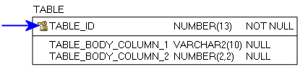
Figure 1: Primary Key Example
Foreign Key (FK):
When a Primary Key from a Parent Table appears as a column in the Child Table it is referred to as a Foreign Key (FK). The FK may retain the same name of the Parent Table column, or it may be renamed.
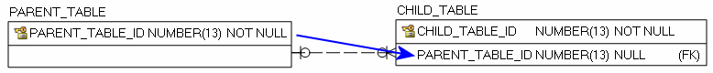
Figure 2: Foreign Key Example

Alternate Key (AK):
Alternate Keys (AK) are secondary unique identifiers in a Parent Table. A Child Table can link to a Parent Table AK and use it as a Foreign Key (FK). The FK may retain the same name of the Parent Table column, or it may be renamed. Alternate Keys allow null values.
Figure 3: Alternate Key Example

There are two relationship type options, identifying and non-identifying, which are described below.
An Identifying Relationship occurs when a column from the Parent Table is added to the key section of the Child Table. Though technically a Foreign Key (FK) in the child table, it now forms part of the Primary Key (PK). Identifying Relationships are symbolized with a solid line.
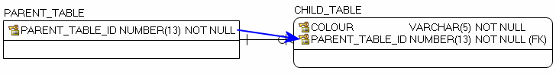
Figure 4: Example of an Identifying Relationship
A Non-identifying Relationship occurs when a column from the Parent Table is added to the main body of the Child Table where it is treated as a Foreign Key (FK). Non-identifying Relationships are symbolized with a dashed line.
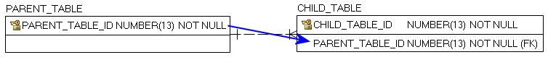
Figure 5: Example of a Non-identifying Relationship
The relationships between tables are set up with cardinality rules describing if the feature record in the Parent Table can relate to zero, one or more records in the associated Child Table and vice versa. These rules are symbolized in the model diagram as follows.
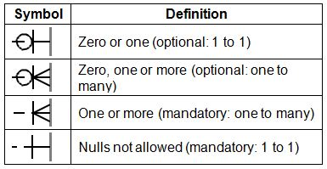
Figure 6: Model Diagram Relationship Symbology Table

APPENDIX C: Frequently Asked Questions

What is the difference between ORN Road Net Element (ORNELEM) and ORN Composite?
ORNELEM is a Linear Referencing System (LRS) relational database that locates point and line events along a linear segment at distance measures. ORN Composite is a segmented single table database derived from ORNELEM. Major differences between the two products can be found below.
ORN Composite
- Simplified version of the ORN database recommended for most mapping and general spatial analysis
- End user focus with easily consumable geospatial road information
- More segmentation of linear road features – segmentation based on all attributes
- Some information stored in simplified composite text fields
ORNELEM
- Requires an advanced knowledge of GIS including LRS and complex table relationships.
- Less segmentation of linear road features – segmentation occurs only at intersections
- Most road information is stored in related tables and referenced to measurements along linear road features
- Ability to generate custom derivatives based on any of the road information tables
Attribute tables included in ORNELEM that do not exist in ORN Composite:
- ORN_ROAD_NET_ELEMENT_FT
- JUNCTION
- ROAD_NET_ELEMENT_SOURCE
- ROUTE_NAME
- STREET_NAME_PARSED
Attributes included in ORN Composite
- ADDRESS_INFO
- ALTERNATE_STREET_NAME
- DIRECTION_OF_TRAFFIC_FLOW
  - Found in ORNELEM in ORN_ROAD_NET_ELEMENT_FT
- JURISDICTION
- NUMBER OF LANES
- OFFICIAL_STREET_NAME
- PAVEMENT STATUS
- ROAD_CLASS
- ROAD_NET_ELEMENT_TYPE
  - Found in ORNELEM in ORN_ROAD_NET_ELEMENT_FT
- ROUTE NUMBER
- SHIELD TYPE
- SPEED LIMIT

What is a Linear Reference System (LRS)?
A Linear Reference System (LRS) allows attributes to be assigned to specific positions (distance measures) along a linear segment. Attributes are stored in separate tables and linked to the geometry through a unique ID.
For additional information on Linear Referencing visit ESRI’s ArcGIS Resources: What is linear referencing? (http://resources.arcgis.com/en/help/main/10.1/index.html#//003900000001000000)

Where do I find 911 addresses?
The ORN receives data from authoritative sources responsible for 911 address management for the purposes of emergency management. Not all areas of Ontario are covered by a 911 addressing management system but those areas will typically have a system of addressing assigned to roads which are represented in the ORN. Addressing information is available in ORN Road Net Element in the ADDRESS_INFO table, and in the ORN Composite attributes.

What is the difference between 911 and civic addresses?
A civic address consists of a street number, street name, municipality name, province code and postal code. A 911 address is similar and they combine to uniquely describe a specific location to help emergency services locate properties. In some areas of the province, a 911 address and civic address terms are used interchangeably or a 911 address may only refer to rural properties.

What is the difference between shield type and road class?
A shield type identifies a route assigned by a road authority, e.g. MTO, and is also used for cartographic purposes. Shield Type is part of ROUTE_NUMBER, found in both ORNELEM and ORN Composite. A road class identifies a type of road based on a functional class (e.g. highway, arterial). The ROAD_CLASS table is in both ORN data classes.

What is the difference between the Jurisdiction, Agency Name, and Road Net Element Source tables?
Jurisdiction indicates the agency has custodianship of a road with responsibility to ensure maintenance occurs but may not undertake it directly.
An Agency Name identifies the source agency that provided attributes. Agency Name is not available in ORN Composite.
The Road Net Element Source identifies the source agency that provided road net element geometry. Often Road Net Element Source and Agency Name are the same. Road Net Element Source is not available in ORN Composite.

What projection is used to calculate LENGTH in ORN?
The length of the ORN Composite is calculated in UTM. Each feature determines which UTM projection to use based on the centre of the feature.
UTM Zones in Ontario:
- 15 = -96 to -90
- 16 = -90 to -84
- 17 = -84 to -78
- 18 = -78 to -72

I have an issue or disagreement with a road name in the ORN. Are you able to rename the road or remove the name?
The ORN relies on partner organizations to provide authoritative road data including official road names. As we are not responsible for assigning official road names we cannot rename or remove the name of a road feature. The quality control processes used to maintain the ORN will identify names that have been rescinded by the Government of Ontario for geographical features (such as lakes, rivers, bays). If a name is identified the ORN team will inform the original road data source owner. It is at the discretion of the source data owner to decide if a road is to be renamed. Users can contact source data owners directly to inquire about road names.

I still need help!
For more information visit GEO (https://www.ontario.ca/page/geospatial-ontario) or email your questions to geospatial@ontario.ca.

APPENDIX D: Creating a Network with ORN Composite

Introduction
The ORN Composite data class can be used to create a network for analysis and routing. The following appendix demonstrates one method for creating a network dataset using ArcGIS Pro and the Network Analyst extension. However, there are many ways to build a network using various software packages.

Creating the Network

Steps to Create the Network Dataset
- Load ArcGIS Pro and click on the Settings icon (Figure 7).
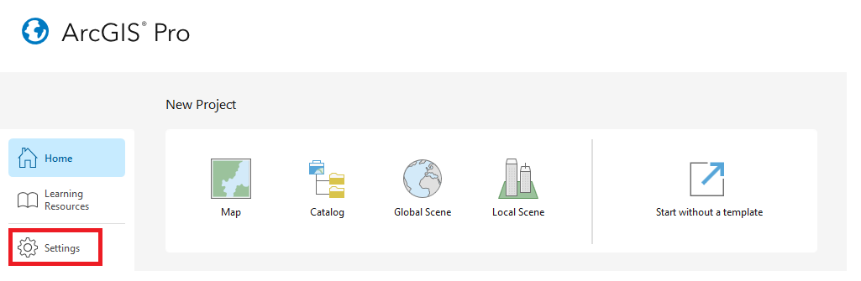
Figure 7: Accessing ArcGIS Pro Settings

- Open the Licensing menu and click the Configure your licensing options button (Figure 8).
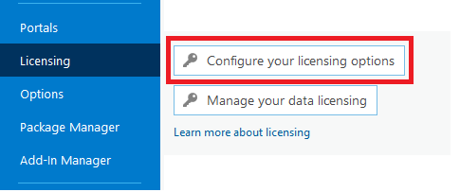
Figure 8: Configure Your Data Licensing
- Select the Advanced Pro core product license level and ensure that the Network Analyst extension is enabled (Figure 9).
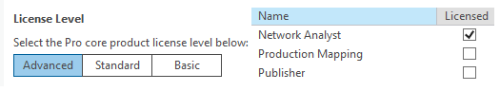
Figure 9: Enable Network Analyst Extension
- Create a new Catalog project (Figure 10).
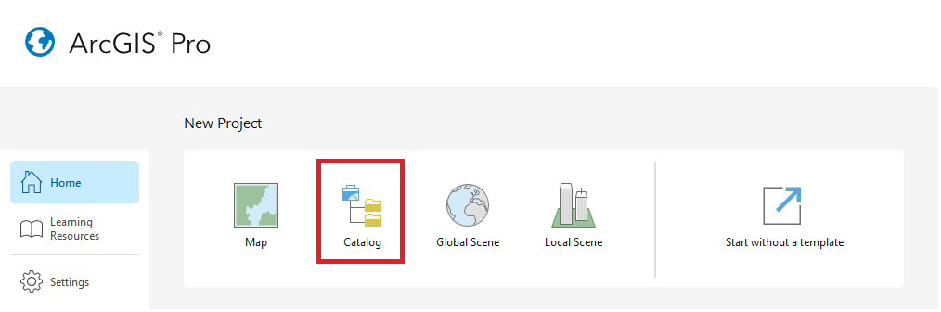
Figure 10: Create New Catalog Project
- In Catalog, navigate to your ORN Composite file geodatabase. Right click on the geodatabase and create a new feature dataset (Figure 11).
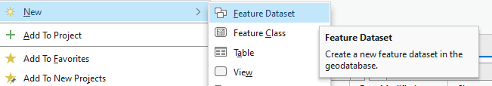
Figure 11: Create New Feature Dataset

- Input the Create Feature Dataset parameters and ensure that the coordinate system matches the coordinate system of your file geodatabase and click on the Run button (Figure 12).
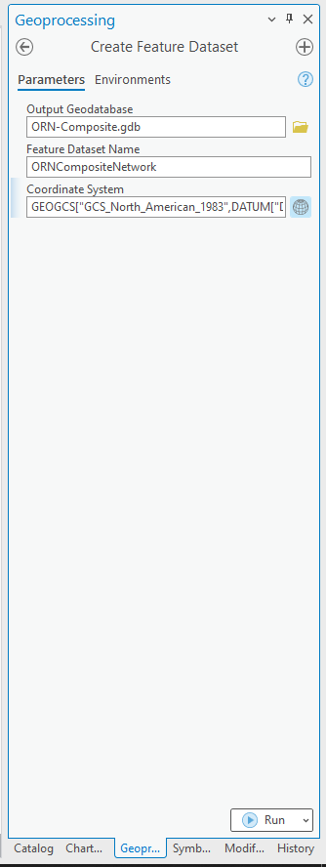
Figure 12: Create New Feature Dataset Parameters
- Copy ORN Composite feature classes and paste them into your newly created feature dataset.
- Right click on newly created feature dataset. Create new Network Dataset (Figure 13).
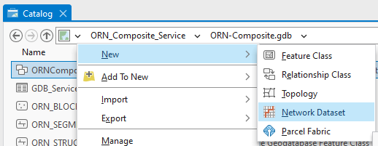
Figure 13: Create New Network Dataset

- Fill out the Create Network Dataset parameters and click Run (Figure 14).
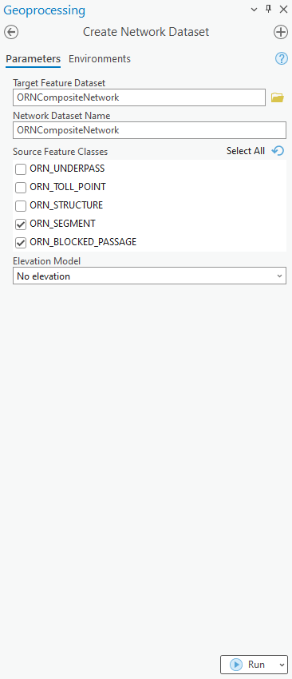
Figure 14: Create Network Dataset Parameters

Steps to Define the Network Attributes
- In Catalog, right click on your newly created Network Dataset and open Properties (Figure 15). The Network Dataset Properties window will open (Figure 16). The Network Dataset Properties can be used to define your network attributes.
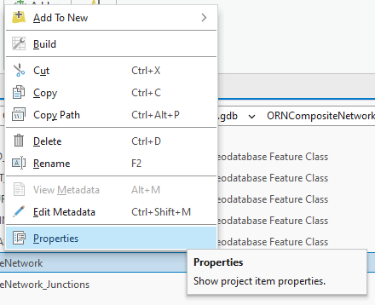
Figure 15: Open Network Dataset Properties
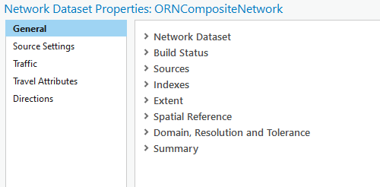
Figure 16: Network Dataset Properties Window

Steps to Enforce One Way Restrictions
It is important to enforce traffic flow restrictions to ensure that rules along one-way roads are followed and that network analyses behave as expected. The ORN Composite data class contains traffic flow direction information in the “DIRECTION” field of the ORN_SEGMENT feature class. Possible values are described in Table 1.
Table 1 – Possible values in the “DIRECTION” field
DIRECTION | Description
Both | Traffic can travel in both directions along the given segment
Positive | Traffic can only travel in the same direction as the segment’s geometry.
Negative | Traffic can only travel in the opposite direction as the segment’s geometry.

- In the Network Dataset Properties window, navigate to Travel Attributes, click on the Restrictions tab and use the menu button to create a new restriction (Figure 17).
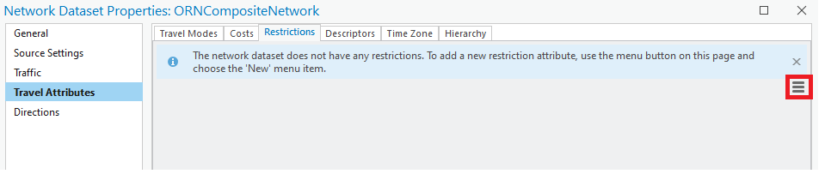
Figure 17: Creating a New Restriction
- Within the Properties dropdown of your new restriction, give it a name and ensure that the Usage Type is Prohibited. Within the Evaluators dropdown, update the ORN Segment Along and Against type to Field Script. Within the Prohibited column of the Evaluators dropdown menu, click on the Field Script menu button to define your expressions for ORN Segment Along and Against (Figure 18).
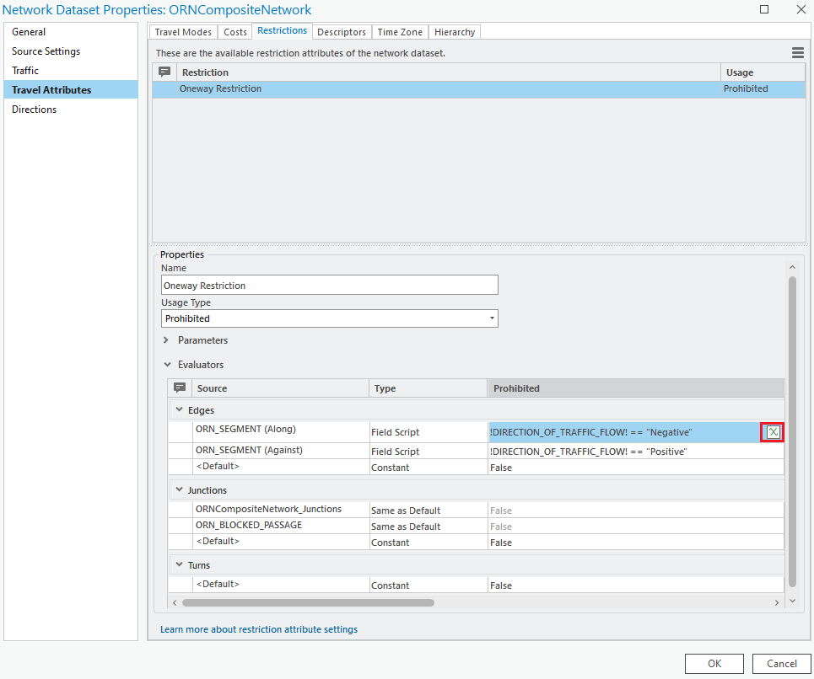
Figure 18: Restriction Properties and Evaluators

- Set the value equal to the appropriate expression listed in Table 2 and click OK (Figure 19).
Table 2 – Expressions for enforcing traffic flow directions
Direction | Value Expression
Along | !DIRECTION_OF_TRAFFIC_FLOW! == "Negative"
Against | !DIRECTION_OF_TRAFFIC_FLOW! == "Positive"

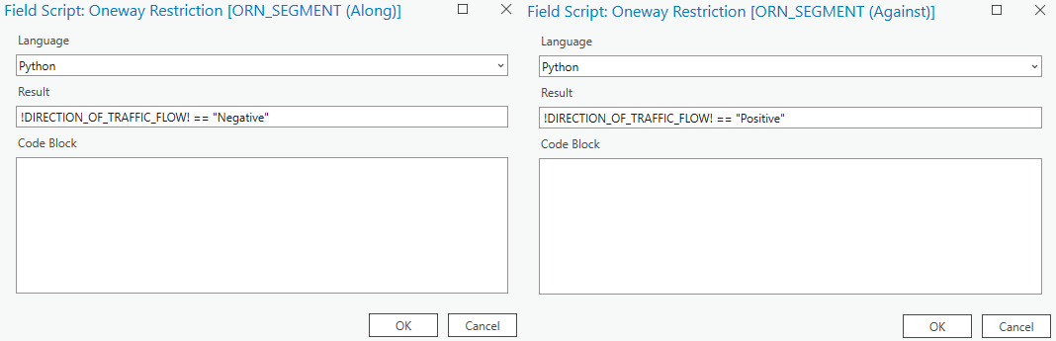
Figure 19: Field Script Window for One Way Restrictions

Steps to Enforce Blocked Passage Restrictions
In addition to one-way travel restrictions, additional restrictions can be configured using the data supplied with the ORN Composite service, including Structures (width and weight restrictions for truck travel), Underpasses (height restrictions for truck travel), and Toll points (enable users to avoid tolls while travelling). Using these features may require the addition of information not currently included in the dataset to be effective, such as bridge width and weight restrictions (structures), height restrictions (underpasses), or toll cost.
Blocked passage restrictions, however, can be used directly without gathering additional attribute information.
- In the Network Dataset Properties window, navigate to Travel Attributes, click on the Restrictions tab and use the menu button to create a new restriction (Figure 17).
- Give the restriction a name (e.g. BlockedPassage) and that the Usage Type is Prohibited
- Optionally, you can further configure the restriction, or set up a second restriction, that prohibits travel only for permanent barriers. To do so:
  - Under Evaluators, Junctions, update the Type for ORN_BLOCKED_PASSAGE to Field Script. Open the Field Script settings (Figure 20) and input the following (Figure 21):
!BLOCKED_PASSAGE_TYPE! == ‘Permanent’

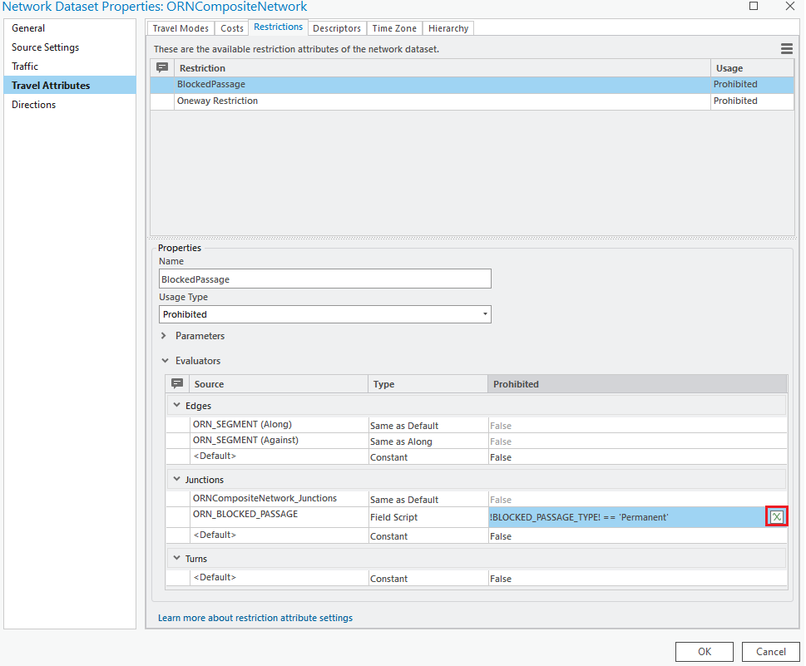
Figure 20. Blocked Passage Evaluators for Permanent Barrier Only Restriction

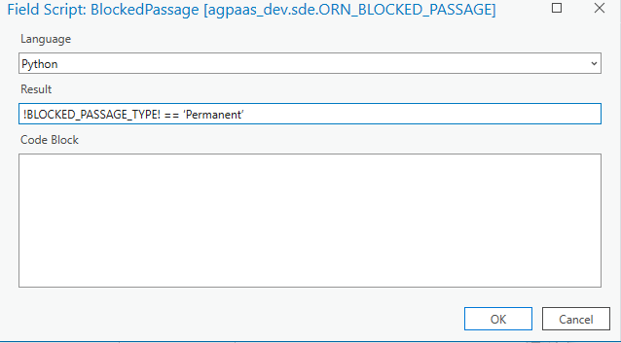
Figure 21. Field Script Window for Permanent Blocked Passage Restrictions

Steps to Build a Road Class Hierarchy
A hierarchy can be built using road classifications to help reduce network analysis computation time. The hierarchy classifies the roads into several levels which are then used by the networking algorithms to primarily search the higher levels of the hierarchy (ex. Travel over highways will be preferred over local roads). It is important to consider that enforcing a road hierarchy will often result in solutions with a higher cost (ex. total distances and travel times may be greater when using a hierarchy). It will be necessary to experiment with hierarchy settings if one decides to use it.
- In the Network Dataset Properties window, navigate to Travel Attributes, click on the Hierarchy tab and click on the Add Hierarchy Attribute checkbox to create a new Hierarchy (Figure 22).
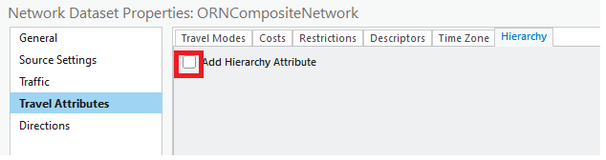
Figure 22: Add Hierarchy Attribute
- In the Ranges dropdown, ensure Primary Roads are 1 -1, Secondary Roads are 2 -2, and Local Roads are ≥ 3. Set <Default> as Type “Constant” and value as ‘4’.
- In the Evaluators dropdown, update the Type for Along to Field Script. The Type for Against will be set as “Same as Along”. Open the Field Script settings for Along (Figure 23).

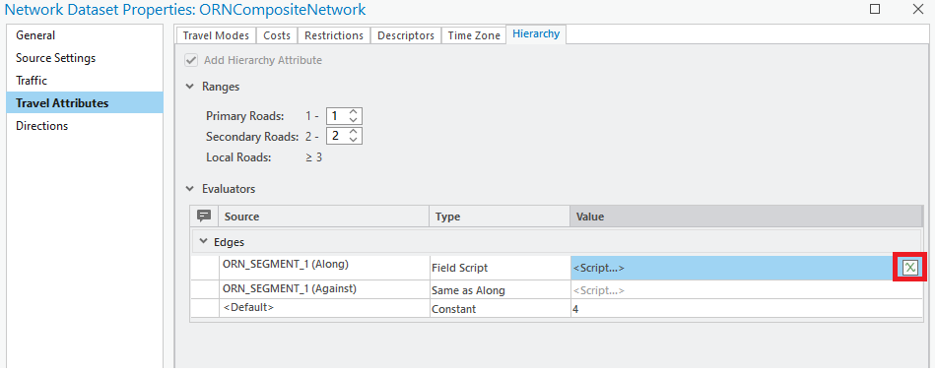
Figure 23: Hierarchy Ranges and Evaluators
- Write an expression to calculate an integer value for each road classification (Figure 24).

RoadClass = 4

if "Freeway" in !ROAD_CLASS!:
RoadClass = 1
elif "Ramp" in !ROAD_CLASS!:
RoadClass = 1
elif "Expressway / Highway" in !ROAD_CLASS!:
RoadClass = 2
elif "Arterial" in !ROAD_CLASS!:
RoadClass = 2
elif "Collector" in !ROAD_CLASS!:
RoadClass = 3
elif "Local / Street" in !ROAD_CLASS!:
RoadClass = 3
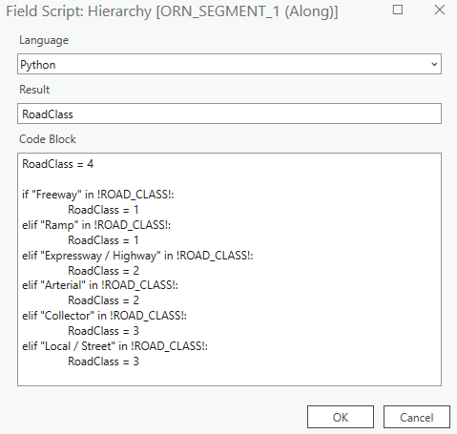
Figure 24: Hierarchy Evaluators Field Script

Steps to Estimate Travel Time
- In the Network Dataset Properties window, navigate to Travel Attributes, click on the Descriptors tab and use the menu button to create a new descriptor (Figure 25).
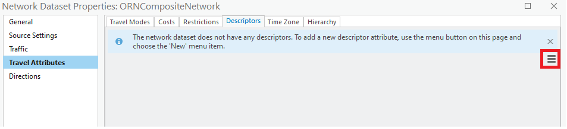
Figure 25: Create New Descriptor
- In the Properties dropdown ensure that Units are set to Kilometers/Hour and Data Type is set to integer.
- In the Evaluators dropdown, update the Type for Along to Field Script. The Type for Against will be set as “Same as Along”. Open the Field Script settings for Along (Figure 26).
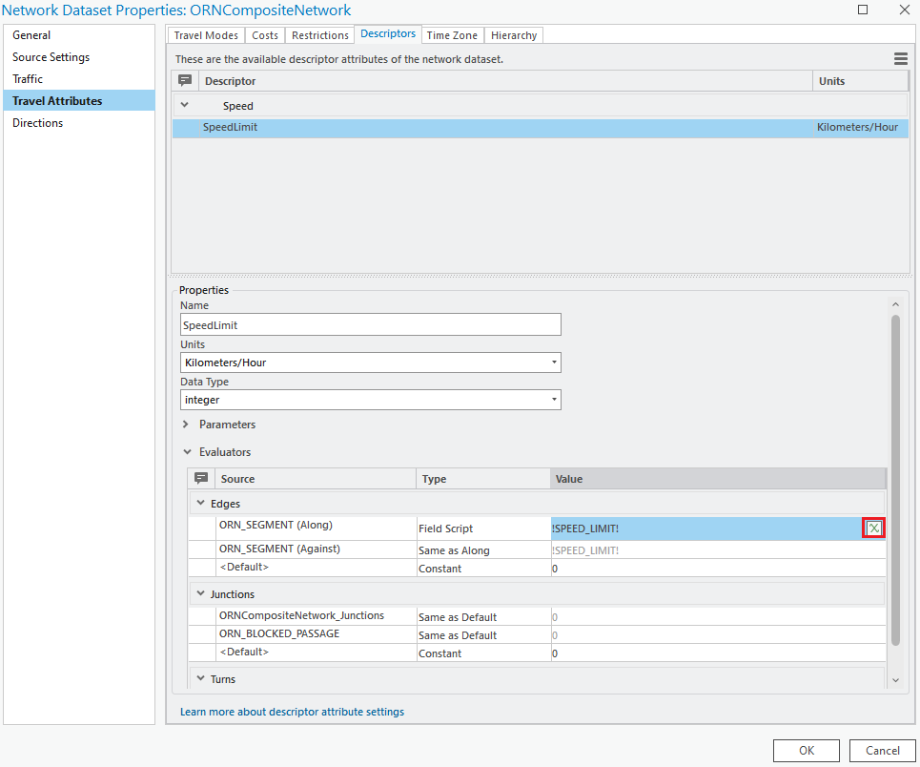
Figure 26: Descriptor Properties and Evaluators

- Write an expression to identify speed limit (Figure 27).
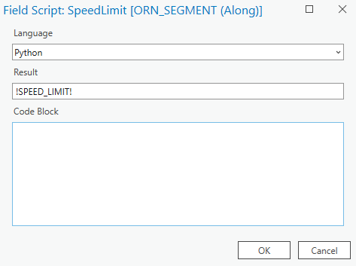
Figure 27: Speed Limit Field Script
- In the Network Dataset Properties window, navigate to Travel Attributes, click on the Costs tab.
- Highlight the Length attribute, navigate to the Evaluators dropdown and update the value of ORN_SEGMENT (Along) to !LENGTH! (Figure 28).
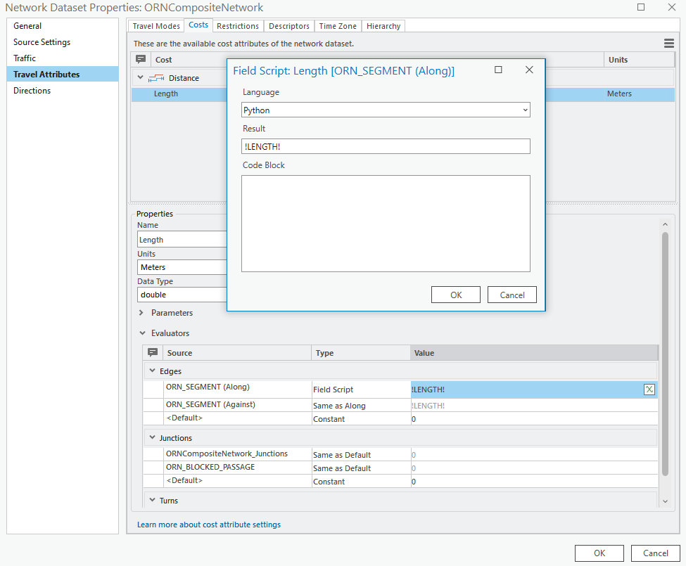
Figure 28: Length Field Script
- In the Network Dataset Properties window, navigate to Travel Attributes, click on the Costs tab and use the menu button to create a new cost (Figure 29).
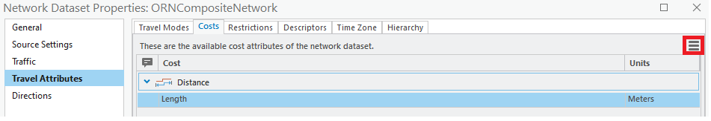
Figure 28: Create New Restriction
- In the Properties dropdown, ensure that Minutes are assigned for Units and double is assigned for Data Type.
- In the Evaluators dropdown, update the Type for Along to Field Script. The Type for Against will be set as “Same as Along”. Open the Field Script settings for Along (Figure 30).
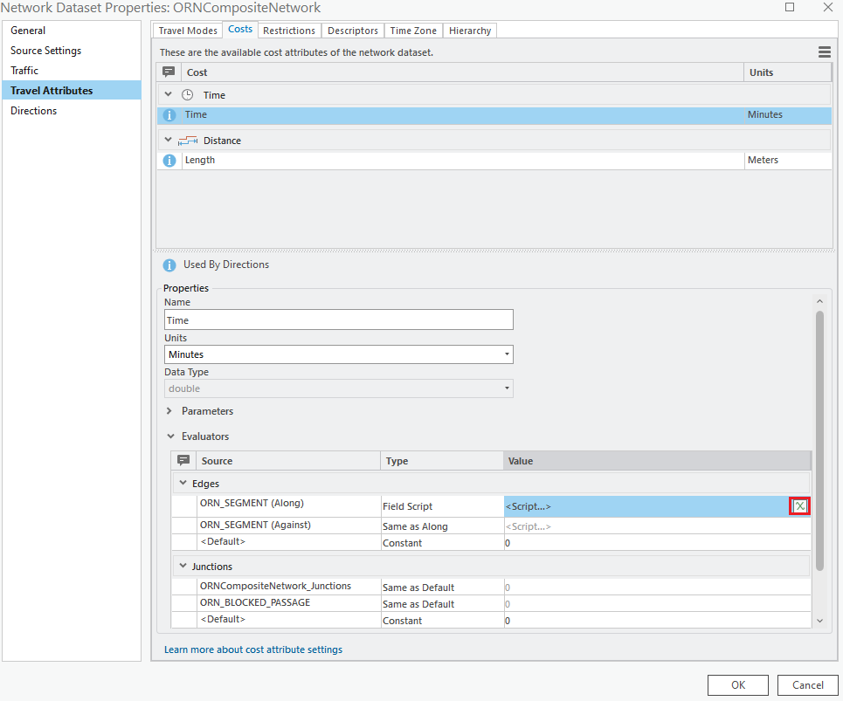
Figure 29: Costs Properties and Evaluators

- Write an expression to calculate the time needed to travel each edge segment based on its length and speed limit (Figure 31). An example Python script is shown below.

Time = ((!LENGTH! / 1000) / !SPEED_LIMIT!) * 60

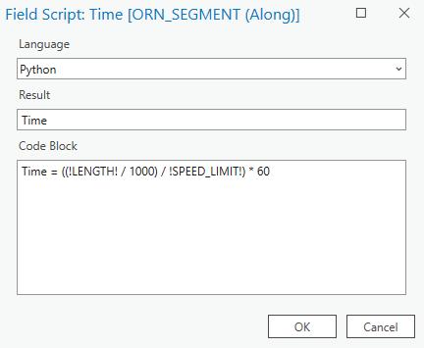
Figure 30: Time Calculation Field Script
Note: Road segments that have a ROAD_ELEMENT_TYPE value of FERRY CONNECTION or VIRTUAL ROAD will have a SPEED_LIMIT value of <Null>. If you would like this script to work for these road segments, replace these <Null> values with an estimated speed limit numeric value.

Steps to Establish Driving Directions
- Create a travel mode if desired (Figure 32). Otherwise, in the Network Dataset Properties window, navigate to Directions, click on the General tab and click on the Support Directions checkbox (Figure 33).
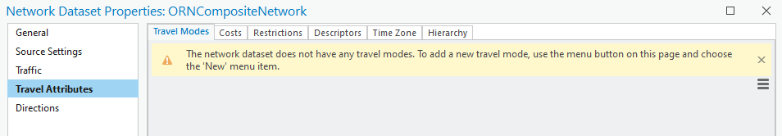
Figure 31: Create New Travel Mode
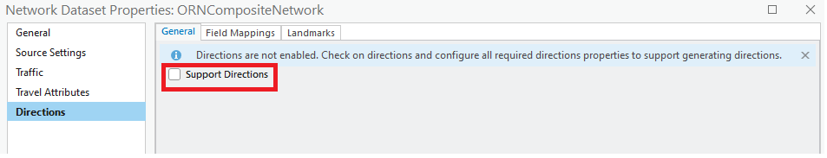
Figure 32: Network Dataset Properties - Directions

- Select the “Field Mappings” tab and populate the street name and alternate street name columns with the field names as shown in Figure 34 and click on the OK button.
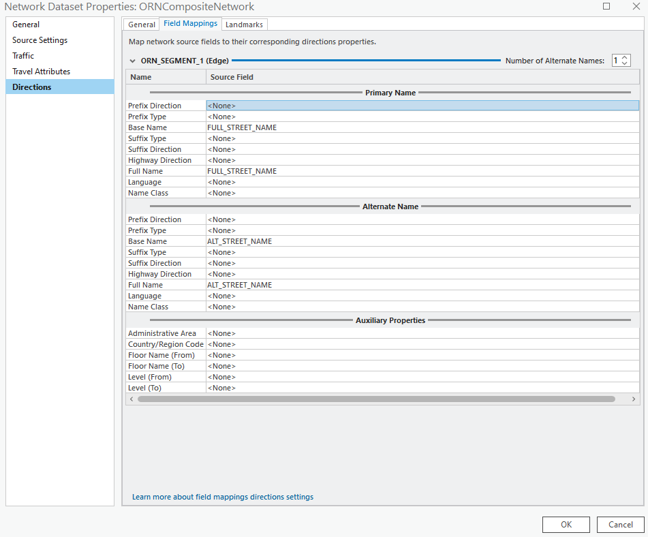
Figure 33: Field Mapping Window for Directions

Steps to Finish Building the Network Dataset
- In Catalog, right click on the network dataset and select “Build” (Figure 35). In the “Build Network” window, ensure that the Input Network Dataset parameter in populated and click on the “Run” button.
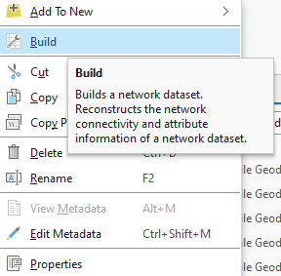
Figure 34: Build Network Dataset

- Add your network and network junctions to a new map to view the completed network dataset (Figure 36) and begin exploring the different Network Analyst tools (Figure 37).

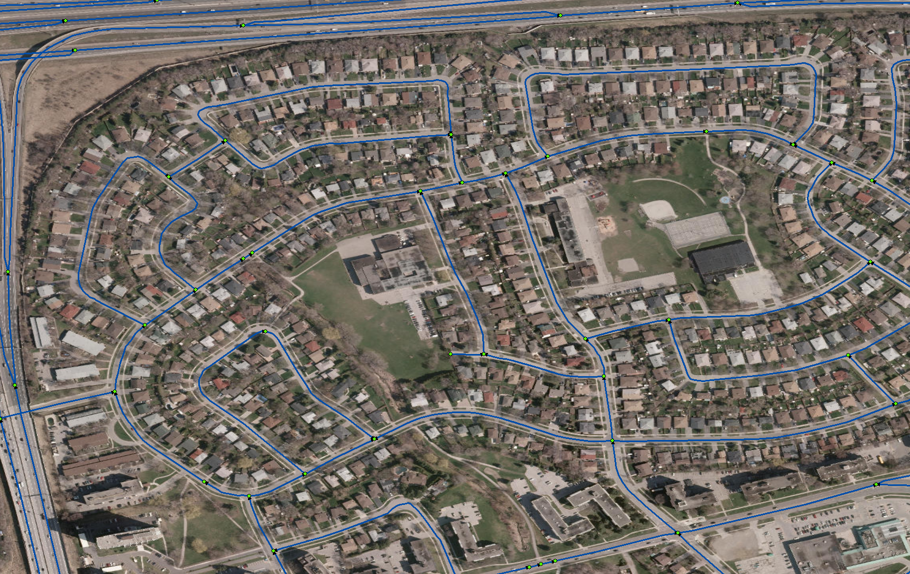
Figure 35: The Network Dataset
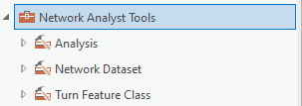
Figure 36: The Network Analyst tools.

Version 2526.1
Version 2324.1

