
Land Information Ontario (LIO) Warehouse
Data Class Name: Ownership Parcel
Documentation
Produced by: Produced by: Spatial Data Support Unit
Ministry of Natural Resources and Forestry
Date: December 12, 2017

Purpose

This document provides additional information to support the use of geospatial data. The Physical Model Diagram provides a visual representation of the relationships in the data class. The Data Change History lists all the modelling and access changes that have occurred during the lifecycle of the data class. A data description identifying table and field names is available upon request.

Need Assistance?
Please contact LIO Support at lio@ontario.ca or 705-755-1878 if you require help.

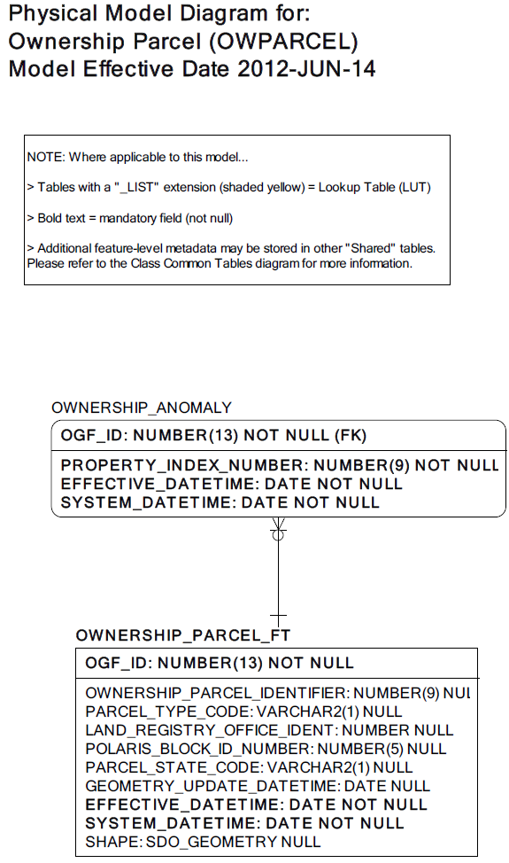
Data Class Change History

Data Class Name: Ownership Parcel
Data Class Short Name: OWPARCEL
Date  YYYY-MM-DD | Details of Change
2017-12-12 | Abstract Class changed from Single Non-Tessellating Polygons (SPSNTPOLY) to Multi Non-Tessellating Polygons (SPMNTPOLY). This reflects the current spatial rules and software capabilities associated with the spatial data being submitted. The change is also due to the fact that at the Spatial Database Engine (SDE) Layer Definition level, all polygon layers are defined as multi-part polygons and overlaps are permitted.
2015-06-15 | Data type changed from NUMBER to VARCHAR for: OWNERSHIP_PARCEL_FT.OWNERSHIP_PARCEL_IDENTIFIER OWNERSHIP_PARCEL_FT.POLARIS_BLOCK_ID_NUMBER  OWNERSHIP_ANOMOLY.PROPERTY_INDEX_NUMBER  Change included data maintenance to add leading zeros to the text strings in the fields with changed datatypes
2005 | NEW Data Class
Data Description
Please refer to the metadata record for the data description.

