Updating Provincial Elevation Data Using Least Cost Path Analysis
Technical Guide

  - Geospatial Ontario
  - Digital, Data, Information and Business Services Branch
  - Corporate Management and Information Division
  - Ministry of Natural Resources

2026-03-09

Disclaimer
This technical documentation has been prepared by His Majesty the King in right of Ontario as represented by the Ministry of Natural Resources (the “Ministry”). No warranties or representations, express or implied, statutory or otherwise shall apply or are being made by the Ministry with respect to the documentation, its accuracy or its completeness. In no event will the Ministry be liable or responsible for any lost profits, loss of revenue or earnings, claims by third parties or for any economic, indirect, special, incidental, consequential or exemplary damage resulting from any errors, inaccuracies or omissions in this documentation; and in no event will the Ministry’s liability for any such errors, inaccuracies or omissions on any particular claim, proceeding or action, exceed the actual consideration paid by the claimant involved to the Ministry for the materials to which this instructional documentation relates. Save and except for the liability expressly provided for above, the Ministry shall have no obligation, duty or liability whatsoever in contract, tort or otherwise, including any liability or negligence. The limitations, exclusions and disclaimers expressed above shall apply irrespective of the nature of any cause of action, demand or action, including but not limited to breach of contract, negligence, strict liability, tort or any other legal theory, and shall survive any fundamental breach or breaches.

Additional Information
This document does not comply with all the applicable guidelines for accessible digital documents. For an alternative format please email Geospatial Ontario at geospatial@ontario.ca.
For more information about this document, please contact Geospatial Ontario at geospatial@ontario.ca.

Executive Summary

Key Words
Buffer, Digital Elevation Model, DEM, Digital Surface Model, DSM, Digital Terrain Model, DTM, Least Cost Path, Mapping and Geomatics Services Section, MGSS, Mosaic, Provincial Mapping Unit, PMU, Raster, Tool

Abstract
This technical user guide provides support on how to use the ‘Create Cost Path’ Python tool which was originally developed in ESRI ArcGIS version 10.3.1 and ported over to ArcGIS Pro. This guide also steps through the data preparation, and the final DEM clipping and mosaicking process to update the Provincial DEM (PDEM).

Revision History
Date | Edition/  Version | Description
2018-05-17 | 0.1 | Initial Draft Version
2018-07-05 | 0.2 | Draft – limited release
2020-04-08 | 1.0 | First public release
2022-08-03 | 1.1 | Updated OWIT references
2026-03-09 | 2.0 | New template and French translation

Table of Contents
Disclaimer 2
Software Disclaimer 3
Additional Information 3
Executive Summary 4
Key Words 4
Abstract 4
Revision History 5
Table of Contents 6
List of Acronyms 7
1. Introduction 8
2. Objectives 9
3. Preparing the Elevation Data 10
4. Create Cost Path Tool 16
5. Final DEM Update Process 20
6. References 22

List of Acronyms
DEM: Digital Elevation Model
DSM: Digital Surface Model
DTM: Digital Terrain Model
GIS: Geographic Information System
GTA: Greater Toronto Area
LCP: Least Cost Path
MGSS: Mapping and Geomatics Services Section
MIRB: Mapping and Information Resources Branch
MNR: (Ontario) Ministry of Natural Resources
OWIT: Ontario Watershed Information Tool
OIH: Ontario Integrated Hydrology data
QA/QC: Quality Assurance / Quality Control
PDEM: Provincial Digital Elevation Model
PMU: Provincial Mapping Unit
SWOOP: Southwestern Ontario Orthophotography Project
- Introduction
The Provincial DEM (PDEM) is a unique product composed of several elevation data sources across Ontario. The data used to compile the PDEM traditionally comprised of Ontario Basic Mapping elevation sources (a combination of DTM and contours) captured at 1:10 000 for southern Ontario and 1:20 000 for central Ontario, and the Shuttle Radar DSM product for northern Ontario. The intent of the PDEM was to support ministry broad scale mapping and analysis applications at the regional level. Despite the stated vertical accuracies of +/- 5 metres for these data sources, they are a snap shot in time and do not necessarily reflect the current terrain and the constant change that is occurring due to natural resource activities, urbanization and natural disturbance from erosion and weather related events. For these reasons, there is an interest to update the PDEM using more recent data acquisitions starting with the photogrammetrically derived DTM’s for the Greater Toronto Area (GTA), southwestern Ontario (SWOOP), and the Lidar derived DTM’s for Lake Erie, Peterborough County, and potentially other regions of Ontario.
The Least Cost Path (LCP) method was introduced in 2011 as a way to seamlessly incorporate the Shuttle Radar DSM product into the PDEM where previously there was no data north of the Forestry Management Area of Undertaking. This update was required to support community based land use planning in the Far North. This method proved effective in minimizing artificial cliff and valley artifacts along the mosaic cutline between differently sourced elevation products, and therefore has been adopted as the main method for updating the PDEM for the rest of Ontario.
The LCP method was subsequently automated in Python with the development of the “Create Cost Path” tool. However, there is a fair amount of data preparation required before running the tool which is also described in this document.
Unless otherwise noted, visual examples portrayed in this document pertain to the 2017/18 Lidar acquisition for Peterborough County, a relatively small area (approximately 6800 square kilometres) which proved effective in illustrating the key interim and final outputs of the LCP procedure.
- Objectives
The objective is to implement an effective method of updating the Provincial Digital Elevation Model (PDEM) with newly acquired elevation products across the province of Ontario while preserving the original terrain values as much as possible from the respective data sources. Many of the new products have improved levels of accuracy when compared to older data sources which can be explained by technology innovation and changes to the terrain over time. This variation can cause issues when two different products meet. Complicating the issue further is the fact that the PDEM is used in several key products and online services produced by the Provincial Mapping Unit (PMU) for resource management activities including the Ontario Watershed Information Tool (OWIT), Ontario’s Integrated Hydrology and Watershed Boundaries. Therefore, a clear and defensible approach to creating a smooth transition between data sources becomes important. Traditional methods like merging and mosaic blending have their own inherent issues. Simply dropping in newer more accurate products could create an artificial cliff effect where they merge. The blending option applies a weighted average to values between sources which has the following limitations:
- Blending results can vary depending on the amount of overlap.
- Elevation artifacts can be introduced in fringe areas where previously there was no data.
- It is difficult to estimate the level of accuracy of overlapping areas that have been blended. It is also difficult to source these values for metadata purposes.
- The less overlap you have, the greater the chance of the “cliff effect” to occur.
This method and its automation also contribute to streamlining data processing workflows and updates to all our inter-related products specifically the fundamental surface water derivative products managed by the PMU such as the Ontario Integrated Hydrology (OIH) and Ontario Watershed Boundary (OWB) data products. Finally, implementing standardized and efficient updating processes allow us to be more responsive to changes over time.
- Preparing the Elevation Data
The PDEM update process begins with preparing the new and existing elevation data to be run through the Create Cost Path tool explained in the next section.
- Load PDEM into a new ArcMap session and save the MXD.
- Ensure Data Frame matches loaded raster projection.
- Obtain new DEM source. Typically, the new acquisition may already include a geodatabase raster mosaic for internal staff use or you can create your own. When creating a new mosaic, keep in mind the following tips:
  - Overviews should be built for each mosaic which are required for resampling.
  - If the following error is encountered when trying to add rasters, ensure your Environment Settings are set to the projection of the input data and processing extents are set to “Union of Inputs”.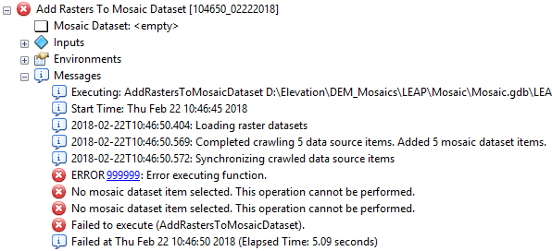
Figure 1: Error produced when trying to add rasters to a mosaic dataset with incorrect environment settings

- Reset the Environment Settings > Output Coordinate System to NAD_1983_Ontario_MNR_Lambert.
- Create an extent box polygon around the new DEM source using the Draw toolset. Save graphic as a polygon feature.
- Reset the following Environment Settings:
  - Processing Extent: Select the extent box polygon just created. Round off each extent value so that they are exactly divisible by 30.
  - Snap Raster: PDEM (if you previously saved your settings to defaults, check to make sure this layer actually exists before continuing or else ArcMap will ignore this setting resulting in a cell shift when resampling!)
  - Raster Analysis > Cell Size: 30m
  - Raster Storage > Resample: BILINEAR
- Resample entire New DEM mosaic to 30m using the PDEM for the Output Cell Size. The Resampling Technique should be automatically set to BILINEAR. (Note the LEAP 2010 1m mosaic took about 35 minutes to process)
- Create a footprint of the 30m raster just created. Quickest way to do this is by using 3D Analyst Tools > Conversion > From Raster > Raster Domain. Choose the LINE option. (NewDEM_rasterDomain_ln)
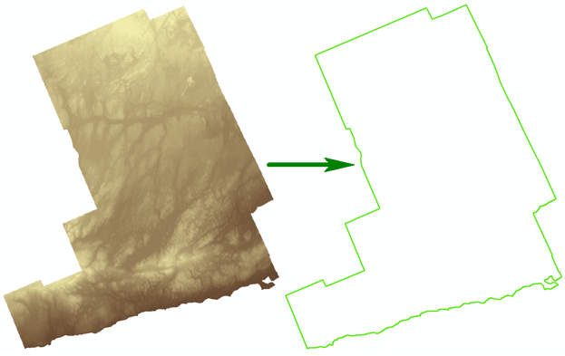
Figure 2: Example of raster domain outline of Peterborough County Lidar acquisition.
- Save the portion of the footprint that traverses only on land to a separate layer. (NewDEM_edge) A cost path does not need to be generated in large water bodies like the Great Lakes or Lake Simcoe, and also at the outer edge of the PDEM. However, extending the cost path a few cells into the lake is advisable so the entire land portion is properly interpolated. The in-lake portions of the footprint should be discarded in the resultant layer. Traversing over smaller water bodies may be unavoidable and is usually okay in most cases. An example is shown in Figure 3 below where the northwestern edge of the Lidar acquisition traverses over Pigeon Lake. A visual inspection of the cost path generated in these areas is advisable. If the results are not acceptable (e.g. an exaggerated difference in lake elevation between data sources may cause an artificial ‘waterfall’ effect), altering the centre line created in the next couple steps so that the line traverses around a problem water body inside the new data study area may correct the problem.
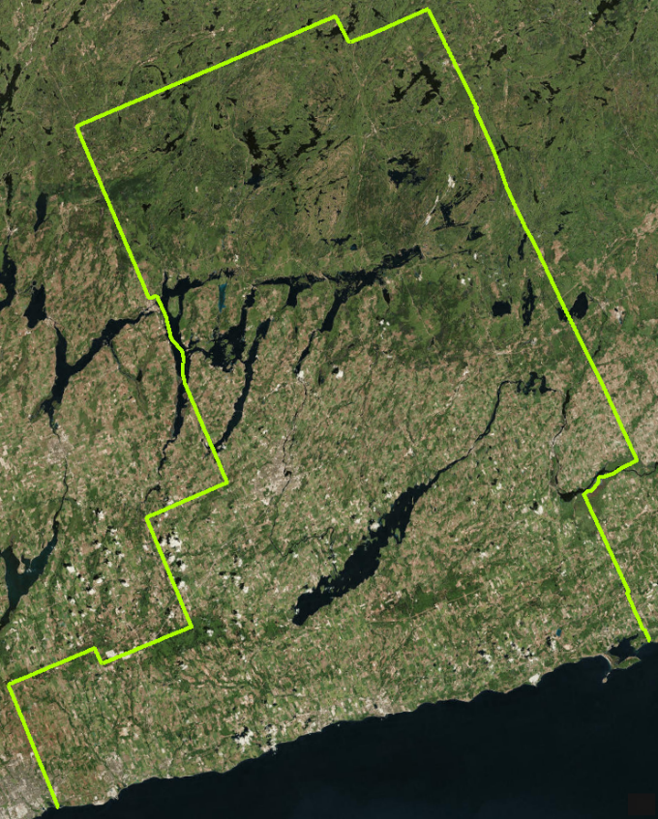
Figure 3: Inland edge of the acquisition excluding Lake Ontario saved to a new layer.
- Buffer in from the edge of the domain extent a certain distance to create the Initial Buffer (see Figure 4A). This distance will depend on the quality and vintage of the DEM/DTM’s you are mosaicking together. It should also be slightly more than half the width of the analysis corridor to be created. For example, if you are mosaicking over an older OBM based area using a new large scale data source, there could be a wider range of difference between the two products than if you were mosaicking over a more recent DTM data source. Therefore, a wider buffer distance should be used for updating an OBM based area (e.g. 500m for OBM-DTM or 1000m for OBM-Contour) versus updating a newer data source (e.g. 250m or even 100m can be sufficient if there is a high co-relation between the products being mosaicked). Note you should add 1m to the desired buffer value when creating the Initial Buffer to ensure you are completely within the new dataset’s domain. The Create Cost Path tool supports a predefined list of buffer distances (which can be modified if necessary). Table 1 below lists these buffer distances along with the suggested 1m addition for the initial buffer:
Table 1: Initial and Final Buffer Distance Options
Desired Distance (m) for the Final LCP Buffer Corridor | Suggested Distance (m) for the Initial Buffer
100 | 101
200 | 201
250 | 251
500 | 501
1000 | 1001
2000 | 2001
X | X + 1
In the end, use your best judgment when choosing the appropriate distance. Accept all other defaults for the buffer command.
- Convert the initial buffer to a line (NewDEM_centreline) and edit the line so that only the side that is completely inside the new data extents is retained (Figure 4B). Make sure to dissolve this line into one continuous feature before running the LCP tool.

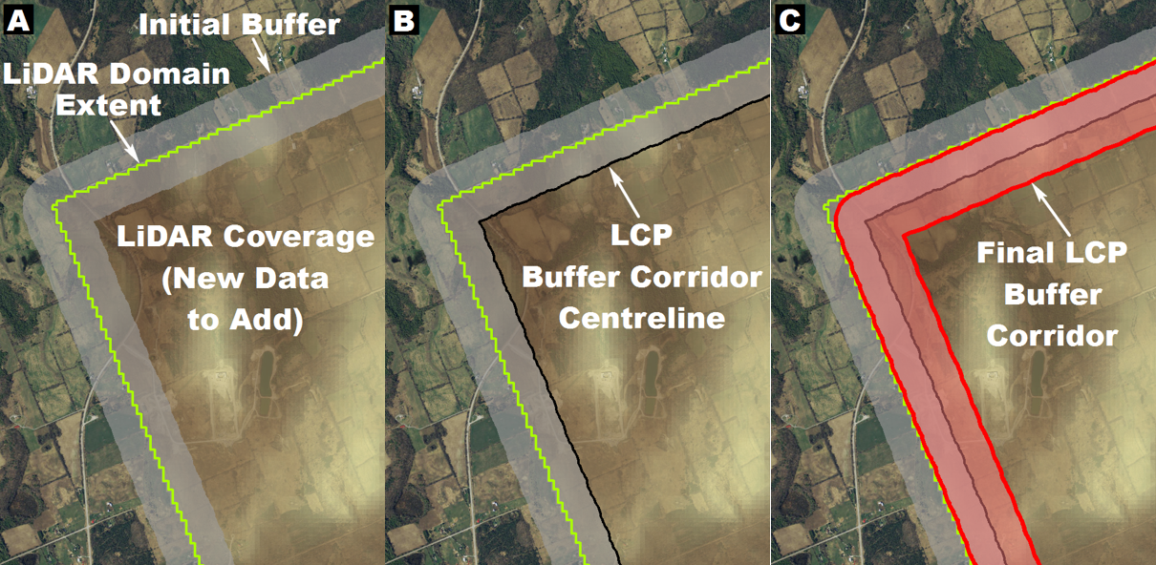
Figure 4: Zoom-in illustrating the creation of the LCP Buffer Corridor polygon.
- As an optional test to understand the process of the tool, buffer this line again but this time select a distance that is 1m less than the previous distance selected (e.g. 500, 1000 or 250m). This would in principle be equivalent to the LCP Buffer Corridor polygon layer the Create Cost Path tool generates (Figure 4C above), but you also have the option of customizing the buffer and using this as input to the tool instead (described later in section 4). But for the purpose of this test, manually creating the buffer allows you to see if it will meet all the criteria for a successful run through the tool. Figure 5 illustrates some of the outputs of the Create Cost Path tool and offers up a few criteria to manually check for before running the tool. Note this step is optional as the tool automatically creates this buffer for you, but it serves as a good quick visual test before running the tool. Things to check for:
  - The LCP Buffer Corridor should intersect an overlap region between both DEM’s that need to be merged. There needs to be valid coincidental elevation values in each DEM in order to perform the LCP analysis successfully.
  - Make sure a portion of the new data falls within the buffered ends of the corridor or else you may encounter an error when running the Create Cost Path tool (unless you create your own source and destination points which is explained later).
  - As mentioned previously, you may want to avoid instances where the buffer corridor traverses completely over water where possible by altering the NewDEM_centreline to go over land around the water bodies. This change should be done within the data overlap and should also be weighed against how much of the new data will be lost by performing this modification.
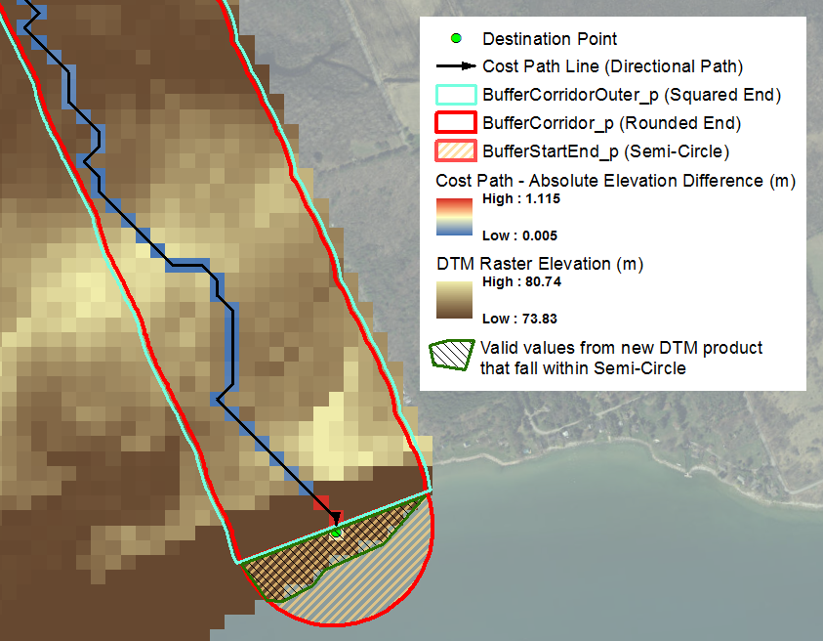
Figure 5: Outputs from the Create Cost Path tool. The area focuses on the southeastern corner of the Peterborough acquisition where the cost path interpolation ends over the nearshore area of Lake Ontario. It is important to have valid elevation values that fall within the semi-circle region for the new product being incorporated. However, these values do not have to cover the entire extent of the semi-circle.
- ArcMap may tie up layers which may interfere with further processing, so it is good practice to save your MXD at this stage and exit.
- Note for a new area that is completely inland (e.g. landlocked) that you would like to add to the PDEM and there is a mosaic or elevation data service available for the new data, there is an optional tool (currently under development) you can use to automate steps 4 to 10 to create the required buffer corridor polygon for input to the Create Cost Path tool described in the next section.

- Create Cost Path Tool

Summary
This tool creates the optimum path of least elevation difference between the New DEM product being added and the Base DEM being updated (e.g. the PDEM). The main outputs include the cost path line and a cost path polygon buffer which will be used in the next section when combining DEM’s.

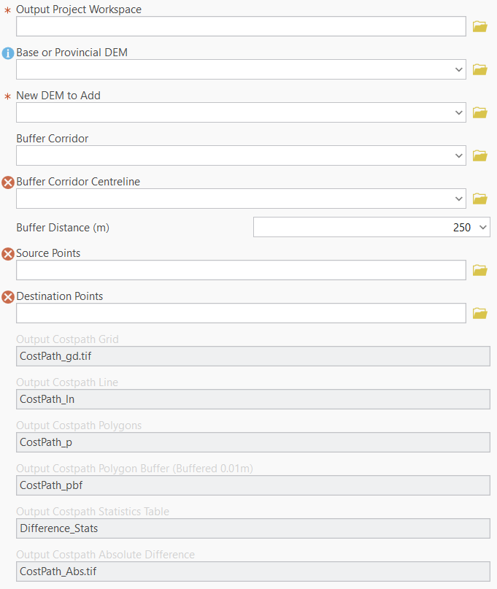
Figure 6: Create Cost Path tool in ArcGIS Pro

Data and Variable Inputs
- Output Project Workspace or subfolder where all vector and raster data outputs will be stored. Note when this parameter is populated with a valid path, all data output entries are automatically populated. Note all vector outputs will be stored in a file geodatabase called “Costpath.gdb” and rasters will be stored in the “Layers” subfolder.
- Base or PDEM (Grid) Existing DEM being updated.
- New DEM to ADD (Grid) New DEM that will be mosaicked to the Base DEM. Note this DEM should be resampled to the same cell size as the Base DEM.
- Buffer Corridor (Optional polygon) where the cost path analysis will be conducted. If a customized buffer corridor polygon has already been created, enter it here. Otherwise leave blank.
- Buffer Corridor Centreline (Optional polyline) used to create the Buffer Corridor. This input is required if the Buffer Corridor entry is left blank.
- Buffer Distance (Dropdown List) the distance in metres the centreline will be buffered to create the analysis corridor.
- Source Points (Optional point) where the cost path analysis will start. If the entry is left blank, the source point will be automatically created in the semi-circle region beyond the from-node of the centreline.
- Destination Points (Optional point) where the cost path analysis will end. If the entry is left blank, the destination point will be automatically created in the semi-circle region beyond the to-node of the centreline.

Data Outputs
- Output Output Costpath Grid (CostPath_gd) Cost path raster outlining the path of least elevation difference between DEM's in metres. Values can be positive (where older DEM grid cells are higher than corresponding new DEM grid cells) or negative (where the new DEM grid cells are higher).
- Output Costpath Line (CostPath_ln) Line equivalent following the cell centroids of the Output Costpath Grid connecting the Source Point to the Destination Point.
- Output Costpath Polygons (CostPath_p) Polygon equivalent of the Output Costpath Grid.
- Output Costpath Polygon Buffer (CostPath_pbf) The Output Costpath Grid buffered by 1 cm. This is a useful layer for creating the domain polygons for cutting/clipping each DEM before mosaicking.
- Output Costpath Statistics Table (Difference_Stats) Includes the minimum, maximum and average difference in elevation along the entire cost path.
- Output Costpath Absolute Difference (CostPath_Abs) Cost path raster showing the positive difference in elevation. This grid is useful for symbolization in ArcMap to qualitatively examine the final results of the cost path analysis.

Detailed Notes
The user may have to run the tool a number of times with various sized buffers to get optimal results. Manually modifying the buffer from a previous run to increase/decrease the corridor width in certain areas might be a preferred approached. This modified buffer can then be used as the Buffered Corridor input in a future run of the tool. Figure 7 below shows an example of a manually modified variable sized buffer used for Prince Edward County area.
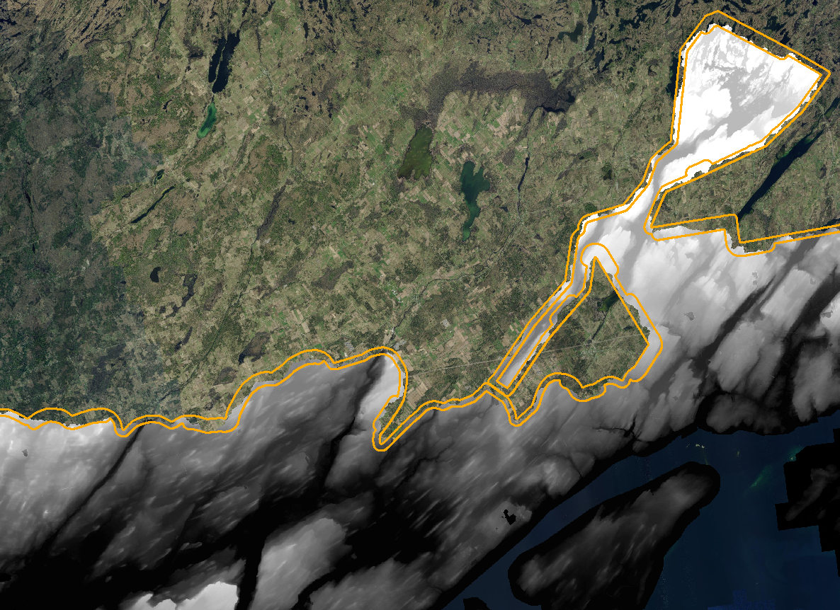
Figure 7: Variable buffer (250 to 500m buffer resulting in a 500 to 1000m corridor width for LCP analysis) applied to the 2009 LEAP Lidar acquisition. The DEM is overlaid to show the LCP cut that was performed, which falls within the buffer corridor.
You may prefer to create your own source and destination points for the analysis, for example, over open paved surfaces or areas known to be similar in elevation between the different data sources. If you do, make sure to include only one point in each of the Source Point and Destination Point layers. Tests using multiple points were unsuccessful. Therefore, for multiple LCP’s, run each path separately in separate sub-folders and then combine the results later on.

- Final DEM Update Process
The tool outputs can then be used for the final DEM update procedure. The buffered polygon version of the path of least elevation difference or LCP should be used as the 'cut line' between the new DEM data and the old data. The path covered by the cost path grid will be the only area of overlap between DEM's and effectively, the only area which will be impacted by mosaic interpolation (Figure 8). When mosaicking, the averaging or ‘MEAN’ option should be used for interpolation.
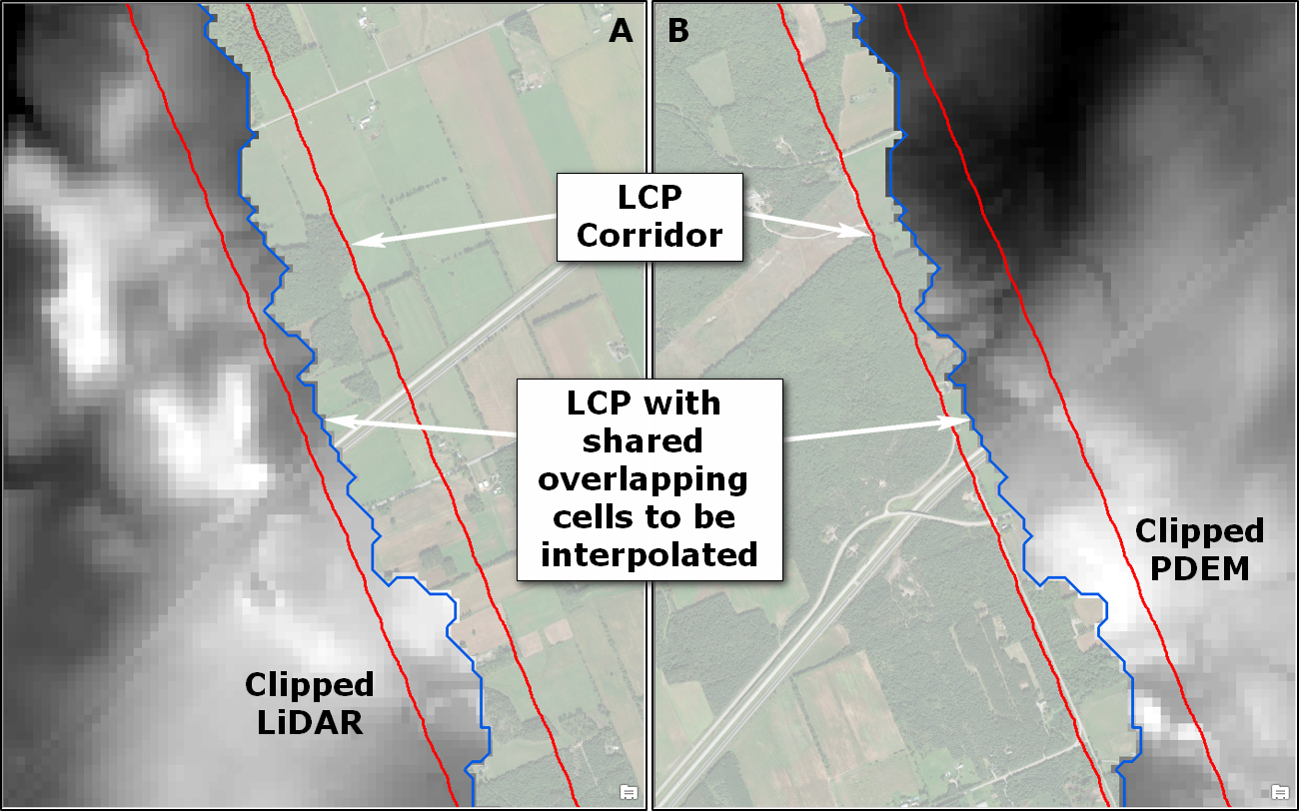
Figure 8: Zoom-in for Peterborough region of clipped rasters sharing a common overlapping boundary. A) shows the Lidar data on the left side of the boundary and B) shows the PDEM on the right side of the boundary.
Two polygon mask layers are created using the LCP buffer polygon layer as a shared boundary: one polygon mask for the new DEM to be added; the other for a subset of the PDEM to be modified. It is important to work on just a subset of the PDEM because processing will be significantly faster and it is inherently safer to do so in case you make a mistake or data becomes corrupt (e.g. from a power, hardware or software failure). The Extract by Mask option in ArcToolbox was used to create the ‘PDEM Subset with Hole’ and the ‘Clipped Lidar Update’ intermediate layers for Peterborough as shown in Figure 9 below. These layers were then mosaicked together using the ‘MEAN’ mosaic operator to create an updated subset layer, which was then mosaicked again back to the original PDEM raster as a final step – this time using the ‘LAST’ mosaic operator.
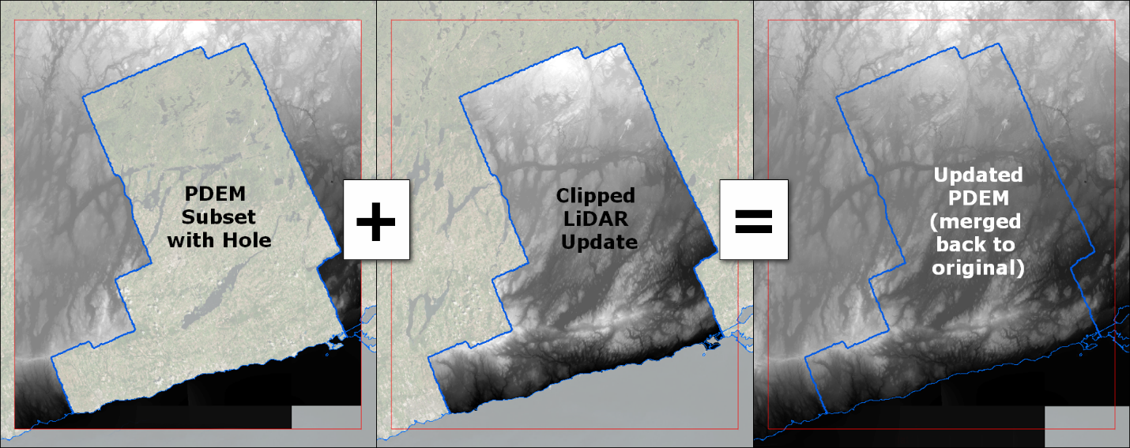
Figure 9: Clipped products are mosaicked together using ‘MEAN’ and then mosaicked again using ‘LAST’ to create the final DEM
For a further discussion on the Least Cost Path method and concepts, please refer to the ‘PDEM Methods and Processes Technical Report’ (MNRF, 2022).

- References
Environmental Science Research Institute (ESRI), 2012. Creating the least cost path, ArcGIS Help 10.1. (http://resources.arcgis.com/en/help/main/10.1/index.html#//009z00000021000000)
Python Software Foundation (PSF), 2016. The Python Standard Library. Python Software Foundation, Version 2.7.11. (https://docs.python.org/3/library/index.html).
Ministry of Natural Resources and Forestry (MNRF), 2022. Provincial Digital Elevation Model (PDEM) Methods and Processes Technical Report. Provincial Mapping Unit, Mapping and Information Resources Branch, Corporate Management and Information Division. (https://geohub.lio.gov.on.ca/search?q=PDEM_en)

Version 2324.1

Imagery Source: Esri, DigitalGlobe, GeoEye, Earthstar Geographics, CNES/Airbus DS, USDA, USGS, AeroGRID, IGN, and the GIS User Community
Imagery Source: Unless otherwise stated, the imagery was derived from the Geospatial Ontario Imagery Web Map Service (OIWMS)
Imagery Source: Esri, DigitalGlobe, GeoEye, Earthstar Geographics, CNES/Airbus DS, USDA, USGS, AeroGRID, IGN, and the GIS User Community

