Provincial Digital Elevation Model (PDEM) Methods and Processes
Technical Report
  - Provincial Mapping Unit
  - Mapping and Information Resources Branch
  - Corporate Management and Information Division
  - Ministry Natural Resources and Forestry
2022-08-03

Disclaimer
This technical documentation has been prepared by Her Majesty the Queen in right of Ontario as represented by the Ministry of Natural Resources and Forestry (the “Ministry”). No warranties or representations, express or implied, statutory or otherwise shall apply or are being made by the Ministry with respect to the documentation, its accuracy or its completeness. In no event will the Ministry be liable or responsible for any lost profits, loss of revenue or earnings, claims by third parties or for any economic, indirect, special, incidental, consequential or exemplary damage resulting from any errors, inaccuracies or omissions in this documentation; and in no event will the Ministry’s liability for any such errors, inaccuracies or omissions on any particular claim, proceeding or action, exceed the actual consideration paid by the claimant involved to the Ministry for the materials to which this instructional documentation relates. Save and except for the liability expressly provided for above, the Ministry shall have no obligation, duty or liability whatsoever in contract, tort or otherwise, including any liability or negligence. The limitations, exclusions and disclaimers expressed above shall apply irrespective of the nature of any cause of action, demand or action, including but not limited to breach of contract, negligence, strict liability, tort or any other legal theory, and shall survive any fundamental breach or breaches.
Cette publication spécialisée n’est disponible qu’en anglais.

Additional Information
This document does not comply with all the applicable guidelines for accessible digital documents. For an alternative format please email Provincial Mapping Unit at pmu@ontario.ca.
For more information about this document, please contact Provincial Mapping Unit at pmu@ontario.ca.

Executive Summary

Key Words
Digital elevation model, raster, resample, interpolation, mosaic, regional scale, Ontario, Mapping and Geomatics Services, Provincial Mapping Unit.

Abstract
The Provincial Digital Elevation Model (PDEM) is a seamless medium scale digital elevation model (DEM) that portrays the best available elevation data at a consistent 30 metre resolution for Ontario. Different processes and methods of compilation were employed over time since the PDEM was introduced in 2002. This technical report attempts to capture these methods in more detail than what is described in the PDEM User Guide and provides rationale for the continued maintenance of the PDEM product in its current format to support a wide range of regional applications across Ontario.
Methods for resampling large scale elevation data sources will be discussed along with the innovative Least Cost Path (LCP) approach for mosaicking differently sourced DEM products. Digital Terrain Models (DTMs) were employed where possible to represent the ground surface, but in some cases Digital Surface Models (DSMs) were used where no other reasonable option was available (e.g., Ontario Radar DSM for the far north of Ontario). Some historical interpolation methods and processes will also be discussed for areas in the province still covered by Ontario Basic Mapping (OBM) Contour/DTM and spaceborne radar data.

Revision History
Date | Edition/  Version | Description
2018-10-19 | 0.1 | Initial draft version
2022-03-31 | 0.2 | Final draft version
2022-04-11 | 1.0 | First public release
2022-08-03 | 1.1 | Updated OWIT and MNRF references

Table of Contents
Disclaimer 2
Additional Information 2
Executive Summary 3
Key Words 3
Abstract 3
Table of Contents 5
List of Figures 7
List of Acronyms 11
1. Introduction 13
2. Resampling and Interpolation Methods 14
2.1 PDEM Pilot Project 2017 15
2.2 Results 16
3. Justification for a 30m PDEM Product 17
3.1 Large Scale Hydrology and Watershed Processing and Tool Testing Pilot Project 2019 17
3.2 Results 19
3.3 Decisions and Recommendations Moving Forward 20
4. Provincial DEM Update Procedures and Enhancements 22
4.1 Least Cost Path Method Overview 22
4.1.1 Method Outline 24
4.2 Method for Modifying SWOOP Forest Surface with OBM 25
4.3 Lake Flattening Method 33
4.4 Minimum Resampling Method from Raster 43
4.5 Historical Methods and Processes 47
4.5.1 ANUDEM Software 47
4.5.2 Interpolation Workflow 48
4.5.3 OBM DTM De-Striping 48
4.5.4 OBM Spot Height Filtering 49
4.5.5 Lake Shoreline Elevations 50
4.5.6 Contour Edits 50
References 52
APPENDIX A 54
4.6 Methods Tested in 2017 Pilot Project 54
4.6.1 SWOOP Analysis Using Resampling and Various Interpolation Techniques 54
4.6.2 SWOOP/SCOOP/PDEM Comparison with LiDAR 2017 58
4.7 Observations and Results 59
4.7.1 Determining Significant Difference 59
4.7.2 Resampling Methods Tested 60
4.7.3 Comparison of Interpolation Results – SWOOP Investigation 64

List of Figures
Figure 1: A) Catfish CA watershed with large scale watercourses and buffered LiDAR DTM displayed. B) Location of CA in southwestern Ontario. 18
Figure 2: Example of least cost path calculated using elevation differences between two overlapping DEM’s. Areas in orange and red represent areas with higher differences; white and grey areas represent small elevation difference. 23
Figure 3: OBM Contour or DTM (A) versus SWOOP 2015 DTM (B) 26
Figure 4: Two zones of significant elevation difference were identified: the first zone was greater than 10 metres difference (in red) and the second zone was from 4 to 10 metres (in green). 27
Figure 5: Illustrating the ‘ring effect’ created after the removal of tall, forested vegetation. 29
Figure 6: Orange areas are greater than 10 metres difference, light green areas are between 4 to 10 metres and a combined buffer around these areas was also added to the analysis (in light blue). 30
Figure 7: ‘A’ shows the location of subsequent images (black inset box) in Bruce Peninsula region where it is predominantly forest vegetation (mixed conifer and deciduous). ‘B’ is a zoom-in of 2020 SWOOP imagery. ‘C’ shows tree canopy height artifacts in the original SWOOP DTM, and ‘D’ shows the result after the forest removal adjustment. In this complex area, the process was quite successful while preserving other features like the gravel pit highlighted by the green box. 32
Figure 8: Niagara River break-lines in green draped over the clipped in-river DEM in varying shades from white to black representing the riverbank extents and the background source TIN that was generated from the break-lines. Only the values within the river were used for flattening the PDEM. The headwater of the river was limited to approximately 174.2m in elevation at the mouth of Lake Erie. 37
Figure 9: Zoom-in of Niagara Falls and break-lines used for creating the resulting river raster at a 30m cell size. 38
Figure 10: Lake Erie TIN generated from manually plotted elevation points constraining the shoreline and the St. Clair River – Lake St. Clair – Detroit River Connecting Channel system. 39
Figure 11: Elevations applied to lake and some surrounding tributaries for a smooth transition to inland elevation values. The extent of elevation change in this area is within 10cm with a downward gradient towards Lake St. Clair. Most of this change is limited to St. Clair River itself as it flows down from Lake Huron. 40
Figure 12: Lake Ontario TIN and raster products. 41
Figure 13: Lake Superior TIN and raster products. 42
Figure 14: Overview of Duck Islands region (red box) and areas where resampling was conducted for Great Duck Island and Outer Duck Island (yellow box). 44
Figure 15: (A) shows the contour coverage in northern Great Duck Island overlaying the COOP 2016 DEM 2m mosaic. Red line represents the elevation profile line plotted for Figure 16. (B) shows the revised PDEM derived from the COOP DEM using minimum value resampling. (C) shows the COOP imagery for the islands and the difference in forest cover – deciduous leaf-off in the brown areas and conifer in the green areas. Green box indicates where minimum resampling did a decent job in capturing ground elevations. Orange box indicates region where minimum resampling did not always extract ground elevations particularly in dense conifer areas. 45
Figure 16: Elevation profile comparing the original highly generalized OBM Contour (red line), the detailed COOP 2016 DEM 2m mosaic (black line) and the minimum resampled PDEM (blue line). The resampling technique smoothed out most sharp peaks in the original COOP mosaic with an overall average reduction of 1 to 2 metres throughout the entire surface and the removal of spike elevations upwards of 11 metres in this example profile. The original contour also clearly did not capture true ground in many cases and missed undulating detail between 10 metre intervals. 46
Figure 17: Interpolation workflow for the PDEM prior to 2015. 48
Figure 18: Striping in the DEM resulting from the systematic artefact in the OBM DTM elevation data 50
Figure 19: Error in creating a mosaic dataset that may occur if the environment settings are not set properly. 55
Figure 20: Example Interpolation Method parameters for Study Area 2. 57
Figure 21: Incomplete results encountered when resampling from a tiled mosaic. 61
Figure 22: Exporting a mosaic to a raster dataset of the same resolution. 62
Figure 23: Accessing and modifying the ‘Maximum Number of Rasters per Mosaic’ setting under Mosaic Dataset Properties. 64
Figure 24: Study areas (SA) selected for the 2017 pilot project were all within the SWOOP DTM 2015 coverage, each having different terrain characteristics. The SA’s discussed in this section include 1) Beaver Valley, 3) Maitland River mouth and 4) Town of Merlin area. SA2 north of London and just southwest of St. Marys had similar characteristics to SA4 and therefore will not be discussed here. The question mark highlighting Niagara region was another potential site where data was extracted but not included in the project due to time constraints. 65
Figure 25: Study area imagery and tile extents and a 2m Average DTM interpolation of LAS ground elevation points. 66
Figure 26: (A) ‘Resample – Average’ elevation difference versus (B) ‘Resample – IDW’ difference. 67
Figure 27: ‘Resample – Minimum Interpolation’ elevation difference for SA1 is shown in the image on the left where two areas of interest are shown. Photo on right highlights black box “a” in left image, where cells outlined in yellow range from 18.5 to 23m higher than the resampled grid, and the red cells range from 26.6 to 35.4m higher than the resampled grid. Light grey ellipse “b” is illustrated and discussed next in Figure 28 below. The undulating terrain and areas of increasing slope to the steep ridges average between 2 to 4 metres difference. 68
Figure 28: LAS point cloud overlaying top left corner of raster in previous figure. Notice the gaps in true ground classification because of thick vegetation cover and steep terrain in this area. 69
Figure 29: Comparing the elevation profiles of different SWOOP interpolation and resampling methods in steep terrain. 71
Figure 30: Method profile comparison across a road allowance. The vertical exaggeration is extreme to emphasize the differences in each method. The 2m interpolation methods pick up the small hills and road embankment details whereas the coarse 30m interpolation smooths out the terrain capturing only the major trends. Note the Minimum technique drops significantly below the rest which suggests it may be useful as a ‘burning’ technique for hydrology applications (discussed later in more detail). However, this technique also underestimates the surrounding and predominant values of the terrain and therefore should not be used for a general-purpose DEM. 72
Figure 31: Same profile cross-section as above but also showing interpolation at 5 and 10m resolutions, where varying levels of detail are captured. Performing a Minimum interpolation may be the most desirable approach when working in finer resolutions. This finding may prove to be useful if PMU decides to move to a finer resolution for the PDEM in the future. 73
Figure 32: Image with culvert highlighted by green circle and watercourse features of interest highlighted in orange and purple. 75
Figure 33: Average interpolation to 30m resolution. 76
Figure 34: Minimum interpolation to 30m resolution. 77
Figure 35: Zoom-in of road and water crossing from the previous figures. 78
Figure 36: Study area in flat terrain dominated by agriculture and artificial drainage. 79
Figure 37: SWOOP imagery for Sarnia (left) and the original PDEM terrain (right) derived from very sparse OBM contour and spot height information that was previously available prior to 2017. 81
Figure 38: SWOOP DTM 2015 on the left overlaid with LCP buffer corridor (dashed line) and cutline (solid black line). White line represents eastern edge of the 2017 LiDAR coverage that was acquired and was incorporated into the right image which covers the southern part of Sarnia draining to St. Clair River. Some LiDAR improvements are also noted. 82

List of Acronyms
ANUDEM: Australian National University Digital Elevation Model software
ASL: Above Sea Level
AVG: Average interpolation method
CGVD2013: Canadian Geodetic Vertical Datum 2013
CGVD28: Canadian Geodetic Vertical Datum 1928
CHS: Canadian Hydrographic Service
CO-OPS: Center for Operational Oceanographic Products and Services
COOP: Central Ontario Orthophotography Project
CNT: Canadian National Transformation
DEM: Digital Elevation Model
DFO: Fisheries and Oceans Canada
DSM: Digital Surface Model
DTM: Digital Terrain Model
FOC: Fisheries and Oceans Canada
GTA: Greater Toronto Area
HUC: Hydrologic Unit Code (USGS Watershed Boundary Dataset)
IDW: Inverse Distance Weighting interpolation method
IJC: International Joint Commission
LCC: Lambert Conformal Conic
LIDAR: Light Detection and Ranging
LIO: Land Information Ontario
MIN: Minimum interpolation method
MNRF: (Ontario) Ministry of Natural Resources and Forestry
MSL: Mean Sea Level
NAD83: North American Datum of 1983
NASA: National Aeronautics and Space Administration
NOAA: National Oceanic and Atmospheric Administration
NRVIS: Natural Resources Values Information System
OBM: Ontario Basic Mapping
OHN: Ontario Hydro Network
OIH: Ontario Integrated Hydrology
ORDSM: Ontario Radar Digital Surface Model
OWIT: Ontario Watershed Information Tool
PDEM: Provincial Digital Elevation Model
PMU: Provincial Mapping Unit
SCOOP: South Central Ontario Orthophotography Project
SDSU: Spatial Data Support Unit
SOLRIS: Southern Ontario Land Resource Information System
SRTM: Shuttle Radar Topography Mission
SWOOP: South Western Ontario Orthophotography Project
UTM: Universal Transverse Mercator
WRIP: Water Resources Information Program

- Introduction
The Provincial Digital Elevation Model (PDEM) was initially introduced in 2002 by the Water Resources Information Program (WRIP) of the Ontario Ministry of Natural Resources (MNRF) and was considered the first seamless medium scale digital elevation model (DEM) for southern and central Ontario. The PDEM is currently maintained by the Provincial Mapping Unit (PMU) of the Ontario Ministry of Northern Development, Mines, Natural Resources and Forestry (MNDMNRF). The PDEM and its derivative Ontario Integrated Hydrology (OIH) products form the key foundation for the Ontario Watershed Information Tool (OWIT), and is leveraged in broader international efforts such as the International Joint Commission’s Data Harmonization Initiative (also referred to as the International Watersheds Initiative – IJC, 2009), the USGS implementation of StreamStats (an online watershed analysis and water flow modeling tool) for the Rainy River basin (Sanocki et.al., 2019), the USGS SPARROW water quality model for the Great Lakes and Rainy River basins (Vouk et.al., 2018), and the University of Michigan’s Great Lakes Aquatic Habitat Framework (Forsyth et.al., 2016) – to name a few.
The PDEM was originally compiled as a single sourced tiled product using Ontario Basic Mapping (OBM) derived elevation data covering multiple UTM Zones, scales and cell size resolutions up to the northern limit of the Forest Management Area of Undertaking.
This product has since gone through several changes and updates since 2010 including:
- The adoption of a single standardized projection (the North American Datum 1983 Ontario Lambert Conformal Conic projection) to minimize the issue of reconciling interpolation differences across multiple projections.
- The adoption of a common cell size of 30m for the entire province, which matches the lowest common denominator – the resolution of the Ontario Radar DSM – a derivative of the Shuttle Radar Topography Mission (SRTM) completed by NASA in 2000.
- The completion of the entire province using the SRTM product to help support community-based land use planning for indigenous communities in the far north, among several other regional science and planning applications.
- The transition from a tiled raster product to a single mosaicked raster for northern and southern Ontario.
Despite these accomplishments, many areas in southern and central Ontario still rely on vintage data sources which no longer reflect the current landscape. The 2017-18 Provincial DEM Update project aimed to address this data deficiency primarily for southern Ontario, and further improvements were also made to central and northern Ontario to include areas draining in from neighbouring jurisdictions (see PDEM User Guide for the extent of coverage outside of Ontario) and some major lake flattening was also applied. Future updates are expected to be conducted on an annual to bi-annual basis sourced from current elevation acquisitions across the province.
The 2017 update project was divided into two phases: the first part involved a pilot which reviewed various interpolation, resampling, and mosaicking techniques for incorporating large scale data; and the second part involved the process of updating the PDEM following the recommendations of the pilot. A subsequent pilot project in 2019 was conducted to test PDEM and OIH processes on large scale elevation and hydrography. This report will discuss the findings of each pilot project, recommendations moving forward and document all the current and historical methods and tools used in the creation and maintenance of the PDEM.

- Resampling and Interpolation Methods
Past methods of PDEM maintenance involved interpolating a raster from point and contour line data for OBM sources in central and southern Ontario and Spaceborne Radar in northern Ontario (see historical methods in section 4.5). By 2015, PMU began to re-evaluate PDEM maintenance as new data sources became available, first the finer resolution DEM’s LIO’s Imagery Program was producing for orthorectifying imagery, followed by the OMAFRA-PMU partnership to acquire LiDAR for southwestern Ontario, which marked the beginning of a new phase of LiDAR elevation acquisition in Ontario. This prompted PMU to investigate new PDEM processing methods for leveraging large scale DTM data sources as part of the pilot project described in the following sections.

  - PDEM Pilot Project 2017
A pilot project was conducted in the spring-summer of 2017 to determine the most efficient and effective methods for incorporating large scale elevation updates into the PDEM. The data sources considered for incorporation were captured at finer resolutions and different projections than the Lambert Conformal Conic 30m PDEM. The primary objective was to find a common consistent method that could be applied to all these data sources.
Various raster resampling and point cloud interpolation techniques were compared including:
- Resampling from a DTM mosaic (using the resample command was preferred over on-the-fly techniques like data copying or exporting). BILINEAR and CUBIC resampling methods were explored because they were the preferred methods for continuous data (ESRI, 2016).
- Interpolating from a LAS point cloud using AVERAGE, IDW (Inverse Distance Weighting), and MINIMUM cell assignment techniques. Also interpolating to various cell sizes (2/5/10/30m) were examined to qualitatively observe the impact on the terrain profile.
The results were evaluated by comparing elevation difference grids and cross-section profiles of the different techniques. Some interesting examples and results are shown in Appendix A.

  - Results
There were nominal differences between interpolation and resampling at coarse resolutions where interpolation provides a slight advantage in defining ridge top and valley bottom elevations. These advantages were offset by the extensive time it took to re-interpolate from raw data sources. Because fine resolution Digital Terrain Models (DTM) have already been made available for most large-scale data acquired in Ontario (usually at resolutions of 0.5m for LiDAR and 2m for photogrammetric data sources), PMU decided the most effective way to produce a 30m derivative was to use a DTM resampling method. Of the two methods examined, the BILINEAR interpolation approach was preferred because the CUBIC method sometimes created elevation values outside of the range found in the source data. This phenomenon is well documented in ESRI publications (2016). See Appendix A for more details of the methods tested and a further comparison of the results.

- Justification for a 30m PDEM Product
The rationale for maintaining a 30m resolution DEM product for Ontario has been widely discussed with ministry staff and end users. Some benefits highlighted include:
- Supporting regional-scale analyses for hydrology flow modeling and watershed delineation including producing derivative products like the Ontario Integrated Hydrology Dataset and the Ontario Watershed Boundaries.
- Providing a quick and consistent medium scale DEM product for online applications such as OWIT and Make a Topographic Map.
- Ensuring compatibility with stateside regional USGS 3DEP 1-arc second and global DEM products.
Despite these obvious benefits, an exploration of the LiDAR point cloud and derived DTM products to support large scale hydrology applications seemed appropriate to highlight further limitations if any and determine whether our existing tools can work well in the large-scale scenario. This set the stage for the large-scale data pilot conducted in 2019 which is described in the next section followed by results and decisions moving forward.
  - Large Scale Hydrology and Watershed Processing and Tool Testing Pilot Project 2019
The MNRF Terrain Processing Tools are a set of ArcToolbox Python script tools used to create the Ontario Integrated Hydrology (OIH) dataset. OIH leverages the PDEM as a key data source and therefore its derivatives are produced in the same native resolution as the PDEM. However, the tools were designed from the outset to work with any raster product regardless of its projection or resolution. For more information on OIH and its tools, please refer to the OIH User Guide (MNRF, 2022a).
In 2019, PMU embarked on a pilot project in partnership with Catfish Conservation Authority (CA) to test these tools in a large-scale environment. The test included processing the Lake Erie LiDAR acquired in 2017 and the new large-scale hydrography derived from the Southwestern Ontario Orthophotography (SWOOP) 2015 project provided by the conservation authority.
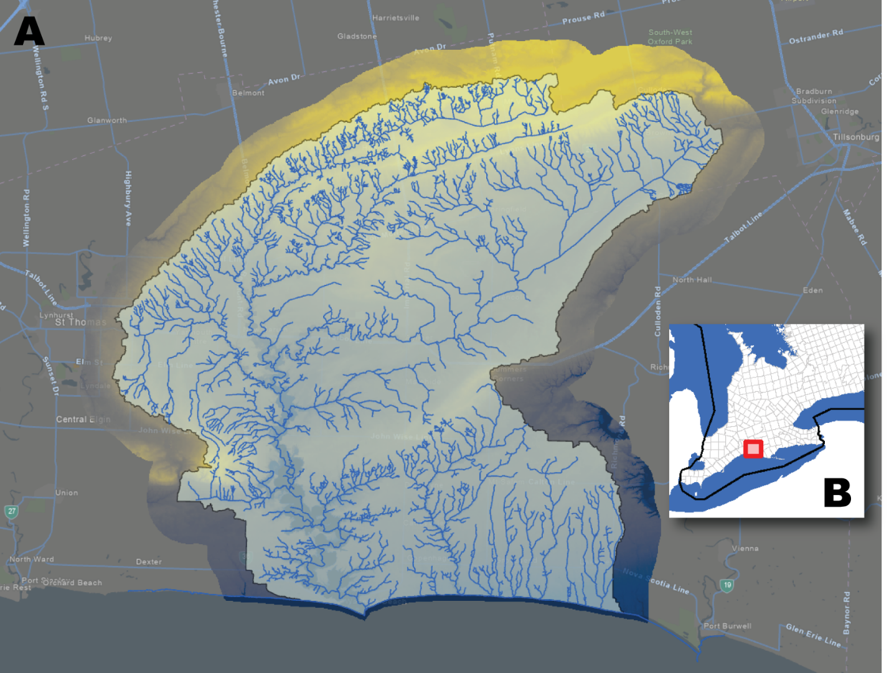
Figure 1: A) Catfish CA watershed with large scale watercourses and buffered LiDAR DTM displayed. B) Location of CA in southwestern Ontario.

  - Results
The OIH tools worked well in handling and processing large scale data sources. The outputs were delivered and reviewed by Catfish CA, and many benefits were realized in working through the OIH processes and tools in a large-scale environment. However, processing times noticeably increased with the finer resolution data and some processing challenges could be encountered if going beyond the size of Catfish CA region which is consistent with the quaternary watershed level in Ontario. The tiling capability of the OIH tools (to dice the data into manageable ‘work units’) can potentially overcome this barrier, but further testing would be required to verify this. Also, with the better-defined features in the high-resolution DEM, lake enforcement in OIH processing may no longer be necessary or as critical as in the 30m environment, which means significantly less processing time.
One key finding of the pilot followed this basic principle: the output can only be as good as the input data that is used. Even though a highly accurate elevation model was used for the study area, knowing all the barriers to water flow across this detailed surface becomes critical when working at finer resolutions. Of course, barriers which occurred on the watercourse network were effectively handled through the DEM stream burning process. However, there were numerous barriers or culverts off the network (e.g., in the headwaters and small ditches) which had a significant impact on the DEM filling process creating unnatural pooling around these barriers which in turn created incorrect catchment delineations upstream of these areas. Adding the culvert information that was collected by the CA on site during the pilot vastly improved the catchment delineation results.
Since the province does not have a comprehensive culvert database to work with and the sparse data that is available is not in a format that can be used for DEM post-processing, PMU has found that working at a 30m resolution is sufficient to effectively resolve most barrier issues that fall along road allowances that are typically 20m wide or less. This concept is described further in Appendix A (e.g., the ‘Maitland River Mouth’ and ‘Town of Merlin’ discussions).

  - Decisions and Recommendations Moving Forward
The current PDEM at a 30m resolution continues to provide several benefits for broad-scale science and international applications, including supporting the current requirements of OWIT, and is consistent with stateside broad-scale resolutions. The province lacks consistent and complete elevation coverage at the larger scale and comparable large-scale hydrology data that would effectively support large scale analysis. Also, the fact that the province lacks a complete and reliable culvert inventory makes it problematic to work in finer resolutions as discussed earlier. Therefore, maintaining a standardized 30m equivalent of the best available elevation data sources across the province remains an important objective. The results of the 2017 pilot project suggested that resampling large-scale sourced DTM’s is the most effective method of updating and maintaining the PDEM because it produces comparable results to the preferred interpolation methods directly from point cloud sources at a coarse 30m resolution, which are within the acceptable accuracy range specifications for the PDEM.
The difference in the new CGVD2013 and old CGVD28 vertical datum standards was also investigated in the 2017 pilot project. However, since over 75 percent of the PDEM was natively captured in CGVD28, the decision for the interim was to create and maintain two versions of the PDEM: one following the CGVD2013 standard and the other the older CGVD28 standard. Several derivative products maintained by PMU would be impacted if we were to completely move to CGVD2013, primarily OIH, which has just gone through a major update recently for much of Ontario in 2018-19. This issue may be revisited in the next PMU update cycle for its foundational data products.
Adopting a finer resolution for the PDEM would also have major implications on all derived products and services currently relying on the 30m resolution product including PMU’s OIH data, provincial watersheds and the previously stated online tools and applications. Existing data creation and management processes, tools and resources would have to be evaluated against cost, performance, and data storage concerns.
The prevailing decision to maintain the PDEM at a 30m resolution would allow PMU to complete an updated version of the OIH data that was already in progress and completed in the fall of 2019. The OIH data was refreshed using the latest elevation and hydrography data sources available at that time. However, in the future, entertaining a finer resolution for all these derivative products will have to be assessed and justified further in terms of practicality, feasibility, and processing capability.
In the meantime, there is a wealth of other options available if users are interested in exploring the large-scale realm further. Many of the data sources incorporated into the current PDEM are available separately in their native resolutions and formats and can be accessed through the Ontario GeoHub website. Users are encouraged to check out the Ontario Elevation Data Index for a complete list of what is available.

- Provincial DEM Update Procedures and Enhancements
This section highlights all the current and historical methods and processes that have been used in updating the PDEM. The Least Cost Path method described in section 4.1 is one of the most important methods employed currently for combining different elevation data sources seamlessly and smoothly across boundaries with the least modification to the source data. Other methods like removing forest cover from SWOOP DTM coverage (section 4.2), large lake flattening (section 4.3), and minimum elevation resampling (section 4.4) will be discussed, followed by section 4.5 describing our historical methods and processes.
  - Least Cost Path Method Overview
The elevation variant of the Least Cost Path (LCP) method was introduced in 2011 to seamlessly incorporate the Shuttle Radar DSM product into the PDEM where previously there was no data north of the Forestry Management Area of Undertaking. This update was required to support community-based land use planning in the Far North. This method proved effective in minimizing artificial cliff and valley artifacts along the mosaic cut line between differently sourced elevation products, and therefore has been adopted as the main method for updating the PDEM for the rest of Ontario.
This method analyzes two DEM sources where they overlap to determine the ‘Path of Least Difference’ in elevation, an area where the two products can be merged as seamlessly as possible (see Figure 2 below). The aim is to produce a smooth transition between surfaces minimizing the ‘edge effect’ when mosaicking DEM’s of differing quality or vintage. Issues can include the level of accuracy the elevation was acquired at, and various temporal changes in the landscape (e.g., resulting from anthropogenic land use alterations erosion, or filling).
The PDEM update process involved generating a separate subset of the PDEM dataset for certain areas of the province based on the extents of specific source elevation data that was used for updating. These extents are illustrated in the PDEM User Guide (MNRF, 2022b) for all products incorporated into the PDEM. A customized tool was developed utilizing the ESRI Least Cost Path (LCP) function (MNRF, 2022c). This tool generates an LCP of least elevation difference, represented as a line feature class, which is used as a guide to clip and then mosaic DEM data into one seamless raster dataset. The LCP method is a significant improvement over simply using a mosaic or overlay function.
Standard mosaic functions do have the ability to combine two raster datasets, but in many cases large variations in elevation can still exist along the original boundaries and mosaicking using CUBIC, BLEND or other options makes sourcing specific DEM's problematic in overlapping regions. Minimizing unnatural barriers or elevation offsets in the dataset allows for more effective use of the DEM for hydrologic or terrain derivative applications.
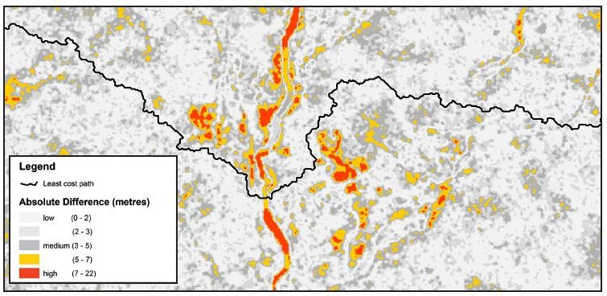
Figure 2: Example of least cost path calculated using elevation differences between two overlapping DEM’s. Areas in orange and red represent areas with higher differences; white and grey areas represent small elevation difference.

    - Method Outline
Below are the basic steps to follow when preparing and updating the PDEM data while employing the LCP method.
- Set appropriate environment settings to match the resolution and alignment of the PDEM. However, the extents should reflect the general extents of the update source DEM (the extent values should be dividable by 30m to ensure there is no cell shifting during resampling). A tight extent (instead of using the PDEM extents) will also speed up processing of certain steps to follow.
- Resample update source DEM to 30m using BILINEAR option. (SourceRs30m)
- Prepare a corridor polygon buffer for the LCP analysis that runs along the inner edge of the update source DEM. Ensure this corridor overlaps both the update source DEM and the PDEM.
- Run the Create Cost Path Tool to create the necessary LCP line and related outputs. For more information regarding this tool, please refer to the in-depth technical report available on Ontario GeoHub (MNRF, 2022c).
- Use the polygon version of the cost path grid generated from the Create Cost Path Tool to create a closed boundary between the new data and the old data. The cost path should typically end just offshore of the terrestrial limit of mainland Ontario if the new acquisition is adjacent to it. Otherwise, if the acquisition is completely inland, the cost path should be an enclosed ring except for one cell distance separating the start from the destination of the cost path analysis. Use the Auto-complete Polygon editing tool to close the one cell gap or the in-water edge between the source and destination of the cost path polygon. This inner polygon in addition to the cost path polygon becomes the cut polygon for the new data to be added. (CutPoly)
- Exit out of your polygon edit session and save the inner polygon to a separate layer. (Hole_p)
- Create a graphic box around the CutPoly layer ensuring there is some buffer beyond the layer extents. Convert to a polygon layer. (Extent_box)
- Erase Hole_p from the Extent_box to create a new clip mask. (Clip_region)
- Set Environment Extents to the Extent_box (ensure to round off to the nearest 30m meaning each extent value should be dividable by the cell resolution. Otherwise, shifting may occur even though the Snap To setting is set to the PDEM). Extract by mask from the PDEM using the Clip_region as the mask. (PDEM_subset)
- Extract by mask from SourceRs30m using CutPoly as the mask. (DEM_update)
- Mosaic DEM_update onto PDEM_subset using the MEAN option (do not use the BLEND option because the algorithm looks at the surrounding cells and takes the weighted value which tends to favour the old data. Instead, the MEAN will take the exact mid-point between old and new values in the overlapping ring of cells).
- Set extents to entire PDEM.
- Mosaic PDEM_subset onto PDEM using the LAST operator option.
For more information on how the LCP outputs are generated, please refer to a companion PDEM Technical Report detailing the Least Cost Path Analysis method available for download from Ontario Geohub (MNRF, 2022c).
  - Method for Modifying SWOOP Forest Surface with OBM
While working with the SWOOP 2015 DTM product, PMU discovered some areas behaved more like a DSM than representing true ground. This was particularly the case in areas with very dense forest vegetation cover which occurs more frequently as you venture north of Mount Forest towards Bruce Peninsula. Figure below shows an example of the forest cover artifact in the SWOOP product.
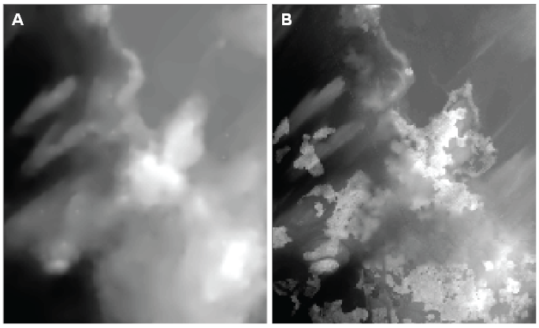
Figure 3: OBM Contour or DTM (A) versus SWOOP 2015 DTM (B)

These areas were identified (see Figure 4) and corrected using OBM Contour, OBM DTM or GTA 2002 as a reference to true ground where possible (hereafter referred to as 'reference grid'). The best available data source was used for the reference grid. A difference grid was produced in subtracting the reference grid from the SWOOP DTM.
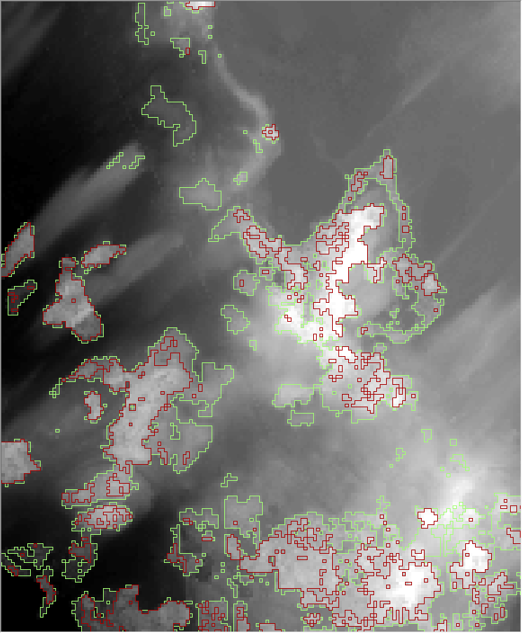
Figure 4: Two zones of significant elevation difference were identified: the first zone was greater than 10 metres difference (in red) and the second zone was from 4 to 10 metres (in green).
Three criteria were applied in the elevation correction:
- If the positive difference (SWOOP > reference grid) was greater than 10 metres, then the SWOOP elevations were completely replaced by the reference grid elevations.
- If the difference was between 4 and 10 metres, a differential percentage was applied whereby the percentage the elevation was derived from SWOOP decreased from 100 percent at 4m difference to 0 percent at 10m difference, and vice versa for the reference grid.
- These first 2 criteria were further filtered out using forest polygons derived from SOLRIS Land Cover data sources to ensure the differences were because of forest cover elevation differences and not some legitimate change in elevation over time or inaccuracy in the reference grid.
When these criteria were applied to level the DEM, a ‘ring effect’ (Figure 5) was left behind in the marginal areas around the forested regions which were most often small trees or low-lying dense vegetation upon review of the SWOOP 2015 imagery data source.
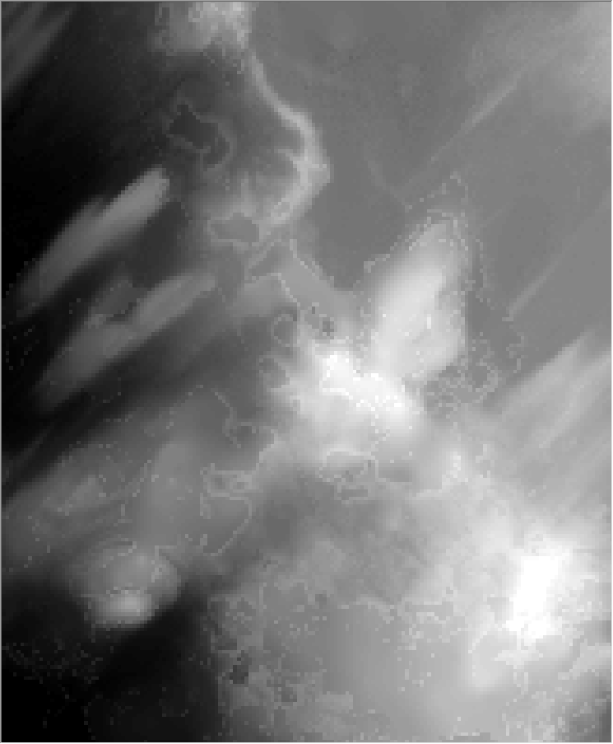
Figure 5: Illustrating the ‘ring effect’ created after the removal of tall, forested vegetation.
To address this issue, a small 2 cell buffer (60m) was then applied around the first 2 criteria (highlighted in light blue in Figure 6 below).
to further smooth out the transition in elevations.
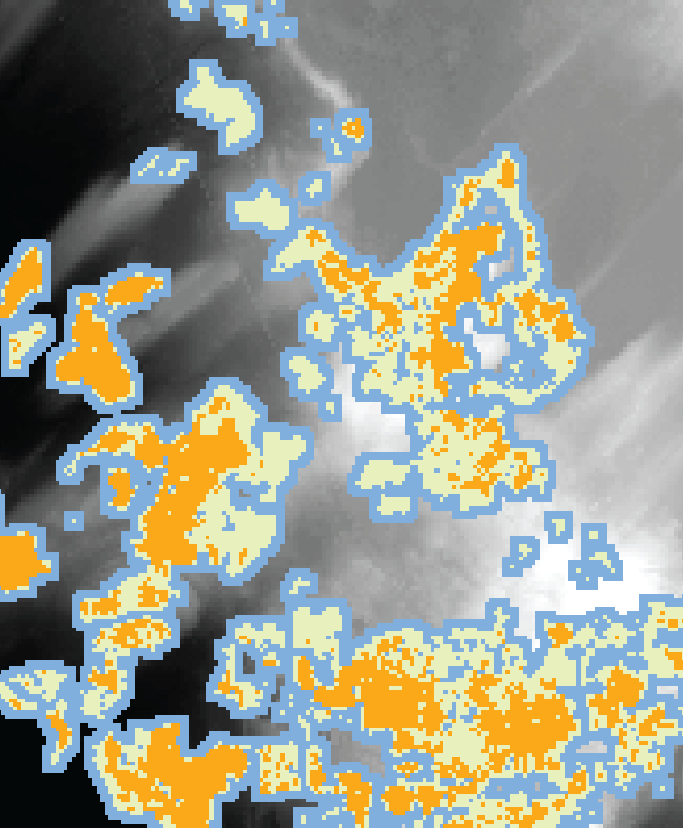
Figure 6: Orange areas are greater than 10 metres difference, light green areas are between 4 to 10 metres and a combined buffer around these areas was also added to the analysis (in light blue).

Both the green and blue areas in Figure 6 were combined into one zone and within this zone, values that had a positive difference from 0 to 10 metres (where SWOOP was higher than the reference grid) were selected out and included in the differential analysis.
This effectively smoothed out the ‘ring effect’ around forested regions that fell between 0 and 4 metres difference. The remaining areas that fell within 4 metres difference including areas that were lower in SWOOP compared to the reference grid were left unchanged in the final product. See Figure 7 for sample results in a highly forested area of Bruce Peninsula.
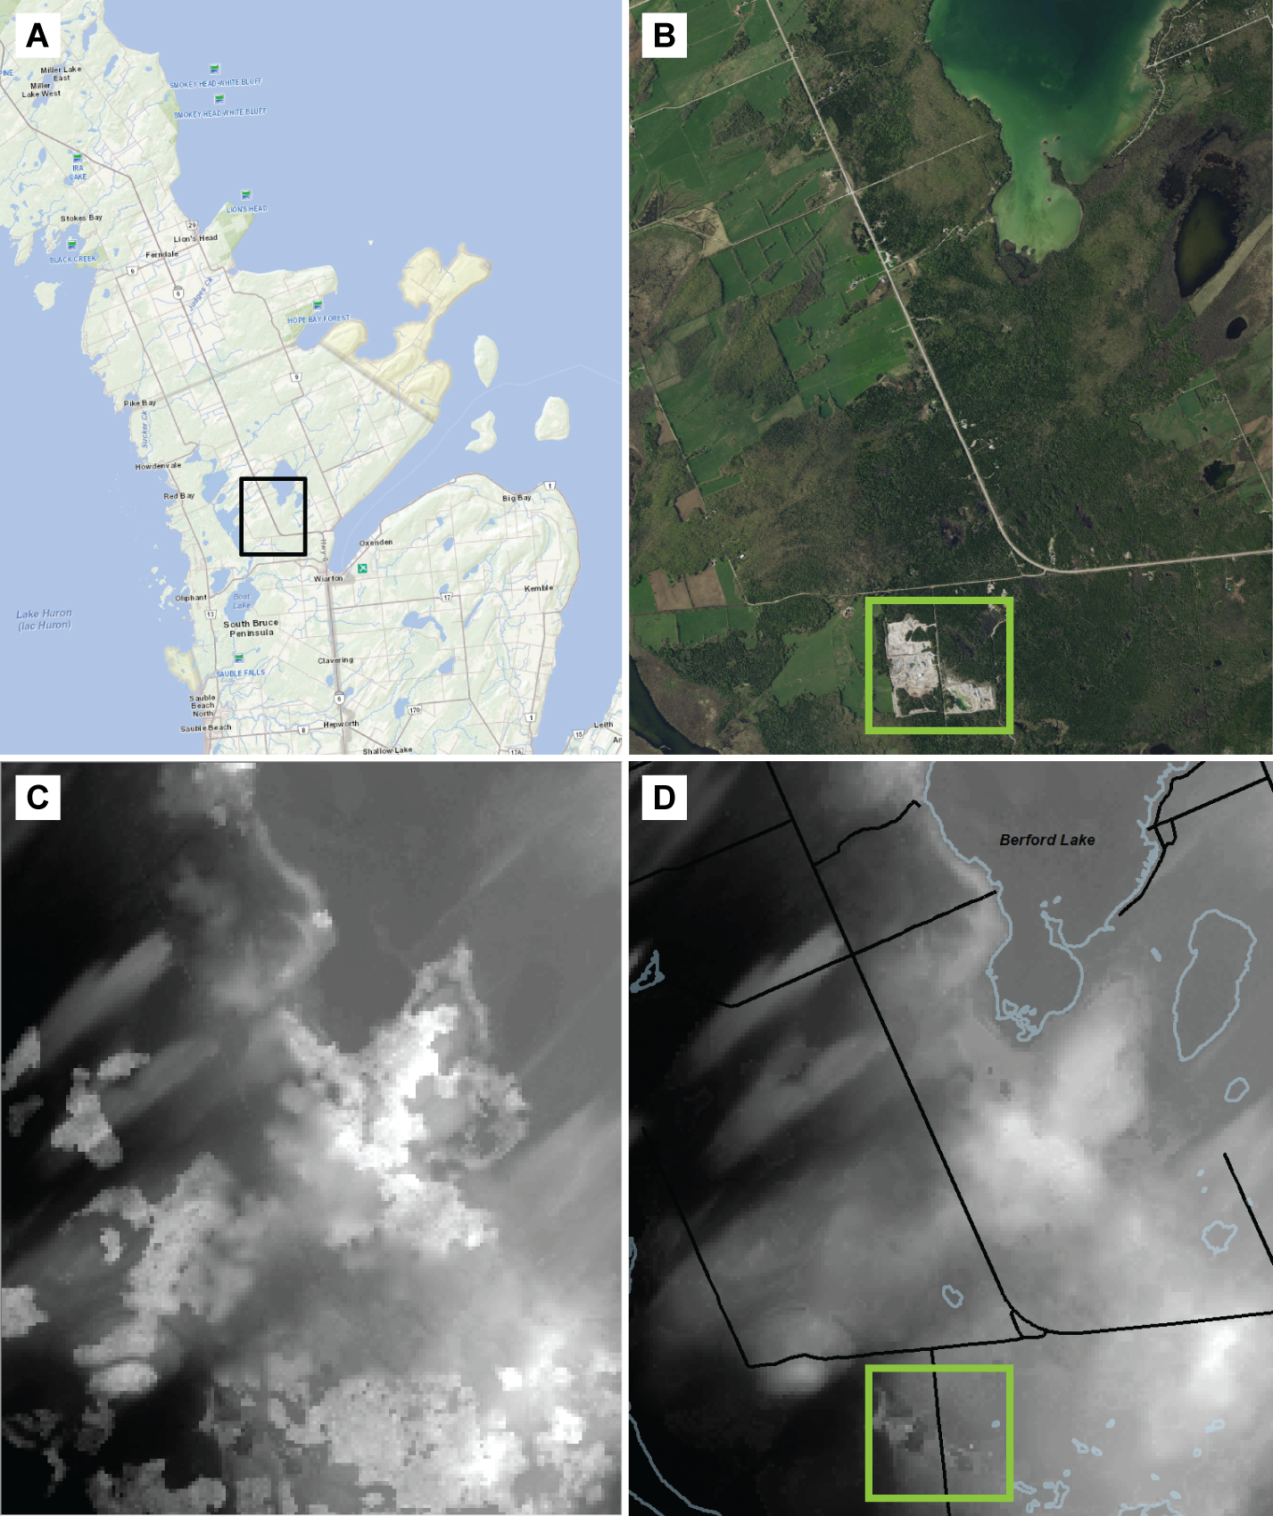
Figure 7: ‘A’ shows the location of subsequent images (black inset box) in Bruce Peninsula region where it is predominantly forest vegetation (mixed conifer and deciduous). ‘B’ is a zoom-in of 2020 SWOOP imagery. ‘C’ shows tree canopy height artifacts in the original SWOOP DTM, and ‘D’ shows the result after the forest removal adjustment. In this complex area, the process was quite successful while preserving other features like the gravel pit highlighted by the green box.
Please refer to the PDEM User Guide (MNRF, 2022b) or the PDEM Spatial Metadata Index for the extents of the forest flattening that was conducted for Lake Huron region.
  - Lake Flattening Method
In older versions of the PDEM, there was no consideration for elevations in transboundary waters including the Great Lakes system and St. Lawrence River. The values that did exist were arbitrary and residual based on mosaics of multiple data sources that did not capture reliable values on water. The result was in fact aesthetically untidy and meaningless and could lead to misinterpretation for some users of in-water values.
The 2018 version of the PDEM marked the first concerted attempt to clean up the values in transboundary waters, replacing them with levels consistent with recorded all-time long-term averages for the Great Lakes, Connecting Channels (where available), and the St. Lawrence River. Lake and river levels were obtained from NOAA's Center for Operational Oceanographic Products and Services (CO-OPS) and Department of Fisheries and Oceans' Canadian Hydrographic Service websites, which record daily, monthly, and long-term averages. Slight downward sloping gradients were applied to each Great Lake to help facilitate hydrologic modeling of these systems and consistent stream burning in the Ontario Integrated Hydrology (OIH) products.
One challenge here is both sources (NOAA and DFO) use a different vertical datum that is specific to the Great Lakes system known as the International Great Lakes Datum devised in 1985 (IGLD85). Currently there is no known method to convert IGLD85 directly to CGVD28, the original vertical datum used for the PDEM. One method was quite elaborate to convert between datums which required a 3-step conversion process from IGLD85 to CGVD28 via the North American Vertical Datum 1988 (NAVD88 – the commonly used vertical datum in the United States) and the North American Datum of 1983 (NAD83 – the horizontal control datum for North America). The downside to this method was this study was only specific to Lake Erie (Zhou, 2005) and it appears to not have been applied to other areas. At the end of the day, determining an exact ‘correct’ value for each lake is quite improbable due to the high variability depending on the year, the season, and even daily weather and tidal influences. Some conversion tool or algorithm may be investigated for a future version of the PDEM if warranted, but for the interim, a manual comparison approach was applied to convert IGLD85 levels to CGVD28 where necessary using known benchmarks from Natural Resources Canada and Ontario's COSINE database. This method was deemed suitable for determining average lake levels considering the stated vertical accuracies of the general purpose PDEM product.
Another challenge is the recognized and notable variability in lake levels over large distances, and the influence of wind and tidal activity on these systems. There were also some observed differences in elevations between Connecting Channel inlets and outlets of each lake which had to be considered as well – where the above-mentioned data sources were available. In the end, some assumptions had to be made to create a best fit between river inlets and outlets, while observing not only the all-time averages, but the all-time average highs and lows of each system to ensure the levels chosen were within this range. Another consideration was how well the chosen lake/river elevations fit with surrounding upstream and onshore terrestrial elevations. If discrepancies were found, further adjustments were made where necessary.
Elevations applied on the United States side were just an approximation to produce a smooth downward gradient for each lake. For the connecting channels however, stateside levels were compared and referenced using NOAA water level gauge observations – except for Niagara River where break-lines were used instead.
Steps applied:
- Create elevation points around lake / river polygon based on all time averages ensuring a gradual downward gradient to the outlet of each feature.
- Convert points to a TIN and observe results. Adjust or add points where necessary and redo TIN until results are satisfactory.
- Convert TIN to raster ensuring alignment and resolution matches the PDEM.
- Clip raster to the extents of the lake or river feature.
- The result is an elevation ‘flattened’ subset representing the new values for the lake or river feature to be mosaicked over the final PDEM product.
Niagara River posed a unique challenge because it is not part of the NOAA-NRCan water level monitoring network. The reason for this is simply because it is not a navigable stream due to the presence of Niagara Falls. The levels particularly at the falls and the downstream rapids had to be obtained elsewhere. Fortunately, PMU had two data sources in their holdings that contained elevation break-lines for Niagara River. The SWOOP 2010 product contained break-lines for the entire Niagara River both on the Canadian side and stateside. However, the quality of these break-lines was poor with frequent breaks or gaps, and they were not always following a downward gradient. However, the 2002 Greater Toronto Area (GTA 2002) photogrammetric dataset contained high quality break-lines that were fully connected and tighter to the shoreline, but the problem here was that it only covered the Canadian side of the river. To follow the principle of using the 'best available data' where possible, the GTA 2002 product was used for the Canadian side and the SWOOP 2010 product was used stateside. The SWOOP break-lines were cleaned up and connected the entire length of the river including the major islands upstream of the falls. Then the two datasets were merged into one, from which a TIN surface was generated and converted to raster and examined for major discrepancies. One unavoidable discrepancy was the fact that the GTA break-lines were slightly higher than the SWOOP counterpart resulting in a slight lateral tilt in the river surface. Different water levels during these time periods could be the cause of this discrepancy. Other discrepancies such as sudden changes in elevation were adjusted in the break-lines, and then iteratively re-interpolated to TIN and raster and re-examined to ensure a smoother transition. Some subsequent overall flattening could have been applied to improve the surface further, but the results of this process were more than adequate for a 30-metre product. If necessary, further flattening could be investigated in a future version of the PDEM.
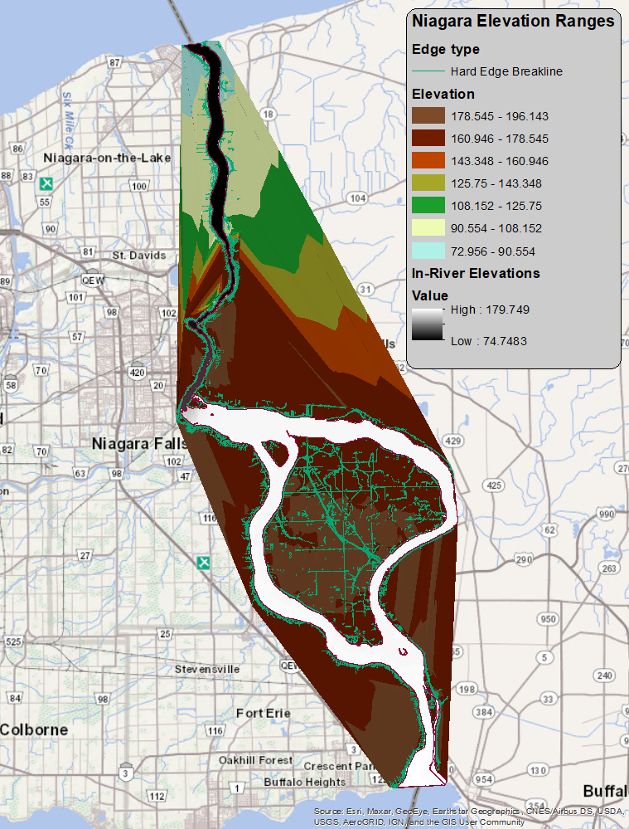
Figure 8: Niagara River break-lines in green draped over the clipped in-river DEM in varying shades from white to black representing the riverbank extents and the background source TIN that was generated from the break-lines. Only the values within the river were used for flattening the PDEM. The headwater of the river was limited to approximately 174.2m in elevation at the mouth of Lake Erie.
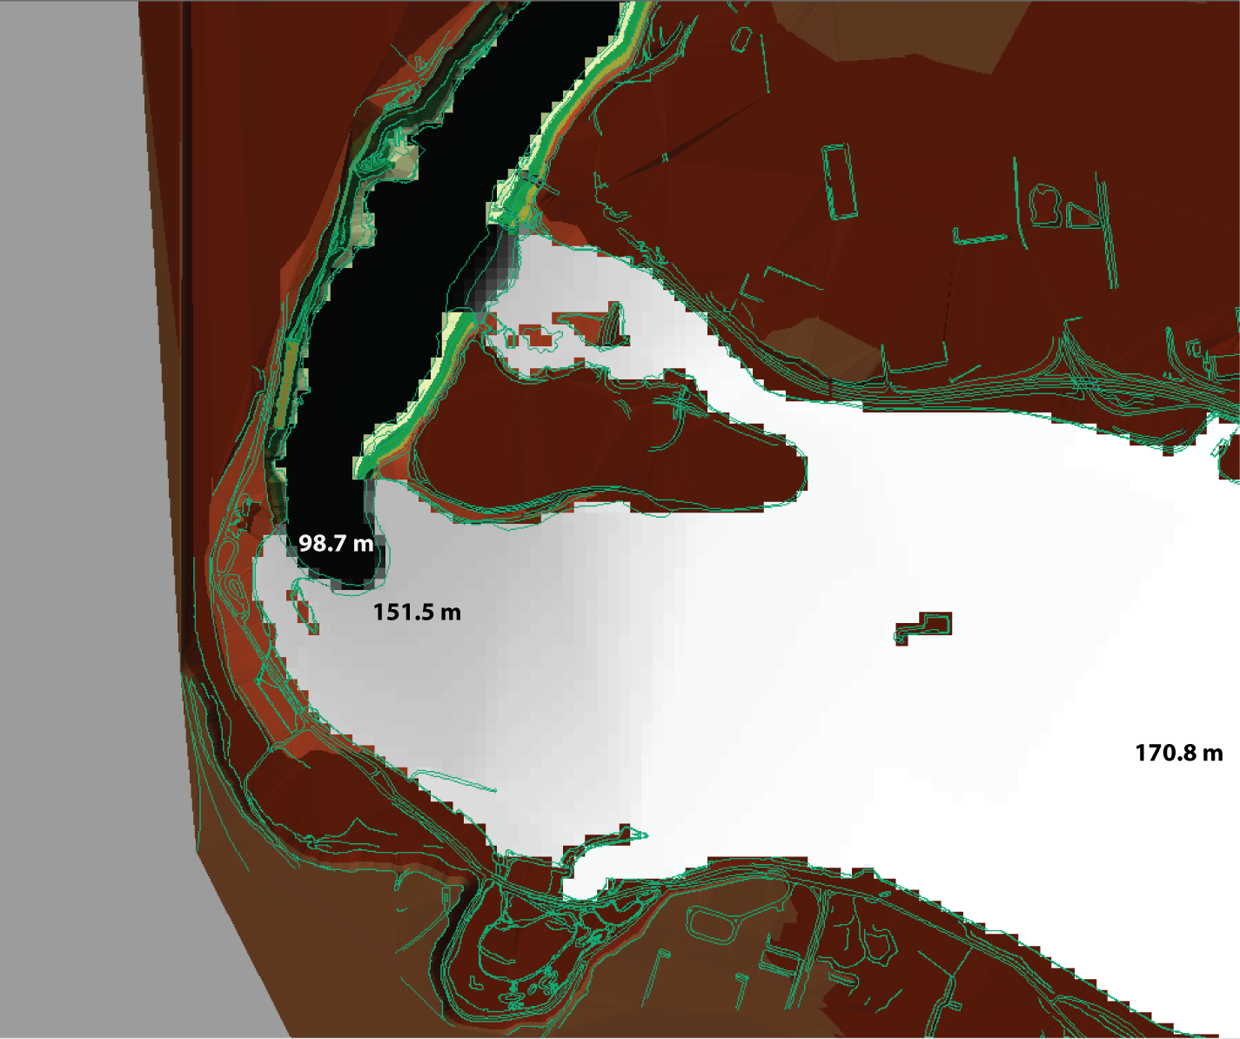
Figure 9: Zoom-in of Niagara Falls and break-lines used for creating the resulting river raster at a 30m cell size.
Lake Erie was the first lake flattened using the NOAA-NRCan water levels as a guide. The all-time yearly average water level was calculated by NRCan to be 174.14m ASL for the lake. Values slightly higher than this were assigned to the outlet of Detroit River feeding into Lake Erie, and values slightly lower than the average were assigned at the lake outlet to Niagara River – in effect creating a slight downward gradient towards the lake outlet. St. Clair River, Lake St. Clair and Detroit River were also included in the interpolation. For this stretch, there were a series of water level observations to draw upon to create a realistic downward gradient throughout the system. A series of elevation points were placed near shore and inland to control the elevations at the edge of the lake and the adjacent river systems.
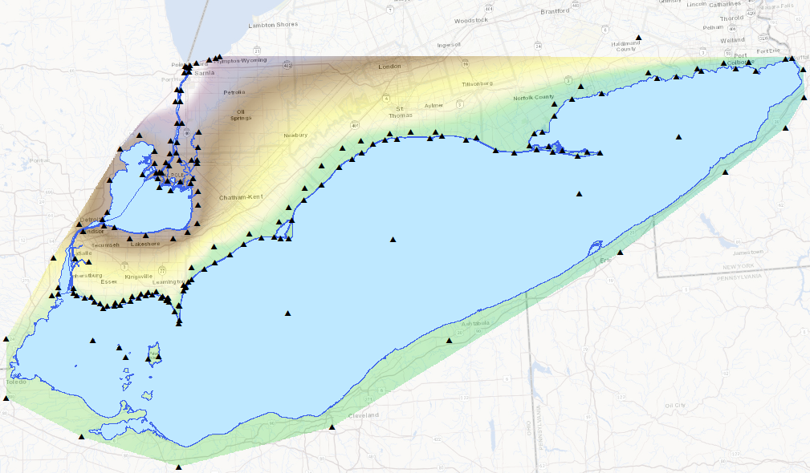
Figure 10: Lake Erie TIN generated from manually plotted elevation points constraining the shoreline and the St. Clair River – Lake St. Clair – Detroit River Connecting Channel system.
Some of the smaller rivers including the Thames River feeding into the Connecting Channel region did not meet the width criteria for flattening in the 2017/18 LiDAR product. Therefore, some of the returns were below the surface of the river or reflecting low water conditions depending on time of capture and were less than the all-time yearly average water level for Lake St. Clair. The lower Thames River and surrounding tributaries are influenced by water levels in Lake St. Clair, characterized by the low flat terrain of the region (Thames River Clear Water Revival, 2019). These rivers were uniformly raised so that they were consistent with the lake level to the west and the riverbank elevation some distance inland so that the transition was smooth and still honouring a downward gradient in the river channels. Figure 11 below illustrates the extent of the river flattening that was done around Lake St. Clair.
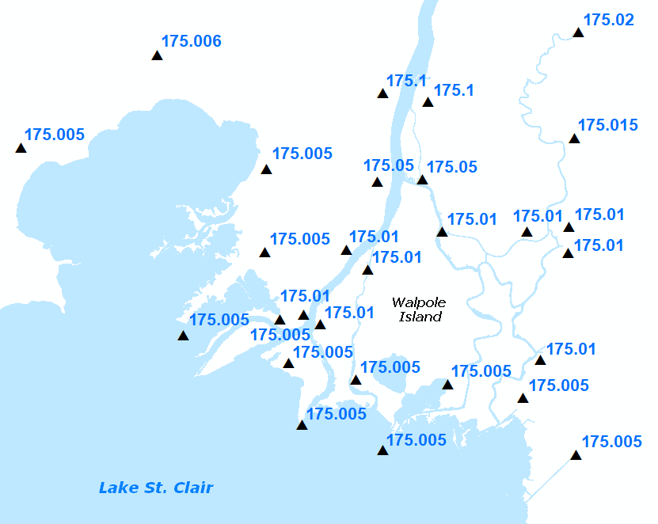
Figure 11: Elevations applied to lake and some surrounding tributaries for a smooth transition to inland elevation values. The extent of elevation change in this area is within 10cm with a downward gradient towards Lake St. Clair. Most of this change is limited to St. Clair River itself as it flows down from Lake Huron.

Lake Ontario flattening included the upper St. Lawrence River to the Iroquois Dam and Locks system. The portion downstream of the dam was not flattened as the PDEM is currently clipped close to the river shoreline. Future versions could entertain flattening in this area especially if there is any interest to further extend the PDEM into the United States to capture the entire Great Lakes Basin.
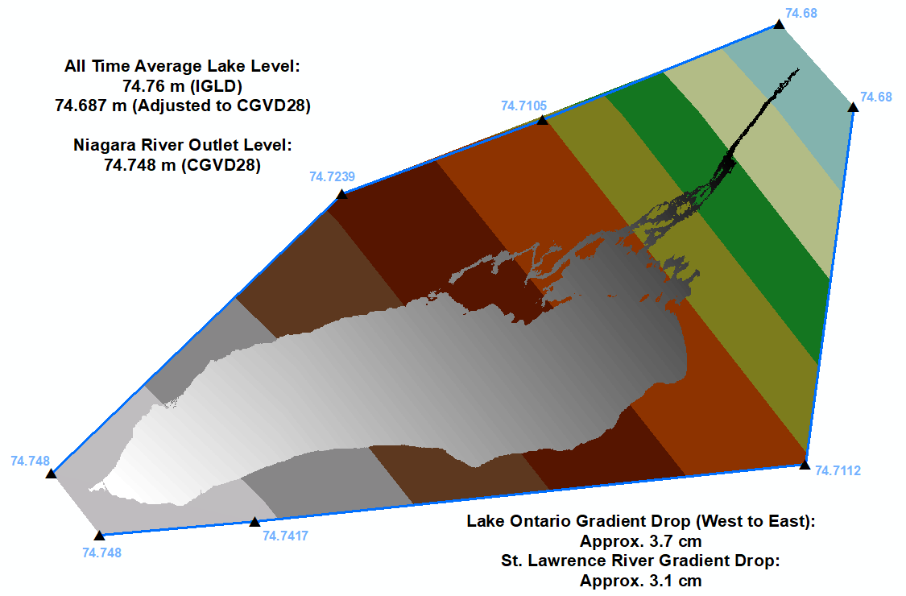
Figure 12: Lake Ontario TIN and raster products.
For Lake Superior, the all-time yearly average recorded was 183.4m ASL. A slight gradient of 4mm was applied upstream to the western tip of the lake which was sufficient and fit well with surrounding terrestrial elevations on the Canadian side.
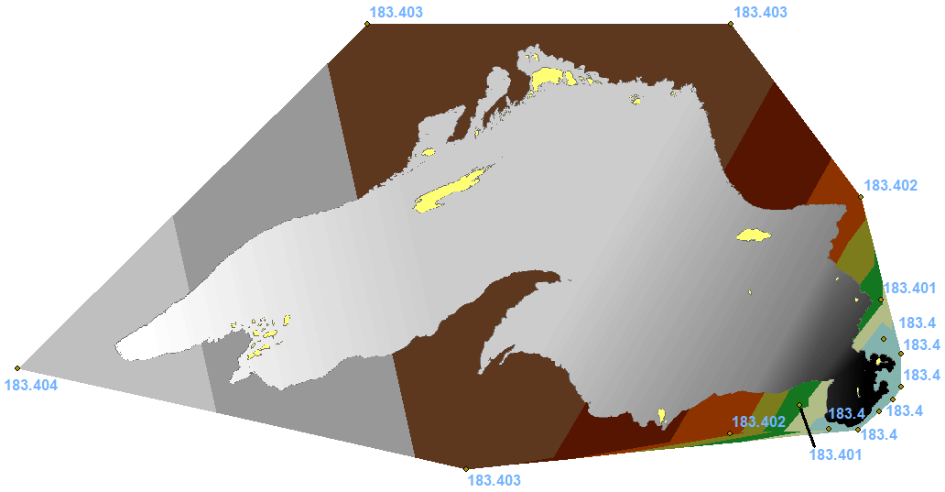
Figure 13: Lake Superior TIN and raster products.
Other notable areas that were hydro-flattened include Lake Nipissing and Lake Simcoe based on monthly average lake levels reported by Water Survey of Canada at HYDAT Station 02DD006 (LAKE NIPISSING AT NORTH BAY) for 2019 and monthly minimum lake levels reported by Parks Canada at Jacksons Point, Lake Simcoe. Monthly minimums were used for the latter site to better align with LiDAR elevation values at the lake interface. Please refer to the PDEM Spatial Metadata Index for the extent of flattening conducted. For these lakes, a single value was calculated and applied to the OHN vector geometry before conversion to raster. Below are the estimated elevation values used for each lake.
Lake Nipissing – 195.6 m
Lake Simcoe – 218.5 m
Islands with well-defined elevation were not flattened during this process. For Lake Huron – Georgian Bay, islands smaller than 10 cells or 9000 square metres were typically regarded as ‘elevation noise’ at a 30m resolution and were removed from the OHN water body polygon and included in the flattening mask. If you require elevation data for these masked out areas, please refer to the source elevation data to see if there is information available for this area using the Ontario Elevation Data Index available in Ontario GeoHub.
  - Minimum Resampling Method from Raster
A new method of interpolation was employed for the Duck Islands situated just south of Manitoulin Island where previously there was no data in the PDEM for Outer Duck Island and the southern portion of Great Duck Island as shown in Figure 14 below. Only the northern tip of Great Duck Island has data in raster format originating from the OBM Contour acquired for the area.
One option to fill in this void area was to revisit the original contour line data (as shown in the LIO Topographic Data Cache in Figure 14 below) and re-interpolate a surface from it. Since the vintage of the data is old dating back to 1984 and the contour spacing was very coarse at 10 metre intervals, this data is considered quite inadequate for representing any detail in the terrain and was not worth investing time incorporating.
PMU opted to leverage a newer data source acquired through the imagery program in 2016 for the Central Ontario Orthophotography (COOP) region. Even though the elevation product is a DEM representing both ground and surface top features, it was interpolated at a fine 2m cell size and when generalizing up to a 30m product, there were several elevation values from the COOP DEM to reference for each 30m cell in the PDEM – specifically 30/2 x 30/2 or 225 possible values. The likelihood of one of these values representing the ground surface or near-ground is reasonably high except in areas of very dense conifer canopy cover. Such generalization could also result in certain ridge detail defining drainage areas being lost or displaced. Further testing would be required to verify this assumption if this method is to be adopted for other inland areas in Ontario.
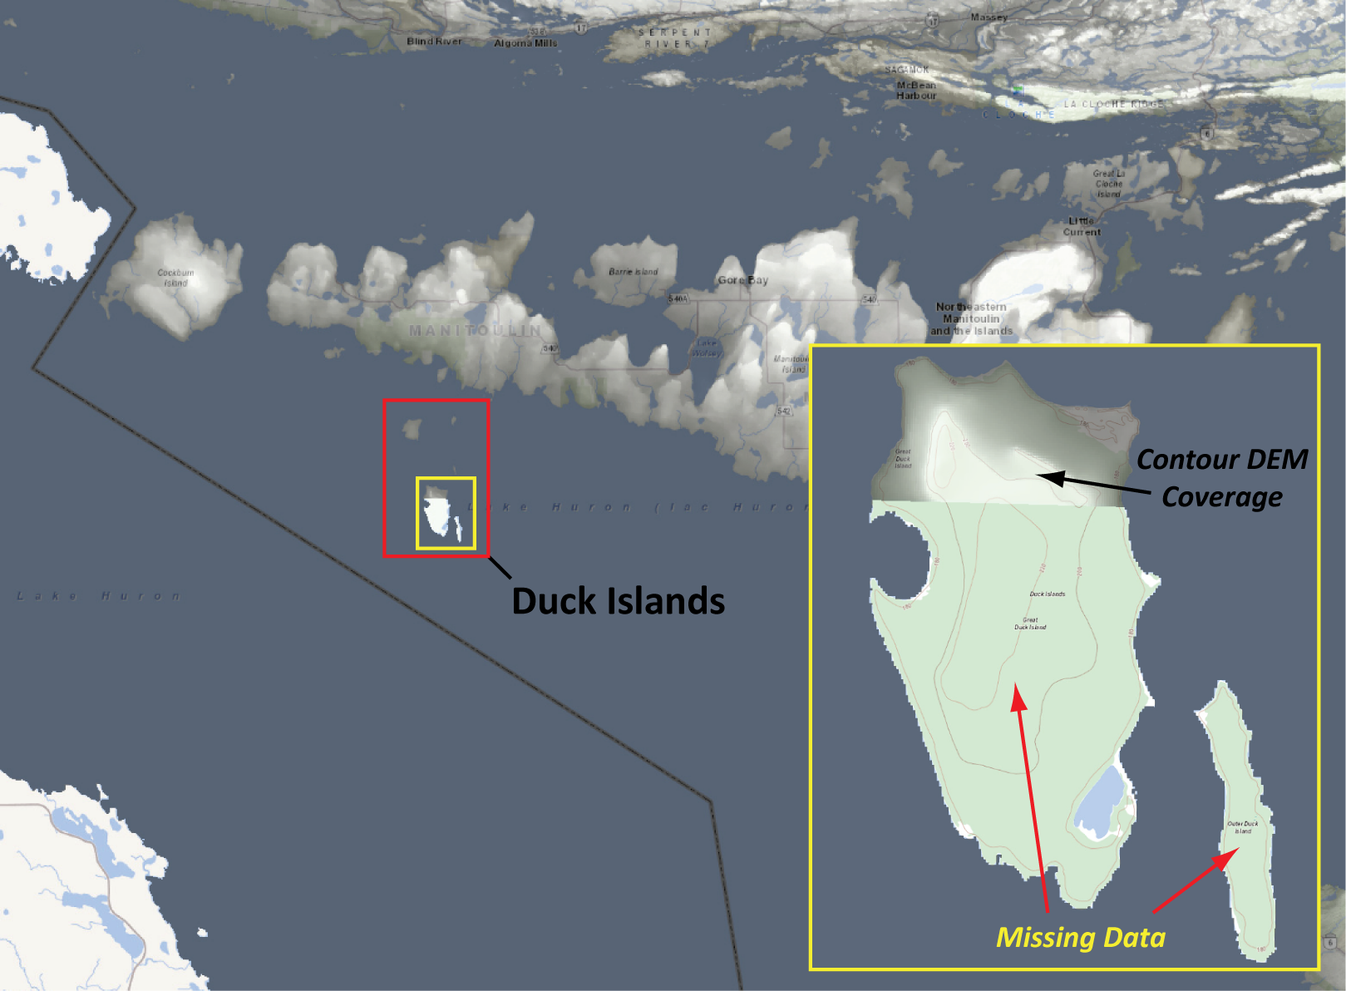
Figure 14: Overview of Duck Islands region (red box) and areas where resampling was conducted for Great Duck Island and Outer Duck Island (yellow box).
The interpolation method employed was the Resample function using the Minimum Resampling Type which is new to ArcGIS Pro. In traditional ArcGIS Desktop, the Minimum option was only possible when interpolating from the original LAS point cloud and could not be performed on raster datasets. Utilizing the new raster functionality could make the process more streamlined than working with the tiled point cloud data source depending on the results achieved. Figure 15 illustrates the results of resampling.
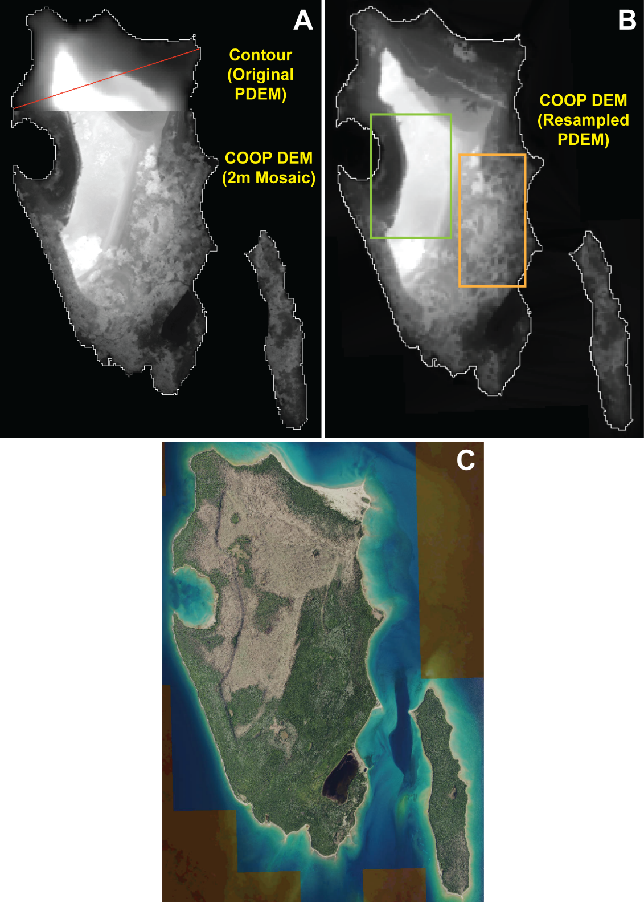
Figure 15: (A) shows the contour coverage in northern Great Duck Island overlaying the COOP 2016 DEM 2m mosaic. Red line represents the elevation profile line plotted for Figure 16. (B) shows the revised PDEM derived from the COOP DEM using minimum value resampling. (C) shows the COOP imagery for the islands and the difference in forest cover – deciduous leaf-off in the brown areas and conifer in the green areas. Green box indicates where minimum resampling did a decent job in capturing ground elevations. Orange box indicates region where minimum resampling did not always extract ground elevations particularly in dense conifer areas.
Even though the minimum resampling method did not always result in true ground, the elevation surface was still reduced and smoothed out compared to the original DEM product. This is clearly demonstrated in the section profile in Figure 16 and is still an improvement in representing the terrain in more detail compared to the original contour dataset. For these reasons, and because the study area was small and remote, the new data was used to enhance the PDEM in this area.
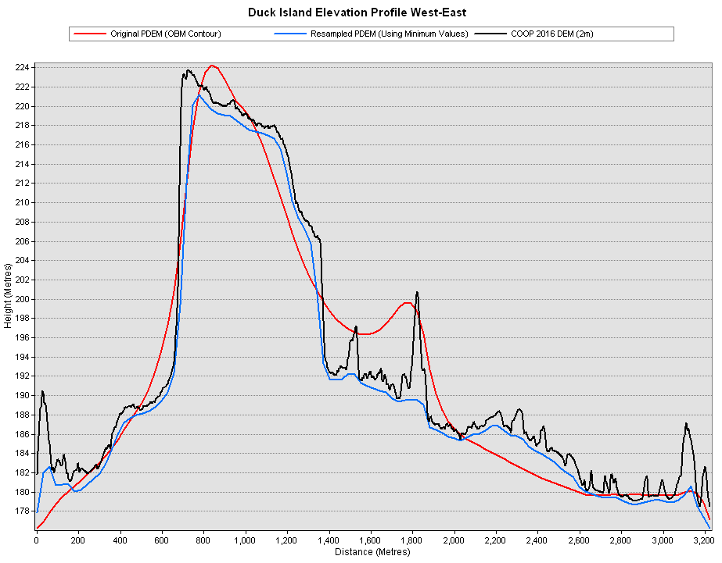
Figure 16: Elevation profile comparing the original highly generalized OBM Contour (red line), the detailed COOP 2016 DEM 2m mosaic (black line) and the minimum resampled PDEM (blue line). The resampling technique smoothed out most sharp peaks in the original COOP mosaic with an overall average reduction of 1 to 2 metres throughout the entire surface and the removal of spike elevations upwards of 11 metres in this example profile. The original contour also clearly did not capture true ground in many cases and missed undulating detail between 10 metre intervals.
Caution should be emphasized if this technique is implemented notably in areas of steep terrain as discussed in the appendix for the Beaver Valley study area using the SWOOP point cloud Minimum interpolation technique since the terrain elevation could be significantly underestimated at a coarse resolution. It may require an iterative process of first performing a Minimum interpolation from the point cloud to a fine resolution DTM (e.g., 2m) and then performing Bilinear resampling to 30m from there. Further testing is recommended before considering this technique in other areas of the province. DTM testing should be compared against interpolating straight from the original point cloud using both the Imagery-Derived and LiDAR-Derived point cloud products for Ontario. As new LiDAR data is acquired, this technique might be only of value in (and should be limited to) flat to rolling unpopulated areas of northern Ontario covered by imagery but lacking LiDAR where a straight ground classification can be reliably extracted.
  - Historical Methods and Processes
    - ANUDEM Software
ANUDEM (Australian National University Digital Elevation Model) is a well-recognized software package that “calculates values on a regular grid of a discretized smooth surface fitted to large numbers of irregularly spaced elevation data points, contour line data and stream line data” (Hutchinson, 1989). ANUDEM was used for creating previous DEM products, such as DEM Version 1.0.0 and DEM Version 2.0.0. After a review of other interpolation products, ANUDEM was still identified as the optimal software package for consecutively interpolating both contour and point elevation datasets. An upgrade was made to ANUDEM with the release of Version 5.2 (Hutchinson, 2005) which was used for areas covered by OBM and Spaceborne Radar (originating from SRTM). This version included a major revision of the drainage enforcement algorithm involving:
- Improved handling of stream and lake data as an input to the DEM, and
- Improved interpolation for complex topography around ridges and valleys using contour data.
    - Interpolation Workflow
Figure 17 illustrates how the various elevation data sources have been integrated. To include these elevation datasets, several pre-processing steps were required. Four interpolations were performed separately based on whether Contour, DTM, Spaceborne Radar or GTA Ortho data was used as the primary elevation dataset. These four products were then mosaicked to create the PDEM.
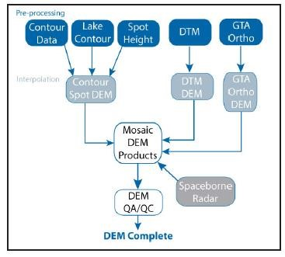
Figure 17: Interpolation workflow for the PDEM prior to 2015.
    - OBM DTM De-Striping
DTM elevation points were not captured for all areas of the province during the OBM program. Between 1978 and 1987, only contours were generated using traditional cartographic techniques and a DTM was not produced. In 1988, digital contours were produced from the DTM elevation point dataset using automated photogrammetric software utilities. In total, OBM DTM elevation point data was captured for approximately 70% of the extent of OBM mapping in the province (See Figure 2).
The OBM DTM dataset contains the highest vertical elevation accuracy standard that was defined for the OBM program, with a vertical accuracy of 2.5 metres in Southern Ontario and 5.0 metres in Northern Ontario. The OBM DTM dataset was originally generated using a manual profiling photogrammetric technique, commonly used in the late 1980’s and early 1990’s. One of the drawbacks of this older technology was a resulting systematic artefact, or striping, caused by an over-sampling and under-sampling of elevations in the direction of the elevation profiling. This is a well-documented systematic artefact and various methods have been approached to deal with artefacts within DTM datasets (Oimoen, 2000; Albani and Klinkenberg, 2003). After reviewing and testing existing de-striping methodologies, the team was found that none of the existing filters effectively removed the entire stripe artefact occurring within the OBM DTM dataset. Using a combination of methods proposed from both Albani and Klinkenberg (2003) and Oimoen (2000), it was found that the stripe artefact within the OBM DTM dataset was effectively isolated and removed (see Figure 5). This method has been developed and summarized for several pilot areas within the province (Zhao et al., 2008).
    - OBM Spot Height Filtering
OBM Spot Heights are an elevation layer representing elevation in metres above mean sea level. These points were generated with less density than the OBM DTM dataset and identify local minima and maxima (e.g., hilltops, road/rail crossings, vertical control points and lake water levels) within the OBM project. In many cases, the OBM Spot heights do not correlate with elevations assigned to the OBM Contour elevations. This is often the result of Spot Heights that have been captured for buildings or other constructed features which do not represent the bare-earth surface. Since the OBM specifications did not require unique attributing of raised features, a filter was developed to identify Spot Heights that are not consistent in elevation with the OBM Contours. By removing these elevation points from the OBM Spot height dataset, the remaining elevation points were used in conjunction with the OBM Contour dataset to provide definition of local minimum or maximum elevations in the DEM product.
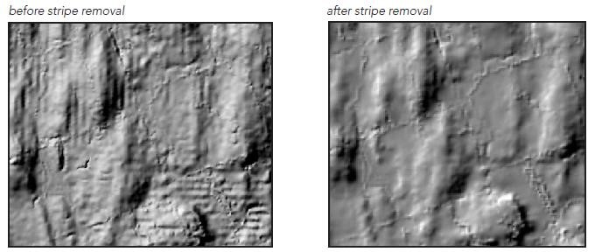
Figure 18: Striping in the DEM resulting from the systematic artefact in the OBM DTM elevation data
    - Lake Shoreline Elevations
An additional enhancement for the PDEM was the inclusion of lake shoreline elevations for lake features. Lake elevations were photogrammetrically captured during the OBM program and included within the OBM Spot Height dataset. By associating the OBM Spot Height dataset with lake polygons, lake shoreline contours were integrated into the PDEM. Pre-processing techniques were developed to capture elevations for both inland lakes and the Great Lakes water system.
    - Contour Edits
A contour is a linear vector layer representing isolines, or lines of equal elevation, in metres above MSL. Within the OBM program, contours were captured for each OBM mapping tile across the province. However, the process for acquiring this contour mapping varied based on the timeframe at which the OBM tile was interpreted.
A general history of the transformations of the OBM contour data is documented below:
- From 1976 to 1988, contours were derived using photogrammetric techniques for the original OBM program. These contours were originally intended for cartographic use and were only plotted in hard copy format.
- In 1988, digital contours were produced from the DTM elevation point data set using automated software utilities. DTM elevation points were acquired through photogrammetric techniques only in certain portions of the province, therefore digital contours only existed in these areas.
- Starting in 1992, areas without digital contours were digitized from the original hardcopy OBM series. Approximately 5,000 of the 10,000+ tiles were created using this method.
- In 1996, individual OBM tiles were aggregated into NRVIS and stored by MNRF district.
- In 1998, several automated procedures were developed by the NRVIS team to search and correct attribute coding errors in the contour coverage. This process did not eliminate all attribute errors.
- In 2001, WRIP developed new procedures to search and correct additional attribute coding errors in the contour coverage. This process did not eliminate all attribute errors.
- In 2001-2002, WRIP used a digital elevation model technique to identify contour attribute errors and manually correct them. This process was completed in 2002.
- In 2004, spatial errors located along UTM Zone boundaries were updated by the NRVIS data team. This process did not eliminate all spatial errors or attribute errors due to the nature of this dataset.
In the area of OBM coverage where DTM data are not available, OBM contour and OBM Spot Heights were the primary datasets used to derive elevations.
Please refer to the PDEM User Guide for more information on the current spatial distribution of areas still covered by OBM, Spaceborne Radar or newer technology.

References
Albani, M. and Klinkenberg, B. 2003. A spatial filter for the removal of striping artefacts in digital elevation models. Photogrammetric Engineering & Remote Sensing, Vol. 69, No. 7, pp. 755 – 765.
Burrough, P.A. and McDonnell, R.A. 1998. Principles of Geographical Information Systems, New York: Oxford University Press, 333p.
ESRI, 2016. Resample. Environmental Systems Research Institute. Tool description. (https://desktop.arcgis.com/en/arcmap/10.3/tools/data-management-toolbox/resample.htm)
Forsyth, D., Riseng, C.M., Wehrly, K.E., Mason, L.A., Gaiot, J., Hollenhorst, T., Johnston, C.M., Wyrzykowski, C., Annis, G., Castiglione, C., Todd, K., Robertson, M., Infante, D.M., Wang, L., McKenna, J.E., Whelan, G., 2016. The Great Lakes Hydrography Dataset: consistent, binational watersheds for the Laurentian Great Lakes Basin. Journal of the American Water Resources Association. JAWRA-15-0052-P.
(https://doi.org/10.1111/1752-1688.12435)
Hutchinson, M.F. 1989. A new procedure for gridding elevation and stream line data with automatic removal of pits. Journal of Hydrology 106: pp. 211 – 232.
Hutchinson, M.F. 2005. ANUDEM 5.1 User’s Guide. 2005. Centre for Resources and Environmental Studies, Australian National University, Canaberra, Australia.
IJC, 2009. The International Watersheds Initiative: Implementing a New Paradigm for Transboundary Basins. 3rd Report. International Joint Commission. ISBN: 978-1-100-12002-7.
Ministry of Natural Resources and Forestry (MNRF), 2022a. User Guide for Ontario Integrated Hydrology. Provincial Mapping Unit, Mapping and Information Resources Branch, Corporate Management and Information Division. (https://geohub.lio.gov.on.ca/search?q=OIH)
MNRF, 2022b. Provincial Digital Elevation Model User Guide. Provincial Mapping Unit, Mapping and Information Resources Branch, Corporate Management and Information Division.
(https://geohub.lio.gov.on.ca/search?q=PDEM)
MNRF, 2022c. Updating Provincial Elevation Data Using Least Cost Path Analysis Technical Report. Provincial Mapping Unit, Mapping and Information Resources Branch, Corporate Management and Information Division.
(https://geohub.lio.gov.on.ca/search?q=PDEM)
Oimoen, M.J. 2000. An effective filter for removal of production artefacts in U.S. Geological Survey 7.5-minute digital elevation models, in Fourteenth International Conference on Applied Geologic Remote Sensing, Las Vegas, Nevada, November 6-8, 2000, Proceedings: Ann Arbor, Michigan, Veridian ERIM International, pp. 311 – 319.
Sanocki, C.A., Williams-Sether, T., Steeves, P.A., and Christensen, V.G., 2019. Techniques for estimating the magnitude and frequency of peak flows on small streams in the binational U.S. and Canadian Lake of the Woods–Rainy River Basin upstream from Kenora, Ontario, Canada, based on data through water year 2013: U.S. Geological Survey Scientific Investigations Report 2019–5012, p. 8. (https://doi.org/10.3133/sir20195012)
Thames River Clear Water Revival. 2019. The Thames River (Deshkan Ziibi) Shared Waters Approach to Water Quality and Quantity. Final Draft, pp. 24 – 25.
Vouk, I., Burcher, R.S., Johnston, C.M., Jenkinson, R.W., Saad, D.A., Gaiot, J.S., Benoy, G.A., Robertson, D.M., Laitta, M., 2018. Geospatial data for developing nutrient SPARROW models for the Midcontinental region of Canada and the United States. Technical Report, National Research Council of Canada, Ocean, Coastal and River Engineering. NRC Publications Archive.
(https://doi.org/10.4224/23004810)

APPENDIX A
  - Methods Tested in 2017 Pilot Project
    - SWOOP Analysis Using Resampling and Various Interpolation Techniques
- Create study areas based on watershed polygons. HUC12-like draft units were used for southern Ontario. Five study areas were created:
  - 2 in areas covered by OBM Contour, one in significant topography (Beaver Valley – SA1), the other in flat terrain (Lower Thames region draining to L. Erie – SA2)
  - 2 in areas covered by OBM DTM, one in significant topography (Maitland River mouth – SA3), the other in flat terrain (Lower Thames region draining to L. Erie – SA4)
  - 1 additional area straddling OBM DTM / Contour defining the Tertiary watershed level divide between Grey Sauble and Saugeen Valley in the headwaters of Beaver Valley. A potential watershed discrepancy exists here in part due to undefined disconnected drainage in this area. The claim is that this area flows west into the Saugeen potentially via the subsurface (sink hole phenomenon). An examination of the SWOOP will be conducted to assess drainage pattern in this area.
- A tool was created to extract DTM raster tiles from SWOOP intersecting each study area (buffered 1km) for the resampling method. Results are placed in separate study area folders. The tool created is stored here: z_MNRF OIH Integration Tools > 1. DEM Preprocessing > 2. Select & Copy Elevation Tiles. This tool also can extract the appropriate ZLAS files for the buffered study area for the interpolation method. In this case, make sure to leave the ‘Input Source Package Field’ parameter blank since there are no package subfolders for the ZLAS files. Separate geodatabases and raster folders are created for each method.

      - Resampling Method
- Create mosaic datasets and store in a file geodatabase for each study area using the script mentioned above.
Important tips for mosaic creation:
- Overviews should be built for each mosaic (required for resampling).
- If the following error is encountered when trying to add raster datasets, ensure your environment settings are set to the projection of the input data and processing extents are set to “Union of Inputs”.
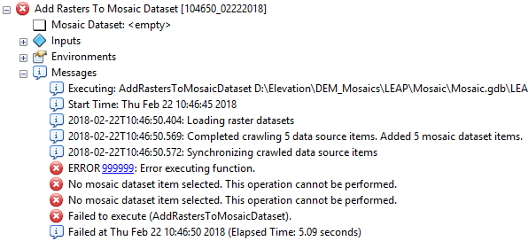
Figure 19: Error in creating a mosaic dataset that may occur if the environment settings are not set properly.
- Test various resampling methods: Extract by Mask, ‘Export Data’ option, re-projection, and resampling using Image Analysis Window.
- The above step is to be repeated for 10m and 5m (and potentially 2m) resolutions.
      - Interpolation Method
- Set Environment Settings to the following:
  - Coord System: NAD_1983_CSRS_UTM_Zone_17N
  - Extents: Set to the “SA_bf” polygon boundary created in Resampling Method section (if the projection does not match, make sure to reproject the layer to NAD_1983_CSRS_UTM_Zone_17N)
- Extract a subset of each study area ~ 25 ZLAS files to test for significant difference with the resampling method. If there is a significant difference in terms of hydrological watershed modeling results or the results are inconclusive, this method would be revisited to include the ZLAS tiles for the entire study area. The selection polygon can be extracted from the tile index layer, but it should match the native projection of the ZLAS point files.
- Create the LAS Dataset and a LAS Layer filtering out for ground elevations (Class Code = 2).
- Convert the LAS Layer to a Raster using the Binning option and the appropriate Binning Method parameters and Output Cell Size. The image below shows an example of these parameters, but the optimum parameters will depend upon the comparison of the final DEM results, and therefore this tool will be run multiple times for each Binning Method and Output Cell Size tested. But note when choosing the interpolation method, the Input Source Package Field parameter must be left blank.
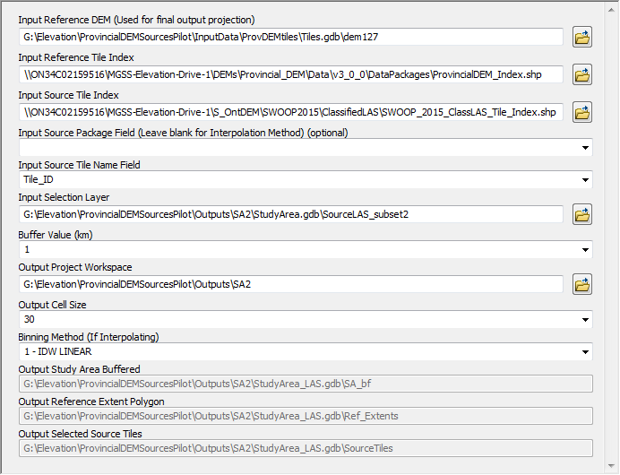
Figure 20: Example Interpolation Method parameters for Study Area 2.

- Produce difference grids comparing the resampling method to each of the interpolation methods including Average, Inverse Distance Weighting, and Minimum interpolation. Below is the legend depicting the elevation difference categories used in subsequent figures of this appendix.
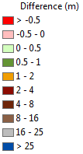
- Create cross-sections traversing various features such as roadways, streams/rivers, cliffs, forested and open terrain.
- Extract elevation profiles for each cross-section based on each elevation type including the PDEM as a reference, and an Average (and in some cases a Minimum) LAS interpolated 2m product serving as a relative baseline to the 30m generated products.
    - SWOOP/SCOOP/PDEM Comparison with LiDAR 2017
- Produce similar difference grids using the preferred LiDAR technique (resampling or interpolation) from Phase 1, and compare the difference with each of the SWOOP, SCOOP and PDEM products at a 30m resolution.
- If necessary, conduct the analysis at a finer resolution (e.g., 2m matching the Ortho DTM product).
- Report any issues found and recommendations for updating the PDEM.

  - Observations and Results
    - Determining Significant Difference
The emphasis of this exercise is to provide a qualitative assessment of the various interpolation and resampling techniques. To obtain a reasonable baseline for determining what constitutes a ‘significant difference,’ a comparison of the preferred interpolation method for continuous data (ESRI suggests the Average technique) with the resampling method was conducted by calculating the standard deviation from the mean.
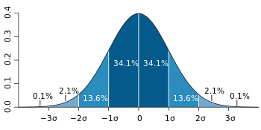
In flat terrain, 68 percent of the elevation values (equivalent to one standard deviation away from the mean) fell within +/- 0.1 metres. In steep terrain, the values were within +/-0.8m. At 3 standard deviations (99.7 percent of the values), the elevations were within 0.3m in flat terrain and 2.4m in hilly terrain. For simplicity of classification, a value of +/-0.5m was chosen as the point where elevation differences become significantly different.

    - Resampling Methods Tested
- Extracting by Mask using the DTM mosaic as input and setting environments to Ontario LCC projection and 30m cell size does not maintain float precision. The output is converted to 16bit integer, which is not acceptable. A possible work-around would be to convert float to integer by multiplying values by a factor of at least 1000. This would involve extra steps in processing and loss of precision in conversion to integer and back to float format.
- Resampling from a raster mosaic produced only partial results. First, resampling does not seem to honour the Extent environment setting even though the help says it should. This behaviour has also been verified with the recent spring 2020 Imagery Services Pilot. Given this issue, make sure the mosaic you are sampling from is not too large because the command will attempt to resample the entire mosaic at once. If it is too large, you can Extract by Mask but ensure the cell size and snap grid matches the DTM mosaic or else you will encounter the data type conversion error as stated previously. For the pilot, the raw DTM tiles were physically extracted, and a mosaic was recreated on the extracted tiles for each study area, so Extracting by Mask was not necessary. However, the resampling results initially were incomplete as shown in the figure below. This was conducted in ArcMap and ArcCatalog with identical results. It also occurred without changing the output projection. Below is an example for SA1.
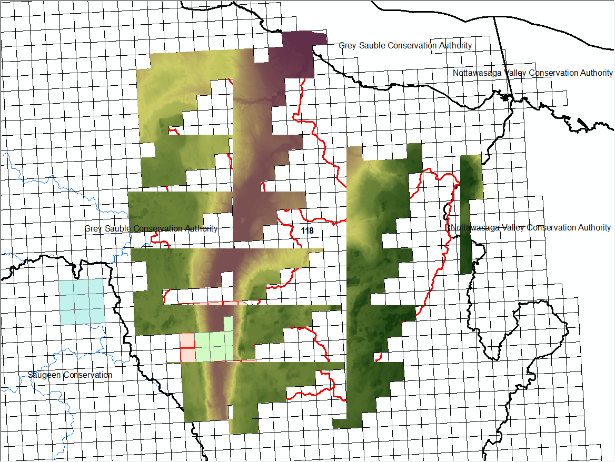
Figure 21: Incomplete results encountered when resampling from a tiled mosaic.
- Resampling using the Image Analysis Window did not successfully change the output resolution (even though 30m was selected, the output was still the original 2m raster mosaic).
- Exporting Mosaic Dataset Data to a physical raster using the same extents and cell size of the mosaic was also tested and appeared to be successful. Then resampling to coarser resolutions from the raster was possible. However, exporting does not preserve the same elevation range as the mosaic. In addition, selecting the “Square” option produced altogether a different range but was slightly closer to the mosaic range.
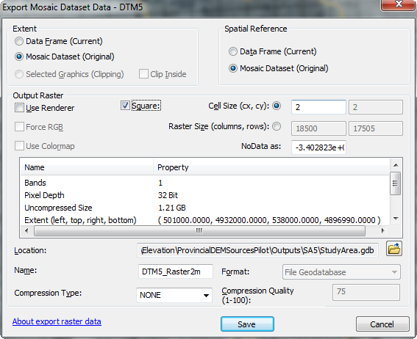
Figure 22: Exporting a mosaic to a raster dataset of the same resolution.
The changes experienced can occur if there is overlap between the raster tiles in the mosaic causing a re-interpolation but in the case of the SWOOP DTM 2015, these tiles appeared to be created with no overlap, which is difficult to verify without manually inspecting every tile. When resampling, the values would change again (e.g., high and low values would be smoothed out or trimmed when coarsening the data to 30m) potentially compounding the difference. All these discrepancies and the multiple steps involved would reduce the overall confidence in the results. Therefore, this method was not recommended.
- Project the mosaic to raster using the following settings:
  - Output Projection: NAD_1983_Ontario_MNR_Lambert
  - Cell Size: 30m
  - Processing Extent and Snap Raster: South_Mosaic (PDEM)
  - Resampling Technique: BILINEAR (CUBIC is not recommended as it produces values outside of the range found in the source data)
This method was successful at 30m, but also produces the same phenomenon as the resampling method when trying to project the mosaic to a 5m raster.
Subsequent Findings:
For the resampling or projecting mosaic methods to work properly, you should set the Maximum Number of Rasters per Mosaic to a value much larger than the default of 20. A value of 2000 was recommended by SDSU Imagery/Elevation staff.
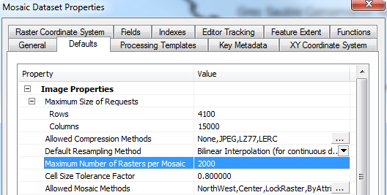
Figure 23: Accessing and modifying the ‘Maximum Number of Rasters per Mosaic’ setting under Mosaic Dataset Properties.
After applying this setting, resampling works consistently with no resulting gaps and is now the preferred method over all other methods tested.
    - Comparison of Interpolation Results – SWOOP Investigation
As previously mentioned in the Methods section, four study areas were chosen for this evaluation as shown in Figure 24.
The SWOOP DTM was resampled to 30m, and the LAS files were interpolated using Average, IDW, and Minimum techniques for each study area.
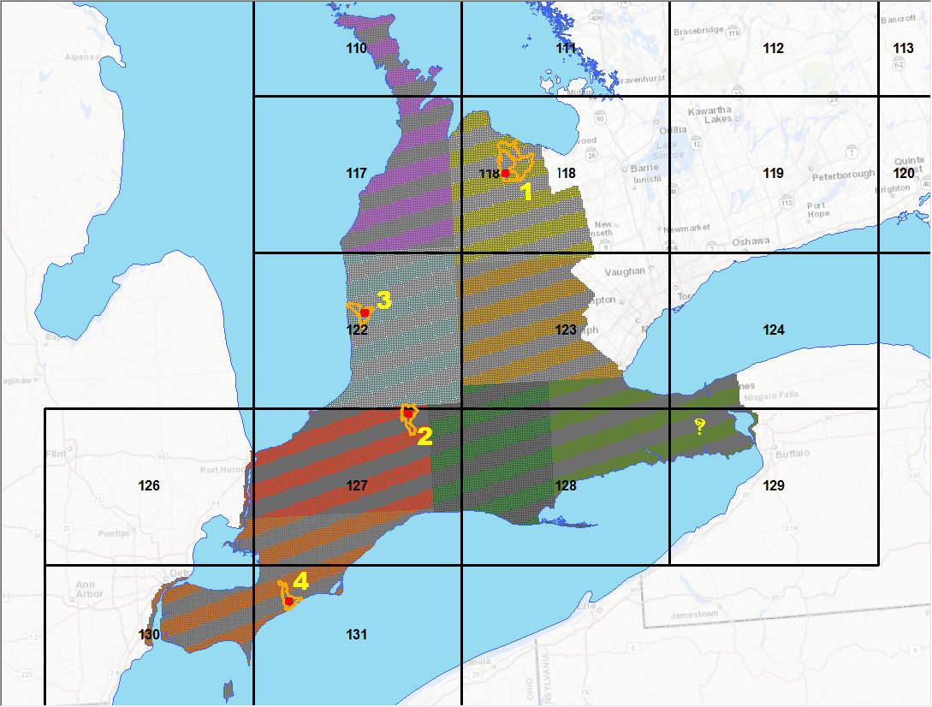
Figure 24: Study areas (SA) selected for the 2017 pilot project were all within the SWOOP DTM 2015 coverage, each having different terrain characteristics. The SA’s discussed in this section include 1) Beaver Valley, 3) Maitland River mouth and 4) Town of Merlin area. SA2 north of London and just southwest of St. Marys had similar characteristics to SA4 and therefore will not be discussed here. The question mark highlighting Niagara region was another potential site where data was extracted but not included in the project due to time constraints.

In addition to the three interpolation or ‘Cell Assignment Methods’ tested, additional surfaces were generated using the Linear and Natural Neighbor ‘Void Filling Method’ options. There was no discernible difference between the two methods when coarsening up to a 30m product. Therefore, either the Natural Neighbor or Linear void filling option (but not both) was used for the remainder of the exercise.
A series of difference grids were created for each study area. This report will illustrate some examples where key findings were discovered, particularly focusing on study area SA1 for a detailed analysis, and study areas SA3 and SA4 for general summary findings. SA2 was not completely reviewed at the time of writing, but the source data has been prepared in case a future investigation is warranted.
      - SA1 – Beaver Valley (Current PDEM data source: OBM Contour)
This study area is characterized by extremely high relief including the steep ridges of Beaver Valley, which runs along the northeastern side of Niagara Escarpment.

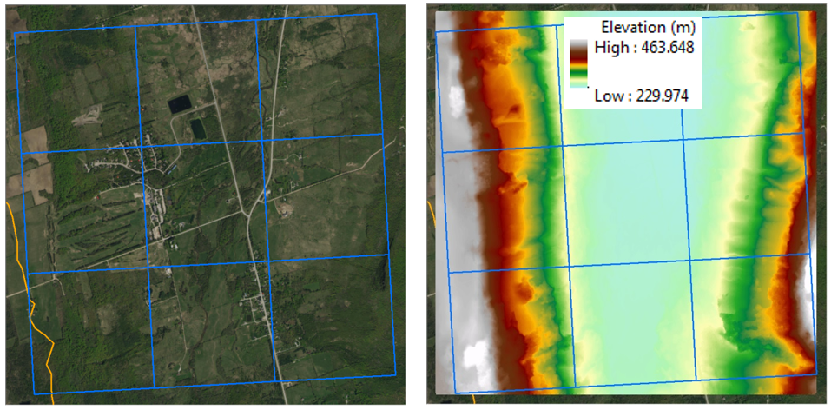
Figure 25: Study area imagery and tile extents and a 2m Average DTM interpolation of LAS ground elevation points.

In areas where the terrain is relatively flat, there was a good correlation between elevations derived from resampling and both IDW and Average techniques. Averaging produced results where 22 percent of the elevation values were greater than +/-0.5m difference when compared to the resampling method. IDW yielded slightly better results where only 16.5 percent (1834 of 11130 cell values) were greater than +/-0.5m difference. Most of these differences were confined to areas of very steep slopes and dense vegetation.
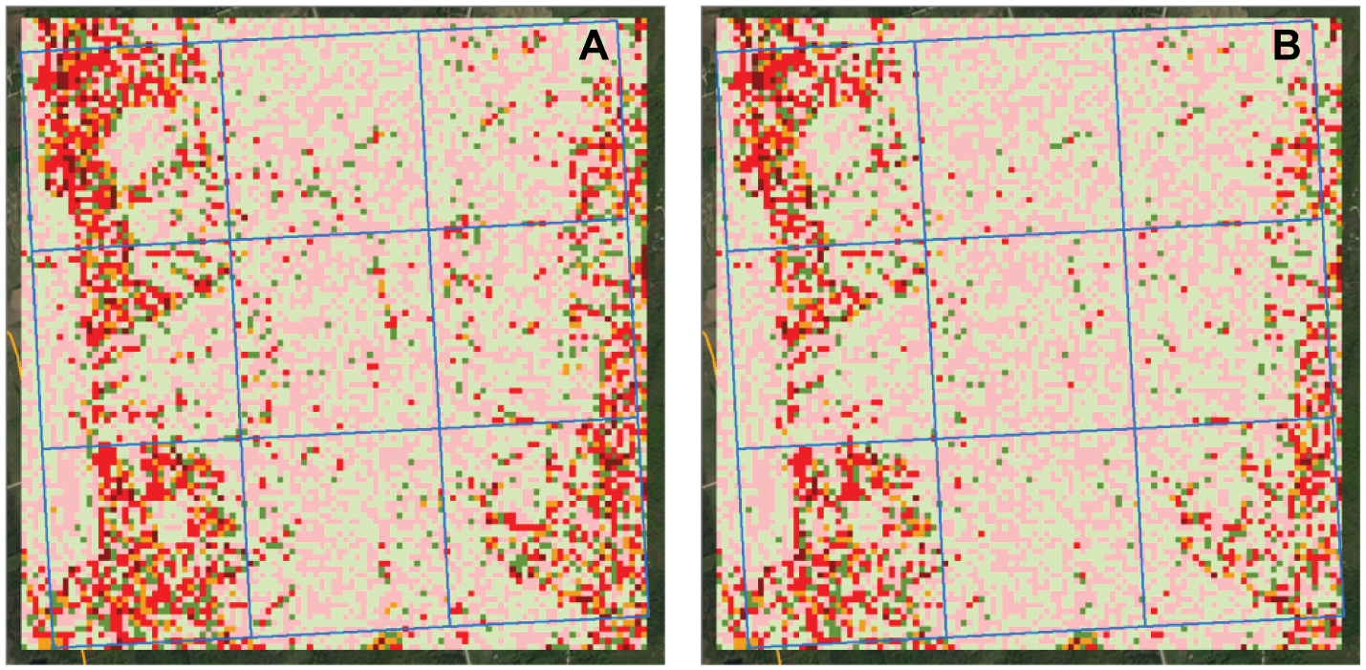
Figure 26: (A) ‘Resample – Average’ elevation difference versus (B) ‘Resample – IDW’ difference.
When comparing the Minimum (MIN) interpolation with the resampling method, most of the elevation values were predictably lower in the minimum grid than the resampled grid. In steep areas, the difference was up to 35 metres along a steep cliff ridge (purple cells highlighted by the black box inset in Figure 27 below), where the change in elevation over a 30m horizontal distance is very extreme. Similarly, the very steep terrain which occurs in the valley at the Maitland River mouth (described in next section) has upwards of 25m difference between AVG/IDW and MIN interpolation techniques. Therefore, this proves performing a coarse level Minimum interpolation can grossly underestimate values in steeply sloped hilly terrain.
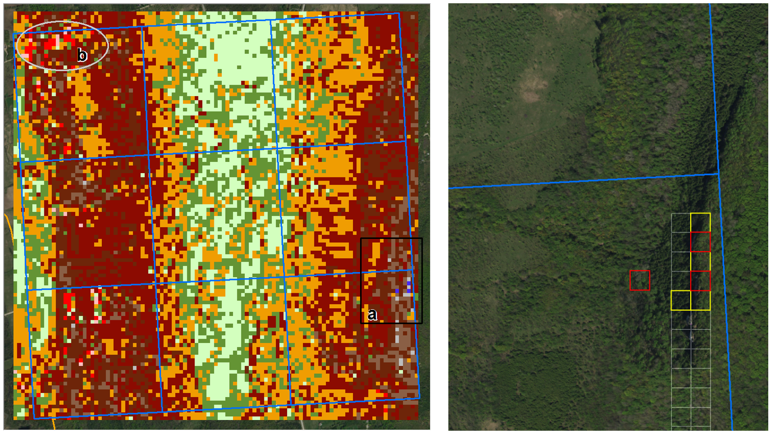
Figure 27: ‘Resample – Minimum Interpolation’ elevation difference for SA1 is shown in the image on the left where two areas of interest are shown. Photo on right highlights black box “a” in left image, where cells outlined in yellow range from 18.5 to 23m higher than the resampled grid, and the red cells range from 26.6 to 35.4m higher than the resampled grid. Light grey ellipse “b” is illustrated and discussed next in Figure 28 below. The undulating terrain and areas of increasing slope to the steep ridges average between 2 to 4 metres difference.
It was interesting to note that there were instances in red in the Figure 27 above where the minimum grid was still higher than the resampled grid which seemed unusual. Upon examination of the LAS files, this phenomenon primarily occurs in areas of dense vegetation and steeply changing terrain where there is a void of representative ground elevation points. Below is a zoom-in of the area “b” encircled in the figure above showing a sample void in ground elevation points. A cross-section was drawn through the predominantly void areas to better understand the results of each interpolation technique and resampling method.
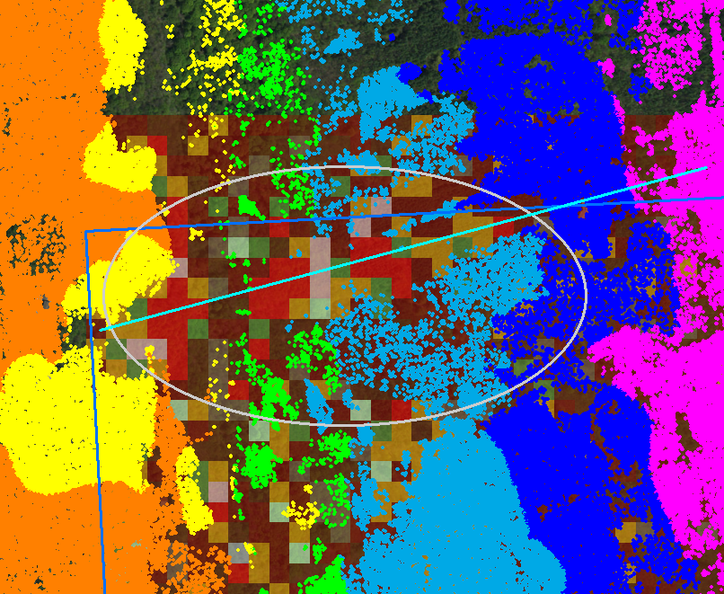
Figure 28: LAS point cloud overlaying top left corner of raster in previous figure. Notice the gaps in true ground classification because of thick vegetation cover and steep terrain in this area.

Figure 29 below shows the same area as above rotated to line up with the cross-section profile. IDW and Average techniques are almost identical at this scale and show an over-estimation of the elevation for each red area within the void. The Minimum 30m technique is closer to the resampled surface at the top end of the escarpment than the other two techniques and then consistently falls below all other techniques at the bottom end where the vegetation becomes sparser resulting in more ground returns. What is particularly interesting is that the resampled 30m product lines up very well with the 2m Average interpolation and original LAS point profile (an exception for the latter is at the top end of the escarpment where there are no points nearby resulting in a straight-line underestimation in the LAS profile). This finding makes the resampling technique most favourable in reflecting steep terrain when generalizing to 30m.
Also, for comparison, the OBM contour profile captures the trend of the escarpment quite well except in the mid-section where it underestimates the surface up to 7 metres below the SWOOP-derived surfaces (if the SWOOP surface is considered accurate, then this difference is beyond the OBM stated elevation accuracy specification of +/- 5m). However, further subsequent examination of this phenomenon indicated the opposite is true where the SWOOP product was capturing the heights of trees in dense vegetation cover and areas with steep forested terrain and the OBM was better in reflecting true ground conditions. This phenomenon is prevalent in the Bruce Peninsula and Beaver Valley region where forested vegetation is predominant, and the elevation data behaved more like a DSM than a true ground DTM. The section entitled “Method for Modifying SWOOP Forest Surface with OBM” further describes the extent of the issue and how it was handled and mitigated in the final product.
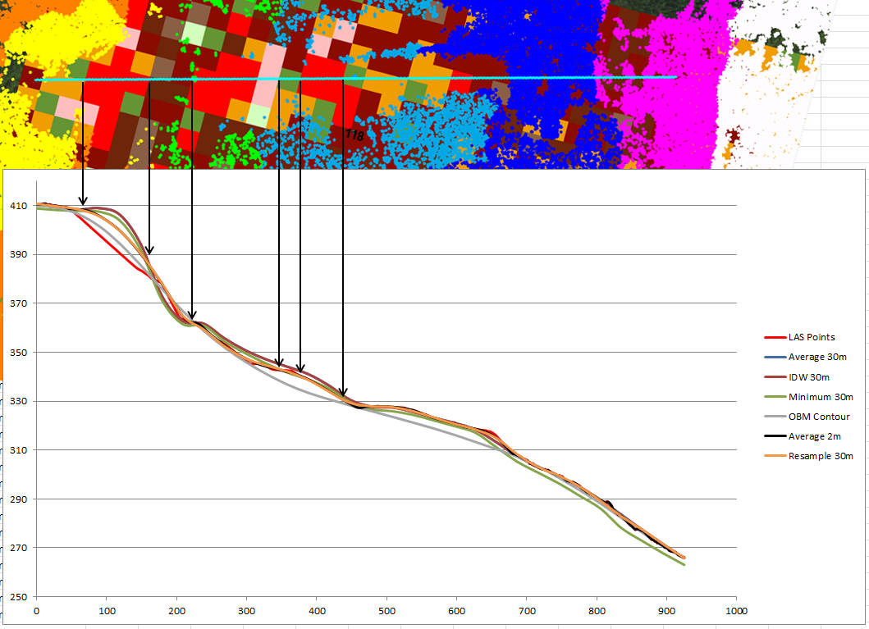
Figure 29: Comparing the elevation profiles of different SWOOP interpolation and resampling methods in steep terrain.
A simpler cross-section was sampled in this study area over a road allowance to capture its profile. The results are shown below for key interpolation and resampling techniques at 30m (first profile), and all the various techniques and cell resolution scenarios tested at this location (second profile).
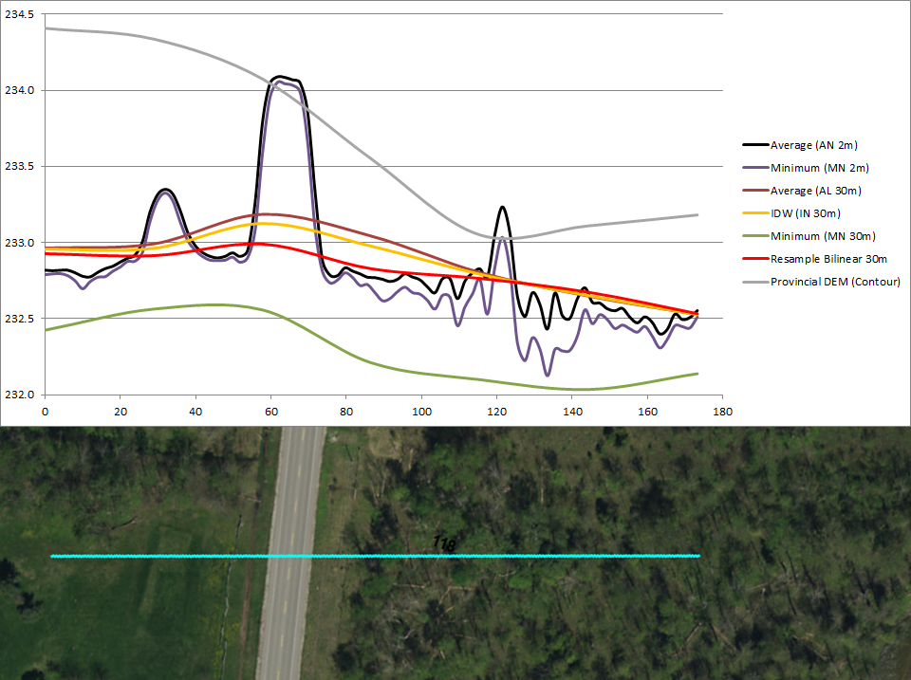
Figure 30: Method profile comparison across a road allowance. The vertical exaggeration is extreme to emphasize the differences in each method. The 2m interpolation methods pick up the small hills and road embankment details whereas the coarse 30m interpolation smooths out the terrain capturing only the major trends. Note the Minimum technique drops significantly below the rest which suggests it may be useful as a ‘burning’ technique for hydrology applications (discussed later in more detail). However, this technique also underestimates the surrounding and predominant values of the terrain and therefore should not be used for a general-purpose DEM.
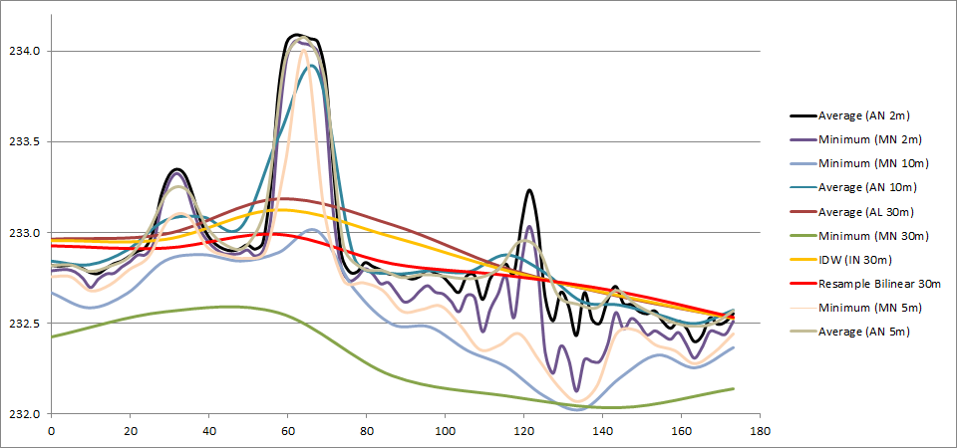
Figure 31: Same profile cross-section as above but also showing interpolation at 5 and 10m resolutions, where varying levels of detail are captured. Performing a Minimum interpolation may be the most desirable approach when working in finer resolutions. This finding may prove to be useful if PMU decides to move to a finer resolution for the PDEM in the future.
The vertical exaggeration in the above profiles is extreme to highlight the difference between approaches. The maximum elevation difference occurs when comparing the OBM contour surface with the SWOOP minimum interpolation surface (see the first profile figure). Even so, the maximum difference was no more than 2 metres. However, the OBM contours do not capture the 1-metre-high road embankments at all which may be problematic for localized water flow routing applications. All other SWOOP derived methods capture a rise in elevation at or near the road in this instance, but this may not always be the case at coarser resolutions (particularly 30m and 10m) especially for smaller access roads. The second profile figure shows additional interpolations at 10m and 5m resolutions both of which capture the height of the road. However, upon examination of longer stretches of roads within the study area, only a 5m resolution surface or better seems to capture the entire road network consistently without interruption. Note this may not always be an advantage for watershed delineation if there are undocumented culverts that are crossing these roads. With the interruptions at coarser scales, this allows water to 'flow through' the road. Conversely, if the road is truly a barrier without culverts, you may not want the water to 'flow through' or follow the trend of the surrounding terrain. It is difficult to determine what the best solution is without local knowledge of the terrain. In the absence of a comprehensive culvert database, maintaining a coarser DEM resolution (e.g., 30m) is preferable for maintain natural water behaviour. If the province does acquire locations of finer culverts in the future and keeps a good record of them, only then would finer DEM resolutions be worth investigating for the purpose of watershed delineation.

      - SA3 – Maitland River Mouth (Current PDEM data source: OBM DTM)
Some tributaries were examined to observe the effects of the various interpolation techniques.
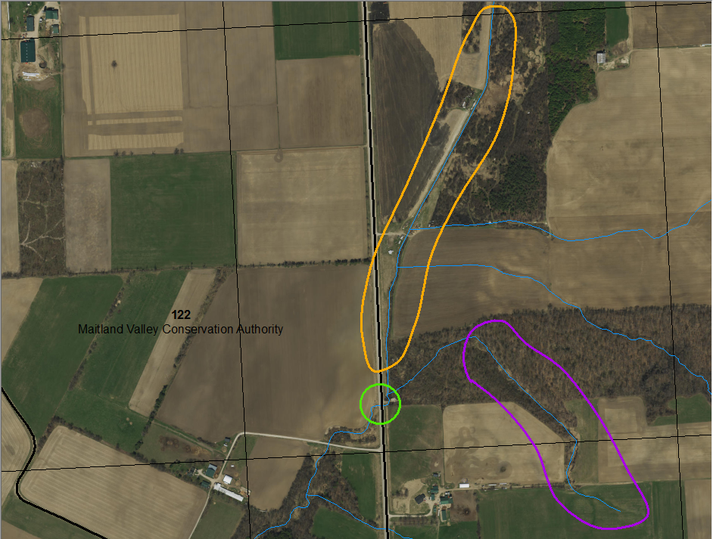
Figure 32: Image with culvert highlighted by green circle and watercourse features of interest highlighted in orange and purple.
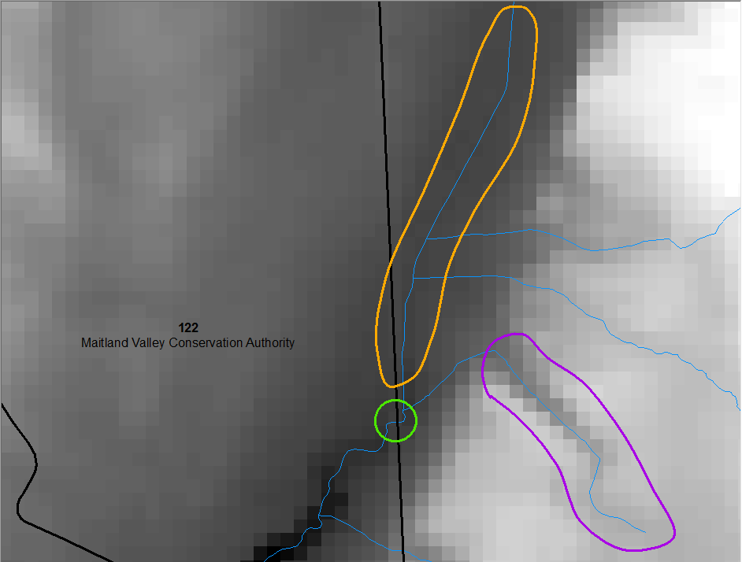
Figure 33: Average interpolation to 30m resolution.
IDW and Average interpolation produced comparable results and therefore only one example is shown above. The tributary highlighted in orange is not distinctly defined as its banks fall within the width of a single cell at a 30m resolution. The area encircled in green is where the watercourse intersects and flows under a road through a culvert. The elevation at this point captures the height of the road allowance. The area in purple highlights a gully depression draining down into the valley.
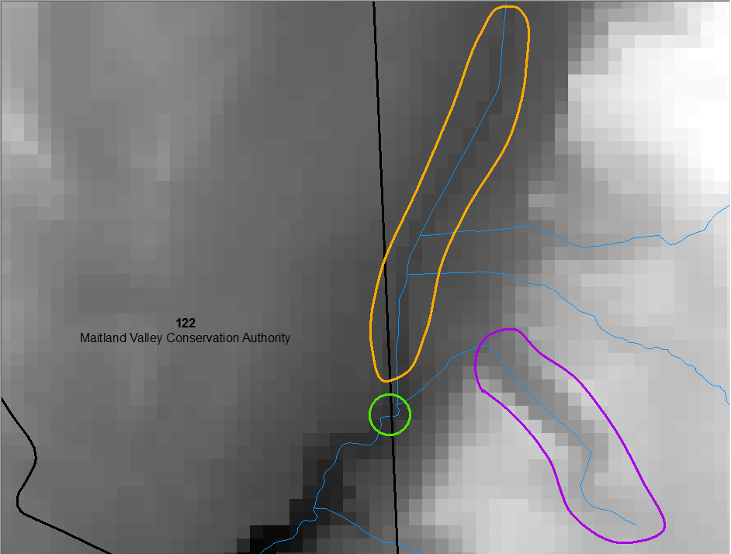
Figure 34: Minimum interpolation to 30m resolution.
The figure above illustrates a DEM interpolated using the minimum technique. Notice the stream highlighted in orange is better defined, but the gully width in purple becomes exaggerated as the minimum elevation values take precedence. One interesting finding with the Minimum technique is that it also 'burns' a path through small access roads or roads with narrow road allowances, as a minimum ditch elevation may fall within the same cell as the road itself. This finding should be explored further as it may capture areas that should drain through roads even off the network. This is only made possible because of the coarse raster cell size we are working in. This type of product would only be useful for watershed delineation purposes. However, for extracting surface elevation values, the Average or IDW techniques are more suitable for this purpose.
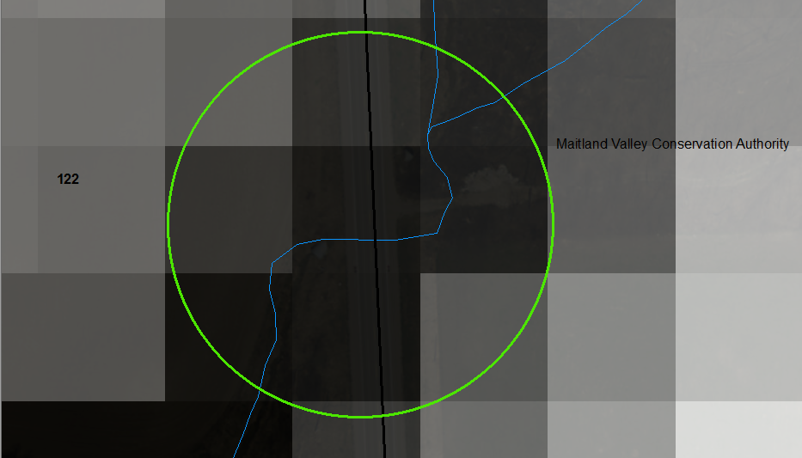
Figure 35: Zoom-in of road and water crossing from the previous figures.
Figure above shows a zoom-in of the water crossing and how the Minimum technique effectively ‘burns’ through the road surface.
      - SA4 – Town of Merlin (Current PDEM data source: OBM DTM)
This area is characterized by flat open terrain that is predominantly agriculture.
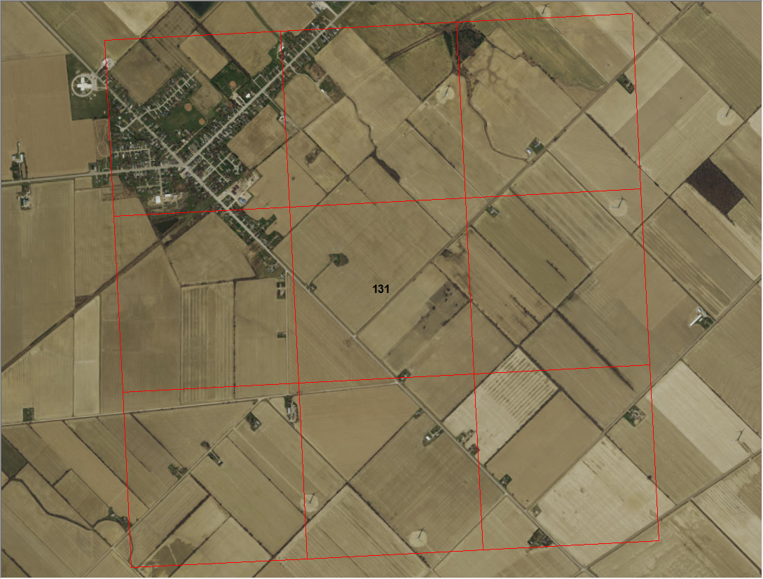
Figure 36: Study area in flat terrain dominated by agriculture and artificial drainage.
A series of difference grids like those for SA1 were generated. Interpolation using the various methods in open flat terrain yielded comparable results except for MIN interpolation where ditches were too exaggerated and practically obliterated the adjacent road elevations at a 30m resolution especially when ditches were present on both sides of the road. Resampling also produced comparable results to IDW or AVG in gradually sloping terrain although sharp linear features (raised roads and ditches) lost some definition. However, this difference is not enough to significantly impact watershed delineation at a 30m resolution because of the reasons stated previously concerning the interruption in road elevations. In most cases, where culvert information was not available, the 30m resolution compensated by ensuring that natural flow conditions were honoured by breaching narrow barriers like road allowances.
      - 2017/18 LiDAR Comparison
The key format differences in the LiDAR and SWOOP large scale products included:
- Finer native resolution of the LiDAR DTM products supplied by the vendor at 0.5m for LiDAR versus 2m for SWOOP.
- The adoption of the new vertical datum CGVD2013 in the recent LiDAR acquisitions.
Once the LiDAR transformation back to CGVD28 was accounted for to match the PDEM, LiDAR interpolation and resampling to 30m produced comparable results to SWOOP. Note that current methods now reference all processing to the new vertical datum and a transformation back to CGVD28 is only done as a last step for the purpose of maintaining two vertical datums in the PDEM product.
Some qualitative investigations were also performed near Sarnia where the terrain is characterized as being typically flat and urbanized.
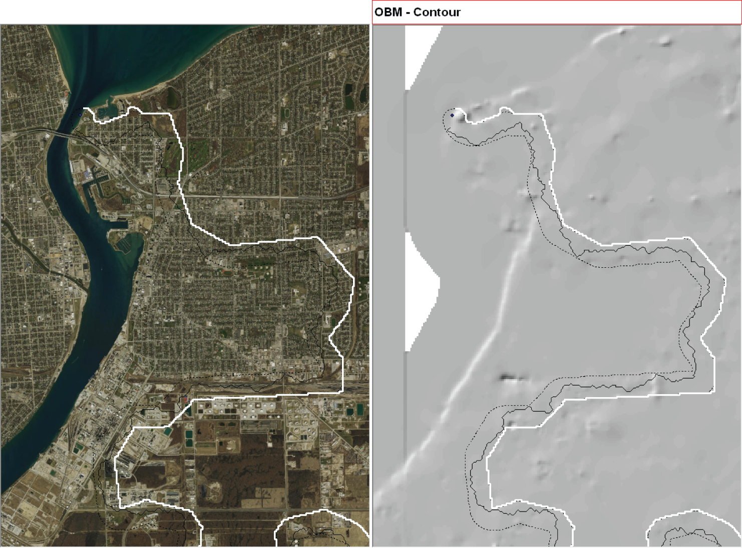
Figure 37: SWOOP imagery for Sarnia (left) and the original PDEM terrain (right) derived from very sparse OBM contour and spot height information that was previously available prior to 2017.

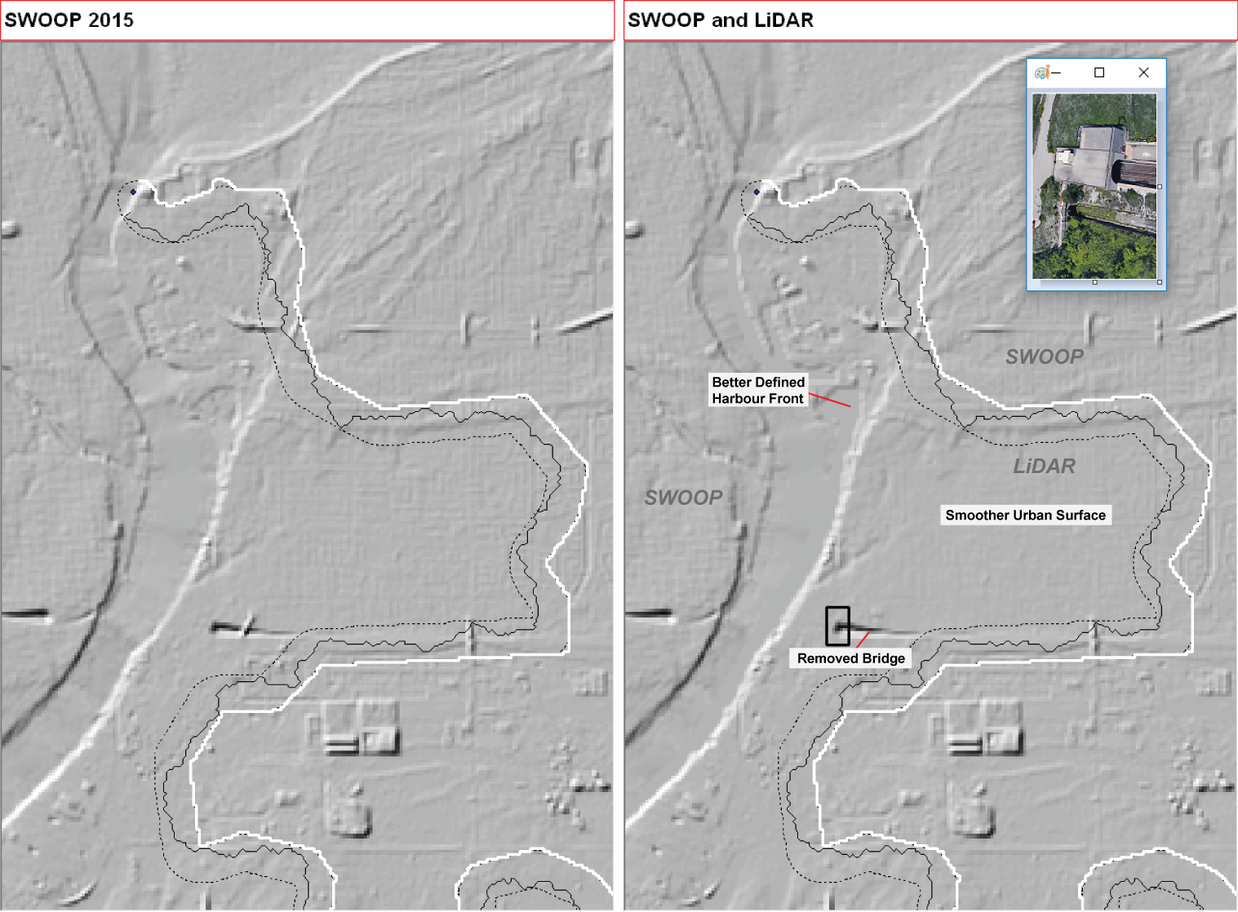
Figure 38: SWOOP DTM 2015 on the left overlaid with LCP buffer corridor (dashed line) and cutline (solid black line). White line represents eastern edge of the 2017 LiDAR coverage that was acquired and was incorporated into the right image which covers the southern part of Sarnia draining to St. Clair River. Some LiDAR improvements are also noted.
The left image in Figure 37 above shows the entire Sarnia region covered by the SWOOP 2015 DTM, which is a notably significant improvement over the OBM Contour product in Figure 36. The image on the right in Figure 37 shows the LiDAR 2017/18 product mosaicked over top of SWOOP. The white line illustrates the easterly extent of the LiDAR coverage, while the dotted line is buffered in 200m from the LiDAR edge to create an overlapping corridor between both products to conduct the Least Cost Path analysis as discussed in the ‘Least Cost Path Method Overview’ section of this document. The solid black line is the result of the LCP analysis and serves as the effective 'cut-line' between the two products. The western edge of the LiDAR coverage is bounded by the St. Clair River. Some subtle improvements in the LiDAR coverage are noted when compared to SWOOP such as removed bridges over water, smoother surfaces in the urban area and a better-defined waterfront along the St. Clair River.

Version 1920.1

