Frequently Asked Questions, Tips, and Tricks

How do I access the research plot layers?
The main channels to use to access research plots layers for viewing and analysis are:
  - LIO editor
  - LIO mapper
  - LIO data warehouse
  - Geospatial Data Delivery Service (GDDS)
  - Annual deliveries to forest industry via the forest information (FI) portal FIPortalSupport@ontario.ca

Note
The distribution channels (data sources listed above) differ in how current they are. For the most up-to-date data use the LIO data warehouse. For more information about data currency and update schedules, contact LIO support at lio@ontario.ca.

Who edits the research plot layers?
Each owner/publisher is responsible for arranging and facilitating entry of their research plot data into the LIO editor. This should be part of their standard operating plan and be factored into work planning.
Each owner/publisher of data contributed to the research plot data class is responsible for ensuring their data is compliant, correct, complete, current, published, and maintained throughout its full lifecycle.
Current limitations in the LIO editor infrastructure and/or programming, limit program area-specific management of edit and check in rights. As such, we rely on an environment of trust, policy, and best practices to ensure data integrity is not compromised. Please:
• only edit your own data
• be diligent when selecting items for edit
• always confirm the location of the item being created or edited

How do I get editing privileges?
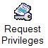
The request privileges function allows you to request privileges for a specific feature class and to view your edit privileges. If you require edit privileges, or need increased privileges for a specific feature class (or classes), use the options in this function to e-mail a request for privileges to the appropriate administrator.

I cannot see the research plot model layers in the add data list in the LIO editor/mapper.
Research plot model can be displayed by adding the layer named research plots. The 7 spatial layers comprising the model are part of a group layer named research plots. Figure 1 shows the add data menu and the research plots layer in the thematic folder. Also shown is the contents list showing the layers that are added when the research plots group layer is added to your user map.
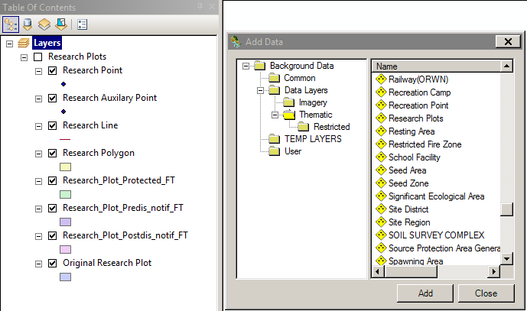
Figure 1. Screen capture showing how to add research plot layers to the LIO editor and mapper.

How do I add a feature to research plot (point, line, or polygon)?
Direct entry using the LIO editor is strongly encouraged. The steps required to enter a new feature are:
- Create or select an appropriate study record including owner and sponsor descriptions
- Create or select an appropriate study contact record; if no suitable record, create a new research contact record.
- Create a research point, research line, or research polygon.
- Select your study record from the drop-down menu in the editor
- Select your study contact from the drop-down menu in the editor
- Assign the appropriate protection prescription record.
- Assign a protection end date.
- Assign pre-disturbance notification information if needed.
- Assign post-disturbance notification information if needed.
- Validate, save, and post to the LIO editor database.

I have several features to add/update in the research plot layers
When posting several features, it’s best to do your edit locally in empty layers that match the schema (table names, column names) of the existing layers. These layers can be bulk imported by following the steps below.

Use the LIO MNRF template database (INTERNAL USE ONLY – not for distribution), which is an empty file geodatabase (FGDB) with several MNRF data layers. This product was created to support MNRF data collection, including mobile data collection.
Note: If the study or contact name is not yet in the research contact and/or research study tables, add these values into the tables before using the import data tool in the LIO editor to import records.
- Create an appropriate study record including owner and sponsor descriptions
- Create an appropriate study contact record; if no suitable record, create a new research contact record.
- Use the import data tool in the LIO editor to import the spatial features (point, line, or polygon).

How do I add a feature to the research plot protected layer?
Research plot protected is one of the derived layers. Features in this layer are automatically generated based on values in the parent layers: research point, research line and/or research polygon. Features posted to the parent layers will be be added to the derived layers based on the protection date and buffer distance entered in the parent layer(s). See Figure 3 in the User Guide for a diagram of the functional relationship among the research plot data layers. Derived layers are generated each night.

Existing record:
For existing records (features) in a parent layer, create the conditions for a record in the research plot protected layer (e.g., Figure 2) as follows:
- Select the record that requires protection
- Select the appropriate protection status under protection prescription identifier. Either:
  - Fully protected
  - Fully protected — negotiable
- Enter an appropriate date in the protection end date field
  - Note: To generate a buffer for the parent feature represented in the research plot protected layer the protection end date must be later than the current date.
- Enter an appropriate protection buffer distance ( in metres).
- Save, validate, and post.
- The changes will be posted to the LIO editor database. During nightly maintenance edits will be transferred to the LIO data warehouse and simultaneously a buffer will be calculated and research plot protected layer will be updated with a feature representing a buffer of the research feature (point, line, or polygon).
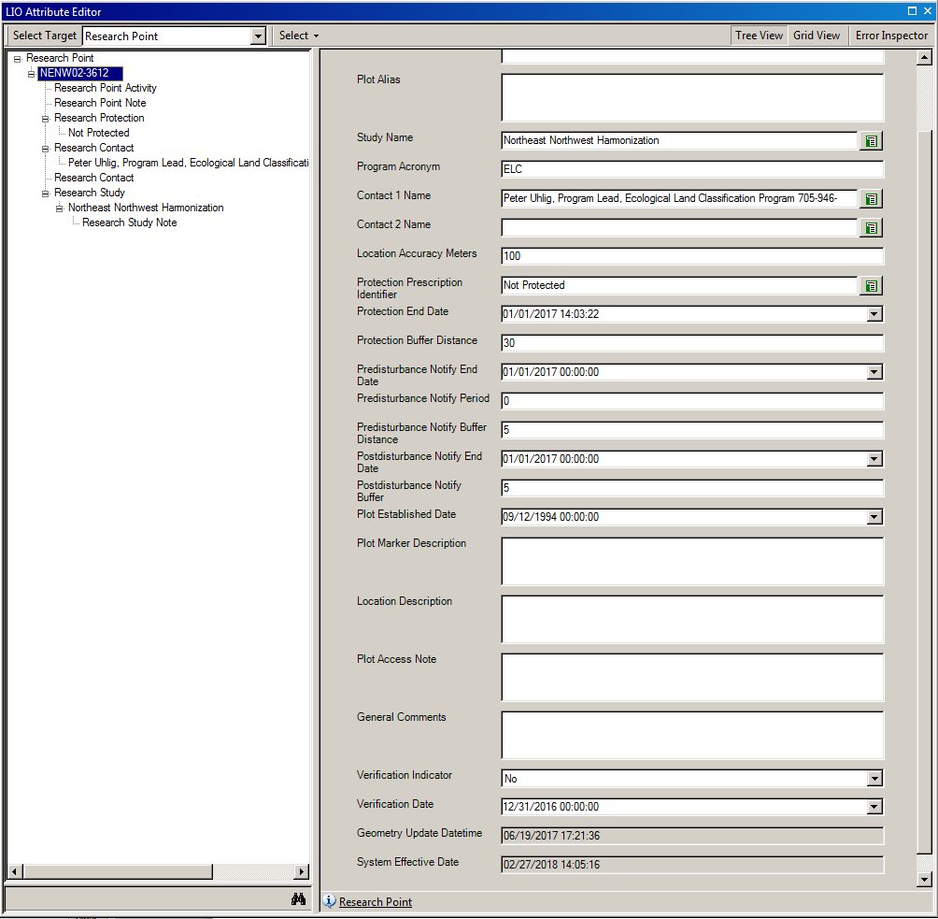
Figure 2. Screen capture showing fields in which protection values are entered in the LIO attribute editor marked with black arrows.

Non-existing record:
As research plot protected is a derived layer, features cannot be added to it without a defined research point, line, or polygon. First, add e a record in one or more of the Parent layers using the step-by-step instructions provided above.

How do I add a feature to the research plot predisturbance or postdisturbance notification layers?
Pre- and postdisturbance layers are similar to the research plot protected (see previous section). To define a buffer area around a research plot, enter a date after the current date in either the predisturbance notify end date or postdisturbance notify end date fields (see Figure 3) and enter a buffer distance in metres. The default is 5 m.
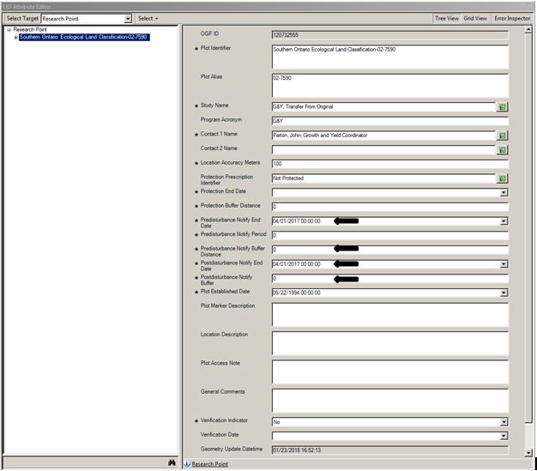
Figure 3. Screen capture showing fields that need to be populated to create features in the derived layers for notification are marked black arrows.

I have validated and posted my edits but cannot see them?
Feature edits made to the research point, line or polygon layers in the LIO editor can be accessed via the editable data folder (see Figure 4). Research auxilliary point, research line, research point, and research polygon layers can be found in the editable data folder under the spatial classes folder. To see these layers, request editing privileges (see the request privileges section above). Edits are visible immediately after posting.
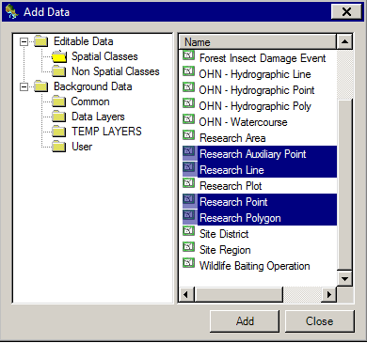
Figure 4. Screen capture with the 4 editable parent research plot layers highlighted.
Posted feature edits in the research point, line or polygon layers accessed through the data layers folder will not be visible until the next day. Changes are synced with the LIO data warehouse each night.
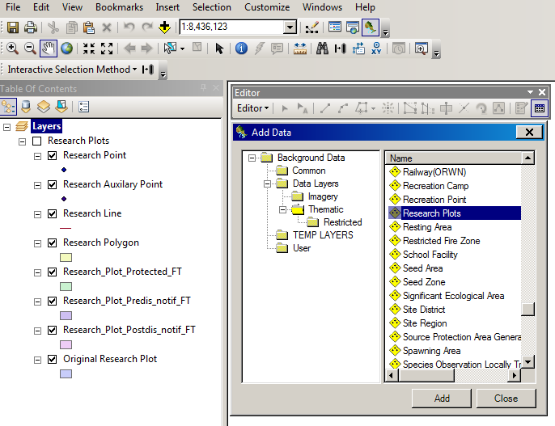
Figure 5. Screen capture showing how to access the research plots group layer from the thematic folder under the data layers folder.
Figure 5 shows how to find the research plots group layer in the add data menu in the thematic folder. These layers are used for analysis and cartography and are updated from the edited layers each night. Point, line, polygon and auxiliary layers are also updated each night after editable layers have been validated and posted.
For additional help using the LIO Editor and Mapper, access online help or contact LRC Application support at LRC-Application-Support-GIS@ontario.ca or 705-755-1650.

I posted data in the research point layer in the LIO editor. When will my edits be reflected in the derived layer, research plot protected, etc.?
Edits made to the parent layers research point, line, and polygon and with a protection end date value set to a future date will have buffers calculated, features created, and be posted in derivative layers overnight so these features will be visible the day after they are posted to the parent layer(s).

How do I download the most recent data?
For the most up-to-date data, order and download the data layers from the LIO Data Warehouse. To get the required user account contact LIO support at lio@ontario.ca.

Why can I not see my edits in GDDS (NDD)?
GDDS (formerly NDD) is refreshed on a monthly basis, shortly after the LIO database monthly maintenance. Any changes will not be reflected until after the refresh.

I have a question about using the research plot layers in the LIO editor and mapper.
For additional help using the LIO editor and mapper, access the online help or contact LRC Application support at LRC-Application-Support-GIS@ontario.ca or 705-755-1650.

I have a data specific question or observation about the layers and tables in the research plot model.
Technical contact.

